Nontarget Analysis of Disinfection Byproducts Using Sequential Extraction and Elution
Anna Anderssonª*, Mourad Harir^{b,c}, Michael Gonsior^{d}, Norbert Hertkornª, Philippe Schmitt-Kopplin^{b,c}, Henrik Kylin^{a,e}, Ämma Pettersson^{f}, Felicia Larsson^{g} and David Bastvikenª
ª Department of Thematic Studies – Environmental Change, Linköping University, SE-581 83 Linköping, Sweden
^{b} Research Unit Analytical BioGeoChemistry, Helmholtz Munich, Ingolstaedter Landstraße 1, 85764 Neuherberg, Germany
^{c} Chair of Analytical Food Chemistry, Technical University of Munich, 85354 Freising, Germany
^{d} Catalan Institute for Water Research (ICRA), 17003 Girona, Spain
^{e} Research Unit: Environmental Sciences and Management, North-West University, Potchefstroom, South Africa
^{f} Nodra, Borgs vattenverk, SE-603 36 Norrköping, Sweden
^{g} Tekniska verken i Linköping AB (publ), SE-581 15 Linköping, Sweden

*Corresponding author: anna.e.andersson@liu.se

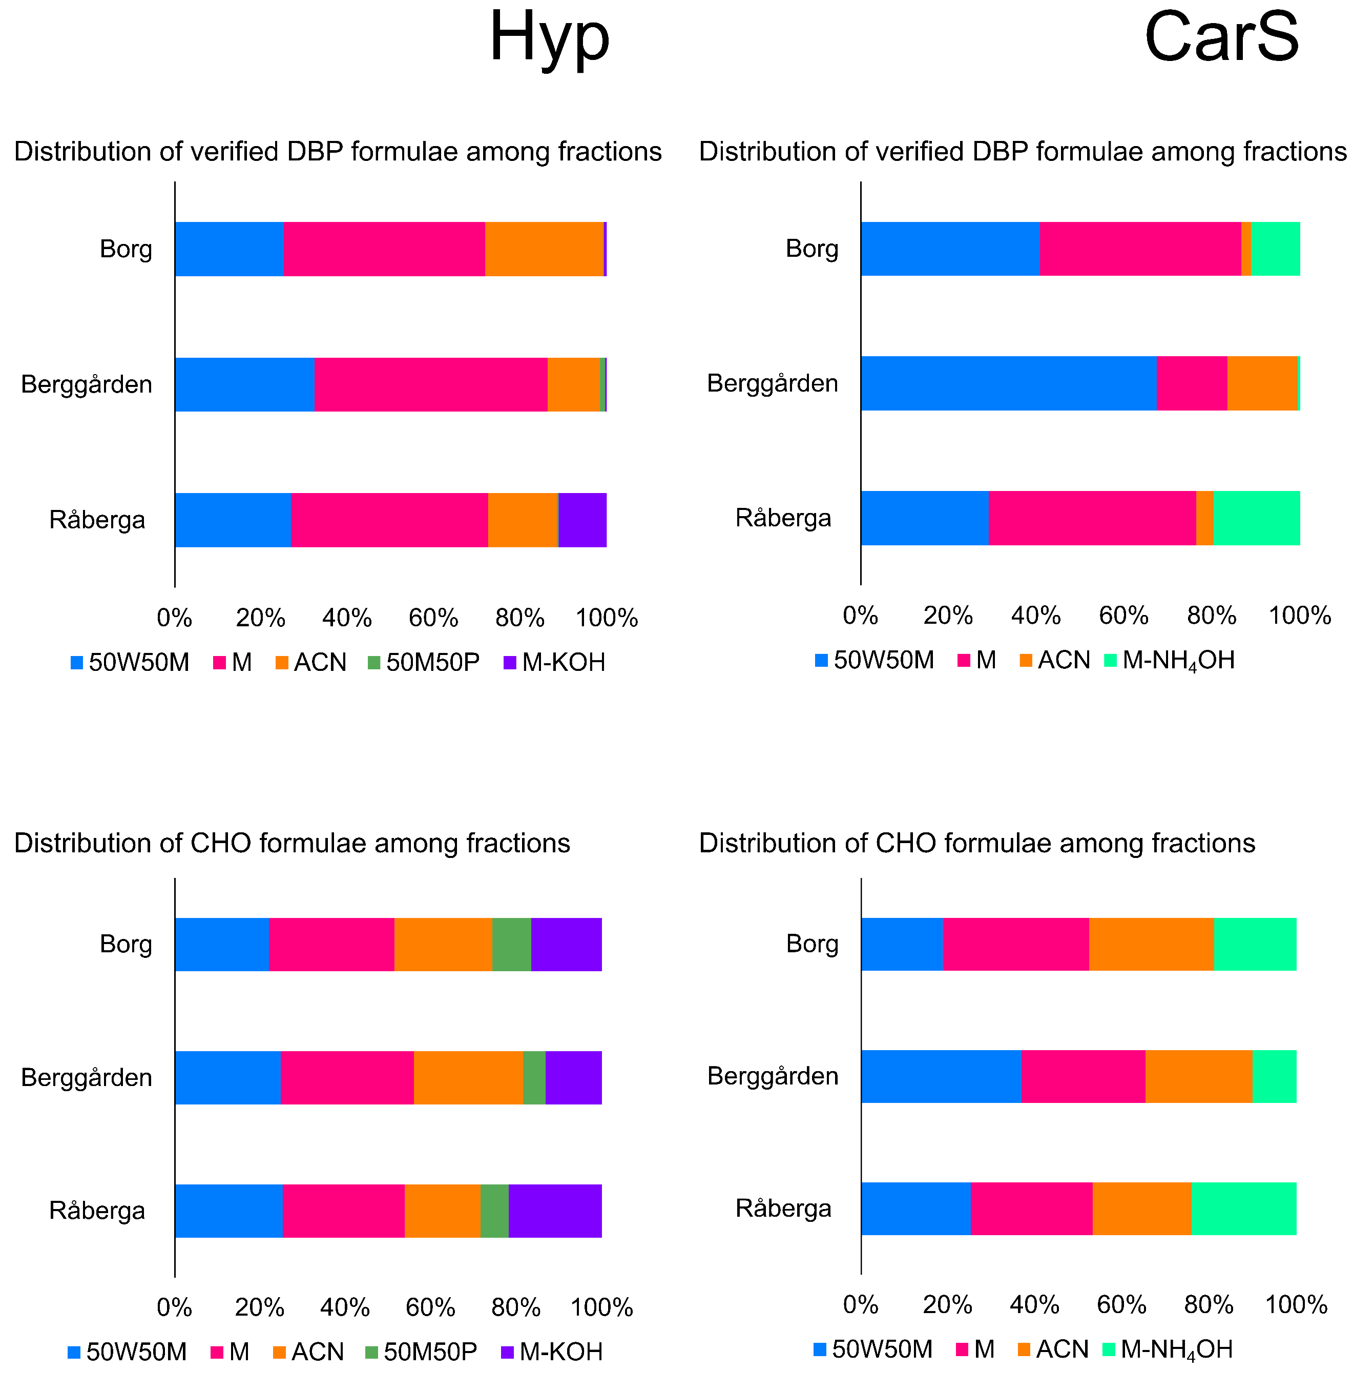
Figure S1. Percentage of verified DBP formulae and CHO formulae sorbed by Hyper Sep (Hyp) and Carbon S (CarS) detected in different fractions.
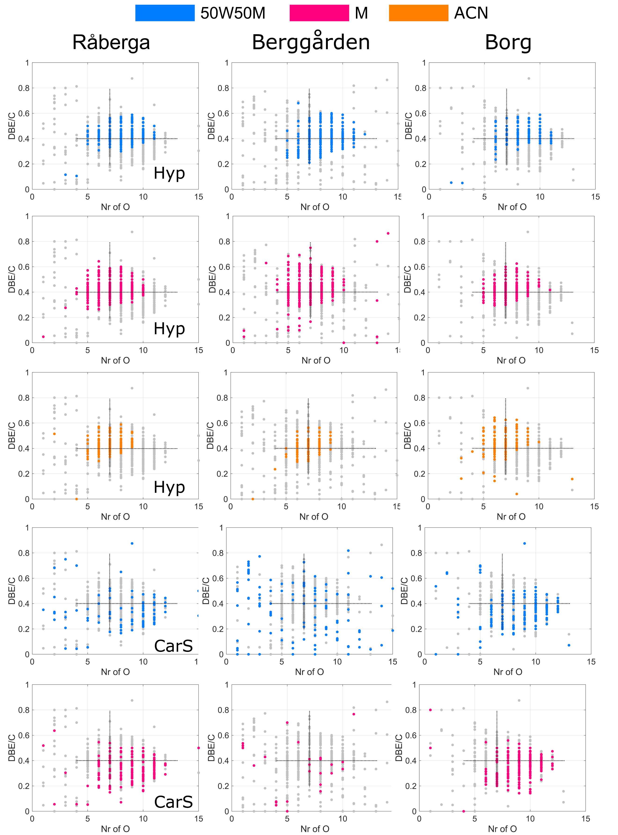
Figure S2. DBE/C against number of oxygen of verified DBP formulae detected at the three DWTPs in different fractions, i.e., water:methanol (50:50, v/v) (50W50M), methanol (M) and acetonitrile (ACN), eluted on Hyper Sep (Hyp) and subsequent Carbon S (CarS) cartridges. The grey dots demonstrate all DBPs detected, with the DBPs detected in a fraction highlighted in different colors. The lines forming a cross are just reference points to facilitate detection of shifts.
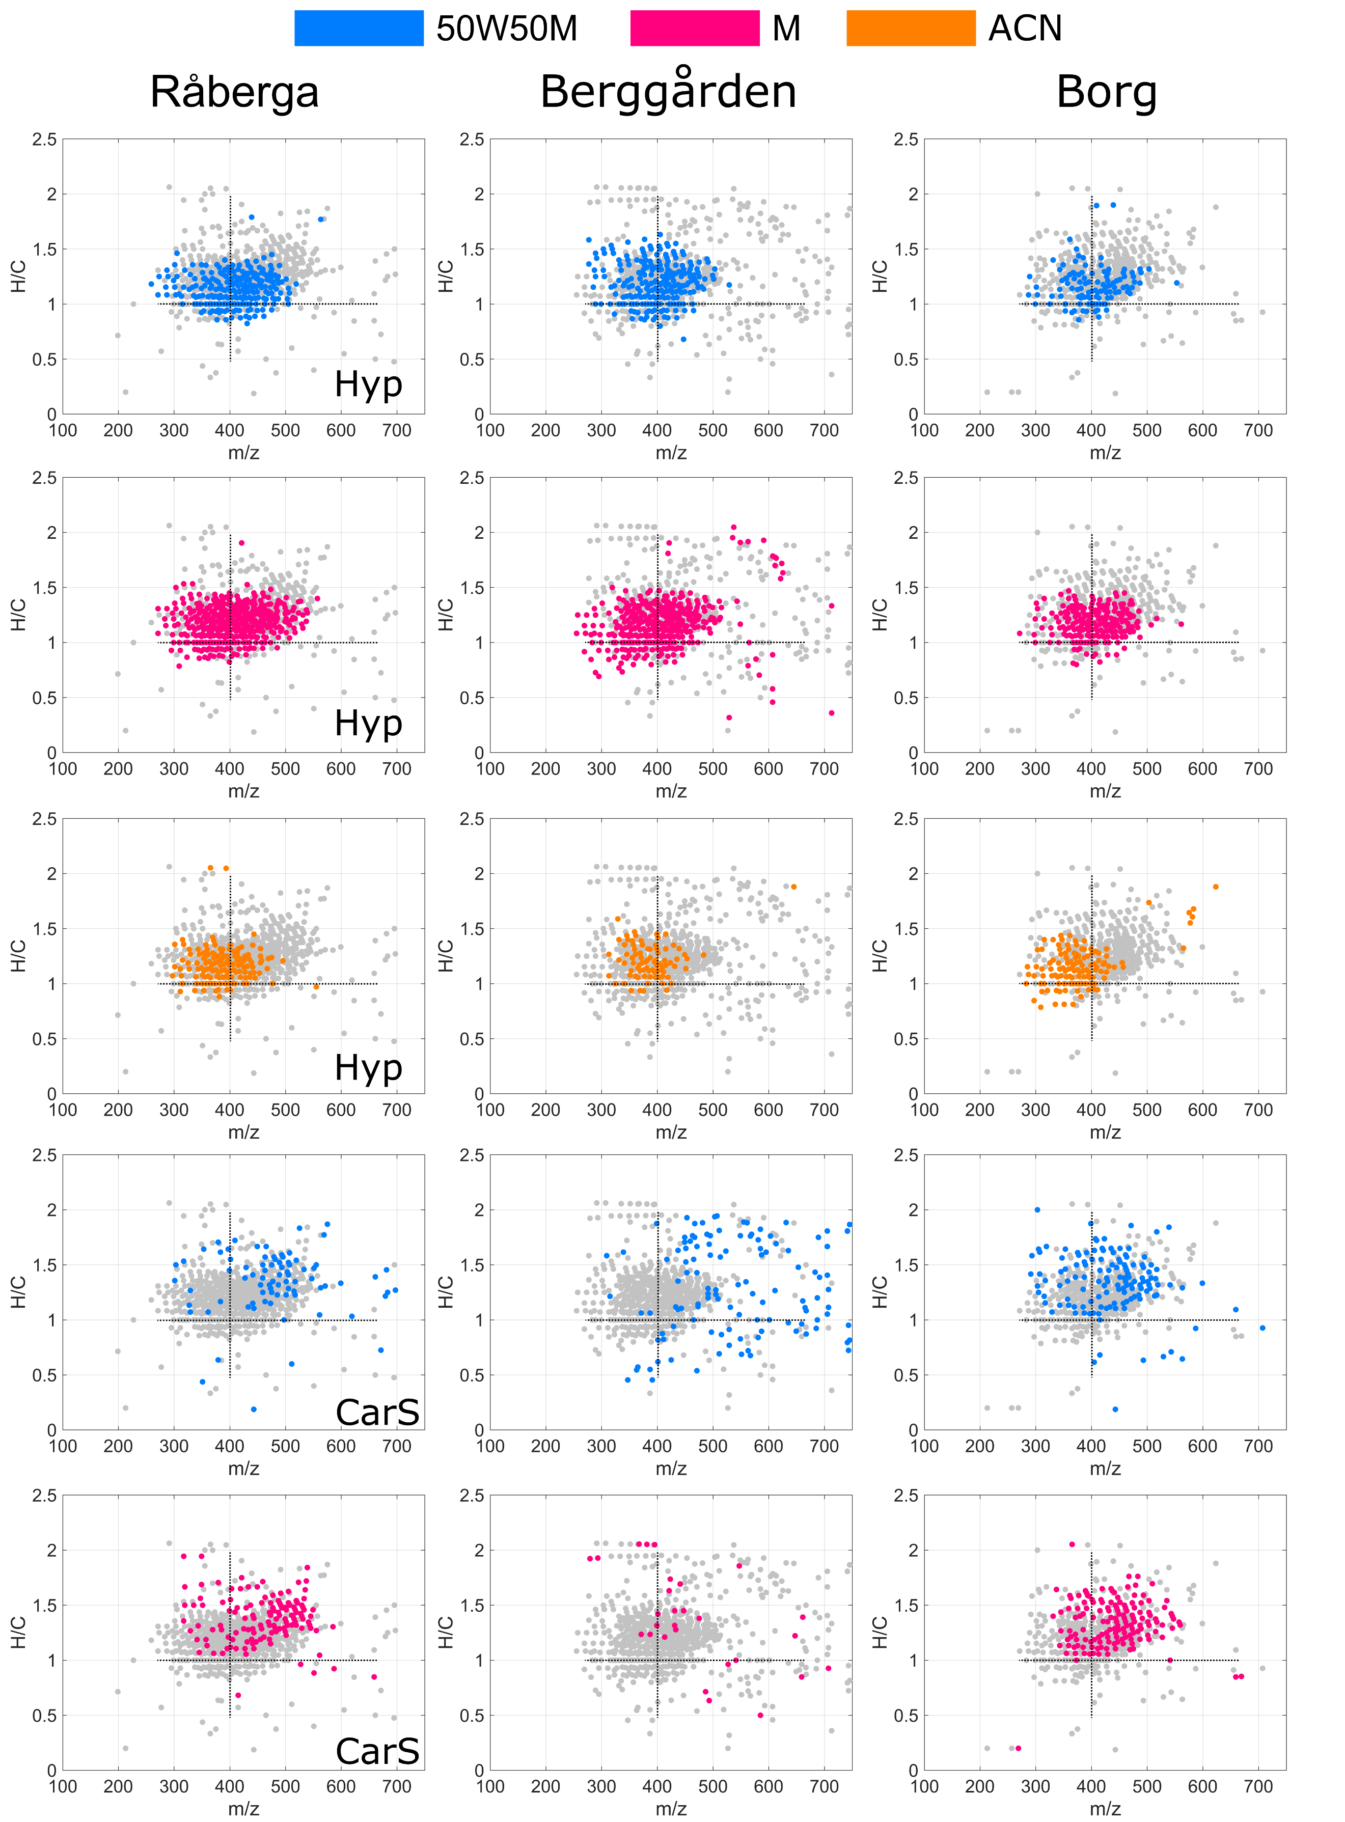
Figure S3. H/C against mass plots of verified DBP formulae detected at the three DWTPs in different fractions, i.e., water:methanol (50:50, v/v) (50W50M), methanol (M) and acetonitrile (ACN), eluted on Hyper Sep (Hyp) and subsequent Carbon S (CarS) cartridges. The lines forming a cross are just reference points to facilitate detection of shifts.
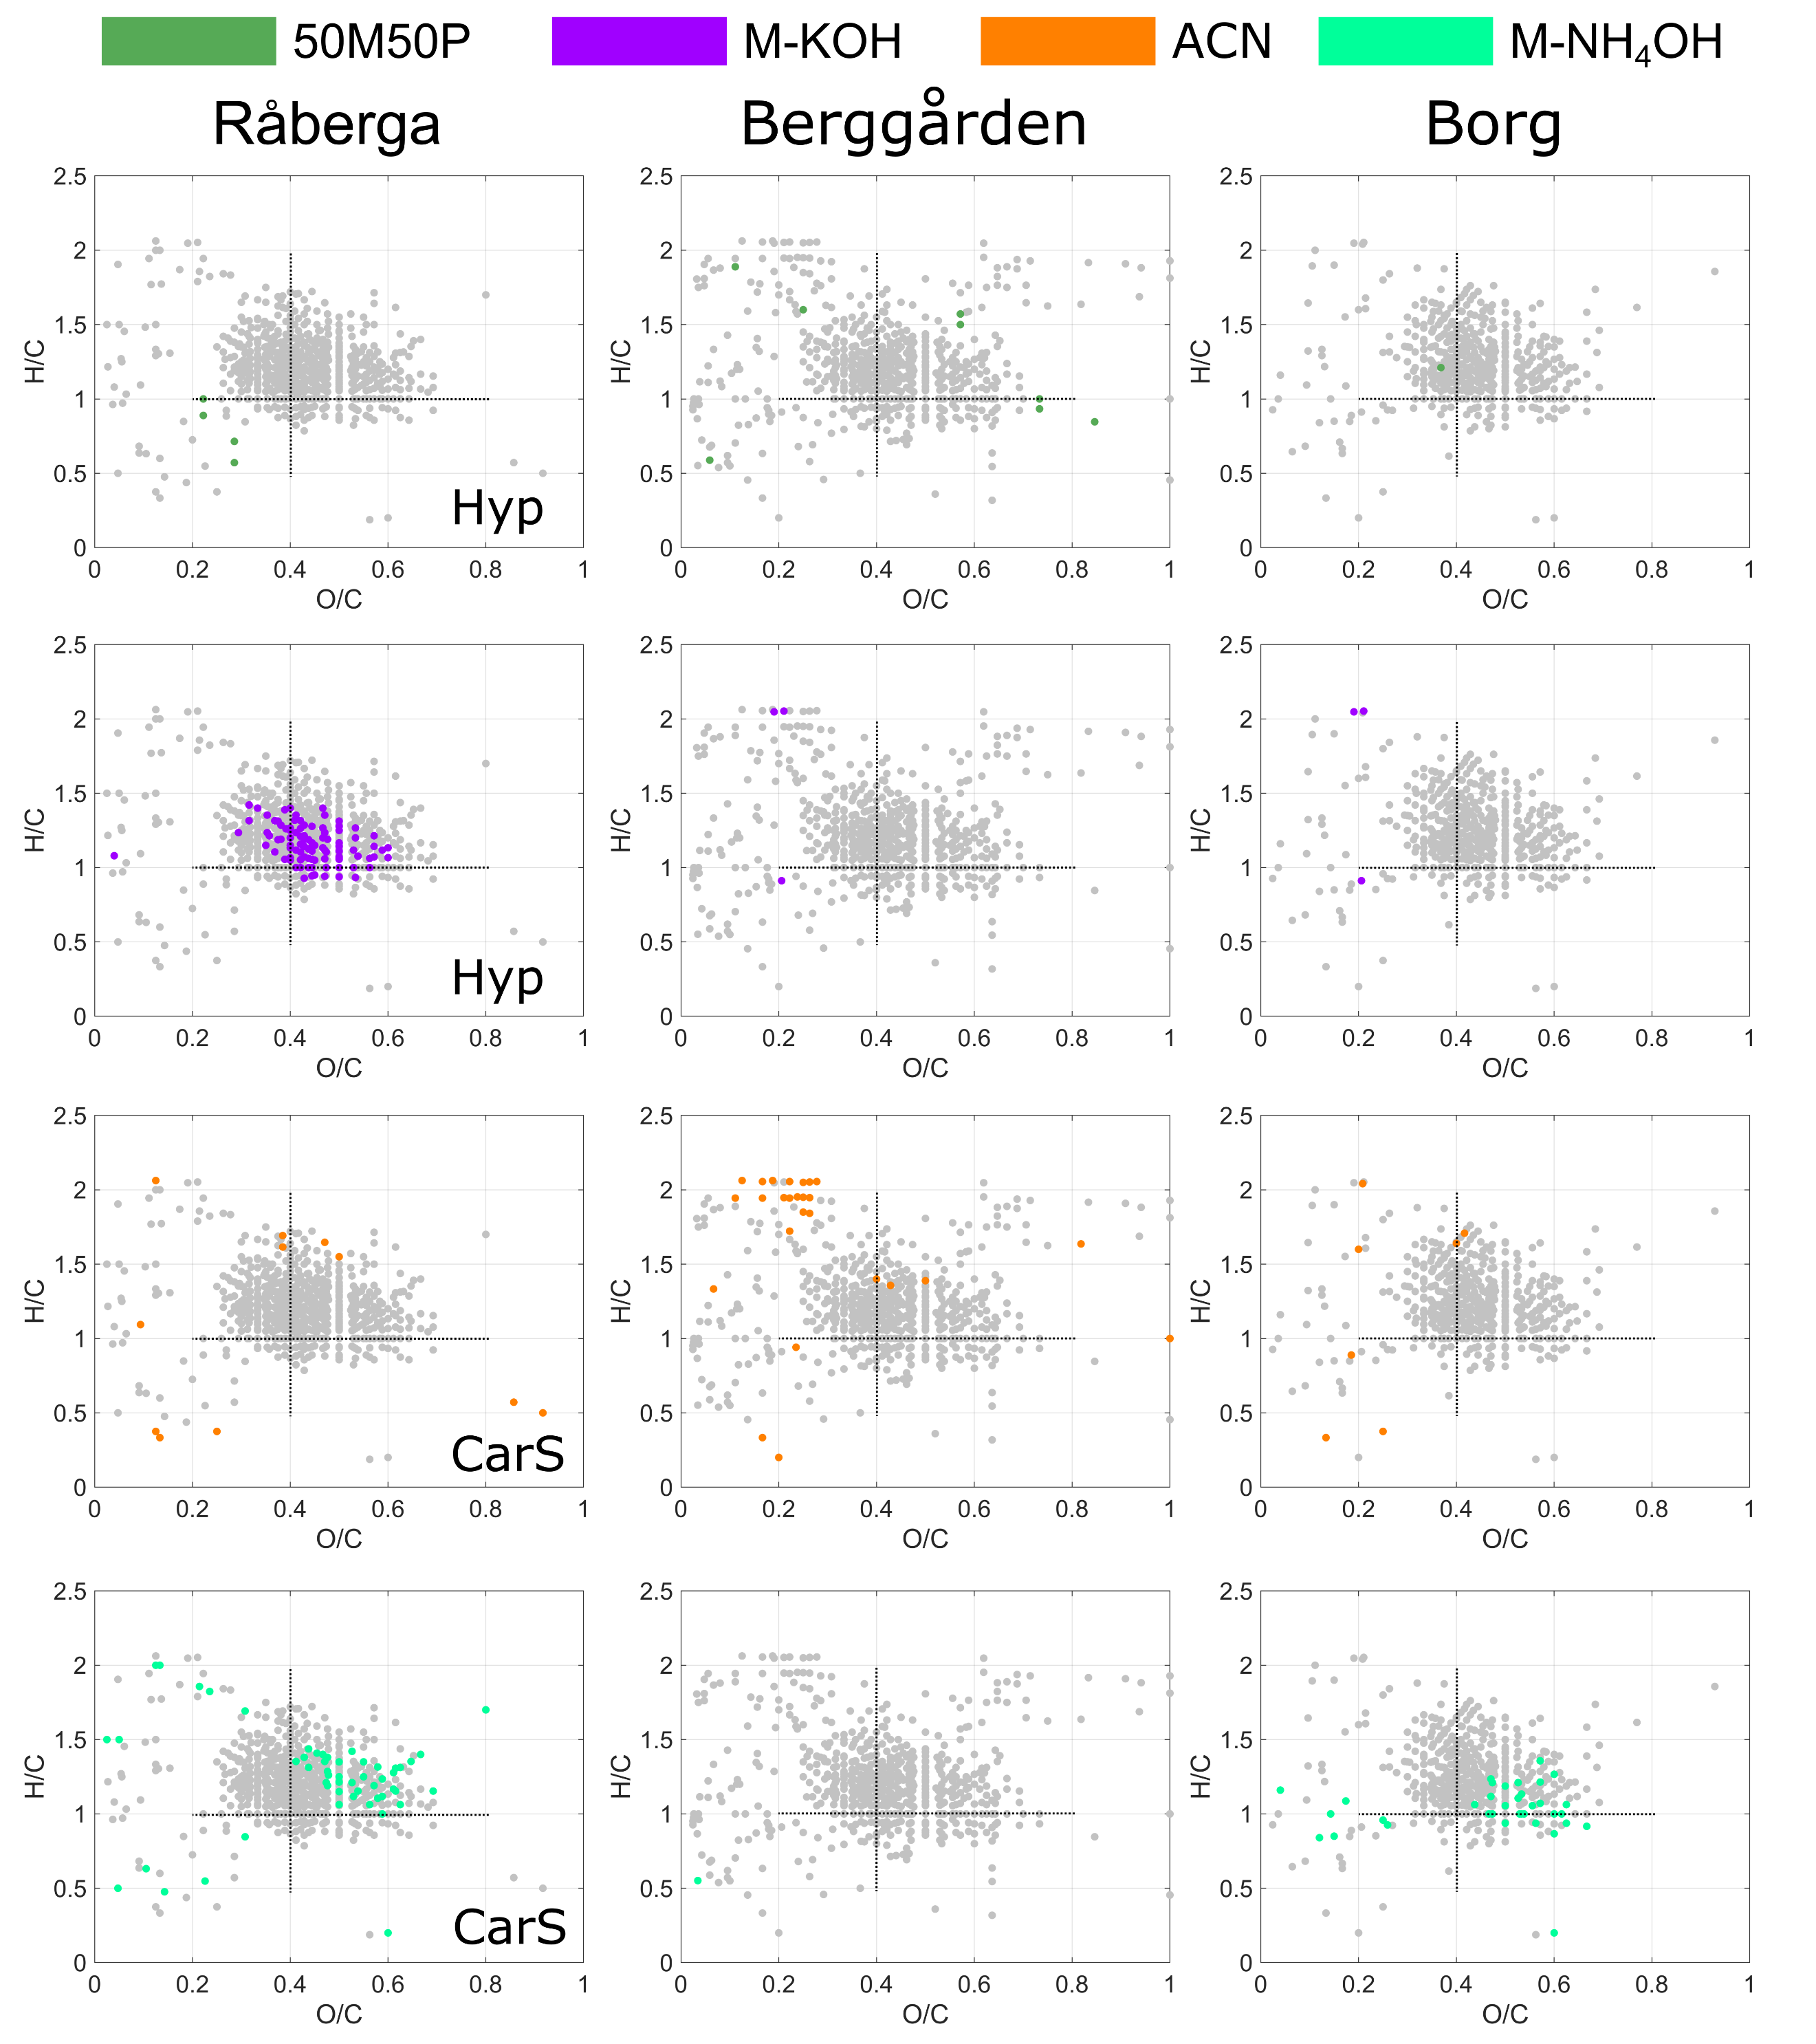Figure S4. Van Krevelen diagrams of verified DBP formulae detected at the three DWTPs in different fractions, i.e., methanol:pentane (50:50, v/v) (50M50P) and methanol containing 1 mM KOH (M-KOH) eluted on Hyper Sep (Hyp) and acetonitrile (ACN) and methanol containing 1% NH₄OH (M-NH₄OH) eluted on subsequent Carbon S (CarS) cartridges. The grey dots demonstrate all DBPs detected, with the DBPs detected in a fraction highlighted in different colors. The lines forming a cross are just reference points to facilitate detection of shifts.

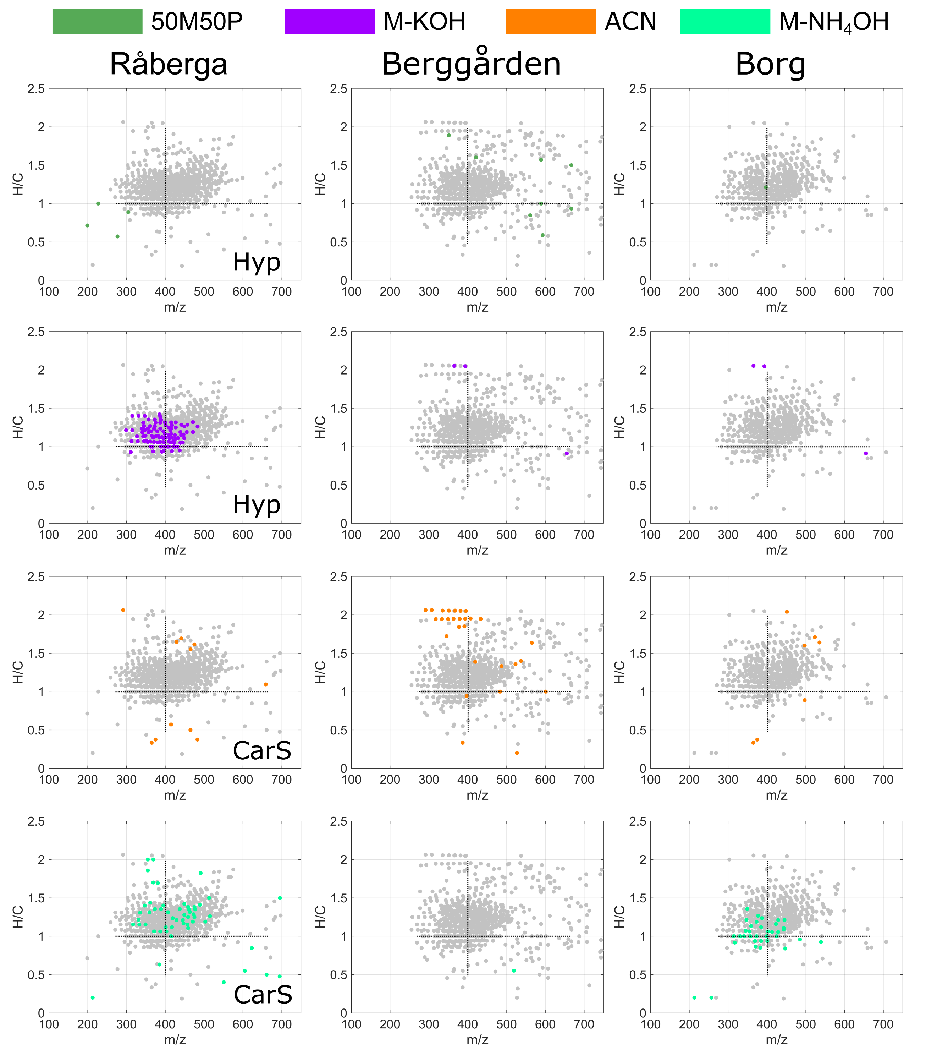
Figure S5. H/C to mass plots of verified DBP formulae detected at the three DWTPs in different fractions, i.e., methanol:pentane (50:50, v/v) (50M50P) and methanol containing 1 mM KOH (M-KOH) eluted on Hyper Sep (Hyp) and acetonitrile (ACN) and methanol containing 1% NH₄OH (M-NH₄OH) eluted on subsequent Carbon S (CarS) cartridges. The grey dots demonstrate all DBPs detected, with the DBPs detected in a fraction highlighted in different colors. The lines forming a cross are just reference points to facilitate detection of shifts.

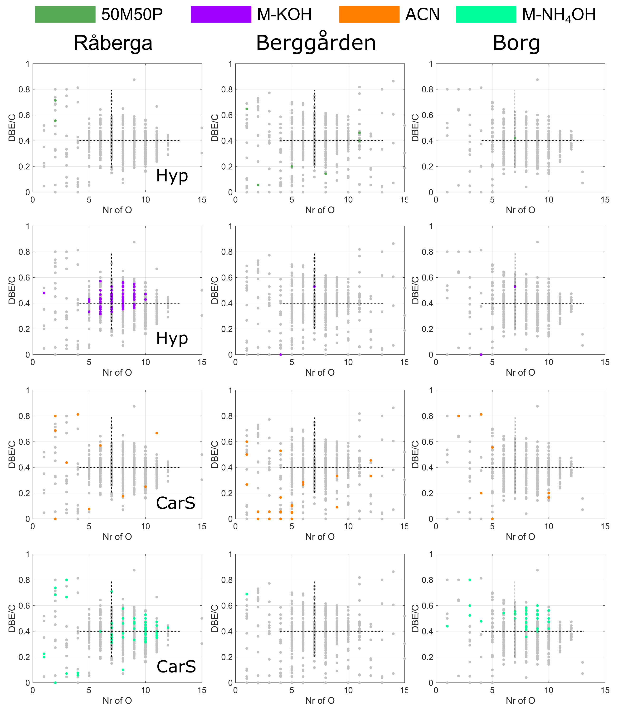
Figure S6. DBE/C to number of oxygen plots of verified DBP formulae detected at the three DWTPs in different fractions, i.e., methanol:pentane (50:50, v/v) (50M50P) and methanol containing 1 mM KOH (M-KOH) eluted on Hyper Sep (Hyp) and acetonitrile (ACN) and methanol containing 1% NH₄OH (M-NH₄OH) eluted on subsequent Carbon S (CarS) cartridges. The grey dots demonstrate all DBPs detected, with the DBPs detected in a fraction highlighted in different colors. The lines forming a cross are just reference points to facilitate detection of shifts.

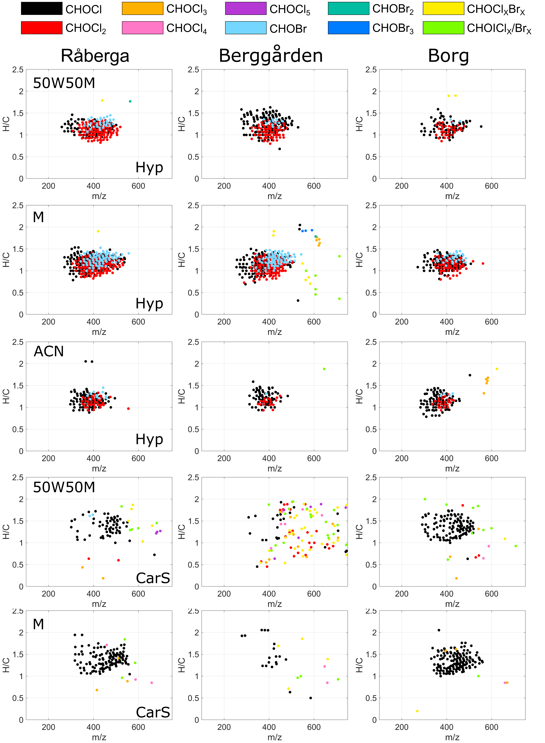
Figure S7. Characteristics of verified DBP formulae detected at the three DWTPs in different fractions, i.e., water:methanol (50:50, v/v) (50W50M), methanol (M) and acetonitrile (ACN), eluted on Hyper Sep (Hyp) and subsequent Carbon S (CarS) cartridges, displayed in H/C to mass plots.
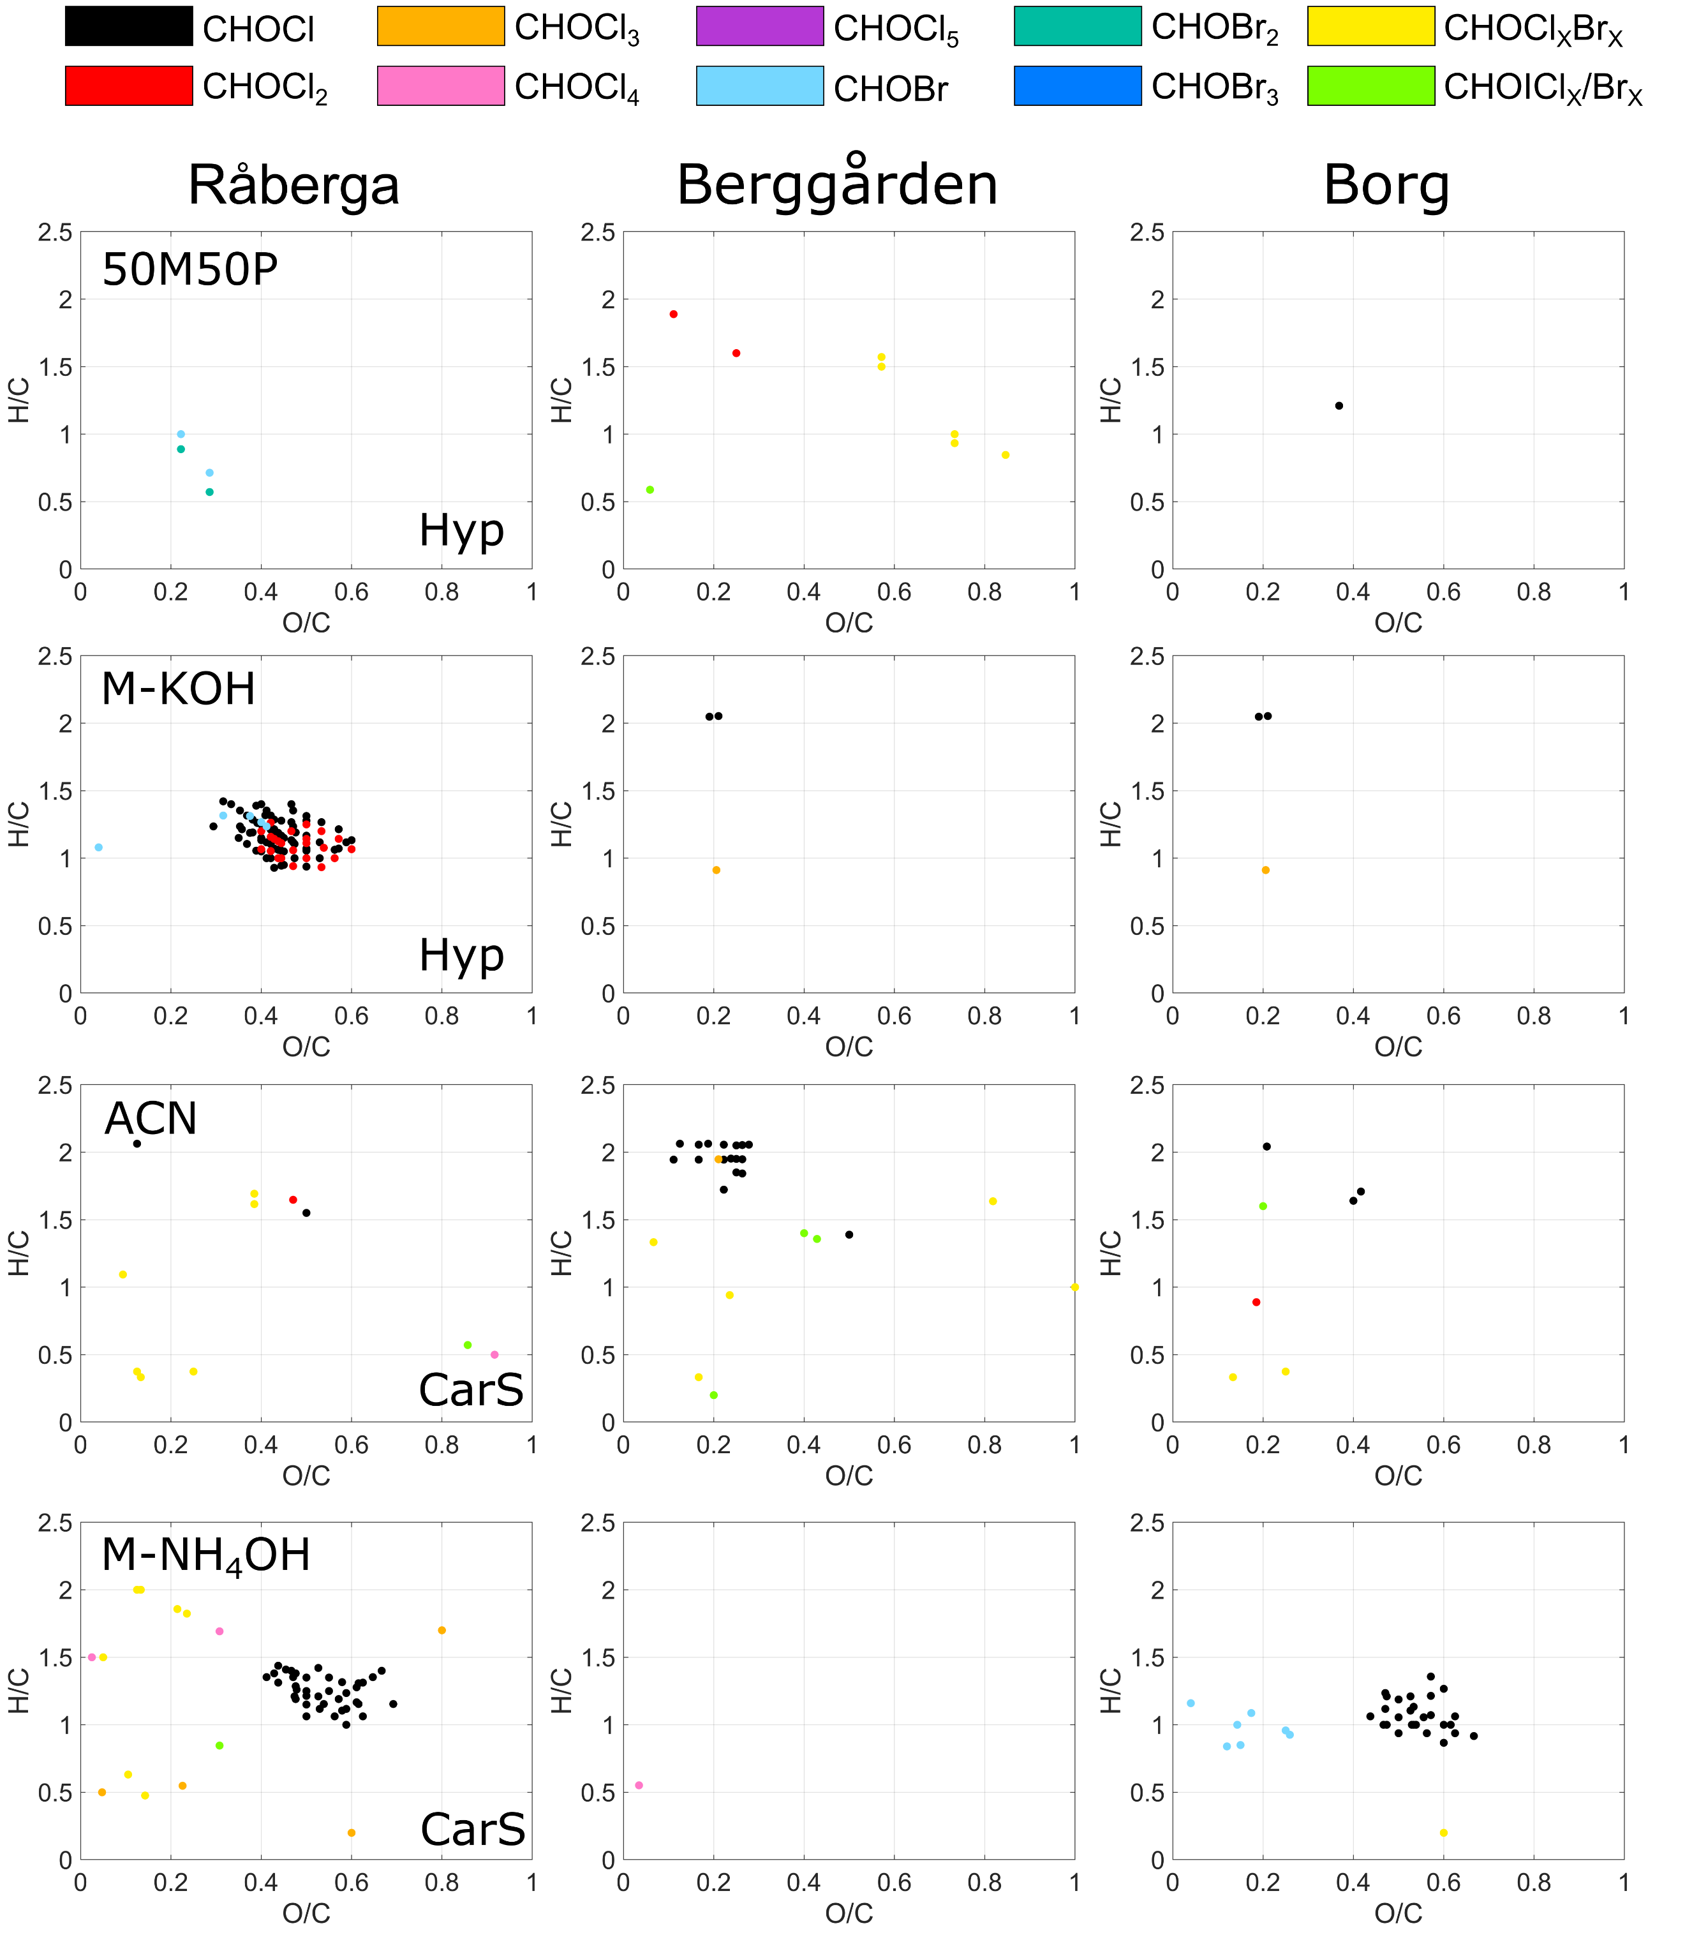
Figure S8. Characteristics of verified DBP formulae detected at the three DWTPs in different fractions, i.e., methanol:pentane (50:50, v/v) (50M50P) and methanol containing 1 mM KOH (M- KOH) eluted on Hyper Sep (Hyp) and acetonitrile (ACN) and methanol containing 1% NH₄OH (M-NH₄OH) eluted on subsequent Carbon S (CarS) cartridges, displayed in van Krevelen diagrams.

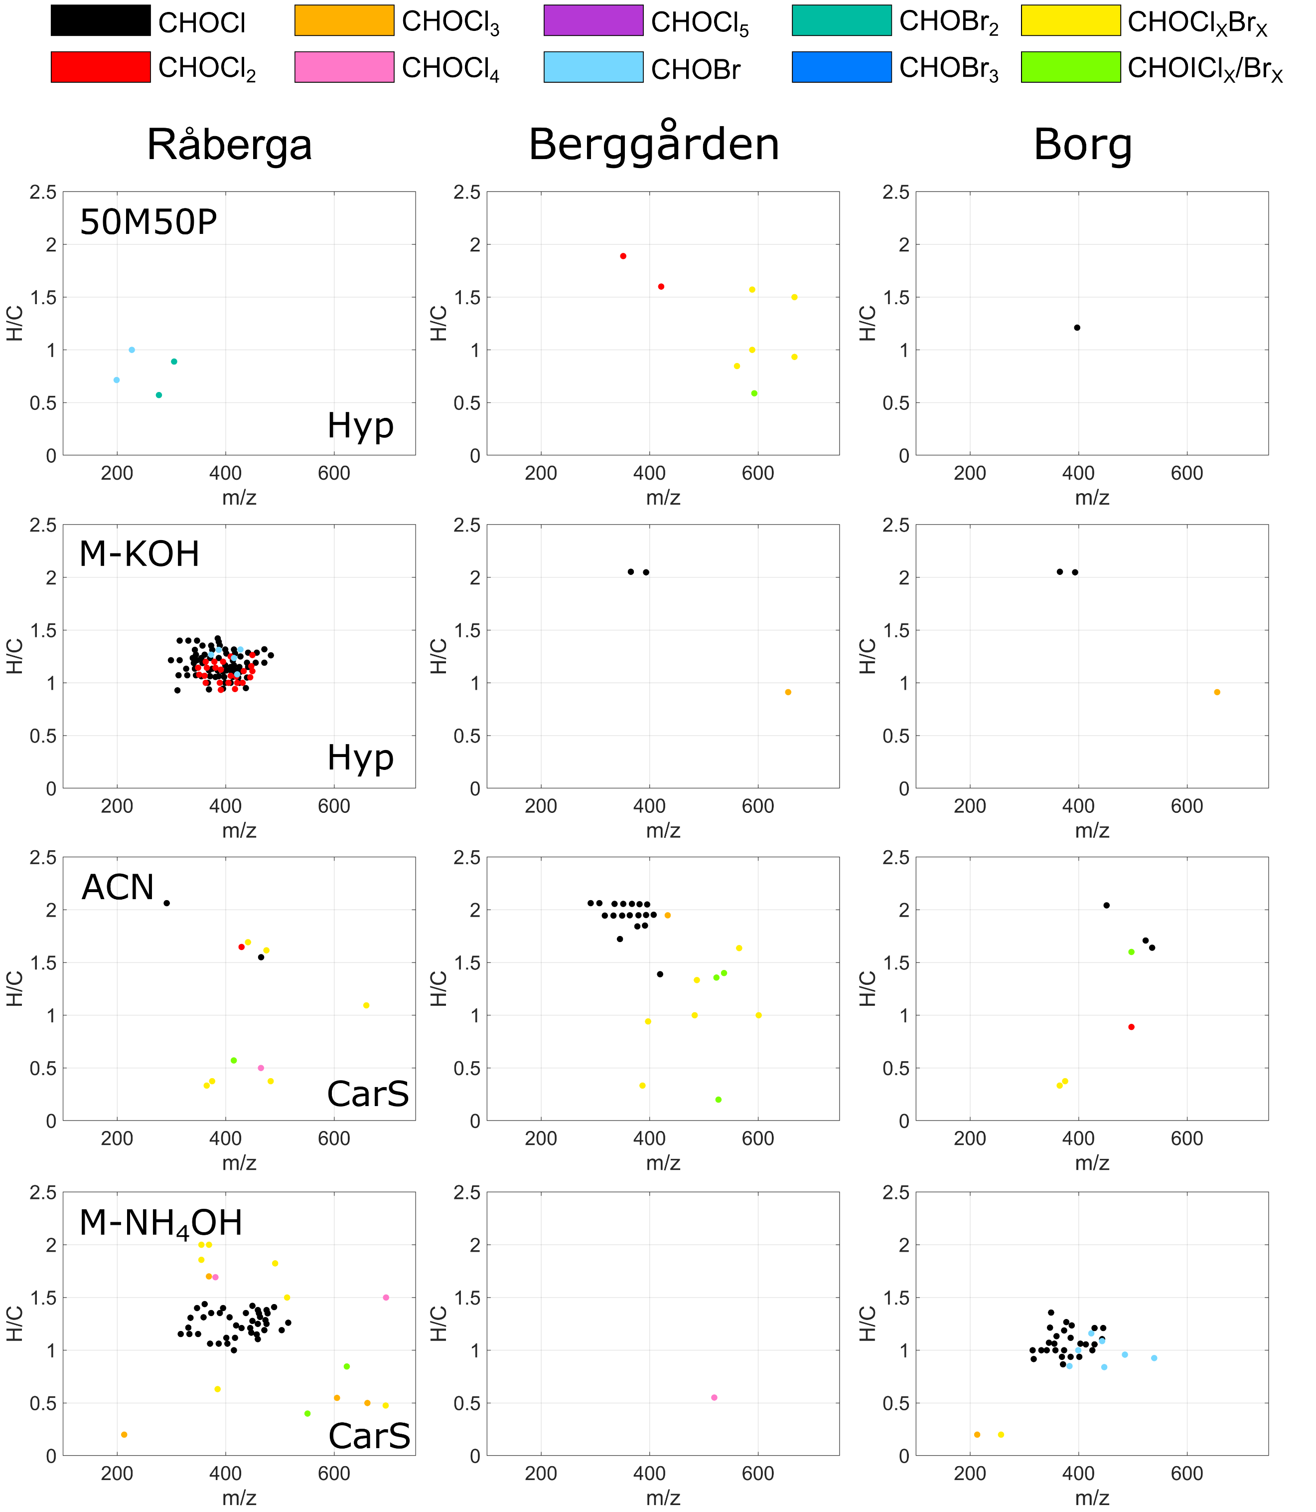
Figure S9. Characteristics of verified DBP formulae detected at the three DWTPs in different fractions, i.e., methanol:pentane (50:50, v/v) (50M50P) and methanol containing 1 mM KOH (M- KOH) eluted on Hyper Sep (Hyp) and acetonitrile (ACN) and methanol containing 1% NH₄OH (M-NH₄OH) eluted on subsequent Carbon S (CarS) cartridges, displayed in H/C to mass plots.

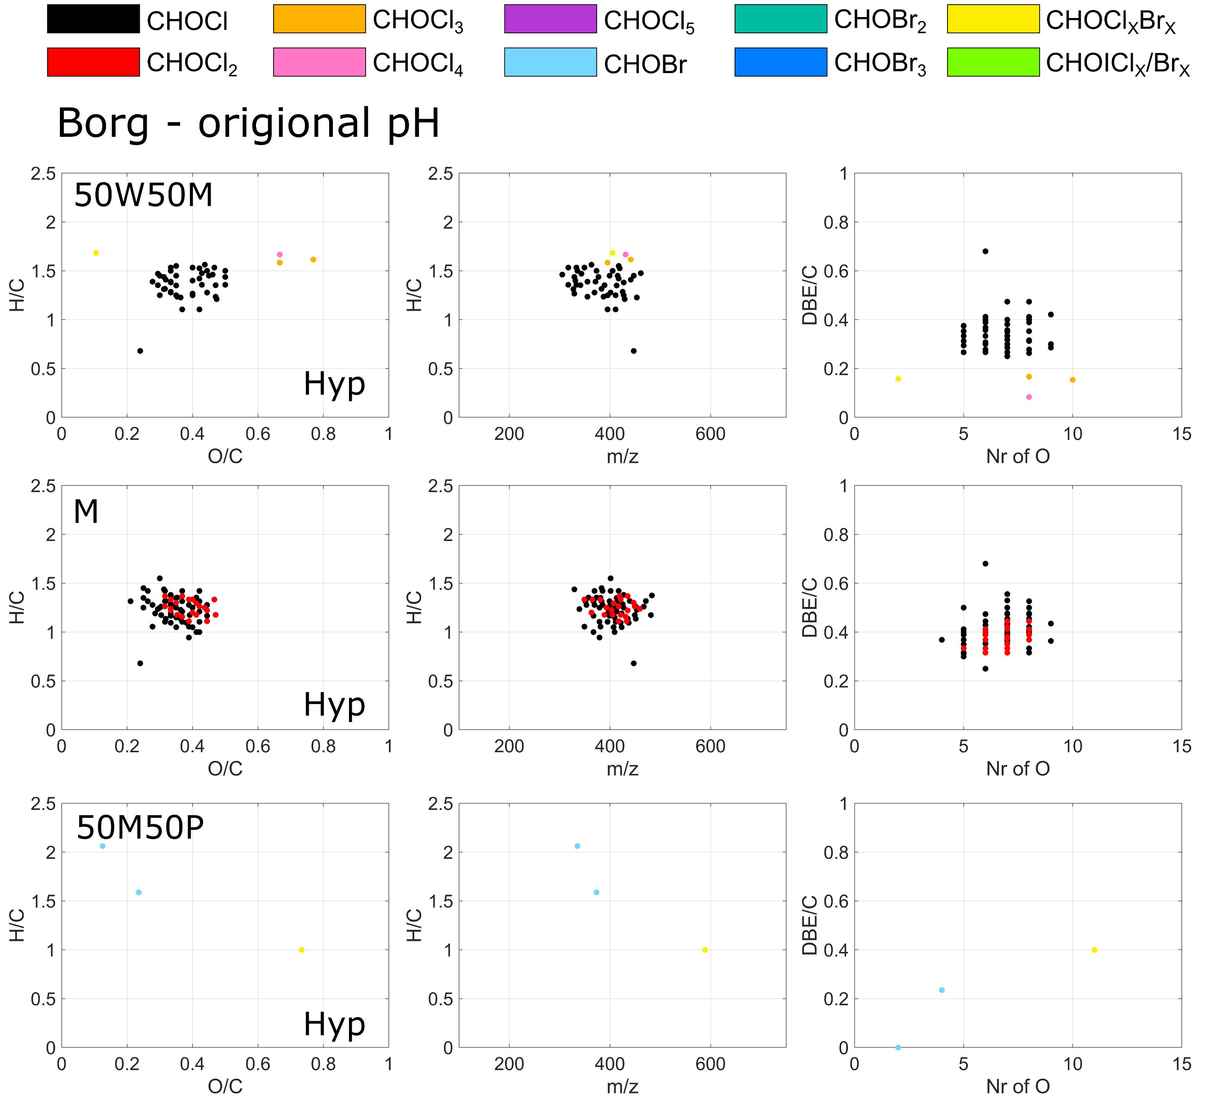
Figure S10. Characteristics of verified DBP formulae detected at DWTP Borg at original pH (pH 8) in different fractions, i.e., water:methanol (50:50, v/v), methanol (M) and methanol:pentane (50:50, v/v) (50M50P) eluted on Hyper Sep (Hyp) cartridges, displayed in van Krevelen diagrams, H/C to mass and DBE/C to number of oxygen plots.

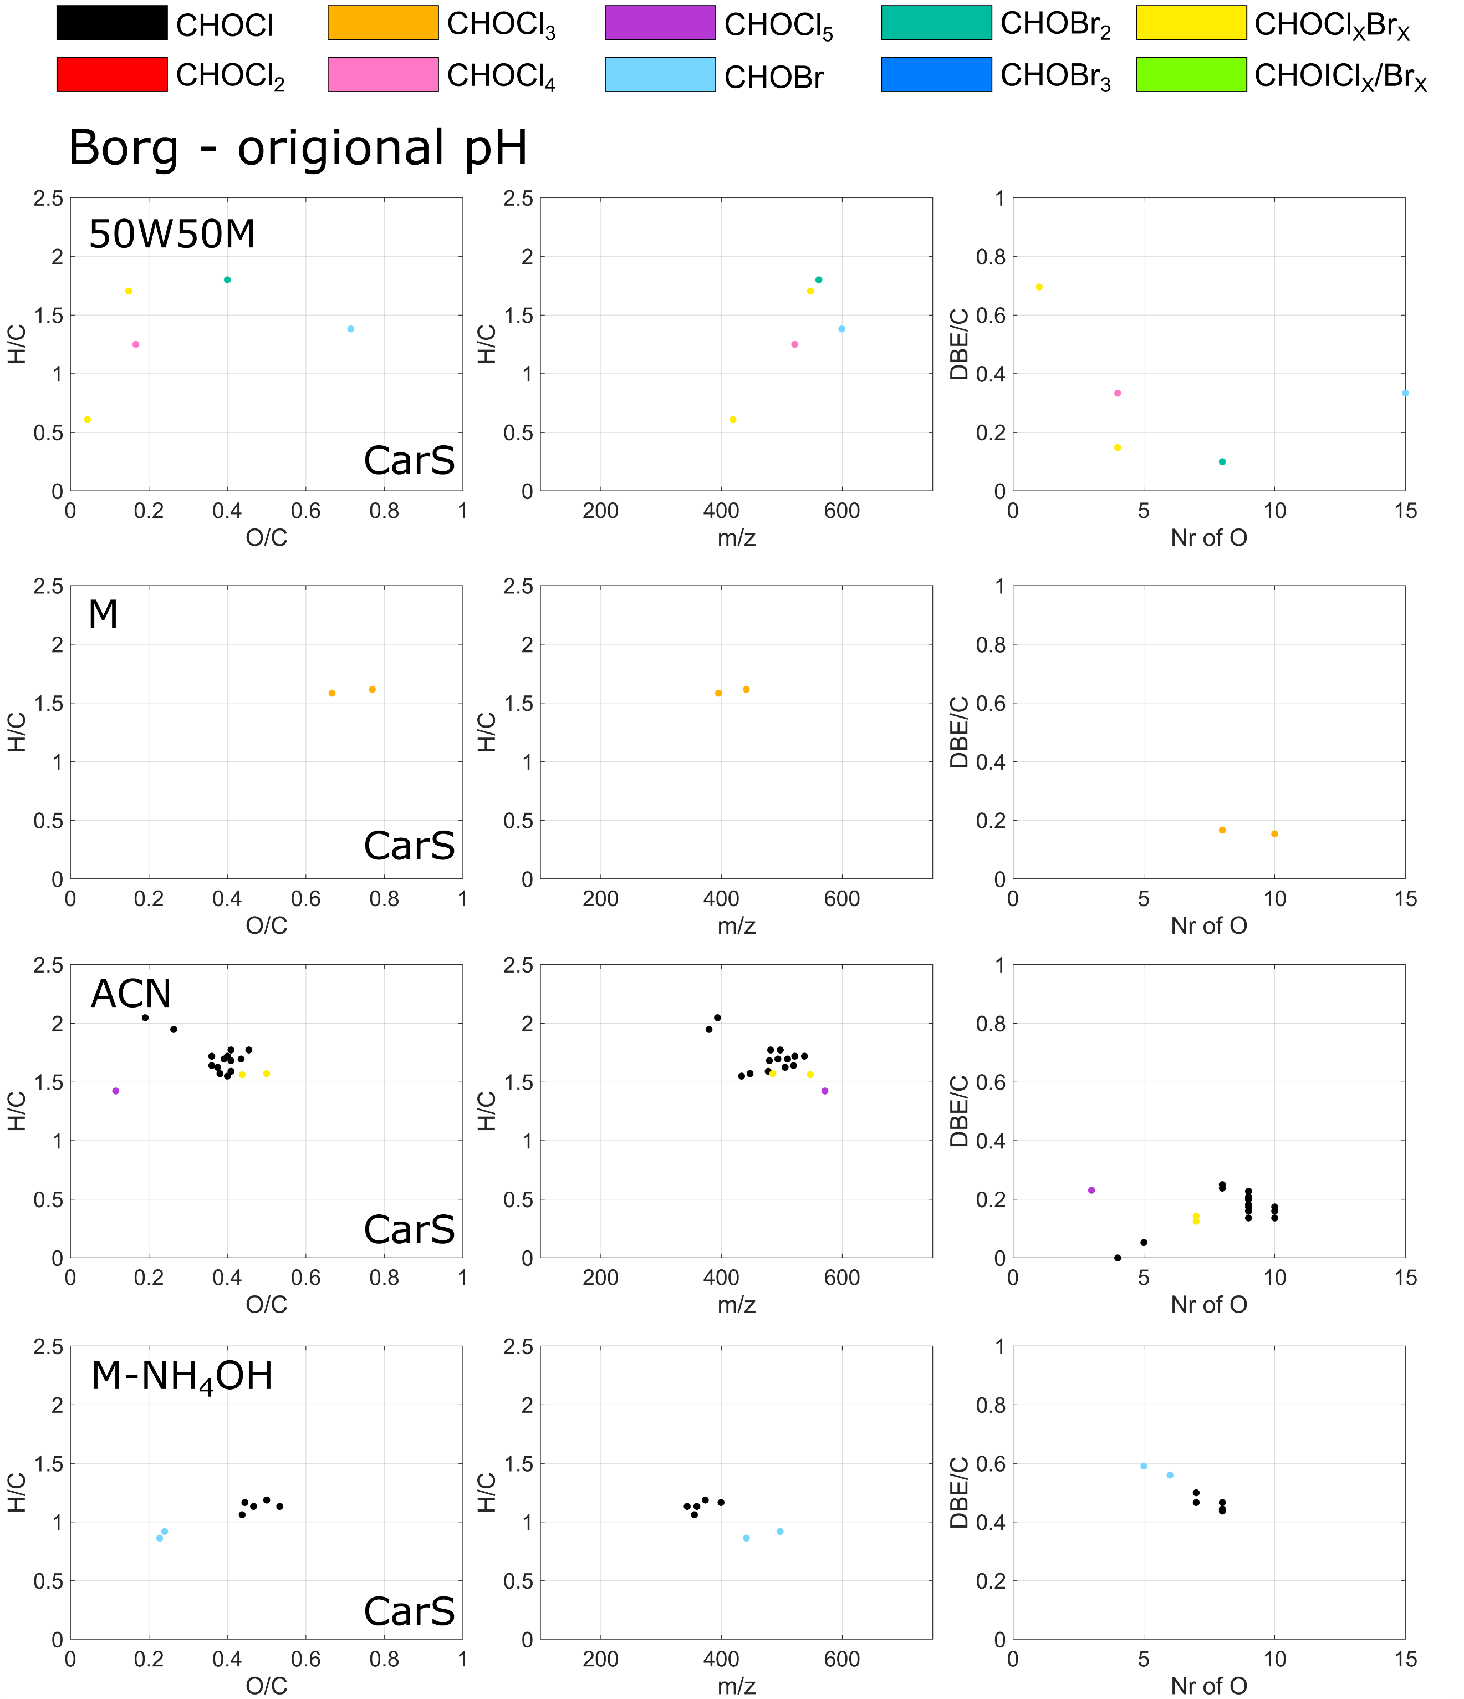
Figure S11. Characteristics of verified DBP formulae detected at DWTP Borg at original pH (pH 8) in different fractions, i.e., water:methanol (50:50, v/v) (50W50M), methanol (M), acetonitrile (ACN) and methanol containing 1% NH₄OH (M-NH₄OH) eluted on subsequent Carbon S (CarS) cartridges, displayed in van Krevelen diagrams, H/C to mass and DBE/C to number of oxygen plots.
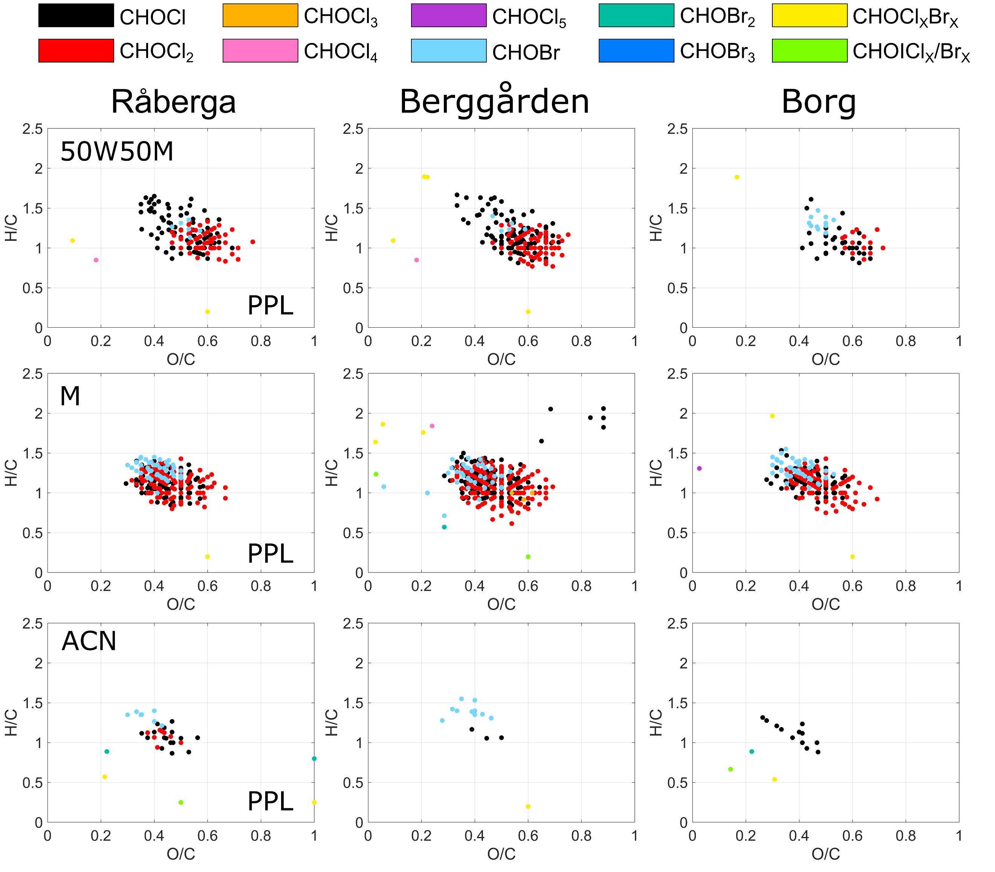
Figure S12. Characteristics of verified DBP formulae sorbed to PPL and eluted with water:methanol (50:50, v/v) (50W50M), methanol (M) and acetonitrile (ACN) displayed in Van Krevelen diagrams.

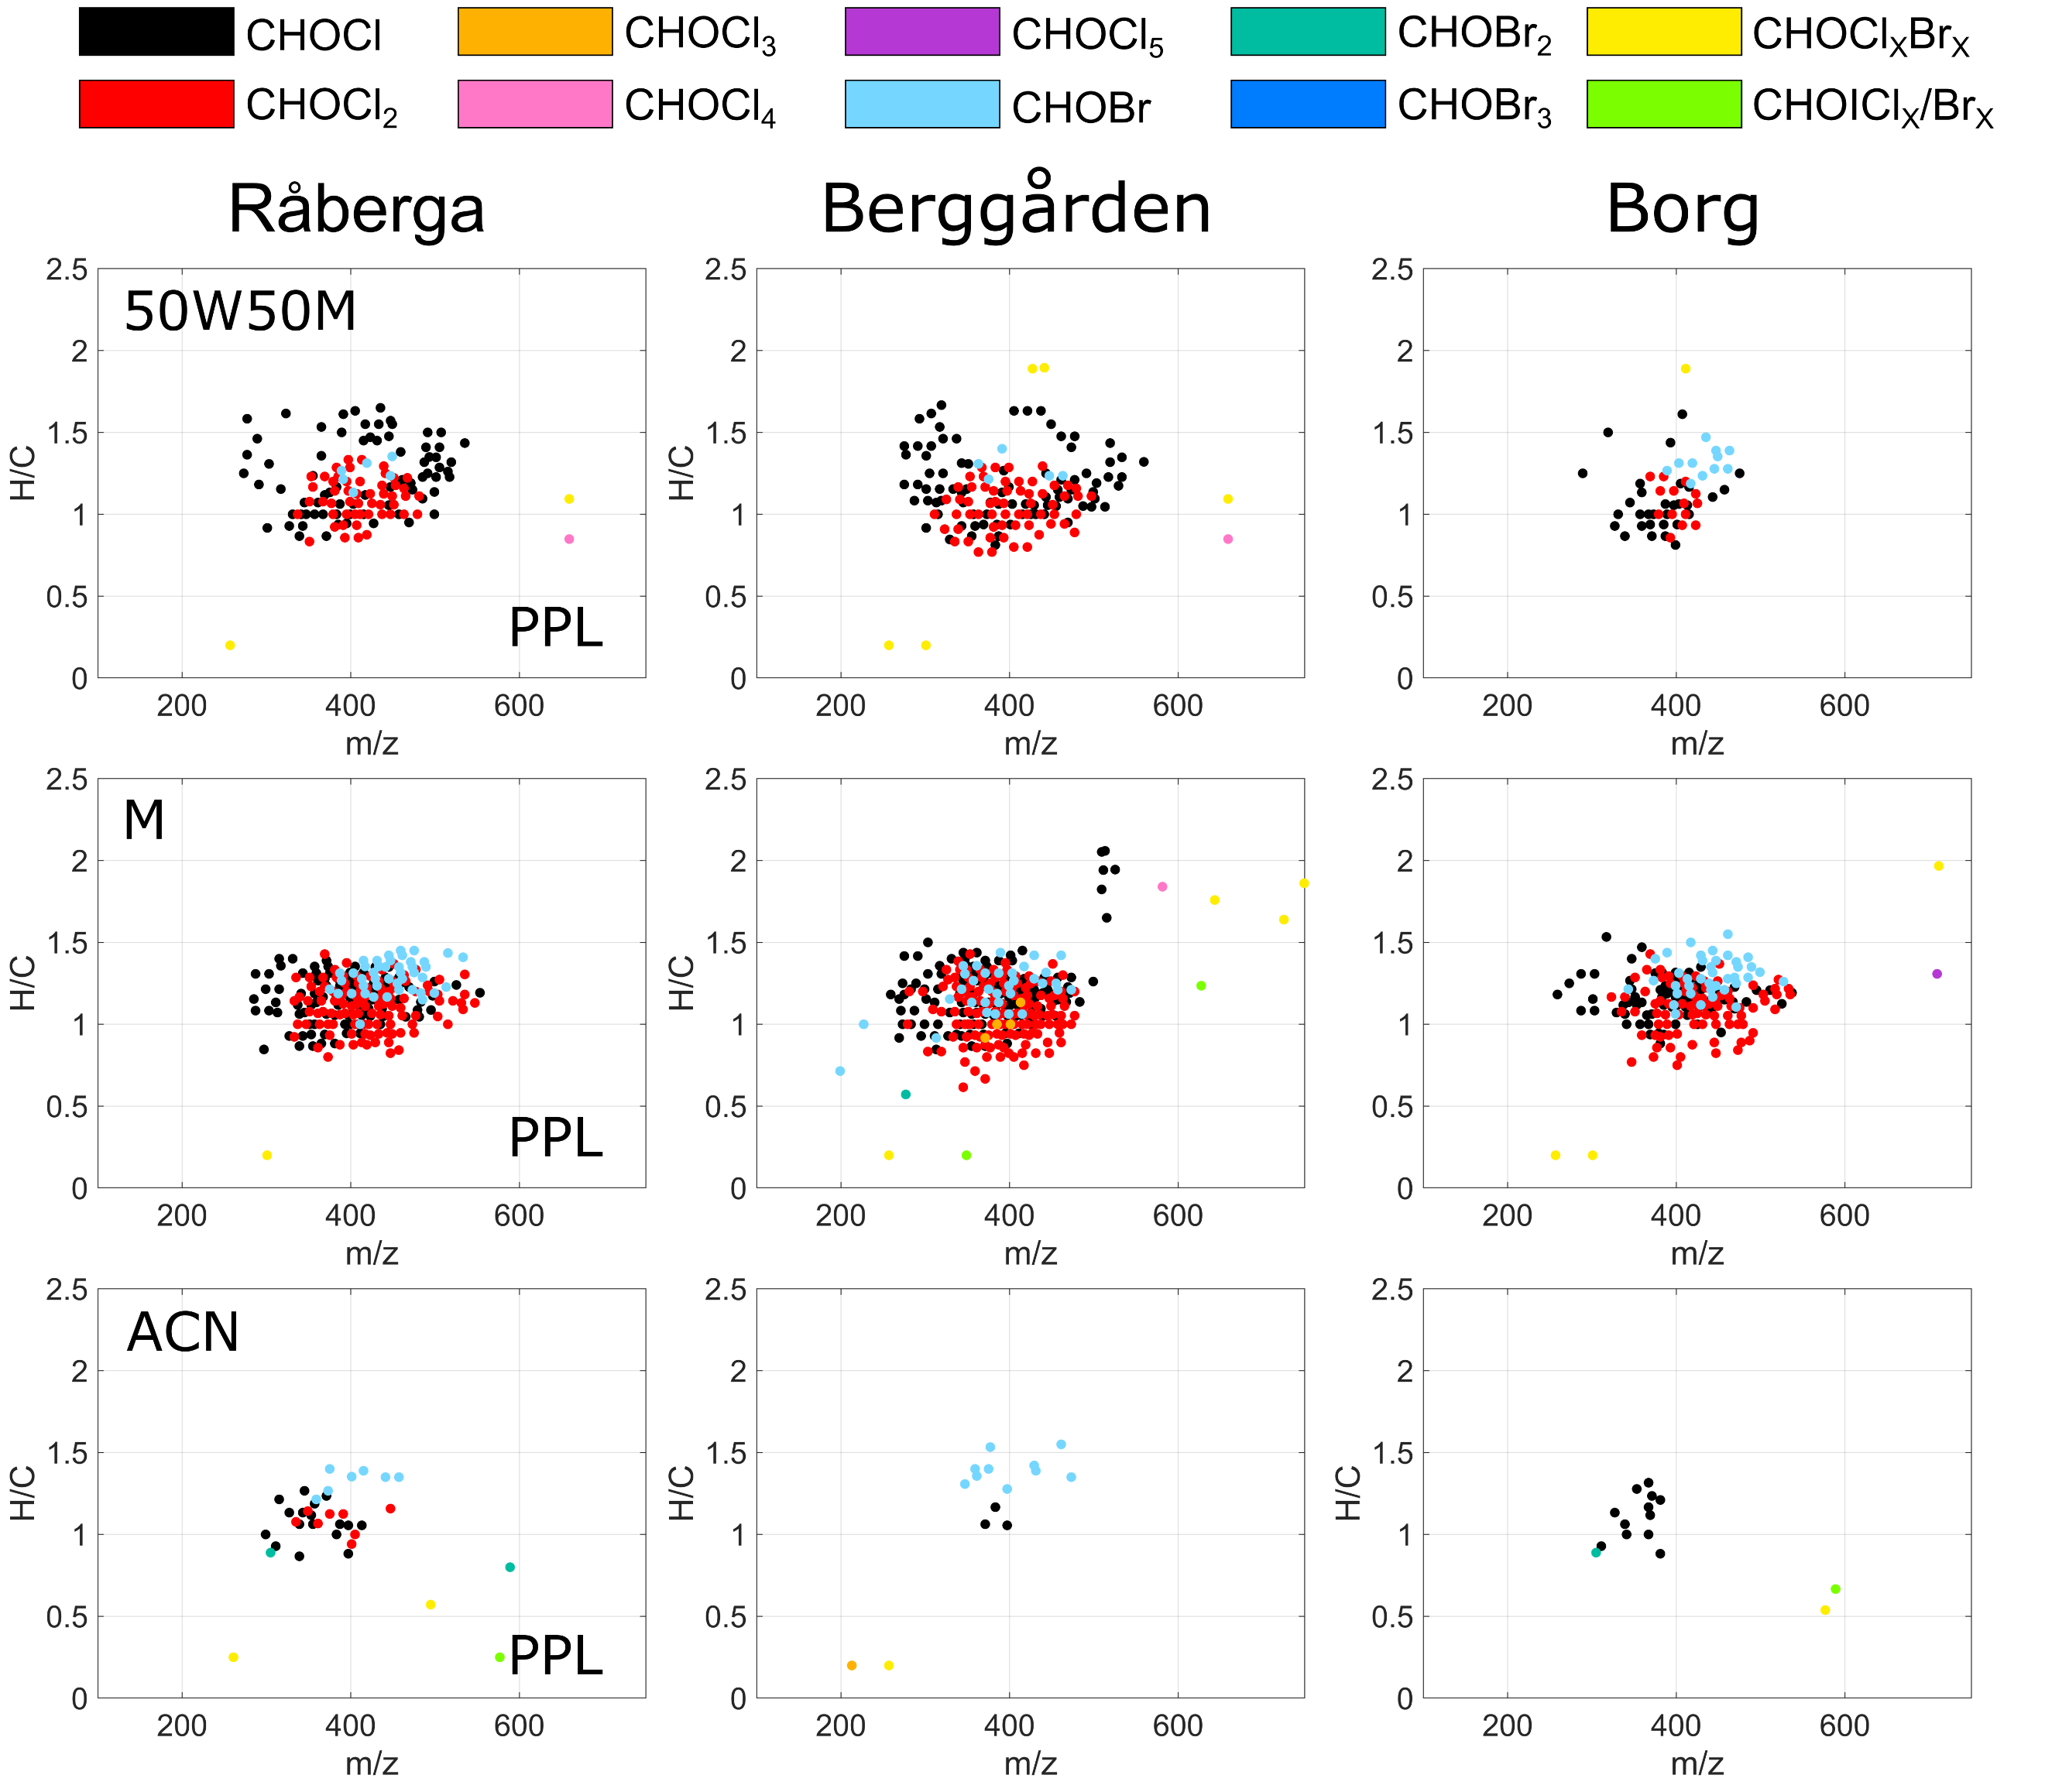
Figure S13. Characteristics of verified DBP formulae sorbed to PPL and eluted with water:methanol (50:50, v/v) (50W50M), methanol (M) and acetonitrile (ACN) displayed in H/C to mass plots.

Table S1. Volumes of water extracted.
Sample description | Date | Volume Extracted
Råberga Bef Hyp pH 2.5 R1 | 2023-10-17 | 700
Råberga Bef Hyp pH 2.5 R2 | 2023-10-17 | 600
Råberga Bef Hyp pH 2.5 R3 | 2023-10-17 | 1000
Råberga Bef CarS pH 2.5 R1 | 2023-10-17 | 700
Råberga Bef CarS pH 2.5 R2 | 2023-10-17 | 600
Råberga Bef CarS pH 2.5 R3 | 2023-10-17 | 1000
Råberga Bef PPL pH 2.5 R1 | 2023-10-17 | 900
Råberga Aft Hyp pH 2.5 R1 | 2023-10-17 | 1000
Råberga Aft Hyp pH 2.5 R2 | 2023-10-17 | 1000
Råberga Aft Hyp pH 2.5 R3 | 2023-10-17 | 1000
Råberga Aft CarS pH 2.5 R1 | 2023-10-17 | 1000
Råberga Aft CarS pH 2.5 R2 | 2023-10-17 | 1000
Råberga Aft CarS pH 2.5 R3 | 2023-10-17 | 1000
Råberga Aft PPL pH 2.5 R1 | 2023-10-17 | 1000
Berggården Bef Hyp pH 2.5 R1 | 2023-11-07 | 1000
Berggården Bef Hyp pH 2.5 R2 | 2023-11-07 | 500
Berggården Bef Hyp pH 2.5 R3 | 2023-11-07 | 1000
Berggården Bef CarS pH 2.5 R1 | 2023-11-07 | 825
Berggården Bef CarS pH 2.5 R2 | 2023-11-07 | 350
Berggården Bef CarS pH 2.5 R3 | 2023-11-07 | 750
Berggården Bef PPL pH 2.5 R1 | 2023-11-07 | 1000
Berggården Aft Hyp pH 2.5 R1 | 2023-11-07 | 1000
Berggården Aft Hyp pH 2.5 R2 | 2023-11-07 | 1000
Berggården Aft Hyp pH 2.5 R3 | 2023-11-07 | 1000
Berggården Aft CarS pH 2.5 R1 | 2023-11-07 | 800
Berggården Aft CarS pH 2.5 R2 | 2023-11-07 | 100
Berggården Aft CarS pH 2.5 R3 | 2023-11-07 | 150
Berggården Aft PPL pH 2.5 R1 | 2023-11-07 | 1000
Borg Bef Hyp pH 2.5 R1 | 2024-02-28 | 400
Borg Bef Hyp pH 2.5 R2 | 2024-02-28 | 500
Borg Bef CarS pH 2.5 R1 | 2024-02-28 | 400
Borg Bef CarS pH 2.5 R2 | 2024-02-28 | 500
Borg Bef PPL pH 2.5 R1 | 2024-02-28 | 700
Borg Aft Hyp pH 2.5 R1 | 2024-02-28 | 700
Borg Aft Hyp pH 2.5 R2 | 2024-02-28 | 1000
Borg Aft Hyp pH 2.5 R3 | 2024-02-28 | 800
Borg Aft CarS pH 2.5 R1 | 2024-02-28 | 700
Borg Aft CarS pH 2.5 R2 | 2024-02-28 | 1000
Borg Aft CarS pH 2.5 R3 | 2024-02-28 | 800
Borg Aft PPL pH 2.5 R1 | 2024-02-28 | 500
Borg Aft Hyp pH 8 R1 | 2024-02-28 | 650
Borg Aft Hyp pH 8 R2 | 2024-02-28 | 400
Borg Aft CarS pH 8 R1 | 2024-02-28 | 650
Borg Aft CarS pH 8 R2 | 2024-02-28 | 400
Table S2. Summary of verified DBP formulae at Råberga detected using Hyper Sep and Carbon S in combination with step-wise elution using 50W50M: water:methanol (50:50, v/v), M: methanol, ACN: acetonitrile, 50M50P: methanol:pentane (50:50, v/v), M-KOH: methanol containing 1 mM KOH and M-NH₄OH: methanol containing 1% NH₄OH. Even if some DBP formula were detected in multiple replicates, they are only reported once in this list.
DBP Formula  Neutral form | Theoretical Mass  Negative Ion | Fraction
C11 H12 O6 Cl2 | 308.99382 | Hyp 50W50M
C11 H13 O5 Cl1 | 259.03788 | Hyp 50W50M
C12 H12 O7 Cl2 | 336.98874 | Hyp 50W50M
C12 H13 O5 Cl1 | 271.03788 | Hyp 50W50M
C12 H13 O6 Cl1 | 287.03279 | Hyp 50W50M
C12 H13 O7 Cl1 | 303.02771 | Hyp 50W50M
C12 H14 O7 Cl2 | 339.00439 | Hyp 50W50M
C12 H14 O8 Cl2 | 354.9993 | Hyp 50W50M
C12 H15 O5 Cl1 | 273.05353 | Hyp 50W50M
C12 H15 O6 Cl1 | 289.04844 | Hyp 50W50M
C12 H15 O7 Cl1 | 305.04336 | Hyp 50W50M
C13 H12 O7 Cl2 | 348.98874 | Hyp 50W50M
C13 H12 O8 Cl2 | 364.98365 | Hyp 50W50M
C13 H12 O9 Cl2 | 380.97857 | Hyp 50W50M
C13 H13 O7 Cl1 | 315.02771 | Hyp 50W50M
C13 H14 O6 Cl2 | 335.00947 | Hyp 50W50M
C13 H14 O7 Cl2 | 351.00439 | Hyp 50W50M
C13 H14 O8 Cl2 | 366.9993 | Hyp 50W50M
C13 H14 O9 Cl2 | 382.99422 | Hyp 50W50M
C13 H15 O5 Cl1 | 285.05353 | Hyp 50W50M
C13 H15 O6 Cl1 | 301.04844 | Hyp 50W50M
C13 H15 O7 Cl1 | 317.04336 | Hyp 50W50M
C13 H15 O8 Cl1 | 333.03827 | Hyp 50W50M
C13 H16 O6 Cl2 | 337.02512 | Hyp 50W50M
C13 H16 O7 Cl2 | 353.02004 | Hyp 50W50M
C13 H16 O8 Cl2 | 369.01495 | Hyp 50W50M
C13 H17 O5 Cl1 | 287.06918 | Hyp 50W50M
C13 H17 O7 Cl1 | 319.05901 | Hyp 50W50M
C13 H19 O6 Cl1 | 305.07974 | Hyp 50W50M
C14 H12 O8 Cl2 | 376.98365 | Hyp 50W50M
C14 H12 O9 Cl2 | 392.97857 | Hyp 50W50M
C14 H14 O6 Cl2 | 347.00947 | Hyp 50W50M
C14 H14 O7 Cl2 | 363.00439 | Hyp 50W50M
C14 H14 O8 Cl2 | 378.9993 | Hyp 50W50M
C14 H14 O9 Cl2 | 394.99422 | Hyp 50W50M
C14 H15 O6 Cl1 | 313.04844 | Hyp 50W50M
C14 H15 O7 Br1 | 372.99284 | Hyp 50W50M
C14 H15 O8 Cl1 | 345.03827 | Hyp 50W50M
C14 H16 O6 Cl2 | 349.02512 | Hyp 50W50M
C14 H16 O7 Cl2 | 365.02004 | Hyp 50W50M
C14 H16 O8 Cl2 | 381.01495 | Hyp 50W50M
C14 H16 O9 Cl2 | 397.00987 | Hyp 50W50M
C14 H17 O5 Cl1 | 299.06918 | Hyp 50W50M
C14 H17 O6 Br1 | 359.01358 | Hyp 50W50M
C14 H17 O7 Br1 | 375.00849 | Hyp 50W50M
C14 H18 O6 Cl2 | 351.04077 | Hyp 50W50M
C14 H18 O7 Cl2 | 367.03569 | Hyp 50W50M
C14 H18 O8 Cl2 | 383.0306 | Hyp 50W50M
C14 H18 O9 Cl2 | 399.02552 | Hyp 50W50M
C14 H19 O5 Cl1 | 301.08483 | Hyp 50W50M
C14 H19 O7 Br1 | 377.02414 | Hyp 50W50M
C14 H19 O7 Cl1 | 333.07466 | Hyp 50W50M
C14 H19 O8 Cl1 | 349.06957 | Hyp 50W50M
C15 H14 O7 Cl2 | 375.00439 | Hyp 50W50M
C15 H14 O8 Cl2 | 390.9993 | Hyp 50W50M
C15 H14 O9 Cl2 | 406.99422 | Hyp 50W50M
C15 H15 O7 Cl1 | 341.04336 | Hyp 50W50M
C15 H15 O8 Cl1 | 357.03827 | Hyp 50W50M
C15 H15 O9 Cl1 | 373.03319 | Hyp 50W50M
C15 H16 O10 Cl2 | 425.00478 | Hyp 50W50M
C15 H16 O6 Cl2 | 361.02512 | Hyp 50W50M
C15 H16 O7 Cl2 | 377.02004 | Hyp 50W50M
C15 H16 O8 Cl2 | 393.01495 | Hyp 50W50M
C15 H16 O9 Cl2 | 409.00987 | Hyp 50W50M
C15 H17 O6 Cl1 | 327.06409 | Hyp 50W50M
C15 H17 O7 Br1 | 387.00849 | Hyp 50W50M
C15 H17 O9 Cl1 | 375.04884 | Hyp 50W50M
C15 H18 O6 Cl2 | 363.04077 | Hyp 50W50M
C15 H18 O7 Cl2 | 379.03569 | Hyp 50W50M
C15 H18 O8 Cl2 | 395.0306 | Hyp 50W50M
C15 H18 O9 Cl2 | 411.02552 | Hyp 50W50M
C15 H19 O6 Cl1 | 329.07974 | Hyp 50W50M
C15 H19 O7 Br1 | 389.02414 | Hyp 50W50M
C15 H20 O7 Cl2 | 381.05134 | Hyp 50W50M
C15 H20 O8 Cl2 | 397.04625 | Hyp 50W50M
C15 H21 O7 Br1 | 391.03979 | Hyp 50W50M
C16 H14 O10 Cl2 | 434.98913 | Hyp 50W50M
C16 H14 O8 Cl2 | 402.9993 | Hyp 50W50M
C16 H14 O9 Cl2 | 418.99422 | Hyp 50W50M
C16 H15 O7 Cl1 | 353.04336 | Hyp 50W50M
C16 H15 O8 Cl1 | 369.03827 | Hyp 50W50M
C16 H15 O9 Cl1 | 385.03319 | Hyp 50W50M
C16 H16 O10 Cl2 | 437.00478 | Hyp 50W50M
C16 H16 O7 Cl2 | 389.02004 | Hyp 50W50M
C16 H16 O8 Cl2 | 405.01495 | Hyp 50W50M
C16 H16 O9 Cl2 | 421.00987 | Hyp 50W50M
C16 H17 O6 Cl1 | 339.06409 | Hyp 50W50M
C16 H17 O8 Cl1 | 371.05392 | Hyp 50W50M
C16 H17 O9 Cl1 | 387.04884 | Hyp 50W50M
C16 H18 O10 Cl2 | 439.02043 | Hyp 50W50M
C16 H18 O7 Cl2 | 391.03569 | Hyp 50W50M
C16 H18 O8 Cl2 | 407.0306 | Hyp 50W50M
C16 H18 O9 Cl2 | 423.02552 | Hyp 50W50M
C16 H19 O10 Cl1 | 405.0594 | Hyp 50W50M
C16 H19 O7 Br1 | 401.02414 | Hyp 50W50M
C16 H19 O8 Br1 | 417.01906 | Hyp 50W50M
C16 H20 O7 Cl2 | 393.05134 | Hyp 50W50M
C16 H20 O8 Cl2 | 409.04625 | Hyp 50W50M
C16 H20 O9 Cl2 | 425.04117 | Hyp 50W50M
C16 H21 O7 Br1 | 403.03979 | Hyp 50W50M
C16 H21 O9 Cl1 | 391.08014 | Hyp 50W50M
C17 H14 O9 Cl2 | 430.99422 | Hyp 50W50M
C17 H16 O10 Cl2 | 449.00478 | Hyp 50W50M
C17 H16 O8 Cl2 | 417.01495 | Hyp 50W50M
C17 H16 O9 Cl2 | 433.00987 | Hyp 50W50M
C17 H17 O10 Cl1 | 415.04375 | Hyp 50W50M
C17 H17 O7 Cl1 | 367.05901 | Hyp 50W50M
C17 H17 O8 Cl1 | 383.05392 | Hyp 50W50M
C17 H17 O9 Cl1 | 399.04884 | Hyp 50W50M
C17 H18 O10 Cl2 | 451.02043 | Hyp 50W50M
C17 H18 O7 Cl2 | 403.03569 | Hyp 50W50M
C17 H18 O8 Cl2 | 419.0306 | Hyp 50W50M
C17 H18 O9 Cl2 | 435.02552 | Hyp 50W50M
C17 H19 O10 Cl1 | 417.0594 | Hyp 50W50M
C17 H19 O8 Br1 | 429.01906 | Hyp 50W50M
C17 H19 O9 Cl1 | 401.06449 | Hyp 50W50M
C17 H20 O10 Cl2 | 453.03608 | Hyp 50W50M
C17 H20 O7 Cl2 | 405.05134 | Hyp 50W50M
C17 H20 O8 Cl2 | 421.04625 | Hyp 50W50M
C17 H20 O9 Cl2 | 437.04117 | Hyp 50W50M
C17 H21 O10 Cl1 | 419.07505 | Hyp 50W50M
C17 H21 O6 Cl1 | 355.09539 | Hyp 50W50M
C17 H21 O7 Br1 | 415.03979 | Hyp 50W50M
C17 H21 O8 Br1 | 431.03471 | Hyp 50W50M
C17 H21 O9 Br1 | 447.02962 | Hyp 50W50M
C17 H21 O9 Cl1 | 403.08014 | Hyp 50W50M
C17 H22 O7 Cl2 | 407.06699 | Hyp 50W50M
C17 H22 O8 Cl2 | 423.0619 | Hyp 50W50M
C17 H22 O9 Cl2 | 439.05682 | Hyp 50W50M
C17 H23 O6 Cl1 | 357.11104 | Hyp 50W50M
C17 H23 O7 Br1 | 417.05544 | Hyp 50W50M
C17 H23 O8 Br1 | 433.05036 | Hyp 50W50M
C17 H23 O9 Cl1 | 405.09579 | Hyp 50W50M
C18 H16 O10 Cl2 | 461.00478 | Hyp 50W50M
C18 H16 O8 Cl2 | 429.01495 | Hyp 50W50M
C18 H16 O9 Cl2 | 445.00987 | Hyp 50W50M
C18 H17 O7 Cl1 | 379.05901 | Hyp 50W50M
C18 H17 O8 Cl1 | 395.05392 | Hyp 50W50M
C18 H17 O9 Cl1 | 411.04884 | Hyp 50W50M
C18 H18 O10 Cl2 | 463.02043 | Hyp 50W50M
C18 H18 O11 Cl2 | 479.01535 | Hyp 50W50M
C18 H18 O8 Cl2 | 431.0306 | Hyp 50W50M
C18 H18 O9 Cl2 | 447.02552 | Hyp 50W50M
C18 H19 O10 Cl1 | 429.0594 | Hyp 50W50M
C18 H19 O7 Cl1 | 381.07466 | Hyp 50W50M
C18 H19 O8 Cl1 | 397.06957 | Hyp 50W50M
C18 H19 O9 Cl1 | 413.06449 | Hyp 50W50M
C18 H20 O10 Cl2 | 465.03608 | Hyp 50W50M
C18 H20 O7 Cl2 | 417.05134 | Hyp 50W50M
C18 H20 O8 Cl2 | 433.04625 | Hyp 50W50M
C18 H20 O9 Cl2 | 449.04117 | Hyp 50W50M
C18 H21 O6 Cl1 | 367.09539 | Hyp 50W50M
C18 H21 O7 Br1 | 427.03979 | Hyp 50W50M
C18 H21 O7 Cl1 | 383.09031 | Hyp 50W50M
C18 H21 O8 Br1 | 443.03471 | Hyp 50W50M
C18 H21 O9 Cl1 | 415.08014 | Hyp 50W50M
C18 H22 O10 Cl2 | 467.05173 | Hyp 50W50M
C18 H22 O7 Cl2 | 419.06699 | Hyp 50W50M
C18 H22 O8 Cl2 | 435.0619 | Hyp 50W50M
C18 H22 O9 Cl2 | 451.05682 | Hyp 50W50M
C18 H23 O10 Cl1 | 433.0907 | Hyp 50W50M
C18 H23 O7 Br1 | 429.05544 | Hyp 50W50M
C18 H23 O7 Cl1 | 385.10596 | Hyp 50W50M
C18 H23 O8 Br1 | 445.05036 | Hyp 50W50M
C18 H23 O9 Br1 | 461.04527 | Hyp 50W50M
C18 H24 O8 Cl2 | 437.07755 | Hyp 50W50M
C18 H24 O9 Cl2 | 453.07247 | Hyp 50W50M
C18 H25 O7 Br1 | 431.07109 | Hyp 50W50M
C18 H25 O8 Br1 | 447.06601 | Hyp 50W50M
C19 H18 O10 Cl2 | 475.02043 | Hyp 50W50M
C19 H18 O9 Cl2 | 459.02552 | Hyp 50W50M
C19 H19 O8 Cl1 | 409.06957 | Hyp 50W50M
C19 H19 O9 Cl1 | 425.06449 | Hyp 50W50M
C19 H20 O10 Cl2 | 477.03608 | Hyp 50W50M
C19 H20 O8 Cl2 | 445.04625 | Hyp 50W50M
C19 H20 O9 Cl2 | 461.04117 | Hyp 50W50M
C19 H21 O10 Cl1 | 443.07505 | Hyp 50W50M
C19 H21 O8 Cl1 | 411.08522 | Hyp 50W50M
C19 H21 O9 Cl1 | 427.08014 | Hyp 50W50M
C19 H22 O10 Cl2 | 479.05173 | Hyp 50W50M
C19 H22 O7 Cl2 | 431.06699 | Hyp 50W50M
C19 H22 O8 Cl2 | 447.0619 | Hyp 50W50M
C19 H22 O9 Cl2 | 463.05682 | Hyp 50W50M
C19 H23 O7 Cl1 | 397.10596 | Hyp 50W50M
C19 H23 O8 Br1 | 457.05036 | Hyp 50W50M
C19 H23 O9 Br1 | 473.04527 | Hyp 50W50M
C19 H23 O9 Cl1 | 429.09579 | Hyp 50W50M
C19 H24 O10 Cl2 | 481.06738 | Hyp 50W50M
C19 H24 O8 Cl2 | 449.07755 | Hyp 50W50M
C19 H24 O9 Cl2 | 465.07247 | Hyp 50W50M
C19 H25 O8 Br1 | 459.06601 | Hyp 50W50M
C19 H25 O8 Cl1 | 415.11652 | Hyp 50W50M
C19 H25 O9 Br1 | 475.06092 | Hyp 50W50M
C19 H27 O8 Br1 | 461.08166 | Hyp 50W50M
C19 H34 O4 Cl1 Br1 | 439.12563 | Hyp 50W50M
C20 H19 O9 Cl1 | 437.06449 | Hyp 50W50M
C20 H20 O11 Cl2 | 505.031 | Hyp 50W50M
C20 H21 O8 Cl1 | 423.08522 | Hyp 50W50M
C20 H21 O9 Cl1 | 439.08014 | Hyp 50W50M
C20 H22 O10 Cl2 | 491.05173 | Hyp 50W50M
C20 H22 O11 Cl2 | 507.04665 | Hyp 50W50M
C20 H22 O9 Cl2 | 475.05682 | Hyp 50W50M
C20 H23 O10 Cl1 | 457.0907 | Hyp 50W50M
C20 H23 O11 Cl1 | 473.08562 | Hyp 50W50M
C20 H23 O9 Cl1 | 441.09579 | Hyp 50W50M
C20 H24 O10 Cl2 | 493.06738 | Hyp 50W50M
C20 H24 O9 Cl2 | 477.07247 | Hyp 50W50M
C20 H25 O11 Cl1 | 475.10127 | Hyp 50W50M
C20 H25 O8 Br1 | 471.06601 | Hyp 50W50M
C20 H25 O8 Cl1 | 427.11652 | Hyp 50W50M
C20 H25 O9 Br1 | 487.06092 | Hyp 50W50M
C20 H25 O9 Cl1 | 443.11144 | Hyp 50W50M
C20 H27 O8 Br1 | 473.08166 | Hyp 50W50M
C20 H27 O9 Br1 | 489.07657 | Hyp 50W50M
C20 H29 O8 Br1 | 475.09731 | Hyp 50W50M
C21 H22 O10 Cl2 | 503.05173 | Hyp 50W50M
C21 H22 O9 Cl2 | 487.05682 | Hyp 50W50M
C21 H23 O10 Cl1 | 469.0907 | Hyp 50W50M
C21 H24 O10 Cl2 | 505.06738 | Hyp 50W50M
C21 H25 O11 Cl1 | 487.10127 | Hyp 50W50M
C21 H25 O9 Cl1 | 455.11144 | Hyp 50W50M
C21 H27 O10 Cl1 | 473.122 | Hyp 50W50M
C21 H27 O8 Cl1 | 441.13217 | Hyp 50W50M
C21 H27 O9 Cl1 | 457.12709 | Hyp 50W50M
C22 H23 O10 Cl1 | 481.0907 | Hyp 50W50M
C22 H23 O9 Cl1 | 465.09579 | Hyp 50W50M
C22 H25 O10 Cl1 | 483.10635 | Hyp 50W50M
C22 H26 O10 Cl2 | 519.08303 | Hyp 50W50M
C22 H27 O10 Cl1 | 485.122 | Hyp 50W50M
C22 H27 O11 Cl1 | 501.11692 | Hyp 50W50M
C22 H27 O9 Cl1 | 469.12709 | Hyp 50W50M
C26 H46 O3 Br2 | 563.1741 | Hyp 50W50M
C12 H12 O6 Cl2 | 320.99382 | Hyp M
C12 H13 O5 Cl1 | 271.03788 | Hyp M
C12 H14 O5 Cl2 | 307.01456 | Hyp M
C12 H14 O6 Cl2 | 323.00947 | Hyp M
C13 H12 O7 Cl2 | 348.98874 | Hyp M
C13 H13 O6 Cl1 | 299.03279 | Hyp M
C13 H14 O5 Cl2 | 319.01456 | Hyp M
C13 H14 O6 Cl2 | 335.00947 | Hyp M
C13 H14 O7 Cl2 | 351.00439 | Hyp M
C13 H14 O8 Cl2 | 366.9993 | Hyp M
C13 H15 O5 Cl1 | 285.05353 | Hyp M
C13 H15 O6 Cl1 | 301.04844 | Hyp M
C13 H16 O5 Cl2 | 321.03021 | Hyp M
C13 H16 O6 Cl2 | 337.02512 | Hyp M
C13 H16 O7 Cl2 | 353.02004 | Hyp M
C13 H17 O4 Cl1 | 271.07426 | Hyp M
C13 H17 O5 Cl1 | 287.06918 | Hyp M
C13 H17 O6 Cl1 | 303.06409 | Hyp M
C14 H11 O6 Cl1 | 309.01714 | Hyp M
C14 H12 O6 Cl2 | 344.99382 | Hyp M
C14 H12 O7 Cl2 | 360.98874 | Hyp M
C14 H13 O5 Cl1 | 295.03788 | Hyp M
C14 H13 O6 Cl1 | 311.03279 | Hyp M
C14 H14 O6 Cl2 | 347.00947 | Hyp M
C14 H14 O7 Cl2 | 363.00439 | Hyp M
C14 H14 O8 Cl2 | 378.9993 | Hyp M
C14 H14 O9 Cl2 | 394.99422 | Hyp M
C14 H15 O5 Cl1 | 297.05353 | Hyp M
C14 H15 O6 Cl1 | 313.04844 | Hyp M
C14 H16 O5 Cl2 | 333.03021 | Hyp M
C14 H16 O6 Cl2 | 349.02512 | Hyp M
C14 H16 O7 Cl2 | 365.02004 | Hyp M
C14 H16 O8 Cl2 | 381.01495 | Hyp M
C14 H17 O4 Cl1 | 283.07426 | Hyp M
C14 H17 O5 Br1 | 343.01866 | Hyp M
C14 H17 O5 Cl1 | 299.06918 | Hyp M
C14 H17 O6 Br1 | 359.01358 | Hyp M
C14 H17 O7 Cl1 | 331.05901 | Hyp M
C14 H18 O5 Cl2 | 335.04586 | Hyp M
C14 H18 O6 Cl2 | 351.04077 | Hyp M
C14 H18 O7 Cl2 | 367.03569 | Hyp M
C14 H19 O5 Br1 | 345.03431 | Hyp M
C14 H19 O5 Cl1 | 301.08483 | Hyp M
C14 H19 O6 Cl1 | 317.07974 | Hyp M
C14 H21 O5 Cl1 | 303.10048 | Hyp M
C15 H13 O6 Cl1 | 323.03279 | Hyp M
C15 H13 O8 Cl1 | 355.02262 | Hyp M
C15 H14 O5 Cl2 | 343.01456 | Hyp M
C15 H14 O6 Cl2 | 359.00947 | Hyp M
C15 H14 O7 Cl2 | 375.00439 | Hyp M
C15 H14 O8 Cl2 | 390.9993 | Hyp M
C15 H15 O5 Cl1 | 309.05353 | Hyp M
C15 H15 O6 Br1 | 368.99793 | Hyp M
C15 H15 O6 Cl1 | 325.04844 | Hyp M
C15 H15 O7 Cl1 | 341.04336 | Hyp M
C15 H16 O5 Cl2 | 345.03021 | Hyp M
C15 H16 O6 Cl2 | 361.02512 | Hyp M
C15 H16 O7 Cl2 | 377.02004 | Hyp M
C15 H16 O8 Cl2 | 393.01495 | Hyp M
C15 H17 O5 Br1 | 355.01866 | Hyp M
C15 H17 O6 Br1 | 371.01358 | Hyp M
C15 H17 O6 Cl1 | 327.06409 | Hyp M
C15 H17 O7 Br1 | 387.00849 | Hyp M
C15 H17 O7 Cl1 | 343.05901 | Hyp M
C15 H17 O8 Cl1 | 359.05392 | Hyp M
C15 H18 O5 Cl2 | 347.04586 | Hyp M
C15 H18 O6 Cl2 | 363.04077 | Hyp M
C15 H18 O7 Cl2 | 379.03569 | Hyp M
C15 H18 O8 Cl2 | 395.0306 | Hyp M
C15 H19 O4 Cl1 | 297.08991 | Hyp M
C15 H19 O5 Br1 | 357.03431 | Hyp M
C15 H19 O5 Cl1 | 313.08483 | Hyp M
C15 H19 O6 Br1 | 373.02923 | Hyp M
C15 H19 O6 Cl1 | 329.07974 | Hyp M
C15 H19 O7 Cl1 | 345.07466 | Hyp M
C15 H20 O5 Cl2 | 349.06151 | Hyp M
C15 H20 O6 Cl2 | 365.05642 | Hyp M
C15 H20 O7 Cl2 | 381.05134 | Hyp M
C15 H21 O5 Br1 | 359.04996 | Hyp M
C15 H21 O5 Cl1 | 315.10048 | Hyp M
C15 H21 O6 Br1 | 375.04488 | Hyp M
C15 H21 O6 Cl1 | 331.09539 | Hyp M
C15 H23 O5 Cl1 | 317.11613 | Hyp M
C15 H23 O6 Cl1 | 333.11104 | Hyp M
C16 H14 O6 Cl2 | 371.00947 | Hyp M
C16 H14 O7 Cl2 | 387.00439 | Hyp M
C16 H14 O8 Cl2 | 402.9993 | Hyp M
C16 H15 O6 Cl1 | 337.04844 | Hyp M
C16 H15 O7 Cl1 | 353.04336 | Hyp M
C16 H15 O8 Cl1 | 369.03827 | Hyp M
C16 H16 O5 Cl2 | 357.03021 | Hyp M
C16 H16 O6 Cl2 | 373.02512 | Hyp M
C16 H16 O7 Cl2 | 389.02004 | Hyp M
C16 H16 O8 Cl2 | 405.01495 | Hyp M
C16 H17 O5 Cl1 | 323.06918 | Hyp M
C16 H17 O6 Br1 | 383.01358 | Hyp M
C16 H17 O6 Cl1 | 339.06409 | Hyp M
C16 H17 O7 Br1 | 399.00849 | Hyp M
C16 H17 O7 Cl1 | 355.05901 | Hyp M
C16 H17 O8 Cl1 | 371.05392 | Hyp M
C16 H17 O9 Cl1 | 387.04884 | Hyp M
C16 H18 O5 Cl2 | 359.04586 | Hyp M
C16 H18 O6 Cl2 | 375.04077 | Hyp M
C16 H18 O7 Cl2 | 391.03569 | Hyp M
C16 H18 O8 Cl2 | 407.0306 | Hyp M
C16 H18 O9 Cl2 | 423.02552 | Hyp M
C16 H19 O5 Br1 | 369.03431 | Hyp M
C16 H19 O5 Cl1 | 325.08483 | Hyp M
C16 H19 O6 Br1 | 385.02923 | Hyp M
C16 H19 O6 Cl1 | 341.07974 | Hyp M
C16 H19 O7 Br1 | 401.02414 | Hyp M
C16 H19 O7 Cl1 | 357.07466 | Hyp M
C16 H19 O8 Cl1 | 373.06957 | Hyp M
C16 H19 O9 Cl1 | 389.06449 | Hyp M
C16 H20 O5 Cl2 | 361.06151 | Hyp M
C16 H20 O6 Cl2 | 377.05642 | Hyp M
C16 H20 O7 Cl2 | 393.05134 | Hyp M
C16 H20 O8 Cl2 | 409.04625 | Hyp M
C16 H21 O5 Cl1 | 327.10048 | Hyp M
C16 H21 O6 Br1 | 387.04488 | Hyp M
C16 H21 O6 Cl1 | 343.09539 | Hyp M
C16 H21 O7 Br1 | 403.03979 | Hyp M
C16 H21 O7 Cl1 | 359.09031 | Hyp M
C16 H21 O8 Cl1 | 375.08522 | Hyp M
C16 H22 O6 Cl2 | 379.07207 | Hyp M
C16 H23 O5 Br1 | 373.06561 | Hyp M
C16 H23 O5 Cl1 | 329.11613 | Hyp M
C16 H23 O6 Cl1 | 345.11104 | Hyp M
C17 H14 O7 Cl2 | 399.00439 | Hyp M
C17 H15 O7 Cl1 | 365.04336 | Hyp M
C17 H15 O8 Cl1 | 381.03827 | Hyp M
C17 H16 O6 Cl2 | 385.02512 | Hyp M
C17 H16 O7 Cl2 | 401.02004 | Hyp M
C17 H16 O8 Cl2 | 417.01495 | Hyp M
C17 H16 O9 Cl2 | 433.00987 | Hyp M
C17 H17 O5 Cl1 | 335.06918 | Hyp M
C17 H17 O6 Br1 | 395.01358 | Hyp M
C17 H17 O6 Cl1 | 351.06409 | Hyp M
C17 H17 O7 Cl1 | 367.05901 | Hyp M
C17 H17 O8 Cl1 | 383.05392 | Hyp M
C17 H18 O6 Cl2 | 387.04077 | Hyp M
C17 H18 O7 Cl2 | 403.03569 | Hyp M
C17 H18 O8 Cl2 | 419.0306 | Hyp M
C17 H18 O9 Cl2 | 435.02552 | Hyp M
C17 H19 O5 Cl1 | 337.08483 | Hyp M
C17 H19 O6 Br1 | 397.02923 | Hyp M
C17 H19 O6 Cl1 | 353.07974 | Hyp M
C17 H19 O7 Br1 | 413.02414 | Hyp M
C17 H19 O7 Cl1 | 369.07466 | Hyp M
C17 H19 O8 Br1 | 429.01906 | Hyp M
C17 H19 O8 Cl1 | 385.06957 | Hyp M
C17 H19 O9 Cl1 | 401.06449 | Hyp M
C17 H20 O5 Cl2 | 373.06151 | Hyp M
C17 H20 O6 Cl2 | 389.05642 | Hyp M
C17 H20 O7 Cl2 | 405.05134 | Hyp M
C17 H20 O8 Cl2 | 421.04625 | Hyp M
C17 H21 O5 Br1 | 383.04996 | Hyp M
C17 H21 O5 Cl1 | 339.10048 | Hyp M
C17 H21 O6 Br1 | 399.04488 | Hyp M
C17 H21 O6 Cl1 | 355.09539 | Hyp M
C17 H21 O7 Br1 | 415.03979 | Hyp M
C17 H21 O7 Cl1 | 371.09031 | Hyp M
C17 H21 O8 Br1 | 431.03471 | Hyp M
C17 H21 O8 Cl1 | 387.08522 | Hyp M
C17 H22 O6 Cl2 | 391.07207 | Hyp M
C17 H22 O7 Cl2 | 407.06699 | Hyp M
C17 H22 O8 Cl2 | 423.0619 | Hyp M
C17 H23 O5 Br1 | 385.06561 | Hyp M
C17 H23 O5 Cl1 | 341.11613 | Hyp M
C17 H23 O6 Br1 | 401.06053 | Hyp M
C17 H23 O7 Br1 | 417.05544 | Hyp M
C17 H23 O7 Cl1 | 373.10596 | Hyp M
C17 H23 O8 Cl1 | 389.10087 | Hyp M
C17 H24 O6 Cl2 | 393.08772 | Hyp M
C18 H16 O7 Cl2 | 413.02004 | Hyp M
C18 H16 O8 Cl2 | 429.01495 | Hyp M
C18 H17 O6 Cl1 | 363.06409 | Hyp M
C18 H17 O7 Cl1 | 379.05901 | Hyp M
C18 H17 O8 Cl1 | 395.05392 | Hyp M
C18 H18 O10 Cl2 | 463.02043 | Hyp M
C18 H18 O6 Cl2 | 399.04077 | Hyp M
C18 H18 O7 Cl2 | 415.03569 | Hyp M
C18 H18 O8 Cl2 | 431.0306 | Hyp M
C18 H18 O9 Cl2 | 447.02552 | Hyp M
C18 H19 O5 Cl1 | 349.08483 | Hyp M
C18 H19 O6 Cl1 | 365.07974 | Hyp M
C18 H19 O7 Br1 | 425.02414 | Hyp M
C18 H19 O7 Cl1 | 381.07466 | Hyp M
C18 H19 O8 Cl1 | 397.06957 | Hyp M
C18 H19 O9 Cl1 | 413.06449 | Hyp M
C18 H20 O6 Cl2 | 401.05642 | Hyp M
C18 H20 O7 Cl2 | 417.05134 | Hyp M
C18 H20 O8 Cl2 | 433.04625 | Hyp M
C18 H20 O9 Cl2 | 449.04117 | Hyp M
C18 H21 O5 Cl1 | 351.10048 | Hyp M
C18 H21 O6 Br1 | 411.04488 | Hyp M
C18 H21 O6 Cl1 | 367.09539 | Hyp M
C18 H21 O7 Br1 | 427.03979 | Hyp M
C18 H21 O7 Cl1 | 383.09031 | Hyp M
C18 H21 O8 Br1 | 443.03471 | Hyp M
C18 H21 O8 Cl1 | 399.08522 | Hyp M
C18 H21 O9 Cl1 | 415.08014 | Hyp M
C18 H22 O6 Cl2 | 403.07207 | Hyp M
C18 H22 O7 Cl2 | 419.06699 | Hyp M
C18 H22 O8 Cl2 | 435.0619 | Hyp M
C18 H23 O5 Br1 | 397.06561 | Hyp M
C18 H23 O5 Cl1 | 353.11613 | Hyp M
C18 H23 O6 Br1 | 413.06053 | Hyp M
C18 H23 O6 Cl1 | 369.11104 | Hyp M
C18 H23 O7 Br1 | 429.05544 | Hyp M
C18 H23 O7 Cl1 | 385.10596 | Hyp M
C18 H23 O8 Br1 | 445.05036 | Hyp M
C18 H23 O8 Cl1 | 401.10087 | Hyp M
C18 H23 O9 Cl1 | 417.09579 | Hyp M
C18 H24 O6 Cl2 | 405.08772 | Hyp M
C18 H24 O7 Cl2 | 421.08264 | Hyp M
C18 H25 O5 Br1 | 399.08126 | Hyp M
C18 H25 O6 Br1 | 415.07618 | Hyp M
C18 H25 O6 Cl1 | 371.12669 | Hyp M
C18 H25 O7 Br1 | 431.07109 | Hyp M
C18 H25 O7 Cl1 | 387.12161 | Hyp M
C19 H17 O8 Cl1 | 407.05392 | Hyp M
C19 H18 O7 Cl2 | 427.03569 | Hyp M
C19 H18 O8 Cl2 | 443.0306 | Hyp M
C19 H18 O9 Cl2 | 459.02552 | Hyp M
C19 H19 O6 Cl1 | 377.07974 | Hyp M
C19 H19 O7 Cl1 | 393.07466 | Hyp M
C19 H19 O8 Cl1 | 409.06957 | Hyp M
C19 H19 O9 Cl1 | 425.06449 | Hyp M
C19 H20 O7 Cl2 | 429.05134 | Hyp M
C19 H20 O8 Cl2 | 445.04625 | Hyp M
C19 H20 O9 Cl2 | 461.04117 | Hyp M
C19 H21 O5 Cl1 | 363.10048 | Hyp M
C19 H21 O6 Br1 | 423.04488 | Hyp M
C19 H21 O6 Cl1 | 379.09539 | Hyp M
C19 H21 O7 Br1 | 439.03979 | Hyp M
C19 H21 O7 Cl1 | 395.09031 | Hyp M
C19 H21 O8 Br1 | 455.03471 | Hyp M
C19 H21 O8 Cl1 | 411.08522 | Hyp M
C19 H21 O9 Cl1 | 427.08014 | Hyp M
C19 H22 O10 Cl2 | 479.05173 | Hyp M
C19 H22 O6 Cl2 | 415.07207 | Hyp M
C19 H22 O7 Cl2 | 431.06699 | Hyp M
C19 H22 O8 Cl2 | 447.0619 | Hyp M
C19 H22 O9 Cl2 | 463.05682 | Hyp M
C19 H23 O5 Cl1 | 365.11613 | Hyp M
C19 H23 O6 Br1 | 425.06053 | Hyp M
C19 H23 O6 Cl1 | 381.11104 | Hyp M
C19 H23 O7 Br1 | 441.05544 | Hyp M
C19 H23 O7 Cl1 | 397.10596 | Hyp M
C19 H23 O8 Br1 | 457.05036 | Hyp M
C19 H23 O8 Cl1 | 413.10087 | Hyp M
C19 H23 O9 Cl1 | 429.09579 | Hyp M
C19 H24 O6 Cl2 | 417.08772 | Hyp M
C19 H24 O7 Cl2 | 433.08264 | Hyp M
C19 H24 O8 Cl2 | 449.07755 | Hyp M
C19 H24 O9 Cl2 | 465.07247 | Hyp M
C19 H25 O5 Br1 | 411.08126 | Hyp M
C19 H25 O6 Br1 | 427.07618 | Hyp M
C19 H25 O6 Cl1 | 383.12669 | Hyp M
C19 H25 O7 Br1 | 443.07109 | Hyp M
C19 H25 O8 Br1 | 459.06601 | Hyp M
C19 H25 O8 Cl1 | 415.11652 | Hyp M
C19 H25 O9 Cl1 | 431.11144 | Hyp M
C19 H26 O6 Cl2 | 419.10337 | Hyp M
C19 H26 O7 Cl2 | 435.09829 | Hyp M
C19 H27 O5 Br1 | 413.09691 | Hyp M
C19 H27 O6 Cl1 | 385.14234 | Hyp M
C19 H27 O7 Br1 | 445.08674 | Hyp M
C19 H27 O7 Cl1 | 401.13726 | Hyp M
C19 H27 O8 Br1 | 461.08166 | Hyp M
C19 H29 O6 Br1 | 431.10748 | Hyp M
C20 H19 O9 Cl1 | 437.06449 | Hyp M
C20 H20 O8 Cl2 | 457.04625 | Hyp M
C20 H20 O9 Cl2 | 473.04117 | Hyp M
C20 H21 O6 Cl1 | 391.09539 | Hyp M
C20 H21 O7 Cl1 | 407.09031 | Hyp M
C20 H21 O8 Cl1 | 423.08522 | Hyp M
C20 H21 O9 Cl1 | 439.08014 | Hyp M
C20 H22 O10 Cl2 | 491.05173 | Hyp M
C20 H22 O6 Cl2 | 427.07207 | Hyp M
C20 H22 O7 Cl2 | 443.06699 | Hyp M
C20 H22 O8 Cl2 | 459.0619 | Hyp M
C20 H22 O9 Cl2 | 475.05682 | Hyp M
C20 H23 O6 Cl1 | 393.11104 | Hyp M
C20 H23 O7 Cl1 | 409.10596 | Hyp M
C20 H23 O8 Cl1 | 425.10087 | Hyp M
C20 H23 O9 Cl1 | 441.09579 | Hyp M
C20 H24 O6 Cl2 | 429.08772 | Hyp M
C20 H24 O7 Cl2 | 445.08264 | Hyp M
C20 H24 O8 Cl2 | 461.07755 | Hyp M
C20 H25 O6 Br1 | 439.07618 | Hyp M
C20 H25 O6 Cl1 | 395.12669 | Hyp M
C20 H25 O7 Br1 | 455.07109 | Hyp M
C20 H25 O7 Cl1 | 411.12161 | Hyp M
C20 H25 O8 Br1 | 471.06601 | Hyp M
C20 H25 O8 Cl1 | 427.11652 | Hyp M
C20 H25 O9 Cl1 | 443.11144 | Hyp M
C20 H26 O7 Cl2 | 447.09829 | Hyp M
C20 H26 O8 Cl2 | 463.0932 | Hyp M
C20 H27 O5 Br1 | 425.09691 | Hyp M
C20 H27 O6 Br1 | 441.09183 | Hyp M
C20 H27 O6 Cl1 | 397.14234 | Hyp M
C20 H27 O7 Br1 | 457.08674 | Hyp M
C20 H27 O7 Cl1 | 413.13726 | Hyp M
C20 H27 O8 Br1 | 473.08166 | Hyp M
C20 H27 O8 Cl1 | 429.13217 | Hyp M
C20 H27 O9 Cl1 | 445.12709 | Hyp M
C20 H29 O6 Br1 | 443.10748 | Hyp M
C20 H29 O6 Cl1 | 399.15799 | Hyp M
C20 H29 O7 Br1 | 459.10239 | Hyp M
C21 H20 O9 Cl2 | 485.04117 | Hyp M
C21 H21 O8 Cl1 | 435.08522 | Hyp M
C21 H22 O9 Cl2 | 487.05682 | Hyp M
C21 H23 O7 Cl1 | 421.10596 | Hyp M
C21 H23 O8 Cl1 | 437.10087 | Hyp M
C21 H24 O7 Cl2 | 457.08264 | Hyp M
C21 H24 O8 Cl2 | 473.07755 | Hyp M
C21 H24 O9 Cl2 | 489.07247 | Hyp M
C21 H25 O10 Cl1 | 471.10635 | Hyp M
C21 H25 O6 Cl1 | 407.12669 | Hyp M
C21 H25 O7 Cl1 | 423.12161 | Hyp M
C21 H25 O8 Br1 | 483.06601 | Hyp M
C21 H25 O8 Cl1 | 439.11652 | Hyp M
C21 H25 O9 Br1 | 499.06092 | Hyp M
C21 H25 O9 Cl1 | 455.11144 | Hyp M
C21 H26 O7 Cl2 | 459.09829 | Hyp M
C21 H26 O8 Cl2 | 475.0932 | Hyp M
C21 H27 O6 Br1 | 453.09183 | Hyp M
C21 H27 O6 Cl1 | 409.14234 | Hyp M
C21 H27 O7 Br1 | 469.08674 | Hyp M
C21 H27 O7 Cl1 | 425.13726 | Hyp M
C21 H27 O8 Br1 | 485.08166 | Hyp M
C21 H27 O8 Cl1 | 441.13217 | Hyp M
C21 H27 O9 Br1 | 501.07657 | Hyp M
C21 H27 O9 Cl1 | 457.12709 | Hyp M
C21 H28 O7 Cl2 | 461.11394 | Hyp M
C21 H29 O6 Br1 | 455.10748 | Hyp M
C21 H29 O7 Cl1 | 427.15291 | Hyp M
C21 H29 O8 Br1 | 487.09731 | Hyp M
C21 H29 O8 Cl1 | 443.14782 | Hyp M
C21 H40 O1 Cl1 Br1 | 421.18783 | Hyp M
C22 H23 O8 Cl1 | 449.10087 | Hyp M
C22 H23 O9 Cl1 | 465.09579 | Hyp M
C22 H24 O10 Cl2 | 517.06738 | Hyp M
C22 H24 O9 Cl2 | 501.07247 | Hyp M
C22 H25 O10 Cl1 | 483.10635 | Hyp M
C22 H25 O7 Cl1 | 435.12161 | Hyp M
C22 H25 O8 Cl1 | 451.11652 | Hyp M
C22 H25 O9 Cl1 | 467.11144 | Hyp M
C22 H26 O7 Cl2 | 471.09829 | Hyp M
C22 H26 O9 Cl2 | 503.08812 | Hyp M
C22 H27 O10 Cl1 | 485.122 | Hyp M
C22 H27 O7 Cl1 | 437.13726 | Hyp M
C22 H27 O9 Br1 | 513.07657 | Hyp M
C22 H27 O9 Cl1 | 469.12709 | Hyp M
C22 H28 O7 Cl2 | 473.11394 | Hyp M
C22 H28 O9 Cl2 | 505.10377 | Hyp M
C22 H29 O7 Br1 | 483.10239 | Hyp M
C22 H29 O8 Br1 | 499.09731 | Hyp M
C22 H29 O8 Cl1 | 455.14782 | Hyp M
C22 H29 O9 Br1 | 515.09222 | Hyp M
C22 H30 O8 Cl2 | 491.1245 | Hyp M
C22 H31 O6 Br1 | 469.12313 | Hyp M
C22 H31 O8 Br1 | 501.11296 | Hyp M
C23 H25 O9 Cl1 | 479.11144 | Hyp M
C23 H26 O10 Cl2 | 531.08303 | Hyp M
C23 H26 O9 Cl2 | 515.08812 | Hyp M
C23 H27 O7 Cl1 | 449.13726 | Hyp M
C23 H28 O7 Cl2 | 485.11394 | Hyp M
C23 H28 O8 Cl2 | 501.10885 | Hyp M
C23 H28 O9 Cl2 | 517.10377 | Hyp M
C23 H29 O10 Cl1 | 499.13765 | Hyp M
C23 H29 O7 Cl1 | 451.15291 | Hyp M
C23 H29 O8 Cl1 | 467.14782 | Hyp M
C23 H29 O9 Cl1 | 483.14274 | Hyp M
C23 H31 O7 Br1 | 497.11804 | Hyp M
C23 H31 O8 Cl1 | 469.16347 | Hyp M
C23 H31 O9 Cl1 | 485.15839 | Hyp M
C24 H25 O10 Cl1 | 507.10635 | Hyp M
C24 H27 O9 Cl1 | 493.12709 | Hyp M
C24 H28 O9 Cl2 | 529.10377 | Hyp M
C24 H29 O10 Cl1 | 511.13765 | Hyp M
C24 H29 O8 Cl1 | 479.14782 | Hyp M
C24 H30 O9 Cl2 | 531.11942 | Hyp M
C24 H31 O10 Cl1 | 513.1533 | Hyp M
C24 H33 O8 Br1 | 527.12861 | Hyp M
C25 H29 O9 Cl1 | 507.14274 | Hyp M
C25 H35 O9 Br1 | 557.13917 | Hyp M
C26 H31 O10 Cl1 | 537.1533 | Hyp M
C26 H33 O10 Cl1 | 539.16895 | Hyp M
C26 H33 O9 Cl1 | 523.17404 | Hyp M
C27 H35 O9 Cl1 | 537.18969 | Hyp M
C27 H37 O8 Cl1 | 523.21042 | Hyp M
C29 H43 O3 Cl1 | 473.2828 | Hyp M
C13 H13 O7 Cl1 | 315.02771 | Hyp ACN
C13 H14 O7 Cl2 | 351.00439 | Hyp ACN
C13 H15 O6 Cl1 | 301.04844 | Hyp ACN
C13 H16 O7 Cl2 | 353.02004 | Hyp ACN
C14 H13 O6 Cl1 | 311.03279 | Hyp ACN
C14 H14 O7 Cl2 | 363.00439 | Hyp ACN
C14 H15 O5 Cl1 | 297.05353 | Hyp ACN
C14 H15 O6 Cl1 | 313.04844 | Hyp ACN
C14 H16 O6 Cl2 | 349.02512 | Hyp ACN
C14 H16 O7 Cl2 | 365.02004 | Hyp ACN
C14 H17 O6 Cl1 | 315.06409 | Hyp ACN
C14 H19 O5 Cl1 | 301.08483 | Hyp ACN
C14 H19 O6 Cl1 | 317.07974 | Hyp ACN
C15 H14 O7 Cl2 | 375.00439 | Hyp ACN
C15 H15 O7 Cl1 | 341.04336 | Hyp ACN
C15 H15 O8 Cl1 | 357.03827 | Hyp ACN
C15 H16 O6 Cl2 | 361.02512 | Hyp ACN
C15 H16 O7 Cl2 | 377.02004 | Hyp ACN
C15 H16 O8 Cl2 | 393.01495 | Hyp ACN
C15 H17 O5 Cl1 | 311.06918 | Hyp ACN
C15 H17 O6 Cl1 | 327.06409 | Hyp ACN
C15 H17 O7 Cl1 | 343.05901 | Hyp ACN
C15 H17 O8 Cl1 | 359.05392 | Hyp ACN
C15 H18 O6 Cl2 | 363.04077 | Hyp ACN
C15 H18 O7 Cl2 | 379.03569 | Hyp ACN
C15 H18 O8 Cl2 | 395.0306 | Hyp ACN
C15 H19 O6 Br1 | 373.02923 | Hyp ACN
C15 H19 O6 Cl1 | 329.07974 | Hyp ACN
C15 H19 O7 Cl1 | 345.07466 | Hyp ACN
C15 H19 O8 Cl1 | 361.06957 | Hyp ACN
C15 H21 O5 Cl1 | 315.10048 | Hyp ACN
C16 H15 O6 Cl1 | 337.04844 | Hyp ACN
C16 H15 O7 Cl1 | 353.04336 | Hyp ACN
C16 H16 O6 Cl2 | 373.02512 | Hyp ACN
C16 H16 O8 Cl2 | 405.01495 | Hyp ACN
C16 H17 O6 Cl1 | 339.06409 | Hyp ACN
C16 H17 O7 Cl1 | 355.05901 | Hyp ACN
C16 H18 O6 Cl2 | 375.04077 | Hyp ACN
C16 H18 O7 Cl2 | 391.03569 | Hyp ACN
C16 H18 O8 Cl2 | 407.0306 | Hyp ACN
C16 H19 O5 Cl1 | 325.08483 | Hyp ACN
C16 H19 O6 Br1 | 385.02923 | Hyp ACN
C16 H19 O6 Cl1 | 341.07974 | Hyp ACN
C16 H19 O7 Cl1 | 357.07466 | Hyp ACN
C16 H19 O8 Cl1 | 373.06957 | Hyp ACN
C16 H20 O6 Cl2 | 377.05642 | Hyp ACN
C16 H20 O7 Cl2 | 393.05134 | Hyp ACN
C16 H20 O8 Cl2 | 409.04625 | Hyp ACN
C16 H21 O5 Cl1 | 327.10048 | Hyp ACN
C16 H21 O6 Br1 | 387.04488 | Hyp ACN
C16 H21 O6 Cl1 | 343.09539 | Hyp ACN
C16 H21 O7 Cl1 | 359.09031 | Hyp ACN
C17 H15 O8 Cl1 | 381.03827 | Hyp ACN
C17 H16 O7 Cl2 | 401.02004 | Hyp ACN
C17 H17 O6 Cl1 | 351.06409 | Hyp ACN
C17 H17 O7 Cl1 | 367.05901 | Hyp ACN
C17 H17 O8 Cl1 | 383.05392 | Hyp ACN
C17 H17 O9 Cl1 | 399.04884 | Hyp ACN
C17 H18 O6 Cl2 | 387.04077 | Hyp ACN
C17 H18 O7 Cl2 | 403.03569 | Hyp ACN
C17 H18 O8 Cl2 | 419.0306 | Hyp ACN
C17 H18 O9 Cl2 | 435.02552 | Hyp ACN
C17 H19 O6 Cl1 | 353.07974 | Hyp ACN
C17 H19 O7 Cl1 | 369.07466 | Hyp ACN
C17 H19 O8 Cl1 | 385.06957 | Hyp ACN
C17 H19 O9 Cl1 | 401.06449 | Hyp ACN
C17 H20 O6 Cl2 | 389.05642 | Hyp ACN
C17 H20 O7 Cl2 | 405.05134 | Hyp ACN
C17 H20 O8 Cl2 | 421.04625 | Hyp ACN
C17 H21 O6 Cl1 | 355.09539 | Hyp ACN
C17 H21 O7 Br1 | 415.03979 | Hyp ACN
C17 H21 O7 Cl1 | 371.09031 | Hyp ACN
C17 H21 O8 Cl1 | 387.08522 | Hyp ACN
C17 H22 O7 Cl2 | 407.06699 | Hyp ACN
C17 H23 O6 Br1 | 401.06053 | Hyp ACN
C17 H23 O6 Cl1 | 357.11104 | Hyp ACN
C17 H23 O7 Cl1 | 373.10596 | Hyp ACN
C18 H17 O7 Cl1 | 379.05901 | Hyp ACN
C18 H17 O8 Cl1 | 395.05392 | Hyp ACN
C18 H18 O8 Cl2 | 431.0306 | Hyp ACN
C18 H19 O6 Cl1 | 365.07974 | Hyp ACN
C18 H19 O7 Cl1 | 381.07466 | Hyp ACN
C18 H19 O8 Cl1 | 397.06957 | Hyp ACN
C18 H20 O7 Cl2 | 417.05134 | Hyp ACN
C18 H21 O6 Cl1 | 367.09539 | Hyp ACN
C18 H21 O7 Cl1 | 383.09031 | Hyp ACN
C18 H21 O8 Cl1 | 399.08522 | Hyp ACN
C18 H21 O9 Cl1 | 415.08014 | Hyp ACN
C18 H22 O7 Cl2 | 419.06699 | Hyp ACN
C18 H22 O8 Cl2 | 435.0619 | Hyp ACN
C18 H23 O5 Cl1 | 353.11613 | Hyp ACN
C18 H23 O6 Br1 | 413.06053 | Hyp ACN
C18 H23 O6 Cl1 | 369.11104 | Hyp ACN
C18 H23 O7 Cl1 | 385.10596 | Hyp ACN
C18 H24 O7 Cl2 | 421.08264 | Hyp ACN
C18 H25 O6 Cl1 | 371.12669 | Hyp ACN
C19 H19 O7 Cl1 | 393.07466 | Hyp ACN
C19 H19 O8 Cl1 | 409.06957 | Hyp ACN
C19 H19 O9 Cl1 | 425.06449 | Hyp ACN
C19 H20 O7 Cl2 | 429.05134 | Hyp ACN
C19 H20 O8 Cl2 | 445.04625 | Hyp ACN
C19 H21 O6 Cl1 | 379.09539 | Hyp ACN
C19 H21 O7 Cl1 | 395.09031 | Hyp ACN
C19 H21 O8 Cl1 | 411.08522 | Hyp ACN
C19 H21 O9 Cl1 | 427.08014 | Hyp ACN
C19 H22 O7 Cl2 | 431.06699 | Hyp ACN
C19 H23 O6 Br1 | 425.06053 | Hyp ACN
C19 H23 O6 Cl1 | 381.11104 | Hyp ACN
C19 H23 O7 Cl1 | 397.10596 | Hyp ACN
C19 H23 O8 Br1 | 457.05036 | Hyp ACN
C19 H23 O8 Cl1 | 413.10087 | Hyp ACN
C19 H24 O7 Cl2 | 433.08264 | Hyp ACN
C19 H25 O6 Cl1 | 383.12669 | Hyp ACN
C19 H25 O7 Cl1 | 399.12161 | Hyp ACN
C19 H25 O8 Cl1 | 415.11652 | Hyp ACN
C19 H27 O5 Cl1 | 369.14743 | Hyp ACN
C19 H39 O4 Cl1 | 365.24641 | Hyp ACN
C20 H22 O7 Cl2 | 443.06699 | Hyp ACN
C20 H23 O8 Cl1 | 425.10087 | Hyp ACN
C20 H23 O9 Cl1 | 441.09579 | Hyp ACN
C20 H25 O6 Cl1 | 395.12669 | Hyp ACN
C20 H25 O7 Br1 | 455.07109 | Hyp ACN
C20 H25 O8 Cl1 | 427.11652 | Hyp ACN
C20 H27 O6 Br1 | 441.09183 | Hyp ACN
C20 H29 O6 Br1 | 443.10748 | Hyp ACN
C21 H23 O8 Cl1 | 437.10087 | Hyp ACN
C21 H23 O9 Cl1 | 453.09579 | Hyp ACN
C21 H25 O8 Cl1 | 439.11652 | Hyp ACN
C21 H25 O9 Cl1 | 455.11144 | Hyp ACN
C21 H26 O8 Cl2 | 475.0932 | Hyp ACN
C21 H43 O4 Cl1 | 393.27771 | Hyp ACN
C22 H25 O9 Cl1 | 467.11144 | Hyp ACN
C22 H27 O9 Cl1 | 469.12709 | Hyp ACN
C22 H29 O8 Cl1 | 455.14782 | Hyp ACN
C23 H23 O9 Cl1 | 477.09579 | Hyp ACN
C24 H29 O9 Cl1 | 495.14274 | Hyp ACN
C35 H34 O2 Cl2 | 555.18631 | Hyp ACN
C7 H4 O2 Br2 | 276.85053 | Hyp 50M50P
C7 H5 O2 Br1 | 198.94002 | Hyp 50M50P
C9 H8 O2 Br2 | 304.88183 | Hyp 50M50P
C9 H9 O2 Br1 | 226.97132 | Hyp 50M50P
C13 H14 O7 Cl2 | 351.00439 | Hyp M-KOH
C14 H13 O6 Cl1 | 311.03279 | Hyp M-KOH
C14 H14 O7 Cl2 | 363.00439 | Hyp M-KOH
C14 H15 O6 Cl1 | 313.04844 | Hyp M-KOH
C14 H15 O7 Cl1 | 329.04336 | Hyp M-KOH
C14 H15 O8 Cl1 | 345.03827 | Hyp M-KOH
C14 H16 O6 Cl2 | 349.02512 | Hyp M-KOH
C14 H16 O7 Cl2 | 365.02004 | Hyp M-KOH
C14 H16 O8 Cl2 | 381.01495 | Hyp M-KOH
C14 H17 O5 Cl1 | 299.06918 | Hyp M-KOH
C14 H17 O6 Cl1 | 315.06409 | Hyp M-KOH
C14 H17 O8 Cl1 | 347.05392 | Hyp M-KOH
C15 H14 O8 Cl2 | 390.9993 | Hyp M-KOH
C15 H16 O6 Cl2 | 361.02512 | Hyp M-KOH
C15 H16 O9 Cl2 | 409.00987 | Hyp M-KOH
C15 H17 O6 Cl1 | 327.06409 | Hyp M-KOH
C15 H17 O7 Cl1 | 343.05901 | Hyp M-KOH
C15 H17 O9 Cl1 | 375.04884 | Hyp M-KOH
C15 H18 O6 Cl2 | 363.04077 | Hyp M-KOH
C15 H18 O7 Cl2 | 379.03569 | Hyp M-KOH
C15 H18 O8 Cl2 | 395.0306 | Hyp M-KOH
C15 H19 O6 Br1 | 373.02923 | Hyp M-KOH
C15 H19 O7 Cl1 | 345.07466 | Hyp M-KOH
C15 H19 O8 Cl1 | 361.06957 | Hyp M-KOH
C15 H21 O5 Cl1 | 315.10048 | Hyp M-KOH
C15 H21 O6 Cl1 | 331.09539 | Hyp M-KOH
C15 H21 O7 Cl1 | 347.09031 | Hyp M-KOH
C16 H15 O8 Cl1 | 369.03827 | Hyp M-KOH
C16 H16 O7 Cl2 | 389.02004 | Hyp M-KOH
C16 H16 O8 Cl2 | 405.01495 | Hyp M-KOH
C16 H16 O9 Cl2 | 421.00987 | Hyp M-KOH
C16 H17 O7 Cl1 | 355.05901 | Hyp M-KOH
C16 H17 O8 Cl1 | 371.05392 | Hyp M-KOH
C16 H17 O9 Cl1 | 387.04884 | Hyp M-KOH
C16 H18 O7 Cl2 | 391.03569 | Hyp M-KOH
C16 H19 O6 Cl1 | 341.07974 | Hyp M-KOH
C16 H19 O7 Cl1 | 357.07466 | Hyp M-KOH
C16 H20 O8 Cl2 | 409.04625 | Hyp M-KOH
C16 H21 O6 Br1 | 387.04488 | Hyp M-KOH
C16 H21 O6 Cl1 | 343.09539 | Hyp M-KOH
C16 H21 O8 Cl1 | 375.08522 | Hyp M-KOH
C17 H16 O8 Cl2 | 417.01495 | Hyp M-KOH
C17 H17 O7 Cl1 | 367.05901 | Hyp M-KOH
C17 H17 O9 Cl1 | 399.04884 | Hyp M-KOH
C17 H18 O8 Cl2 | 419.0306 | Hyp M-KOH
C17 H19 O10 Cl1 | 417.0594 | Hyp M-KOH
C17 H19 O7 Cl1 | 369.07466 | Hyp M-KOH
C17 H19 O8 Cl1 | 385.06957 | Hyp M-KOH
C17 H19 O9 Cl1 | 401.06449 | Hyp M-KOH
C17 H21 O5 Cl1 | 339.10048 | Hyp M-KOH
C17 H21 O6 Cl1 | 355.09539 | Hyp M-KOH
C17 H21 O7 Br1 | 415.03979 | Hyp M-KOH
C17 H21 O7 Cl1 | 371.09031 | Hyp M-KOH
C17 H21 O8 Cl1 | 387.08522 | Hyp M-KOH
C17 H23 O6 Cl1 | 357.11104 | Hyp M-KOH
C17 H23 O7 Cl1 | 373.10596 | Hyp M-KOH
C17 H23 O8 Cl1 | 389.10087 | Hyp M-KOH
C18 H17 O8 Cl1 | 395.05392 | Hyp M-KOH
C18 H18 O8 Cl2 | 431.0306 | Hyp M-KOH
C18 H19 O7 Cl1 | 381.07466 | Hyp M-KOH
C18 H19 O8 Cl1 | 397.06957 | Hyp M-KOH
C18 H19 O9 Cl1 | 413.06449 | Hyp M-KOH
C18 H20 O8 Cl2 | 433.04625 | Hyp M-KOH
C18 H20 O9 Cl2 | 449.04117 | Hyp M-KOH
C18 H21 O8 Cl1 | 399.08522 | Hyp M-KOH
C18 H21 O9 Cl1 | 415.08014 | Hyp M-KOH
C18 H23 O8 Cl1 | 401.10087 | Hyp M-KOH
C18 H23 O9 Cl1 | 417.09579 | Hyp M-KOH
C18 H25 O7 Cl1 | 387.12161 | Hyp M-KOH
C19 H19 O8 Cl1 | 409.06957 | Hyp M-KOH
C19 H19 O9 Cl1 | 425.06449 | Hyp M-KOH
C19 H20 O8 Cl2 | 445.04625 | Hyp M-KOH
C19 H21 O7 Cl1 | 395.09031 | Hyp M-KOH
C19 H21 O8 Cl1 | 411.08522 | Hyp M-KOH
C19 H21 O9 Cl1 | 427.08014 | Hyp M-KOH
C19 H22 O8 Cl2 | 447.0619 | Hyp M-KOH
C19 H23 O8 Cl1 | 413.10087 | Hyp M-KOH
C19 H24 O8 Cl2 | 449.07755 | Hyp M-KOH
C19 H25 O6 Br1 | 427.07618 | Hyp M-KOH
C19 H25 O7 Cl1 | 399.12161 | Hyp M-KOH
C19 H25 O8 Cl1 | 415.11652 | Hyp M-KOH
C19 H27 O6 Cl1 | 385.14234 | Hyp M-KOH
C20 H19 O9 Cl1 | 437.06449 | Hyp M-KOH
C20 H21 O8 Cl1 | 423.08522 | Hyp M-KOH
C20 H21 O9 Cl1 | 439.08014 | Hyp M-KOH
C20 H23 O7 Cl1 | 409.10596 | Hyp M-KOH
C20 H23 O8 Cl1 | 425.10087 | Hyp M-KOH
C20 H23 O9 Cl1 | 441.09579 | Hyp M-KOH
C20 H25 O8 Cl1 | 427.11652 | Hyp M-KOH
C21 H25 O10 Cl1 | 471.10635 | Hyp M-KOH
C21 H25 O8 Cl1 | 439.11652 | Hyp M-KOH
C21 H25 O9 Cl1 | 455.11144 | Hyp M-KOH
C21 H27 O8 Cl1 | 441.13217 | Hyp M-KOH
C21 H27 O9 Cl1 | 457.12709 | Hyp M-KOH
C22 H29 O9 Cl1 | 471.14274 | Hyp M-KOH
C23 H29 O9 Cl1 | 483.14274 | Hyp M-KOH
C25 H27 O1 Br1 | 421.11725 | Hyp M-KOH
C18 H33 O5 Cl2 I1 | 525.0677 | CarS 50W50M
C24 H31 O3 Cl2 I1 | 563.06222 | CarS 50W50M
C24 H32 O3 Cl3 I1 | 599.0389 | CarS 50W50M
C26 H34 O4 Cl1 I1 | 571.11176 | CarS 50W50M
C33 H48 O2 Br1 I1 | 681.18096 | CarS 50W50M
C13 H21 O8 Br1 | 383.03471 | CarS 50W50M
C14 H15 O7 Cl1 | 329.04336 | CarS 50W50M
C14 H15 O9 Cl1 | 361.03319 | CarS 50W50M
C14 H19 O5 Cl1 | 301.08483 | CarS 50W50M
C14 H21 O5 Cl1 | 303.10048 | CarS 50W50M
C14 H23 O8 Br1 | 397.05036 | CarS 50W50M
C14 H23 O8 Cl1 | 353.10087 | CarS 50W50M
C15 H17 O6 Cl1 | 327.06409 | CarS 50W50M
C15 H19 O6 Cl1 | 329.07974 | CarS 50W50M
C15 H23 O5 Cl1 | 317.11613 | CarS 50W50M
C16 H3 O9 Cl3 | 442.87699 | CarS 50W50M
C16 H7 O3 Cl3 | 350.9388 | CarS 50W50M
C17 H19 O11 Cl1 | 433.05432 | CarS 50W50M
C17 H25 O18 Cl1 | 551.06567 | CarS 50W50M
C17 H29 O7 Cl1 | 379.15291 | CarS 50W50M
C18 H21 O12 Cl1 | 463.06488 | CarS 50W50M
C18 H21 O7 Cl1 | 383.09031 | CarS 50W50M
C18 H31 O8 Cl1 | 409.16347 | CarS 50W50M
C19 H21 O10 Cl1 | 443.07505 | CarS 50W50M
C20 H23 O11 Cl1 | 473.08562 | CarS 50W50M
C20 H23 O9 Cl1 | 441.09579 | CarS 50W50M
C20 H25 O10 Cl1 | 459.10635 | CarS 50W50M
C20 H25 O11 Cl1 | 475.10127 | CarS 50W50M
C20 H27 O11 Cl1 | 477.11692 | CarS 50W50M
C20 H29 O10 Cl1 | 463.13765 | CarS 50W50M
C20 H29 O6 Cl1 | 399.15799 | CarS 50W50M
C20 H31 O11 Cl1 | 481.14822 | CarS 50W50M
C20 H31 O6 Cl1 | 401.17364 | CarS 50W50M
C21 H27 O10 Cl1 | 473.122 | CarS 50W50M
C21 H27 O12 Cl1 | 505.11183 | CarS 50W50M
C21 H29 O7 Cl1 | 427.15291 | CarS 50W50M
C21 H29 O9 Cl1 | 459.14274 | CarS 50W50M
C21 H31 O11 Cl1 | 493.14822 | CarS 50W50M
C21 H31 O7 Cl1 | 429.16856 | CarS 50W50M
C21 H33 O10 Cl1 | 479.16895 | CarS 50W50M
C21 H33 O11 Cl1 | 495.16387 | CarS 50W50M
C21 H33 O9 Cl1 | 463.17404 | CarS 50W50M
C21 H35 O8 Cl1 | 449.19477 | CarS 50W50M
C21 H35 O9 Cl1 | 465.18969 | CarS 50W50M
C22 H14 O2 Cl2 | 379.02981 | CarS 50W50M
C22 H23 O15 Cl1 | 561.06528 | CarS 50W50M
C22 H27 O10 Cl1 | 485.122 | CarS 50W50M
C22 H27 O11 Cl1 | 501.11692 | CarS 50W50M
C22 H27 O12 Cl1 | 517.11183 | CarS 50W50M
C22 H29 O10 Cl1 | 487.13765 | CarS 50W50M
C22 H29 O8 Cl1 | 455.14782 | CarS 50W50M
C22 H29 O9 Cl1 | 471.14274 | CarS 50W50M
C22 H31 O10 Cl1 | 489.1533 | CarS 50W50M
C22 H31 O11 Cl1 | 505.14822 | CarS 50W50M
C22 H31 O7 Cl1 | 441.16856 | CarS 50W50M
C22 H33 O11 Cl1 | 507.16387 | CarS 50W50M
C22 H33 O8 Cl1 | 459.17912 | CarS 50W50M
C22 H33 O9 Cl1 | 475.17404 | CarS 50W50M
C22 H35 O10 Cl1 | 493.1846 | CarS 50W50M
C22 H39 O3 Cl4 Br1 | 569.07639 | CarS 50W50M
C23 H29 O11 Cl1 | 515.13257 | CarS 50W50M
C23 H31 O10 Cl1 | 501.1533 | CarS 50W50M
C23 H31 O11 Cl1 | 517.14822 | CarS 50W50M
C23 H32 O15 Cl1 Br1 | 661.05404 | CarS 50W50M
C23 H33 O10 Cl1 | 503.16895 | CarS 50W50M
C23 H35 O10 Cl1 | 505.1846 | CarS 50W50M
C23 H35 O9 Cl1 | 489.18969 | CarS 50W50M
C23 H37 O10 Cl1 | 507.20025 | CarS 50W50M
C23 H43 O4 Cl1 Br2 | 575.11439 | CarS 50W50M
C24 H33 O12 Cl1 | 547.15878 | CarS 50W50M
C24 H35 O11 Cl1 | 533.17952 | CarS 50W50M
C24 H36 O3 Cl3 Br1 | 555.08407 | CarS 50W50M
C24 H37 O10 Cl1 | 519.20025 | CarS 50W50M
C27 H27 O7 Cl1 | 497.13726 | CarS 50W50M
C30 H18 O4 Cl2 | 511.05094 | CarS 50W50M
C31 H32 O2 Cl3 Br1 | 619.05785 | CarS 50W50M
C36 H45 O2 Cl5 | 683.17894 | CarS 50W50M
C37 H45 O1 Cl5 | 679.18403 | CarS 50W50M
C37 H47 O2 Cl5 | 697.19459 | CarS 50W50M
C40 H29 O8 Cl1 | 671.14782 | CarS 50W50M
C14 H15 O8 Cl1 | 345.03827 | CarS M
C14 H19 O6 Cl1 | 317.07974 | CarS M
C14 H21 O6 Cl1 | 319.09539 | CarS M
C14 H21 O7 Cl1 | 335.09031 | CarS M
C14 H21 O8 Cl1 | 351.08522 | CarS M
C14 H24 O8 Cl4 | 459.01526 | CarS M
C15 H17 O8 Cl1 | 359.05392 | CarS M
C15 H19 O6 Cl1 | 329.07974 | CarS M
C15 H25 O5 Cl1 | 319.13178 | CarS M
C16 H17 O8 Cl1 | 371.05392 | CarS M
C16 H17 O9 Cl1 | 387.04884 | CarS M
C16 H19 O10 Cl1 | 405.0594 | CarS M
C16 H19 O6 Cl1 | 341.07974 | CarS M
C16 H19 O7 Cl1 | 357.07466 | CarS M
C16 H21 O6 Cl1 | 343.09539 | CarS M
C16 H23 O10 Cl1 | 409.0907 | CarS M
C16 H25 O6 Cl1 | 347.12669 | CarS M
C16 H27 O6 Cl1 | 349.14234 | CarS M
C17 H19 O9 Cl1 | 401.06449 | CarS M
C17 H29 O7 Cl1 | 379.15291 | CarS M
C18 H19 O10 Cl1 | 429.0594 | CarS M
C18 H21 O10 Cl1 | 431.07505 | CarS M
C18 H21 O11 Cl1 | 447.06997 | CarS M
C18 H23 O10 Cl1 | 433.0907 | CarS M
C18 H23 O6 Cl1 | 369.11104 | CarS M
C18 H23 O7 Cl1 | 385.10596 | CarS M
C18 H27 O10 Cl1 | 437.122 | CarS M
C18 H35 O2 Cl1 | 317.22528 | CarS M
C18 H35 O4 Cl1 | 349.21511 | CarS M
C19 H21 O10 Cl1 | 443.07505 | CarS M
C19 H21 O7 Cl1 | 395.09031 | CarS M
C19 H21 O8 Cl1 | 411.08522 | CarS M
C19 H21 O9 Cl1 | 427.08014 | CarS M
C19 H23 O11 Cl1 | 461.08562 | CarS M
C19 H23 O7 Cl1 | 397.10596 | CarS M
C19 H25 O12 Cl1 | 479.09618 | CarS M
C19 H25 O6 Cl1 | 383.12669 | CarS M
C19 H29 O6 Cl1 | 387.15799 | CarS M
C19 H35 O5 Cl2 I1 | 539.08335 | CarS M
C20 H23 O11 Cl1 | 473.08562 | CarS M
C20 H23 O9 Cl1 | 441.09579 | CarS M
C20 H25 O11 Cl1 | 475.10127 | CarS M
C20 H25 O7 Cl1 | 411.12161 | CarS M
C20 H25 O9 Cl1 | 443.11144 | CarS M
C20 H29 O11 Cl1 | 479.13257 | CarS M
C20 H29 O6 Cl1 | 399.15799 | CarS M
C20 H31 O6 Cl1 | 401.17364 | CarS M
C20 H33 O6 Cl1 | 403.18929 | CarS M
C20 H33 O7 Cl1 | 419.18421 | CarS M
C20 H35 O7 Cl1 | 421.19986 | CarS M
C21 H25 O10 Cl1 | 471.10635 | CarS M
C21 H25 O8 Cl1 | 439.11652 | CarS M
C21 H25 O9 Cl1 | 455.11144 | CarS M
C21 H27 O11 Cl1 | 489.11692 | CarS M
C21 H27 O7 Cl1 | 425.13726 | CarS M
C21 H27 O8 Cl1 | 441.13217 | CarS M
C21 H27 O9 Cl1 | 457.12709 | CarS M
C21 H29 O7 Cl1 | 427.15291 | CarS M
C21 H29 O8 Cl1 | 443.14782 | CarS M
C21 H31 O10 Cl1 | 477.1533 | CarS M
C21 H31 O11 Cl1 | 493.14822 | CarS M
C21 H31 O6 Cl1 | 413.17364 | CarS M
C21 H31 O7 Cl1 | 429.16856 | CarS M
C21 H33 O9 Cl1 | 463.17404 | CarS M
C21 H35 O7 Cl1 | 433.19986 | CarS M
C21 H35 O8 Cl1 | 449.19477 | CarS M
C22 H15 O2 Cl3 | 415.00649 | CarS M
C22 H23 O15 Cl1 | 561.06528 | CarS M
C22 H27 O11 Cl1 | 501.11692 | CarS M
C22 H29 O11 Cl1 | 503.13257 | CarS M
C22 H29 O12 Cl1 | 519.12748 | CarS M
C22 H29 O8 Cl1 | 455.14782 | CarS M
C22 H29 O9 Cl1 | 471.14274 | CarS M
C22 H31 O10 Cl1 | 489.1533 | CarS M
C22 H31 O7 Cl1 | 441.16856 | CarS M
C22 H31 O7 Cl3 | 511.10626 | CarS M
C22 H31 O9 Cl1 | 473.15839 | CarS M
C22 H33 O10 Cl1 | 491.16895 | CarS M
C22 H33 O11 Cl1 | 507.16387 | CarS M
C22 H35 O9 Cl1 | 477.18969 | CarS M
C23 H29 O10 Cl1 | 499.13765 | CarS M
C23 H29 O9 Cl1 | 483.14274 | CarS M
C23 H30 O3 Cl3 I1 | 585.02325 | CarS M
C23 H31 O10 Cl1 | 501.1533 | CarS M
C23 H31 O11 Cl1 | 517.14822 | CarS M
C23 H31 O8 Cl1 | 469.16347 | CarS M
C23 H33 O11 Cl1 | 519.16387 | CarS M
C23 H33 O8 Cl1 | 471.17912 | CarS M
C23 H33 O9 Cl1 | 487.17404 | CarS M
C23 H35 O10 Cl1 | 505.1846 | CarS M
C23 H35 O11 Cl1 | 521.17952 | CarS M
C23 H35 O7 Cl1 | 457.19986 | CarS M
C23 H35 O8 Cl1 | 473.19477 | CarS M
C23 H35 O9 Cl1 | 489.18969 | CarS M
C23 H37 O9 Cl1 | 491.20534 | CarS M
C24 H31 O11 Cl1 | 529.14822 | CarS M
C24 H31 O12 Cl1 | 545.14313 | CarS M
C24 H31 O8 Cl1 | 481.16347 | CarS M
C24 H31 O9 Cl1 | 497.15839 | CarS M
C24 H33 O10 Cl1 | 515.16895 | CarS M
C24 H33 O11 Cl1 | 531.16387 | CarS M
C24 H33 O8 Cl1 | 483.17912 | CarS M
C24 H33 O9 Cl1 | 499.17404 | CarS M
C24 H35 O10 Cl1 | 517.1846 | CarS M
C24 H35 O11 Cl1 | 533.17952 | CarS M
C24 H35 O12 Cl1 | 549.17443 | CarS M
C24 H35 O9 Cl1 | 501.18969 | CarS M
C24 H37 O10 Cl1 | 519.20025 | CarS M
C24 H37 O8 Cl1 | 487.21042 | CarS M
C24 H39 O9 Cl1 | 505.22099 | CarS M
C24 H41 O10 Cl1 | 523.23155 | CarS M
C25 H33 O11 Cl1 | 543.16387 | CarS M
C25 H33 O9 Cl1 | 511.17404 | CarS M
C25 H35 O10 Cl1 | 529.1846 | CarS M
C25 H35 O11 Cl1 | 545.17952 | CarS M
C25 H35 O9 Cl1 | 513.18969 | CarS M
C25 H37 O10 Cl1 | 531.20025 | CarS M
C25 H37 O8 Cl1 | 499.21042 | CarS M
C25 H37 O9 Cl1 | 515.20534 | CarS M
C25 H39 O10 Cl1 | 533.2159 | CarS M
C25 H41 O10 Cl1 | 535.23155 | CarS M
C25 H43 O10 Cl1 | 537.2472 | CarS M
C26 H23 O7 Cl3 | 551.04366 | CarS M
C26 H24 O7 Cl4 | 587.02034 | CarS M
C26 H33 O11 Cl1 | 555.16387 | CarS M
C26 H35 O10 Cl1 | 541.1846 | CarS M
C26 H37 O9 Cl1 | 527.20534 | CarS M
C26 H39 O9 Cl1 | 529.22099 | CarS M
C27 H26 O1 Cl1 I1 | 527.06441 | CarS M
C33 H28 O6 Cl4 | 659.05673 | CarS M
C32 H35 O3 Cl1 Br2 | 659.05687 | CarS ACN
C13 H21 O5 Cl4 Br1 | 474.92537 | CarS ACN
C13 H22 O5 Cl3 Br1 | 440.96435 | CarS ACN
C15 H5 O2 Cl2 Br1 | 364.87772 | CarS ACN
C16 H6 O2 Cl5 Br1 | 482.79211 | CarS ACN
C16 H6 O4 Cl1 Br1 | 374.90653 | CarS ACN
C7 H4 O6 Cl3 I1 | 414.80454 | CarS ACN
C12 H6 O11 Cl4 | 464.85915 | CarS ACN
C16 H33 O2 Cl1 | 291.20963 | CarS ACN
C17 H28 O8 Cl2 | 429.10885 | CarS ACN
C20 H31 O10 Cl1 | 465.1533 | CarS ACN
C10 H17 O8 Cl3 | 368.99163 | CarS M-NH4OH
C13 H15 O7 Cl1 | 317.04336 | CarS M-NH4OH
C13 H15 O8 Cl1 | 333.03827 | CarS M-NH4OH
C13 H15 O9 Cl1 | 349.03319 | CarS M-NH4OH
C13 H17 O8 Cl1 | 335.05392 | CarS M-NH4OH
C13 H22 O4 Cl4 | 381.01995 | CarS M-NH4OH
C14 H17 O7 Cl1 | 331.05901 | CarS M-NH4OH
C14 H26 O3 Cl1 Br1 | 355.06811 | CarS M-NH4OH
C15 H21 O10 Cl1 | 395.07505 | CarS M-NH4OH
C15 H21 O7 Cl1 | 347.09031 | CarS M-NH4OH
C15 H30 O2 Cl1 Br1 | 355.1045 | CarS M-NH4OH
C16 H17 O10 Cl1 | 403.04375 | CarS M-NH4OH
C16 H17 O8 Cl1 | 371.05392 | CarS M-NH4OH
C16 H17 O9 Cl1 | 387.04884 | CarS M-NH4OH
C16 H21 O10 Cl1 | 407.07505 | CarS M-NH4OH
C16 H21 O7 Cl1 | 359.09031 | CarS M-NH4OH
C16 H23 O7 Cl1 | 361.10596 | CarS M-NH4OH
C16 H32 O2 Cl1 Br1 | 369.12015 | CarS M-NH4OH
C17 H17 O10 Cl1 | 415.04375 | CarS M-NH4OH
C17 H19 O10 Cl1 | 417.0594 | CarS M-NH4OH
C17 H19 O9 Cl1 | 401.06449 | CarS M-NH4OH
C17 H21 O10 Cl1 | 419.07505 | CarS M-NH4OH
C17 H23 O11 Cl1 | 437.08562 | CarS M-NH4OH
C17 H23 O7 Cl1 | 373.10596 | CarS M-NH4OH
C17 H23 O8 Cl1 | 389.10087 | CarS M-NH4OH
C17 H31 O4 Cl1 Br2 | 491.02049 | CarS M-NH4OH
C18 H21 O11 Cl1 | 447.06997 | CarS M-NH4OH
C18 H23 O11 Cl1 | 449.08562 | CarS M-NH4OH
C19 H12 O2 Cl1 Br1 | 384.96365 | CarS M-NH4OH
C19 H21 O11 Cl1 | 459.06997 | CarS M-NH4OH
C19 H23 O10 Cl1 | 445.0907 | CarS M-NH4OH
C19 H23 O9 Cl1 | 429.09579 | CarS M-NH4OH
C19 H25 O11 Cl1 | 463.10127 | CarS M-NH4OH
C19 H27 O10 Cl1 | 449.122 | CarS M-NH4OH
C20 H23 O10 Cl1 | 457.0907 | CarS M-NH4OH
C20 H25 O10 Cl1 | 459.10635 | CarS M-NH4OH
C20 H25 O11 Cl1 | 475.10127 | CarS M-NH4OH
C20 H27 O10 Cl1 | 461.122 | CarS M-NH4OH
C20 H27 O11 Cl1 | 477.11692 | CarS M-NH4OH
C20 H30 O1 Cl2 Br2 | 512.99677 | CarS M-NH4OH
C21 H10 O3 Cl2 Br4 | 694.66678 | CarS M-NH4OH
C21 H25 O10 Cl1 | 471.10635 | CarS M-NH4OH
C21 H25 O12 Cl1 | 503.09618 | CarS M-NH4OH
C21 H27 O10 Cl1 | 473.122 | CarS M-NH4OH
C21 H29 O10 Cl1 | 475.13765 | CarS M-NH4OH
C21 H29 O9 Cl1 | 459.14274 | CarS M-NH4OH
C22 H31 O10 Cl1 | 489.1533 | CarS M-NH4OH
C23 H29 O11 Cl1 | 515.13257 | CarS M-NH4OH
C26 H22 O8 Cl1 I1 | 622.99752 | CarS M-NH4OH
C31 H17 O7 Cl3 | 604.99671 | CarS M-NH4OH
C40 H60 O1 Cl4 | 695.33255 | CarS M-NH4OH
C42 H21 O2 Cl3 | 661.05344 | CarS M-NH4OH
C5 H1 O3 Cl3 | 212.89185 | CarS M-NH4OH
C5 H2 O6 Cl4 I2 | 550.66221 | CarS M-NH4OH

Table S3. Summary of verified DBP formulae at Berggården detected using Hyper Sep and Carbon S in combination with step-wise elution using 50W50M: water:methanol (50:50, v/v), M: methanol, ACN: acetonitrile, 50M50P: methanol:pentane (50:50, v/v), M-KOH: methanol containing 1 mM KOH and M-NH₄OH: methanol containing 1% NH₄OH. Even if some DBP formula were detected in multiple replicates, they are only reported once in this list.
DBP Formula  Neutral form | Theoretical Mass  Negative Ion | Fraction
C11 H10 O7 Cl2 | 322.97309 | Hyp 50W50M
C11 H11 O7 Cl1 | 289.01206 | Hyp 50W50M
C11 H12 O7 Cl2 | 324.98874 | Hyp 50W50M
C11 H15 O6 Cl1 | 277.04844 | Hyp 50W50M
C12 H12 O7 Cl2 | 336.98874 | Hyp 50W50M
C12 H12 O8 Cl2 | 352.98365 | Hyp 50W50M
C12 H14 O6 Cl2 | 323.00947 | Hyp 50W50M
C12 H14 O7 Cl2 | 339.00439 | Hyp 50W50M
C12 H14 O8 Cl2 | 354.9993 | Hyp 50W50M
C12 H15 O6 Cl1 | 289.04844 | Hyp 50W50M
C12 H15 O7 Cl1 | 305.04336 | Hyp 50W50M
C12 H17 O6 Cl1 | 291.06409 | Hyp 50W50M
C12 H19 O5 Cl1 | 277.08483 | Hyp 50W50M
C13 H12 O8 Cl2 | 364.98365 | Hyp 50W50M
C13 H12 O9 Cl2 | 380.97857 | Hyp 50W50M
C13 H13 O6 Cl1 | 299.03279 | Hyp 50W50M
C13 H13 O7 Cl1 | 315.02771 | Hyp 50W50M
C13 H13 O8 Cl1 | 331.02262 | Hyp 50W50M
C13 H14 O7 Cl2 | 351.00439 | Hyp 50W50M
C13 H14 O8 Cl2 | 366.9993 | Hyp 50W50M
C13 H14 O9 Cl2 | 382.99422 | Hyp 50W50M
C13 H15 O5 Cl1 | 285.05353 | Hyp 50W50M
C13 H15 O7 Cl1 | 317.04336 | Hyp 50W50M
C13 H15 O9 Cl1 | 349.03319 | Hyp 50W50M
C13 H16 O7 Cl2 | 353.02004 | Hyp 50W50M
C13 H16 O8 Cl2 | 369.01495 | Hyp 50W50M
C13 H17 O5 Cl1 | 287.06918 | Hyp 50W50M
C13 H17 O6 Cl1 | 303.06409 | Hyp 50W50M
C13 H17 O8 Cl1 | 335.05392 | Hyp 50W50M
C13 H19 O5 Cl1 | 289.08483 | Hyp 50W50M
C13 H19 O6 Cl1 | 305.07974 | Hyp 50W50M
C13 H19 O7 Cl1 | 321.07466 | Hyp 50W50M
C14 H12 O8 Cl2 | 376.98365 | Hyp 50W50M
C14 H12 O9 Cl2 | 392.97857 | Hyp 50W50M
C14 H13 O9 Cl1 | 359.01754 | Hyp 50W50M
C14 H14 O7 Cl2 | 363.00439 | Hyp 50W50M
C14 H14 O8 Cl2 | 378.9993 | Hyp 50W50M
C14 H14 O9 Cl2 | 394.99422 | Hyp 50W50M
C14 H15 O8 Cl1 | 345.03827 | Hyp 50W50M
C14 H15 O9 Cl1 | 361.03319 | Hyp 50W50M
C14 H16 O7 Cl2 | 365.02004 | Hyp 50W50M
C14 H16 O8 Cl2 | 381.01495 | Hyp 50W50M
C14 H16 O9 Cl2 | 397.00987 | Hyp 50W50M
C14 H17 O7 Cl1 | 331.05901 | Hyp 50W50M
C14 H17 O8 Cl1 | 347.05392 | Hyp 50W50M
C14 H18 O7 Cl2 | 367.03569 | Hyp 50W50M
C14 H19 O7 Br1 | 377.02414 | Hyp 50W50M
C14 H19 O7 Cl1 | 333.07466 | Hyp 50W50M
C14 H19 O8 Cl1 | 349.06957 | Hyp 50W50M
C14 H21 O5 Cl1 | 303.10048 | Hyp 50W50M
C14 H21 O6 Cl1 | 319.09539 | Hyp 50W50M
C15 H12 O9 Cl2 | 404.97857 | Hyp 50W50M
C15 H13 O8 Cl1 | 355.02262 | Hyp 50W50M
C15 H13 O9 Cl1 | 371.01754 | Hyp 50W50M
C15 H14 O8 Cl2 | 390.9993 | Hyp 50W50M
C15 H14 O9 Cl2 | 406.99422 | Hyp 50W50M
C15 H15 O7 Cl1 | 341.04336 | Hyp 50W50M
C15 H15 O8 Cl1 | 357.03827 | Hyp 50W50M
C15 H15 O9 Cl1 | 373.03319 | Hyp 50W50M
C15 H16 O7 Cl2 | 377.02004 | Hyp 50W50M
C15 H16 O8 Cl2 | 393.01495 | Hyp 50W50M
C15 H16 O9 Cl2 | 409.00987 | Hyp 50W50M
C15 H18 O7 Cl2 | 379.03569 | Hyp 50W50M
C15 H18 O8 Cl2 | 395.0306 | Hyp 50W50M
C15 H18 O9 Cl2 | 411.02552 | Hyp 50W50M
C15 H19 O7 Br1 | 389.02414 | Hyp 50W50M
C15 H19 O9 Cl1 | 377.06449 | Hyp 50W50M
C15 H20 O7 Cl2 | 381.05134 | Hyp 50W50M
C15 H20 O8 Cl2 | 397.04625 | Hyp 50W50M
C15 H21 O6 Cl1 | 331.09539 | Hyp 50W50M
C15 H21 O7 Cl1 | 347.09031 | Hyp 50W50M
C15 H21 O8 Cl1 | 363.08522 | Hyp 50W50M
C15 H21 O9 Cl1 | 379.08014 | Hyp 50W50M
C15 H23 O5 Cl1 | 317.11613 | Hyp 50W50M
C16 H14 O10 Cl2 | 434.98913 | Hyp 50W50M
C16 H14 O9 Cl2 | 418.99422 | Hyp 50W50M
C16 H15 O7 Cl1 | 353.04336 | Hyp 50W50M
C16 H15 O9 Cl1 | 385.03319 | Hyp 50W50M
C16 H16 O10 Cl2 | 437.00478 | Hyp 50W50M
C16 H16 O7 Cl2 | 389.02004 | Hyp 50W50M
C16 H16 O8 Cl2 | 405.01495 | Hyp 50W50M
C16 H16 O9 Cl2 | 421.00987 | Hyp 50W50M
C16 H17 O10 Cl1 | 403.04375 | Hyp 50W50M
C16 H17 O6 Cl1 | 339.06409 | Hyp 50W50M
C16 H17 O7 Cl1 | 355.05901 | Hyp 50W50M
C16 H17 O8 Cl1 | 371.05392 | Hyp 50W50M
C16 H17 O9 Cl1 | 387.04884 | Hyp 50W50M
C16 H18 O10 Cl2 | 439.02043 | Hyp 50W50M
C16 H18 O7 Cl2 | 391.03569 | Hyp 50W50M
C16 H18 O8 Cl2 | 407.0306 | Hyp 50W50M
C16 H18 O9 Cl2 | 423.02552 | Hyp 50W50M
C16 H19 O10 Cl1 | 405.0594 | Hyp 50W50M
C16 H19 O6 Cl1 | 341.07974 | Hyp 50W50M
C16 H19 O8 Br1 | 417.01906 | Hyp 50W50M
C16 H19 O8 Cl1 | 373.06957 | Hyp 50W50M
C16 H19 O9 Cl1 | 389.06449 | Hyp 50W50M
C16 H20 O8 Cl2 | 409.04625 | Hyp 50W50M
C16 H20 O9 Cl2 | 425.04117 | Hyp 50W50M
C16 H21 O10 Cl1 | 407.07505 | Hyp 50W50M
C16 H21 O7 Br1 | 403.03979 | Hyp 50W50M
C16 H21 O8 Br1 | 419.03471 | Hyp 50W50M
C16 H21 O8 Cl1 | 375.08522 | Hyp 50W50M
C16 H21 O9 Cl1 | 391.08014 | Hyp 50W50M
C16 H23 O6 Cl1 | 345.11104 | Hyp 50W50M
C16 H23 O8 Cl1 | 377.10087 | Hyp 50W50M
C16 H25 O6 Cl1 | 347.12669 | Hyp 50W50M
C17 H15 O10 Cl1 | 413.0281 | Hyp 50W50M
C17 H15 O8 Cl1 | 381.03827 | Hyp 50W50M
C17 H15 O9 Cl1 | 397.03319 | Hyp 50W50M
C17 H16 O10 Cl2 | 449.00478 | Hyp 50W50M
C17 H16 O11 Cl2 | 464.9997 | Hyp 50W50M
C17 H16 O8 Cl2 | 417.01495 | Hyp 50W50M
C17 H16 O9 Cl2 | 433.00987 | Hyp 50W50M
C17 H17 O8 Cl1 | 383.05392 | Hyp 50W50M
C17 H17 O9 Cl1 | 399.04884 | Hyp 50W50M
C17 H18 O8 Cl2 | 419.0306 | Hyp 50W50M
C17 H18 O9 Cl2 | 435.02552 | Hyp 50W50M
C17 H19 O10 Cl1 | 417.0594 | Hyp 50W50M
C17 H19 O7 Cl1 | 369.07466 | Hyp 50W50M
C17 H19 O8 Cl1 | 385.06957 | Hyp 50W50M
C17 H19 O9 Cl1 | 401.06449 | Hyp 50W50M
C17 H20 O10 Cl2 | 453.03608 | Hyp 50W50M
C17 H20 O7 Cl2 | 405.05134 | Hyp 50W50M
C17 H20 O8 Cl2 | 421.04625 | Hyp 50W50M
C17 H20 O9 Cl2 | 437.04117 | Hyp 50W50M
C17 H21 O10 Cl1 | 419.07505 | Hyp 50W50M
C17 H21 O7 Br1 | 415.03979 | Hyp 50W50M
C17 H22 O8 Cl2 | 423.0619 | Hyp 50W50M
C17 H22 O9 Cl2 | 439.05682 | Hyp 50W50M
C17 H23 O7 Br1 | 417.05544 | Hyp 50W50M
C17 H23 O8 Br1 | 433.05036 | Hyp 50W50M
C17 H23 O8 Cl1 | 389.10087 | Hyp 50W50M
C17 H23 O9 Cl1 | 405.09579 | Hyp 50W50M
C17 H25 O7 Cl1 | 375.12161 | Hyp 50W50M
C17 H27 O7 Cl1 | 377.13726 | Hyp 50W50M
C18 H17 O8 Cl1 | 395.05392 | Hyp 50W50M
C18 H17 O9 Cl1 | 411.04884 | Hyp 50W50M
C18 H18 O10 Cl2 | 463.02043 | Hyp 50W50M
C18 H18 O8 Cl2 | 431.0306 | Hyp 50W50M
C18 H18 O9 Cl2 | 447.02552 | Hyp 50W50M
C18 H19 O10 Cl1 | 429.0594 | Hyp 50W50M
C18 H19 O8 Cl1 | 397.06957 | Hyp 50W50M
C18 H19 O9 Cl1 | 413.06449 | Hyp 50W50M
C18 H20 O10 Cl2 | 465.03608 | Hyp 50W50M
C18 H20 O8 Cl2 | 433.04625 | Hyp 50W50M
C18 H20 O9 Cl2 | 449.04117 | Hyp 50W50M
C18 H21 O10 Cl1 | 431.07505 | Hyp 50W50M
C18 H21 O11 Cl1 | 447.06997 | Hyp 50W50M
C18 H21 O7 Cl1 | 383.09031 | Hyp 50W50M
C18 H21 O8 Br1 | 443.03471 | Hyp 50W50M
C18 H21 O9 Cl1 | 415.08014 | Hyp 50W50M
C18 H22 O10 Cl2 | 467.05173 | Hyp 50W50M
C18 H23 O10 Cl1 | 433.0907 | Hyp 50W50M
C18 H23 O11 Cl1 | 449.08562 | Hyp 50W50M
C18 H23 O6 Cl1 | 369.11104 | Hyp 50W50M
C18 H23 O7 Br1 | 429.05544 | Hyp 50W50M
C18 H23 O8 Br1 | 445.05036 | Hyp 50W50M
C18 H23 O9 Cl1 | 417.09579 | Hyp 50W50M
C18 H25 O6 Cl1 | 371.12669 | Hyp 50W50M
C18 H25 O7 Cl1 | 387.12161 | Hyp 50W50M
C18 H25 O8 Cl1 | 403.11652 | Hyp 50W50M
C18 H25 O9 Cl1 | 419.11144 | Hyp 50W50M
C18 H27 O6 Cl1 | 373.14234 | Hyp 50W50M
C18 H27 O7 Cl1 | 389.13726 | Hyp 50W50M
C18 H27 O8 Cl1 | 405.13217 | Hyp 50W50M
C19 H19 O10 Cl1 | 441.0594 | Hyp 50W50M
C19 H19 O9 Cl1 | 425.06449 | Hyp 50W50M
C19 H21 O10 Cl1 | 443.07505 | Hyp 50W50M
C19 H21 O11 Cl1 | 459.06997 | Hyp 50W50M
C19 H21 O8 Cl1 | 411.08522 | Hyp 50W50M
C19 H21 O9 Cl1 | 427.08014 | Hyp 50W50M
C19 H22 O10 Cl2 | 479.05173 | Hyp 50W50M
C19 H23 O11 Cl1 | 461.08562 | Hyp 50W50M
C19 H23 O7 Cl1 | 397.10596 | Hyp 50W50M
C19 H23 O8 Cl1 | 413.10087 | Hyp 50W50M
C19 H23 O9 Cl1 | 429.09579 | Hyp 50W50M
C19 H24 O9 Cl2 | 465.07247 | Hyp 50W50M
C19 H25 O10 Cl1 | 447.10635 | Hyp 50W50M
C19 H25 O8 Br1 | 459.06601 | Hyp 50W50M
C19 H27 O8 Cl1 | 417.13217 | Hyp 50W50M
C19 H27 O9 Cl1 | 433.12709 | Hyp 50W50M
C19 H29 O6 Cl1 | 387.15799 | Hyp 50W50M
C19 H29 O7 Cl1 | 403.15291 | Hyp 50W50M
C19 H29 O8 Cl1 | 419.14782 | Hyp 50W50M
C19 H31 O7 Cl1 | 405.16856 | Hyp 50W50M
C20 H23 O11 Cl1 | 473.08562 | Hyp 50W50M
C20 H23 O8 Cl1 | 425.10087 | Hyp 50W50M
C20 H23 O9 Cl1 | 441.09579 | Hyp 50W50M
C20 H25 O10 Cl1 | 459.10635 | Hyp 50W50M
C20 H25 O11 Cl1 | 475.10127 | Hyp 50W50M
C20 H25 O8 Cl1 | 427.11652 | Hyp 50W50M
C20 H25 O9 Cl1 | 443.11144 | Hyp 50W50M
C20 H27 O10 Cl1 | 461.122 | Hyp 50W50M
C20 H27 O9 Cl1 | 445.12709 | Hyp 50W50M
C20 H29 O6 Cl1 | 399.15799 | Hyp 50W50M
C20 H29 O7 Cl1 | 415.15291 | Hyp 50W50M
C20 H29 O8 Cl1 | 431.14782 | Hyp 50W50M
C20 H29 O9 Cl1 | 447.14274 | Hyp 50W50M
C20 H31 O7 Cl1 | 417.16856 | Hyp 50W50M
C20 H31 O8 Cl1 | 433.16347 | Hyp 50W50M
C21 H25 O10 Cl1 | 471.10635 | Hyp 50W50M
C21 H25 O9 Cl1 | 455.11144 | Hyp 50W50M
C21 H27 O10 Cl1 | 473.122 | Hyp 50W50M
C21 H27 O9 Cl1 | 457.12709 | Hyp 50W50M
C21 H29 O10 Cl1 | 475.13765 | Hyp 50W50M
C21 H29 O11 Cl1 | 491.13257 | Hyp 50W50M
C21 H29 O9 Cl1 | 459.14274 | Hyp 50W50M
C21 H31 O7 Cl1 | 429.16856 | Hyp 50W50M
C21 H31 O8 Cl1 | 445.16347 | Hyp 50W50M
C22 H25 O10 Cl1 | 483.10635 | Hyp 50W50M
C22 H27 O10 Cl1 | 485.122 | Hyp 50W50M
C22 H27 O11 Cl1 | 501.11692 | Hyp 50W50M
C22 H29 O11 Cl1 | 503.13257 | Hyp 50W50M
C22 H29 O9 Cl1 | 471.14274 | Hyp 50W50M
C22 H31 O10 Cl1 | 489.1533 | Hyp 50W50M
C23 H27 O12 Cl1 | 529.11183 | Hyp 50W50M
C23 H29 O10 Cl1 | 499.13765 | Hyp 50W50M
C25 H17 O6 Cl1 | 447.06409 | Hyp 50W50M
C10 H10 O7 Cl2 I2 | 564.78202 | Hyp M
C11 H21 O10 Br3 | 548.86121 | Hyp M
C11 H8 O5 Cl2 | 288.96761 | Hyp M
C12 H11 O5 Cl1 | 269.02223 | Hyp M
C12 H12 O6 Cl2 | 320.99382 | Hyp M
C12 H12 O7 Cl2 | 336.98874 | Hyp M
C12 H13 O4 Cl1 | 255.04296 | Hyp M
C12 H13 O5 Cl1 | 271.03788 | Hyp M
C12 H13 O6 Cl1 | 287.03279 | Hyp M
C12 H14 O13 Cl3 Br1 | 548.86107 | Hyp M
C12 H15 O4 Cl1 | 257.05861 | Hyp M
C12 H15 O5 Cl1 | 273.05353 | Hyp M
C12 H15 O6 Cl1 | 289.04844 | Hyp M
C12 H23 O10 Br3 | 562.87686 | Hyp M
C13 H10 O6 Cl2 | 330.97817 | Hyp M
C13 H11 O5 Cl1 | 281.02223 | Hyp M
C13 H11 O7 Cl1 | 313.01206 | Hyp M
C13 H12 O7 Cl2 | 348.98874 | Hyp M
C13 H13 O5 Cl1 | 283.03788 | Hyp M
C13 H13 O6 Cl1 | 299.03279 | Hyp M
C13 H14 O5 Cl2 | 319.01456 | Hyp M
C13 H14 O6 Cl2 | 335.00947 | Hyp M
C13 H14 O7 Cl2 | 351.00439 | Hyp M
C13 H15 O4 Cl1 | 269.05861 | Hyp M
C13 H15 O5 Br1 | 329.00301 | Hyp M
C13 H15 O5 Cl1 | 285.05353 | Hyp M
C13 H15 O6 Cl1 | 301.04844 | Hyp M
C13 H16 O6 Cl2 | 337.02512 | Hyp M
C13 H16 O7 Cl2 | 353.02004 | Hyp M
C13 H17 O5 Cl1 | 287.06918 | Hyp M
C13 H18 O6 Cl2 | 339.04077 | Hyp M
C13 H9 O6 Cl1 | 295.00149 | Hyp M
C14 H12 O6 Cl2 | 344.99382 | Hyp M
C14 H12 O7 Cl2 | 360.98874 | Hyp M
C14 H12 O8 Cl2 | 376.98365 | Hyp M
C14 H13 O5 Cl1 | 295.03788 | Hyp M
C14 H13 O6 Cl1 | 311.03279 | Hyp M
C14 H13 O7 Cl1 | 327.02771 | Hyp M
C14 H14 O6 Cl2 | 347.00947 | Hyp M
C14 H14 O7 Cl2 | 363.00439 | Hyp M
C14 H14 O8 Cl2 | 378.9993 | Hyp M
C14 H15 O4 Cl1 | 281.05861 | Hyp M
C14 H15 O5 Br1 | 341.00301 | Hyp M
C14 H15 O5 Cl1 | 297.05353 | Hyp M
C14 H15 O6 Cl1 | 313.04844 | Hyp M
C14 H16 O5 Cl2 | 333.03021 | Hyp M
C14 H16 O6 Cl2 | 349.02512 | Hyp M
C14 H16 O7 Cl2 | 365.02004 | Hyp M
C14 H17 O6 Br1 | 359.01358 | Hyp M
C14 H18 O5 Cl2 | 335.04586 | Hyp M
C14 H18 O6 Cl2 | 351.04077 | Hyp M
C14 H18 O7 Cl2 | 367.03569 | Hyp M
C14 H19 O5 Br1 | 345.03431 | Hyp M
C14 H19 O5 Cl1 | 301.08483 | Hyp M
C14 H21 O6 Cl1 | 319.09539 | Hyp M
C14 H27 O10 Br3 | 590.90816 | Hyp M
C15 H11 O7 Cl1 | 337.01206 | Hyp M
C15 H12 O6 Cl2 | 356.99382 | Hyp M
C15 H12 O8 Cl2 | 388.98365 | Hyp M
C15 H13 O6 Cl1 | 323.03279 | Hyp M
C15 H13 O7 Cl1 | 339.02771 | Hyp M
C15 H14 O5 Cl2 | 343.01456 | Hyp M
C15 H14 O6 Cl2 | 359.00947 | Hyp M
C15 H14 O7 Cl2 | 375.00439 | Hyp M
C15 H14 O8 Cl2 | 390.9993 | Hyp M
C15 H14 O9 Cl2 | 406.99422 | Hyp M
C15 H15 O5 Br1 | 353.00301 | Hyp M
C15 H15 O6 Cl1 | 325.04844 | Hyp M
C15 H15 O7 Br1 | 384.99284 | Hyp M
C15 H15 O7 Cl1 | 341.04336 | Hyp M
C15 H15 O8 Cl1 | 357.03827 | Hyp M
C15 H16 O5 Cl2 | 345.03021 | Hyp M
C15 H16 O6 Cl2 | 361.02512 | Hyp M
C15 H16 O7 Cl2 | 377.02004 | Hyp M
C15 H16 O8 Cl2 | 393.01495 | Hyp M
C15 H16 O9 Cl2 | 409.00987 | Hyp M
C15 H17 O6 Cl1 | 327.06409 | Hyp M
C15 H17 O7 Cl1 | 343.05901 | Hyp M
C15 H17 O8 Cl1 | 359.05392 | Hyp M
C15 H18 O5 Cl2 | 347.04586 | Hyp M
C15 H18 O6 Cl2 | 363.04077 | Hyp M
C15 H18 O7 Cl2 | 379.03569 | Hyp M
C15 H18 O8 Cl2 | 395.0306 | Hyp M
C15 H19 O5 Br1 | 357.03431 | Hyp M
C15 H19 O5 Cl1 | 313.08483 | Hyp M
C15 H19 O6 Br1 | 373.02923 | Hyp M
C15 H19 O7 Cl1 | 345.07466 | Hyp M
C15 H20 O5 Cl2 | 349.06151 | Hyp M
C15 H20 O6 Cl2 | 365.05642 | Hyp M
C15 H20 O7 Cl2 | 381.05134 | Hyp M
C15 H21 O6 Cl1 | 331.09539 | Hyp M
C16 H13 O6 Cl1 | 335.03279 | Hyp M
C16 H14 O8 Cl2 | 402.9993 | Hyp M
C16 H14 O9 Cl2 | 418.99422 | Hyp M
C16 H15 O6 Cl1 | 337.04844 | Hyp M
C16 H15 O7 Cl1 | 353.04336 | Hyp M
C16 H15 O8 Cl1 | 369.03827 | Hyp M
C16 H16 O5 Cl2 | 357.03021 | Hyp M
C16 H16 O7 Cl2 | 389.02004 | Hyp M
C16 H16 O8 Cl2 | 405.01495 | Hyp M
C16 H16 O9 Cl2 | 421.00987 | Hyp M
C16 H17 O5 Cl1 | 323.06918 | Hyp M
C16 H17 O6 Br1 | 383.01358 | Hyp M
C16 H17 O6 Cl1 | 339.06409 | Hyp M
C16 H17 O7 Br1 | 399.00849 | Hyp M
C16 H17 O7 Cl1 | 355.05901 | Hyp M
C16 H17 O8 Cl1 | 371.05392 | Hyp M
C16 H17 O9 Cl1 | 387.04884 | Hyp M
C16 H18 O5 Cl2 | 359.04586 | Hyp M
C16 H18 O6 Cl2 | 375.04077 | Hyp M
C16 H18 O7 Cl2 | 391.03569 | Hyp M
C16 H18 O8 Cl2 | 407.0306 | Hyp M
C16 H18 O9 Cl2 | 423.02552 | Hyp M
C16 H19 O5 Br1 | 369.03431 | Hyp M
C16 H19 O5 Cl1 | 325.08483 | Hyp M
C16 H19 O6 Br1 | 385.02923 | Hyp M
C16 H19 O6 Cl1 | 341.07974 | Hyp M
C16 H19 O7 Br1 | 401.02414 | Hyp M
C16 H19 O7 Cl1 | 357.07466 | Hyp M
C16 H19 O8 Br1 | 417.01906 | Hyp M
C16 H19 O8 Cl1 | 373.06957 | Hyp M
C16 H19 O9 Cl1 | 389.06449 | Hyp M
C16 H20 O5 Cl2 | 361.06151 | Hyp M
C16 H20 O6 Cl2 | 377.05642 | Hyp M
C16 H20 O7 Cl2 | 393.05134 | Hyp M
C16 H20 O8 Cl2 | 409.04625 | Hyp M
C16 H21 O5 Cl1 | 327.10048 | Hyp M
C16 H21 O6 Br1 | 387.04488 | Hyp M
C16 H21 O6 Cl1 | 343.09539 | Hyp M
C16 H21 O7 Br1 | 403.03979 | Hyp M
C16 H21 O7 Cl1 | 359.09031 | Hyp M
C16 H21 O8 Br1 | 419.03471 | Hyp M
C16 H22 O6 Cl2 | 379.07207 | Hyp M
C16 H22 O7 Cl2 | 395.06699 | Hyp M
C17 H14 O8 Cl2 | 414.9993 | Hyp M
C17 H14 O9 Cl2 | 430.99422 | Hyp M
C17 H15 O6 Cl1 | 349.04844 | Hyp M
C17 H15 O7 Cl1 | 365.04336 | Hyp M
C17 H15 O8 Cl1 | 381.03827 | Hyp M
C17 H16 O7 Cl2 | 401.02004 | Hyp M
C17 H16 O8 Cl2 | 417.01495 | Hyp M
C17 H16 O9 Cl2 | 433.00987 | Hyp M
C17 H17 O6 Cl1 | 351.06409 | Hyp M
C17 H17 O7 Cl1 | 367.05901 | Hyp M
C17 H17 O8 Cl1 | 383.05392 | Hyp M
C17 H17 O9 Cl1 | 399.04884 | Hyp M
C17 H18 O6 Cl2 | 387.04077 | Hyp M
C17 H18 O7 Cl2 | 403.03569 | Hyp M
C17 H18 O8 Cl2 | 419.0306 | Hyp M
C17 H18 O9 Cl2 | 435.02552 | Hyp M
C17 H19 O5 Cl1 | 337.08483 | Hyp M
C17 H19 O6 Br1 | 397.02923 | Hyp M
C17 H19 O6 Cl1 | 353.07974 | Hyp M
C17 H19 O7 Br1 | 413.02414 | Hyp M
C17 H19 O7 Cl1 | 369.07466 | Hyp M
C17 H19 O8 Br1 | 429.01906 | Hyp M
C17 H19 O8 Cl1 | 385.06957 | Hyp M
C17 H19 O9 Cl1 | 401.06449 | Hyp M
C17 H20 O6 Cl2 | 389.05642 | Hyp M
C17 H20 O7 Cl2 | 405.05134 | Hyp M
C17 H20 O8 Cl2 | 421.04625 | Hyp M
C17 H20 O9 Cl2 | 437.04117 | Hyp M
C17 H21 O5 Cl1 | 339.10048 | Hyp M
C17 H21 O6 Br1 | 399.04488 | Hyp M
C17 H21 O6 Cl1 | 355.09539 | Hyp M
C17 H21 O7 Br1 | 415.03979 | Hyp M
C17 H21 O7 Cl1 | 371.09031 | Hyp M
C17 H21 O8 Cl1 | 387.08522 | Hyp M
C17 H22 O6 Cl2 | 391.07207 | Hyp M
C17 H22 O7 Cl2 | 407.06699 | Hyp M
C17 H23 O6 Br1 | 401.06053 | Hyp M
C17 H23 O6 Cl1 | 357.11104 | Hyp M
C17 H23 O7 Br1 | 417.05544 | Hyp M
C17 H23 O7 Cl1 | 373.10596 | Hyp M
C17 H23 O8 Cl1 | 389.10087 | Hyp M
C17 H25 O5 Br1 | 387.08126 | Hyp M
C17 H25 O5 Cl1 | 343.13178 | Hyp M
C17 H25 O6 Br1 | 403.07618 | Hyp M
C18 H16 O8 Cl2 | 429.01495 | Hyp M
C18 H16 O9 Cl2 | 445.00987 | Hyp M
C18 H16 O9 Cl3 I1 | 606.88319 | Hyp M
C18 H17 O7 Cl1 | 379.05901 | Hyp M
C18 H17 O9 Cl1 | 411.04884 | Hyp M
C18 H18 O10 Cl2 | 463.02043 | Hyp M
C18 H18 O6 Cl2 | 399.04077 | Hyp M
C18 H18 O7 Cl2 | 415.03569 | Hyp M
C18 H18 O8 Cl2 | 431.0306 | Hyp M
C18 H18 O9 Cl2 | 447.02552 | Hyp M
C18 H19 O5 Cl1 | 349.08483 | Hyp M
C18 H19 O6 Cl1 | 365.07974 | Hyp M
C18 H19 O7 Br1 | 425.02414 | Hyp M
C18 H19 O7 Cl1 | 381.07466 | Hyp M
C18 H19 O8 Cl1 | 397.06957 | Hyp M
C18 H19 O9 Cl1 | 413.06449 | Hyp M
C18 H20 O6 Cl2 | 401.05642 | Hyp M
C18 H20 O7 Cl2 | 417.05134 | Hyp M
C18 H20 O8 Cl2 | 433.04625 | Hyp M
C18 H20 O9 Cl2 | 449.04117 | Hyp M
C18 H21 O5 Br1 | 395.04996 | Hyp M
C18 H21 O5 Cl1 | 351.10048 | Hyp M
C18 H21 O6 Br1 | 411.04488 | Hyp M
C18 H21 O6 Cl1 | 367.09539 | Hyp M
C18 H21 O7 Br1 | 427.03979 | Hyp M
C18 H21 O7 Cl1 | 383.09031 | Hyp M
C18 H21 O8 Br1 | 443.03471 | Hyp M
C18 H21 O8 Cl1 | 399.08522 | Hyp M
C18 H22 O7 Cl2 | 419.06699 | Hyp M
C18 H22 O8 Cl2 | 435.0619 | Hyp M
C18 H23 O5 Br1 | 397.06561 | Hyp M
C18 H23 O5 Cl1 | 353.11613 | Hyp M
C18 H23 O6 Br1 | 413.06053 | Hyp M
C18 H23 O6 Cl1 | 369.11104 | Hyp M
C18 H23 O7 Br1 | 429.05544 | Hyp M
C18 H23 O8 Br1 | 445.05036 | Hyp M
C18 H23 O8 Cl1 | 401.10087 | Hyp M
C18 H23 O9 Cl1 | 417.09579 | Hyp M
C18 H24 O5 Cl4 I2 | 712.83945 | Hyp M
C18 H24 O6 Cl2 | 405.08772 | Hyp M
C18 H24 O7 Cl2 | 421.08264 | Hyp M
C18 H24 O8 Cl2 | 437.07755 | Hyp M
C18 H25 O5 Br1 | 399.08126 | Hyp M
C18 H25 O5 Cl1 | 355.13178 | Hyp M
C18 H25 O6 Br1 | 415.07618 | Hyp M
C18 H25 O6 Cl1 | 371.12669 | Hyp M
C18 H25 O7 Br1 | 431.07109 | Hyp M
C19 H11 O5 Cl1 I2 | 606.83116 | Hyp M
C19 H15 O8 Cl1 Br2 | 562.87495 | Hyp M
C19 H17 O8 Cl1 | 407.05392 | Hyp M
C19 H18 O7 Cl2 | 427.03569 | Hyp M
C19 H18 O8 Cl2 | 443.0306 | Hyp M
C19 H19 O6 Br1 | 421.02923 | Hyp M
C19 H19 O6 Cl1 | 377.07974 | Hyp M
C19 H19 O7 Cl1 | 393.07466 | Hyp M
C19 H19 O8 Cl1 | 409.06957 | Hyp M
C19 H19 O9 Cl1 | 425.06449 | Hyp M
C19 H20 O7 Cl2 | 429.05134 | Hyp M
C19 H20 O8 Cl2 | 445.04625 | Hyp M
C19 H20 O9 Cl2 | 461.04117 | Hyp M
C19 H21 O6 Br1 | 423.04488 | Hyp M
C19 H21 O6 Cl1 | 379.09539 | Hyp M
C19 H21 O7 Br1 | 439.03979 | Hyp M
C19 H21 O7 Cl1 | 395.09031 | Hyp M
C19 H21 O8 Cl1 | 411.08522 | Hyp M
C19 H21 O9 Cl1 | 427.08014 | Hyp M
C19 H22 O6 Cl2 | 415.07207 | Hyp M
C19 H22 O7 Cl2 | 431.06699 | Hyp M
C19 H22 O8 Cl2 | 447.0619 | Hyp M
C19 H22 O9 Cl2 | 463.05682 | Hyp M
C19 H23 O5 Cl1 | 365.11613 | Hyp M
C19 H23 O6 Br1 | 425.06053 | Hyp M
C19 H23 O6 Cl1 | 381.11104 | Hyp M
C19 H23 O7 Br1 | 441.05544 | Hyp M
C19 H23 O8 Br1 | 457.05036 | Hyp M
C19 H23 O9 Br1 | 473.04527 | Hyp M
C19 H23 O9 Cl1 | 429.09579 | Hyp M
C19 H24 O6 Cl2 | 417.08772 | Hyp M
C19 H24 O7 Cl2 | 433.08264 | Hyp M
C19 H24 O8 Cl2 | 449.07755 | Hyp M
C19 H24 O9 Cl2 | 465.07247 | Hyp M
C19 H25 O5 Br1 | 411.08126 | Hyp M
C19 H25 O5 Cl1 | 367.13178 | Hyp M
C19 H25 O6 Br1 | 427.07618 | Hyp M
C19 H25 O6 Cl1 | 383.12669 | Hyp M
C19 H25 O7 Br1 | 443.07109 | Hyp M
C19 H25 O8 Br1 | 459.06601 | Hyp M
C19 H25 O8 Cl1 | 415.11652 | Hyp M
C19 H26 O6 Cl2 | 419.10337 | Hyp M
C19 H27 O5 Br1 | 413.09691 | Hyp M
C19 H27 O5 Cl1 | 369.14743 | Hyp M
C19 H27 O7 Br1 | 445.08674 | Hyp M
C19 H27 O8 Cl1 | 417.13217 | Hyp M
C20 H17 O8 Cl1 Br2 | 576.8906 | Hyp M
C20 H19 O8 Cl1 | 421.06957 | Hyp M
C20 H19 O9 Cl1 | 437.06449 | Hyp M
C20 H20 O8 Cl2 | 457.04625 | Hyp M
C20 H20 O9 Cl2 | 473.04117 | Hyp M
C20 H21 O7 Cl1 | 407.09031 | Hyp M
C20 H21 O8 Cl1 | 423.08522 | Hyp M
C20 H21 O9 Cl1 | 439.08014 | Hyp M
C20 H22 O7 Cl2 | 443.06699 | Hyp M
C20 H22 O8 Cl2 | 459.0619 | Hyp M
C20 H23 O6 Cl1 | 393.11104 | Hyp M
C20 H23 O7 Br1 | 453.05544 | Hyp M
C20 H23 O7 Cl1 | 409.10596 | Hyp M
C20 H23 O8 Cl1 | 425.10087 | Hyp M
C20 H23 O9 Cl1 | 441.09579 | Hyp M
C20 H24 O7 Cl2 | 445.08264 | Hyp M
C20 H24 O8 Cl2 | 461.07755 | Hyp M
C20 H25 O5 Br1 | 423.08126 | Hyp M
C20 H25 O6 Br1 | 439.07618 | Hyp M
C20 H25 O6 Cl1 | 395.12669 | Hyp M
C20 H25 O7 Br1 | 455.07109 | Hyp M
C20 H25 O8 Br1 | 471.06601 | Hyp M
C20 H25 O8 Cl1 | 427.11652 | Hyp M
C20 H26 O7 Cl2 | 447.09829 | Hyp M
C20 H27 O5 Br1 | 425.09691 | Hyp M
C20 H27 O5 Cl1 | 381.14743 | Hyp M
C20 H27 O6 Br1 | 441.09183 | Hyp M
C20 H27 O6 Cl1 | 397.14234 | Hyp M
C20 H27 O7 Br1 | 457.08674 | Hyp M
C20 H27 O8 Br1 | 473.08166 | Hyp M
C20 H27 O8 Cl1 | 429.13217 | Hyp M
C20 H29 O5 Br1 | 427.11256 | Hyp M
C20 H29 O5 Cl1 | 383.16308 | Hyp M
C20 H29 O6 Br1 | 443.10748 | Hyp M
C20 H29 O7 Br1 | 459.10239 | Hyp M
C21 H23 O9 Cl1 | 453.09579 | Hyp M
C21 H24 O8 Cl2 | 473.07755 | Hyp M
C21 H25 O7 Br1 | 467.07109 | Hyp M
C21 H25 O7 Cl1 | 423.12161 | Hyp M
C21 H25 O8 Br1 | 483.06601 | Hyp M
C21 H25 O8 Cl1 | 439.11652 | Hyp M
C21 H26 O7 Cl2 | 459.09829 | Hyp M
C21 H26 O8 Cl2 | 475.0932 | Hyp M
C21 H27 O7 Br1 | 469.08674 | Hyp M
C21 H27 O7 Cl1 | 425.13726 | Hyp M
C21 H27 O8 Br1 | 485.08166 | Hyp M
C21 H27 O8 Cl1 | 441.13217 | Hyp M
C21 H27 O9 Cl1 | 457.12709 | Hyp M
C21 H28 O9 Cl2 | 493.10377 | Hyp M
C21 H29 O6 Br1 | 455.10748 | Hyp M
C21 H29 O6 Cl1 | 411.15799 | Hyp M
C21 H29 O7 Br1 | 471.10239 | Hyp M
C21 H29 O8 Br1 | 487.09731 | Hyp M
C21 H38 O1 Cl1 Br1 | 419.17218 | Hyp M
C21 H40 O1 Cl1 Br1 | 421.18783 | Hyp M
C21 H41 O13 Cl1 | 535.2163 | Hyp M
C21 H43 O13 Cl1 | 537.23195 | Hyp M
C22 H25 O10 Cl1 | 483.10635 | Hyp M
C22 H25 O7 Cl1 | 435.12161 | Hyp M
C22 H25 O8 Cl1 | 451.11652 | Hyp M
C22 H25 O9 Cl1 | 467.11144 | Hyp M
C22 H26 O8 Cl2 | 487.0932 | Hyp M
C22 H26 O9 Cl2 | 503.08812 | Hyp M
C22 H27 O7 Cl1 | 437.13726 | Hyp M
C22 H27 O8 Br1 | 497.08166 | Hyp M
C22 H27 O9 Br1 | 513.07657 | Hyp M
C22 H27 O9 Cl1 | 469.12709 | Hyp M
C22 H29 O7 Br1 | 483.10239 | Hyp M
C22 H29 O8 Br1 | 499.09731 | Hyp M
C22 H29 O8 Cl1 | 455.14782 | Hyp M
C22 H29 O9 Br1 | 515.09222 | Hyp M
C22 H29 O9 Cl1 | 471.14274 | Hyp M
C22 H31 O7 Br1 | 485.11804 | Hyp M
C22 H31 O7 Cl1 | 441.16856 | Hyp M
C22 H7 O14 Cl1 | 528.94516 | Hyp M
C23 H25 O10 Cl1 | 495.10635 | Hyp M
C23 H28 O8 Cl2 | 501.10885 | Hyp M
C23 H29 O8 Cl1 | 467.14782 | Hyp M
C24 H11 O7 Cl2 I1 | 606.88538 | Hyp M
C24 H27 O9 Cl1 | 493.12709 | Hyp M
C24 H29 O10 Cl1 | 511.13765 | Hyp M
C24 H29 O9 Cl1 | 495.14274 | Hyp M
C24 H33 O7 Br1 | 511.13369 | Hyp M
C24 H33 O9 Br1 | 543.12352 | Hyp M
C25 H9 O13 Cl2 I1 | 712.83922 | Hyp M
C27 H19 O3 Cl1 Br2 | 582.93167 | Hyp M
C28 H50 O4 Br2 | 607.20031 | Hyp M
C30 H49 O7 Cl3 | 625.24711 | Hyp M
C30 H51 O6 Cl3 | 611.26785 | Hyp M
C30 H53 O6 Cl3 | 613.2835 | Hyp M
C31 H49 O6 Cl3 | 621.2522 | Hyp M
C31 H55 O5 Cl3 | 611.30423 | Hyp M
C32 H55 O5 Cl3 | 623.30423 | Hyp M
C13 H14 O7 Cl2 | 351.00439 | Hyp ACN
C14 H15 O6 Cl1 | 313.04844 | Hyp ACN
C14 H16 O7 Cl2 | 365.02004 | Hyp ACN
C14 H16 O8 Cl2 | 381.01495 | Hyp ACN
C14 H17 O7 Cl1 | 331.05901 | Hyp ACN
C15 H14 O7 Cl2 | 375.00439 | Hyp ACN
C15 H15 O6 Cl1 | 325.04844 | Hyp ACN
C15 H15 O7 Cl1 | 341.04336 | Hyp ACN
C15 H16 O6 Cl2 | 361.02512 | Hyp ACN
C15 H16 O7 Cl2 | 377.02004 | Hyp ACN
C15 H16 O9 Cl2 | 409.00987 | Hyp ACN
C15 H18 O7 Cl2 | 379.03569 | Hyp ACN
C15 H18 O8 Cl2 | 395.0306 | Hyp ACN
C15 H19 O5 Cl1 | 313.08483 | Hyp ACN
C15 H19 O7 Cl1 | 345.07466 | Hyp ACN
C15 H19 O8 Cl1 | 361.06957 | Hyp ACN
C15 H21 O6 Cl1 | 331.09539 | Hyp ACN
C15 H21 O7 Cl1 | 347.09031 | Hyp ACN
C16 H15 O7 Cl1 | 353.04336 | Hyp ACN
C16 H15 O8 Cl1 | 369.03827 | Hyp ACN
C16 H17 O9 Cl1 | 387.04884 | Hyp ACN
C16 H18 O6 Cl2 | 375.04077 | Hyp ACN
C16 H18 O7 Cl2 | 391.03569 | Hyp ACN
C16 H18 O8 Cl2 | 407.0306 | Hyp ACN
C16 H19 O6 Cl1 | 341.07974 | Hyp ACN
C16 H19 O7 Cl1 | 357.07466 | Hyp ACN
C16 H19 O8 Cl1 | 373.06957 | Hyp ACN
C16 H21 O6 Br1 | 387.04488 | Hyp ACN
C16 H21 O7 Cl1 | 359.09031 | Hyp ACN
C16 H23 O6 Cl1 | 345.11104 | Hyp ACN
C16 H23 O7 Cl1 | 361.10596 | Hyp ACN
C17 H16 O8 Cl2 | 417.01495 | Hyp ACN
C17 H17 O8 Cl1 | 383.05392 | Hyp ACN
C17 H18 O7 Cl2 | 403.03569 | Hyp ACN
C17 H18 O8 Cl2 | 419.0306 | Hyp ACN
C17 H19 O6 Cl1 | 353.07974 | Hyp ACN
C17 H19 O7 Cl1 | 369.07466 | Hyp ACN
C17 H19 O8 Cl1 | 385.06957 | Hyp ACN
C17 H19 O9 Cl1 | 401.06449 | Hyp ACN
C17 H20 O7 Cl2 | 405.05134 | Hyp ACN
C17 H21 O6 Cl1 | 355.09539 | Hyp ACN
C17 H21 O7 Cl1 | 371.09031 | Hyp ACN
C17 H21 O8 Cl1 | 387.08522 | Hyp ACN
C17 H23 O5 Cl1 | 341.11613 | Hyp ACN
C17 H23 O6 Cl1 | 357.11104 | Hyp ACN
C17 H23 O7 Cl1 | 373.10596 | Hyp ACN
C17 H25 O6 Cl1 | 359.12669 | Hyp ACN
C17 H27 O4 Cl1 | 329.15251 | Hyp ACN
C18 H19 O6 Cl1 | 365.07974 | Hyp ACN
C18 H19 O8 Cl1 | 397.06957 | Hyp ACN
C18 H21 O6 Cl1 | 367.09539 | Hyp ACN
C18 H21 O8 Cl1 | 399.08522 | Hyp ACN
C18 H21 O9 Cl1 | 415.08014 | Hyp ACN
C18 H22 O8 Cl2 | 435.0619 | Hyp ACN
C18 H23 O6 Cl1 | 369.11104 | Hyp ACN
C18 H23 O8 Cl1 | 401.10087 | Hyp ACN
C18 H25 O5 Cl1 | 355.13178 | Hyp ACN
C18 H25 O6 Cl1 | 371.12669 | Hyp ACN
C19 H19 O8 Cl1 | 409.06957 | Hyp ACN
C19 H19 O9 Cl1 | 425.06449 | Hyp ACN
C19 H21 O7 Cl1 | 395.09031 | Hyp ACN
C19 H21 O8 Cl1 | 411.08522 | Hyp ACN
C19 H22 O7 Cl2 | 431.06699 | Hyp ACN
C19 H23 O6 Cl1 | 381.11104 | Hyp ACN
C19 H23 O7 Cl1 | 397.10596 | Hyp ACN
C19 H23 O8 Cl1 | 413.10087 | Hyp ACN
C19 H24 O8 Cl2 | 449.07755 | Hyp ACN
C19 H25 O6 Cl1 | 383.12669 | Hyp ACN
C19 H25 O7 Cl1 | 399.12161 | Hyp ACN
C19 H25 O8 Cl1 | 415.11652 | Hyp ACN
C19 H27 O7 Cl1 | 401.13726 | Hyp ACN
C20 H23 O7 Cl1 | 409.10596 | Hyp ACN
C20 H27 O6 Cl1 | 397.14234 | Hyp ACN
C20 H27 O8 Cl1 | 429.13217 | Hyp ACN
C20 H29 O6 Cl1 | 399.15799 | Hyp ACN
C20 H29 O7 Cl1 | 415.15291 | Hyp ACN
C21 H25 O7 Cl1 | 423.12161 | Hyp ACN
C22 H25 O8 Cl1 | 451.11652 | Hyp ACN
C22 H27 O8 Cl1 | 453.13217 | Hyp ACN
C22 H29 O7 Cl1 | 439.15291 | Hyp ACN
C23 H29 O9 Cl1 | 483.14274 | Hyp ACN
C25 H47 O2 Cl4 I1 | 645.13021 | Hyp ACN
C13 H11 O11 Cl4 Br1 | 560.81661 | Hyp 50M50P
C14 H21 O8 Cl1 Br4 | 666.75857 | Hyp 50M50P
C14 H22 O8 Cl1 Br3 | 588.84806 | Hyp 50M50P
C15 H14 O11 Cl4 Br2 | 666.75843 | Hyp 50M50P
C15 H15 O11 Cl4 Br1 | 588.84791 | Hyp 50M50P
C17 H10 O1 Br3 I1 | 592.72537 | Hyp 50M50P
C18 H34 O2 Cl2 | 351.18631 | Hyp 50M50P
C20 H32 O5 Cl2 | 421.15541 | Hyp 50M50P
C19 H39 O4 Cl1 | 365.24641 | Hyp M-KOH
C21 H43 O4 Cl1 | 393.27771 | Hyp M-KOH
C34 H31 O7 Cl3 | 655.10626 | Hyp M-KOH
C11 H5 O11 Cl1 | 346.94477 | CarS 50W50M
C11 H6 O7 Cl1 Br1 | 362.89127 | CarS 50W50M
C11 H7 O7 Cl5 | 424.85617 | CarS 50W50M
C11 H9 O7 Cl2 Br1 | 400.8836 | CarS 50W50M
C12 H19 O7 Cl1 | 309.07466 | CarS 50W50M
C12 H21 O8 Cl5 | 466.96063 | CarS 50W50M
C13 H21 O8 Cl1 | 339.08522 | CarS 50W50M
C14 H17 O6 Cl1 | 315.06409 | CarS 50W50M
C14 H20 O9 Cl4 | 470.97887 | CarS 50W50M
C14 H24 O8 Cl4 | 459.01526 | CarS 50W50M
C14 H27 O14 Cl1 | 453.10166 | CarS 50W50M
C16 H14 O4 Cl4 | 408.95735 | CarS 50W50M
C16 H17 O8 Cl1 | 371.05392 | CarS 50W50M
C16 H17 O9 Cl1 | 387.04884 | CarS 50W50M
C16 H26 O12 Cl1 Br1 | 523.02235 | CarS 50W50M
C16 H27 O15 Cl1 | 493.09658 | CarS 50W50M
C16 H28 O10 Cl2 | 449.09868 | CarS 50W50M
C16 H29 O16 Cl1 | 511.10714 | CarS 50W50M
C16 H30 O11 Cl2 | 467.10925 | CarS 50W50M
C16 H31 O11 Cl3 | 503.08592 | CarS 50W50M
C17 H14 O2 Cl1 I1 | 410.96543 | CarS 50W50M
C17 H16 O3 Cl1 I1 | 428.97599 | CarS 50W50M
C17 H17 O3 Cl2 I1 | 464.95267 | CarS 50W50M
C17 H19 O11 Cl1 | 433.05432 | CarS 50W50M
C17 H23 O11 Cl1 | 437.08562 | CarS 50W50M
C17 H27 O10 Cl3 | 495.05971 | CarS 50W50M
C17 H28 O12 Cl1 I1 | 585.02413 | CarS 50W50M
C17 H29 O7 Cl3 | 449.09061 | CarS 50W50M
C17 H30 O10 Cl2 | 463.11433 | CarS 50W50M
C17 H30 O11 Cl4 | 549.04695 | CarS 50W50M
C17 H30 O12 Cl2 | 495.10416 | CarS 50W50M
C17 H31 O11 Cl5 | 585.02363 | CarS 50W50M
C17 H32 O11 Cl2 | 481.1249 | CarS 50W50M
C17 H32 O16 Cl2 | 561.09947 | CarS 50W50M
C18 H30 O4 Cl1 I1 | 471.08046 | CarS 50W50M
C18 H32 O10 Cl1 I1 | 569.0656 | CarS 50W50M
C18 H32 O5 Cl1 I1 | 489.09102 | CarS 50W50M
C18 H34 O12 Cl1 Br1 | 555.08495 | CarS 50W50M
C18 H35 O1 Cl1 Br1 I1 | 507.05317 | CarS 50W50M
C19 H21 O10 Cl1 | 443.07505 | CarS 50W50M
C19 H29 O10 Cl1 | 451.13765 | CarS 50W50M
C19 H31 O9 Cl1 | 437.15839 | CarS 50W50M
C20 H11 O2 Cl3 | 386.97519 | CarS 50W50M
C20 H31 O10 Cl1 | 465.1533 | CarS 50W50M
C20 H31 O7 Cl1 | 417.16856 | CarS 50W50M
C20 H33 O9 Cl1 | 451.17404 | CarS 50W50M
C21 H12 O2 Cl2 | 365.01416 | CarS 50W50M
C21 H13 O2 Cl3 | 400.99084 | CarS 50W50M
C21 H22 O10 Cl1 Br1 | 547.00122 | CarS 50W50M
C21 H23 O8 Cl1 | 437.10087 | CarS 50W50M
C21 H24 O8 Cl2 | 473.07755 | CarS 50W50M
C21 H25 O8 Cl3 | 509.05423 | CarS 50W50M
C21 H26 O14 Cl2 | 571.06269 | CarS 50W50M
C21 H26 O9 Cl2 | 491.08812 | CarS 50W50M
C21 H27 O4 Cl2 Br1 | 491.0397 | CarS 50W50M
C21 H30 O2 Cl4 | 453.09272 | CarS 50W50M
C21 H33 O5 Cl2 Br1 | 513.08157 | CarS 50W50M
C21 H35 O24 Cl1 | 705.11341 | CarS 50W50M
C21 H37 O1 Cl3 Br2 | 567.0204 | CarS 50W50M
C21 H37 O6 Cl4 Br1 | 603.04549 | CarS 50W50M
C22 H10 O3 Cl2 | 390.99343 | CarS 50W50M
C22 H28 O9 Cl2 | 505.10377 | CarS 50W50M
C22 H35 O3 Cl1 Br1 I1 | 587.043 | CarS 50W50M
C22 H38 O6 Cl3 Br1 | 581.08446 | CarS 50W50M
C23 H21 O8 Cl3 | 529.02293 | CarS 50W50M
C23 H34 O7 Cl3 I1 | 653.03421 | CarS 50W50M
C25 H18 O11 Cl2 | 563.01535 | CarS 50W50M
C25 H21 O7 Cl2 Br1 | 580.9775 | CarS 50W50M
C25 H28 O2 Cl1 Br1 | 473.08885 | CarS 50W50M
C25 H29 O7 Cl2 Br1 | 589.0401 | CarS 50W50M
C25 H30 O3 Cl1 Br1 | 491.09941 | CarS 50W50M
C25 H33 O4 Cl2 Br1 | 545.08665 | CarS 50W50M
C26 H14 O2 Cl1 Br1 | 470.9793 | CarS 50W50M
C26 H18 O7 Cl2 | 511.03569 | CarS 50W50M
C26 H20 O8 Cl2 | 529.04625 | CarS 50W50M
C26 H29 O1 Cl5 | 531.05883 | CarS 50W50M
C26 H29 O7 Br1 | 531.10239 | CarS 50W50M
C26 H32 O3 Cl1 Br1 | 505.11506 | CarS 50W50M
C26 H35 O4 Cl2 Br1 | 559.1023 | CarS 50W50M
C26 H42 O8 Cl1 Br1 | 595.16789 | CarS 50W50M
C26 H44 O9 Cl1 Br1 | 613.17845 | CarS 50W50M
C26 H47 O13 Cl5 | 741.13866 | CarS 50W50M
C26 H47 O8 Cl4 Br1 | 705.11357 | CarS 50W50M
C26 H49 O6 Cl5 | 631.1899 | CarS 50W50M
C27 H24 O5 Cl2 | 497.09281 | CarS 50W50M
C27 H26 O15 Cl2 | 659.05761 | CarS 50W50M
C27 H44 O8 Cl4 | 635.17176 | CarS 50W50M
C28 H49 O1 Cl1 I2 | 689.14885 | CarS 50W50M
C29 H24 O4 Cl1 Br1 | 549.04738 | CarS 50W50M
C29 H26 O9 Cl2 | 587.08812 | CarS 50W50M
C29 H34 O3 Cl3 I1 | 661.05455 | CarS 50W50M
C29 H37 O18 Cl1 | 707.15957 | CarS 50W50M
C30 H26 O1 Cl1 Br1 | 515.07828 | CarS 50W50M
C30 H38 O9 Cl2 | 611.18202 | CarS 50W50M
C30 H43 O11 Cl3 | 683.17982 | CarS 50W50M
C30 H56 O2 Cl4 Br2 | 745.13284 | CarS 50W50M
C31 H43 O8 Cl2 Br1 | 691.14456 | CarS 50W50M
C31 H56 O1 Cl4 Br2 | 741.13793 | CarS 50W50M
C32 H22 O2 Cl1 Br1 | 551.0419 | CarS 50W50M
C32 H45 O5 Cl2 I1 | 705.1616 | CarS 50W50M
C34 H23 O2 Cl3 | 567.06909 | CarS 50W50M
C35 H39 O9 Cl3 | 707.15869 | CarS 50W50M
C35 H42 O4 Cl1 I1 | 687.17436 | CarS 50W50M
C36 H36 O4 Cl2 | 601.19179 | CarS 50W50M
C36 H39 O3 Cl2 Br1 | 667.13869 | CarS 50W50M
C36 H40 O2 Cl1 I1 | 665.16888 | CarS 50W50M
C38 H31 O14 Cl1 | 745.13296 | CarS 50W50M
C38 H38 O1 Cl2 | 579.2227 | CarS 50W50M
C38 H38 O5 Cl1 Br1 | 687.15184 | CarS 50W50M
C38 H40 O6 Cl1 Br1 | 705.16241 | CarS 50W50M
C39 H31 O13 Cl1 | 741.13805 | CarS 50W50M
C39 H34 O6 Cl2 | 667.16597 | CarS 50W50M
C39 H35 O7 Cl1 | 649.19986 | CarS 50W50M
C39 H36 O7 Cl2 | 685.17654 | CarS 50W50M
C39 H38 O1 Cl1 Br1 | 635.17218 | CarS 50W50M
C41 H39 O1 Cl2 I1 | 743.13499 | CarS 50W50M
C47 H34 O2 Cl1 Br1 | 743.1358 | CarS 50W50M
C8 H15 O3 Cl1 Br1 I1 | 398.8865 | CarS 50W50M
C13 H22 O5 Cl3 Br1 | 440.96435 | CarS M
C13 H25 O4 Cl1 | 279.13686 | CarS M
C14 H27 O4 Cl1 | 293.15251 | CarS M
C17 H21 O7 Cl1 | 371.09031 | CarS M
C17 H21 O8 Cl1 | 387.08522 | CarS M
C18 H23 O10 Cl1 | 433.0907 | CarS M
C18 H37 O5 Cl1 | 367.22568 | CarS M
C19 H23 O8 Cl1 | 413.10087 | CarS M
C19 H25 O7 Cl1 | 399.12161 | CarS M
C19 H25 O9 Cl1 | 431.11144 | CarS M
C19 H27 O7 Cl1 | 401.13726 | CarS M
C19 H31 O8 Cl1 | 421.16347 | CarS M
C19 H33 O8 Cl1 | 423.17912 | CarS M
C19 H39 O5 Cl1 | 381.24133 | CarS M
C20 H29 O8 Cl1 | 431.14782 | CarS M
C20 H29 O9 Cl1 | 447.14274 | CarS M
C20 H41 O5 Cl1 | 395.25698 | CarS M
C21 H29 O10 Cl1 | 475.13765 | CarS M
C21 H39 O4 Cl1 Br2 | 547.08309 | CarS M
C23 H32 O15 Cl1 Br1 | 661.05404 | CarS M
C27 H26 O1 Cl1 I1 | 527.06441 | CarS M
C28 H28 O1 Cl1 I1 | 541.08006 | CarS M
C30 H15 O11 Cl1 | 585.02302 | CarS M
C30 H19 O5 Cl1 | 493.08483 | CarS M
C33 H28 O6 Cl4 | 659.05673 | CarS M
C36 H44 O2 Cl4 | 647.20227 | CarS M
C41 H38 O1 Cl1 I1 | 707.15831 | CarS M
C7 H5 O3 Cl1 Br4 | 486.6588 | CarS M
C11 H11 O12 Cl2 Br1 | 482.87382 | CarS ACN
C11 H18 O9 Cl1 Br3 | 564.81168 | CarS ACN
C12 H12 O12 Cl5 Br1 | 600.78821 | CarS ACN
C14 H19 O6 Cl1 Br1 I1 | 522.90255 | CarS ACN
C15 H20 O1 Cl1 Br3 | 486.86801 | CarS ACN
C15 H21 O6 Cl1 Br1 I1 | 536.9182 | CarS ACN
C16 H33 O2 Cl1 | 291.20963 | CarS ACN
C16 H33 O3 Cl1 | 307.20455 | CarS ACN
C17 H16 O4 Cl1 Br1 | 396.98478 | CarS ACN
C18 H25 O9 Cl1 | 419.11144 | CarS ACN
C18 H31 O4 Cl1 | 345.18381 | CarS ACN
C18 H35 O2 Cl1 | 317.22528 | CarS ACN
C18 H35 O3 Cl1 | 333.2202 | CarS ACN
C18 H35 O4 Cl1 | 349.21511 | CarS ACN
C18 H37 O3 Cl1 | 335.23585 | CarS ACN
C18 H37 O4 Cl1 | 351.23076 | CarS ACN
C18 H37 O5 Cl1 | 367.22568 | CarS ACN
C19 H35 O5 Cl1 | 377.21003 | CarS ACN
C19 H37 O4 Cl1 | 363.23076 | CarS ACN
C19 H37 O4 Cl3 | 433.16847 | CarS ACN
C19 H37 O5 Cl1 | 379.22568 | CarS ACN
C19 H39 O5 Cl1 | 381.24133 | CarS ACN
C20 H37 O5 Cl1 | 391.22568 | CarS ACN
C20 H39 O5 Cl1 | 393.24133 | CarS ACN
C20 H41 O5 Cl1 | 395.25698 | CarS ACN
C21 H41 O5 Cl1 | 407.25698 | CarS ACN
C5 H1 O1 Cl2 I3 | 526.64657 | CarS ACN
C6 H2 O1 Cl4 Br2 | 386.71538 | CarS ACN
C29 H16 O1 Cl4 | 518.98825 | CarS M-NH4OH

Table S4. Summary of verified DBP formulae at Borg detected using Hyper Sep and Carbon S in combination with step-wise elution using 50W50M: water:methanol (50:50, v/v), M: methanol, ACN: acetonitrile, 50M50P: methanol:pentane (50:50, v/v), M-KOH: methanol containing 1 mM KOH and M-NH₄OH: methanol containing 1% NH₄OH. Even if some DBP formula were detected in multiple replicates, they are only reported once in this list.
DBP Formula  Neutral form | Theoretical Mass  Negative Ion | Fraction
C12 H12 O8 Cl2 | 352.98365 | Hyp 50W50M
C12 H13 O6 Cl1 | 287.03279 | Hyp 50W50M
C12 H13 O7 Cl1 | 303.02771 | Hyp 50W50M
C12 H15 O6 Cl1 | 289.04844 | Hyp 50W50M
C13 H12 O8 Cl2 | 364.98365 | Hyp 50W50M
C13 H13 O6 Cl1 | 299.03279 | Hyp 50W50M
C13 H14 O9 Cl2 | 382.99422 | Hyp 50W50M
C13 H15 O6 Cl1 | 301.04844 | Hyp 50W50M
C13 H16 O7 Cl2 | 353.02004 | Hyp 50W50M
C13 H16 O8 Cl2 | 369.01495 | Hyp 50W50M
C14 H12 O8 Cl2 | 376.98365 | Hyp 50W50M
C14 H14 O8 Cl2 | 378.9993 | Hyp 50W50M
C14 H14 O9 Cl2 | 394.99422 | Hyp 50W50M
C14 H15 O7 Cl1 | 329.04336 | Hyp 50W50M
C14 H15 O8 Cl1 | 345.03827 | Hyp 50W50M
C14 H16 O7 Cl2 | 365.02004 | Hyp 50W50M
C14 H16 O8 Cl2 | 381.01495 | Hyp 50W50M
C14 H17 O8 Cl1 | 347.05392 | Hyp 50W50M
C14 H18 O7 Cl2 | 367.03569 | Hyp 50W50M
C14 H18 O8 Cl2 | 383.0306 | Hyp 50W50M
C14 H19 O8 Cl1 | 349.06957 | Hyp 50W50M
C15 H14 O8 Cl2 | 390.9993 | Hyp 50W50M
C15 H14 O9 Cl2 | 406.99422 | Hyp 50W50M
C15 H15 O6 Cl1 | 325.04844 | Hyp 50W50M
C15 H16 O7 Cl2 | 377.02004 | Hyp 50W50M
C15 H16 O8 Cl2 | 393.01495 | Hyp 50W50M
C15 H16 O9 Cl2 | 409.00987 | Hyp 50W50M
C15 H17 O7 Cl1 | 343.05901 | Hyp 50W50M
C15 H17 O9 Cl1 | 375.04884 | Hyp 50W50M
C15 H18 O7 Cl2 | 379.03569 | Hyp 50W50M
C15 H18 O8 Cl2 | 395.0306 | Hyp 50W50M
C15 H18 O9 Cl2 | 411.02552 | Hyp 50W50M
C15 H19 O8 Cl1 | 361.06957 | Hyp 50W50M
C15 H19 O9 Cl1 | 377.06449 | Hyp 50W50M
C15 H21 O6 Cl1 | 331.09539 | Hyp 50W50M
C16 H15 O7 Cl1 | 353.04336 | Hyp 50W50M
C16 H15 O8 Cl1 | 369.03827 | Hyp 50W50M
C16 H15 O9 Cl1 | 385.03319 | Hyp 50W50M
C16 H16 O8 Cl2 | 405.01495 | Hyp 50W50M
C16 H16 O9 Cl2 | 421.00987 | Hyp 50W50M
C16 H17 O9 Cl1 | 387.04884 | Hyp 50W50M
C16 H18 O8 Cl2 | 407.0306 | Hyp 50W50M
C16 H18 O9 Cl2 | 423.02552 | Hyp 50W50M
C16 H19 O7 Cl1 | 357.07466 | Hyp 50W50M
C16 H19 O9 Cl1 | 389.06449 | Hyp 50W50M
C16 H21 O6 Cl1 | 343.09539 | Hyp 50W50M
C16 H23 O8 Cl1 | 377.10087 | Hyp 50W50M
C17 H15 O10 Cl1 | 413.0281 | Hyp 50W50M
C17 H17 O10 Cl1 | 415.04375 | Hyp 50W50M
C17 H17 O9 Cl1 | 399.04884 | Hyp 50W50M
C17 H18 O9 Cl2 | 435.02552 | Hyp 50W50M
C17 H19 O10 Cl1 | 417.0594 | Hyp 50W50M
C17 H19 O9 Cl1 | 401.06449 | Hyp 50W50M
C17 H20 O8 Cl2 | 421.04625 | Hyp 50W50M
C17 H20 O9 Cl2 | 437.04117 | Hyp 50W50M
C17 H21 O6 Cl1 | 355.09539 | Hyp 50W50M
C17 H21 O8 Cl1 | 387.08522 | Hyp 50W50M
C17 H22 O8 Cl2 | 423.0619 | Hyp 50W50M
C17 H23 O7 Br1 | 417.05544 | Hyp 50W50M
C17 H23 O8 Cl1 | 389.10087 | Hyp 50W50M
C17 H27 O6 Cl1 | 361.14234 | Hyp 50W50M
C18 H17 O10 Cl1 | 427.04375 | Hyp 50W50M
C18 H17 O9 Cl1 | 411.04884 | Hyp 50W50M
C18 H19 O10 Cl1 | 429.0594 | Hyp 50W50M
C18 H19 O7 Cl1 | 381.07466 | Hyp 50W50M
C18 H19 O8 Cl1 | 397.06957 | Hyp 50W50M
C18 H19 O9 Cl1 | 413.06449 | Hyp 50W50M
C18 H20 O10 Cl2 | 465.03608 | Hyp 50W50M
C18 H20 O8 Cl2 | 433.04625 | Hyp 50W50M
C18 H20 O9 Cl2 | 449.04117 | Hyp 50W50M
C18 H21 O10 Cl1 | 431.07505 | Hyp 50W50M
C18 H22 O9 Cl2 | 451.05682 | Hyp 50W50M
C18 H23 O6 Cl1 | 369.11104 | Hyp 50W50M
C18 H23 O7 Br1 | 429.05544 | Hyp 50W50M
C18 H23 O8 Cl1 | 401.10087 | Hyp 50W50M
C18 H25 O6 Cl1 | 371.12669 | Hyp 50W50M
C18 H27 O6 Cl1 | 373.14234 | Hyp 50W50M
C19 H19 O8 Cl1 | 409.06957 | Hyp 50W50M
C19 H19 O9 Cl1 | 425.06449 | Hyp 50W50M
C19 H21 O10 Cl1 | 443.07505 | Hyp 50W50M
C19 H21 O7 Cl1 | 395.09031 | Hyp 50W50M
C19 H21 O8 Cl1 | 411.08522 | Hyp 50W50M
C19 H21 O9 Cl1 | 427.08014 | Hyp 50W50M
C19 H22 O9 Cl2 | 463.05682 | Hyp 50W50M
C19 H23 O10 Cl1 | 445.0907 | Hyp 50W50M
C19 H23 O9 Cl1 | 429.09579 | Hyp 50W50M
C19 H25 O8 Br1 | 459.06601 | Hyp 50W50M
C19 H25 O9 Cl1 | 431.11144 | Hyp 50W50M
C19 H27 O6 Cl1 | 385.14234 | Hyp 50W50M
C19 H27 O8 Cl1 | 417.13217 | Hyp 50W50M
C19 H36 O2 Cl1 Br1 | 409.15145 | Hyp 50W50M
C20 H23 O10 Cl1 | 457.0907 | Hyp 50W50M
C20 H23 O11 Cl1 | 473.08562 | Hyp 50W50M
C20 H23 O8 Cl1 | 425.10087 | Hyp 50W50M
C20 H23 O9 Cl1 | 441.09579 | Hyp 50W50M
C20 H24 O9 Cl2 | 477.07247 | Hyp 50W50M
C20 H25 O10 Cl1 | 459.10635 | Hyp 50W50M
C20 H25 O11 Cl1 | 475.10127 | Hyp 50W50M
C20 H25 O8 Cl1 | 427.11652 | Hyp 50W50M
C20 H38 O3 Cl1 Br1 | 439.16201 | Hyp 50W50M
C21 H23 O10 Cl1 | 469.0907 | Hyp 50W50M
C21 H25 O11 Cl1 | 487.10127 | Hyp 50W50M
C21 H25 O8 Cl1 | 439.11652 | Hyp 50W50M
C21 H27 O10 Cl1 | 473.122 | Hyp 50W50M
C21 H27 O11 Cl1 | 489.11692 | Hyp 50W50M
C21 H27 O9 Cl1 | 457.12709 | Hyp 50W50M
C22 H25 O9 Cl1 | 467.11144 | Hyp 50W50M
C22 H29 O10 Cl1 | 487.13765 | Hyp 50W50M
C22 H29 O11 Cl1 | 503.13257 | Hyp 50W50M
C26 H31 O11 Cl1 | 553.14822 | Hyp 50W50M
C12 H13 O5 Cl1 | 271.03788 | Hyp M
C13 H13 O6 Cl1 | 299.03279 | Hyp M
C13 H14 O7 Cl2 | 351.00439 | Hyp M
C13 H16 O6 Cl2 | 337.02512 | Hyp M
C13 H16 O7 Cl2 | 353.02004 | Hyp M
C13 H17 O6 Cl1 | 303.06409 | Hyp M
C14 H14 O8 Cl2 | 378.9993 | Hyp M
C14 H15 O5 Cl1 | 297.05353 | Hyp M
C14 H15 O7 Cl1 | 329.04336 | Hyp M
C14 H16 O6 Cl2 | 349.02512 | Hyp M
C14 H16 O7 Cl2 | 365.02004 | Hyp M
C14 H16 O8 Cl2 | 381.01495 | Hyp M
C14 H17 O5 Cl1 | 299.06918 | Hyp M
C14 H17 O6 Br1 | 359.01358 | Hyp M
C14 H17 O6 Cl1 | 315.06409 | Hyp M
C14 H18 O7 Cl2 | 367.03569 | Hyp M
C14 H19 O5 Cl1 | 301.08483 | Hyp M
C15 H12 O7 Cl2 | 372.98874 | Hyp M
C15 H14 O7 Cl2 | 375.00439 | Hyp M
C15 H15 O6 Cl1 | 325.04844 | Hyp M
C15 H15 O7 Cl1 | 341.04336 | Hyp M
C15 H16 O6 Cl2 | 361.02512 | Hyp M
C15 H16 O7 Cl2 | 377.02004 | Hyp M
C15 H16 O8 Cl2 | 393.01495 | Hyp M
C15 H16 O9 Cl2 | 409.00987 | Hyp M
C15 H17 O5 Cl1 | 311.06918 | Hyp M
C15 H17 O6 Cl1 | 327.06409 | Hyp M
C15 H17 O7 Cl1 | 343.05901 | Hyp M
C15 H17 O8 Cl1 | 359.05392 | Hyp M
C15 H18 O7 Cl2 | 379.03569 | Hyp M
C15 H18 O8 Cl2 | 395.0306 | Hyp M
C15 H19 O5 Br1 | 357.03431 | Hyp M
C15 H19 O6 Br1 | 373.02923 | Hyp M
C15 H19 O6 Cl1 | 329.07974 | Hyp M
C15 H19 O7 Cl1 | 345.07466 | Hyp M
C15 H20 O5 Cl2 | 349.06151 | Hyp M
C15 H20 O6 Cl2 | 365.05642 | Hyp M
C15 H20 O7 Cl2 | 381.05134 | Hyp M
C15 H21 O5 Br1 | 359.04996 | Hyp M
C15 H21 O5 Cl1 | 315.10048 | Hyp M
C16 H13 O8 Cl1 | 367.02262 | Hyp M
C16 H14 O8 Cl2 | 402.9993 | Hyp M
C16 H15 O8 Cl1 | 369.03827 | Hyp M
C16 H16 O6 Cl2 | 373.02512 | Hyp M
C16 H16 O7 Cl2 | 389.02004 | Hyp M
C16 H16 O8 Cl2 | 405.01495 | Hyp M
C16 H17 O7 Cl1 | 355.05901 | Hyp M
C16 H17 O8 Cl1 | 371.05392 | Hyp M
C16 H18 O6 Cl2 | 375.04077 | Hyp M
C16 H18 O7 Cl2 | 391.03569 | Hyp M
C16 H18 O8 Cl2 | 407.0306 | Hyp M
C16 H19 O6 Br1 | 385.02923 | Hyp M
C16 H19 O6 Cl1 | 341.07974 | Hyp M
C16 H19 O7 Cl1 | 357.07466 | Hyp M
C16 H19 O8 Cl1 | 373.06957 | Hyp M
C16 H20 O6 Cl2 | 377.05642 | Hyp M
C16 H20 O7 Cl2 | 393.05134 | Hyp M
C16 H20 O8 Cl2 | 409.04625 | Hyp M
C16 H21 O6 Br1 | 387.04488 | Hyp M
C16 H21 O7 Cl1 | 359.09031 | Hyp M
C16 H21 O8 Cl1 | 375.08522 | Hyp M
C16 H23 O6 Cl1 | 345.11104 | Hyp M
C17 H14 O8 Cl2 | 414.9993 | Hyp M
C17 H17 O7 Cl1 | 367.05901 | Hyp M
C17 H17 O8 Cl1 | 383.05392 | Hyp M
C17 H17 O9 Cl1 | 399.04884 | Hyp M
C17 H18 O7 Cl2 | 403.03569 | Hyp M
C17 H18 O8 Cl2 | 419.0306 | Hyp M
C17 H19 O6 Br1 | 397.02923 | Hyp M
C17 H19 O6 Cl1 | 353.07974 | Hyp M
C17 H19 O7 Cl1 | 369.07466 | Hyp M
C17 H19 O8 Cl1 | 385.06957 | Hyp M
C17 H19 O9 Cl1 | 401.06449 | Hyp M
C17 H20 O6 Cl2 | 389.05642 | Hyp M
C17 H20 O7 Cl2 | 405.05134 | Hyp M
C17 H20 O8 Cl2 | 421.04625 | Hyp M
C17 H20 O9 Cl2 | 437.04117 | Hyp M
C17 H21 O6 Br1 | 399.04488 | Hyp M
C17 H21 O6 Cl1 | 355.09539 | Hyp M
C17 H21 O7 Cl1 | 371.09031 | Hyp M
C17 H21 O8 Cl1 | 387.08522 | Hyp M
C17 H22 O7 Cl2 | 407.06699 | Hyp M
C17 H22 O8 Cl2 | 423.0619 | Hyp M
C17 H23 O6 Br1 | 401.06053 | Hyp M
C17 H23 O7 Cl1 | 373.10596 | Hyp M
C17 H25 O6 Cl1 | 359.12669 | Hyp M
C18 H16 O8 Cl2 | 429.01495 | Hyp M
C18 H16 O9 Cl2 | 445.00987 | Hyp M
C18 H17 O7 Cl1 | 379.05901 | Hyp M
C18 H18 O8 Cl2 | 431.0306 | Hyp M
C18 H18 O9 Cl2 | 447.02552 | Hyp M
C18 H19 O10 Cl1 | 429.0594 | Hyp M
C18 H19 O6 Cl1 | 365.07974 | Hyp M
C18 H19 O7 Cl1 | 381.07466 | Hyp M
C18 H19 O8 Cl1 | 397.06957 | Hyp M
C18 H19 O9 Cl1 | 413.06449 | Hyp M
C18 H20 O10 Cl2 | 465.03608 | Hyp M
C18 H20 O7 Cl2 | 417.05134 | Hyp M
C18 H20 O8 Cl2 | 433.04625 | Hyp M
C18 H21 O6 Cl1 | 367.09539 | Hyp M
C18 H21 O7 Br1 | 427.03979 | Hyp M
C18 H21 O7 Cl1 | 383.09031 | Hyp M
C18 H21 O8 Cl1 | 399.08522 | Hyp M
C18 H21 O9 Cl1 | 415.08014 | Hyp M
C18 H22 O7 Cl2 | 419.06699 | Hyp M
C18 H22 O8 Cl2 | 435.0619 | Hyp M
C18 H23 O5 Cl1 | 353.11613 | Hyp M
C18 H23 O6 Br1 | 413.06053 | Hyp M
C18 H23 O6 Cl1 | 369.11104 | Hyp M
C18 H23 O7 Br1 | 429.05544 | Hyp M
C18 H23 O7 Cl1 | 385.10596 | Hyp M
C18 H23 O8 Cl1 | 401.10087 | Hyp M
C18 H24 O7 Cl2 | 421.08264 | Hyp M
C18 H25 O6 Br1 | 415.07618 | Hyp M
C18 H25 O6 Cl1 | 371.12669 | Hyp M
C18 H25 O7 Br1 | 431.07109 | Hyp M
C18 H25 O8 Cl1 | 403.11652 | Hyp M
C19 H17 O7 Cl1 | 391.05901 | Hyp M
C19 H17 O8 Cl1 | 407.05392 | Hyp M
C19 H18 O9 Cl2 | 459.02552 | Hyp M
C19 H19 O7 Cl1 | 393.07466 | Hyp M
C19 H19 O8 Cl1 | 409.06957 | Hyp M
C19 H19 O9 Cl1 | 425.06449 | Hyp M
C19 H20 O7 Cl2 | 429.05134 | Hyp M
C19 H20 O8 Cl2 | 445.04625 | Hyp M
C19 H20 O9 Cl2 | 461.04117 | Hyp M
C19 H21 O6 Cl1 | 379.09539 | Hyp M
C19 H21 O7 Cl1 | 395.09031 | Hyp M
C19 H21 O8 Cl1 | 411.08522 | Hyp M
C19 H21 O9 Cl1 | 427.08014 | Hyp M
C19 H22 O7 Cl2 | 431.06699 | Hyp M
C19 H22 O8 Cl2 | 447.0619 | Hyp M
C19 H23 O6 Br1 | 425.06053 | Hyp M
C19 H23 O6 Cl1 | 381.11104 | Hyp M
C19 H23 O7 Br1 | 441.05544 | Hyp M
C19 H23 O7 Cl1 | 397.10596 | Hyp M
C19 H23 O8 Cl1 | 413.10087 | Hyp M
C19 H24 O8 Cl2 | 449.07755 | Hyp M
C19 H24 O9 Cl2 | 465.07247 | Hyp M
C19 H25 O5 Cl1 | 367.13178 | Hyp M
C19 H25 O6 Br1 | 427.07618 | Hyp M
C19 H25 O6 Cl1 | 383.12669 | Hyp M
C19 H25 O7 Br1 | 443.07109 | Hyp M
C19 H25 O7 Cl1 | 399.12161 | Hyp M
C19 H25 O8 Cl1 | 415.11652 | Hyp M
C19 H27 O5 Cl1 | 369.14743 | Hyp M
C19 H27 O7 Br1 | 445.08674 | Hyp M
C19 H27 O7 Cl1 | 401.13726 | Hyp M
C20 H21 O10 Cl1 | 455.07505 | Hyp M
C20 H21 O8 Cl1 | 423.08522 | Hyp M
C20 H21 O9 Cl1 | 439.08014 | Hyp M
C20 H22 O7 Cl2 | 443.06699 | Hyp M
C20 H22 O8 Cl2 | 459.0619 | Hyp M
C20 H22 O9 Cl2 | 475.05682 | Hyp M
C20 H23 O6 Cl1 | 393.11104 | Hyp M
C20 H23 O7 Cl1 | 409.10596 | Hyp M
C20 H23 O8 Cl1 | 425.10087 | Hyp M
C20 H23 O9 Cl1 | 441.09579 | Hyp M
C20 H24 O7 Cl2 | 445.08264 | Hyp M
C20 H24 O8 Cl2 | 461.07755 | Hyp M
C20 H25 O6 Cl1 | 395.12669 | Hyp M
C20 H25 O7 Br1 | 455.07109 | Hyp M
C20 H25 O7 Cl1 | 411.12161 | Hyp M
C20 H25 O8 Br1 | 471.06601 | Hyp M
C20 H25 O8 Cl1 | 427.11652 | Hyp M
C20 H26 O8 Cl2 | 463.0932 | Hyp M
C20 H27 O6 Br1 | 441.09183 | Hyp M
C20 H27 O7 Br1 | 457.08674 | Hyp M
C20 H27 O7 Cl1 | 413.13726 | Hyp M
C20 H27 O8 Br1 | 473.08166 | Hyp M
C20 H27 O8 Cl1 | 429.13217 | Hyp M
C20 H29 O6 Br1 | 443.10748 | Hyp M
C20 H29 O7 Br1 | 459.10239 | Hyp M
C21 H22 O9 Cl2 | 487.05682 | Hyp M
C21 H23 O10 Cl1 | 469.0907 | Hyp M
C21 H23 O7 Cl1 | 421.10596 | Hyp M
C21 H23 O8 Cl1 | 437.10087 | Hyp M
C21 H23 O9 Cl1 | 453.09579 | Hyp M
C21 H24 O8 Cl2 | 473.07755 | Hyp M
C21 H25 O7 Cl1 | 423.12161 | Hyp M
C21 H25 O8 Br1 | 483.06601 | Hyp M
C21 H25 O8 Cl1 | 439.11652 | Hyp M
C21 H25 O9 Cl1 | 455.11144 | Hyp M
C21 H26 O8 Cl2 | 475.0932 | Hyp M
C21 H27 O8 Br1 | 485.08166 | Hyp M
C21 H27 O8 Cl1 | 441.13217 | Hyp M
C21 H27 O9 Cl1 | 457.12709 | Hyp M
C21 H29 O7 Br1 | 471.10239 | Hyp M
C22 H25 O10 Cl1 | 483.10635 | Hyp M
C22 H25 O7 Cl1 | 435.12161 | Hyp M
C22 H25 O8 Cl1 | 451.11652 | Hyp M
C22 H25 O9 Cl1 | 467.11144 | Hyp M
C22 H27 O8 Cl1 | 453.13217 | Hyp M
C22 H27 O9 Cl1 | 469.12709 | Hyp M
C22 H29 O8 Cl1 | 455.14782 | Hyp M
C23 H27 O8 Cl1 | 465.13217 | Hyp M
C23 H27 O9 Cl1 | 481.12709 | Hyp M
C23 H28 O9 Cl2 | 517.10377 | Hyp M
C23 H29 O8 Cl1 | 467.14782 | Hyp M
C23 H31 O7 Cl1 | 453.16856 | Hyp M
C23 H31 O8 Cl1 | 469.16347 | Hyp M
C24 H28 O11 Cl2 | 561.0936 | Hyp M
C25 H29 O9 Cl1 | 507.14274 | Hyp M
C15 H19 O6 Br1 | 373.02923 | Hyp ACN
C16 H21 O6 Br1 | 387.04488 | Hyp ACN
C18 H23 O6 Br1 | 413.06053 | Hyp ACN
C19 H25 O6 Br1 | 427.07618 | Hyp ACN
C25 H47 O8 Cl2 Br1 | 623.17586 | Hyp ACN
C12 H13 O6 Cl1 | 287.03279 | Hyp ACN
C13 H11 O6 Cl1 | 297.01714 | Hyp ACN
C13 H13 O5 Cl1 | 283.03788 | Hyp ACN
C13 H13 O7 Cl1 | 315.02771 | Hyp ACN
C13 H14 O6 Cl2 | 335.00947 | Hyp ACN
C13 H15 O5 Cl1 | 285.05353 | Hyp ACN
C13 H15 O6 Cl1 | 301.04844 | Hyp ACN
C13 H17 O6 Cl1 | 303.06409 | Hyp ACN
C14 H11 O6 Cl1 | 309.01714 | Hyp ACN
C14 H13 O6 Cl1 | 311.03279 | Hyp ACN
C14 H13 O8 Cl1 | 343.02262 | Hyp ACN
C14 H14 O7 Cl2 | 363.00439 | Hyp ACN
C14 H15 O5 Cl1 | 297.05353 | Hyp ACN
C14 H15 O6 Cl1 | 313.04844 | Hyp ACN
C14 H15 O7 Cl1 | 329.04336 | Hyp ACN
C14 H15 O8 Cl1 | 345.03827 | Hyp ACN
C14 H16 O6 Cl2 | 349.02512 | Hyp ACN
C14 H16 O7 Cl2 | 365.02004 | Hyp ACN
C14 H17 O7 Cl1 | 331.05901 | Hyp ACN
C15 H14 O7 Cl2 | 375.00439 | Hyp ACN
C15 H15 O5 Cl1 | 309.05353 | Hyp ACN
C15 H15 O7 Cl1 | 341.04336 | Hyp ACN
C15 H16 O6 Cl2 | 361.02512 | Hyp ACN
C15 H16 O7 Cl2 | 377.02004 | Hyp ACN
C15 H16 O8 Cl2 | 393.01495 | Hyp ACN
C15 H17 O5 Cl1 | 311.06918 | Hyp ACN
C15 H17 O6 Cl1 | 327.06409 | Hyp ACN
C15 H17 O7 Cl1 | 343.05901 | Hyp ACN
C15 H17 O8 Cl1 | 359.05392 | Hyp ACN
C15 H18 O6 Cl2 | 363.04077 | Hyp ACN
C15 H18 O7 Cl2 | 379.03569 | Hyp ACN
C15 H19 O7 Cl1 | 345.07466 | Hyp ACN
C15 H21 O5 Cl1 | 315.10048 | Hyp ACN
C15 H21 O6 Cl1 | 331.09539 | Hyp ACN
C15 H21 O7 Cl1 | 347.09031 | Hyp ACN
C16 H13 O6 Cl1 | 335.03279 | Hyp ACN
C16 H13 O7 Cl1 | 351.02771 | Hyp ACN
C16 H13 O8 Cl1 | 367.02262 | Hyp ACN
C16 H15 O5 Cl1 | 321.05353 | Hyp ACN
C16 H15 O6 Cl1 | 337.04844 | Hyp ACN
C16 H15 O7 Cl1 | 353.04336 | Hyp ACN
C16 H16 O6 Cl2 | 373.02512 | Hyp ACN
C16 H16 O7 Cl2 | 389.02004 | Hyp ACN
C16 H16 O8 Cl2 | 405.01495 | Hyp ACN
C16 H17 O6 Cl1 | 339.06409 | Hyp ACN
C16 H17 O7 Cl1 | 355.05901 | Hyp ACN
C16 H17 O9 Cl1 | 387.04884 | Hyp ACN
C16 H18 O6 Cl2 | 375.04077 | Hyp ACN
C16 H18 O7 Cl2 | 391.03569 | Hyp ACN
C16 H18 O8 Cl2 | 407.0306 | Hyp ACN
C16 H19 O5 Cl1 | 325.08483 | Hyp ACN
C16 H19 O6 Cl1 | 341.07974 | Hyp ACN
C16 H19 O7 Cl1 | 357.07466 | Hyp ACN
C16 H19 O8 Cl1 | 373.06957 | Hyp ACN
C16 H20 O6 Cl2 | 377.05642 | Hyp ACN
C16 H20 O7 Cl2 | 393.05134 | Hyp ACN
C16 H21 O4 Cl1 | 311.10556 | Hyp ACN
C16 H21 O6 Cl1 | 343.09539 | Hyp ACN
C16 H21 O7 Cl1 | 359.09031 | Hyp ACN
C16 H23 O6 Cl1 | 345.11104 | Hyp ACN
C16 H23 O7 Cl1 | 361.10596 | Hyp ACN
C17 H15 O8 Cl1 | 381.03827 | Hyp ACN
C17 H17 O6 Cl1 | 351.06409 | Hyp ACN
C17 H17 O7 Cl1 | 367.05901 | Hyp ACN
C17 H17 O8 Cl1 | 383.05392 | Hyp ACN
C17 H17 O9 Cl1 | 399.04884 | Hyp ACN
C17 H18 O7 Cl2 | 403.03569 | Hyp ACN
C17 H19 O6 Cl1 | 353.07974 | Hyp ACN
C17 H19 O7 Cl1 | 369.07466 | Hyp ACN
C17 H19 O8 Cl1 | 385.06957 | Hyp ACN
C17 H20 O7 Cl2 | 405.05134 | Hyp ACN
C17 H20 O8 Cl2 | 421.04625 | Hyp ACN
C17 H21 O6 Cl1 | 355.09539 | Hyp ACN
C17 H21 O7 Cl1 | 371.09031 | Hyp ACN
C17 H21 O8 Cl1 | 387.08522 | Hyp ACN
C17 H22 O7 Cl2 | 407.06699 | Hyp ACN
C17 H23 O5 Cl1 | 341.11613 | Hyp ACN
C17 H23 O6 Cl1 | 357.11104 | Hyp ACN
C17 H23 O7 Cl1 | 373.10596 | Hyp ACN
C18 H17 O8 Cl1 | 395.05392 | Hyp ACN
C18 H17 O9 Cl1 | 411.04884 | Hyp ACN
C18 H19 O6 Cl1 | 365.07974 | Hyp ACN
C18 H19 O8 Cl1 | 397.06957 | Hyp ACN
C18 H20 O7 Cl2 | 417.05134 | Hyp ACN
C18 H21 O6 Cl1 | 367.09539 | Hyp ACN
C18 H21 O7 Cl1 | 383.09031 | Hyp ACN
C18 H21 O8 Cl1 | 399.08522 | Hyp ACN
C18 H23 O5 Cl1 | 353.11613 | Hyp ACN
C18 H23 O6 Cl1 | 369.11104 | Hyp ACN
C18 H23 O8 Cl1 | 401.10087 | Hyp ACN
C18 H25 O6 Cl1 | 371.12669 | Hyp ACN
C18 H25 O7 Cl1 | 387.12161 | Hyp ACN
C19 H19 O6 Cl1 | 377.07974 | Hyp ACN
C19 H21 O6 Cl1 | 379.09539 | Hyp ACN
C19 H21 O7 Cl1 | 395.09031 | Hyp ACN
C19 H21 O9 Cl1 | 427.08014 | Hyp ACN
C19 H22 O7 Cl2 | 431.06699 | Hyp ACN
C19 H23 O8 Cl1 | 413.10087 | Hyp ACN
C19 H25 O6 Cl1 | 383.12669 | Hyp ACN
C19 H25 O7 Cl1 | 399.12161 | Hyp ACN
C19 H33 O13 Cl1 | 503.1537 | Hyp ACN
C20 H19 O7 Cl1 | 405.07466 | Hyp ACN
C20 H21 O8 Cl1 | 423.08522 | Hyp ACN
C20 H23 O10 Cl1 | 457.0907 | Hyp ACN
C20 H23 O7 Cl1 | 409.10596 | Hyp ACN
C20 H23 O9 Cl1 | 441.09579 | Hyp ACN
C20 H25 O8 Cl1 | 427.11652 | Hyp ACN
C21 H25 O7 Cl1 | 423.12161 | Hyp ACN
C21 H25 O9 Cl1 | 455.11144 | Hyp ACN
C28 H45 O6 Cl3 | 581.2209 | Hyp ACN
C28 H47 O6 Cl3 | 583.23655 | Hyp ACN
C29 H45 O5 Cl3 | 577.22598 | Hyp ACN
C31 H41 O3 Cl3 | 565.20485 | Hyp ACN
C31 H51 O3 Cl3 | 575.2831 | Hyp ACN
C19 H23 O7 Cl1 | 397.10596 | Hyp 50M50P
C19 H39 O4 Cl1 | 365.24641 | Hyp M-KOH
C21 H43 O4 Cl1 | 393.27771 | Hyp M-KOH
C34 H31 O7 Cl3 | 655.10626 | Hyp M-KOH
C13 H8 O5 Cl1 I1 | 404.90322 | CarS 50W50M
C19 H35 O5 Cl2 I1 | 539.08335 | CarS 50W50M
C20 H36 O5 Cl1 I1 | 517.12232 | CarS 50W50M
C23 H28 O3 Cl1 I1 | 513.06989 | CarS 50W50M
C24 H31 O3 Cl2 I1 | 563.06222 | CarS 50W50M
C24 H32 O3 Cl3 I1 | 599.0389 | CarS 50W50M
C41 H38 O1 Cl1 I1 | 707.15831 | CarS 50W50M
C8 H15 O3 Cl1 Br1 I1 | 398.8865 | CarS 50W50M
C9 H18 O1 Cl1 I1 | 303.00181 | CarS 50W50M
C12 H15 O7 Cl1 | 305.04336 | CarS 50W50M
C12 H17 O6 Cl1 | 291.06409 | CarS 50W50M
C12 H17 O7 Cl1 | 307.05901 | CarS 50W50M
C12 H19 O6 Cl1 | 293.07974 | CarS 50W50M
C13 H15 O7 Cl1 | 317.04336 | CarS 50W50M
C13 H17 O6 Cl1 | 303.06409 | CarS 50W50M
C13 H19 O9 Cl1 | 353.06449 | CarS 50W50M
C13 H21 O6 Cl1 | 307.09539 | CarS 50W50M
C14 H15 O7 Cl1 | 329.04336 | CarS 50W50M
C14 H17 O6 Cl1 | 315.06409 | CarS 50W50M
C14 H19 O6 Cl1 | 317.07974 | CarS 50W50M
C14 H23 O5 Cl1 | 305.11613 | CarS 50W50M
C14 H23 O8 Cl1 | 353.10087 | CarS 50W50M
C14 H26 O13 Cl2 | 471.06778 | CarS 50W50M
C15 H17 O7 Cl1 | 343.05901 | CarS 50W50M
C15 H17 O8 Cl1 | 359.05392 | CarS 50W50M
C15 H25 O5 Cl1 | 319.13178 | CarS 50W50M
C16 H17 O10 Cl1 | 403.04375 | CarS 50W50M
C16 H17 O8 Cl1 | 371.05392 | CarS 50W50M
C16 H17 O9 Cl1 | 387.04884 | CarS 50W50M
C16 H19 O7 Cl1 | 357.07466 | CarS 50W50M
C16 H21 O11 Cl1 | 423.06997 | CarS 50W50M
C16 H21 O6 Cl1 | 343.09539 | CarS 50W50M
C16 H23 O6 Cl1 | 345.11104 | CarS 50W50M
C16 H25 O6 Cl1 | 347.12669 | CarS 50W50M
C16 H3 O9 Cl3 | 442.87699 | CarS 50W50M
C17 H17 O10 Cl1 | 415.04375 | CarS 50W50M
C17 H19 O10 Cl1 | 417.0594 | CarS 50W50M
C17 H19 O11 Cl1 | 433.05432 | CarS 50W50M
C17 H19 O7 Cl1 | 369.07466 | CarS 50W50M
C17 H19 O8 Cl1 | 385.06957 | CarS 50W50M
C17 H23 O6 Cl1 | 357.11104 | CarS 50W50M
C17 H27 O7 Cl1 | 377.13726 | CarS 50W50M
C18 H19 O8 Cl1 | 397.06957 | CarS 50W50M
C18 H19 O9 Cl1 | 413.06449 | CarS 50W50M
C18 H21 O12 Cl1 | 463.06488 | CarS 50W50M
C18 H21 O8 Cl1 | 399.08522 | CarS 50W50M
C18 H23 O11 Cl1 | 449.08562 | CarS 50W50M
C18 H23 O7 Cl1 | 385.10596 | CarS 50W50M
C18 H25 O11 Cl1 | 451.10127 | CarS 50W50M
C18 H25 O12 Cl1 | 467.09618 | CarS 50W50M
C18 H25 O6 Cl1 | 371.12669 | CarS 50W50M
C18 H25 O7 Cl1 | 387.12161 | CarS 50W50M
C18 H27 O10 Cl1 | 437.122 | CarS 50W50M
C18 H27 O6 Cl1 | 373.14234 | CarS 50W50M
C18 H27 O7 Cl1 | 389.13726 | CarS 50W50M
C18 H29 O10 Cl1 | 439.13765 | CarS 50W50M
C18 H29 O6 Cl1 | 375.15799 | CarS 50W50M
C18 H29 O7 Cl1 | 391.15291 | CarS 50W50M
C18 H31 O8 Cl1 | 409.16347 | CarS 50W50M
C19 H21 O10 Cl1 | 443.07505 | CarS 50W50M
C19 H21 O11 Cl1 | 459.06997 | CarS 50W50M
C19 H21 O9 Cl1 | 427.08014 | CarS 50W50M
C19 H23 O12 Cl1 | 477.08053 | CarS 50W50M
C19 H23 O8 Cl1 | 413.10087 | CarS 50W50M
C19 H25 O10 Cl1 | 447.10635 | CarS 50W50M
C19 H25 O11 Cl1 | 463.10127 | CarS 50W50M
C19 H27 O11 Cl1 | 465.11692 | CarS 50W50M
C19 H29 O10 Cl1 | 451.13765 | CarS 50W50M
C19 H29 O6 Cl1 | 387.15799 | CarS 50W50M
C19 H31 O7 Cl1 | 405.16856 | CarS 50W50M
C19 H31 O8 Cl1 | 421.16347 | CarS 50W50M
C19 H33 O7 Cl1 | 407.18421 | CarS 50W50M
C19 H33 O8 Cl1 | 423.17912 | CarS 50W50M
C20 H23 O10 Cl1 | 457.0907 | CarS 50W50M
C20 H23 O9 Cl1 | 441.09579 | CarS 50W50M
C20 H25 O10 Cl1 | 459.10635 | CarS 50W50M
C20 H25 O8 Cl1 | 427.11652 | CarS 50W50M
C20 H27 O10 Cl1 | 461.122 | CarS 50W50M
C20 H27 O11 Cl1 | 477.11692 | CarS 50W50M
C20 H27 O12 Cl1 | 493.11183 | CarS 50W50M
C20 H27 O7 Cl1 | 413.13726 | CarS 50W50M
C20 H27 O8 Cl1 | 429.13217 | CarS 50W50M
C20 H29 O10 Cl1 | 463.13765 | CarS 50W50M
C20 H29 O7 Cl1 | 415.15291 | CarS 50W50M
C20 H29 O8 Cl1 | 431.14782 | CarS 50W50M
C20 H31 O6 Cl1 | 401.17364 | CarS 50W50M
C20 H31 O7 Cl1 | 417.16856 | CarS 50W50M
C20 H31 O9 Cl1 | 449.15839 | CarS 50W50M
C20 H33 O10 Cl1 | 467.16895 | CarS 50W50M
C20 H33 O7 Cl1 | 419.18421 | CarS 50W50M
C20 H33 O8 Cl1 | 435.17912 | CarS 50W50M
C20 H33 O9 Cl1 | 451.17404 | CarS 50W50M
C21 H25 O10 Cl1 | 471.10635 | CarS 50W50M
C21 H25 O11 Cl1 | 487.10127 | CarS 50W50M
C21 H27 O10 Cl1 | 473.122 | CarS 50W50M
C21 H27 O11 Cl1 | 489.11692 | CarS 50W50M
C21 H27 O12 Cl1 | 505.11183 | CarS 50W50M
C21 H27 O9 Cl1 | 457.12709 | CarS 50W50M
C21 H29 O11 Cl1 | 491.13257 | CarS 50W50M
C21 H29 O12 Cl1 | 507.12748 | CarS 50W50M
C21 H29 O7 Cl1 | 427.15291 | CarS 50W50M
C21 H29 O9 Cl1 | 459.14274 | CarS 50W50M
C21 H31 O11 Cl1 | 493.14822 | CarS 50W50M
C21 H31 O8 Cl1 | 445.16347 | CarS 50W50M
C21 H31 O9 Cl1 | 461.15839 | CarS 50W50M
C21 H33 O11 Cl1 | 495.16387 | CarS 50W50M
C21 H33 O9 Cl1 | 463.17404 | CarS 50W50M
C22 H15 O2 Cl3 | 415.00649 | CarS 50W50M
C22 H27 O10 Cl1 | 485.122 | CarS 50W50M
C22 H27 O12 Cl1 | 517.11183 | CarS 50W50M
C22 H29 O10 Cl1 | 487.13765 | CarS 50W50M
C22 H29 O11 Cl1 | 503.13257 | CarS 50W50M
C22 H29 O12 Cl1 | 519.12748 | CarS 50W50M
C22 H29 O9 Cl1 | 471.14274 | CarS 50W50M
C22 H29 O9 Cl3 | 541.08044 | CarS 50W50M
C22 H33 O10 Cl1 | 491.16895 | CarS 50W50M
C22 H33 O11 Cl1 | 507.16387 | CarS 50W50M
C22 H33 O8 Cl1 | 459.17912 | CarS 50W50M
C22 H33 O9 Cl1 | 475.17404 | CarS 50W50M
C22 H35 O8 Cl1 | 461.19477 | CarS 50W50M
C23 H29 O10 Cl1 | 499.13765 | CarS 50W50M
C23 H31 O10 Cl1 | 501.1533 | CarS 50W50M
C23 H33 O10 Cl1 | 503.16895 | CarS 50W50M
C24 H33 O10 Cl1 | 515.16895 | CarS 50W50M
C24 H35 O10 Cl1 | 517.1846 | CarS 50W50M
C26 H24 O7 Cl4 | 587.02034 | CarS 50W50M
C30 H19 O5 Cl1 | 493.08483 | CarS 50W50M
C30 H20 O5 Cl2 | 529.06151 | CarS 50W50M
C31 H20 O2 Cl4 | 563.01447 | CarS 50W50M
C31 H22 O5 Cl2 | 543.07716 | CarS 50W50M
C32 H35 O3 Cl1 Br2 | 659.05687 | CarS 50W50M
C12 H19 O8 Cl3 | 395.00728 | CarS M
C13 H21 O10 Cl3 | 441.01276 | CarS M
C14 H17 O9 Cl1 | 363.04884 | CarS M
C14 H23 O7 Cl1 | 337.10596 | CarS M
C15 H15 O9 Cl1 | 373.03319 | CarS M
C15 H17 O7 Cl1 | 343.05901 | CarS M
C15 H17 O8 Cl1 | 359.05392 | CarS M
C15 H17 O9 Cl1 | 375.04884 | CarS M
C15 H19 O7 Cl1 | 345.07466 | CarS M
C15 H19 O8 Cl1 | 361.06957 | CarS M
C15 H21 O6 Cl1 | 331.09539 | CarS M
C15 H21 O9 Cl1 | 379.08014 | CarS M
C16 H17 O10 Cl1 | 403.04375 | CarS M
C16 H17 O7 Cl1 | 355.05901 | CarS M
C16 H17 O8 Cl1 | 371.05392 | CarS M
C16 H17 O9 Cl1 | 387.04884 | CarS M
C16 H19 O10 Cl1 | 405.0594 | CarS M
C16 H19 O7 Cl1 | 357.07466 | CarS M
C16 H19 O8 Cl1 | 373.06957 | CarS M
C16 H19 O9 Cl1 | 389.06449 | CarS M
C16 H23 O6 Cl1 | 345.11104 | CarS M
C16 H25 O7 Cl1 | 363.12161 | CarS M
C17 H19 O10 Cl1 | 417.0594 | CarS M
C17 H19 O7 Cl1 | 369.07466 | CarS M
C17 H19 O8 Cl1 | 385.06957 | CarS M
C17 H19 O9 Cl1 | 401.06449 | CarS M
C17 H21 O10 Cl1 | 419.07505 | CarS M
C17 H21 O7 Cl1 | 371.09031 | CarS M
C17 H23 O10 Cl1 | 421.0907 | CarS M
C17 H25 O6 Cl1 | 359.12669 | CarS M
C17 H25 O7 Cl1 | 375.12161 | CarS M
C17 H25 O8 Cl1 | 391.11652 | CarS M
C17 H27 O6 Cl1 | 361.14234 | CarS M
C17 H27 O7 Cl1 | 377.13726 | CarS M
C17 H27 O8 Cl1 | 393.13217 | CarS M
C18 H19 O10 Cl1 | 429.0594 | CarS M
C18 H19 O8 Cl1 | 397.06957 | CarS M
C18 H19 O9 Cl1 | 413.06449 | CarS M
C18 H21 O10 Cl1 | 431.07505 | CarS M
C18 H21 O11 Cl1 | 447.06997 | CarS M
C18 H21 O8 Cl1 | 399.08522 | CarS M
C18 H21 O9 Cl1 | 415.08014 | CarS M
C18 H23 O10 Cl1 | 433.0907 | CarS M
C18 H23 O11 Cl1 | 449.08562 | CarS M
C18 H23 O7 Cl1 | 385.10596 | CarS M
C18 H25 O10 Cl1 | 435.10635 | CarS M
C18 H25 O6 Cl1 | 371.12669 | CarS M
C18 H25 O8 Cl1 | 403.11652 | CarS M
C18 H29 O7 Cl1 | 391.15291 | CarS M
C19 H21 O10 Cl1 | 443.07505 | CarS M
C19 H21 O12 Cl1 | 475.06488 | CarS M
C19 H21 O8 Cl1 | 411.08522 | CarS M
C19 H21 O9 Cl1 | 427.08014 | CarS M
C19 H23 O10 Cl1 | 445.0907 | CarS M
C19 H23 O11 Cl1 | 461.08562 | CarS M
C19 H23 O8 Cl1 | 413.10087 | CarS M
C19 H23 O9 Cl1 | 429.09579 | CarS M
C19 H25 O10 Cl1 | 447.10635 | CarS M
C19 H25 O11 Cl1 | 463.10127 | CarS M
C19 H27 O10 Cl1 | 449.122 | CarS M
C19 H27 O6 Cl1 | 385.14234 | CarS M
C19 H29 O10 Cl1 | 451.13765 | CarS M
C19 H29 O6 Cl1 | 387.15799 | CarS M
C19 H29 O7 Cl1 | 403.15291 | CarS M
C19 H29 O8 Cl1 | 419.14782 | CarS M
C19 H29 O9 Cl1 | 435.14274 | CarS M
C19 H31 O6 Cl1 | 389.17364 | CarS M
C19 H31 O9 Cl1 | 437.15839 | CarS M
C19 H39 O4 Cl1 | 365.24641 | CarS M
C20 H23 O10 Cl1 | 457.0907 | CarS M
C20 H23 O11 Cl1 | 473.08562 | CarS M
C20 H23 O9 Cl1 | 441.09579 | CarS M
C20 H25 O10 Cl1 | 459.10635 | CarS M
C20 H25 O11 Cl1 | 475.10127 | CarS M
C20 H25 O8 Cl1 | 427.11652 | CarS M
C20 H25 O9 Cl1 | 443.11144 | CarS M
C20 H27 O10 Cl1 | 461.122 | CarS M
C20 H27 O11 Cl1 | 477.11692 | CarS M
C20 H27 O8 Cl1 | 429.13217 | CarS M
C20 H27 O9 Cl1 | 445.12709 | CarS M
C20 H29 O10 Cl1 | 463.13765 | CarS M
C20 H29 O7 Cl1 | 415.15291 | CarS M
C20 H29 O8 Cl1 | 431.14782 | CarS M
C20 H29 O9 Cl1 | 447.14274 | CarS M
C20 H31 O6 Cl1 | 401.17364 | CarS M
C20 H31 O7 Cl1 | 417.16856 | CarS M
C20 H33 O7 Cl1 | 419.18421 | CarS M
C20 H33 O8 Cl1 | 435.17912 | CarS M
C21 H23 O10 Cl1 | 469.0907 | CarS M
C21 H25 O10 Cl1 | 471.10635 | CarS M
C21 H25 O11 Cl1 | 487.10127 | CarS M
C21 H25 O12 Cl1 | 503.09618 | CarS M
C21 H25 O9 Cl1 | 455.11144 | CarS M
C21 H27 O10 Cl1 | 473.122 | CarS M
C21 H27 O11 Cl1 | 489.11692 | CarS M
C21 H27 O8 Cl1 | 441.13217 | CarS M
C21 H27 O9 Cl1 | 457.12709 | CarS M
C21 H29 O10 Cl1 | 475.13765 | CarS M
C21 H29 O11 Cl1 | 491.13257 | CarS M
C21 H29 O8 Cl1 | 443.14782 | CarS M
C21 H29 O9 Cl1 | 459.14274 | CarS M
C21 H31 O10 Cl1 | 477.1533 | CarS M
C21 H31 O7 Cl1 | 429.16856 | CarS M
C21 H31 O8 Cl1 | 445.16347 | CarS M
C21 H31 O9 Cl1 | 461.15839 | CarS M
C21 H33 O8 Cl1 | 447.17912 | CarS M
C21 H35 O9 Cl1 | 465.18969 | CarS M
C21 H37 O10 Cl1 | 483.20025 | CarS M
C21 H37 O9 Cl1 | 467.20534 | CarS M
C22 H27 O11 Cl1 | 501.11692 | CarS M
C22 H27 O9 Cl1 | 469.12709 | CarS M
C22 H29 O10 Cl1 | 487.13765 | CarS M
C22 H29 O11 Cl1 | 503.13257 | CarS M
C22 H29 O9 Cl1 | 471.14274 | CarS M
C22 H31 O11 Cl1 | 505.14822 | CarS M
C22 H31 O8 Cl1 | 457.16347 | CarS M
C22 H31 O9 Cl1 | 473.15839 | CarS M
C22 H33 O7 Cl1 | 443.18421 | CarS M
C22 H33 O8 Cl1 | 459.17912 | CarS M
C22 H35 O10 Cl1 | 493.1846 | CarS M
C22 H35 O9 Cl1 | 477.18969 | CarS M
C22 H37 O9 Cl1 | 479.20534 | CarS M
C23 H29 O11 Cl1 | 515.13257 | CarS M
C23 H29 O9 Cl1 | 483.14274 | CarS M
C23 H31 O10 Cl1 | 501.1533 | CarS M
C23 H31 O11 Cl1 | 517.14822 | CarS M
C23 H33 O10 Cl1 | 503.16895 | CarS M
C23 H33 O9 Cl1 | 487.17404 | CarS M
C23 H35 O8 Cl1 | 473.19477 | CarS M
C23 H35 O9 Cl1 | 489.18969 | CarS M
C23 H39 O10 Cl1 | 509.2159 | CarS M
C24 H29 O11 Cl1 | 527.13257 | CarS M
C24 H31 O12 Cl1 | 545.14313 | CarS M
C24 H33 O10 Cl1 | 515.16895 | CarS M
C24 H33 O12 Cl1 | 547.15878 | CarS M
C24 H37 O11 Cl1 | 535.19517 | CarS M
C24 H37 O9 Cl1 | 503.20534 | CarS M
C25 H33 O10 Cl1 | 527.16895 | CarS M
C25 H33 O12 Cl1 | 559.15878 | CarS M
C25 H35 O11 Cl1 | 545.17952 | CarS M
C25 H37 O10 Cl1 | 531.20025 | CarS M
C26 H35 O11 Cl1 | 557.17952 | CarS M
C26 H37 O10 Cl1 | 543.20025 | CarS M
C28 H28 O1 Cl1 I1 | 541.08006 | CarS M
C33 H28 O6 Cl4 | 659.05673 | CarS M
C34 H29 O8 Cl3 | 669.08553 | CarS M
C5 H1 O1 Cl1 Br2 | 268.80099 | CarS M
C15 H5 O2 Cl2 Br1 | 364.87772 | CarS ACN
C16 H6 O4 Cl1 Br1 | 374.90653 | CarS ACN
C20 H32 O4 Cl1 I1 | 497.09611 | CarS ACN
C24 H41 O10 Cl1 | 523.23155 | CarS ACN
C24 H49 O5 Cl1 | 451.31958 | CarS ACN
C25 H41 O10 Cl1 | 535.23155 | CarS ACN
C27 H24 O5 Cl2 | 497.09281 | CarS ACN
C12 H11 O8 Cl1 | 317.00697 | CarS M-NH4OH
C13 H13 O7 Cl1 | 315.02771 | CarS M-NH4OH
C13 H13 O8 Cl1 | 331.02262 | CarS M-NH4OH
C14 H15 O8 Cl1 | 345.03827 | CarS M-NH4OH
C14 H17 O8 Cl1 | 347.05392 | CarS M-NH4OH
C14 H19 O8 Cl1 | 349.06957 | CarS M-NH4OH
C15 H13 O9 Cl1 | 371.01754 | CarS M-NH4OH
C15 H15 O7 Cl1 | 341.04336 | CarS M-NH4OH
C15 H15 O8 Cl1 | 357.03827 | CarS M-NH4OH
C15 H15 O9 Cl1 | 373.03319 | CarS M-NH4OH
C15 H17 O8 Cl1 | 359.05392 | CarS M-NH4OH
C15 H19 O9 Cl1 | 377.06449 | CarS M-NH4OH
C16 H15 O10 Cl1 | 401.0281 | CarS M-NH4OH
C16 H15 O8 Cl1 | 369.03827 | CarS M-NH4OH
C16 H15 O9 Cl1 | 385.03319 | CarS M-NH4OH
C16 H17 O10 Cl1 | 403.04375 | CarS M-NH4OH
C16 H17 O7 Cl1 | 355.05901 | CarS M-NH4OH
C16 H19 O8 Cl1 | 373.06957 | CarS M-NH4OH
C17 H17 O9 Cl1 | 399.04884 | CarS M-NH4OH
C17 H19 O8 Cl1 | 385.06957 | CarS M-NH4OH
C17 H21 O8 Cl1 | 387.08522 | CarS M-NH4OH
C18 H19 O10 Cl1 | 429.0594 | CarS M-NH4OH
C18 H19 O9 Cl1 | 413.06449 | CarS M-NH4OH
C19 H19 O9 Cl1 | 425.06449 | CarS M-NH4OH
C19 H21 O10 Cl1 | 443.07505 | CarS M-NH4OH
C19 H23 O10 Cl1 | 445.0907 | CarS M-NH4OH
C19 H23 O9 Cl1 | 429.09579 | CarS M-NH4OH
C20 H17 O3 Br1 | 383.02883 | CarS M-NH4OH
C21 H21 O3 Br1 | 399.06013 | CarS M-NH4OH
C23 H25 O4 Br1 | 443.08635 | CarS M-NH4OH
C24 H23 O6 Br1 | 485.06053 | CarS M-NH4OH
C25 H21 O3 Br1 | 447.06013 | CarS M-NH4OH
C25 H29 O1 Br1 | 423.1329 | CarS M-NH4OH
C27 H25 O7 Br1 | 539.07109 | CarS M-NH4OH
C5 H1 O3 Cl2 Br1 | 256.84134 | CarS M-NH4OH
C5 H1 O3 Cl3 | 212.89185 | CarS M-NH4OH
C12 H19 O8 Cl3 | 395.00728 | Hyp pH8 50W50M
C12 H20 O8 Cl4 | 430.98396 | Hyp pH8 50W50M
C13 H19 O6 Cl1 | 305.07974 | Hyp pH8 50W50M
C13 H21 O10 Cl3 | 441.01276 | Hyp pH8 50W50M
C14 H19 O6 Cl1 | 317.07974 | Hyp pH8 50W50M
C14 H19 O7 Cl1 | 333.07466 | Hyp pH8 50W50M
C14 H21 O7 Cl1 | 335.09031 | Hyp pH8 50W50M
C15 H19 O6 Cl1 | 329.07974 | Hyp pH8 50W50M
C15 H21 O6 Cl1 | 331.09539 | Hyp pH8 50W50M
C15 H23 O5 Cl1 | 317.11613 | Hyp pH8 50W50M
C15 H23 O6 Cl1 | 333.11104 | Hyp pH8 50W50M
C15 H23 O7 Cl1 | 349.10596 | Hyp pH8 50W50M
C16 H21 O5 Cl1 | 327.10048 | Hyp pH8 50W50M
C16 H23 O5 Cl1 | 329.11613 | Hyp pH8 50W50M
C16 H23 O8 Cl1 | 377.10087 | Hyp pH8 50W50M
C16 H25 O7 Cl1 | 363.12161 | Hyp pH8 50W50M
C17 H21 O6 Cl1 | 355.09539 | Hyp pH8 50W50M
C17 H21 O8 Cl1 | 387.08522 | Hyp pH8 50W50M
C17 H23 O5 Cl1 | 341.11613 | Hyp pH8 50W50M
C17 H23 O8 Cl1 | 389.10087 | Hyp pH8 50W50M
C17 H25 O5 Cl1 | 343.13178 | Hyp pH8 50W50M
C18 H23 O6 Cl1 | 369.11104 | Hyp pH8 50W50M
C18 H23 O8 Cl1 | 401.10087 | Hyp pH8 50W50M
C18 H25 O5 Cl1 | 355.13178 | Hyp pH8 50W50M
C18 H25 O6 Cl1 | 371.12669 | Hyp pH8 50W50M
C18 H27 O6 Cl1 | 373.14234 | Hyp pH8 50W50M
C18 H27 O8 Cl1 | 405.13217 | Hyp pH8 50W50M
C19 H21 O7 Cl1 | 395.09031 | Hyp pH8 50W50M
C19 H21 O8 Cl1 | 411.08522 | Hyp pH8 50W50M
C19 H23 O9 Cl1 | 429.09579 | Hyp pH8 50W50M
C19 H25 O6 Cl1 | 383.12669 | Hyp pH8 50W50M
C19 H27 O8 Cl1 | 417.13217 | Hyp pH8 50W50M
C19 H29 O8 Cl1 | 419.14782 | Hyp pH8 50W50M
C19 H32 O2 Cl1 Br1 | 405.12015 | Hyp pH8 50W50M
C20 H25 O6 Cl1 | 395.12669 | Hyp pH8 50W50M
C20 H25 O7 Cl1 | 411.12161 | Hyp pH8 50W50M
C20 H25 O8 Cl1 | 427.11652 | Hyp pH8 50W50M
C20 H27 O7 Cl1 | 413.13726 | Hyp pH8 50W50M
C20 H29 O6 Cl1 | 399.15799 | Hyp pH8 50W50M
C20 H29 O7 Cl1 | 415.15291 | Hyp pH8 50W50M
C20 H29 O9 Cl1 | 447.14274 | Hyp pH8 50W50M
C20 H31 O7 Cl1 | 417.16856 | Hyp pH8 50W50M
C21 H27 O7 Cl1 | 425.13726 | Hyp pH8 50W50M
C21 H29 O7 Cl1 | 427.15291 | Hyp pH8 50W50M
C21 H31 O9 Cl1 | 461.15839 | Hyp pH8 50W50M
C22 H27 O8 Cl1 | 453.13217 | Hyp pH8 50W50M
C22 H31 O7 Cl1 | 441.16856 | Hyp pH8 50W50M
C25 H17 O6 Cl1 | 447.06409 | Hyp pH8 50W50M
C15 H18 O6 Cl2 | 363.04077 | Hyp pH8 M
C15 H20 O5 Cl2 | 349.06151 | Hyp pH8 M
C15 H20 O6 Cl2 | 365.05642 | Hyp pH8 M
C15 H20 O7 Cl2 | 381.05134 | Hyp pH8 M
C16 H20 O7 Cl2 | 393.05134 | Hyp pH8 M
C16 H23 O5 Cl1 | 329.11613 | Hyp pH8 M
C17 H17 O7 Cl1 | 367.05901 | Hyp pH8 M
C17 H20 O6 Cl2 | 389.05642 | Hyp pH8 M
C17 H20 O7 Cl2 | 405.05134 | Hyp pH8 M
C17 H20 O8 Cl2 | 421.04625 | Hyp pH8 M
C17 H21 O5 Cl1 | 339.10048 | Hyp pH8 M
C17 H22 O7 Cl2 | 407.06699 | Hyp pH8 M
C17 H23 O6 Cl1 | 357.11104 | Hyp pH8 M
C17 H23 O7 Cl1 | 373.10596 | Hyp pH8 M
C18 H17 O7 Cl1 | 379.05901 | Hyp pH8 M
C18 H19 O5 Cl1 | 349.08483 | Hyp pH8 M
C18 H19 O7 Cl1 | 381.07466 | Hyp pH8 M
C18 H20 O7 Cl2 | 417.05134 | Hyp pH8 M
C18 H20 O8 Cl2 | 433.04625 | Hyp pH8 M
C18 H21 O6 Cl1 | 367.09539 | Hyp pH8 M
C18 H21 O8 Cl1 | 399.08522 | Hyp pH8 M
C18 H22 O6 Cl2 | 403.07207 | Hyp pH8 M
C18 H22 O8 Cl2 | 435.0619 | Hyp pH8 M
C18 H23 O5 Cl1 | 353.11613 | Hyp pH8 M
C18 H23 O6 Cl1 | 369.11104 | Hyp pH8 M
C18 H23 O7 Cl1 | 385.10596 | Hyp pH8 M
C18 H23 O8 Cl1 | 401.10087 | Hyp pH8 M
C18 H24 O7 Cl2 | 421.08264 | Hyp pH8 M
C19 H19 O8 Cl1 | 409.06957 | Hyp pH8 M
C19 H21 O6 Cl1 | 379.09539 | Hyp pH8 M
C19 H21 O7 Cl1 | 395.09031 | Hyp pH8 M
C19 H21 O8 Cl1 | 411.08522 | Hyp pH8 M
C19 H22 O7 Cl2 | 431.06699 | Hyp pH8 M
C19 H23 O7 Cl1 | 397.10596 | Hyp pH8 M
C19 H23 O8 Cl1 | 413.10087 | Hyp pH8 M
C19 H24 O6 Cl2 | 417.08772 | Hyp pH8 M
C19 H24 O8 Cl2 | 449.07755 | Hyp pH8 M
C19 H25 O4 Cl1 | 351.13686 | Hyp pH8 M
C19 H25 O5 Cl1 | 367.13178 | Hyp pH8 M
C19 H25 O6 Cl1 | 383.12669 | Hyp pH8 M
C19 H25 O7 Cl1 | 399.12161 | Hyp pH8 M
C19 H25 O8 Cl1 | 415.11652 | Hyp pH8 M
C19 H26 O6 Cl2 | 419.10337 | Hyp pH8 M
C19 H26 O7 Cl2 | 435.09829 | Hyp pH8 M
C19 H27 O5 Cl1 | 369.14743 | Hyp pH8 M
C19 H27 O6 Cl1 | 385.14234 | Hyp pH8 M
C19 H27 O7 Cl1 | 401.13726 | Hyp pH8 M
C19 H27 O8 Cl1 | 417.13217 | Hyp pH8 M
C20 H21 O7 Cl1 | 407.09031 | Hyp pH8 M
C20 H21 O8 Cl1 | 423.08522 | Hyp pH8 M
C20 H23 O7 Cl1 | 409.10596 | Hyp pH8 M
C20 H25 O5 Cl1 | 379.13178 | Hyp pH8 M
C20 H25 O6 Cl1 | 395.12669 | Hyp pH8 M
C20 H25 O7 Cl1 | 411.12161 | Hyp pH8 M
C20 H25 O8 Cl1 | 427.11652 | Hyp pH8 M
C20 H26 O7 Cl2 | 447.09829 | Hyp pH8 M
C20 H27 O5 Cl1 | 381.14743 | Hyp pH8 M
C20 H27 O7 Cl1 | 413.13726 | Hyp pH8 M
C20 H29 O5 Cl1 | 383.16308 | Hyp pH8 M
C20 H31 O6 Cl1 | 401.17364 | Hyp pH8 M
C21 H23 O7 Cl1 | 421.10596 | Hyp pH8 M
C21 H23 O8 Cl1 | 437.10087 | Hyp pH8 M
C21 H25 O6 Cl1 | 407.12669 | Hyp pH8 M
C21 H25 O7 Cl1 | 423.12161 | Hyp pH8 M
C21 H26 O7 Cl2 | 459.09829 | Hyp pH8 M
C21 H27 O7 Cl1 | 425.13726 | Hyp pH8 M
C21 H29 O7 Cl1 | 427.15291 | Hyp pH8 M
C22 H25 O7 Cl1 | 435.12161 | Hyp pH8 M
C22 H25 O8 Cl1 | 451.11652 | Hyp pH8 M
C22 H27 O8 Cl1 | 453.13217 | Hyp pH8 M
C22 H29 O7 Cl1 | 439.15291 | Hyp pH8 M
C22 H29 O9 Cl1 | 471.14274 | Hyp pH8 M
C23 H27 O7 Cl1 | 449.13726 | Hyp pH8 M
C23 H27 O9 Cl1 | 481.12709 | Hyp pH8 M
C23 H29 O7 Cl1 | 451.15291 | Hyp pH8 M
C23 H29 O8 Cl1 | 467.14782 | Hyp pH8 M
C24 H33 O8 Cl1 | 483.17912 | Hyp pH8 M
C25 H17 O6 Cl1 | 447.06409 | Hyp pH8 M
C15 H15 O11 Cl4 Br1 | 588.84791 | Hyp pH8 50M50P
C16 H33 O2 Br1 | 335.15912 | Hyp pH8 50M50P
C17 H27 O4 Br1 | 373.102 | Hyp pH8 50M50P
C20 H36 O8 Br2 | 561.07042 | CarS pH8 50W50M
C21 H29 O15 Br1 | 599.06171 | CarS pH8 50W50M
C23 H14 O1 Cl1 Br1 | 418.98438 | CarS pH8 50W50M
C24 H30 O4 Cl4 | 521.08255 | CarS pH8 50W50M
C27 H46 O4 Cl1 Br1 | 547.21953 | CarS pH8 50W50M
C12 H19 O8 Cl3 | 395.00728 | CarS pH8 M
C13 H21 O10 Cl3 | 441.01276 | CarS pH8 M
C14 H22 O7 Cl3 Br1 | 484.95418 | CarS pH8 ACN
C16 H25 O7 Cl4 Br1 | 546.9465 | CarS pH8 ACN
C19 H37 O5 Cl1 | 379.22568 | CarS pH8 ACN
C20 H31 O8 Cl1 | 433.16347 | CarS pH8 ACN
C21 H33 O8 Cl1 | 447.17912 | CarS pH8 ACN
C21 H43 O4 Cl1 | 393.27771 | CarS pH8 ACN
C22 H35 O9 Cl1 | 477.18969 | CarS pH8 ACN
C22 H37 O9 Cl1 | 479.20534 | CarS pH8 ACN
C22 H39 O10 Cl1 | 497.2159 | CarS pH8 ACN
C22 H39 O9 Cl1 | 481.22099 | CarS pH8 ACN
C23 H39 O10 Cl1 | 509.2159 | CarS pH8 ACN
C23 H39 O9 Cl1 | 493.22099 | CarS pH8 ACN
C24 H39 O9 Cl1 | 505.22099 | CarS pH8 ACN
C25 H41 O9 Cl1 | 519.23664 | CarS pH8 ACN
C25 H43 O10 Cl1 | 537.2472 | CarS pH8 ACN
C25 H43 O9 Cl1 | 521.25229 | CarS pH8 ACN
C26 H37 O3 Cl5 | 571.11126 | CarS pH8 ACN
C15 H17 O7 Cl1 | 343.05901 | CarS pH8 M-NH4OH
C15 H17 O8 Cl1 | 359.05392 | CarS pH8 M-NH4OH
C16 H17 O7 Cl1 | 355.05901 | CarS pH8 M-NH4OH
C16 H19 O8 Cl1 | 373.06957 | CarS pH8 M-NH4OH
C18 H21 O8 Cl1 | 399.08522 | CarS pH8 M-NH4OH
C22 H19 O5 Br1 | 441.03431 | CarS pH8 M-NH4OH
C25 H23 O6 Br1 | 497.06053 | CarS pH8 M-NH4OH

Table S5. Average weighted compositions and indexes for verified DBPs extracted by Hyper Sep and subsequent Carbon S and detected in different fractions at original pH (pH 8) at DWTP Borg.
 | Hyper Sep - - - - - - - - - - - - - |  |  | Carbon S - - - - - - - - - - - - - - - - - - - - - - - -
Elemental composition | 50W50M | M | 50M50P | 50W50M | M | ACN | M-NH₄OH
Borg
mass weighted average [Da] | 392.6 | 406.1 | 414.8 | 437.6 | 431.4 | 466.8 | 407.0
average DBE | 6.0 | 7.8 | 3.6 | 14.5 | 2.0 | 2.8 | 9.7
average AI_{mod} | 0.20 | 0.31 | 0.16 | 0.65 | -0.16 | -0.01 | 0.41
average carbon oxidation state (C_{OS}) | -0.53 | -0.50 | -0.79 | -0.50 | 0.12 | -1.07 | -0.22
average DBE/C | 0.33 | 0.40 | 0.22 | 0.63 | 0.16 | 0.13 | 0.52
average H [%] | 48.7 | 47.0 | 52.2 | 39.1 | 44.8 | 56.2 | 42.0
average C [%] | 35.3 | 37.8 | 33.3 | 52.5 | 27.9 | 31.6 | 41.1
average O [%] | 13.7 | 13.0 | 10.5 | 3.9 | 20.8 | 10.2 | 14.8
average Cl [%] | 2.2 | 2.2 | 1.9 | 2.3 | 6.5 | 1.9 | 1.3
average Br [%] | 0.03 | 0 | 2.0 | 2.3 | 0 | 0.1 | 0.8
computed average H/C ratio | 1.38 | 1.25 | 1.57 | 0.74 | 1.61 | 1.78 | 1.02
computed average O/C ratio | 0.39 | 0.35 | 0.32 | 0.07 | 0.75 | 0.32 | 0.36
computed average Cl/C ratio | 0.061 | 0.058 | 0.056 | 0.044 | 0.235 | 0.061 | 0.033
computed average Br/C ratio | 0.0009 | 0 | 0.061 | 0.043 | 0 | 0.0028 | 0.020

Table S6. Average weighted elemental compositions and indexes for verified DBPs extracted by PPL in different fractions at the three DWTPs.
 | PPL - - - - - - - - - - - - - - - - - - - - -
Elemental composition | 50W50M | M | ACN
Råberga
mass weighted average [Da] | 421.9 | 410.2 | 372.8
average DBE | 7.1 | 7.6 | 7.2
average AI_{mod} | 0.25 | 0.32 | 0.41
average carbon oxidation state (C_{OS}) | -0.14 | -0.20 | -0.049
average DBE/C | 0.40 | 0.43 | 0.47
average H [%] | 44.2 | 43.6 | 41.9
average C [%] | 35.6 | 37.1 | 38.2
average O [%] | 17.6 | 16.4 | 16.7
average Cl [%] | 2.5 | 2.6 | 2.6
average Br [%] | 0.1 | 0.3 | 0.7
computed average H/C ratio | 1.24 | 1.18 | 1.10
computed average O/C ratio | 0.50 | 0.44 | 0.44
computed average Cl/C ratio | 0.069 | 0.070 | 0.068
computed average Br/C ratio | 0.002 | 0.007 | 0.018
Berggården
mass weighted average [Da] | 407.2 | 393.7 | 353.4
average DBE | 6.7 | 7.0 | 5.4
average AI_{mod} | 0.26 | 0.31 | 0.51
average carbon oxidation state (C_{OS}) | -0.10 | -0.17 | 0.11
average DBE/C | 0.40 | 0.42 | 0.40
average H [%] | 43.9 | 43.9 | 44.5
average C [%] | 35.5 | 36.5 | 36.4
average O [%] | 17.7 | 16.7 | 14.8
average Cl [%] | 2.6 | 2.8 | 2.3
average Br [%] | 0.3 | 0.2 | 2.0
computed average H/C ratio | 1.24 | 1.20 | 1.22
computed average O/C ratio | 0.50 | 0.46 | 0.41
computed average Cl/C ratio | 0.074 | 0.077 | 0.063
computed average Br/C ratio | 0.008 | 0.005 | 0.055
Borg
mass weighted average [Da] | 396.3 | 415.6 | 381.2
average DBE | 6.5 | 7.6 | 8.0
average AI_{mod} | 0.28 | 0.32 | 0.43
average carbon oxidation state (C_{OS}) | -0.17 | -0.20 | -0.28
average DBE/C | 0.40 | 0.43 | 0.48
average H [%] | 44.4 | 43.9 | 43.0
average C [%] | 35.6 | 37.0 | 40.1
average O [%] | 17.1 | 16.3 | 13.6
average Cl [%] | 2.3 | 2.5 | 2.4
average Br [%] | 0.5 | 0.3 | 0.9
computed average H/C ratio | 1.25 | 1.19 | 1.07
computed average O/C ratio | 0.48 | 0.44 | 0.34
computed average Cl/C ratio | 0.065 | 0.066 | 0.060
computed average Br/C ratio | 0.015 | 0.009 | 0.022

