Supplementary material:

Supplemental Table 1: Used primers.
gene | sense/forward  5’→3’ orientation | antisense/reverse  5’→3’ orientation | amplicon
γENaC^{wt/wt} | agg gac ttc ttc act ggt cgg aag | aag aag aga ctg tgg gac tac c | 180 bp
γENaC^{ki/ki} | agg gac ttc ttc act ggt cag cag | aag aag aga ctg tgg gac tac c | 180 bp

Supplemental Table 2: Number of mice used for the experiments and sex distribution.
mice | Σ [mice]
total | 159
included | 153
excluded all | 6
excluded due to lack of response (non-nephrotic proteinuria) | 6
treatment groups | Σ [mice]
bolus diuretics and control diet | 36 (17 wt; 19 ki)
low sodium diet (after 1 day control diet) | 50 (25 wt; 25 ki)
amiloride treatment (after 1 day control treatment) | 24 (12 wt; 12 ki)
experimental nephrotic syndrome | 43 (23 wt, 20 ki)
sex | Σ [mice]
male | 85 (47 wt; 38 ki)
female | 68 (30 wt; 38 ki)

Supplemental Figure 1: PCR results from genotyping of γENaC^{wt/wt} and γENaC^{ki/ki} mice.
To determine the correct genotype, two separate PCR runs were run as the size of the amplicon was identical between the amplicons. Lanes from left to right: 50 bp ladder, lanes 2-9 γENaC^{wt/wt} mice, lane 10 γENaC^{ki/ki} mouse, H₂O and positive controls.

Supplemental Figure 2: Linear range of the used antibodies
A Linear range of both the 70 and 26 kDa band detected by Anti-αENaC
Total protein | Anti-αENaC 70 kDa | Anti-αENaC 26 kDa
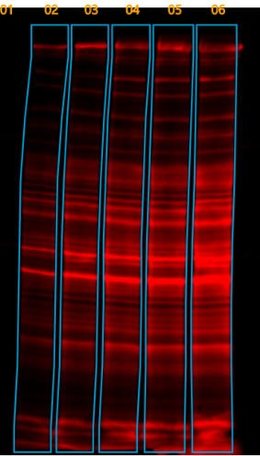 | 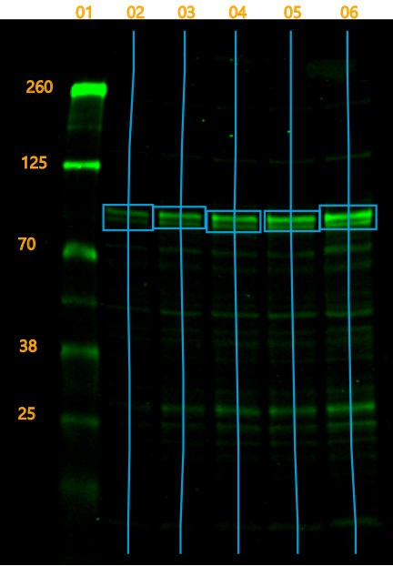 | 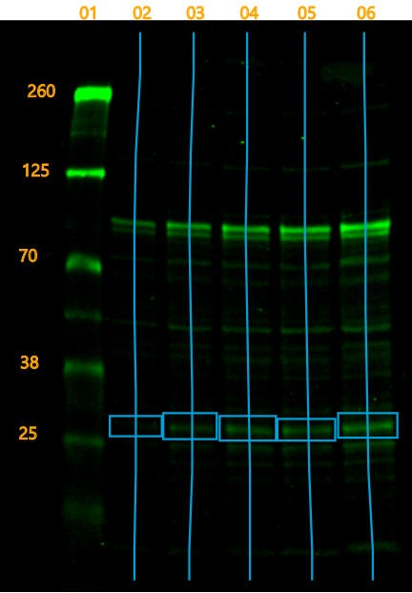
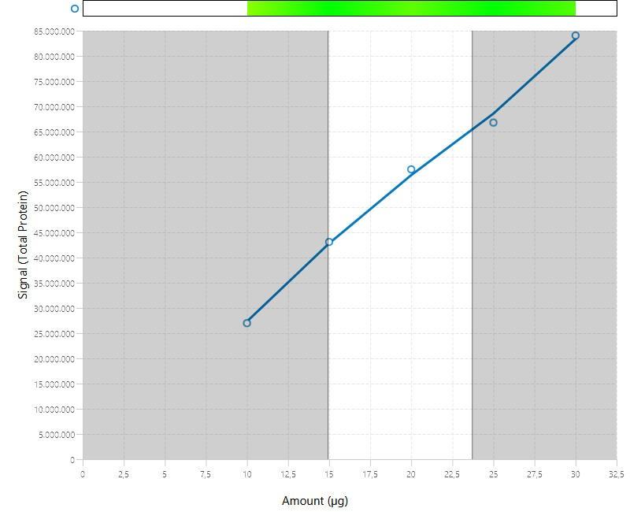 | 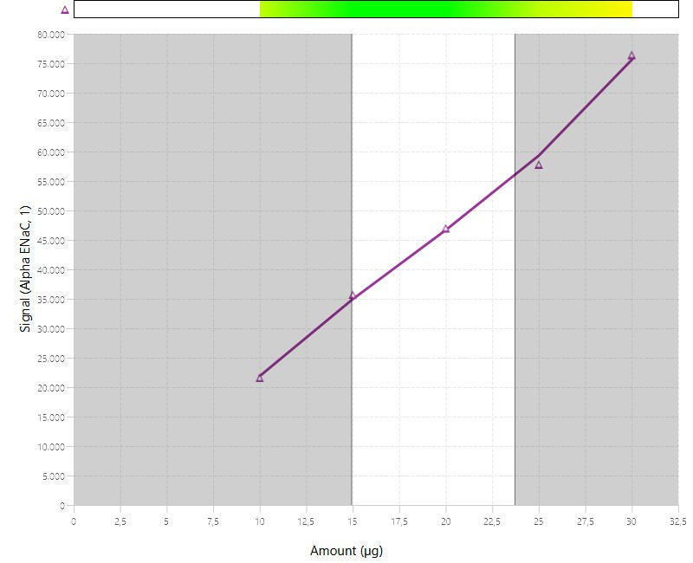 | 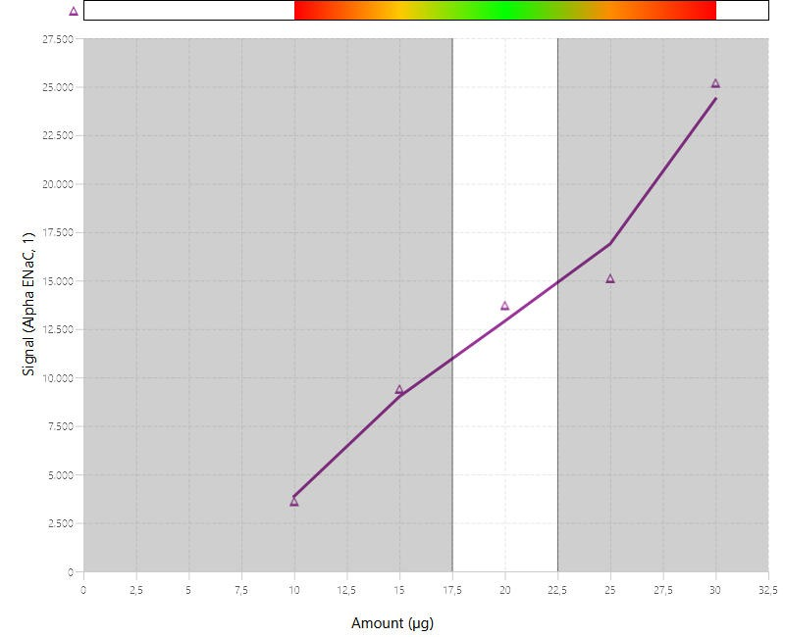

Supplemental Figure 2: Linear range of the used antibodies (continued)
B Linear range of the 90 band detected by Anti-βENaC
Total protein | Anti-βENaC
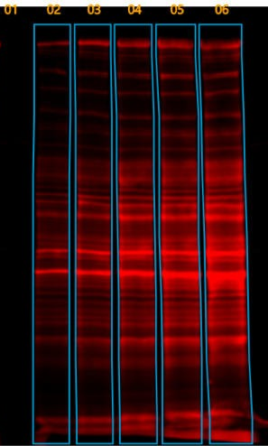 | 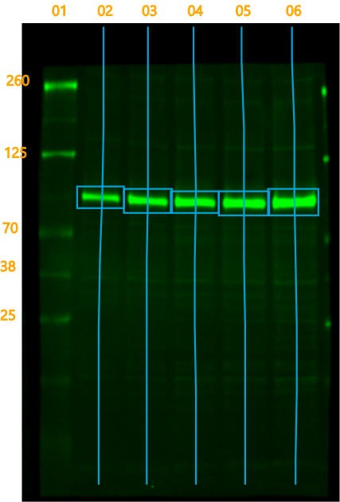
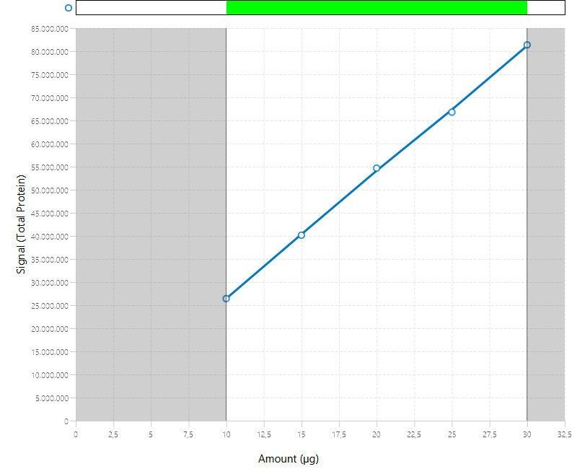 | 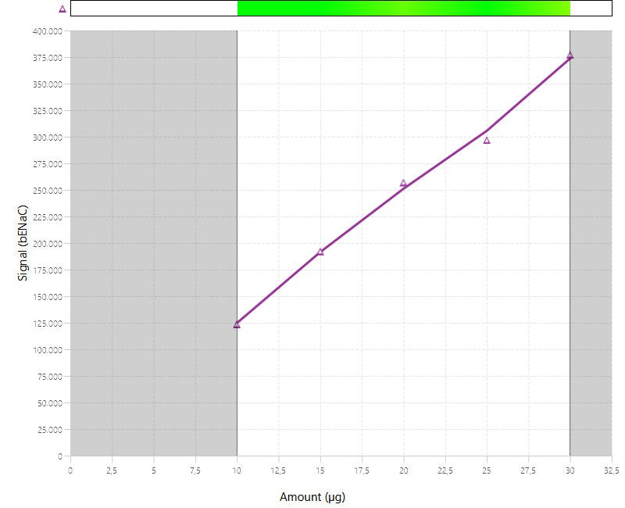

Supplemental Figure 2: Linear range of the used antibodies (continued)
C Linear range of the bands detected by Anti-γENaC
Total protein | Anti-γENaC 70 kDa | Anti-γENaC 60 kDa | Anti-γENaC 55 kDa
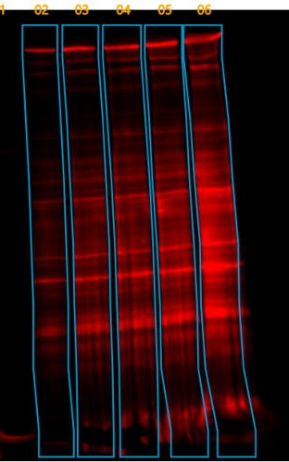 | 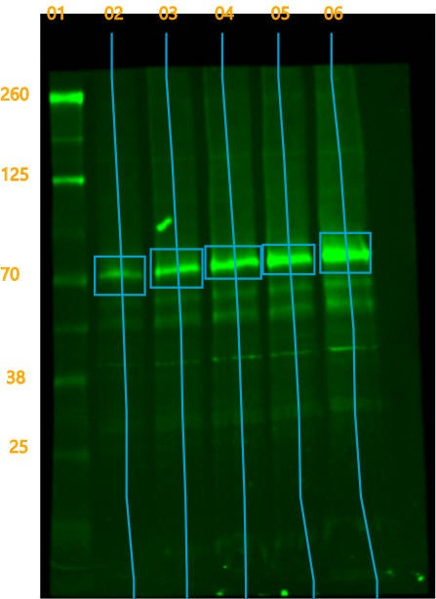 | 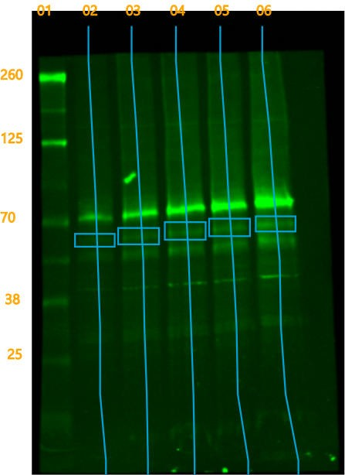 | 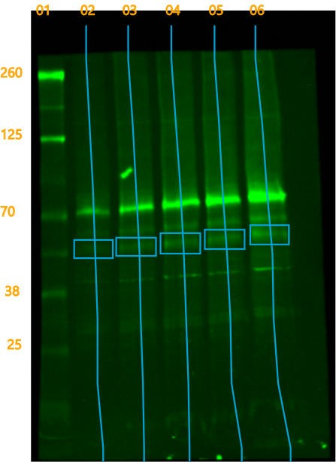
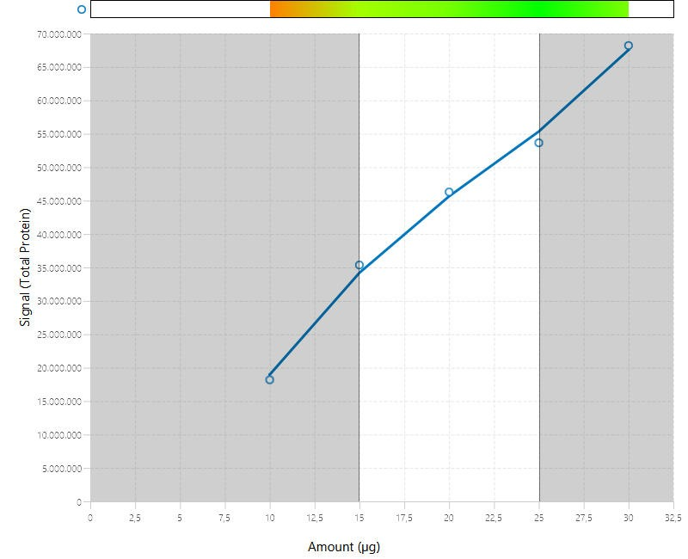 | 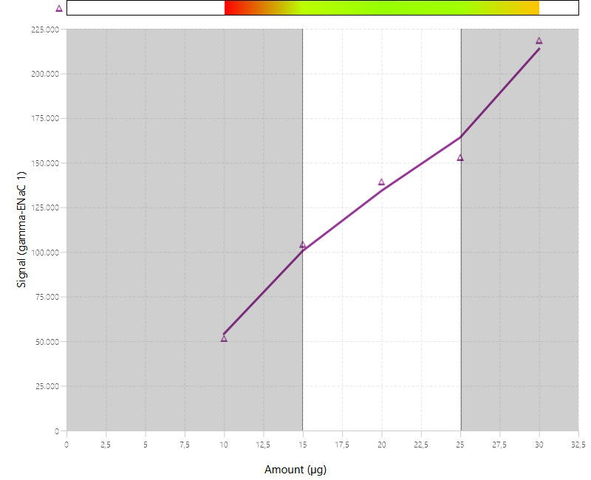 | 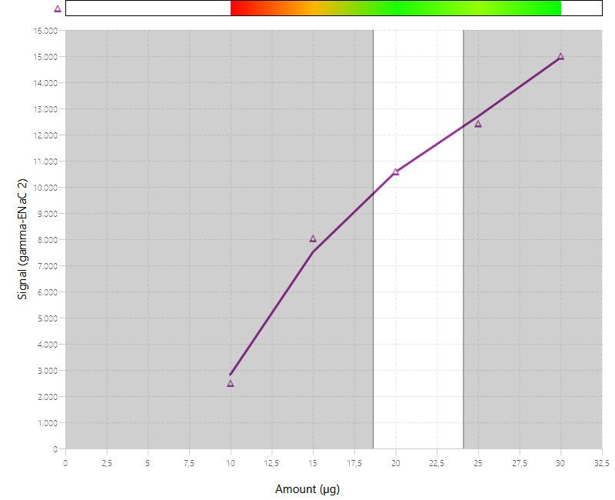 | 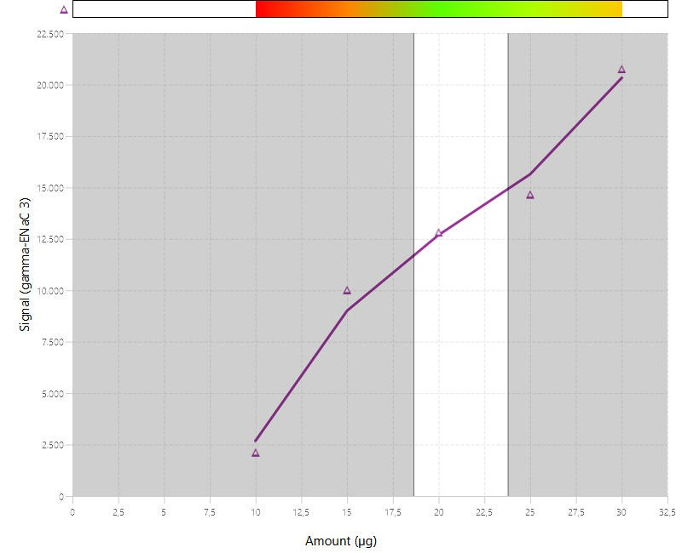

Supplemental Figure 3: Food and fluid intake as well as urine output under a low sodium diet as well as under a 4-day treatment with amiloride in γENaC^{wt/wt} and γENaC^{ki/ki} mice.
A, B, C Course of food and fluid intake as well as urine output over 24h under a low sodium diet
D, E, F Course of food and fluid intake as well as urine output over 24h under a 4-day treatment with amiloride

# significant difference (p<0.05) between control and intervention in mice of the same genotype (ANOVA with Dunnetts multiple comparison test or Kruskal-Wallis with Dunn’s multiple comparison test) * significant difference (p<0.05) between genotypes (two-way ANOVA and/or unpaired t-test or Wilcoxon test)) Note that the control values (d,e,g,h) at day 0 were pooled from all experimental series (indicated by larger symbols).

Supplemental Figure 4: Food (A) and fluid intake (B), calculated sodium intake (C), urinary potassium excretion (D), calculated potassium intake (E) and plasma concentrations of corticosterone (F) before and after induction of experimental nephrotic syndrome in γENaC^{wt/wt} and γENaC^{ki/ki} mice.

# significant difference (p<0.05) between control and intervention in mice of the same genotype (ANOVA with Dunnetts multiple comparison test or Kruskal-Wallis with Dunn’s multiple comparison test) * significant difference (p<0.05) between genotypes (two-way ANOVA and/or unpaired t-test or Wilcoxon test)

