Supplementary figures
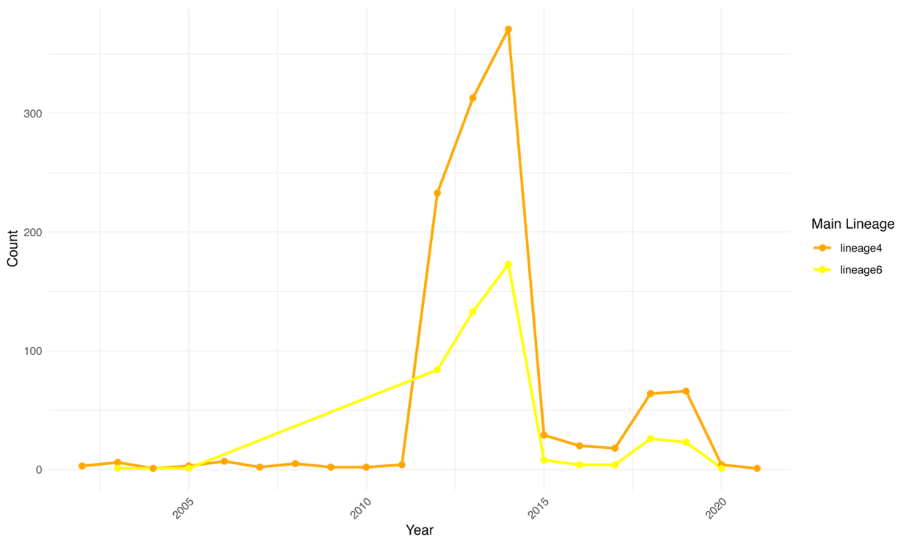

Supp Figure 1: Distribution of MTBC lineage 6 and 4 from 2002 to 2021.

A
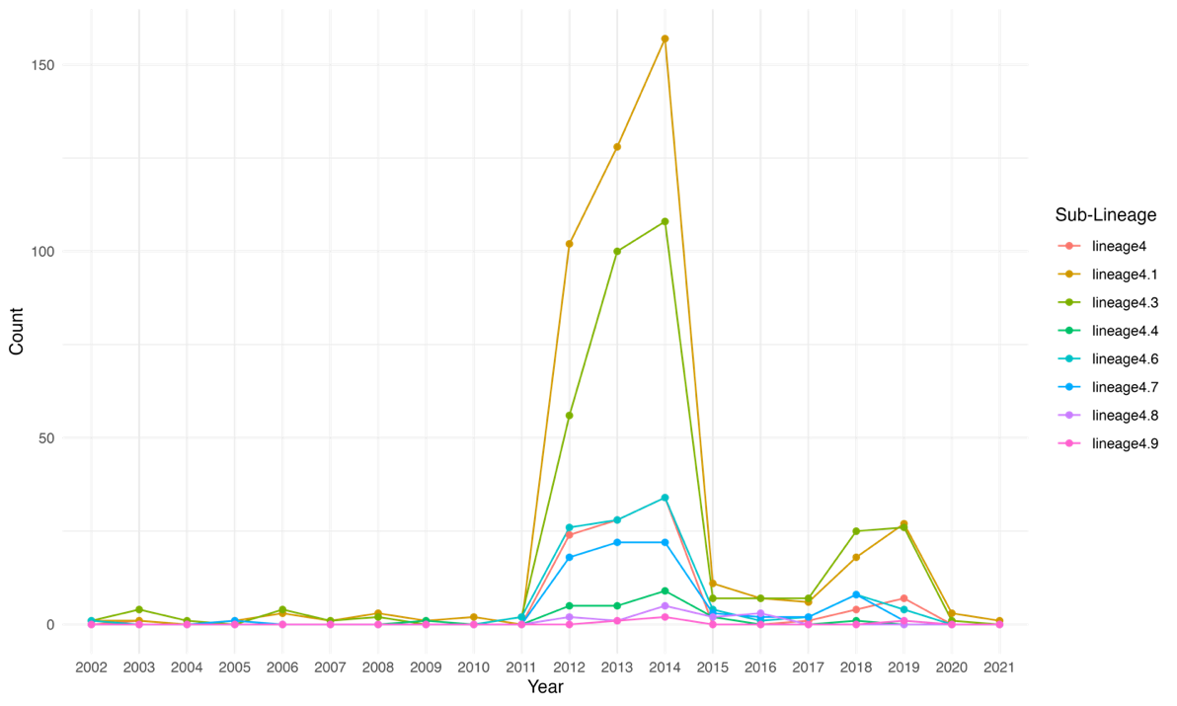

B

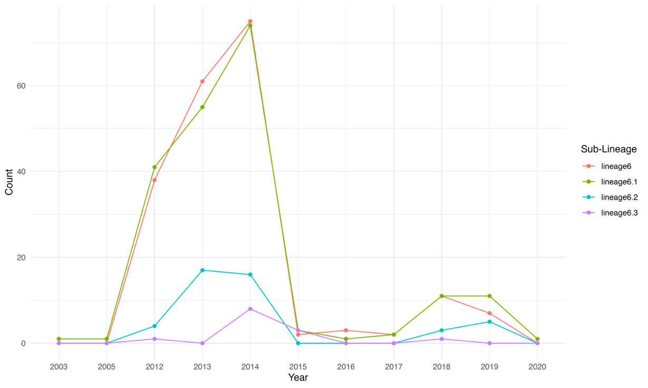

Supp Figure 2: Distribution of MTBC sub-lineages from 2002 to 2020. Panel (A) is for MTBC lineage 4 and (B) for MTBC lineage 6.

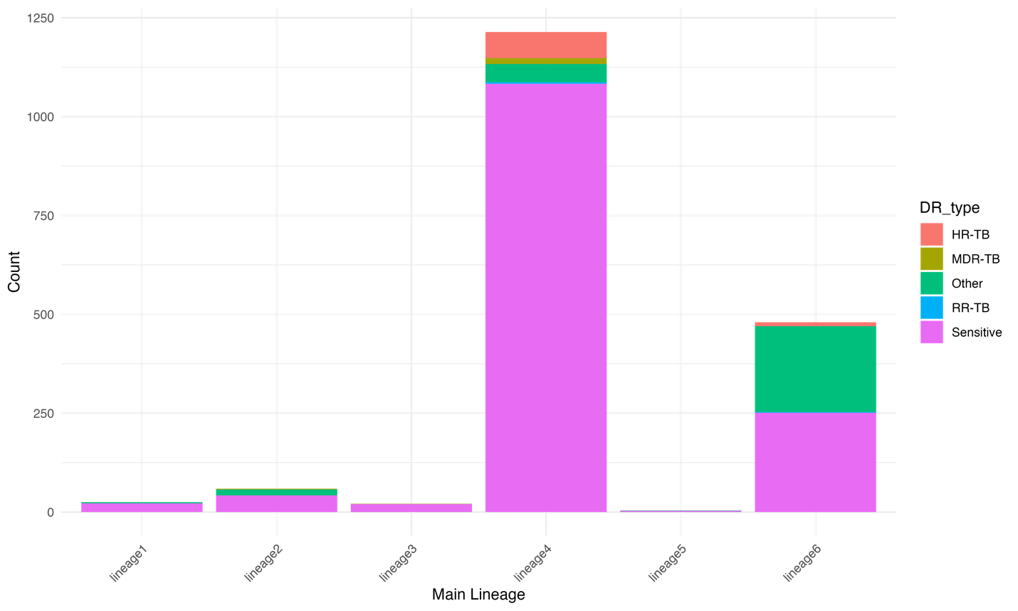

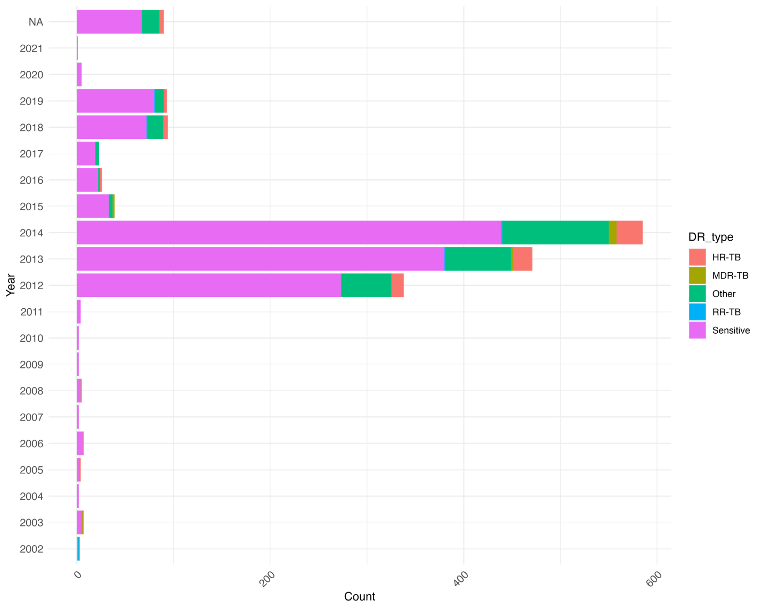
Supp Figure 3: Distribution of drug-resistant strains across MTBC lineages (A) and over time (B) in The Gambia.

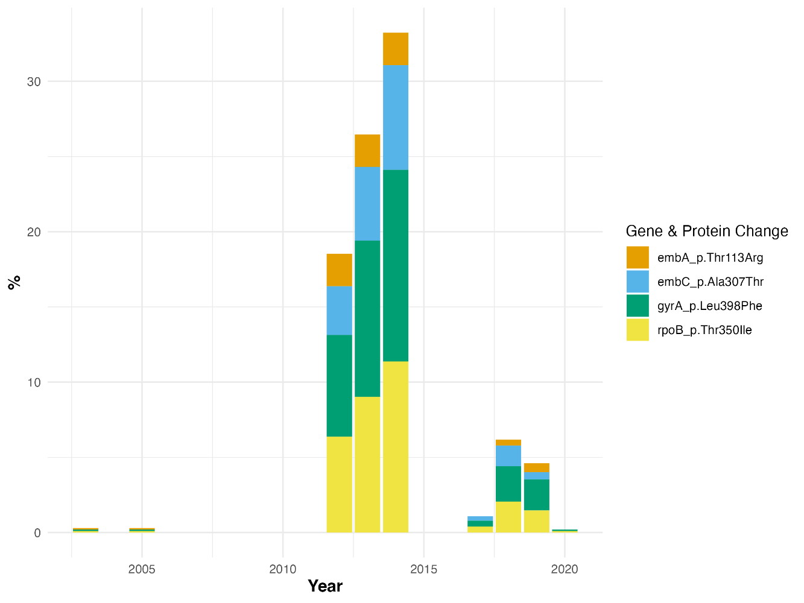

Supp Figure 4: Prevalence of mutations of uncertain resistance significance over time

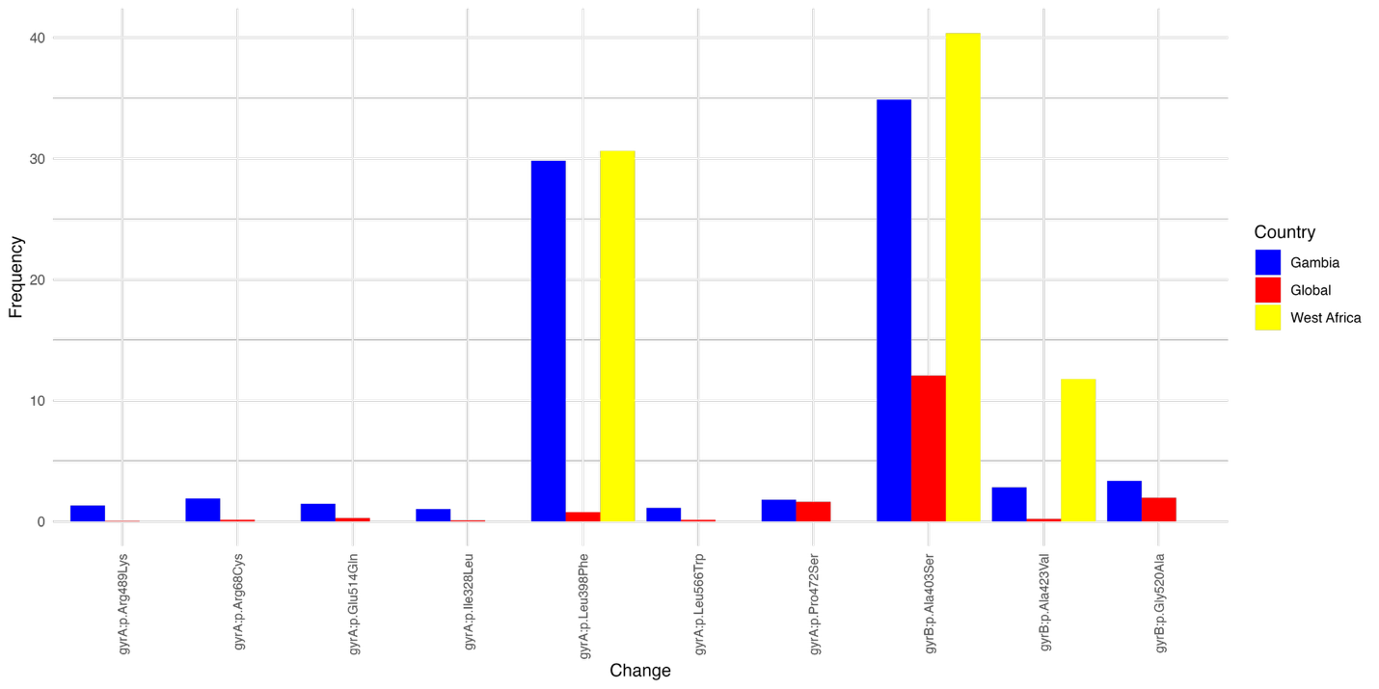

Supp Figure 5: The prevalence of mutations with uncertain significant resistance according to the WHO catalogue in moxifloxacin drug in The Gambia, West Africa and the global database.

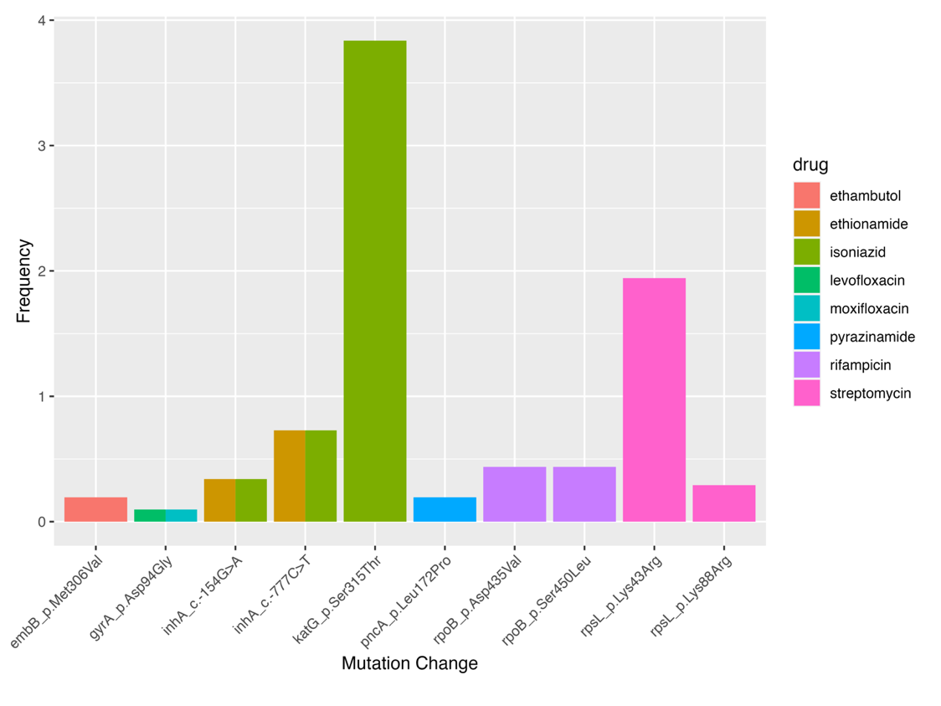

B.
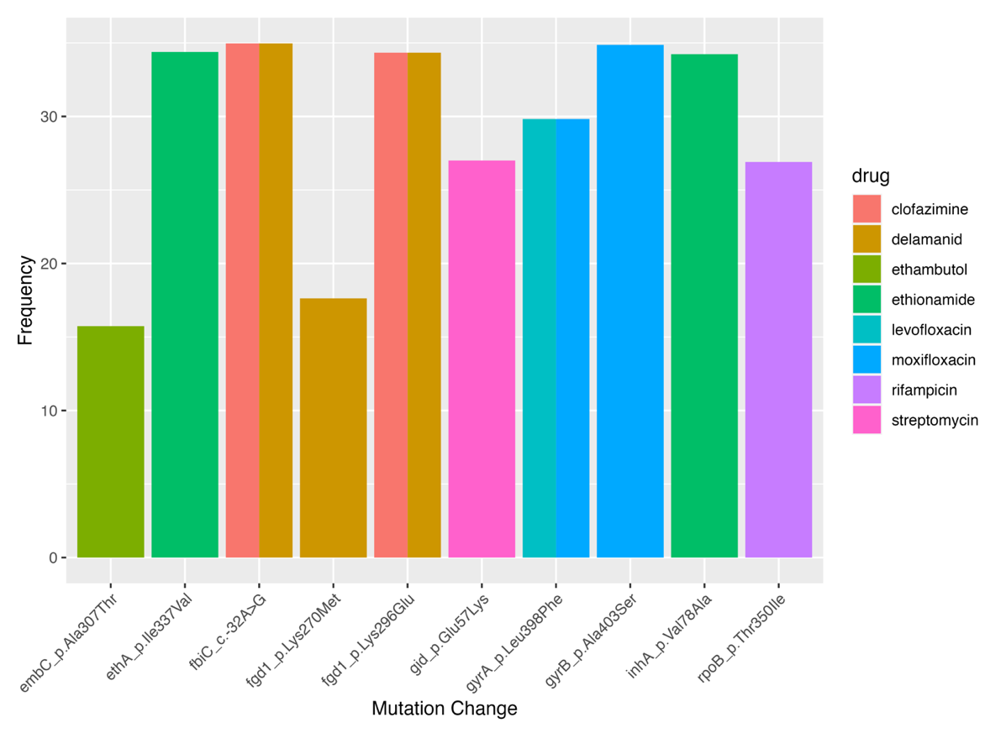
C.
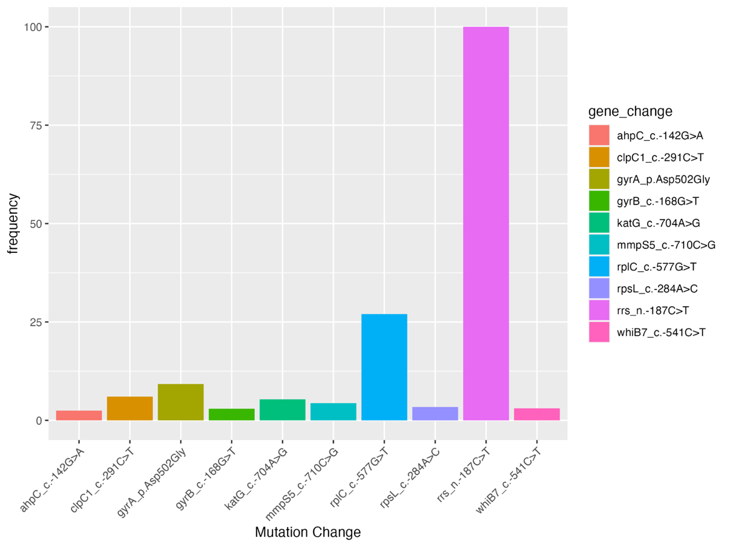
Supp Figure 6: The distribution of variants across different categories, highlighting their association with specific genes or drugs in the Gambian isolates. The categories are classified according to the WHO catalogue: (A) associated with resistance, (B) of uncertain significance, and (C) not in the WHO catalogue.

Supp Figure 7: SDM predicted delta delta G of resistant and susceptible mutations per MTBC lineages for the first-line drugs

