Supporting Information

Oxygen supply of Islets of Langerhans by photosynthetically active microalgae in bioprinted co-cultures maintains their function in a hypoxic environment
Finn Dani, Sarah Duin, Ashwini Rahul Akkineni, Susann Lehmann, Barbara Ludwig, Michael Kühl, Michael Gelinsky, Anja Lode*
* Corresponding author: anja.lode@tu-dresden.de

Table S1: Components of standard INS-1 medium, given in vol%
Concentration | Component
85 % | RPMI 1640
10 % | HI-FBS
1 % | 0.1 m Na-Pyruvate / 5 × 10⁻³ m 2-mercaptoethanol
1 % | 0.2 m L-glutamine
2 % | 1 m HEPES buffer
1 % | 10 × 10³ U mL⁻¹ penicillin / 10 mg mL⁻¹ streptomycin

Table S2: Components of standard medium for rat pancreatic islets, given in vol%
Concentration | Component
86.45 % | RPMI 1640 (no glucose)
10 % | HI-FBS
0.55 % | 1 m glucose
2 % | 1 m HEPES buffer
1 % | 10 × 10³ U mL⁻¹ penicillin / 10 mg mL⁻¹ streptomycin

Table S3: Components of standard TP medium
Concentration | Component
96,8 % | Deionized H₂O
2 % | 1 m TRIS-base
1 % | Salt solution (Table S4)
0.1 % | Phosphate buffer (Table S4)
0.1 % | Hutner’s trace element solution (Table S4)

Table S4: Components of stock solutions for TP medium
Concentration | Component
Salt solution (in ddH₂O)
10 g/L | MgSO₄ • 7 H₂O
5 g/L | CaCl₂ • 2 H₂O
75 g/L | NaNO₃
Phosphate buffer (in ddH₂O)
108 g/L | K₂HPO₄
56 g/L | KH₂PO₄
Hutner’s trace element solution (in ddH₂O)
50 g/L | Na₂EDTA
22 g/L | ZnSO₄ • 7 H₂O
11.4 g/L | H₃BO₃
5.06 g/L | MnCl₂ • 4 H₂O
4.99 g/L | FeSO₄ • 7 H₂O
1.61 g/L | CoCl₂ • 6 H₂O
1.57 g/L | CuSO₄ • 5 H₂O
1.10 g/L | (NH₄)₆Mo₇O₂₄ • 4 H₂O
~16 g/L | KOH

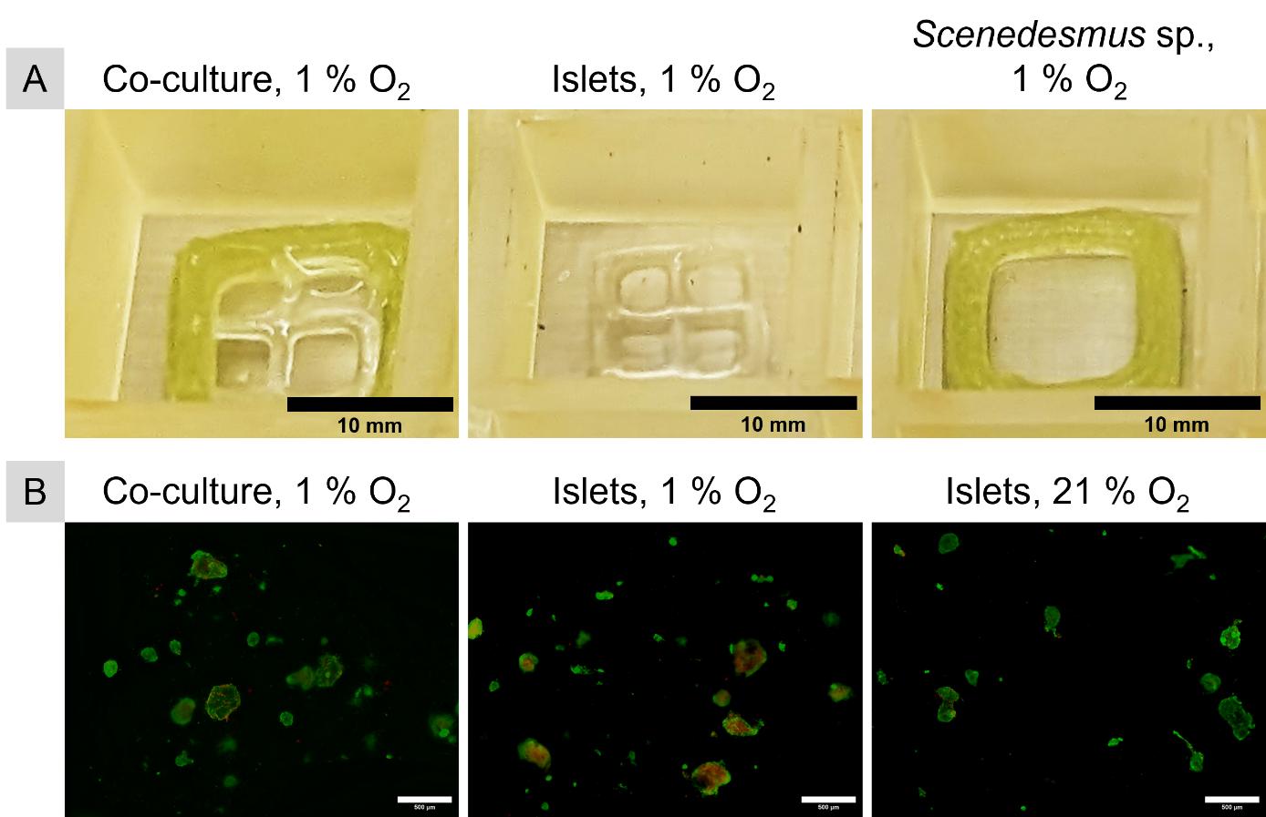
Supplementary Figure S1: A) Macroscopic images of rat pancreatic islet/Scenedesmus sp. co-cultures and respective mono-cultures on day 0 of the cultivation. B) Representative images of viability staining of rat islets in co-culture with Scenedesmus sp. in hypoxia (1% O₂) and in mono-culture in hypoxia or normoxia (21% O₂) (green: live cells, red: dead cells; scale bars: 500 µm).

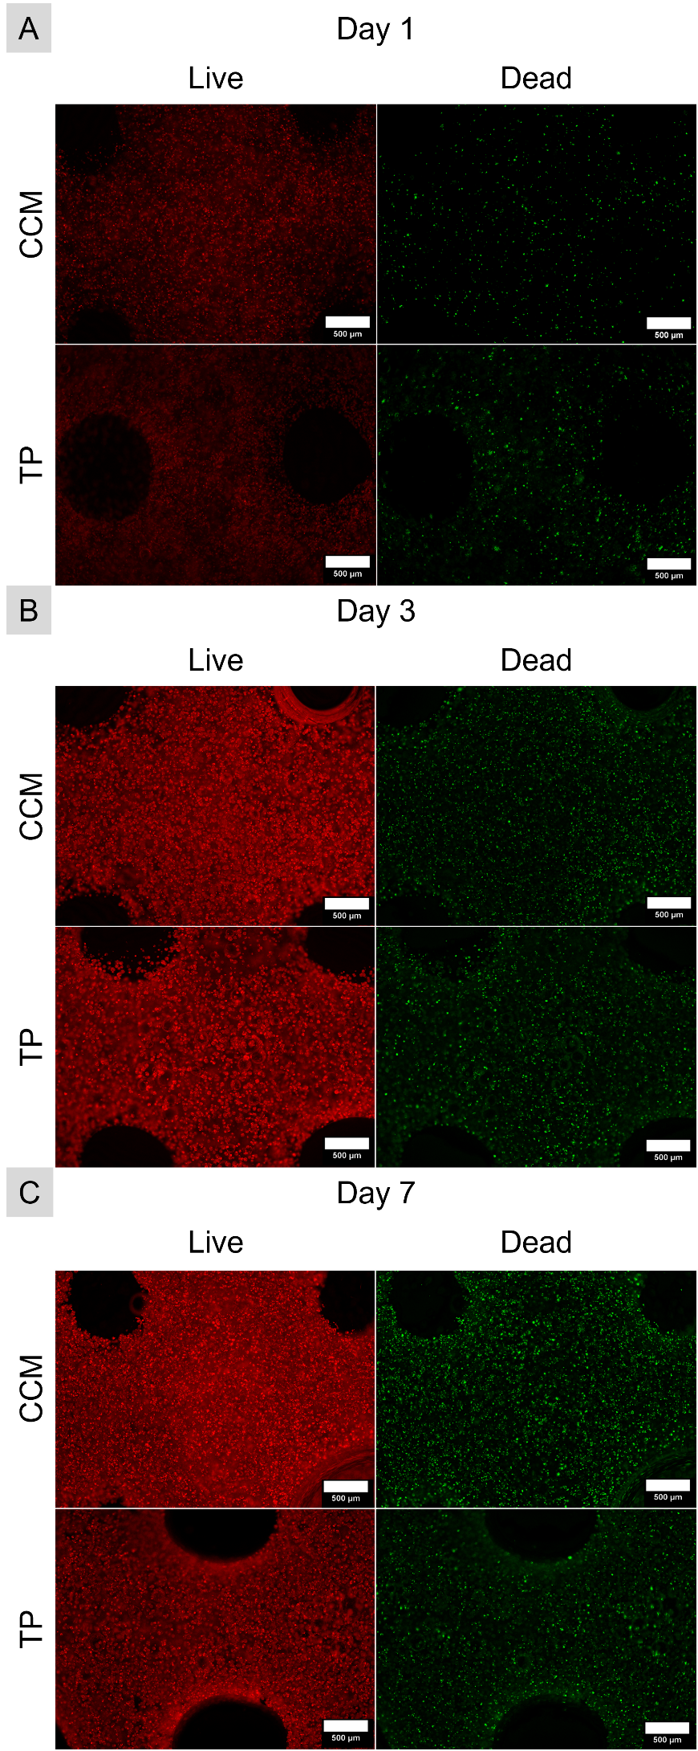
Supplementary Figure S2: Representative images of viability staining of Scenedesmus sp. in co-culture medium (CCM) or standard algal TP medium on day 1 (A), day 3 (B) and day 7 (C) of cultivation under red-light illumination (green: live cells, red: dead cells; scale bars: 500 µm).

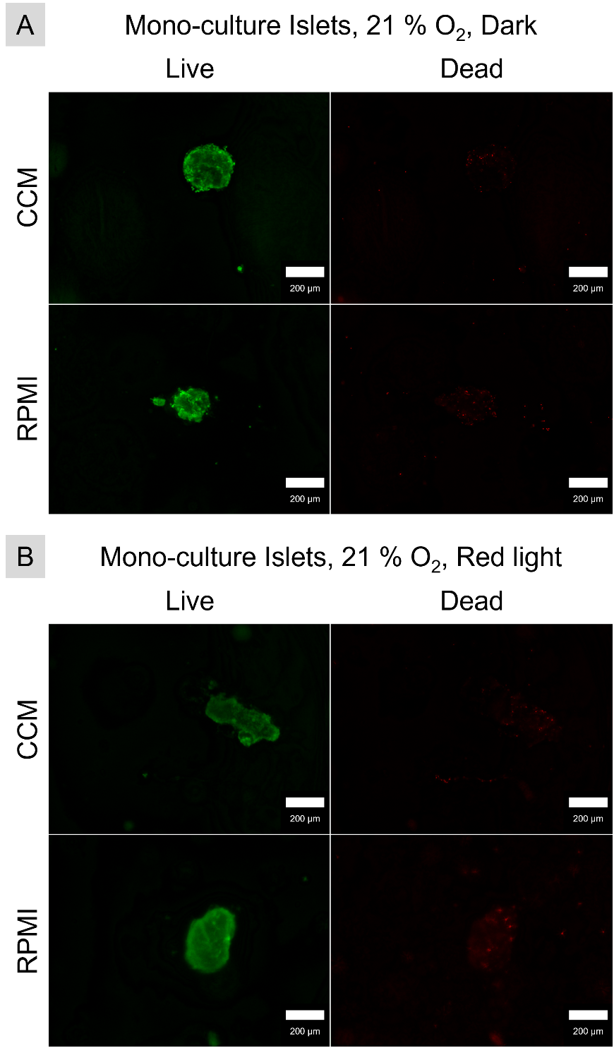
Supplementary Figure S3: Representative images of viability staining of rat pancreatic islets in the dark (A) and under red light illumination (B) after 4 days of cultivation in standard RPMI 1640-based culture medium (green: live cells, red: dead cells; scale bars: 200 µm).

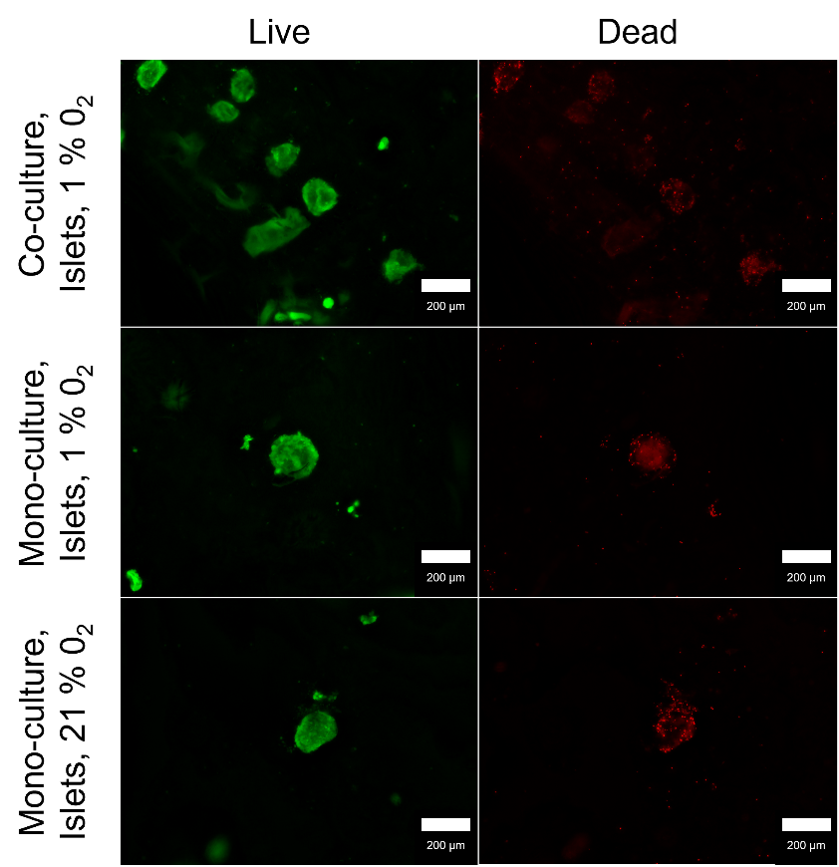
Supplementary Figure S4: Representative images of viability staining of rat pancreatic islets cultivated in co-culture with Scenedesmus sp. in hypoxia (1% O₂) or mono-culture in hypoxia or normoxia (21% O₂) after 4 days of cultivation in co-culture medium (CCM) (green: live cells, red: dead cells; scale bars: 200 µm).

