Impact of sulfamethoxazole, trimethoprim, diclofenac, carbamazepine, and their mixture on the metabolism of Lemna minor: a targeted metabonomic study

Rofida Wahman^{1,2,3,a,*}, Peter Schröder^{4,b}, Geoffroy Duporté ³, Serge Chiron³, Jörg Drewes^{2 ,} Andrés Sauvêtre^{3,#}, and Catarina Cruzeiro^{4,c,d,#}
¹Chair of Urban Water Systems Engineering, Technical University of Munich, Am Coulombwall 3, 85748 Garching, Germany.
²Pharmacognosy Department, Faculty of Pharmacy, Assiut University, Assiut, Arab Republic of Egypt/Egypt.
³HydroSciences Montpellier, IRD, CNRS, University of Montpellier, Montpellier, France.
⁴German Research Center for Environmental Health, Unit Environmental Simulation, Helmholtz Zentrum München, Ingolstädter Street 1, 85764 Neuherberg, Germany.

*Corresponding authors: Rofida.wahman@tum.de
# Both authors contributed equally to this work; joint authors

Present address:
ª Pharmacognosy Department, Faculty of Pharmacy, Assiut University, Assiut, Arab Republic of Egypt/Egypt
^{b} Chair of Organic Agriculture and Agronomy, TUM School of Life Sciences Weihenstephan, Technical University of Munich, Liesel-Beckmann-Str. 2, 85354, Freising, Germany.
^{c} LSRE-LCM – Laboratory of Separation and Reaction Engineering - Laboratory of Catalysis and Materials, Faculty of Engineering, University of Porto, Rua Dr. Roberto Frias, 4200-465 Porto, Portugal
^{d} ALiCE – Associate Laboratory in Chemical Engineering, Faculty of Engineering, University of Porto, Rua Dr. Roberto Frias, 4200-465 Porto, Portugal

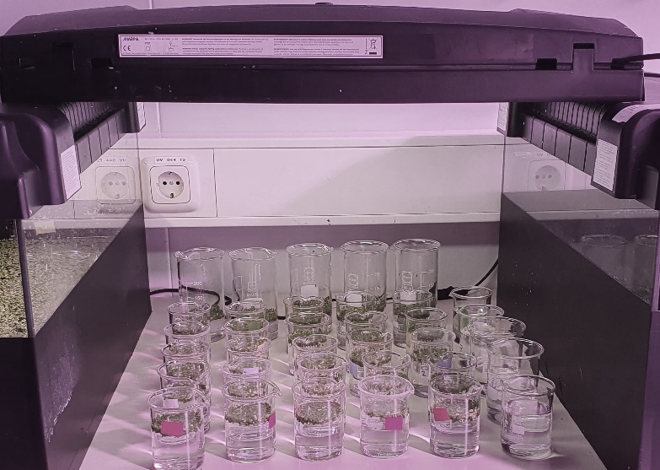

Fig. S1. Photo of Lemna minor exposed to SMX, TRIM, DCF, CBZ, and a mixture of them (MIX) at 5ppb (5µg/L) in Steinberg media for 5 days.

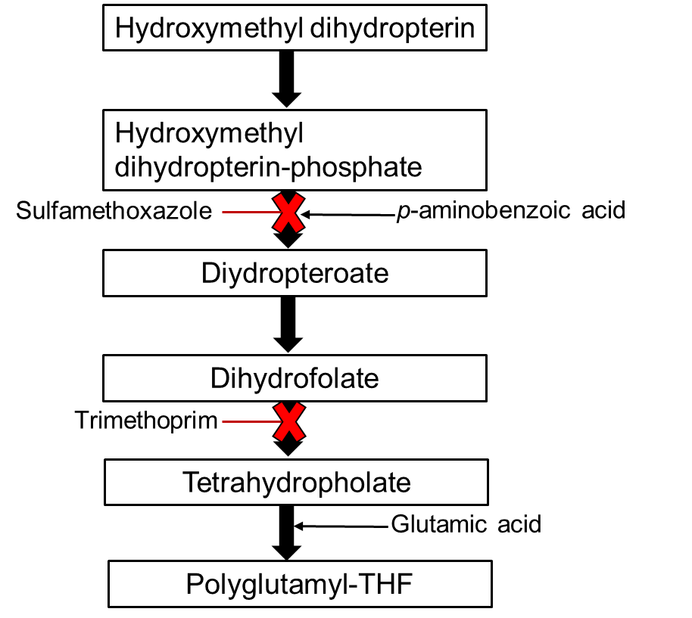

Fig S2. The folate pathway in the mitochondria of a plant cell when is suspected to be inhibited by SMX and TRIM. SMX targets dihydropteroate synthase (DHPS), and trimethoprim targets dihydrofolate reductase (DHFR) in the folate biosynthetic pathway.

Table S1: Steinberg solution composition.
Steinberg solution | Reagents | Molarity (mol/L) | Solution used (mL/L)
Solution 1 | KNO₃ | 1.74E+02 | 2
Solution 1 | KH₂PO₄ | 3.32E+01 | 2
Solution 1 | K₂HPO₄ | 3.59E+00 | 2
Solution 2 | MgSO₄.7H₂O | 2.04E+01 | 2
Solution 3 | Ca(NO₃)₂.4H₂O | 6.20E-01
Solution 4 | H₃BO₃ | 1.90E-03 | 1
Solution 4 | ZnSO₄.7H₂O | 6.00E-04 | 1
Solution 4 | Na₂MOO₄.2H₂O | 2.00E-04 | 1
Solution 4 | MnCl₂.4H₂O | 9.00E-04 | 1
Solution 5 | FeCl₃.6H₂O | 2.81E+00 | 1
Solution 5 | Na₂.EDTA.2H₂O | 4.03E+00 | 1

Name | Mean RT (Min.) | SD | %RSD | Molecular ion species
Carbamazepine-d10 | 12.84 | 0.01 | 0.09 | [M+H]⁺
Sulfamethoxazole-d4 | 11.96 | 0.02 | 0.15 | [M+H]⁺
Diclofenac-d4 | 15.06 | 0.07 | 0.49 | [M+H]⁺
Trimethoprim-d3 | 16.04 | 0.01 | 0.08 | [M+H]⁺
Ibuprofen | 15.90 | 0.10 | 0.66 | [M-H]⁻
Table S2. The average retention time (RT, min), standard deviation (SD), and relative standard deviation (%RSD) of the listed internal standards (n=30 injections).

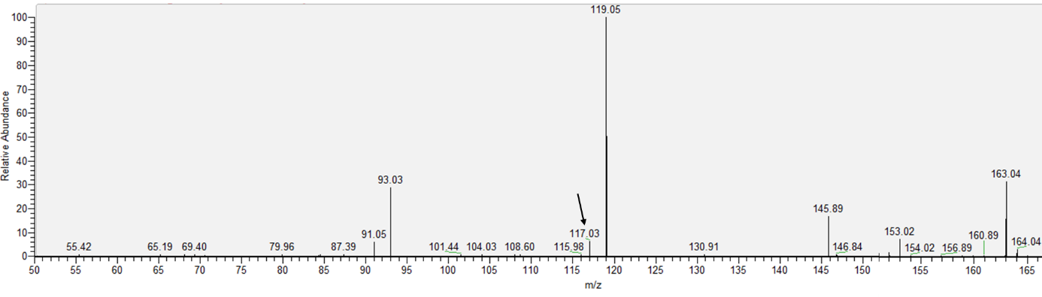
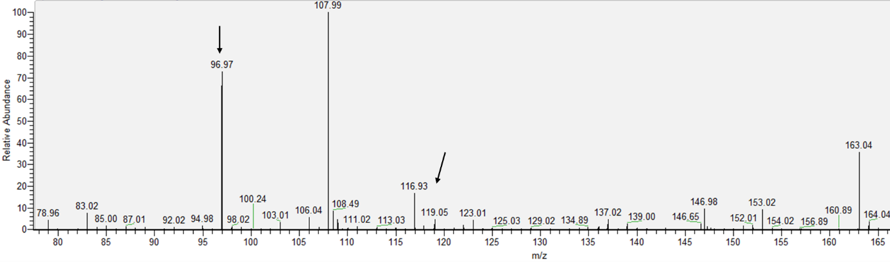
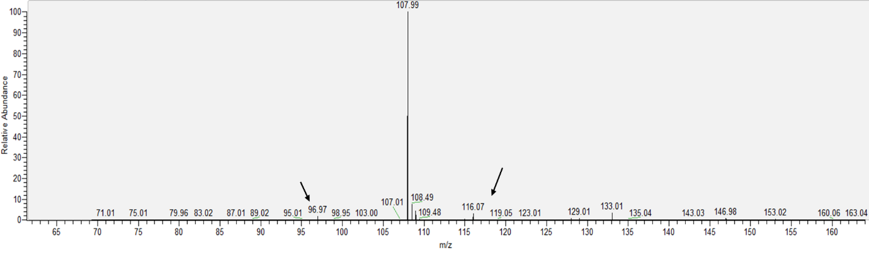
Fig S3. Mass spectrum (m/z) of (a) phenylpyruvate; (b) o-coumaric acid, (c) p-coumaric acid.
b
a
c

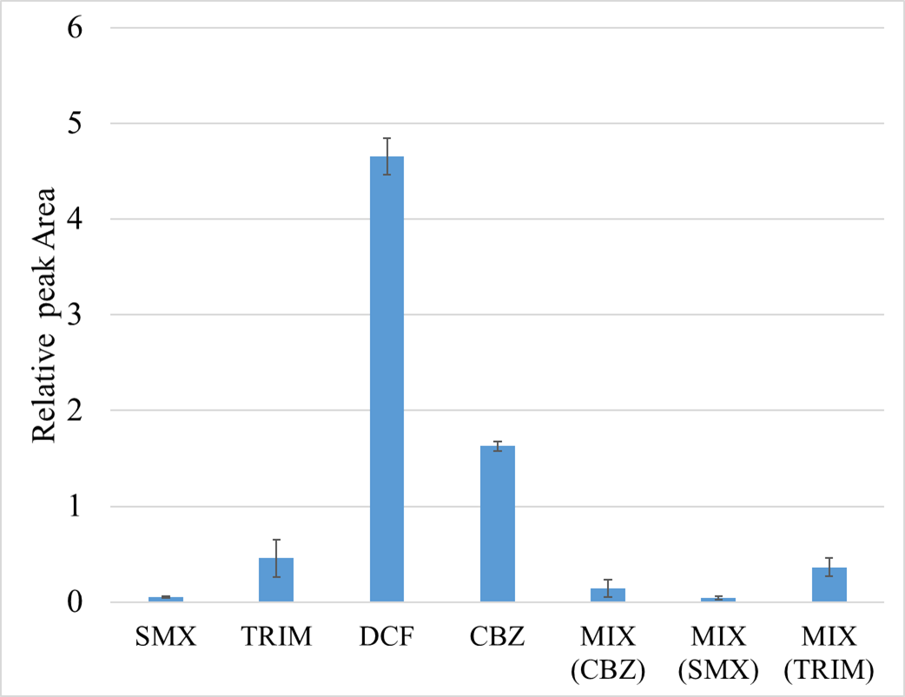

Fig S4. The relative peak areas of SMX, TRIM, DCF, CBZ, and their mixture in the Lemna minor extracts.

Table S3. The mean and standard deviation of different metabolite intensities after normalisation against carbamazepine-d10, assigned to positive mode.
---: under the limit of detection

 | SMX |  | TRIM |  | Control |  | DCF |  | CBZ |  | MIX
 | Mean | SD | Mean | SD | Mean | SD | Mean | SD | Mean | SD | Mean | SD
Apigenin | 0.5917 | 0.2528 | 0.8765 | 0.2954 | 0.3692 | 0.1309 | 0.4397 | 0.2803 | 0.3040 | 0.1080 | 0.3175 | 0.0616
Shikimic acid | 2.5652 | 0.7681 | 2.7771 | 1.0869 | 3.3678 | 1.4476 | 3.1657 | 0.7113 | 4.1322 | 0.4738 | 4.2213 | 0.7641
Tyrosine | 2.8561 | 1.3330 | 3.1087 | 1.1121 | 0.6676 | 0.1807 | 3.7038 | 0.5566 | 2.6701 | 0.5698 | 3.3604 | 0.6119
Cinnamic acid | 1.6047 | 0.5025 | 1.9027 | 0.6778 | 0.5960 | 0.1797 | 1.5872 | 0.3764 | 1.3406 | 0.5681 | 2.5454 | 0.4454
Linoleic acid | 104.5389 | 41.1481 | 396.5225 | 24.3421 | 99.5106 | 8.9559 | 100.2405 | 11.8920 | 94.3306 | 17.5218 | 106.7070 | 21.7614
Ferulic acid | 123.7868 | 84.2098 | 270.8483 | 14.8380 | 122.9662 | 71.3676 | 338.6366 | 7.4107 | 299.8371 | 28.4161 | 361.6101 | 82.4137
Salicylic acid | 2840.6425 | 1076.4631 | 3357.7723 | 1648.2629 | 2906.5876 | 793.0722 | 3762.0003 | 1596.5627 | 2680.9110 | 948.1404 | 3985.8334 | 579.4829
Chrosimic/Prephenic acid | 12.6074 | 5.9244 | 14.7971 | 6.3606 | 8.9646 | 4.3588 | 15.8986 | 6.6956 | 13.6041 | 7.7233 | 19.6693 | 5.7315
p-Coumaric acid | 35.3314 | 19.4901 | 38.3379 | 17.0957 | 27.7534 | 11.9311 | 66.4549 | 14.3068 | 50.4442 | 21.2574 | 87.3169 | 30.3848
o-Coumaric acid | 20.5143 | 9.7127 | 10.0605 | 4.4833 | 4.5263 | 1.3913 | 14.8046 | 2.5898 | 10.5267 | 4.6241 | 22.6751 | 17.4022
Phenylpyruvate | 28.1967 | 13.2444 | 42.7783 | 19.4982 | 16.1577 | 5.0991 | 38.6908 | 12.3294 | 29.2142 | 20.9294 | 49.7198 | 14.1618
Benzoic acid | 10.5448 | 4.6233 | 12.6783 | 4.6610 | 7.9039 | 2.5789 | 11.7409 | 1.5536 | 12.6239 | 7.5266 | 13.3536 | 2.4773
5-hydroxy phenyl pyruvate | 83.7191 | 49.1668 | 77.9732 | 36.7072 | 42.8652 | 7.0837 | 143.7973 | 26.2147 | 96.0870 | 42.6248 | 147.2426 | 69.1958
Caffeic acid | 60.0967 | 40.2215 | 149.7107 | 73.2774 | 47.2659 | 19.6823 | 123.6932 | 70.5740 | 101.7882 | 41.4965 | 113.5663 | 52.0986
Naringenin | 0.0852 | 0.0145 | 0.0983 | 0.0474 | --- | --- | --- | --- | --- | --- | --- | ---
Table S4. The mean and standard deviation of different metabolite intensities after normalisation against Ibuprofen, assigned to negative mode.
 | SMX |  | TRIM |  | Control |  | DCF |  | CBZ |  | MIX
 | Mean | SD | Mean | SD | Mean | SD | Mean | SD | Mean | SD | Mean | SD
Phenylalanine | 117.6525 | 24.6398 | 91.3023 | 48.3821 | 23.3408 | 7.8579 | 118.9190 | 37.6988 | 147.7161 | 11.0249 | 52.7724 | 24.2711
Tryptophan | 415.5987 | 62.1477 | 393.1164 | 167.7497 | 97.6274 | 26.0372 | 401.7505 | 21.6777 | 283.2876 | 99.6746 | 269.1168 | 153.7202
Glutmatic acid | 38.3397 | 5.2660 | 39.7024 | 11.8161 | 24.0494 | 4.4507 | 30.5486 | 11.5110 | 55.4927 | 6.3681 | 23.4120 | 13.4980
Anthranilic acid | 0.0085 | 0.0026 | 0.0041 | 0.0017 | 0.0035 | 0.0014 | 0.0071 | 0.0039 | 0.0099 | 0.0013 | 0.0038 | 0.0007
4-Amino benzoic acid | 0.1314 | 0.0211 | 0.1253 | 0.0503 | 0.0697 | 0.0414 | 0.1091 | 0.0205 | 0.1798 | 0.0472 | 0.0527 | 0.0431
Indole | 0.0634 | 0.0034 | 0.0077 | 0.0037 | 0.0019 | 0.0005 | 0.0120 | 0.0030 | 0.0084 | 0.0020 | 0.0045 | 0.0017
Apigenin | 0.0179 | 0.0057 | 0.0288 | 0.0099 | 0.0051 | 0.0003 | 0.0141 | 0.0002 | 0.0050 | 0.0024 | 0.0030 | 0.0011

