Title: The Impact of ERAP1 Inhibition on Metabolite Homeostasis of Melanoma Cells
Aroosha Raja^{1#}, Martha Nikopaschou^{2,3#}, Joke H. de Boer¹, Jeannette Ossewaarde-van Norel¹, Anna Artati⁴, Michael Witting^{4,5}, Efstratios Stratikos^{2,3*}, Jonas J.W. Kuiper^{1*}
¹ Center for Translational Immunology, Department of Ophthalmology, University Medical Center Utrecht, Utrecht University, The Netherlands
² Department of Chemistry, National and Kapodistrian University of Athens, Panepistimiopolis Zographou, Athens, Greece
³ National Centre for Scientific Research Demokritos, Agia Paraskevi, Athens, Greece
⁴ Metabolomics and Proteomics Core, Helmholtz Zentrum München, Neuherberg, Germany
⁵ Chair of Analytical Food Chemistry, TUM School of Life Sciences, Technical University of Munich, Freising-Weihenstephan, Germany
*# contributed equally

Corresponding Authors:

Jonas J. W. Kuiper
Center For Translational Immunology,
Department of Ophthalmology
Heidelberglaan 100
3584 CX Utrecht
The Netherlands
Email: j.j.w.kuiper@umcutrecht.nl

Efstratios Stratikos
Department of Chemistry, National and Kapodistrian University of Athens, Zographou 15772, Athens, Greece
National Centre for Scientific Research Demokritos, Agia Paraskevi 15341, Athens, Greece
Email: estratikos@chem.uoa.gr

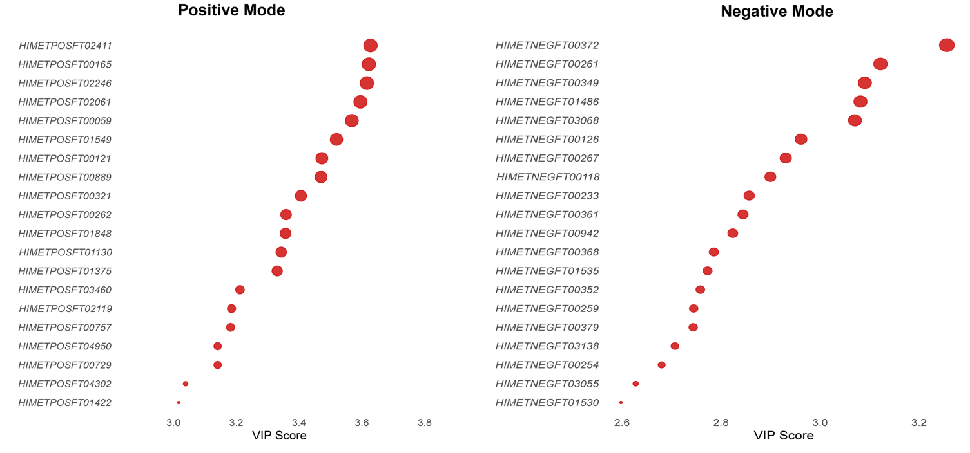
S1 Figure: Top metabolite features identified in positive (left) and negative (right) ionization mode through variable importance Analysis (VOA).

