Supplementary Material

Neuronal correlates of spatial memory retrieval: c-Fos and GAD67 expression in the object-place recognition task
Rafaela Polanczyk, Stoyan Dimitrov, Xia Shan, Jan Born, Marion Inostroza
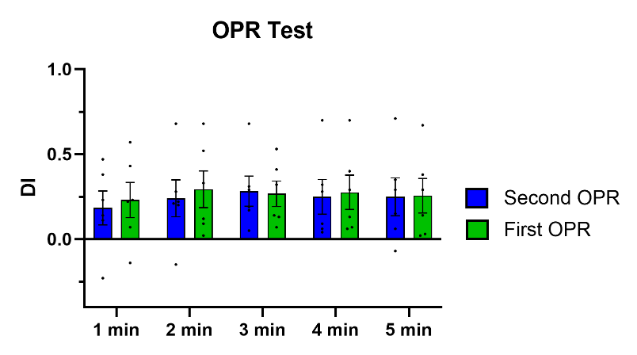
Figure S1. Discrimination index for the OPR task in the within-subject design, as used for the animals of the OPR and STA groups. Animals performing the OPR task second (blue; n=6) or first (green, n=6). Means ± SEM are indicated, individual values overlaid.
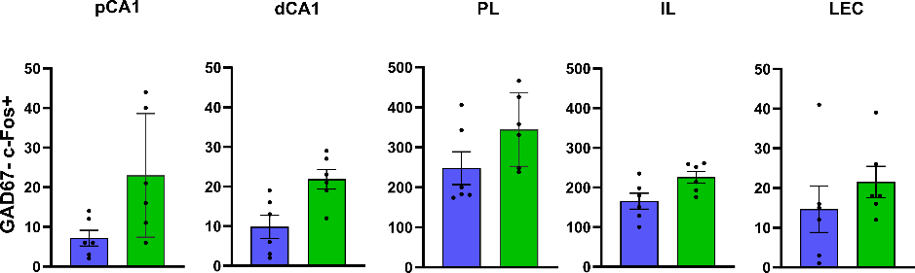
Figure S2. c-Fos expression during retrieval. c-Fos+ GAD67- cell counts in pCA1, dCA1, PL, IL and LEC. Data are presented as mean ± SEM with individual subject values overlaid.

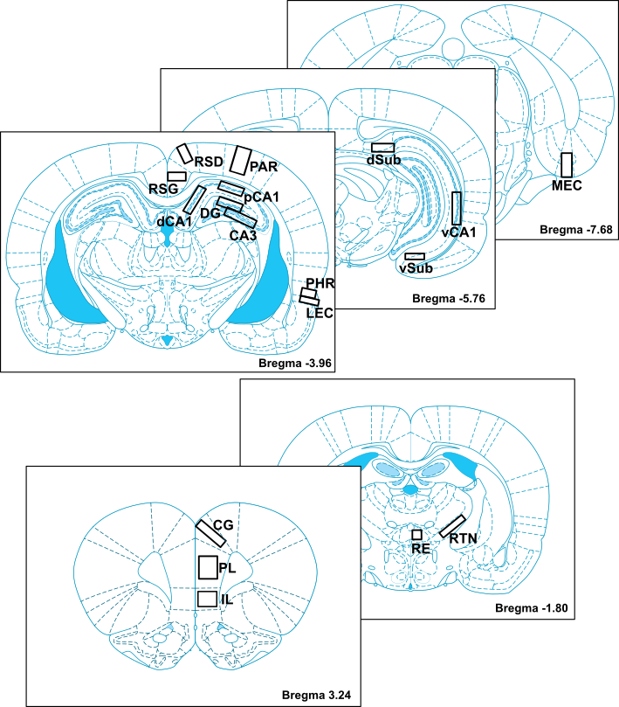
Figure S3. Brain regions of interest. +3.24 mm for PL – prelimbic medial prefrontal cortex, IL – prelimbic prefrontal cortex, and CG – cingulate cortex; -1.8 mm for RE – thalamic reuniens nucleus and RTN – thalamic reticular nucleus; -3.96 mm for pCA1 – proximal cornu ammonis 1, dCA1 – distal cornu ammonis 1, CA3 – cornu ammonis 3, DG – dentate gyrus, RSG – retrosplenial cortex granular, RSD – retrosplenial cortex dysgranular, PAR – parietal, PRH – perirhinal cortex and LEC – lateral entorhinal cortex; -5.76 mm for vCA1 – ventral cornu ammonis 1, dSub – dorsal subiculum, vSub – ventral subiculum; -7.68 mm for MEC – medial entorhinal cortex.
Table S1: Pairwise comparison of GAD67+% expression per region
Hippocampal subregions
vCA1 | p = 0.672
dCA1 | p = 0.684
pCA1 | p = 0.013*
CA3 | p = 0.918
DG | p = 0.109
Prefrontal cortex subregions
PL | p = 0.865
IL | p = 0.874
CG | p = 0.240
Thalamic regions
RE | p = 0.919
RTN | p = 0.928
Posterior cortex subregions
LEC | p = 0.578
PRH | p = 0.878
RSG | p = 0.249
RSD | p = 0.119
PAR | p = 0.102

