Supplementary material

Table S1: Precipitation [mm] in the week before sampling at the two different sites.
Freising (Kranzberg) |  | Kelheim
Date | Precipitation [mm] | Date | Precipitation [mm]
07/21/2021 | 0 | 09/01/2021 | 0
07/22/2021 | 0 | 09/02/2021 | 0
07/23/2021 | 0 | 09/03/2021 | 0
07/24/2021 | 5 | 09/04/2021 | 0
07/25/2021 | 5.5 | 09/05/2021 | 0
07/26/2021 | 8.7 | 09/06/2021 | 0
07/27/2021 | 1 | 09/07/2021 | 0

Table S2: Bacterial strains utilized in this study including their isolation medium and origin.
Strain | Isolation medium | Origin | Accession No.
Pseudomonas sp. Ke1 | M9 medium | Beech roots in Kelheim | PV918716
Paraburkholderia sp. Ke15 | M9 medium | Beech roots in Kelheim | PV918717
Paraburkholderia sp. Ke24 | M9 medium | Beech roots in Kelheim | PV918718
Rhizobium sp. Ke26 | M9 medium | Beech roots in Kelheim | PV918719
Caballeronia sp. Ke41 | M9 medium | Beech roots in Kelheim | PV918720
Caballeronia sp. Ke57 | M9 medium | Spruce roots in Kelheim | PV918721
Bacillus sp. Ke157 | King’s B medium | Beech roots in Kelheim | PV918722
Paraburkholderia sp. Ke162 | King’s B medium | Beech roots in Kelheim | PV918723
Paraburkholderia sp. Ke296 | MMNC medium | Beech roots in Kelheim | PV918724
Paraburkholderia sp. Ke341 | MMNC medium | Beech roots in Kelheim | PV918725
Collimonas sp. Ke374 | MMNC medium | Spruce roots in Kelheim | PV918726
Paraburkholderia sp. Ke398 | MMNC medium | Spruce roots in Kelheim | PV918727
Caballeronia sp. Ke431 | MMNC medium | Spruce roots in Kelheim | PV918728
Streptomyces sp. Ke434 | KM4 agar | Beech roots in Kelheim | PV918729
Rhodococcus sp. Ke442 | KM4 agar | Beech roots in Kelheim | PV918730
Streptomyces sp. Ke462 | KM4 agar | Beech roots in Kelheim | PV918731
Rhodococcus sp. Ke466 | KM4 agar | Beech roots in Kelheim | PV918732
Sporosarcina sp. Ke477 | KM4 agar | Beech roots in Kelheim | PV918733
Streptomyces sp. Ke502 | KM4 agar | Spruce roots in Kelheim | PV918734
Streptomyces sp. Ke507 | KM4 agar | Spruce roots in Kelheim | PV918735
Bacillus sp. KF3 | King’s B medium | Beech roots in Kranzberg | PV918736
Lysinibacillus sp. KF19 | King’s B medium | Beech roots in Kranzberg | PV918737
Bacillus sp. KF21 | King’s B medium | Beech roots in Kranzberg | PV918738
Bacillus sp. KF47 | MMNC medium | Spruce roots in Kranzberg | PV918739
Pseudomonas sp. KF80 | King’s B medium | Beech roots in Kranzberg | PV918740
Psychrobacillus sp. KF94 | KM4 agar | Spruce roots in Kranzberg | PV918741
Viridibacillus sp. KF108 | MMNC medium | Spruce roots in Kranzberg | PV918742
Herbaspirillum sp. KF115 | MMNC medium | Spruce roots in Kranzberg | PV918743
Caballeronia sp. KF127 | MMNC medium | Beech roots in Kranzberg | PV918744
Streptomyces sp. KF143 | King’s B medium | Beech roots in Kranzberg | PV918745
Streptomyces sp. KF147 | MMNC medium | Spruce roots in Kranzberg | PV918746
Pseudomonas sp. KF164 | M9 medium | Beech roots in Kranzberg | PV918747
Streptomyces sp. KF207 | KM4 agar | Spruce roots in Kranzberg | PV918748
Streptomyces sp. KF209 | MMNC medium | Spruce roots in Kranzberg | PV918749
Streptomyces sp. KF215 | KM4 agar | Spruce roots in Kranzberg | PV918750
Variovorax sp. KF227 | M9 medium | Spruce roots in Kranzberg | PV918751

Table S3: Fungal strains utilized in this study including their isolation medium and origin.
Strain | Isolation medium | Origin | Accession No.
Umbelopsis sp. F4 | MMNC medium | Beech roots in Kelheim | PV918698
Tolypocladium sp. F5 | MMNC medium | Spruce roots in Kelheim | PV918699
Metapochonia sp. F6 | M9 medium | Spruce roots in Kelheim | PV918700
Umbelopsis sp. F10 | MMNC medium | Spruce roots in Kelheim | PV918686
Umbelopsis sp. F11 | MMNC medium | Spruce roots in Kelheim | PV918694
Umbelopsis sp. F12 | MMNC medium | Spruce roots in Kelheim | PV918687
Umbelopsis sp. F14 | MMNC medium | Spruce roots in Kelheim | PV918688
Lycoperdon sp. F31 | MMNC medium | Fruiting body near beech roots in Kelheim | -
Collybiopsis sp. F32 | MMNC medium | Fruiting body near spruce roots in Kelheim | PV918690
Umbelopsis sp. F34 | MMNC medium | Spruce roots in Kelheim | PV918691
Tolypocladium sp. F36 | MMNC medium | Spruce roots in Kelheim | PV918692
Podila sp. F37 | MMNC medium | Spruce roots in Kelheim | PV918693
Podila sp. F40 | King’s B medium | Spruce roots in Kelheim | PV918697
Umbelopsis sp. F7 | MMNC medium | Beech roots in Kranzberg | PV918701
Umbelopsis sp. F17 | MMNC medium | Beech roots in Kranzberg | PV918689
Mortierella sp. F38 | MMNC medium | Beech roots in Kranzberg | PV918695
Mortierella sp. F39 | MMNC medium | Spruce roots in Kranzberg | PV918696

Table S4: PEG, NaCl and H⁺ concentrations used in the stress tolerance assays, along with the defined thresholds for assigning scores from 0 to 3 for both stress tolerance and IAA production assays.
PEG [MPa] | NaCl [%] | pH (H⁺) | Bacterial IAA production [µg mL⁻¹] | Fungal IAA production fungi [µg mg⁻¹] | Scoring
0 | 0 | 7 and 8 | <5 | <0.5 | 0
-0.25 | 0.1 | 6 | 5-10 | 0.5-1 | 1
-0.5 | 2.5 | - |  |  | 1
-0.75 | 3.5 | 5 | 10-15 | 1-5 | 2
-1.0 | 5.5 | - |  |  | 2
-1.25 | 7.5 | 4 | >15 | >5 | 3
-1.5 | 12 | 3 |  |  | 3
-1.75 | 15 | 2 |  |  | 3

Table S5: Fungal phyla and genera isolated as single strains from beech and spruce roots in Kelheim and Kranzberg.
Phylum | Genus | Number of isolates
Phylum | Genus | Kranzberg |  | Kelheim |  | Sum
Phylum | Genus | Beech | Spruce | Beech | Spruce | Sum
Ascomycota | Penicillium | 4 | 2 | 2 | 0 | 8
Ascomycota | Cladosporium | 0 | 3 | 0 | 0 | 3
Ascomycota | Geomyces/Pseudogymnoascus | 0 | 0 | 0 | 1 | 1
Ascomycota | Trichoderma | 0 | 0 | 3 | 0 | 3
Ascomycota | Tolypocladium | 0 | 0 | 0 | 2 | 2
Ascomycota | Acremonium/Scopulariopsis | 0 | 0 | 1 | 1 | 2
Ascomycota | Verticillium/Simplicillium | 0 | 0 | 2 | 0 | 2
Ascomycota | Metapochonia | 0 | 0 | 0 | 1 | 1
Mucoromycota | Umbelopsis | 2 | 0 | 1 | 5 | 8
Mucoromycota | Mortierella | 1 | 2 | 0 | 1 | 4
Mucoromycota | Podila | 0 | 0 | 0 | 2 | 2
Mucoromycota | Mucor | 0 | 0 | 1 | 0 | 1
Basidiomycota | Lycoperdon | 0 | 0 | 1 | 0 | 1
Basidiomycota | Collybiopsis | 0 | 0 | 0 | 1 | 1
Sum |  | 7 | 7 | 11 | 14 | 39

Table S6: Recovery of bacteria from the 2-3 highest NaCl, PEG and H⁺ concentrations. The highest concentration from which strains could recover is indicated. Non-recovery of strains is indicated by “-“.
Strain | NaCl | PEG | H⁺
Pseudomonas sp. Ke1 | - | -1.25 | -
Paraburkholderia sp. Ke15 | - | -1.5 | 4
Paraburkholderia sp. Ke24 | - | - | 4
Rhizobium sp. Ke26 | - | - | 4
Caballeronia sp. Ke41 | - | - | 4
Caballeronia sp. Ke57 | 15 | -1.75 | 3
Bacillus sp. Ke157 | 15 | -1.75 | 2
Paraburkholderia sp. Ke162 | - | - | 4
Paraburkholderia sp. Ke296 | 15 | -1.25 | 4
Paraburkholderia sp. Ke341 | 15 | -1.75 | 4
Collimonas sp. Ke374 | 12 | -1.75 | 4
Paraburkholderia sp. Ke398 | 15 | -1.75 | 4
Caballeronia sp. Ke431 | - | - | 4
Streptomyces sp. Ke434 | 15 | -1.75 | 3
Rhodococcus sp. Ke442 | 15 | -1.75 | 3
Streptomyces sp. Ke462 | 15 | -1.75 | 4
Rhodococcus sp. Ke466 | 15 | -1.5 | 2
Sporosarcina sp. Ke477 | 15 | -1.75 | -
Streptomyces sp. Ke502 | 15 | -1.75 | 3
Streptomyces sp. Ke507 | 15 | -1.75 | 3
Bacillus sp. KF3 | 15 | -1.75 | 3
Lysinibacillus sp. KF19 | 15 | -1.75 | -
Bacillus sp. KF21 | 15 | -1.75 | 4
Bacillus sp. KF47 | 15 | -1.75 | 3
Pseudomonas sp. KF80 | - | - | -
Psychrobacillus sp. KF94 | - | -1.75 | 4
Viridibacillus sp. KF108 | 15 | -1.75 | 2
Herbaspirillum sp. KF115 | - | - | -
Caballeronia sp. KF127 | - | - | -
Streptomyces sp. KF143 | 15 | -1.75 | -
Streptomyces sp. KF147 | 15 | -1.75 | -
Pseudomonas sp. KF164 | - | - | -
Streptomyces sp. KF207 | 12 | -1.75 | 4
Streptomyces sp. KF209 | 12 | -1.75 | 4
Streptomyces sp. KF215 | 15 | -1.75 | -
Variovorax sp. KF227 | - | - | -

Table S7: Bacterial IAA production with and without tryptophan in µg mL⁻¹ with the respective standard deviation. PC = positive control.
Strain | IAA production [µg mL⁻¹]
Strain | With tryptophan | Without tryptophan
Pseudomonas sp. Ke1 | 25.4 ± 7.0 | 6.5 ± 0.3
Paraburkholderia sp. Ke15 | 7.8 ± 1.9 | 6.2 ± 2.7
Paraburkholderia sp. Ke24 | 9.8 ± 3.8 | 8.2 ± 5.6
Rhizobium sp. Ke26 | 10.6 ± 2.1 | 9.9 ± 0.8
Caballeronia sp. Ke41 | 8.3 ± 5.9 | 2.3 ± 1.5
Caballeronia sp. Ke57 | 10.4 ± 1.0 | 9.2 ± 6.8
Bacillus sp. Ke157 | 10.9 ± 1.0 | 1.1 ± 0.8
Paraburkholderia sp. Ke162 | 5.7 ± 1.4 | 6.0 ± 3.4
Paraburkholderia sp. Ke296 | 2.7 ± 1.2 | 1.8 ± 1.2
Paraburkholderia sp. Ke341 | 7.7 ± 2.9 | 9.6 ± 7.0
Collimonas sp. Ke374 | 10.1 ± 3.0 | 5.3 ± 2.2
Paraburkholderia sp. Ke398 | 2.3 ± 1.2 | 1.4 ± 0.4
Caballeronia sp. Ke431 | 10.0 ± 1.0 | 5.8 ± 3.2
Streptomyces sp. Ke434 | 1.4 ± 0.6 | 0.4 ± 0.1
Rhodococcus sp. Ke442 | 0.5 ± 0.4 | 0.4 ± 0.6
Streptomyces sp. Ke462 | 7.7 ± 0.7 | 3.6 ± 2.4
Rhodococcus sp. Ke466 | 1.9 ± 0.2 | 0.1 ± 0.1
Sporosarcina sp. Ke477 | 18.0 ± 7.8 | 6.6 ± 3.0
Streptomyces sp. Ke502 | 2.2 ± 0.3 | 3.2 ± 0.2
Streptomyces sp. Ke507 | 1.2 ± 0.0 | 0.3 ± 0.1
Bacillus sp. KF3 | 11.0 ± 3.1 | 2.3 ± 0.6
Lysinibacillus sp. KF19 | 41.1 ± 12.3 | 2.7 ± 1.5
Bacillus sp. KF21 | 6.1 ± 1.1 | 1.6 ± 0.5
Bacillus sp. KF47 | 8.6 ± 3.5 | 2.3 ± 1.1
Pseudomonas sp. KF80 | 24.4 ± 4.6 | 8.4 ± 1.4
Psychrobacillus sp. KF94 | 19.9 ± 11.6 | 10.0 ± 12.6
Viridibacillus sp. KF108 | 55.7 ± 11.8 | 14.2 ± 9.2
Herbaspirillum sp. KF115 | 11.0 ± 2.1 | 4.6 ± 1.1
Caballeronia sp. KF127 | 39.4 ± 2.7 | 7.5 ± 3.1
Streptomyces sp. KF143 | 11.6 ± 1.9 | 2.8 ± 2.4
Streptomyces sp. KF147 | 19.9 ± 12.1 | 8.4 ± 13.6
Pseudomonas sp. KF164 | 39.4 ± 3.4 | 4.9 ± 1.8
Streptomyces sp. KF207 | 20.7 ± 3.0 | 20.3 ± 2.4
Streptomyces sp. KF209 | 1.1 ± 0.7 | 1.6 ± 0.9
Streptomyces sp. KF215 | 16.6 ± 8.7 | 7.0 ± 8.7
Variovorax sp. KF227 | 1.0 ± 0.1 | 1.7 ± 0.2
Herbaspirillum frisingense GSF30 (PC) | 12.4 ± 2.1 | 8.5 ± 1.0

Table S8: Fungal IAA production with and without tryptophan in µg mg⁻¹ with the respective standard deviation.
Strain | IAA production [µg mg⁻¹]
Strain | With tryptophan | Without tryptophan
Umbelopsis sp. F4 | 0.36 ± 0.15 | 0.04 ± 0.02
Tolypocladium sp. F5 | 0.50 ± 0.20 | 0.02 ± 0.02
Metapochonia sp. F6 | 0.05 ± 0.03 | 0.02 ± 0.03
Umbelopsis sp. F7 | 0.59 ± 0.38 | 0.03 ± 0.02
Umbelopsis sp. F10 | 0.89 ± 0.08 | 0.02 ± 0.00
Umbelopsis sp. F11 | 5.53 ± 2.25 | 0.13 ± 0.05
Umbelopsis sp. F12 | 0.43 ± 0.15 | 0.00 ± 0.01
Umbelopsis sp. F14 | 1.75 ± 0.42 | 0.01 ± 0.00
Umbelopsis sp. F17 | 0.82 ± 0.34 | -0.02 ± 0.06
Lycoperdon sp. F31 | 1.74 ± 0.09 | 0.00 ± 0.01
Collybiopsis sp. F32 | 1.78 ± 1.07 | -0.05 ± 0.01
Umbelopsis sp. F34 | 0.90 ± 0.27 | -0.02 ± 0.02
Tolypocladium sp. F36 | 1.41 ± 0.23 | 0.04 ± 0.04
Podila sp. sp. F37 | 2.21 ± 0.37 | 0.01 ± 0.01
Mortierella sp. F38 | 4.73 ± 1.71 | -0.02 ± 0.04
Mortierella sp. F39 | 6.35 ± 1.46 | -0.08 ± 0.06
Podila sp. F40 | 3.99 ± 1.29 | -0.03 ± 0.03

Table S9: Summary of the plant survival rates and colony forming units (CFUs) after inoculation with the different isolates and growth for 3 weeks in a phytochamber. Survival rates are indicated in relation to the respective uninoculated control plants of each experiment as relative values. An improvement of the survival rate is highlighted in grey.
Strain | Increase/decrease in survival (fold change, relative values) |  | CFU count
Strain | WW | DS | WW | DS
Pseudomonas sp. Ke1 | 1.47 | 2.0 | 1.5 x 10⁶ | 2.6 x 10⁵
Paraburkholderia sp. Ke15 | 1.35 | 0.75 | 3.1 x 10⁷ | 2.5 x 10⁷
Paraburkholderia sp. Ke24 | 1.18 | 0.75 | 4.9 x 10⁷ | 1.5 x 10⁷
Caballeronia sp. Ke41 | 0.8 | 0.89 | 1.5 x 10⁷ | 7.5 x 10⁶
Caballeronia sp. Ke57 | 0.94 | 0.71 | 6.8 x 10⁶ | 3.4 x 10⁵
Paraburkholderia sp. Ke162 | 0.91 | 0.72 | 1.3 x 10⁷ | 1.8 x 10⁷
Paraburkholderia sp. Ke296 | 1.11 | 1.18 | 5.7 x 10⁶ | 4.8 x 10⁶
Paraburkholderia sp. Ke341 | 0.83 | 0.87 | 3.9 x 10⁷ | 3.5 x 10⁷
Collimonas sp. Ke374 | 1.0 | 1.07 | 3.0 x 10⁷ | 1.0 x 10⁷
Paraburkholderia sp. Ke398 | 0.83 | 0.63 | 2.7 x 10⁷ | 7.7 x 10⁷
Caballeronia sp. Ke431 | 1.0 | 3.01 | 6.2 x 10⁵ | 2.3 x 10⁵
Streptomyces sp. Ke434 | 1.11 | 1.0 | 1.8 x 10⁶ | 5.0 x 10⁶
Rhodococcus sp. Ke442 | 0.96 | 0.72 | 1.3 x 10⁶ | 1.8 x 10⁶
Streptomyces sp. Ke462 | 0.83 | 1.0 | 1.6 x 10⁴ | 8.7 x 10⁵
Rhodococcus sp. Ke466 | 0.94 | 0.5 | 2.1 x 10⁶ | 4.0 x 10⁶
Sporosarcina sp. Ke477 | 0.72 | 1.36 | 2.8 x 10⁶ | 1.2 x 10⁴
Streptomyces sp. Ke507 | 0.61 | 0 | 2.5 x 10⁵ | dead
Bacillus sp. KF3 | 1.1 | 2.0 | 4.8 x 10⁶ | 1.6 x 10⁴
Bacillus sp. KF21 | 1.0 | 0.25 | 9.3 x 10⁴ | 7.4 x 10⁵
Bacillus sp. KF47 | 1.1 | 1.78 | 2.5 x 10⁴ | 1.4 x 10⁴
Psychrobacillus sp. KF94 | 1.2 | 2.83 | - | -
Viridibacillus sp. KF108 | 1.47 | 3.16 | - | 4.9 x 10³
Herbaspirillum sp. KF115 | 1.17 | 1.57 | 1.5 x 10⁷ | 2.9 x 10⁶
Caballeronia sp. KF127 | 0.78 | 1.36 | 3.6 x 10⁷ | 7.0 x 10⁶
Streptomyces sp. KF143 | 0.83 | 0.63 | 6.6 x 10⁶ | 4.8 x 10⁶
Streptomyces sp. KF147 | 1.47 | 1.0 | 8.9 x 10⁵ | 3.1 x 10⁶
Pseudomonas sp. KF164 | 0.91 | 1.14 | 1.3 x 10⁶ | 9.6 x 10⁵
Streptomyces sp. KF207 | 0.8 | 0.67 | 1.5 x 10⁵ | 3.6 x 10⁵
Streptomyces sp. KF215 | 1.0 | 1.18 | 4.0 x 10⁵ | 1.9 x 10⁶

Table S10: Summary of the effects of the isolates on plant growth promotion in comparison their respective control in the 24-well test system. Significant plant growth promotion after inoculation is marked with “+”. In the experiment with Ke431 and Ke434 inoculation, dry weight measurement was not performed for the control plants (n.c.). Bacteria are listed in descending order of importance with respect to their ability to promote plant growth.
Inoculated bacteria | Significant plant growth promotion, indicated by “+”
Strain | Seedling length |  | Seedling fresh weight |  | Root length |  | Root fresh weight |  | Shoot length |  | Shoot fresh weight |  | Seedling dry weight
Strain | WW | DS | WW | DS | WW | DS | WW | DS | WW | DS | WW | DS | WW | DS
Caballeronia sp. Ke431 | + | + | + |  | + | + | + |  |  |  | + |  | n.c.
Paraburkholderia sp. Ke296 |  | + |  |  |  | +
Paraburkholderia sp. Ke15 | + |  | + |  | + |  | + |  | + |  | + |  | +
Paraburkholderia sp. Ke24 | + |  | + |  | + |  | + |  |  |  | + |  | +
Herbaspirillum sp. KF115 |  |  | + |  |  |  | + |  |  |  | + |  | +
Streptomyces sp. KF215 | + |  |  |  | + |  | +
Paraburkholderia sp. Ke162 |  |  |  |  |  |  | +
Psychrobacillus sp. KF94 |  |  |  |  |  |  |  |  |  |  |  |  |  | +
Rhodococcus sp. Ke466 |  |  |  |  |  |  |  |  |  |  |  |  | +
Bacillus sp. KF21 |  |  |  |  |  |  |  |  |  |  |  |  | +
No effect in vivo: Pseudomonas sp. Ke1, Caballeronia sp. Ke41, Caballeronia sp. Ke57, Paraburkholderia sp. Ke431, Collimonas sp. Ke374, Paraburkholderia sp. Ke398, Streptomyces sp. Ke434, Rhodococcus sp. Ke442, Streptomyces sp. Ke462, Sporosarcina sp. Ke477, Streptomyces/Kitasatospora sp. Ke507, Bacillus sp. KF3, Bacillus sp. KF47, Viridibacillus sp. KF108, Caballeronia sp. KF127, Streptomyces sp. KF143, Streptomyces sp. KF147, Pseudomonas sp. KF164, Streptomyces sp. KF207

Table S11: Summary of the PGP properties and stress tolerance of the seven PGPB identified within the 24-well-based test system. The assigned scores for PEG, NaCl, and pH tolerance, as well as for IAA-production, are indicated. ACC-utilization, N-fixation, P-solubilization and siderophore (S) production is marked with “X”.
Strain | PEG | NaCl | pH | IAA | ACC | N | P | S
Paraburkholderia sp. Ke15 | 2 | 1 | 3 | 1 | X | - | X | -
Paraburkholderia sp. Ke24 | 2 | 1 | 3 | 1 | X | - | X | -
Paraburkholderia sp. Ke162 | 2 | 1 | 3 | 1 | X | - | X | X
Paraburkholderia sp. Ke296 | 2 | 1 | 3 | - | X | X | X | -
Caballeronia sp. Ke431 | 1 | 1 | 2 | 2 | X | X | - | -
Herbaspirillum sp. KF115 | 1 | 1 | 2 | 2 | X | - | - | X
Streptomyces sp. KF215 | 3 | 2 | 2 | 3 | - | - | - | -

A
C
E
B
D
F
Figure S1: Comparison of the initially used internal controls under well-watered conditions. CAsum is the average of the internal controls CA1 and CA2. CBsum is the average of the internal controls CB1-CB4. There is no significant difference between the average of the internal controls and the internal controls.

Figure S2: Relative abundance [%] of the fungal phyla in beech and spruce rhizosphere communities in Kelheim and Kranzberg. Community composition was evaluated using the microbiome packages (v1.24.0, Leo et al. 2017) in R. Bray-Curtis distance was calculated using the R package vegan (v2.6.6, Oksanen et al. 2017). The plot was generated using origin pro (version 2021b).

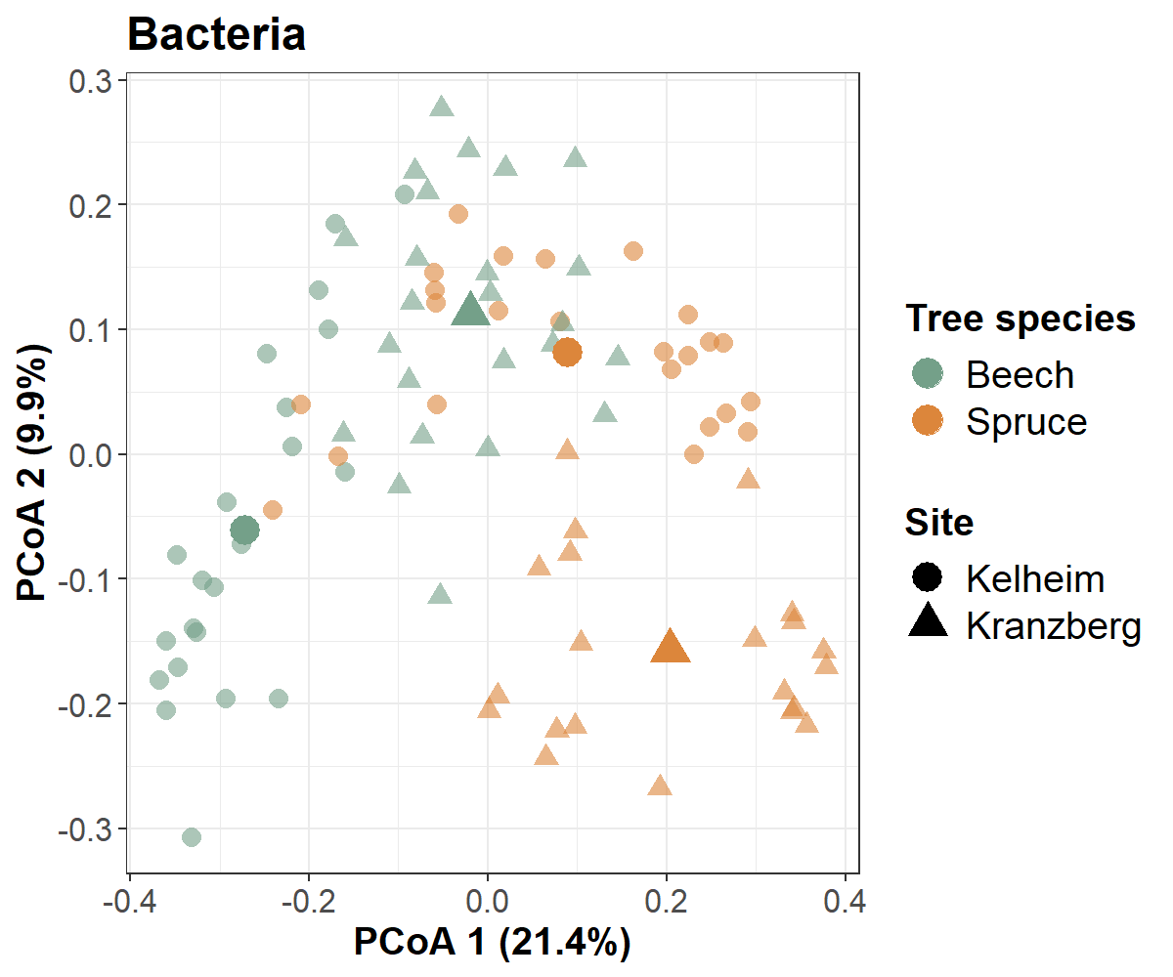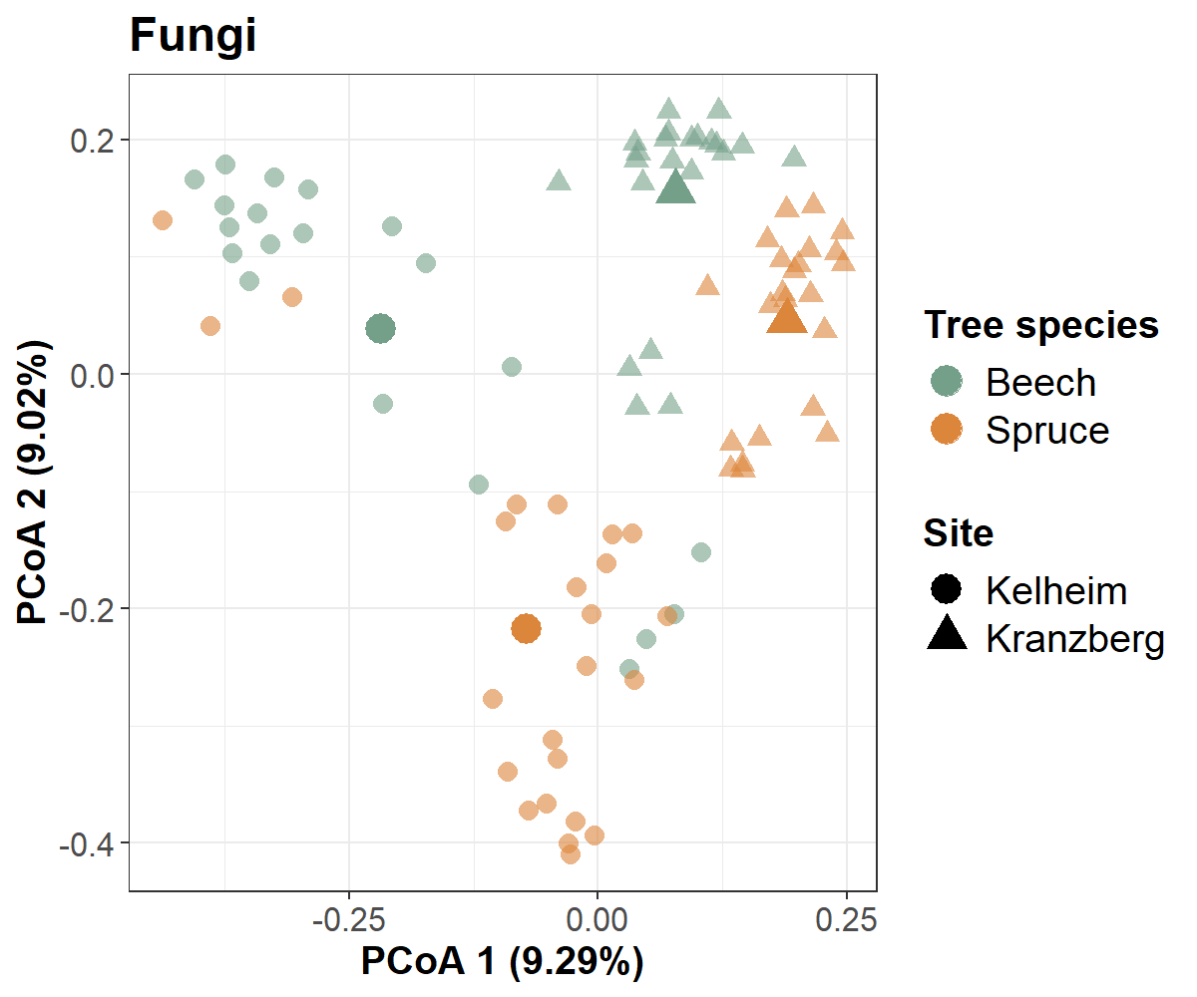
B
A
Figure S3: Principal Coordinate Analysis (PCoA) showing the site- and tree species-related differences in the (A) bacterial and (B) fungal rhizosphere community composition. The average of each combination is highlighted by a more intense color and a bigger size of the respective symbols.

A
B
Figure S4: Root length after inoculation with (A) Caballeronia sp. Ke431 and (B) Paraburkholderia sp. Ke296 and Streptomyces sp. KF215.

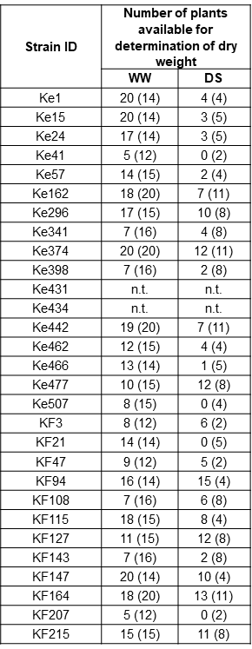
A
B
C
Figure S5: Absolute changes in seedling dry weight under (A) well-watered (WW) and (B) drought stress (DS) conditions after inoculation with individual bacterial isolates. The red zero baseline represents the mean of the uninoculated control within each experiment. Positive values indicate an absolute increase, and negative values a decrease in dry weight compared to the respective control. Individual experiments are separated by dashed lines. Significant plant growth-promotion after inoculation with the isolates compared to the respective control is marked with asterisks. (C) The number of plants available for dry weight determination depended on the survival rate and excluded plants used for CFU count. The number of control plants is given in brackets.

Figure S6: Absolute increase or decrease in root length under well-watered conditions after inoculation with individual bacterial isolates. The red zero baseline represents the mean of the uninoculated control within each experiment. Positive values indicate an absolute increase, and negative values a decrease in length compared to the respective control. Individual experiments are separated by dashed lines. Significant plant growth-promotion after inoculation with the isolates compared to the respective control is marked with asterisks.

A
B
Figure S7: Absolute changes in root fresh weight under (A) well-watered and (B) drought stress conditions after inoculation with individual bacterial isolates. The red zero baseline represents the mean of the uninoculated control within each experiment. Positive values indicate an absolute increase, and negative values a decrease in fresh weight compared to the respective control. Individual experiments are separated by dashed lines. Significant plant growth-promotion after inoculation with the isolates compared to the respective control is marked with asterisks.

A
B
Figure S8: Absolute changes in shoot fresh weight under (A) well-watered and (B) drought stress conditions after inoculation with individual bacterial isolates. The red zero baseline represents the mean of the uninoculated control within each experiment. Positive values indicate an absolute increase, and negative values a decrease in fresh weight compared to the respective control. Individual experiments are separated by dashed lines. Significant plant growth-promotion after inoculation with the isolates compared to the respective control is marked with asterisks.

A
B
Figure S9: Absolute changes in shoot length under (A) well-watered and (B) drought stress conditions after inoculation with individual bacterial isolates. The red zero baseline represents the mean of the uninoculated control within each experiment. Positive values indicate an absolute increase, and negative values a decrease in length compared to the respective control. Individual experiments are separated by dashed lines. Significant plant growth-promotion after inoculation with the isolates compared to the respective control is marked with asterisks.

Figure S10: Absolute changes in seedling fresh weight under drought stress conditions after inoculation with individual bacterial isolates. The red zero baseline represents the mean of the uninoculated control within each experiment. Positive values indicate an absolute increase, and negative values a decrease in fresh weight compared to the respective control. Individual experiments are separated by dashed lines. Significant plant growth-promotion after inoculation with the isolates compared to the respective control is marked with asterisks.

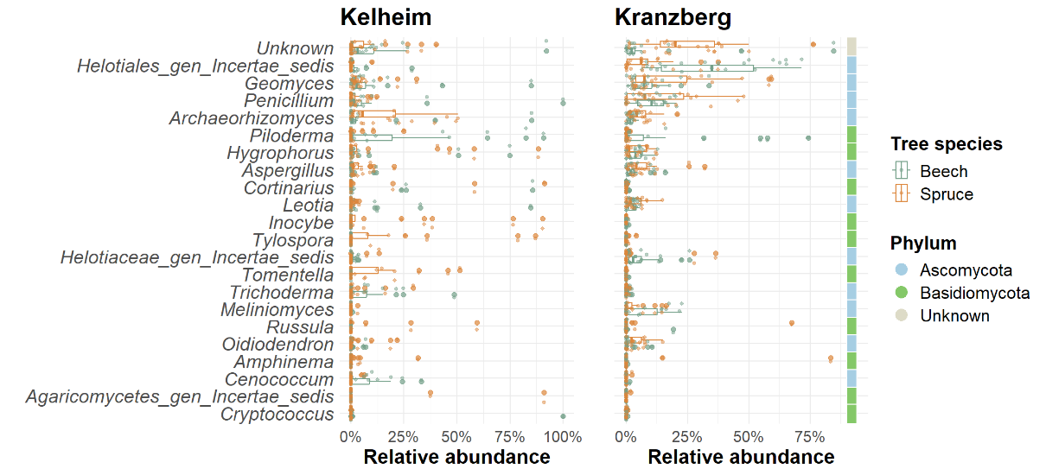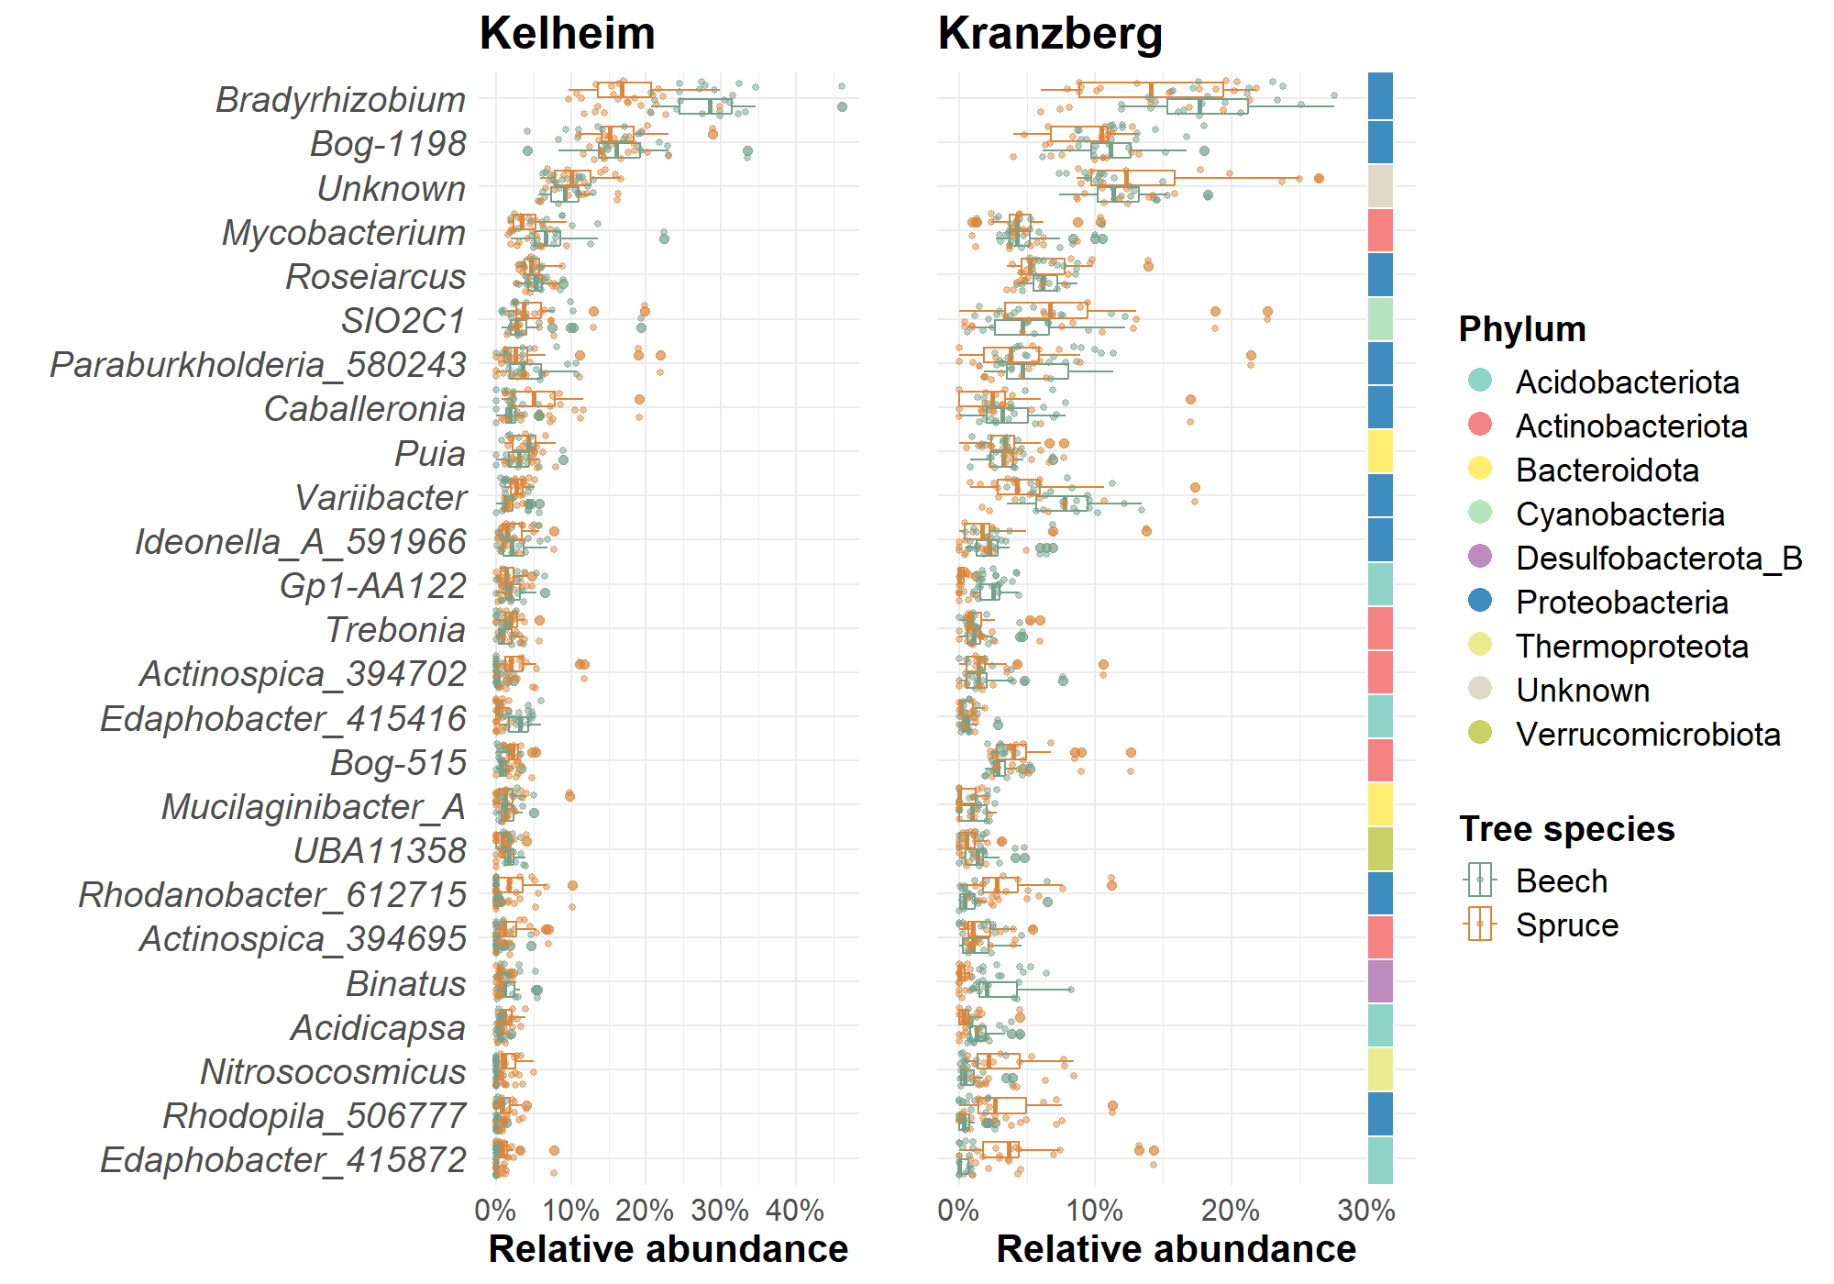
A
B
Figure S11: Relative abundance [%] of the (A) bacterial and (B) fungal genera in beech and spruce rhizosphere communities in Kelheim and Kranzberg, sorted according to their global abundance (descending order). The colors on the right indicate their phylum affiliation.

