Supplementary Table S1. Percentage (%) of samples below the limit of detection (LOD).

Metal | N samples <LOD/Total | % samples <LOD
Total Se | 0/151 | 0
Se-SELENOP | 0/151 | 0
Se-Met | 4/151 | 2.7
Se-Cys | 23/151 | 15.2
Se-GPX | 0/151 | 0
Se-TXNRD | 11/151 | 7.3
Se IV | 1/151 | 0.7
Se VI | 5/151 | 3.3
Se-HSA | 10/151 | 6.6
Cd | 32/75 | 42.7
Cu | 0/75 | 0
Fe | 0/75 | 0
Mn | 0/75 | 0
Zn | 0/75 | 0

Supplementary Table S2. Characteristics of the study population (urinary cotinine and trace elements as µg/L) according to leukemia subtypes. *Calculated on samples with serum metal determinations

 |  | Acute Lymphoblastic Leukemia |  |  | Acute Myeloid Leukemia
Variable | N | Median (IQR) | Min - Max | N | Median (IQR) | Min - Max
Age | 70 | 4.00 (3.00 - 8.00) | 0.00 - 16.00 | 7 | 11.00 (2.00 - 14.00) | 1.00 - 16.00
Urinary cotinine | 65 | 0.48 (0.05 - 1.45) | 0.05 - 488.06 | 7 | 0.68 (0.47 - 1.03) | 0.05 - 15.64
Total Se | 70 | 113.50 (80.33 - 156.00) | 31.10 - 310.00 | 7 | 106.00 (93.80 - 146.00) | 60.44 - 169.00
Se-SELENOP | 70 | 68.18 (45.99 - 111.12) | 4.18 - 292.10 | 7 | 60.50 (47.63 - 77.36) | 33.10 - 131.52
Se-Met | 70 | 2.08 (1.06 - 4.09) | 0.15 - 48.22 | 7 | 3.98 (1.32 - 5.52) | 0.01 - 6.15
Se-Cys | 70 | 1.53 (0.42 - 3.51) | 0.01 - 35.94 | 7 | 3.95 (0.01 - 5.56) | 0.01 - 6.65
Se-GPX | 70 | 5.47 (2.62 - 16.30) | 0.27 - 95.29 | 7 | 7.44 (4.71 - 20.83) | 0.19 - 36.36
Se-TXNRD | 70 | 1.92 (0.77 - 3.45) | 0.12 - 17.53 | 7 | 4.39 (3.02 - 7.93) | 0.57 - 13.31
Se IV | 70 | 6.08 (2.90 - 10.60) | 0.58 - 41.19 | 7 | 13.16 (6.34 - 17.97) | 3.34 - 31.76
Se VI | 70 | 3.95 (1.64 - 7.71) | 0.01 - 102.88 | 7 | 2.87 (0.01 - 6.93) | 0.01 - 11.14
Se-HSA | 70 | 1.67 (0.62 - 3.40) | 0.01 - 36.14 | 7 | 6.55 (0.91 - 9.71) | 0.38 - 12.58
Age* | 52 | 5.00 (3.00 - 8.50) | 0.00 - 16.00 | 6 | 9.50 (2.00 - 14.00) | 1.00 - 16.00
Urinary Cotinine* | 49 | 0.54 (0.16 - 1.62) | 0.05 - 488.06 | 6 | 0.67 (0.47 - 1.03) | 0.05 - 15.64
Cd | 52 | 0.02 (0.02 - 0.03) | 0.01 - 0.28 | 6 | 0.02 (0.02 - 0.02) | 0.02 - 0.04
Cu | 52 | 1665 (1325 - 2335) | 339 - 3270 | 6 | 1420 (1310 - 1700) | 556 - 2880
Fe | 52 | 1950 (1245 - 2935) | 686 - 19300 | 6 | 1735 (820 - 4460) | 511 - 15300
Mn | 52 | 0.97 (0.67 - 1.51) | 0.07 - 2.44 | 6 | 1.10 (0.79 - 1.41) | 0.75 - 1.86
Zn | 52 | 810 (704 - 995) | 445 - 1880 | 6 | 858 (706 - 958) | 501 - 1300

Supplementary Table S3. Risk of childhood leukemia according to tertiles of Se and Se species distribution including only subjects diagnosed with acute lymphoblastic leukemia (n = 70).

Variable | Min and max in the exposure tertiles (μg/L) | Median in the exposure tertile (μg/L) | N Cases/  Controls | Adjusted for age and sex OR (95% CI) | Adjusted for age, sex, and urinary cotinine OR (95% CI)
Total Se
Ref | < 85.85 | 70.05 | 23/24 | Ref | Ref
2nd tertile | 85.85 – 129.99 | 108.00 | 19/25 | 0.82 (0.35 - 1.94) | 0.81 (0.33 - 2.04)
3rd tertile | > 129.99 | 167.00 | 28/25 | 1.13 (0.50 - 2.54) | 1.05 (0.45 - 2.48)
Se-SELENOP
Ref | < 40.30 | 25.83 | 14/24 | Ref | Ref
2nd tertile | 40.30 – 76.38 | 59.02 | 26/25 | 2.08 (0.84 - 5.10) | 1.99 (0.77 - 5.17)
3rd tertile | > 76.38 | 105.46 | 30/25 | 2.27 (0.94 - 5.49) | 1.94 (0.76 - 4.92)
Se-Met
Ref | < 0.88 | 0.41 | 15/24 | Ref | Ref
2nd tertile | 0.88 – 3.55 | 1.95 | 35/25 | 2.18 (0.93 - 5.09) | 2.73 (1.09 - 6.80)
3rd tertile | > 3.55 | 5.74 | 20/25 | 1.29 (0.52 - 3.17) | 1.47 (0.57 - 3.80)
Se-Cys
Ref | < 1.09 | 0.41 | 29/24 | Ref | Ref
2nd tertile | 1.09 – 4.08 | 2.09 | 27/25 | 0.96 (0.43 - 2.15) | 0.86 (0.36 - 2.03)
3rd tertile | > 4.08 | 5.59 | 14/25 | 0.51 (0.21 - 1.22) | 0.45 (0.18 - 1.12)
Se-GPX
Ref | < 2.90 | 1.56 | 19/24 | Ref | Ref
2nd tertile | 2.90 – 16.19 | 5.54 | 33/25 | 1.59 (0.70 - 3.62) | 1.39 (0.58 - 3.36)
3rd tertile | > 16.19 | 30.49 | 18/25 | 0.93 (0.38 - 2.24) | 0.81 (0.32 - 2.03)
Se-TXNRD
Ref | < 0.39 | 0.22 | 8/24 | Ref | Ref
2nd tertile | 0.39 – 1.12 | 0.68 | 15/25 | 1.95 (0.69 - 5.56) | 3.07 (0.97 - 9.75)
3rd tertile | > 1.12 | 2.59 | 47/25 | 4.93 (1.90 - 12.81) | 6.21 (2.15 - 17.94)
Se IV
Ref | < 4.61 | 2.26 | 29/24 | Ref | Ref
2nd tertile | 4.61 – 15.63 | 8.11 | 30/25 | 1.10 (0.50 - 2.42) | 1.45 (0.62 - 3.36)
3rd tertile | > 15.63 | 24.78 | 11/25 | 0.34 (0.13 - 0.86) | 0.45 (0.17 - 1.18)
Se VI
Ref | < 1.83 | 0.75 | 19/24 | Ref | Ref
2nd tertile | 1.83 – 7.37 | 3.49 | 32/25 | 1.17 (0.50 - 2.72) | 0.91 (0.37 - 2.24)
3rd tertile | > 7.37 | 16.03 | 19/25 | 0.73 (0.30 - 1.79) | 0.75 (0.29 - 1.93)
Se-HSA
Ref | < 0.36 | 0.21 | 10/24 | Ref | Ref
2nd tertile | 0.36 – 1.15 | 0.60 | 13/25 | 1.33 (0.48 - 3.67) | 1.67 (0.56 - 4.94)
3rd tertile | > 1.15 | 2.92 | 47/25 | 4.09 (1.66 - 10.09) | 4.15 (1.60 - 10.75)

Supplementary Table S4. Risk of childhood leukemia according to tertiles of metal distribution including only subjects diagnosed with acute lymphoblastic leukemia (n = 52).

Variable (μg/L) | Min and max in the exposure tertiles (μg/L) | Median in the exposure tertile (μg/L) | N Cases/  Controls | Adjusted for age and sex OR (95% CI) | Adjusted for age, sex, and urinary cotinine OR (95% CI)
Cd
Ref | < 0.0153 | 0.0114 | 12/5 | Ref | Ref
2nd tertile | 0.0153 - 0.0252 | 0.0209 | 21/6 | 1.08 (0.25 - 4.65) | 1.30 (0.29 - 5.75)
3rd tertile | > 0.0252 | 0.0405 | 19/6 | 1.16 (0.28 - 4.80) | 1.39 (0.33 - 5.96)
Cu
Ref | < 882.00 | 537.0 | 6/5 | Ref | Ref
2nd tertile | 882.00 – 1009.97 | 927.5 | 2/6 | 0.30 (0.04 - 2.34) | 0.30 (0.04 - 2.34)
3rd tertile | > 1009.97 | 1720 | 44/6 | 5.85 (1.33 - 25.72) | 5.36 (1.21 - 23.68)
Fe
Ref | < 1069.99 | 904.00 | 9/5 | Ref | Ref
2nd tertile | 1069.99 – 2349.78 | 1785.00 | 24/6 | 2.13 (0.51 - 8.93) | 2.25 (0.52 - 9.73)
3rd tertile | > 2349.78 | 3760.00 | 19/6 | 1.52 (0.35 - 6.58) | 1.69 (0.38 - 7.45)
Mn
Ref | < 0.618 | 0.489 | 9/5 | Ref | Ref
2nd tertile | 0.618 – 0.770 | 0.673 | 8/6 | 0.71 (0.15 - 3.40) | 0.65 (0.13 - 3.16)
3rd tertile | > 0.770 | 1.280 | 35/6 | 3.18 (0.77 - 13.14) | 2.88 (0.69 - 11.96)
Zn
Ref | < 867.97 | 747 | 30/5 | Ref | Ref
2nd tertile | 867.97 – 1079.90 | 965 | 14/6 | 0.42 (0.11 - 1.66) | 0.47 (0.12 - 1.88)
3rd tertile | > 1079.90 | 1240 | 8/6 | 0.21 (0.05 - 0.91) | 0.21 (0.05 - 0.95)

Supplementary Figure S1. Dose-response odds ratio of childhood leukemia according to serum selenium species concentrations (solid black line OR curve, gray area 95% confidence interval), adjusting for age, sex, and urinary cotinine.
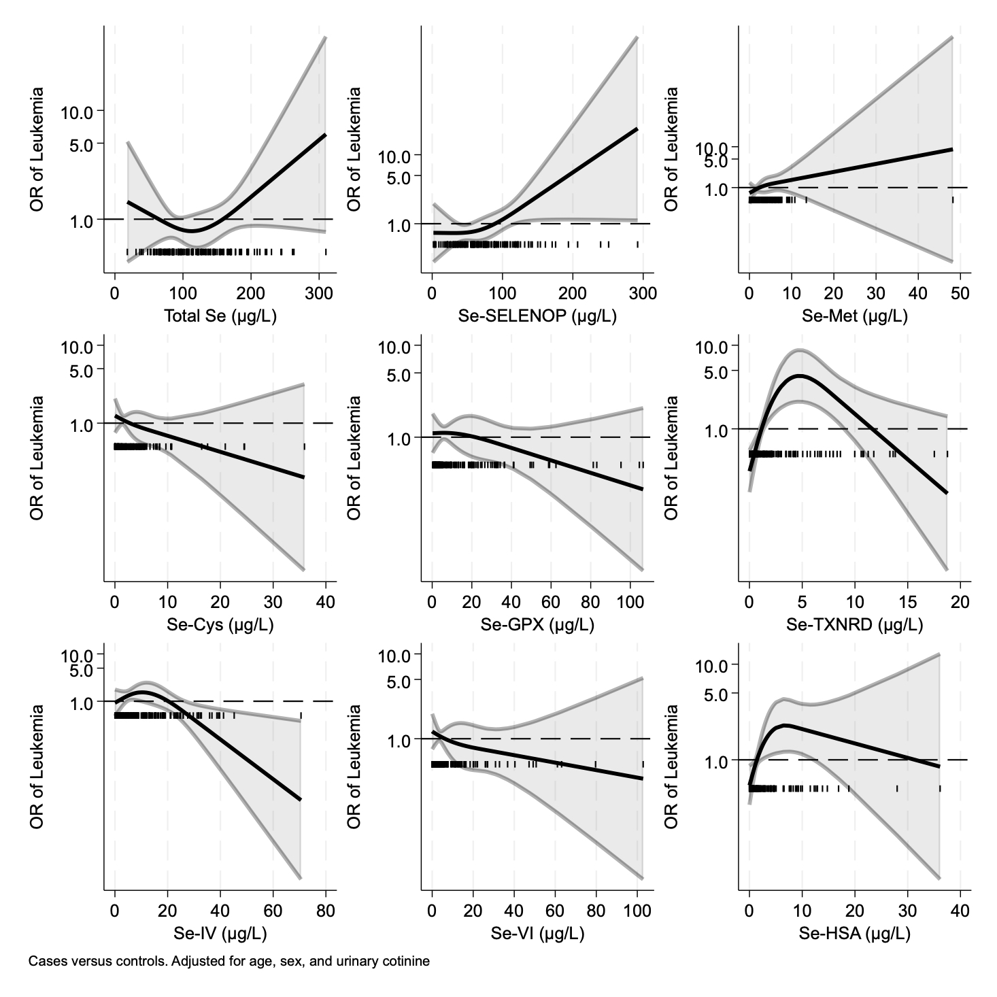

Figure S2. Dose-response odds ratio of childhood leukemia according to serum metal concentrations (solid black line OR curve, gray area 95% confidence interval), adjusting for age, sex, and urinary cotinine.
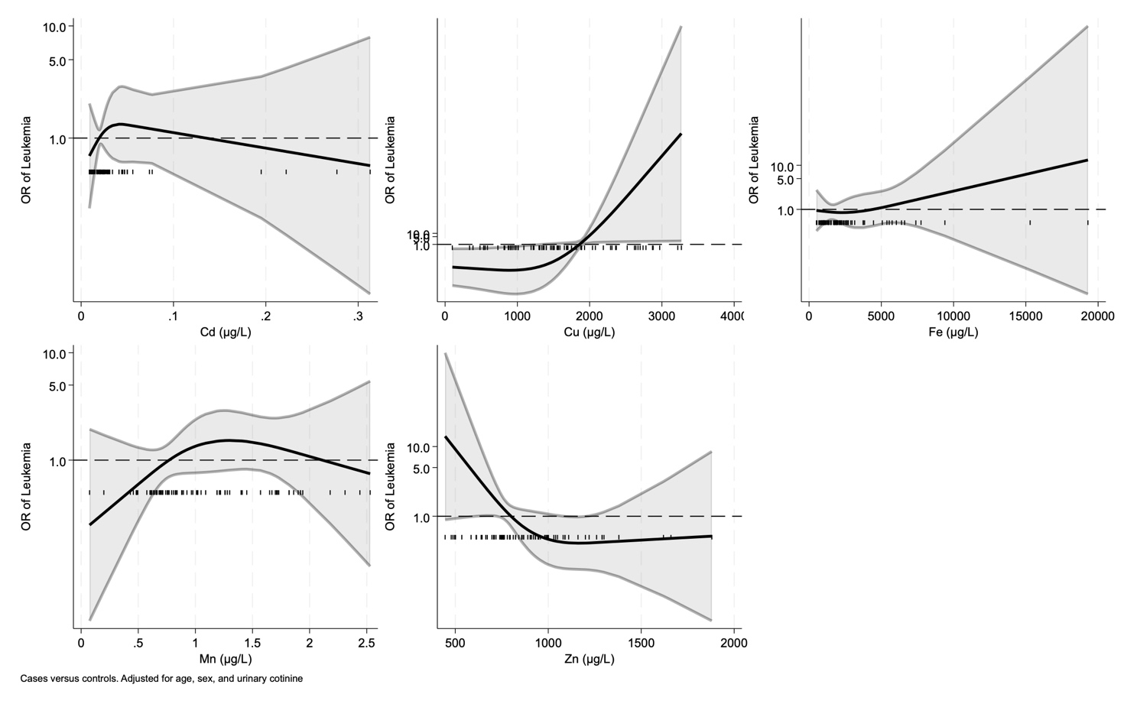

Supplementary Figure S3. Dose-response odds ratio of childhood leukemia according to serum selenium species concentrations (solid black line OR curve, gray area 95% confidence interval), adjusting for age and sex. Acute Lymphoblastic Leukemia cases only.
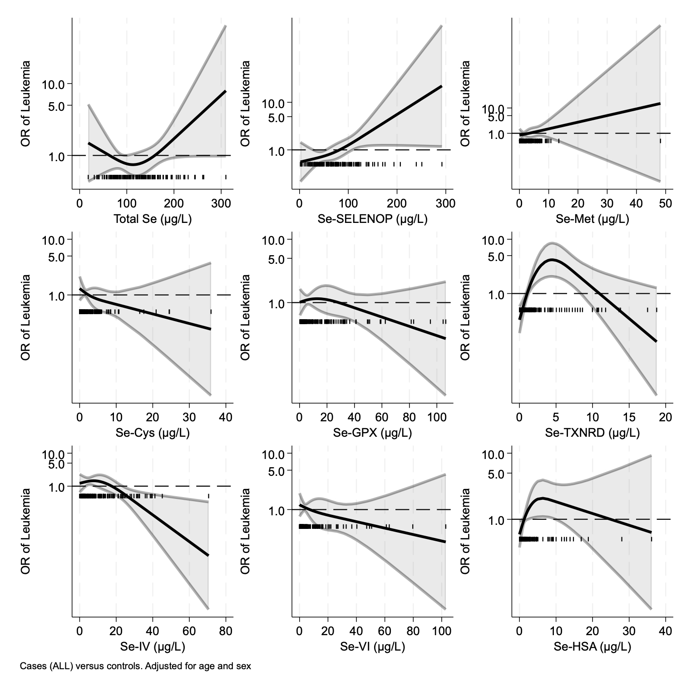

Supplementary Figure S4. Dose-response odds ratio of childhood leukemia according to serum metal concentrations (solid black line OR curve, gray area 95% confidence interval), adjusting for age and sex. Acute Lymphoblastic Leukemia cases only.
