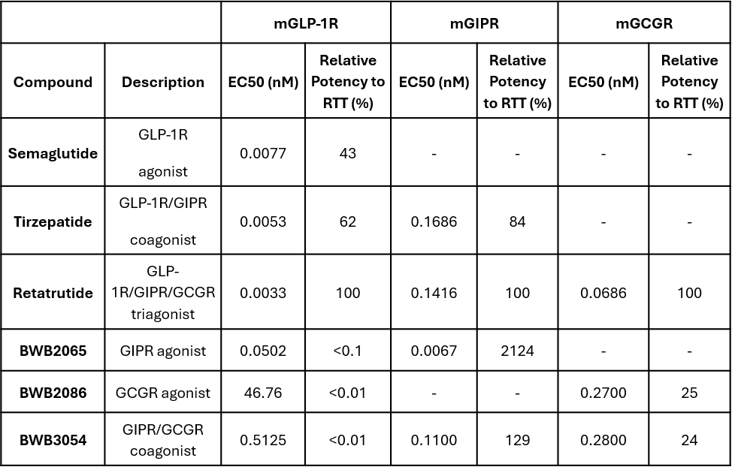
Table S1. Mouse Receptor Profile of Biological Activity

Table S2. Rat Receptor Profile of Biological Activity
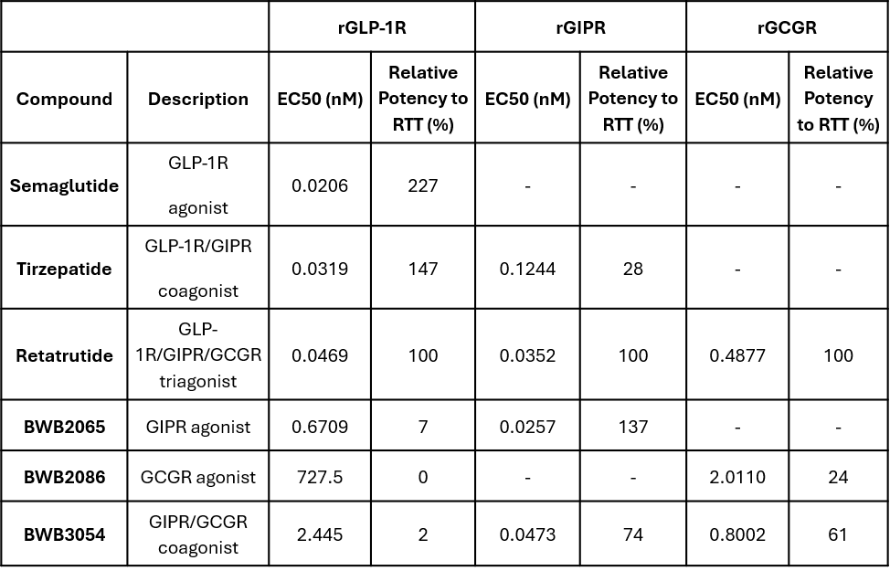

Figure S1. Receptor Profile of Biological Activity at Mouse (m) and Rat (r) GLP-1 Receptors

mGLP-1R
rGLP1R

Figure S2. Receptor Profile of Biological Activity at Mouse (m) and Rat (r) GIP Receptor

mGIPR

rGIPR

Figure S3. Receptor Profile of Biological Activity at Mouse (m) and Rat (r) Gcg Receptors

mGcgR

rGcgR

Figure S4. Receptor Profile of Biological Activity at Human (h) GLP-1 , GIP and Gcg Receptors

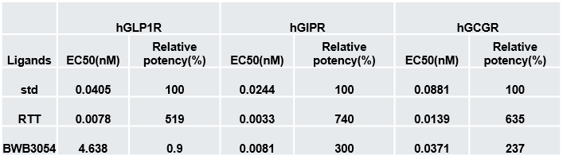

Figure S5. Receptor Profile of Biological Activity at Monkey (mk) GLP-1, GIP and Gcg Receptors

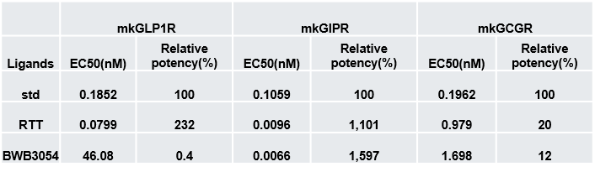

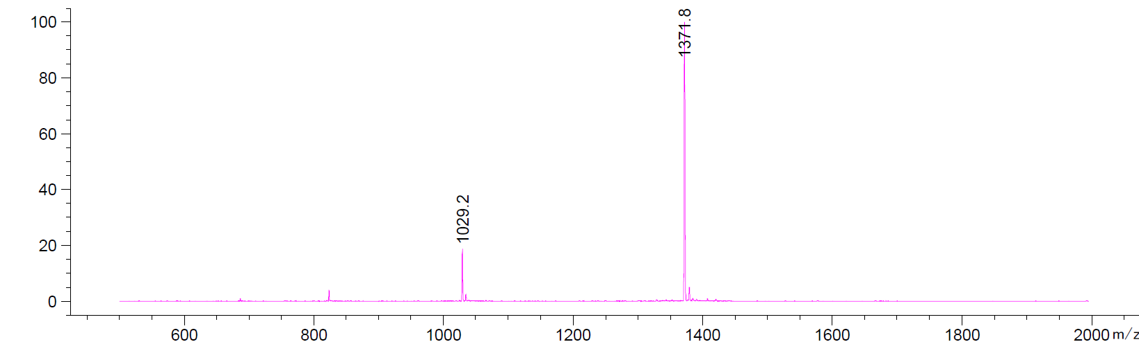
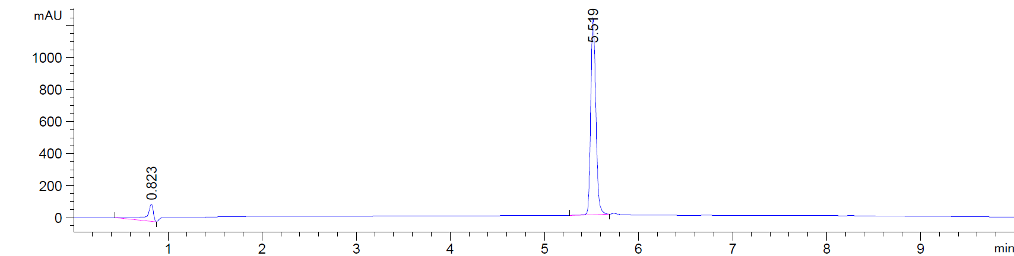
Figure S6. LC-MS profile of purified Semaglutide (MW 4113.6)

Figure S7. LC-MS profile of purified Tirzepatide (MW = 4813.5
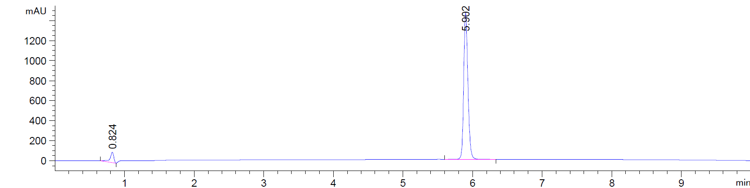

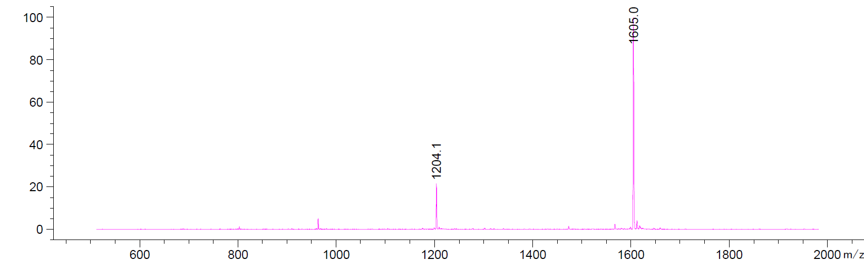

F
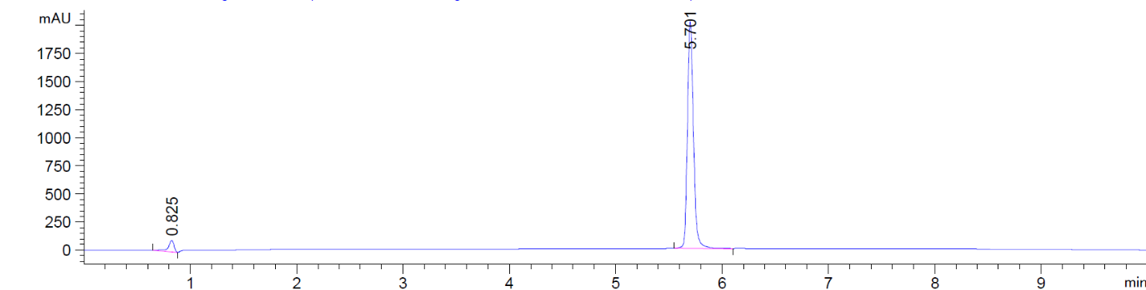
Figure S8. LC-MS profile of purified Retatrutide (MW = 4731.4)

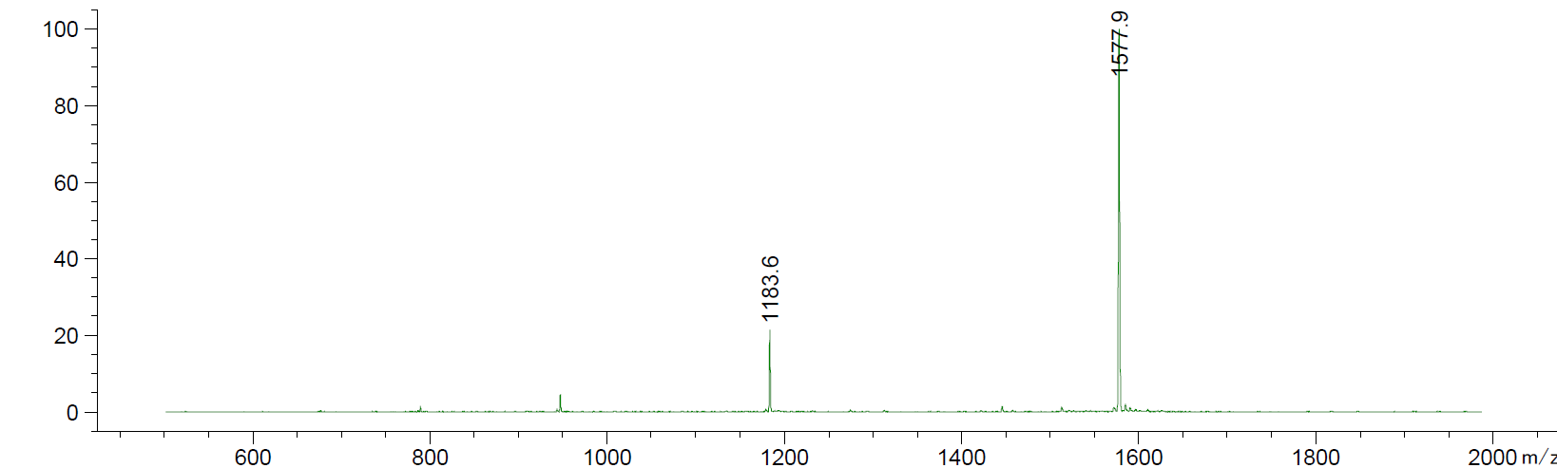

Figure S9. LC-MS profile of purified BWB2065 (MW = 4839.6)
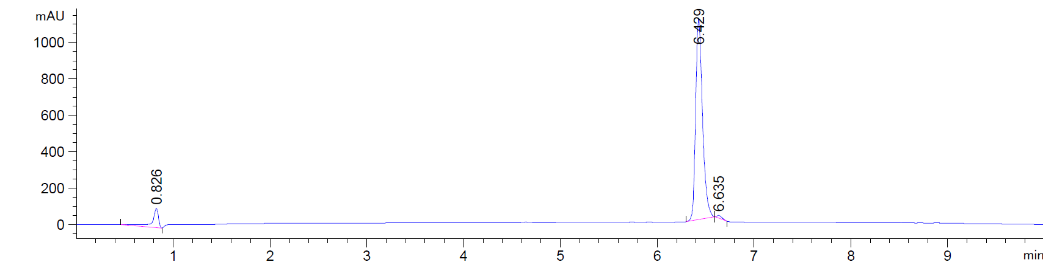

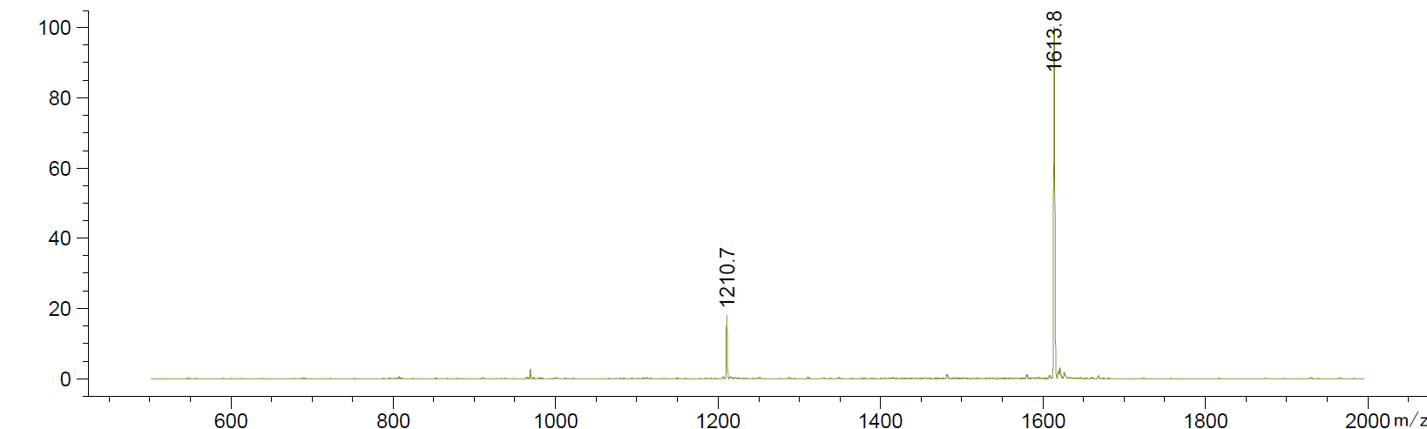

Figure S10. LC-MS profile of purified BWB2086 (MW = 4261.8)
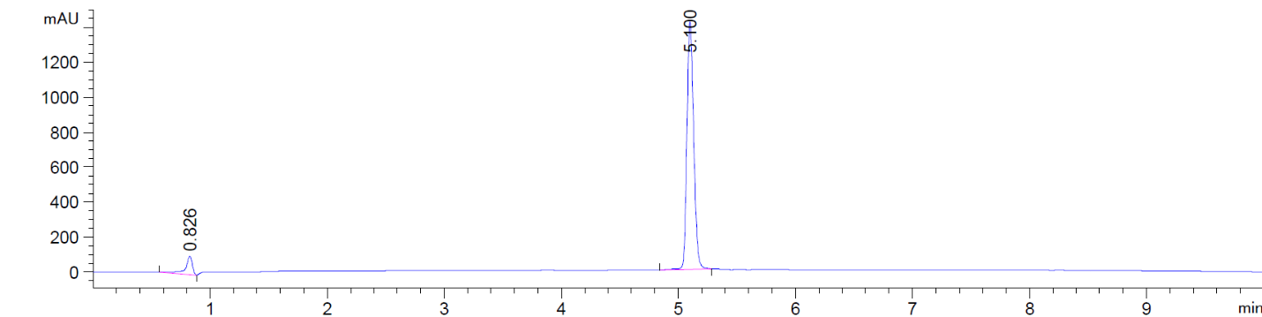

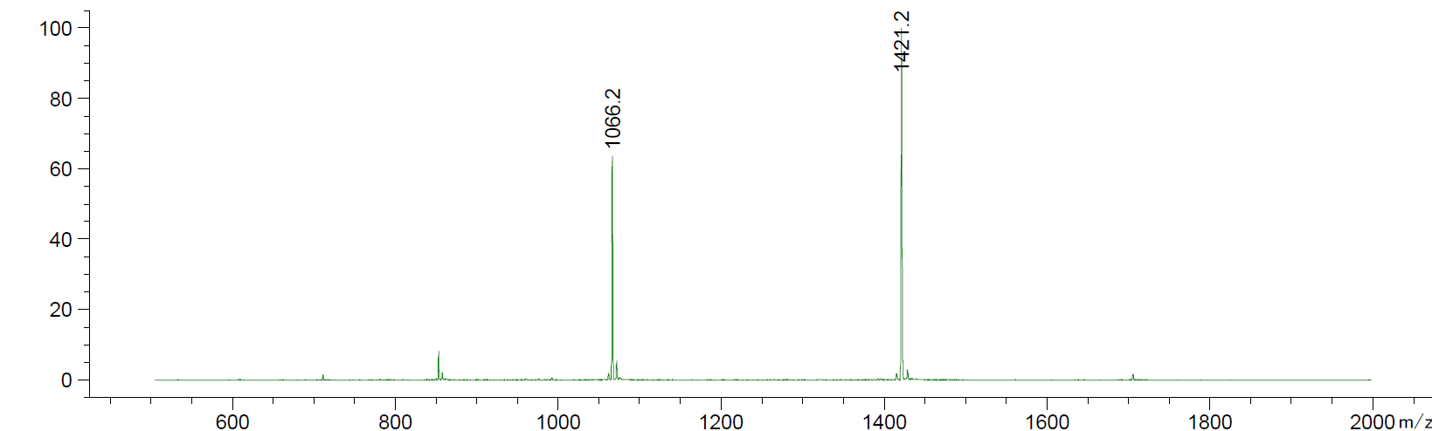

Figure S11. LC-MS profile of purified LY3537021 (MW = 4971.6)
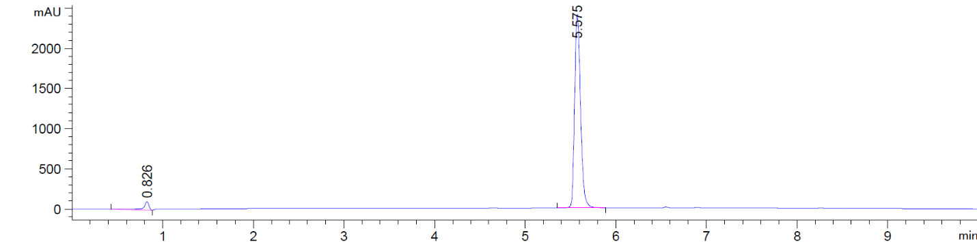

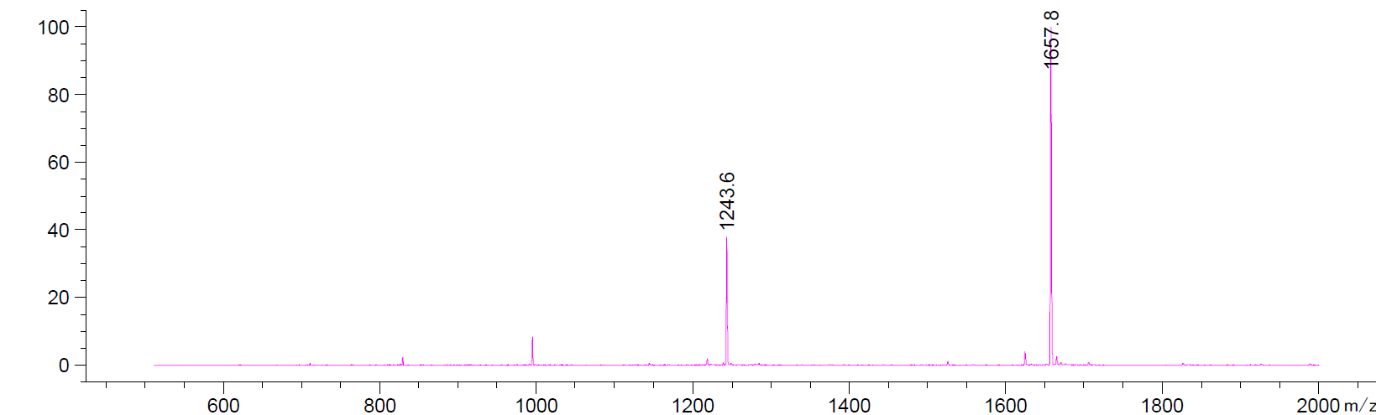

Figure S12. LC-MS profile of purified BWB3054 (MW = 4896.7)
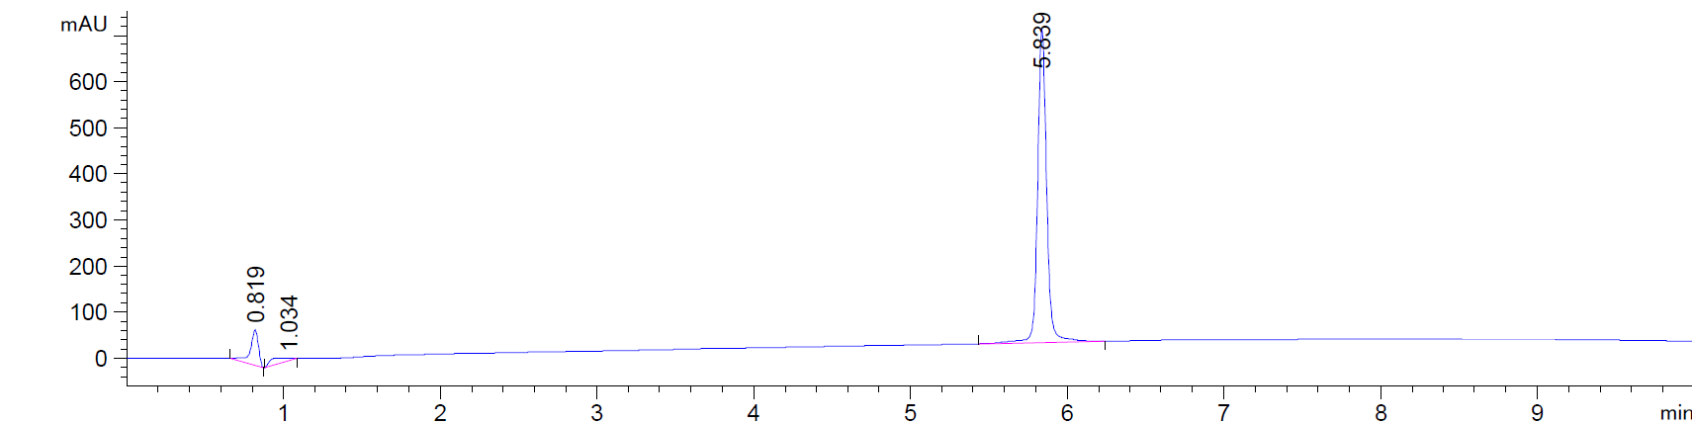

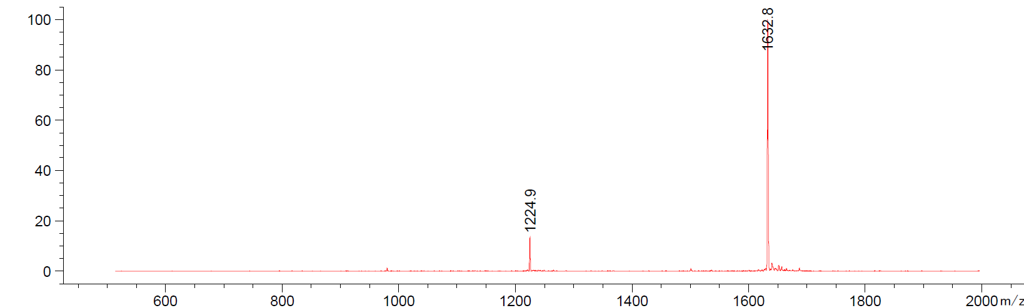

Figure S13. CRO (Inotiv-Evansville) NHP Study Protocol In-Life Evaluation Parameters

Figure S1. Receptor Profile of Biological Activity at Mouse (m) and Rat (r) GLP-1 Receptors

mGLP-1R
rGLP1R

