Figure S1. Sampling calendar – overview of start and end of sampling period, with days sampled simultaneously by both samplers, and days with missing data for one or both devices.
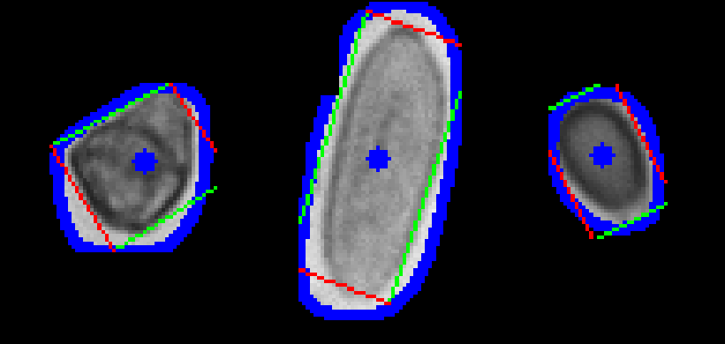
Figure S2. Masked spore images after rotation and alignment, showing bounding boxes with red lines for width, green lines for height, and blue contours and crosses marking the spore perimeter and centroid.

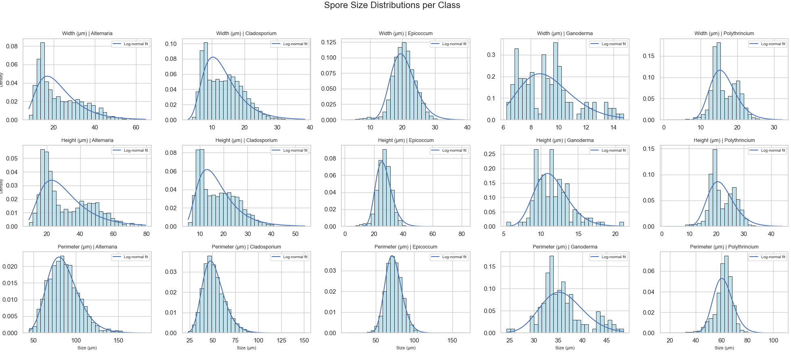
Figure S3. Size distributions of fungal spores. Histograms of spore (a) width, (b) height, and (c) perimeter for individual spore types, with fitted log-normal curves (blue lines) based on log-transformed data.

Figure S4. Spearman correlation plots comparing spore concentrations measured by the POMO (x-axis) and BURK (y-axis) samplers, expressed as spores/m³, for five fungal spore types and total (summed) concentrations at 6-hour resolution.

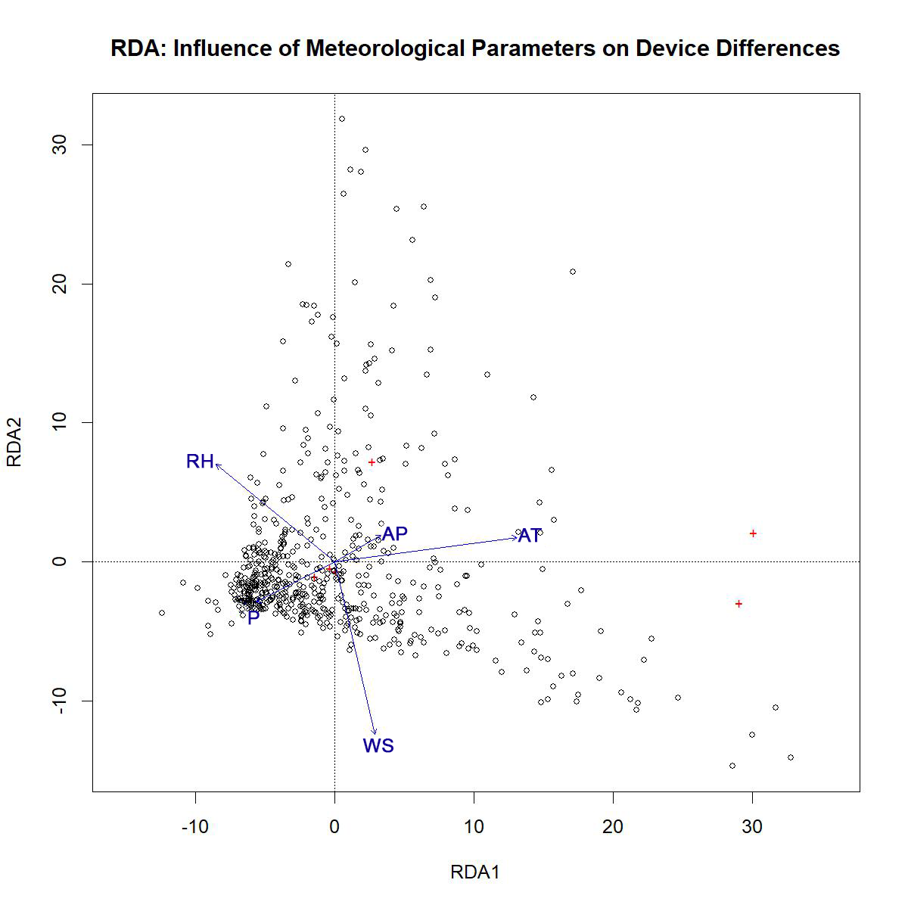
Figure S5. Redundancy analysis (RDA) biplot showing the influence of meteorological parameters (RH – relative humidity, AP – atmospheric pressure, AT – air temperature, WS – wind speed, R – rainfall) on differences in spore concentrations between the two samplers.

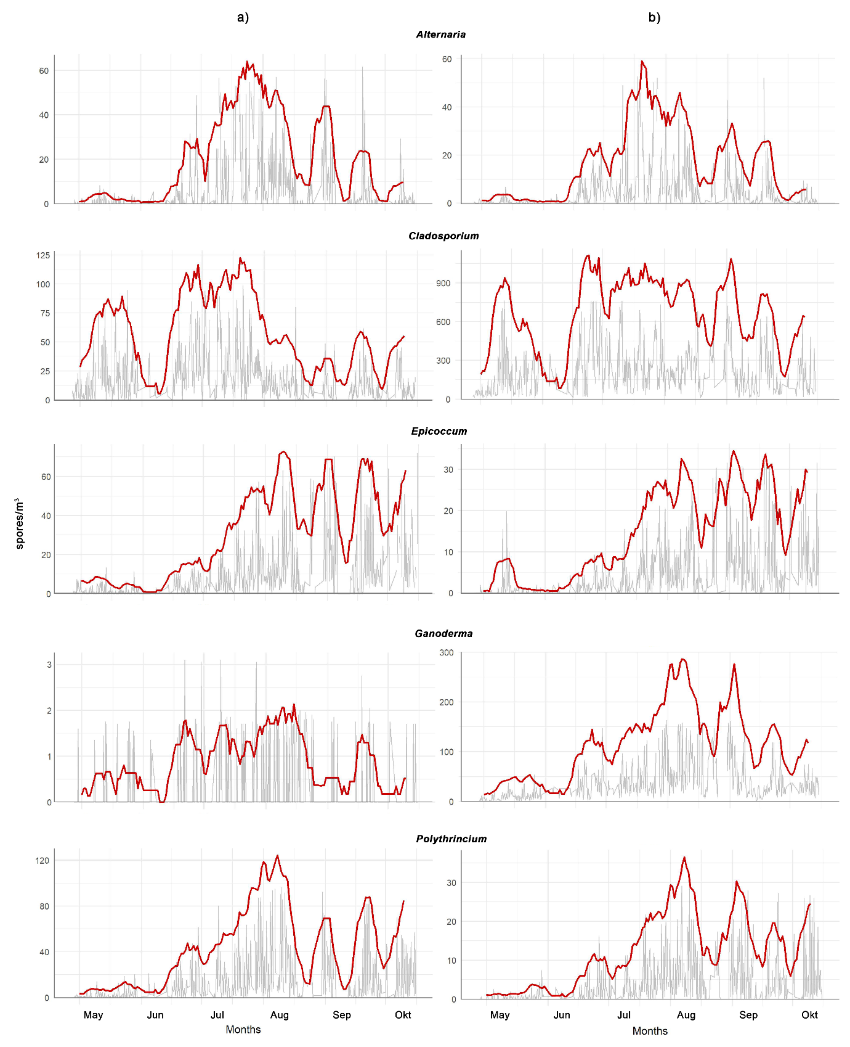Figure S6. Seasonal variation of fungal spore concentrations (spores/m³) during the study period, collected using (a) the POMO and (b) BURK samplers. Six-hourly concentrations are on figure back in grey, red line indicates 10-day centered rolling mean of daily sums. Note the different scales.

Table S1 Width, height, and perimeter measurements from POMO images for individual spore types after excluding images with incorrect masks.
Metric | Spore type | Sample size  (spores) | Minimum spore size (µm) | 5th perc. | Median | 95th perc. | Maximum  spore size (µm) | LF | UF | Nº below LF | Nº above UF
Width | Alt | 1,090 | 8.1 | 11.3 | 19.2 | 43.2 | 64.6 | -11.2 | 19.2 | 0 | 6
 | Cla | 7,365 | 2.8 | 6.4 | 13 | 23.6 | 38.5 | -5.2 | 13 | 0 | 21
 | Epi | 4,430 | 3 | 15.3 | 20.4 | 26.2 | 39.1 | 11.6 | 20.4 | 71 | 29
 | Gan | 129 | 6.3 | 6.7 | 9.2 | 13.5 | 14.7 | 3.5 | 9.2 | 0 | 2
 | Pol | 5,653 | 0.7 | 12.1 | 15.4 | 21.9 | 32.4 | 6.2 | 15.4 | 14 | 5
Height | Alt | 1,090 | 9.2 | 15.3 | 25.4 | 58.3 | 79.4 | -17.8 | 25.4 | 0 | 0
 | Cla | 7,365 | 5.2 | 8.2 | 16.3 | 31.7 | 54 | -8.6 | 16.3 | 0 | 20
 | Epi | 4,430 | 1.8 | 19.8 | 27 | 34.9 | 81.7 | 15.2 | 27 | 85 | 21
 | Gan | 129 | 5.4 | 8.8 | 11.3 | 15.7 | 21.1 | 4.9 | 11.3 | 0 | 3
 | Pol | 5,653 | 1.6 | 16.2 | 20.7 | 29.2 | 44.2 | 8.1 | 20.7 | 13 | 2
Diameter | Alt | 1,090 | 44.5 | 58.5 | 84.1 | 117.6 | 182.1 | 36.2 | 84.1 | 0 | 21
 | Cla | 7,365 | 23.4 | 35 | 50 | 74.3 | 151.1 | 20.1 | 50 | 0 | 150
 | Epi | 4,430 | 12.9 | 57.3 | 73.2 | 91.5 | 165.7 | 44.8 | 73.2 | 16 | 19
 | Gan | 129 | 24.4 | 30.6 | 34.8 | 45.4 | 48.5 | 26.3 | 34.8 | 2 | 8
 | Pol | 5,653 | 17 | 48.6 | 62.3 | 70.9 | 107.2 | 47.6 | 62.3 | 224 | 49
Alt – Alternaria; Cla – Cladosporium; Epi – Epicoccum; Gan – Ganoderma; Pol – Polythrincium; perc. – percentile; LF – lower fence; UF – upper fence

