Supplementary Material

Table S1. Percentage of reactive CT-26 spheroid and parental cells detected by flow cytometry using pooled sera from vaccinated mice
Group A (5×10⁵ cells for tumor induction)
 | CSC lysate-based vaccinated mice sera  (CSC subgroup sera) | Parental lysate-based vaccinated mice sera  (Parental subgroup sera) | Normal saline-injected mice sera  (Normal saline subgroup sera)
CT-26 spheroid cell populations | 15% | 36.2% | 26.1%
CT-26 Parental cell populations | 28.4% | 35.9% | 20.1%
Group B (2.5×10⁵ cells for tumor induction)
CT-26 spheroid cell populations | 22.7% | 25.1% | 18%
CT-26 Parental cell populations | 50.7% | 26% | 29.5%

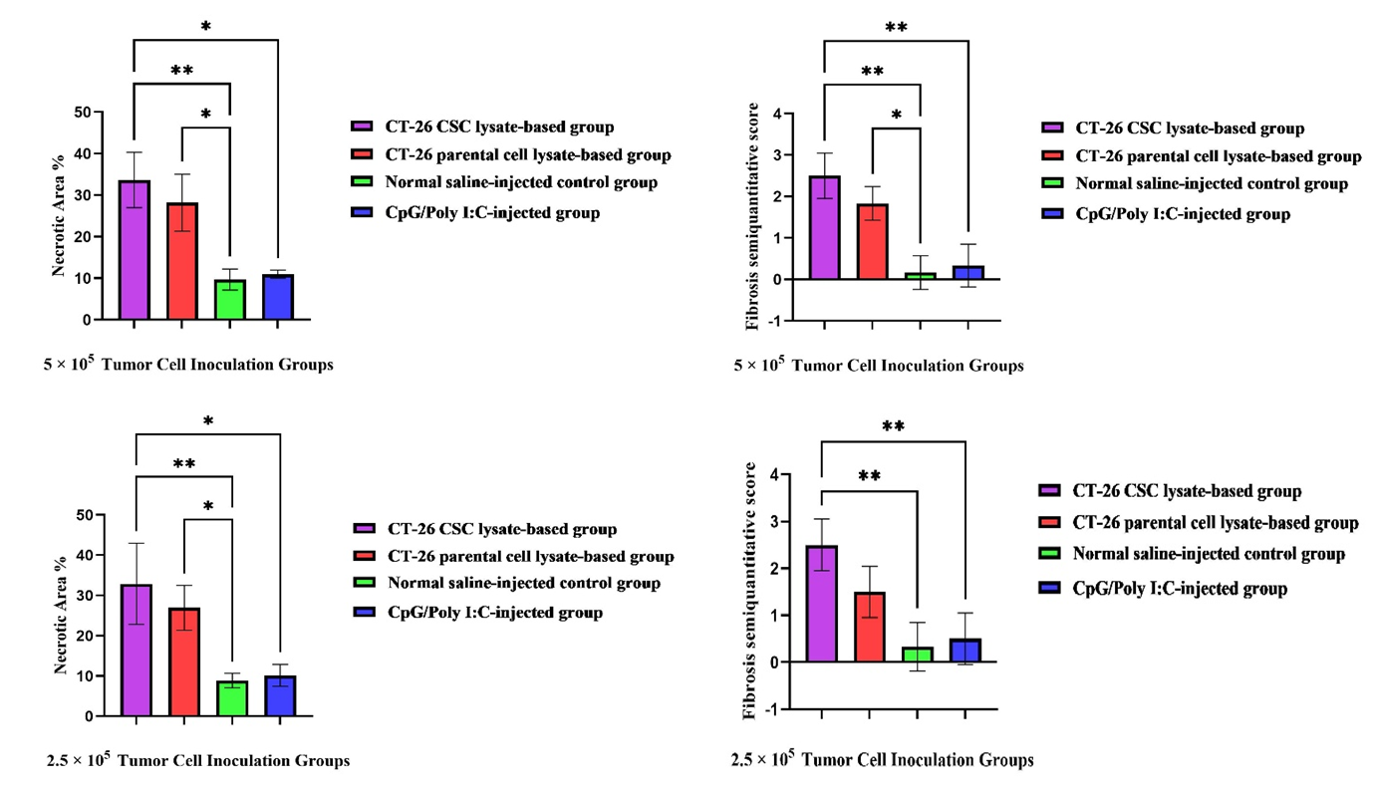
Fig. S1. Comparative histological assessment of necrosis and fibrosis in experimental subgroups. Representative histological sections of colorectal tumors from Groups A (5×10⁵ cells for induction) and B (2.5×10⁵ cells for induction) demonstrating the extent of necrosis and fibrotic remodeling across treatment subgroups. In both tumor induction models, the CT-26 CSC lysate–based group exhibited substantial central necrosis (≈33.65±6.8% in Group A; 32.89±10.0% in Group B), accompanied by pronounced fibrotic changes (fibrosis score 2.5±0.5). The CT-26 parental cell lysate–based group showed moderate necrosis (≈28.19±6.7% in Group A; 26.94±5.7% in Group B) with moderate fibrosis (scores 1.8±0.4 and 1.5±0.7, respectively). In contrast, the normal saline–injected and CpG/Poly (I:C)–injected groups displayed limited necrosis (≈8.91–10.96%) and minimal fibrosis (scores 0.1–0.5), consistent with reduced stromal remodeling.
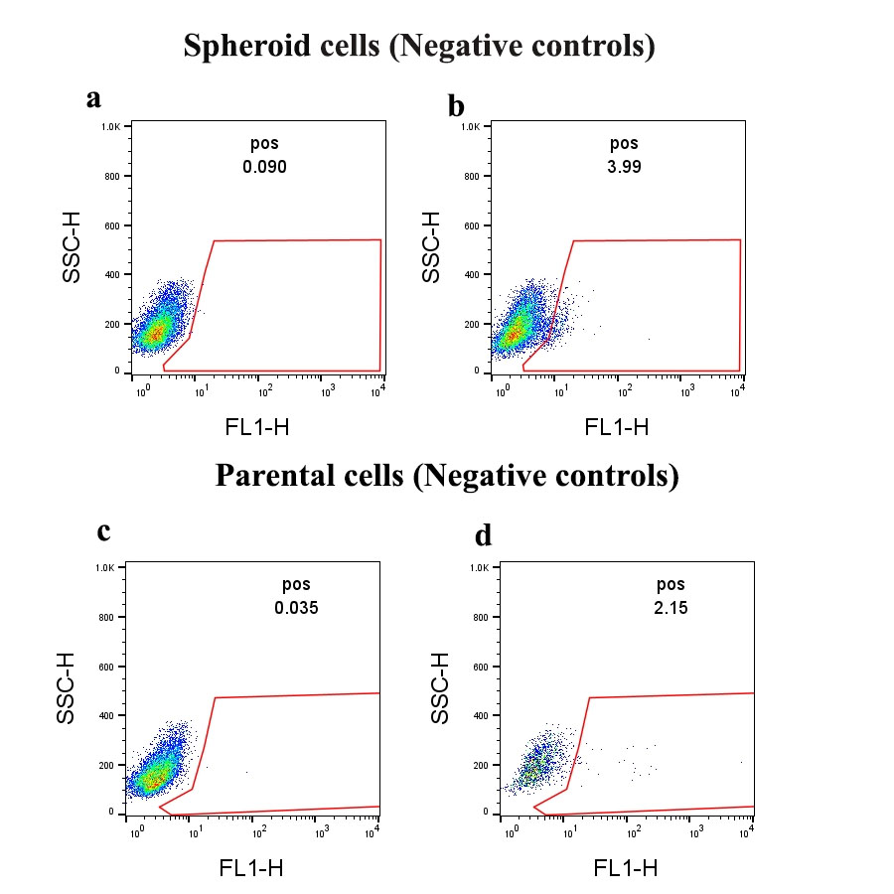
Fig. S2. Representative flow cytometry profiles of negative controls for spheroid (a,b) and parental (c,d) cells. Unstained cells and cells stained with non-immunized mouse serum were used to define background fluorescence, set gating thresholds, and exclude nonspecific binding. All samples were analyzed under identical conditions.

