Supplementary Material

Supplementary Figures and Tables

Supplementary Tables
Supplementary Table 1 Sociodemographic characteristics, Planetary Health Diet Index-2019, Planetary Health Diet Index-2025, and mHEI-2015 of the unweighted study population (n = 1,100). Values are given as % (n), unless specified otherwise.
Variable | n = 1,100
Sex
Male | 44 (485)
Female | 56 (615)
Mean (SD) age in years | 49.3 (14.9)
Age group
18-24 | 6 (71)
25-34 | 14 (156)
35-50 | 27 (297)
51-64 | 35 (387)
≥65 | 17 (189)
Mean (SD) BMI in kg/m² | 25.8 (4.8)
BMI group
Underweight | 2 (23)
Normal weight | 47 (520)
Pre-obesity | 33 (367)
Obesity | 17 (190)
Education
Low | 20 (220)
Medium | 29 (317)
High | 51 (563)
Smoking status
Never | 53 (587)
Currently | 16 (172)
In the past | 31 (340)
Physical activity group
Sedentary | 27 (294)
Low active | 27 (298)
Active | 23 (250)
Very active | 23 (258)
Mean (Median; IQR) Planetary Health Diet Index-2019 | 19.6 (19.0; 16.0, 23.0)
Mean (Median; IQR) Planetary Health Diet Index-2025 | 21.1 (21.0; 18.0, 24.0)
Mean (Median; IQR) mHEI-2015 | 52.5 (52.0; 43.9, 60.9)
Abbreviations: BMI body mass index, IQR interquartile range, mHEI metric Healthy Eating Index, SD standard deviation

Supplementary Table 2 Diet-related environmental sustainability metrics across PHDI and mHEI-2015 quintiles in Bavaria. Sustainability metrics are adjusted to an energy intake of 2,500 kcal. WFP was estimated using a database with system boundaries different from those used for GHGE and LU; direct comparison across indicators should therefore be interpreted cautiously. Data are weighted to represent the Bavarian population.
Planetary Health Diet Index-2019 quintiles
Characteristic | Lowest, n = 304 (28%)¹ | Low, n = 189 (17%)¹ | Medium, n = 220 (20%)¹ | High, n = 208 (19%)¹ | Highest, n = 179 (16%)¹ | p-value² | p-trend³
GHGE (in kg CO₂eq) | 6.4 (6.1; 5.3, 7.3) | 6.2 (6.1; 5.2, 6.8) | 6.3 (6.2; 5.4, 7.1) | 6.2 (5.9; 5.1, 7.0) | 5.4 (5.2; 4.3, 6.3) | <.001 | <.001
LU (in m²*yr) | 8.2 (7.8; 6.7, 9.5) | 7.8 (7.4; 6.0, 8.7) | 7.8 (7.4; 6.4, 8.6) | 7.4 (6.7; 5.6, 8.7) | 5.8 (5.3; 4.5, 6.6) | <.001 | <.001
WFP (in kiloliters) | 4.3 (4.1; 3.6, 4.8) | 4.3 (4.2; 3.6, 5.1) | 4.5 (4.0; 3.6, 5.3) | 4.5 (4.1; 3.7, 5.1) | 4.4 (4.1; 3.4, 4.8) | .828 | .305
Planetary Health Diet Index-2025 quintiles
Characteristic | Lowest, n = 280 (25%)¹ | Low, n = 219 (20%)¹ | Medium, n = 170 (15%)¹ | High, n = 226 (21%)¹ | Highest, n = 205 (19%)¹ | p-value² | p-trend³
GHGE (in kg CO₂eq) | 6.4 (6.3; 5.3, 7.3) | 6.1 (6.0; 5.2, 6.8) | 6.4 (6.2; 5.4, 7.3) | 6.1 (5.7; 5.1, 7.0) | 5.6 (5.4; 4.4, 6.6) | .002 | <.001
LU (in m²*yr) | 8.4 (8.1; 7.2, 9.6) | 7.7 (7.4; 6.3, 8.6) | 7.9 (7.4; 6.3, 8.6) | 7.2 (6.8; 5.6, 8.4) | 6.0 (5.3; 4.6, 6.7) | <.001 | <.001
WFP (in kiloliters) | 4.3 (4.1; 3.6, 4.7) | 4.3 (4.0; 3.6, 5.1) | 4.4 (4.1; 3.5, 4.9) | 4.5 (4.1; 3.7, 5.1) | 4.5 (4.1; 3.5, 5.0) | .842 | .146
mHEI-2015 quintiles
Characteristic | Lowest, n = 220 (20%)¹ | Low, n = 221 (20%)¹ | Medium, n = 220 (20%)¹ | High, n = 219 (20%)¹ | Highest, n = 220 (20%)¹ | p-value² | p-trend³
GHGE (in kg CO₂eq) | 6.1 (5.7; 5.2, 6.8) | 6.0 (5.8; 5.0, 6.6) | 6.3 (6.3; 5.1, 7.4) | 6.4 (6.2; 5.5, 7.2) | 5.9 (5.7; 4.6, 7.0) | .063 | .849
LU (in m²*yr) | 8.0 (7.5; 6.6, 8.6) | 7.6 (7.3; 6.1, 8.7) | 7.7 (7.4; 6.0, 8.8) | 7.5 (7.2; 5.9, 8.7) | 6.7 (6.2; 4.9, 7.8) | .004 | .008
WFP (in kiloliters) | 4.2 (4.0; 3.6, 4.8) | 4.1 (4.0; 3.5, 4.5) | 4.4 (4.0; 3.6, 5.2) | 4.4 (4.2; 3.7, 4.8) | 4.9 (4.5; 3.9, 5.5) | .002 | .001
Abbreviations: CO2eq carbon dioxide equivalents, GHGE greenhouse gas emissions, IQR interquartile range, LU land use, mHEI metric Healthy Eating Index, WFP water footprint
¹Mean (Median; IQR)
²Design-based Kruskal Wallis test
³Design-based generalized linear model with ordered factor levels

Supplementary Figures
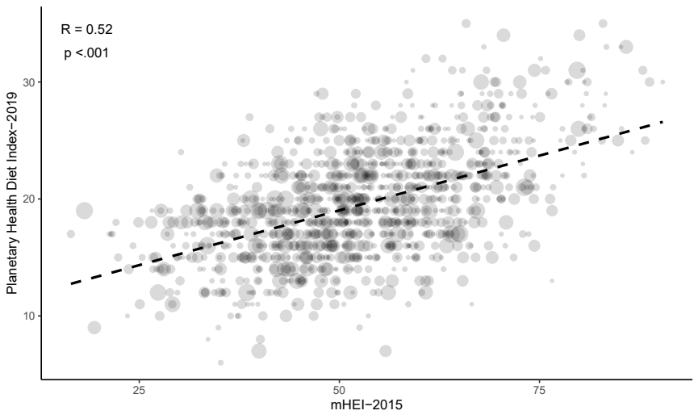
Supplementary Figure 1 Weighted correlation between the Planetary Health Diet Index-2019 and mHEI-2015 (n = 1,100). The bubble size represents the survey weight of the observation. Data are weighted to represent the Bavarian population.
Abbreviations: mHEI metric Healthy Eating Index,

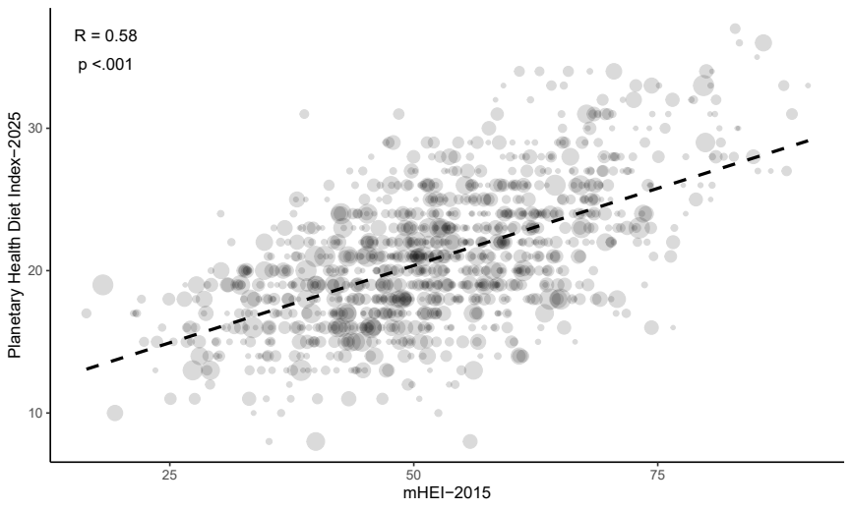
Supplementary Figure 2 Weighted correlation between the Planetary Health Diet Index-2025 and mHEI-2015 (n = 1,100). The bubble size represents the survey weight of the observation. Data are weighted to represent the Bavarian population.
Abbreviations: mHEI metric Healthy Eating Index,

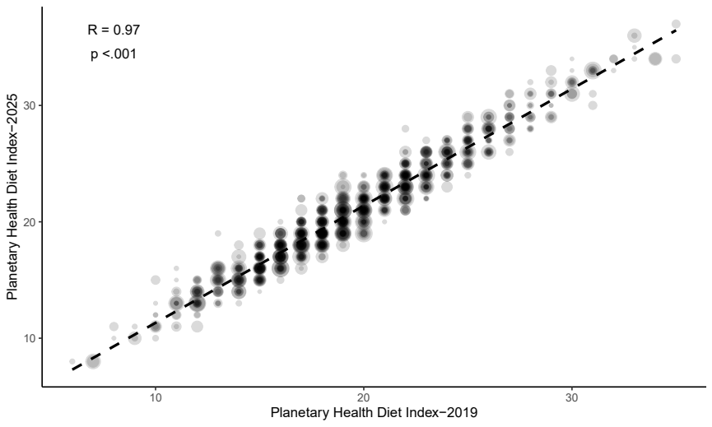
Supplementary Figure 3 Weighted correlation between the Planetary Health Diet Index-2025 and the Planetary Health Diet Index-2019 (n = 1,100). The bubble size represents the survey weight of the observation. Data are weighted to represent the Bavarian population.
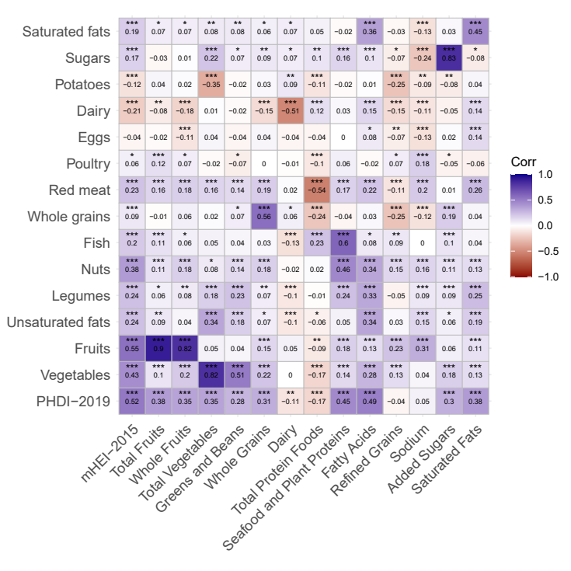
Supplementary Figure 4 Pearson’s correlations between the Planetary Health Diet Index-2019, including its components (y-axis), and mHEI-2015 and its components (x-axis) (n = 1,100). Red indicates negative and blue positive correlation. No correlation is represented as white. Data are weighted to represent the Bavarian population. Significance levels: * p<.05, ** p <.01, *** p <.001).
Abbreviations: mHEI metric Healthy Eating Index, PHDI Planetary Health Diet Index

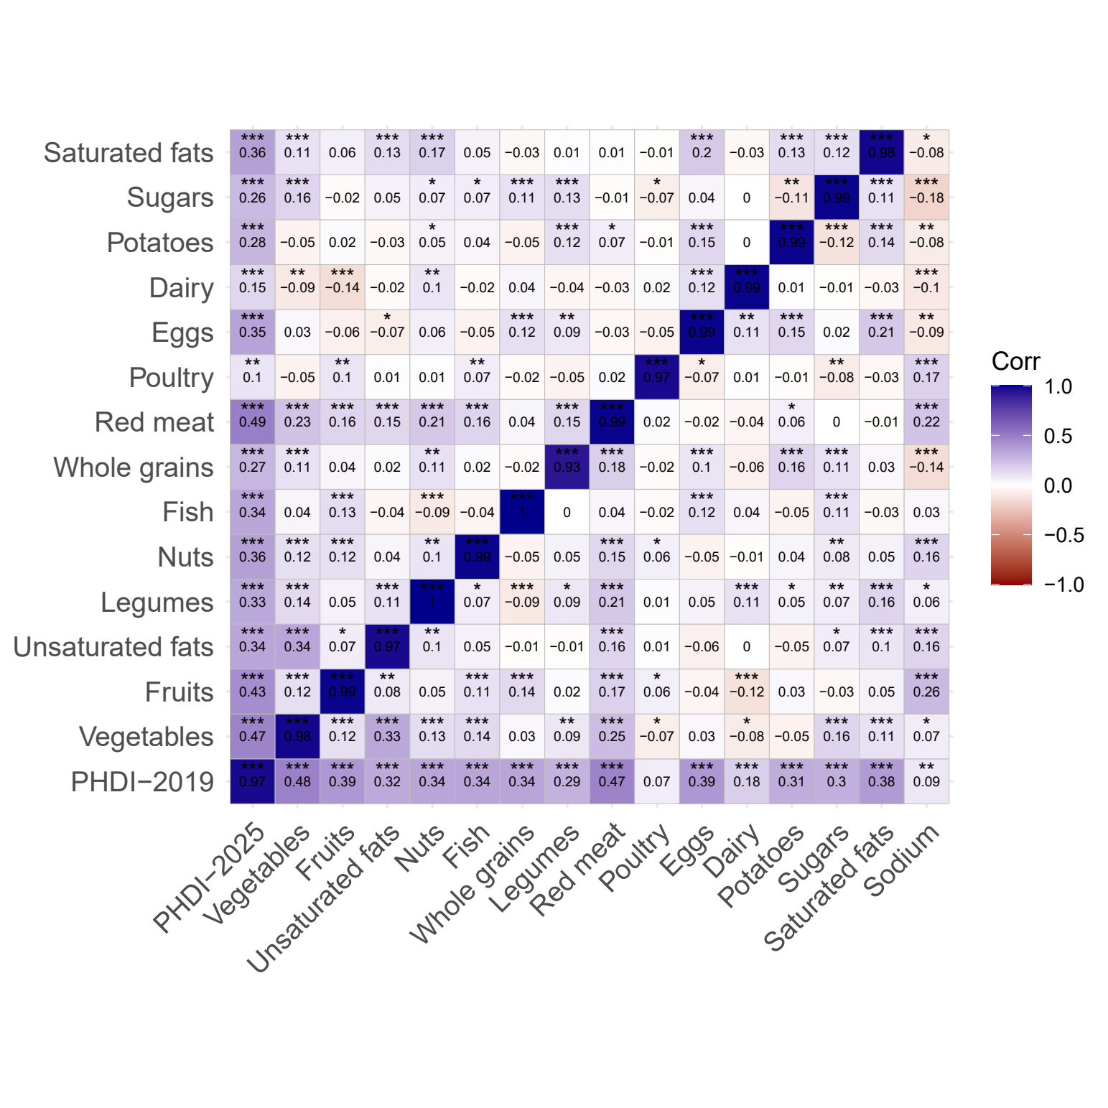
Supplementary Figure 5 Pearson’s correlations between the Planetary Health Diet Index-2025, including its components (y-axis), and Planetary Health Diet Index-2019 and its components (x-axis) (n = 1,100). Red indicates negative and blue positive correlation. No correlation is represented as white. Data are weighted to represent the Bavarian population. Significance levels: * p<.05, ** p <.01, *** p <.001).
Abbreviations: PHDI Planetary Health Diet Index

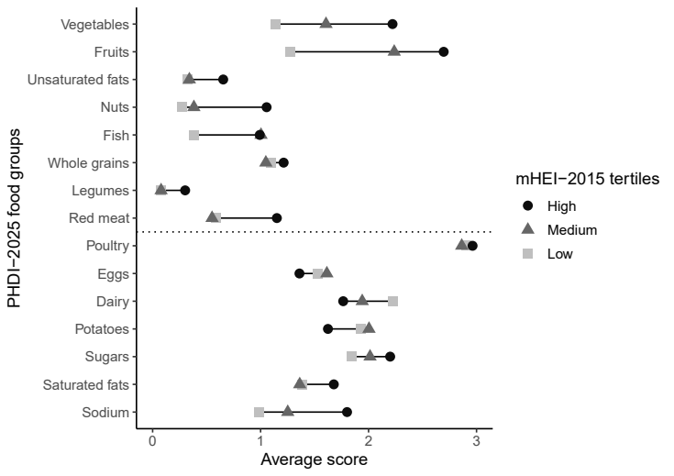
Supplementary Figure 6 Dotchart of the average scores across the PHDI-2025 food groups by mHEI-2015 (n = 1,100). Food groups for recommended consumption are shown above and for discouraged consumption below the dotted line. Data are weighted to represent the Bavarian population.
Abbreviations: mHEI metric Healthy Eating Index, PHDI Planetary Health Diet Index

