AI-supported Colorimetric Multi-Biomarker Sensor to Enable Critical Neonatal Monitoring
Alejandra Castelblanco^{1,2,†}, Elisabetta Ruggeri^{3,†}, Giusy Matzeu³, Motaharehsadat Heydarian⁴, Kai Foerster^{4,5}, Ahmed Bahnasy², Andreas Flemmer⁵, Julia A. Schnabel^{1,2,6}, Benjamin Schubert^{1,*}, Fiorenzo G. Omenetto^{3,8,9,*}, Anne Hilgendorff ^{4,5,7,*}

¹Computational Health Center, Helmholtz Center Munich, 85764 Neuherberg, Germany.
²School of Computation, Information and Technology, Technical University of Munich, 85748 Munich, Germany.
³Silklab, Dept. of Biomedical Engineering, Tufts University, Medford, MA 02155, USA.
⁴Comprehensive Pneumology Center with the CPC-M bioArchive and Institute of Lung Health and Immunity, Helmholtz Center Munich, Member of the German Center of Lung Research (DZL), 81399 Munich, Germany.
⁵Dr. von Hauner Children’s Hospital, Hospital of the Ludwig-Maximilians-Universität München, 80337 Munich, Germany.
⁶School of Biomedical Engineering and Imaging Sciences, King’s College London, London WC2R 2LS, UK.
⁷School of Medicine and Health Sciences, Department of Paediatrics, Section of Neonatology, Pediatric Intensive Care, Pediatric Cardiology, Pediatric Pneumology and Allergology and Research Centre Neurosensory Science, Carl von Ossietzky University Oldenburg, 26129 Oldenburg, Germany
⁸Dept. of. Electrical and Computer Engineering, Tufts University, Medford, MA 02155, USA.
⁹Dept. Of Physics, Tufts University, Medford, MA 02155, USA.

† Denotes equal contribution.
* Authors to whom correspondence should be addressed.
Corresponding Authors:
Email: Anne.hilgendorff@uni-oldenburg.de
Email: Fiorenzo.Omenetto@tufts.edu
Email: Benjamin.schubert@helmholtz-munich.de

Supplementary Text

Sensor Fabrication and Design
Materials: Sodium carbonate, lithium bromide, Glucose Oxidase from Aspergillus niger Type VII (Gox), Peroxidase from horseradish Type I (HRP), sodium 3,5-dichloro-2-hydroxybenzenesulfonate, 4-aminoantipyrine, chitosan, acetic acid, bromocresol green sodium salt, nitrazine yellow, phenol red sodium salt, chromoionophore I, sodium ionophore X, potassium tetrakis(4-chlorophenyl)borate, poly(vinyl chloride), bis(2-ethylhexyl) sebacate, tetrahydrofuran, and Whatman™ Grade 1 filter paper were purchased from Sigma-Aldrich (USA). Acid Yellow 34 was purchased from Chem Cruz (USA). Thermochromic pigments were purchased from Atlanta Chemical (USA). Transparent double-sided adhesive films were provided by FLEXcon (USA). Tegaderm™ film dressings (size: 4.4 x 4.4 cm) were purchased from 3M (USA). Silk cocoons of Bombyx mori silkworm were purchased from Tajima Shoji (Japan). Wax ink blocks were purchased from Xerox (USA). Deionized (DI) water with resistivity of 18.2 MΩ cm was obtained with a Milli-Q reagent-grade water system and used to prepare aqueous solutions.

Deep Learning Imaging Methods
Pipeline for Experimental Data Augmentation: Images of the sensors under white light (scene illuminated with LED 4500K) were used to capture the pixel color distributions for each of the variables (Fig. S6-7). Pictures of multiple sensor skeletons (n=20) were obtained from the experimental in-vitro validations, and sensing areas were masked. Random pixels from the experimental color distributions were sampled into the corresponding sensing areas of a sensor skeleton, generating augmented sensor images that contain different combinations of all the measured parameters (pH, temperature, glucose, sodium) at randomly sampled levels (Fig. S5).
Illumination Perturbations: The data generation pipeline randomly sampled illumination noises with different spatial distribution kernels $f(x,y)$, with random linear, polynomial, and radial distributions [35], adding them to every color channel ($R_{ch}$, ${ G}_{ch}$, ${ B}_{ch}$) with a different intensity value ($α$, $β$, $γ$), bound from 0 to ±10% or ±20% of the overall intensity (0-255), (eq. 1). After the noise kernel was added to each RGB channel, a min-max image normalization was applied. Image rotation (±20°), shear (±0.1%), and random cropping (±0.1%), as available in torchvision transforms, were added to simulate real test conditions and to generate a final noisy image $I_{noise}$.

$I_{noise}= [R_{ch}+ α f(x,y) ;{ G}_{ch}+ β f(x,y) ;{ B}_{ch}+ γ f(x,y)]$(eq. 1)

Colorimetric Parameter Reading - Baseline Model: Estimation of parameters from the sensor images under reference white light (scene illuminated with LED 4500K), including image zoom/shear/rotation, was first performed with a deep learning model for every variable, consisting of a convolutional neural network (CNN) coupled with an multilayer perceptron (MLP) model, the model input consisted of the RGB sensor image and a mask of the target sensing areas, with an input size of (128,128,4). The ground truth label was the corresponding variable value, min-max normalized in the measured range from [0-1].
The CNN module consisted of two convolutional layers (32 filters and 64 filters, respectively, both with a kernel of 5), followed by max pooling and ReLU operations. After applying a flattening operation, the MLP module consisted of 3 fully connected layers (with 53824, 2600, and 1200 neurons), followed by a ReLU operation. The last neuron integrated a sigmoid activation function. The final model configuration was the result of a hyperparameter optimization using Optuna [51], aiming to minimize the mean square error of the predictions in the validation set. We also tested prediction performance with a RESNET18 module (testing both with pretrained weights and untrained) as a feature extractor, which showed lower performance. Different activation functions and learning rates were also evaluated (see final values of the hyperparameters in Table S3).
A total of 3200 images were used for training/validation of each CNN+MLP model for parameter regression, with a total of 20 epochs (128 training images and 32 validation images per epoch). Evaluation was performed on 240 images for every parameter.
Colorimetric Parameter Reading and Color Correction - U-Net Model: Estimation of the parameters from sensor images under varying non-uniform illumination noise, was conducted by developing denoising autoencoders based on the U-Net model [38] coupled with MLPs to perform regression for each variable from the latent features, thus integrating both the color correction and inference tasks into a single framework (code available in: github.com/SchubertLab/biofluid_colorimetric_sensors). The input consisted of the noisy RGB image and a fourth channel with a mask of the corresponding sensing areas, with input image size (128, 128, 4); the models were trained to disentangle the illumination noise, by reconstructing the original RGB image colors (only the sensing areas), and an estimation of the spatial distribution of the illumination noise on the image (noise kernel) (Fig. 3a). The loss of the denoising autoencoder $\left(D_{loss}\right)$ was therefore defined as the sum of the losses for each RGB channel and the illumination kernel loss $\left(K_{loss}\right)$ (eq. 2). The best U-Net denoising loss combined a sigmoid function and a Binary Cross Entropy loss and was implemented as a pytorch function BCEWithLogitsLoss (pytorch 2.2.2).

$D_{loss} = R_{loss} +G_{loss} {+B}_{loss} {+K}_{loss}$ (eq. 2)

Simultaneously, the U-Net latent features were passed to the MLP networks as input, the MLP models were trained with an L1 loss between the parameter predictions and the corresponding label for the sampled variable. Labels were min-max normalized in the sensing range from [0-1] for every variable in their measurement range.
The denoising U-Net architecture comprised four encoding blocks, each containing two convolutional layers, followed by batch normalization and ReLU activation functions. The first encoding block utilized 32 filters, with the number of filters increasing progressively in subsequent blocks by factors of 2, 4, and 8, respectively. This hierarchical encoding resulted in a latent representation with a dimensionality of 32768 neurons. The decoding path mirrored the encoder's structure, consisting of four up-convolutional layers. Each decoding stage incorporated skip connections from the corresponding encoding layer to facilitate spatial information recovery and enhance feature propagation. The MLP latent regression module consisted of 4 fully connected layers (the size corresponding to the latent dimensions divided by 4, 8, and 16, respectively). The last neuron had a sigmoid activation function. See model and training scripts in (http://github.com/SchubertLab/biofluid_colorimetric_sensors). Evaluation with other loss types and learning rates was performed to select the optimal model configuration; the chosen configuration had the lowest MSE in the validation set, see final hyperparameter values in Table S4.
A total of 9600 sensor-generated images were used in training and 2560 for validation of the U-Net MLP model (40 epochs, 240 train images and 64 validation images per epoch); model evaluation was performed on 240 sensor images for every parameter.
Sensor Segmentation in the Incubator: An instance segmentation model using a Mask R-CNN model with a feature pyramid network (FPN) [38], [45], was trained for real-time detection of the newborn wearable sensors in the neonatal incubator conditions. Models were trained and tested on challenging conditions such as movement of the infant, temporary occlusions (Sheets, hands, electrocardiography electrodes), and varying illumination (Table S2). During training, input images were resized to 800$×$1333 pixels and augmented via contrast and saturation jittering, as well as random rotations. The Region Proposal Network (RPN) used anchors at five scales and three aspect ratios. The model was trained for 7000 iterations using Adam (learning rate=4.5$×$10⁻³, decayed by 0.1 at iterations 5000 and 6000; weight decay=1$×$10⁻⁴; momentum=0.9). The model architecture was optimized through hyperparameter tuning using Optuna [51] (see Table S5).
At inference, the top 1000 proposals were retained from the FPN stage, bounding-box regression was applied, followed by non-maximum suppression. The mask branch was then executed on the 100 highest-scoring detections. For each region of interest (ROI), only the mask corresponding to the predicted class was selected and resized to the ROI’s dimensions. The predicted masks were binarized at a 0.5 threshold to produce the final segmentations.

Statistical Analysis
Pilot Evaluation in Human Biofluid Samples: Statistically significant differences were observed among the sensor-predicted pixel-wise glucose distributions across all experimental conditions in saliva samples. A Kruskal–Wallis (KW) H test confirmed an overall effect (H = 5392.224, p < 0.001), followed by one-sided paired Mann–Whitney U tests with Benjamini–Hochberg correction for multiple comparisons. Significant pairwise differences were detected between fasting and exercise (U=688352.5, p=2.65e-228), fasting and postprandial at 10 min and 25 min (U = 0, p < 0.001), and postprandial at 10 min and 25 min (U = 165, p < 0.001). Similarly, for pH measurements, the sensor-predicted distributions differed significantly across all conditions. The KW H test indicated a significant overall difference (H = 3902.37, p < 0.001), with subsequent corrected one-sided Mann–Whitney U tests revealing significant differences between fasting and exercise (U=2581322, p < 0.001), fasting and postprandial at 10 min (U = 65835, p =2.56e-310), and exercise and postprandial (U = 0, p < 0.001). Complete analysis available in the code repository (github.com/SchubertLab/biofluid_colorimetric_sensors/notebooks/; in the files: 2026_Statistical_tests_ph_saliva.ipynb; 2026_Statistical_tests_glucose_saliva.ipynb).

Supplementary Tables
Sup. Table 1 - Reference values for targeted physiological variables for neonatal biological fluids (Perspiration / Interstitial Fluid or Saliva).
Physiological Variable | Perspiration or Interstitial Fluid | Saliva
pH | Interstitial Fluid - Healthy Range:  7.35–7.45 pH ^{[42]} | Healthy Range*:  6.2 - 7.6 pH ^{[48]}
Glucose | Interstitial Fluid - Healthy Range:  2.6 - 15 mmol/L ^{[4]}  2.2 - 8 mmol/L ^{[6]} | Healthy Range*  0.23 - 0.38 mmol/L ^{[48]}  Diabetic:  0.55-1.77 mmol/L ^{[48]}
Sodium | Healthy Range:  17.67 ± 7.58 mmol/L (Mean ± SD) ^{[40]}  22 mmol/L^{[46]}  Cystic Fibrosis:  95.62 ± 28.38 mmol/L (Mean ± SD) ^{[40]}  89 (IQR 67–109)^{[46]}  Hypernatremia (electrolyte measurements in Serum): 0.155 mol/L (3.5 mg/mL) ^{[41]} | Healthy Range:  14.37 ± 6.50 mmol/L (Mean ± SD) ^{[10]}  Cystic Fibrosis:  21.09 ± 9.29 mmol/L ^{[40]}
All estimates are taken from studies with pediatric participants except the starred ones (*) that were acquired from adult studies. Standard Deviation (SD). Interquartile Range (IQR).

Sup. Table 2 - Videos Dataset for Sensor Segmentation in the Neonatal Incubator.
Mannequin Type | Camera  Location | Recording Conditions | Illumination | Sensor(s) Location | Train/Test Dataset
Regular Baby Mannequin  (14 videos) | Top of the Incubator | Mannequin in Different Body Orientations and Rotation | Room LED white light | Chest | Train (N=25)  Test (N=25)
Regular Baby Mannequin  (14 videos) | Top of the Incubator | Mannequin in Different Body Orientations and Rotation | Natural Daylight | Chest | Train (N=25)  Test (N=25)
Regular Baby Mannequin  (14 videos) | Top of the Incubator | Mannequin in Different Body Orientations and Rotation | Low lights and Shadows (with incubator cover) | Chest | Train (N=25)  Test (N=25)
Regular Baby Mannequin  (14 videos) | Top of the Incubator | Mannequin in Different Body Orientations and Rotation | Low lights and Camera In/Out of Focus | Chest | Train (N=25)
Regular Baby Mannequin  (14 videos) | Top of the Incubator | Sheets/ Hand Occlusions | Room LED white light | Chest,  Back | Train (N=25)  Test (N=25)
Regular Baby Mannequin  (14 videos) | Top of the Incubator | ECG Cable and Hand Occlusions | Room LED white light | Chest,  Back | Train (N=25)  Test (N=50)
Regular Baby Mannequin  (14 videos) | Top of the Incubator | Plastic Film Reflections and High Exposure | Room LED white light | Chest | Train (N=25)  Test (N=25)
Mechanical Baby  Mannequin  (16 videos) | Top of the Incubator | Mannequin breathing  (30, 60, 90 breaths per minute) | Room LED white light | Chest | Train  (N=45)
Mechanical Baby  Mannequin  (16 videos) | Top of the Incubator | Mannequin breathing  (30, 60 breaths per minute) and limb movement | Room LED white light | Chest, Arm,  Leg | Test  (N=30)
Mechanical Baby  Mannequin  (16 videos) | Top of the Incubator | Mannequin breathing  (60, 90 breaths per minute) and limb movement | Natural Daylight | Chest, Arm,  Leg | Train  (N=30)
Mechanical Baby  Mannequin  (16 videos) | Side of the Incubator | Mannequin breathing  (30, 60 breaths per minute) and limb movement | Room LED white light | Chest, Arm,  Leg | Train  (N=30)
Mechanical Baby  Mannequin  (16 videos) | Side of the Incubator | Mannequin breathing  (90 breaths per minute) and limb movement | Room LED white light | Chest, Arm,  Leg | Test  (N=15)
Mechanical Baby  Mannequin  (16 videos) | Side of the Incubator | Mannequin breathing  (90 breaths per minute) and limb movement | Natural Daylight | Chest, Arm,  Leg | Test  (N=15)
Mechanical Baby  Mannequin  (16 videos) | Side of the Incubator | Mannequin breathing  (60 breaths per minute) and limb movement | Low lights (with incubator cover) | Chest, Arm,  Leg | Train  (N=15)
Mechanical Baby  Mannequin  (16 videos) | Side of the Incubator | Mannequin breathing  (90 breaths per minute) and limb movement | Low lights (with incubator cover) | Chest, Arm,  Leg | Train  (N=15)
Mechanical Baby  Mannequin  (16 videos) | New Camera View (Top right/left corners in the incubator). | Mannequin breathing  (90 breaths per minute) and limb movement | Room LED white light  (with glass reflection). | Chest, Arm,  Leg | Train  (N=15)  Test  (N=45)
N = number of images with all sensor areas manually annotated.

Sup. Table 3: Hyper-parameter search ranges and best values for the CNN+MLP color-based regression model.
Hyper Parameter Name | Range / Options | Best Value | Description
Model Type | CNN or RESNET18 | CNN | Model for Extraction of Visual Features. If RESNET18 was chosen, the options (pretrained or not pretrained) were evaluated.
Base LR | [1e-7, 1e-2] | 7.952e-4 | Learning rate
Dropout | [True, False] | False | Apply 0.05 dropout after every CNN layer.
Last Neuron Activation | [sigmoid, softplus, ReLU] | sigmoid | Activation function of the last neuron in the CNN+MLP model.

Sup. Table 4: Hyper-parameter search ranges and best values for the U-Net denoising, coupled with a latent MLP color-based regression model.
Hyper Parameter Name | Range / Options | Best Value | Description
Model Type | Denosing U-Net or Autoencoder | U-Net | Model for performing the denoising task and extraction of latent features.
Denoising U-Net Loss | [BCE, MSE] | BCE | Loss for training the Denosing U-Net
Denoising U-Net LR | [1e-7, 1e-1] | 0.5 | Initial learning rate with a reduction to 0.05 (10% of initial value) after 20 epochs.
Latent MLP LR | [1e-4, 1e-2] | 1e-2 | Learning rate for latent MLP model
Latent MLP Neuron Activation | [sigmoid, softplus, ReLU] | sigmoid | Activation function of the last neuron in the latent MLP model.
Latent MLP Loss | [L1, MSE] | L1 | Loss function for training latent MLP model.

Sup. Table 5: Hyper-parameter search ranges and best values for the Mask RCNN-based sensor detection and segmentation model.
Hyper Parameter Name | Range | Best Value | Description
Freeze Stage | [0, 5] | 2 | Backbone Freeze Stage.  0 means all the backbone is trainable, 5 means  all backbone stages are frozen.
Base LR | [1e-6, 1e-1] | 4.57e-5 | Learning rate
Backbone Length | 50, 101 | 50 | Feature Extractor Length
Detection Per Image | [5, 10] | 9 | Top K scoring bounding boxes considered for final prediction
RoI Head Threshold Score | [0.5, 0.9] | 0.68 | Threshold at which the RoI is considered as Positive prediction
Batch size | 2, 4, 8, 16, 32 | 16 | Mini-batch size

Sup. Table 6. Per Category Instance Segmentation Results on the Incubator Dataset
Category of Video Recording | AP_{IOU=0.50:0.95} | AP_{IOU=0.50} | AP_{IOU=0.75}
Patient Movement Simulation | 0.823 | 0.983 | 0.880
Obstructions  (Hands, Bedclothes, Electrodes) | 0.695 | 0.925 | 0.730
Low Illumination | 0.820 | 1.000 | 1.000
Reflections in the Incubator Glass | 0.770 | 0.995 | 0.995
Unseen Camera View | 0.890 | 1.000 | 1.000

Best (1 Class) Mask R-CNN Model. AP=average precision. IOU=Intersection over Union.

Supplementary Figures

Supplementary Figure 1.
Confusion matrices for newborn disease classification using relevant biomarker thresholds (label 0 is healthy, and label 1 is unhealthy). A. Hypernatremia (for sodium above 3.5 mg/mL in perspiration fluid). B. Cystic fibrosis (for sodium above 2.0 mg/mL in perspiration fluid). C. Hypoglycemia (for glucose below 0.5 mg/mL in interstitial subcutaneous fluid). D. pH imbalance (below 7) E. pH imbalance (above 7.5), for a healthy pH range of 7.30-7.45 in interstitial fluid. F. Hypothermia (temperature below 36.5°C). G. Hyperthermia (temperature above 37.5°C).
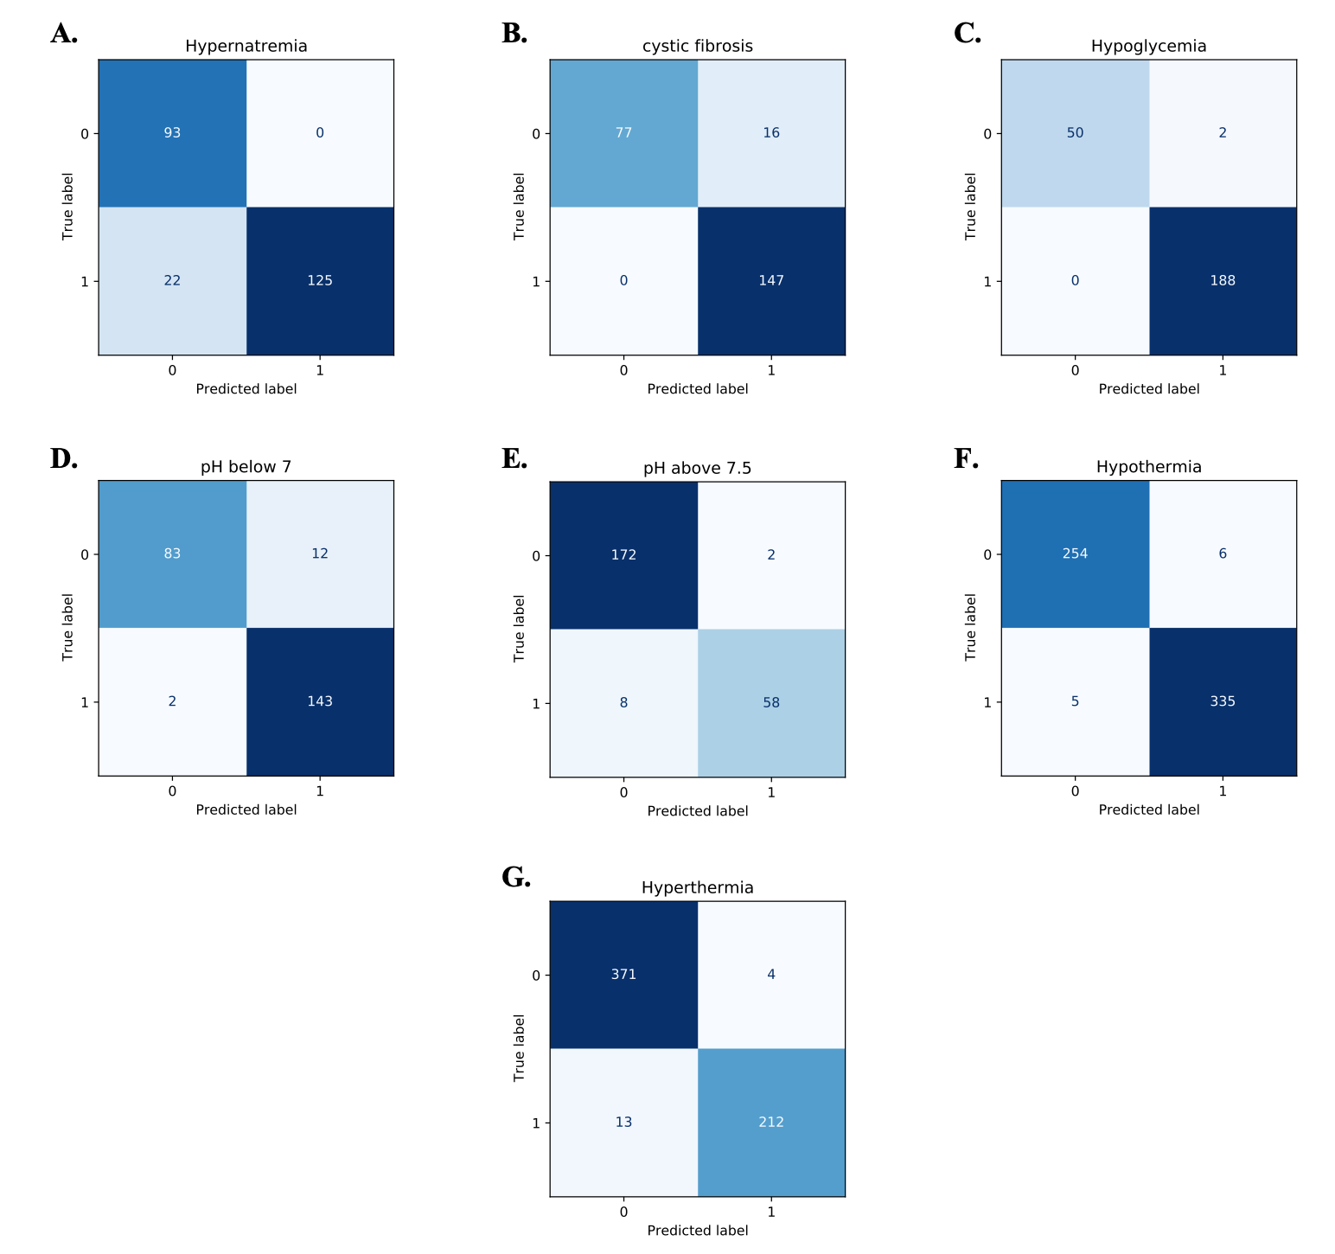

Supplementary Figure 2.
A. Color Scale for Temperature Dyes (T1-T7).  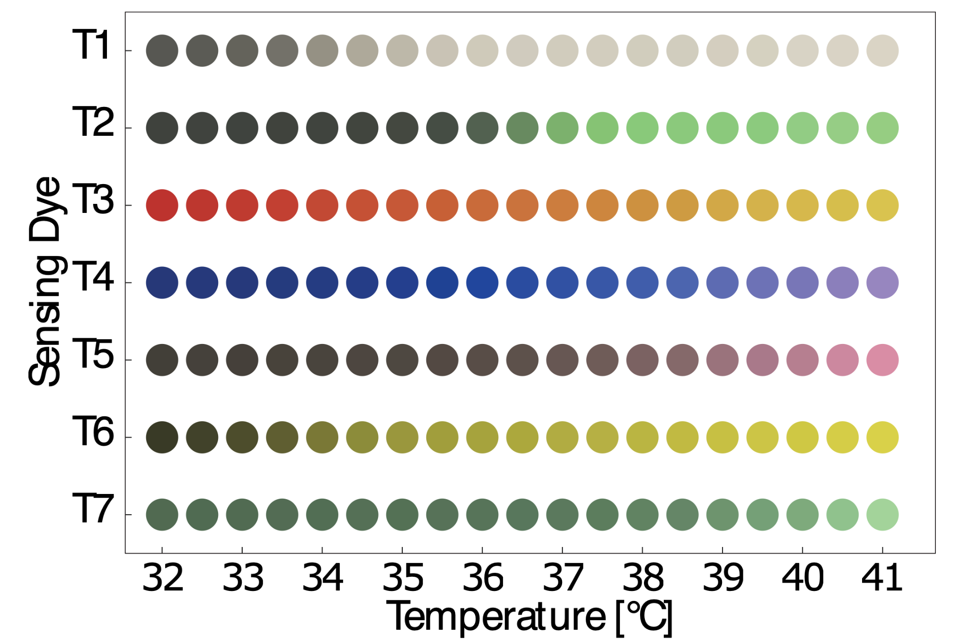 | B. Color Scale for pH Dyes (PR, BG, NY).  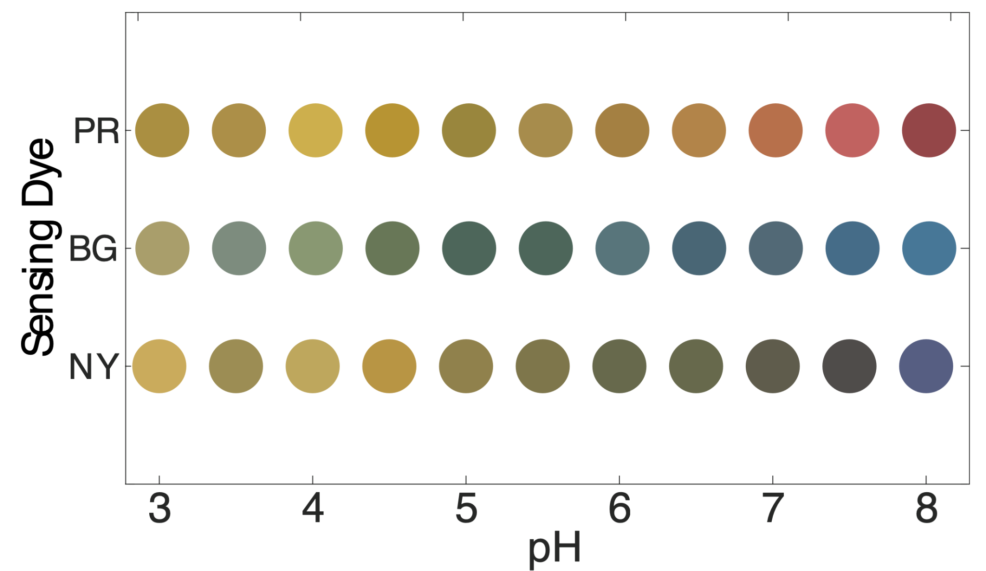

Supplementary Figure 3.
A. Baseline CNN+MLP Model Regression Performance for Glucose, pH, Sodium, and Temperature, Under White Light Illumination with Sensor Shear/Rotation.
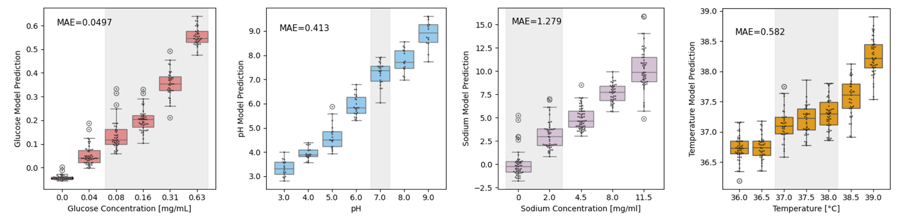
B. U-Net Denoising Model Regression Performance for Glucose, pH, Sodium, and Temperature, Under White Light Illumination with Sensor Shear/Rotation.
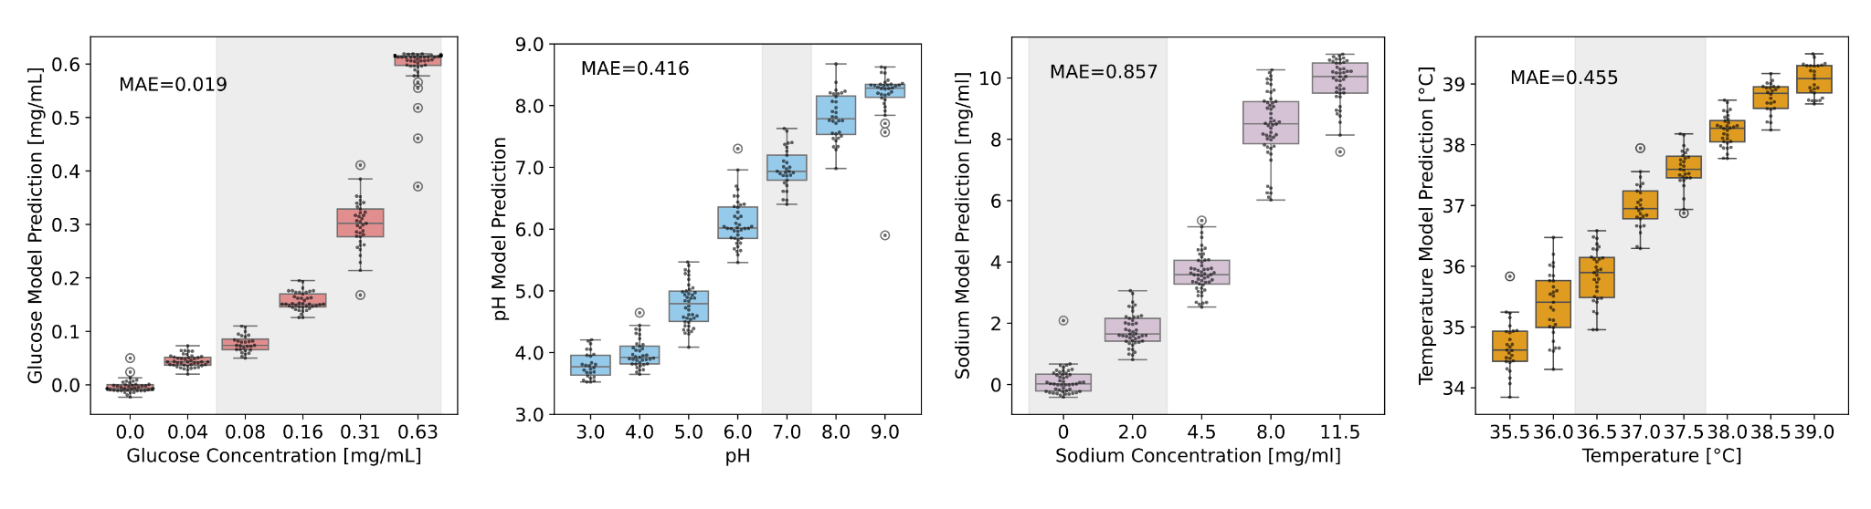

Supplementary Figure 4.
A. Temperature dye colorimetric cyclic response (down-up-down cycle).
i. Normalized Grayscale vs Temperature for Two sensors (S1, S2). Increasing temperature (up) in dark gray, decreasing temperature (down) in light gray.
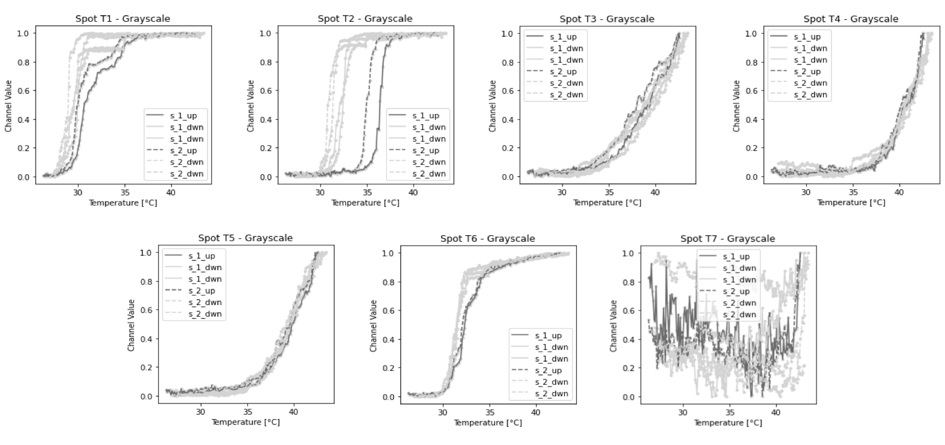
ii. Cyclic experiment, temperature vs time. Data points displayed in the recorded dye color.
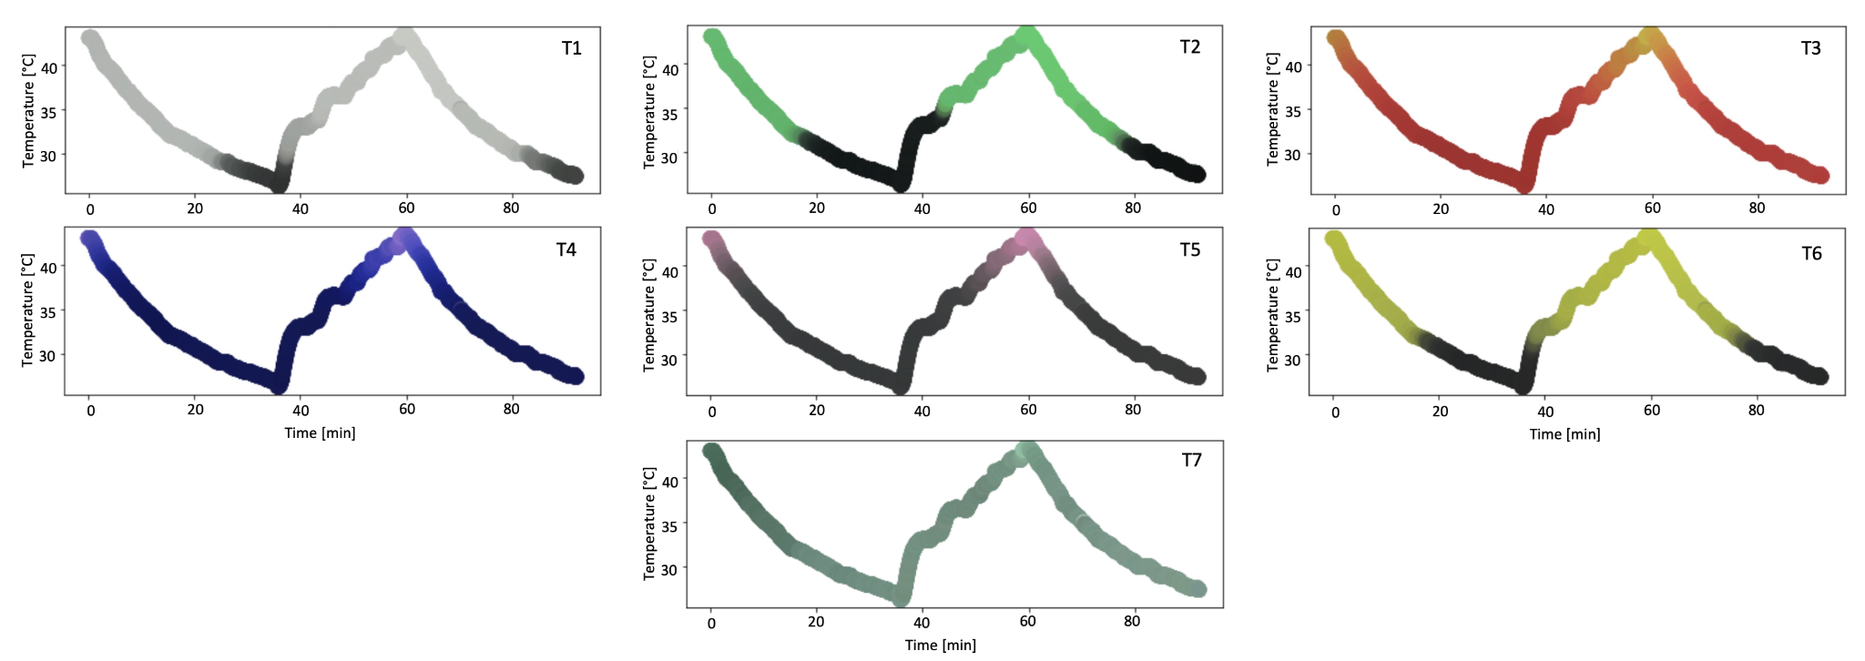
B. Colorimetric cyclic response for the pH dye (up-down cycle) for one sensor.
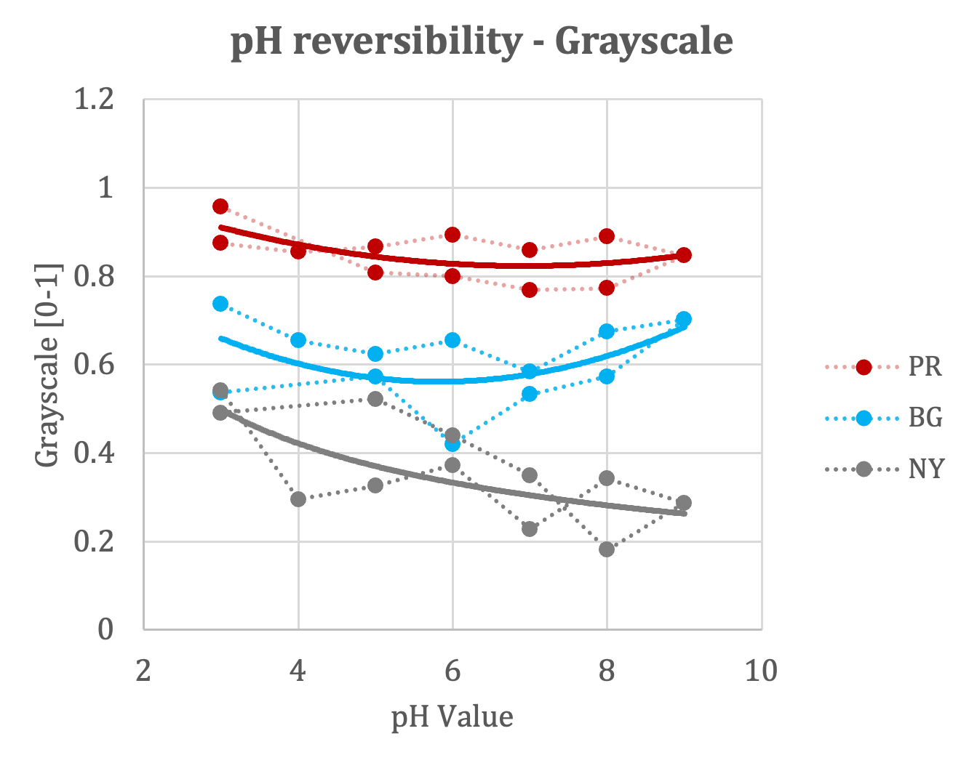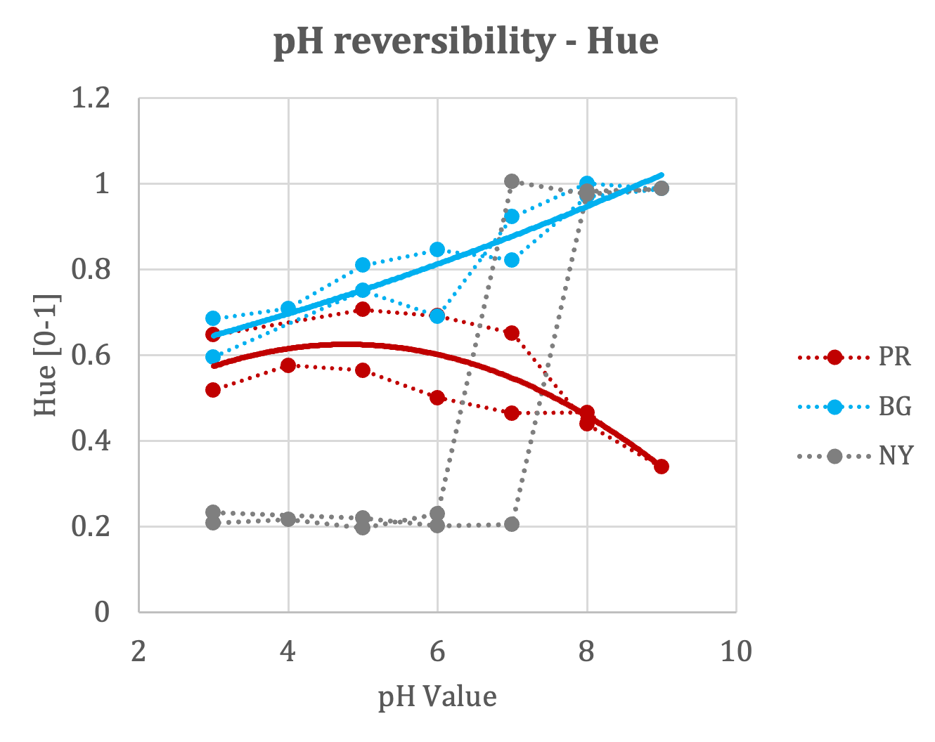
Supplementary Figure 5
A. Sensor augmentation from experimental data.
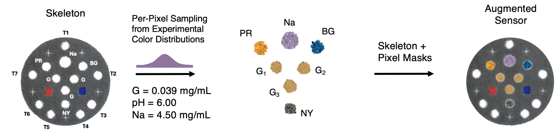
B. Affine transformations (rotation, shear projection, and random crop).
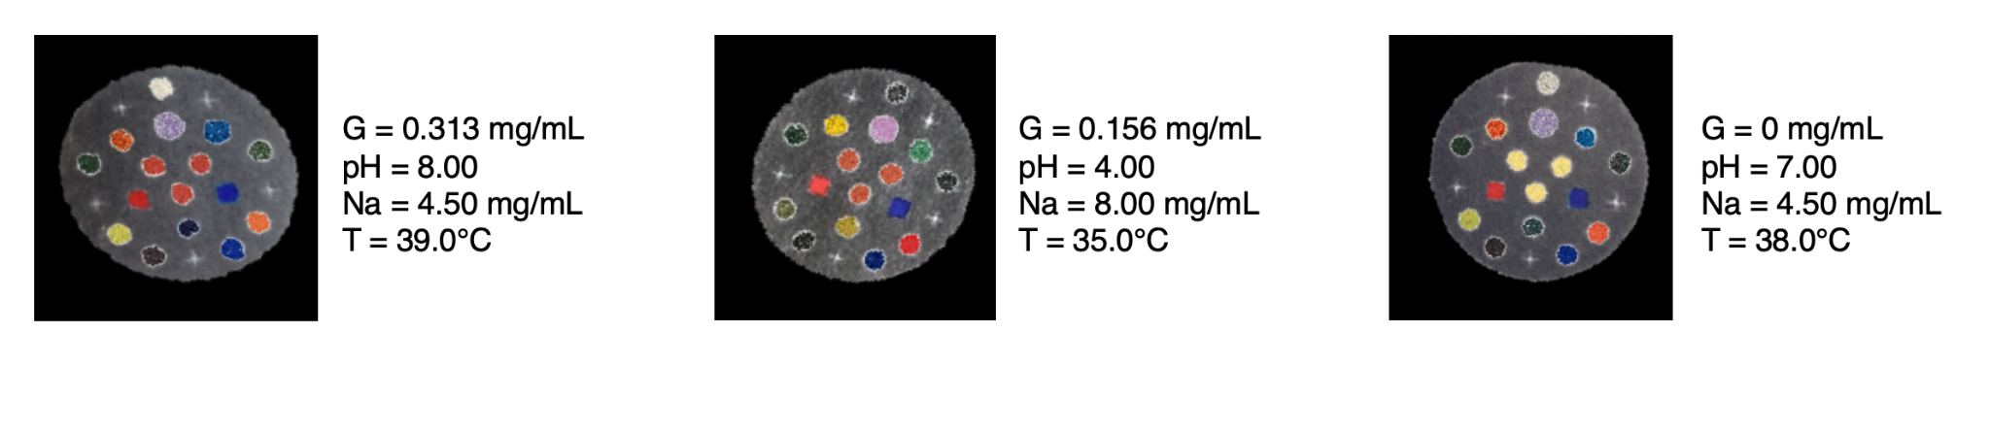
C. Illumination noise added via non-uniform spatial kernels f(x).
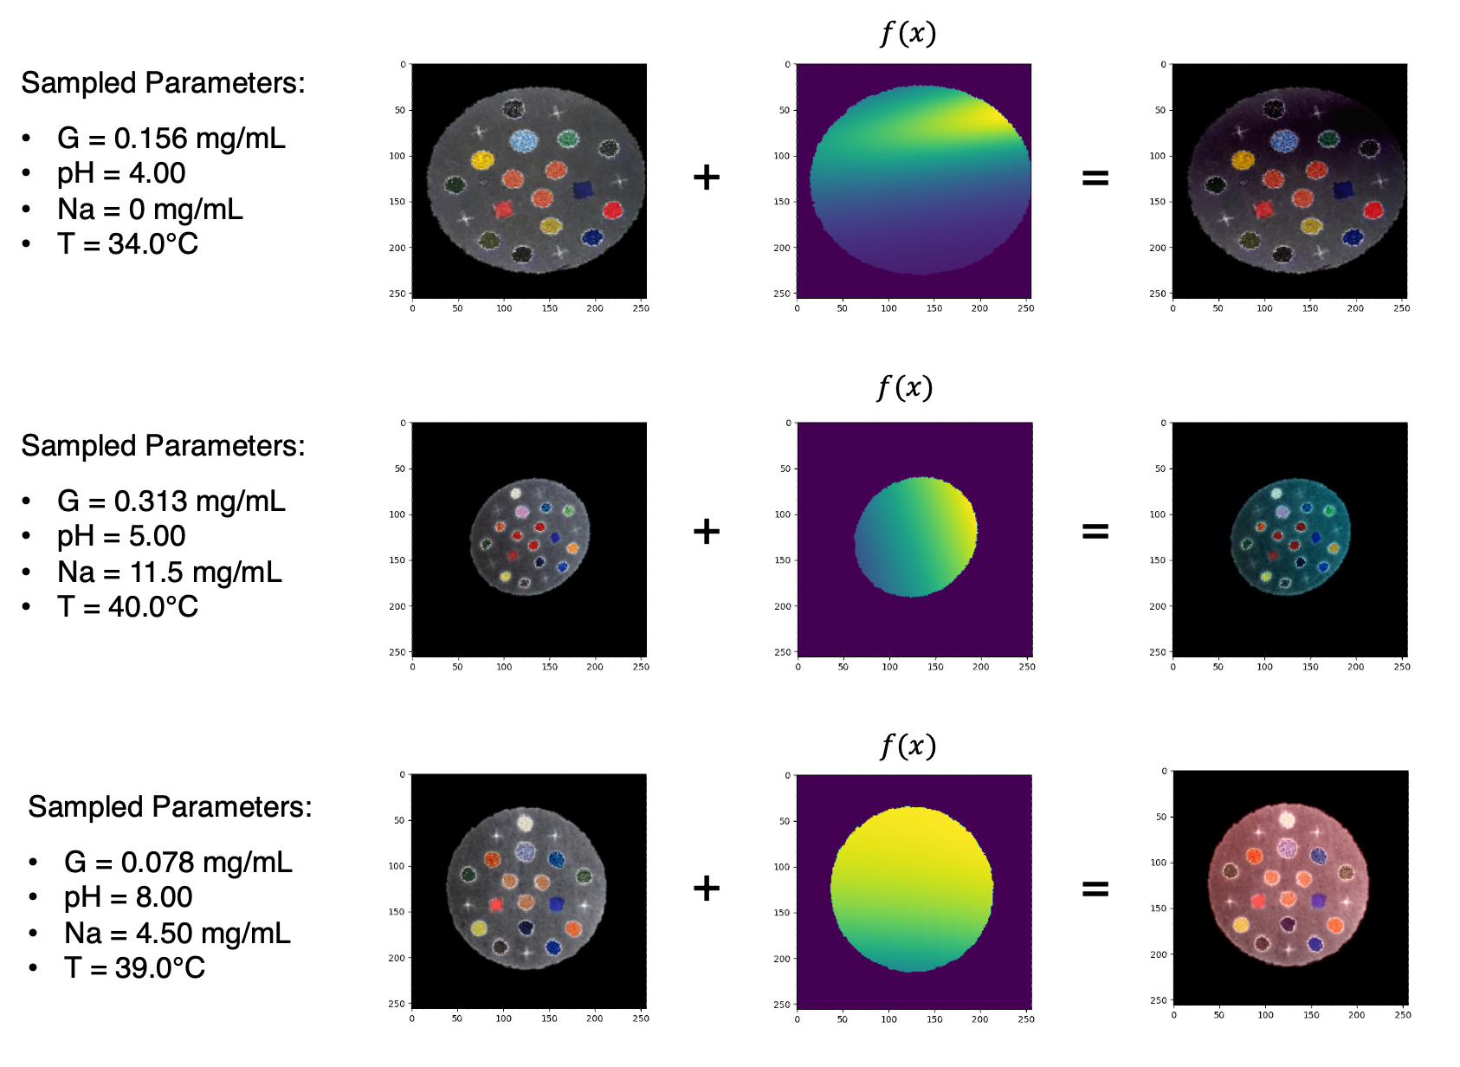

Supplementary Figure 6
A. Glucose Dye Colorimetric Distributions.
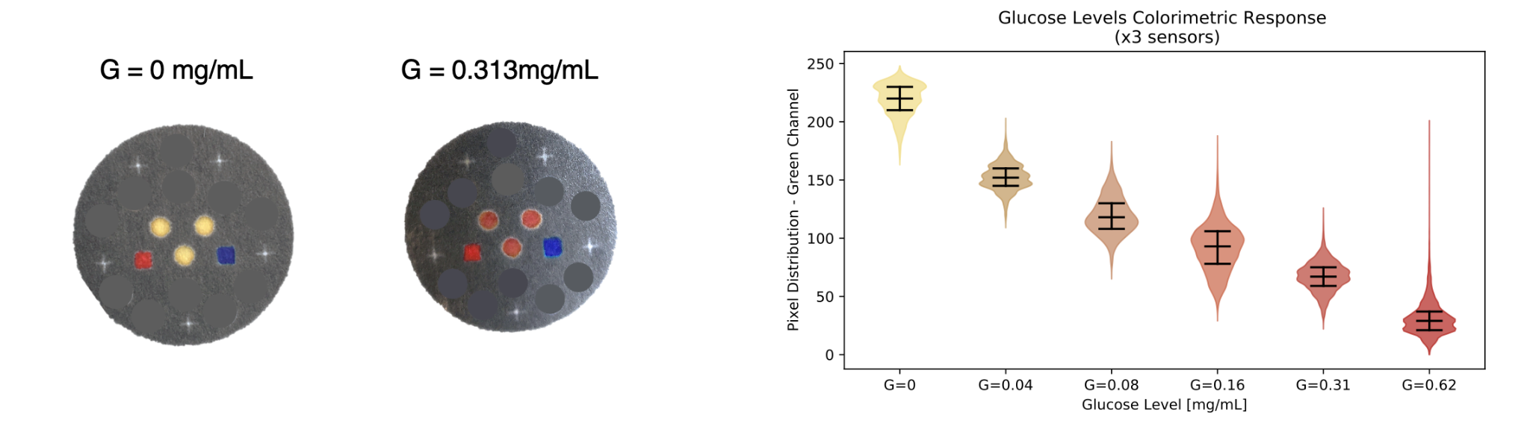
B. pH Dye Colorimetric Distributions (PR, BG, NY).
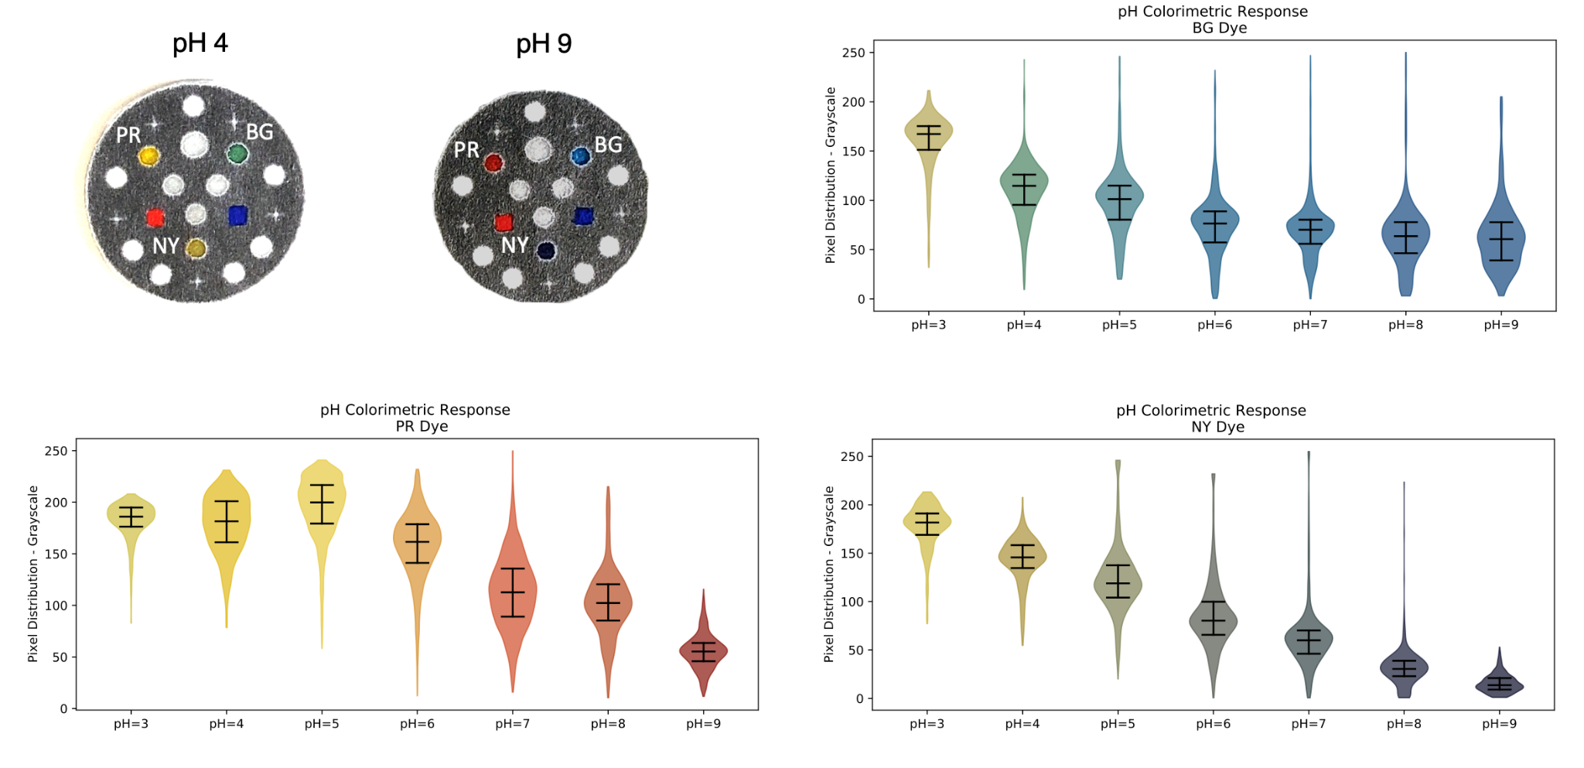

C. Sodium Dye Colorimetric Distributions.
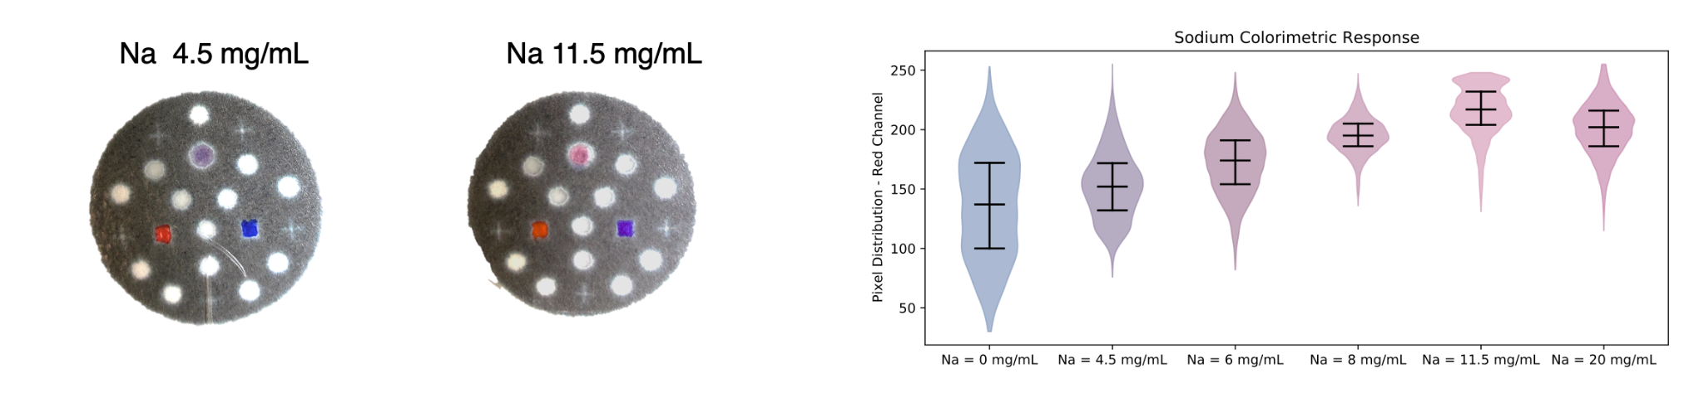

Supplementary Figure 7
A. Temperature Dyes (T1-T7) Colorimetric Distributions.
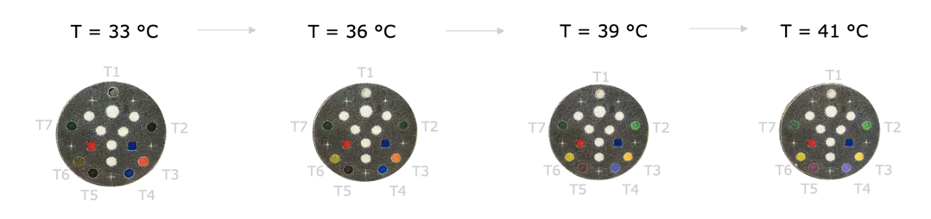
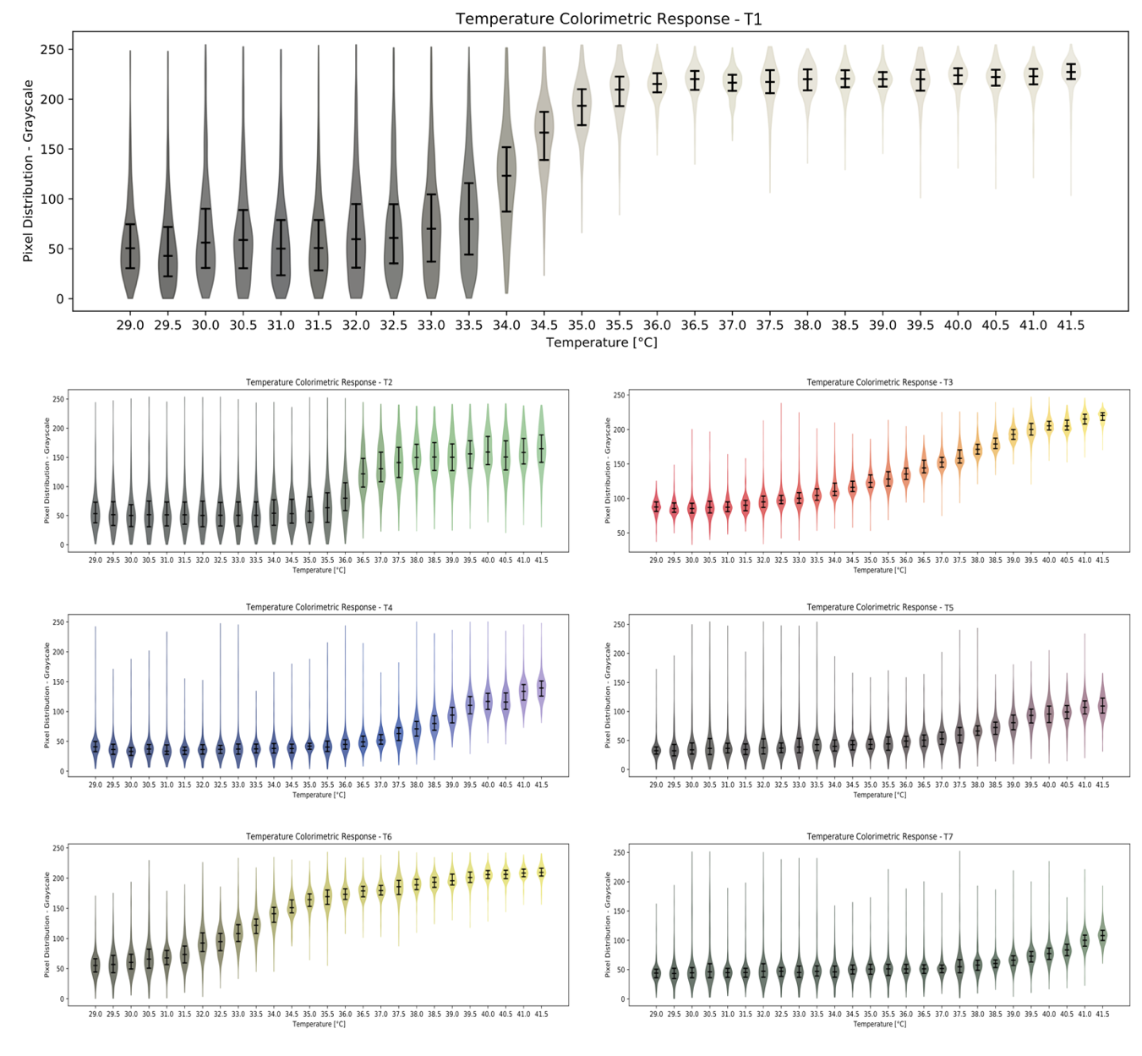

Supplementary Figure 8
A. Deep Learning Pipeline for Processing Experimental Videos of the Colorimetric Sensors.
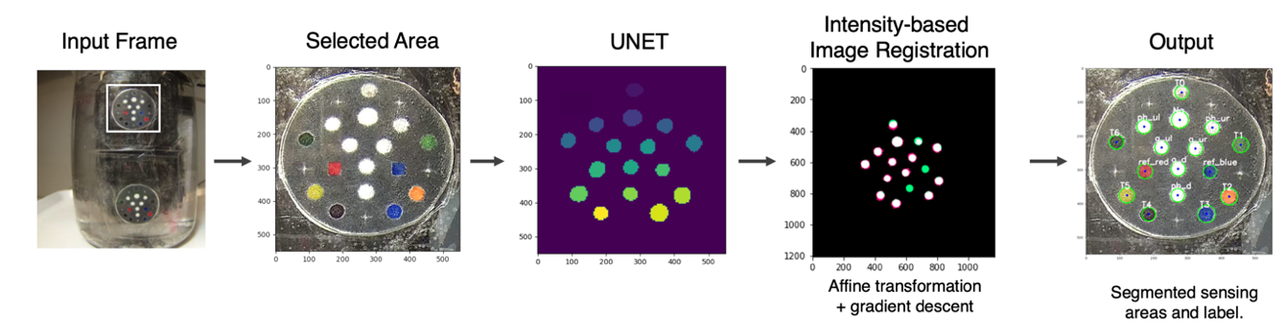
B. Experimental Set-Up for Continuous Temperature Recording.
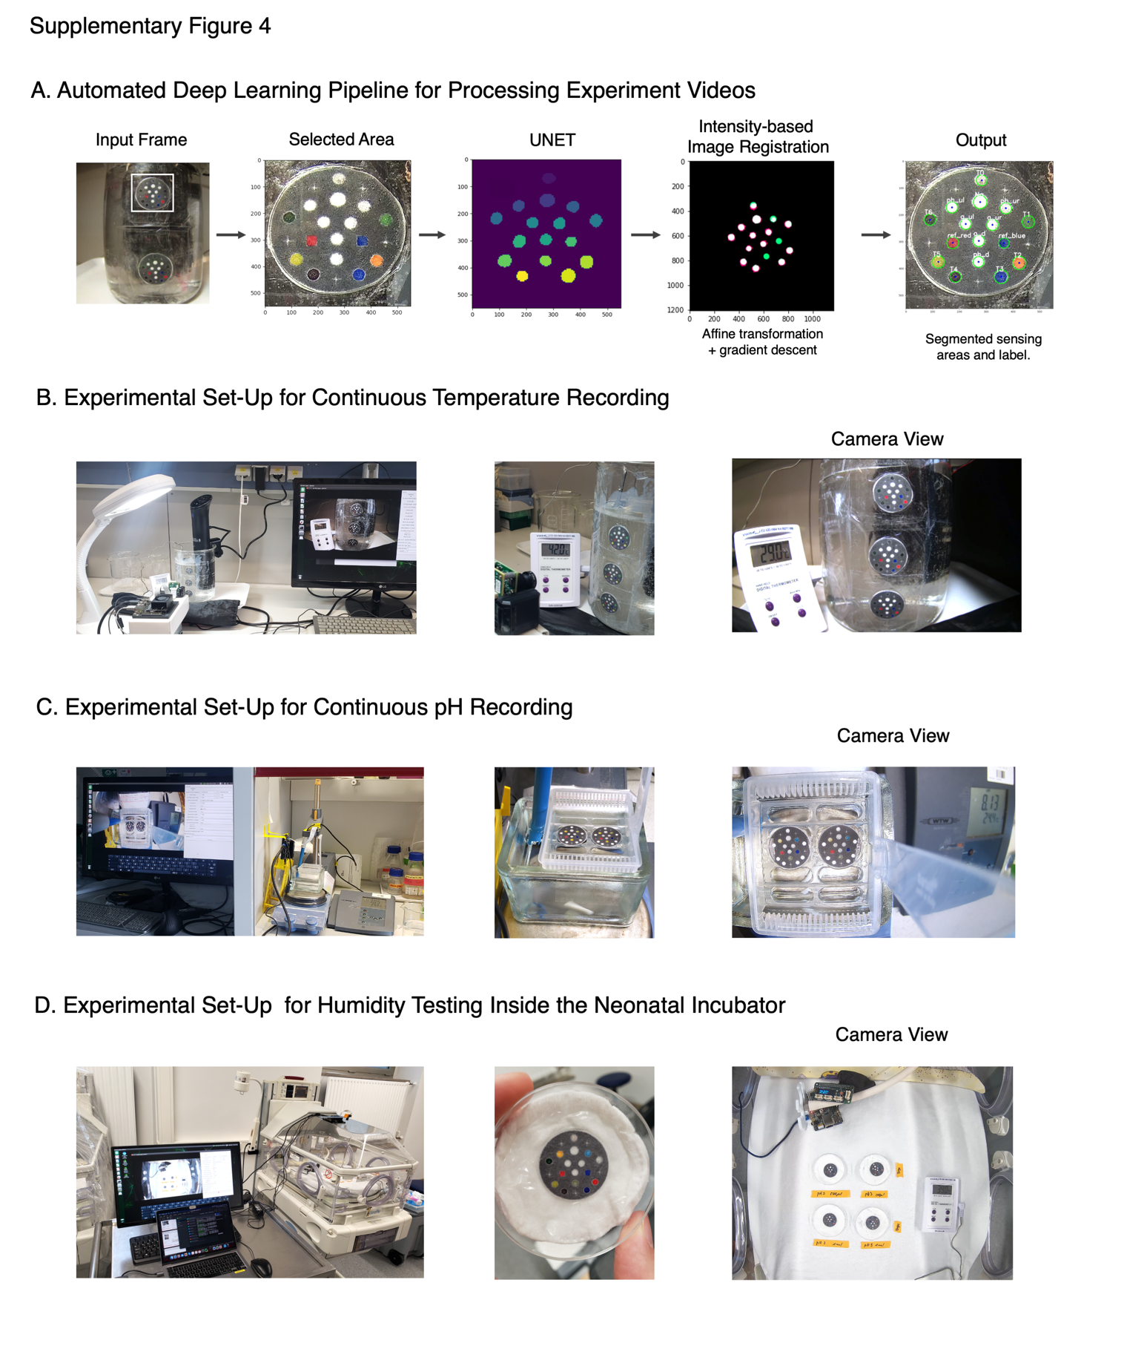

C. Experimental Set-Up for Continuous pH Recording.

D. Experimental Set-Up for Humidity Testing Inside the Neonatal Incubator. The right image corresponds to the color saturation of the pH dyes without/with waterproof film after 120 min of high humidity (80%) exposure.
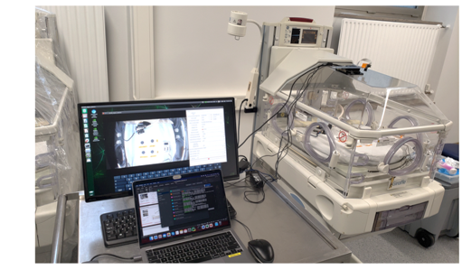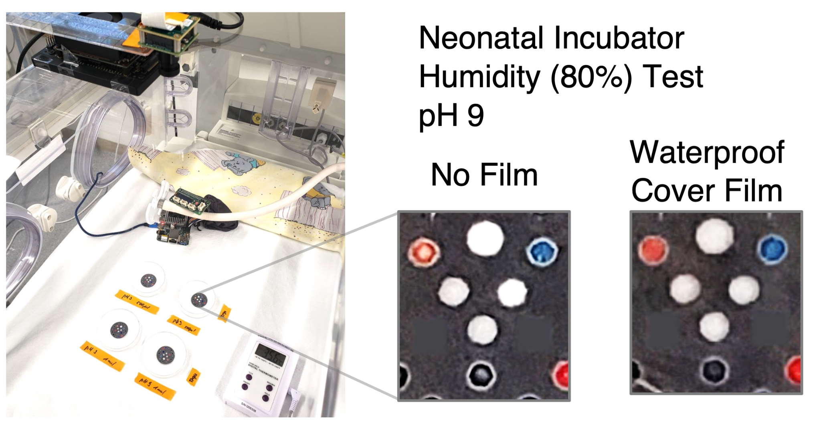

Supplementary Figure 9
A. Experimental Bench for Recording in the Neonatal Incubator
i) Camera and Board Set-Up ii) Baby breathing simulation
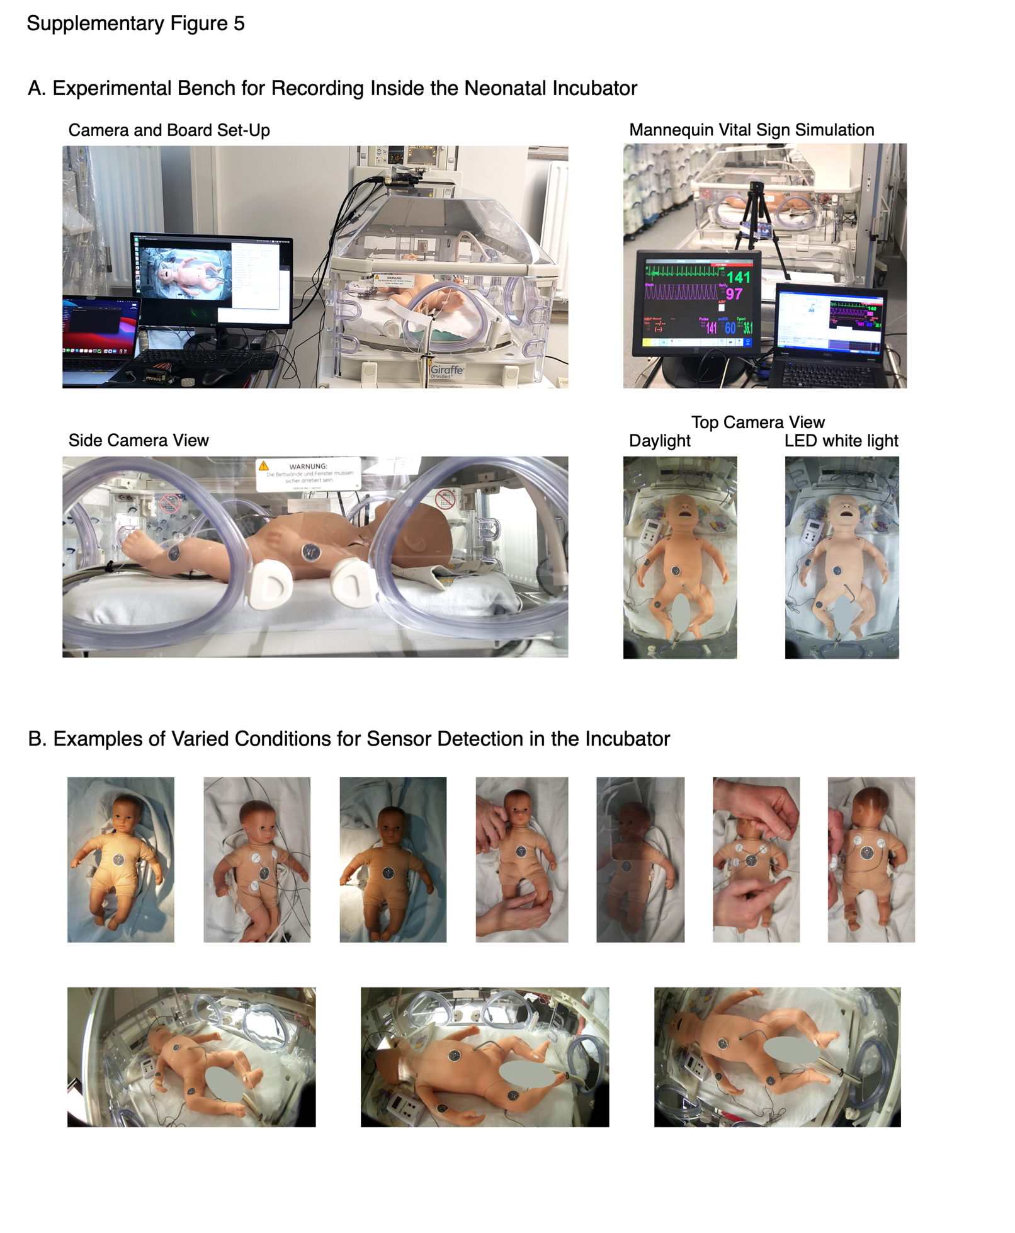
i) Side Camera View ii) Daylight (left), LED (right)

B. Examples of Varied Mannequin Conditions for Sensor Detection in the Incubator
