Supporting Information to
Quantification of Specific Urinary Oligosaccharide Biomarkers
for Diagnosis and Treatment Monitoring of alpha-Mannosidosis

Dominik Dörfel ^{1,2}, Benjamin Dreyer ^{1,2}, Mona Lindschau ^{1,2}, Antonio Barbato ³, Nadia Altavilla ³, Giancarlo la Marca ^{4,5}, Lara Maleen Marten ⁶, Friederike Bürger ⁷, Mara Botti ⁸, Lina Verena Sevenich ⁹, Ronen Spiegel ¹⁰, Anke Schumann ¹¹, Melanie Herrmann ¹², Davor Fielitz ¹³, Nicole Muschol ^{1,2}, René Santer ^{1,14}, Simona Murko ^{1,2 *}
¹ University Children's Hospital, University Medical Center Hamburg-Eppendorf, 20246 Hamburg, Germany
² International Center for Lysosomal Disorders (ICLD), University Medical Center Hamburg-Eppendorf, 20246 Hamburg, Germany
³ Department of Clinical Medicine and Surgery, Federico II University, 80131 Naples, Italy
⁴ Department of Experimental and Clinical Biomedical Sciences, University of Florence, 50134 Florence, Italy
⁵ Newborn Screening, Clinical Chemistry and Clinical Pharmacy Lab, Meyer Children’s Hospital IRCCS, 50134 Florence, Italy
⁶ Department of Pediatrics and Adolescent Medicine, University Medical Center Goettingen, 37075 Goettingen, Germany
⁷ Center for Pediatric and Adolescent Medicine, Department of Pediatrics I, Heidelberg University, 69120 Heidelberg, Germany
⁸ Rare Disease Center, Fondazione IRCCS San Gerardo dei Tintori, 20900 Monza, Italy
⁹ Department of Pediatric Gastroenterology, Nephrology and Metabolic Diseases, Center for Chronically Sick Children, Charité-Universitätsmedizin Berlin, 13353 Berlin, Germany
¹⁰ Department of Pediatrics B, Emek Medical Center, Afula 1810100, Ruth and Bruce Rappaport Faculty of Medicine, Technion, Haifa, Israel
¹¹ Department of Pediatrics and Adolescent Medicine, Faculty of Medicine, Medical Center, University of Freiburg, 79110 Freiburg, Germany
¹² University Children’s Hospital, Ruhr University, 44791 Bochum, Germany
¹³ Clinical Business Unit, Waters GmbH, 65760 Eschborn, Germany
¹⁴ Institute of Human Genetics, Helmholtz Center Munich, 85764 Neuherberg, Germany

* Corresponding Author:
Dr. Simona Murko, Newborn Screening and Metabolic Laboratory, University Children’s Hospital, University Medical Center Hamburg-Eppendorf, Martinistraße 52, 20246 Hamburg, Germany; phone: +49 (0)40 7410 57037; s.murko@uke.de

Table of Contents
Samples 4
Table S1: Overview of AM patients in this study including results of genetic analyses, residual enzymatic activity, and individual data for biomarkers GlcNAc(Man)₂, GlcNAc(Man)₃, and GlcNAc(Man)₄ measured in urine. 5
Table S2: Overview of patients with other lysosomal storage diseases in this study. 8
Sample preparation and analysis 9
Sample preparation 9
Ultra-performance liquid chromatography tandem-mass spectrometry 9
Table S3: MS/MS parameters for the detection of all four analytes. 10
Method validation 10
Linearity 11
Figure S1: Linearity assessment for all three biomarkers in solvent and matrix. 12
Table S4: Linear regression parameters for all three biomarkers in solvent and matrix. 12
Carry-over 13
Table S5: Recoveries of GlcNAc(Man)₃ and GlcNAc(Man)₄ at each calibration level. Concentrations were calculated via the solvent calibration. 14
Limit of detection and quantification 14
Table S6: LOD and LOQ in urine of all three analytes. 15
Accuracy and precision 15
Table S7: Results for the accuracies and precisions of all three biomarkers. 16
Matrix effect 17
Table S8: Accuracies for all six individual sample matrices at low (L; 10 ng/mL) and high (H; 100 ng/mL) spiking levels (n = 3). 17
Table S9: Assessment of matrix factor, IS-normalized matrix factor, extraction recovery, and process efficiency in low (L; 10 ng/mL) and high (H; 100 ng/mL) spiked samples (n = 6 matrices measured in triplicate). 19
Stability 21
Figure S2: Long-term and freeze-thaw stability of all three biomarkers in urine. 24
Analytical specificity 24
Results 26
Table S10: Biomarker concentrations in samples of patients with other lysosomal storage diseases. 27
Table S11: Overview of upper (U) and lower (L) limits of the concentration ranges of all three biomarkers for all study cohorts. 28
Figure S3: Scatterplot of all samples analyzed in this study. GlcNAc(Man)₃ concentrations are plotted against the age of the subject at the time of sampling. AM, alpha-mannosidosis; ERT, enzyme replacement therapy; HSCT, hematopoietic stem cell transplantation. 28
Figure S4: Scatterplot of all samples analyzed in this study. GlcNAc(Man)₄ concentrations are plotted against the age of the subject at the time of sampling. AM, alpha-mannosidosis; ERT, enzyme replacement therapy; HSCT, hematopoietic stem cell transplantation. 29
Treatment Monitoring 29
Figure S5: Course of biomarker concentration in patients 28 and 72 before (0 months) and approximately one year after starting ERT treatment (13 and 14 months, respectively). ERT, enzyme replacement therapy 30
Figure S6: Course of biomarker concentration in patient 39 (untreated) over time. 30
Figure S7: Course of biomarker concentration in patient 35 (ERT) over time. 31
References 32

Samples
The following tables contain information on the patients included in this study.
Table S1 lists the patients affected by AM, their treatment status, age, and sex as well as results from genetic analyses, residual enzymatic activity, and individual data for biomarkers GlcNAc(Man)₂, GlcNAc(Man)₃, and GlcNAc(Man)₄ measured in urine. Table S2 lists the patients with other lysosomal storage disorders, their lysosomal storage disease, age, and sex. Along with this data, patient and sample numbers are indicated in the same way they were indexed in our study cohort and referred to in the sample lists and data files to allow a comprehensive assessment of the results. The sample identifier is the combination of patient number and sample number in the format XXXX_XXXX. For example, the first sample obtained from patient 2 in 2025 would be 0002_0125. It should be noted that the patient number series omits some numbers. The omitted numbers refer to patients from which we did not obtain urine samples.

Table S1: Overview of AM patients in this study including results of genetic analyses, residual enzymatic activity, and individual data for biomarkers GlcNAc(Man)₂, GlcNAc(Man)₃, and GlcNAc(Man)₄ measured in urine.
 | Age | Sex | Genotype MAN2B1 |  |  |  |  |  |  |  |  | Residual Activity * | Treatment Status | Biomarker Concentration
Pt # | [y] |  | First Allele  ClinVar CADD GeneBe |  |  |  | Second Allele  ClinVar CADD GeneBe |  |  |  |  | [%] |  | GlcNAc(Man)₂ [µmol/mmol creatinine] | GlcNAc(Man)₃ [µmol/mmol creatinine] | GlcNAc(Man)₄ [µmol/mmol creatinine]
0001 0124 | 9 | f | c.212_215delCACA |  | p.Thr71Metfs*85 |  | c.1830+1G>C |  |  | donor splice variant |  | 1 | ERT | 24.8 | 5.5 | 4.1
0001 0124 | 9 | f | P | --- |  | P | P | 28 |  |  | P
0006 0124 | 11 | f | c.2151delG |  | p.Pro718Argfs*48 |  | c.2151delG |  | p.Pro718Argfs*48 |  |  | 0 | ERT | 14.2 | 2.8 | 2.6
0006 0124 | 11 | f | --- | --- |  | P | --- | --- |  |  | P
0028 0124 | 43 | m | c.2248C>T |  | p.Arg750Trp |  | c.2183_2185delAGG |  | p.Glu728del |  |  | 1 | Untreated | 76.5 | 14.4 | 10.2
0028 0125 | 44 | m | P / LP | 27 |  | P | --- | --- |  |  | VUS | 1 | ERT | 17.5 | 4.6 | 1.9
0035 0124 | 33 | f | c.1830+1G>C |  | donor splice variant |  | c.2248C>T |  | p.Arg750Trp |  |  | n/a | ERT | 13.0 | 3.3 | 2.2
0035 0224 | 33 | f | P | 28 |  | P | P / LP | 27 |  |  | P | n/a | ERT | 12.1 | 3.4 | 2.6
0038 0124 | 6 | m | c.2248C>T |  | p.Arg750Trp |  | c.2248C>T |  | p.Arg750Trp |  |  | 1 | HSCT | 9.1 | 2.1 | 1.4
0038 0124 | 6 | m | P / LP | 27 |  | P | P / LP | 27 |  |  | P
0039 0124 | 40 | m | n/a |  |  |  |  |  |  |  |  | 1 | Untreated | 45.3 | 10.0 | 8.6
0039 0224 | 40 | m |  |  |  |  |  |  |  |  |  | 1 | Untreated | 46.9 | 10.8 | 6.4
0039 0125 | 41 | m | --- | --- |  | --- | --- | --- |  |  | --- | 1 | Untreated | 39.4 | 8.9 | 7.0
0040 0124 | 22 | m | c.2161dupG |  | p.Val721Glyfs*14 |  | n/a † |  |  | p.His611_Lys682del |  | 2 | Untreated | 46.4 | 9.7 | 8.7
0040 0224 | 23 |  |  |  |  |  |  |  |  |  |  |  | ERT | 12.2 | 2.9 | 2.0
0040 0324 | 23 | m | --- | --- |  | P | --- | --- |  |  | --- | 2 | ERT | 17.6 | 3.8 | 2.6

0041 0124 | 29 | f | c.598C>A |  |  | p.His200Asn |  |  |  |  |  | c.2746C>A |  | p.Arg916Ser |  |  |  |  | 1 | Untreated | 53.0 | 9.2 | 8.2
0041 0224 | 29 |  |  |  |  |  |  |  |  |  |  |  |  |  |  |  |  |  |  | ERT | 14.1 | 2.9 | 2.3
0041 0324 | 30 | f | P / LP | 28 |  |  |  |  | P |  |  | --- | 27 |  |  |  |  | LP | 1 | ERT | 14.1 | 2.9 | 2.2
0042 0124 | 21 | m | n/a |  |  |  |  |  |  |  |  |  |  |  |  |  |  |  | 9 / 2 ** | HSCT | 3.3 | 0.8 | 0.6
0042 0124 | 21 | m | --- | --- |  |  |  |  |  | --- |  | --- | --- |  |  |  |  | ---
0043 0124 | 13 | m | n/a |  |  |  |  |  |  |  |  |  |  |  |  |  |  |  | 9 / 2 ** | HSCT | 5.6 | 1.3 | 1.0
0043 0124 | 13 | m | --- | --- |  |  |  |  |  | --- |  | --- | --- |  |  |  |  | ---
0049 0124 | 35 | m | c.599A>T |  |  |  | p.His200Leu |  |  |  |  | c.164G>T |  |  |  | p.Cys55Phe |  |  | 11 | ERT | 19.7 | 5.2 | 3.4
0049 0124 | 35 | m | LP | 27 |  |  |  |  |  | P |  | LP | 29 |  |  |  |  | P
0050 0124 | 41 | m | c.599A>T |  |  | p.His200Leu |  |  |  |  |  | c.164G>T |  | p.Cys55Phe |  |  |  |  | 11 | ERT | 17.2 | 3.9 | 2.5
0050 0124 | 41 | m | LP | 27 |  |  |  |  |  | P |  | LP | 29 |  |  |  |  | P
0054 0125 | 36 | m | n/a |  |  |  |  |  |  |  |  |  |  |  |  |  |  |  | 5 | Untreated | 98.8 | 16.2 | 14.9
0054 0125 | 36 | m | --- |  | --- |  |  |  |  | --- |  | --- | --- |  |  |  | ---
0055 0125 | 9 | m | c.283G>C |  |  |  |  | p.Ala95Pro |  |  |  | c.283G>C |  |  | p.Ala95Pro |  |  |  | 1 | Untreated | 86.0 | 18.5 | 18.8
0055 0125 | 9 | m | VUS |  | 24 |  |  |  |  | VUS |  | VUS | 24 |  |  |  | VUS
0056 0125 | 34 | f | c.2248C>T |  |  |  |  | p.Arg750Trp … |  |  |  | c. c.2248C>T |  |  | p.Arg750Trp |  |  |  | 1 | Untreated | 44.9 | 8.3 | 8.6
0056 0125 | 34 | f | P / LP |  | 27 |  |  |  |  |  | P | P / LP | 27 |  |  |  | P
0061 0125 | 3 | m | c.1925_1927delTCT |  |  |  |  | p.Phe642del |  |  |  | c.1925_1927delTCT |  |  | p.Phe642del |  |  |  | 1 / 0 *** | Untreated | 94.0 | 18.1 | 17.4
0061 0125 | 3 | m | LP / VUS |  | 27 |  |  |  |  |  | LP | LP | --- |  |  |  | VUS
0062 0125 | 4 | m | c.2248C>T |  |  |  |  | p.Arg750Trp |  |  |  | c.2248C>T |  |  | p.Arg750Trp |  |  |  | 1 / 0 *** | Untreated | 65.6 | 15.4 | 17.6
0062 0125 | 4 | m | P / LP |  | 27 |  |  |  |  |  | P | P / LP | 27 |  |  |  | P

0064 0125 | 3 | f | c.2544_2568dup |  | p.Arg857Serfs*82 |  | c.2544_2568dup |  | p.Arg857Serfs*82 |  | 0 / 0 *** | Untreated | 99.3 | 27.5 | 15.4
0064 0125 | 3 | f | LP | --- |  | P | LP | --- |  | P
0072 0124 | 40 | m | c.2670_2671delAG |  | p.Gly891Alafs*39 |  | c.2670_2671delAG |  | p.Gly891Alafs*39 |  | n/a | Untreated | 64.2 | 13.5 | 12.8
0072 0425 | 41 | m | P | --- |  | P | P | --- |  | P | n/a | ERT | 34.8 | 8.3 | 6.9
0073 0125 | 2 | m | c.1694delT |  | p.Leu565Argfs*16 |  | c.1694delT |  | p.Leu565Argfs*16 |  | 0 | ERT | 68.2 | 16.1 | 8.9
0073 0125 | 2 | m | P | --- |  | P | P | --- |  | P

AM, alpha-mannosidosis
In addition to the genotype the variant classification according to ClinVar, the CADD score, and the summary assessment in accordance with GeneBe are provided with ‘VUS’, ‘LP’ and ‘P’ representing variants of unknown significance, likely pathogenic and pathogenic variants, respectively.
† variant determined from transcript
* from different materials
**_in leukocytes and dried blood spots, respectively
***_in leukocytes and plasma, respectively

Table S2: Overview of patients with other lysosomal storage diseases in this study.
Patient number | Sample number | Lysosomal storage disease | Age [y] | Sex
0002 | 0124 | MPS I | 5 | Male
0009 | 0124 | Pompe disease | 40 | Female
0010 | 0124 | Fabry disease | 14 | Female
0011 | 0124 | Fabry disease | 66 | Female
0019 | 0124 | Fabry disease | 46 | Male
0020 | 0124 | Fabry disease | 14 | Male
0021 | 0124 | Gaucher disease | 16 | Female
0022 | 0124 | MPS I | 5 | Female
0023 | 0124 | MPS I | 29 | Female
0025 | 0124 | Schindler disease | 6 | Male
0025 | 0224 | Schindler disease | 7 | Male
0026 | 0124 | Pompe disease | 40 | Female
0027 | 0124 | Gaucher disease | 34 | Female
0029 | 0124 | MPS VI | 52 | Female
0029 | 0224 | MPS VI | 53 | Female
0030 | 0124 | MPS II | 13 | Male
0031 | 0124 | GM₂ gangliosidosis | 2 | Female
0033 | 0124 | Pompe disease | 10 | Female
0034 | 0124 | Sialidosis type II | 8 | Male
0044 | 0124 | MPS IIIA | 12 | Female
0045 | 0124 | MPS I | 3 | Male
0046 | 0124 | Sialidosis type II | 8 | Male
0051 | 0124 | ClC-7 hyperactivity | 6 | Male
0051 | 0125 | ClC-7 hyperactivity | 7 | Male
0053 | 0125 | Fucosidosis | 9 | Male
0058 | 0125 | MPS II | 20 | Male
0059 | 0125 | MPS IV | 6 | Female
0063 | 0125 | Fabry disease | 73 | Male
0065 | 0125 | MPS I | 4 | Male
MPS, mucopolysaccharidosis; ClC-7, chloride co-transporter-7

Sample preparation and analysis

Sample preparation
Frozen samples were thawed at room temperature (20 °C). After thorough shaking, 10 µL of urine was added to 990 µL extraction solvent consisting of 10.1 ng/mL GlcNAc(Man)₂-IS in 80 % (v/v) acetonitrile with 0.1 % formic acid. This resulted in a GlcNAc(Man)₂-IS concentration of 10 ng/mL in the sample extract. Subsequently, sample extracts were centrifuged with a Mini Centrifuge C-1200 (Labnet International, Inc., Edison, NJ, USA) for 1 min. The supernatant was transferred into a 2 mL glass vial and measured by UPLC-MS/MS using an external calibration calculated from the relative response of the GlcNAc(Man)₂ signal to the internal standard GlcNAc(Man)₂-IS. External calibrations without internal standards were used for GlcNAc(Man)₃ and GlcNAc(Man)₄ determination since accuracies and precisions were not satisfactory when using GlcNAc(Man)₂-IS as internal standard also for these two oligosaccharides and since isotope-labelled standards were not available commercially for them and would have to be synthesized at substantial cost. Method validation proved satisfactory accuracy and precision without internal standards. All study samples were analyzed in duplicate.

Ultra-performance liquid chromatography tandem-mass spectrometry
Analyte separation was carried out on a Waters ACQUITY UPLC I-Class coupled to a Waters Xevo TQ-S Micro triple quadrupole mass spectrometer. An ACQUITY UPLC Glycan BEH Amide column (130 Å, 1.7 µm, 2.1 mm × 150 mm, Waters, Eschborn, Germany) in combination with an ACQUITY UPLC Glycan BEH Amide pre-column (130 Å, 1.7 µm, 2.1 mm × 5 mm, Waters, Eschborn, Germany) was used. Column temperature was set to 40 ± 5.0 °C. The mobile phase consisted of acetonitrile (eluent A) and water (eluent B), to both of which 0.1 % (v/v) formic acid was added. A linear gradient elution was performed starting at 80 % A for 1 min, before a linear decrease to 62 % over 0.1 min, then to 52 % over 2 min, and to 30 % over another 1.4 min. Subsequently, eluent A was increased to 80 % within 0.5 min. Lastly, the column was equilibrated at 80 % A for 1 min before the next injection. Flow rate was set to 0.4 mL/min with an injection volume of 10 µL. The MS/MS parameters are provided in Table S3.

Table S3: MS/MS parameters for the detection of all four analytes.
Analyte | Precursor Ion  [m/z] | Product Ion  [m/z] | Dwell Time  [s] | Cone Voltage  [V] | Collision Energy  [V]
GlcNAc(Man)₂ | 546.2 | 204.0 * | 0.065 | 35 | 18
GlcNAc(Man)₂ | 546.2 | 222.0 | 0.065 | 35 | 9
GlcNAc(Man)₂-IS | 551.2 | 209.0 * | 0.065 | 35 | 18
GlcNAc(Man)₂-IS | 551.2 | 227.0 | 0.065 | 35 | 9
GlcNAc(Man)₃ | 708.3 | 204.0 * | 0.065 | 40 | 25
GlcNAc(Man)₃ | 708.3 | 222.0 | 0.065 | 40 | 14
GlcNAc(Man)₄ | 870.3 | 204.0 * | 0.065 | 70 | 30
GlcNAc(Man)₄ | 870.3 | 222.0 | 0.065 | 70 | 18

m/z, mass-to-charge ratio; GlcNAc(Man)₂-IS, GlcN-[1,2-¹³C₂; 2-²H₃]-Ac(Man)₂;
* indicates the quantifier transition.

Method validation
Method validation was conducted according to the ICH guideline M10 on bioanalytical method validation and study sample analysis supplied by the Committee for Medicinal Products for Human Use, European Medical Agency (1), with modifications where necessary. The method was validated for linearity, carry-over, limit of detection (LOD) and quantification (LOQ), precision and recovery, accuracy, matrix effect, stability, and analytical specificity. During the method development, it was found that all urine samples contain small amounts of the analytes. Therefore, no blank samples were available. The following sections give a detailed overview of the validation process and results.

Linearity
No blank matrix is available for the three biomarkers. Thus, linearity was assessed in solvent by independent and randomized triplicate analysis of a 12(+0)-point calibration curve ranging from 1 – 1000 ng/mL for each oligosaccharide biomarker (GlcNAc(Man)₂, GlcNAc(Man)₃, and GlcNAc(Man)₄). The concentration of the internal standard GlcNAc(Man)₂-IS was kept constant at 10 ng/mL. Additionally, the linearity of the analytes was assessed in matrix by adding the same concentrations to the urine sample of a healthy volunteer. Linear regression was performed for both assays. The acceptance criteria were R² > 0.99 and randomly distributed residuals.
The results are shown in Figure S1. Linearity in solvent was confirmed in the range of 1 to 1000 ng/mL for GlcNAc(Man)₂, while the linear range of GlcNAc(Man)₃ and GlcNAc(Man)₄ ranged from 10 to 1000 ng/mL. The R² was above 0.99 for all three analytes in both solvent and matrix (Table S4). The residuals of all three analytes are randomly distributed. Thus, the linearity between the detector response and the analyte concentration has been confirmed for all three analytes in solvent and matrix. The LLOQ is calculated as the analyte concentration in urine required to achieve a concentration in the extract that is equal to the concentration of the lowest calibration level. Therefore, the LLOQ of GlcNAc(Man)₂ is 100 ng/mL urine and the LLOQs of GlcNAc(Man)₃ and GlcNAc(Man)₄ are 1 µg/mL urine.

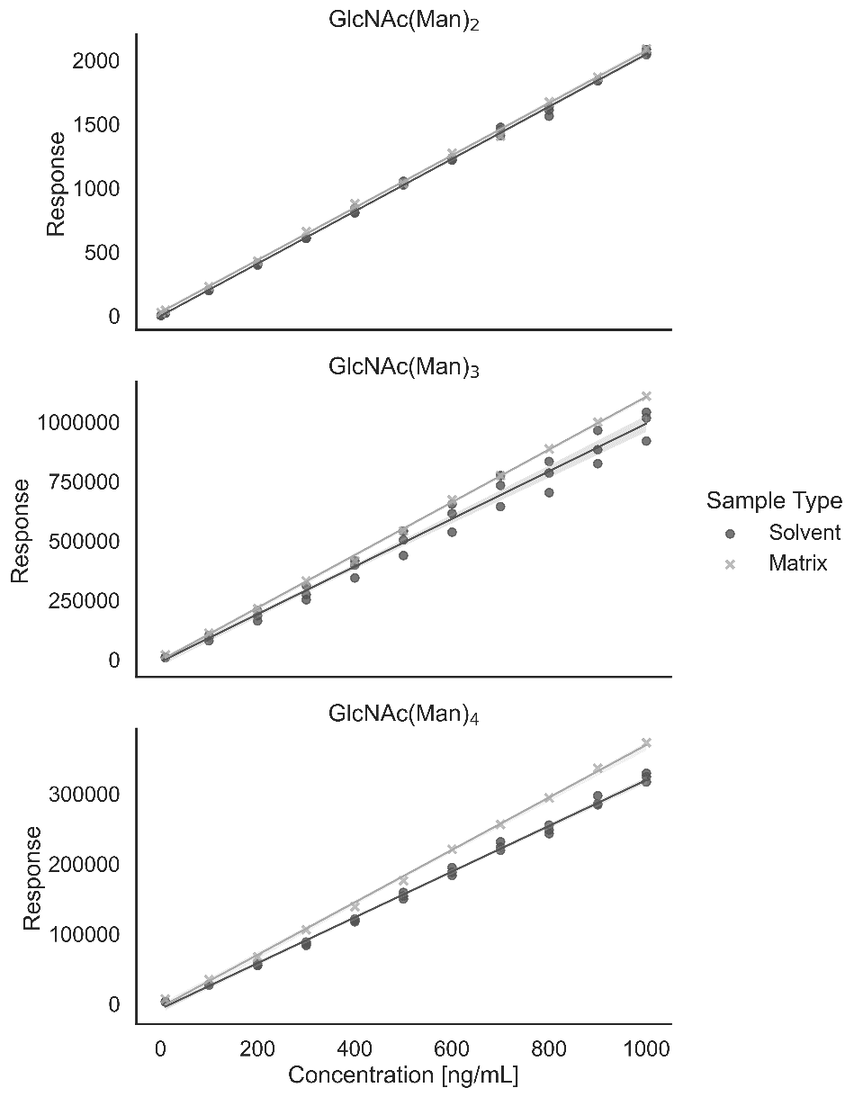

Figure S1: Linearity assessment for all three biomarkers in solvent and matrix.

Table S4: Linear regression parameters for all three biomarkers in solvent and matrix.
Analyte | Calibration Type | Solvent Calibration |  | Matrix Calibration
Analyte | Calibration Type | R² | Slope | R² | Slope
GlcNAc(Man)₂ | Internal Standard | 0.9991 | 2.042 | 0.9996 | 2.054
GlcNAc(Man)₃ | External Calibration | 0.9927 | 986.4 | 0.9996 | 1089.9
GlcNAc(Man)₄ | External Calibration | 0.9977 | 314.2 | 0.9983 | 360.0

For GlcNAc(Man)₂, a matrix calibration is not required, as the concentration is derived from the ratio to the internal standard. Since no internal standard is used for the quantification of GlcNAc(Man)₃ and GlcNAc(Man)₄, we assessed the suitability of a solvent calibration for the reliable quantification of GlcNAc(Man)₃ and GlcNAc(Man)₄ by calculating the recoveries for each matrix calibration point against the solvent calibration (Table S5). All calibration points are within ±20 % of the target value. Hence, we demonstrated that a solvent calibration results in concentrations equivalent to a matrix calibration.
To summarize, a linear relationship between analyte concentration and detector response was demonstrated in matrix and solvent. Additionally, the suitability of an external calibration without internal standard for the quantification of GlcNAc(Man)₃ and GlcNAc(Man)₄ was shown.

Carry-over
We assessed the carry-over by measuring a blank immediately after a calibration standard with concentrations of 1000 ng/mL for all three analytes. If a peak was detected (signal-to-noise ratio > 3), the area was subsequently divided by the area of the peak of the corresponding analyte’s LLOQ. The acceptance criteria were below 20 % for the analytes and below 5 % for the internal standard, in alignment with the criteria set forth by the method validation guideline.
For GlcNAc(Man)₂ and the internal standard GlcNAc(Man)₂-IS, no peak was detected. Hence, the carry-over is 0 % of the LLOQ for both substances. For GlcNAc(Man)₃ and GlcNAc(Man)₄, a peak was detected, which resulted in a carry-over of 2 % for both analytes. Thus, the carry-over is within the acceptable range for all four compounds.

Table S5: Recoveries of GlcNAc(Man)₃ and GlcNAc(Man)₄ at each calibration level. Concentrations were calculated via the solvent calibration.
Concentration [ng/mL] | GlcNAc(Man)₃ Recovery | GlcNAc(Man)₄ Recovery
10 | 114% | 118%
100 | 104% | 101%
200 | 105% | 102%
300 | 109% | 109%
400 | 108% | 108%
500 | 108% | 110%
600 | 112% | 115%
700 | 111% | 115%
800 | 111% | 116%
900 | 112% | 118%
1000 | 111% | 118%

Limit of detection and quantification
The LOD and LOQ are usually determined by 10-fold analysis of a matrix blank against a calibration curve. They are calculated by Formula 1 and 2, respectively:
(1) $LOD=3.3*σ$
(2) $LOQ=10* σ$
where σ is the standard deviation of the ten measurements.
During method development, we found that all urine samples contain certain amounts of the three biomarkers. Therefore, no true blank sample was available. Since substitution with water resulted in multiple runs without any response, especially for GlcNAc(Man)₄ (flat line), we decided to use a urine from the control cohort with very low concentrations for all three analytes (reference sample 26). The resulting LODs and LOQs for each analyte are presented in Table S6.

Table S6: LOD and LOQ in urine of all three analytes.
Analyte | LOD  [ng/mL Urine] | LOQ  [ng/mL Urine]
GlcNAc(Man)₂ | 40.7 | 123.3
GlcNAc(Man)₃ | 24.2 | 73.2
GlcNAc(Man)₄ | 19.0 | 57.5

LOD, limit of detection; LOQ, limit of quantification

In comparison to the LLOQ, which was calculated based on the lowest concentration of the calibration, the LOQ of GlcNAc(Man)₂ is very similar, while the LOQ of GlcNAc(Man)₃ and GlcNAc(Man)₄ are notably lower than their respective LLOQs of 1 µg/mL urine. The reason for this is the lower accuracy of this method for GlcNAc(Man)₃ and GlcNAc(Man)₄ in low concentrations, which has prompted us to increase the lowest calibration level to 10 ng/mL for GlcNAc(Man)₃ and GlcNAc(Man)₄ as compared to 1 ng/mL for GlcNAc(Man)₂. Nonetheless, with LOQs below 0.2 µg/mL, this assay proves sufficient sensitivity for the analysis of all three oligosaccharide biomarkers in urine.

Accuracy and precision
To determine accuracy and precision, we spiked the urine sample of a healthy volunteer with three different concentrations of all three analytes. The selected concentrations corresponded to a low spike level of 1 µg/mL urine, a medium spike level of 5 µg/mL urine, and a high spike level of 10 µg/mL urine. For these spiked samples along with a non-spiked sample, intra-assay (n = 6) and inter-assay (n = 6) measurements were performed. The inter-assay measurements were conducted on three different days by two different scientists. Accuracies are calculated by Formula 3:
(3) $Accuracy= \frac{c_{sample}-c_{blank}}{c_{spiked}}$,
where c_{sample} is the measured concentration of the spiked samples, c_{blank} is the measured concentration of the non-spiked sample, and c_{spiked} is the nominal concentration that was added to the spiked samples. Precision is determined by calculating the relative standard deviation of the accuracies. Acceptance criteria were ±15 % of the nominal concentration for accuracies and precision below 15 % for each spike level and assessment, as per the method validation guideline. The results are displayed in Table S7.

Table S7: Results for the accuracies and precisions of all three biomarkers.
Analyte | Accuracy [%] |  |  | Intra-assay precision [% RSD] |  |  | Inter-assay precision [% RSD]
 | L | M | H | L | M | H | L | M | H
GlcNAc(Man)₂ | 91 | 90 | 90 | 4 | 3 | 2 | 3 | 7 | 3
GlcNAc(Man)₃ | 88 | 89 | 90 | 4 | 2 | 2 | 3 | 7 | 1
GlcNAc(Man)₄ | 106 | 107 | 108 | 3 | 1 | 2 | 6 | 5 | 3

RSD, relative standard deviation

All accuracies are within ±15 % of the nominal concentration. All intra-assay precisions are below 5 % and all inter-assay precisions are below 8 %. Hence, the precision and accuracy of this method fulfill the method validation guideline acceptance criteria. The accuracy and precision of this method are validated successfully and highlight the high accuracy of our method.

Matrix effect
To evaluate the matrix effect according to the validation guideline, we selected six urine samples from six different individuals with a creatinine concentration from 0.10 to 1.78 g/L (mean: 0.68 g/L; standard deviation: 0.62 g/L).
From these urine samples, we prepared three different sample extracts: one was prepared without addition of any standards (neat) and two were spiked with an amount of all three oligosaccharide biomarkers, both before (pre) and after sample extraction (post), resulting in added concentrations of 10 ng/mL (low) or 100 ng/mL (high) in the sample extract, respectively. In addition, we prepared a calibration curve ranging from 1 - 1000 ng/mL, which also contained standard solutions with a concentration of 10 ng/mL or 100 ng/mL (standard). All solutions were prepared and analyzed in triplicate.

Table S8: Accuracies for all six individual sample matrices at low (L; 10 ng/mL) and high (H; 100 ng/mL) spiking levels (n = 3).
Matrix | Creatinine  [g/L] | GlcNAc(Man)₂ [mean ± RSD] |  | GlcNAc(Man)₃  [mean ± RSD] |  | GlcNAc(Man)₄ [mean ± RSD]
Matrix | Creatinine  [g/L] | L [%] | H [%] | L [%] | H [%] | L [%] | H [%]
1 | 0.10 | 102 ± 5 | 93 ± 2 | 97 ± 3 | 96 ± 1 | 93 ± 3 | 97 ± 2
2 | 0.21 | 102 ± 2 | 93 ± 1 | 97 ± 2 | 96 ± 3 | 98 ± 2 | 103 ± 2
3 | 0.44 | 105 ± 1 | 96 ± 1 | 99 ± 2 | 98 ± 2 | 102 ± 2 | 108 ± 2
4 | 0.61 | 107 ± 3 | 95 ± 3 | 103 ± 1 | 100 ± 3 | 101 ± 2 | 105 ± 4
5 | 0.92 | 94 ± 10 | 93 ± 3 | 95 ± 5 | 96 ± 3 | 96 ± 7 | 100 ± 3
6 | 1.78 | 114 ± 5 | 97 ± 5 | 99 ± 5 | 94 ± 6 | 118 ± 9 | 106 ± 6

RSD, relative standard deviation.
According to the validation guideline, the acceptance criteria for the matrix effect validation are accuracies between 85 and 115 % and variations of less than 15 % for each individual matrix. The results are presented in Table S8.
To summarize, except for the GlcNAc(Man)₄ concentration of the low spiking level of matrix six, the accuracies and variations are within the acceptance criteria for all matrices, analytes, and levels. The small deviation observed for GlcNAc(Man)₄ at the low spiking level of matrix six (118 %) is considered acceptable, as it is slight, only affects the secondary biomarker GlcNAc(Man)₄, and occurred only in a single sample with high creatinine concentration. Hence, the matrix effect is validated successfully.
To provide a more complete picture on the influence of matrix and sample preparation on the analyte detection by MS/MS, we assessed four additional parameters:
- Matrix Factor (MF): describes the influence of co-eluting matrix components on the analyte signal intensity after ionization in the mass spectrometer (i.e., ion suppression/enhancement)
- IS-normalized MF (IS-MF): corrects the matrix factor for ionization variability by normalization of the MF to that of the internal standard
- Extraction recovery (ER): represents the efficiency with which the analyte is extracted from the matrix during sample preparation
- Process efficiency (PE): demonstrates the overall efficiency from sample preparation to detector signal
These parameters are calculated based on the peak area rather than the corresponding concentrations. The results thus provide information about the amount of analytes that are injected into the detector which in turn allows insights into the behavior of the analytes throughout the analytical method. They are therefore not meant to assess the accuracy, precision, or matrix effect of our method, which have been successfully validated before. The four parameters are calculated via Formulas 4-7:
(4) $MF= \frac{Area\left(post\right)-Area(neat)}{Area(standard)}$
(5) $IS-MF= \frac{MF(Analyte)}{MF(IS)}$
(6) $ER= \frac{Area\left(pre\right)-Area(neat)}{Area\left(post\right)-Area(neat)}$
(7) $PE=\frac{Area\left(pre\right)-Area(neat)}{Area(standard)}$

The results, expressed as averages of the values calculated for each individual matrix and their relative standard deviations, are presented in Table S9.

Table S9: Assessment of matrix factor, IS-normalized matrix factor, extraction recovery, and process efficiency in low (L; 10 ng/mL) and high (H; 100 ng/mL) spiked samples (n = 6 matrices measured in triplicate).
Parameter | GlcNAc(Man)₂  [mean ± RSD] |  | GlcNAc(Man)₃  [mean ± RSD] |  | GlcNAc(Man)₄  [mean ± RSD]
Parameter | L [%] | H [%] | L [%] | H [%] | L [%] | H [%]
Matrix Factor | 108 ± 5 | 91 ± 9 | 100 ± 3 | 97 ± 2 | 118 ± 9 | 113 ± 4
IS-normalized Matrix Factor | 113 ± 4 | 94 ± 8
Extraction Recovery | 78 ± 18 | 81 ± 5 | 90 ± 9 | 84 ± 3 | 86 ± 23 | 86 ± 4
Process Efficiency | 85 ± 20 | 74 ± 5 | 90 ± 10 | 81 ± 4 | 101 ± 19 | 97 ± 3

RSD, relative standard deviation

The average MF is close to 100 % for GlcNAc(Man)₂ and GlcNAc(Man)₃, with low relative standard deviations for both compounds, indicating only marginal ion suppression and enhancement by matrix components in all six urine samples. Moreover, the IS-MF for GlcNAc(Man)₂ is similar, indicating that the calculation of GlcNAc(Man)₂ concentrations based on the internal standard is not influenced by any major ionization effects due to the sample matrix. Minor matrix-induced ion enhancement was observed for GlcNAc(Man)₄ (118 ± 9 % at 10 ng/mL and 113 ± 4 % at 100 ng/mL). Yet, previous investigations of the matrix effect showed that this deviation is mostly compensated for by the calibration curve during quantification.
The average ER is between 78 to 90 % for all analytes and concentration levels. Notably, at the lower concentration, the extraction recovery showed a higher variance of up to ± 23 % for GlcNAc(Man)₄, while the maximum variance at the high concentration is ± 5 % for GlcNAc(Man)₂. These results demonstrate that, for lower analyte concentrations, analyte extraction is generally worse in urine with higher creatinine concentrations (data not shown). For pathologic biomarker concentrations, however, analyte extraction is generally high (81 – 86 %) and comparable (< ± 6 %) even in urine samples with highly different creatinine concentrations. Moreover, calculation of analyte concentrations by internal standard and calibration curve effectively compensates for most of the effects that result in lower ER. Since the PE is the product of MF and ER, its overall results are also acceptable.
These results demonstrate that our simple dilute-and-shoot approach generally results in reliable biomarker concentrations. The addition of an internal standard effectively compensates for most of the adverse effects observed during extraction and detection, resulting in a more robust quantification. Therefore, we will use GlcNAc(Man)₂ as the primary biomarker, which is also supported by the highest concentrations and the largest separation between untreated AM patients and unaffected controls.

Stability
To assess the stability, we deviated slightly from the method validation guideline due to the high cost of the standards, that would be required to perform a thorough analysis of the stability of the analyte in matrix by spiking a blank matrix, as well as the lack of a blank matrix. To circumvent these limitations, we used the fresh urine (sampled at day 0) of a confirmed untreated AM patient and divided this bulk sample into aliquots of 100 µL. To investigate the long-term stability in matrix at different storage conditions, we measured the concentration on day 0 and stored at least 15 aliquots each at room temperature (20 °C), under refrigeration conditions (4 °C), in the freezer (-20 °C), and in the deep freezer (-80 °C). One aliquot of the samples stored at room temperature was analyzed every working day for two weeks, to investigate the possibility of unrefrigerated shipping. Furthermore, one aliquot of each storage condition was analyzed every two weeks for eight weeks. All analyses were performed in duplicate.
In addition to the long-term sample stability assessments, we examined the freeze-thaw stability by storing aliquots in the deep freezer (-80 °C) and analyzing them every two weeks for eight weeks. At every sampling day, we thawed all aliquots at room temperature, resulting in a total of four freeze-thaw-cycles before the last analysis after eight weeks. The method validation guideline’s acceptance criteria are ±15 % of the nominal concentration. However, the sample we employed for stability assessment did not have a nominal concentration. Therefore, taking into account the intra-assay imprecision of below 5 % for the initial measurement, we accepted a deviation of ±20 % of the initial concentration. The results of both stability assessments (long-term and freeze-thaw experiments) are shown in Figure S2.
For GlcNAc(Man)₂, results for all storage conditions (long-term and freeze-thaw experiments) are within the acceptance criterion of ± 20 % of the initial measurement, except for the aliquot analyzed after eight weeks of storage under refrigerated conditions (4 °C), which resulted in a slightly elevated recovery of 121 %. The results for GlcNAc(Man)₃ are similar to those of GlcNAc(Man)₂. Only the samples stored at 4 °C fall outside the acceptable range at sampling days 28 and 56, with GlcNAc(Man)₃ recoveries of 128 % and 124 %, respectively. While the samples stored at 4 °C resulted in an increased of measured concentrations of GlcNAc(Man)₂ and GlcNAc(Man)₃ at some sampling days, the GlcNAc(Man)₄ concentrations were significantly decreased to 68 % recovery after six weeks of storage and 56 % after eight weeks of storage. Additionally, the GlcNAc(Man)₄ concentration of the freeze-thaw stability assessment after four weeks (= after two freeze-thaw cycles) slightly surpassed the acceptance criterion with a recovery of 126 %. At six and eight weeks, the recoveries were again within the target range (80 - 120 %). These results show that the analytes are stable in urine for the investigated period at room temperature (20 °C), in the freezer (-20 °C), and in the deep freezer (-80 °C). Under refrigeration conditions (4 °C), however, GlcNAc(Man)₄ is likely to degrade, leading to decreased GlcNAc(Man)₄ concentrations after four weeks of storage. We hypothesize that psychrophilic microbes (i.e., microbes that grow at 0 °C or below and up to 20 °C) degrade GlcNAc(Man)₄ into GlcNAc(Man)₃, GlcNAc(Man)₂, and other compounds, resulting in elevated concentrations of GlcNAc(Man)₂ and GlcNAc(Man)₃. Hence, sample storage under refrigeration conditions negatively impacts the stability of the analytes in matrix. Since the GlcNAc(Man)₄ concentrations of the freeze-thaw stability assessments were within the acceptance criteria for all but one freeze-thaw cycle, while the results for GlcNAc(Man)₂ and GlcNAc(Man)₃ were within the acceptance criteria at all sampling days, we concluded that the measurement of GlcNAc(Man)₄ that did not meet the acceptance criteria is an acceptable outlier.
In conclusion, the long-term stability of the analytes in matrix for up to eight weeks and the freeze-thaw stability in matrix for up to four freeze-thaw cycles are successfully validated. The results show that the analytes are stable in urine stored at room temperature for an extended time period, enabling shipment of samples without the need for refrigeration. Additionally, samples are long-term stable at -20 °C and -80 °C and can be frozen and thawed multiple times without affecting analysis results. For now, time restrictions limited the assessment to eight weeks and the long-term stability validation is still ongoing for up to another ten months. Nonetheless, the results do not show any indication suggesting that long-term sample stability may be less than one year.
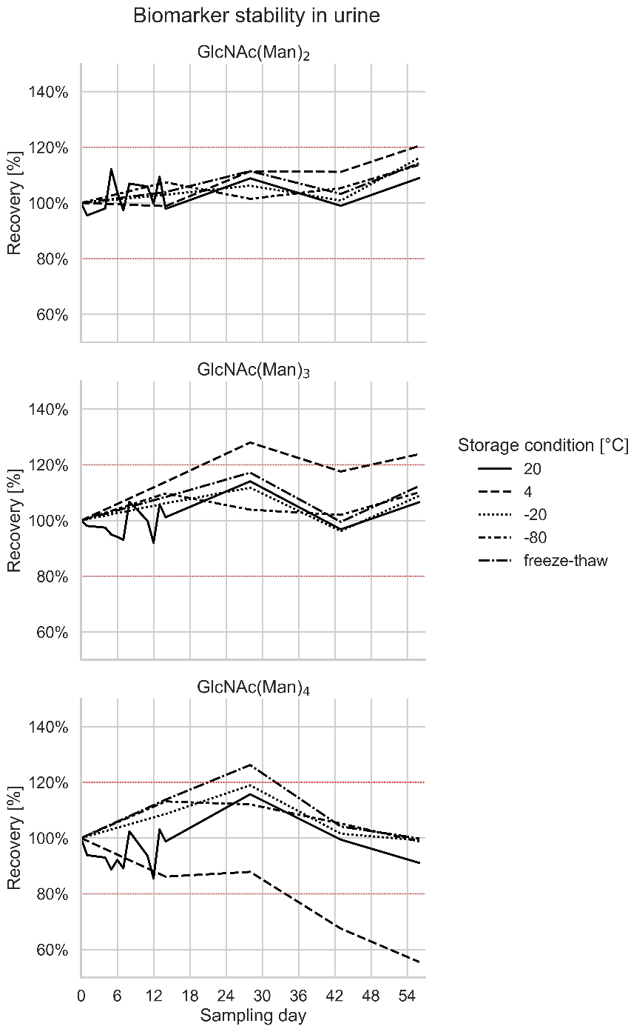

Figure S2: Long-term and freeze-thaw stability of all three biomarkers in urine.

Analytical specificity
According to the method validation guideline, the analytical specificity of a method is the ability to detect and differentiate the analyte from other substances. Liquid chromatography (LC) tandem-mass spectrometry (MS/MS) assays generally exhibit a high level of analytical specificity because of the combination of analyte separation by liquid chromatography and MS/MS detection, where fragment ions are often specific for the compound.
However, during method development, we found that other compounds may be present in urine that exhibit the same retention time and molecular weight as GlcNAc(Man)₂, GlcNAc(Man)₃, and GlcNAc(Man)₄, respectively. Extensive method development, including the investigation of three different column chemistries, multiple eluents with different additives, and a selection of the most sensitive MS/MS-transitions, even including formate and sodium adducts, did not resolve this co-elution. MS/MS fragmentation of these compounds also results in fragment ions with m/z 204, which is a signature fragment ion of all compounds with a terminal N-acetylated hexose and is used as the quantifier transition for all three analytes in this assay. This observation in combination with the finding that the unknown compounds are particularly abundant in control samples from infants below two years of age (Figure 1, Figure S3, and Figure S4), led us to the hypothesis, that the unknown compounds could be oligosaccharides derived from milk ingested with food. The other fragment ion with sufficient intensity for the analysis of GlcNAc(Man)₂, GlcNAc(Man)₃, and GlcNAc(Man)₄ (i.e., the qualifier transition) has an m/z of 222, which corresponds to a very unspecific neutral loss of a water molecule (mass of 18 u) compared to the signature fragment ion. Therefore, we cannot exclude that the response of the qualifier transition is also affected by the unknown compounds. For GlcNAc(Man)₂, further investigations have shown that the two urine samples with relatively high concentrations of these other compounds are also extreme outliers regarding their quantifier/qualifier ratios (> 20). These quantifier/qualifier ratios are very different from the quantifier/qualifier ratios observed when measuring standards and samples of known AM patients (1.1 - 1.3). Hence, the elevated quantifier/qualifier ratio indicates the presence of other compounds in the sample. Nevertheless, the oligosaccharide concentrations of samples with a high GlcNAc(Man)₂ quantifier/qualifier ratio (> 20) were lower than the lowest GlcNAc(Man)₂ concentrations found in untreated AM patients and, in case of uncertainties, the quantifier/qualifier ratio can be used as an additional threshold criterion. Thus, we concluded that, while the analytical specificity of this method is not within the method validation guideline’s acceptance criteria, there is no negative impact on the diagnostic sensitivity and, subsequently, the diagnostic power of this assay.

Results
Individual analyte concentrations from the samples of AM patients are listed in Table S1. The results of the quantification of GlcNAc(Man)₂, GlcNAc(Man)₃, and GlcNAc(Man)₄ in urine samples of patients with other lysosomal storage disorders are provided in Table . Table provides the cohort-specific upper and lower limits of the concentration ranges for each analyte. While results of the key biomarker GlcNAc(Man)₂ are presented in the main text, results of GlcNAc(Man)₃ and GlcNAc(Man)₄ of all study samples are shown below as scatterplots in Figure S3 and Figure S4, respectively.

Table S10: Biomarker concentrations in samples of patients with other lysosomal storage diseases.
Patient number | Sample number | GlcNAc(Man)₂ [µmol/mmol creatinine] | GlcNAc(Man)₃ [µmol/mmol creatinine] | GlcNAc(Man)₄ [µmol/mmol creatinine]
0002 | 0124 | 0.8 | 0.5 | 0.7
0009 | 0124 | 0.3 | 0.3 | 0.3
0010 | 0124 | 0.5 | 0.3 | 0.3
0011 | 0124 | 0.2 | 0.1 | 0.2
0019 | 0124 | 0.3 | 0.2 | 0.2
0020 | 0124 | 0.4 | 0.3 | 0.3
0021 | 0124 | 1.1 | 0.7 | 0.6
0022 | 0124 | 0.9 | 0.6 | 0.7
0023 | 0124 | 0.3 | 0.2 | 0.2
0025 | 0124 | 0.8 | 0.5 | 0.5
0025 | 0224 | 0.8 | 0.4 | 0.5
0026 | 0124 | 0.3 | 0.2 | 0.2
0027 | 0124 | 0.9 | 1.8 | 0.3
0029 | 0124 | 0.4 | 0.2 | 0.2
0029 | 0224 | 0.3 | 0.2 | 0.2
0030 | 0124 | 0.4 | 0.2 | 0.3
0031 | 0124 | 1.2 | 0.8 | 0.9
0033 | 0124 | 0.5 | 0.3 | 0.4
0034 | 0124 | 0.2 | 0.1 | 0.2
0044 | 0124 | 0.5 | 0.3 | 0.3
0045 | 0124 | 0.4 | 0.3 | 0.3
0046 | 0124 | 0.3 | 0.2 | 0.3
0051 | 0124 | 7.8 | 8.1 | 12.7
0051 | 0125 | 3.4 | 3.2 | 2.8
0053 | 0125 | 0.5 | 0.4 | 0.5
0058 | 0125 | 0.2 | 0.2 | 0.2
0059 | 0125 | 0.6 | 0.4 | 0.4
0063 | 0125 | 0.4 | 0.1 | 0.2
0065 | 0125 | 0.7 | 0.6 | 0.6

Table S11: Overview of upper (U) and lower (L) limits of the concentration ranges of all three biomarkers for all study cohorts.
Cohort | GlcNAc(Man)₂/Creatinine [µmol/mmol] |  | GlcNAc(Man)₃/Creatinine [µmol/mmol] |  | GlcNAc(Man)₄/Creatinine [µmol/mmol]
Cohort | L | U | L | U | L | U
Controls | 0.0 | 9.0 | 0.0 | 41.0 | 0.0 | 3.1
Untreated | 39.4 | 99.3 | 8.3 | 27.5 | 6.4 | 18.8
ERT | 12.1 | 68.2* | 2.9 | 16.1* | 2.2 | 8.9*
HSCT | 3.3 | 9.1 | 0.8 | 2.1 | 0.6 | 1.4
Other LSDs | 0.2 | 7.8 | 0.1 | 8.1 | 0.2 | 12.7**

ERT, enzyme replacement therapy; HSCT, hematopoetic stem cell transplantation; LSD, lysosomal storage disorder.

* Overlap between the upper limits in patients on ERT and the ranges in untreated patients with alpha-mannosidosis is the result of one sample only (patient 73, sample 0125) – this is also discussed in the main text.
** Overlap between the upper limit of GlcNAc(Man)₄ in patients with other LSD and the range of GlcNAc(Man)₄ in untreated patients with alpha-mannosidosis is the result of one sample only (patient 51, sample 0124) – this can also be seen in Figure 4 of the main text.

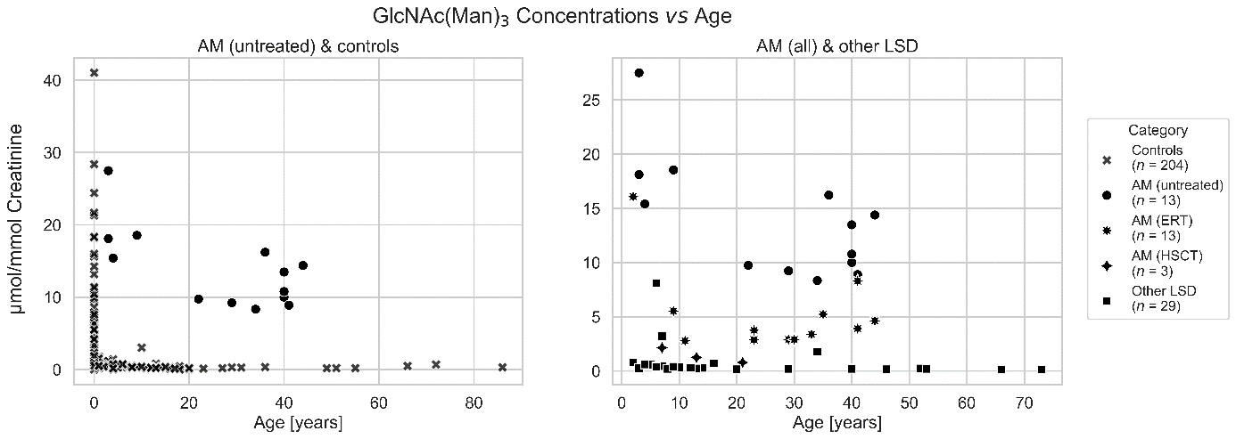

Figure S3: Scatterplot of all samples analyzed in this study. GlcNAc(Man)₃ concentrations are plotted against the age of the subject at the time of sampling. AM, alpha-mannosidosis; ERT, enzyme replacement therapy; HSCT, hematopoietic stem cell transplantation.
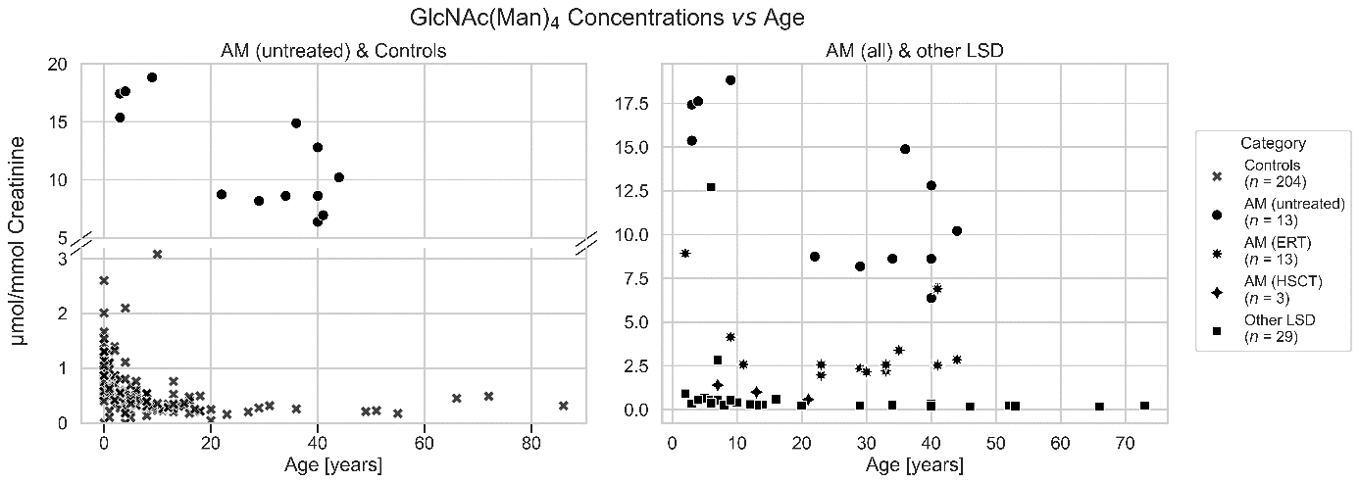

Figure S4: Scatterplot of all samples analyzed in this study. GlcNAc(Man)₄ concentrations are plotted against the age of the subject at the time of sampling. AM, alpha-mannosidosis; ERT, enzyme replacement therapy; HSCT, hematopoietic stem cell transplantation.

Treatment Monitoring
From some patients, multiple samples have been obtained at different time points. Two samples were available from patients 28 and 72, one each before any treatment and one approximately one year after starting ERT (Figure S5). Furthermore, three samples from patient 39 were available, which were all collected prior to the start of any treatment. The concentrations of all three biomarkers in the three samples are displayed in Figure S6. Likewise, two samples were obtained from patient 35, which however were both sampled after the start of ERT (Figure S7).
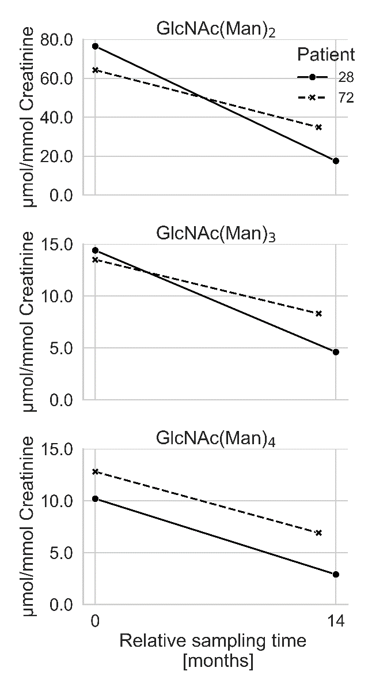

Figure S5: Course of biomarker concentration in patients 28 and 72 before (0 months) and approximately one year after starting ERT treatment (13 and 14 months, respectively). ERT, enzyme replacement therapy
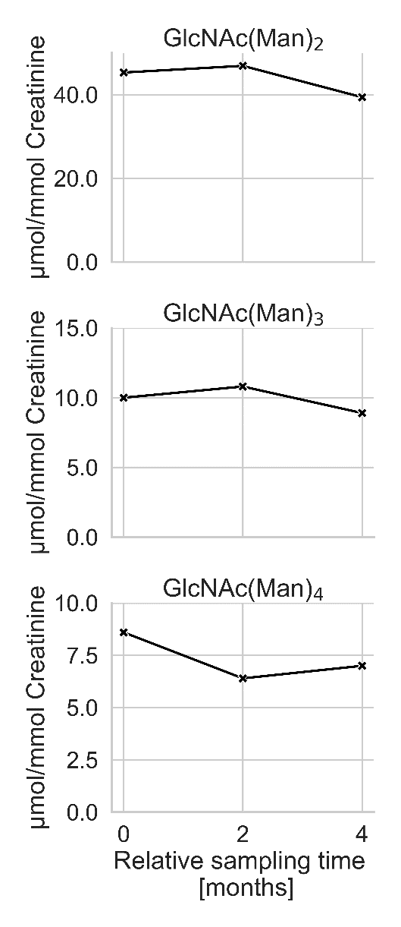

Figure S6: Course of biomarker concentration in patient 39 (untreated) over time.
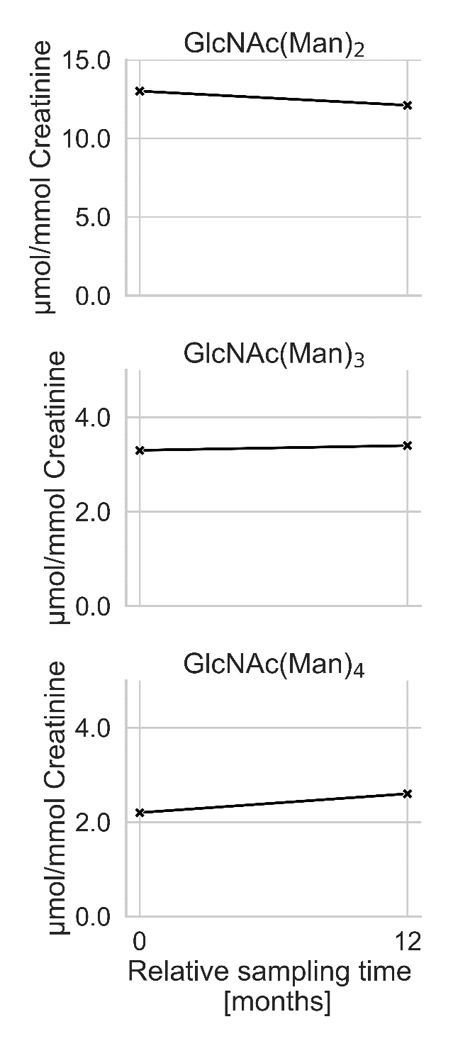

Figure S7: Course of biomarker concentration in patient 35 (ERT) over time.

References
- Committee for Medicinal Products for Human Use, European Medical Agency. International Council for Harmonisation of Technical Requirements for Pharmaceuticals for Human Use (ICH) guideline M10 on bioanalytical method validation and study sample analysis.
https://www.ema.europa.eu/en/documents/scientific-guideline/ich-guideline-m10-bioanalytical-method-validation-step-5_en.pdf (Accessed Oct 2025).

