Supplementary Material

Shear-Wave Ultrasound Elastography for Tissue-Specific Quantification of Radiation-Induced Cervical Fibrosis

Supplementary material A

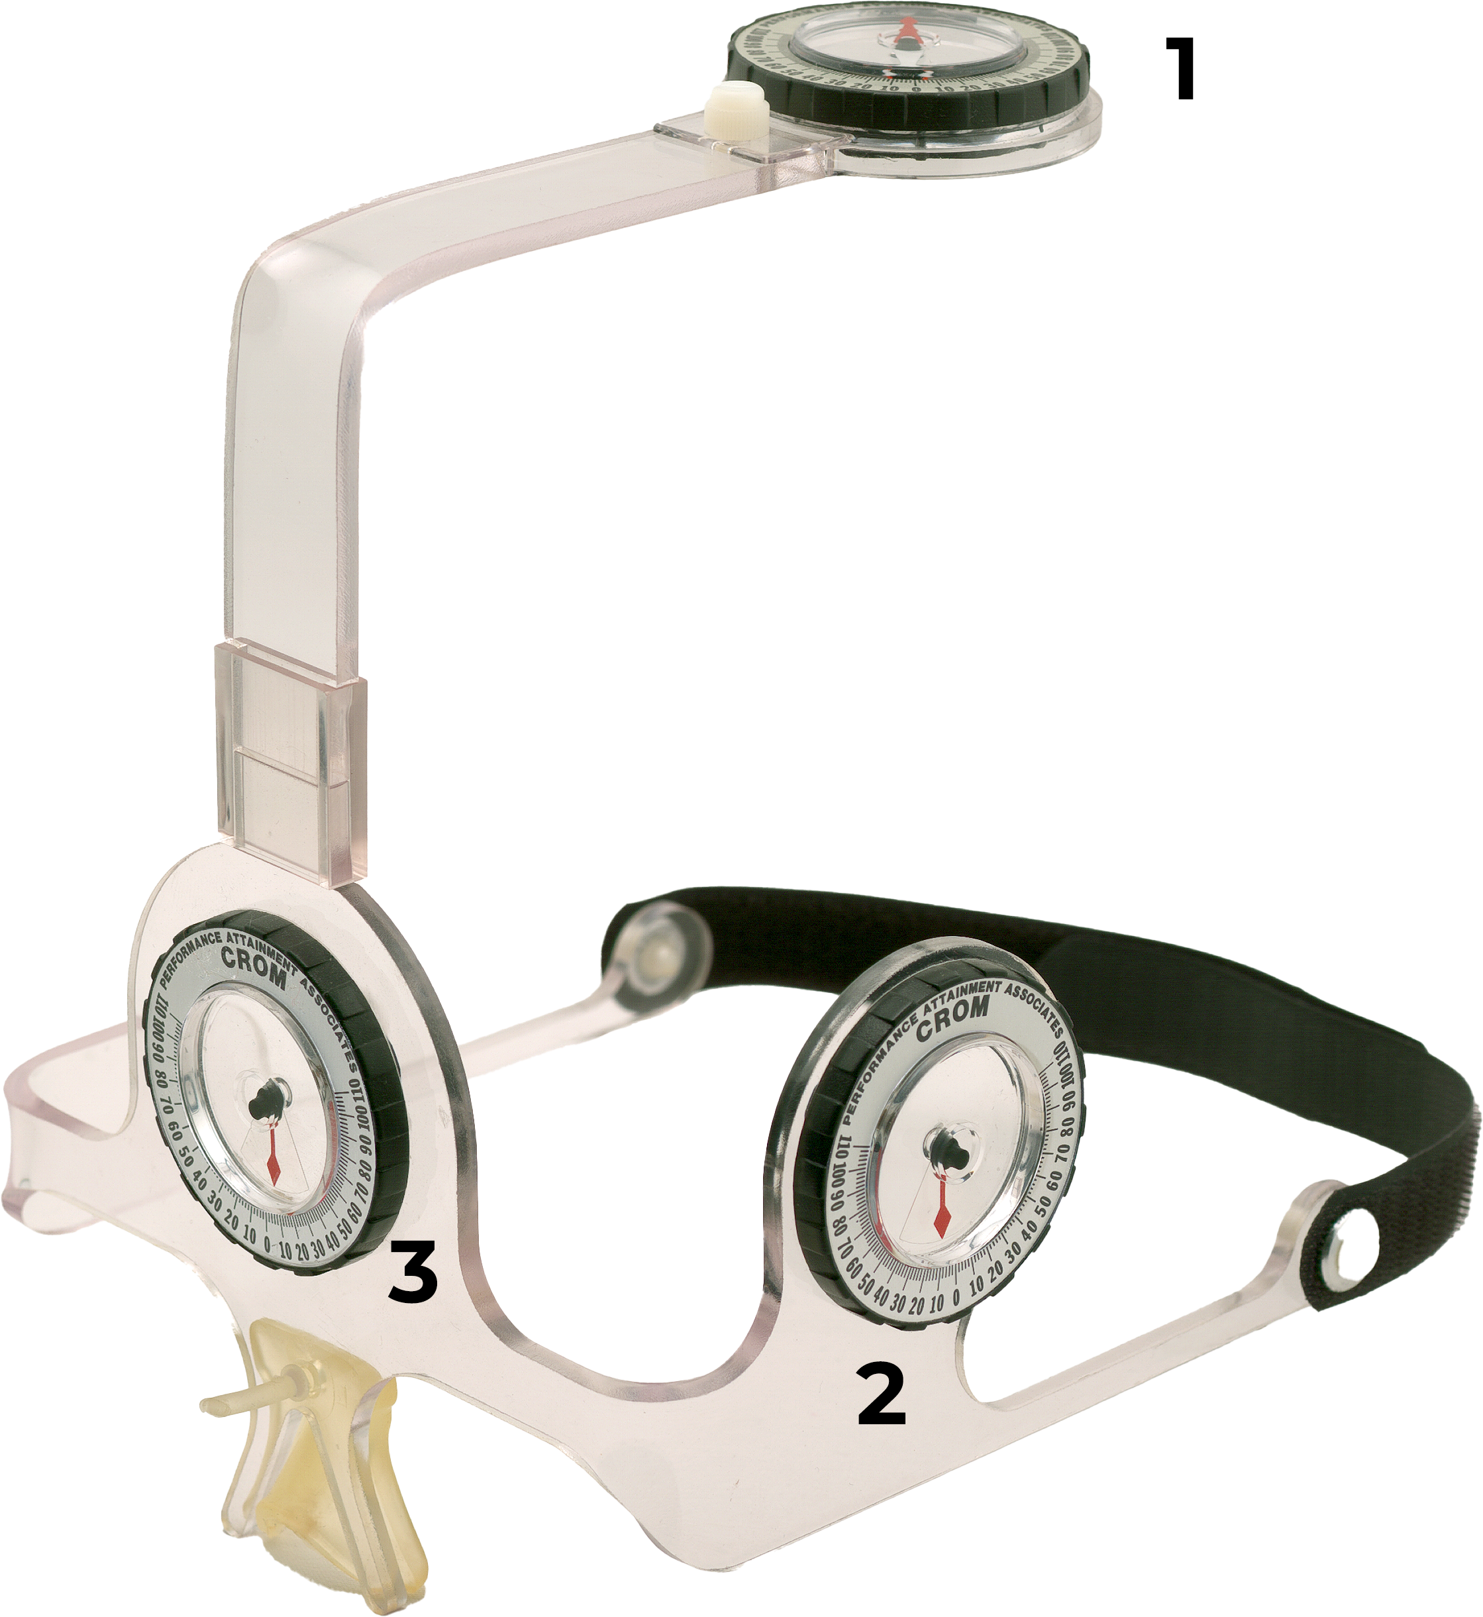
Figure S1 Cervical Range of Motion Device (CROM) 1 Compass goniometer for rotation measure- ment, 2 Gravity goniometer for flexion and extension measurement, 3 Gravity goniometer for lateral flexion measurement

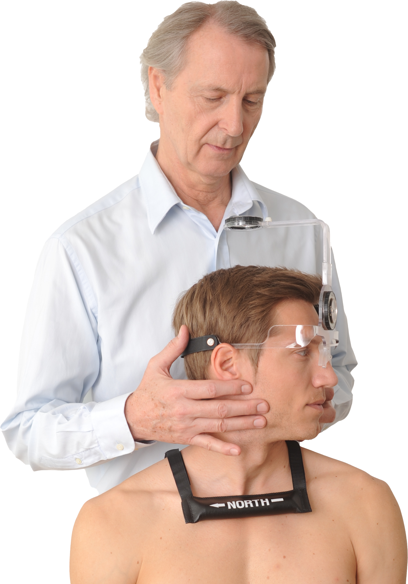

Figure S2 Rotation measurement with the compass goniometer of the CROM device. A magnetic yoke stabilizes the compass needle, compensating for the influence of electromagnetic fields.

Figure S3 Schematic illustration of the positioning of the ultrasound probe along the sternocleidomastoid muscle.

Power Analysis (Post-irradiated vs. Controls)
Method of Power Analysis
Comparison: Independent groups (post-irradiated patients vs. controls) for each measurement site.
Effect size: Cohen’s d = (M_post − M_control) / SD_pooled, where SD_pooled = sqrt((SD_post² + SD_control²) / 2).
Test: Two-sided t-test, α = 0.05, 1:1 allocation.
Assumed sample size for power estimation: n = 16 per group.
Data source: Means and standard deviations provided.

Main Results (n = 16 per group)
All measurement sites showed markedly higher stiffness in the post-irradiated group. Absolute differences ranged from +39.6 to +72.8 kPa. Standardized effect sizes were consistently large (d = 1.01–1.35). The corresponding statistical power was high—≥ 0.85 for all but one site (range 0.79–0.96). Reported p-values (<0.001) are consistent with these large effects.

Site Δ Mean (kPa) Cohen’s d Power (n=16)
L mid SCM 47.7 1.15 0.88
L low SCM 44.3 1.35 0.96
R mid SCM 48.8 1.14 0.88
R low SCM 56.1 1.16 0.89
Mean SCM 44.7 1.33 0.95
L mid superficial fascia 39.6 1.11 0.86
L low superficial fascia 51.1 1.18 0.90
R mid superficial fascia 42.9 1.01 0.79
R low superficial fascia 72.8 1.09 0.85
Mean superficial fascia 48.6 1.28 0.94

Highlights
• Largest standardized effect: L low SCM (d = 1.35; Power 0.96)
• Largest absolute difference: R low superficial fascia (+72.8 kPa; d = 1.09; Power 0.85)
• Compartment means: Mean SCM d = 1.33 (Power 0.95), Mean superficial fascia d = 1.28 (Power 0.94)
• Only one site fell slightly below the conventional 0.80 threshold for adequate power: R mid superficial fascia (Power 0.79)

Sample Size Planning (Future Studies)
Required n per group for 80% power (α = 0.05, two-sided), based on observed d-values:
• 10–11 per group are sufficient for Mean SCM (d = 1.33) and Mean superficial fascia (d = 1.28)
• 10–15 per group for most individual sites (e.g., L mid SCM 13; R low superficial fascia 15)
• Up to 17 per group if aiming to detect the smallest observed effect (R mid superficial fascia, d = 1.01) with ≥0.80 power individually

Interpretation
The post-irradiated group exhibited markedly increased tissue stiffness of both the sternocleidomastoid (SCM) and the superficial fascia compared to controls. The large effect sizes indicate clinically relevant differences, and with n = 16 per group, statistical power was high for almost all sites. For future studies, n ≈ 12–15 per group will generally be sufficient; only the weakest effect would require ≈ 17 per group for robust detection.
Note: This power analysis is based on group means/SDs and the assumption of independent samples with a two-sided t-test. If variances differ substantially or distributions deviate from normality, robust or transformed analyses should be considered in addition.

