Online-Only Supplemental Material

Supplemental Data 1: Physical activity recommendations protocol
The aerobic effort increased gradually, starting with 20 minutes of aerobic training at 65% maximum heart rate, and increased to 45-60 minutes of aerobic training at 80% maximum heart rate. The full workout program included 45-60 minutes of aerobic training 3-4 times/week. Resistance training started with one set of weights corresponding to 60% of the maximum weight, eventually reaching the use of two sets of weights corresponding to 80% of the maximum weight. The resistance training included leg extensions, leg curls, squats, lateral pull-downs, push-ups, shoulder presses, elbow flexions, triceps extensions, and bent-leg sit-ups. The PA recommendations were delivered as part of the 90-minute nutritional and PA sessions in the workplace with multidisciplinary guidance (physicians, clinical dietitians, and fitness instructors). In addition, a website listing all PA information needed for the participants was accessible to them. Assessment of lifestyle habits including PA was performed using validated self-reported food-frequency questionnaires at baseline, after 6- and 18-months[1-3]. The PA was measured in metabolic equivalent (MET) units[4].

Supplemental Data 2: Polyphenol-rich foods, provided at no cost to participants
Walnuts (groups MED, green-MED): The main polyphenols in walnuts are ellagitannins, ellagic acid, and their derivatives[5]. Walnuts are considered to have a beneficial effect on health maintenance and disease prevention[6, 7]. Additionally, ellagitannins found in nuts were reported to reduce WC, LDL-c, and TG[8]. The nutrition composition of walnuts (28g), taken from the USDA: energy:183 kcal, protein: 4.3g, lipids: 18.3g, carbohydrates: 3.8, fiber: 1.9g, total saturated fatty acids– 1.7g, total monounsaturated fatty acids– 2.5g, total polyunsaturated fatty acids – 13.2g.
Green tea (group green-MED): an unfermented tea produced from the leaves of Camellia sinensis, prepared by drying and steaming the leaves, and is a rich source of polyphenols[9]. Most of the polyphenols found in green tea are catechins (the monomer form of flavanols), mainly epigallocatechin (EGC), epicatechin gallate (ECG), and epigallocatechin gallate (EGCG)[10, 11]. Short-term (weeks long) intervention studies and meta-analyses have found an association of green tea or its extracts with improvements in cardiometabolic health[12, 13], weight reduction[11], and cognitive function[14, 15]. The participants were required to pour heated water over the green tea bag and steep for 3 minutes.

Wolffia globosa duckweed - Mankai (group green-MED): A specific strain of Wolffia globosa, an aquatic plant in the duckweed family[16, 17], can serve as a plant protein source. In Asian cuisines, Wolffia globosa is considered a natural food source or "vegetable meatball"[16]. Nutritionally, Mankai is characterized by high protein content (more than 45% of the dry matter) and the presence of 9 essential and 6 conditional amino acids[18]. In addition, it is a good source of omega-3 fatty acids[19]. The Mankai plant is rich in insoluble fibers, vitamins (including vitamin B12)[20], minerals (including iron and zinc), and polyphenols, including ellagic acid, benzoic acid, naringenin, luteolin, quercetin, p-coumaric acid, and caffeic acid[21, 22]. The nutrition composition of Mankai (values for 100gr of frozen cubes Mankai shake (~20g dry): Energy:80 kcal, protein: 9g, lipids: 1.6g, carbohydrates: 7.5, fiber: 1.9g, total saturated fatty acids– 1.7g.
Mankai provides bioavailable essential amino acids[18] and iron[23] and has a beneficial effect on postprandial and fasting glycemic control[24]. We guided the participants to prepare a green Mankai shake with additional ingredients, which were also part of the diet regimen (fruits, walnuts, or vegetables) each evening. The green protein shake partially substituted for dinner, replacing beef/poultry protein sources.

Supplemental Data 3: Adherence data
The participants in the green-MED diet reported an average (weighted mean of both 6- and 18-month reports) green tea consumption of 2.7(1.5)/day (median=2.7 cups/day) and weekly consumption of Mankai of 2.6(1.8)/week (median=2.3 shakes/week). Both MED groups reported a similar intake of walnuts (median amount per day=28g, p=0.91) and a higher frequency walnut intake compared to HDG (p<0.001 HDG vs. MED; p<0.001 HDG vs. green-MED). Furthermore, over 18 months, the MED groups had similar carbohydrate intake reductions (MED:-29.4%(31.9); green-MED:-29.1%(31.7), p=0.79) compared to the HDG group (-14.4%(36.4), p=0.02 vs. green-MED and p=0.01 vs. MED). There were no significant differences in PA intensity levels, measured in MET units, across groups after 18 months of intervention (p=0.85).

Supplemental Data 4: Sample size calculations
The sample size calculation for the visceral fat changes was based on findings from our previous CENTRAL trial[25] and estimated a total of n=250 participants (-47.3±36.6 visceral fat reduction in the MED diet vs. -32.9±33.5 in the reference low-fat diet; 14.4 difference; power= 90%, alpha= 5%).

Supplemental Data 5: We explored whether the association between folate change and methionine change is modified by genotype. We observed a significant interaction between folate change and MTHFR genotype in predicting methionine concentrations (p interaction = 0.009) adjusted for age and sex.
In TT individuals, the association between methionine change and folate change was reversed (r=-0.46; p=0.026).

Supplemental Table1: Outline of dietary and PA recommendations
Green-MED |  | MED | HDG
18-months group sessions in the workplace, weekly for the first month and monthly thereafter  18 months free gym membership  18 months of PA educational sessions  45-60 minutes of aerobic training + resistance training, 3-4 times/week |  |  |  | Lifestyle group sessions, including PA
Limit dietary cholesterol, trans-fat, saturated fat, sugars, and salt and increase intake of vegetables |  |  |  | General dietary guidance
1500-1800 kcal/day for men, 1200-1400 kcal/day for women |  |  | Guidelines for a healthy MED diet with no specific recipes or calorie restriction | Energy, kcal/day
~40% mainly PUFA and MUFA |  |  |  | Total fat, % of daily consumption
Less than 40 gr/day in the first 2 months with increased gradual intake for up to 80 gr/day |  |  |  | Carbohydrates, gr/day
Less red and processed meats. Reduced poultry intake |  |  |  | Specific recommendations
+1240 mg/day  [source: provided walnuts (28 g/day), green tea (3-4 cups/day), Wolffia globosa duckweed (Mankai) shake (100 g frozen cubes)] | +440 mg/day  [source: provided  walnuts (28g/day] |  |  | Polyphenols, mg/day

Supplemental Table2: Baseline characteristics of the study population and comparison with the mRNA and genotyped subcohorts
 | Genetic variation SNP rs1801133 | mRNA analysis | Entire
Men, % of study population | 215 (93.1%) | 131 (89.7%) | 266 (90.6%)
Age, years | 50.2 (9.8) | 49.7 (9.5) | 50.1 (10.0)
BMI, kg/m² | 31.2 (3.8) | 31.1 (3.9) | 31.4 (4.0)
WC, cm
Men | 110.7 (9.1) | 109.9 (9.7) | 110.9 (9.3)
Women | 101.7 (7.8) | 100.8 (6.8) | 102.6 (9.3)
Blood pressure, mm Hg
Diastolic | 81.1 (10.3) | 80.5 (11.0) | 81.2 (10.1)
Systolic | 129.8 (13.9) | 129.3 (14.7) | 129.7 (14.0)
Serum LDL cholesterol, mg/dL | 124.3 (29.6) | 123.4 (29.5) | 126.1 (31.0)
Serum HDL cholesterol, mg/dL
Men | 44.3 (9.7) | 44.8 (9.7) | 44.2 (10.0)
Women | 54.7 (10.7) | 54.0 (11.9) | 54.6 (11.3)
Fasting glucose, mg/dL | 101.6 (17.1) | 101.2 (15.9) | 101.6 (16.7)
Fasting insulin, µIU/mL | 14.5 (7.3) | 14.0 (6.9) | 14.9 (7.9)
Serum folate, ng/mL | 7.6 (3.0) | 8.0 (3.1) | 7.6 (2.9)
B12 vitamin, pg/mL | 396.2 (146.7) | 394.1 (143.4) | 397.2 (145.6)
Ferritin, ng/mL | 165.8 (113.1) | 165.1 (115.0) | 169.9 (114.2)
Transferrin, mg/dL | 266.8 (33.4) | 269.0 (35.7) | 267.7 (33.7)
Hemoglobin, g/dL | 15.0 (1.1) | 15.0 (1.1) | 14.9 (1.1)

The clinical characteristics of the mRNA subset were comparable to those of the entire study cohort, with no statistically significant differences observed (all adjusted P > 0.05).

Supplemental Table 3. Phenotype characteristics after 18 months of the DIRECT PLUS clinical trial participants across baseline fasting folate levels

Serum Folate baseline quantiles (ng/mL)  Phenotype Characteristics | Q1: <= 5.12  N=51 |  | Q2: 5.12 - 6.49  N=51 |  | Q3: 6.49 - 7.90  N=49 |  | Q4: 7.90 - 9.53  N=51 |  | Q5: 9.53+  N=49
 | Mean | SD | Mean | SD | Mean | SD | Mean | SD | Mean | SD | p of trend
Folate _{T0} (ng/mL) | 4.01 | 0.83 | 5.85 | 0.42 | 7.19 | 0.37 | 8.81 | 0.52 | 11.54 | 1.93
Age _{T0} | 47.07 | 9.93 | 50.39 | 9.21 | 49.96 | 9.08 | 52.11 | 9.35 | 48.75 | 10.94 | 0.30
absolute weight change _{T18-T0} | -3.18 | 5.93 | -1.68 | 5.36 | -2.44 | 5.83 | -2.67 | 6.51 | -2.10 | 4.83 | 0.89
Waist Circumference change_{T18-T0} (cm) | -5.84 | 6.50 | -5.09 | 5.25 | -5.32 | 4.84 | -5.60 | 7.19 | -5.73 | 4.14 | 0.74
Glucose change _{T18-T0} | 0.54 | 8.20 | -1.21 | 17.68 | 0.93 | 9.75 | -0.96 | 9.49 | 0.32 | 9.25 | 0.97
HbA1c change _{T18-T0} | 0.08 | 0.19 | -0.01 | 0.77 | -0.04 | 0.61 | 0.03 | 0.32 | 0.04 | 0.20 | 0.64
Insulin change_{T18-T0} | -1.96 | 5.93 | -2.19 | 6.48 | -1.42 | 5.28 | -1.88 | 5.85 | -1.20 | 6.27 | 0.85
HOMA-IR change _{T18-T0} | -0.48 | 1.61 | -0.78 | 2.42 | -0.26 | 1.47 | -0.55 | 1.73 | -0.29 | 1.88 | 0.90
Leptin change _{T18-T0} | -2.99 | 6.27 | -3.33 | 10.25 | -1.77 | 5.52 | -1.22 | 4.56 | -2.01 | 4.75 | 0.17
FGF21 _{T18-T0} | 0.80 | 160.81 | 7.68 | 158.36 | 22.85 | 175.68 | -9.99 | 89.03 | 14.55 | 87.46 | 0.43
Folate change _{T18-T0} | 1.27 | 1.69 | 0.76 | 2.08 | 0.74 | 1.80 | 0.43 | 2.58 | -0.43 | 2.40 | <0.001
ALT _{T18-T0} | -0.92 | 10.57 | -0.29 | 12.09 | -3.49 | 13.81 | -4.76 | 11.49 | -7.61 | 19.55 | 0.004
ALKP _{T18-T0} | -1.33 | 9.98 | -0.88 | 9.55 | -3.45 | 9.86 | -4.34 | 11.10 | -3.41 | 7.16 | 0.12
AST _{T18-T0} | 1.45 | 7.31 | 0.05 | 6.84 | -2.11 | 7.64 | -2.47 | 5.43 | -3.57 | 8.60 | 0.002

Continuous data presented as means ± SD. Values in bold indicate variables with a statistically significant trend across baseline folate quintiles (p for trend < 0.05).
exclusion: consumption of vitamin B complex, folic acid, and multivitamin at baseline and after 18 months.
2 tested using T-test/Man-Whitney.

Supplemental Table 4: Phenotype characteristics in association with rs1801133

 | CC (mean±SD) | CT (mean±SD) | TT (mean±SD) | P-value: rs1801133 add/dom/rec
N | 89 | 115 | 27 | add[§] | dom[$] | rec[#]
AgeT0 | 49.90±9.2 | 50.2±10.0 | 53.0±10.9 | 0.40 | 0.18 | 0.59
BMIT0 (kg/m2) | 31.0±3.9 | 31.4±3.5 | 31.5±4.2 | 0.39 | 0.99 | 0.19
BMIT18 | 30.1±4.1 | 30.7±4.1 | 30.6±4.6 | 0.55 | 0.98 | 0.30
BMI changeT18-T0 | -0.9±2.1 | -0.7±1.9 | -0.9±1.4 | 0.57 | 0.31 | 0.98
Waist CircumferenceT0 (cm) | 108.9±9.9 | 110.4±8.3 | 112.1±10.9 | 0.20 | 0.22 | 0.11
Waist CircumferenceT18 (cm) | 102.9±11.1 | 105.2±10.3 | 105.6±9.9 | 0.09 | 0.36 | 0.03
Waist Circumference changeT18-T0 (cm) | -6.0±6.0 | -5.3±5.8 | -6.5±5.1 | 0.41 | 0.26 | 0.72
GlucoseT0 (mg/dl) | 100.8±19.4 | 104.3±26.2 | 103.0±14.7 | 0.37 | 0.23 | 0.30
GlucoseT18 (mg/dl) | 100.6±11.9 | 101.0±14.3 | 101.7±10.3 | 0.60 | 0.31 | 0.77
Glucose changeT18-T0 (mg/dl) | 0.9±13.5 | -0.9±11.2 | -1.4±8.3 | 0.66 | 0.48 | 0.46
InsulinT0 (µU/ml) | 15.4±7.5 | 13.9±6.1 | 14.1±10.9 | 0.13 | 0.08 | 0.15
InsulinT18 (µU/ml) | 13.9±8.0 | 12.1±6.4 | 12.4±6.7 | 0.38 | 0.77 | 0.17
Insulin changeT18-T0 (µU/ml) | -1.4±6.1 | -1.8±5.0 | -1.6±7.1 | 0.67 | 0.42 | 0.89
HbA1cT0 (%) | 5.4±0.6 | 5.5±0.7 | 5.5±0.5 | 0.25 | 0.38 | 0.11
HbA1cT18 (%) | 5.4±0.4 | 5.6±0.6 | 5.5±0.4 | 0.27 | 0.38 | 0.12
HbA1c changeT18-T0 (%) | 0.0±0.4 | 0.0±0.6 | 0.0±0.2 | 0.59 | 0.30 | 0.79
CholesterolT0 (mg/dl) | 190.8±31.9 | 187.2±30.7 | 186.8±35.4 | 0.80 | 0.77 | 0.52
CholesterolT18 (mg/dl) | 191.4±31.1 | 190.0±35.1 | 192.8±39.3 | 0.94 | 0.95 | 0.76
Cholesterol changeT18-T0 (mg/dl) | 0.5±30.4 | 2.8±24.5 | 6.0±26.9 | 0.88 | 0.70 | 0.67
HDL CholesterolT0 (mg/dl) | 44.7±10.1 | 45.8±9.9 | 44.1±10.9 | 0.45 | 0.29 | 0.74
HDL CholesterolT18 (mg/dl) | 47.4±1.5 | 48.2±11.6 | 43.2±10.6 | 0.07 | 0.02 | 0.84
HDL Cholesterol changeT18-T0 (mg/dl) | 2.6±6.8 | 2.4±7.7 | -1.0±7.1 | 0.12 | 0.05 | 0.25
LDL CholesterolT0 (mg/dl) | 125.6±29.4 | 122.8±29.1 | 127.4±32.3 | 0.78 | 0.57 | 0.81
LDL CholesterolT18 (mg/dl) | 125.4±29.7 | 122.5±31.5 | 128.7±35.1 | 0.65 | 0.59 | 0.57
LDL Cholesterol changeT18-T0 (mg/dl) | -0.2±28.2 | -0.4±21.3 | 1.3±25.8 | 0.66 | 0.87 | 0.42
ALKPT0 (mg/dl) | 72.4±17.5 | 76.8±20.4 | 67.5±13.3 | 0.04 | 0.03 | 0.45
ALKPT18 (mg/dl) | 69.2±16.7 | 73.1±19.0 | 67.3±13.4 | 0.18 | 0.26 | 0.27
ALKP changeT18-T0 (mg/dl) | -3.3±9.3 | -3.7±11.0 | -0. 2±6.7 | 0.24 | 0.09 | 0.60
FerritinT0 (ng/ml) | 165.9±112.6 | 172.6±116.8 | 145.4±101.3 | 0.64 | 0.38 | 0.95
FerritinT18 (mg/dl) | 153.1±105.1 | 162.4±103.7 | 130.0±106.9 | 0.21 | 0.11 | 0.79
Ferritin changeT18-T0 (mg/dl) | -12.8±51.2 | -10.2±58.2 | -15.4±52.0 | 0.49 | 0.34 | 0.67
TransferrinT0 (mg/dl) | 270.1±34.1 | 264.3±33.9 | 266.3±26.9 | 0.56 | 0.87 | 0.33
TransferrinT18 (mg/dl) | 268.9±37.3 | 264.4±33.9 | 267.4±31.5 | 0.68 | 0.81 | 0.47
Transferrin changeT18-T0 (mg/dl) | -1.2±23.5 | 0.1±23.9 | 1.1±18.5 | 0.57 | 0.60 | 0.30
Folate T0 (ng/mL) | 8.0±2.8 | 7.5±2.8 | 7.0±3.8 | 0.06 | 0.04 | 0.10
Folate T18(ng/mL) | 8.4±2.9 | 8.4±3.5 | 7.1±3.8 | 0.09 | 0.04 | 0.16
Folate changeT18-T0 (mg/dl) | 0.4±2.4 | 0.9±2.5 | 0.5±2.1 | 0.82 | 0.69 | 0.72
Vitamine B12T0 (pg/ml) | 390.8±138.4 | 405.1±142.7 | 380.5±192.8 | 0.41 | 0.21 | 0.97
Vitamine B12T18 (mg/dl) | 424.2±153.5 | 447.8±160.0 | 382.8±148.6 | 0.14 | 0.06 | 0.90
Vitamine B12T18-T0 (mg/dl) | 33.4±80.5 | 42.7±101.3 | 2.4±115.2 | 0.49 | 0.24 | 0.68

Non-parametric test due to non-normal distributed phenotypes; using the additive mode of inheritance: CC vs CT vs TT (Kruskal-Wallis,§); the recessive mode of inheritance: CC/CT vs TT (Mann-Whitney U, $) and the dominant mode of inheritance: CC vs CT/TT (Mann-Whitney U, #). Significant P-values are highlighted in bold.

Supplemental Table 5: Sample size by endpoint, time point, intervention group, and genotype

Endpoint | Timepoint | Total n | HDG | MED | Green-MED | CC | CT | TT
Serum folate | Baseline | 266 | 91 | 90 | 85 | 89 | 115 | 27
 | 18 months | 222 | 77 | 73 | 72 | 89 | 115 | 26
VAT | Baseline | 260 | 91 | 88 | 81 | 88 | 111 | 27
 | 18 months | 189 | 71 | 60 | 58 | 81 | 94 | 23
FRS | Baseline | 259 | 89 | 86 | 84 | 89 | 113 | 26
 | 18 months | 184 | 67 | 60 | 57 | 80 | 92 | 23
mRNA expression | Baseline | 146 | 50 | 46 | 50 | 54 | 73 | 17
 | 18 months | 146 | 50 | 46 | 50 | 54 | 73 | 17

Supplemental Table 6: Associations between 18-m serum folate change and 18-month liver enzymes, anemia status biomarkers, and inflammation outcomes
 | Model 1 |  | Model 2 |  |  | Model 3
 | Beta coefficient | p value | Beta coefficient | p value |  | Beta coefficient | p value
Liver enzymes
∆ALT | 0.032 | 0.638 | 0.048 |  | 0.478 | 0.148 | 0.044
∆AST | 0.188 | 0.005 | 0.195 |  | 0.003 | 0.232 | <0.001
∆ALKP | -0.127 | 0.058 | -0.097 |  | 0.146 | -0.084 | 0.203
∆GGT | -0.207 | 0.003 | -0.176 |  | 0.013 | -0.132 | 0.071
∆ALT/AST | -0.198 | 0.004 | -0.175 |  | 0.009 | -0.124 | 0.102
Anemia status biomarkers
∆Iron | 0.066 | 0.325 | 0.069 |  | 0.294 | 0.055 | 0.403
∆Ferritin | 0.098 | 0.147 | 0.113 |  | 0.088 | 0.122 | 0.063
∆Transferrin | 0.097 | 0.150 | 0.086 |  | 0.198 | 0.086 | 0.192
∆Vitamin B12 | 0.255 | <0.001 | 0.236 |  | <0.001 | 0.210 | 0.002
Inflammation
∆hsCRP | -0.075 | 0.296 | -0.046 |  | 0.513 | -0.022 | 0.753
∆IL-6 | -0.112 | 0.096 | -0.105 |  | 0.111 | -0.151 | 0.024
Model 1: Adjusted for age and sex
Model 2: Adjusted for age, sex, and intervention groups
Model 3: Adjusted for age, sex, intervention groups, and 18-m weight change
hsCRP, high sensitivity C reactive protein.

Supplemental Table 7: Sensitivity analyses using multiple imputation
Analysis | Imputed data
Intervention - folate changes  (Complete-case: Figure 2) | The green-MED diet significantly increased serum folate levels and was found significantly different as compared to the HDG and MED diet after 18 months adjusted for age and sex and weight weight-loss: green-MED vs HDG:p=0.02, green-MED vs MED p=0.04).
Folate - VAT: Adjusted for age, sex, and intervention groups (Complete-case: Table 2) | t=-2.34; p-value=0.020
Folate - HOMA-IR  : Adjusted for age, sex, and intervention groups, and weight loss  (Complete-case: Table 2) | t=−2.92; p-value=0.003
Genotype x Mankai - VAT | p-int = 0.035
Genotype x Mankai - FRS | p-int = 0.045

Supplemental Figure 1. The differences between baseline folate ranges and the trajectories of liver enzymes

**P<0.05 considered statistically significant between tertile groups. Participants who started with lower serum folate concentrations at baseline were more successful in increasing their folate concentrations (p <0.001) and less successful in decreasing their liver enzymes Alanine aminotransferase (ALT) and Aspartate aminotransferase (AST), after 18 months of intervention (p<0.05).

Supplemental Figure 2. Independent associations among 18-month changes in serum folate and clinical parameters

Multivariate linear regression models were adjusted for age, sex, and Mankai consumption. The associations are presented by the β standardized coefficient. *P<0.05 considered statistically significant.

Supplemental Figure 3. Methionine levels after 18-month of intervention

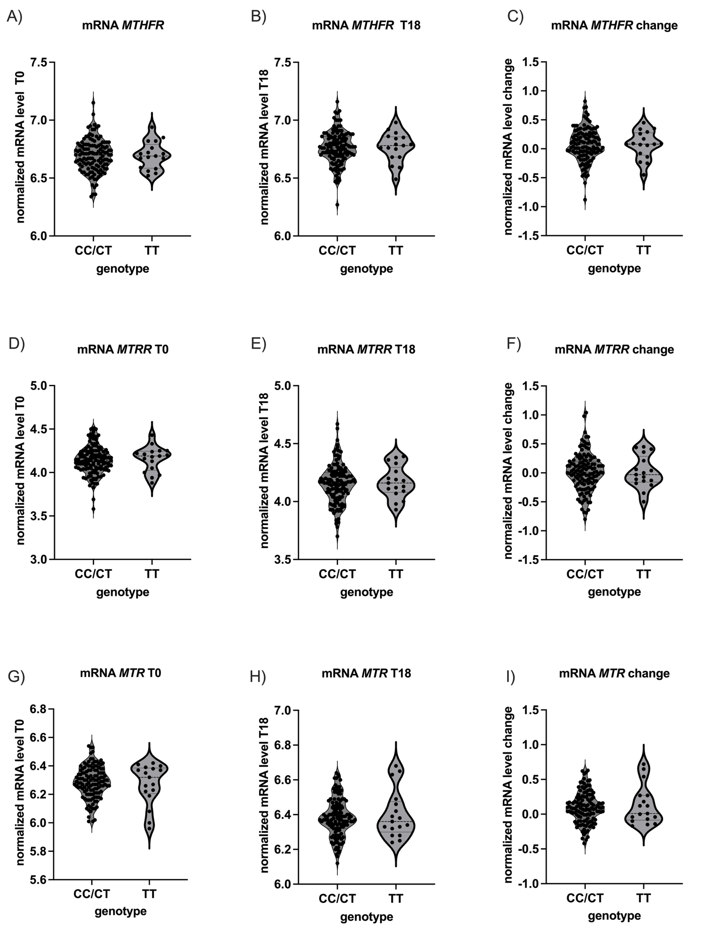
Supplemental Figure 4. Expression of folate cycle relevant genes (part 1)

Figures show violin plots including median and quartiles of normalized mRNA levels of each gene from baseline (T0) and after the end of the intervention (T18) as well as the change (T18-T0). mRNA values are given for the recessive mode of inheritance. N: CC/TT=127; TT=17

Supplemental Figure 5. Expression of folate cycle relevant genes (part 2).
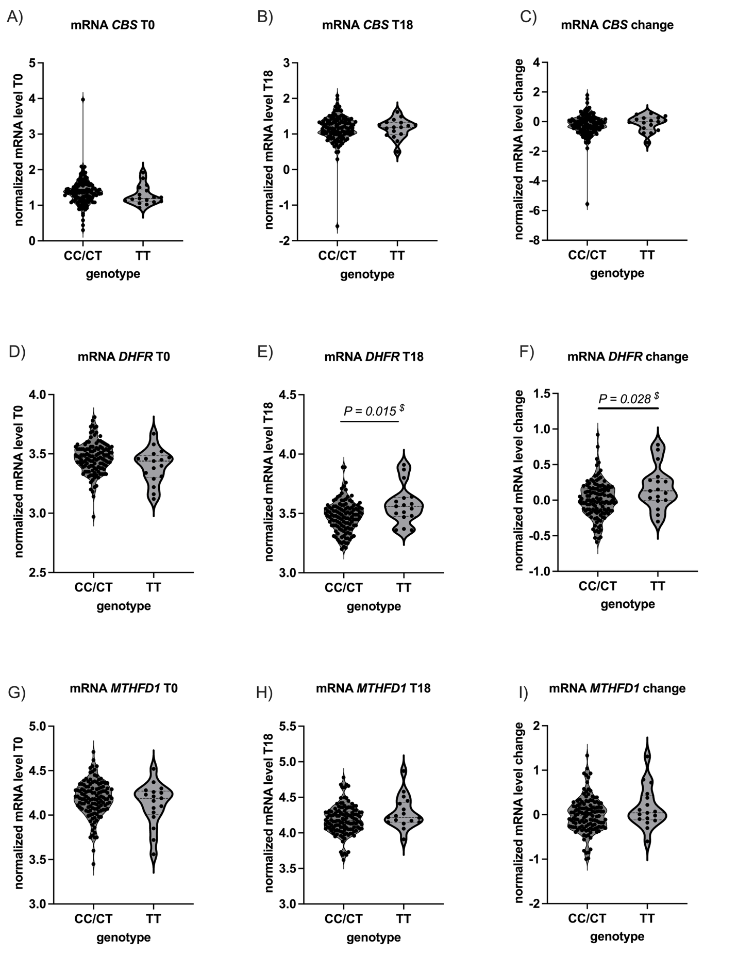Figures show violin plots including median and quartiles of normalized mRNA levels of each gene from baseline (T0) and after the end of the intervention (T18) as well as the change (T18-T0). mRNA values are given for the recessive mode of inheritance. N: CC/TT=127; TT=17

Supplemental Figure 6. MTHFD2 mRNA expression levels during 18-month across intervention groups.

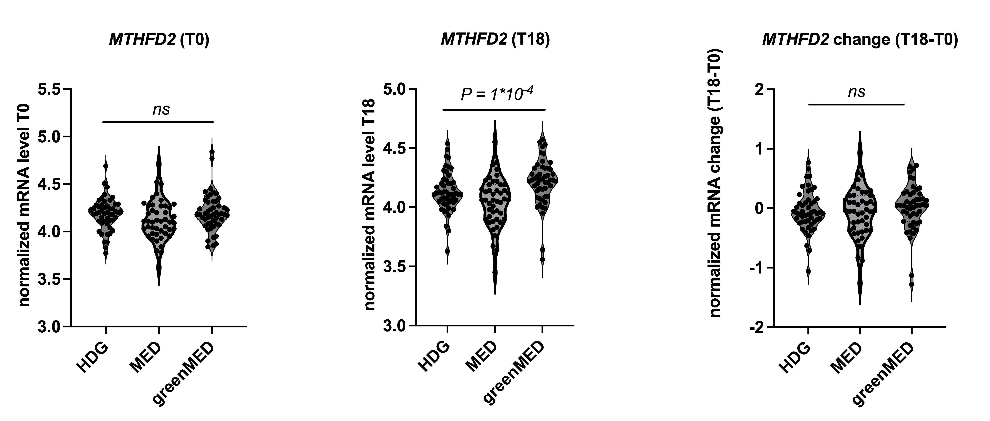

Shows average, normalized MTHFD2 mRNA expression levels detected in blood as violin plots. §= additive; $= dominant and #= recessive mode of inheritance. Differences between the groups were assessed with non-parametric test statistics. Available mRNA expression data stratified by genotype distribution (N) HDG vs MED vs greenMED – 50 vs 46 vs 50.

Supplemental Figure 7. Fiber consumption change and changes in serum Folate after 18 month of intervention

Multivariate models for assessment of the association between fiber consumption change and folate change adjusted for age, sex, and weight loss. fiber consumption tertiles (18-month change;gr): lower≤-6.73; medium= -6.72 to -0.17, top: -0.16=>; Excluded vitamin B complex, folic acid and multivitamin consumers.

REFERENCES

1. Shai, I., et al., Dietary evaluation and attenuation of relative risk: multiple comparisons between blood and urinary biomarkers, food frequency, and 24-hour recall questionnaires: the DEARR study. J Nutr, 2005. 135(3): p. 573-9.
2. Shai, I., et al., Selection of food items for inclusion in a newly developed food-frequency questionnaire. Public Health Nutr, 2004. 7(6): p. 745-9.
3. Gepner, Y., et al., Effects of Initiating Moderate Alcohol Intake on Cardiometabolic Risk in Adults With Type 2 Diabetes: A 2-Year Randomized, Controlled Trial. Ann Intern Med, 2015. 163(8): p. 569-79.
4. Ainsworth, B.E., et al., Compendium of physical activities: an update of activity codes and MET intensities. Med Sci Sports Exerc, 2000. 32(9 Suppl): p. S498-504.
5. Regueiro, J., et al., Comprehensive identification of walnut polyphenols by liquid chromatography coupled to linear ion trap-Orbitrap mass spectrometry. Food Chem, 2014. 152: p. 340-8.
6. Sánchez-González, C., et al., Health benefits of walnut polyphenols: An exploration beyond their lipid profile. Crit Rev Food Sci Nutr, 2017. 57(16): p. 3373-3383.
7. Kris-Etherton, P.M., Walnuts decrease risk of cardiovascular disease: a summary of efficacy and biologic mechanisms. J Nutr, 2014. 144(4 Suppl): p. 547s-554s.
8. García-Conesa, M.T., et al., Meta-Analysis of the Effects of Foods and Derived Products Containing Ellagitannins and Anthocyanins on Cardiometabolic Biomarkers: Analysis of Factors Influencing Variability of the Individual Responses. Int J Mol Sci, 2018. 19(3).
9. Pérez-Jiménez, J., et al., Identification of the 100 richest dietary sources of polyphenols: an application of the Phenol-Explorer database. Eur J Clin Nutr, 2010. 64 Suppl 3: p. S112-20.
10. Manach, C., et al., Polyphenols: food sources and bioavailability. Am J Clin Nutr, 2004. 79(5): p. 727-47.
11. Huang, J., et al., The anti-obesity effects of green tea in human intervention and basic molecular studies. Eur J Clin Nutr, 2014. 68(10): p. 1075-87.
12. Zheng, X.X., et al., Green tea intake lowers fasting serum total and LDL cholesterol in adults: a meta-analysis of 14 randomized controlled trials. Am J Clin Nutr, 2011. 94(2): p. 601-10.
13. Hooper, L., et al., Flavonoids, flavonoid-rich foods, and cardiovascular risk: a meta-analysis of randomized controlled trials. Am J Clin Nutr, 2008. 88(1): p. 38-50.
14. Park, S.K., et al., A combination of green tea extract and l-theanine improves memory and attention in subjects with mild cognitive impairment: a double-blind placebo-controlled study. J Med Food, 2011. 14(4): p. 334-43.
15. Wightman, E.L., et al., Epigallocatechin gallate, cerebral blood flow parameters, cognitive performance and mood in healthy humans: a double-blind, placebo-controlled, crossover investigation. Hum Psychopharmacol, 2012. 27(2): p. 177-86.
16. Bhanthumnavin, K. and M.G. McGarry, Wolffia arrhiza as a possible source of inexpensive protein. Nature, 1971. 232(5311): p. 495.
17. Kawamata, Y., et al., Genotoxicity and repeated-dose toxicity evaluation of dried Wolffia globosa Mankai. Toxicol Rep, 2020. 7: p. 1233-1241.
18. Kaplan, A., et al., Protein bioavailability of Wolffia globosa duckweed, a novel aquatic plant - A randomized controlled trial. Clin Nutr, 2019. 38(6): p. 2576-2582.
19. Yan, Y., et al., Survey of the total fatty acid and triacylglycerol composition and content of 30 duckweed species and cloning of a Δ6-desaturase responsible for the production of γ-linolenic and stearidonic acids in Lemna gibba. BMC Plant Biol, 2013. 13: p. 201.
20. Sela, I., et al., Wolffia globosa-Mankai Plant-Based Protein Contains Bioactive Vitamin B(12) and Is Well Absorbed in Humans. Nutrients, 2020. 12(10).
21. Daduang, J., et al., High phenolics and antioxidants of some tropical vegetables related to antibacterial and anticancer activities. Afr J Pharm Pharmacol, 2011. 5(5): p. 608-15.
22. Edelman, M. and M. Colt, Nutrient Value of Leaf vs. Seed. Front Chem, 2016. 4: p. 32.
23. Yaskolka Meir, A., et al., A Green-Mediterranean Diet, Supplemented with Mankai Duckweed, Preserves Iron-Homeostasis in Humans and Is Efficient in Reversal of Anemia in Rats. J Nutr, 2019. 149(6): p. 1004-1011.
24. Zelicha, H., et al., The Effect of Wolffia globosa Mankai, a Green Aquatic Plant, on Postprandial Glycemic Response: A Randomized Crossover Controlled Trial. Diabetes Care, 2019. 42(7): p. 1162-1169.
25. Gepner, Y., et al., Effect of Distinct Lifestyle Interventions on Mobilization of Fat Storage Pools: CENTRAL Magnetic Resonance Imaging Randomized Controlled Trial. Circulation, 2018. 137(11): p. 1143-1157.

