Sex-specific associations between long-term exposure to ambient air pollution and the cardiac conduction system – a longitudinal analysis of the KORA cohort
Yujiao Li^{a,b,*}, Siqi Zhang^{c}, David Diaz-Sanchez^{d}, Kathrin Wolfª, Ina-Maria Rückert-Ehebergª, Stefan Kääb^{e,f}, Georg Schmidt^{e,g}, Alexander Strom^{h,i}, Annette Peters^{a,b,e,i}, Alexandra Schneider^{a,†}, Susanne Breitner-Busch^{a,b,†}
a Institute of Epidemiology, Helmholtz Zentrum München, German Research Center for Environmental Health (GmbH), Neuherberg, Germany
b Institute for Medical Information Processing, Biometry and Epidemiology (IBE), Faculty of Medicine, LMU Munich, Pettenkofer School of Public Health, Munich, Germany
c Department of Environmental Health Sciences, Yale School of Public Health, New Haven, CT, USA
d US Environmental Protection Agency, Durham, North Carolina
e German Research Center for Cardiovascular Disease (DZHK), Partner site Munich Heart Alliance, Munich, Germany
f Department of Cardiology, Medical Policlinic and University Clinic I, Munich, Germany
g Department of Internal Medicine I, TUM University Hospital, Technical University of Munich, Ismaninger Str. 22, 81675, Munich, Germany
h Institute for Clinical Diabetology, German Diabetes Center, Leibniz Center for Diabetes Research at Heinrich Heine University Düsseldorf, Düsseldorf, Germany
i German Center for Diabetes Research (DZD), München-Neuherberg, Germany
* Authors for correspondence: Yujiao Li, E-mail: yujiao.li@helmholtz-munich.de
Address: Ingolstädter Landstraße 1, 85764, Neuherberg, Germany
† Shared last authors
Number of tables: 5
Number of figures: 22

Supplementary Materials
Contents
Table S1. Descriptive statistics of ECG parameters by examination wave. 5
Table S2. Distribution of LUR-predicted residential air pollution concentrations across KORA examination waves (N = 9,181 observations). 6
Table S3. Sex-specific distribution and Spearman correlation coefficients of annual average air pollutant concentrations (N = 9,181). 7
Table S4. 2×2 Cross-tabulations between education status, smoking, obesity, medication, beta-blockers, cardiovascular disease, residential surrounding greenness, urbanization, and physical activity in women. (N=4,754). 8
Table S5. 2×2 Cross-tabulations between education status, smoking, and obesity in men. (N=4,427). 10
Figure S1. Venn diagram of participant overlaps across S4, F4, and FF4 waves. 10
Figure S2. Correlation matrix and distributions of electrocardiographic parameters across study visits. 11
Figure S3. Correlation matrix of electrocardiographic parameters across all observations. 12
Figure S4. Correlation matrix of exposure parameters across all observations 12
Figure S5. Sex-specific associations between air pollution and cardiac conduction markers considering effect modification by age. 13
Figure S6. Sex-specific associations between air pollution and cardiac conduction markers considering effect modification by obesity. 14
Figure S7. Sex-specific associations between air pollution and cardiac conduction markers considering effect modification by education. 15
Figure S8. Sex-specific associations between air pollution and cardiac conduction markers considering effect modification by smoking. 16
Figure S9. Sex-specific associations between air pollution and cardiac conduction markers considering effect modification by CVD. 17
Figure S10. Sex-specific associations between air pollution and cardiac conduction markers considering effect modification by blockers. 18
Figure S11. Sex-specific associations between air pollution and cardiac conduction markers considering effect modification by greenness. 19
Figure S12. Sex-specific associations between air pollution and cardiac conduction markers considering effect modification by urbanization. 20
Figure S13. Sex-specific associations between air pollution and cardiac conduction markers considering effect modification by physical activity. 21
Figure S14. Directed acyclic graph for covariate selection in the association between long-term air pollution exposure and ECG parameters. 22
Figure S15. Sex-specific associations between long-term air pollution exposure and cardiac conduction markers in the primary model and DAG-informed sensitivity model. 23
Figure S16. Sex-specific associations of air pollution and cardiac conduction system derived from generalized additive mixed models with an interaction term for sex among participants with 3 measurements. 24
Figure S17. Sex-specific associations of air pollution and cardiac conduction system derived from generalized additive mixed models with an interaction term for sex among participants without CVD. 24
Figure S18. Sex-specific associations of air pollution and cardiac conduction system derived from generalized additive mixed models with an interaction term for sex among participants without taking beta-blockers. 25
Figure S19. Sex-specific associations of air pollution and cardiac conduction system derived from generalized additive mixed models with an interaction term and IPW adjustment. 25
Figure S20. Sex-specific associations of air pollution and cardiac conduction system derived from generalized additive mixed models with an interaction term without 3SD outliers. 26
Figure S21. Sex-specific associations of air pollution and cardiac conduction system derived from generalized additive mixed models with an interaction term additionally adjusted for temperature and relative humidity on the ECG examination date. 27
Figure S22. Sex-specific associations between air pollution and cardiac conduction markers with additional adjustment for same-day air pollution. 28
Figure S23. Comparison of single- and two-pollutant models for long-term PNC and NO₂ in relation to ECG parameters. 29
Figure S24. Wave-specific associations between air pollution and cardiac conduction markers. 30

Table S1. Descriptive statistics of ECG parameters by examination wave.
ECG parameter | visit | N | Mean ± SD | Median (IQR) | Min-Max
QTc (ms) | S4 | 4068 | 421.00 ± 21.72 | 421.00 (407.00, 435.00) | 328.00–544.00
QTc (ms) | F4 | 2922 | 424.37 ± 21.49 | 424.00 (411.00, 438.00) | 328.00–543.00
QTc (ms) | FF4 | 2191 | 425.79 ± 21.79 | 425.00 (411.00, 440.00) | 329.00–544.00
PQ interval (ms) | S4 | 4068 | 162.57 ± 22.79 | 160.00 (146.00, 176.00) | 80.00–324.00
PQ interval (ms) | F4 | 2922 | 167.70 ± 24.30 | 166.00 (150.00, 182.00) | 84.00–328.00
PQ interval (ms) | FF4 | 2191 | 169.20 ± 25.86 | 166.00 (152.00, 184.00) | 108.00–292.00
QRS (ms) | S4 | 4068 | 93.05 ± 12.05 | 92.00 (86.00, 98.00) | 64.00–188.00
QRS (ms) | F4 | 2922 | 93.82 ± 13.02 | 92.00 (86.00, 98.00) | 62.00–182.00
QRS (ms) | FF4 | 2191 | 93.39 ± 14.32 | 92.00 (84.00, 98.00) | 62.00–190.00
P-wave (ms) | S4 | 4068 | 108.94 ± 11.75 | 108.00 (100.00, 116.00) | 70.00–190.00
P-wave (ms) | F4 | 2922 | 111.05 ± 12.09 | 112.00 (102.00, 118.00) | 68.00–230.00
P-wave (ms) | FF4 | 2191 | 109.66 ± 12.25 | 110.00 (102.00, 118.00) | 66.00–196.00
JTc (ms) | S4 | 4068 | 327.94 ± 22.62 | 329.00 (313.00, 343.00) | 242.00–434.00
JTc (ms) | F4 | 2922 | 330.55 ± 22.60 | 331.00 (316.00, 346.00) | 228.00–437.00
JTc (ms) | FF4 | 2191 | 332.39 ± 22.12 | 333.00 (318.00, 348.00) | 227.00–452.00
HR (bpm) | S4 | 4068 | 65.04 ± 10.59 | 64.00 (58.00, 71.00) | 36.00–117.00
HR (bpm) | F4 | 2922 | 64.44 ± 10.13 | 64.00 (58.00, 70.00) | 33.00–114.00
HR (bpm) | FF4 | 2191 | 64.25 ± 9.87 | 63.00 (58.00, 70.00) | 37.00–123.00

Table S2. Distribution of LUR-predicted residential air pollution concentrations across KORA examination waves (N = 9,181 observations).
Study wave | Pollutant | N | Mean (SD) | Median | IQR | Min | Max
S4 | PM2.5 | 4,068 | 11.73 (1.01) | 11.85 | 11.1–12.47 | 8.2 | 14.37
S4 | PM10 | 4,068 | 16.51 (1.49) | 16.28 | 15.39–17.48 | 12.07 | 22.01
S4 | PM2.5abs | 4,068 | 1.19 (0.17) | 1.18 | 1.06–1.31 | 0.77 | 1.73
S4 | PMcoarse | 4,068 | 5.01 (1.10) | 5.02 | 4.28–5.76 | 2.49 | 8.2
S4 | PNC | 4,068 | 7189.93 (1727.22) | 7199.25 | 6163.06–8066.95 | 2946.09 | 14496.3
S4 | NO2 | 4,068 | 14.38 (4.48) | 13.96 | 10.73–17.86 | 6.86 | 28.56
F4 | PM2.5 | 2,922 | 11.72 (1.00) | 11.82 | 11.09–12.47 | 8.2 | 14.09
F4 | PM10 | 2,922 | 16.50 (1.46) | 16.29 | 15.38–17.45 | 12.07 | 22.01
F4 | PM2.5abs | 2,922 | 1.19 (0.17) | 1.18 | 1.06–1.31 | 0.78 | 1.73
F4 | PMcoarse | 2,922 | 5.00 (1.09) | 5.01 | 4.26–5.73 | 2.49 | 8.2
F4 | PNC | 2,922 | 7164.31 (1713.36) | 7199.53 | 6130.4–8042.01 | 2946.09 | 14496.3
F4 | NO2 | 2,922 | 14.34 (4.46) | 13.94 | 10.75–17.68 | 6.86 | 27.46
FF4 | PM2.5 | 2,191 | 11.69 (1.02) | 11.79 | 11.03–12.48 | 8.2 | 14.09
FF4 | PM10 | 2,191 | 16.45 (1.45) | 16.24 | 15.34–17.41 | 12.11 | 22.01
FF4 | PM2.5abs | 2,191 | 1.18 (0.17) | 1.18 | 1.04–1.31 | 0.78 | 1.73
FF4 | PMcoarse | 2,191 | 4.95 (1.10) | 4.95 | 4.21–5.73 | 2.49 | 8.15
FF4 | PNC | 2,191 | 7110.34 (1723.03) | 7140.52 | 6035.89–8027.34 | 2946.09 | 14086.03
FF4 | NO2 | 2,191 | 14.16 (4.43) | 13.74 | 10.59–17.57 | 6.86 | 27.2
Abbreviations: IQR, interquartile range; NO2, nitrogen dioxide; PM2.5, particulate matter with an aerodynamic diameter of ≤ 2.5 µm; PM10, particulate matter with an aerodynamic diameter of ≤10 µm; PMcoarse, particulate matter with an aerodynamic diameter of 2.5–10 µm; PM2.5abs, PM2.5absorbance; PNC, particle number concentration; SD, standard deviation.

Table S3. Sex-specific distribution and Spearman correlation coefficients of annual average air pollutant concentrations (N = 9,181).
 | Weighted Mean ± SD |  | P value* | Range | IQR | Correlation coefficients
 | Men (N = 4,427) | Women (N = 4,754) | P value* | Range | IQR | PM_{2.5} | PM₁₀ | PM_{2.5}abs | PM_{coarse} | PNC |  | NO₂
PM_{2.5}(μg/m³) | 11.7 ± 1.0 | 11.7 ± 1.0 | 0.324 | 8.2 – 14.4 | 1.4 | 1
PM₁₀ (μg/m³) | 16.5 ± 1.5 | 16.5 ± 1.5 | 0.898 | 12.1 – 22.0 | 2.0 | 0.60 | 1
PM_{2.5}abs(10^{–5}/m) | 1.2 ± 0.2 | 1.2 ± 0.2 | 0.349 | 0.8 – 1.7 | 0.3 | 0.73 | 0.76 | 1
PM_{coarse} (μg/m³) | 5.0 ± 1.1 | 5.0 ± 1.1 | 0.897 | 2.5 – 8.2 | 1.5 | 0.59 | 0.80 | 0.79 | 1
PNC (10³/cm³) | 7.2 ± 1.7 | 7.2 ± 1.7 | 0.980 | 2.9 – 14.5 | 1.9 | 0.71 | 0.81 | 0.75 | 0.77 | 1
NO₂ (μg/m³) | 14.4 ± 4.5 | 14.3 ± 4.5 | 0.532 | 6.9 – 28.6 | 7.1 | 0.77 | 0.72 | 0.86 | 0.83 | 0.76 | 1
* P value represents the comparison between women and men, estimated by t-test. All summary statistics (range, IQR and correlation coefficients) are derived from all observations. Abbreviations: IQR, interquartile range; NO₂, nitrogen dioxide; PM_{2.5}, particulate matter with an aerodynamic diameter of ≤ 2.5 µm; PM₁₀, particulate matter with an aerodynamic diameter of ≤10 µm; PMcoarse, particulate matter with an aerodynamic diameter of 2.5–10 µm; PM_{2.5}abs, PM_{2.5}absorbance; PNC, particle number concentration; SD, standard deviation.

Table S4. 2×2 Cross-tabulations between education status, smoking, obesity, medication, beta-blockers, cardiovascular disease, residential surrounding greenness, urbanization, and physical activity in women. (N=4,754).
 |  | Education status N (%)
 |  | Low education | High education
Smoking | Smokers | 1104 (23.2%) | 1214 (25.5%)
Smoking | Never smoker | 1311 (27.6%) | 1125 (23.7%)
Obesity | Yes | 826 (17.4%) | 392 (8.3%)
Obesity | No | 1589 (33.4%) | 1947 (40.9%)
Medication | Yes | 923 (19.4%) | 566 (11.9%)
Medication | No | 1492 (31.4%) | 1773 (37.3%)
Beta-blockers | Yes | 477 (10.0%) | 254 (5.3%)
Beta-blockers | No | 1938 (40.8%) | 2085 (43.9%)
CVD | Yes | 990 (20.8%) | 552 (11.6%)
CVD | No | 1425 (30.0%) | 1787 (37.6%)
Physical activity | Yes | 1534 (32.3%) | 1756 (36.9%)
Physical activity | No | 881 (18.5%) | 583 (12.3%)
Greenness | High | 1293 (27.2%) | 1153 (24.3%)
Greenness | Low | 1122 (23.6%) | 1186 (24.9%)
Urbanization | Urban | 974 (20.5%) | 1049 (22.1%)
Urbanization | Rural | 1441 (30.3%) | 1290 (27.1%)
 |  | Obesity N (%)
 |  | Yes | No
Smoking | Smokers | 542 (11.4%) | 1776 (37.4%)
Smoking | Never smoker | 676 (14.2%) | 1760 (37.0%)
Medication | Yes | 600 (12.6%) | 889 (18.7%)
Medication | No | 618 (13.0%) | 2647 (55.7%)
Beta-blockers | Yes | 333 (7.0%) | 398 (8.4%)
Beta-blockers | No | 885 (18.6%) | 3138 (66.0%)
CVD | Yes | 674 (14.2%) | 868 (18.3%)
CVD | No | 544 (11.4%) | 2668 (56.1%)
Low education | Smokers | 350 (14.5%) | 754 (31.2%)
Low education | Never smoker | 476 (19.7%) | 835 (34.6%)
High education | Smokers | 192 (8.2%) | 1022 (43.7%)
High education | Never smoker | 200 (8.5%) | 925 (39.6%)
Physical activity | Yes | 722 (15.2%) | 2568 (54.0%)
Physical activity | No | 496 (10.4%) | 968 (20.4%)
Greenness | High | 616 (13.0%) | 1830 (38.5%)
Greenness | Low | 602 (12.7%) | 1706 (35.9%)
Urbanization | Urban | 490 (10.3%) | 1533 (32.3%)
Urbanization | Rural | 728 (15.3%) | 2003 (42.1%)
 |  | Smoking N (%)
 |  | Smokers | Never smoker
CVD | Yes | 644 (13.5%) | 898 (18.9%)
CVD | No | 1674 (35.2%) | 1538 (32.4%)
Beta-blockers | Yes | 292 (6.1%) | 439 (9.2%)
Beta-blockers | No | 2026 (42.6%) | 1997 (42.0%)
 | Yes | 651 (13.7%) | 838 (17.6%)
 | No | 1667 (35.1%) | 1598 (33.6%)
Physical activity | Yes | 1669 (35.1%) | 1621 (34.1%)
Physical activity | No | 649 (13.7%) | 815 (17.1%)
Greenness | High | 1102 (23.2%) | 1344 (28.3%)
Greenness | Low | 1216 (25.6%) | 1092 (23.0%)
Urbanization | Urban | 1077 (22.6%) | 946 (20.0%)
Urbanization | Rural | 1241 (26.1%) | 1490 (31.3%)
 |  | CVD N (%)
 |  | Yes | No
Beta-blockers | Yes | 634 (13.3%) | 97 (2.0%)
Beta-blockers | No | 908 (19.1%) | 3115 (65.5%)
Medication | Yes | 1146 (24.1%) | 343 (7.2%)
Medication | No | 396 (8.3%) | 2869 (60.4%)
Physical activity | Yes | 953 (20.0%) | 2337 (49.2%)
Physical activity | No | 589 (12.4%) | 875 (18.4%)
Greenness | High | 783 (16.5%) | 1663 (35.0%)
Greenness | Low | 759 (16.0%) | 1549 (32.6%)
Urbanization | Urban | 638 (13.4%) | 1385 (29.1%)
Urbanization | Rural | 904 (19.0%) | 1827 (38.4%)
 |  | Physical activity N (%)
 |  | No | Yes
Greenness | High | 688 (14.5%) | 1758 (37.0%)
Greenness | Low | 776 (16.3%) | 1532 (32.2%)
Urbanization | Urban | 681 (14.3%) | 1342 (28.2%)
Urbanization | Rural | 783 (16.5%) | 1948 (41.0%)
Low greenness | Obesity | 283 (10.4%) | 445 (16.3%)
Low greenness | Non-obesity | 500 (18.3%) | 1503 (55.0%)
High greenness | Obesity | 213 (10.5%) | 277 (13.7%)
High greenness | Non-obesity | 468 (23.1%) | 1065 (52.6%)
Obesity, Yes = BMI ≥30 kg/m², No = BMI <30 kg/m²; CVD, participant has hypertension or stroke or MI; Medication, was defined based on whether the participant was taking at least one type of medication related to the treatment of CVD conditions: aspirin; beta-adrenergic receptor blockers (beta-blockers); angiotensin-converting enzyme inhibitors (ACE inhibitors); diuretics; angiotensin receptor antagonists; calcium channel antagonists (calcium channel blockers); or other antihypertensives; Physical activity, no = no or almost no exercise; yes = regular exercise (≥1 hour/week).

Table S5. 2×2 Cross-tabulations between education status, smoking, and obesity in men. (N=4,427).
Education status | Smoking status | Obesity N (%)
Education status | Smoking status | Yes | No
Low education | Smokers | 517 (22.7%) | 1168 (51.1%)
Low education | Never smoker | 168 (7.4%) | 427 (18.7%)
High education | Smokers | 277 (13.0%) | 1086 (51.0%)
High education | Never smoker | 120 (5.6%) | 646 (30.4%)
Obesity, Yes = BMI ≥ 30 kg/m², No = BMI < 30 kg/m².
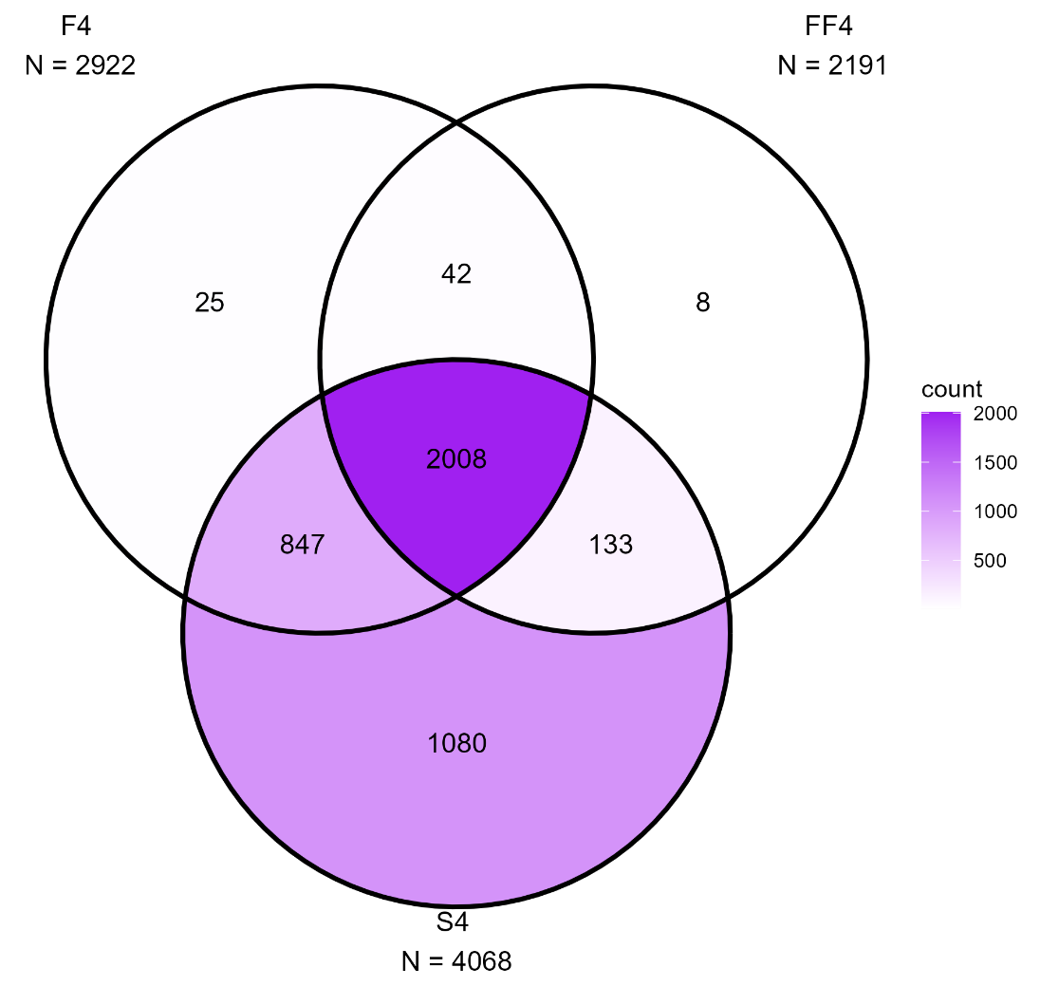

Figure S1. Venn diagram of participant overlaps across S4, F4, and FF4 waves.

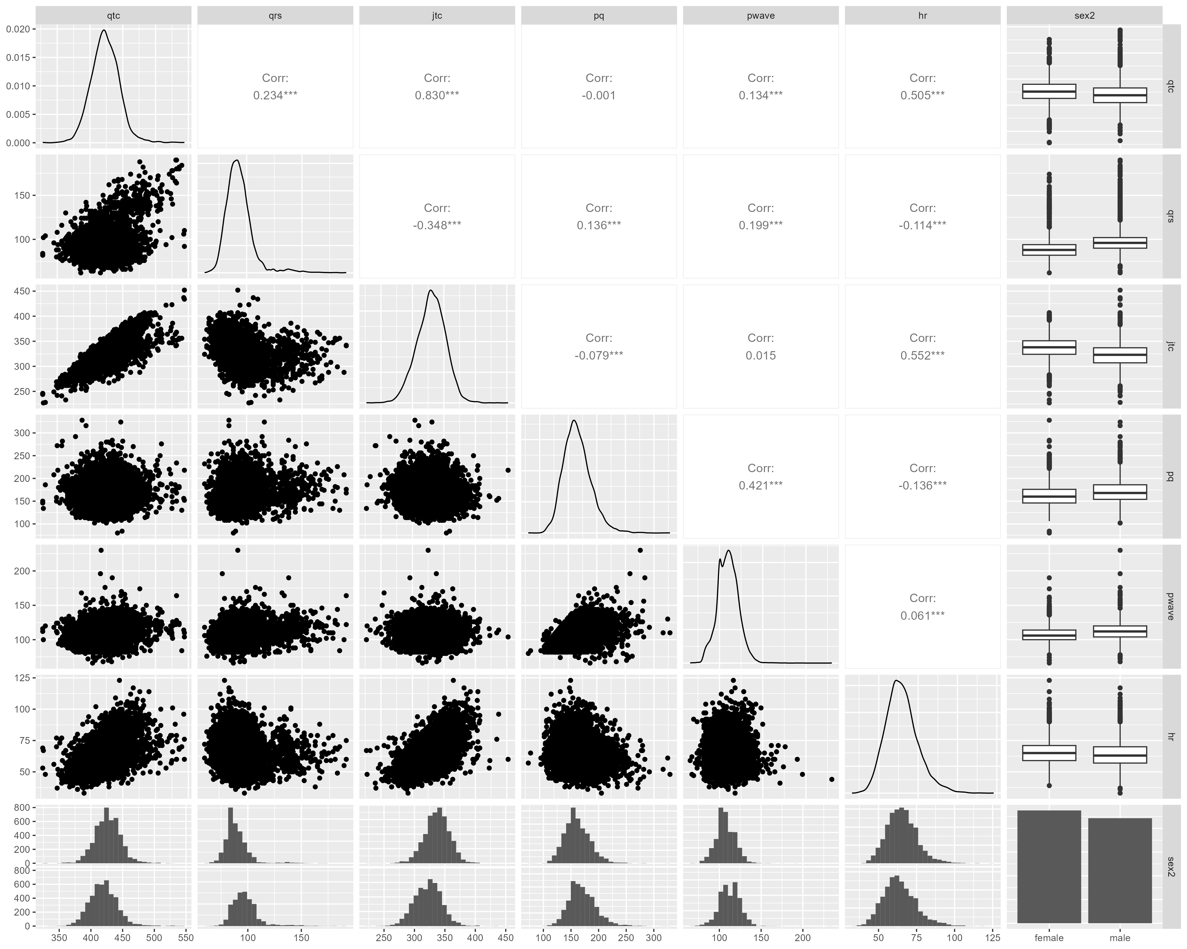

Figure S2. Correlation matrix and distributions of electrocardiographic parameters across study visits.
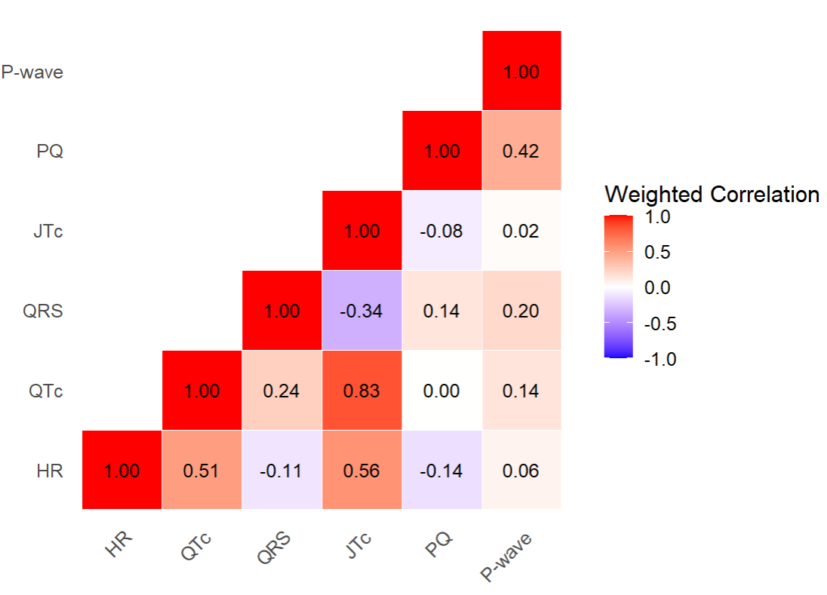
Figure S3. Correlation matrix of electrocardiographic parameters across all observations.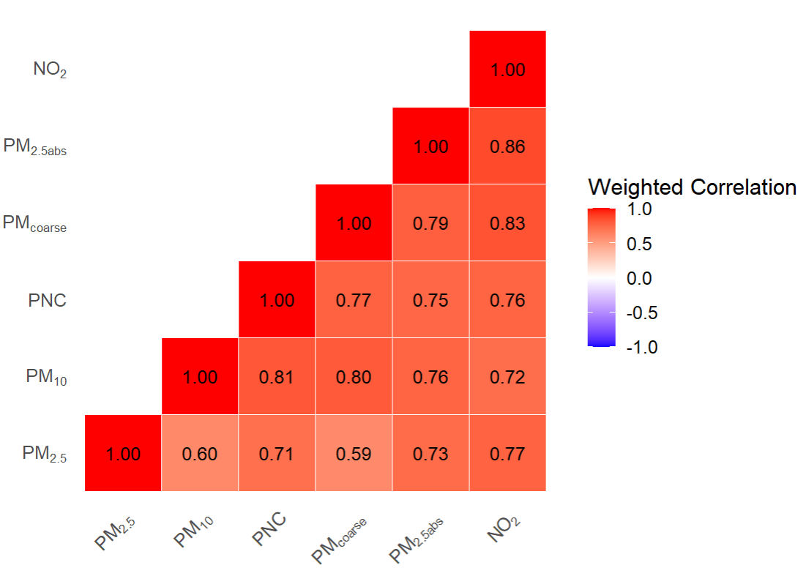

Figure S4. Correlation matrix of exposure parameters across all observations

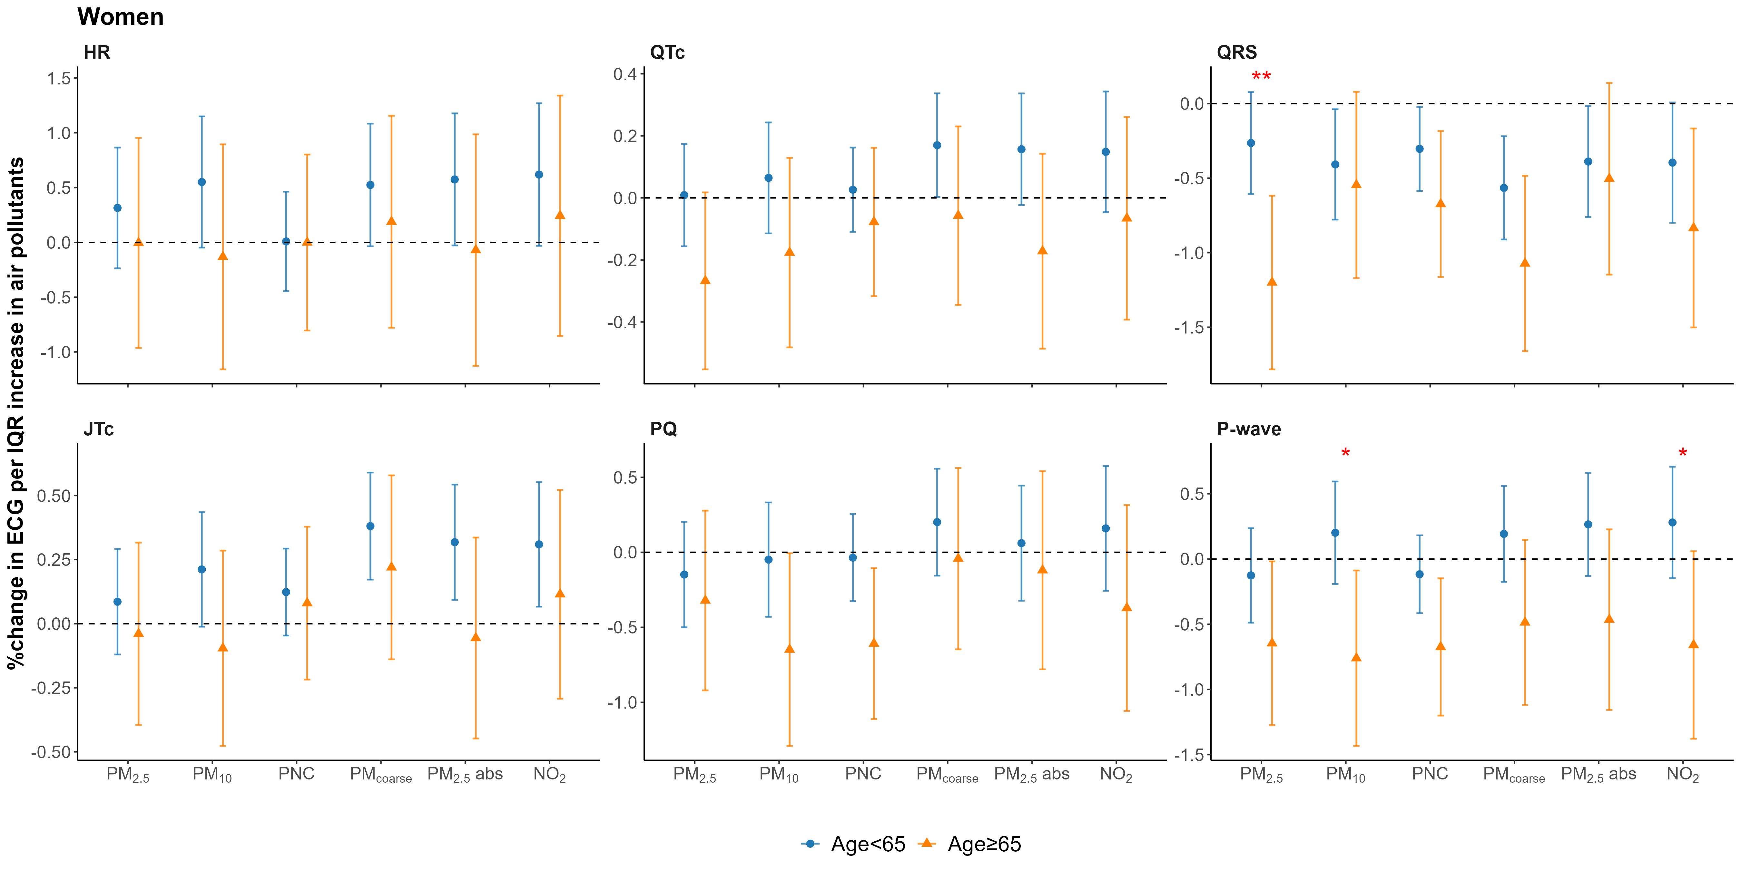
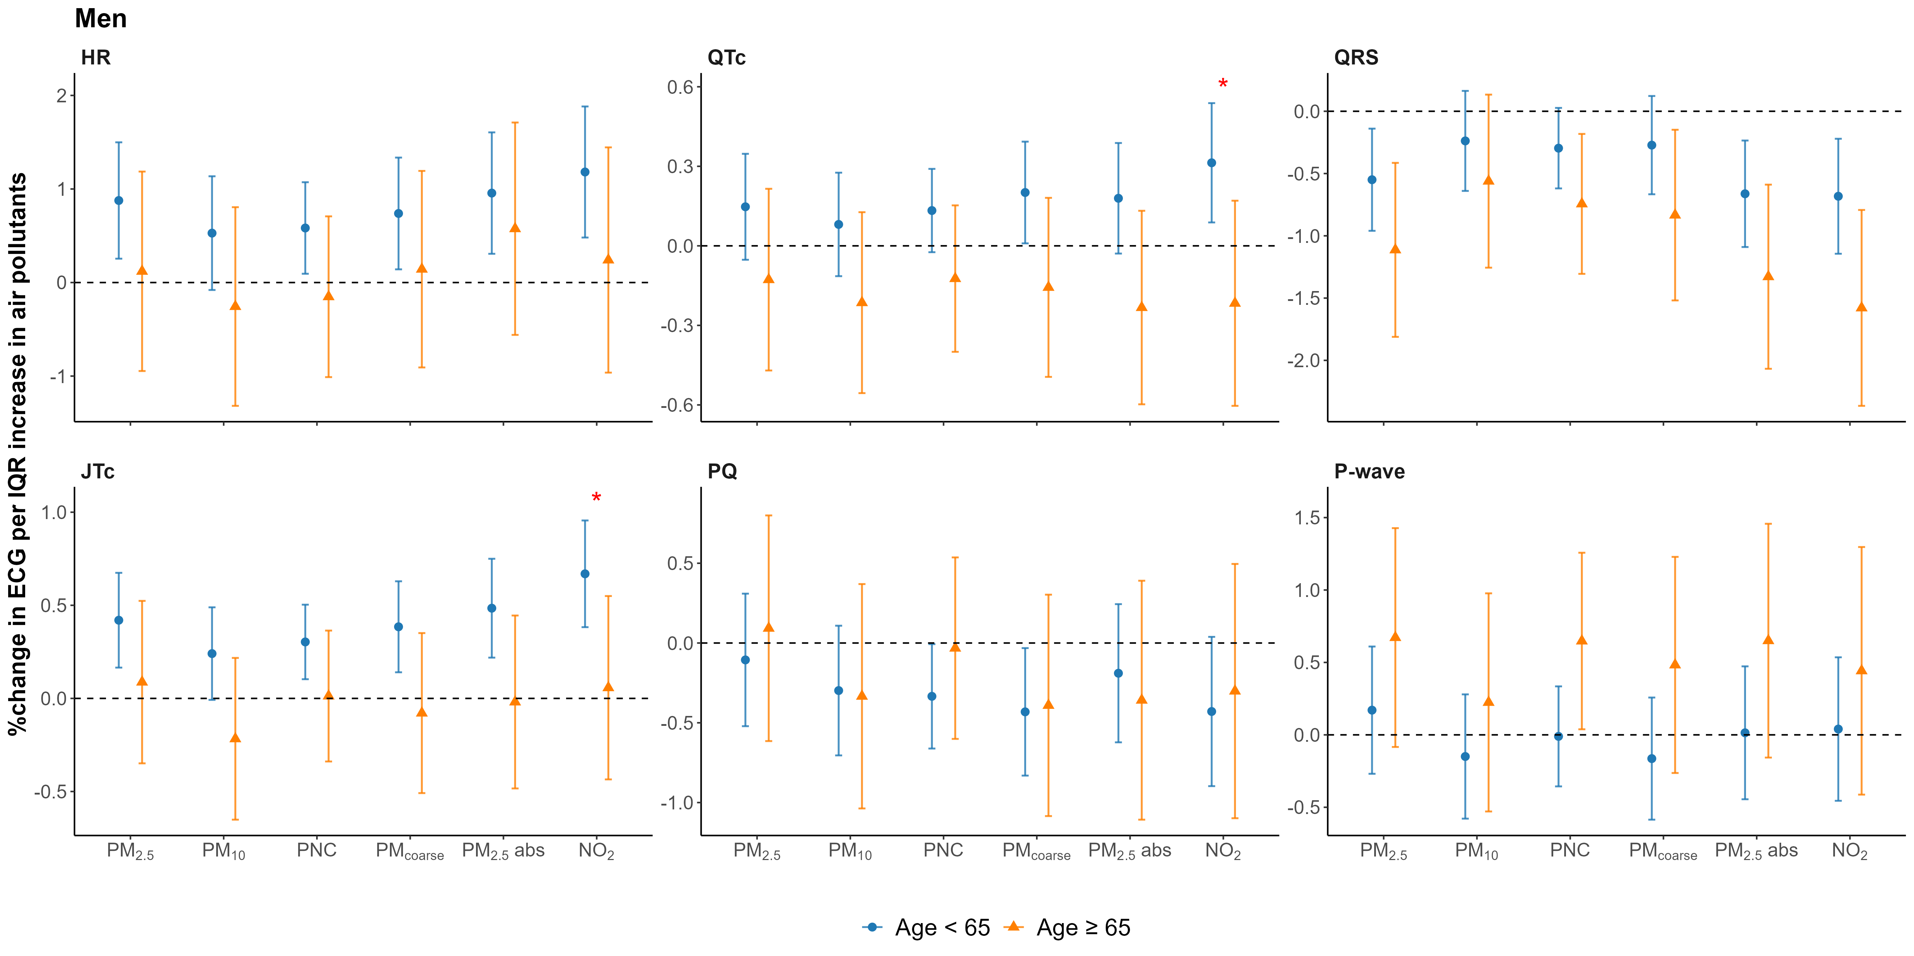
Figure S5. Sex-specific associations between air pollution and cardiac conduction markers considering effect modification by age. Age-specific effect estimates are given as percent differences relative to the mean outcome (together with 95% confidence intervals) of the repeatedly assessed outcomes per interquartile range (IQR) increase in exposure adjusted for BMI, physical activity, smoking, alcohol, education, CVD, medication. Stars indicate statistically significant interactions (p < 0.05 for *; p < 0.01 for **).
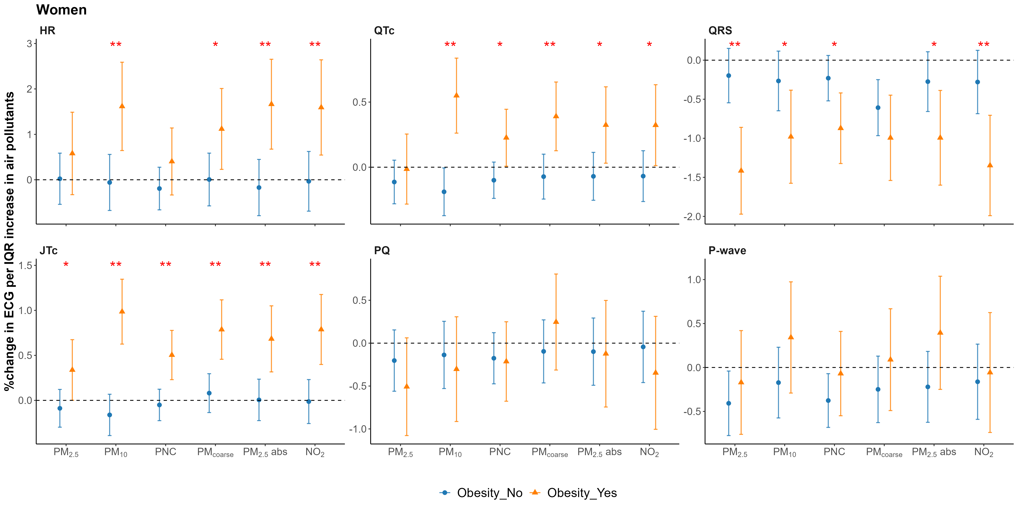
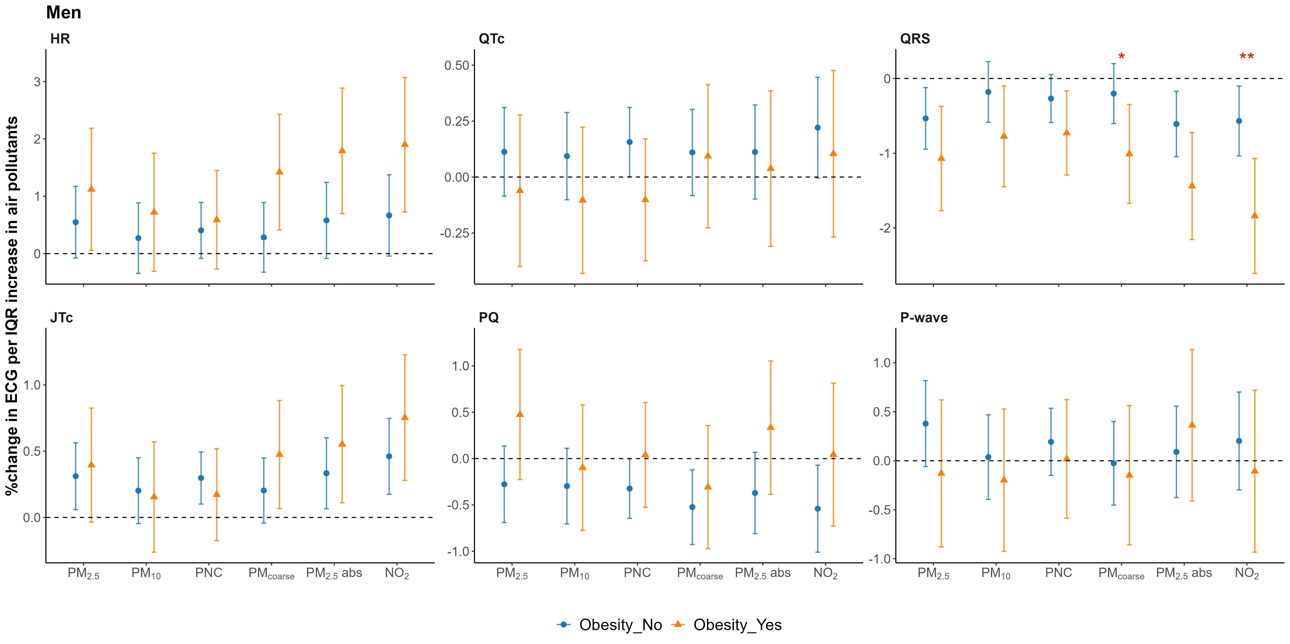
Figure S6. Sex-specific associations between air pollution and cardiac conduction markers considering effect modification by obesity. Obesity-specific effect estimates are given as percent differences relative to the mean outcome (together with 95% confidence intervals) of the repeatedly assessed outcomes per interquartile range (IQR) increase in exposure adjusted for age, physical activity, smoking, alcohol, education, CVD, medication. Stars indicate statistically significant interactions (p < 0.05 for *; p < 0.01 for **).
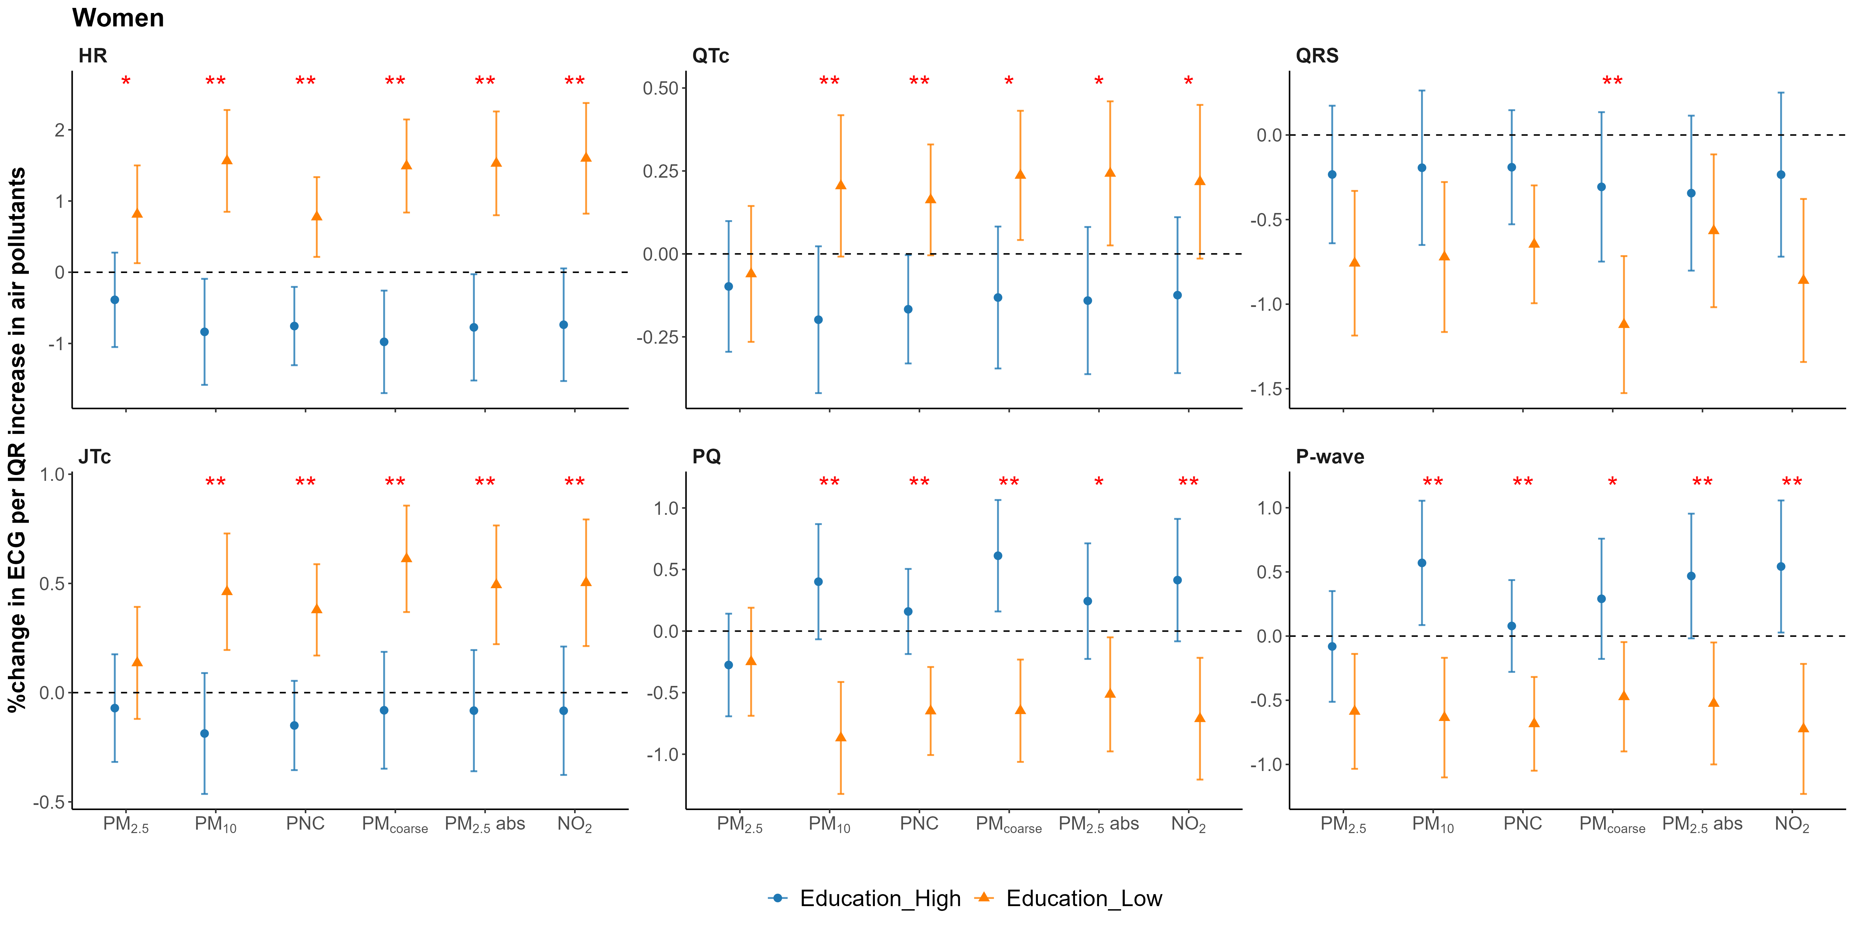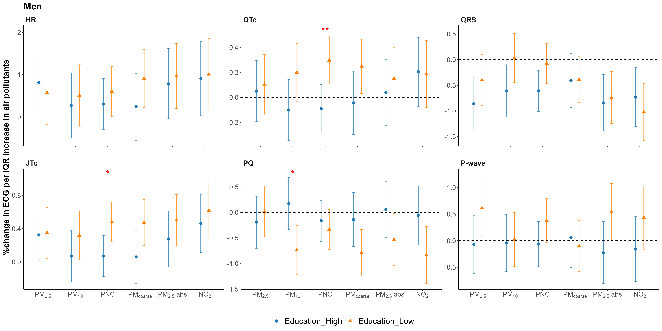
Figure S7. Sex-specific associations between air pollution and cardiac conduction markers considering effect modification by education. Education-specific effect estimates are given as percent differences relative to the mean outcome (together with 95% confidence intervals) of the repeatedly assessed outcomes per interquartile range (IQR) increase in exposure adjusted for age, BMI, physical activity, smoking, alcohol, CVD, medication. Stars indicate statistically significant interactions (p < 0.05 for *; p < 0.01 for **).

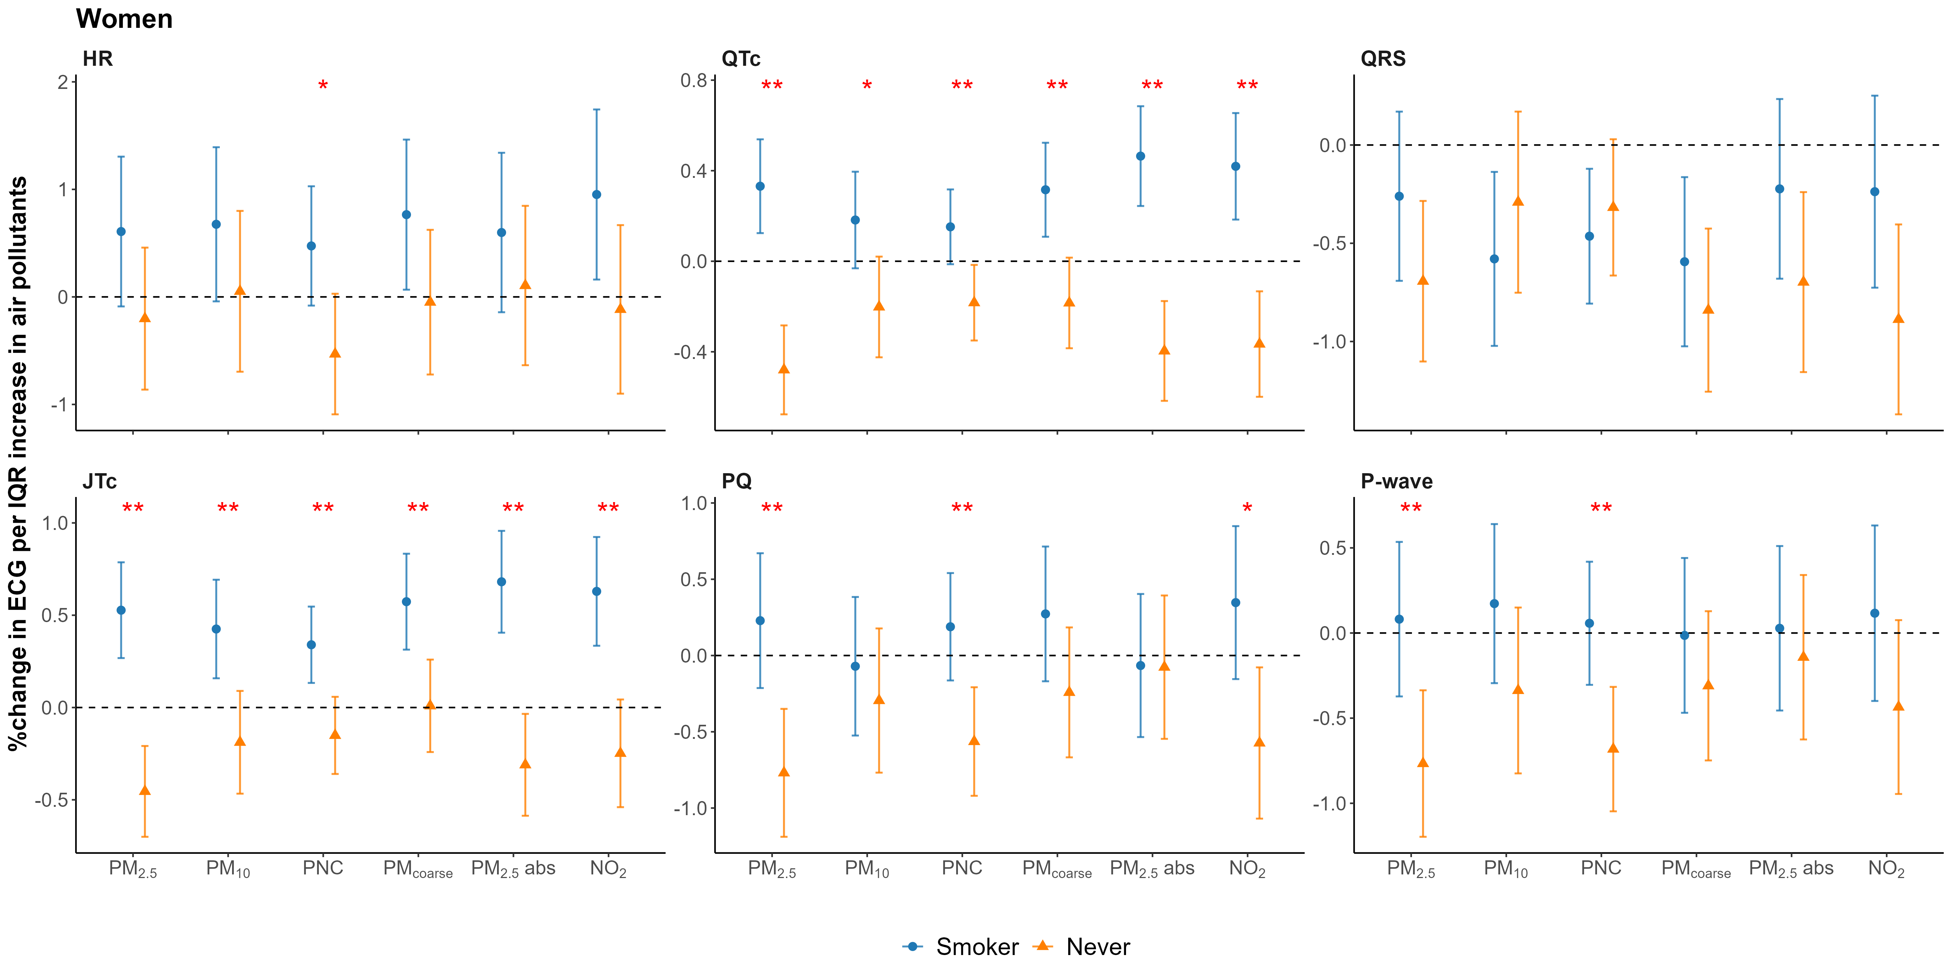
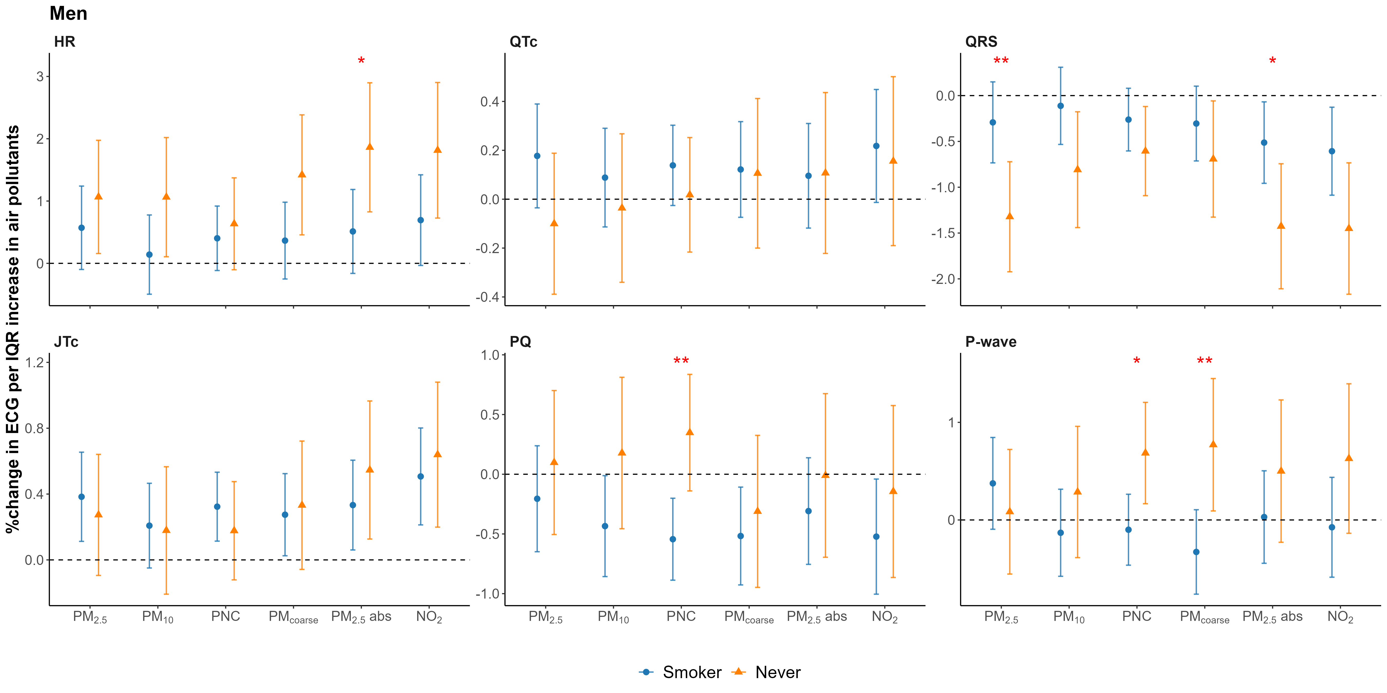
Figure S8. Sex-specific associations between air pollution and cardiac conduction markers considering effect modification by smoking. Smoking-specific effect estimates are given as percent differences relative to the mean outcome (together with 95% confidence intervals) of the repeatedly assessed outcomes per interquartile range (IQR) increase in exposure adjusted for age, BMI, physical activity, education, alcohol, CVD, medication. Stars indicate statistically significant interactions (p < 0.05 for *; p < 0.01 for **).

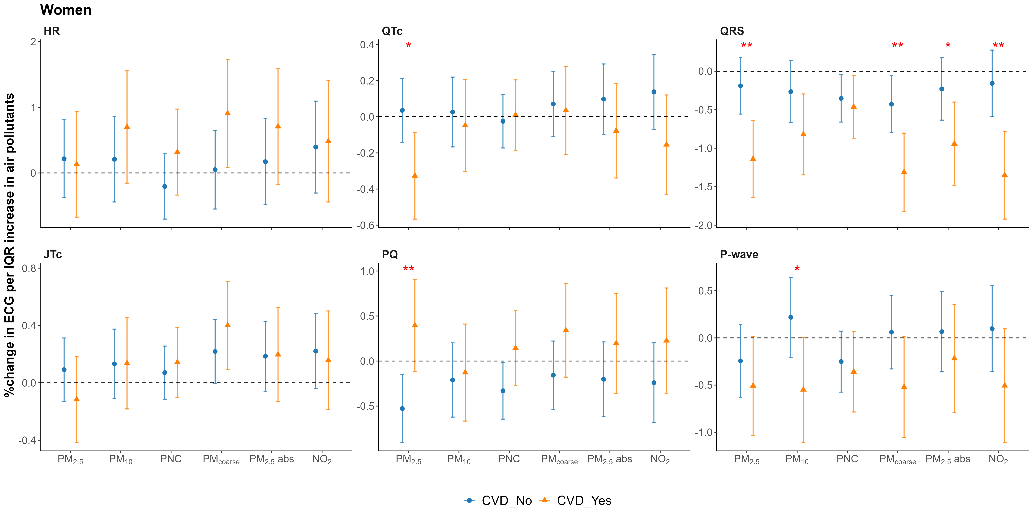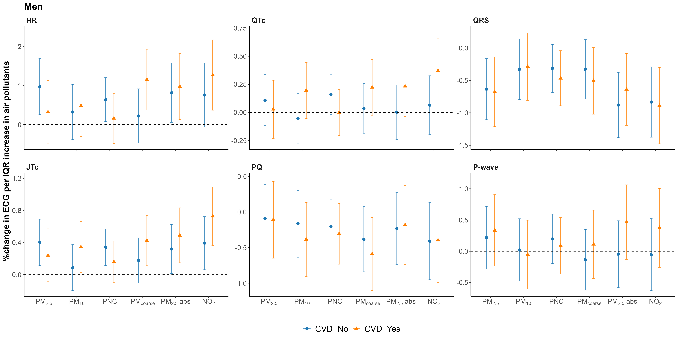
Figure S9. Sex-specific associations between air pollution and cardiac conduction markers considering effect modification by CVD. CVD-specific effect estimates are given as percent differences relative to the mean outcome (together with 95% confidence intervals) of the repeatedly assessed outcomes per interquartile range (IQR) increase in exposure adjusted for age, BMI, physical activity, smoking, education, alcohol, medication. Stars indicate statistically significant interactions (p < 0.05 for *; p < 0.01 for **).
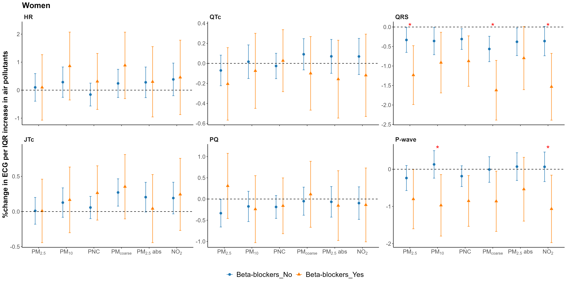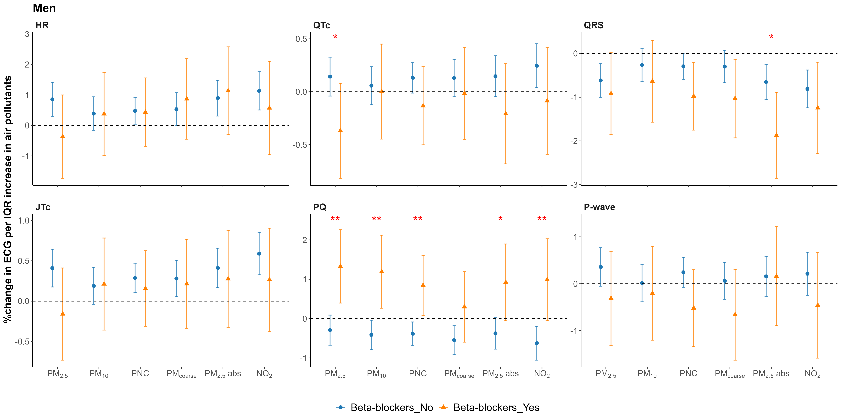
Figure S10. Sex-specific associations between air pollution and cardiac conduction markers considering effect modification by blockers. Beta-blockers-specific effect estimates are given as percent differences relative to the mean outcome (together with 95% confidence intervals) of the repeatedly assessed outcomes per interquartile range (IQR) increase in exposure adjusted for age, BMI, physical activity, smoking, education, alcohol, CVD. Stars indicate statistically significant interactions (p < 0.05 for *; p < 0.01 for **).
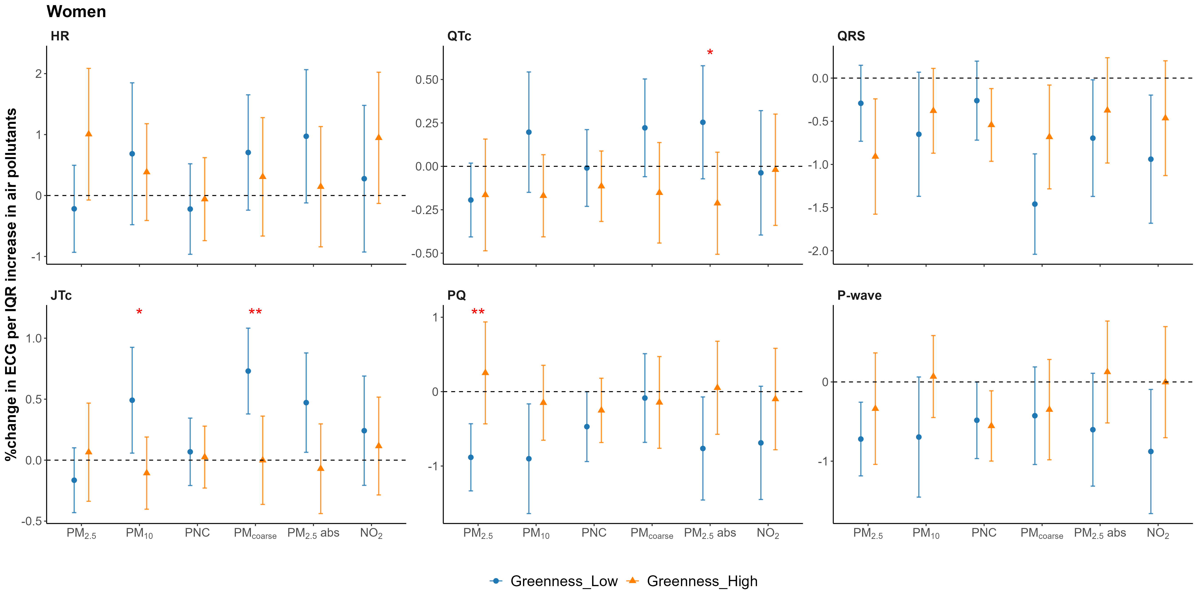
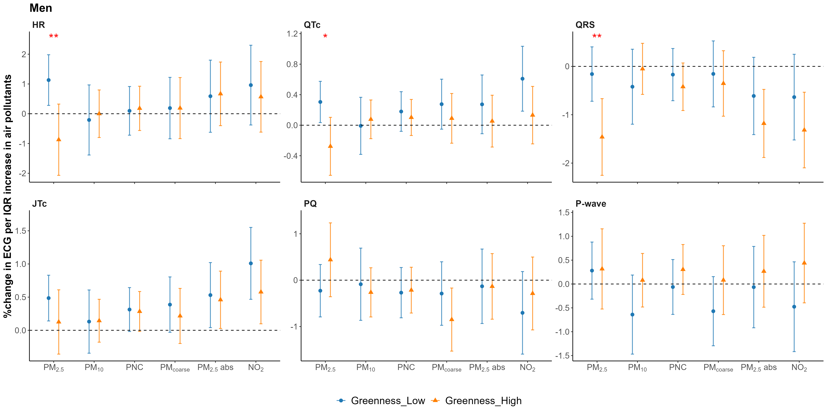
Figure S11. Sex-specific associations between air pollution and cardiac conduction markers considering effect modification by greenness. Greenness-specific effect estimates are given as percent differences relative to the mean outcome (together with 95% confidence intervals) of the repeatedly assessed outcomes per interquartile range (IQR) increase in exposure adjusted for age, BMI, physical activity, smoking, education, alcohol, CVD, medication. Stars indicate statistically significant interactions (p < 0.05 for *; p < 0.01 for **).
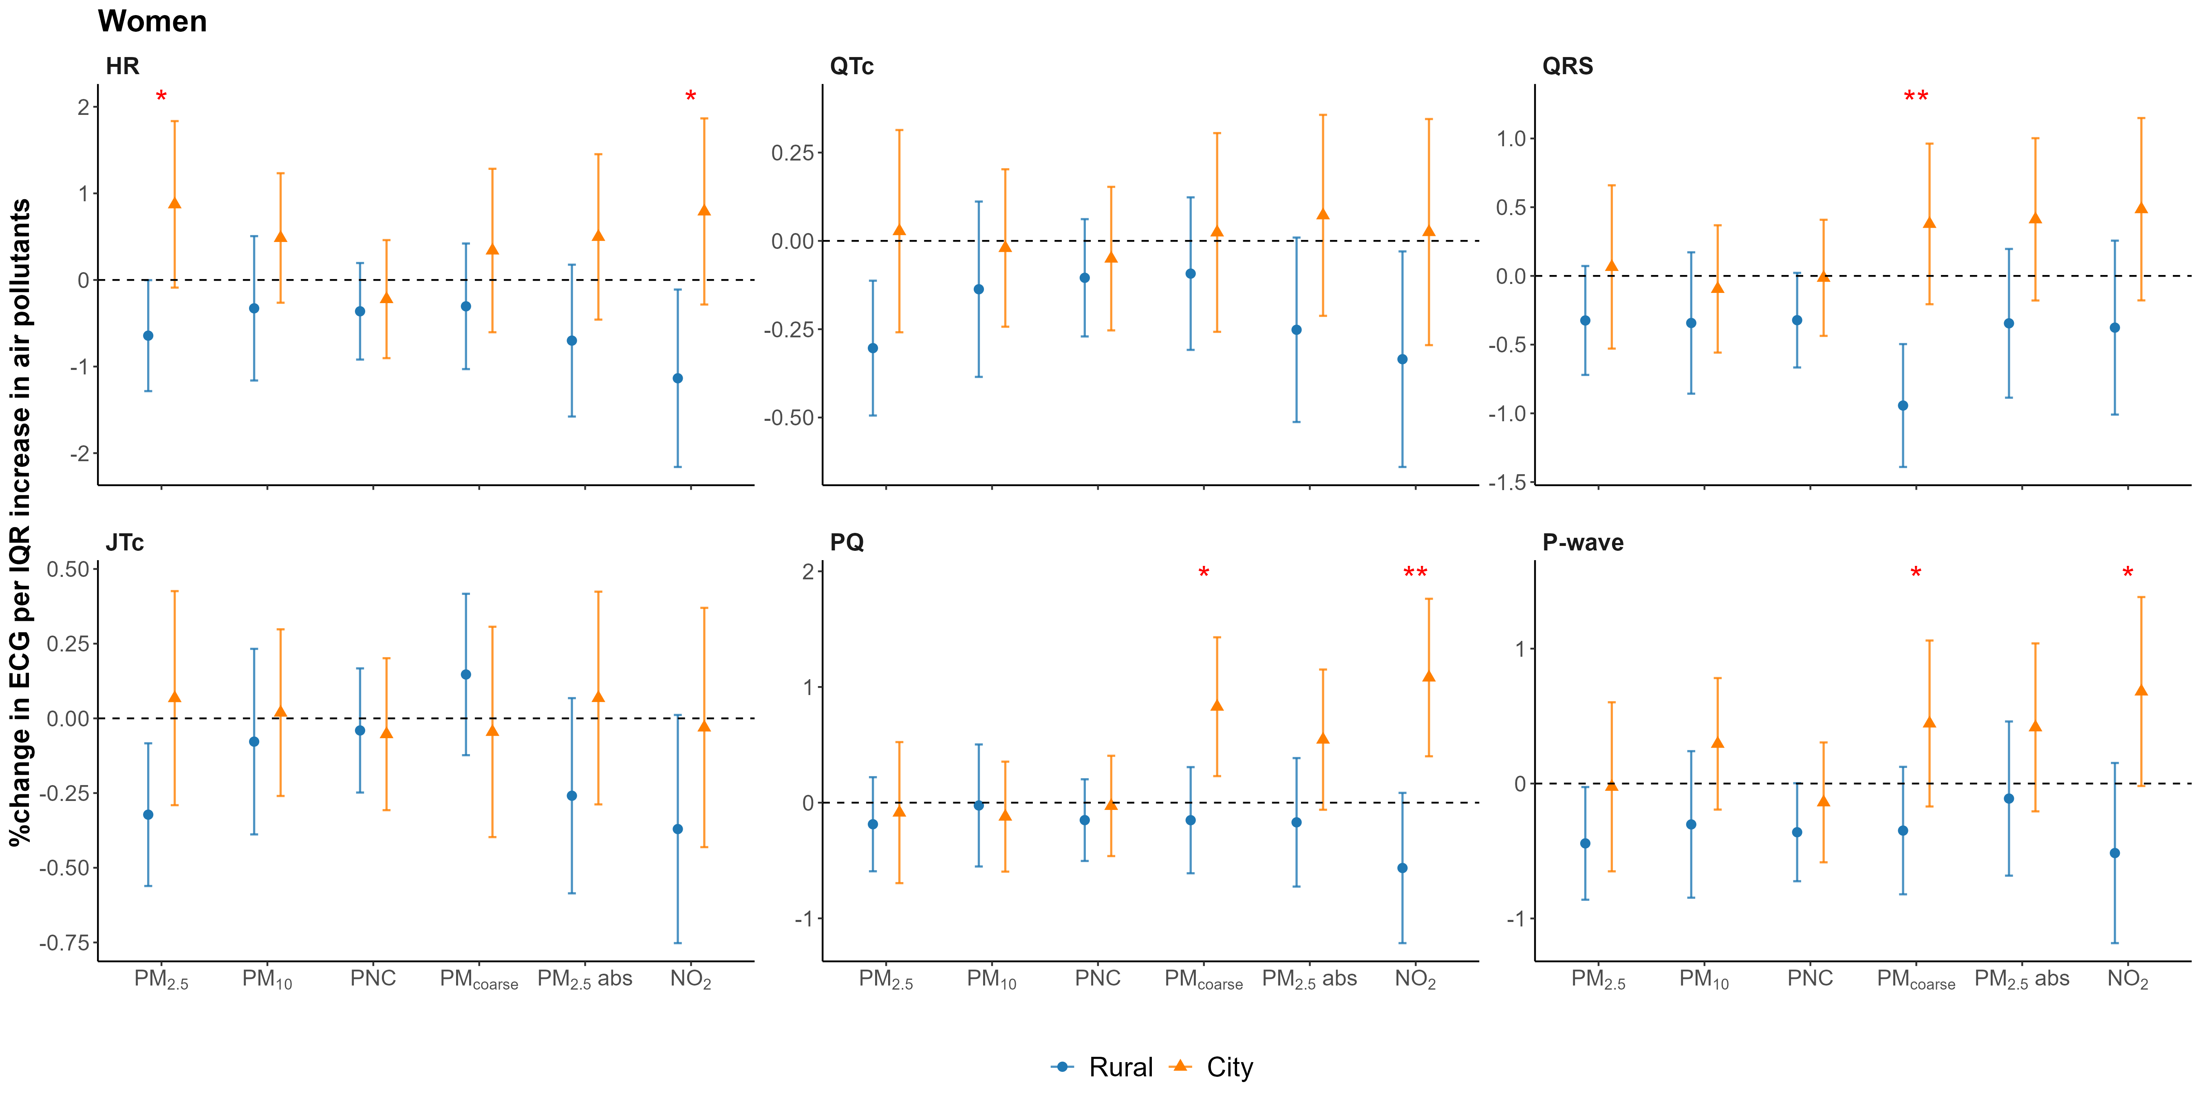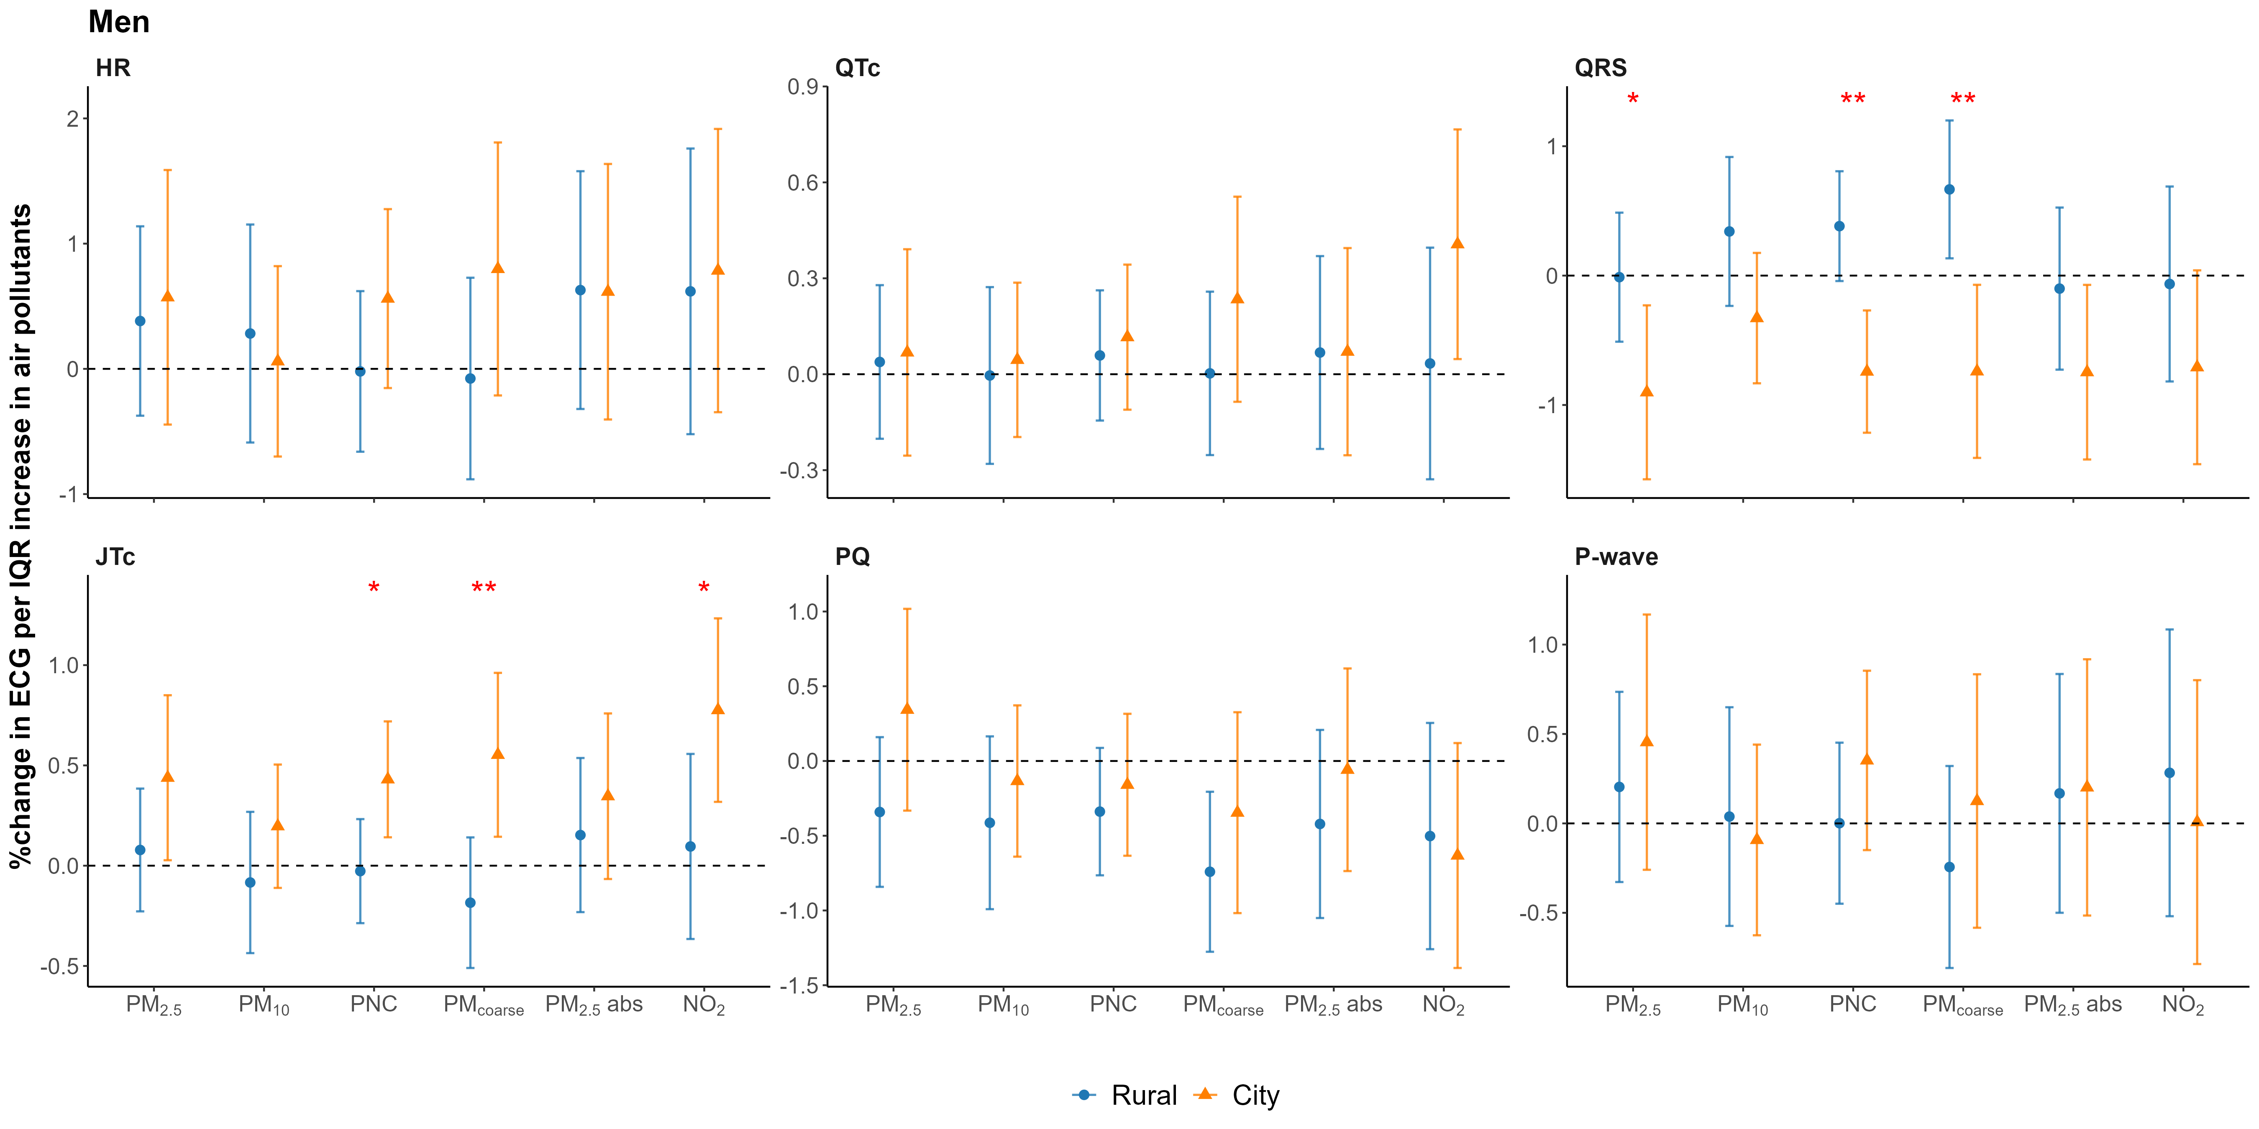
Figure S12. Sex-specific associations between air pollution and cardiac conduction markers considering effect modification by urbanization. Urbanization-specific effect estimates are given as percent differences relative to the mean outcome (together with 95% confidence intervals) of the repeatedly assessed outcomes per interquartile range (IQR) increase in exposure adjusted for age, BMI, physical activity, smoking, education, alcohol, CVD, medication. Stars indicate statistically significant interactions (p < 0.05 for *; p < 0.01 for **).

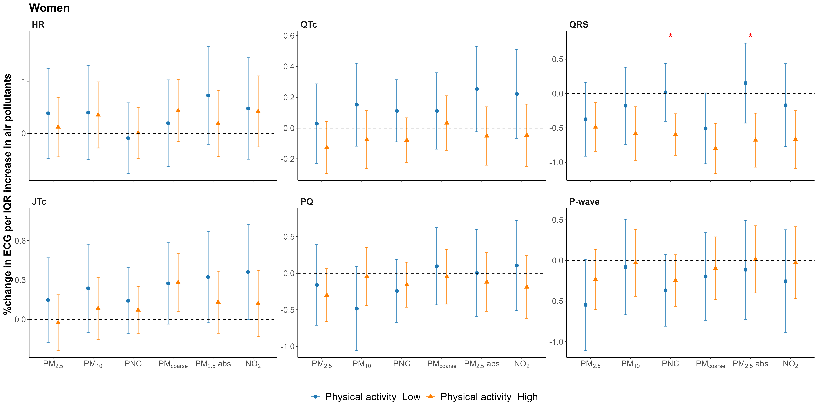
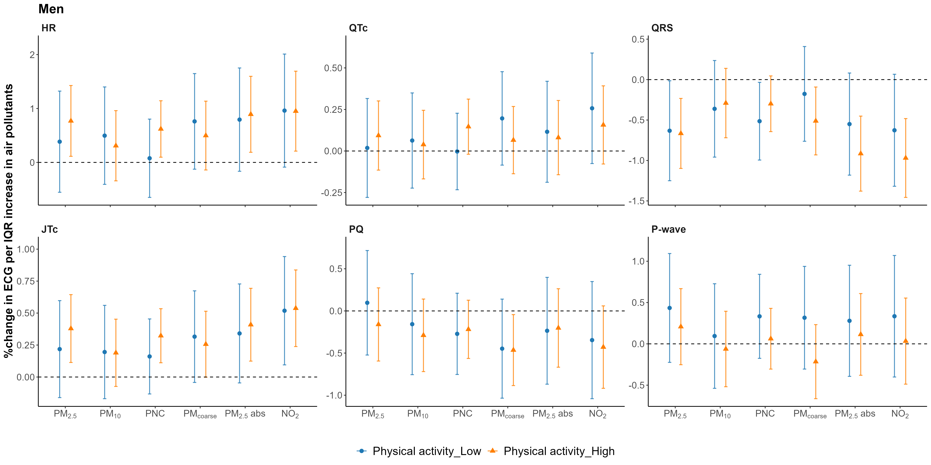
Figure S13. Sex-specific associations between air pollution and cardiac conduction markers considering effect modification by physical activity. Physical activity-specific effect estimates are given as percent differences relative to the mean outcome (together with 95% confidence intervals) of the repeatedly assessed outcomes per interquartile range (IQR) increase in exposure adjusted for age, BMI, physical activity, smoking, education, alcohol, CVD, medication. Stars indicate statistically significant interactions (p < 0.05 for *; p < 0.01 for **).

Figure S14. Directed acyclic graph for covariate selection in the association between long-term air pollution exposure and ECG parameters.
Figure S15. Sex-specific associations between long-term air pollution exposure and cardiac conduction markers in the primary model and DAG-informed sensitivity model.
Panel A shows the primary fully adjusted model, and Panel B shows the sensitivity model using the DAG-derived minimally sufficient adjustment set. Effect estimates are presented as percent differences relative to the mean outcome per interquartile range (IQR) increase in air pollutant concentration, with 95% confidence intervals.
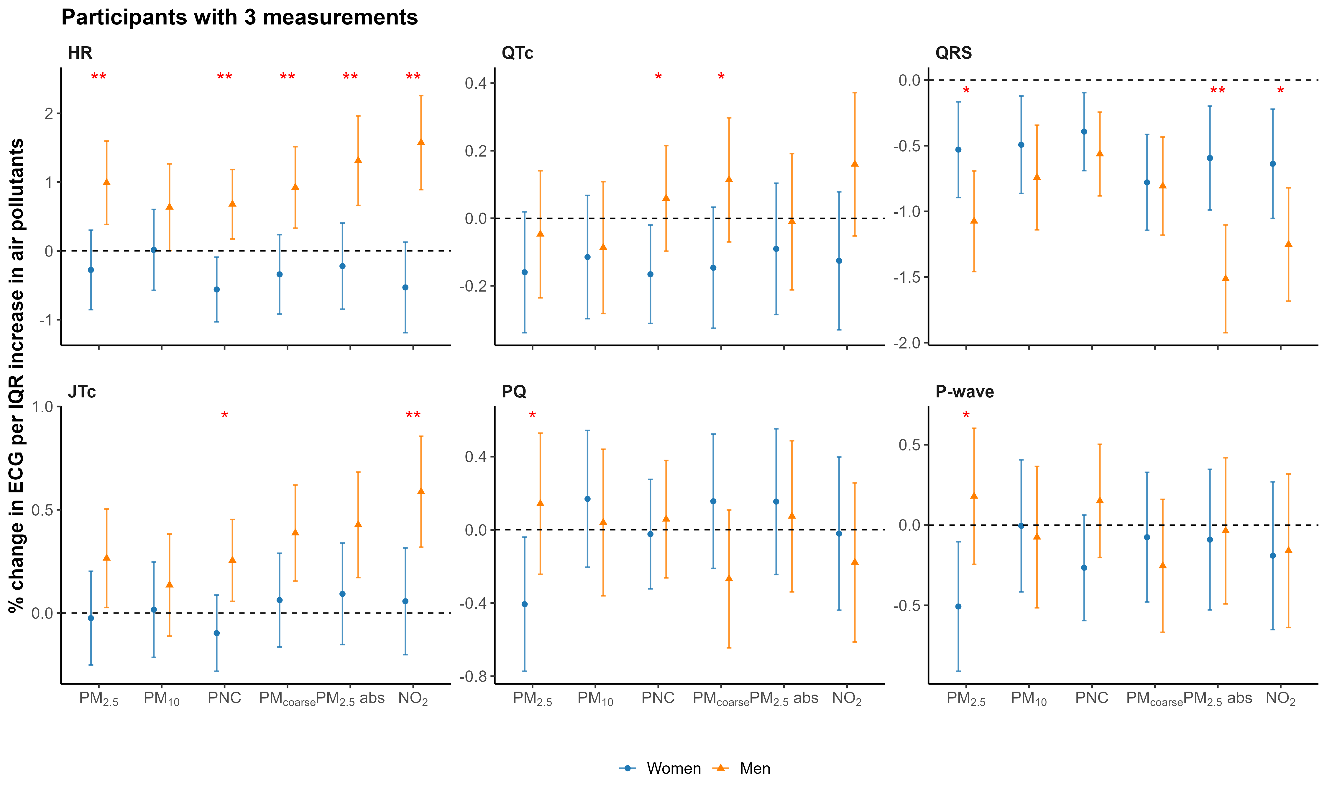
Figure S16. Sex-specific associations of air pollution and cardiac conduction system derived from generalized additive mixed models with an interaction term for sex among participants with 3 measurements. Stars indicate statistically significant interactions (p < 0.05 for *; p < 0.01 for **).
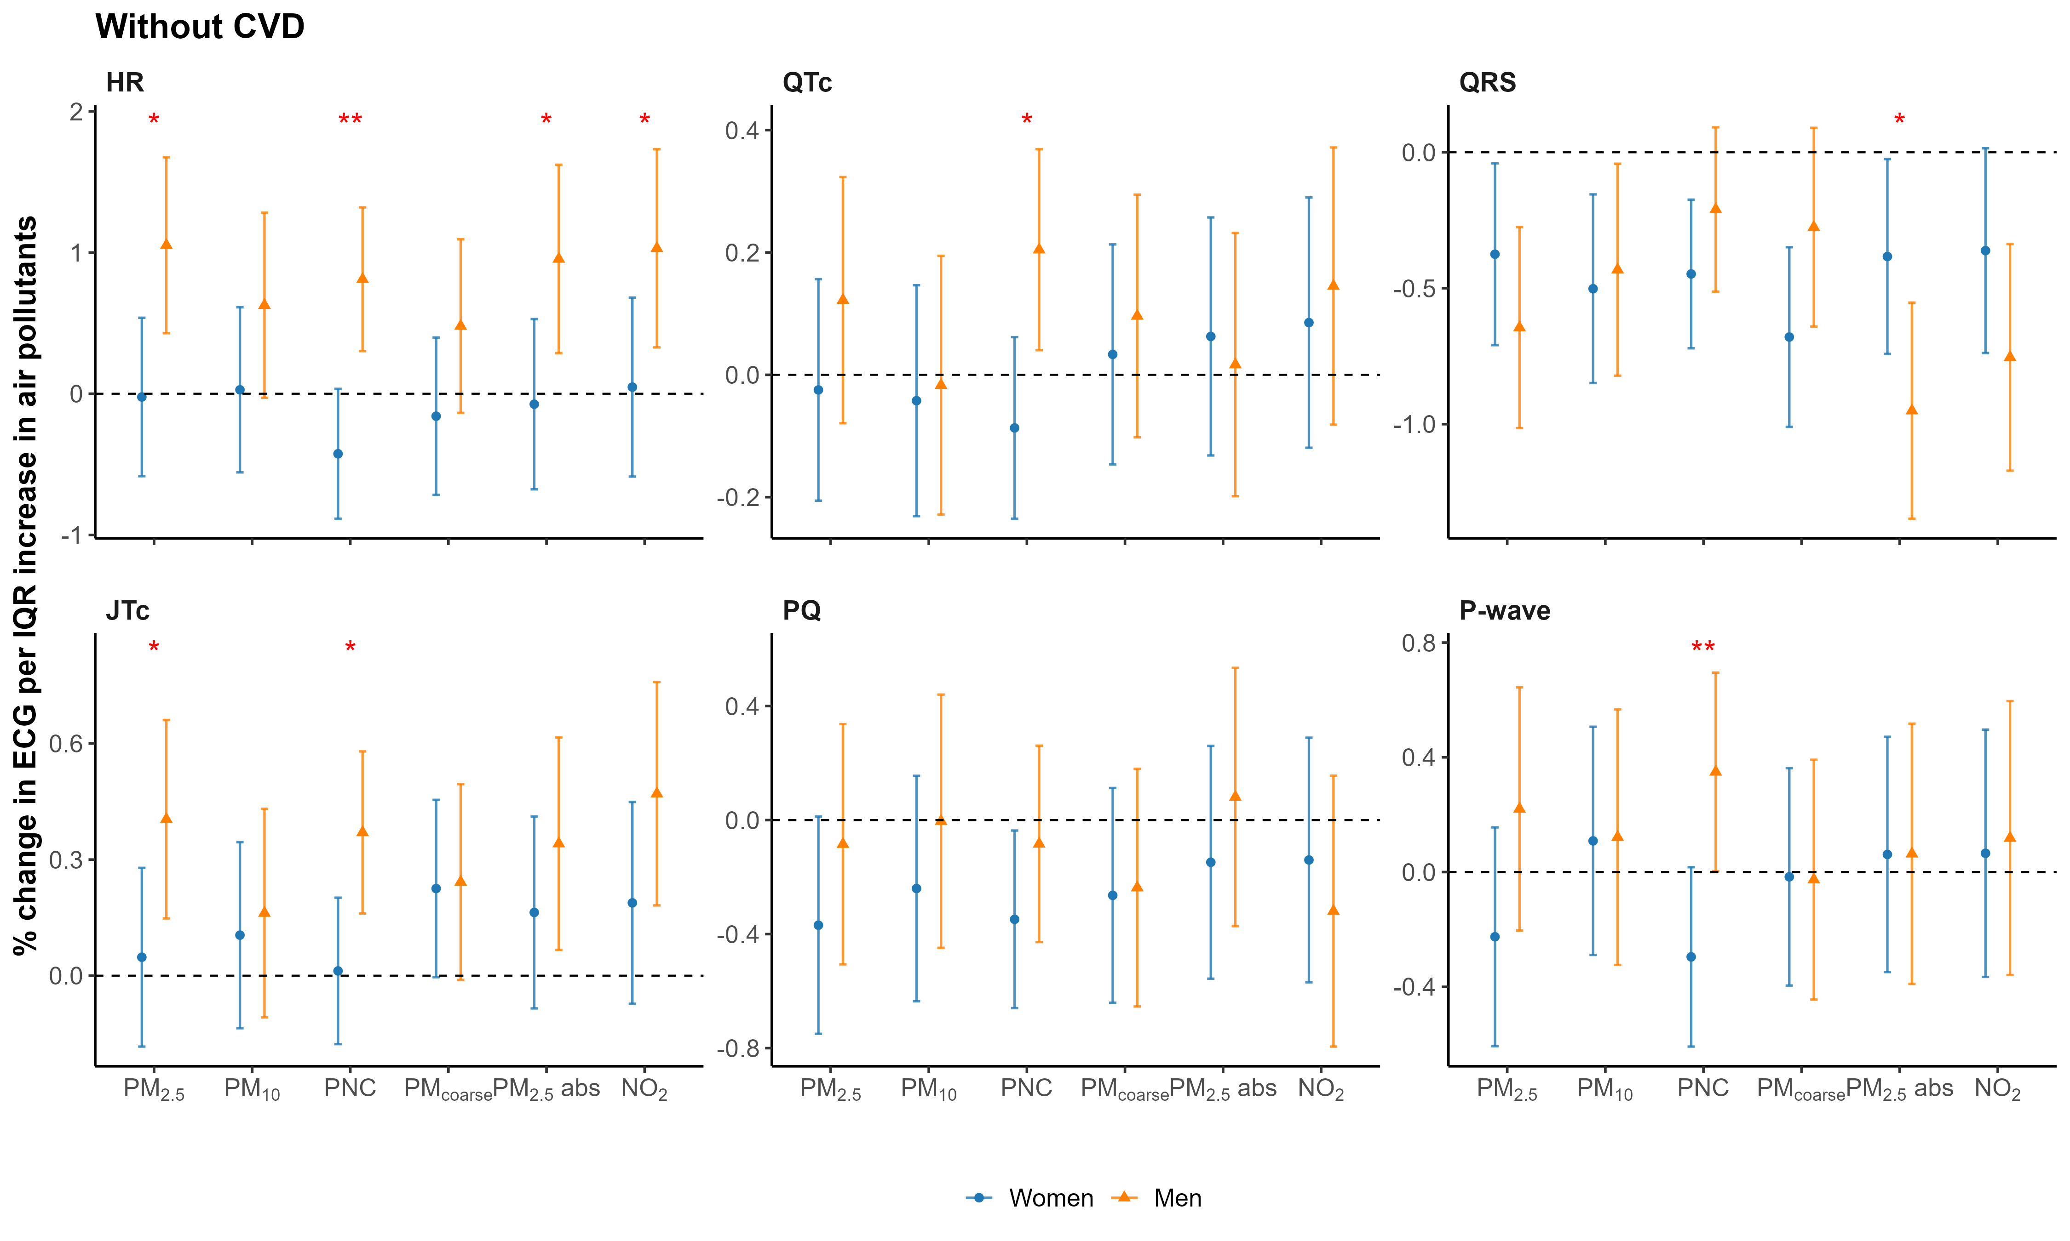
Figure S17. Sex-specific associations of air pollution and cardiac conduction system derived from generalized additive mixed models with an interaction term for sex among participants without CVD. Stars indicate statistically significant interactions (p < 0.05 for *; p < 0.01 for **).
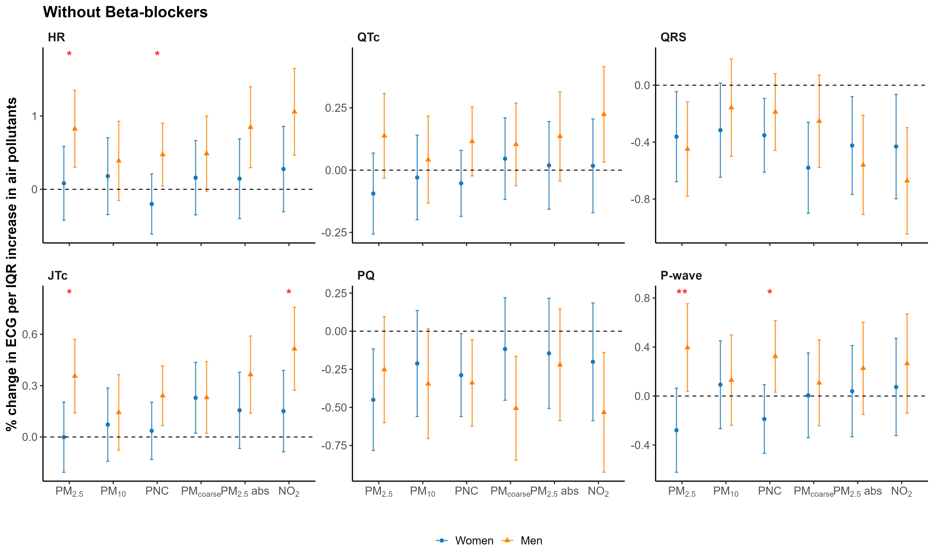
Figure S18. Sex-specific associations of air pollution and cardiac conduction system derived from generalized additive mixed models with an interaction term for sex among participants without taking beta-blockers. Stars indicate statistically significant interactions (p < 0.05 for *; p < 0.01 for **).
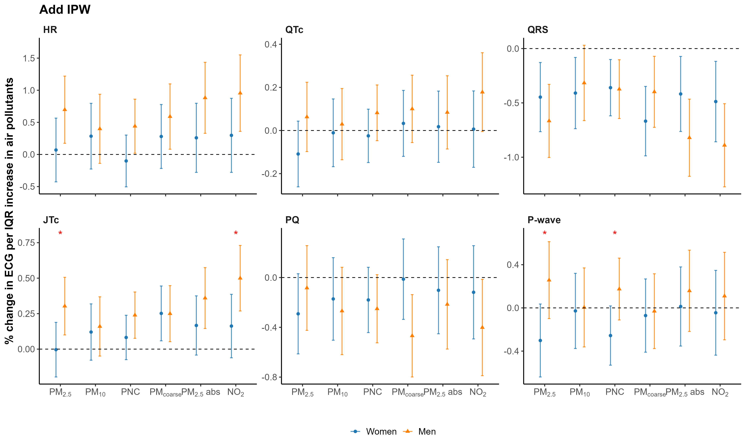
Figure S19. Sex-specific associations of air pollution and cardiac conduction system derived from generalized additive mixed models with an interaction term and IPW adjustment. Stars indicate statistically significant interactions (p < 0.05 for *; p < 0.01 for **).
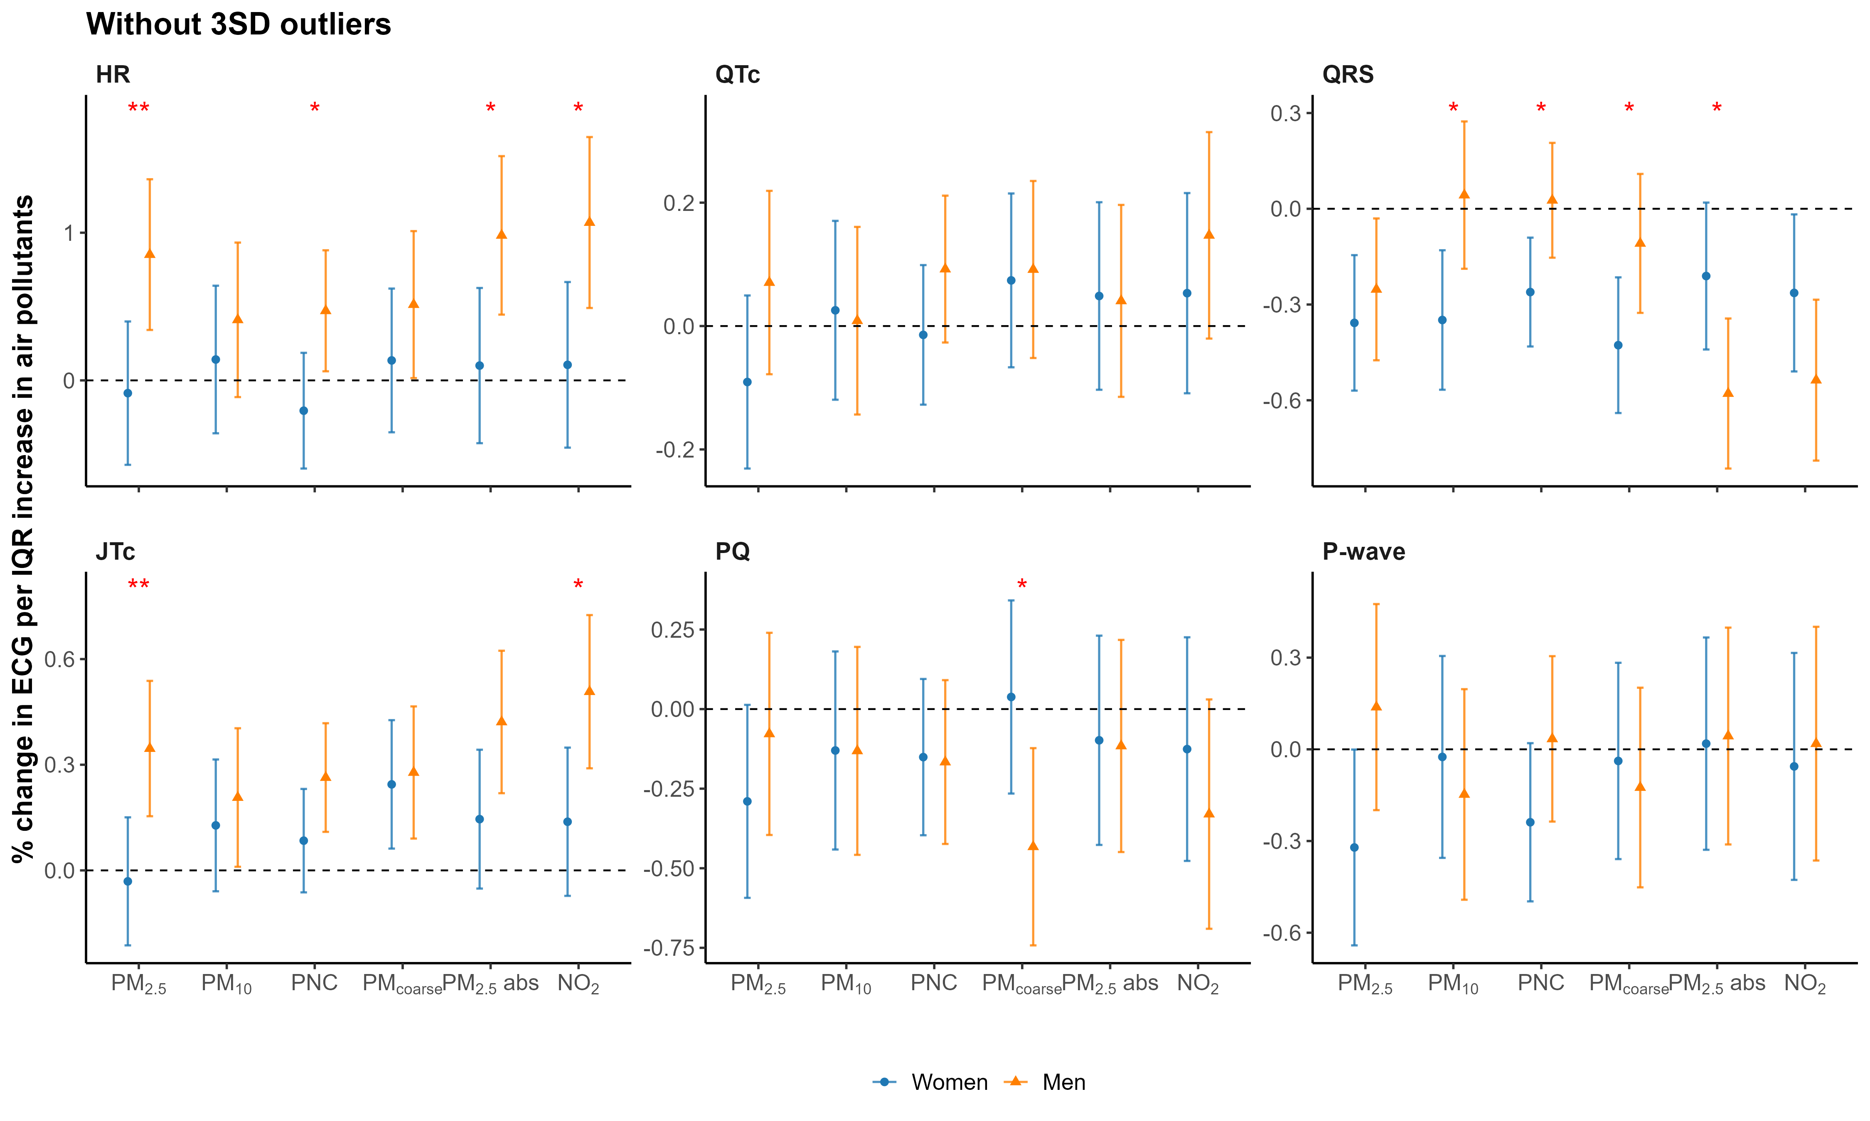
Figure S20. Sex-specific associations of air pollution and cardiac conduction system derived from generalized additive mixed models with an interaction term without 3SD outliers. Stars indicate statistically significant interactions (p < 0.05 for *; p < 0.01 for **).
Figure S21. Sex-specific associations of air pollution and cardiac conduction system derived from generalized additive mixed models with an interaction term additionally adjusted for temperature and relative humidity on the ECG examination date. Stars indicate statistically significant interactions (p < 0.05 for *; p < 0.01 for **).
Figure S22. Sex-specific associations between air pollution and cardiac conduction markers with additional adjustment for same-day air pollution.
Panel A shows the primary model, and Panel B shows the model additionally adjusted for the corresponding same-day daily pollutant concentration on the ECG examination date. Effect estimates are shown as percent differences relative to the mean outcome per IQR increase in exposure, with 95% confidence intervals. Stars indicate statistically significant interactions (p < 0.05 for *; p < 0.01 for **).
Figure S23. Comparison of single- and two-pollutant models for long-term PNC and NO₂ in relation to ECG parameters.
Effect estimates (mean-normalized percent change per interquartile range increase) and 95% confidence intervals for long-term exposure to PNC and NO₂ in single-pollutant models and in two-pollutant models including both exposures simultaneously. All models were adjusted for age, study visit, body mass index, smoking status, alcohol consumption, physical activity, educational attainment, cardiovascular disease, medication use, and beta-blocker use. Two-pollutant models were mutually adjusted for PNC and NO₂. Estimates are shown for the total sample.
Figure S24. Wave-specific associations between air pollution and cardiac conduction markers. Wave-specific effect estimates are given as percent differences relative to the mean outcome, together with 95% confidence intervals, per interquartile range (IQR) increase in exposure from models fitted separately within S4, F4, and FF4, adjusted for sex, age, BMI, smoking status, alcohol consumption, physical activity, education, CVD, and medication use.

