Supplementary Material:
Frailty among older adults in Germany: Regional variation across NAKO study centers

Maximilian König¹,², Stefan Rach³, Rafael Mikolajczyk⁴, Ben Schöttker⁵,⁶, Ute Mons⁷,⁸, Manuel Amthor¹, Henry Völzke⁹, Claudia Meinke-Franze⁹, Volker Harth¹⁰, Nadia Obi¹⁰, Matthias B. Schulze¹¹,¹², Barbara Thorand¹³^{,14}, Karin Halina Greiser¹⁵, Michael Leitzmann¹⁶, , Anne Herrmann^{16, 17}, Wolfgang Lieb¹⁸, Jasmin Kiekert¹⁹, Thomas Keil^{20,21,22}, Lilian Krist²⁰, Börge Schmidt²³, Jana-Kristin Heise²⁴, Katharina Nimptsch²⁵ , Tobias Pischon^{25,26,27} and Till Ittermann⁹

Affiliations
¹ Department of Internal Medicine D – Geriatrics, Universitätsmedizin Greifswald, Greifswald, Germany
² Housing and Digitalization Competence Center Mecklenburg-Vorpommern, Greifswald, Germany³ Department of Epidemiological Methods and Etiological Research, Leibniz Institute for Prevention Research and Epidemiology – BIPS, Bremen, Germany
⁴ Institute for Medical Epidemiology, Biometrics, and Informatics, Interdisciplinary Center for Health Sciences, Medical Faculty of the Martin Luther University Halle-Wittenberg, Halle (Saale), Germany
⁵ Division of Clinical Epidemiology and Aging Research, German Cancer Research Center (DKFZ), Heidelberg, Germany
⁶ Network Aging Research, University of Heidelberg, Heidelberg, Germany
⁷ Division of Primary Cancer Prevention, German Cancer Research Center (DKFZ), Heidelberg, Germany
⁸ Medical Faculty Mannheim, Heidelberg University, Mannheim, Germany
⁹ Department of Study of Health in Pomerania/Clinical-Epidemiological Research, Institute for Community Medicine, Universitätsmedizin Greifswald, Greifswald, Germany
¹⁰ Institute for Occupational and Maritime Medicine (ZfAM), University Medical Center Hamburg-Eppendorf, Hamburg, Germany
¹¹ Department of Molecular Epidemiology, German Institute of Human Nutrition Potsdam-Rehbruecke, Nuthetal, Germany
¹² Institute of Nutritional Science, University of Potsdam, Nuthetal, Germany
¹³ Institute of Epidemiology, Helmholtz Zentrum München, German Research Center for Environmental Health, Neuherberg, Germany
¹⁴Institute for Medical Information Processing, Biometry and Epidemiology (IBE), Faculty of Medicine, LMU Munich; Pettenkofer School of Public Health, Munich, Germany
¹⁵ Division of Cancer Epidemiology, German Cancer Research Center (DKFZ), Heidelberg, Germany
¹⁶ Institute for Epidemiology and Preventive Medicine, University Medicine Regensburg, Regensburg, Germany
¹⁷Department of Hematology and Medical Oncology, University Hospital Regensburg, Germany
¹⁸ Institute of Epidemiology, Christian-Albrechts-University of Kiel and University Hospital Schleswig-Holstein (UKSH), Campus Kiel, Kiel, Germany
¹⁹ Institute for Epidemiology and Prevention, Universitätsklinikum Freiburg, Freiburg, Germany
²⁰ Institute of Social Medicine, Epidemiology, and Health Economics, Charité-Universitätsmedizin Berlin, Berlin, Germany.
²¹ Institute of Clinical Epidemiology and Biometry, University of Würzburg, Würzburg, Germany.
²² State Institute of Health I, Bavarian Health and Food Safety Authority, Erlangen, Germany
²³ Institute for Medical Informatics, Biometry and Epidemiology, University Hospital of Essen, University of Duisburg-Essen, Germany
²⁴ Department of Epidemiology, Helmholtz-Centre for Infection Research (HZI), Braunschweig, Germany
²⁵ Molecular Epidemiology Research Group, Max Delbrück Center for Molecular Medicine (MDC) in the Helmholtz Association, Berlin, Germany
²⁶ Biobank Technology Platform, Max Delbrück Center for Molecular Medicine (MDC) in the Helmholtz Association, Berlin, Germany
²⁷ Charité - Universitätsmedizin Berlin, corporate member of Freie Universität Berlin and Humboldt-Universität zu Berlin, Berlin, Germany

Corresponding author:
Prof. Dr. med. Maximilian König, MSc
Klinik und Poliklinik für Innere Medizin D – Geriatrie
Universitätsmedizin Greifswald
D-17475 Greifswald
maximilian.koenig@med.uni-greifswald.de

Supplementary Table 1. Frailty index items

Nr. | Variable name | Description | Coding
1 | rheuma_fi | Rheumatism (Arthritis/Polyarthritis) | 0 = no, 1 = yes
2 | ckd_fi | Chronic Kidney Disease (CKD) | 0 = no, 1 = yes
3 | asthma_fi | Asthma | 0 = no, 1 = yes
4 | hyperlipidemia_fi | Elevated blood lipids (cholesterol or triglycerides) | 0 = no, 1 = yes
5 | gout_fi | Gout | 0 = no, 1 = yes
6 | sleep_fi | Sleep quality (Subjective sleep quality) | 1=0, 2=0.33, 3=0.66, 4=1
7 | thyroid_fi | Thyroid disease | 0 = no, 1 = yes
8 | iadl8_fi | ... going to the doctor, pharmacy, physiotherapy, or other medical facilities (possibly using public transport)? | 0 = independent; 0.25; 0.5; 0.75; 1 =impaired
9 | iadl7_fi | ... making phone calls? | 0 = independent; 0.25; 0.5; 0.75; 1 =impaired
10 | iadl6_fi | ... receiving and entertaining visitors? | 0 = independent; 0.25; 0.5; 0.75; 1 =impaired
11 | iadl5_fi | ... writing letters, filling out forms? | 0 = independent; 0.25; 0.5; 0.75; 1 =impaired
12 | iadl4_fi | ... managing your financial affairs? | 0 = independent; 0.25; 0.5; 0.75; 1 =impaired
13 | iadl3_fi | ... doing laundry, ironing? | 0 = independent; 0.25; 0.5; 0.75; 1 =impaired
14 | iadl2_fi | ... shopping for food, clothing, household items, etc.? | 0 = independent; 0.25; 0.5; 0.75; 1 =impaired
15 | iadl1_fi | ... cleaning your home? | 0 = independent; 0.25; 0.5; 0.75; 1 =impaired
16 | satisfied_fi | Life satisfaction (“How satisfied are you currently, all in all, with your life?”) | 0, 0.2, …, 0.9, 1
17 | exhaustion_fi | Exhaustion (“During the past 7 days, to what extent have you suffered from unusual exhaustion and fatigue?”) | 0, 0.2, …, 0.9, 1
18 | subj_health_fi | Subjective health (“How would you describe your general state of health?”) | 0, 0.25, 0.5, 0.75, 1
19 | strength_fi | Loss of strength (“...climbing several flights of stairs”) | 0, 0.5, 1
20 | sad_fi | “...feeling discouraged and sad?” | 0, 0.5, 1
21 | fit_fi | Fitness (self-assessed) | 0, 0.1, 0.2, 0.3, 0.4, 0.5, 0.6, 0.7, 0.8, 0.9, 1
22 | fracture50_fi | Bone fracture after age 50 | 0 = no, 1 = yes
23 | teeth_fi | Number of teeth | 0–9=0, 10–19=0.33, 20–26=0.66, 27+=1
24 | glaucoma_fi | Glaucoma | 0 = no, 1 = yes
25 | macula_fi | Macular degeneration | 0 = no, 1 = yes
26 | cataract_fi | Cataract | 0 = no, 1 = yes
27 | mi_fi | Myocardial infarction | 0 = no, 1 = yes
28 | cad_fi | Coronary heart disease (CHD) | 0 = no, 1 = yes
29 | chf_fi | Congestive heart failure (CHF) | 0 = no, 1 = yes
30 | arrhythmia_fi | Cardiac arrhythmia | 0 = no, 1 = yes
31 | pad_fi | Peripheral arterial disease (PAD) | 0 = no, 1 = yes
32 | dm_fi | Diabetes mellitus (any form) | 0 = no, 1 = yes
33 | copd_fi | Chronic obstructive pulmonary disease (COPD) | 0 = no, 1 = yes
34 | xirrhosis_fi | Liver cirrhosis | 0 = no, 1 = yes
35 | polypharma_fi | Polypharmacy | „0–4“=0, „5–9“= 0.5, „≥10“ = 1
36 | backpain_fi | Back pain (“Back pain for 3 months or longer, almost daily”) | 0 = no, 1 = yes
37 | osteoporosis_fi | Osteoporosis | 0 = no, 1 = yes
38 | parkinson_fi | Parkinson’s disease | 0 = no, 1 = yes
39 | stroke_fi | Stroke (Number of strokes) | 0 = no, 0.75 = yes, 1 = recurrent stroke
40 | cancer_fi | Cancer (“Have you ever been diagnosed with cancer by a doctor?”) | 0 = no, 1 = yes

Notes and abbreviations: all information is self-reported, 0 generally indicates absence of deficit, 1 indicates presence of full deficit; these 10 candidate items were excluded during the selection process: Hearing impairment, Neuropathy, Dental prostheses, Hypertension, HIV, Diabetic foot, Gastric ulcer, Alcohol addiction, Vertigo, Osteoarthritis.

Supplementary Table 2. Regional variation in the prevalence of frailty, mean frailty index, and possible determinants
NAKO Study Center | Mean FI | Prevalence  of frailty (FI ≥ 0.25) | Age structure (61-64/65-69/70-75) | Mean net equivalence  Income | Weak social network | Subjective health# | Education⁺ | Migration  Background | East/West | North/  South | Urbanization | Excluded*
Freiburg | 0.14±0.06 | 5.9 % | 44.2/48.1/7.8 % | 2586 € | 51.2 % | 2.86±0.70 | 5 (3;5) | 14.1 % | W | S | M | 18.8 %
Bremen | 0.14±0.06 | 6.0 % | 44.8/48.2/7.1 % | 2500 € | 49.8 % | 2.84±0.66 | 5 (3;5) | 10.3 % | W | N | U | 18.9 %
Münster | 0.14±0.06 | 6.0 % | 47.4/49.2/3.5 % | 2906 € | 47.8 % | 2.84±0.67 | 5 (3;5) | 8.6 % | W | N | U | 14.8 %
Hamburg | 0.14±0.06 | 6.3 % | 38.1/50.4/11.5 % | 2567 € | 54.9 % | 2.86±0.68 | 4 (3;5) | 14.3 % | W | N | U | 11.8 %
Hannover | 0.14±0.06 | 6.3 % | 42.9/48.7/8.4 % | 2620 € | 52.7 % | 2.88±0.66 | 5 (3;5) | 13.0 % | W | N | U | 25.5 %
Kiel | 0.15±0.07 | 7.1 % | 45.4/50.0/4.6 % | 2356 € | 51.1 % | 2.86±0.66 | 5 (3;5) | 9.9 % | W | N | M | 19.7 %
Berlin (South) | 0.15±0.06 | 7.2 % | 36.8/47.7/15.5 % | 2496 € | 61.7 % | 2.89±0.64 | 5 (3;5) | 15.4 % | W | C | U | 21.2 %
Mannheim | 0.15±0.06 | 7.4 % | 44.9/48.1/7.0 % | 2458 € | 51.6 % | 2.93±0.66 | 4 (3;5) | 18.8 % | W | S | U | 20.0 %
Total | 0.15±0.07 | 7.7 % | 44.7/47,6/7.7 % | 2306 € | 51.6 % | 2.92±0.65 | 5 (3;5) | 11.8 % | - | - | - | 22.3 %
Neubrandenburg | 0.15±0.07 | 7.7 % | 51.3/44.9/3.8 % | 1819 € | 48.7 % | 3.01±0.60 | 5 (3;5) | 7.3 % | E | N | S/R | 39.9 %
Augsburg | 0.15±0.07 | 7.8 % | 45.2/46.8/8.0 % | 2260 € | 46.6 % | 2.90±0.68 | 3 (3;5) | 16.8 % | W | S | M | 23.9 %
Halle | 0.15±0.07 | 8.5 % | 43.5/48.5/8.0 % | 1852 € | 50.9 % | 3.01±0.57 | 5 (3;5) | 6.2 % | E | C | M | 26.0 %
Leipzig | 0.15±0.07 | 8.6 % | 45.5/44.7/9.7 % | 1711 € | 50.2 % | 3.06±0.59 | 5 (3;5) | 6.6 % | E | C | U | 10.4 %
Berlin (North) | 0.15±0.07 | 8.7 % | 47.9/48.2/3.9 % | 2049 € | 53.7 % | 2.96±0.59 | 5 (3;5) | 6.0 % | E | C | U | 13.5 %
Düsseldorf | 0.15±0.07 | 8.9 % | 43.3/49.2/7.5 % | 2695 € | 58.9 % | 2.88±0.67 | 5 (3;5) | 18.8 % | W | C | U | 30.1 %
Saarbrücken | 0.15±0.07 | 8.9 % | 45.8/50.7/3.51 % | 2338 € | 44.8 % | 2.91±0.65 | 4 (3;5) | 9.7 % | W | S | M | 25.7 %
Regensburg | 0.16±0.07 | 8.9 % | 43.8/45.2/11.1 % | 2307 € | 43.7 % | 2.96±0.65 | 3 (3;5) | 12.0 % | W | S | M | 24.5 %
Berlin (Mitte) | 0.16±0.07 | 9.4 % | 43.1/45.5/11.4 % | 2204 € | 64.7 % | 2.95±0.67 | 5 (3;5) | 12.4 % | E | C | U | 15.9 %
Essen | 0.16±0.07 | 10.3 % | 46.4/47.1/6.5 % | 2424 € | 51.0 % | 3.00±0.67 | 4 (3;5) | 13.9 % | W | C | U | 17.0 %
Notes and abbreviations: Data are presented as mean w/ and w/o (±SD), percentages, median (25th;7th percentile); SES = Socio-Economic Status (European Socio-economic Classification), Weak social network = Social Network Index Level I or II, Urbanization: U=urban, S=suburban, R=rural, M=mixture of all three categories according to Wolf et al. [28], C=Central, N= North, S= South, W= West, E = East, FI = Frailty Index, #Subjective Health: 1=excellent, 2=very good, 3= good, 4 = fair, 5 = bad; ⁺Education: ISCED-97 (International Standard Classification of Education, 1997 version) defines levels of education from 0 to 6; *this proportion of participants was excluded from the analyses because the Frailty Index (FI) could not be computed when more than 20% of FI items were missing

Supplementary Figure 1. Study flow chart

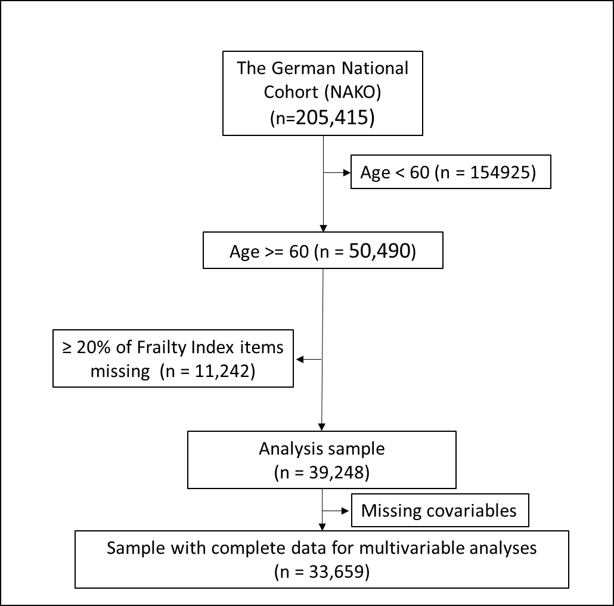

Supplementary Table 3. Frailty distribution by urbanization
Frailty category | Urban  (n =22,499) | Mixture  (n=13,359) | Suburban/Rural  (n=3,390) | Total  (n=39,248)
Robust/Prefrail | 20,772 (92.3 %) | 12,313 (92.2 %) | 3,130 (92.3 %) | 36,215 (92.3 %)
Frail | 1,727 (7.7 %) | 1,046 (7.8 %) | 260 (7.7 %) | 3,033 (7.7%)
Notes: Data are presented as numbers(percentages), Pearson chi²(2) = 0.297, p = 0.862

Supplementary Table 4. Prevalence of frailty across the study sites (design-weighted)
Frailty category | Augsburg | Regensburg | Mannheim | Freiburg | Saarbrücken | Essen | Münster | Düsseldorf | Halle | Leipzig | Berlin Nord | Berlin Mitte | Berlin Süd | Hannover | Hamburg | Bremen | Kiel | Neubrandenburg | Total
Robust, % | 56.87 | 51.56 | 59.14 | 61.16 | 54.77 | 52.10 | 63.00 | 56.81 | 56.38 | 54.89 | 56.43 | 54.34 | 58.16 | 63.40 | 61.47 | 62.26 | 61.57 | 60.94 | 58.10
Prefrail, % | 35.57 | 39.20 | 33.42 | 33.06 | 36.84 | 37.58 | 31.55 | 34.17 | 35.07 | 36.52 | 34.88 | 36.23 | 34.49 | 30.22 | 32.21 | 31.68 | 31.49 | 31.43 | 34.13
Frail, % | 7.56 | 9.24 | 7.44 | 5.79 | 8.39 | 10.32 | 5.45 | 9.02 | 8.55 | 8.59 | 8.69 | 9.44 | 7.35 | 6.38 | 6.31 | 6.06 | 6.94 | 7.63 | 7.78
Total, % | 100 | 100 | 100 | 100 | 100 | 100 | 100 | 100 | 100 | 100 | 100 | 100 | 100 | 100 | 100 | 100 | 100 | 100 | 100

Supplementary Table 5. Individual-level associations of frailty (multivariable logistic regression, design-weighted), n = 33,659.
 | OR (95% CI) | p-value
Male Sex | 1 (Ref.) | —
Female Sex | 0.99 (0.88–1.12) | 0.867
Age, years | 1.04 (1.02–1.06) | <0.001
Income (ordinal) | 0.73 (0.71–0.76) | <0.001
Education (ordinal) | 0.87 (0.82–0.92) | <0.001
w/ immigr. background | 1.00 (Ref.)
w/o immigr. background | 1.06 (0.92–1.22) | 0.419
Social network index (ordinal) | 0.79 (0.72–0.86) | <0.001
Study site
Augsburg | 1.00 (Ref.)
Regensburg | 1.41 (1.39–1.43) | <0.001
Mannheim | 1.13 (1.11–1.15) | <0.001
Freiburg | 0.88 (0.86–0.89) | <0.001
Saarbrücken | 1.31 (1.29–1.33) | <0.001
Essen | 1.53 (1.52–1.55) | <0.001
Münster | 0.97 (0.94–0.99) | 0.032
Düsseldorf | 1.47 (1.43–1.50) | <0.001
Halle | 1.05 (1.00–1.10) | 0.038
Leipzig | 1.01 (0.97–1.06) | 0.493
Berlin Nord | 1.27 (1.22–1.32) | <0.001
Berlin Mitte | 1.23 (1.19–1.28) | <0.001
Berlin Süd | 1.10 (1.05–1.14) | <0.001
Hannover | 1.05 (1.03–1.08) | 0.001
Hamburg | 0.95 (0.92–0.97) | <0.001
Bremen | 0.90 (0.88–0.92) | <0.001
Kiel | 1.03 (1.02–1.05) | 0.001
Neubrandenburg | 0.94 (0.90–0.99) | 0.014
Notes and abbreviations: Odds ratios (OR) and 95% confidence intervals (CI), w/ = with, w/o = without
Supplementary Table 6. Comparison of Recruitment (n = 50490), Analysis (n = 39248)
and Complete Covariable Samples (n = 33659).
 | Recruiment  (n = 50490) | Analysis  (n = 39248) | Complete Covariable Sample  (n = 33659)
Age | 65.3±2.9 | 65.2±2.8 | 65.1±2.8
Males sex | 25261 (50.3) | 20506 (52.3) | 18058 (53.6)
Migration status | 7,254 (14.4) | 4,643 (11.8) | 3,808 (11.3)
Income | 2168 ± 1481 | 2306 ± 1531 | 2344 ± 1558
Sample composition, %
- Augsburg | 10.13 | 9.92 | 9.48
- Regensburg | 4.94 | 4.79 | 4.74
- Mannheim | 4.85 | 5.00 | 5.01
- Freiburg | 4.84 | 5.06 | 5.24
- Saarbrücken | 5.01 | 4.79 | 4.15
- Essen | 4.85 | 5.17 | 5.34
- Münster | 4.82 | 5.29 | 5.33
- Düsseldorf | 4.36 | 3.92 | 3.89
- Halle | 5.04 | 4.80 | 4.88
- Leipzig | 5.22 | 6.02 | 6.46
- Berlin Nord | 4.88 | 5.43 | 5.57
- Berlin Mitte | 5.15 | 5.57 | 5.75
- Berlin Süd | 5.02 | 5.09 | 5.20
- Hannover | 5.23 | 5.02 | 4.96
- Hamburg | 4.89 | 5.55 | 5.62
- Bremen | 5.04 | 5.26 | 5.37
- Kiel | 4.52 | 4.67 | 4.74
- Neubrandenburg | 11.18 | 8,64 | 8,27

Notes: Values are presented as mean ± standard deviation for continuous variables and as absolute numbers (percentages)
for categorical variables. Percentages refer to the respective column sample size. Sample composition by study center
is shown as relative frequencies (%). Percentages for study centers do not sum exactly to 100% due to rounding.

Supplementary Table 7. Absolute sample sizes and frequencies of robust, prefrail, and frail, total and by sex

Robust prefrail frail total
MEN
61-64 years 5,754 2,564 543 8,861
64.94 % 28.94 % 6.13 % 100.00 %

65-69 years 5,952 3,196 779 9,927
59.96 % 32.20 % 7.85 % 100.00 %

70-75 years 888 668 162 1,718
51.69 % 38.88 % 9.43 % 100.00 %
WOMEN
61-64 years 5,096 2,923 667 8,686
58.67 % 33.65 % 7.68 % 100.00 %

65-69 years 4,585 3,426 726 8,737
52.48 % 39.21 % 8.31 % 100.00 %

70-75 years 564 599 156 1,319
42.76 % 45.41 % 11.83 % 100.00 %

Total 22,839 13,376 3,033 39,248
58.19 % 34.08 % 7.73 % 100.00 %

