Supplementary Material

Suppl. Table 1 Imputed values for covariates used in regression models
Parameter | Missing values (%)
Sex | 0 (0)
Age | 0 (0)
%pred. VO2peak | 0 (0)
BMI [kg/m²] | 0 (0)
HDL-cholesterol [mg/dL] | 1 (0.6)
Diabetes | 1 (0.6)
Hypertension | 0 (0)
Coronary artery disease | 7 (4.1)
Atrial fibrillation | 0 (0)
eGFR [mL/min/1.73 m²] | 1 (0.6)
ACE inhibitors | 0 (0)
Angiotensin receptor blockers | 0 (0)
Diuretics | 0 (0)
Statins | 0 (0)
Data is shown as number (%).

Suppl. Figure 1 Metabolites (A-G) and ratios (H-J) stratified by sex and in relation to age
Plots A-J include all 171 analysed patients (n= 58 men, n= 113 women)

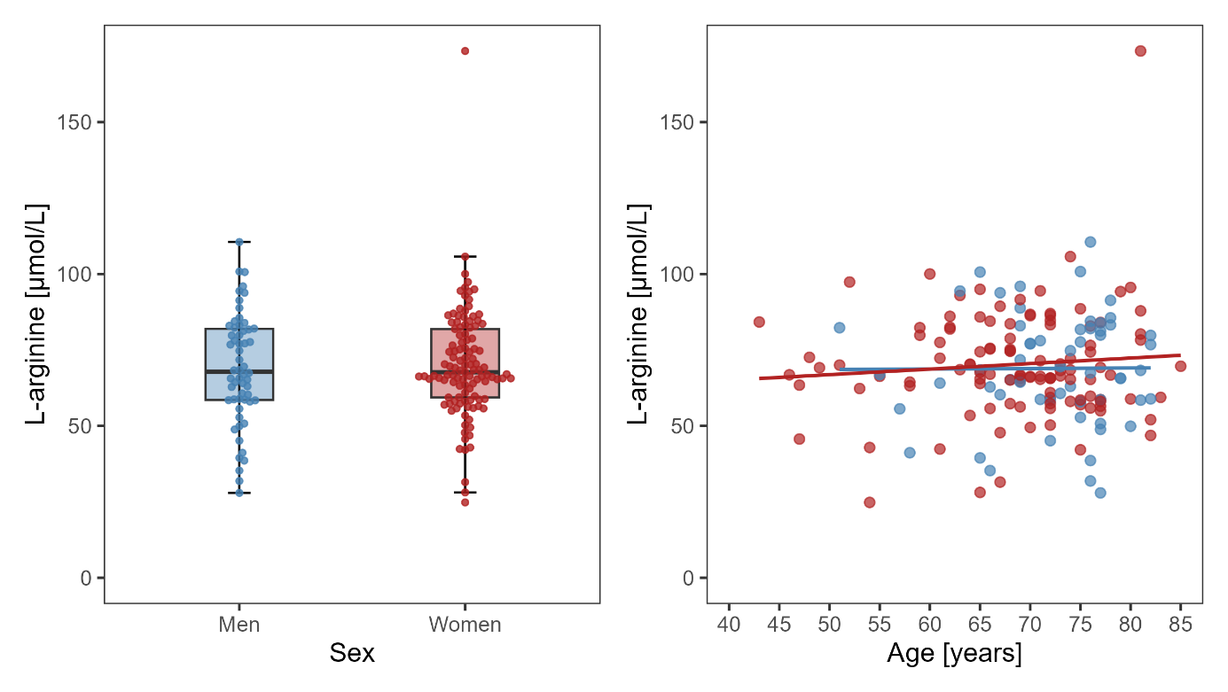
B)
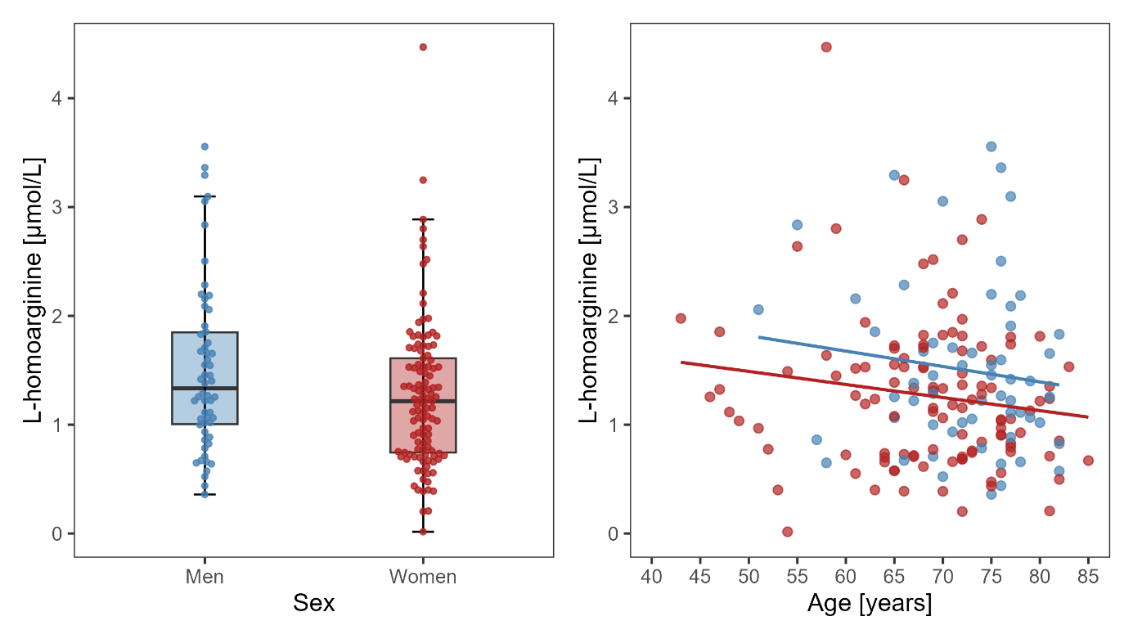

C)
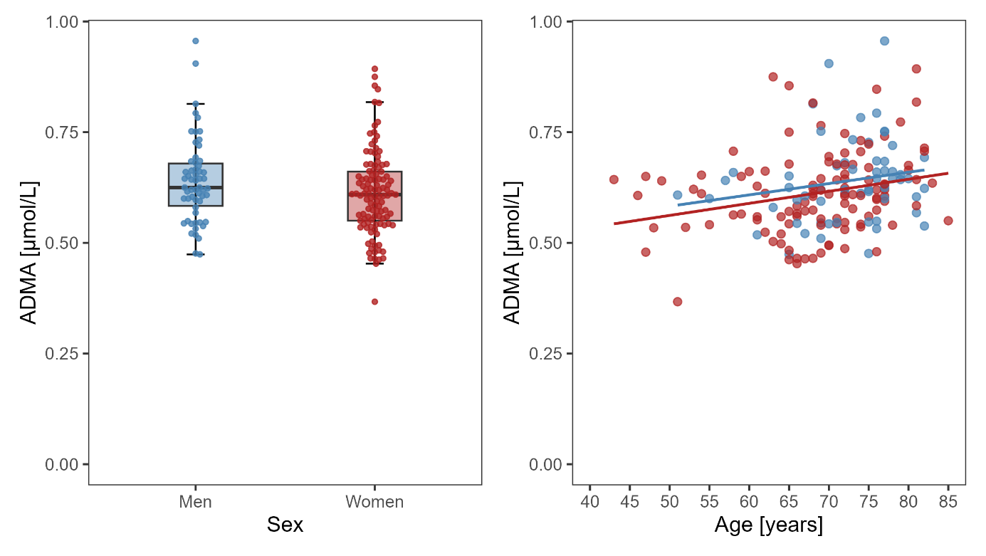

D) 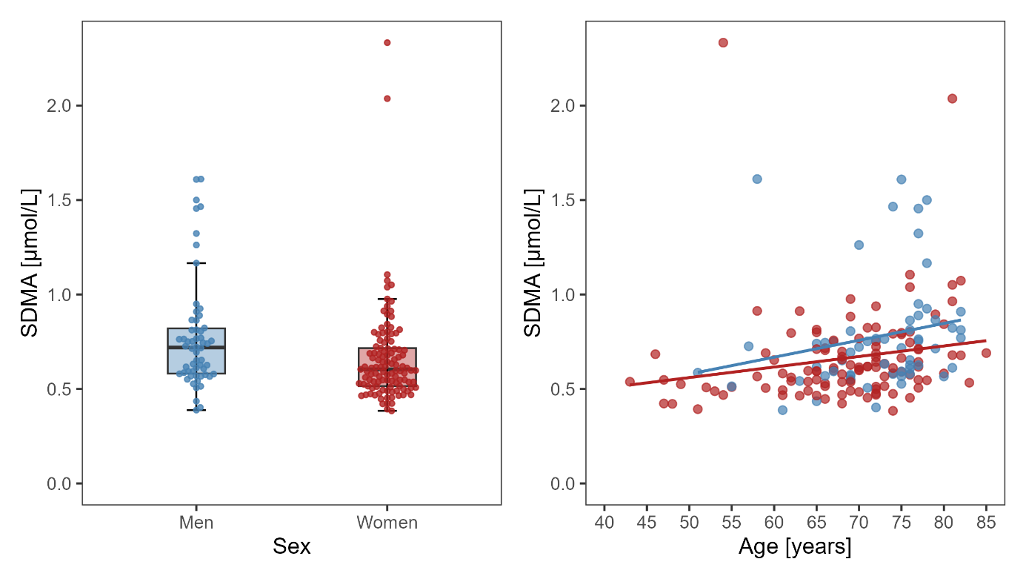

E) 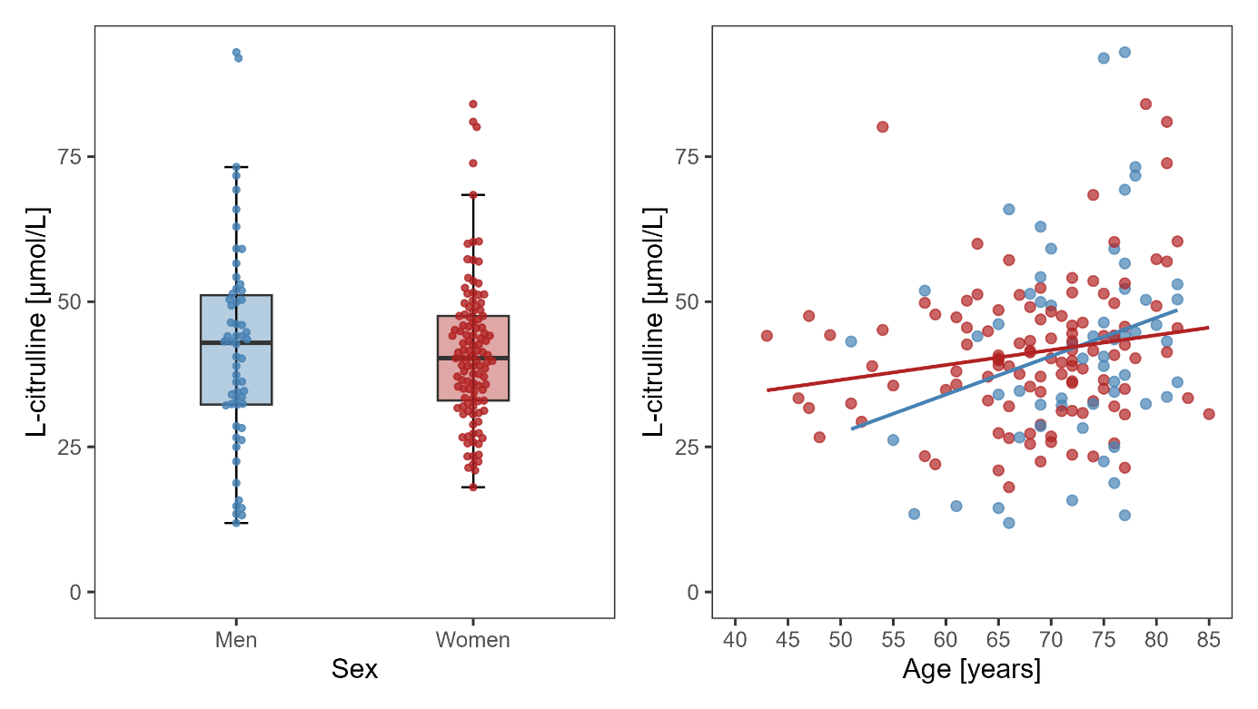

F)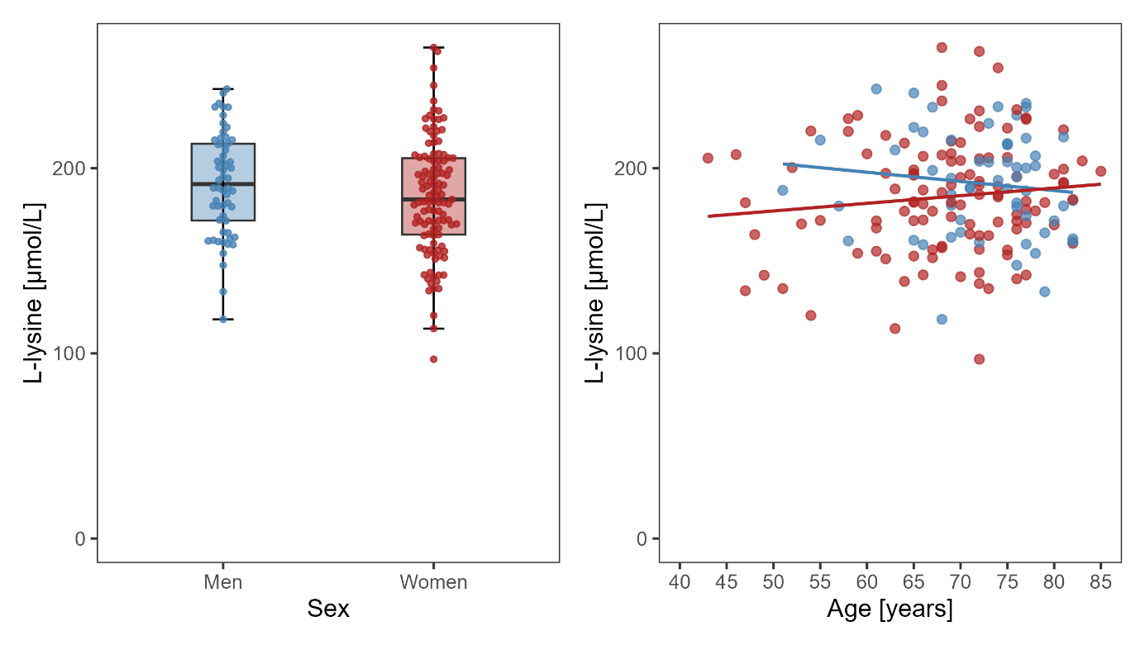

G)
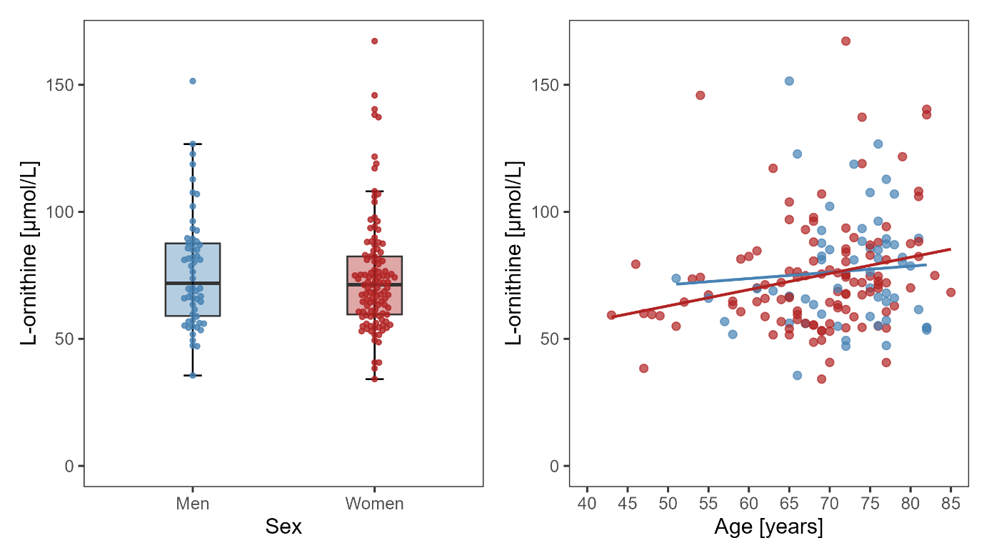

H) 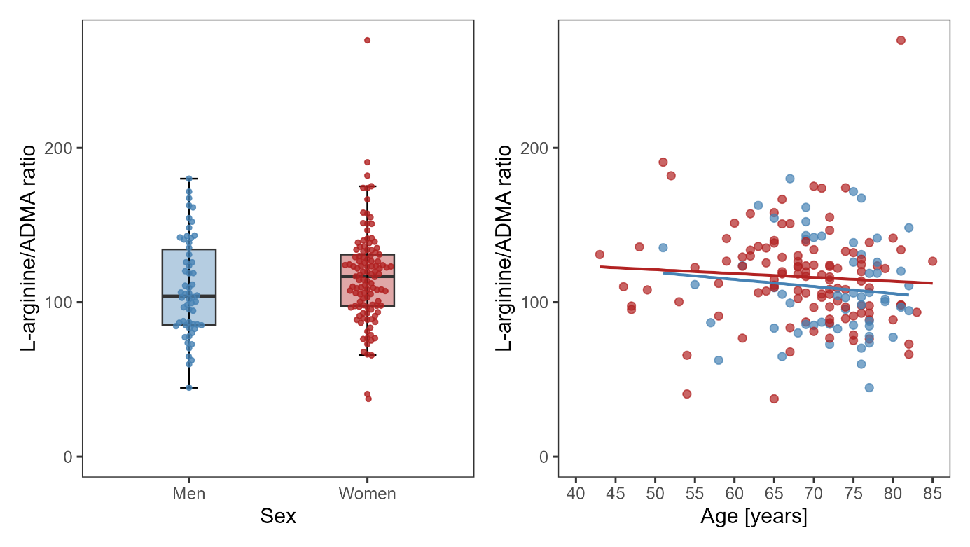

I) 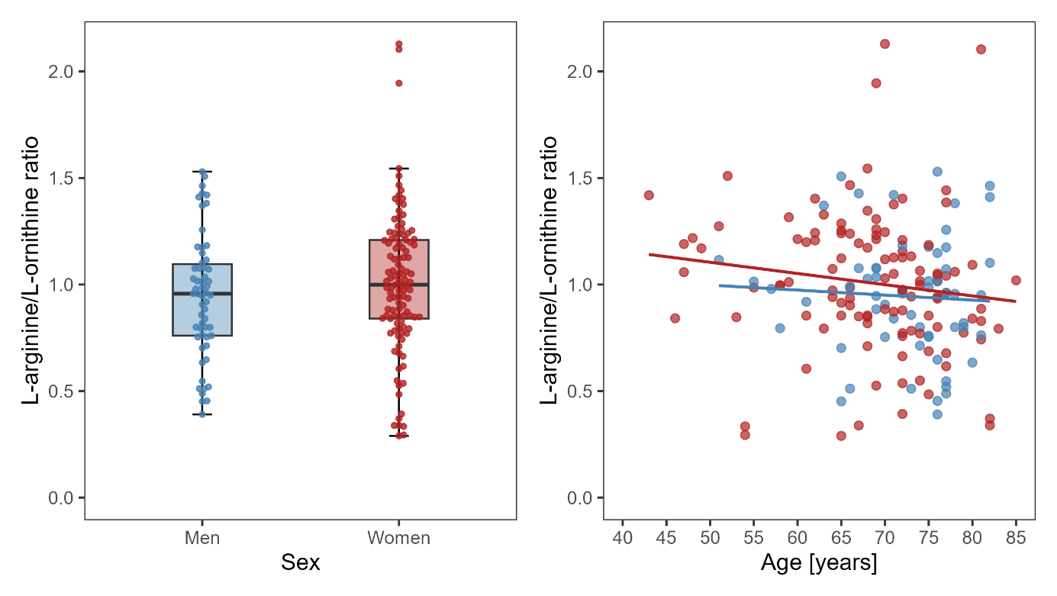
J)