Post-diagnosis Physical Activity in Relation to Mortality among Gynecological Cancer Survivors

Supplementary material

Supplementary Figure 1. Hazard ratios for all-cause mortality among survivors of gynecological cancers, comparing high physical activity (exceeding guidelines of 7,5 MET-hours per week) with the lowest physical activity category
Supplementary Figure 2. Hazard ratios for all-cause mortality among survivors of gynecological cancers, comparing medium physical activity (below the WHO recommendation of 7.5 MET-hours per week) with the lowest physical activity category
Supplementary Figure 3. Funnel plot of included studies to evaluate publication bias
Supplementary Table 1. Covariate details of all studies included in the systematic review

Corresponding author: Michael J. Stein, Tel.: +49 941 944 521 6, Mail: michael.stein@helmholtz-munich.de, Department of Epidemiology and Preventive Medicine, University of Regensburg, Regensburg, Germany

Supplementary Figure 1. Hazard ratios for all-cause mortality among survivors of gynecological cancers, comparing high physical activity (exceeding guidelines of 7,5 MET-hours per week) with the lowest physical activity category
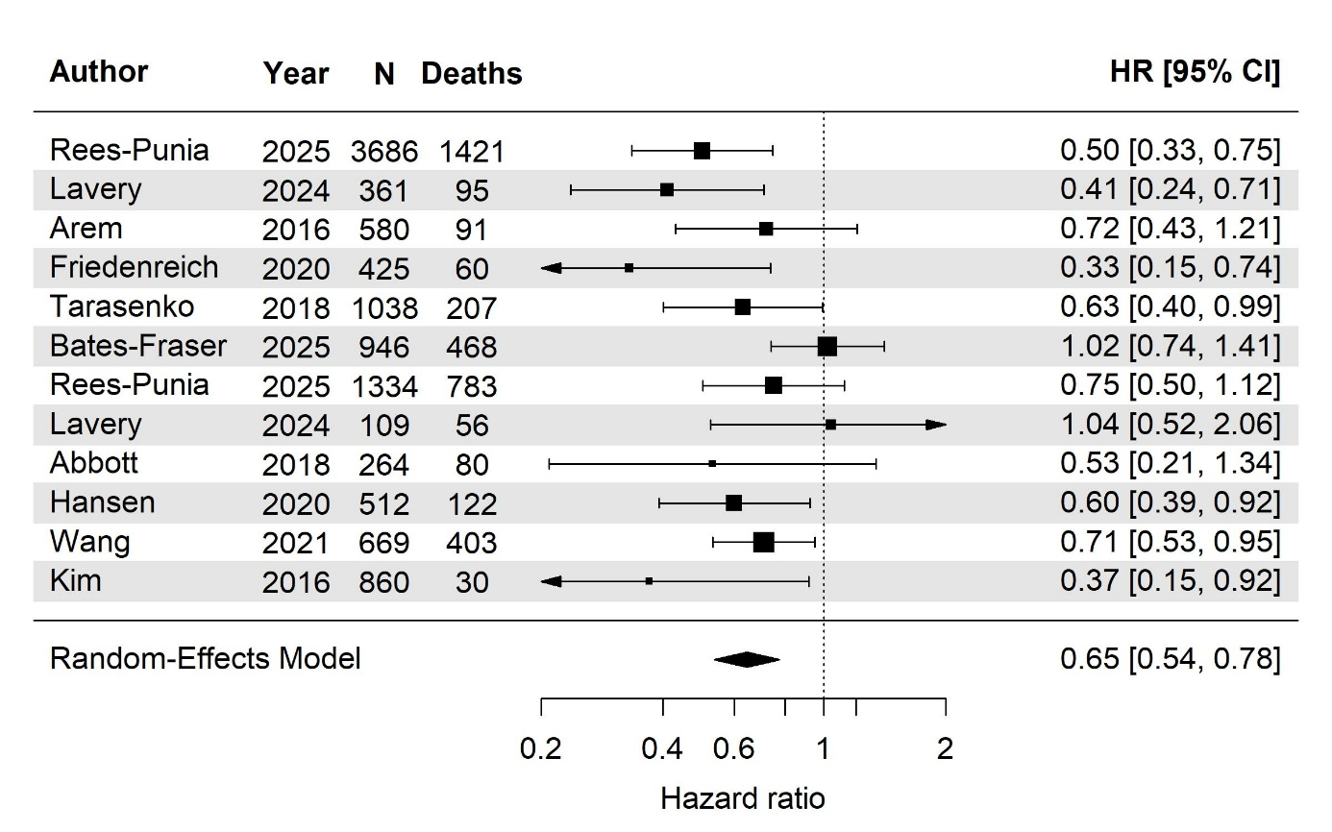

Supplementary Figure 2. Hazard ratios for all-cause mortality among survivors of gynecological cancers, comparing medium physical activity (below the WHO recommendation of 7.5 MET-hours per week) with the lowest physical activity category
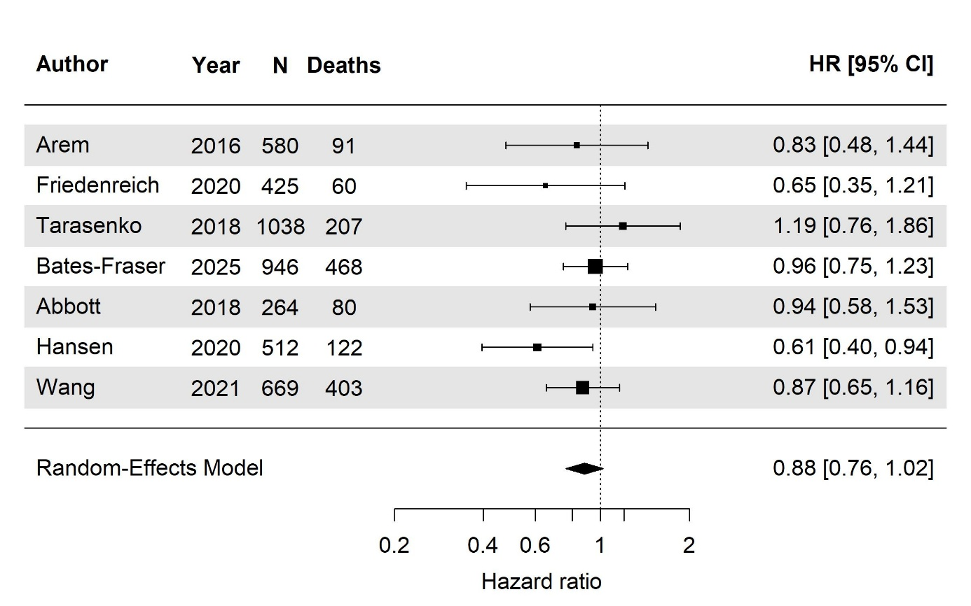
Supplementary Figure 3. Funnel plot of included studies to evaluate publication bias
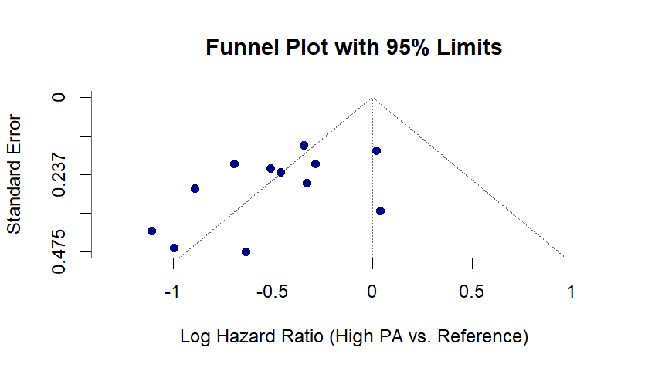

Supplementary Table 1. Covariate details of all studies included in the systematic review
Study, Year | Covariates | Assessment Methods
Rees-Punia, 2025 | age, sex, race/ethnicity, smoking status, alcohol use, cancer treatment and stage, BMI | self-reported, cancer registries, medical record verification
Lavery, 2024 | age, time since diagnosis, sex, race/ethnicity, BMI, comorbidities, smoking status, cancer treatment and stage | self-reported, medical record verification, follow-up assessments
Arem, 2016 | diagnosis age, grade, diabetes, age at menarche, hormone use, TV, BMI, health status, cancer treatment and stage | self-reported, follow-up assessments
Friedenreich, 2020 | age, grade, BMI, hormone use, menopausal status, family history, comorbidities, recurrence, pre-diagnosis PA, cancer treatment and stage | self-reported, follow-up assessments, anthropometric measurements
Tarasenko, 2018 | age, sex, race/ethnicity, education, marital status, insurance, activity limitations, smoking status, BMI, comorbidities, diagnosis age, health status | self-reported
Bates-Fraser, 2025 | age, education, marital status, race/ethnicity, pregnancy history, smoking status, alcohol use, treatment and stage, pre-diagnosis BMI | self-reported, cancer registries, medical records
Abbott, 2018 | age, cancer stage, region, comorbidities, education, income, pre-diagnosis physical activity | self-reported, follow-up survey
Hansen, 2020 | age, education, comorbidities, cancer stage, histology, residual disease | self-reported, medical records, follow-up assessments
Wang, 2021 | age, diagnosis year, histology, cancer stage, BMI, smoking status, NSAID | self-reported, follow-up assessments
Kim, 2016 | age, diagnosis age, cancer treatment and stage, time since diagnosis, follow-up time | self-reported, cancer registries, medical records
Jiang, 2025 | age, sex, Townsend deprivation score, ethnicity, smoking status, alcohol intake frequency, BMI, waist circumference, self-reported general health, cancer duration, cardiovascular disease history, diabetes history, long-standing illness, disability or infirmity, grip strength, FEV1, and wear season | self-reported, anthropometric measurements, medical records, spirometry, accelerometer data

