Supplements

Supplementary Table S1 PERMANOVA analysis based on Bray-Curtis distances (10,000 permutations) of bacterial/archaeal communities in root-affected soils (RA) and in the rhizosphere (RH) of winter wheat obtained from central plots and root windows. *p < 0.05, **p < 0.01, ***p < 0.001.
Factor | Root Window |  | Central Plot
Factor | Explained variance [%]  RA | Explained variance [%]  RH | Explained variance [%]  RA | Explained variance [%]  RH
Tillage practice | 17.8*** | 29.2*** | 17.6*** | 28.2***
N-fertilization | 9.6* | 8.2 | 6.5 | 6.1
Tillage practice x N-fertilization | 7.7 | 6.7 | 6.4 | 6.4
Residuals | 64.9 | 55.8 | 69.4 | 59.3

Supplementary Table S2 PERMANOVA analysis based on Bray-Curtis distances (10,000 permutations) of fungal communities in root-affected soils (RA) and in the rhizosphere (RH) of winter wheat obtained from central plots and root windows. *p < 0.05, **p < 0.01, ***p < 0.001
Factor | Root Window |  | Central Plot
Factor | Explained variance [%]  RA | Explained variance [%]  RH | Explained variance [%]  RA | Explained variance [%]  RH
Tillage practice | 28.2*** | 23.6*** | 33.6*** | 41.2***
N-fertilization | 15.7** | 17.1*** | 18.1*** | 13.5**
Tillage practice x N-fertilization | 4.6 | 12.5*** | 8.2* | 6.3
Residuals | 51.5 | 46.8 | 40.1 | 39.1

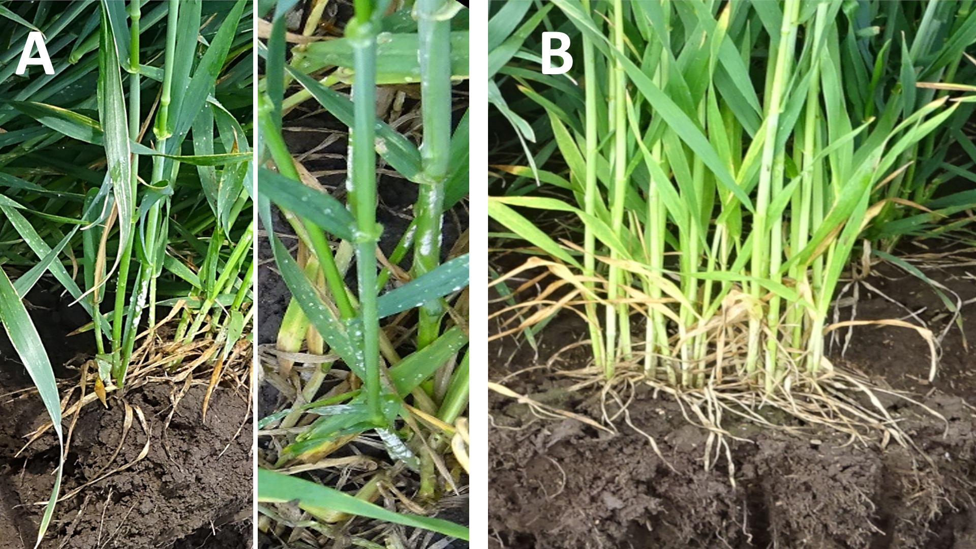
Suppl. Fig. S1 Symptoms of powdery mildew caused by Blumeria graminis on winter wheat (cv. Lemmy) in MP-Int plants with high N supply (A) compared to uninfected plants with reduced N supply (B).

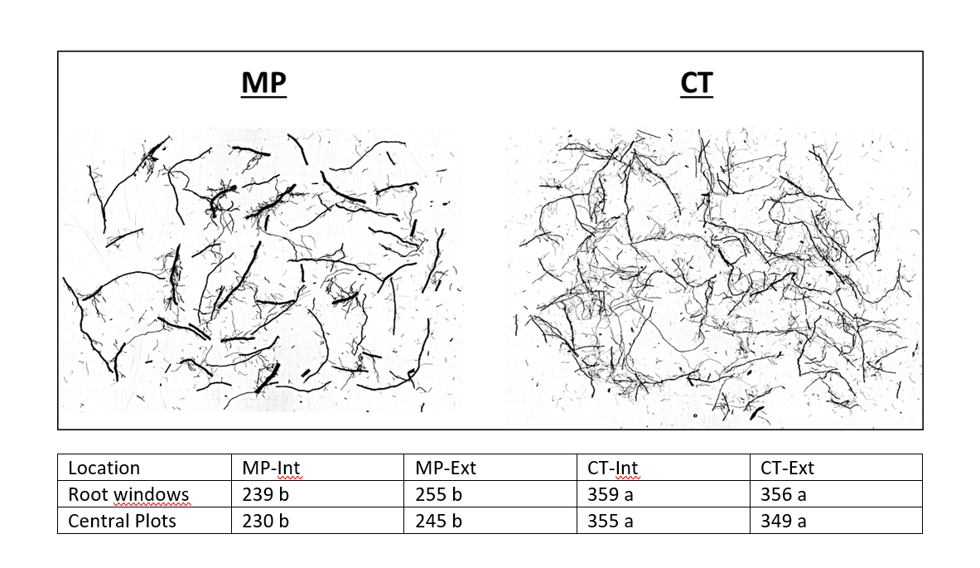
Suppl. Fig. S2 Root Scans and total length [m] of fine roots (diameter < 2mm] affected by installation of root windows, by tillage intensity (MP = mouldboard plough; CT = cultivator tillage) and fertilization management (Int = intensive N-fertilization including fungicides and growth regulators; Ext = extensive N-fertilization without fungicides and growth regulators). Means sharing different letters are significantly different by the Tukey-test ( P ≤.05).

