Supplementary Methods

Study Participants

Both studied patients were assessed within the framework of a multicentre research project designed to identify rare variants in patients with rare diseases including dystonia¹. Written informed consent was obtained from all participants and/or their legal guardians, as appropriate. The institutional ethics committees of participating centres approved the study procedures. The study was conducted in accordance with the principles set forth in the Declaration of Helsinki.

ES and srWGS

ES and srWGS were performed using established Illumina sequencing protocols. Variant calling and interpretation methodologies were applied as described previously¹. Single-nucleotide variants and short insertions/deletions were identified using custom short-read sequencing pipelines based on GATK and Samtools. Copy number variants (CNVs) in ES data were detected using the ExomeDepth tool². Structural variant (SV) calling in srWGS data was performed using six independent callers, as described previously¹. The GRCh37/hg19 reference assembly was used for all short-read sequencing analyses.

srRNAseq

Methodologies for fibroblast culture, RNA processing, and sequencing have been described in detail by Saparov et al.³. An established DROP (Detection of RNA Outliers Pipeline, v.1.4.0) workflow⁴, incorporating OUTRIDER (Outlier in RNA-seq Finder, v.1.20.1) and FRASER 2.0 (Find Rare Splicing Events in RNA-seq), was employed for the detection of aberrant RNA expression and splicing events.

Oxford Nanopore Technologies (ONT)-based lrGS and lrRNAseq

Genomic DNA was extracted using either the Prepito DNA Blood400 Kit (Revvity) or the Nanobind CBB Kit (PacBio). Prior to library preparation, DNA was sheared using a Megaruptor 3 instrument (Diagenode, Liège, Belgium) at speed setting 34. Whole-genome libraries were prepared from 1,000 ng of input DNA according to the ONT Ligation Sequencing Kit V14 protocol. Following purification, each library was sequenced over a total period of 72 hours on a PromethION 24 device using ONT R10.4.1 flow cell chemistry. The sample from patient 1 yielded a median genome read depth of 7,3-fold, mean genome coverage of 96%, and median read length of 2142 bp, with read length N50 values of 4291 bp. Patient 2 achieved a median genome read depth above 50-fold, mean genome coverage of 97,3%, and median read length of 4252 bp, with read length N50 values of 5754 bp. Base-calling was performed using the super-accurate basecalling model (v4.3.0) in accordance with ONT-recommended guidelines⁵. Secondary analyses of the ONT lrGS data were conducted using the automated open-source “Epi2me-labs/wf-human-variation” workflow (v2.3.0), with read alignment to the human reference genome (GRCh38/hg38; GenBank assembly GCA_000001405.15) performed using minimap2 (v2.28-r1209). CNV detection was carried out using Spectre (v0.2.1) (https://github.com/fritzsedlazeck/Spectre), while SV discovery—including cxSVs—was performed with Sniffles2 (v2.4) (https://github.com/fritzsedlazeck/Sniffles). A second-tier check for SVs was subsequently performed using the detection tool cuteSV (v2.1.3) (https://github.com/tjiangHIT/cuteSV), complemented by the re-genotyping tool cuteFC (v1.0.2) (https://github.com/Meltpinkg/cuteFC). For lrRNAseq, skin biopsy-derived fibroblasts were grown according to standard conditions. The cells were divided in two subsets, one of which was treated with cycloheximide (Sigma-Aldrich) at a concentration of 150 μg/mL for 24 hours. RNA for lrRNAseq was extracted using the RNeasy Mini Kit (Qiagen). RNA quality and quantity were assessed as previously described³. Full-length complementary DNA (cDNA) libraries were generated using the SQK-PCB114.24 kit (ONT) following the manufacturer’s instructions. Five RNA samples per run were pooled and sequenced for 72 hours on a PromethION 24 device with ONT R10.4.1 flow cell chemistry. cDNA reads were pre-processed with Pychopper to enrich and orient full-length molecules, retaining only those reads containing both primer sequences. Full-length transcript isoforms were subsequently characterised from ONT lrRNAseq data using the FLAIR pipeline (Full-Length Alternative Isoform Analysis of RNA, v2.2.0) and aligned to the human reference genome.

Proteomic Analysis

Fibroblasts proteomics and raw-file processing were performed as described previously with minor modifications¹ ⁶. Shortly, fibroblast pellets were lysed in 8 M urea buffer. 15 µg protein input was reduced (10 mM DTT), alkylated (55 mM CAA) and digested with Trypsin Gold (Promega) at an enzyme-to-protein ratio of 1:50, Peptides were acidified, desalted and labelled with TMT11-plex reagents (Thermo Fisher Scientific)⁷. Each batch comprised 10 patient samples and one common reference sample for cross-batch normalization. Labelled peptides were off-line fractionated using basic reverse-phase chromatography (XBridge Peptide BEH C18, 130 Å, 3.5 µm, 2.1 mm x 150 mm, Waters) and pooled to 32 fractions. Data were acquired on a Fusion Lumos Tribrid mass spectrometer (Thermo Fischer Scientific) in data-dependent acquisition and multi-notch MS3 mode at the BayBioMS core facility (Technical University of Munich, Freising, Germany). Peptide identification and protein quantification, including canonical and isoform entries, were performed using MaxQuant⁸. Outlier detection was carried out using PROTRIDER (PROTein abundance outlier detection from mass spectrometry-based proteomics data with a conditional autoencodeR, v.1.0)⁹, a denoising autoencoder-based algorithm that corrects for batch effects and other confounders, yielding per-sample expression outlier rankings. The ranking was performed on proteomics data from 254 passage-matched fibroblasts samples obtained from subjects with rare diseases within our internal cohort. Statistical comparison of the signal intensity of individual peptide sequences between the patient´s sample and same-batch controls was performed using a standard one sample t-test.

Supplementary Results
Patient 1 – PANK2-related NBIA – Clinical data
The patient first presented to the neuropediatric specialty clinic at eight years of age. She was born to consanguineous parents following an uncomplicated pregnancy and spontaneous vaginal delivery. Early motor development was notably delayed: she acquired the ability to sit and walk only between the ages of three and five years, with a history of frequent stumbling and falls. Expressive language was absent, with vocalisation limited to non-specific sounds. Subsequent clinical assessments confirmed severe motor and intellectual impairment, which reached a profound state by the age of eleven. Additionally, she developed prominent dystonia of the extremities and progressive muscular wasting. A single episode of generalised seizures was reported, with no definitive abnormalities identified on interictal electroencephalography. Brain MRI at the age of nine demonstrated bilateral T2-signal hypointensity within the globus pallidus, consistent with the “eye of the tiger” sign¹⁰, thereby raising the diagnostic consideration of PANK2-related NBIA type 1. The family history was unremarkable.

Patient 2 – 16p13.3 duplication-triplication – Clinical data

The second patient was a 22-year-old woman, born at term to healthy unrelated parents following an uncomplicated pregnancy and spontaneous vaginal delivery. She had a clinical history of mild intellectual disability, gait abnormalities with falls beginning in childhood, and progressive scoliosis. Over subsequent years, her phenotype evolved to encompass progressive bradykinesia and generalised muscular rigidity, consistent with a parkinsonian syndrome, in addition to manifestation of generalised dystonia, dysarthria, and minor axonal motor and sensory neuropathy with pes cavus. No recordings of seizures or ataxic movements have been reported. Brain MRI scan and electromyography were normal. Administration of levodopa was effective in reducing parkinsonian symptoms and partly also dystonia, even at low doses. However, attempts to increase the dosage caused behavioural changes and psychomotor agitation. At the time of the last evaluation, she was taking 25 mg of levodopa four times a day and amantadine 100 mg three times a day. No relevant family history was reported.

Supplementary Figure 1
Short-read DNA sequencing (srRNAseq) analysis of the PANK2 locus in patient 1.
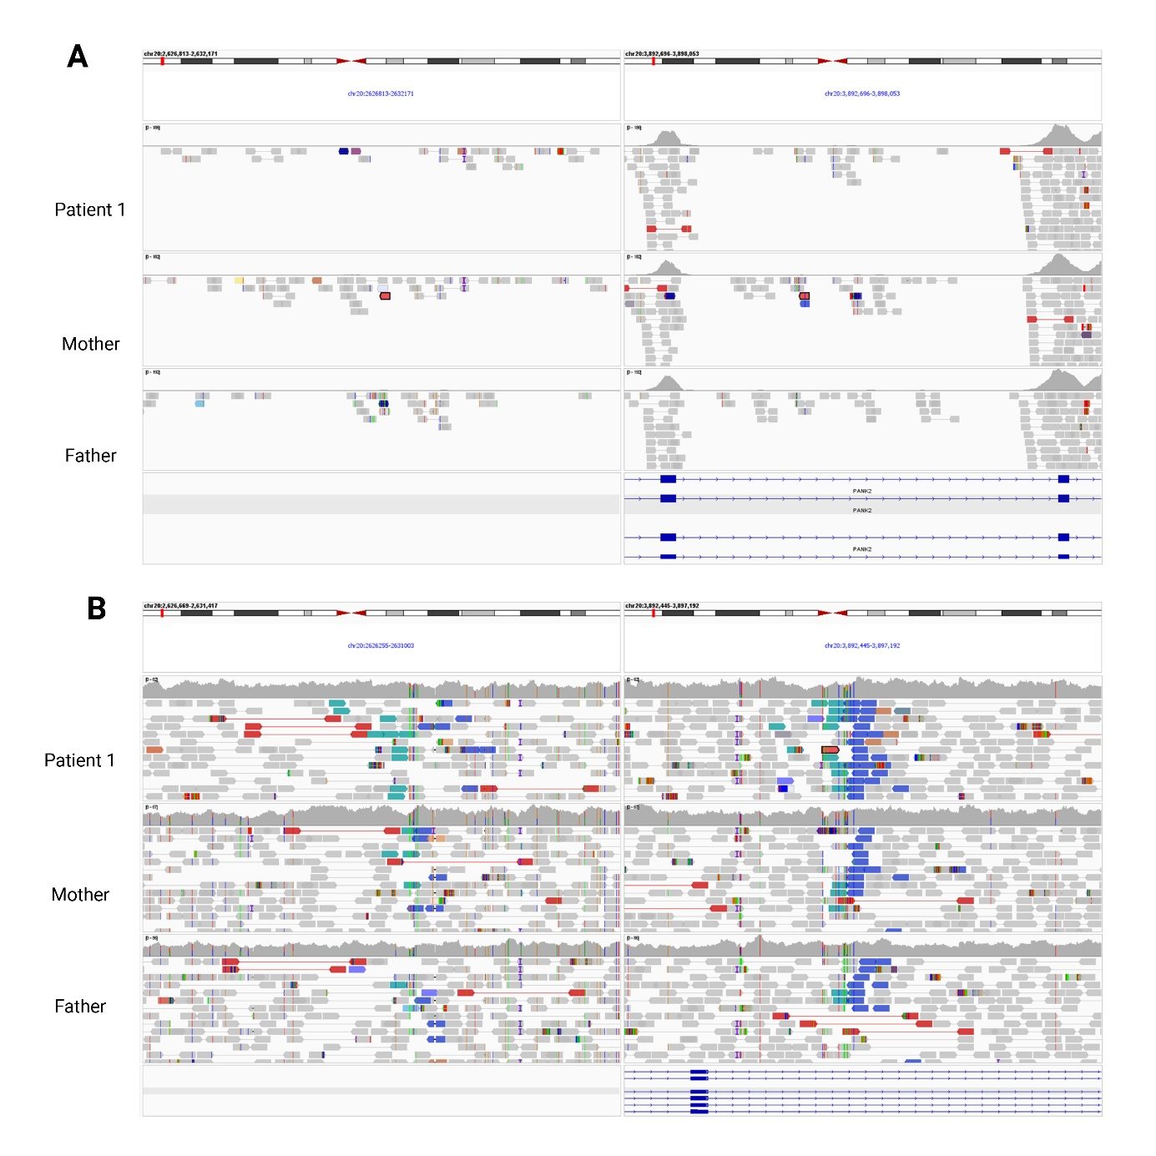
(A) Integrative Genomics Viewer (IGV)¹¹ visualisation of exome sequencing (ES) data from patient 1 and both parents at the centromeric and telomeric inversion breakpoint regions. No reads supporting the presence of a structural variant (SV) were detectable, consistent with the failure of ES-based variant calling to identify the inversion. (B) IGV visualisation of short-read whole-genome sequencing (srWGS) data from patient 1 and both parents at the same breakpoint regions. Paired-end read alignments compatible with an inversion were visible in patient 1 in a homozygous configuration and in both parents in a heterozygous configuration, as indicated by the standard IGV colour scheme (blue and teal reads). The finding was flagged by only a subset of implemented SV callers and could not be unambiguously characterised from short-read data alone.

Supplementary Figure 2
Short-read RNA sequencing (srRNAseq) analysis of the PANK2 locus in patient 1.
(A) Box plot of FRASER 2.0 splicing outlier analysis, displaying the observed intron Jaccard index for patient 1 relative to 913 individuals with rare diseases from our internal cohort. Patient 1 was identified as a significant splicing outlier at the PANK2 locus. (B) OUTRIDER rank plot of PANK2 mRNA expression across 914 available srRNAseq samples. Patient 1 ranked third lowest (rank 3/914; log₂ fold-change approximately −0.35), indicating reduced PANK2 expression at the sample level, though not reaching statistical significance as a formal expression outlier. The sample with the lowest PANK2 expression had a confirmed diagnosis of PANK2-related NBIA (biallelic pathogenic variants), while the individual ranked second to lowest carried a single heterozygous pathogenic PANK2 variant, providing further contextual support for the clinical relevance of the observed expression reduction in patient 1. (C) Integrative Genomics Viewer (IGV) visualisation of srRNAseq read alignments at the PANK2 locus in patient 1 and a representative control sample, demonstrating a marked overall reduction in read coverage across PANK2 exons in patient 1. (D) Sashimi plot of exons 3, 4, and 5 in patient 1 and the control sample. Read coverage spanning the exon 4–5 junction was markedly reduced in patient 1 relative to the control, though an apparent residual signal suggested the possible presence of transcripts encompassing both exons. Reads supported by fewer than two junctional reads were excluded to preserve visual clarity. (E) IGV visualisation of srRNAseq reads at the exon 4–5 junction in patient 1, with BLAT alignment of the query sequence. Reads apparently bridging exons 4 and 5 were shown to originate from the telomeric inversion breakpoint region on chromosome 20, confirming that the residual junction signal observed in panel D represented a misalignment artefact rather than genuine exon 4–5 splicing.
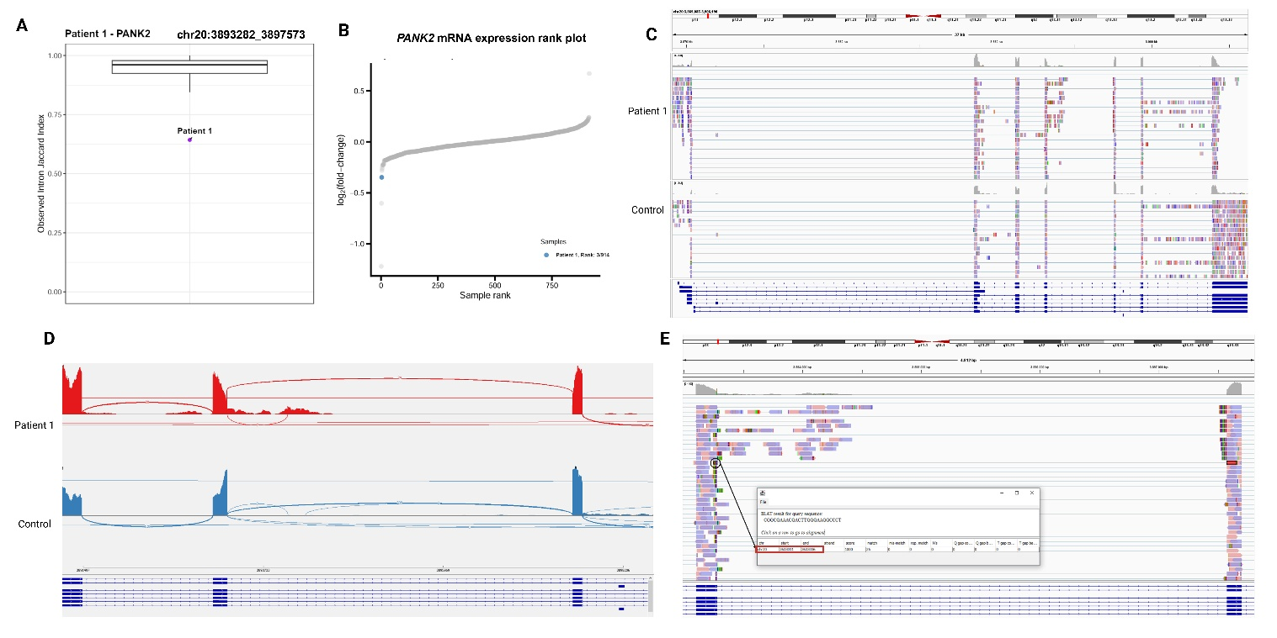

Supplementary Figure 3: Distribution of single-nucleotide variant allele fractions across chromosome 20p13–20p12.3 in patient 1, demonstrating a large contiguous homozygous stretch. The y-axis represents allele fraction; the x-axis represents genomic position along NC_000020.11.
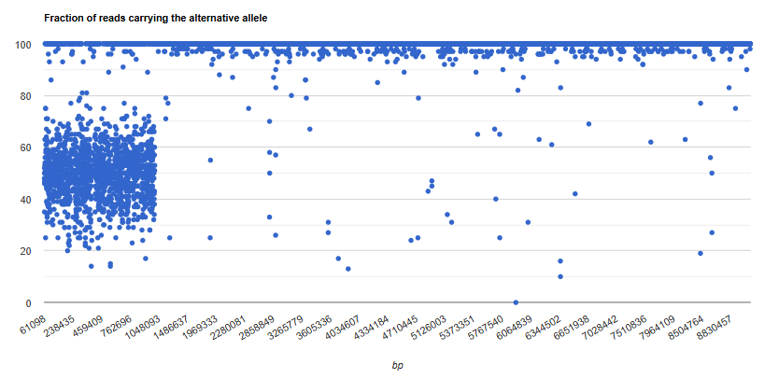

Supplementary Figure 4: Graphical interpretation of ONT lrGS read alignments at the centromeric (BP2) and telomeric (BP1) breakpoints of the 20p13 inversion. Four read types are distinguished based on their alignment position and the proportion of soft-clipped bases. In the accompanying ideogram, red “X” symbols denote misaligned reads and green “V” symbols indicate the correct alignment interpretation. Circling arrows illustrate that transposing and inverting the misaligned reads (shown in reduced saturation) yields the correctly aligned reads (shown in full saturation). BP1: telomeric breakpoint; BP2: centromeric breakpoint. RC: reverse complement.

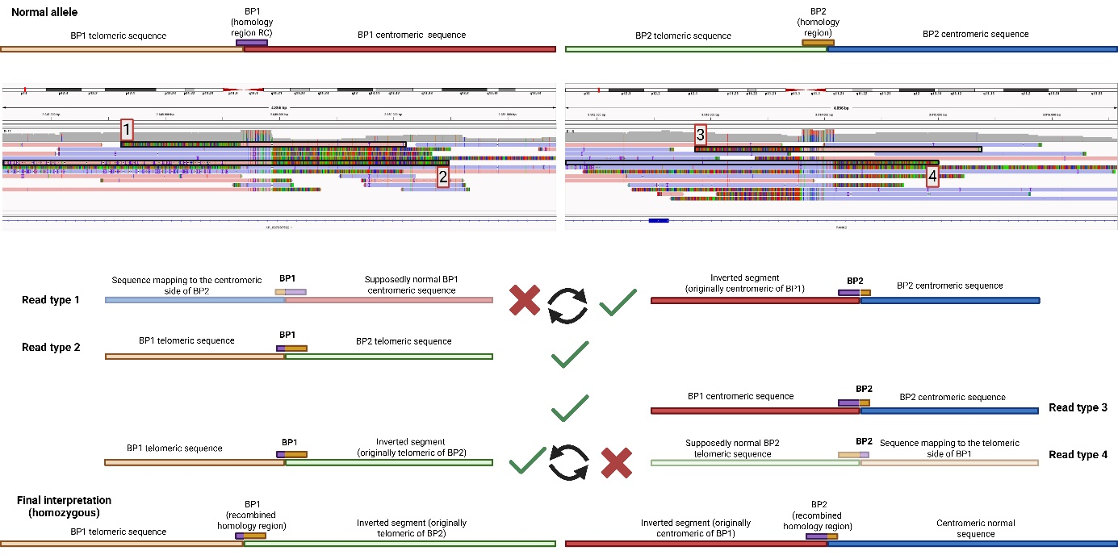

Supplementary Figure 5
Long-read RNA sequencing (lrRNAseq) of the PANK2 locus
(A) Integrative Genomics Viewer (IGV) visualisation of lrRNAseq read alignments at the PANK2 locus in patient 1, without and with nonsense-mediated decay (NMD)- inhibitor, and a representative control sample. Full-length PANK2 transcripts were entirely absent in both patient conditions. Residual reads were restricted to truncated isoforms derived from either the 5′ or 3′ segment of the inverted allele, consistent with the homozygous inversion architecture. (B) Isoform visualisation of lrRNAseq data in patient 1 and the control sample, displaying the repertoire of expressed PANK2 transcript isoforms. At least three truncated 5′ isoforms and one truncated 3′ isoform encompassing exclusively exons 5, 6, and 7 were identified in patient 1, with no full-length isoforms detected.
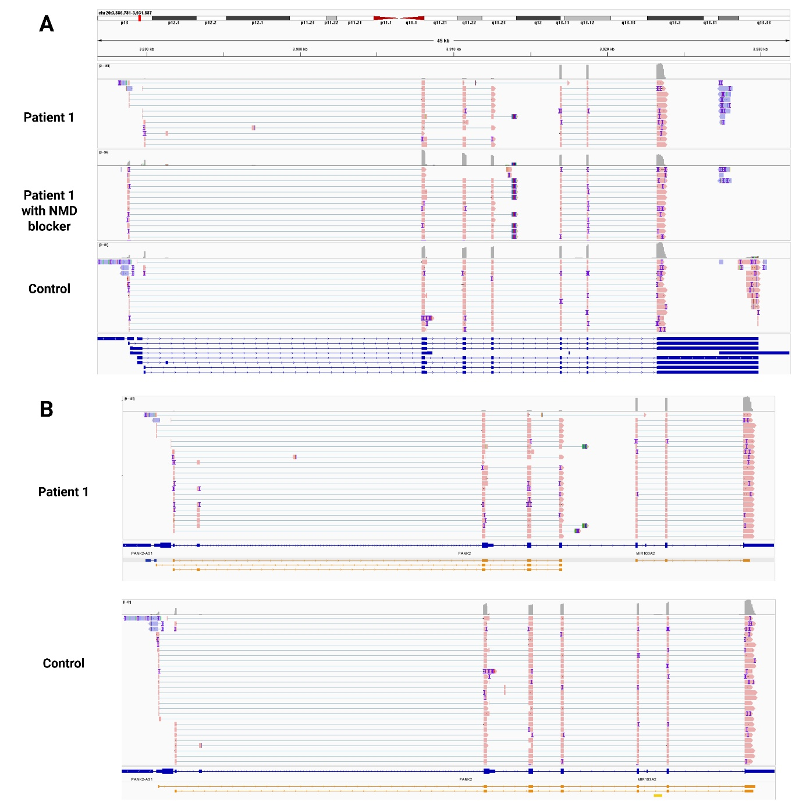

Supplementary Figure 6
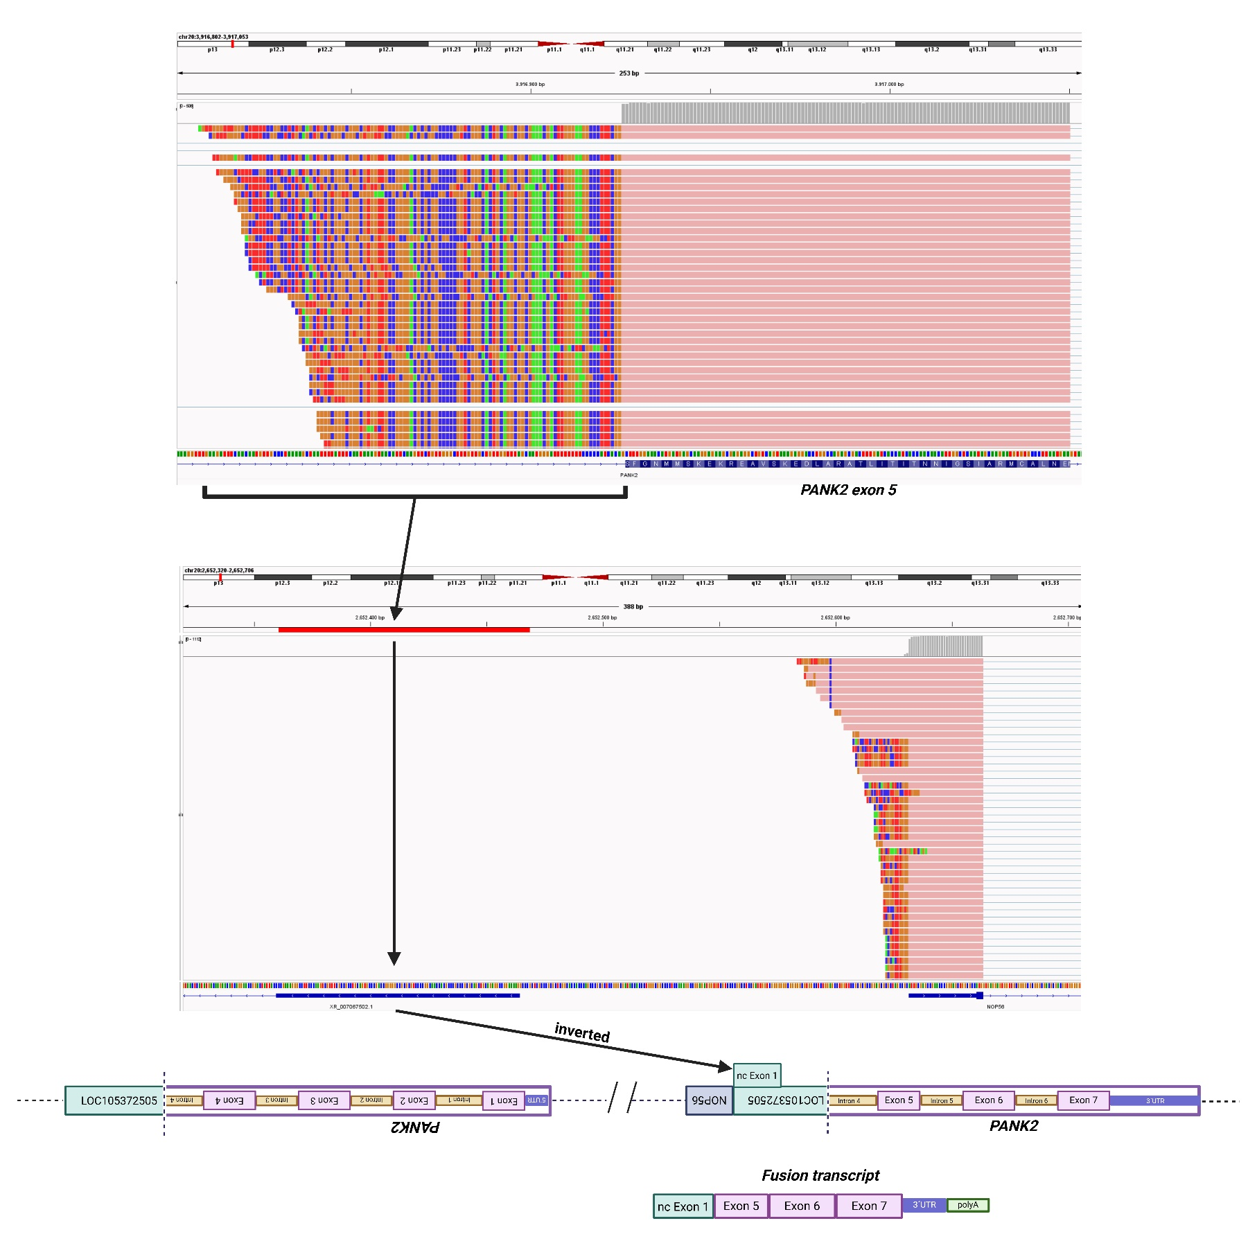
Long-read RNA sequencing (lrRNAseq) of the 5´end of the truncated isoform encompassing exons 5, 6, and 7 of PANK2 (NMD-uninhibited condition). The IGV visualisation shows that the transcript includes also a sequence corresponding to the first exon of the uncharacterized locus LOC105372505 (XR_007067502.1 in the IGV reference sequence). The inclusion of this sequence into the final transcript could affect the stability of the 5’ end of the fusion isoform leading to inefficient translation. Based on the available data, accelerated degradation of the transcript or the translated protein cannot be ruled out either, nor can incomplete detection by the proteomic assay due to incomplete overlap of the translated protein with canonical peptides or the formation of non-canonical ones.”

Supplementary Figure 7: (A) Schematic overview of the 16p13.3 rearrangement from Figure 2C, with black rectangles indicating the breakpoint regions examined by direct inspection of lrGS read alignments. Four read types are annotated in the IGV visualisations, classified according to alignment position and the orientation of soft-clipped sequences. (B) Schematic interpretation of the composition and relative positioning of the four soft-clipped read types at each breakpoint, and the predicted structural architecture of the rearrangement inferred from these data. Read types 1 and 2 share the same sequence composition as read types 4 and 3, respectively, but appear misaligned in IGV owing to differences in the relative lengths of their constituent segments. Bt: telomeric end of segment B; Ct: telomeric end of segment C.

Supplementary Figure 7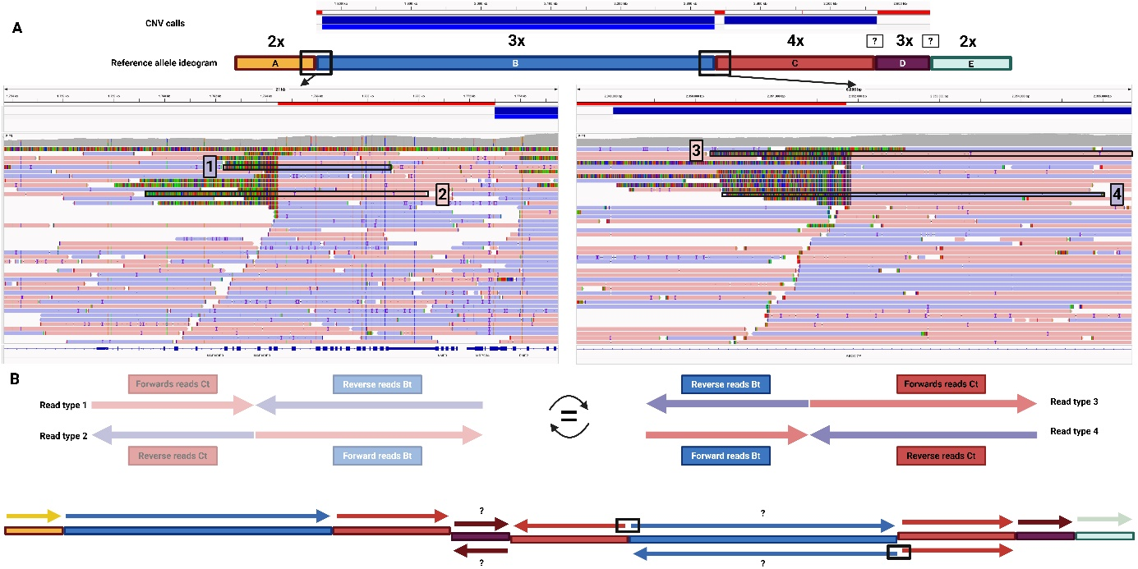

Supplementary Table 1: Reporter intensity values for peptides mapping to the PANK2 protein in patient 1 and ten control individuals from the same batch. Peptide sequences, corresponding exon assignments, and individual intensity values are reported for each sample.

Peptide sequence | Exon number | Reporter intensity, Patient 1 | Reporter intensity, Controls 1-10
ASATSVSSAGEQAAGDPEGR | Exon 1 | 0 | 11332 | 16358 | 15980 | 11740 | 14827 | 11473 | 15409 | 15430 | 12352 | 10573
LVYFEPK | Exon 2 | 40815 | 81530 | 108050 | 100890 | 92443 | 119900 | 105330 | 113870 | 127390 | 86266 | 87807
DITAEEEEEEVESLK | Exon 2 | 0 | 0 | 0 | 0 | 0 | 0 | 0 | 0 | 0 | 0 | 0
YLTSNVAYGSTGIR | Exon 2 | 0 | 0 | 0 | 0 | 0 | 0 | 0 | 0 | 0 | 0 | 0
DVHLELK | Exon 2 | 0 | 0 | 0 | 0 | 0 | 0 | 0 | 0 | 0 | 0 | 0
DLTLCGR | Exon 2 | 0 | 0 | 0 | 0 | 0 | 0 | 0 | 0 | 0 | 0 | 0
KGNLHFIR | Exon 2 | 0 | 0 | 0 | 0 | 0 | 0 | 0 | 0 | 0 | 0 | 0
LDELDCLIK | Exon 3 | 11078 | 13731 | 15850 | 16536 | 14944 | 19759 | 18388 | 17238 | 17990 | 15856 | 14527
GILYIDSVGFNGR | Exon 3 | 0 | 0 | 0 | 0 | 0 | 0 | 0 | 0 | 0 | 0 | 0
SQCYYFENPADSEK | Exon 3 | 0 | 0 | 0 | 0 | 0 | 0 | 0 | 0 | 0 | 0 | 0
DIYGGDYER | Exon 4 | 38664 | 55128 | 74002 | 81410 | 58986 | 81294 | 72608 | 66580 | 66258 | 63641 | 65297
ATLITITNNIGSIAR | Exon 5 | 5096,8 | 7053,4 | 8246,9 | 8803,8 | 9087,3 | 10815 | 6564,8 | 10742 | 9547,6 | 9692,6 | 8193
MCALNENINQVVFVGNFLR | Exon 5 + 6 | 0 | 0 | 0 | 0 | 0 | 0 | 0 | 0 | 0 | 0 | 0

Supplementary Table 2: Complete list of genes encompassed by the 16p13.3 duplication-triplication variant identified in patient 2, with genomic coordinates (GRCh38), OMIM disease association status (last accessed on 27.05.2026), mode of inheritance of the associated disorder, anticipated copy-number dosage in patient 2, triplosensitivity estimate according to ClinGen, and overlap of the associated disease to patient 2 phenotype. Gene names associated with neurological and movement-disorder phenotypes are shown in bold. OMIM: Online Mendelian Inheritance in Man® (https://omim.org); AD: autosomal dominant; AR: autosomal recessive; “-“: no information available.

Gene | Location (GRCh38) | OMIM / Morbid | Associated disease name | Inheritance  mode | Anticipated dosage in Patient 2 | Triplo-sensitivity  (ClinGen) | Phenotypic  overlap
MAPK8IP3 | 16:1706166-1770351 | Morbid | Neurodevelopmental disorder with or without variable brain abnormalities | AD | 3x (partial, one copy is likely interrupted) | Unknown | Partial (Impaired intellectual development; gait instability; scoliosis)
NME3 | 16:1770317-1771732 | OMIM | - |  | 3x | Unknown | -
MRPS34 | 16:1771890-1773158 | Morbid | Combined oxidative phosphorylation deficiency 32 | AR | 3x | Unknown | Partial (Delayed psychomotor development; dystonia)
EME2 | 16:1772810-1781708 | OMIM | - | - | 3x | Unknown | -
SPSB3 | 16:1776710-1793700 | OMIM | - | - | 3x | Unknown | -
NUBP2 | 16:1782932-1789189 | OMIM | - | - | 3x | Unknown | -
IGFALS | 16:1790413-1794971 | Morbid | Acid-labile subunit, deficiency of | AR | 3x | Unknown | No
HAGH | 16:1795620-1827157 | Morbid | [Glyoxalase II deficiency] | AD | 3x | Unknown | No
FAHD1 | 16:1826967-1840207 | OMIM | - | - | 3x | Unknown | -
MEIOB | 16:1833986-1884294 | Morbid | Spermatogenic failure 22/ Premature ovarian failure 23 | AR | 3x | Unknown | No
LINC02124 | 16:1859900-1890762 | - | - | - | 3x | Unknown | -
LINC00254 | 16:1878285-1884233 | - | - | - | 3x | Unknown | -
HS3ST6 | 16:1911475-1918415 | Morbid | ?Angioedema, hereditary, 8 | AD | 3x | Unknown | No
MSRB1 | 16:1938229-1943199 | OMIM | - | - | 3x | Unknown | -
RPL3L | 16:1943968-1957606 | Morbid | Cardiomyopathy, dilated, 2D | AR | 3x | Unknown | No
NDUFB10 | 16:1959508-1962021 | Morbid | ?Mitochondrial complex I deficiency, nuclear type 35 | AR | 3x | Unknown | No
RPS2 | 16:1962050-1965510 | OMIM | - | - | 3x | Unknown | -
SNORA10 | 16:1962334-1962466 | - | - | - | 3x | Unknown | -
SNORA64 | 16:1962973-1963106 | - | - | - | 3x | Unknown | -
SNHG9 | 16:1964526-1965513 | - | - | - | 3x | Unknown | -
SNORA78 | 16:1965184-1965310 | - | - | - | 3x | Unknown | -
RNF151 | 16:1966823-1968975 | - | - | - | 3x | Unknown | -
TBL3 | 16:1972050-1982929 | OMIM | - | - | 3x | Unknown | -
NOXO1 | 16:1978912-1984636 | OMIM | - | - | 3x | Unknown | -
GFER | 16:1984193-1987749 | Morbid | Myopathy, mitochondrial progressive, with congenital cataract and developmental delay | AR | 3x | No  evidence | Partial  (Impaired intellectual development; scoliosis)
SYNGR3 | 16:1989660-1994275 | OMIM | - | - | 3x | Unknown | -
ZNF598 | 16:1997654-2009821 | OMIM | - | - | 3x | Unknown | -
NPW | 16:2009926-2020755 | OMIM | - | - | 3x | Unknown | -
RN7SL219P | 16:2013181-2013476 | - | - | - | 3x | Unknown | -
NHERF2 | 16:2025356-2039026 | OMIM | - | - | 3x | Unknown | -
NTHL1 | 16:2039814-2047866 | Morbid | Familial adenomatous polyposis 3 | AR | 3x | No  evidence | No
TSC2 | 16:2047345-2089491 | Morbid | Tuberous sclerosis-2 | AD | 3x | No  evidence | No
PKD1 | 16:2088708-2135898 | Morbid | Polycystic kidney disease 1 | AD | 3x | No  evidence | No
MIR1225 | 16:2090195-2090284 | OMIM | - | - | 3x | Unknown | -
PKD1-AS1 | 16:2091436-2095433 | - | - | - | 3x | Unknown | -
MIR6511B1 | 16:2106669-2106753 | - | - | - | 3x | Unknown | -
MIR4516 | 16:2133119-2133204 | - | - | - | 3x | Unknown | -
MIR3180-5 | 16:2135977-2136129 | - | - | - | 3x | Unknown | -
RAB26 | 16:2140803-2154165 | OMIM | - | - | 3x | Unknown | -
SNHG19 | 16:2151103-2155672 | - | - | - | 3x | Unknown | -
SNORD60 | 16:2155023-2155105 | - | - | - | 3x | Unknown | -
TRAF7 | 16:2155692-2178129 | Morbid | Cardiac, facial, and digital anomalies with developmental delay | AD | 3x | No  evidence | Partial  (Delayed development)
CASKIN1 | 16:2177180-2196605 | OMIM | - | - | 3x | Unknown | -
MLST8 | 16:2204248-2209453 | OMIM | - | - | 3x | Unknown | -
BRICD5 | 16:2209253-2210905 | - | - | - | 3x | Unknown | -
PGP | 16:2211593-2214840 | OMIM | - | - | 3x | Unknown | -
E4F1 | 16:2223440-2235743 | OMIM | - | - | 3x | Unknown | -
DNASE1L2 | 16:2235816-2238711 | OMIM | - | - | 3x | Unknown | -
ECI1 | 16:2239402-2252300 | OMIM | - | - | 3x | Unknown | -
ECI1-AS1 | 16:2240487-2241818 | - | - | - | 3x | Unknown | -
RNPS1 | 16:2253116-2268397 | OMIM | - | - | 3x | Unknown | -
MIR3677HG | 16:2267881-2273428 | - | - | - | 3x | Unknown | -
MIR3677 | 16:2270713-2270772 | - | - | - | 3x | Unknown | -
MIR940 | 16:2271747-2271840 | - | - | - | 3x | Unknown | -
MIR4717 | 16:2274620-2274691 | - | - | - | 3x | Unknown | -
ABCA3 | 16:2275878-2340749 | Morbid | Surfactant metabolism dysfunction, pulmonary, 3 | AR | 3x | Unknown | No
ABCA17P | 16:2361144-2425685 | - | - | - | 3x | Unknown | -
CCNF | 16:2429394-2458854 | Morbid | Frontotemporal dementia and/or amyotrophic lateral sclerosis 5 | AD | 4x | Unknown | No
MIR6767 | 16:2445392-2445457 | - | - | - | 4x | Unknown | -
TEDC2 | 16:2460086-2464963 | - | - | - | 4x | Unknown | -
MIR6768 | 16:2463967-2464038 | - | - | - | 4x | Unknown | -
TEDC2-AS1 | 16:2464950-2468213 | - | - | - | 4x | Unknown | -
NTN3 | 16:2471297-2474145 | OMIM | - | - | 4x | Unknown | -
TBC1D24 | 16:2475051-2509671 | Morbid | Developmental and epileptic encephalopathy 16; DOORS syndrome; Epilepsy, rolandic, with paroxysmal exercise-induce dystonia and writer's cramp; Myoclonic epilepsy, infantile, familial; Deafness, autosomal dominant 65; Deafness, autosomal recessive 86 | AD/AR | 4x | Unknown | Partial  (Impaired intellectual development; dystonia;  extrapyramidal signs; peripheral polyneuropathy)
ATP6V0C | 16:2513713-2520218 | Morbid | Epilepsy, early-onset, 3, with or without developmental delay | AD | 4x | Unknown | Partial  (Impaired intellectual development; gait instability)
AMDHD2 | 16:2520340-2531422 | OMIM | - | - | 4x | Unknown | -
CEMP1 | 16:2530035-2531417 | OMIM | - | - | 4x | Unknown | -
MIR3178 | 16:2531922-2532005 | - | - | - | 4x | Unknown | -
PDPK1 | 16:2537978-2603190 | OMIM | - | - | 4x | Unknown | -
ERVK13-1 | 16:2608379-2682398 | - | - | - | 3x | Unknown | -
PDPK2P | 16:2616453-2642432 | - | - | - | 3x | Unknown | -

Supplementary references

1. Zech M, Dzinovic I, Skorvanek M, et al. Combined genomics and proteomics unveils elusive variants and vast aetiologic heterogeneity in dystonia. Brain 2025;148(8):2827-46. doi: 10.1093/brain/awaf059
2. Plagnol V, Curtis J, Epstein M, et al. A robust model for read count data in exome sequencing experiments and implications for copy number variant calling. Bioinformatics 2012;28(21):2747-54. doi: 10.1093/bioinformatics/bts526 [published Online First: 20120831]
3. Saparov A, Dzinovic I, Brunet T, et al. Fibroblast Transcriptomics in Molecular Diagnostics of a Comprehensive Dystonia Cohort. Ann Neurol 2026 doi: 10.1002/ana.78171 [published Online First: 20260202]
4. Yepez VA, Mertes C, Muller MF, et al. Detection of aberrant gene expression events in RNA sequencing data. Nat Protoc 2021;16(2):1276-96. doi: 10.1038/s41596-020-00462-5 [published Online First: 20210118]
5. Sorrentino U, Pavlov M, Mirza-Schreiber N, et al. Integrating Long-Read Nanopore Sequencing for Precision Resolution of Genomic Variants in Dystonia. Mov Disord 2026;41(1):70-83. doi: 10.1002/mds.70072 [published Online First: 20250930]
6. Pascual-Alonso A, Xiol C, Smirnov D, et al. Identification of molecular signatures and pathways involved in Rett syndrome using a multi-omics approach. Hum Genomics 2023;17(1):85. doi: 10.1186/s40246-023-00532-1 [published Online First: 20230915]
7. Zecha J, Satpathy S, Kanashova T, et al. TMT Labeling for the Masses: A Robust and Cost-efficient, In-solution Labeling Approach. Mol Cell Proteomics 2019;18(7):1468-78. doi: 10.1074/mcp.TIR119.001385 [published Online First: 20190409]
8. Tyanova S, Temu T, Cox J. The MaxQuant computational platform for mass spectrometry-based shotgun proteomics. Nat Protoc 2016;11(12):2301-19. doi: 10.1038/nprot.2016.136 [published Online First: 20161027]
9. Klaproth-Andrade D, Scheller IF, Tsitsiridis G, et al. PROTRIDER: protein abundance outlier detection from mass spectrometry-based proteomics data with a conditional autoencoder. Bioinformatics 2025;41(12) doi: 10.1093/bioinformatics/btaf628
10. Goldberg M, Malik K, Jiswant R, et al. Eye-of-the-tiger Sign in Neurodegeneration with Brain Iron Accumulation. Cureus 2019;11(6):e4936. doi: 10.7759/cureus.4936 [published Online First: 20190618]
11. Robinson JT, Thorvaldsdottir H, Winckler W, et al. Integrative genomics viewer. Nat Biotechnol 2011;29(1):24-6. doi: 10.1038/nbt.1754

