Supplementary Information

Metabolomic profile of Edible Amazonian Arecaceae Fruits by FT-ICR-MS: Insights into Chemical, Nutritional and Antioxidant Profiles

Gesiane da S. Lima^{a,b}; Lanaia I. L. Maciel^{a,b}; Tamara Lenz^{,c}; Hugo G. Machadoª; Nerilson M. Limaª; Jorge L. S. Simãoª; Vanessa G. P. Severinoª; Michael Rychlik^{c}; Boniek Gontijoª*; Stefan A. Pieczonka^{b,c}; Philippe Schmitt-Kopplin^{b,c}*

ª Chemistry Institute, Federal University of Goiás, Goiânia, GO 74690-900, Brazil
^{b}Analytical BioGeoChemistry, Helmholtz Association, Helmholtz Munich, Neuherberg, Germany
^{c}Analytical Food Chemistry, TUM School of Life Sciences, Technical University of Munich, Freising, Germany

* Corresponding authors
boniek@ufg.br (B.G. Vaz) schmitt-kopplin@tum.de (P. Schmitt-Kopplin).

Contents

Figure S1. Fruits of Amazonian palm trees belong to the Arecaceae family. Bacaba (A), açaí (B), buriti (C), pupunha (D), and tucumã (E).
Figure S2. Venn diagrams illustrating the distribution of shared and unique metabolites among the five Amazonian palm fruits (açaí, bacaba, buriti, pupunha, and tucumã) for EtOH and MeOH eluates. The diagrams highlight a large proportion of metabolites common to all species, along with a smaller subset of unique features that contribute to their metabolic differentiation. These results support the high degree of chemical similarity observed in the Van Krevelen analysis while emphasizing species-specific metabolic signatures.
Figure S3. Linear analytical curves calculated for the reference standards used in the total phenolic content (TPC), total flavonoid content (TFC), total tannin content (TTC) determination.
Figure S4. Antiradical activity (%) and IC₅₀ values (concentration of each extract required to inhibit 50% of the DPPH) of palm tree fruit extracts calculated from the log(inhibitor) versus normalizes response.
Figure S5. Principal Component Analysis (PCA) score plots of the metabolomic profiles of the five Amazonian palm fruits. A-I) EtOH eluates. A-II) MeOH eluates. PCA was used as an unsupervised exploratory approach to evaluate the intrinsic structure of the dataset and revealed grouping tendencies according to fruit species.
Figure S6. Hierarchical cluster analysis (HCA) based on differential metabolites (VIP > 1) obtained from PLS-DA models. Dendrograms correspond to EtOH eluates (A-I) and MeOH eluates (A-II). Clustering was performed using only variables with VIP scores greater than 1, highlighting metabolites that contribute most to class discrimination. The analysis shows improved consistency clustering among fruit species compared to the global HCA, confirming that the selected features capture the main sources of metabolic variation.
Figure S7. Permutation test results for the PLS-DA models built from the metabolomic profiles of the five Amazonian palm fruits. A-I) EtOH eluates. A-II) MeOH eluates. The observed classification performance was higher than that obtained for permuted models, supporting the statistical significance and robustness of the supervised discrimination.
Table S1. Molecular formula, exact mass, and error (ppm) for the most relevant metabolites (VIP scores obtained in the PLS-DA models) found in the MEOH Arecaceae fruit extracts. Each compound was tentatively annotated based on comparisons with previous studies and database information.
Table S2. Molecular formula, exact mass, and error (ppm) for the most relevant metabolites (VIP scores obtained in the PLS-DA models) found in the EtOH Arecaceae fruit extracts. Each compound was tentatively annotated based on comparisons with previous studies and database information.

Figures

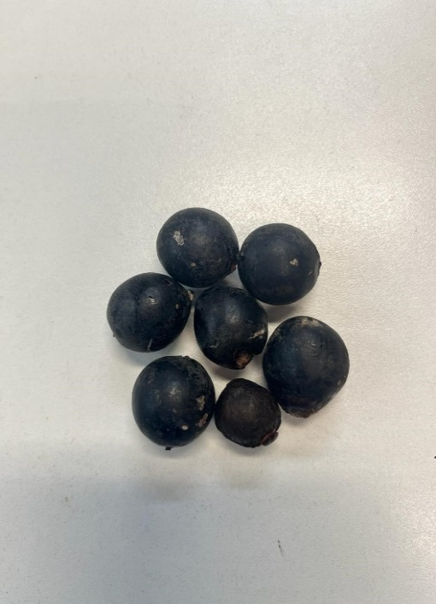
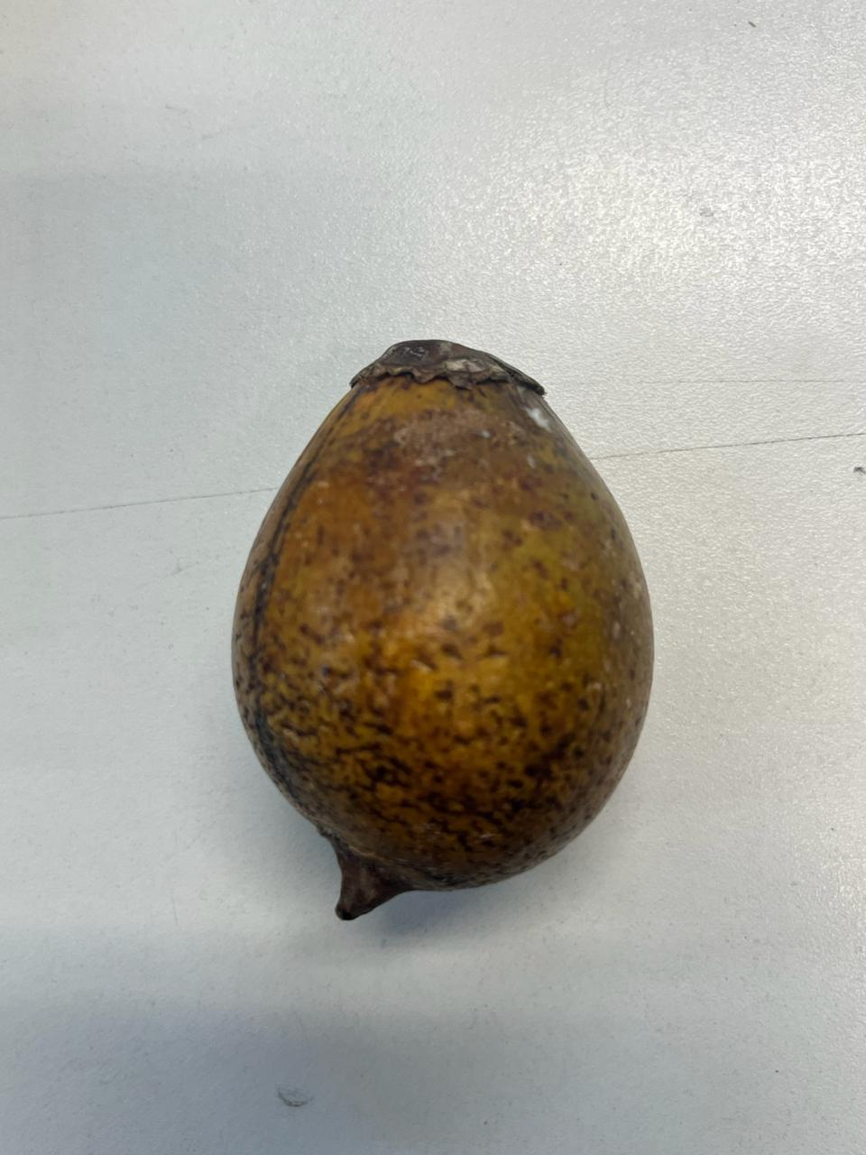
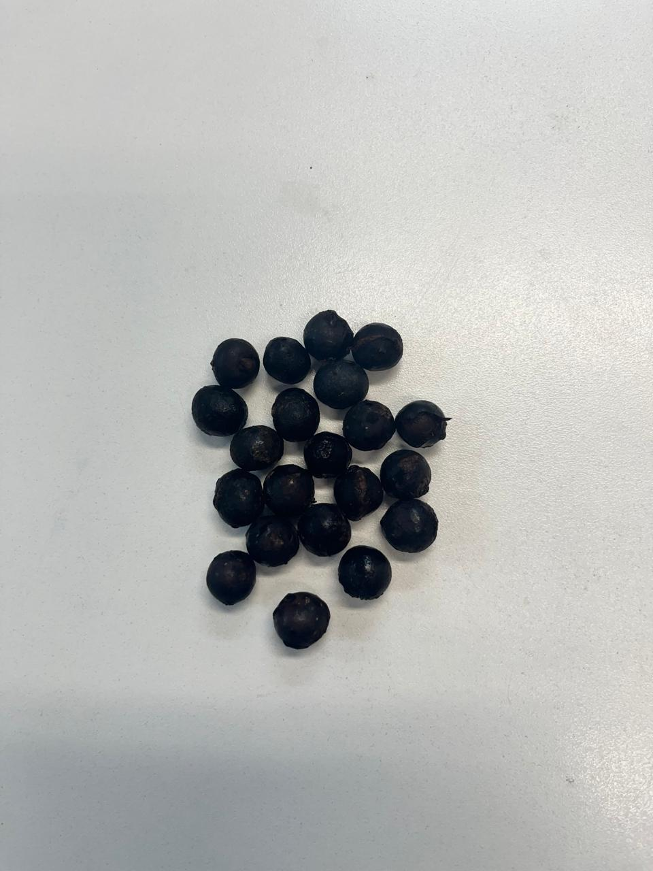
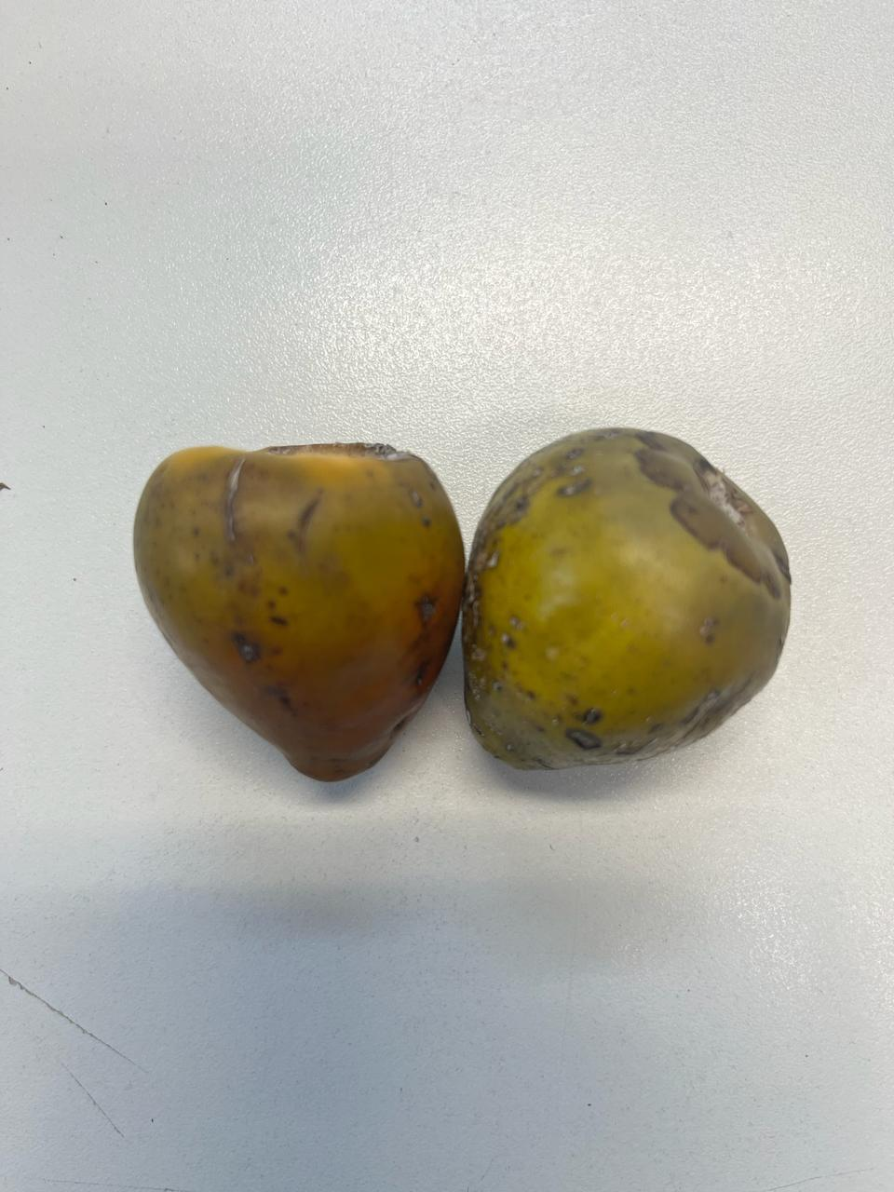
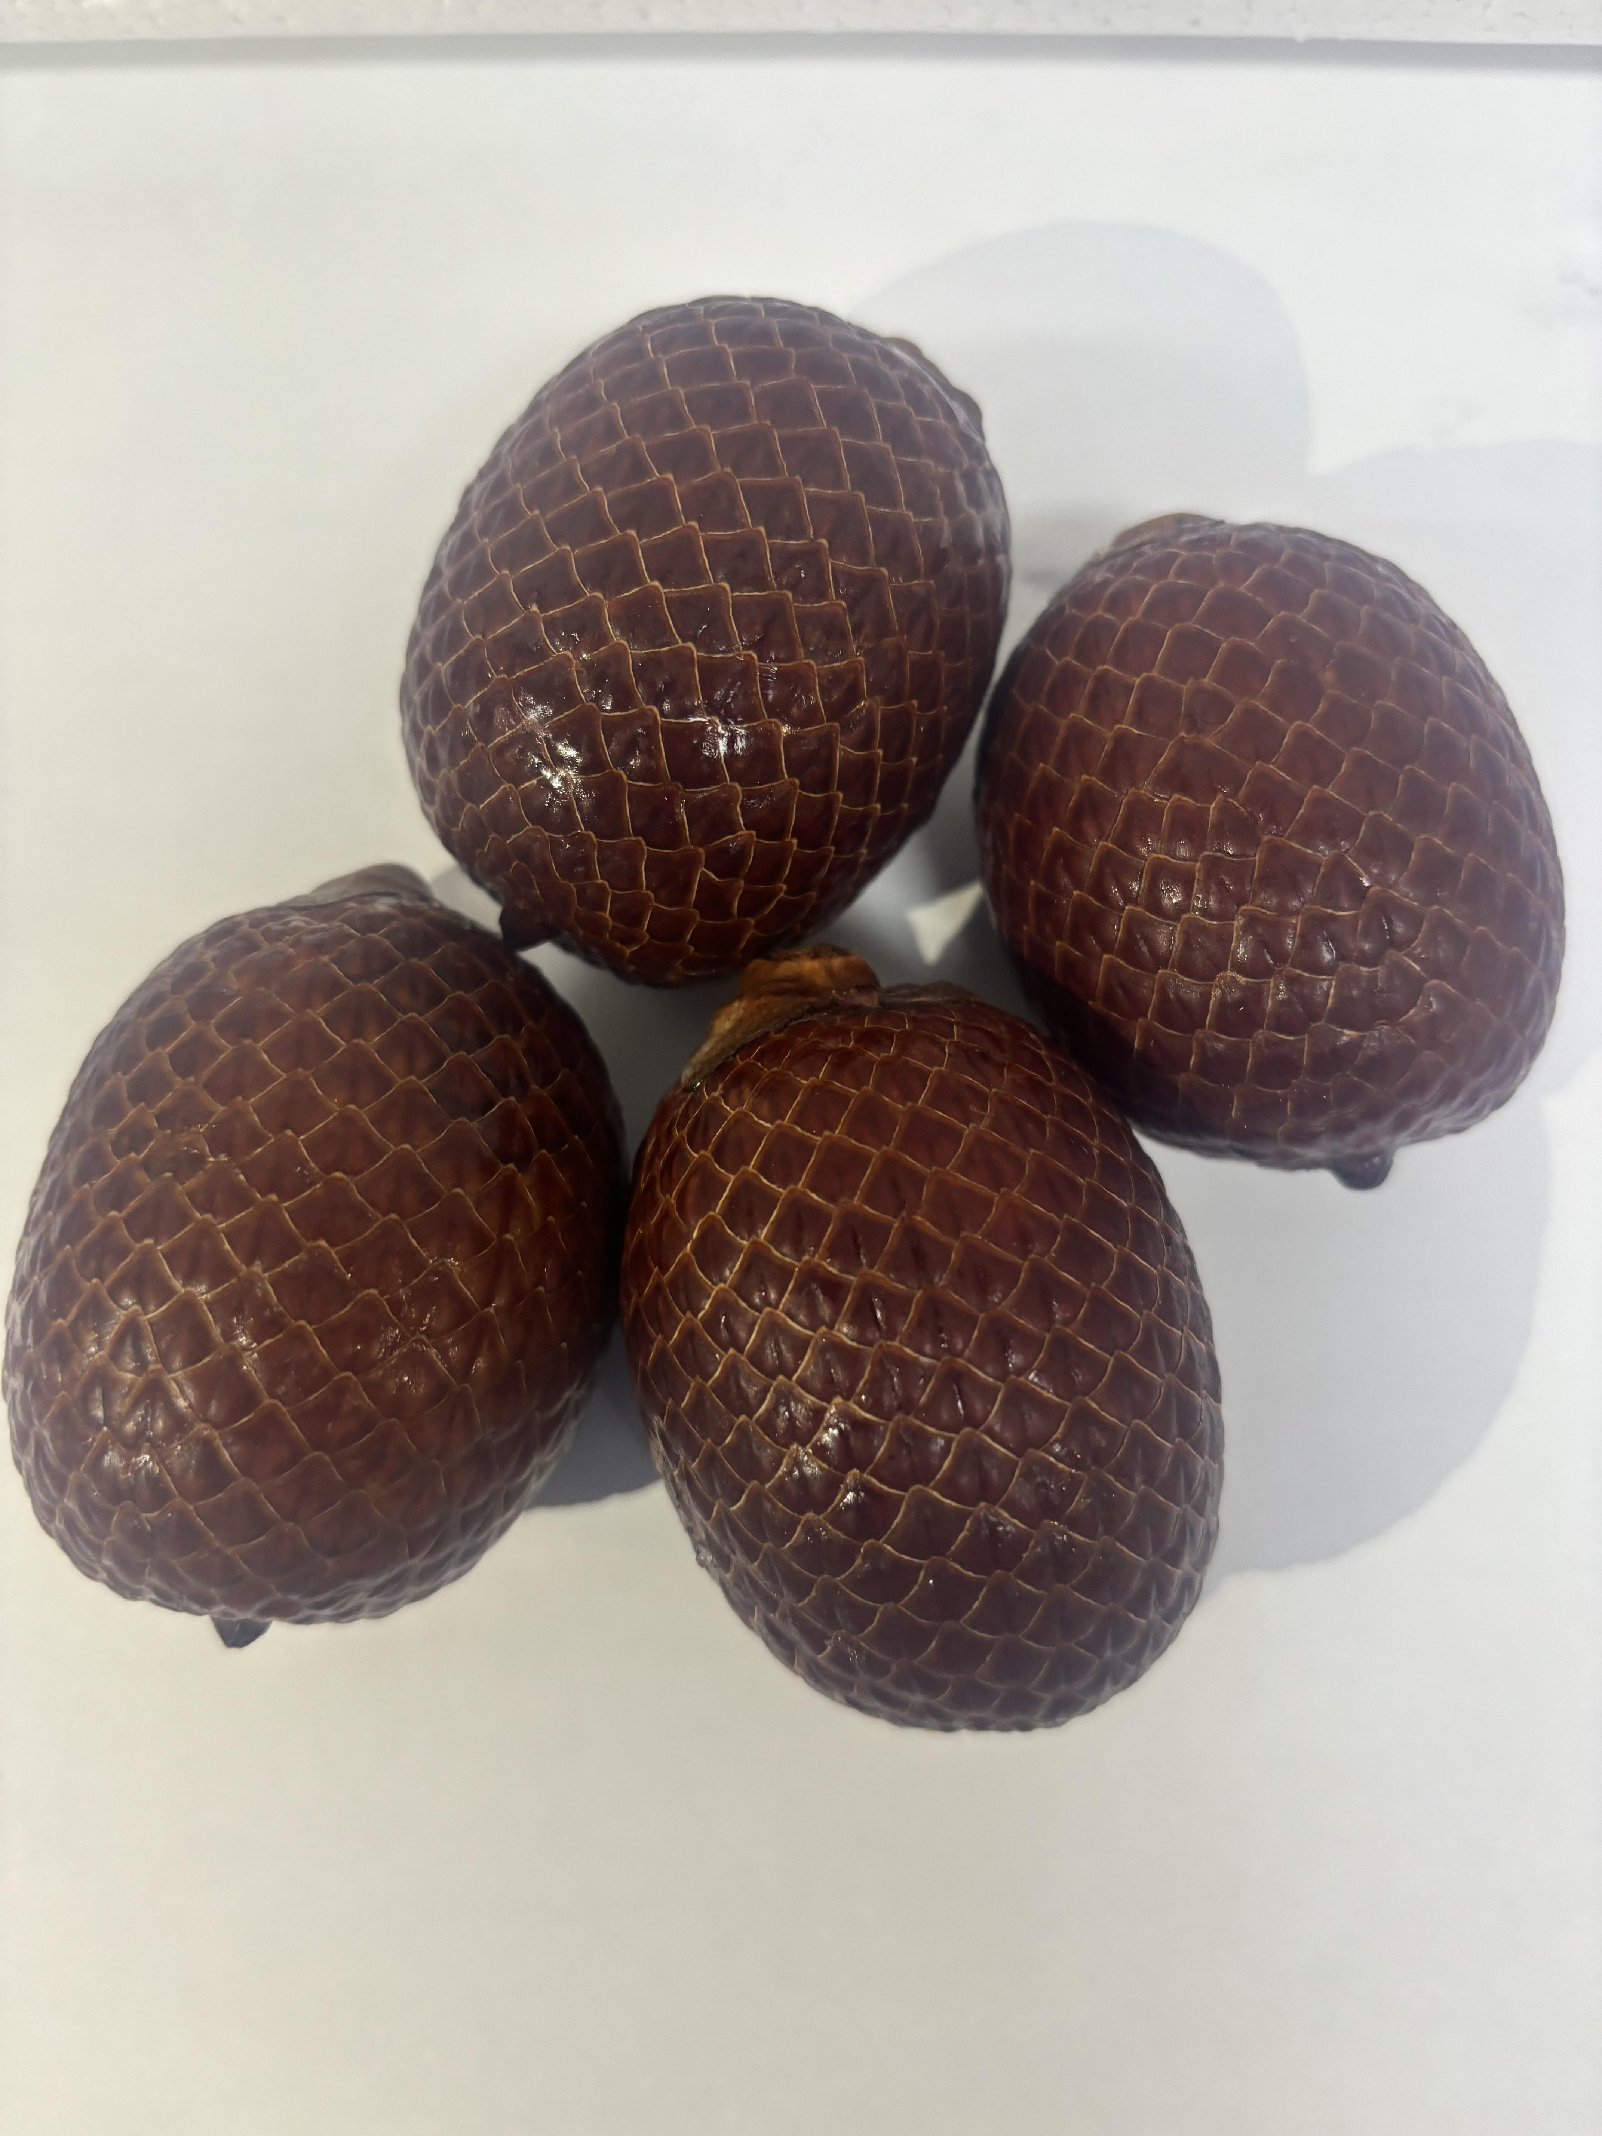
A
B
C
D
E
C

Figure S1. Fruits of Amazonian palm trees belong to the Arecaceae family. Bacaba (A), açaí (B), buriti (C), pupunha (D), and tucumã (E).

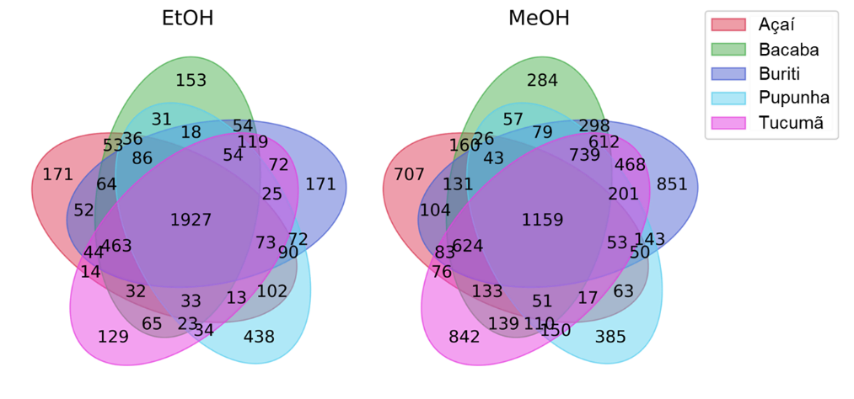
Figure S2. Venn diagrams illustrating the distribution of shared and unique metabolites among the five Amazonian palm fruits (açaí, bacaba, buriti, pupunha, and tucumã) for EtOH and MeOH eluates. The diagrams highlight a large proportion of metabolites common to all species, along with a smaller subset of unique features that contribute to their metabolic differentiation. These results support the high degree of chemical similarity observed in the Van Krevelen analysis while emphasizing species-specific metabolic signatures.

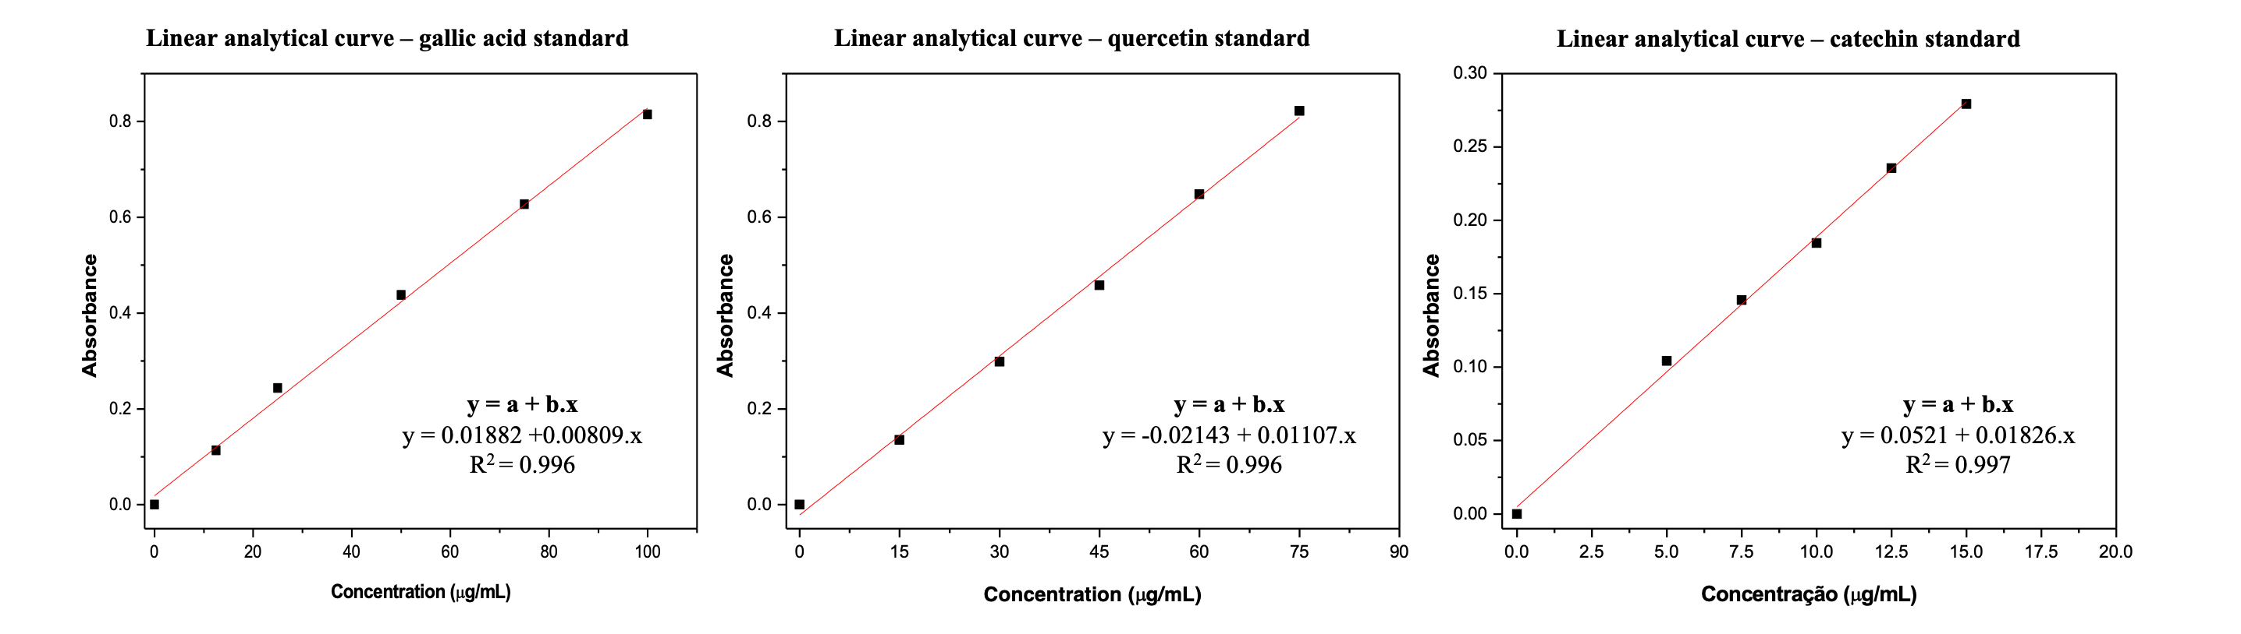
Figure S3. Linear analytical curves calculated for the reference standards used in the total phenolic content (TPC), total flavonoid content (TFC), total tannin content (TCT) determination.

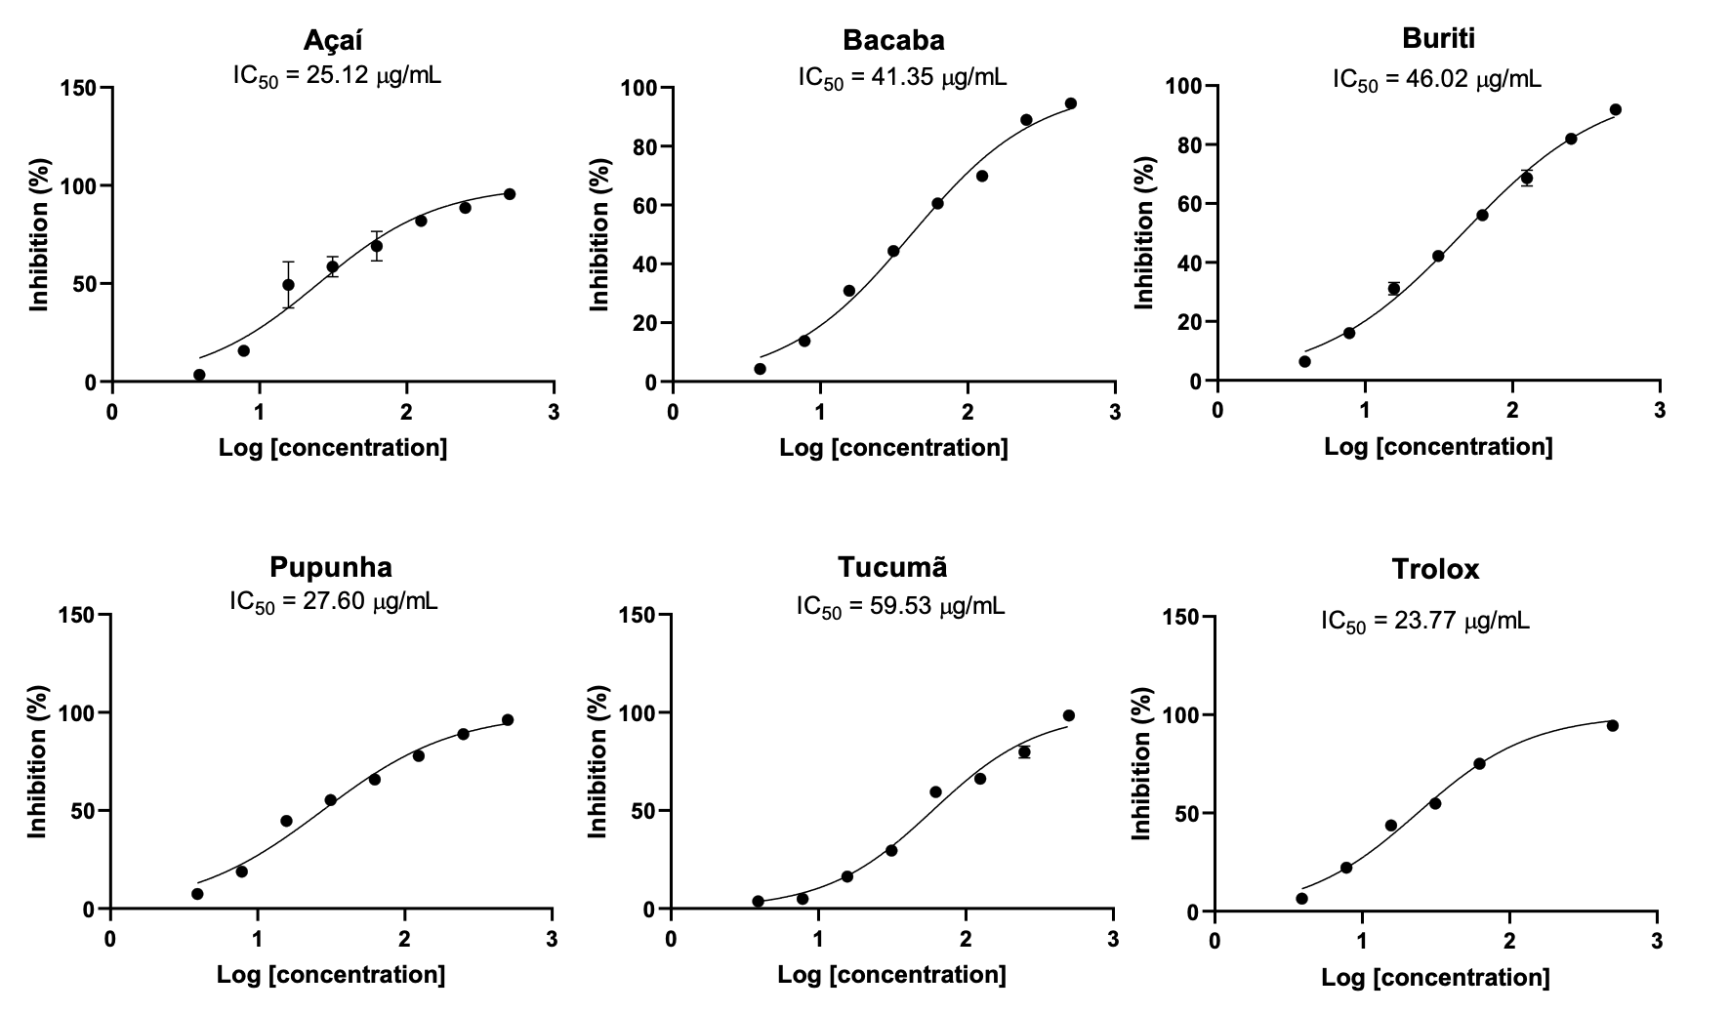
Figure S4. Antiradical activity (%) and IC₅₀ values (concentration of each extract required to inhibit 50% of the DPPH) of palm tree fruit extracts calculated from the log(inhibitor) versus normalizes response.

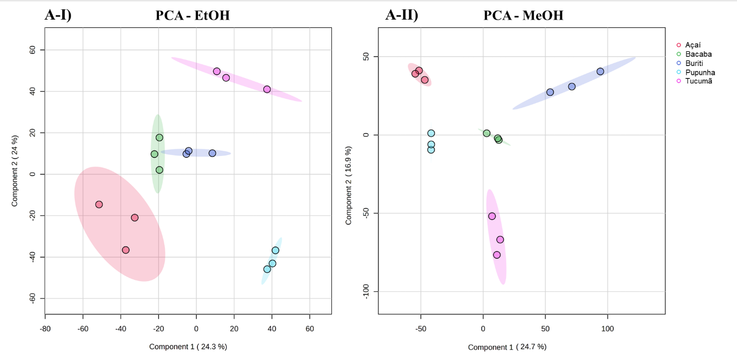
Figure S5. Principal Component Analysis (PCA) score plots of the metabolomic profiles of the five Amazonian palm fruits. A-I) EtoH eluates. A-II) MeOH eluates. PCA was used as an unsupervised exploratory approach to evaluate the intrinsic structure of the dataset and revealed grouping tendencies according to fruit species.

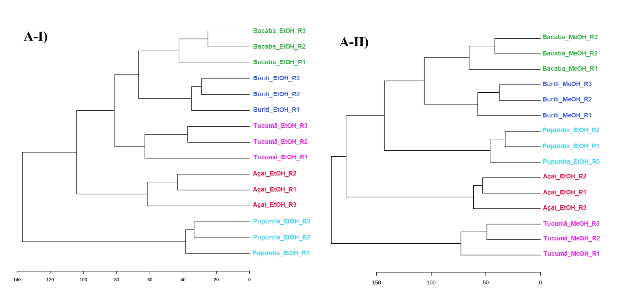
Figure S6. Hierarchical cluster analysis (HCA) based on differential metabolites (VIP > 1) obtained from PLS-DA models. Dendrograms correspond to EtOH eluates (A-I) and MeOH eluates (A-II). Clustering was performed using only variables with VIP scores greater than 1, highlighting metabolites that contribute most to class discrimination. The analysis shows improved consistency clustering among fruit species compared to the global HCA, confirming that the selected features capture the main sources of metabolic variation.

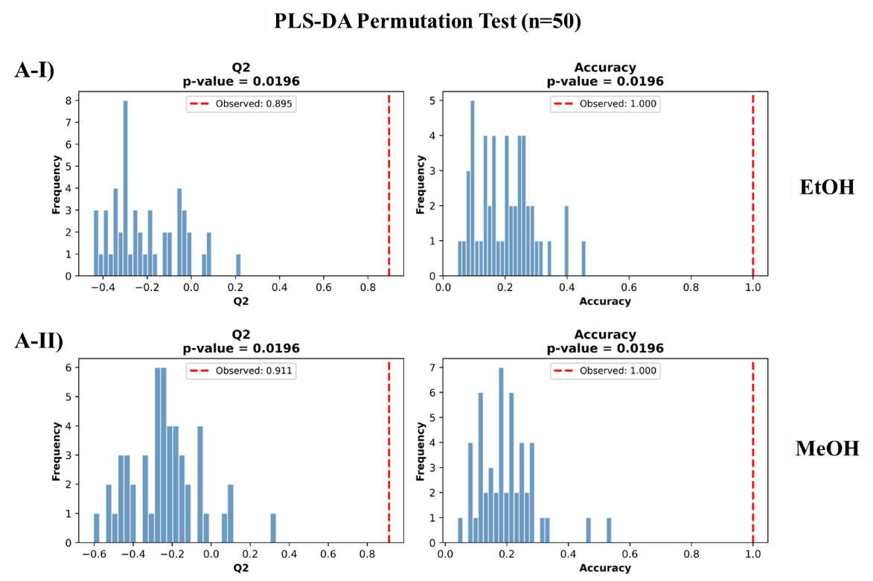
Figure S7. Permutation test results for the PLS-DA models built from the metabolomic profiles of the five Amazonian palm fruits. A-I) EtOH eluates. A-II) MeOH eluates. The observed classification performance was higher than that obtained for permuted models, supporting the statistical significance and robustness of the supervised discrimination.

Tables

Table S1. Molecular formula, exact mass, and error (ppm) for the most relevant metabolites (VIP scores obtained in the PLS-DA models) found in the MEOH Arecaceae fruit extracts. Each compound was tentatively annotated based on comparisons with previous studies and database information
MeOH
Molecular formula | Exact mass | Error (ppm) | Putative annotation
C₁₇H₂₅NO₆ | 340.1754 | 0.05 | Pyridine-derived alkaloid linked to a phenolic acid unit derived from gallic acid (piperidine and pyridine-derived alkaloids have been reported in the family)
C₁₅H₂₀N₂O₄ | 293.1496 | 0.03 | Quinone linked to an acyclic amine derived from amino acid residue
C₁₆H₁₆N₂O₄ | 301.1182 | 0.21 | Aromatic alkaloid with a pyridine ring
C₁₂H₂₀N₂O₃ | 241.1547 | 0.13 | Pyridine nucleus linked to an aliphatic chain
C₂₁H₃₂O₃Na | 355.2245 | 0.44 | hydroxysteroids
C₈H₁₆O₄Na | 199.0941 | 0.06 | -
C₁₅H₂₀N₂O₅ | 309.1446 | 0.26 | Hydroxylated quinone linked to an acyclic amine derived from an amino acid residue
C₂₀H₂₈O₂Na | 323.1983 | 0.33 | diterpenoid
C₃₀H₅₀O₁₁Na | 609.3246 | 0.16 | Glycosylated steroid
C₂₄H₃₉NO₁₀ | 502.2645 | 0.39 | Glycoside esterified with unsaturated fatty acid and nitrite
C₂₄H₄₁NO₁₀ | 504.2803 | 0.08 | Glycoside esterified with unsaturated fatty acid and nitrite
C₁₉H₂₃NO₆ | 362.1597 | 0.36 | Piperidine-derived alkaloid linked to a chromone
C₁₂H₁₉NO₄ | 242.1387 | 0.14 | Lactone linked to an aliphatic group
C₃₃H₅₄O₁₁Na | 649.3558 | 0.09 | Glycosylated steroid (steroidal saponin)
C₁₅H₁₄N₂O₃ | 271.1077 | 0.06 | -

Table S2. Molecular formula, exact mass, and error (ppm) for the most relevant metabolites (VIP scores obtained in the PLS-DA models) found in the EtOH Arecaceae fruit extracts. Each compound was tentatively annotated based on comparisons with previous studies and database information

EtOH
Molecular formula | Exact mass | Error (ppm) | Compound
C₉H₁₁NO₂Na | 188.0682 | 0.04 | Phenylalanine
C₃₀H₅₀O₆Na | 529.3500 | 0.11 | Polyoxygenated triterpene
C₄₁H₇₉NO₅ | 666.6028 | 0.41 | ceramide
C₃₇H₇₄O₆Na | 637.5377 | 0.15 | Fatty acid
C₁₈H₂₂O₅Na | 341.1360 | 0.23 | Phenylpropanoid-derived (a stilbene or lignan, both classes occur in the genus)
C₂₉H₅₀O₄Na | 485.3601 | 0.13 | Acid derivative Steroid
C₃₇H₇₂O₆Na | 635.5219 | 0.20 | Fatty acid
C₁₆H₂₆O₄ | 283.1904 | 0.14 | Lipid-derived
C₂₄H₄₀O₃Na | 399.2870 | 0.13 | Acid derivative Steroid
C₃₅H₆₂O₁₁Na | 681.4184 | 0.09 | Steroidal saponin
C₃₆H₆₀O₁₀Na | 675.4078 | 0.05 | Triterpenic saponin
C₁₈H₁₅N | 246.1277 | 0.06 | -
C₁₀H₁₇NO₅ | 232.1179 | 0.12 | -
C₁₅H₂₅O₇N | 332.1704 | 0.06 | Amine acetylated
C₄₂H₆₆O₆Na | 689.4755 | 0.51 | Tetraterpene acetylated

