Comparing Vascular Contrast of Breast Cancer in Multispectral Optoacoustic Tomography Above and Below 1000 Nanometers

Maximilian Bader^{a,b,†}, Patmaa Sridharan^{a,b,†}, Evangelos Fragkiadakis^{a,b}, Benedict E. Mc Larney^{c}, Sarkis Ter Martirosyan^{a,b}, Vipul Gujrati^{b}, Pia Anzenhofer^{a,b}, Katja Pinker^{d,e}, Jan Grimm^{c,d,f,g}, Dominik Jüstel^{a,b,i}, Ivy S. Curren^{a,b}, Vasilis Ntziachristos^{a,b,j,k,l,✉}

ªChair of Biological Imaging, Central Institute for Translational Cancer Research (TranslaTUM), School of Medicine and Health & School of Computation, Information and Technology, Technical University of Munich, Munich, Germany

^{b}Institute of Biological and Medical Imaging, Bioengineering Center, Helmholtz Zentrum München, Neuherberg, Germany

^{c}Molecular Pharmacology Program, Memorial Sloan Kettering Cancer Center, New York, USA

^{d}Department of Radiology, Memorial Sloan Kettering Cancer Center, New York, USA

^{e}Department of Radiology, Columbia University Vagelos College of Physicians and Surgeons, New York, USA

^{f}Department of Pharmacology, Weill Cornell Medicine, New York, USA

^{g}Department of Radiology, Weill Cornell Medicine, New York, USA

^{h}Molecular Imaging Therapy Service, Memorial Sloan Kettering Cancer Center, New York, USA

^{i}Institute of Computational Biology, Computational Health Center, Helmholtz Zentrum München, Neuherberg, Germany

^{j}Institute of Electronic Structure and Laser (IESL), Foundation for Research and Technology Hellas (FORTH), Heraklion, Greece

^{k}Munich Institute of Biomedical Engineering (MIBE), Technical University of Munich, Garching b. München, Germany

^{l}Munich Institute of Robotics and Machine Intelligence (MIRMI), Technical University of Munich, Munich, Germany

†These authors share first authorship

✉bioimaging.translatum@tum.de, Address: Technical University of Munich, Chair of Biological Imaging, Ismaninger Straße 22, D-81675 Munich, Germany

Abstract

Resolving angiogenesis and other morphological tissue changes in breast cancer non-invasively has been one of the prime applications of optoacoustic (OptA) tomography. Imaging devices, illuminating tissue at wavelengths below and above 1000 nanometers (nm), have been employed to image hemoglobin contrast in breast tumors. However, there has not been a comparison of arterial vascular contrast in in vivo OptA images of human breast tumors above and below 1000 nm. Here, we compare the contrast of arterial breast tumor vascularization in one mouse and one human in OptA images at 850 nm and 1060 nm. The analysis provided can serve as a reference for selecting the correct wavelength range to visualize breast tumor-related contrast in future clinical studies employing OptA tomography.

Keywords: Multispectral optoacoustic tomography, in vivo imaging, breast cancer, photoacoustic imaging, near-infrared window

INTRODUCTION
Optoacoustic (OptA) tomography has been utilized to non-invasively resolve morphological changes like angiogenesis in human breast tumors,^{1–4} which could aid the non-invasive diagnosis and treatment monitoring of breast cancer.^{5–7} In clinical studies, imaging was either performed with tunable laser illumination between 650 nm and 900 nm, commonly employing commercial Multispectral Optoacoustic Tomography (MSOT) devices,^{8,9} or at 1064 nm.^{10,11} Some studies have also combined illumination below and above 1060 nm to differentiate Hb and HbO2, most notably the largest clinical studies, which utilize hybrid OptA and ultrasound imaging to enhance breast cancer diagnosis.^{12–15}
Optical absorption by deoxygenated hemoglobin (Hb) is the highest below 800 nm; thus, Hb is assessed using wavelengths in the Near-infrared I window.¹⁶ In turn, oxygenated hemoglobin (HbO2) needs to be assessed at wavelengths above 800 nm, given its higher optical absorption at these wavelengths. For wavelengths above 1000 nm, lipids and water absorb similarly strongly, like hemoglobin,¹⁷ but tissue scattering is reduced compared to wavelengths below 1000 nm¹⁸ which improves OptA contrast. This raises the question of whether HbO2-rich arteries should be imaged above or below 1000 nm. Previous studies, including simulations, ex vivo tissue, and in vivo animals, have suggested that arterial contrast is higher at wavelengths above 1000 nm than at wavelengths below 1000 nm.^{19,20} However, it remains unknown whether these findings directly translate to in vivo human imaging.
This work compares the arterial vascular contrast in the breast tumor environment in OptA images acquired with commercial MSOT devices of one mouse and one human at 850 nm and 1060 nm. We observed higher vasculature contrast, as measured by contrast resolution (CR) and contrast-to-noise ratio (CNR), at 1060 nm compared to 850 nm in the mouse. However, we observed the opposite for the human image, with contrast being primarily higher at 850 nm than at 1060 nm.
Our work serves as a reference for selecting the correct wavelength range to visualize arterial breast tumor-related contrast using commercial MSOT devices. It can guide the design of future clinical studies aimed at enhancing clinical routine in breast cancer diagnosis and treatment using OptA imaging.

METHODS
MSOT imaging was conducted using two commercial MSOT devices, which are compared in Fig. 1. A MSOT Acuity Echo® prototype (iThera Medical GmbH, Munich, Germany), displayed in Fig. 1A, was utilized for human scanning. Fig. 1B illustrates the geometry of the handheld imaging probe, which comprises a 256-element ultrasound transducer (UT) array with 125° angular coverage. The transducers have a center frequency of approximately 4 MHz and a bandwidth >111%. The probe is separated from human tissue by a membrane, and a gel coupling pad is located between the membrane and the array to ensure acoustic coupling. The device provides images with a field of view of 4 cm in width and 2.7 cm in depth, at a resolution of 100µm. Optical excitation is performed using an optical parametric oscillator (OPO) laser that emits nanosecond laser pulses between 660 nm and 1300 nm (with a 10 nm step size) at a 25 Hz repetition rate. In parallel to MSOT imaging, brightness-mode reflection ultrasound tomography images are acquired, enabling hybrid optoacoustic and multispectral optoacoustic tomography (MS-OPUS) imaging. Fig. 1C displays the optical energy measured at the membrane, i.e., tissue interface, provided by the laser. Generally, the laser energy output peaks around 800 nm and decreases for larger wavelengths. Accordingly, the laser energy at 850 nm is 77.7% higher than at 1060 nm. The human data presented were collected by a professional radiologist at Memorial Sloan Kettering Cancer Center, New York City, New York, USA. The patient with suspected malignant breast cancer provided voluntary written informed consent prior to imaging. The study was approved by the Memorial Sloan Kettering Cancer Center institutional review board (IRB number Rad21-003).
For animal imaging, we employed an MSOT inVision (iThera Medical GmbH, Munich, Germany) device, as shown in Fig. 1D. The device features a specialized imaging chamber that hosts the 256-element UT array, displayed in Fig. 1E, with 270° angular coverage. All transducers have a center frequency of approximately 5 MHz and a bandwidth >65%. The mouse is fixed in the center of rotation, and images of a 4 cm by 4 cm field of view are acquired (resolution: 100µm). The chamber is filled with heavy water, i.e., deuterium oxide (D2O), to ensure acoustic coupling and optimized optical transmission. For tissue excitation, an OPO laser emits nanosecond pulses between 680 nm and 1300 nm (step size: 10 nm) at a 20 Hz repetition rate. The laser energy, as displayed in Fig. 1F, exhibits a similar pattern to the clinical laser energy in Fig. 1c, but with a stronger intensity and two laser energy peaks. The laser energy at 850 nm is 42.0% higher than at 1060 nm. Animal imaging was performed at the Helmholtz Zentrum München, Munich, Germany. An athymic nude mouse (Foxn1 strain; Charles River Laboratories) was injected with tumor cells (4T1 murine mammary carcinoma cells; ATCC) subcutaneously in the lower dorsal region. Imaging was performed ten days after tumor injection. All animal experiments were conducted at Helmholtz Zentrum München in accordance with institutional and national guidelines for animal care and use in research. The study protocol was reviewed and approved by the Government of Upper Bavaria.
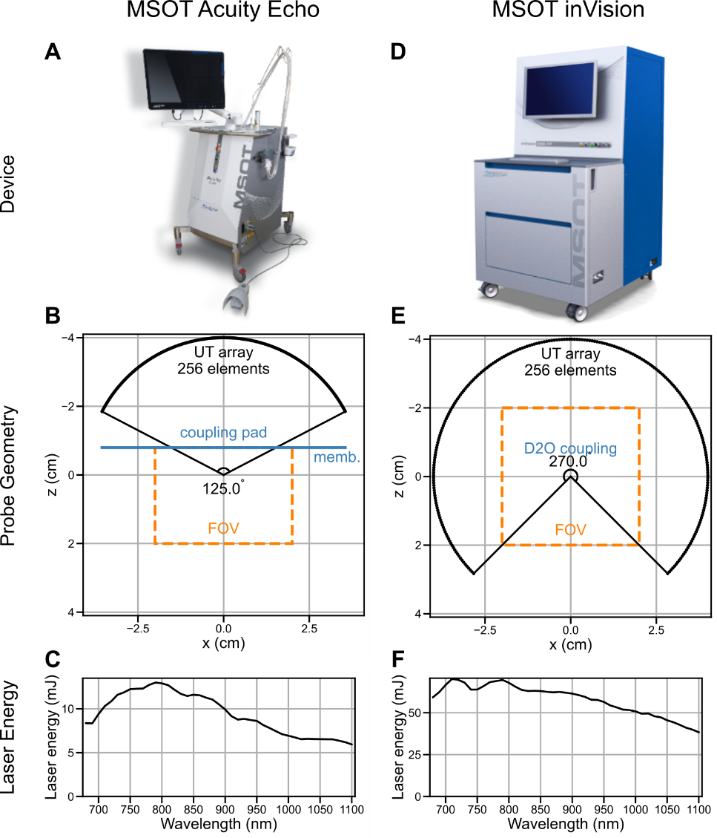
Figure 1 Comparison of commercial human and animal Multispectral Optoacoustic Tomography (MSOT) devices. (A-C) The MSOT Acuity Echo® (A; iThera Medical GmbH, Munich, Germany) is a human MSOT device featuring a handheld probe with a 125° ultrasound transducer (UT) array, a field of view (FOV) of 4 cm x 2.7 cm (B), and a tunable near-infrared laser source with varying laser energy output plotted between 680 nm and 1100 nm (C). (D-F) The MSOT inVision® device (D; iThera Medical GmbH, Munich, Germany) is an animal MSOT device featuring an imaging chamber with a 270° UT array, a FOV of 4 cm x 4 cm (E), and a tunable near-infrared laser source with varying laser energy output plotted between 680 nm and 1100 nm (F). The laser energy at 850 nm is 42.0% higher than at 1060 nm. Abbreviations: membr. – membrane; D2O – deuterium oxide. (A,D) Provided by iThera Medical GmbH with permission for use.
Human and animal signal data were filtered with a Butterworth bandpass filter (300kHz-12MHz and 700kHz-12MHz). Human data was additionally preprocessed with a motion quantification algorithm²¹ and a neural network-based electrical denoising algorithm.²² Human OptA images were reconstructed using a custom model-based reconstruction algorithm with a non-negativity constraint.^{23–25} Animal data were reconstructed using a custom dual-frequency band non-negativity constraint reconstruction algorithm for visualization purposes.²⁶ The speed of sound and regularization parameters were manually tuned. Images were corrected by laser energy, but no additional fluence correction was performed. For visualization only, the human images were enhanced using a low-frequency image envelope. Contrast was assessed in the laser energy-corrected images using CR and CNR.²² Regions of interest for the vessels, background, and noise were manually segmented.

RESULTS

Optical tissue characteristics above and below 1000 nanometers
Fig. 2 highlights that both 850 nm and 1060 nm are suitable for visualizing arterial vascularization, as HbO2 is the strongest endogenous tissue absorber, aside from melanin. However, optical absorption by lipids and water (H2O), the main constituents of breast tissue, optical scattering, and safety limits for skin exposure to light vary strongly between the two wavelengths and considerably affect the OptA contrast of vascularization. Hence, it remains unknown whether arterial vascular contrast can be visualized with higher contrast at wavelengths above or below 1000 nm with commercial MSOT imaging devices.
The absorption spectra of the primary endogenous tissue chromophores expected in breast tissue between 680 nm and 1100 nm are displayed in Fig. 2A. Melanin’s optical absorption (orange line) decreases continuously and is at least 1.6 orders of magnitude stronger than absorption by Hb, HbO2, H2O, and lipids over the wavelength range displayed. At 800 nm, the isosbestic point of hemoglobin absorption, HbO2 (pink line) and Hb (blue line) absorb light equally strongly. For wavelengths smaller than 800 nm, Hb absorption is stronger than HbO2 absorption, and for wavelengths above 800 nm, vice versa. At wavelengths below 900 nm, the optical extinction coefficients of HbO2 and Hb are multiple orders of magnitude higher than the coefficients of H2O (purple line) and lipid (green line). At wavelengths beyond 900 nm, the optical absorption of both H2O and lipids increases, being 3.56 and 8.96 times higher at 1060 nm than at 850 nm, respectively. In comparison to the optical absorption spectra, Fig. 2B displays the range of optical reduced scattering coefficients in human breast tissue across wavelengths. On average, the optical scattering decreases for increasing wavelength and is 25% smaller at 1060 nm than at 850 nm. Besides the optical absorption and scattering, OptA imaging contrast is also affected by the injected light energy, which is confined by the safety limit for the skin’s maximum permissible exposure (MPE) to light across wavelengths, showcased in Fig. 2C. The MPE increases for larger wavelengths and is 263% higher at 1060 nm than at 850 nm. Comparing the laser energy of the commercial MSOT devices in Fig. 1C,F with the MPE in Fig. 2C, it becomes evident that the MSOT devices do not exploit the increasing MPE for larger wavelengths, but the laser energy is approximately half at 1060 nm compared to 850 nm.
The lower laser energy of MSOT devices and increased optical absorption of lipids at wavelengths greater than 1000 nm negatively impact arterial vascular contrast in lipid-rich breast tissue compared to 850 nm. On the other hand, optical scattering is reduced at 1060 nm compared to 850 nm, resulting in less attenuation with depth and a stronger imaging contrast in deep tumors.
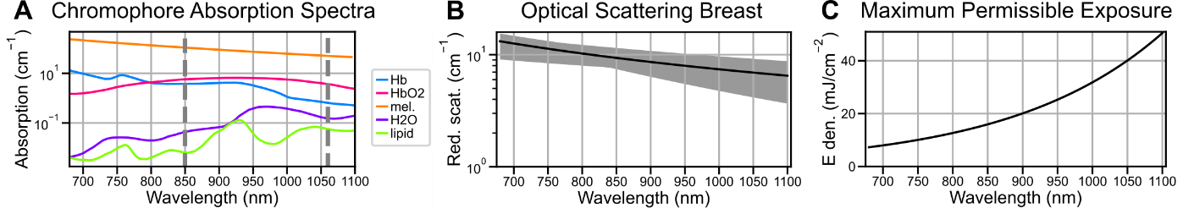
Figure 2 Chromophore Absorption Spectra, Optical Scattering in Breast Tissue, and Maximum Permissible Exposure (MPE). (A) The absorption spectrum of dominant tissue chromophores in breast tissue in the wavelength range between 680 nm and 1100 nm. Wavelengths 850 nm and 1060 nm are highlighted (gray dashed lines). (B) Different approximations for the reduced scattering (red. scat.) coefficient in breast tissue (black line: mean, gray dashed area: minimum to maximum). (C) The MPE of skin to light between 680 and 1100 nm according to American safety limits. Abbreviations: Hb – deoxygenated hemoglobin; HbO2 – oxygenated hemoglobin; mel. – melanin; H2O – water; E den. – energy density. (A) prepared using data from OMLC¹⁷ and human skin²⁷ databases. (B) prepared using S. L. Jacques, Phys. Med. Biol., 2013.¹⁸ (C) prepared using ANSI standards.²⁸

Contrast of suspected arteries in a breast tumor injected into a mouse
To assess the contrast of suspected arteries in the breast tumor environment in in vivo OptA images, we imaged a mouse with implanted breast tissue utilizing the commercial MSOT inVision device (iThera Medical GmbH, Munich, Germany). Fig. 3 shows that the contrast in terms of CR and CNR of suspected arteries in a breast tumor environment is higher at 1060 nm than at 850 nm.
Fig. 3A shows a cross-sectional OptA image of the mouse at 800 nm (filter band: 300 kHz-12 MHz). The tumor (yellow dashed line) is located in the lower dorsal region of the mouse. Three vessels are highlighted: two vessels in the tumor neighborhood, directly under the skin (numbers 1 and 2), and one deeper inside the mouse (number 3). Fig. 3B quantitatively assesses the contrast of the three highlighted vessels (see Fig. 3A) in terms of CR and CNR for two different reconstructed filter bands: 300 kHz – 12 MHz (dashed lines) and 700 kHz – 12 MHz (dotted lines). For both superficial vessels (1: blue lines, 2: orange lines), CR, a relative measure of contrast between the vessel and its background, is higher at 850 nm than at 1060 nm, regardless of the filter band. However, for vessel 3 (green line), located deeper in tissue, the CR decreases from 850 nm to 1060 nm. The CNR, an absolute measure relating vessel contrast to image noise (standard deviation of pixel intensities in a region outside the mouse), is higher at 850 nm than at 1060 nm for the superficial, suspected arteries 1 and 2, but lower for the deeper suspected artery 3, analogous to the CR.
In conclusion, 1060 nm achieves higher contrast than 850 nm for arteries inside the mouse. This suggests that wavelengths above 1000 nm are better suited for imaging arterial vascular contrast in animals using the MSOT inVision with D2O coupling.
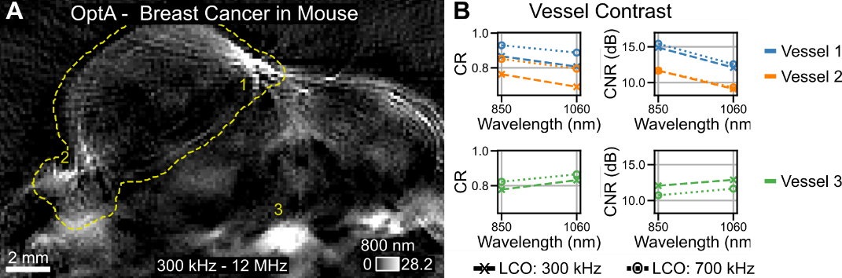
Figure 3 Vascular Contrast at 850 nm and 1060 nm in Optoacoustic (OptA) images of a mouse. (A) OptA image at 800 nm (filter band: 300 kHz – 12 MHz) shows strong vascular contrast in the tumor environment with two vessels highlighted (numbers 1,2). For reference, a suspected artery inside the mouse is also denoted (number 3). (B) Contrast resolution (CR) and contrast-to-noise ratio (CNR) of the vessels 1-3 (see A) show higher contrast at 1060 nm than 850 nm inside the mouse (vessels 1,2) in OptA images at two different filter bands (dashed line: 300 kHz – 12 MHz, dotted line: 700 kHz – 12 MHz). The opposite is the case for superficial suspected arteries in the tumor environment (vessel 3). Abbreviations: LCO – lower cutoff frequency.

Contrast of suspected arteries in a human breast tumor
Moving from animal to human imaging, we also assessed breast tumor vascularization in a human in vivo employing a commercial MSOT Acuity Echo prototype (iThera Medical GmbH, Munich, Germany). Fig. 4 highlights that the contrast of suspected arteries in human breast tissue superficially under the skin is lower at 850 nm than at 1060 nm. For suspected arteries in the tumor environment, i.e., deeper in tissue, contrast at 850 nm is predominantly higher than at 1060 nm.
Fig. 4A displays a cross-sectional OptA image of a human with lobular carcinoma in situ (yellow dashed outline). Three suspected arteries in the tumor environment (numbers 1-3) and three superficially under the skin (numbers 4-6) are labelled. Fig. 4B compares absolute image contrast in terms of CNR and CR for all six suspected arteries (see Fig. 4A), analogous to Fig. 3B, for two different filter bands. The CR of the three vessels (1: blue lines, 2: orange lines, 3: green lines) in the tumor environment drops between 850 nm and 1060 nm, whereas they rise for the three superficial vessels (4: pink lines, 5: brown lines, 6: purple lines), independent of the filter band. The CNR decreases for all vessels in the tumor environment between 850 and 1060 nm for both filter bands, except for vessel 1 in the 300 kHz – 12 MHz image. In superficial vessel 4, the CNR drops regardless of both filter bands. In contrast, the CNR of vessels 5 and 6 increases slightly in the 300 kHz – 12 MHz filter band, but decreases in the 700 kHz – 12 MHz reconstruction.
In contrast to the observations in the mouse, in humans, suspected arteries in the tumor environment, i.e., deeper in the tissue, show stronger contrast at 850 nm than at 1060 nm. This suggests that, when using the MSOT Acuity device, wavelengths below 1000 nm are better suited for assessing arterial breast cancer vasculature in humans.
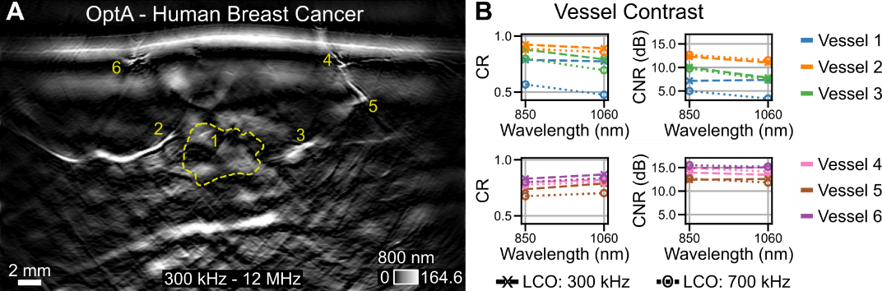
Figure 4: Vascular Contrast at 850 nm and 1060 nm in Optoacoustic (OptA) images of a human. (A) OptA image at 800 nm (filter band: 300 kHz – 12 MHz) shows strong vascular contrast in the tumor environment with three suspected arteries highlighted (numbers 1-3). For reference, three suspected arteries in the superficial tissue are also highlighted (numbers 4-6). (B) Contrast resolution (CR) and contrast-to-noise ratio (CNR) of the vessels 1-6 (see A) show predominantly higher contrast at 850 nm than 1060 nm in the tumor environment (vessels 1-3) in OptA images at two different filter bands (dashed line: 300 kHz – 12 MHz, dotted line: 700 kHz – 12 MHz). The opposite is the case for superficial vessels (4-6). Abbreviations: LCO – lower cutoff frequency.

DISCUSSION
Here, we present a case study comparing arterial contrast in breast tumors of one human and one mouse each for wavelengths above and below 1000 nm using two commercial MSOT devices. While previous studies have investigated the contrast in simulations, phantoms, or animals,^{19,20} these results do not necessarily translate to human interrogations, given the strongly varying tissue environment and different device specifications, both affecting OptA image contrast.^{3,29,30}
In a mouse, we observed stronger contrast for supposed arteries deep in tissue at 1060 nm than at 850 nm. These observations align with previous studies employing different devices^{19,20} despite a considerably lower laser output energy achieved above 1000 nm than below by the MSOT inVision device.
In a human, we observed the opposite trend, with the contrast of suspected arteries being stronger at 850 nm than at 1060 nm deep in tissue. Previous investigations have shown that blood absorption exceeds breast tissue absorption by multiple orders of magnitude over the entire wavelength range¹² and theoretical considerations suggest a stronger contrast at 1060 nm than at 850 nm deep in tissue due to optical scattering being considerably lower (see Fig. 2B). However, the increasing extinction coefficient of lipids and H2O above 1000 nm (see Fig. 2A) will result in stronger absorption by breast tissue, causing a stronger bulk background OptA signal than at 850 nm. The background signal can be reduced at the cost of bulk tissue information by increasing the lower cutoff frequency of the bandpass filter in data preprocessing or by employing a filtered back-projection reconstruction algorithm, which automatically dampens low-frequency signals.^{9,26,31} Nevertheless, our observations are based on OptA images acquired with a laser, which achieves a lower output energy at 1060 nm than at 850 nm (see Fig. 2C, F). The effects of decreased laser energy are hypothetically the reason for a rise in noise between 850 nm and 1060 nm which can be deducted from the stronger decrease in CNR than CR for deep vessels (see Fig. 4B). Therefore, our observations might not translate to systems with different lasers allowing higher output energies above 1000 nm exploiting the higher MPE (see Fig. 3C), like employed in numerous other clinical studies.^{10,11,15,32–36}
To date, there has been no comparison of arterial contrasts in the two wavelength ranges for commercial MSOT devices, with which most human in vivo studies have been performed.^{1,4} Our observations highlight that OptA imaging contrast depends not only on the imaged tissue and skin but also on the device specifications (laser energy, coupling medium, …). Consequently, findings from studies with other experimental settings are not directly transferable.
However, statistically reliable results cannot be deduced from the single mouse and human presented here. Thus, future work should extend this case study to include more subjects, allowing for definitive conclusions about arterial contrast in OptA images above and below 1000 nm. Reconstruction artifacts, such as limited-view^{37,38} or low-frequency ringing,³⁹ cause physically unreasonable contrast. Especially for human applications, high contrast at wavelengths above 1000 nm could be physically feasible due to the larger MPE (see Fig. 2C). Therefore, in a future study, the arterial contrast in human breast cancer should be investigated with illumination setups that employ the output energy according to the MPE limits.²⁸ Moreover, the effect of skin tone as well as the depth-dependence on the contrast of arterial vasculature has not been assessed. Because melanin absorbs considerably less at 1060 nm than at 850 nm, 1060 nm contrast might be more equitable in terms of skin tone. Light attenuation by scattering and absorption increases exponentially with depth, thereby affecting OptA imaging contrast notably differently at different depths. Fluence correction would mitigate both effects. However, to date, no fluence correction method has been developed that is accurate and reliable in clinical scenarios. Therefore, both skin tone and depth effects on vascular contrast in OptA tomography should be investigated in future studies.
Our case study suggests that human arteries in breast tissue exhibit stronger OptA image contrast at wavelengths below 1000 nm than at wavelengths above when imaged with a commercial MSOT device. Hence, the study serves as guidance for wavelength selection in future clinical OptA imaging studies aimed at resolving morphological and functional vascular features of breast cancer, aiding diagnosis, treatment monitoring, and treatment planning.

Acknowledgements
The research leading to these results has received funding from the Deutsche Forschungsgemeinschaft (DFG), Sonderforschungsbereich-824 (SFB-824), subproject A1, and 455422993 as part of the Research Unit FOR 5298 (iMAGO, subproject TP2, GZ: NT 3/32-1); and the European Research Council (ERC) through the European Union’s Horizon 2020 research and innovation programme under grant agreement No 694968 (PREMSOT).

Disclosures
V.N. is a founder and equity owner of Maurus OY, sThesis GmbH, Spear UG, Biosense Innovations P.C., and I3 Inc. All other authors have nothing to disclose.

References
[1] Ntziachristos, V., “Addressing unmet clinical need with optoacoustic imaging,” Nature Reviews Bioengineering (2024).
[2] Manohar, S. and Dantuma, M., “Current and future trends in photoacoustic breast imaging,” Photoacoustics 16(September 2018), 100134 (2019).
[3] Park, J., Choi, S., Knieling, F., Clingman, B., Bohndiek, S. E., Wang, L. V. and Kim, C., “Clinical translation of photoacoustic imaging,” Nature Reviews Bioengineering (2024).
[4] Knieling, F., Lee, S. and Ntziachristos, V., “A primer on current status and future opportunities of clinical optoacoustic imaging,” npj Imaging 3(1), 4 (2025).
[5] Tromberg, B. J., Cerussi, A., Shah, N., Compton, M., Durkin, A., Hsiang, D., Butler, J. and Mehta, R., “Imaging in breast cancer: Diffuse optics in breast cancer: detecting tumors in pre-menopausal women and monitoring neoadjuvant chemotherapy,” Breast Cancer Research 7(6), 279 (2005).
[6] Weissleder, R., “Molecular imaging in cancer,” Science (1979) 312(5777), 1168–1171 (2006).
[7] Brindle, K., “New approaches for imaging tumour responses to treatment,” Nat Rev Cancer 8(2), 94–107 (2008).
[8] Diot, G., Metz, S., Noske, A., Liapis, E., Schroeder, B., Ovsepian, S. V., Meier, R., Rummeny, E. and Ntziachristos, V., “Multispectral Optoacoustic Tomography (MSOT) of human breast cancer,” Clinical Cancer Research 23(22), 6912–6922 (2017).
[9] Kukačka, J., Metz, S., Dehner, C., Muckenhuber, A., Paul-Yuan, K., Karlas, A., Fallenberg, E. M., Rummeny, E., Jüstel, D. and Ntziachristos, V., “Image processing improvements afford second-generation handheld optoacoustic imaging of breast cancer patients,” Photoacoustics 26(February) (2022).
[10] Lin, L., Hu, P., Shi, J., Appleton, C. M., Maslov, K., Li, L., Zhang, R. and Wang, L. V., “Single-breath-hold photoacoustic computed tomography of the breast,” Nat Commun 9 (2018).
[11] Heijblom, M., Piras, D., Engh, F. M. Van Den, Van der Schaaf, M., Klaase, J. M., Steenbergen, W. and Manohar, S., “The state of the art in breast imaging using the Twente Photoacoustic Mammoscope : results from 31 measurements on malignancies,” Eur Radiol 26, 3874–3887 (2016).
[12] Oraevsky, A. A., Savateeva, E. V, Solomatin, S. V, Karabutov, A. A., Andreev, V. G., Gatalica, Z., Khamapirad, T. and Henrichs, P. M., “Optoacoustic imaging of blood for visualization and diagnostics of breast cancer” (2002).
[13] Ermilov, S. A., Khamapirad, T., Conjusteau, A., Leonard, M. H., Lacewell, R., Mehta, K., Miller, T. and Oraevsky, A. A., “Laser optoacoustic imaging system for detection of breast cancer,” J Biomed Opt 14(2), 024007 (2009).
[14] Oraevsky, A. A., Clingman, B., Zalev, J., Stavros, A. T., Yang, W. T. and Parikh, J. R., “Clinical optoacoustic imaging combined with ultrasound for coregistered functional and anatomical mapping of breast tumors,” Photoacoustics 12(May), 30–45 (2018).
[15] Neuschler, E. I., Butler, R. S., Young, C. A., Barke, L. D., Bertrand, M. L., Böhm-Vélez, M., Destounis, S., Donlan, P., Grobmyer, S. R., Katzen, J., Kist, K. A., Lavin, P. T., Makariou, E. V., Parris, T. M., Schilling, K. J., Tucker, F. L. and Dogan, B. E., “A pivotal study of optoacoustic imaging to diagnose benign and malignant breast masses: A new evaluation tool for radiologists,” Radiology 287(2), 398–412 (2018).
[16] Oraevsky, A. A., Savateeva, E. V, Solomatin, S. V, Karabutov, A. A., Andreev, V. G., Gatalica, Z., Khamapirad, T. and Henrichs, P. M., “Optoacoustic imaging of blood for visualization and diagnostics of breast cancer,” Proc. SPIE 4618, Biomedical Optoacoustics III, A. A. Oraevsky, Ed. (2002).
[17] Prahl, S. A. and Jacques, S. L., “OMLC Assorted Spectra,” https://omlc.org/spectra/index.html, 2018, <https://omlc.org/spectra/index.html> (3 December 2025 ).
[18] Jacques, S. L., “Optical properties of biological tissues: A review,” Phys Med Biol 58(14), 5007–5008 (2013).
[19] Sharma, A., Srishti, S., Periyasamy, V. and Pramanik, M., “Photoacoustic imaging depth comparison at 532-, 800-, and 1064-nm wavelengths: Monte Carlo simulation and experimental validation,” J Biomed Opt 24(12), 1 (2019).
[20] Vincely, V. D. and Bayer, C. L., “Photoacoustic imaging of rat kidney tissue oxygenation using second near-infrared wavelengths,” J Biomed Opt 30(02) (2025).
[21] Kukačka, J., “Advancing Clinical Optoacoustic Tomography,” PhD (2024).
[22] Dehner, C., Olefir, I., Chowdhury, K. B., Justel, D. and Ntziachristos, V., “Deep-learning-based electrical noise removal enables high spectral optoacoustic contrast in deep tissue,” IEEE Trans Med Imaging 41(11), 3182–3193 (2022).
[23] Chowdhury, K. B., Prakash, J., Karlas, A., Justel, D. and Ntziachristos, V., “A Synthetic Total Impulse Response Characterization Method for Correction of Hand-Held Optoacoustic Images,” IEEE Trans Med Imaging 39(10), 3218–3230 (2020).
[24] Chowdhury, K. B., Bader, M., Dehner, C., Jüstel, D. and Ntziachristos, V., “Individual transducer impulse response characterization method to improve image quality of array-based handheld optoacoustic tomography,” Opt Lett 46(1), 1 (2021).
[25] Bader, M., Haim, P., Scheel-Platz, L. I., Karlas, A., Irl, H., Ntziachristos, V. and Jüstel, D., “Spatial Pulse Response - A Precise Numerical Simulation of Optoacoustic Wave Detection with Arbitrarily Shaped Transducers,” ArXiv (2023).
[26] Longo, A., Jüstel, D. and Ntziachristos, V., “Disentangling the frequency content in optoacoustics,” IEEE Trans Med Imaging 41(11), 3373–3384 (2022).
[27] Baranoski, G. V. G., “Human Skin Data - Natural Phenomena Simulation Group at University of Waterloo,” https://www.npsg.uwaterloo.ca/data/skin.php, 2025, <https://www.npsg.uwaterloo.ca/data/skin.php> (3 December 2025 ).
[28] ANSI Inc., [American national standard for the safe use of lasers], Laser Institute of America, Orlando (2007).
[29] Cox, B. T., Laufer, J. G., Arridge, S. R. and Beard, P. C., “Quantitative spectroscopic photoacoustic imaging: a review,” J Biomed Opt 17(6), 061202 (2012).
[30] Beard, P., “Biomedical photoacoustic imaging,” Interface Focus 1(4), 602–631 (2011).
[31] Xu, M. and Wang, L. V., “Universal back-projection algorithm for photoacoustic computed tomography,” Phys Rev E Stat Nonlin Soft Matter Phys 71(1), 1–7 (2005).
[32] Lin, L., Tong, X., Hu, P., Invernizzi, M., Lai, L. and Wang, L. V., “Photoacoustic Computed Tomography of Breast Cancer in Response to Neoadjuvant Chemotherapy,” Advanced Science 8(7), 1–10 (2021).
[33] Neuschler, E. I., Lavin, P. T., Tucker, F. L., Barke, L. D., Bertrand, M. L., Böhm-vélez, M., Destounis, S., Dogan, B. E., Grobmyer, S. R., Katzen, J., Kist, K. A., Makariou, E. V., Parris, T. M., Young, C. A. and Butler, R. S., “Downgrading and Upgrading Gray-Scale Ultrasound BI-RADS Categories of Benign and Malignant Masses With Optoacoustics: A Pilot Study,” American Journal of Roentgenology 211(3), 689–700 (2018).
[34] Butler, R. S., Lavin, P. T., Tucker, F. L., Barke, L. D., Böhm-vélez, M., Katzen, J., Kist, K. A., Makariou, E. V., Schilling, K. J., Young, C. A., Dogan, B. E. and Neuschler, E. I., “Optoacoustic Breast Imaging: Imaging-Pathology Correlation of Optoacoustic Features in Benign and Malignant Breast Masses,” American Journal of Roentgenology 211(5), 1155–1170 (2018).
[35] Dogan, B. E., Menezes, G. L. G., Butler, R. S., Neuschler, E. I., Aitchison, R., Lavin, P. T., Tucker, F. L., Grobmyer, S. R., Otto, P. M. and Stavros, A. T., “Optoacoustic imaging and gray-scale us features of breast cancers: Correlation with molecular subtypes,” Radiology 292(3), 564–572 (2019).
[36] Seiler, S. J., Neuschler, E. I., Butler, R. S., Lavin, P. T. and Dogan, B. E., “Optoacoustic Imaging With Decision Support for Differentiation of Benign and Malignant Breast Masses: A 15-Reader Retrospective Study,” American Journal of Roentgenology 220(5), 646–658 (2023).
[37] Deán-Ben, X. L. and Razansky, D., “On the link between the speckle free nature of optoacoustics and visibility of structures in limited-view tomography,” Photoacoustics 4(4), 133–140 (2016).
[38] Xu, Y., Wang, L. V., Ambartsoumian, G. and Kuchment, P., “Reconstructions in limited-view thermoacoustic tomography,” Med Phys 31(4), 724–733 (2004).
[39] Bader, M., Longo, A., Jüstel, D. and Ntziachristos, V., “Low Frequency Detection in Clinical Multispectral Optoacoustic Tomography,” Photoacoustics 46, 100785 (2025).

