Pollen exposure and asthma-related outpatient emergency treatments: a multicentric retrospective time series analysis in Bavaria, Germany

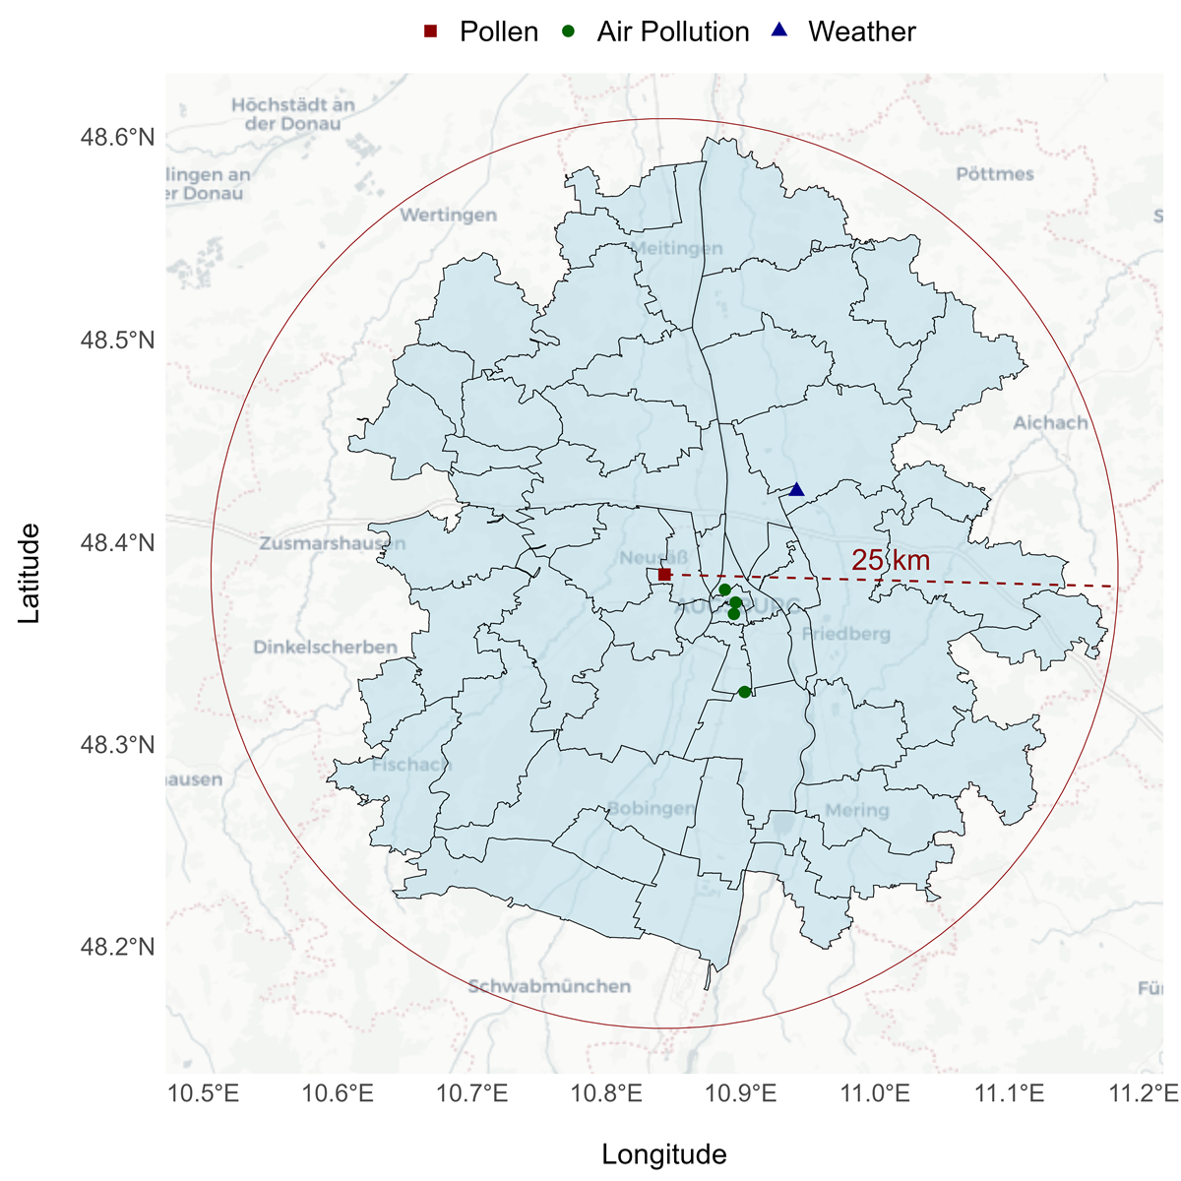
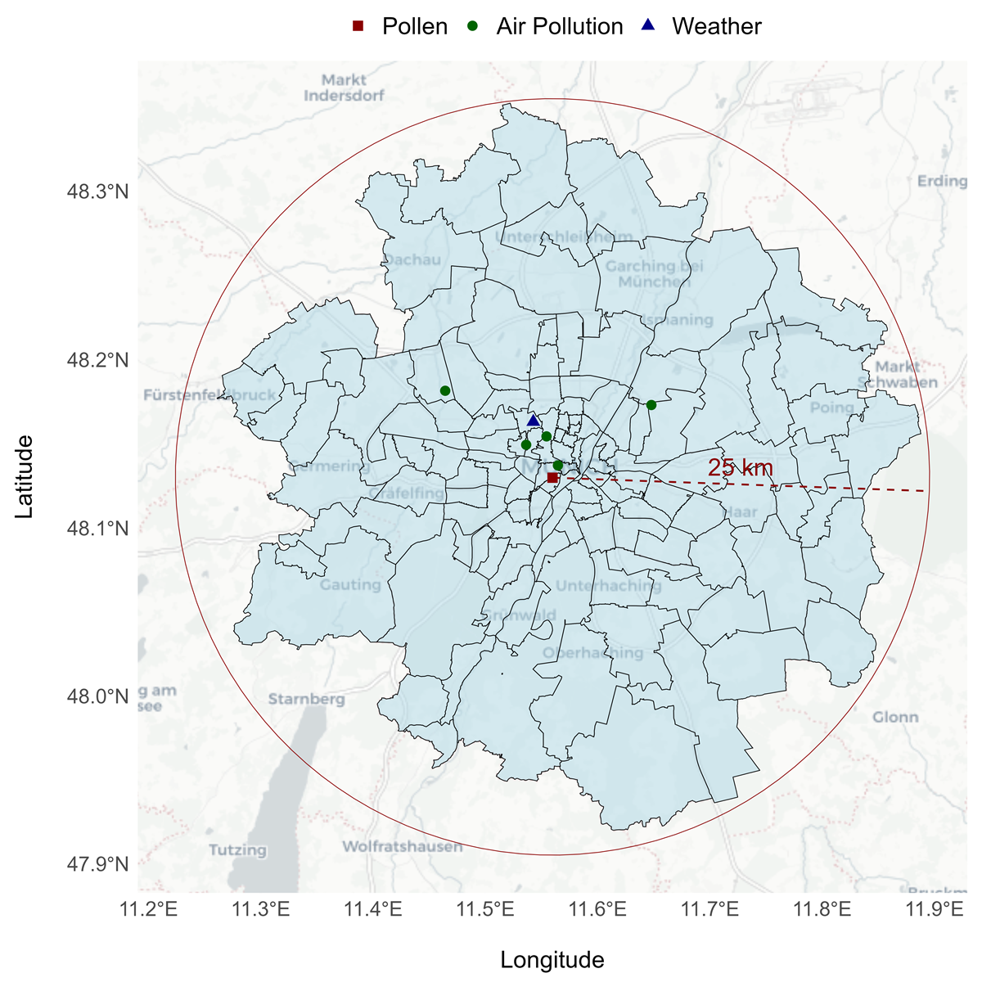
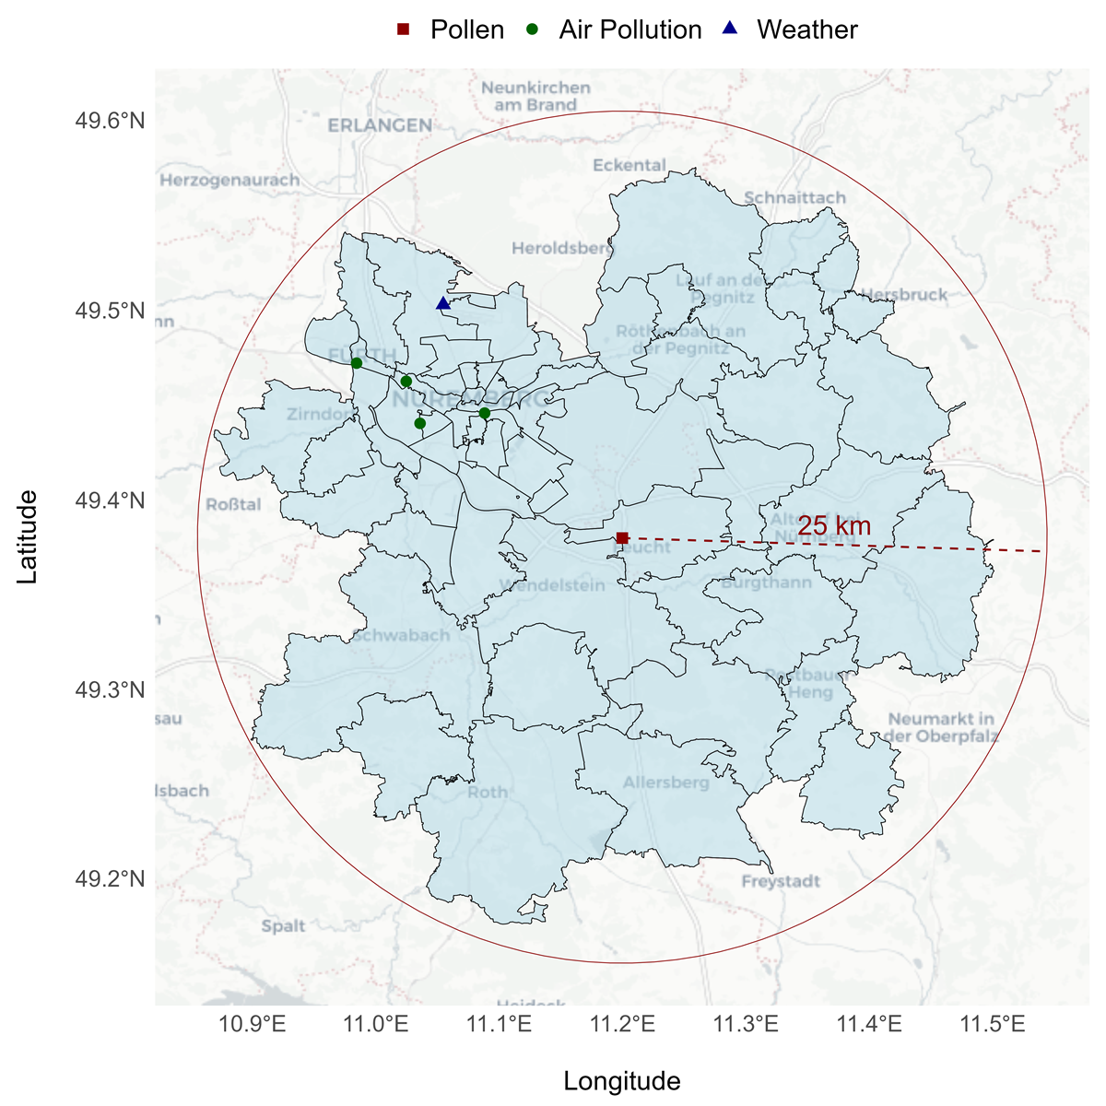
Figure S1 Maps with the location of the automated pollen monitors, the other measurement stations and the included postal code areas at the three considered study sites: Augsburg (left), Munich (center) and Nuremberg (right).

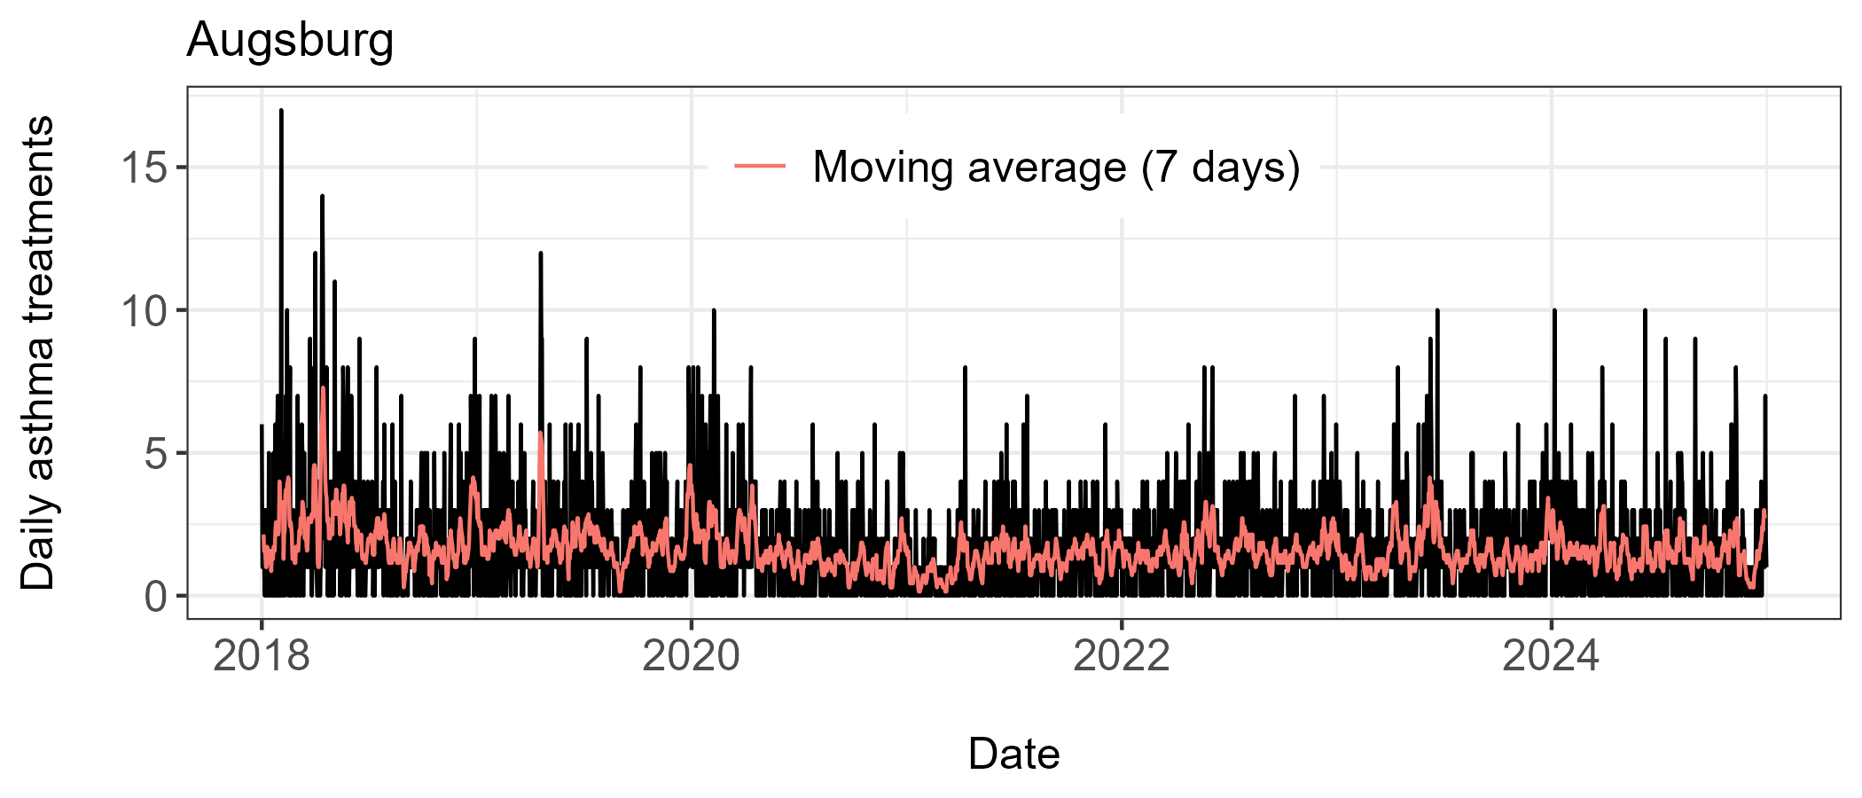
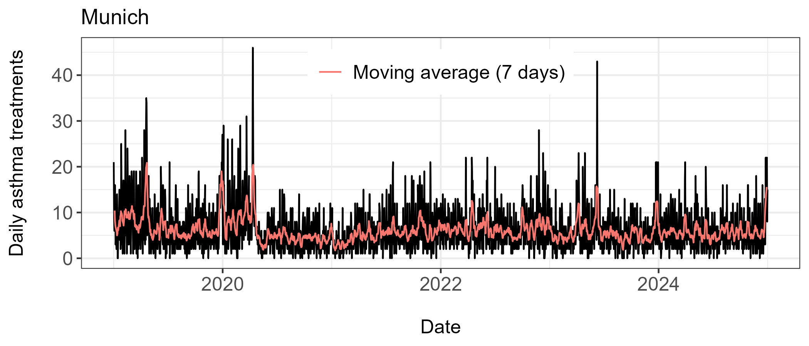
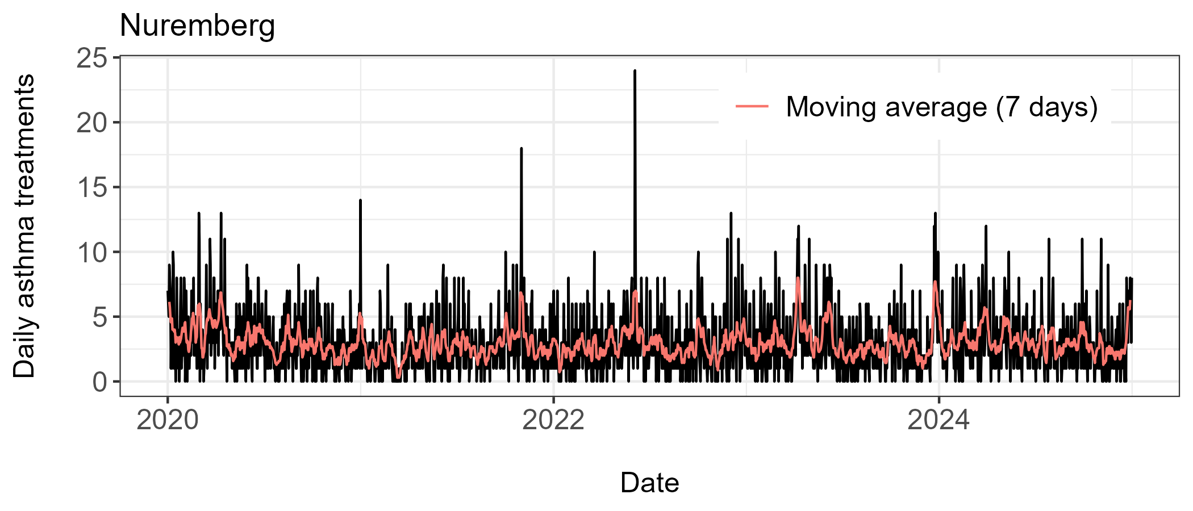
Figure S2 Time series of the daily number of asthma treatments with a seven-day moving average in the three considered study locations: Augsburg (top, left), Munich (top, right) and Nuremberg (bottom).
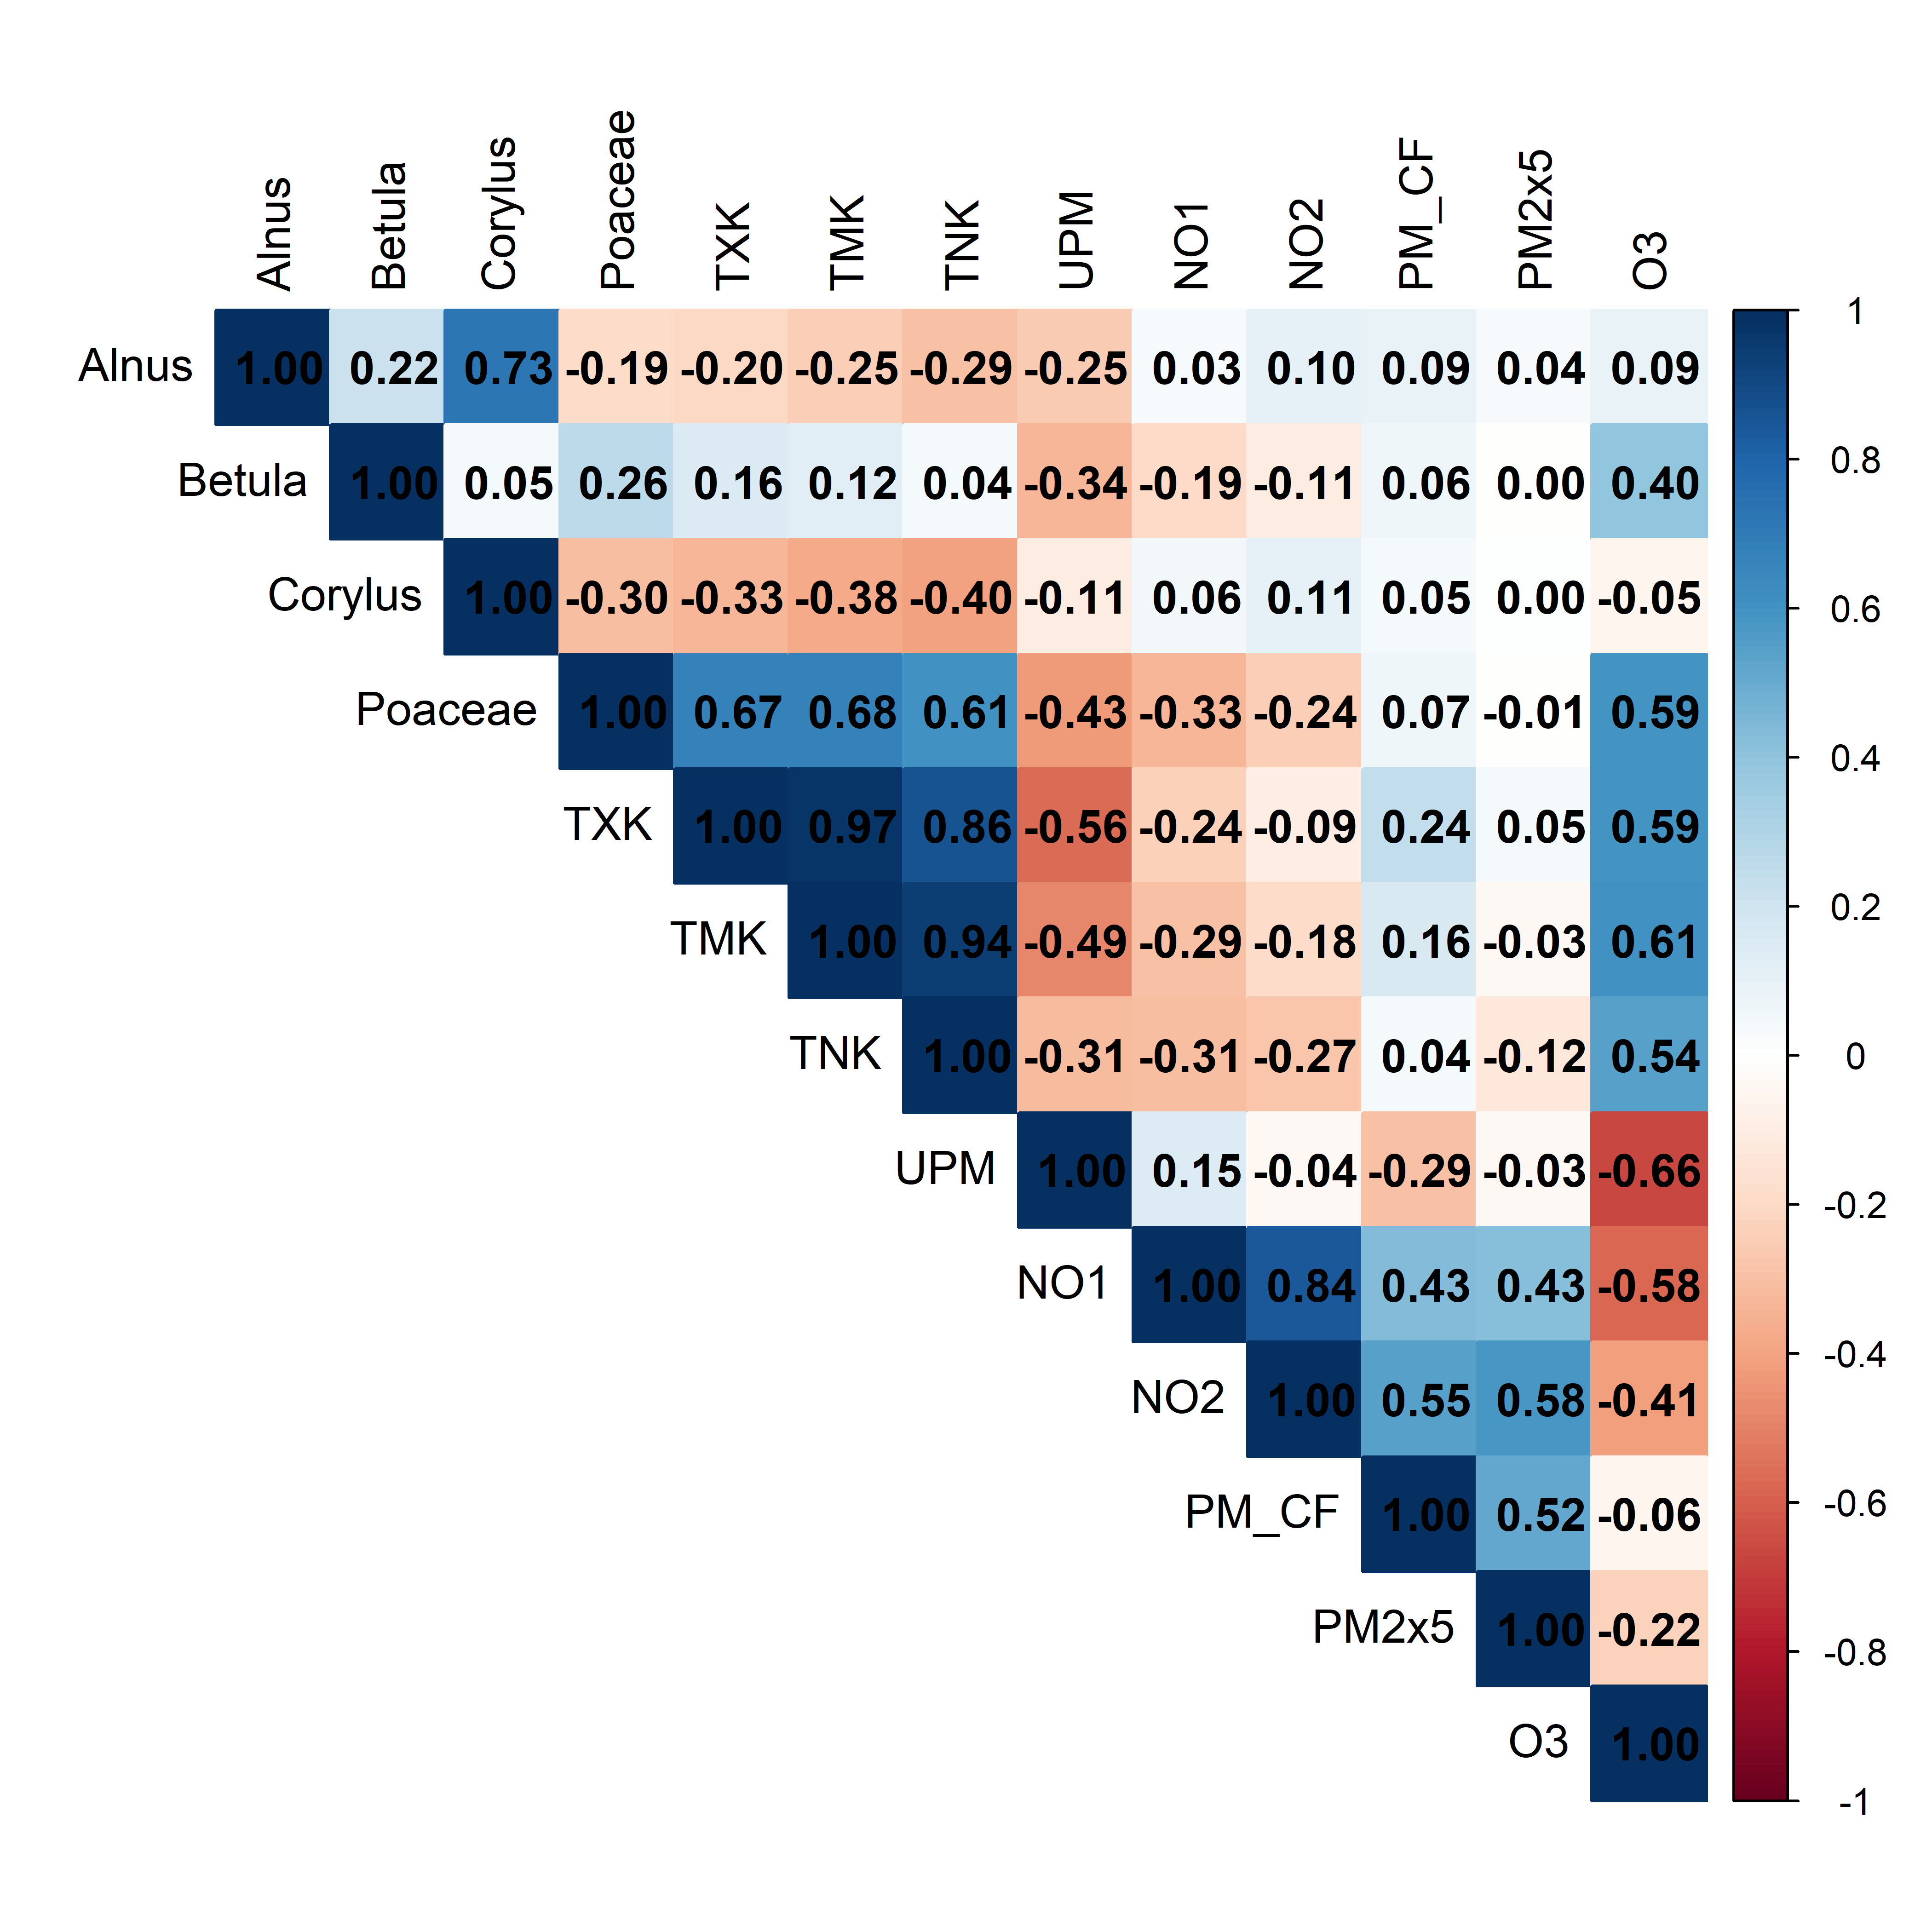
Figure S3 Spearman correlation coefficients across the different environmental exposures.

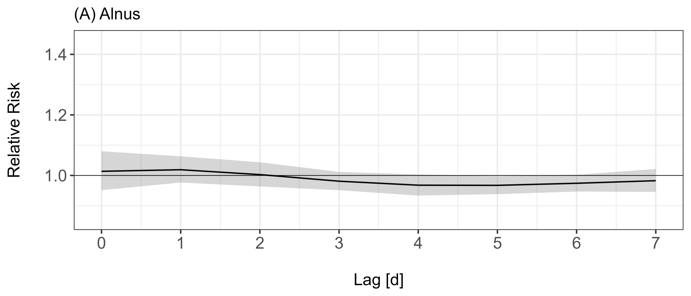
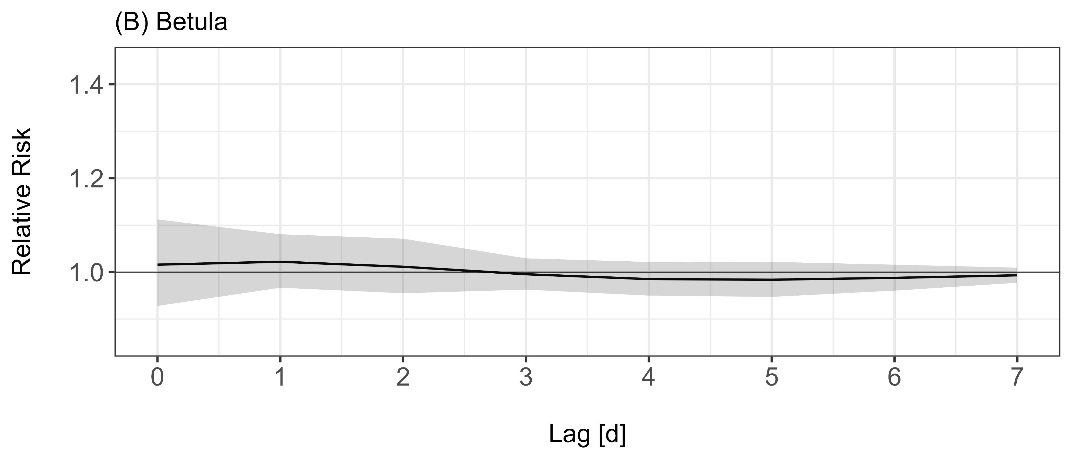
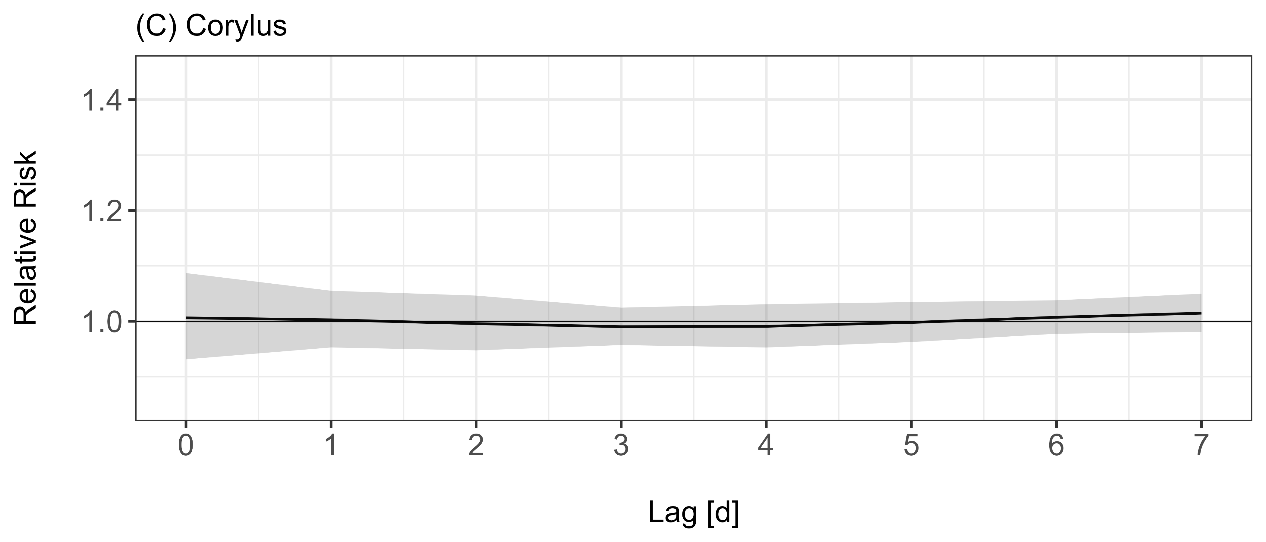
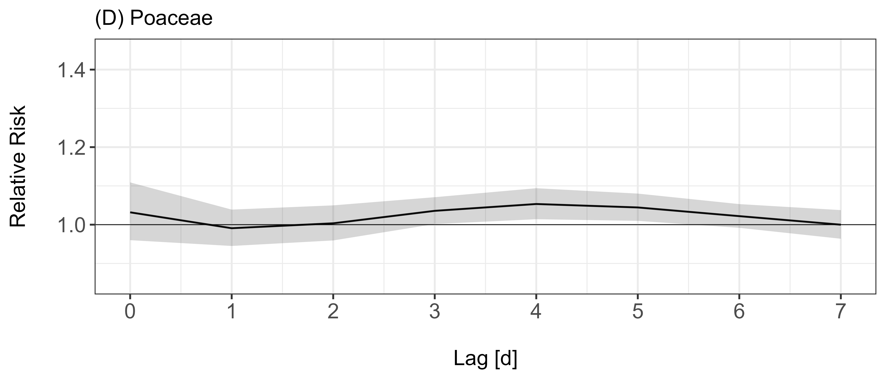
Figure S4 Lag structure of the effect of medium pollen exposure on asthma treatments reported as relative risk for the four considered pollen taxa Alnus (A), Betula (B), Corylus (C) and Poaceae (D). Shaded areas indicate 95% confidence intervals.

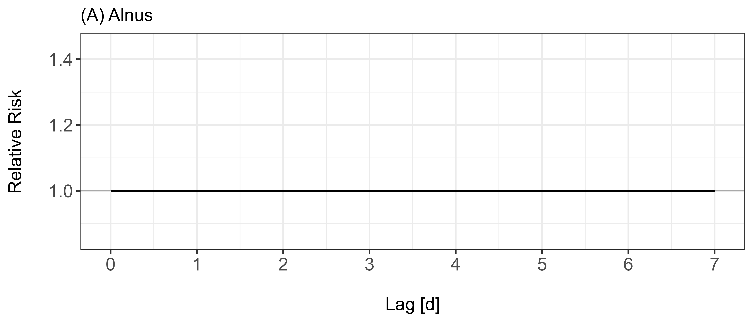
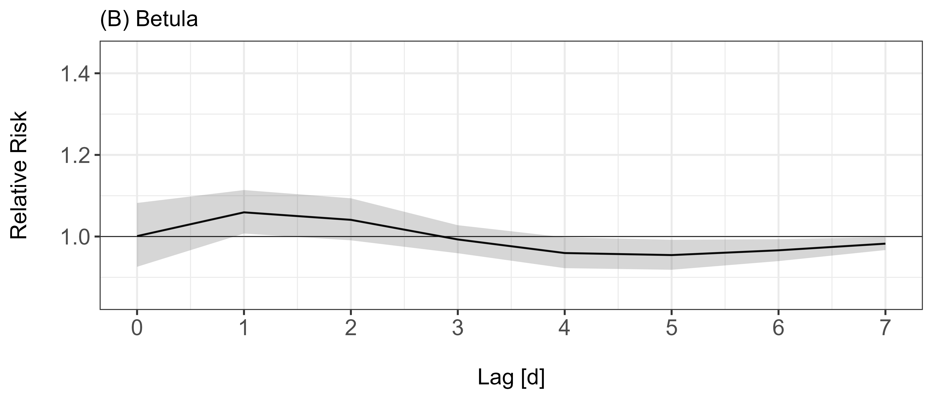
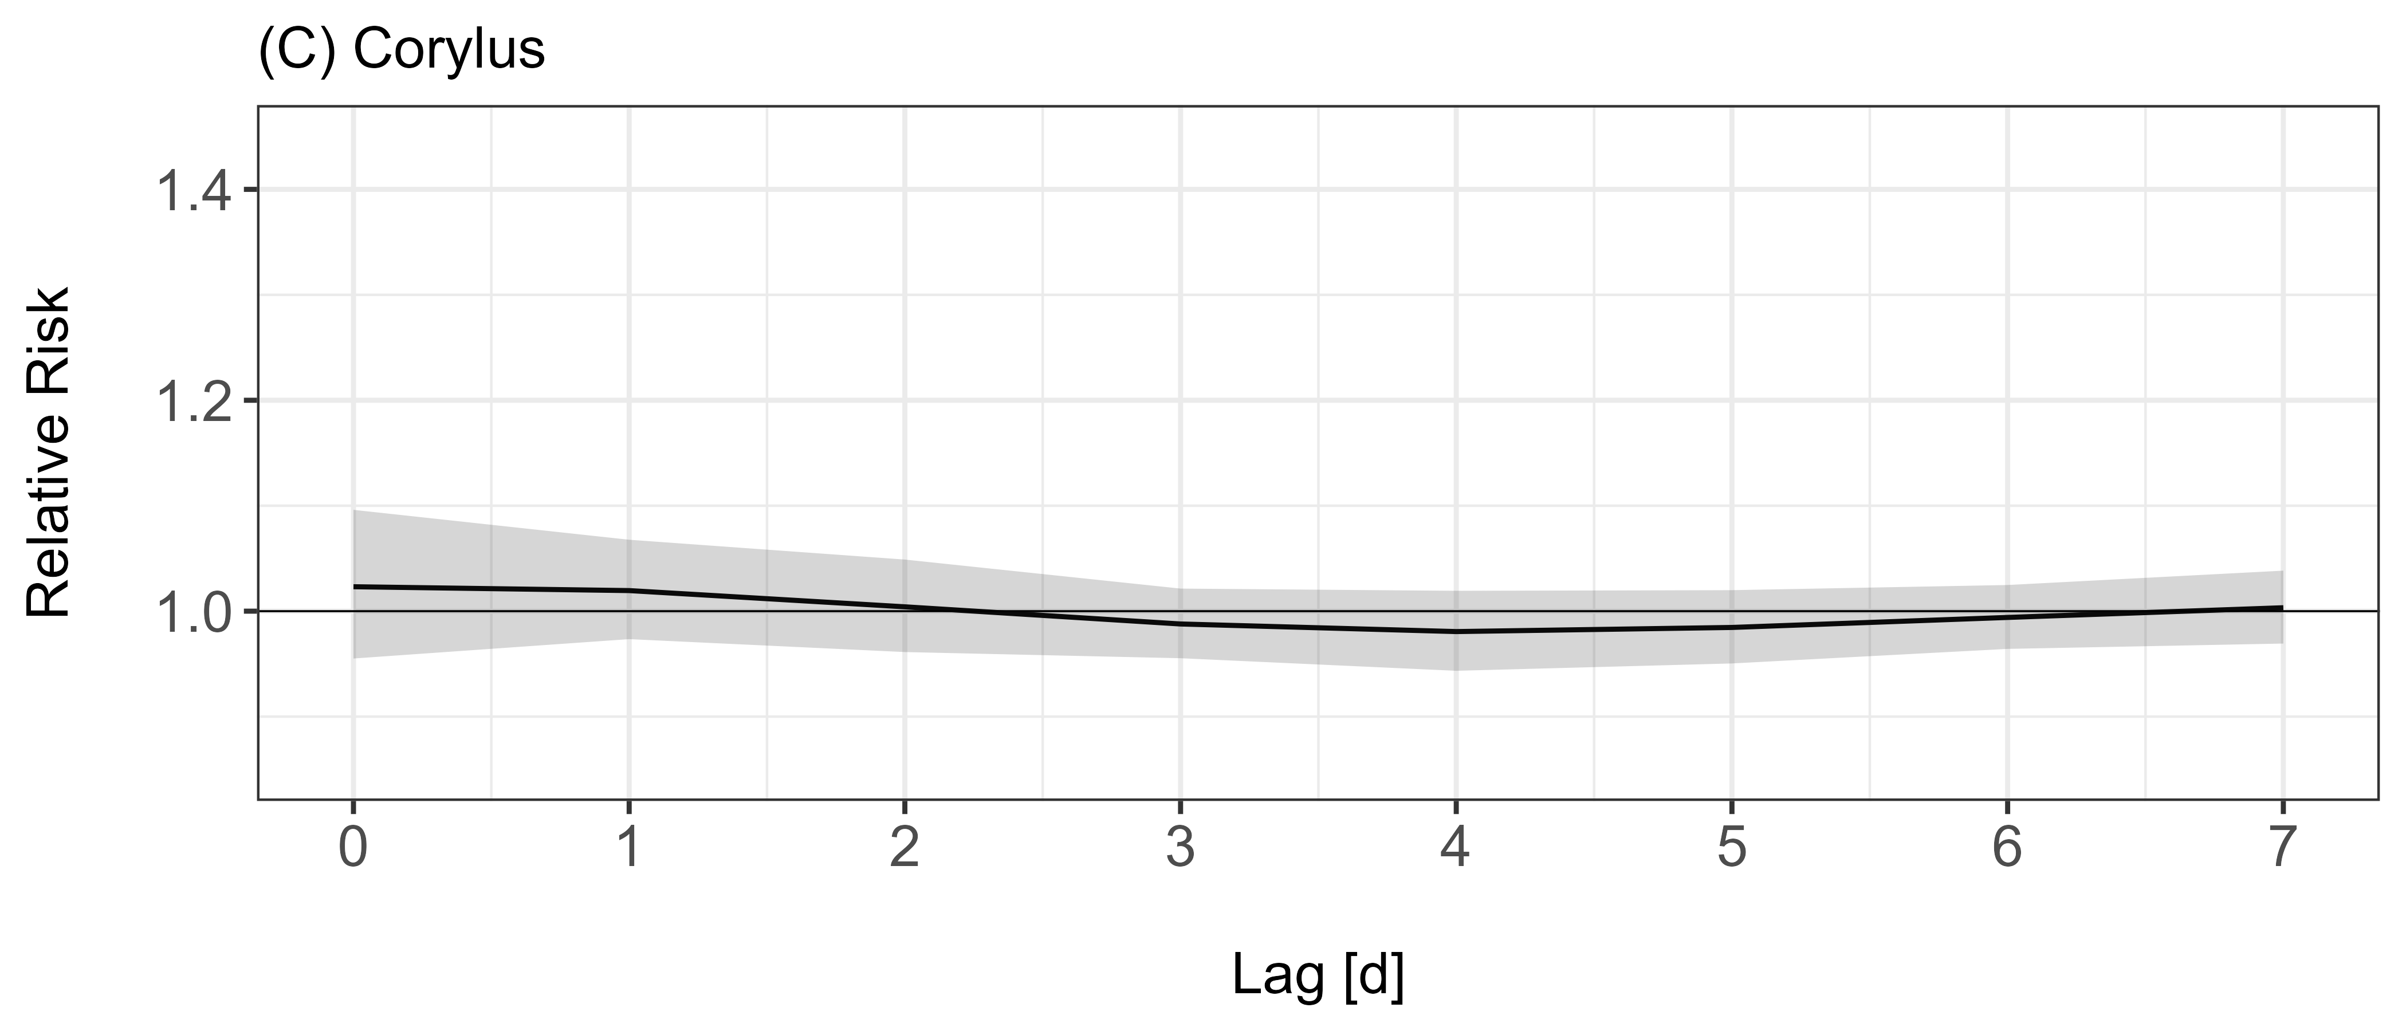
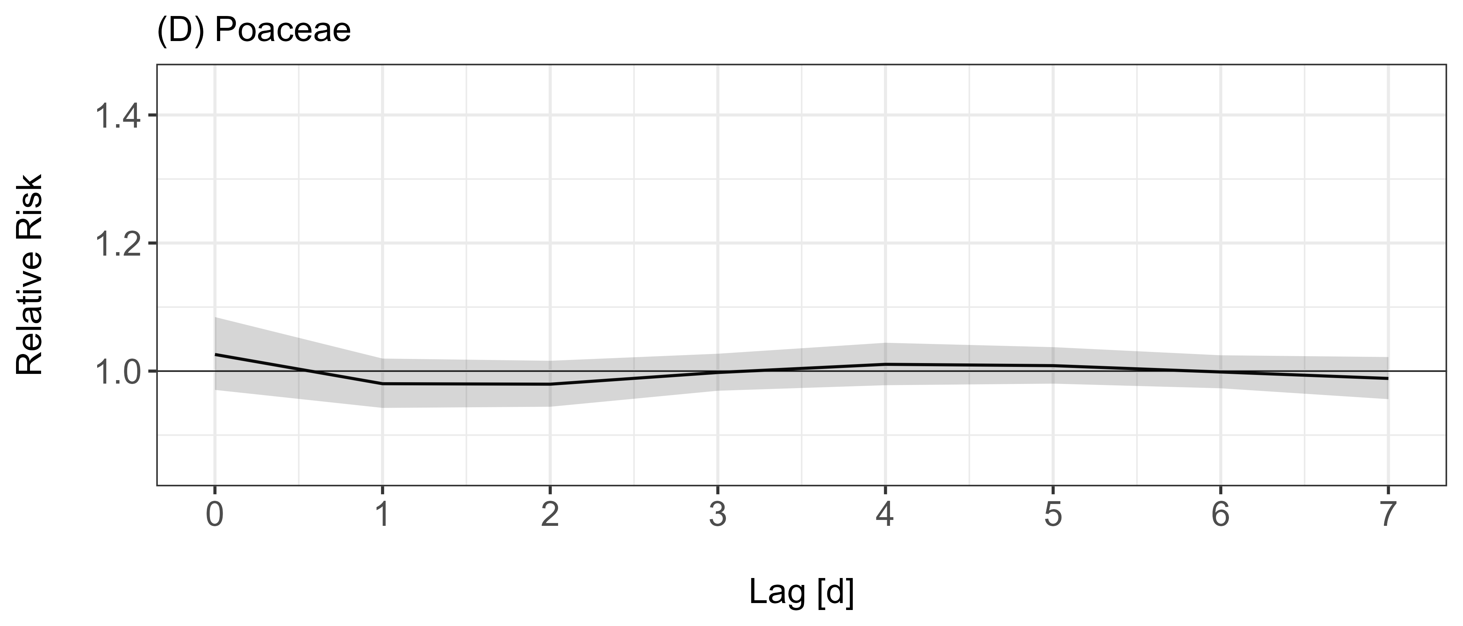
Figure S5 Lag structure of the effect of low pollen exposure on asthma treatments reported as relative risk for the four considered pollen taxa Alnus (A), Betula (B), Corylus (C) and Poaceae (D). Shaded areas indicate 95% confidence intervals.

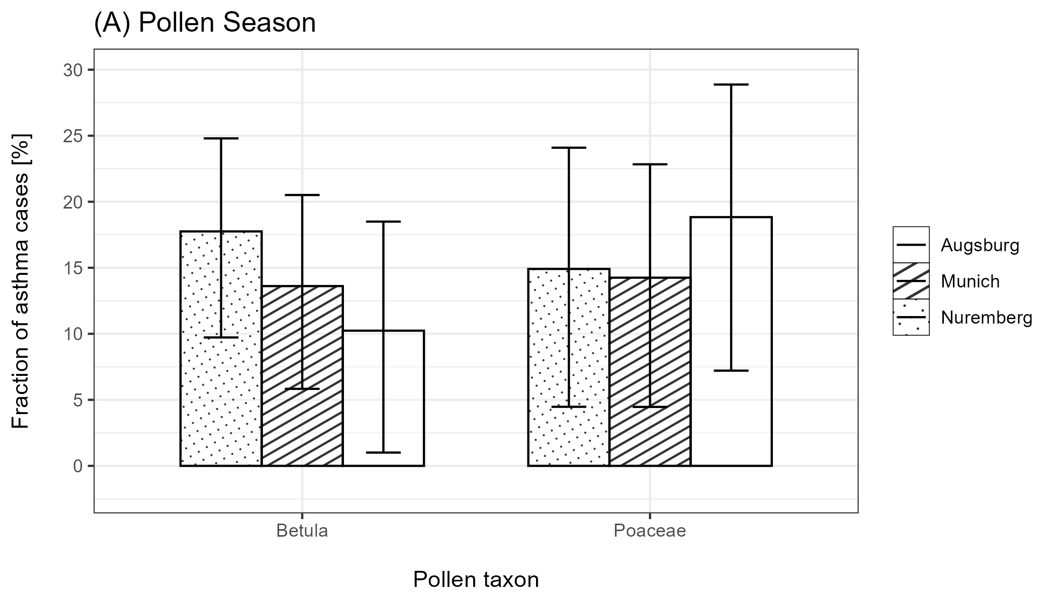
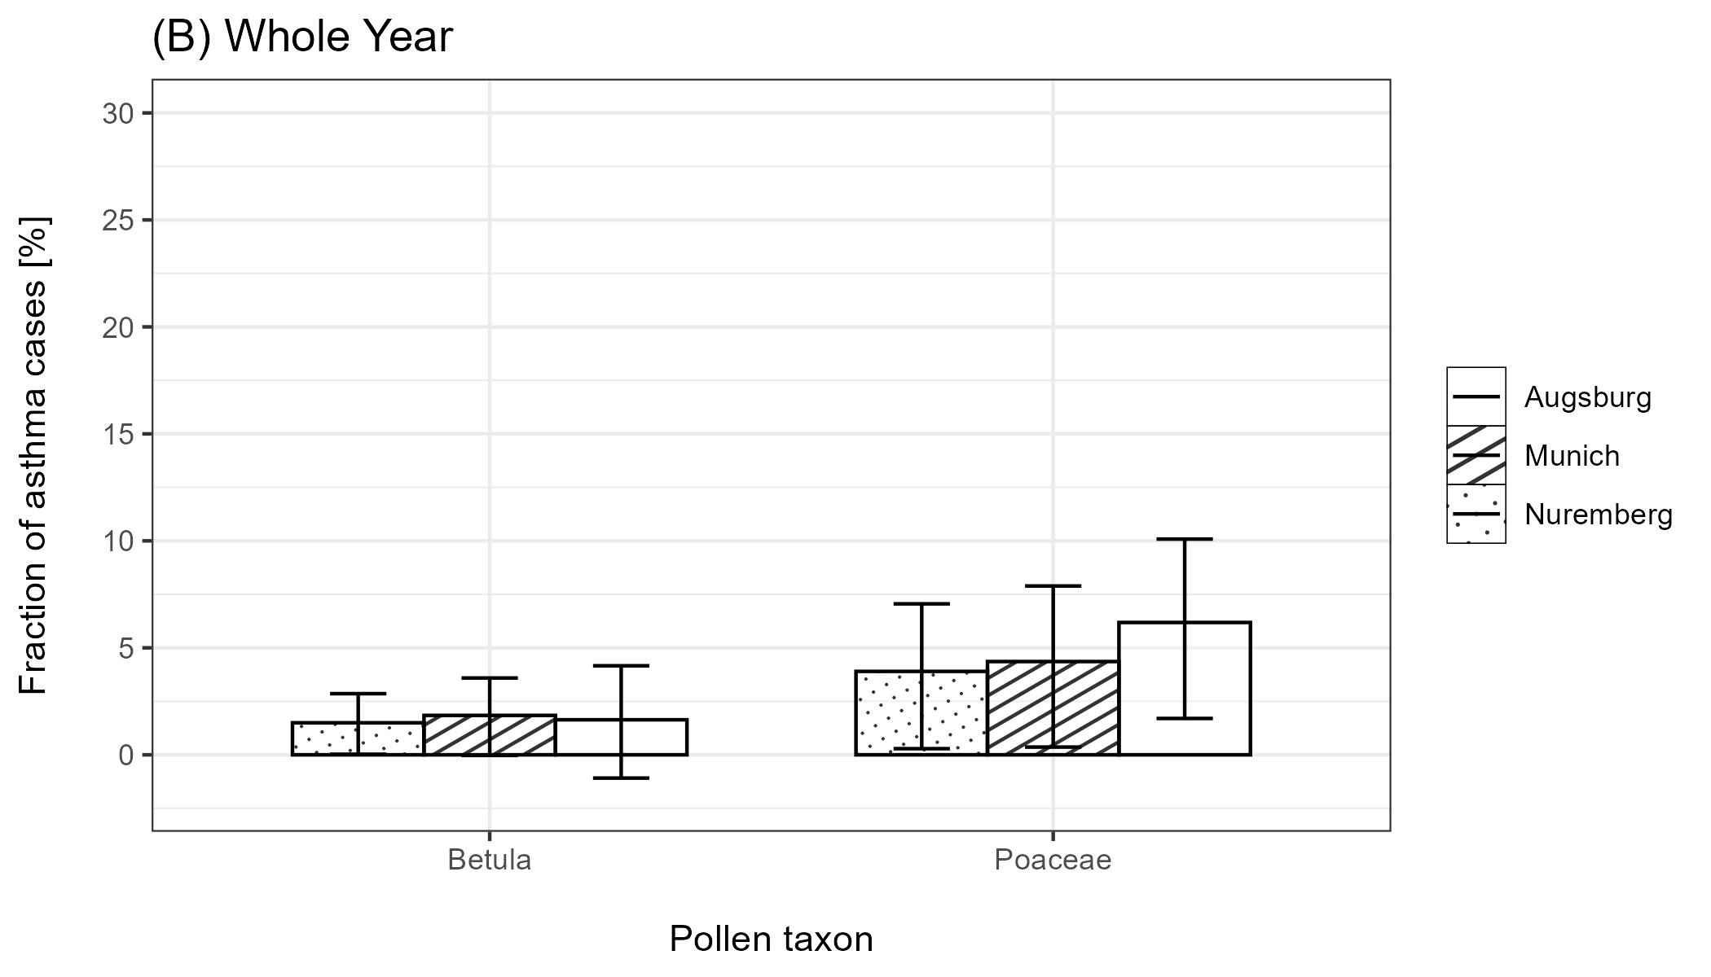
Figure S6 Attributable fraction of asthma cases attributed to the exposure to Betula and Poaceae pollen by the DLNM model for the three different study locations; (A): within the respective pollen taxon’s season, (B): over the whole year. Whiskers indicate 95% confidence intervals.

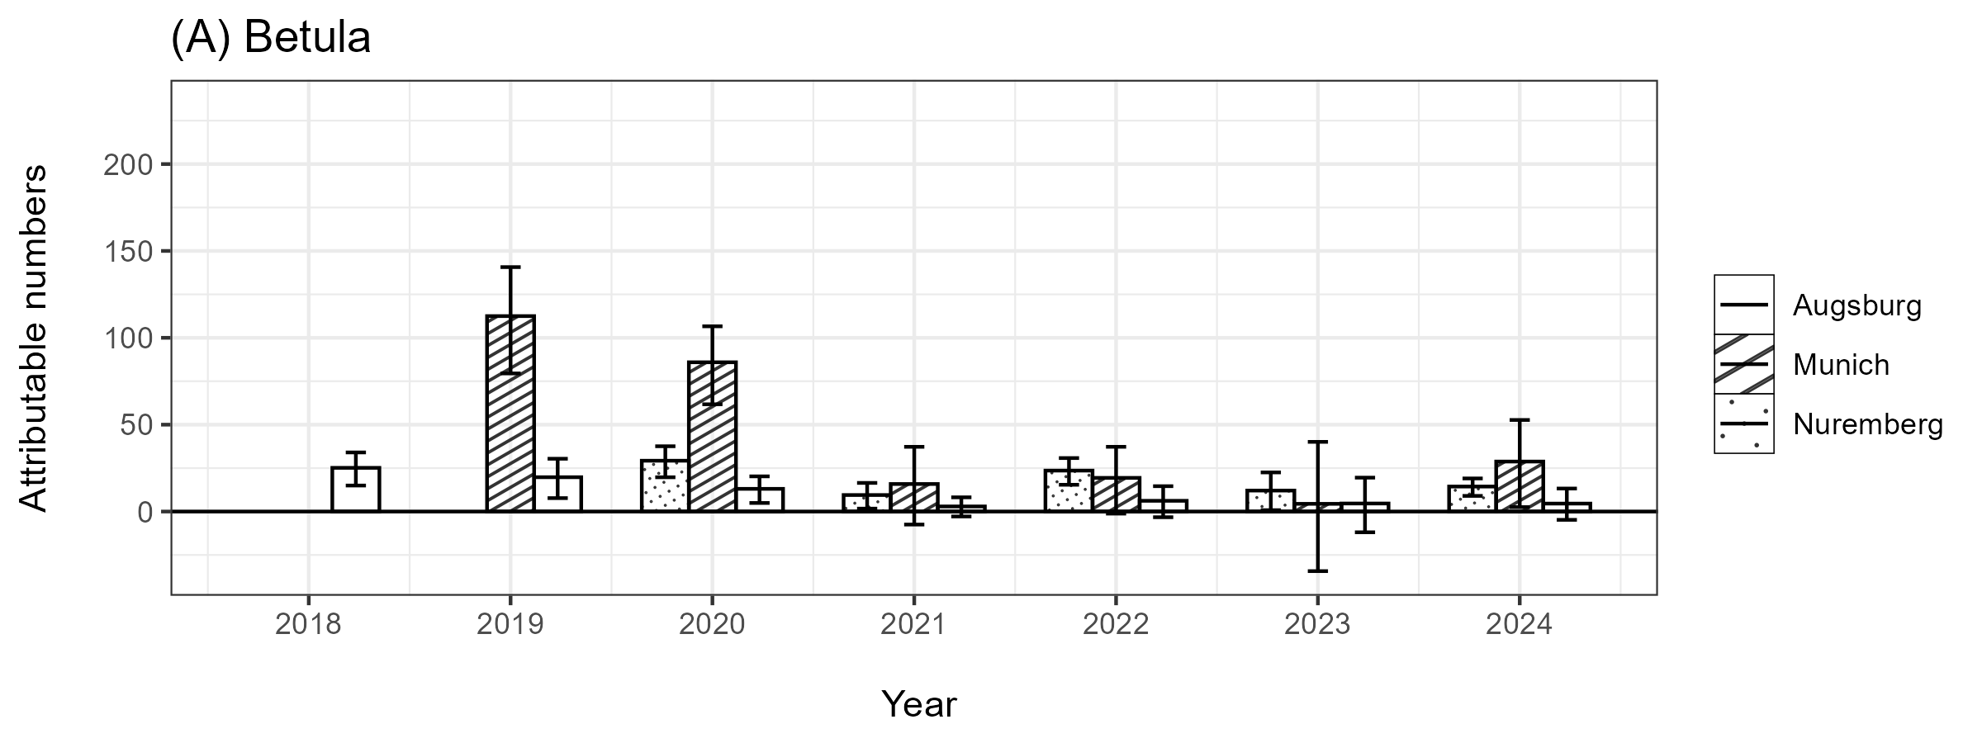
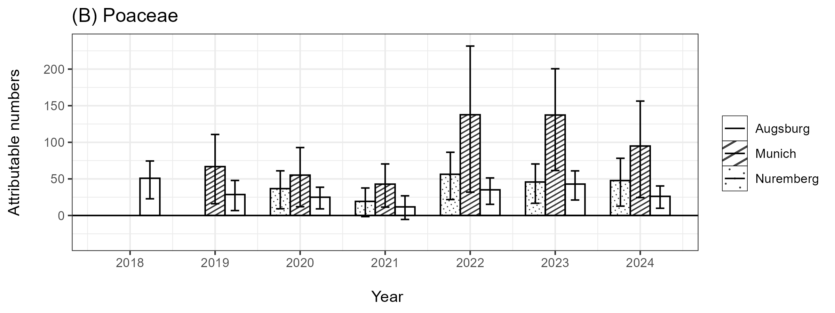
Figure S7 Attributable numbers of as Attributable fractions of asthma cases related to the exposure of Betula (A) and Poaceae (B) pollen within the respective season calculated for each year separately. Whiskers indicate 95% confidence intervals.

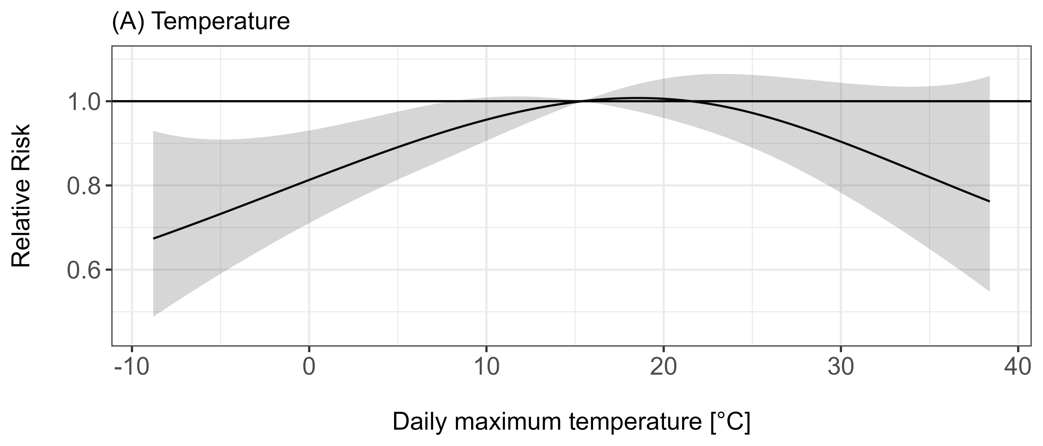
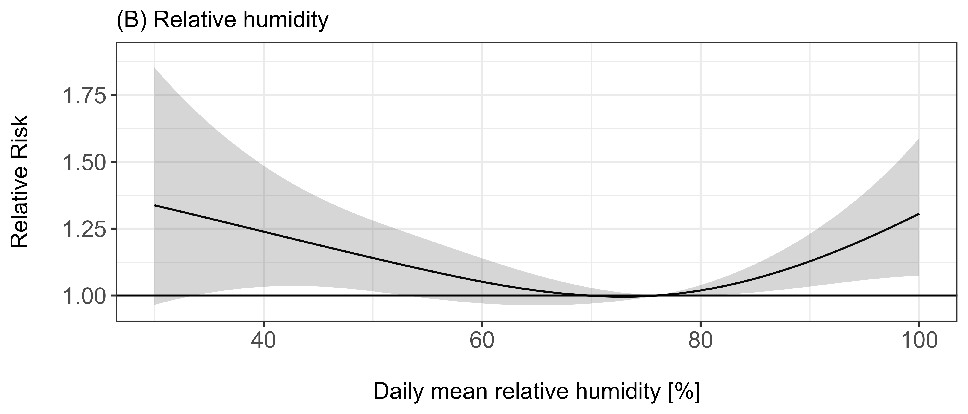
Figure S8 Cumulative effect of daily maximum temperature (A) and relative humidity (B) on the number of asthma treatments, displayed as relative risks with the median as the reference exposure. Shaded regions indicate 95% confidence intervals.

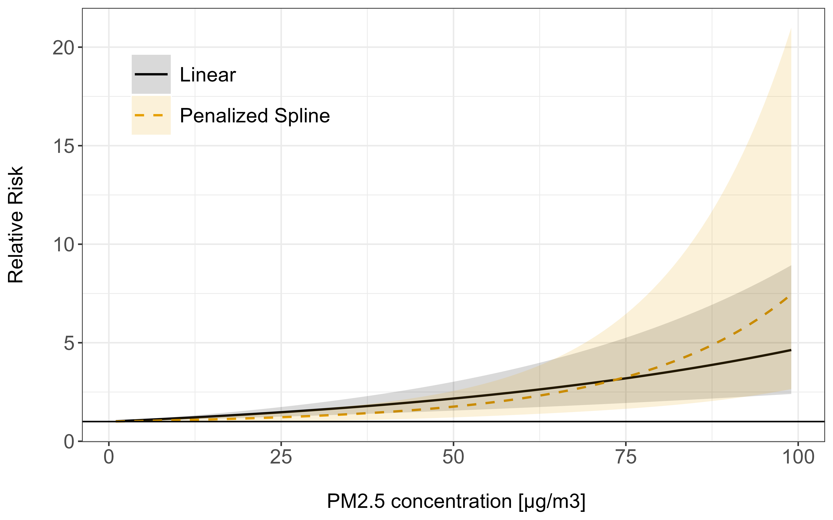
Figure S9 Cumulative relative risk of PM_{2.5} on the daily number of asthma treatments for two effect parameterizations: linear (Black, solid) and P-Spline (Yellow, dashed). Shaded regions indicate 95% confidence intervals.
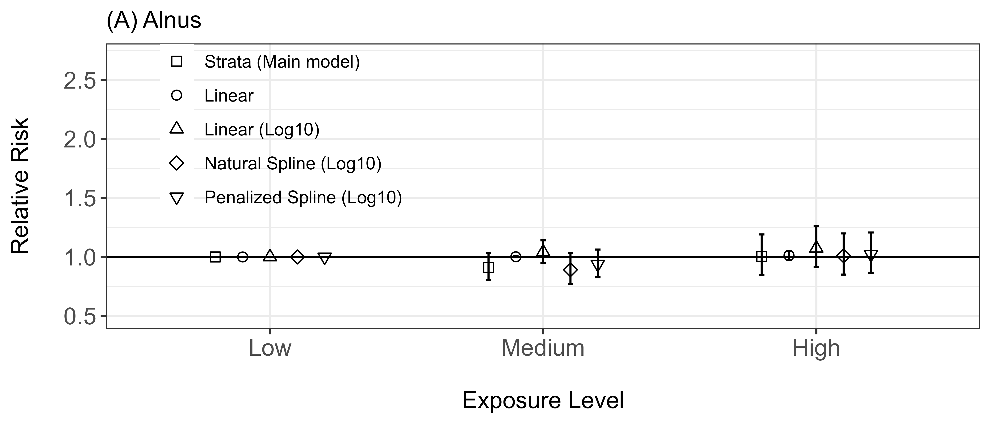
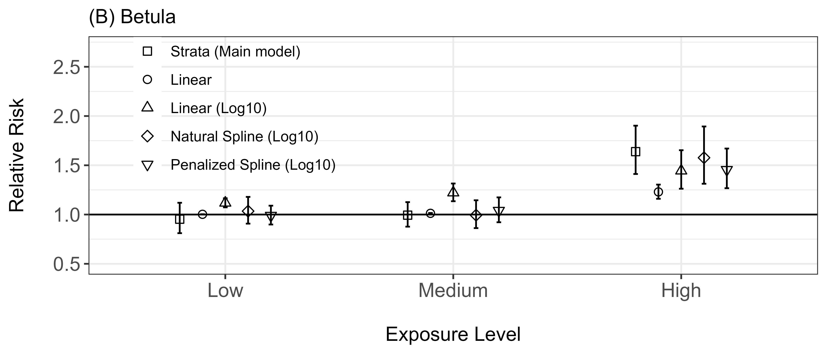
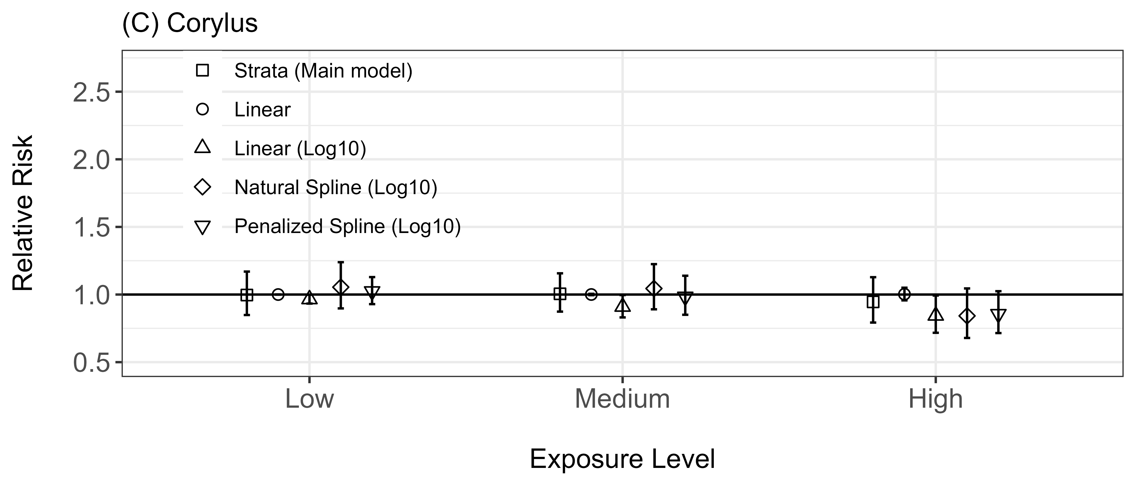
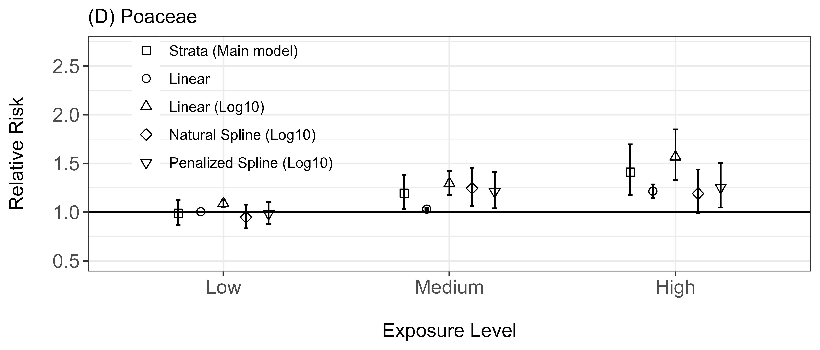
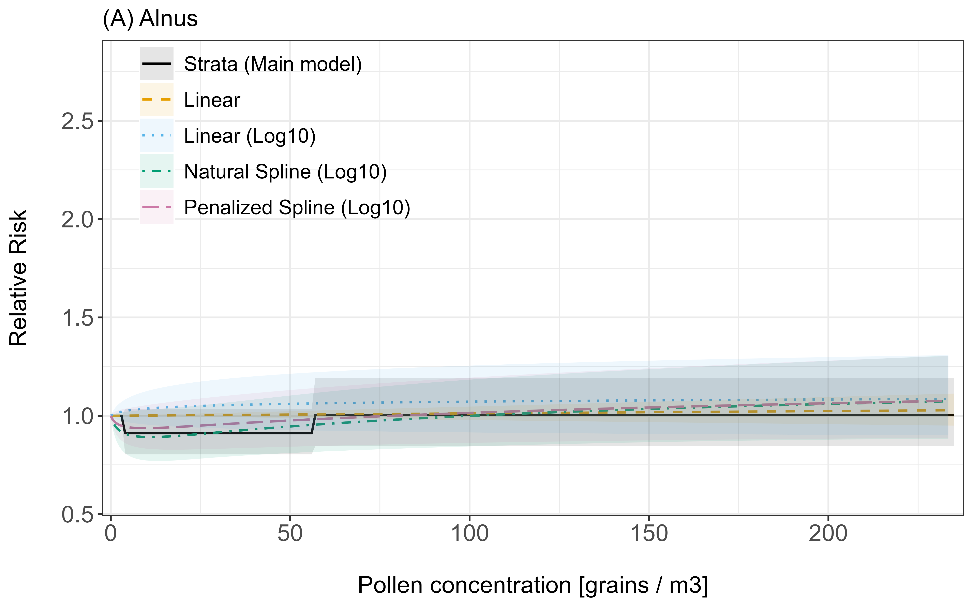
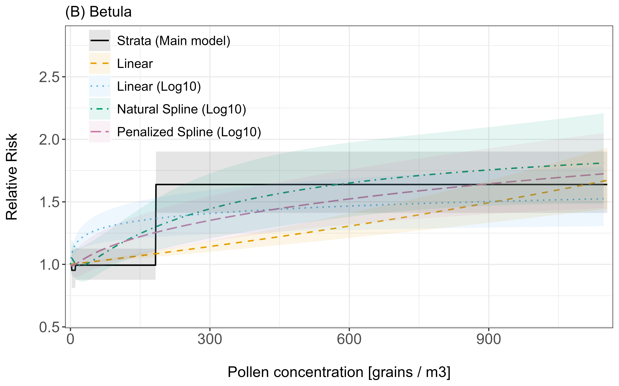
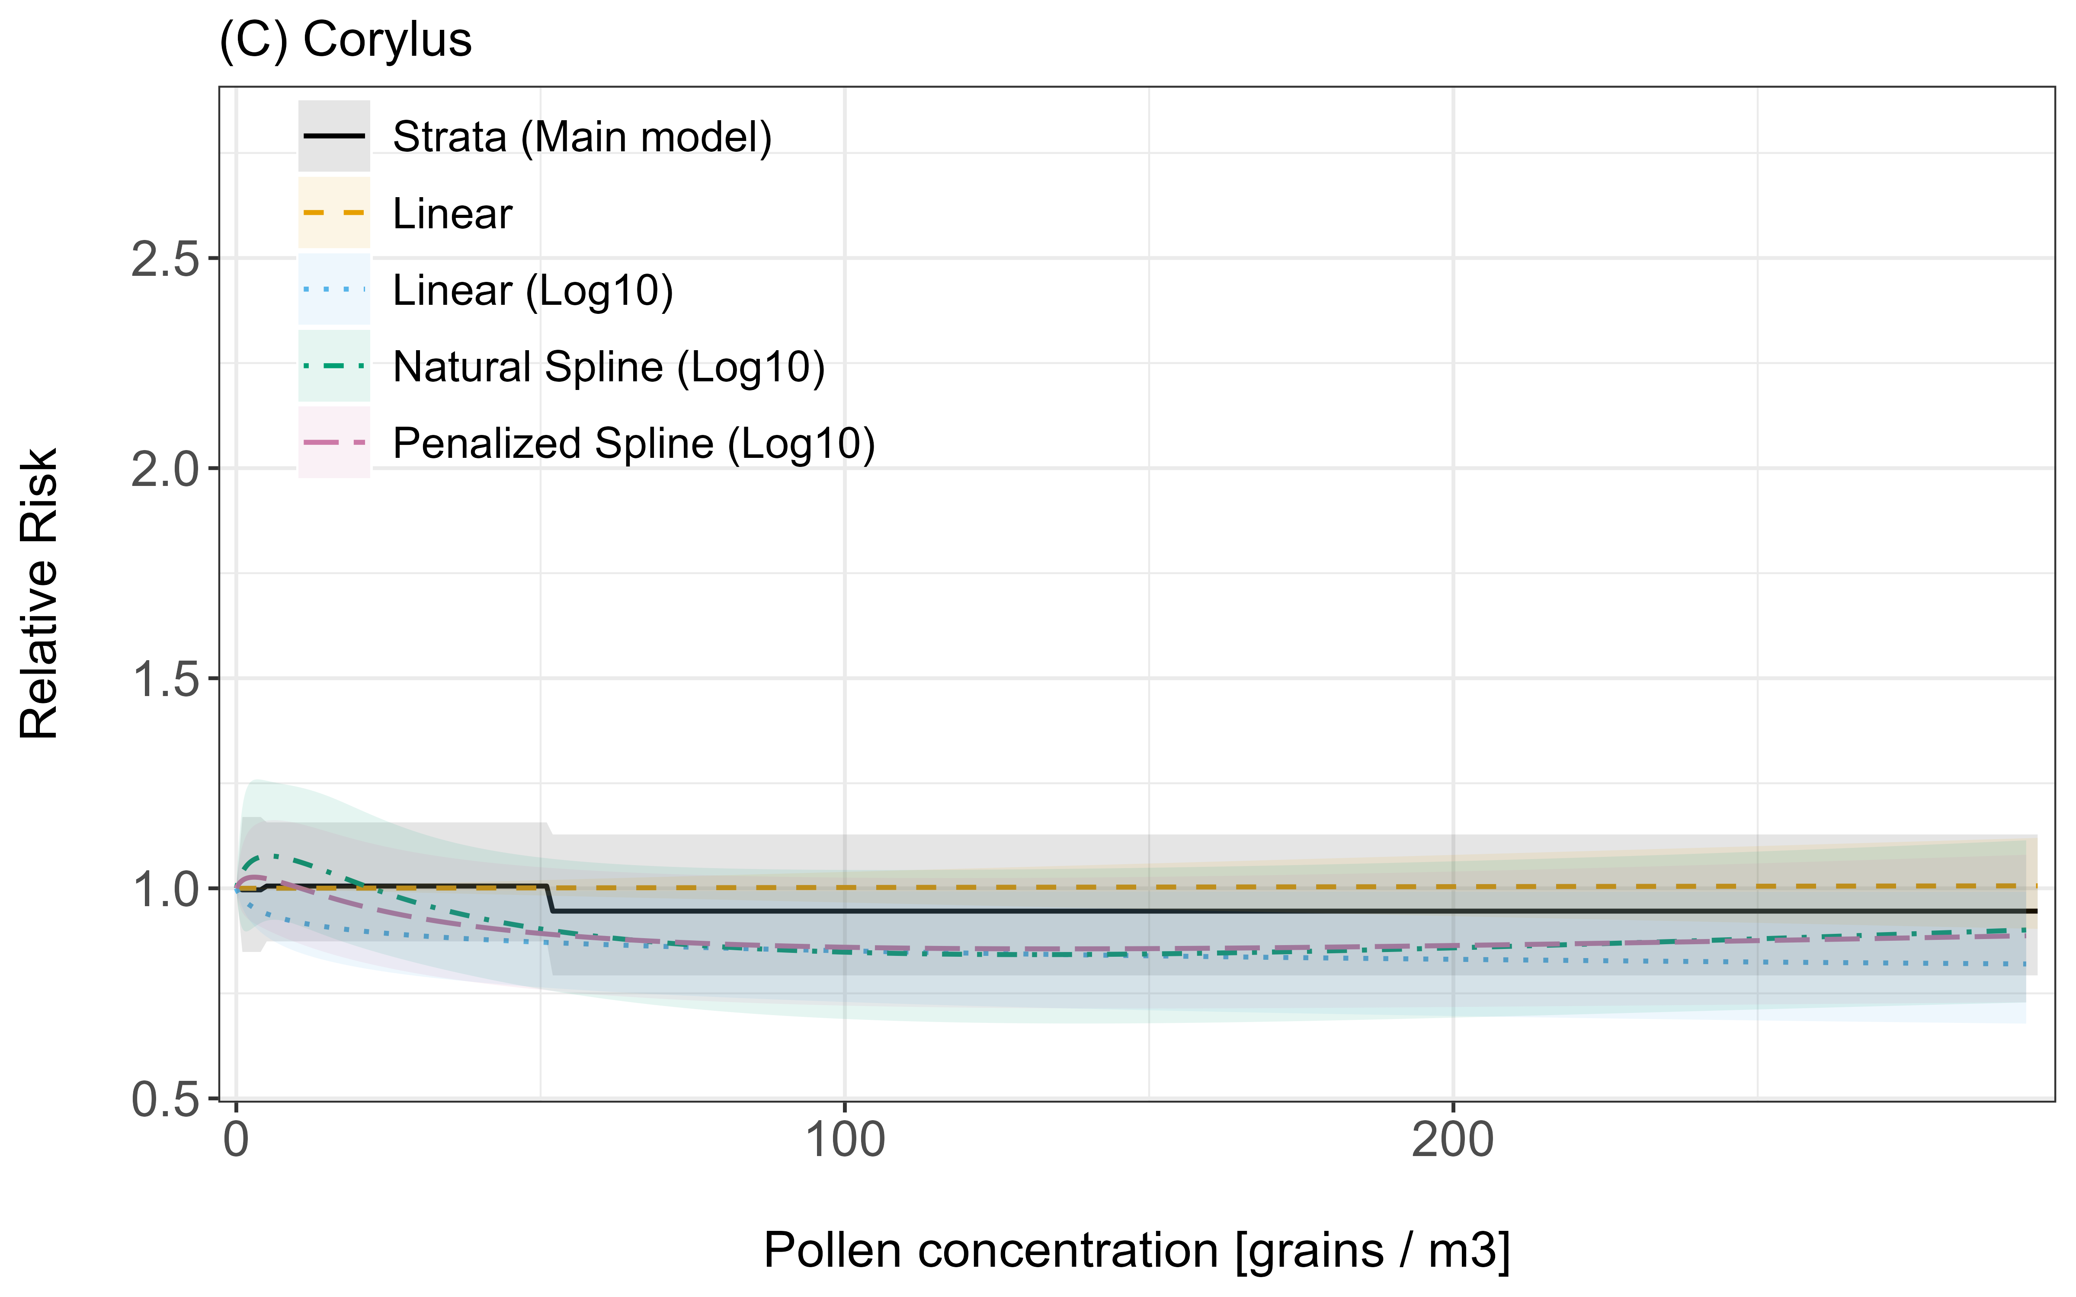
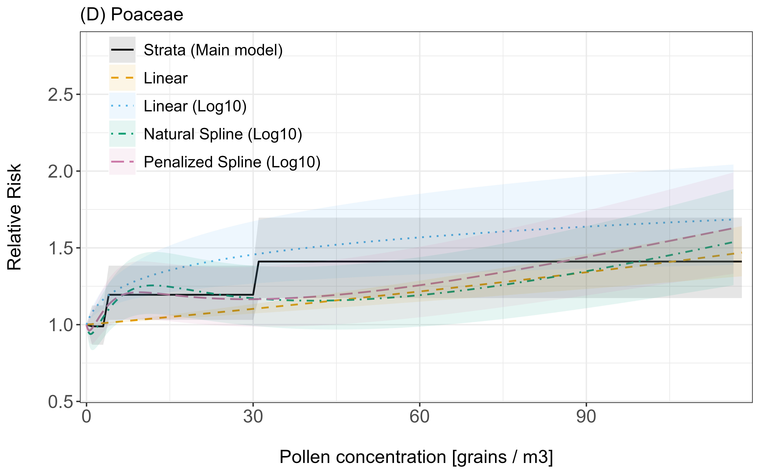
Figure S10 Cumulative relative risk at different exposure levels for the four different pollen taxa under different parametrization of the pollen effect. Models with the annotation (“(Log10)”) were fitted on the log₁₀-transformed pollen concentrations, while the other models were fitted on the raw, untransformed pollen concentrations. Whiskers indicate 95% confidence intervals.
Figure S11 Cumulative relative risk against the pollen concentrations for the four considered pollen taxa and varying modelling assumptions. The x-axis was clipped at the 95th percentile of the observed in-season pollen concentrations. Shaded areas indicate 95% confidence intervals.

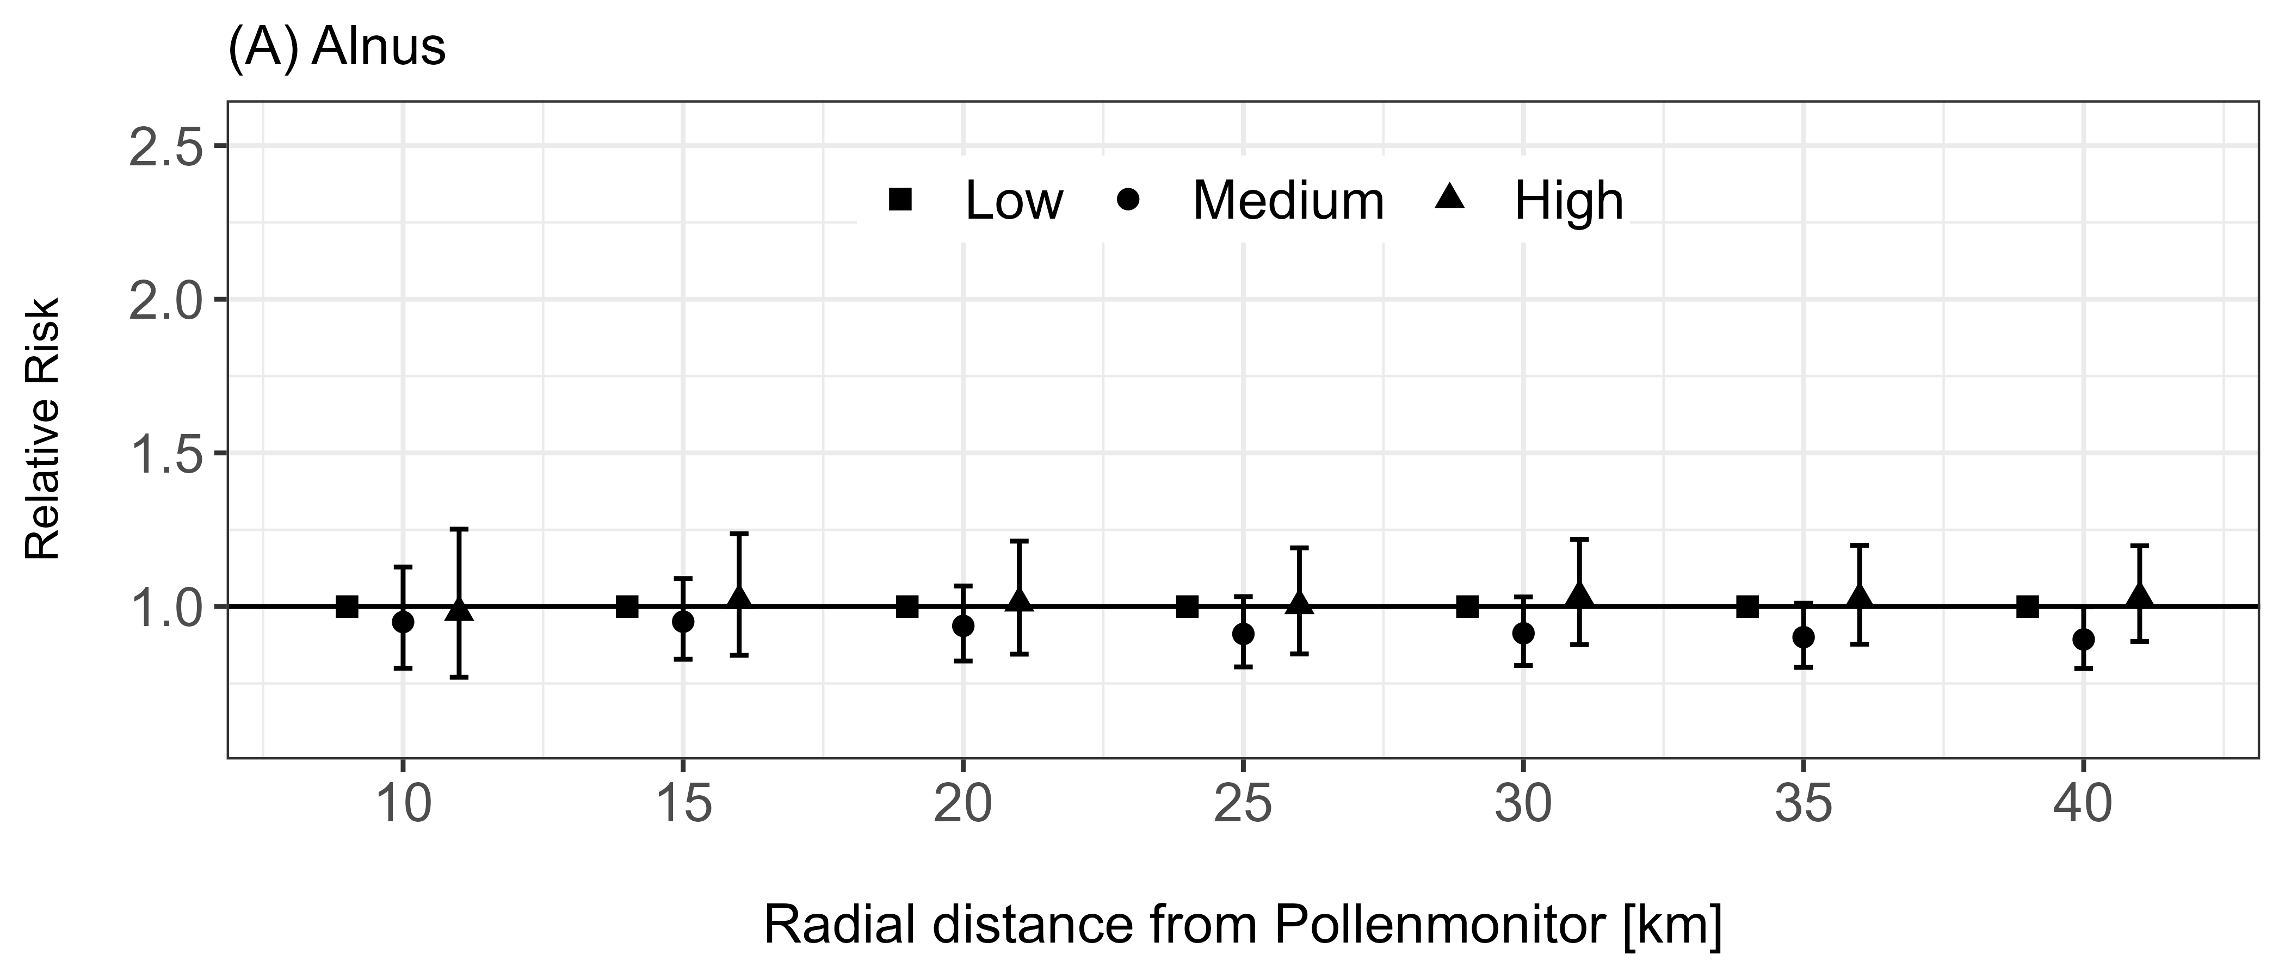
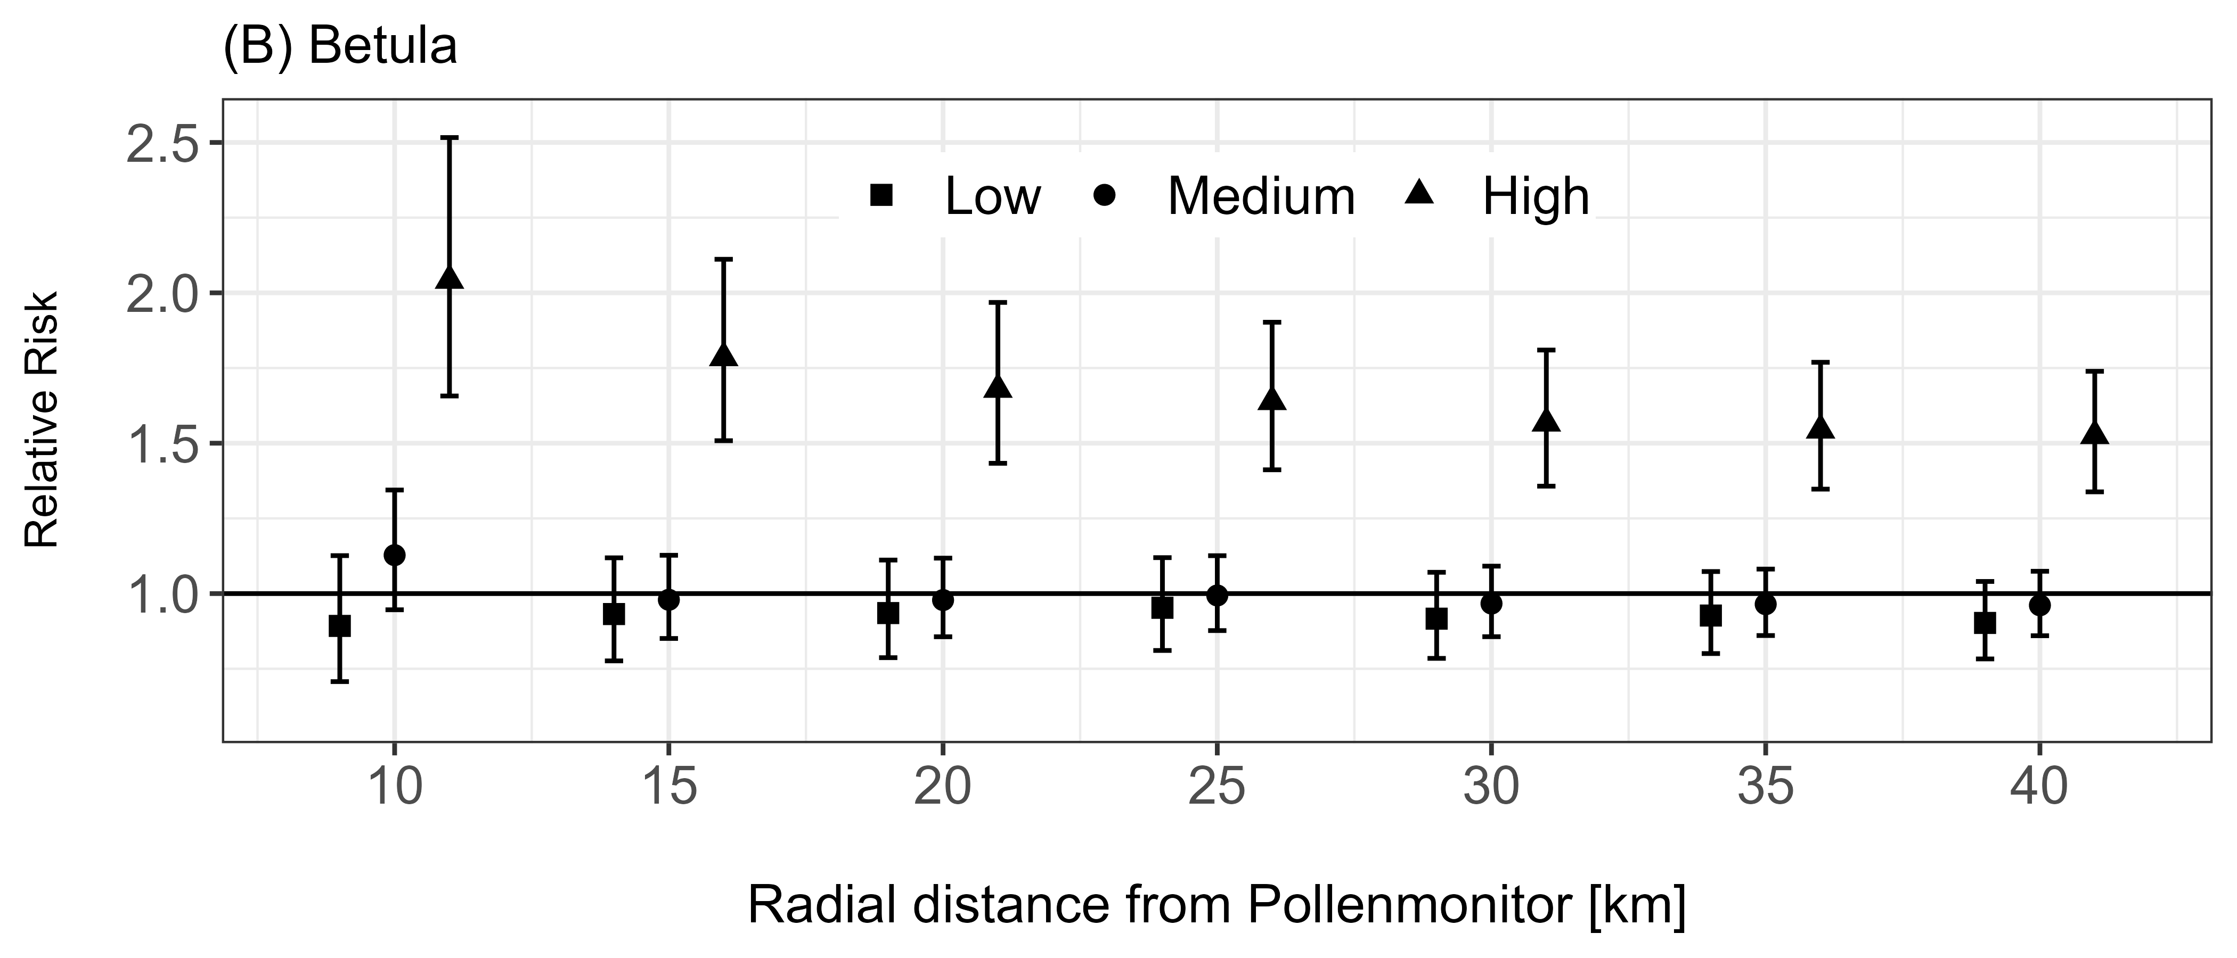
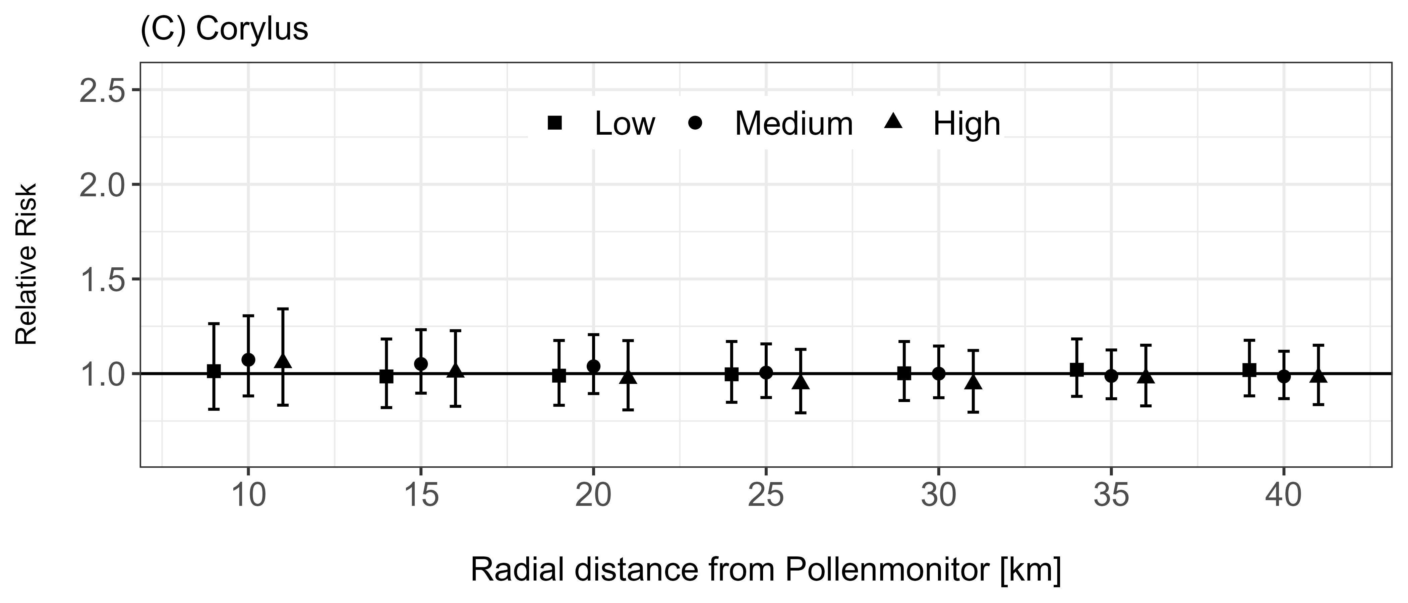
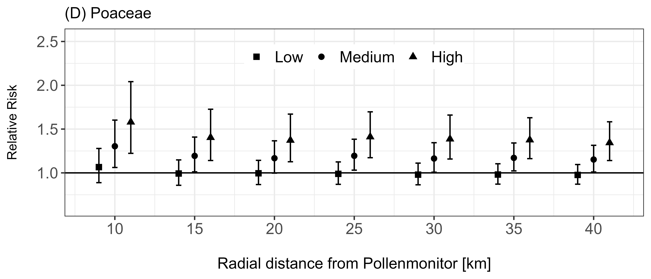
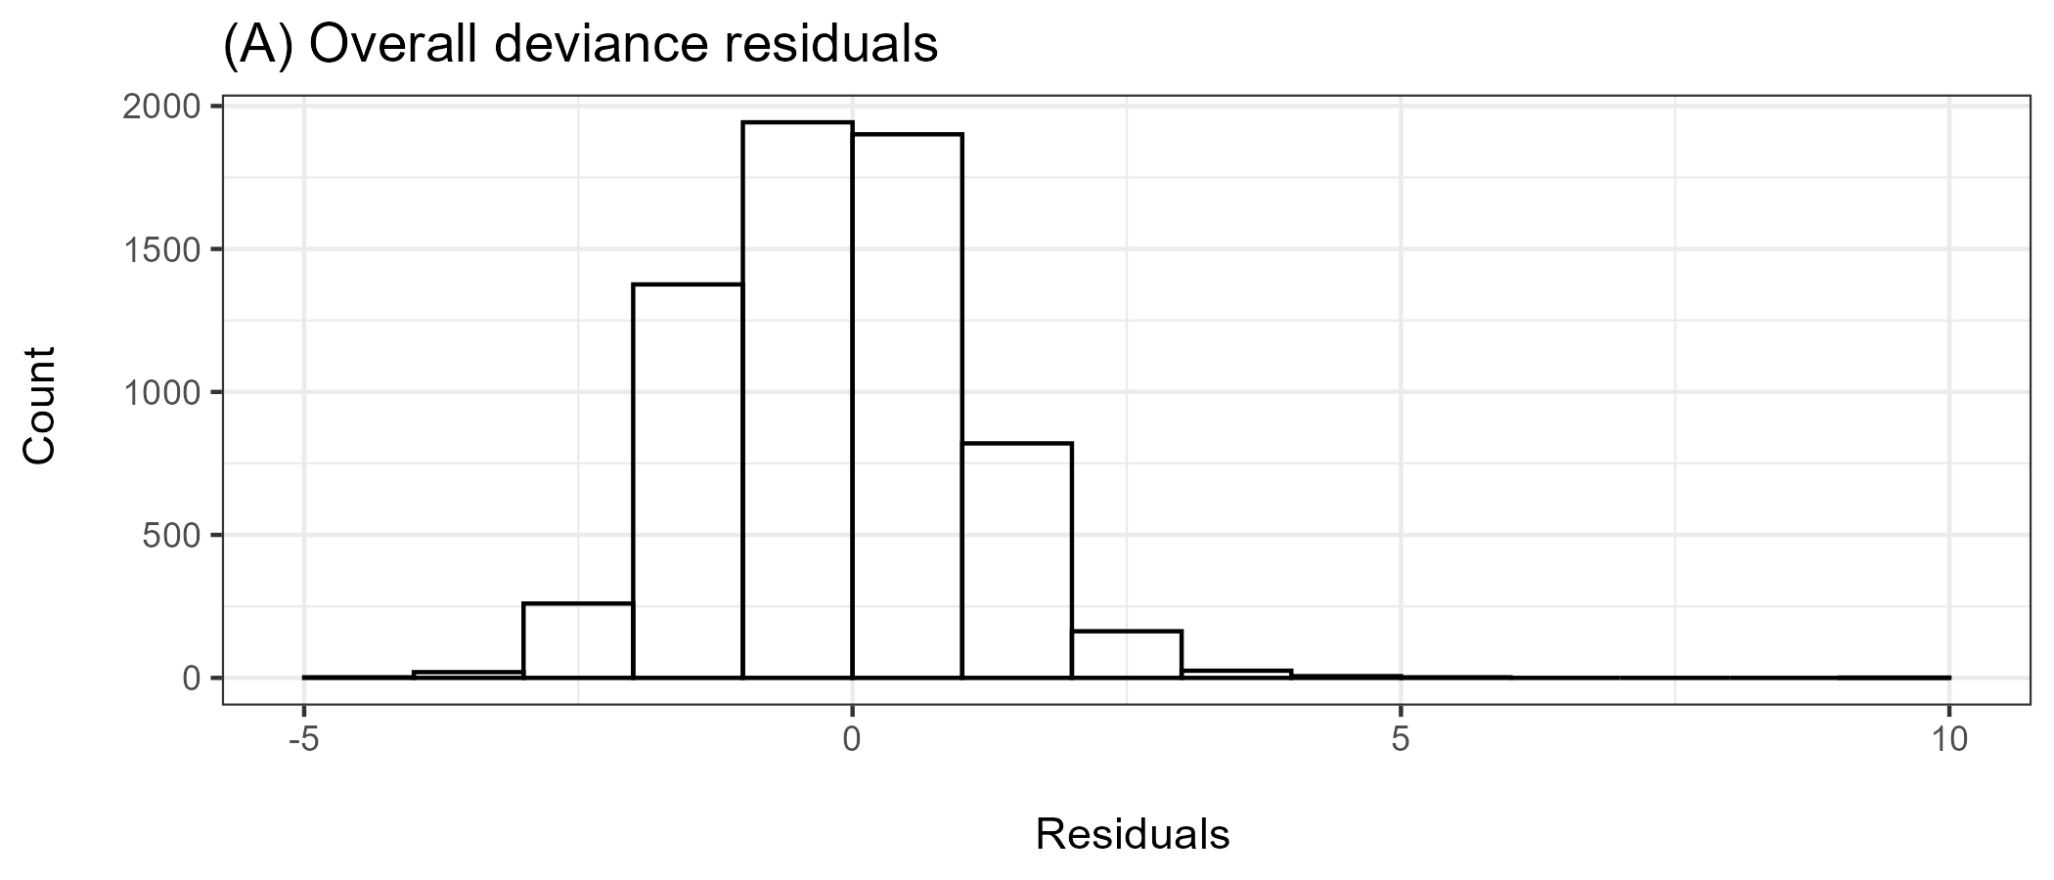
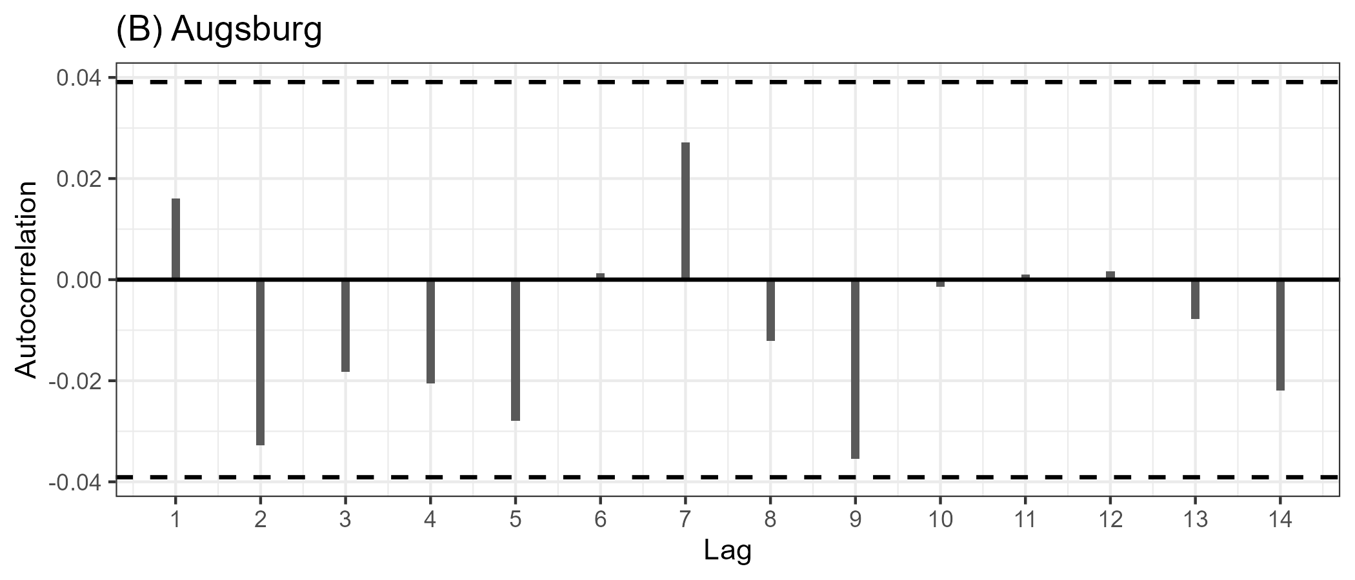
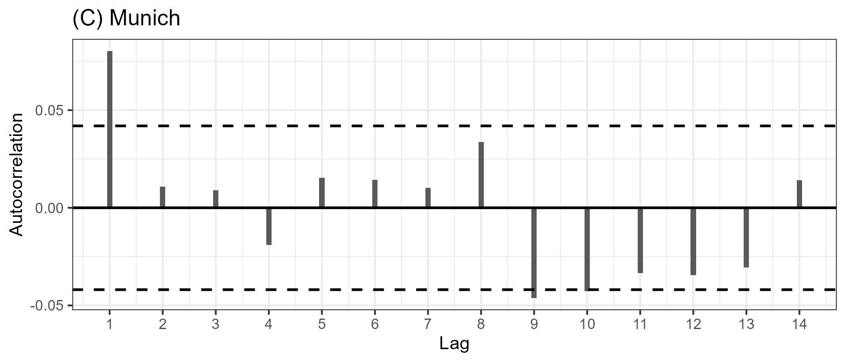
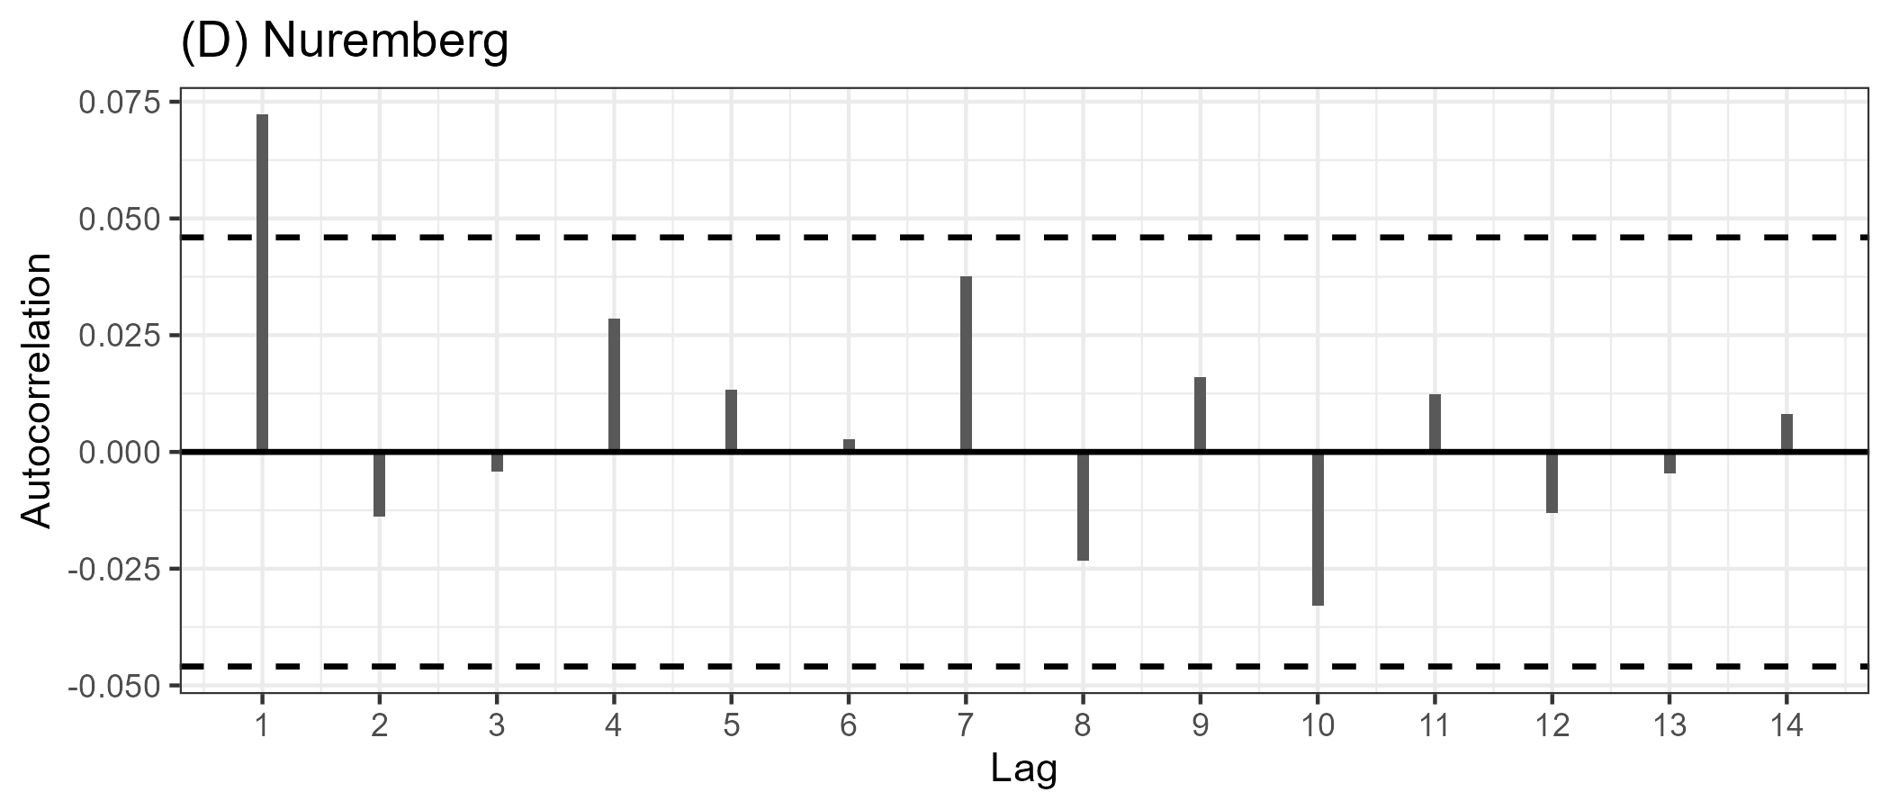
Figure S12 Sensitivity analysis of the found effect estimates of the four considered pollen taxa - Alnus (A), Betula (B), Corylus (C) and Poaceae (D) - with respect to the radius of the treatment inclusion area. Whiskers indicate 95% confidence intervals.
Figure S13 Diagnostic plots for the main model showing the distribution of the overall residuals (A) and the location-wise partial autocorrelation of the deviance residuals for Augsburg (B), Munich (C) and Nuremberg (D).
Table S1 Pollen season characteristics for the four considered taxa in Augsburg.
 | Year | Start date | End date | Duration (d) | Peak date | Peak value | Pollen integral
Augsburg
Alnus | 2018 | 23.02. | 23.04. | 60 | 12.04. | 665.17 | 5,708.42
Alnus | 2019 | 16.02. | 31.03. | 44 | 22.03. | 350.90 | 2,918.83
Alnus | 2020 | 29.01. | 22.03. | 54 | 16.02. | 863.46 | 6,204.49
Alnus | 2021 | 27.01. | 21.03. | 54 | 26.02. | 876.56 | 3,366.58
Alnus | 2022 | 05.01. | 29.03. | 84 | 18.03. | 126.86 | 2,318.71
Alnus | 2023 | 07.01. | 25.03. | 78 | 22.02. | 162.36 | 1,736.71
Alnus | 2024 | 06.02. | 30.03. | 54 | 18.02. | 3,353.72 | 16,383.11
Betula | 2018 | 10.04. | 10.05. | 31 | 12.04. | 3,575.86 | 16,826.67
Betula | 2019 | 03.04. | 06.06. | 65 | 08.04. | 1,926.21 | 11,141.88
Betula | 2020 | 05.04. | 28.05. | 54 | 12.04. | 1,686.80 | 11,876.37
Betula | 2021 | 05.04. | 20.05. | 46 | 22.04. | 696.50 | 3,830.24
Betula | 2022 | 08.04. | 27.05. | 50 | 14.04. | 1,842.64 | 9,115.88
Betula | 2023 | 04.04. | 14.06. | 68 | 22.04. | 1,826.82 | 7,284.70
Betula | 2024 | 18.02. | 03.05. | 76 | 06.04. | 1,388.87 | 7,999.72
Corylus | 2018 | 13.02. | 23.04. | 70 | 23.04. | 222.88 | 4,087.81
Corylus | 2019 | 16.02. | 30.03. | 43 | 23.02. | 443.42 | 2,949.96
Corylus | 2020 | 16.01. | 18.03. | 63 | 01.02. | 1,320.20 | 6,753.71
Corylus | 2021 | 04.02. | 26.03. | 51 | 26.02. | 377.11 | 2,930.75
Corylus | 2022 | 04.01. | 28.03. | 84 | 14.03. | 51.30 | 1,597.83
Corylus | 2023 | 02.01. | 20.03. | 78 | 13.01. | 526.61 | 7,050.33
Corylus | 2024 | 27.01. | 30.03. | 64 | 03.02. | 718.76 | 5,835.20
Poaceae | 2018 | 05.05. | 03.08. | 91 | 19.05. | 307.84 | 6,753.27
Poaceae | 2019 | 09.05. | 16.08. | 100 | 08.06. | 136.44 | 2,093.35
Poaceae | 2020 | 08.05. | 18.08. | 103 | 03.06. | 103.74 | 2,695.49
Poaceae | 2021 | 14.05. | 06.09. | 116 | 12.06. | 31.87 | 512.73
Poaceae | 2022 | 04.05. | 24.07. | 82 | 22.05. | 362.69 | 6,829.75
Poaceae | 2023 | 12.05. | 09.08. | 90 | 02.06. | 513.37 | 8,591.23
Poaceae | 2024 | 10.05. | 10.08. | 93 | 05.06. | 289.29 | 2,760.95

 | Year | Start date | End date | Duration (d) | Peak date | Peak value | Pollen integral
Munich
Alnus | 2019 | 10.02. | 01.05. | 81 | 28.02. | 971.76 | 5,105.21
Alnus | 2020 | 17.01. | 25.04. | 100 | 17.02. | 304.39 | 3,778.00
Alnus | 2021 | 05.02. | 04.05. | 89 | 26.02. | 543.34 | 3,112.93
Alnus | 2022 | 10.02. | 11.05. | 91 | 18.02. | 306.07 | 1,299,72
Alnus | 2023 | 05.01. | 27.05. | 143 | 22.02. | 180.22 | 2,590.75
Alnus | 2024 | 24.01. | 09.04. | 77 | 16.02. | 774.96 | 7,919.95
Betula | 2019 | 03.04. | 02.05. | 30 | 10.04. | 1,621,84 | 12,061.83
Betula | 2020 | 04.04. | 25.04. | 22 | 13.04. | 1,382.94 | 11,446.53
Betula | 2021 | 02.04. | 26.05. | 55 | 11.04. | 801.77 | 3,891.39
Betula | 2022 | 07.04. | 03.05. | 27 | 15.04. | 749.26 | 3,255.87
Betula | 2023 | 02.04. | 08.06. | 68 | 21.04. | 551.68 | 3,380.01
Betula | 2024 | 16.02. | 15.04. | 60 | 30.03. | 3,012.49 | 15,269.25
Corylus | 2019 | 16.02. | 25.03. | 38 | 21.02. | 1,350.63 | 5,419.06
Corylus | 2020 | 14.01. | 03.04. | 81 | 01.02. | 2,074.60 | 9,491.13
Corylus | 2021 | 06.02. | 09.04. | 63 | 20.02. | 440.67 | 3,460.37
Corylus | 2022 | 04.01. | 30.04. | 117 | 17.02. | 443.98 | 3,912.80
Corylus | 2023 | 04.01. | 31.03. | 87 | 13.01. | 610.57 | 7,101.50
Corylus | 2024 | 04.01. | 16.03. | 73 | 03.02. | 404.57 | 3195.74
Poaceae | 2019 | 08.05. | 05.08. | 90 | 08.06. | 144.52 | 1,278.18
Poaceae | 2020 | 16.05. | 07.08. | 84 | 12.06. | 163.16 | 1,482.61
Poaceae | 2021 | 23.05. | 19.07. | 58 | 14.06. | 133.37 | 1,264.88
Poaceae | 2022 | 10.02. | 13.08. | 185 | 27.05. | 102.61 | 2,227.99
Poaceae | 2023 | 08.05. | 10.08. | 95 | 03.06. | 380.87 | 6,160.92
Poaceae | 2024 | 28.04. | 23.08. | 118 | 06.06. | 100.86 | 1,751.85
Table S2 Pollen season characteristics for the four considered taxa in Munich.

Table S3 Pollen season characteristics for the four considered taxa in Nuremberg (Feucht).
 | Year | Start date | End date | Duration (d) | Peak date | Peak value | Pollen integral
Nuremberg
Alnus | 2020 | 01.02. | 12.05. | 102 | 16.02. | 1,585.35 | 7,147.10
Alnus | 2021 | 17.02. | 29.04. | 72 | 26.02. | 1,260.85 | 4,525.90
Alnus | 2022 | 02.02. | 08.05. | 96 | 24.02. | 758.56 | 7,124.84
Alnus | 2023 | 30.01. | 24.04. | 85 | 24.02. | 283.95 | 1,967.35
Alnus | 2024 | 05.02. | 09.04. | 65 | 15.02. | 1,156.00 | 9,905.80
Betula | 2020 | 07.04. | 02.05. | 26 | 10.04. | 2,411.21 | 16,268.88
Betula | 2021 | 05.04. | 09.05. | 35 | 29.04. | 504.61 | 3,289.66
Betula | 2022 | 07.04. | 08.05. | 32 | 14.04. | 2,118.87 | 14,700.65
Betula | 2023 | 07.04. | 07.05. | 31 | 23.04. | 870.79 | 3,981.93
Betula | 2024 | 30.03. | 13.04. | 15 | 07.04. | 3,624.21 | 15,464.82
Corylus | 2020 | 31.01. | 09.03. | 39 | 01.02. | 1,834.68 | 6,974.97
Corylus | 2021 | 11.02. | 29.03. | 47 | 26.02. | 222.58 | 1,415.49
Corylus | 2022 | 30.01. | 28.03. | 58 | 10.02. | 185.75 | 1,790.93
Corylus | 2023 | 02.01. | 31.03. | 89 | 18.02. | 153.20 | 2,458.21
Corylus | 2024 | 25.01. | 09.04. | 76 | 10.02. | 203.06 | 1,421.50
Poaceae | 2020 | 02.05. | 27.07. | 87 | 12.06. | 98.99 | 1,121.89
Poaceae | 2021 | 18.05. | 08.08. | 83 | 12.06. | 67.78 | 785.68
Poaceae | 2022 | 19.04. | 20.07. | 93 | 31.05. | 115.77 | 1,851.49
Poaceae | 2023 | 07.05. | 31.07. | 86 | 02.06. | 124.47 | 2,001.20
Poaceae | 2024 | 01.05. | 05.08. | 97 | 05.06. | 117.55 | 1,812.16

Table S4 Descriptive statistics of the considered environmental exposures between 2018 and 2024 across the three study locations: Augsburg, Munich and Nuremberg. The statistics for pollen were calculated from data within each taxon’s season.
 | Min. | Max. | Mean | Median | IQR
Pollen (in season)
Alnus (grains / m3) | 0.0 | 3,353.72 | 47.48 | 17.64 | 52.65
Betula (grains / m3) | 0.0 | 3,624.21 | 73.88 | 37.42 | 172.91
Corylus (grains / m3) | 0.0 | 2,074.60 | 36.26 | 15.87 | 46.79
Poaceae (grains / m3) | 0.0 | 513.37 | 21.13 | 10.96 | 27.25
Meteorological variables
Maximum Temperature (°C) | -8.80 | 38.40 | 15.59 | 15.40 | 14.60
Relative Humidity (%) | 30.00 | 100.00 | 74.60 | 76.00 | 18.00
Air pollutants
PM_{CF} (µg/m³) | -6.31 | 102.42 | 6.93 | 5.99 | 4.64
PM_{2.5} (µg/m³) | 0.52 | 144.70 | 10.15 | 9.04 | 6.98
O₃ (µg/m³) | 0.16 | 115.04 | 47.83 | 50.27 | 34.20
NO (µg/m³) | 0.70 | 208.18 | 15.83 | 11.18 | 13.61
NO₂ (µg/m³) | 3.53 | 76.58 | 26.31 | 24.81 | 13.67

Table S5 Median of the pollen concentration across the defined exposure levels.
Median at different exposure levels
 | Reference | Low | Medium | High
Alnus (grains / m3) | 0 | 0 | 13.56 | 113.34
Betula (grains / m3) | 0 | 5.47 | 27.46 | 464.71
Corylus (grains / m3) | 0 | 1.75 | 14.06 | 128.55
Poaceae (grains / m3) | 0 | 1.16 | 9.45 | 59.64

Table S6 Number of gaps in daily pollen and meteorological data used in the main model. In parentheses the percentage with respect to the total number of days in the respective study period is given.
 | Number of gaps (Percentage)
 | Augsburg 2018 - 2024 | Munich 2019 - 2024 | Nuremberg 2020 - 2024
Pollen | 213 (8.33 %) | 59 (2.69 %) | 40 (2.19 %)
Mean Temperature (°C) | 0 (0.00 %) | 0 (0.00 %) | 0 (0.00 %)
Relative Humidity (%) | 17 (0.66 %) | 3 (0.14%) | 2 (0.11 %)

Table S7 Cumulative percentage change in relative risk per interquartile-range increase in concentration for the considered air pollutants, included as cross-basis objects as part of the sensitivity analysis. Parentheses contain 95% confidence intervals.
Percentage change in RR per IQR increase in concentration
PM_{CF} (IQR = 4.6 µg/m³) | PM_{2.5} (IQR = 7.0 µg/m³) | O₃ (IQR =34.2 µg/m³) | NO (IQR = 13.6 µg/m³) | NO₂ (IQR = 13.7 µg/m³)
-2.82% (-7.00, 1.54) | 11.45% (6.39, 16.75) | 6.47% (-4.94, 19.25) | -4.74% (-10.37, 1.25) | 2.13 % (-6.18, 11.17)

Table S8 Sensitivity analysis for the effect estimates for Alnus pollen on the daily number of asthma treatments, reported as the relative risk at different exposure levels. Parentheses contain 95% confidence intervals.

Alnus | Relative Risk at different Exposure Levels
 | Low | Medium | High
Main Model | 1.00 (1.00, 1.00) | 0.91 (0.80, 1.03) | 1.00 (0.85, 1.19)
Seasonality: 6 df / year | 1.00 (1.00, 1.00) | 0.88 (0.78, 0.99) | 1.00 (0.84, 1.19)
Seasonality: 7 df / year | 1.00 (1.00, 1.00) | 0.90 (0.79, 1.01) | 0.99 (0.83, 1.18)
Seasonality: 9 df / year | 1.00 (1.00, 1.00) | 0.93 (0.82, 1.06) | 1.05 (0.88, 1.25)
Seasonality: 10 df / year | 1.00 (1.00, 1.00) | 0.95 (0.83, 1.09) | 1.07 (0.87, 1.30)
Seasonality: month:year strata | 1.00 (1.00, 1.00) | 0.93 (0.81, 1.08) | 1.01 (0.83, 1.21)
Lag Dimension: Linear | 1.00 (1.00, 1.00) | 0.91 (0.80, 1.03) | 1.03 (0.86, 1.22)
Lag Dimension: NS with 2 equally spaced knots | 1.00 (1.00, 1.00) | 0.91 (0.80, 1.04) | 1.00 (0.84, 1.20)
Lag Dimension: Maximum Lag 10 days | 1.00 (1.00, 1.00) | 0.87 (0.75, 1.00) | 0.92 (0.76, 1.11)
Lag Dimension: Maximum Lag 14 days | 1.00 (1.00, 1.00) | 0.82 (0.69, 0.97) | 0.83 (0.67, 1.03)
Air pollution control | 1.00 (1.00, 1.00) | 0.90 (0.79, 1.02) | 0.95 (0.80, 1.13)
Influenza control | 1.00 (1.00, 1.00) | 0.91 (0.81, 1.03) | 1.00 (0.84, 1.19)
COVID-19 control | 1.00 (1.00, 1.00) | 0.91 (0.80, 1.03) | 1.00 (0.85, 1.19)
Daily mean temperature in cb_{Temp} | 1.00 (1.00, 1.00) | 0.91 (0.80, 1.03) | 1.03 (0.86, 1.22)
Daily min. temperature in cb_{Temp} | 1.00 (1.00, 1.00) | 0.92 (0.81, 1.04) | 1.05 (0.89, 1.25)
One-day lagged deviance residuals | 1.00 (1.00, 1.00) | 0.90 (0.80, 1.02) | 0.98 (0.83, 1.17)
Alnus Only (January – March) | 1.00 (1.00, 1.00) | 0.91 (0.77, 1.06) | 1.04 (0.86, 1.26)
PoMo Missing Value Handling:  Moving Mean | 1.00 (1.00, 1.00) | 0.93 (0.82, 1.05) | 1.00 (0.85, 1.19)
PoMo Value Handling:  Linear interpolation on log10 scale | 1.00 (1.00, 1.00) | 0.93 (0.82, 1.05) | 1.01 (0.85, 1.20)
PoMo: Minimum requirement of 4 measurements per day | 1.00 (1.00, 1.00) | 0.90 (0.79, 1.03) | 0.98 (0.81, 1.18)
Without temperature effect (cb_{Temp}) | 1.00 (1.00, 1.00) | 0.91 (0.81, 1.04) | 1.04 (0.88, 1.23)
COVID-19: Exclude Year 2020 | 1.00 (1.00, 1.00) | 0.93 (0.82, 1.07) | 1.01 (0.83, 1.24)
COVID-19: Exclude Year 2021 | 1.00 (1.00, 1.00) | 0.92 (0.80, 1.04) | 1.06 (0.89, 1.27)

Table S9 Sensitivity analysis for the effect estimates for Betula pollen on the daily number of asthma treatments, reported as the relative risk at different exposure levels. Parentheses contain 95% confidence intervals.
Betula | Relative Risk at different Exposure Levels
 | Low | Medium | High
Main Model | 0.95 (0.81, 1.12) | 0.99 (0.88, 1.13) | 1.64 (1.41, 1.90)
Seasonality: 6 df / year | 0.99 (0.85, 1.15) | 1.03 (0.91, 1.16) | 1.61 (1.39, 1.87)
Seasonality: 7 df / year | 0.93 (0.79, 1.10) | 0.96 (0.85, 1.10) | 1.58 (1.35, 1.85)
Seasonality: 9 df / year | 0.97 (0.82, 1.15) | 0.97 (0.84, 1.13) | 1.60 (1.35, 1.90)
Seasonality: 10 df / year | 0.93 (0.78, 1.10) | 0.88 (0.74, 1.05) | 1.38 (1.10, 1.73)
Seasonality: month:year strata | 1.01 (0.85, 1.19) | 0.97 (0.84, 1.11) | 1.51 (1.25, 1.83)
Lag Dimension: Linear | 0.95 (0.81, 1.13) | 0.98 (0.86, 1.12) | 1.62 (1.39, 1.88)
Lag Dimension: NS with 2 equally spaced knots | 0.95 (0.80, 1.12) | 0.96 (0.85, 1.10) | 1.61 (1.38, 1.87)
Lag Dimension: Maximum Lag 10 days | 0.95 (0.79, 1.13) | 0.95 (0.83, 1.09) | 1.67 (1.42, 1.96)
Lag Dimension: Maximum Lag 14 days | 0.95 (0.77, 1.17) | 0.92 (0.78, 1.08) | 1.77 (1.47, 2.13)
Air pollution control | 0.96 (0.81, 1.12) | 1.00 (0.89, 1.14) | 1.64 (1.41, 1.91)
Influenza control | 0.95 (0.81, 1.12) | 0.99 (0.88, 1.12) | 1.64 (1.42, 1.91)
COVID-19 control | 0.95 (0.81, 1.12) | 0.99 (0.88, 1.13) | 1.64 (1.41, 1.90)
Daily mean temperature in cb_{Temp} | 0.94 (0.80, 1.11) | 0.98 (0.87, 1.11) | 1.62 (1.40, 1.88)
Daily min. temperature in cb_{Temp} | 0.93 (0.79, 1.09) | 0.96 (0.85, 1.09) | 1.60 (1.38, 1.86)
One-day lagged deviance residuals | 0.95 (0.81, 1.12) | 1.00 (0.88, 1.13) | 1.63 (1.41, 1.89)
Betula Only (March – April) | 0.96 (0.79, 1.16) | 0.82 (0.71, 0.96) | 1.25 (1.06, 1.46)
PoMo Missing Value Handling:  Moving Mean | 0.94 (0.80, 1.10) | 1.00 (0.88, 1.13) | 1.64 (1.41, 1.91)
PoMo Value Handling:  Linear interpolation on log10 scale | 0.94 (0.80, 1.10) | 1.00 (0.88, 1.14) | 1.65 (1.42, 1.92)
PoMo: Minimum requirement of 4 measurements per day | 0.93 (0.78, 1.11) | 0.99 (0.87, 1.13) | 1.51 (1.28, 1.78)
Without temperature effect (cb_{Temp}) | 0.93 (0.79, 1.09) | 0.97 (0.85, 1.09) | 1.59 (1.37, 1.84)
COVID-19: Exclude Year 2020 | 0.99 (0.83, 1.17) | 1.07 (0.93, 1.22) | 1.65 (1.40, 1.94)
COVID-19: Exclude Year 2021 | 0.91 (0.77, 1.08) | 0.98 (0.86, 1.11) | 1.62 (1.39, 1.89)

Table S10 Sensitivity analysis for the effect estimates for Corylus pollen on the daily number of asthma treatments, reported as the relative risk at different exposure levels. Parentheses contain 95% confidence intervals.
Corylus | Relative Risk at different Exposure Levels
 | Low | Medium | High
Main Model | 1.00 (0.85, 1.17) | 1.01 (0.87, 1.16) | 0.95 (0.79, 1.13)
Seasonality: 6 df / year | 1.03 (0.88, 1.20) | 1.15 (1.00, 1.31) | 0.92 (0.77, 1.09)
Seasonality: 7 df / year | 1.01 (0.87, 1.18) | 1.08 (0.94, 1.23) | 0.93 (0.78, 1.10)
Seasonality: 9 df / year | 1.04 (0.88, 1.23) | 1.02 (0.88, 1.18) | 0.96 (0.79, 1.15)
Seasonality: 10 df / year | 1.00 (0.84, 1.18) | 0.99 (0.85, 1.16) | 0.97 (0.79, 1.19)
Seasonality: month:year strata | 1.04 (0.87, 1.23) | 1.15 (0.98, 1.34) | 1.04 (0.85, 1.26)
Lag Dimension: Linear | 1.00 (0.85, 1.18) | 1.01 (0.87, 1.16) | 0.95 (0.79, 1.14)
Lag Dimension: NS with 2 equally spaced knots | 1.00 (0.84, 1.18) | 1.02 (0.88, 1.18) | 0.93 (0.78, 1.11)
Lag Dimension: Maximum Lag 10 days | 1.00 (0.83, 1.21) | 1.05 (0.89, 1.22) | 0.98 (0.81, 1.19)
Lag Dimension: Maximum lag 14 days | 1.05 (0.84, 1.31) | 1.17 (0.97, 1.41) | 1.00 (0.80, 1.26)
Air pollution control | 1.00 (0.85, 1.17) | 1.02 (0.88, 1.18) | 0.99 (0.83, 1.19)
Influenza control | 1.00 (0.85, 1.17) | 1.01 (0.88, 1.16) | 0.96 (0.80, 1.15)
COVID-19 control | 1.00 (0.85, 1.17) | 1.01 (0.87, 1.16) | 0.95 (0.79, 1.13)
Daily mean temperature in cb_{Temp} | 1.01 (0.86, 1.19) | 1.04 (0.90, 1.20) | 1.00 (0.84, 1.19)
Daily min. temperature in cb_{Temp} | 1.02 (0.87, 1.20) | 1.07 (0.93, 1.23) | 1.05 (0.88, 1.24)
One-day lagged deviance residuals | 1.00 (0.85, 1.17) | 1.01 (0.88, 1.16) | 0.96 (0.80, 1.14)
Corylus Only (January – April) | 0.89 (0.73, 1.08) | 0.96 (0.82, 1.11) | 1.00 (0.83, 1.21)
PoMo Missing Value Handling:  Moving Mean | 1.02 (0.86, 1.20) | 1.02 (0.88, 1.17) | 0.97 (0.81, 1.16)
PoMo Value Handling:  Linear interpolation on log10 scale | 1.02 (0.86, 1.21) | 1.00 (0.87, 1.16) | 0.94 (0.79, 1.13)
PoMo: Minimum requirement of 4 measurements per day | 1.00 (1.00, 1.00) | 1.15 (1.00, 1.34) | 0.95 (0.78, 1.16)
Without temperature effect (cb_{Temp}) | 1.01 (0.86, 1.19) | 1.05 (0.92, 1.21) | 1.03 (0.87, 1.22)
COVID-19: Exclude Year 2020 | 1.08 (0.90, 1.29) | 0.99 (0.84, 1.17) | 1.00 (0.82, 1.21)
COVID-19: Exclude Year 2021 | 0.97 (0.82, 1.15) | 0.97 (0.84, 1.12) | 0.95 (0.79, 1.14)

Table S11 Sensitivity analysis for the effect estimates for Poaceae pollen on the daily number of asthma treatments, reported as the relative risk at different exposure levels. Parentheses contain 95% confidence intervals.
Poaceae | Relative Risk at different Exposure Levels
 | Low | Medium | High
Main Model | 0.99 (0.87, 1.13) | 1.19 (1.03, 1.38) | 1.41 (1.17, 1.70)
Seasonality: 6 df / year | 0.94 (0.83, 1.06) | 1.13 (0.99, 1.28) | 1.47 (1.26, 1.73)
Seasonality: 7 df / year | 0.94 (0.83, 1.07) | 1.22 (1.06, 1.40) | 1.52 (1.25, 1.83)
Seasonality: 9 df / year | 0.97 (0.85, 1.11) | 1.15 (0.99, 1.33) | 1.50 (1.23, 1.84)
Seasonality: 10 df / year | 0.96 (0.84, 1.10) | 1.08 (0.93, 1.27) | 1.44 (1.17, 1.76)
Seasonality: month:year strata | 1.02 (0.89, 1.18) | 1.18 (1.01, 1.37) | 1.40 (1.15, 1.69)
Lag Dimension: Linear | 0.99 (0.87, 1.13) | 1.18 (1.01, 1.37) | 1.40 (1.16, 1.69)
Lag Dimension: NS with 2 equally spaced knots | 0.98 (0.86, 1.12) | 1.16 (1.00, 1.35) | 1.33 (1.10, 1.61)
Lag Dimension: Maximum Lag 10 days | 1.02 (0.89, 1.18) | 1.21 (1.03, 1.42) | 1.39 (1.13, 1.71)
Lag Dimension: Maximum Lag 14 days | 1.02 (0.86, 1.21) | 1.23 (1.01, 1.48) | 1.40 (1.11, 1.76)
Air pollution control | 0.99 (0.87, 1.12) | 1.19 (1.02, 1.38) | 1.36 (1.13, 1.64)
Influenza control | 0.99 (0.87, 1.13) | 1.19 (1.03, 1.38) | 1.41 (1.17, 1.69)
COVID-19 control | 0.99 (0.87, 1.13) | 1.20 (1.03, 1.39) | 1.41 (1.17, 1.70)
Daily mean temperature in cb_{Temp} | 0.99 (0.87, 1.13) | 1.19 (1.03, 1.38) | 1.39 (1.16, 1.68)
Daily min. temperature in cb_{Temp} | 0.99 (0.87, 1.13) | 1.18 (1.02, 1.36) | 1.36 (1.13, 1.64)
One-day lagged deviance residuals | 0.99 (0.88, 1.13) | 1.20 (1.03, 1.38) | 1.42 (1.18, 1.70)
Poaceae Only (May – September) | 1.00 (0.84, 1.19) | 1.21 (1.01, 1.45) | 1.45 (1.17, 1.81)
PoMo Missing Value Handling:  Moving Mean | 0.97 (0.85, 1.10) | 1.17 (1.01, 1.36) | 1.39 (1.15, 1.67)
PoMo Value Handling:  Linear interpolation on log10 scale | 0.97 (0.86, 1.09) | 1.20 (1.04, 1.39) | 1.44 (1.20, 1.73)
PoMo: Minimum requirement of 4 measurements per day | 0.99 (0.87, 1.13) | 1.16 (1.00, 1.35) | 1.38 (1.14, 1.67)
Without temperature effect (cb_{Temp}) | 0.98 (0.86, 1.12) | 1.17 (1.01, 1.35) | 1.35 (1.13, 1.62)
COVID-19: Exclude Year 2020 | 0.99 (0.87, 1.14) | 1.19 (1.02, 1.39) | 1.36 (1.13, 1.65)
COVID-19: Exclude Year 2021 | 0.95 (0.83, 1.10) | 1.20 (1.02, 1.41) | 1.45 (1.19, 1.77)

Table S12 Sensitivity analysis for attributable fraction of asthma-related outpatient emergency treatments estimated for Betula and Poaceae pollen in the three considered study locations. Parentheses indicate 95% confidence intervals.
In-season Attributable Fractions
 | Betula | Poaceae
Strata (Main model)
Augsburg | 10.24% (1.01, 18.50) | 18.84% (7.21, 28.88)
Munich | 13.61% (5.83, 20.51) | 14.25% (4.46, 22.84)
Nuremberg | 17.75% (9.72, 24.80) | 14.91% (4.47, 24.09)
Linear
Augsburg | 9.56% (7.19, 11.69) | 13.92% (10.17, 17.10)
Munich | 10.48% (7.87, 12.87) | 7.80% (5.76, 9.63)
Nuremberg | 15.14% (11.29, 18.52) | 6.06% (4.38, 7.63)
Linear (Log10 scale)
Augsburg | 21.39% (14.22, 27.69) | 27.56% (18.36, 35.37)
Munich | 20.67% (13.58, 26.76) | 21.02% (13.82, 27.29)
Nuremberg | 24.14% (16.38, 30.87) | 21.93% (14.51, 28.42)
Natural Spline (Log10 scale)
Augsburg | 13.31 (3.56, 22.09) | 19.86 (7.48, 29.70)
Munich | 16.35 (7.57, 23.91) | 14.13 (3.60, 22.89)
Nuremberg | 19.69 (10.73, 27.35) | 12.97 (1.34, 22.61)
Penalized Spline (Log10 scale)
Augsburg | 13.38 (3.84, 21.93) | 20.45 (9.81, 30.16)
Munich | 14.95 (6.50, 22.55) | 14.38 (4.72, 23.03)
Nuremberg | 19.59 (10.89, 27.32) | 13.52 (2.89, 23.11)

