Long-term Metabolic Consequences: Persistence of Visceral Obesity and Diabetes Mellitus after Remission from Cushing’s Syndrome
German Rubinstein ¹, Vanessa Fedtke ¹, Cornelia Then ¹, Elisabeth Nowak ¹, Frederick Vogel ¹, Leah Braun ¹, Stephanie Zopp ¹, Petra Zimmermann ², Annette Peters ^{3,4,5,6}, Margit Heier ^{3, 11}, Birgit Linkohr ^{3,4}, Michael Roden ^{6,7,8}, Martin Bidlingmaier ¹, Felix Beuschlein ^{1,9,10}, Martin Reincke ¹, Katrin Ritzel ¹

Supplemental Data:

Supplemental Text 1: Treatment of CS
Almost all patients with CD were treated by transsphenoidal surgical resection (TSS) of the pituitary tumor (n = 61), and one patient received bilateral adrenalectomy (BADX) as first line therapy. From 62 patients with CD, 35 patients had remission after initial therapy, while 27 patients needed additional treatment lines after TSS due to persistent disease. Repeat TSS was applied in 22 patients, radiation in 12 patients, BADX was used in 14 patients and 7 patients received medical treatment as a bridging before finally achieving biochemical control.
Removal of the ACTH producing tumor was first-line treatment in 7 patients with ECS while 2 patients underwent first-line BADX before an ectopic tumor was discovered.
In patients with ACS, 24 patients with unilateral adenoma received adrenalectomy. Patients with bilateral hyperplasia received adrenalectomy of the dominant side (n= 2) and BADX (n= 2).
Median duration of uncontrolled hypercortisolism from confirmation of the diagnosis until remission was 10.3 weeks (5.5-45.4). Median time from self-reported first symptoms until remission was 179.7 weeks (73.4-449.6). Median follow-up time was 97 months (82.5-168.5).

Supplemental Table 1:
 | CS | KORA
 | Characteristics at 14 years of follow up
N | 49 | 396
Weight (kg) | 69.9 (62-82) | 72.2 (63-84)
BMI (kg/m²) | 25.7 (22.7-29.9) | 26.3 (23.6-29.6)
WHR | 0.87 (0.84-0.95) | 0.86 (0.8-0.93)
RFM (%) | 38.4 (33-42.6) | 36.5 (31.8-42.3)
HbA1c (%) | 5.5 (5.2-5.9) | 5.4 (5.2-5.6)
HOMA-IR-Index | 1.7 (0.58-2.7) | 2.1 (1.4-3.5)
HOMA-B-Index | 112 (63-169) | 98 (58-163)
Triglycerides (mg/dl) | 132 (63-167) | 100 (74-143)
Cholesterol (mg/dl) | 202 (162-238) | 216 (190-245)
LDL cholesterol (mg/dl) | 131 (108-156) | 131 (109-154)
HDL cholesterol (mg/dl) | 64 (55-79) | 70 (56-84)
Diabetes mellitus | 10% | 7%
Antidiabetic drugs | 7% | 6%
Lipid lowering drugs | 8% | 12%
CRP (mg/l) | 2 (1-5.1) | 1.2 (0.6-2.8)
25-Hydroxyvitamine D (ng/ml) | 32 (18.4-37.3) | 22.9 (15.2-32.5)
Supplemental Table 1: Clinical characteristics at 14 years of follow up of the CS and KORA cohorts in percentage or as median and IQR. Limited patient numbers and power at 14 years yielded no statistical analysis.
Abbreviations: IQR: interquartile range, BMI: Body mass index, WHR: waist-to-hip ratio, RFM: relative fat mass.

Supplemental Table 2:
Hormonal characteristics in patients with CS | At baseline | 7 years post-remission
Morning serum cortisol (µg/dl) | 35.0 (7.5-77,0) | 6.0 (1.8-10.9)
UFC index | 3.4 (1.9- 5.3) | 0.4 (0.1-0.7)
LNSC (ng/ml) | 7.2 (4.3-13.6) | 1,0 (0.8- 1.7)
1 mg DST, Cortisol (µg/dl) | 14.3 (7.1- 27.4) | 0,9 (0,8- 1.4)
Adrenal insufficiency | n/a | 46.2%
Hydrocortisone dose | n/a | 20 mg (15-25)
Hormone substitution  Thyroid axis  Somatotropic axis  Gonadotropic axis | 15.1%  0.9%  10.1% | 41.2%  5.2%  21.2%
Supplemental Table 2: Parameter of cortisol metabolism and hormone substitution at baseline and 7 years after biochemical remission in patients with Cushing’s syndrome (CS,) in percentage or as median and IQR.
Abbreviations: IQR: interquartile range, LNSC: late-night salivary cortisol, DST: Dexamethasone suppression test, UFC index: 24h-urinary free cortisol value divided by assay specific upper limit of normal.

Supplemental Figure 1:
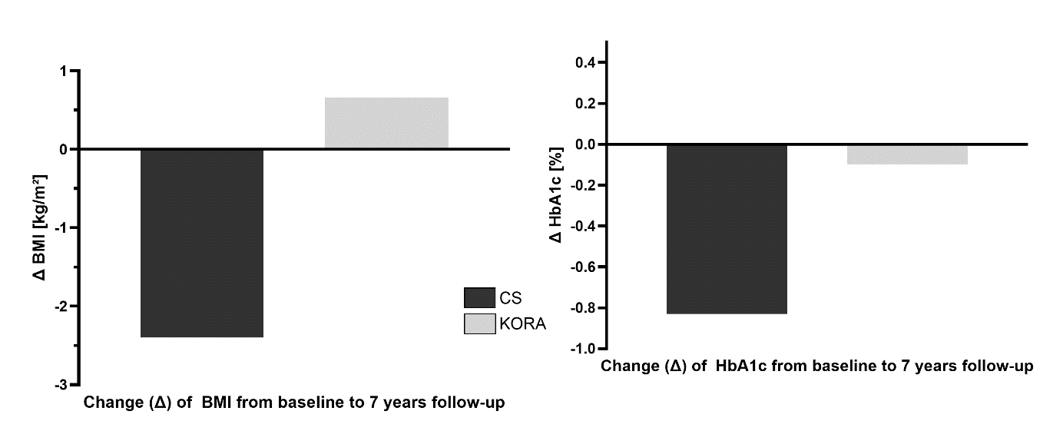
Supplemental Figure 1: Changes of BMI and HbA1c from baseline to 7 years follow for both groups.

