Supporting Information

Introduction of optimized folate group modification on lipid-coated magnetic nanobeads enables targeting of folate receptor beta

Maximilian Schaafª, Svenja Offer^{b}, Haiyun Zhang^{c}, Ana Mateos-Marotoª, Chenxi Li^{c}, Karl Normak^{d}, Jacopo Cardellini^{d}, Lin Jianª, Kaloian Koynovª, Manuel Antonio González Gómez^{e}, Yolanda Piñeiro^{e}, José Rivas^{e}, Paolo Arosio^{d}, Ralf Zimmermann^{b,f}, Andrea Zendrini^{d,h}, Antonella Bongiovanni^{g}, Paolo Bergese^{h,g,i}, Markus Rehberg^{c}, Katharina Landfesterª, Svenja Morsbach^{a,*}, Sebastiano Di Bucchianico^{b,f}
ª Department of Physical Chemistry of Polymers, Max Planck Institute for Polymer Research, Mainz 55128, Germany
^{b} Comprehensive Molecular Analytics, Helmholtz Center Munich, Neuherberg 85764, Germany
^{c} Institute of Lung Health and Immunity (LHI), Comprehensive Pneumology Center (CPC), Helmholtz Center Munich; Member of the German Center for Lung Research (DZL), Munich, Germany
^{d} Department of Chemistry and Applied Biosciences, ETH Zurich, Zurich 8093, Switzerland
^{e} Department of Applied Physics, Nanomag Group, Materials Institute – iMATUS, Health Research Institute - IDIS, Universidade de Santiago de Compostela-USC, E-15782 Santiago de Compostela, Spain
^{f} Department Life, Light & Matter, University of Rostock, Rostock 18059, Germany
^{g} IRIB - Institute for Research and Biomedical Innovation of CNR, Palermo, Italy
^{h} Department of Molecular and Translational Medicine, Università degli Studi di Brescia, Brescia, Italy
^{i} CSGI - Center for Colloid and Interface Science, Firenze, Italy
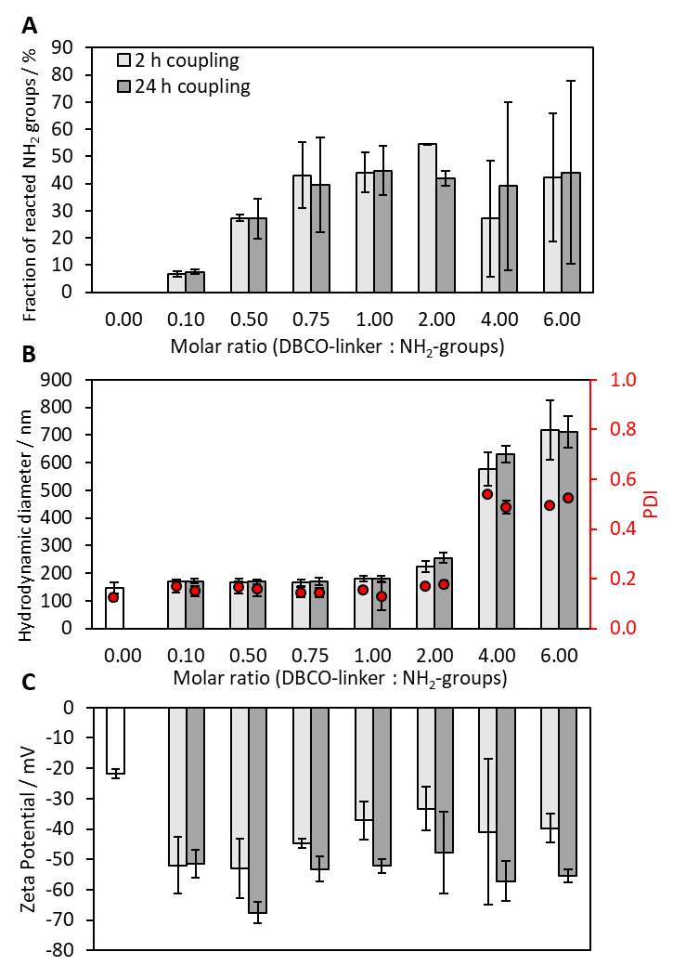
Figure S1: Physicochemical characterization of linker-functionalized liposomes, comparing 2 h and 24 h linker conjugation. (A) Fraction of reacted amine groups on liposomes, based on primary amine concentration determined via fluorescamine assay (before linker conjugation) and DBCO concentration determined via anthracene azide assay (after linker conjugation). (B) DLS analysis of linker-functionalized liposomes. (C) Zeta potential analysis of linker-functionalized liposomes.

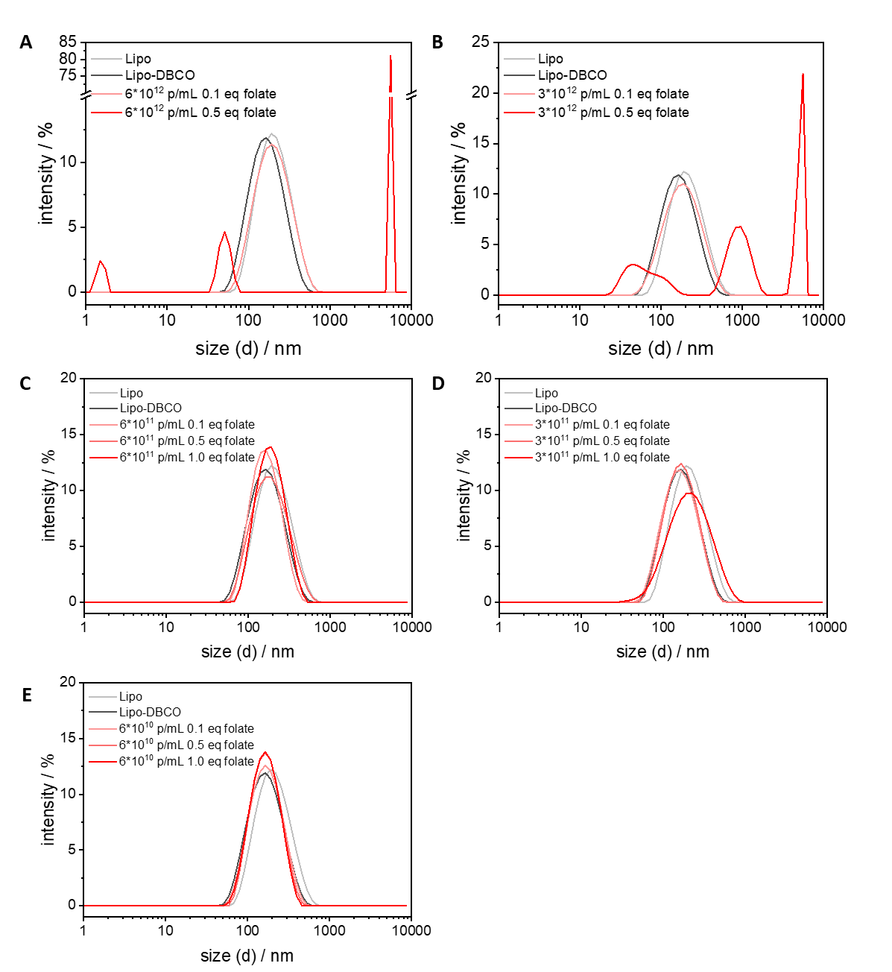
Figure S2: Representative size distributions of DLS measurements reported in Figure 2D of the main manuscript showing the intensity weighted hydrodynamic diameters before and after folate functionalization for different liposome concentrations and folate equivalents. (A) 6∙10¹² liposomes/mL, (B) 3∙10¹² liposomes/mL, (C) 6∙10¹¹ liposomes/mL, (D) 3∙10¹¹ liposomes/mL, (E) 6∙10¹⁰ liposomes/mL.

Table S1: Values obtained from fitting of FCS curves shown in Figures 2F-G.
#component fixed in the fitting
Batch | Sample | R_{h1} / nm | Fraction / % | R_{h2} / nm | Fraction / % | R_{h3} / nm | Fraction / %
 | sec. Ab. | 9±1 | 100 | - | 0 | - | 0
 | sec. Ab.+anti-folate Ab. | 9±1# | 50 | 64±6 | 50 | - | 0
with folate | (sec. Ab.+anti-folate Ab.) + Lipo(10:1) | 9±1# | 11 | 64±6# | 48 | 223±22 | 41
with folate | (sec. Ab.+anti-folate Ab.) + Lipo(100:1) | 9±1# | 7 | 64±6# | 46 | 292±29 | 47
without folate | (sec. Ab.+anti-folate Ab.) + Lipo(10:1) | 9±1# | 44 | 64±6# | 56 | - | 0
without folate | (sec. Ab.+anti-folate Ab.) + Lipo(100:1) | 9±1# | 51 | 64±6# | 49 | - | 0

TEM-based morphological analysis of MBDs
The morphology of the MBDs was observed using high-resolution transmission electron microscopy (HR-TEM) operated at 200 kV (Carl Zeiss Iberia, Madrid). For imaging, the samples were deposited onto Formvar®-coated copper grids and allowed to dry prior to observation. Particle size measurements were carried out using ImageJ software (NIH, USA).
The morphological features of MBDs were assessed using high-resolution electron microscopy (HR-TEM). As shown in Figure S2 (a), well-defined spherical core-shell nanostructures could be observed where the high-contrast inner domains, corresponding to the magnetic cores, were surrounded by lower-contrast regions, associated with the silica matrix. The particles appeared well dispersed with only minor clustering. The accompanying size-distribution analysis (Figure S2 (b) revealed an average particle diameter close to 80 nm and a relatively narrow size spread, indicating a well-controlled fabrication process.
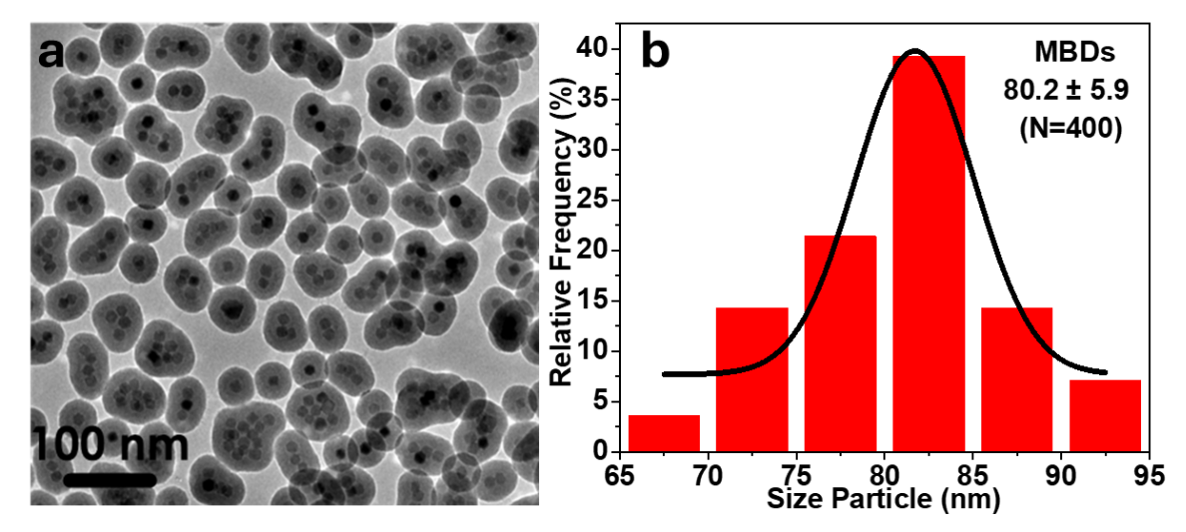
Figure S3: (a) HRTEM micrograph, (b) size distribution of the MBDs. The size distribution was performed by measuring a sample consisting of 400 MBDs with ImageJ software.
Table S2: Physico-chemical characterization properties of MBDs before lpMBD production.
Transmission Electron Microscopy (TEM) | Dynamic Light Scattering (DLS)
Hydrodynamic diameter / nm | Hydrodynamic diameter / nm | PDI | Zeta potential / mV
80 ± 6 | 101 ± 10 | 0.1 | -61 ± 6

Magnetic properties of MBDs
Magnetization curves of the dried MBD samples were obtained using a vibrating sample magnetometer (VSM, DMS, Lowell, MA, USA), recording room-temperature hysteresis loops under applied fields ranging from −10 to 10 kOe. Temperature-dependent magnetic behavior of the magnetic sample was evaluated through zero-field-cooled and field-cooled (ZFC–FC) measurements using a SQUID magnetometer (Quantum Design, Darmstadt, Germany).

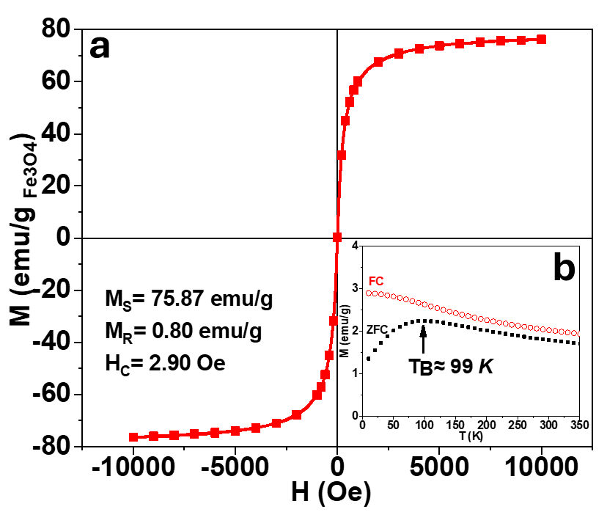
Figure S4: (a) Room-temperature magnetization curve of the MBD recorded by VSM under applied fields ranging from −10 to +10 kOe. (b) Inset, Zero-field-cooled (ZFC) and field-cooled (FC) magnetization curves measured at 100 Oe, illustrating the temperature-dependent magnetic behavior of the MBD.

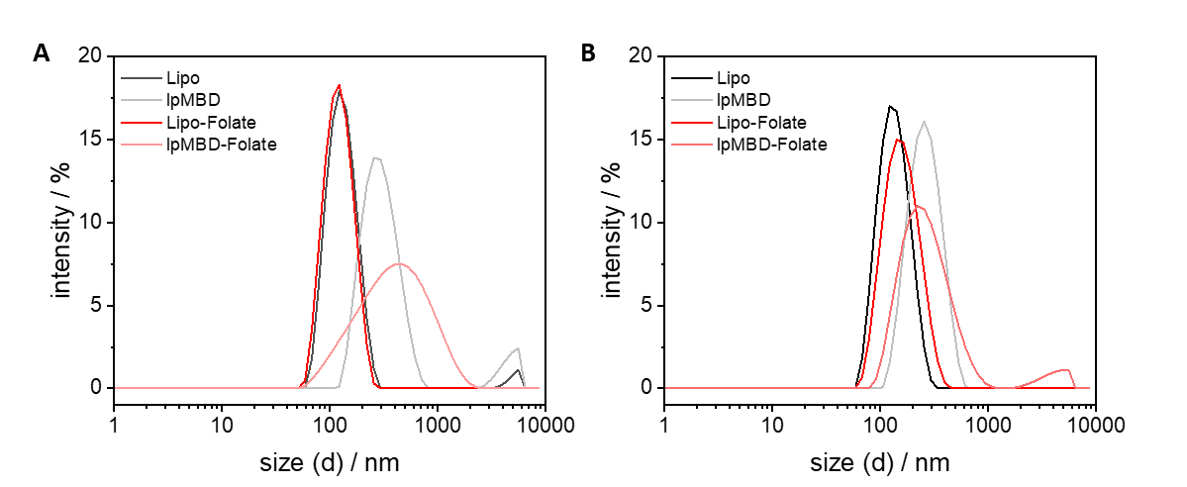
Figure S5: Representative size distributions of DLS measurements reported in Table 3 of the main manuscript showing the intensity weighted hydrodynamic diameters before and after folate functionalization for liposomes and lpMBDs. (A) MemGlowTM 488 labeled, (B) MemGlowTM 590 labeled.

Table S3: log₂ fold changes (Log2FC) and p-values of immunomodulatory proteins. Proteins discussed in the main text are shown in bold, together with their corresponding Log2FC and p-values under parallel experimental conditions.
Condition | Protein name | lpMBD-folate |  | lpMBD
 |  | Log2FC | p-value | Log2FC | p-value
M0 macrophages 4 hours | CD274 | 1.015 | 0.0129 | 1.181 | 0.0402
M0 macrophages 4 hours | CLEC4D | 0.342 | 0.8437 | 0.332 | 0.056
M0 macrophages 4 hours | SPRY2 | 0.861 | 0.0357 | 1.046 | 0.092
M0 macrophages 4 hours | CCL13 | 0.812 | 0.0146 | 0.6467 | 0.456
M0 macrophages 4 hours | CCL19 | 0.29 | 0.0107 | 0.153 | 0.5996
M0 macrophages 4 hours | IL10RA | 0.309 | 0.0578 | 0.159 | 0.1108
M0 macrophages 4 hours | IL18 | 0.739 | 0.098 | 0.4596 | 0.3024
M0 macrophages 4 hours | IL33 | 0.724 | 0.0634 | 0.476 | 0.1445
M0 macrophages 24 hours | DPP10 | -0.455 | 0.0726 | -0.312 | 0.0497
M0 macrophages 24 hours | IFNLR1 | -0.492 | 0.0671 | -0.42 | 0.029
M0 macrophages 24 hours | IRAK4 | -0.39 | 0.0578 | -0.395 | 0.0474
M0 macrophages 24 hours | TGFB1 | 0.308 | 0.3009 | 0.376 | 0.0815
M0 macrophages 24 hours | SULT1A1 | 0.375 | 0.337 | 0.752 | 0.0287
M0 macrophages 24 hours | CX3CL1 | -0.09 | 0.6087 | 0.439 | 0.0455
M0 macrophages 24 hours | CLEC7A | -0.349 | 0.1988 | -0.322 | 0.0108
M0 macrophages 24 hours | IL6 | -0.1424 | 0.155 | -0.342 | 0.0565
M2 macrophages 24 hours | FGF21 | 0.394 | 0.0278 | 0.357 | 0.0943
M2 macrophages 24 hours | DFFA | 1.591 | 0.1592 | 1.515 | 0.0803
M2 macrophages 24 hours | TRAF2 | 0.4073 | 0.3935 | 0.42 | 0.0835
M2 macrophages 24 hours | TANK | 0.4462 | 0.4654 | 0.91 | 0.0669
M2 macrophages 24 hours | IL15RA | 0.1852 | 0.114 | 0.315 | 0.0285
M2 macrophages 24 hours | CD40 | 0.3229 | 0.3282 | 0.406 | 0.0858
M2 macrophages 24 hours | IL6 | 0.2663 | 0.05982 | 0.344 | 0.0295
M2 macrophages 24 hours | ADA | 1.118 | 0.1565 | 1.022 | 0.0737
M2 macrophages 24 hours | EGLN1 | 0.6255 | 0.3486 | 0.589 | 0.0981
M2 macrophages 24 hours | HEXIM1 | 1.158 | 0.1595 | 1.071 | 0.09
M2 macrophages 24 hours | PRDX5 | 0.7933 | 0.2121 | 0.715 | 0.0512
M2 macrophages 24 hours | CCL25 | 0.392 | 0.0217 | 0.2497 | 0.2917
M2 macrophages 24 hours | CCL28 | 0.405 | 0.067 | 0.224 | 0.2577
M2 macrophages 24 hours | CD6 | 0.385 | 0.0124 | 0.1607 | 0.2473
M2 macrophages 24 hours | CD8A | 0.351 | 0.0981 | 0.1665 | 0.3887
M2 macrophages 24 hours | TREM1 | 0.951 | 0.095 | 2.009 | 0.1242

