Supplementary information for

Drone-measured canopy spectra can be a complementary predictor of belowground arbuscular mycorrhizal fungi variations in urban community gardens
Yasamin Afrasiabian¹, Diana Rocío Andrade-Linares^{2,5}, Stefanie Schulz², Michael Schloter², Elisa Van Cleemput³, Monika Egerer⁴, Kang Yu^{1,*}
¹ Precision Agriculture Lab, TUM School of Life Sciences, Technical University of Munich, Dürnast 9, 85354 Freising, Germany
² Research Unit Comparative Microbiome Analysis, Helmholtz Zentrum München, Ingolstaedter Landstraße 1, D-85764, Neuherberg, Germany
³ Leiden University College The Hague, Leiden University, Anna van Buerenplein 301, 2595 DG Den Haag, The Netherlands.
⁴ Urban Productive Ecosystems, TUM School of Life Sciences, Technical University of Munich, Hans Carl-von-Carlowitz-Platz 2, 85354 Freising, Germany
⁵ Research Group of Environmental Microbiology, Biological Sciences Department, University of Limerick, Limerick, V94 T9PX, Ireland
* Correspondence: Kang Yu, TUM Precision Agriculture Lab, Dürnast 9, 85354, Email: kang.yu@tum.de

Supplementary Methods
Supplementary Methods S1. Canopy spectral and structural metrics
We derived canopy spectral and structural traits from the UAV multispectral orthomosaics and canopy height models (CHM) at the scale of each 1 × 1 m quadrat. To capture spectral variability as an indicator of functional heterogeneity, we calculated three established metrics: the coefficient of variation (CV; e.g., Wang et al., 2016), spectral entropy (Shannon, 1948), and the spectral angle mapper (SAM; Kruse et al., 1993). For each quadrat, we extracted valid pixels across the five multispectral bands (blue, green, red, red-edge, and near-infrared). We computed CV for each band based on pixel values within the quadrat and then averaged these across the bands to yield a single quadrat-level value. For spectral entropy, we first normalized each pixel's five-band reflectance vector into a probability distribution (by dividing each band's reflectance by the sum across bands) and applied Shannon’s formula; we then averaged pixel-level entropy values to obtain the quadrat-level metric. SAM involved calculating the spectral angle between all unique pairs of pixel reflectance vectors in the quadrat, with the mean pairwise angle serving as the quadrat-level value, where larger angles reflect greater spectral dissimilarity. We performed these calculations using the full five-band vectors and, where appropriate, for targeted band subsets (e.g., RGB or red-edge + NIR) to assess the role of specific spectral regions in canopy traits.
To quantify spatial patterns in canopy structure and texture, we extracted second-order texture metrics from the multispectral orthomosaics and structural metrics from the CHM. We assessed texture using grey-level co-occurrence matrices (GLCM; Haralick et al., 1973). For each band, we computed GLCMs within a 3 × 3 moving window across four directions (0°, 45°, 90°, 135°) at a one-pixel offset, then averaged the direction-specific matrices for rotational invariance. From these, we derived four key features, contrast, correlation, energy, and homogeneity for each band and averaged them across intersecting windows to produce quadrat-level texture metrics. For structural diversity, we calculated the coefficient of variation in canopy height (height CV) and a height-based entropy index to describe the distribution of height values within each quadrat. Additionally, we included a structural richness metric as the count of distinct non-zero height values (or height classes) to represent vertical complexity. Table S1 provides an overview of all spectral, texture, and structural metrics, including their mathematical definitions.
Table S1. Overview of canopy metrics derived from UAV multispectral imagery and canopy height models (CHM) used as predictors of arbuscular mycorrhizal fungi (AMF) abundance. Metrics are grouped into spectral diversity measures, vegetation indices, texture features based on grey-level co-occurrence matrices (GLCM), and structural (CHM-derived) variables. For each metric, the symbol, analytical formula, and key reference are provided. NIR, R, G and RE denote near-infrared, red, green and red-edge reflectance, respectively; p(i,j) is the GLCM probability for grey levels i and j, and "q" _"k" is the proportion of canopy height values in height class k used to compute height entropy (foliage height diversity).
Category | Metric name | Symbol | Formula | Reference
Spectral diversity | Coefficient of variation | CV | $$\frac{{\text{σ}}_{\text{λ}}}{{\text{μ}}_{\text{λ}}}$$ | (Wang et al., 2016)
Spectral diversity | Spectral entropy | H_{spec}​ | $$\text{-}\sum_{\text{λ=1}}^{\text{N}}{{\text{p}}_{\text{λ}}\text{ln}{\text{p}}_{\text{λ}}}$$ | (Shannon, 1948)
Spectral diversity | Spectral angle mapper | $${\text{θ}}_{SAM}$$ | $$\text{​} \text{arccos}\text{(}\frac{{\text{R}}_{\text{i}}\text{.}{\text{R}}_{\text{j}}\text{​​}}{\left\|{\text{R}}_{\text{i}}\right.\text{||.||}{\text{R}}_{\text{j}}\text{||}}\text{)}\text{.}$$ | (Kruse et al., 1993)
Vegetation Indices | Normalized Difference Vegetation Index | NDVI | $$\frac{NIR-R}{NIR+R}$$ | (Rouse et al., 1973)
Vegetation Indices | Green NDVI | GNDVI | $$\frac{NIR-G}{NIR+G}$$ | (Gitelson et al., 1996)
Vegetation Indices | Red-edge NDVI | NDRE | $$\frac{NIR-RE}{NIR+RE}$$ | (Gitelson et al., 1994)
Vegetation Indices | Enhanced Vegetation Index | EVI | $$2.5 \frac{NIR-R}{NIR+6R-7.5 B+1}$$ | (Huete et al., 2002)
Vegetation Indices | Soil-Adjusted Vegetation Index | SAVI | $$1.5 \frac{NIR-R}{NIR+R+0.5}$$ | (Huete, 1988)
Vegetation Indices | Optimized SAVI | OSAVI | $$\frac{NIR-R}{NIR+R+0.16}$$ | (Rondeaux et al., 1996)
Vegetation Indices |  |  | $$\frac{NIR}{G}-1$$ | (Gitelson et al., 2003)
  Green Chlorophyll Vegetation Index
  GCVI
Texture Features (GLCM) | Contrast | CON | $$\sum_{i}{\sum_{j}{{\left(i-j\right)}^{2}p(i,j)}}$$ | (Haralick et al., 1973)
Texture Features (GLCM) | Correlation | COR | $$\sum_{i}{\sum_{j}{\frac{(i- μ_{i})(j- μ_{j})}{σ_{i}σ_{j}}p(i,j)}}$$ | (Haralick et al., 1973)
Texture Features (GLCM) | Energy | ENG | $$\sum_{i}{\sum_{j}{{p(i,j)}^{2}}}$$ | (Haralick et al., 1973)
Texture Features (GLCM) | Homogeneity | HOM | $$\sum_{i}{\sum_{j}{\frac{p(i,j)}{1+{(i-j)}^{2}}}}$$ | (Haralick et al., 1973)
Canopy Height Model | Height entropy | H_{h}​ | $$\text{-}\sum_{\text{λ=1}}^{\text{N}}{{\text{q}}_{\text{k}}\text{ln}{\text{q}}_{\text{k}}}$$ | (Valbuena et al., 2012)
Canopy Height Model | Structural richness | S_{h}​ | - | (McElhinny et al., 2005)

Table S2. Robustness of UAV-based predictions of arbuscular mycorrhizal fungal abundance. Predictive performance was evaluated separately for each UAV predictor group using 100 iterations of random 80:20 training-testing splits. R² represents the squared Pearson correlation between observed and predicted log-transformed AMF abundance. RMSE represents the root mean squared prediction error on the log-transformed AMF scale. Values are means across the 100 repetitions, with standard deviations presented in parentheses. Sample size (n) indicates the number of observations without missing values available for each predictor group.
UAV predictor group | Sample size (n) | R², mean (SD) | RMSE, mean (SD)
Spectral diversity | 144 | 0.20 (0.13) | 0.98 (0.12)
Texture | 81 | 0.36 (0.17) | 0.83 (0.17)
Vegetation indices | 144 | 0.22 (0.12) | 1.15 (0.95)
Canopy height | 132 | 0.09 (0.09) | 0.99 (0.11)

Table S3. Standardised path coefficients from the piecewise structural equation model (SEM) testing hypothesised links among climate (CLIM_PC1), UAV-derived vegetation indices (VIS_PC1), plant diversity (BIO_PC1), canopy height metrics (CHM_PC1), and arbuscular mycorrhizal fungi abundance (AMF_z). Values shown are standardised regression coefficients (β) with standard errors (SE), degrees of freedom (df), and p-values from the component linear mixed-effects models (garden as a random intercept). Significance codes: ns p ≥ 0.05; * p < 0.05; ** p < 0.01; *** p < 0.001.
Response (endogenous) | Predictor (exogenous) | β | SE | df | p-value | Sig.
Biodiversity | Climate | 0.36 | 0.11 | 122.01 | 0.000 | ***
Biodiversity | Vegetation indices | -0.39 | 0.07 | 74.20 | 0.000 | ***
Vegetation indices | Climate | −0.31 | 0.12 | 127.31 | 0.000 | ***
Vegetation indices | Biodiversity | −0.41 | 0.08 | 126.86 | 0.000 | ***
Canopy height | Climate | 0.05 | 0.14 | 128.35 | 0.575 | ns
Canopy height | Biodiversity | 0.37 | 0.09 | 128.34 | 0.000 | ***
AMF abundance | Climate | −0.71 | 0.09 | 124.50 | 0.000 | ***
AMF abundance | Biodiversity | 0.05 | 0.06 | 123.10 | 0.464 | ns
AMF abundance | Vegetation indices | 0.21 | 0.06 | 126.41 | 0.001 | **
AMF abundance | Canopy height | −0.07 | 0.06 | 125.22 | 0.244 | ns
Table S4. Sensitivity analysis of direct pathways to arbuscular mycorrhizal fungal abundance using an alternative non-PCA piecewise structural equation model. PCA-derived predictors were replaced with composite variables calculated as the mean of the standardized observed variables within each predictor group. Reported values are standardized path coefficients (β). The direction of the linear climate coefficient differs from the original PCA-based model because PCA-axis orientation is arbitrary; the ecological inference and quadratic climate response remained unchanged.
Predictor | Direct pathway | Standardized β | p-value | Sig.
Climate | Climate composite → AMF | 0.508 | < 0.001 | ***
Climate | Climate composite² → AMF | 0.243 | 0.016 | *
Biodiversity | Biodiversity composite → AMF | −0.048 | 0.439 | ns
Vegetation indices | Vegetation-index composite → AMF | 0.252 | < 0.001 | ***
Canopy height | Canopy-height composite → AMF | −0.008 | 0.893 | ns

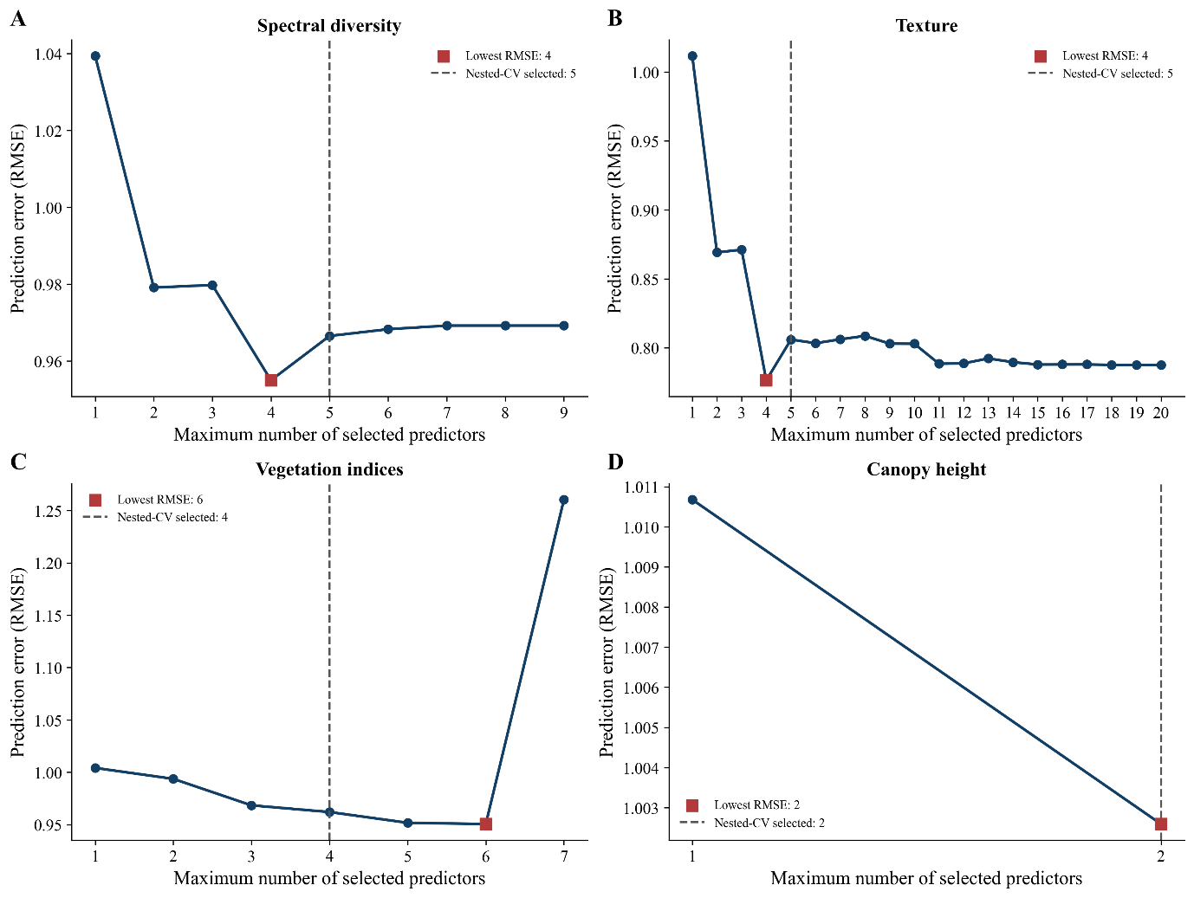
Figure S1. Cross-validation assessment of the optimal number of predictors retained in LASSO-based models for each group of UAV-derived metrics. Panels show the root mean squared error (RMSE) obtained when different maximum numbers of LASSO-ranked predictors were retained for (A) spectral diversity metrics, (B) texture features, (C) vegetation indices and (D) canopy-height metrics. Blue circles and lines represent cross-validated RMSE for each tested number of predictors. Red squares indicate the number of predictors associated with the lowest RMSE, and dashed vertical lines show the median number of predictors selected across folds by nested cross-validation.
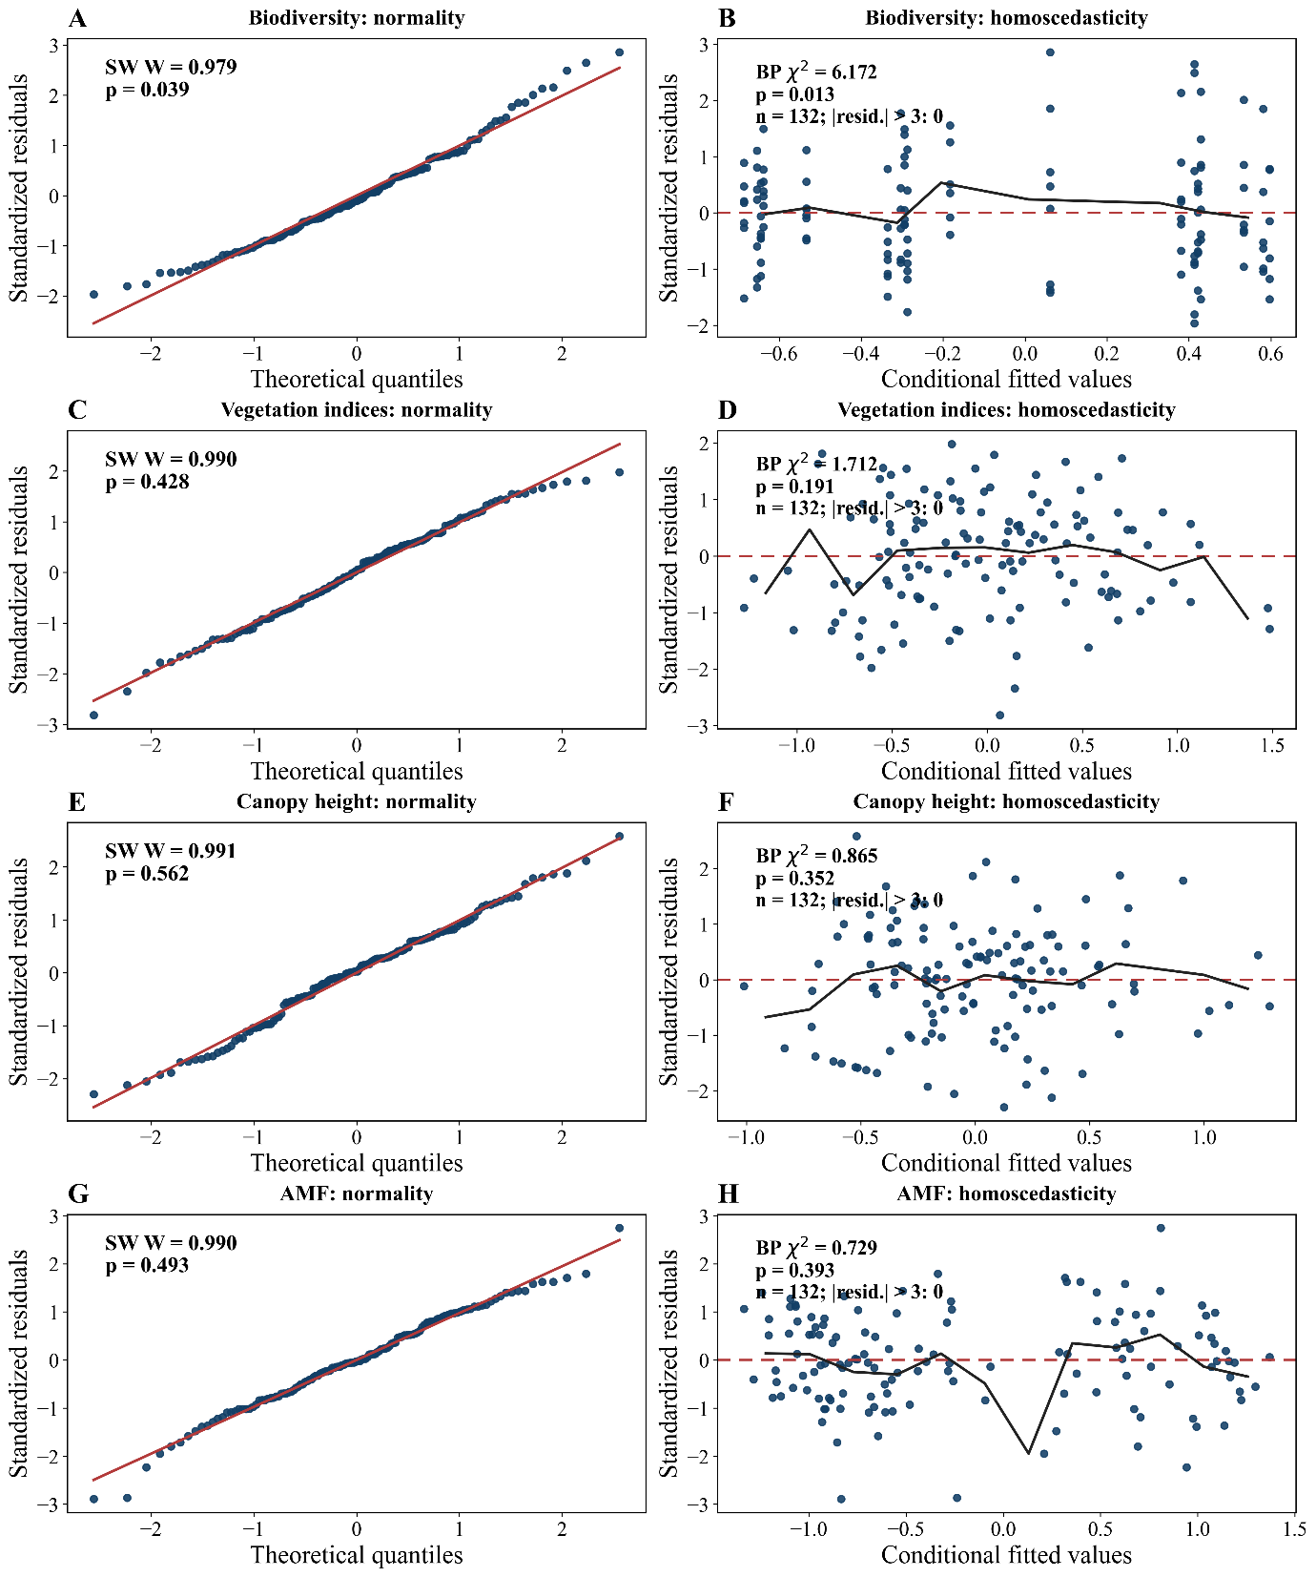
Figure S2. Residual diagnostics for the linear mixed-effects component models included in the piecewise structural equation model. Residual normality and homoscedasticity were evaluated for the component models representing biodiversity (A-B), vegetation indices (C-D), canopy height (E-F), and log-transformed arbuscular mycorrhizal fungal abundance (AMF; G-H). Normal quantile-quantile (Q-Q) plots (A, C, E, G) compare standardized residuals against theoretical normal quantiles. The red solid lines indicate the expected relationship under normally distributed residuals. Residual-versus-fitted plots (B, D, F, H) show standardized residuals against conditional fitted values. Red dashed lines indicate zero residuals, while black lines represent smoothed residual trends. Breusch-Pagan (BP) tests were used to assess heteroscedasticity, with chi-squared (χ²) statistics and associated p-values reported within each panel. The abbreviation “resid.” represents standardized residuals, and (n) represents the number of complete observations included in each component model.
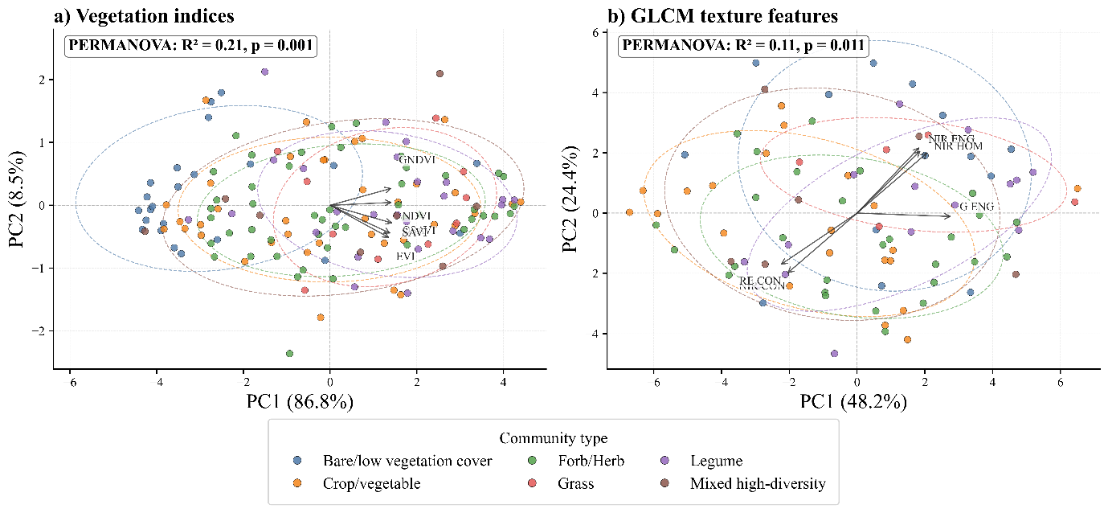
Figure S3. Principal component analysis (PCA) of unmanned aerial vehicle (UAV)-derived canopy metrics, grouped by field-defined vegetation community type. (a) Vegetation indices. (b) Grey-level co-occurrence matrix (GLCM) texture features. Points represent individual 1 m² quadrats, coloured by community type. Dashed ellipses indicate 95% confidence ellipses of group dispersion. Arrows show the strongest-loading UAV variables on the first two principal components. Permutational multivariate analysis of variance (PERMANOVA) results indicate the degree of multivariate separation among community types in each UAV feature space.
Table S5. Plant species-cover associations with log arbuscular mycorrhizal fungal abundance. Species-level models were fitted for plant species present in at least eight quadrats. For each species, log10-transformed AMF abundance was modelled as a function of species cover while accounting for garden identity and sampling month. Effect sizes represent the change in log10 AMF abundance per 10% increase in species cover. P-values were adjusted across species using the Benjamini-Hochberg false-discovery-rate procedure.
Species | Family | Status | n | Mean cover (%) | Effect per 10% cover | 95% CI | p | FDR p | Direction
Pisum sativum | Fabaceae | cultivated | 9 | 7.0 | -0.724 | -0.991 to -0.456 | <0.001 | <0.001 | Negative (FDR-significant)
Mentha × piperita | Lamiaceae | cultivated | 8 | 7.2 | 0.535 | 0.271 to 0.800 | <0.001 | 0.002 | Positive (FDR-significant)
Brassica oleracea | Brassicaceae | cultivated | 24 | 6.8 | -0.37 | -0.566 to -0.174 | <0.001 | 0.004 | Negative (FDR-significant)
Fragaria × ananassa | Rosaceae | cultivated | 28 | 19.8 | 0.087 | 0.039 to 0.135 | <0.001 | 0.006 | Positive (FDR-significant)
Erigeron annuus | Asteraceae | wild | 16 | 4.0 | 0.593 | 0.251 to 0.935 | <0.001 | 0.008 | Positive (FDR-significant)
Trifolium repens | Fabaceae | wild | 66 | 11.6 | 0.179 | 0.054 to 0.305 | 0.005 | 0.048 | Positive (FDR-significant)
Chenopodium album | Amaranthaceae | wild | 18 | 2.5 | -1.576 | -2.757 to -0.396 | 0.009 | 0.071 | Negative (nominal; not FDR-significant)
Erigeron canadensis | Asteraceae | wild | 8 | 2.5 | 1.206 | 0.091 to 2.320 | 0.034 | 0.238 | Positive (nominal; not FDR-significant)
Taraxacum sect Taraxacum sp | Asteraceae | wild | 93 | 4.5 | 0.14 | 0.000 to 0.280 | 0.050 | 0.297 | Positive (nominal; not FDR-significant)
Achillea millefolium | Asteraceae | wild | 32 | 5.4 | 0.257 | -0.003 to 0.518 | 0.053 | 0.297 | Positive (not significant)
Veronica arvensis | Plantaginaceae | wild | 15 | 2.1 | -2.731 | -5.766 to 0.303 | 0.078 | 0.396 | Negative (not significant)
Malva sp | Malvaceae | wild | 10 | 3.2 | 0.63 | -0.154 to 1.414 | 0.115 | 0.537 | Positive (not significant)
Stellaria media | Caryophyllaceae | wild | 23 | 2.2 | -1.099 | -2.534 to 0.335 | 0.133 | 0.544 | Negative (not significant)
Galinsoga parviflora | Asteraceae | wild | 13 | 18.2 | -0.113 | -0.261 to 0.036 | 0.137 | 0.544 | Negative (not significant)
Cucurbita pepo | Cucurbitaceae | cultivated | 8 | 18.4 | -0.168 | -0.400 to 0.064 | 0.155 | 0.544 | Negative (not significant)
Geranium sp | Geraniaceae | wild | 8 | 1.4 | 3.124 | -1.209 to 7.457 | 0.158 | 0.544 | Positive (not significant)
Sonchus sp | Asteraceae | wild | 9 | 1.6 | 1.262 | -0.520 to 3.043 | 0.165 | 0.544 | Positive (not significant)
Persicaria maculosa | Polygonaceae | wild | 13 | 3.0 | -0.493 | -1.234 to 0.248 | 0.192 | 0.581 | Negative (not significant)
Potentilla reptans | Rosaceae | wild | 22 | 3.8 | 0.105 | -0.056 to 0.266 | 0.201 | 0.581 | Positive (not significant)
Daucus sativus | Apiaceae | cultivated | 18 | 7.7 | 0.098 | -0.056 to 0.252 | 0.213 | 0.581 | Positive (not significant)
Note. AMF = arbuscular mycorrhizal fungi; CI = confidence interval; FDR = false discovery rate. Associations are observational and should not be interpreted as causal species effects

References
Gitelson, A., physiology, M.M.-J. of plant, 1994, undefined, 1994. Spectral reflectance changes associated with autumn senescence of Aesculus hippocastanum L. and Acer platanoides L. leaves. Spectral features and relation to. Elsevier 143, 286–292. https://doi.org/10.1016/S0176-1617(11)81633-0
Gitelson, A.A., Kaufman, Y.J., Merzlyak, M.N., 1996. Use of a green channel in remote sensing of global vegetation from EOS-MODIS. Remote Sens. Environ. 58, 289–298. https://doi.org/10.1016/S0034-4257(96)00072-7
Gitelson, A.A., Vina, A., Arkebauer, T.J., Rundquist, D.C., Keydan, G., Leavitt, B., 2003. Remote estimation of leaf area index and green leaf biomass in maize canopies. Wiley Online Libr. Gitelson, A Viña, TJ Arkebauer, DC Rundquist, G Keydan, B LeavittGeophysical Res. Lett. 2003•Wiley Online Libr. 30, 1248. https://doi.org/10.1029/2002GL016450
Haralick, R.M., Dinstein, I., Shanmugam, K., 1973. Textural Features for Image Classification. IEEE Trans. Syst. Man Cybern. SMC-3, 610–621. https://doi.org/10.1109/TSMC.1973.4309314
Huete, A., Didan, K., Miura, T., Rodriguez, E., … X.G.-R. sensing of, 2002, undefined, n.d. Overview of the radiometric and biophysical performance of the MODIS vegetation indices. Elsevier.
Huete, A.R., 1988. A soil-adjusted vegetation index (SAVI). Remote Sens. Environ. 25, 295–309. https://doi.org/10.1016/0034-4257(88)90106-X
Kruse, F.A., Lefkoff, A.B., Boardman, J.W., Heidebrecht, K.B., Shapiro, A.T., Barloon, P.J., Goetz, A.F.H., 1993. The spectral image processing system (SIPS)—interactive visualization and analysis of imaging spectrometer data. Remote Sens. Environ. 44, 145–163. https://doi.org/10.1016/0034-4257(93)90013-N
McElhinny, C., Gibbons, P., Brack, C., Bauhus, J., 2005. Forest and woodland stand structural complexity: Its definition and measurement. For. Ecol. Manage. 218, 1–24. https://doi.org/10.1016/j.foreco.2005.08.034
Rondeaux, G., Steven, M., Baret, F., 1996. Optimization of soil-adjusted vegetation indices. Remote Sens. Environ. 55, 95–107. https://doi.org/10.1016/0034-4257(95)00186-7
Rouse, J., Haas, R., Schell, J., Publ, D.D.-N.S., 1974, undefined, n.d. Monitoring vegetation systems in the Great Plains with ERTS. books.google.comJW Rouse, RH Haas, JA Schell, DW DeeringNASA Spec. Publ, 1974•books.google.com.
Shannon, C.E., 1948. A Mathematical Theory of Communication. Bell Syst. Tech. J. 27, 379–423. https://doi.org/10.1002/J.1538-7305.1948.TB01338.X
Valbuena, R., Packalén, P., Martín-Fernández, S., Maltamo, M., 2012. Diversity and equitability ordering profiles applied to study forest structure. For. Ecol. Manage. 276, 185–195. https://doi.org/10.1016/J.FORECO.2012.03.036
Wang, R., Gamon, J.A., Emmerton, C.A., Li, H., Nestola, E., Pastorello, G.Z., Menzer, O., 2016. Integrated analysis of productivity and biodiversity in a southern Alberta prairie. Remote Sens. 8, 1–20. https://doi.org/10.3390/rs8030214

