Supplements
Figure S1. Kaplan Meier estimates for freedom from target lesion revascularization over five years with corresponding numbers at risk. KM: Kaplan-Meier, SD: Standard deviation, TLR: Target lesion revascularization.
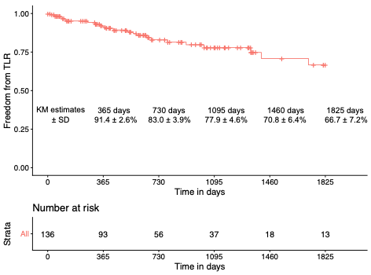

Figure S2. Kaplan-Meier analysis for overall survival stratified for clinical presentation at baseline over five years with corresponding risk table. KM: Kaplan-Meier, SD: Standard deviation, CLTI: Chronic limb threatening ischemia.
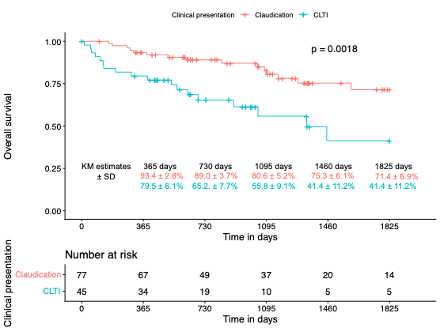

Table S1. Causes of death through 365 days of follow up.
Causes of death | Number of patients
Malignancy | 4
Sepsis/pneumonia | 5
Heart insufficiency | 1
Unknown | 4

