Supplementary Materials for

Targeting super elongation complex–driven RNA polymerase II elongation reduces plaque vulnerability

Karoline E. Kokot, Sebastian Reichardt, Christian Menedo, Stephan Erbe, Jasmin M. Kneuer, Kaylin C.A. Palm, Julian Hoba, Michael Andritschke, Mirko Katzmann, Annika Reuser, Moritz von Scheidt, Michal Mokry, Junjie Xiao, Bilal N. Sheikh, Nora Klöting, Ulrich Laufs and Jes-Niels Boeckel
Correspondence to: Boeckel@medizin.uni-leipzig.de

This PDF file includes:

Figures. S1 to S6
Tables S1 to S3
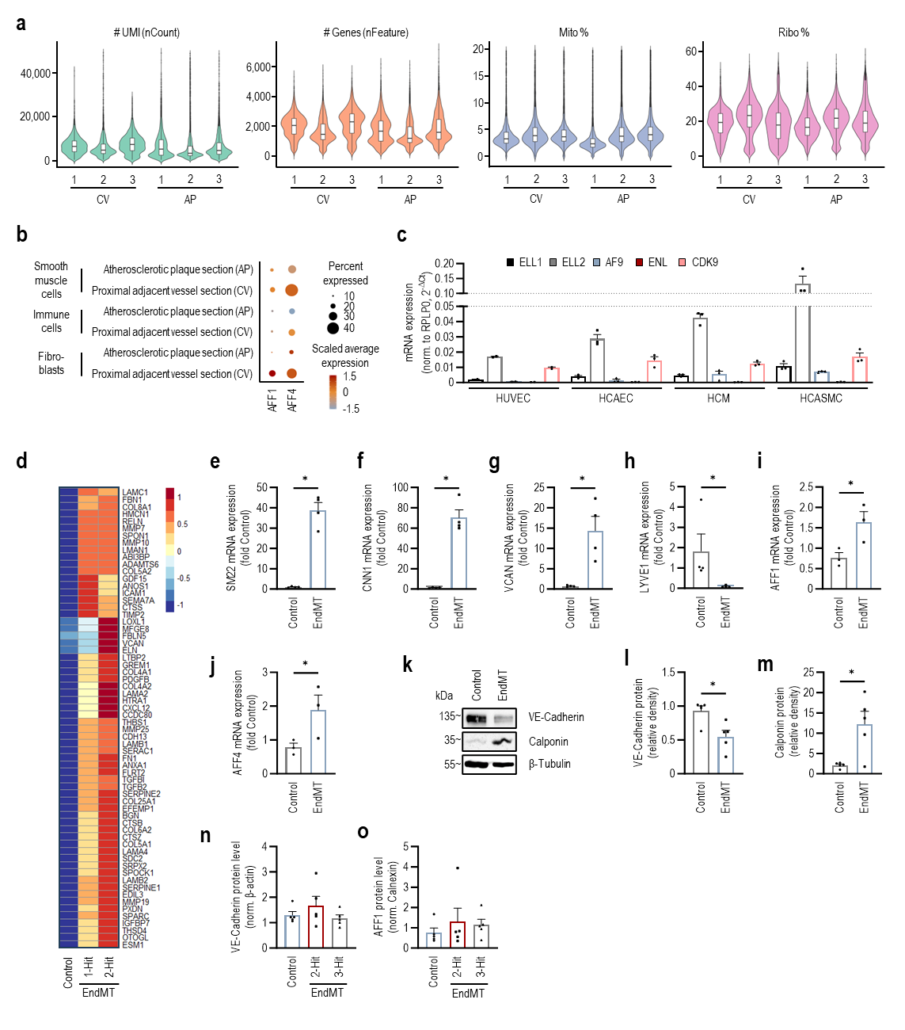
Figure. S1.

(a) Summary of detected UMI counts, features and mitochondrial and ribosomal gene fractions for the scRNA-seq carotid artery dataset (Proximal adjacent vessel section (CV): n = 3, Atherosclerotic plaque section (AP): n = 3). Human carotid artery plaques and proximal adjacent vessel sections (used as control) from the same patient were analyzed. (b) Dotplot showing gene expression profiles of AFF1 and AFF4 in smooth muscle cells, immune cells and fibroblasts of CV and AP sections (CV: n = 3, AP: n = 3). (c) mRNA expression of common proteins forming the SEC: ELL1, ELL2, AF9, ENL and CDK9 in HUVEC, HCAEC, HCM and HCASMC (n = 2-3). (d) Heatmap depicting expression of ECM-associated genes in RNA sequencing data of HCAEC under control conditions and undergoing EndMT (1-Hit, 2-Hit) cell culture model (n = 4). (e-h) Validation of EndMT in EndMT cell culture model. mRNA expression of mesenchymal markers (e) SM22, (f) CNN1, (g) VCAN and of the endothelial marker (h) LYVE1 in HUVECs and HUVECs undergoing EndMT (2-Hit model) was determined by qPCR (n = 4, e/f/g: t-test; h: Mann-Whitney test). (i) AFF1 mRNA expression and (j) AFF4 mRNA expression in EndMT samples compared to controls (n = 3, t-test). (k) Representative immunoblot depicting VE-Cadherin and Calponin protein levels under control and EndMT conditions. Quantification of (l) VE-Cadherin and (m) Calponin protein expression in HUVECs undergoing EndMT determined by immunoblotting (n=5, l: Mann-Whitney test, m: t-test). Quantification of (n) VE-Cadherin and (o) AFF1 protein level in HUVECs undergoing EndMT (2-Hit, 3-Hit) determined by immunoblotting normed to β-actin (n=5).

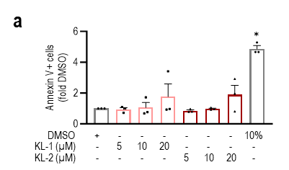

Figure. S2.

Annexin V-positive (+) HUVECs after treatment with increasing concentrations of KL-1 and KL-2 for 24 h determined by flow cytometry. 10% DMSO serves as a positive control (n = 3).

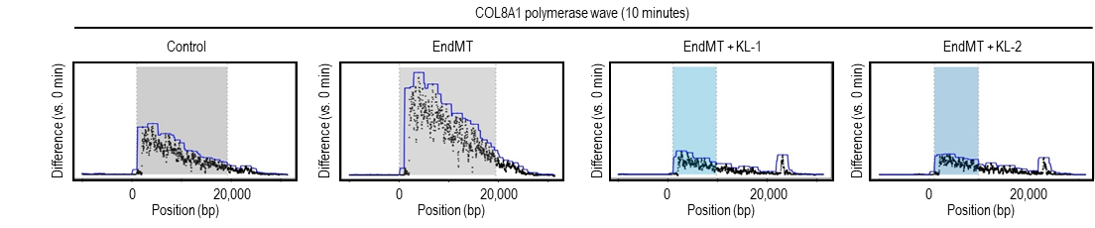

Figure. S3.
COL8A1 calculated using the Hidden Markov model with groHMM depicting the read changes between 10 and 0 minutes after EndMT induction with or without KL-1 and KL-2 inhibition.

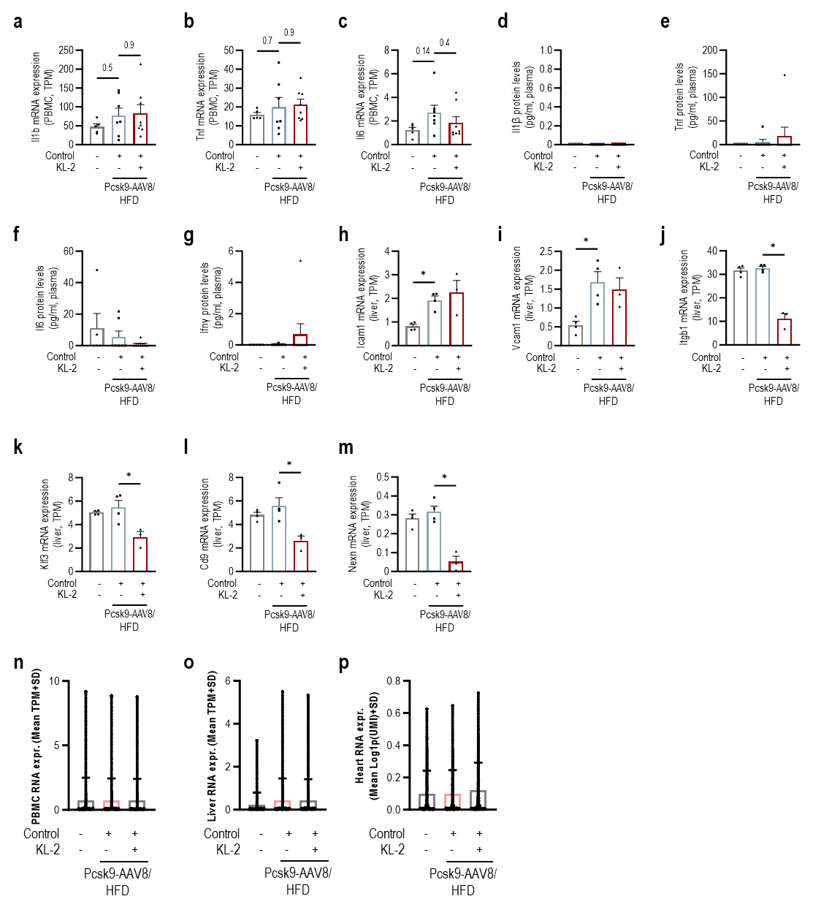

Figure. S4.
(a-c) mRNA expression of inflammation markers (a) Il1b, (b) Tnf and (c) Il6 in mice PBMC treated with Pcsk9-AAV8 (n = 7 (DMSO) vs. n = 8 (KL-2) or PBS after 20 weeks as analyzed by RNA seq. (Ordinary one-way ANOVA with Dunnett's multiple comparisons test). (d-g) Plasma protein levels of inflammation markers (d) Il-1β, (e) Tnf-α, (f) Il-6 and (g) Ifn-γ of atherosclerotic mice with or without KL-2 treatment determined by ELISA (n = 7 (DMSO) vs. n = 8 (KL-2). (h-m) Vascular inflammation marker (h) Icam1, (i) Vcam1 and SEC target genes (j) Itgb1, (k) Klf3, (l) Cd9 and (m) Nexn mRNA expression in livers of mice treated with Pcsk9-AAV8 (n = 4 (DMSO) vs. 3 (KL-2) or PBS after 20 weeks as analyzed by RNA seq.; One-way ANOVA with Dunnett's multiple comparisons test). Analysis of overall transcription in (n) peripheral blood mononuclear cells (PBMCs), (o) liver and (p) heart tissue of mice treated with Pcsk9-AAV8 and vehicle or KL-2.

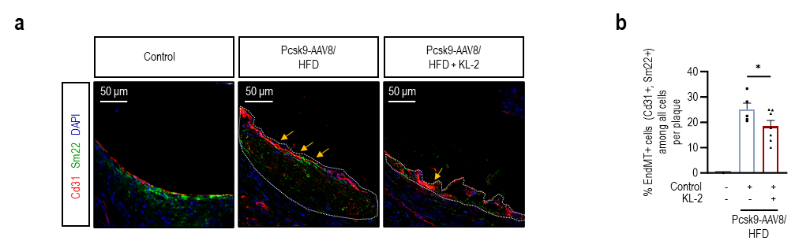

Figure. S5.

(a) Representative images and (b) quantification of EndMT-positive EC as indicated by Sm22+ Cd31+ cells in atherosclerotic plaques (n = 5-8, t-test). All bar graphs represent mean + SEM, * indicates P < 0.05.
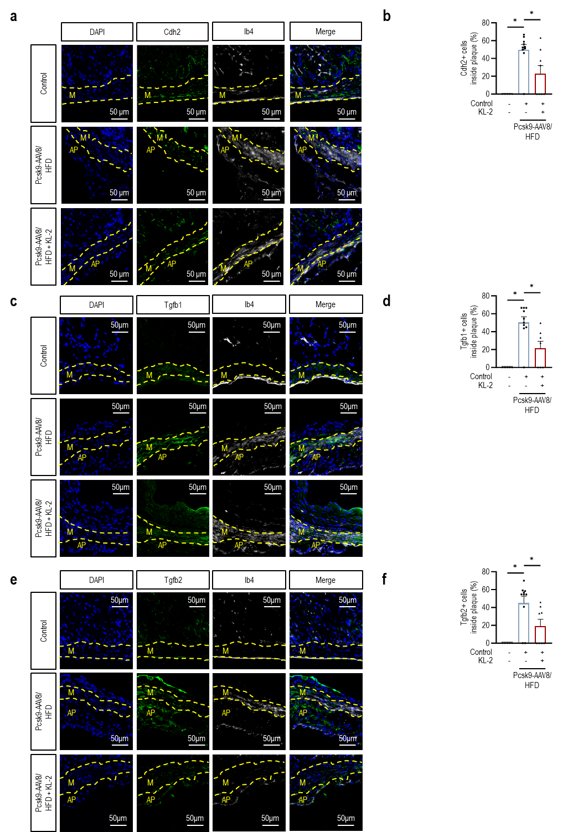

Figure. S6.

(a) Representative depiction of immunofluorescence staining of N-Cadherin (Cdh2) and Isolectin B4 in frozen aortic root sections and (b) quantification of Cdh2 positive cells in atherosclerotic plaques (n = 5-10, One way ANOVA, Dunnett’s multiple comparisons test). (c) Representative depiction of immunofluorescence staining of Tgf-β1 and Isolectin B4 in frozen aortic root sections and (d) quantification of Tgf-β1 positive cells in atherosclerotic plaques (n = 5-10, Kruskal-Wallis test with Dunn’s multiple comparisons test). (e) Representative depiction of immunofluorescence staining of Tgf-β2 and Isolectin B4 in frozen aortic root sections and (f) quantification of Tgf-β2 positive cells in atherosclerotic plaques (n = 5-10, One way ANOVA, Dunnett’s multiple comparisons test). All bar graphs represent mean + SEM, * indicates P < 0.05.

Table S1. Primer sequences

Name | Sequence (F+R) 5->3 | Species
RPLP0 | TCGACAATGGCAGCATCTAC | Human
RPLP0 | ATCCGTCTCCACAGACAAGG
CDH5 | ACGCCTCTGTCATGTACCAA | Human
CDH5 | ACGATCTCATACCTGGCCTG
VWF | GAGTACGCCCGGACCTGT | Human
VWF | TTCATTGATGTGCAGGCTCT
AFF1 | GCCAAGCTCACCAAACTGAAG | Human
AFF1 | AAAGGAGGCGGCCATGAATG
AFF2 | CAAAACCCAAGCGTCAGACA | Human
AFF2 | GGAGGGAGCAAGCAGATAGT
AFF3 | GGCCACCTCCACCAGTAATA | Human
AFF3 | GATGCATCAGAGAGGGGTGA
AFF4 | GAAAAGCACACGAGAGAGGC | Human
AFF4 | GGTTTCTTGCTCTCACTGGC
ELL1 | GACAAGGACGCGCTGGAT | Human
ELL1 | AGTCCTTCTGCACATCCTTG
ELL2 | CGAGAAAGAATGACCCAGGC | Human
ELL2 | GCTTGAGGTGCTTTCCGAAT
AF9 | CCCAATGATTCAGATGTGGAGG | Human
AF9 | TGGTCTGGGATGGTGTGAAG
ENL | GAGTTCCGGTACAAGCTCCT | Human
ENL | TGGTTTGGTCTTCTTGGGGT
CDK9 | GTGTTCAAGGCCAGGCAC | Human
CDK9 | GCAAGGCTGTAATGGGGAA
SM22 | AAGAATGATGGGCACTACCG | Human
SM22 | ATGACATGCTTTCCCTCCTG
CNN1 | CTGGCTGCAGCTTATTGATG | Human
CNN1 | CTGAGAGAGTGGATCGAGGG
LYVE1 | TTCCAGTGAGCCGACAGTTT | Human
LYVE1 | CTGGAATGCACGAGTTAGTCC
VCAN | ATGGATTCCGTTCTCCCCAG | Human
VCAN | CACTCTTTTGCAGCCTCCTC
B2m | TTCTGGTGCTTGTCTCACTGA | Mouse
B2m | CAGTATGTTCGGCTTCCCATTC
Eng | TGACGTTTACCACCAGCCA | Mouse
Eng | GTCTCCGTGCCATTTTGCTT

Table S2. Baseline patient data of the Athero-Express cohort

Baseline Table Athero-Express RNA Cohort
 | less vulnerable | more vulnerable | p-value
n = 1,048 | 703 | 345
Sex = male (%) | 509 (72.4) | 254 (73.6) | 0.732
Age (median [IQR]) | 70.00 [63.00, 75.00] | 70.00 [62.00, 76.00] | 0.963
Diabetes = yes (%) | 160 (23.3) | 61 (17.9) | 0.061
Smoking status = yes (%) | 239 (34.1) | 118 (34.6) | 0.938
Kidney function (%) |  |  | 0.825
Normal kidney function | 126 (18.4) | 70 (20.7)
CKD 2 (Mild) | 385 (56.1) | 185 (54.7)
CKD 3 (Moderate) | 163 (23.8) | 79 (23.4)
CKD 4 (Severe) | 11 (1.6) | 4 (1.2)
CKD 5 (Failure) | 1 (0.1) | 0 (0.0)
Statin use = yes (%) | 542 (77.2) | 282 (81.7) | 0.109
LDL cholesterol levels (mg/dL)  (median [IQR]) | 2.70 [2.00, 3.34] | 2.60 [2.00, 3.40] | 0.764
HDL cholesterol levels (mmol/L)  (median [IQR]) | 1.11 [0.91, 1.39] | 1.10 [0.89, 1.34] | 0.354
Total cholesterol levels (mg/dL)  (median [IQR]) | 4.64 [3.80, 5.46] | 4.54 [3.76, 5.51] | 0.803
Triglyceride levels (mmol/L)  (median [IQR]) | 1.31 [0.99, 1.81] | 1.41 [1.06, 2.10] | 0.045
Diastolic (median [IQR]) | 80.00 [70.25, 90.00] | 81.00 [70.75, 90.00] | 0.298
Systolic (median [IQR]) | 150.00 [135.00, 169.00] | 152.00 [135.00, 170.00] | 0.302
eGFR (mL/min/1.73 m²)  (mean (SD)) | 72.72 (20.16) | 73.49 (20.90) | 0.572
BMI (kg/m²) (median [IQR]) | 26.20 [24.09, 28.73] | 26.09 [24.15, 28.31] | 0.526
Plasma hsCRP (median [IQR]) | 1.92 [0.92, 4.47] | 1.75 [0.70, 4.31] | 0.339
CAD history = yes (%) | 237 (33.8) | 99 (28.7) | 0.114
Major events (endpoints) (%) | 86 (12.4) | 45 (13.1) | 0.816
Symptomatic (%) | 438 (65.8) | 248 (77.5) | <0.001
Plaque macrophage content = moderate/heavy (%) | 339 (52.2) | 201 (66.3) | <0.001
Plaque SMC content =  moderate/heavy (%) | 431 (66.2) | 204 (66.9) | 0.894
Plaque fat content = >10% (%) | 466 (69.8) | 266 (83.9) | <0.001
Plaque collagen content =  moderate/heavy (%) | 492 (79.7) | 226 (78.7) | 0.798
CKD, chronic kidney disease; HDL, high-density lipoprotein; IQR, interquartile range; BMI, body mass index; CAD, coronary artery disease; SMC, smooth muscle cell

Table S3. Statistical tests
Figure | Panel | Biological n | Independent replicate definition | Quantification unit | statistical test used | exact p-value
1 | m/n/p/q | Control: 4 | independently treated cell cultures | one bulk RNA-seq sample per biological replicate | negative binomial exact test | p<0.05
1 | m/n/p/q | EndMT (1-Hit): 4
1 | m/n/p/q | EndMT (2-Hit): 4
1 | r | Control: 4 | independently treated cell cultures | one bulk RNA-seq sample per biological replicate | One-way ANOVA with Dunnett's multiple comparisons test, with a single pooled variance | Control vs. 1-Hit: 0.0062
1 | r | EndMT, 1-Hit: 4 | independently treated cell cultures | one bulk RNA-seq sample per biological replicate |  | Control vs. 2-Hit: 0.0136
1 | r | EndMT, 2-Hit: 4 | independently treated cell cultures | one bulk RNA-seq sample per biological replicate
1 | s | Control: 4 | independently treated cell cultures | one bulk RNA-seq sample per biological replicate | One-way ANOVA with Dunnett's multiple comparisons test, with a single pooled variance | Control vs. 1-Hit: 0.0221
1 | s | EndMT, 1-Hit: 4 | independently treated cell cultures | one bulk RNA-seq sample per biological replicate |  | Control vs. 2-Hit: 0.0244
1 | s | EndMT, 2-Hit: 4 | independently treated cell cultures | one bulk RNA-seq sample per biological replicate
1 | v | Control: 5 | independently treated cell cultures | one immunoblot sample per biological replicate | One-way ANOVA with Dunnett's multiple comparisons test, with a single pooled variance | Control vs. 2-Hit: 0.0324
1 | v | EndMT, 2-Hit: 5 | independently treated cell cultures | one immunoblot sample per biological replicate |  | Control vs. 3-Hit: 0.0075
1 | v | EndMT, 3-Hit: 5 | independently treated cell cultures | one immunoblot sample per biological replicate
1 | w | Control: 5 | independently treated cell cultures | one immunoblot sample per biological replicate | One-way ANOVA with Dunnett's multiple comparisons test, with a single pooled variance | Control vs. 2-Hit: 0.0375
1 | w | EndMT, 2-Hit: 5 | independently treated cell cultures | one immunoblot sample per biological replicate
1 | w | EndMT, 3-Hit: 5 | independently treated cell cultures | one immunoblot sample per biological replicate
Figure | Panel | Biological n | Independent replicate definition | Quantification unit | statistical test used | exact p-value
2 | b | Control: 4 | independently treated cell cultures | one immunoblot sample and image per biological replicate | One-way ANOVA with Tukey's multiple comparisons test, with a single pooled variance | DMSO vs. KL-1: 0.0424
2 | b | KL-1: 4 | independently treated cell cultures | one immunoblot sample and image per biological replicate |  | DMSO vs. KL-2: 0.0096
2 | b | KL-2: 4 | independently treated cell cultures | one immunoblot sample and image per biological replicate
2 | d | Control: 4 | independently treated cell cultures | one immunoblot sample and image per biological replicate | One-way ANOVA with Tukey's multiple comparisons test, with a single pooled variance | Control vs. KL-1: 0.0460
2 | d | KL-1: 4 | independently treated cell cultures | one immunoblot sample and image per biological replicate |  | Control vs. KL-2: 0.0138
2 | d | KL-2: 4 | independently treated cell cultures | one immunoblot sample and image per biological replicate
2 | f | DMSO: 3 | independently treated cell cultures | one flow cytometry sample per biological replicate | One-way ANOVA with Tukey's multiple comparisons test, with a single pooled variance | All vs. DMSO (10%): < 0.001
2 | f | KL-1 (20 µM): 3 | independently treated cell cultures | one flow cytometry sample per biological replicate
2 | f | KL-1 (20 µM): 3 | independently treated cell cultures | one flow cytometry sample per biological replicate
2 | f | KL-1 (20 µM): 3 | independently treated cell cultures | one flow cytometry sample per biological replicate
2 | f | KL-2 (20 µM): 3 | independently treated cell cultures | one flow cytometry sample per biological replicate
2 | f | KL-2 (20 µM): 3 | independently treated cell cultures | one flow cytometry sample per biological replicate
2 | f | KL-2 (20 µM): 3 | independently treated cell cultures | one flow cytometry sample per biological replicate
2 | f | DMSO (10%): 3 | independently treated cell cultures | one flow cytometry sample per biological replicate
2 | g | DMSO: 3 | independently treated cell cultures | one cDNA sample per biological replicate | One-way ANOVA with Tukey's multiple comparisons test, with a single pooled variance | DMSO vs. EndMT + DMSO: 0.0176
2 | g | EndMT + DMSO: 3 | independently treated cell cultures | one cDNA sample per biological replicate |  | EndMT + DMSO vs. EndMT + KL-1 (5 µM): 0.057
2 | g | EndMT + KL-1 (2.5 µM): 3 | independently treated cell cultures | one cDNA sample per biological replicate |  | EndMT + DMSO vs. EndMT + KL-1 (10 µM): 0.039
2 | g | EndMT + KL-1 (5 µM): 3 | independently treated cell cultures | one cDNA sample per biological replicate |  | EndMT + DMSO vs. EndMT + KL-2 (5 µM): 0.0097
2 | g | EndMT + KL-1 (10 µM): 3 | independently treated cell cultures | one cDNA sample per biological replicate |  | EndMT + DMSO vs. EndMT + KL-1 (10 µM): 0.0045
2 | g | EndMT + KL-2 (2.5 µM): 3 | independently treated cell cultures | one cDNA sample per biological replicate
2 | g | EndMT + KL-2 (5 µM): 3 | independently treated cell cultures | one cDNA sample per biological replicate
2 | g | EndMT + KL-2 (10 µM): 3 | independently treated cell cultures | one cDNA sample per biological replicate
2 | h | DMSO: 4 | independently treated cell cultures | one cDNA sample per biological replicate | One-way ANOVA with Tukey's multiple comparisons test, with a single pooled variance | DMSO vs. EndMT + DMSO: 0.0293
2 | h | EndMT + DMSO: 4 | independently treated cell cultures | one cDNA sample per biological replicate |  | EndMT + DMSO vs. EndMT + KL-1: 0.0391
2 | h | EndMT + ActD (1:1000): 4 | independently treated cell cultures | one cDNA sample per biological replicate |  | EndMT + DMSO vs. EndMT + KL-2: 0.0473
2 | h | EndMT + DRB (1:1000): 4 | independently treated cell cultures | one cDNA sample per biological replicate
2 | h | EndMT + KL-1: 4 | independently treated cell cultures | one cDNA sample per biological replicate
2 | h | EndMT + KL-2: 3 | independently treated cell cultures | one cDNA sample per biological replicate
2 | i | EndMT + DMSO: 3 | independently treated cell cultures | one cDNA sample per biological replicate | One-way ANOVA with Dunnett's multiple comparisons test, with a single pooled variance | EndMT + DMSO vs. EndMT + KL-1: 0.0005
2 | i | EndMT + KL-1: 3 | independently treated cell cultures | one cDNA sample per biological replicate |  | EndMT + DMSO vs. EndMT + KL-2: 0.0005
2 | i | EndMT + KL-2: 3 | independently treated cell cultures | one cDNA sample per biological replicate
2 | j | EndMT + DMSO: 3 | independently treated cell cultures | one cDNA sample per biological replicate | One-way ANOVA with Dunnett's multiple comparisons test, with a single pooled variance | EndMT + DMSO vs. EndMT + KL-1: 0.0098
2 | j | EndMT + KL-1: 3 | independently treated cell cultures | one cDNA sample per biological replicate |  | EndMT + DMSO vs. EndMT + KL-2: 0.0089
2 | j | EndMT + KL-2: 3 | independently treated cell cultures | one cDNA sample per biological replicate
2 | k | EndMT + DMSO: 3 | independently treated cell cultures | one cDNA sample per biological replicate | Kruskal-Wallis test with Dunn's multiple comparisons test | ns
2 | k | EndMT + KL-1: 3 | independently treated cell cultures | one cDNA sample per biological replicate | Kruskal-Wallis test with Dunn's multiple comparisons test
2 | k | EndMT + KL-2: 3 | independently treated cell cultures | one cDNA sample per biological replicate | Kruskal-Wallis test with Dunn's multiple comparisons test
2 | m | Control: 5 | independently treated cell cultures | one immunoblot sample and image per biological replicate | One-way ANOVA with Tukey's multiple comparisons test, with a single pooled variance | Control vs. EndMT, 2-Hit: <0.0001
2 | m | EndMT, 2-Hit: 5 | independently treated cell cultures | one immunoblot sample and image per biological replicate |  | Control vs. EndMT, 3-Hit: <0.0001
2 | m | EndMT, 2-Hit + KL-1: 5 | independently treated cell cultures | one immunoblot sample and image per biological replicate |  | EndMT, 2-Hit vs. EndMT, 2-Hit + KL-1: <0.0001
2 | m | EndMT, 2-Hit + KL-2: 5 | independently treated cell cultures | one immunoblot sample and image per biological replicate |  | EndMT, 2-Hit vs. EndMT, 2-Hit + KL-2: <0.0001
2 | m | EndMT, 3-Hit: 5 | independently treated cell cultures | one immunoblot sample and image per biological replicate |  | EndMT, 3-Hit vs. EndMT, 3-Hit + KL-1: <0.0001
2 | m | EndMT, 3-Hit + KL-1: 5 | independently treated cell cultures | one immunoblot sample and image per biological replicate |  | EndMT, 3-Hit vs. EndMT, 3-Hit + KL-2: <0.0001
2 | m | EndMT, 3-Hit + KL-2: 5 | independently treated cell cultures | one immunoblot sample and image per biological replicate
2 | n | pcDNA: 6 | independently treated cell cultures | one cDNA sample per biological replicate | t-test | pcDNA vs. AFF4: 0.0070
2 | n | AFF4: 6 | independently treated cell cultures | one cDNA sample per biological replicate | t-test
2 | o | pcDNA: 6 | independently treated cell cultures | one cDNA sample per biological replicate | t-test | pcDNA vs. AFF4: 0.0287
2 | o | AFF4: 6 | independently treated cell cultures | one cDNA sample per biological replicate | t-test
2 | p | pcDNA: 5 | independently treated cell cultures | one cDNA sample per biological replicate | t-test | pcDNA vs. AFF4: 0.0239
2 | p | AFF4: 5 | independently treated cell cultures | one cDNA sample per biological replicate | t-test
2 | q | EndMT + SiScrG: 4 | independently treated cell cultures | one cDNA sample per biological replicate | t-test | EndMT + SiScrG vs. EndMT + siAFF1: 0.0004
2 | q | EndMT + siAFF1: 4 | independently treated cell cultures | one cDNA sample per biological replicate | t-test
2 | r | Control: 4 | independently treated cell cultures | one cDNA sample per biological replicate | One-way ANOVA with Tukey's multiple comparisons test, with a single pooled variance | Control vs. EndMT + SiScrG: < 0.0001
2 | r | EndMT + SiScrG: 4 | independently treated cell cultures | one cDNA sample per biological replicate |  | EndMT + SiScrG vs. EndMT + siAFF1: 0.0028
2 | r | EndMT + siAFF1: 4 | independently treated cell cultures | one cDNA sample per biological replicate
2 | s | Control: 4 | independently treated cell cultures | one cDNA sample per biological replicate | One-way ANOVA with Tukey's multiple comparisons test, with a single pooled variance | Control vs. EndMT + SiScrG: 0.0004
2 | s | EndMT + SiScrG: 4 | independently treated cell cultures | one cDNA sample per biological replicate |  | EndMT + SiScrG vs. EndMT + siAFF1: 0.0342
2 | s | EndMT + siAFF1: 4 | independently treated cell cultures | one cDNA sample per biological replicate
2 | t | EndMT + SiScrG: 4 | independently treated cell cultures | one cDNA sample per biological replicate | t-test | EndMT + SiScrG vs. EndMT + siAFF4: 0.0013
2 | t | EndMT + siAFF4: 4 | independently treated cell cultures | one cDNA sample per biological replicate | t-test
2 | u | Control: 4 | independently treated cell cultures | one cDNA sample per biological replicate | One-way ANOVA with Tukey's multiple comparisons test, with a single pooled variance | Control vs. EndMT + SiScrG: < 0.0001
2 | u | EndMT + SiScrG: 4 | independently treated cell cultures | one cDNA sample per biological replicate |  | EndMT + SiScrG vs. EndMT + siAFF4: 0.0028
2 | u | EndMT + siAFF4: 4 | independently treated cell cultures | one cDNA sample per biological replicate
2 | v | Control: 4 | independently treated cell cultures | one cDNA sample per biological replicate | One-way ANOVA with Tukey's multiple comparisons test, with a single pooled variance | Control vs. EndMT + SiScrG: 0.0005
2 | v | EndMT + SiScrG: 4 | independently treated cell cultures | one cDNA sample per biological replicate |  | EndMT + SiScrG vs. EndMT + siAFF4: 0.0092
2 | v | EndMT + siAFF4: 4 | independently treated cell cultures | one cDNA sample per biological replicate
Figure | Panel | Biological n | Independent replicate definition | Quantification unit | statistical test used | exact p-value
4 | b | Control: 934 (genes) | independently treated cell cultures | one 4sU-seq sample per biological replicate | Friedman test with Dunn's multiple comparisons test | Control vs. EndMT: < 0.0001
4 | b | EndMT + DMSO: 934 (genes) | independently treated cell cultures | one 4sU-seq sample per biological replicate | Friedman test with Dunn's multiple comparisons test | EndMT vs. EndMT + KL-1: < 0.0001
4 | b | EndMT + KL-1: 934 (genes) | independently treated cell cultures | one 4sU-seq sample per biological replicate | Friedman test with Dunn's multiple comparisons test | EndMT vs. EndMT + KL-2: < 0.0001
4 | b | EndMT + KL-2: 934 (genes) | independently treated cell cultures | one 4sU-seq sample per biological replicate | Friedman test with Dunn's multiple comparisons test
4 | e | Control: 934 (genes) | independently treated cell cultures | one 4sU-seq sample per biological replicate | Friedman test with Dunn's multiple comparisons test | Control vs. EndMT: < 0.0001
4 | e | EndMT + DMSO: 934 (genes) | independently treated cell cultures | one 4sU-seq sample per biological replicate | Friedman test with Dunn's multiple comparisons test | EndMT vs. EndMT + KL-1: < 0.0001
4 | e | EndMT + KL-1: 934 (genes) | independently treated cell cultures | one 4sU-seq sample per biological replicate | Friedman test with Dunn's multiple comparisons test | EndMT vs. EndMT + KL-2: < 0.0001
4 | e | EndMT + KL-2: 934 (genes) | independently treated cell cultures | one 4sU-seq sample per biological replicate | Friedman test with Dunn's multiple comparisons test
4 | h | Control: 1 | independently treated cell cultures | one 4sU-seq sample per biological replicate | Ranked-GSEA | p<0.05
4 | h | EndMT + DMSO: 1
4 | j | IP: IgG: 4 | independently treated cell cultures | one immunoblot sample and image per biological replicate | t-test | IP: IgG vs. IP: pSMAD2/3: 0.0309
4 | j | IP: pSMAD2/3: 4 | independently treated cell cultures | one immunoblot sample and image per biological replicate | t-test
4 | k | IP: IgG: 4 | independently treated cell cultures | one immunoblot sample and image per biological replicate | Mann-Whitney test | IP: IgG vs. IP: pSMAD2/3: 0.0286
4 | k | IP: pSMAD2/3: 4 | independently treated cell cultures | one immunoblot sample and image per biological replicate | Mann-Whitney test
4 | m | IP: IgG: 4 | independently treated cell cultures | one immunoblot sample and image per biological replicate | Mann-Whitney test | IP: IgG vs. IP: pCDK9: 0.0286
4 | m | IP: pCDK9: 4 | independently treated cell cultures | one immunoblot sample and image per biological replicate | Mann-Whitney test
4 | n | IP: IgG: 4 | independently treated cell cultures | one immunoblot sample and image per biological replicate | t-test | IP: IgG vs. IP: pCDK9: 0.0146
4 | n | IP: pCDK9: 4 | independently treated cell cultures | one immunoblot sample and image per biological replicate | t-test
4 | o | IP: IgG: 4 | independently treated cell cultures | one immunoblot sample and image per biological replicate | t-test | IP: IgG vs. IP: pCDK9: 0.0031
4 | o | IP: pCDK9: 4 | independently treated cell cultures | one immunoblot sample and image per biological replicate | t-test
4 | q | IP: IgG: 4 | independently treated cell cultures | one immunoblot sample and image per biological replicate | t-test | IP: IgG vs. IP: pAFF4: 0.0151
4 | q | IP: AFF4: 4 | independently treated cell cultures | one immunoblot sample and image per biological replicate | t-test
4 | r | IP: IgG: 4 | independently treated cell cultures | one immunoblot sample and image per biological replicate | t-test | IP: IgG vs. IP: pAFF4: 0.0109
4 | r | IP: AFF4: 4 | independently treated cell cultures | one immunoblot sample and image per biological replicate | t-test
4 | s | IP: IgG: 4 | independently treated cell cultures | one immunoblot sample and image per biological replicate | t-test | IP: IgG vs. IP: pAFF4: 0.0192
4 | s | IP: AFF4: 4 | independently treated cell cultures | one immunoblot sample and image per biological replicate | t-test
Figure | Panel | Biological n | Independent replicate definition | Quantification unit | statistical test used | exact p-value
5 | b | DMSO: 29 | independently treated organoids | one count per organoid at baseline and 24 h (EndMT induction) | One-way ANOVA with Dunnett's multiple comparisons test, with a single pooled variance | DMSO vs. EndMT + DMSO: < 0.0001
5 | b | EndMT + DMSO: 26 | independently treated organoids |  |  | EndMT vs. EndMT + KL-1: 0.0005
5 | b | EndMT + KL-1: 30 | independently treated organoids |  |  | EndMT vs. EndMT + KL-2: < 0.0001
5 | b | EndMT + KL-2: 27 | independently treated organoids
5 | c | DMSO: 29 | independently treated organoids | one count per organoid at baseline and 48 h (EndMT induction) | One-way ANOVA with Dunnett's multiple comparisons test, with a single pooled variance | DMSO vs. EndMT + DMSO: < 0.0001
5 | c | EndMT + DMSO: 26 | independently treated organoids |  |  | EndMT vs. EndMT + KL-1: 0.0159
5 | c | EndMT + KL-1: 30 | independently treated organoids |  |  | EndMT vs. EndMT + KL-2: < 0.0001
5 | c | EndMT + KL-2: 27 | independently treated organoids
5 | d | DMSO: 29 | independently treated organoids | one count per organoid at baseline and 72 h (EndMT induction) | One-way ANOVA with Dunnett's multiple comparisons test, with a single pooled variance | DMSO vs. EndMT + DMSO: < 0.0001
5 | d | EndMT + DMSO: 26 | independently treated organoids |  |  | EndMT vs. EndMT + KL-1: 0.0187
5 | d | EndMT + KL-1: 30 | independently treated organoids |  |  | EndMT vs. EndMT + KL-2: < 0.0001
5 | d | EndMT + KL-2: 27 | independently treated organoids
5 | f | DMSO: 5 | independently treated organoids | one organoid and image per biological replicate | One-way ANOVA with Dunnett's multiple comparisons test, with a single pooled variance | DMSO vs. EndMT + DMSO: 0.0004
5 | f | EndMT + DMSO: 5 | independently treated organoids | one organoid and image per biological replicate |  | EndMT vs. EndMT + KL-1: < 0.0001
5 | f | EndMT + KL-1: 5 | independently treated organoids | one organoid and image per biological replicate |  | EndMT vs. EndMT + KL-2: 0.0002
5 | f | EndMT + KL-2: 5 | independently treated organoids | one organoid and image per biological replicate
5 | h | DMSO: 4 | independently treated cells in collagen gel | one cell collagen gel and image per biological replicate | One-way ANOVA with Dunnett's multiple comparisons test, with a single pooled variance | DMSO vs. EndMT + DMSO: 0.0073
5 | h | EndMT + DMSO: 4 | independently treated cells in collagen gel | one cell collagen gel and image per biological replicate |  | EndMT vs. EndMT + KL-1: 0.0088
5 | h | EndMT + KL-1: 4 | independently treated cells in collagen gel | one cell collagen gel and image per biological replicate |  | EndMT vs. EndMT + KL-2: < 0.0001
5 | h | EndMT + KL-2: 4 | independently treated cells in collagen gel | one cell collagen gel and image per biological replicate
5 | i | Control: 28 | independently treated organoids | one count per organoid at baseline and 24 h (EndMT induction) | One-way ANOVA with Dunnett's multiple comparisons test, with a single pooled variance | Control vs. EndMT + SiScrG: < 0.0001
5 | i | EndMT + SiScrG: 32 | independently treated organoids |  |  | EndmT + SiScrG vs. EndMT + siEndoglin: 0.0146
5 | i | EndMT + siEndoglin: 24 | independently treated organoids
5 | j | Control: 28 | independently treated organoids | one count per organoid at baseline and 48 h (EndMT induction) | One-way ANOVA with Dunnett's multiple comparisons test, with a single pooled variance | Control vs. EndMT + SiScrG: < 0.0001
5 | j | EndMT + SiScrG: 32 | independently treated organoids |  |  | EndmT + SiScrG vs. EndMT + siEndoglin: 0.0339
5 | j | EndMT + siEndoglin: 24 | independently treated organoids
5 | k | Control: 28 | independently treated organoids | one count per organoid at baseline and 72 h (EndMT induction) | One-way ANOVA with Dunnett's multiple comparisons test, with a single pooled variance | Control vs. EndMT + SiScrG: < 0.0001
5 | k | EndMT + SiScrG: 32 | independently treated organoids |  |  | EndmT + SiScrG vs. EndMT + siEndoglin: 0.0001
5 | k | EndMT + siEndoglin: 24 | independently treated organoids
5 | m | Control: 5 | independently treated organoids | one organoid and image per biological replicate | One-way ANOVA with Dunnett's multiple comparisons test, with a single pooled variance | Control vs. EndMT + SiScrG: 0.0048
5 | m | EndMT + SiScrG: 5 | independently treated organoids | one organoid and image per biological replicate |  | EndmT + SiScrG vs. EndMT + siEndoglin: 0.0325
5 | m | EndMT + siEndoglin: 5 | independently treated organoids | one organoid and image per biological replicate
5 | o | Control: 4 | independently treated cells in collagen gel | one cell collagen gel and image per biological replicate | One-way ANOVA with Dunnett's multiple comparisons test, with a single pooled variance | Control vs. EndMT + SiScrG: < 0.0001
5 | o | EndMT + SiScrG: 4 | independently treated cells in collagen gel | one cell collagen gel and image per biological replicate |  | EndmT + SiScrG vs. EndMT + siEndoglin: < 0.0001
5 | o | EndMT + siEndoglin: 4 | independently treated cells in collagen gel | one cell collagen gel and image per biological replicate
Figure | Panel | Biological n | Independent replicate definition | Quantification unit | statistical test used | exact p-value
6 | c | Normal Chow: 6 | independently treated animals | one serum per biological replicate | One-way ANOVA with Dunnett's multiple comparisons test, with a single pooled variance | Normal Chow vs. Pcsk9-AAV8/HFD + DMSO: 0.0002
6 | c | Pcsk9-AAV8/HFD + DMSO: 7 | independently treated animals | one serum per biological replicate |  | Normal Chow vs. Pcsk9-AAV8/HFD + KL-2: < 0.0001
6 | c | Pcsk9-AAV8/HFD + KL-2: 8 | independently treated animals | one serum per biological replicate
6 | e | Normal Chow: 7 | independently treated animals | one aorta and image per biological replicate | One-way ANOVA with Dunnett's multiple comparisons test, with a single pooled variance | Normal Chow vs. Pcsk9-AAV8/HFD + DMSO: 0.0011
6 | e | Pcsk9-AAV8/HFD + DMSO: 11 | independently treated animals | one aorta and image per biological replicate |  | Pcsk9-AAV8/HFD + DMSO vs. Pcsk9-AAV8/HFD + KL-2: 0.0030
6 | e | Pcsk9-AAV8/HFD + KL-2: 7 | independently treated animals | one aorta and image per biological replicate
6 | g | Normal Chow: 8 | independently treated animals | one aortic root section and image per biological replicate | One-way ANOVA with Dunnett's multiple comparisons test, with a single pooled variance | Normal Chow vs. Pcsk9-AAV8/HFD + DMSO: 0.0005
6 | g | Pcsk9-AAV8/HFD + DMSO: 12 | independently treated animals | one aortic root section and image per biological replicate |  | Pcsk9-AAV8/HFD + DMSO vs. Pcsk9-AAV8/HFD + KL-2: 0.0041
6 | g | Pcsk9-AAV8/HFD + KL-2: 6 | independently treated animals | one aortic root section and image per biological replicate
6 | h | Normal Chow: 10 | independently treated animals | one aortic root section and image per biological replicate | Kruskal-Wallis test with Dunn's multiple comparisons test | Normal Chow vs. Pcsk9-AAV8/HFD + DMSO: 0.0008
6 | h | Pcsk9-AAV8/HFD + DMSO: 12 | independently treated animals | one aortic root section and image per biological replicate | Kruskal-Wallis test with Dunn's multiple comparisons test | Pcsk9-AAV8/HFD + DMSO vs. Pcsk9-AAV8/HFD + KL-2: 0.0237
6 | h | Pcsk9-AAV8/HFD + KL-2: 8 | independently treated animals | one aortic root section and image per biological replicate | Kruskal-Wallis test with Dunn's multiple comparisons test
6 | j | Normal Chow: 5 | independently treated animals | one aortic root section and image per biological replicate | Kruskal-Wallis test with Dunn's multiple comparisons test | Normal Chow vs. Pcsk9-AAV8/HFD + DMSO: 0.0001
6 | j | Pcsk9-AAV8/HFD + DMSO: 11 | independently treated animals | one aortic root section and image per biological replicate | Kruskal-Wallis test with Dunn's multiple comparisons test | Pcsk9-AAV8/HFD + DMSO vs. Pcsk9-AAV8/HFD + KL-2: 0.0337
6 | j | Pcsk9-AAV8/HFD + KL-2: 7 | independently treated animals | one aortic root section and image per biological replicate | Kruskal-Wallis test with Dunn's multiple comparisons test
6 | m | Normal Chow: 6 | independently treated animals | one serum per biological replicate | Kruskal-Wallis test with Dunn's multiple comparisons test | Normal Chow vs. Pcsk9-AAV8/HFD + DMSO: < 0.0001
6 | m | Pcsk9-AAV8/HFD + DMSO: 6 | independently treated animals | one serum per biological replicate | Kruskal-Wallis test with Dunn's multiple comparisons test | Normal Chow vs. Pcsk9-AAV8/HFD + KL-2: < 0.0001
6 | m | Pcsk9-AAV8/HFD + KL-2: 6 | independently treated animals | one serum per biological replicate | Kruskal-Wallis test with Dunn's multiple comparisons test
6 | o | Normal Chow: 7 | independently treated animals | one aorta and image per biological replicate | Kruskal-Wallis test with Dunn's multiple comparisons test | Normal Chow vs. Pcsk9-AAV8/HFD + DMSO: 0.0002
6 | o | Pcsk9-AAV8/HFD + DMSO: 6 | independently treated animals | one aorta and image per biological replicate | Kruskal-Wallis test with Dunn's multiple comparisons test | Pcsk9-AAV8/HFD + DMSO vs. Pcsk9-AAV8/HFD + KL-2: 0.0006
6 | o | Pcsk9-AAV8/HFD + KL-2: 6 | independently treated animals | one aorta and image per biological replicate | Kruskal-Wallis test with Dunn's multiple comparisons test
6 | q | Normal Chow: 6 | independently treated animals | one aortic root section and image per biological replicate | One-way ANOVA with Dunnett's multiple comparisons test, with a single pooled variance | Normal Chow vs. Pcsk9-AAV8/HFD + DMSO: 0.0002
6 | q | Pcsk9-AAV8/HFD + DMSO: 7 | independently treated animals | one aortic root section and image per biological replicate |  | Pcsk9-AAV8/HFD + DMSO vs. Pcsk9-AAV8/HFD + KL-2: 0.00374
6 | q | Pcsk9-AAV8/HFD + KL-2: 7 | independently treated animals | one aortic root section and image per biological replicate
6 | r | Normal Chow: 6 | independently treated animals | one aortic root section and image per biological replicate | Kruskal-Wallis test with Dunn's multiple comparisons test | Normal Chow vs. Pcsk9-AAV8/HFD + DMSO: < 0.0001
6 | r | Pcsk9-AAV8/HFD + DMSO: 7 | independently treated animals | one aortic root section and image per biological replicate | Kruskal-Wallis test with Dunn's multiple comparisons test | Pcsk9-AAV8/HFD + DMSO vs. Pcsk9-AAV8/HFD + KL-2: < 0.0001
6 | r | Pcsk9-AAV8/HFD + KL-2: 7 | independently treated animals | one aortic root section and image per biological replicate | Kruskal-Wallis test with Dunn's multiple comparisons test
6 | t | Normal Chow: 6 | independently treated animals | one aortic root section and image per biological replicate | Kruskal-Wallis test with Dunn's multiple comparisons test | Normal Chow vs. Pcsk9-AAV8/HFD + DMSO: < 0.0001
6 | t | Pcsk9-AAV8/HFD + DMSO: 7 | independently treated animals | one aortic root section and image per biological replicate | Kruskal-Wallis test with Dunn's multiple comparisons test | Pcsk9-AAV8/HFD + DMSO vs. Pcsk9-AAV8/HFD + KL-2: 0.0002
6 | t | Pcsk9-AAV8/HFD + KL-2: 7 | independently treated animals | one aortic root section and image per biological replicate | Kruskal-Wallis test with Dunn's multiple comparisons test
Figure | Panel | Biological n | Independent replicate definition | Quantification unit | statistical test used | exact p-value
7 | b | Normal Chow: 5 | independently treated animals | one aortic root section and image per biological replicate | Kruskal-Wallis test with Dunn's multiple comparisons test | Normal Chow vs. Pcsk9-AAV8/HFD + DMSO: 0.0015
7 | b | Pcsk9-AAV8/HFD + DMSO: 10 | independently treated animals | one aortic root section and image per biological replicate | Kruskal-Wallis test with Dunn's multiple comparisons test | Pcsk9-AAV8/HFD + DMSO vs. Pcsk9-AAV8/HFD + KL-2: 0.0258
7 | b | Pcsk9-AAV8/HFD + KL-2: 5 | independently treated animals | one aortic root section and image per biological replicate | Kruskal-Wallis test with Dunn's multiple comparisons test
7 | d | Normal Chow: 5 | independently treated animals | one aortic root section and image per biological replicate | Kruskal-Wallis test with Dunn's multiple comparisons test | Normal Chow vs. Pcsk9-AAV8/HFD + DMSO: 0.0233
7 | d | Pcsk9-AAV8/HFD + DMSO: 11 | independently treated animals | one aortic root section and image per biological replicate | Kruskal-Wallis test with Dunn's multiple comparisons test | Pcsk9-AAV8/HFD + DMSO vs. Pcsk9-AAV8/HFD + KL-2: 0.0194
7 | d | Pcsk9-AAV8/HFD + KL-2: 7 | independently treated animals | one aortic root section and image per biological replicate | Kruskal-Wallis test with Dunn's multiple comparisons test
7 | e | Normal Chow: 6 | independently treated animals | one cDNA of one apex cordis per biological replicate | t-test | Normal Chow vs. Pcsk9-AAV8/HFD + DMSO: 0.0455
7 | e | Pcsk9-AAV8/HFD + DMSO: 6 | independently treated animals | one cDNA of one apex cordis per biological replicate | t-test | Pcsk9-AAV8/HFD + DMSO vs. Pcsk9-AAV8/HFD + KL-2: 0.0345
7 | e | Pcsk9-AAV8/HFD + KL-2: 8 | independently treated animals | one cDNA of one apex cordis per biological replicate | t-test
7 | f | Normal Chow: 6 | independently treated animals | one plasma per biological replicate | One-way ANOVA with Dunnett's multiple comparisons test, with a single pooled variance | Normal Chow vs. Pcsk9-AAV8/HFD + DMSO: 0.0006
7 | f | Pcsk9-AAV8/HFD + DMSO: 6 | independently treated animals | one plasma per biological replicate |  | Pcsk9-AAV8/HFD + DMSO vs. Pcsk9-AAV8/HFD + KL-2: 0.0017
7 | f | Pcsk9-AAV8/HFD + KL-2: 8 | independently treated animals | one plasma per biological replicate
7 | g | less vulnerable atherosclerotic plaques: 703 | independent human patients | one plaque from one human patient per biological replicate | generalized linear model; PVI evaluated using Spearmans rank correlation coefficient | p<0.05
7 | g | more vulnerable atherosclerotic plaques: 345
7 | h | less vulnerable atherosclerotic plaques: 703 | independent human patients | one plaque from one human patient per biological replicate | generalized linear model | p<0.05
7 | h | more vulnerable atherosclerotic plaques: 345
7 | j | Normal Chow: 6 | independently treated animals | one aortic root section and image per biological replicate | One-way ANOVA with Dunnett's multiple comparisons test, with a single pooled variance | Normal Chow vs. Pcsk9-AAV8/HFD + DMSO: < 0.0001
7 | j | Pcsk9-AAV8/HFD + DMSO: 7 | independently treated animals | one aortic root section and image per biological replicate |  | Pcsk9-AAV8/HFD + DMSO vs. Pcsk9-AAV8/HFD + KL-2: 0.0276
7 | j | Pcsk9-AAV8/HFD + KL-2: 7 | independently treated animals | one aortic root section and image per biological replicate
7 | l | Normal Chow: 6 | independently treated animals | one aortic root section and image per biological replicate | One-way ANOVA with Dunnett's multiple comparisons test, with a single pooled variance | Normal Chow vs. Pcsk9-AAV8/HFD + DMSO: < 0.0001
7 | l | Pcsk9-AAV8/HFD + DMSO: 7 | independently treated animals | one aortic root section and image per biological replicate |  | Pcsk9-AAV8/HFD + DMSO vs. Pcsk9-AAV8/HFD + KL-2: 0.0008
7 | l | Pcsk9-AAV8/HFD + KL-2: 7 | independently treated animals | one aortic root section and image per biological replicate
Supplementary Figures
Figure | Panel | Biological n | Independent replicate definition | Quantification unit | statistical test used | exact p-value
S1 | d | Control: 4 | independently treated cell cultures | one bulk RNA-seq sample per biological replicate | Negative binomial exact test | p<0.05
S1 | d | EndMT, 1-Hit: 4
S1 | d | EndMT, 2-Hit: 4
S1 | e | Control: 4 | independently treated cell cultures | one cDNA sample per biological replicate | t-test | Control vs. EndMT: < 0.0001
S1 | e | EndMT: 4 | independently treated cell cultures | one cDNA sample per biological replicate | t-test
S1 | f | Control: 4 | independently treated cell cultures | one cDNA sample per biological replicate | t-test | Control vs. EndMT: < 0.0001
S1 | f | EndMT: 4 | independently treated cell cultures | one cDNA sample per biological replicate | t-test
S1 | g | Control: 4 | independently treated cell cultures | one cDNA sample per biological replicate | t-test | Control vs. EndMT: 0.0087
S1 | g | EndMT: 4 | independently treated cell cultures | one cDNA sample per biological replicate | t-test
S1 | h | Control: 4 | independently treated cell cultures | one cDNA sample per biological replicate | Mann-Whitney test | Control vs. EndMT: 0.0143
S1 | h | EndMT: 4 | independently treated cell cultures | one cDNA sample per biological replicate | Mann-Whitney test
S1 | i | Control: 3 | independently treated cell cultures | one cDNA sample per biological replicate | t-test | Control vs. EndMT: 0.0208
S1 | i | EndMT: 3 | independently treated cell cultures | one cDNA sample per biological replicate | t-test
S1 | j | Control: 3 | independently treated cell cultures | one cDNA sample per biological replicate | t-test | Control vs. EndMT: 0.0377
S1 | j | EndMT: 3 | independently treated cell cultures | one cDNA sample per biological replicate | t-test
S1 | l | Control: 5 | independently treated cell cultures | one immunoblot sample and image per biological replicate | Mann-Whitney test | Control vs. EndMT: 0.0159
S1 | l | EndMT: 5 | independently treated cell cultures | one immunoblot sample and image per biological replicate | Mann-Whitney test
S1 | m | Control: 5 | independently treated cell cultures | one immunoblot sample and image per biological replicate | t-test | Control vs. EndMT: 0.0122
S1 | m | EndMT: 5 | independently treated cell cultures | one immunoblot sample and image per biological replicate | t-test
Figure | Panel | Biological n | Independent replicate definition | Quantification unit | statistical test used | exact p-value
S4 | a | Normal Chow: 5 | independently treated animals | one bulk RNA-seq sample per biological replicate | One-way ANOVA with Dunnett's multiple comparisons test, with a single pooled variance | Normal Chow vs. Pcsk9-AAV8/HFD + DMSO: 0.5387
S4 | a | Pcsk9-AAV8/HFD + DMSO: 7 | independently treated animals | one bulk RNA-seq sample per biological replicate |  | Pcsk9-AAV8/HFD + DMSO vs. Pcsk9-AAV8/HFD + KL-2: 0.9551
S4 | a | Pcsk9-AAV8/HFD + KL-2: 8 | independently treated animals | one bulk RNA-seq sample per biological replicate
S4 | b | Normal Chow: 5 | independently treated animals | one bulk RNA-seq sample per biological replicate | One-way ANOVA with Dunnett's multiple comparisons test, with a single pooled variance | Normal Chow vs. Pcsk9-AAV8/HFD + DMSO: 0.7245
S4 | b | Pcsk9-AAV8/HFD + DMSO: 7 | independently treated animals | one bulk RNA-seq sample per biological replicate |  | Pcsk9-AAV8/HFD + DMSO vs. Pcsk9-AAV8/HFD + KL-2: 0.9519
S4 | b | Pcsk9-AAV8/HFD + KL-2: 8 | independently treated animals | one bulk RNA-seq sample per biological replicate
S4 | c | Normal Chow: 5 | independently treated animals | one bulk RNA-seq sample per biological replicate | Kruskal-Wallis test with Dunn's multiple comparisons test | Normal Chow vs. Pcsk9-AAV8/HFD + DMSO: 0.1607
S4 | c | Pcsk9-AAV8/HFD + DMSO: 7 | independently treated animals | one bulk RNA-seq sample per biological replicate | Kruskal-Wallis test with Dunn's multiple comparisons test | Pcsk9-AAV8/HFD + DMSO vs. Pcsk9-AAV8/HFD + KL-2: 0.2648
S4 | c | Pcsk9-AAV8/HFD + KL-2: 8 | independently treated animals | one bulk RNA-seq sample per biological replicate | Kruskal-Wallis test with Dunn's multiple comparisons test
S4 | h | Normal Chow: 4 | independently treated animals | one bulk RNA-seq sample per biological replicate | One-way ANOVA with Dunnett's multiple comparisons test, with a single pooled variance | Normal Chow vs. Pcsk9-AAV8/HFD + DMSO: 0.0261
S4 | h | Pcsk9-AAV8/HFD + DMSO: 4 | independently treated animals | one bulk RNA-seq sample per biological replicate
S4 | h | Pcsk9-AAV8/HFD + KL-2: 3 | independently treated animals | one bulk RNA-seq sample per biological replicate
S4 | i | Normal Chow: 4 | independently treated animals | one bulk RNA-seq sample per biological replicate | One-way ANOVA with Dunnett's multiple comparisons test, with a single pooled variance | Normal Chow vs. Pcsk9-AAV8/HFD + DMSO: 0.0131
S4 | i | Pcsk9-AAV8/HFD + DMSO: 4 | independently treated animals | one bulk RNA-seq sample per biological replicate
S4 | i | Pcsk9-AAV8/HFD + KL-2: 3 | independently treated animals | one bulk RNA-seq sample per biological replicate
S4 | j | Normal Chow: 4 | independently treated animals | one bulk RNA-seq sample per biological replicate | One-way ANOVA with Dunnett's multiple comparisons test, with a single pooled variance | Pcsk9-AAV8/HFD + DMSO vs. Pcsk9-AAV8/HFD + KL-2: < 0.0001
S4 | j | Pcsk9-AAV8/HFD + DMSO: 4 | independently treated animals | one bulk RNA-seq sample per biological replicate
S4 | j | Pcsk9-AAV8/HFD + KL-2: 3 | independently treated animals | one bulk RNA-seq sample per biological replicate
S4 | k | Normal Chow: 4 | independently treated animals | one bulk RNA-seq sample per biological replicate | One-way ANOVA with Dunnett's multiple comparisons test, with a single pooled variance | Pcsk9-AAV8/HFD + DMSO vs. Pcsk9-AAV8/HFD + KL-2: 0.0080
S4 | k | Pcsk9-AAV8/HFD + DMSO: 4 | independently treated animals | one bulk RNA-seq sample per biological replicate
S4 | k | Pcsk9-AAV8/HFD + KL-2: 3 | independently treated animals | one bulk RNA-seq sample per biological replicate
S4 | l | Normal Chow: 4 | independently treated animals | one bulk RNA-seq sample per biological replicate | One-way ANOVA with Dunnett's multiple comparisons test, with a single pooled variance | Pcsk9-AAV8/HFD + DMSO vs. Pcsk9-AAV8/HFD + KL-2: 0.0069
S4 | l | Pcsk9-AAV8/HFD + DMSO: 4 | independently treated animals | one bulk RNA-seq sample per biological replicate
S4 | l | Pcsk9-AAV8/HFD + KL-2: 3 | independently treated animals | one bulk RNA-seq sample per biological replicate
S4 | m | Normal Chow: 4 | independently treated animals | one bulk RNA-seq sample per biological replicate | One-way ANOVA with Dunnett's multiple comparisons test, with a single pooled variance | Pcsk9-AAV8/HFD + DMSO vs. Pcsk9-AAV8/HFD + KL-2: 0.0002
S4 | m | Pcsk9-AAV8/HFD + DMSO: 4 | independently treated animals | one bulk RNA-seq sample per biological replicate
S4 | m | Pcsk9-AAV8/HFD + KL-2: 3 | independently treated animals | one bulk RNA-seq sample per biological replicate
Figure | Panel | Biological n | Independent replicate definition | Quantification unit | statistical test used | exact p-value
S5 | b | Normal Chow: | independently treated animals | one aortic root section and image per biological replicate | t-test | Pcsk9-AAV8/HFD + DMSO vs. Pcsk9-AAV8/HFD + KL-2: 0.0393
S5 | b | Pcsk9-AAV8/HFD + DMSO: 5 | independently treated animals | one aortic root section and image per biological replicate | t-test
S5 | b | Pcsk9-AAV8/HFD + KL-2: 7 | independently treated animals | one aortic root section and image per biological replicate | t-test
Figure | Panel | Biological n | Independent replicate definition | Quantification unit | statistical test used | exact p-value
S6 | b | Normal Chow: 5 | independently treated animals | one aortic root section and image per biological replicate | One-way ANOVA with Dunnett's multiple comparisons test, with a single pooled variance | Normal Chow vs. Pcsk9-AAV8/HFD + DMSO: 0.0004
S6 | b | Pcsk9-AAV8/HFD + DMSO: 10 | independently treated animals | one aortic root section and image per biological replicate |  | Pcsk9-AAV8/HFD + DMSO vs. Pcsk9-AAV8/HFD + KL-2: 0.0183
S6 | b | Pcsk9-AAV8/HFD + KL-2: 8 | independently treated animals | one aortic root section and image per biological replicate
S6 | d | Normal Chow: 5 | independently treated animals | one aortic root section and image per biological replicate | Kruskal-Wallis test with Dunn's multiple comparisons test | Normal Chow vs. Pcsk9-AAV8/HFD + DMSO: 0.0018
S6 | d | Pcsk9-AAV8/HFD + DMSO: 10 | independently treated animals | one aortic root section and image per biological replicate | Kruskal-Wallis test with Dunn's multiple comparisons test | Pcsk9-AAV8/HFD + DMSO vs. Pcsk9-AAV8/HFD + KL-2: 0.0374
S6 | d | Pcsk9-AAV8/HFD + KL-2: 7 | independently treated animals | one aortic root section and image per biological replicate | Kruskal-Wallis test with Dunn's multiple comparisons test
S6 | f | Normal Chow: 5 | independently treated animals | one aortic root section and image per biological replicate | One-way ANOVA with Dunnett's multiple comparisons test, with a single pooled variance | Normal Chow vs. Pcsk9-AAV8/HFD + DMSO: 0.0015
S6 | f | Pcsk9-AAV8/HFD + DMSO: 10 | independently treated animals | one aortic root section and image per biological replicate |  | Pcsk9-AAV8/HFD + DMSO vs. Pcsk9-AAV8/HFD + KL-2: 0.0318
S6 | f | Pcsk9-AAV8/HFD + KL-2: 8 | independently treated animals | one aortic root section and image per biological replicate

