Supplementary document

Joint effects of air pollution and temperature on glycemia: an exposome analysis in European cohorts

A. Jeong^{1, 2}, J. Edstorp³, G. Lovison^{1, 2}, R. Pickford⁴, A. Bergström³, N. Blay⁵, A. Bussalleu^{1, 2}, P. Dadvand⁶, A. Dalecka⁷, M. Imboden^{1, 2}, S. Kress⁸, Y. Shen⁹, E. Sochacka-Tatara¹⁰, E. Thiering⁴, B. Thorand^{4,11,12}, K. Wolf⁴, Z. Yu³, R. de Cid⁵, U. Gehring⁹, P. Ljungman³, P. Magnusson³, O. Mikeš⁷, A. Pac¹⁰, H. Pikhart^{7,13}, D. Rizzuto^{3,14}, T. Schikowski⁸, M. Standl⁴, K. de Hoogh⁹, E. Melén³, R. C. Vermeulen⁹, J. J. Vlaanderen¹⁵, G. Pershagen³, A. Peters^{4,11,16}, N. Probst-Hensch^{1, 2}
¹ Swiss Tropical and Public Health Institute, Allschwil, Switzerland
² University of Basel, Basel, Switzerland
³ Karolinska Institutet, Stockholm, Sweden
⁴ Institute of Epidemiology, Helmholtz Zentrum München – German Research Center for Environmental Health (GmbH), Neuherberg, Germany
⁵ Genomes for Life-GCAT Lab, CORE Program, Germans Trias i Pujol Research Institute (IGTP), Badalona, Spain
⁶ ISGlobal, Barcelona, Spain
⁷ RECETOX, Masaryk University, Brno, Czech Republic
⁸ IUF – Leibniz Research Institute for Environmental Medicine, Düsseldorf, Germany
⁹ Institute for Risk Assessment Sciences, Utrecht University, Utrecht, Netherlands
¹⁰ Jagiellonian University Medical College, Chair of Epidemiology and Preventive Medicine, Kraków, Poland
¹¹ Chair of Epidemiology, Institute for Medical Information Processing, Biometry and Epidemiology, Medical Faculty, Ludwig-Maximilians-Universität München, Munich, Germany
¹² German Center for Diabetes Research (DZD), Neuherberg, Germany
¹³ Department of Epidemiology and Public Health, University College London, London, United Kingdom
¹⁴ Stockholm University, Stockholm, Sweden
¹⁵ National Institute for Public Health and the Environment, Bilthoven, Netherlands
¹⁶ German Center for Cardiovascular Research (DZHK e.V.), Munich Heart Alliance – Partner site Munich, Munich, Germany

Corresponding authors: a.jeong@swisstph.ch, nicole.probst@swisstph.ch

SUPPLEMENTARY METHODS

Inclusion/exclusion criteria
We invited cohorts applying the following inclusion criteria:
- Provide data for pooled analysis in the context of a data transfer agreement
- Provide data on HbA1c from at least one time point in persons without indication of any type of diabetes (none of diagnosis, medication, or hyperglycemia above diabetes cutoff)
- Provide data from years 2000-2020, the temporal coverage of the EXPANSE exposure models. Data from shortly before 2000 or after 2020 are not excluded, considering the strong temporal correlation of exposures from the EXPANSE models(1). The ranking of exposures remains valid despite the temporal mismatch, which is important for the current cross-sectional analysis.
Excluded from the analysis are:
- Persons with any indication of past or current diabetes (self-reported diabetes diagnosis, self-reported diabetes medication, registry-confirmed diabetes diagnosis, HbA1c ≥6.5%, fasting glucose ≥126 mg/dl, or random glucose >200 mg/dl
- Persons with missing information on glycemia, external exposome features, age, sex, marital status, smoking status, employment, and education level
- Missingness in BMI, considered as potential mediator rather than a confounder, was not considered as exclusion criteria

Outcome
HbA1c was measured either in venous or capillary blood using various instruments, depending on the cohort. Cohort-specific HbA1c measurement methods are described in the following sections. Given the heterogeneity of HbA1c measurement methods across cohorts, rank-based z-scores were used as primary endpoint rather than nominal HbA1c values.

Exposures
Table S1 describes the exposure variables available from the EXPANSE models, which the current analysis utilized. The exposures of interest were adapted from Jeong et al 2025(2), including the following changes:
- Ozone was not considered, considering its negative correlation with other air pollutants. Ozone concentration is probably high on the outskirts but low in the city center, leading to the negative correlation observed in many European areas.
- Warm season average of daily maximum temperature and cold season average of daily minimum temperature were no longer considered, to reduce the misclassification error due to extrapolation of daily temperature variables in 2003 when Europe experienced a heat wave to the earlier blood sampling.
- Noise was additionally considered as diabetes relevant exposome feature. However, there was no pan-European noise model covering the entire study areas in this analysis. Therefore, we decided to utilize cohort-specific local noise models. Given that only a small subset of participating cohorts had local noise models available, noise was considered only as a secondary exposure and examined in the single exposure models to determine if noise adjustment would modify the association between HbA1c and primary exposures, and not included in the main analysis.
- Population density was made available as an urbanicity indicator from the EXPANSE exposure models. Population density was included in the models as an adjustment rather than exposure, and explored as a potential effect modifier in the sensitivity analysis.
Annual mean estimates for the year of blood sampling and for the year before were assigned to participants’ residential address at the time point of blood sampling. If there is no annual estimate available for the year of blood sampling, the closest year was taken. In case exposure estimates available for years before and after blood sampling were equally close to the year of blood sampling, the year before blood sampling was selected. For temperature variables, daily mean estimates were obtained instead of annual mean, for the 365 days before the date of blood sampling. Given the temporal stability of exposure profiles(1), temporal mismatch is of less concern. We allowed temporal extrapolation e.g. assigning 2019 annual air pollution estimates to the 2020-2021 assessments in BAMSE and SAPALDIA; assigning 2000 annual air pollution estimates to the 1999 assessments in KORA; deriving aggregated temperature variables from 2020 daily temperature to the 2021 assessments in BAMSE; deriving aggregated temperature variables from 2003 daily temperature to the 1999-2003 assessments in KORA, SAPALDIA, and SNACK.
Table S1. Overview of external exposome factors provided by pan European models in EXPANSE
Environment domain | Variable | Time period | Temporal resolution | Spatial resolution | Unit | Method
Air pollution | Annual NO₂ | 2000 - 2019 | Annual | 25x25 m | μg/m³ | GTWR
Air pollution | Annual PM₁₀ | 2000 - 2019 | Annual | 25x25 m | μg/m³ | GTWR
Air pollution | Annual PM_{2.5} | 2000 - 2019 | Annual | 25x25 m | μg/m³ | GTWR
Greenness | Mean NDVI within 500m | 2000 - 2020 | Annual (every 5y) | 250x250 m | index | Google Earth Engine computation; raster focal average
Greenness | Distance to nearest green space using CORINE | 2000 - 2018 | Annual (every 6y) | 100x100 m | meters | Raster proximity analysis
Temperature | Mean temperature | 2003 - 2020 | Daily | 1x1 km | Celsius | 2 stage RF models
Urbanicity | Population density | 2015 | Annual | 100x100m | index | Raster Focal mean within 1500m square
GTWR: geographically and temporally weighted regression; RF: random forest
* Only used as covariate (for adjustment and for stratification), not as an exposome factor
Description of the participating mature birth cohorts
BAMSE
The BAMSE (Children, Allergy, Environment, Stockholm, Epidemiology) study is an ongoing population-based birth cohort in Stockholm, Sweden, including 4089 newborns in 1994-1996. Details on study design, recruitment procedure and data collection have been provided elsewhere (3-5). Follow-ups with questionnaires were conducted at the ages of 1, 2, 4, 8, 12, 16 and 24 years, while at ages of 8, 16, 24 clinical examinations were also conducted. During the pandemic, the 26-year follow-ups with web-based questionnaires and a clinical examination were further conducted (Phase 1 from August 2020 to March 2021, Phase 2 from October 2020 to June 2021, Phase 3 from October 2021 to February 2022). The study was approved by the Swedish Ethical Review Authority and all participants or their caregivers during childhood, gave written informed consent. HbA1c values in the current study were measured in the Phase 2 clinical examination of 26-y follow-up. The levels of hemoglobin A1c (HbA1c) were quantified in non-fasting plasma samples using capillary electrophoresis at the accredited Karolinska University Hospital Laboratory (Stockholm, Sweden), and reported in mmol/L according to the international HbA1c calibration (IFCC). The BAMSE study received support from Swedish Research Council, Swedish Research Council for health, working life and welfare, Swedish Heart-Lung Foundation, Region Stockholm (ALF).

PIAMA
The Prevention and Incidence of Asthma and Mite Allergy (PIAMA) birth cohort was set up in The Netherlands with two main aims: to investigate the effect of mite-allergen avoidance on the incidence of childhood asthma (Intervention study) and to assess lifestyle and environmental risk factors for childhood asthma (Natural History study). The baseline study population consisted of 3963 children born in 1996– 1997. Questionnaires were completed by parents during pregnancy, when the child was 3 months old, then annually from 1 up to 8 years, and then by parents as well as children at ages 11, 14 and 17 years, and by the participants only at ages 20 and older. Data were obtained on child and family characteristics, a wide range of environmental and lifestyle exposures and on asthma and other allergic and respiratory outcomes. Home visits and clinical examinations were conducted in sub-groups at the ages of 1, 4, 8, 12 and 16 years to obtain objective measures. These included anthropometric measures, measurements of lung function, bronchial hyper-responsiveness and blood pressure, house dust and blood samples, which were used to determine total and specific IgEs, cholesterol and HbA1c and to extract DNA. For more details see (6-8).
HbA1c was determined in blood collected during medical examinations at ages 8, 12 and 16 by ion-exchange chromatography using the HA-8140 Hi-Auto HbA1c (age 8 years) and Adams A1c HA-8160 HPLC Auto analyzer (ages 12 and 16 years, Menarini Diagnostics Benelux, Valkenswaard, the Netherlands).
Ethical approval was obtained from the ethical review boards of participating institutes and written informed consent was obtained from participants as well as their parents/legal guardians.
The PIAMA study previously received funding from The Netherlands Organization for Health Research and Development; The Netherlands Organization for Scientific Research; The Lung Foundation Netherlands; The Netherlands Ministry of Spatial Planning, Housing, and the Environment; The Netherlands Ministry of Health, Welfare, and Sport; and the National Institute for Public Health and the Environment.

Description of the participating adult cohorts
GCAT
The GCAT | Genomes for Life cohort is an adulthood population-based cohort conducted in Catalonia, Spain, designed to investigate the genetic and environmental determinants of complex diseases. Between 2014 and 2018, approximately 20,000 participants aged 40 to 65 years at recruitment were voluntarily enrolled through the Blood and Tissue Bank of Catalonia donation centers. Participation was open to all residents of Catalonia within this age range and was not restricted to blood donors. This study also included 69 relatives of recruited individuals of younger ages (aged 18–39 years). The biobank was established from collected biological samples, and linkage with public healthcare registries has been in place since 2010, with annual updates enabling longitudinal follow-up. Data collection included anthropometric measurements, blood samples, and detailed self-reported questionnaires covering sociodemographic characteristics, lifestyle factors, and health status. Participants consented to linkage with their electronic health records from the Catalan public healthcare system, enabling longitudinal follow-up under the PADRIS framework. The complete cohort profile is described in M. Obon-Santacana et al. (9). All participants provided written informed consent prior to inclusion. The GCAT study protocol was approved by the Ethics Committee of the Germans Trias i Pujol University Hospital (PI-13-020).
HbA1c measurements were available for a subset of 6,000 participants, as assessment started systematically on May 2016, and continued until the end of recruitment. HbA1c was measured in blood samples using a DCA Vantage Analyzer (Siemens Healthcare Diagnostics), a point-of-care immunoassay-based system that quantitatively determines HbA1c levels by spectrophotometric detection using disposable reagent cartridges.
We express our sincere gratitude to the GCAT cohort study volunteers and the Blood and Tissue Bank team for their dedication. We also extend special appreciation to the GCAT project investigators; for a complete list of investigators, please visit www.genomesforlife.com. We thank the Catalan Agency for Quality and Health Assessment for providing data through the PADRIS program. This work was supported by the Spanish Ministry of Health (PI18/01512) and (PI 17/01388).

HAPIEE
The HAPIEE (Health, Alcohol and Psychosocial Indicators in Eastern Europe) cohort was established in 2002–2005 recruiting population-representative subjects from four post-communist Central and Eastern European countries (Czech Republic, Poland, Lithuania, and Russia) (10). Only the Czech arm of the study was included due to the availability of the geocoded residential addresses needed for estimating environmental exposures. The Czech HAPIEE cohort enrolled participants from seven urban areas and consisted of 8856 subjects at baseline. HbA1c was measured in a serum sample in the study subsample during baseline investigation (N=632). Noise exposure estimates were not available at the time of manuscript preparation.
HbA1c was measured in fresh whole blood by high-performance liquid chromatography approach using a Biomen Hi-Auto1c HA-8121 analyzer and reagents and a calibrator linked to Biomen reference values.
The baseline and the first follow-up investigations were funded by grants from the Welcome Trust (no. 064947/Z/01/Z), the US National Institute on Aging (grant no. 1R01 AG23522-01) and the MacArthur Foundation (Health and Social Upheaval network). Work on the study was also supported from the European Union’s Horizon 2020 research and innovation programme under grant agreement No 857487 (R-Exposome Chair), and No 857560 (CETOCOEN Excellence), and from the NPO „Systemic Risk Institute“, number LX22NPO5101, funded by European Union – Next Generation EU (Ministry of Education, Youth and Sports, NPO: EXCELES), and the JAC programme project AGEING-CZ [CZ.02.01.01/00/23_025/0008743] financed by MEYS (co-funded by the European Union).. Study team also thanks the RECETOX Research Infrastructure (No LM2023069) financed by the Ministry of Education, Youth and Sports for supportive background.
The study was approved by the University College London/University College London Hospital ethics committee and by the local ethics committee in each participating centre. Informed consent was obtained from all individual participants included in the study.

KORA
KORA is a prospective cohort, and regional research platform for population-based surveys and subsequent follow-up studies in the fields of epidemiology, health economics, and health care research (11). This analysis includes one cross-sectional population-representative survey that was conducted in 1999-2001 (survey S4) and two follow-ups in 2006-2008 (F4) and 2013-2014 (FF4) in the city of Augsburg and two adjacent rural districts including inhabitants of German nationality aged 25 to 74 at baseline.
HbA1c was measured based on capillary blood without exclusion criteria. For substudy S4, Turbidimetric inhibition immunoassay Tina Quant HBA1C II on a Hitachi 717 instrument (Roche Diagnostics GmbH, Mannheim, Germany) was used; for substudy F4, a Cation-exchange high performance liquid chromatographic, photometric assay on an Adams HA 8160 Hemoglobin Analysis System (Arkray Inc., distributed by A. Menarini Diagnostics, Florence, Italy) was used; and for substudy S4, a Cation-exchange high performance liquid chromatographic, photometric VARIANT II TURBO HbA1c Kit - 2.0 assay on a VARIANT II TURBO Hemoglobin Testing System (Bio-Rad Laboratories Inc., Hercules, USA) was used. Details can be found in Laxy et at., 2016 (12).
Long-term road traffic noise was modeled by the company ACCON GmbH (DIN ENISO14001:2009 certified), an environmental and engineering consultancy for sound and vibration technology, air pollution control and environmental planning. Noise levels were estimated by the guidelines for noise protection at roads (“Richtlinien für den Lärmschutz an Straßen”, RLS-90) and interim calculation method for environmental noise at roads (“Vorläufigen Berechnungsmethode für den Umgebungslärm an Straßen”, VBUS) (13).
The KORA study was initiated and financed by the Helmholtz Zentrum München – German Research Center for Environmental Health, which is funded by the German Federal Ministry of Education and Research (BMBF) and by the State of Bavaria. Data collection in the KORA study is done in cooperation with the University Hospital of Augsburg.
All participants provided prior written informed consent. The KORA study was approved by the Ethics Committee of the Bavarian Medical Association (Bayerische Landesärztekammer). The ethics committee number for the KORA S4 Study is 99186, for the F4 and FF4 follow-up studies the number is 06068.

SALIA
The Study on the influence of Air pollution on Lung function, Inflammation and Aging (SALIA) study was performed between 1985 and 1994 as part of the Environmental Health surveys as an element of the Clean Air Plan introduced by the Government of North-Rhine Westphalia (West Germany). Initially, 4,874 women (70%) aged 55 years living between 1985 and 1994 in the urban Ruhr area and the adjacent rural Münsterland in Western Germany, were enrolled. Several follow-up examinations were conducted. Further details of the study have been described previously (14). In this study, data from the follow-up examination of the years 2007-2010 were included. HbA1c was measured in venous blood using a Variant-II (Bio-Rad, Munich, Germany). No local noise assessment is available. The study has been performed in accordance with the Declaration of Helsinki and approval was obtained from the Ethics Committee of the Ruhr University, Bochum (reference number: 2732). Written informed consent from all women was received.
The IUF is funded by the federal and state governments - the Ministry of Culture and Science of North Rhine-Westphalia (MKW) and the Federal Ministry of Research, Technology and Space (BMFTR). The SALIA cohort study was supported by grants from the Deutsche Forschungsgemeinschaft (DFG) [HE-4510/2-1, KR 1938/3-1, LU 691/4-1 and SCHI 1358/3-1], the Ministry of the Environment of the state North Rhine-Westphalia (Düsseldorf, Germany), the Federal Ministry of the Environment (Berlin, Germany), the German Statutory Accident Insurance (DGUV) [VT 266.1], the European Community’s Seventh Framework Program (FP7/2007-2011) under grant agreement number [211250] and the German Federal Ministry of Education and Research (BMBF).
Acknowledgements: SALIA group: Study directorate: R Dolgner; U Krämer, U Ranft, T Schikowski, A Vierkötter. Scientific Team Baseline: AW Schlipköter, MS Islam; A Brockhaus, H Idel, R Stiller-Winkler, W Hadnagy, T Eikmann, Scientific Team Follow-up: D Sugiri, A Hüls, B Pesch, A Hartwig, H Käfferlein, V Harth, T Brüning, T Weiss. Study Nurses: G Seitner-Sorge, V Jäger, G Petczelies, I Podolski, T Hering, M Goseberg. Administrative Team: B Schulten, S Stolz. We thank all study members and staff involved in data collection and also the respective funding bodies. During the last decades, many scientists, study nurses and laboratories were involved in conducting the studies. We are most grateful for all the individuals who participated in the study over decades.

SALT
SALT (The Screening Across the Lifespan Twin Study) included in total about 45,000 twins born 1958 or earlier, recruited from the Swedish Twin Registry (15). The present study includes participants residing in Stockholm County at recruitment. Data on zygosity, disease history, medication use, occupation, education and lifestyle habits were collected during an interview 1998–2002. Additionally, a subgroup of around 2,500 subjects underwent a clinical examination including blood sampling and anthropometrics. HbA1c was measured in venous blood samples by high-performance liquid chromatography (HPLC) using Variant II or Variant II Turbo (Bio-Rad). To assess long-term individual transportation noise exposure, a noise database for Stockholm County was developed from 1990 and onwards, with detailed estimation every fifth year. To calculate noise levels for road traffic, a modification of the Nordic Prediction Method was used, where possible reflection and shielding were taken into account by a Ground Space Index based on building density (16). For the years 2000–2020, a computationally more efficient simplification of the Nordic noise prediciton method, specifically adapted for the Swedish CArdioPulmonary bioImage Study (SCAPIS) cohort, was used to estimate noise levels. A dynamic resolution was adopted between 25 m and 100 m depending on noise levels, and the resulting map raster has an effective resolution of about 10 m. Linear regression was used to estimate noise levels for intervening years. Data collection in SALT was approved by the Research Ethics Committee at Karolinska Institutet (Dnr 97–051 and 00–132). All participants provided informed consent. SALT is funded by the Swedish Environmental Protection Agency, the Swedish Council for Health, Working Life and Social Research, the Swedish Heart-Lung Foundation. The SALT cohort was additionally supported by NIH grant 575 AG-08724. The Swedish Twin Registry is managed by Karolinska Institutet and receives funding through the Swedish Research Council under the grant no 2017-00641.

SAPALDIA
The SAPALDIA study was initiated in 1991 recruiting 9651 population-representative subjects of age 18-60 years (17, 18). Four follow-ups have been completed: 8047 out of the 9651 subjects participated in SAPALDIA2 in 2001/2002, 6088 in SAPALDIA3 in 2010/2011, 5189 in SAPALDIA4 in 2017/2018, and 3068 in SAPALDIA5 in 2021/2022. HbA1c was measured in a serum sample by high-performance liquid chromatography (HPLC) approach using Adams A1c HA 8180V device at SAPALDIA2 and SAPALDIA3 (19), while it was measured in capillary blood using Afinion HbA1c point-of-care test with Alere Afinion AS100 Analyzer at SAPALDIA4. Swiss noise models were developed in the SiRENE project for the years 2001 and 2011 (20) and extended for the year 2015. In brief, road traffic-related day-evening-night noise level (Lden, with 5 dB penalty for evening (19-23h) and 10 dB penalty for nighttime (23-07h)) was estimated at the maximum exposed façade of the residential buildings. Lden estimates in 2001, 2011, and 2015 were assigned to SAPALDIA2, SAPALDIA3, and SAPALDIA4, respectively. Data collected in SAPALDIA2, SAPALDIA3, and SAPALDIA4 were used in the current study. All participants provided prior written informed consent. The study protocol of SAPALDIA was approved by the Swiss Academy of Medical Sciences and the regional committees for each study center.
SAPALDIA was supported by the Swiss National Science Foundation (grants no 33CS30-177506/1, 33CS30-148470/1&2, 33CSCO-134276/1, 33CSCO-108796, 324730_135673, 3247BO-104283, 3247BO-104288, 3247BO-104284, 3247-065896, 3100-059302, 3200-052720, 3200-042532, 4026-028099, PMPDP3_129021/1, PMPDP3_141671/1), the Federal Office for the Environment, the Federal Office of Public Health, the Federal Office of Roads and Transport, the canton's government of Aargau, Basel-Stadt, Basel-Land, Geneva, Luzern, Ticino, Valais, and Zürich, the Swiss Lung League, the canton's Lung League of Basel Stadt/ Basel Landschaft, Geneva, Ticino, Valais, Graubünden and Zurich, Stiftung ehemals Bündner Heilstätten, SUVA, Freiwillige Akademische Gesellschaft, UBS Wealth Foundation, Talecris Biotherapeutics GmbH, Abbott Diagnostics, Klinik Barmelweid, Hirslanden Klinik Aarau, European Commission 018996 (GABRIEL), Wellcome Trust WT 084703MA, Exposomics EC FP7 grant(Grant agreement No: 308610).

SNACK
Participants in SNAC-K (The Swedish National Study of Aging and Care in Kungsholmen) aged 60 to 104 years were recruited in Kungsholmen area in central Stockholm over the years 2001–2004 with the aim to investigate the ageing process and identify strategies to improve health and care in the elderly (21). Information including assessment of physical and cognitive functioning was collected through social interviews and clinical examinations. Follow-up investigations are performed every three to six years depending on age. Until December 2010, glycated hemoglobin (HbA1c [%]) was measured using Swedish Mono-S High Performance Liquid Chromatography. Beginning in January 2011, HbA1c was standardized using the International Federation of Clinical Chemistry (IFCC)’s method. Venous blood samples were used. To assess long-term individual transportation noise exposure, a noise database for Stockholm County was developed from 1990 and onwards, with detailed estimation every fifth year. To calculate noise levels for road traffic, a modification of the Nordic Prediction Method was used, where possible reflection and shielding were taken into account by a Ground Space Index based on building density (16). For the years 2000–2020, a computationally more efficient simplification of the Nordic noise prediciton method, specifically adapted for the Swedish CArdioPulmonary bioImage Study (SCAPIS) cohort, was used to estimate noise levels. A dynamic resolution was adopted between 25 m and 100 m depending on noise levels, and the resulting map raster has an effective resolution of about 10 m. Linear regression was used to estimate noise levels for intervening years. SNAC-K was approved by the ethical committee at Karolinska Institutet and the regional ethical review board in Stockholm, Sweden. Written informed consent was obtained from all participants or a proxy (ie, family member or guardian) in the case of cognitive impairment. SNAC-K was funded by the Swedish Environmental Protection Agency, the
Swedish Council for Health, Working Life, the Swedish Research Council and Social Research, the Swedish Heart-Lung Foundation, the Ministry of Health and Social Affairs, Sweden, Stockholm County Council, the participating municipalities and University departments.

SUPPLEMENTARY RESULTS
Table S2. Elastic net regression* and 10-fold cross-validation results
Variable | Coefficient from step 1 | Penalty | Coefficient from step 2 | N.nonzero
no2 | 0 | 1 | 0 | 0
pm25 | 0 | 0 | 0.0054 | 2
pm10 | 0 | 0 | 0.0061 | 6
ndvi5 | 0 | 1 | 0 | 1
gsc | 0 | 1 | 0 | 1
tav | 0 | 0 | 0.0043 | 2
tsd | 0.014 | 0 | 0.027 | 9
no2sq | 0 | 1 | 0 | 0
pm25sq | 0 | 1 | 0 | 0
pm10sq | 0 | 0 | -0.0099 | 2
ndvi5sq | 0 | 1 | 0 | 0
gscsq | 0 | 1 | 0 | 0
tavsq | 0 | 1 | 0 | 0
tsdsq | 0.013 | 0 | 0.029 | 9
no2_pm25 | 0 | 1 | 0 | 0
no2_pm10 | 0 | 1 | 0 | 0
no2_ndvi5 | 0 | 1 | 0 | 0
no2_gsc | 0 | 1 | 0 | 0
no2_tav | 0 | 1 | 0 | 0
no2_tsd | 0 | 1 | 0 | 0
pm25_pm10 | 0 | 1 | 0 | 0
pm25_ndvi5 | 0 | 1 | 0 | 0
pm25_gsc | 0 | 1 | 0 | 0
pm25_tav | 0.009 | 0 | 0.045 | 3
pm25_tsd | 0 | 1 | 0 | 0
pm10_ndvi5 | 0 | 1 | 0 | 0
pm10_gsc | 0 | 1 | 0 | 0
pm10_tav | 0 | 1 | 0 | 0
pm10_tsd | 0.0081 | 0 | 0.031 | 7
ndvi5_gsc | 0 | 1 | 0 | 1
ndvi5_tav | 0 | 1 | 0 | 2
ndvi5_tsd | 0 | 1 | 0 | 1
gsc_tav | 0 | 1 | 0 | 0
gsc_tsd | 0 | 1 | 0 | 0
tav_tsd | 0 | 1 | 0 | 1
Coefficient from step 1: coefficient as a result of the step 1 elastic net regression
Penalty: penalty assigned to the step 2 elastic net regression, i.e. whether the term was forced into step 2
Coefficient from step 2: coefficient as a result of the step 2 elastic net regression
N.nonzero: how many times out of 10-fold cross-validation non-zero coefficient was identified
* Applied to residuals from a linear mixed effects model of HbA1c z-scores, adjusted for age (linear, quadratic, and cubic terms), sex, smoking status, marital status, employment status, individual education, population density, and cohort. For BAMSE and PIAMA, the model was not adjusted for marital status, employment status, and individual education, but for parental education instead.

Figure S1. HbA1c distribution by age groups
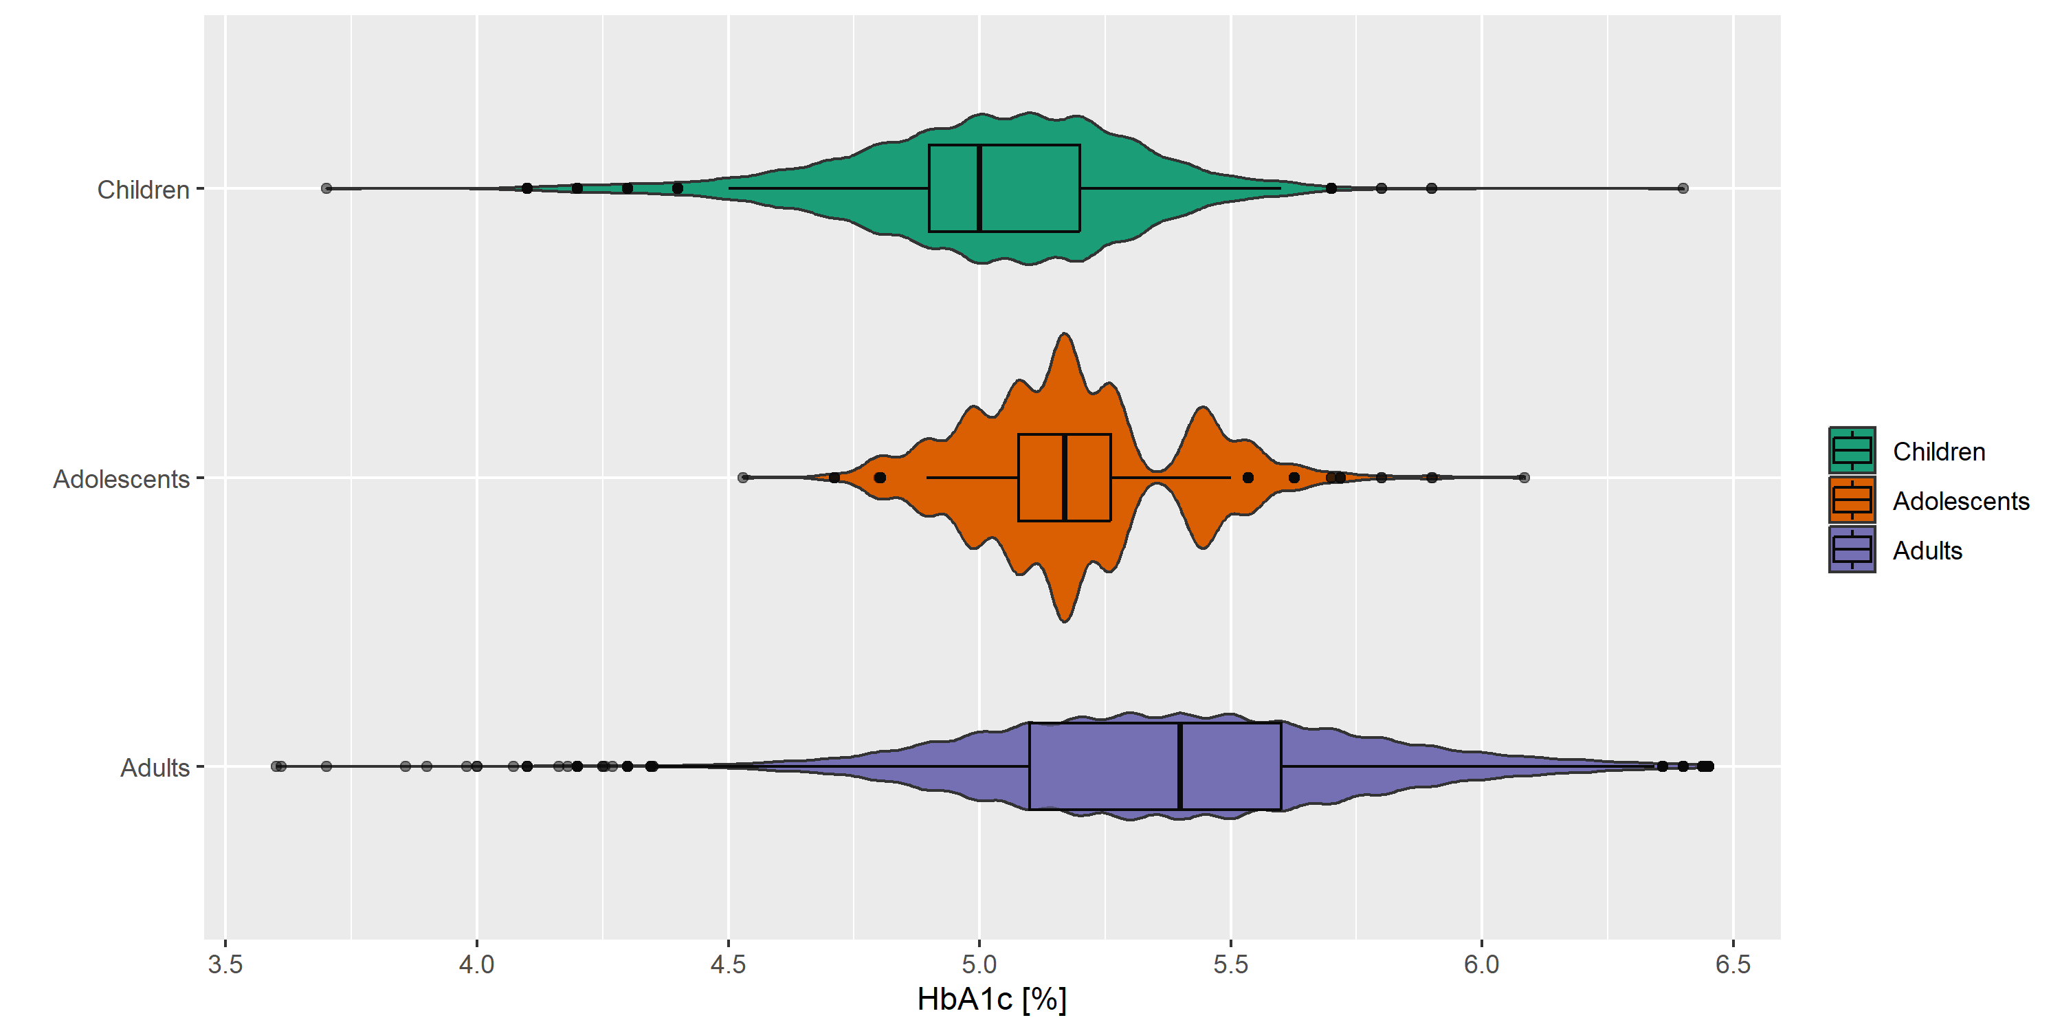
Children: age <15 years; Adolescents: age 15-20 years; Adults: age >20 years

Figure S2. Age distribution per cohort and survey
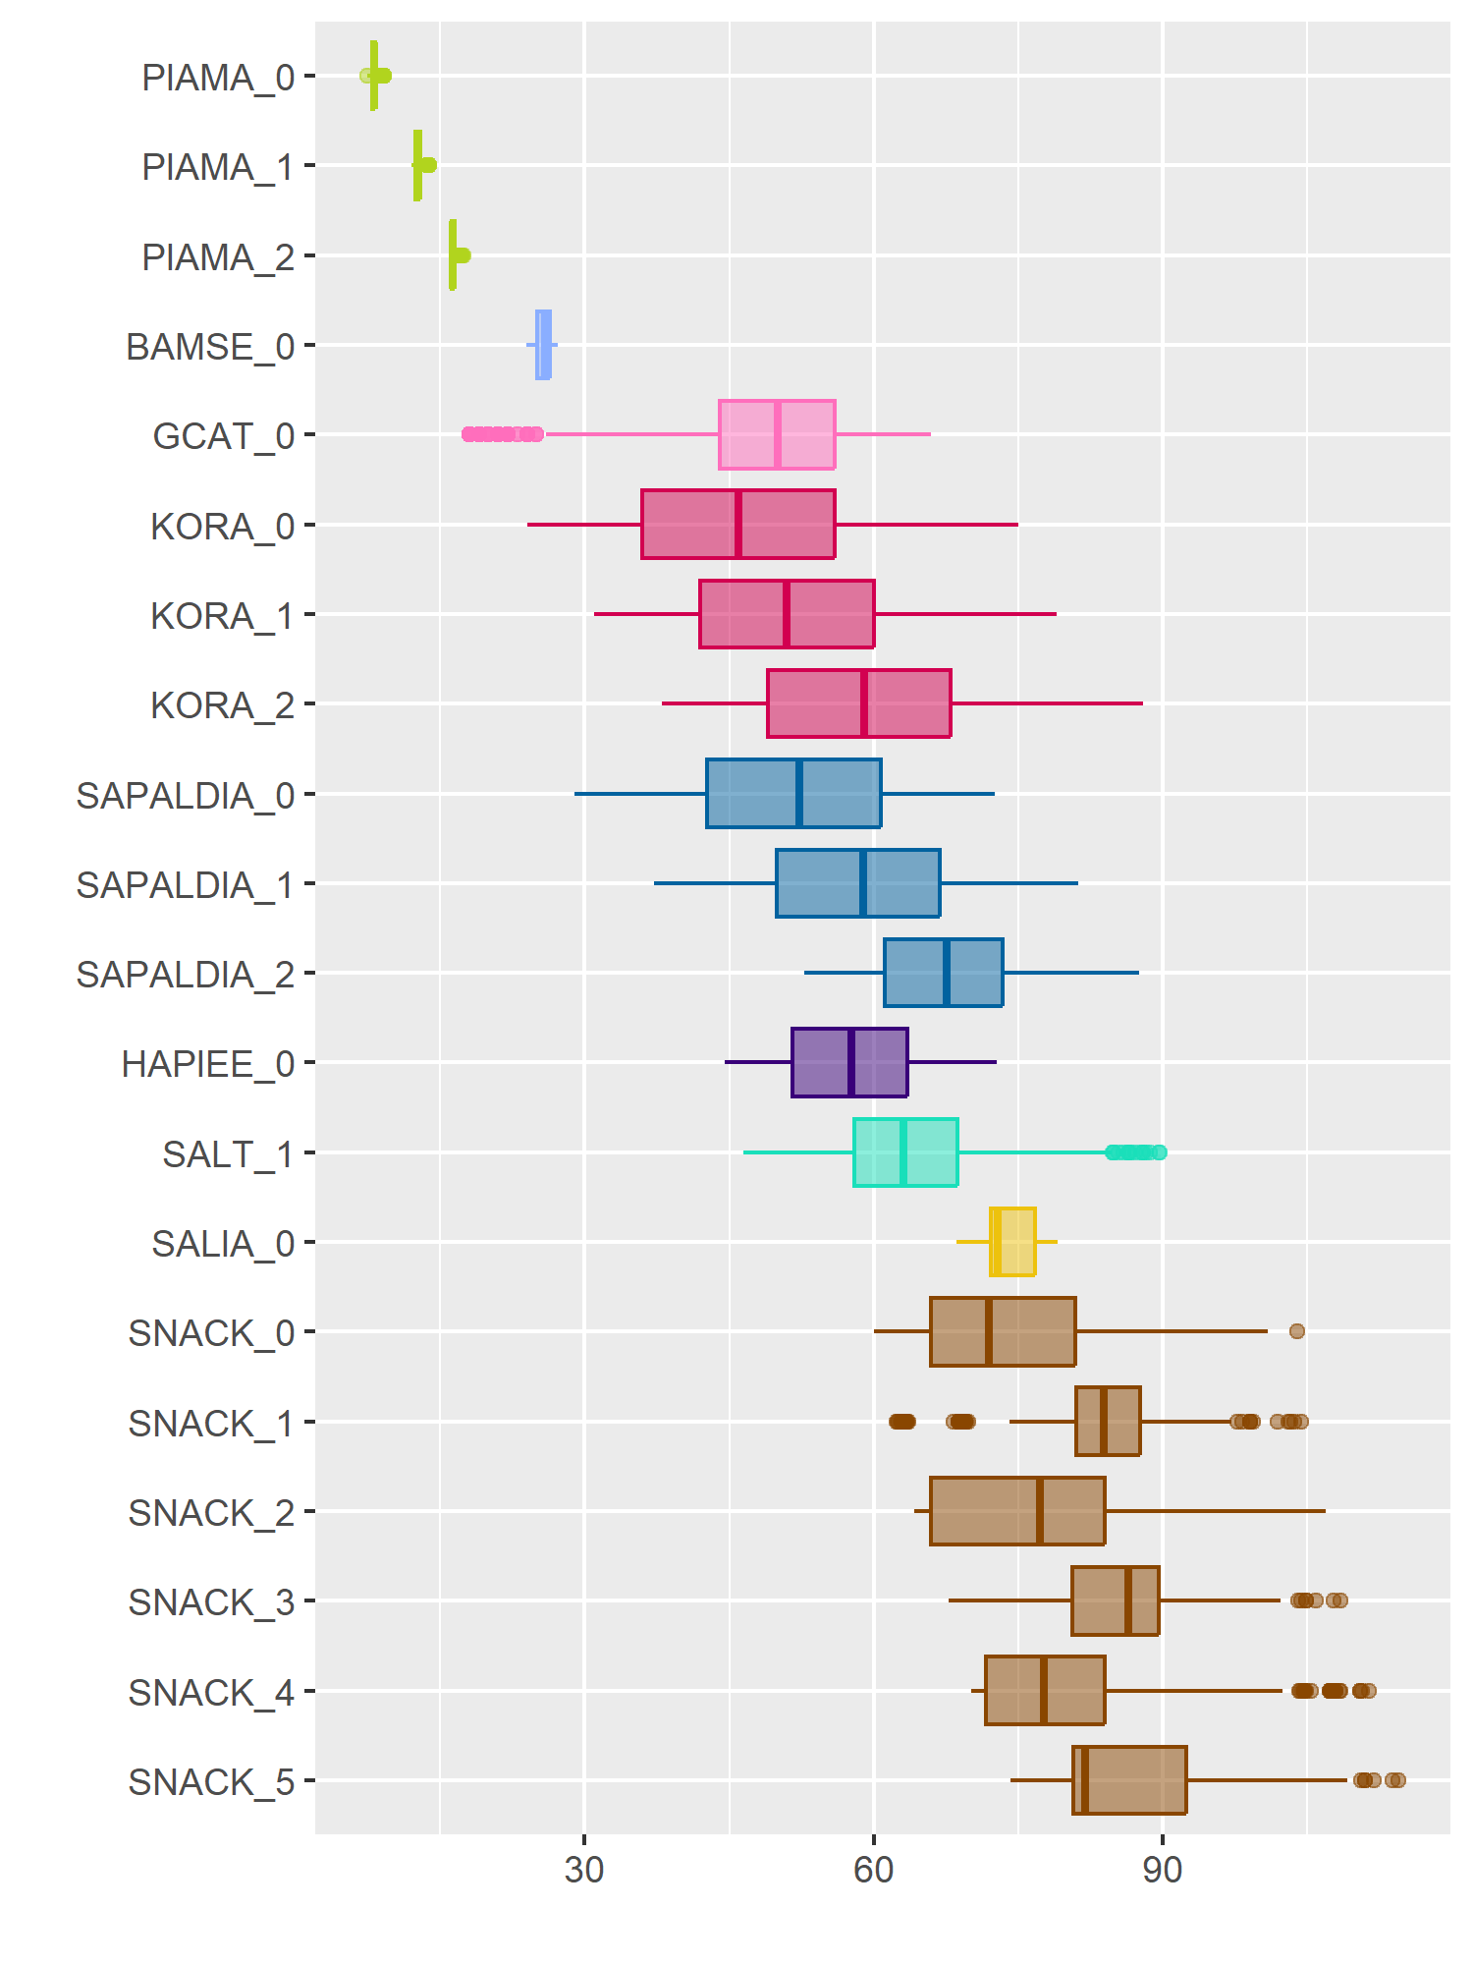
SALIA: women only

Figure S3. Spearman correlation between exposome factors per cohort and survey
(a) PIAMA
PIAMA_0 | PIAMA_1 | PIAMA_2
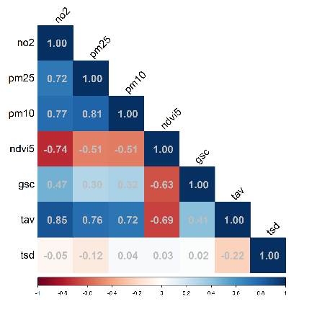 | 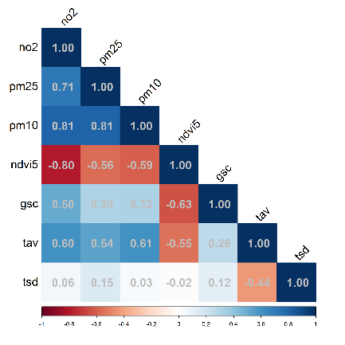 | 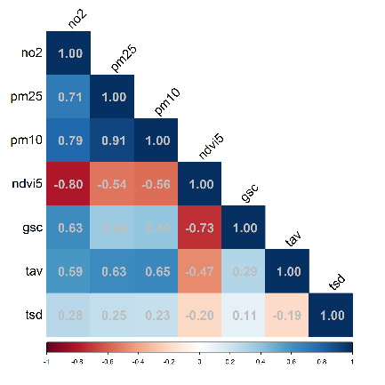
(b) BAMSE
BAMSE_0
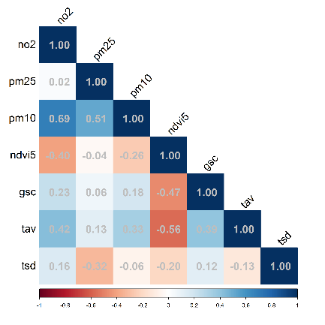
(c) GCAT
GCAT_0
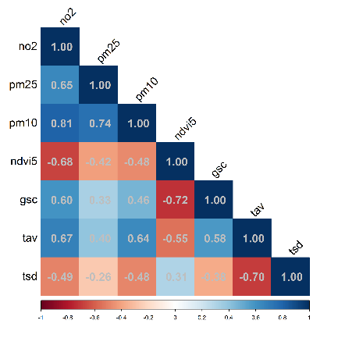

Figure S3. Spearman correlation between exposome factors per cohort and survey (cont.)
(d) KORA
KORA_0 | KORA_1 | KORA_2
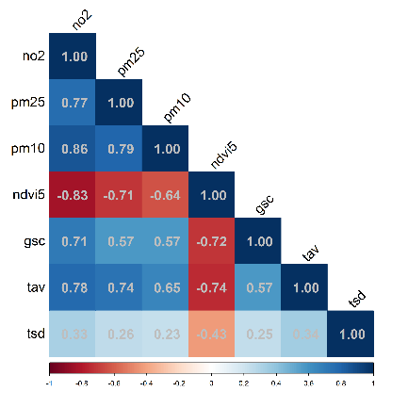 | 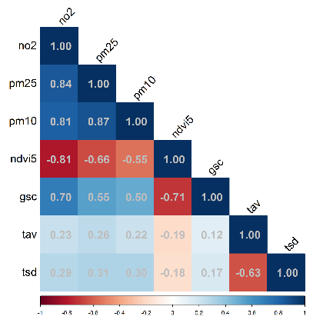 | 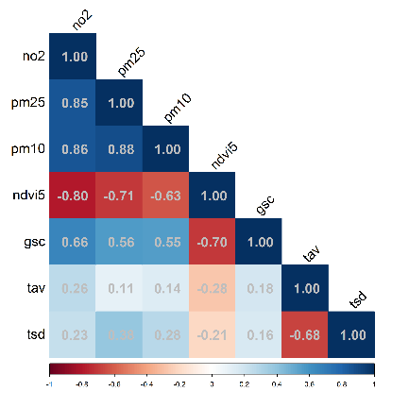
(e) SAPALDIA
SAPALDIA_0 | SAPALDIA_1 | SAPALDIA_2
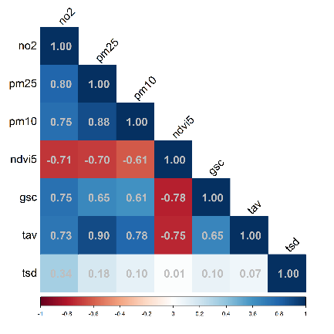 | 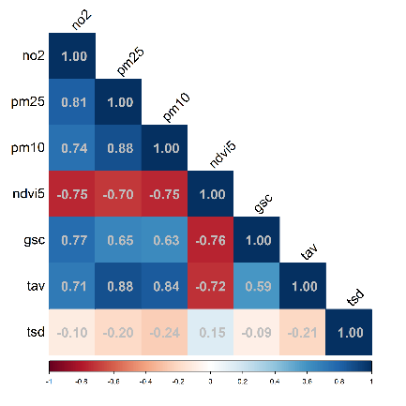 | 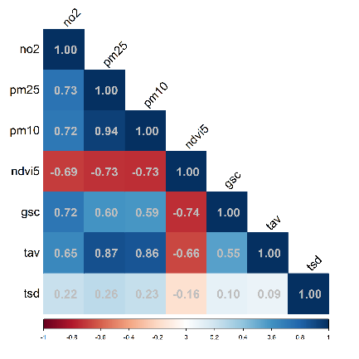
(f) HAPIEE
HAPIEE_0
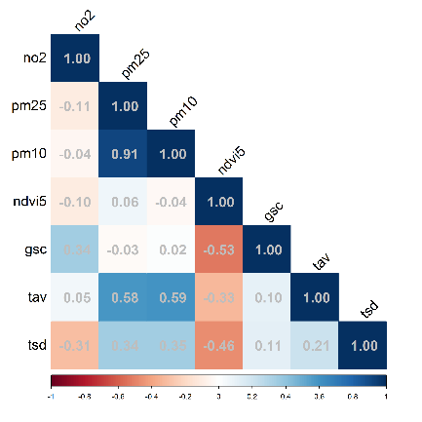

Figure S3. Spearman correlation between exposome factors per cohort and survey (cont.)
(g) SALT
SALT_1
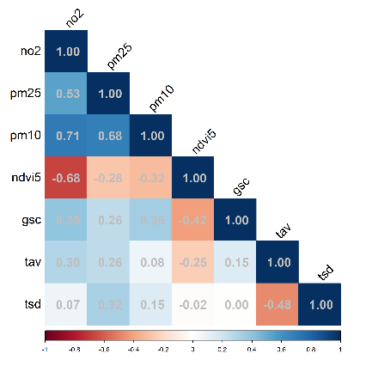
(h) SALIA
SALIA_0
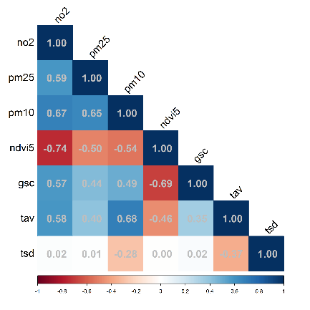
(i) SNACK
SNACK_0 | SNACK_1 | SNACK_2
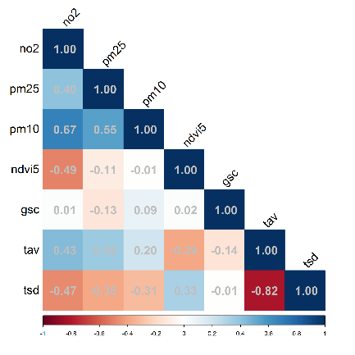 | 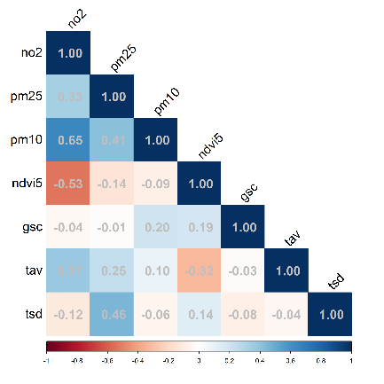 | 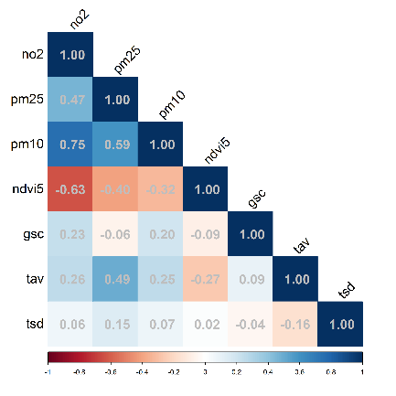
SNACK_3 | SNACK_4 | SNACK_5
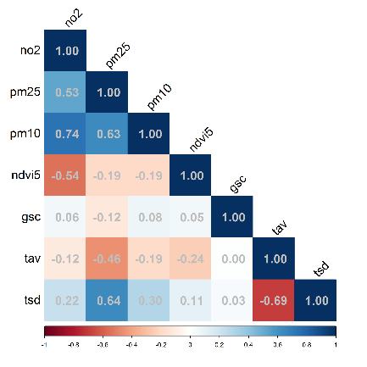 | 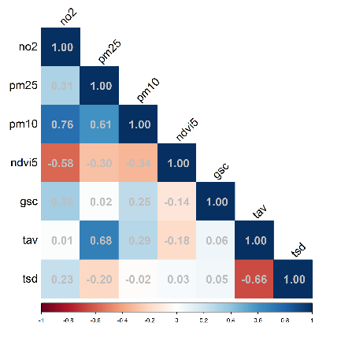 | 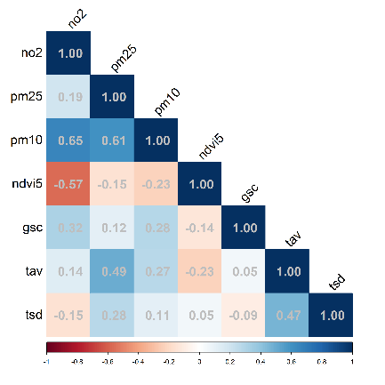

Figure S4. Regression results from single exposure models per cohort
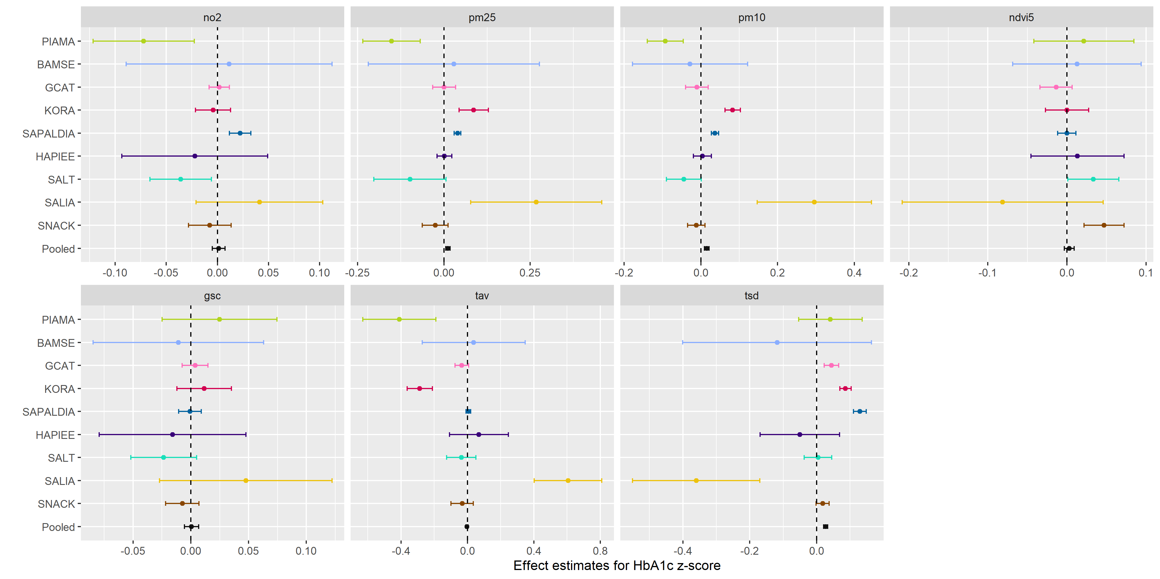
Cohort-specific models were adjusted for age (linear, quadratic, and cubic terms), sex, smoking status, marital status, employment status, individual education, and population density. For BAMSE and PIAMA, the model was not adjusted for marital status, employment status, and individual education, but for parental education instead. Pooled model was additionally adjusted for cohort. For cohorts with multiple surveys or for pooled analysis, linear mixed effects models were used with random intercepts for participants. For cohorts with one survey, Gaussian linear models were used.
Figure S5. Regression results from single exposure models per cohort, with or without adjustment for noise
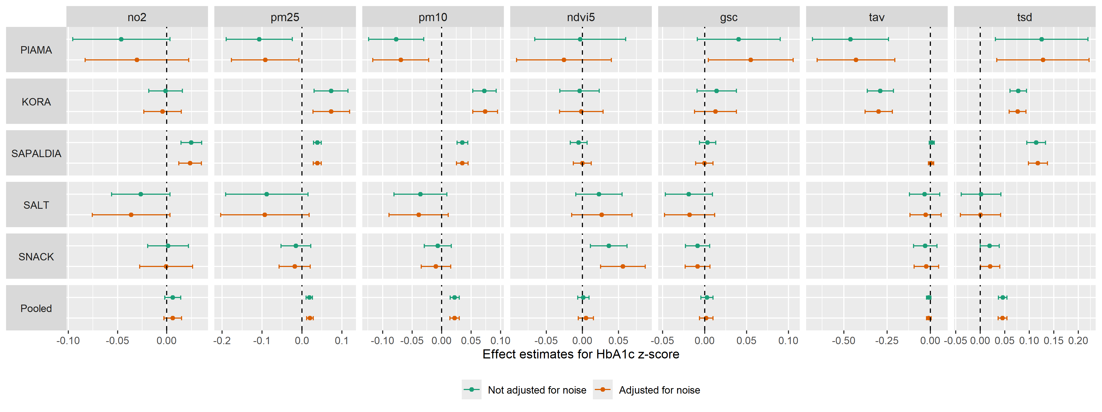 Cohort-specific models were adjusted for age (linear, quadratic, and cubic terms), sex, smoking status, marital status, employment status, individual education, and population density, with or without noise. For PIAMA, the model was not adjusted for marital status, employment status, and individual education, but for parental education instead. Pooled model was additionally adjusted for cohort. For cohorts with multiple surveys or for pooled analysis, linear mixed effects models were used with random intercepts for participants. For cohorts with one survey, Gaussian linear models were used.

Figure S6. 10-fold cross-validation* of the elastic net regression of HbA1c z-score**, stratified by urbanicity
(a) Urban# (N=16965) | (b) Non-urban## (N=17024)
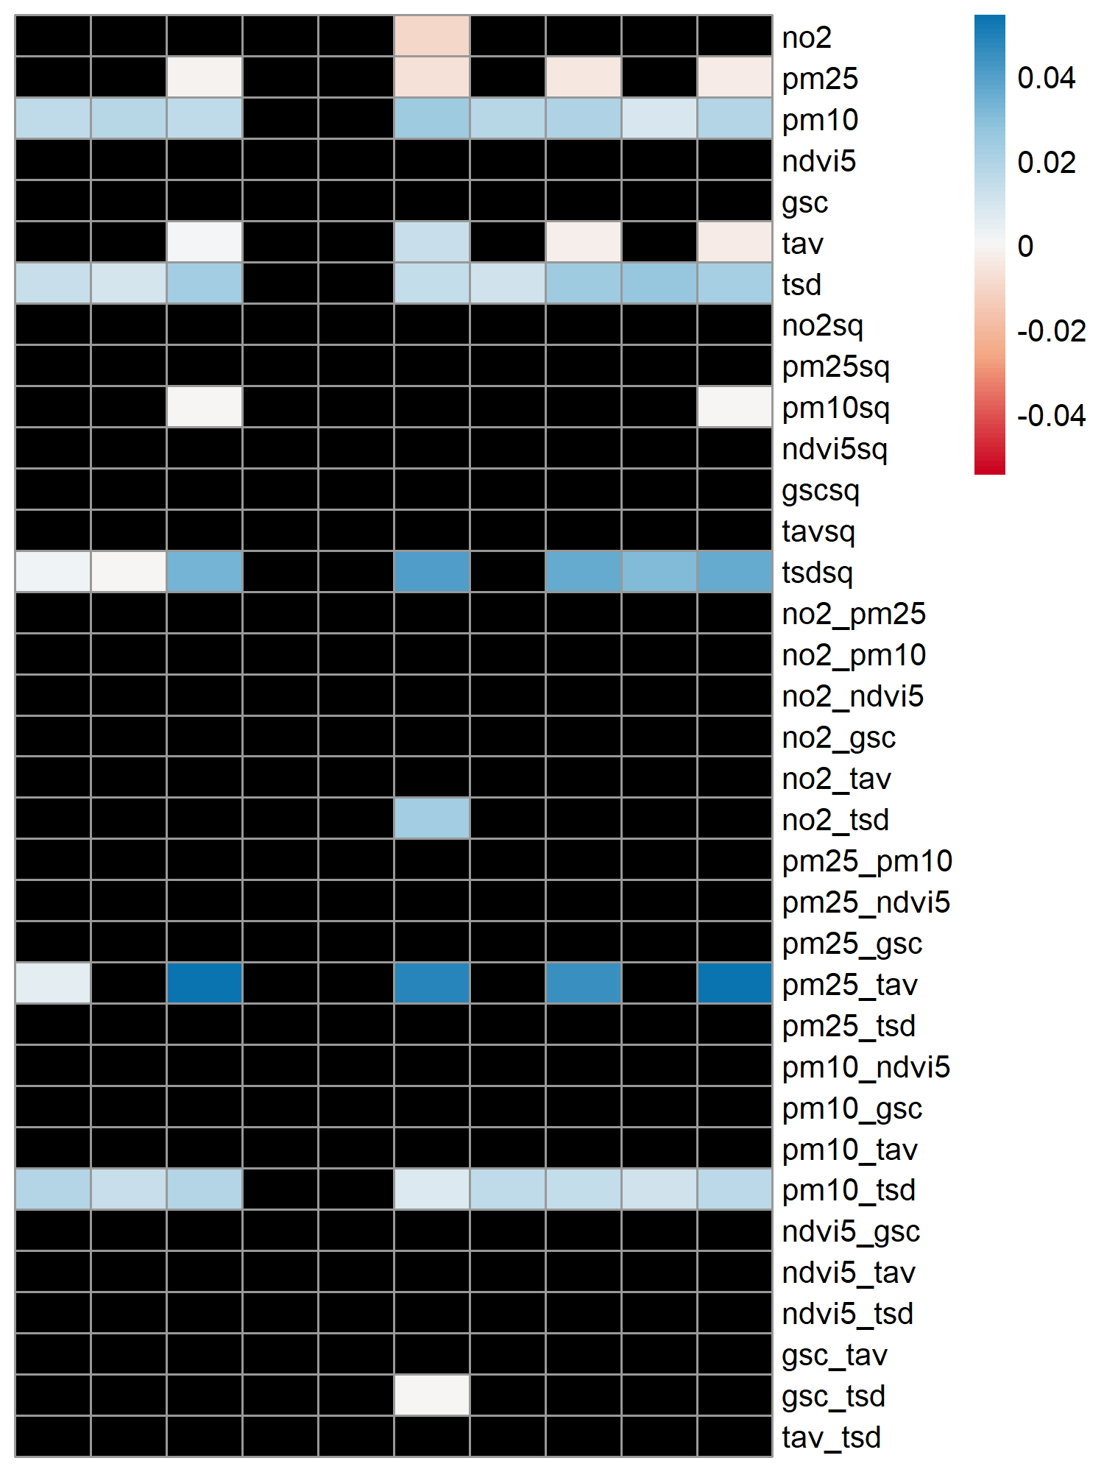 | 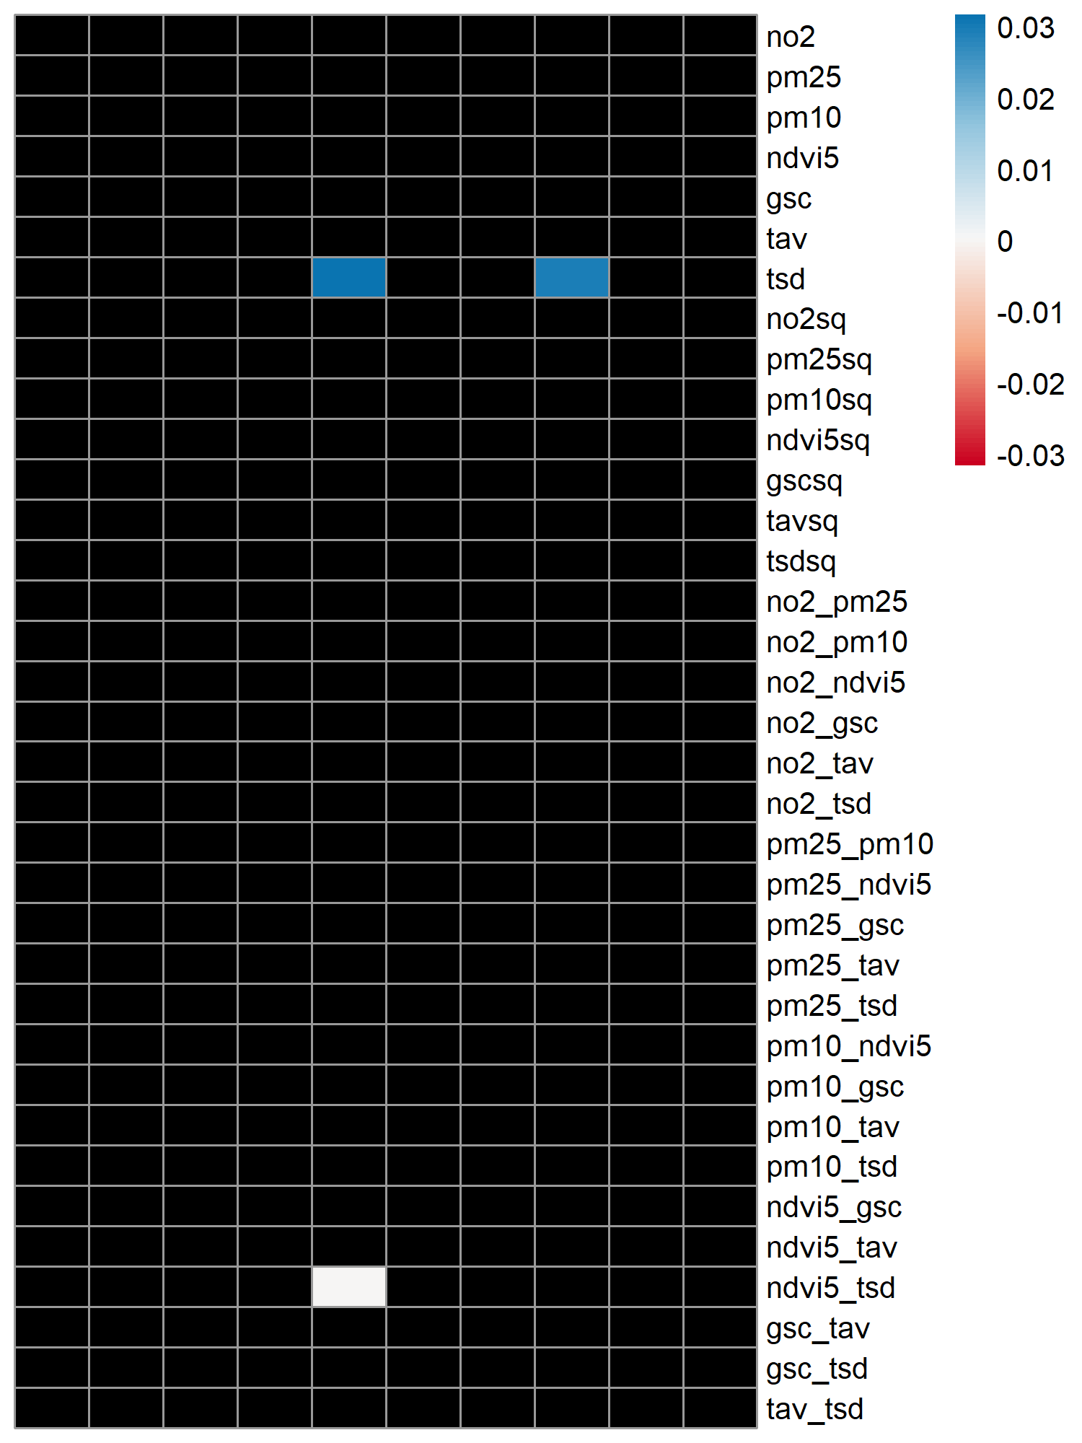
* Total observations were randomly assigned to 10 groups. Within each of the 10 iterations, one group was set aside (a test set), and the entire procedure of the two-step elastic net regression was applied to the remaining 9 groups (a training set). Each column represents the results of each iteration. Black cells indicate zero coefficients.
** Residuals from a linear mixed effects model, adjusted for age (linear, quadratic, and cubic terms), sex, smoking status, marital status, employment status, individual education, population density, and cohort. For BAMSE and PIAMA, the model was not adjusted for marital status, employment status, and individual education, but for parental education instead.
# Urban is defined as population density higher than cohort-specific median.
## Non-urban is defined as population density lower than cohort-specific median.

Figure S7. 10-fold cross-validation* of the elastic net regression of HbA1c z-score**, stratified by BMI cutoff 25 kg/m² or equivalent age- and sex-specific cutoffs for the participants below 18 years
(a) Normal weight (N=15933) | (b) Overweight (N=17678)
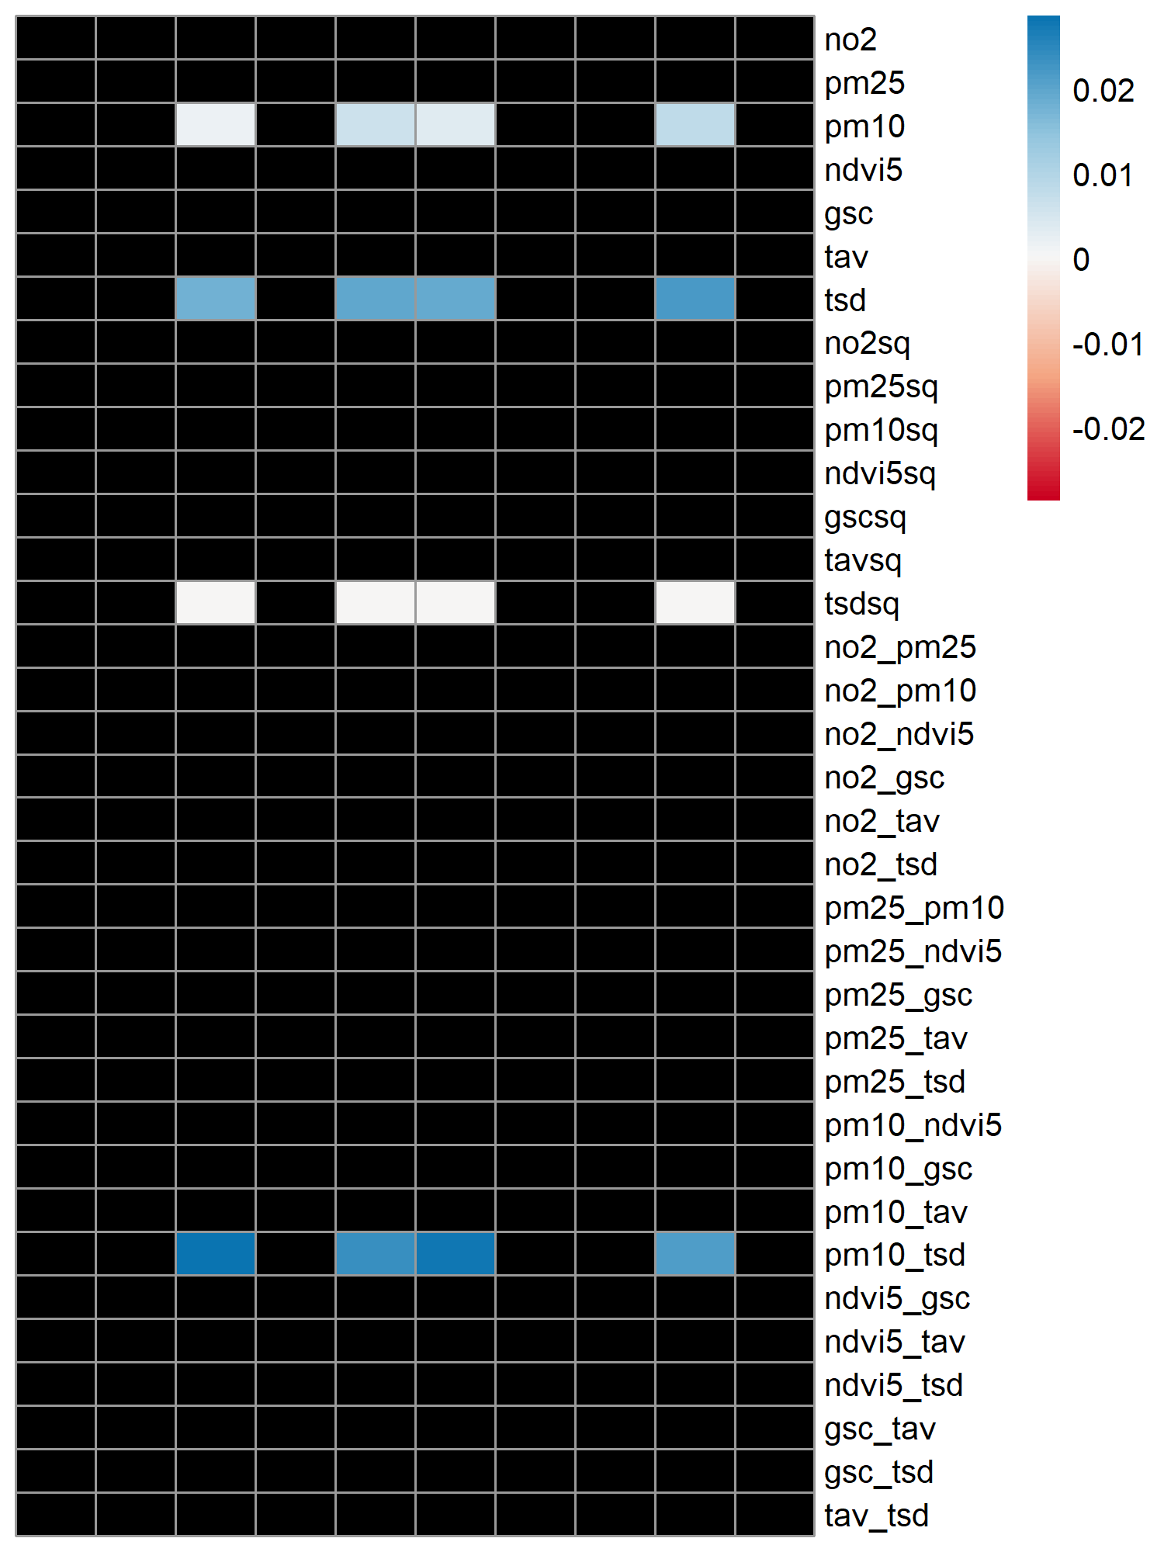 | 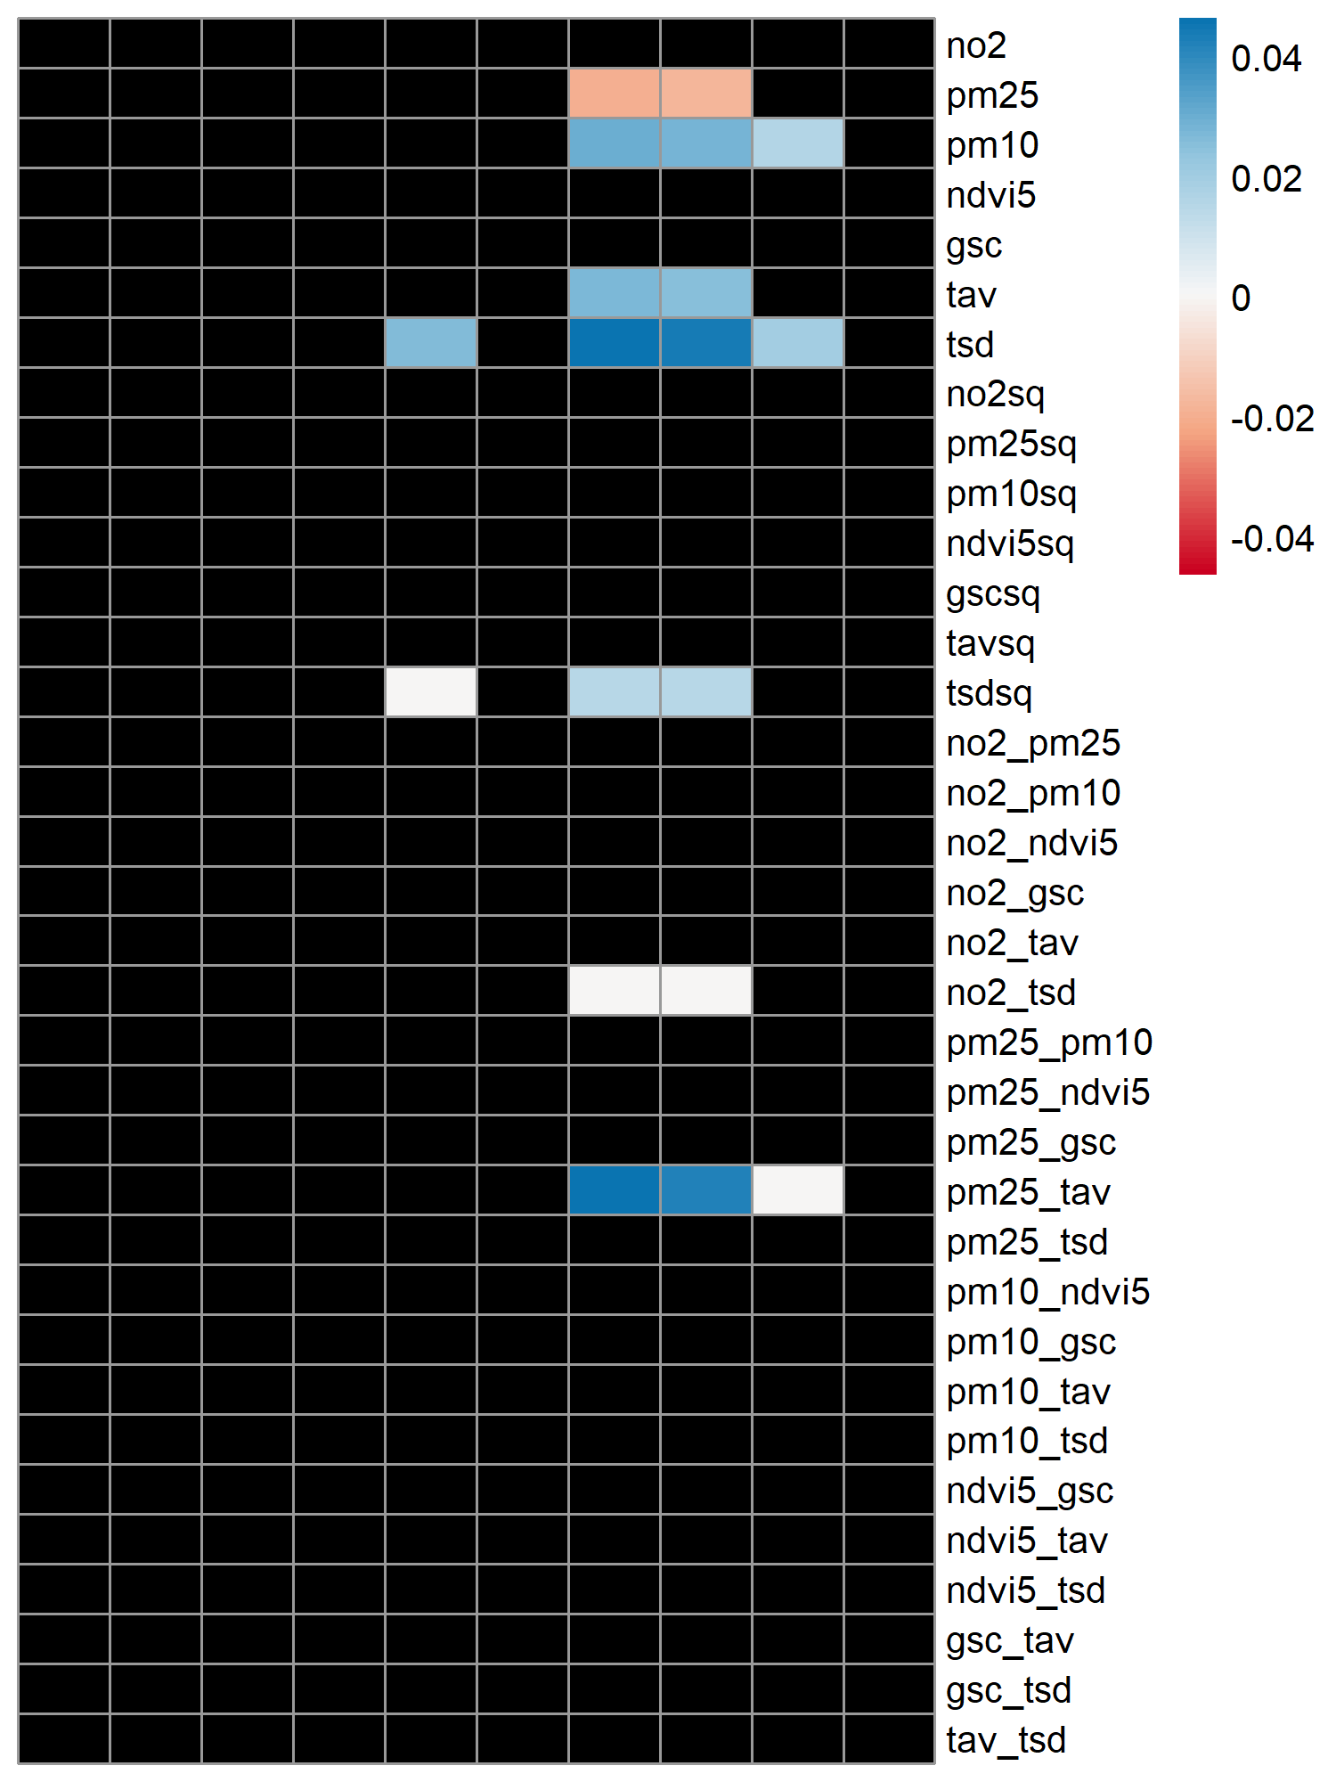
* Total observations were randomly assigned to 10 groups. Within each of the 10 iterations, one group was set aside (a test set), and the entire procedure of the two-step elastic net regression was applied to the remaining 9 groups (a training set). Each column represents the results of each iteration. Black cells indicate zero coefficients.
** Residuals from a linear mixed effects model, adjusted for age (linear, quadratic, and cubic terms), sex, smoking status, marital status, employment status, individual education, population density, and cohort. For BAMSE and PIAMA, the model was not adjusted for marital status, employment status, and individual education, but for parental education instead.

Figure S8. 10-fold cross-validation* of the elastic net regression of HbA1c z-score**, stratified by smoking status
(a) Current smokers (N=5900) | (b) Not current smokers (N=28089)
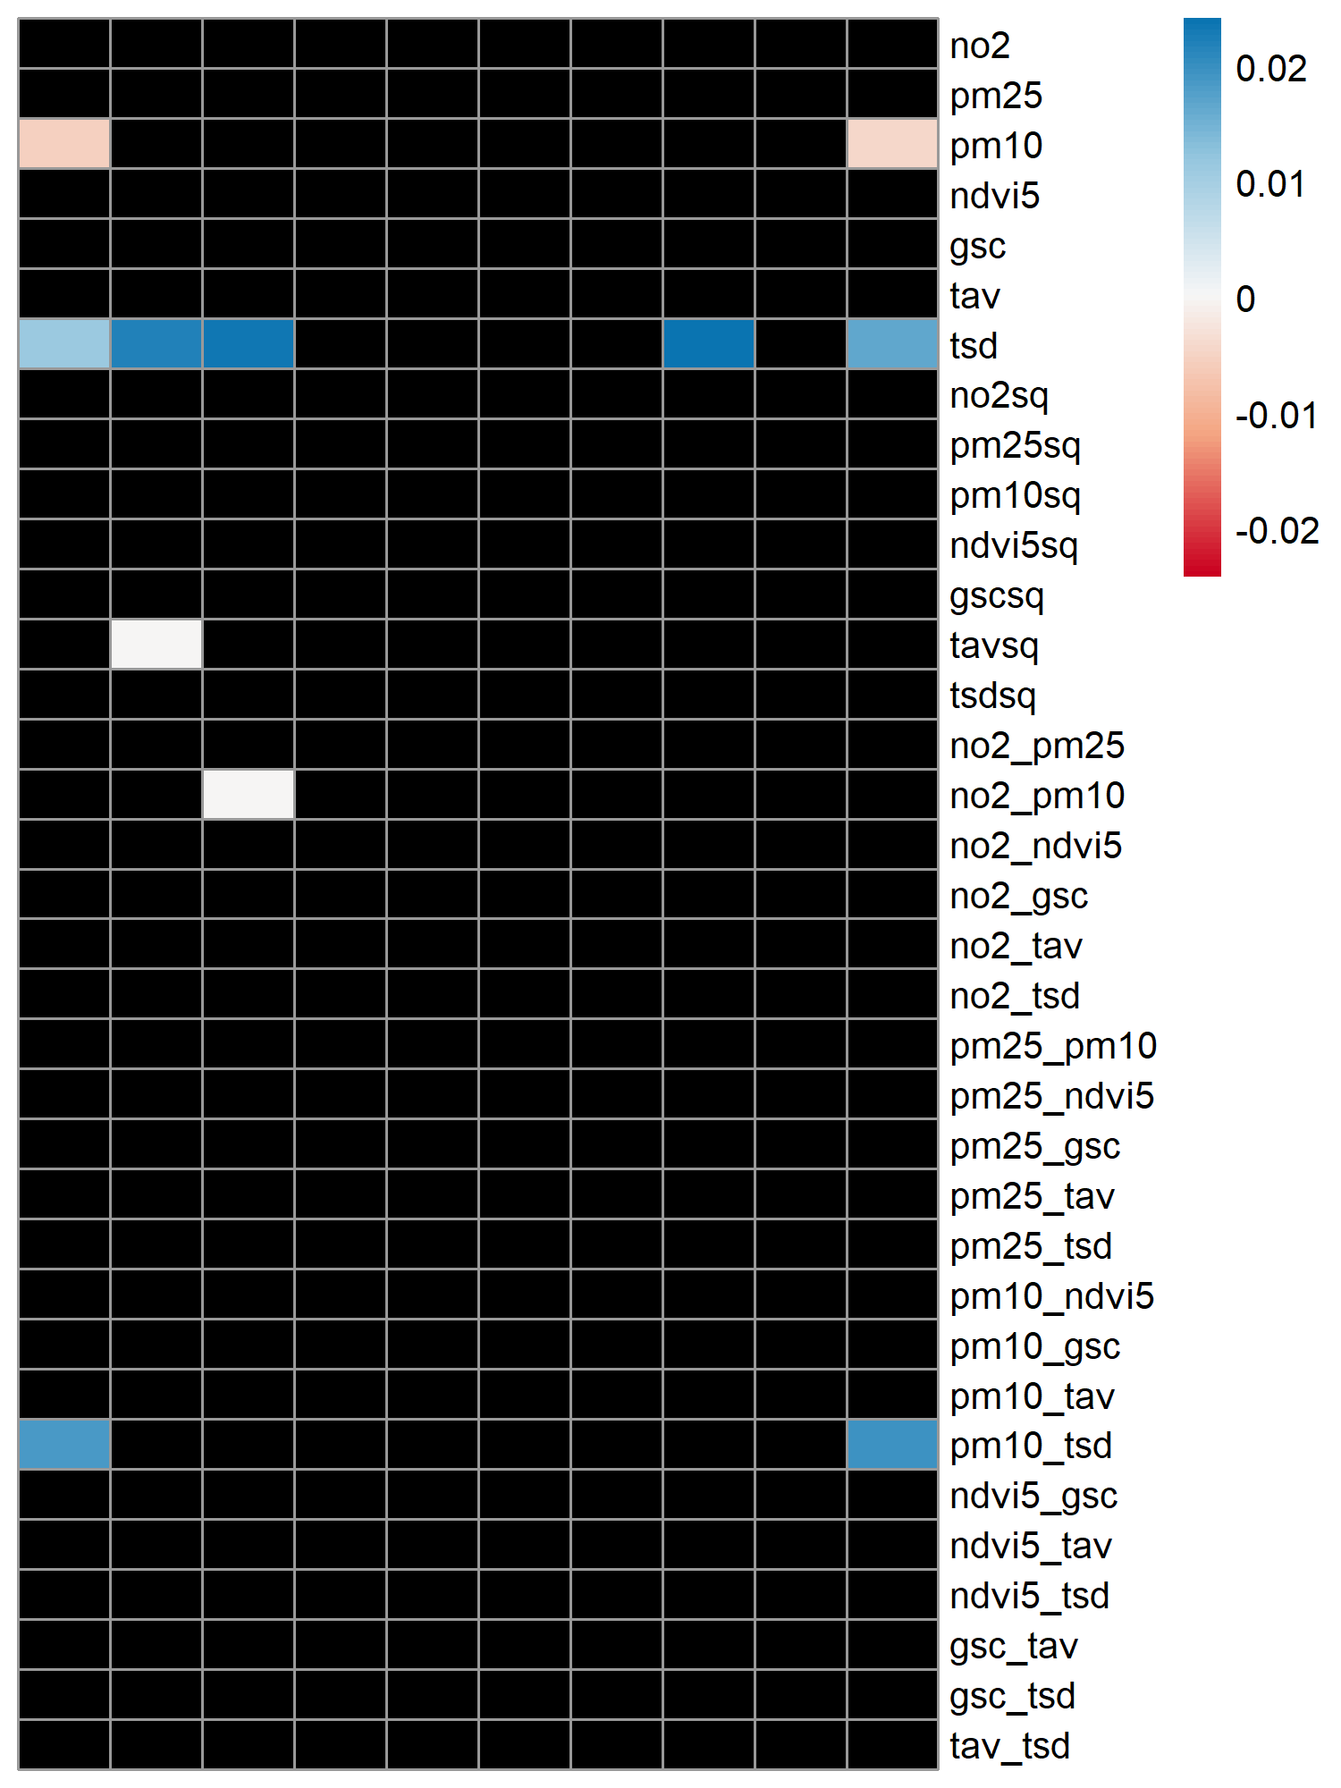 | 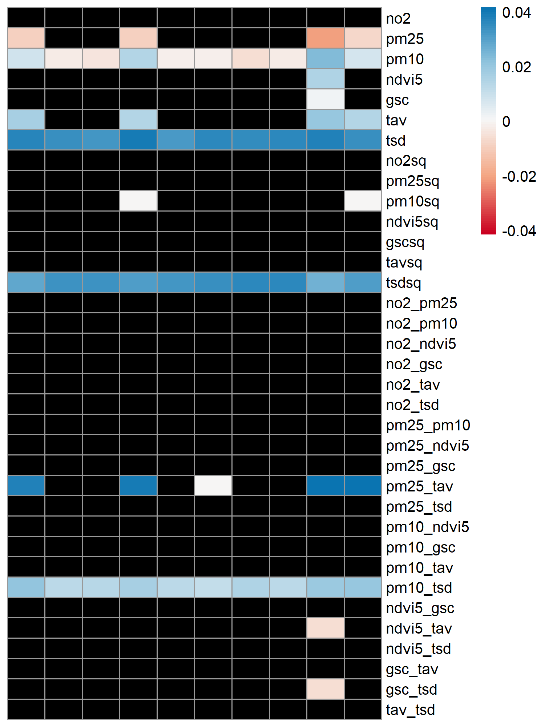
* Total observations were randomly assigned to 10 groups. Within each of the 10 iterations, one group was set aside (a test set), and the entire procedure of the two-step elastic net regression was applied to the remaining 9 groups (a training set). Each column represents the results of each iteration. Black cells indicate zero coefficients.
** Residuals from a linear mixed effects model, adjusted for age (linear, quadratic, and cubic terms), sex, marital status, employment status, individual education, population density, and cohort. For BAMSE and PIAMA, the model was not adjusted for marital status, employment status, and individual education, but for parental education instead.

Figure S9. Exposure distribution per cohort and survey, stratified by urbanicity
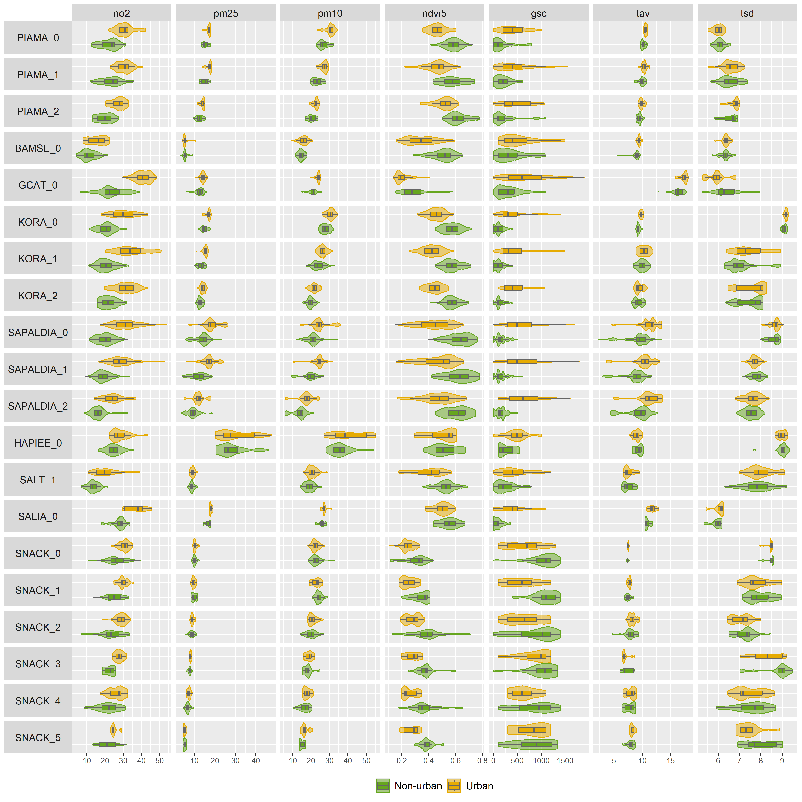
Urban is defined as population density higher than cohort-specific median.
Non-urban is defined as population density lower than cohort-specific median.

References
1. de Hoogh K, Hoek G, Flückiger B, Bussalleu A, Vienneau D, Jeong A, et al. A Europe-wide characterization of the external exposome: A spatio-temporal analysis. Environ Int. 2025;200:109542.
2. Jeong A, Lovison G, Bussalleu A, Cirach M, Dadvand P, de Hoogh K, et al. Lung function-associated exposome profile in the era of climate change: Pooled analysis of 8 population-based European cohorts within the EXPANSE project. Environ Int. 2025;196:109269.
3. Melen E, Bergstrom A, Kull I, Almqvist C, Andersson N, Asarnoj A, et al. Male sex is strongly associated with IgE-sensitization to airborne but not food allergens: results up to age 24 years from the BAMSE birth cohort. Clin Transl Allergy. 2020;10:15.
4. Wickman M, Kull I, Pershagen G, Nordvall SL. The BAMSE project: presentation of a prospective longitudinal birth cohort study. Pediatr Allergy Immunol. 2002;13(s15):11-3.
5. Yu Z, Bjorkander S, Bendes A, Nobile F, Zhang J, Merid SK, et al. Ambient temperature exposure on inflammatory blood proteins-A longitudinal self-sampling survey in young Swedish adults. iScience. 2026;29(1):114383.
6. Brunekreef B, Smit J, de Jongste J, Neijens H, Gerritsen J, Postma D, et al. The prevention and incidence of asthma and mite allergy (PIAMA) birth cohort study: design and first results. Pediatr Allergy Immunol. 2002;13(s15):55-60.
7. Milanzi EB, Koppelman GH, Smit HA, Wijga AH, Oldenwening M, Vonk JM, et al. Air pollution exposure and lung function until age 16 years: the PIAMA birth cohort study. Eur Respir J. 2018;52(3).
8. Wijga AH, Kerkhof M, Gehring U, de Jongste JC, Postma DS, Aalberse RC, et al. Cohort profile: the prevention and incidence of asthma and mite allergy (PIAMA) birth cohort. Int J Epidemiol. 2014;43(2):527-35.
9. Obon-Santacana M, Vilardell M, Carreras A, Duran X, Velasco J, Galvan-Femenia I, et al. GCAT|Genomes for life: a prospective cohort study of the genomes of Catalonia. BMJ Open. 2018;8(3):e018324.
10. Peasey A, Bobak M, Kubinova R, Malyutina S, Pajak A, Tamosiunas A, et al. Determinants of cardiovascular disease and other non-communicable diseases in Central and Eastern Europe: rationale and design of the HAPIEE study. BMC Public Health. 2006;6:255.
11. Linkohr B, Heier M, Gieger C, Thorand B, Grallert H, Holle R, et al. Cohort Profile: Cooperative Health Research in the Region of Augsburg (KORA) 1984-2024. Int J Epidemiol. 2025;54(6).
12. Laxy M, Knoll G, Schunk M, Meisinger C, Huth C, Holle R. Quality of Diabetes Care in Germany Improved from 2000 to 2007 to 2014, but Improvements Diminished since 2007. Evidence from the Population-Based KORA Studies. PLoS One. 2016;11(10):e0164704.
13. Pitchika A, Hampel R, Wolf K, Kraus U, Cyrys J, Babisch W, et al. Long-term associations of modeled and self-reported measures of exposure to air pollution and noise at residence on prevalent hypertension and blood pressure. Sci Total Environ. 2017;593-594:337-46.
14. Teichert T, Vossoughi M, Vierkotter A, Sugiri D, Schikowski T, Schulte T, et al. Association between traffic-related air pollution, subclinical inflammation and impaired glucose metabolism: results from the SALIA study. PLoS One. 2013;8(12):e83042.
15. Lichtenstein P, Sullivan PF, Cnattingius S, Gatz M, Johansson S, Carlstrom E, et al. The Swedish Twin Registry in the third millennium: an update. Twin Res Hum Genet. 2006;9(6):875-82.
16. Ogren M, Barregard L. Road Traffic Noise Exposure in Gothenburg 1975-2010. PLoS One. 2016;11(5):e0155328.
17. Adam M, Schikowski T, Carsin AE, Cai Y, Jacquemin B, Sanchez M, et al. Adult lung function and long-term air pollution exposure. ESCAPE: a multicentre cohort study and meta-analysis. Eur Respir J. 2015;45(1):38-50.
18. Downs SH, Schindler C, Liu LJ, Keidel D, Bayer-Oglesby L, Brutsche MH, et al. Reduced exposure to PM10 and attenuated age-related decline in lung function. N Engl J Med. 2007;357(23):2338-47.
19. Eze IC, Foraster M, Schaffner E, Vienneau D, Heritier H, Rudzik F, et al. Long-term exposure to transportation noise and air pollution in relation to incident diabetes in the SAPALDIA study. Int J Epidemiol. 2017;46(4):1115-25.
20. Karipidis I, Vienneau D, Habermacher M, Köpflii M, Brink M, Probst-Hensch N, et al. Reconstruction of historical noise exposure data for environmental epidemiology in Switzerland within the SiRENE project. Noise Mapping. 2014;1(1):000010247820140002.
21. Lagergren M, Fratiglioni L, Hallberg IR, Berglund J, Elmstahl S, Hagberg B, et al. A longitudinal study integrating population, care and social services data. The Swedish National study on Aging and Care (SNAC). Aging Clin Exp Res. 2004;16(2):158-68.

