SUPPLEMENTAL MATERIAL to

Transcriptomic profiling identifies Tumor Necrosis Factor Receptor-Associated Factor (TRAF)-5 expression in human atherosclerotic plaques as a predictor of future cardiovascular events
Mark Colin Gissler¹, Xin Gu¹, Floor B.H. van der Zalm², Hauke Horstmann¹, Juana Dominguez¹, Patrick M. Siegel¹, Daniela Stallmann¹, Constantin von zur Muehlen¹, Timoteo Marchini¹, Yvonne Döring^{3,4,5,6}, Matthias Heinig⁷, Dirk Westermann¹, Michal Mokry^{2*}, Dennis Wolf^{1*}
¹ Department of Cardiology and Angiology, University Heart Center Freiburg – Bad Krozingen, Faculty of Medicine, University of Freiburg, Germany.
² Central Diagnostic Laboratory, University Medical Center Utrecht, Utrecht, Netherlands.
³ Swiss Cardiovascular Center, Division of Angiology, Inselspital, Bern University Hospital, University of Bern, Bern, Switzerland.
⁴ Institute for Cardiovascular Prevention (IPEK), Ludwig-Maximilians-Universität, Munich, Germany.
⁵ Department for BioMedical Research (DBMR), Bern University Hospital, University of Bern, Bern, Switzerland.
⁶ DZHK (German Center for Cardiovascular Research), Partner Site Munich Heart Alliance, Munich, Germany.
⁷ Institute of Computational Biology, German Research Center for Environmental Health, Helmholtz Zentrum München, Neuherberg, Germany.

*M.M and D.W. share senior authorship

CONTENT
- Supplementary Figure

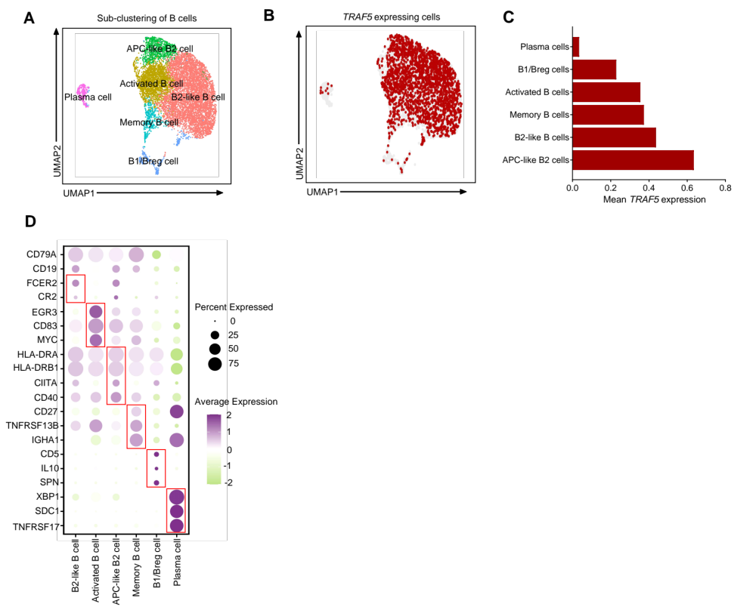
Supplemental Figure. Sub-clustering of B cells derived from a meta data set of 79 pooled human plaques⁽¹⁾ by Harmony and Leiden clustering (A). UMAP overlay of TRAF5 expressing cells (B). Average expression of TRAF5 per cell type (C). Dot plot showing the average expression of immune cell cluster-defining markers for each sub-cluster (D).

REFERENCES

1. Traeuble K, Munz M, Pauli J, Sachs N, Vafadarnejad E, Carrillo-Roa T, et al. Integrated single-cell atlas of human atherosclerotic plaques. Nat Commun. 2025;16(1):8255.

