Supplementary Figures and Tables:

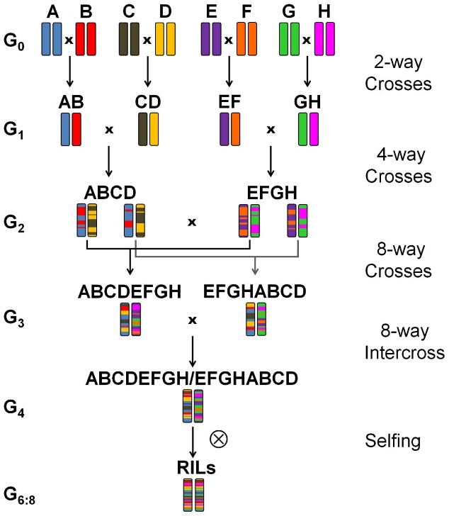

Supplementary Fig. 1. Crossing scheme based on Cavanagh et al. [42]: the eight-founder BMWpop. (A) ‘Event’, (B) ‘Format’, (C) ‘BAYP4535’, (D) ‘Potenzial’, (E) ‘Ambition’, (F) ‘Bussard’, (G) ‘Firl3565’, (H) ‘Julius’ [14].

Supplementary Fig. 2. Principal Component Analysis (PCA) plot illustrating the overall patterns of gene expression variation across all samples under control (black) and drought stress (red) conditions. Each point represents a biological replicate of a specific genotype, with distinct symbols indicating different genotypes (BMW_2007, BMW_2008, BMW_2218, BMW_2209, BMW_2231, BMW_2246, BMW_2346). The axes represent the first two principal components (PC1 and PC2), which account for 17% and 11% of the total variance, respectively. The distribution of samples indicates potential clustering patterns related to water use efficiency (WUE), as well as distinct expression profiles between control and drought conditions.

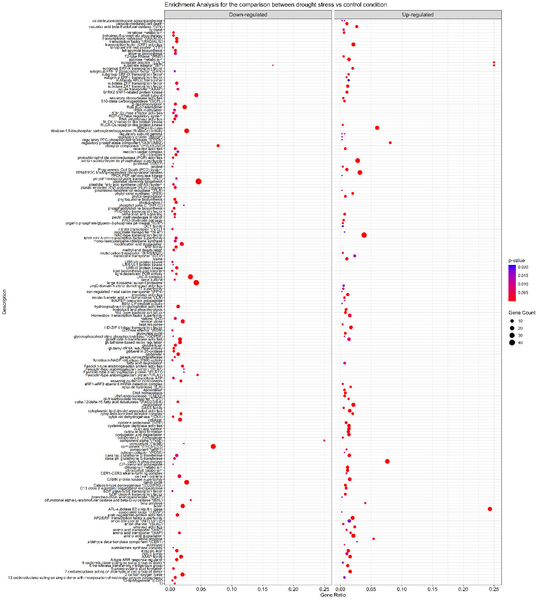
Supplementary Fig. 3. A scatter plot represents the outcome of a functional enrichment analysis performed on a set of genes exhibiting significant differential expression between drought and control conditions. Each point in the scatter plot denotes a biologically annotated pathway that has been identified as significantly enriched amongst the differentially expressed genes. The x-axis depicts the gene ratio, calculated as the number of differentially expressed genes annotated to that pathway divided by the total number of genes within that pathway according to the chosen annotation database. A higher gene ratio indicates a greater proportion of the differentially expressed gene set. The y-axis comprises the list of biological pathways and processes that demonstrated significant enrichment.

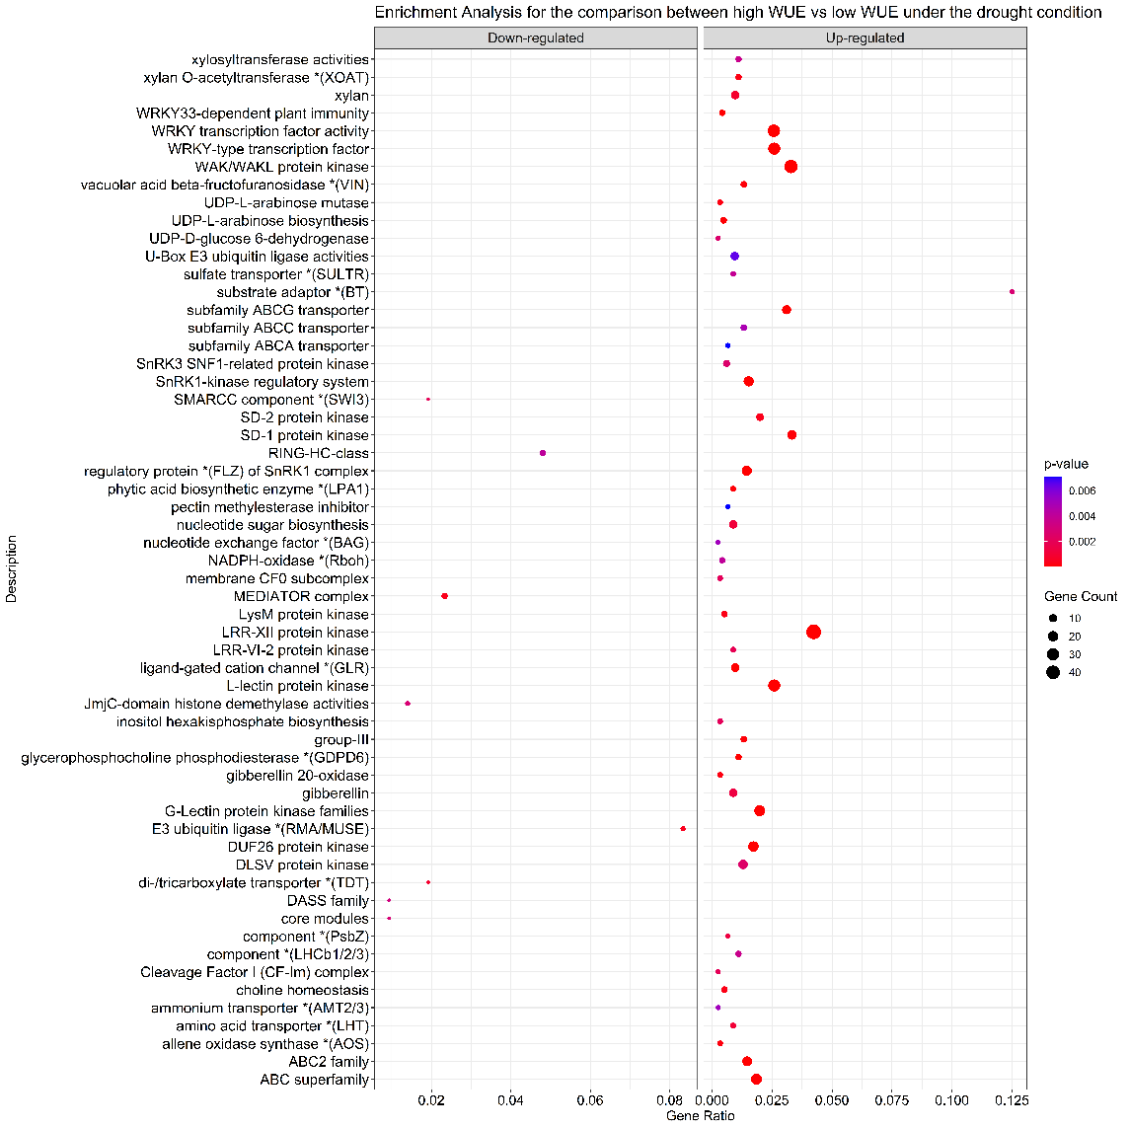
Supplementary Fig. 4. Functional enrichment analysis of differentially expressed genes between low δ¹³C and high δ¹³C wheat lines under drought stress conditions. Enriched functional categories are shown separately for upregulated and downregulated genes. Upregulated genes in high-δ¹³C lines were predominantly associated with stress perception and signaling pathways, including WRKY transcription factors, receptor-like kinases, ABC transporters, and ubiquitin-mediated protein turnover. Only a limited number of categories were enriched among downregulated genes (e.g., RING-HC-class, MEDIATOR complex). Dot size represents the number of genes assigned to each category, while color indicates the significance level (p-value). Gene ratio corresponds to the proportion of differentially expressed genes associated with a given functional category.

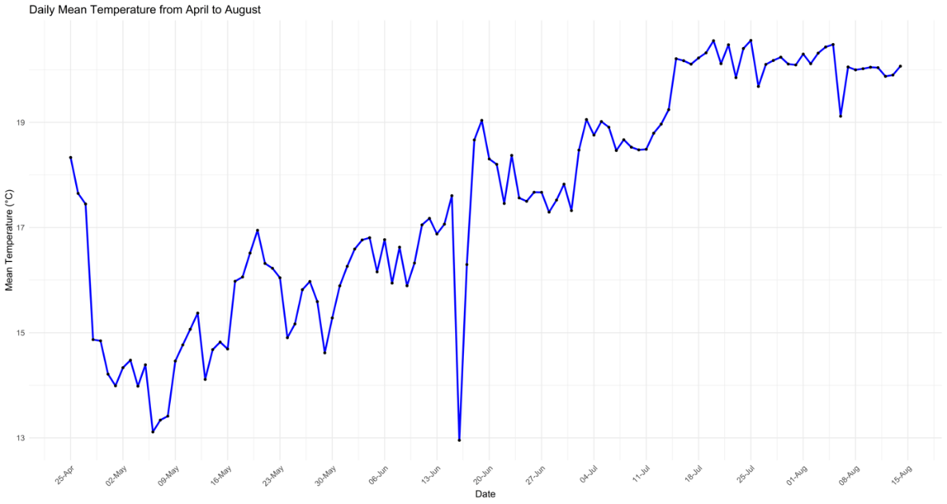

Supplementary Fig. 5. Weekly mean temperature in the greenhouse from April to August. The graph shows the weekly mean temperature (°C) recorded in the greenhouse during the experimental period. These temperature data were used to calculate iWUE from July 1 to August 7, 2020, providing important environmental context for interpreting plant physiological responses in this study.

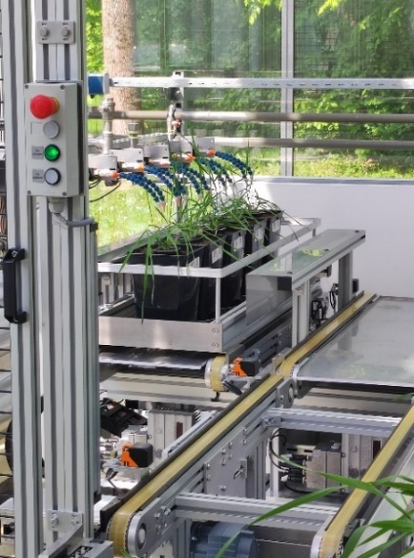
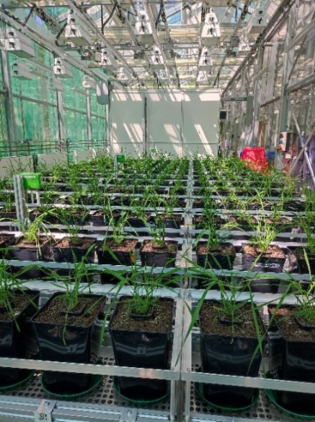
a
b

Supplementary Fig. 6. Phenotyping System at HMGU: (a) The setup of the high-throughput phenotyping system used for assessing all candidate lines under control and drought stress conditions, arranged in a completely randomized distribution design. (b) Illustrates the automated irrigation system, which precisely waters the lines based on weight measurements taken in the booth using integrated scales.

Supplementary Table 1. Summary of QTL detected for δ¹³C across Morgenrot in 2019.
Location | QTL | Chr | Pos | SI_  lower | SI_  upper | Left  Marker | Right  Marker | Next  Marker | P_value | R2 | Effect  MAX | Effect_MAX_SD
Morgenrot | TA002086.1469 | 1D | 12.16221 | 2 | 22 | Kukri_c26168_713 | Excalibur_c43567_679 | TA002086.1469 | 5.15E-06 | 0.002267198 | 0.113080528 | 0.445537539
Morgenrot | loc168 | 2B | 168 | 161 | 177.7554096 | wsnp_RFL_Contig3802_4108582 | BS00034245_51 | BS00034245_51 | 1.59E-12 | 0.183735133 | 0.393617661 | 1.550854491
Morgenrot | BS00030843_51 | 4B | 103.7691 | 89.89871013 | 106 | AX.94403724 | BS00034255_51 | BS00030843_51 | 2.63E-08 | 0.033518584 | 0.147951749 | 0.582930233
Morgenrot | TG0011 | 4D | 27.42983 | 22 | 33 | AX.95148759 | AX.94747406 | TG0011 | 2.22E-16 | 0.06722493 | 0.267068318 | 1.052249789
Morgenrot | loc188 | 6A | 188 | 179.2485889 | 194 | AX.94444906 | RFL_Contig5314_1147 | AX.94444906 | 1.82E-06 | 0.072056816 | 0.255564766 | 1.006925767
Morgenrot | CAP7_c7065_166 | 6B | 105.5105 | 102 | 115 | wsnp_Ex_c1276_2445537 | BS00028997_51 | CAP7_c7065_166 | 1.11E-08 | 0.113475559 | 0.522117894 | 2.057145705

Note: SI, support intervals

Supplementary Table 2 Model-adjusted trait means across treatment and group combinations.
Trait | Treatment | δ¹³C Group | Estimated mean ± SE | lower_CL | upper_CL | tukey
Digital Biomass | Control | High | 41402814.72 ± 639175.42 | 39839501 | 43027474 | a
Digital Biomass | Control | Low | 34381368.44 ± 410455.76 | 33373099 | 35420099 | b
Digital Biomass | Drought Stress | High | 18250511.53 ± 274597.69 | 17578566 | 18948142 | c
Digital Biomass | Drought Stress | Low | 13477078.85 ± 157653.44 | 13089694 | 13875929 | d
Leaf Inclination | Control | High | 1.93 ± 0.01 | 1.91 | 1.94 | a
Leaf Inclination | Control | Low | 1.92 ± 0.00 | 1.91 | 1.94 | a
Leaf Inclination | Drought Stress | High | 1.84 ± 0.01 | 1.83 | 1.86 | c
Leaf Inclination | Drought Stress | Low | 1.87 ± 0.00 | 1.86 | 1.88 | b
Average Height | Control | High | 784.21 ± 6.19 | 768.94 | 799.79 | a
Average Height | Control | Low | 693.72 ± 4.23 | 683.25 | 704.35 | b
Average Height | Drought Stress | High | 612.17 ± 4.71 | 600.54 | 624.01 | c
Average Height | Drought Stress | Low | 532.19 ± 3.18 | 524.31 | 540.177 | d
Leaf Area | Control | High | 52435.18 ± 604.72 | 50948.97 | 53964.74 | a
Leaf Area | Control | Low | 48962.48 ± 436.66 | 47885.81 | 50063.36 | b
Leaf Area | Drought Stress | High | 29694.28 ± 333.76 | 28873.70 | 30538.18 | c
Leaf Area | Drought Stress | Low | 25275.56 ± 220.88 | 24730.82 | 25832.28 | d
Leaf Area Index | Control | High | 0.28 ± 0.00 | 0.27 | 0.29 | a
Leaf Area Index | Control | Low | 0.26 ± 0.00 | 0.26 | 0.27 | b
Leaf Area Index | Drought Stress | High | 0.16 ± 0.00 | 0.16 | 0.16 | c
Leaf Area Index | Drought Stress | Low | 0.14 ± 0.00 | 0.13 | 0.14 | d
Leaf Area Projection | Control | High | 21415.26 ± 257.09 | 20783.77 | 22065.94 | a
Leaf Area Projection | Control | Low | 20107.63 ± 186.67 | 19647.56 | 20578.47 | b
Leaf Area Projection | Drought Stress | High | 13488.48 ± 157.82 | 13100.68 | 13887.75 | c
Leaf Area Projection | Drought Stress | Low | 11480.05 ± 104.43 | 11222.61 | 11743.40 | d
Light Penetration Depth | Control | High | 552.34 ± 5.94 | 537.72 | 567.36 | a
Light Penetration Depth | Control | Low | 460.83 ± 3.84 | 451.36 | 470.49 | b
Light Penetration Depth | Drought Stress | High | 425.43 ± 4.46 | 414.45 | 436.71 | c
Light Penetration Depth | Drought Stress | Low | 353.94 ± 2.89 | 346.81 | 361.21 | d
Leaf Angle | Control | High | 31.39 ± 0.11 | 31.25 | 31.68 | c
Leaf Angle | Control | Low | 31.46 ± 0.08 | 31.12 | 31.67 | c
Leaf Angle | Drought Stress | High | 33.07 ± 0.11 | 32.79 | 33.35 | a
Leaf Angle | Drought Stress | Low | 32.53 ± 0.09 | 32.32 | 32.75 | b
Maximum Height | Control | High | 900.56 ± 6.62 | 884.19 | 917.22 | a
Maximum Height | Control | Low | 789.62 ± 4.49 | 778.50 | 80090 | b
Maximum Height | Drought Stress | High | 727.99 ± 5.22 | 715.10 | 741.12 | c
Maximum Height | Drought Stress | Low | 629.49 ± 3.51 | 620.80 | 638.30 | d
Dry Biomass | Control | High | 13.89 ± 0.68 | 12.27 | 15.72 | a
Dry Biomass | Control | Low | 11.70 ± 0.56 | 10.36 | 13.21 | a
Dry Biomass | Drought Stress | High | 6.29 ± 0.29 | 5.59 | 7.08 | b
Dry Biomass | Drought Stress | Low | 4.51 ± 0.21 | 4.00 | 5.09 | c
TKW | Control | High | 34.87 ± 1.45 | 31.38 | 38.75 | a
TKW | Control | Low | 26.58 ± 1.08 | 23.97 | 29.47 | b
TKW | Drought Stress | High | 29.15 ± 1.16 | 26.35 | 32.24 | b
TKW | Drought Stress | Low | 26.59 ± 1.08 | 23.99 | 29.48 | b
Weight_ear | Control | High | 11.48 ± 0.56 | 10.14 | 13.00 | a
Weight_ear | Control | Low | 10.95 ± 0.52 | 9.70 | 12.36 | a
Weight_ear | Drought Stress | High | 3.32 ± 0.16 | 2.95 | 3.74 | b
Weight_ear | Drought Stress | Low | 3.71 ± 0.18 | 3.29 | 4.19 | b
Filled ears | Control | High | 8.41 ± 0.38 | 7.69 | 9.19 | a
Filled ears | Control | Low | 8.57 ± 0.38 | 7.86 | 9.34 | a
Filled ears | Drought Stress | High | 3.00 ± 0.22 | 2.600 | 3.46 | b
Filled ears | Drought Stress | Low | 3.39 ± 0.24 | 2.96 | 3.89 | b
Partially filled ears | Control | High | 0.14 ± 0.08 | 0.041 | 0.46 | b
Partially filled ears | Control | Low | 0.04 ± 0.05 | 0.005 | 0.35 | b
Partially filled ears | Drought Stress | High | 0.83 ± 0.20 | 0.52 | 1.33 | a
Partially filled ears | Drought Stress | Low | 0.48 ± 0.15 | 0.25 | 0.90 | ab
Total ear | Control | High | 8.55 ± 0.37 | 7.86 | 9.29 | a
Total ear | Control | Low | 8.61 ± 0.36 | 7.93 | 9.34 | a
Total ear | Drought Stress | High | 3.83 ± 0.23 | 3.400 | 4.32 | b
Total ear | Drought Stress | Low | 3.87 ± 0.24 | 3.43 | 4.37 | b
Fertile tillers | Control | High | 8.55 ± 0.35 | 7.89 | 9.25 | a
Fertile tillers | Control | Low | 8.78 ± 0.34 | 8.13 | 9.48 | a
Fertile tillers | Drought Stress | High | 3.77 ± 0.22 | 3.36 | 4.23 | b
Fertile tillers | Drought Stress | Low | 3.91 ± 0.23 | 3.49 | 4.39 | b
UnFertile tillers | Control | High | 0.59 ± 0.25 | 0.26 | 1.35 | a
UnFertile tillers | Control | Low | 0.26 ± 0.16 | 0.077 | 0.88 | a
UnFertile tillers | Drought Stress | High | 0.81 ± 0.28 | 0.41 | 1.60 | a
UnFertile tillers | Drought Stress | Low | 0.39 ± 0.20 | 0.144 | 1.06 | a
Nr_Tillers | Control | High | 8.72± 0.62 | 7.58 | 10.05 | a
Nr_Tillers | Control | Low | 9.04±0.62 | 7.89 | 10.36 | a
Nr_Tillers | Drought Stress | High | 4.62±0.43 | 3.84 | 5.57 | b
Nr_Tillers | Drought Stress | Low | 4.21±0.42 | 3.46 | 5.15 | b
Mature_seeds | Control | High | 230.81±13.07 | 206.57 | 257.91 | a
Mature_seeds | Control | Low | 274±15.10 | 245.95 | 305.26 | a
Mature_seeds | Drought Stress | High | 70.87±4.10 | 63.28 | 79.38 | b
Mature_seeds | Drought Stress | Low | 84.47±4.92 | 75.36 | 94.70 | b
Nr_seeds | Control | High | 234.81±13.38 | 210.00 | 262.57 | a
Nr_seeds | Control | Low | 275.26±15.27 | 246.89 | 306.89 | a
Nr_seeds | Drought Stress | High | 71.45±4.15 | 63.76 | 80.08 | b
Nr_seeds | Drought Stress | Low | 84.91±4.97 | 75.70 | 95.25 | b
Poor_seeds | Control | High | 4±2.29 | 1.30 | 12.34 | a
Poor_seeds | Control | Low | 1.26±0.73 | 0.40 | 3.95 | ab
Poor_seeds | Drought Stress | High | 0.58±0.35 | 0.18 | 1.90 | ab
Poor_seeds | Drought Stress | Low | 0.43±0.27 | 0.12 | 1.51 | b

Note: Values represent estimated marginal means (EMMs ± SE), with lower and upper confidence limits (CL) obtained from a generalized linear model appropriate to each trait. Pairwise comparisons were conducted using Tukey’s HSD test; means sharing the same letter are not significantly different (p < 0.05).

Supplementary Table 3. Functionally annotated candidate genes identified under drought conditions. Upregulated genes are labeled (A) and downregulated genes are labeled (B). Candidate genes were identified through integration of QTL mapping, differential expression analysis, and WGCNA in wheat lines with contrasting δ¹³C/iWUE.
Gene_ID | Chr | Gene Family | Phenotyping/physiological response | Regulated by TFs | Module in WGCNA | Genomic Coordinates  (Start-End)
^{(A)} TraesCS1D02G001500 | 1D | leucine-rich repeat receptor kinase (LRR) | root architecture development; grain protein content | WRKY (51&54), NAC | rown | 392359 | 395787
^{(A)} TraesCS1D02G001700 | 1D | leucine-rich repeat receptor-like kinase | lateral root formation; root length ; root number; WUE; Photosynthesis capacity | WRKY (24&51) | Brown | 447129 | 462647
^{(A)} TraesCS1D02G001800 | 1D | receptor-like protein kinase (RLK) | root development (Root length & number, lateral root number) | WRKY (51,54,24 & 46), NAC (44,36) | Brown | 458727 | 460352
^{(A)} TraesCS1D02G009500 | 1D | BAHD (acyltransferases) | root traits; Cell wall strengthening ; Defence compound production | TaSPT, TaCRF1 | Deeppink | 5243664 | 5245264
^{(A)} TraesCS1D02G010600 | 1D | unknown (evolutionary conservation in Arabidopsis) | Maybe climate adaptation based on orthologs, e.g., GY, GN, GW, GPC | aMYB97, TIFY11A, TaE2F3, TaE2F3, TIFY3, TaAS2, NAC6, EAT1 | Antiquewhite2 | 5454886 | 5457082
^{(A)} TraesCS1D02G013700 | 1D | Old Yellow Enzyme (OYE) | Defence response, Root system, Grain quality | NAC(TaJUB1), ERF.C.3, TaERF96 (Ethylene response) | Brown | 6864265 | 6866168
^{(A)} TraesCS1D02G013800 | 1D | serine/threonine receptor-like kinase (SRK) | Root length; plant height | WRKY (146, 18 &11) | Brown | 392359 | 395787
^{(A)} TraesCS4D02G038000 | 4D | TFs | Transpiration rate, root length, chlorophyll content | WRKY(46,51,54), NAC (61) | Brown | 16427041 | 16427646
^{(A)} TraesCS4D02G041900 | 4D | glutathione S-transferase (GST) | Drought tolerance; actual evapotranspiration | WRKY(18,45,54), NAC | Brown | 19641556 | 19643537
^{(A)} TraesCS4D02G042800 | 4D | ATP synthase (F-type ATPase) | Leaf lamina, seed, shoot system, ATP synthesis | - | Orange | 19901079 | 19902445
^{(A)} TraesCS6A02G312600 | 6A | U-box protein family | Root number & length, plant height, IAA content, GW, Spike weight | WRKY(18) | Brown | 5.49E+08 | 5.49E+08
^{(A)} TraesCS6A02G313300 | 6A | Uncharacterized | Leaf, plant callus | - | Brown | 5.50E+08 | 5.50E+08
^{(A)} TraesCS6A02G314300 | 6A | multiple (LRR) receptor kinases | salt and drought stresses | - | Brown | 5.51E+08 | 5.51E+08
^{(B)} TraesCS4B02G113300 | 4B | GRAS family of transcriptional regulators | Tiller number, Root architecture, phosphorus uptake | - | Sienna3 | 1.28E+08 | 1.28E+08
^{(B)} TraesCS4B02G115500 | 4B | F-box protein family | Germination rate, root length, ROS stress, and Proline content | TaCBF1(drought and cold stress transcription factor) | Darkred | 1.32E+08 | 1.32E+08
^{(B)} TraesCS4B02G116800 | 4B | OVATE Family Protein (OFP) | Leaf angle optimization for water conservation, Cell wall modifications, Osmotic stress responses | - | tan | 1.35E+08 | 1.35E+08
^{(B)} TraesCS4D02G044500 | 4D | uncharacterized | - | HOX4 | Lightsteelblue1 | 20111707 | 20112033
^{(B)} TraesCS6B02G367100 | 6B | Receptor-Like Cytoplasmic Kinase (RLCK) | stomatal opening, lateral root number, | WRKY(24,5), NAC28,TaSCL5,TaSCL1,TIFY11B | Orangered3 | 6.41E+08 | 6.41E+08

Note: Candidate genes were identified through integrative analyses combining QTL mapping, DEG, and weighted gene co-expression network analysis (WGCNA). Gene_ID refers to the IWGSC RefSeq v1.1 annotation of Triticum aestivum. Chr indicates chromosomal location. Gene family refers to the predicted functional classification based on homology and domain annotations. Phenotyping/physiological response summarizes known or inferred biological roles. Regulated by TFs indicates predicted transcription factor regulators derived from network analyses. Modules in WGCNA represent the co-expression module to which each gene belongs. Genomic coordinates refer to physical positions in base pairs on the wheat reference genome.

Supplementary Table 4 Functional description of candidate genes associated with drought adaptation and iWUE in wheat.

Gene_ID | Detailed functional description
TraesCS1D02G001500 | leucine-rich repeat receptor kinase (INRPK1) involved in wheat drought adaptation through signal transduction, root development, and protein regulation. It is co-regulated with the drought-responsive transcription factor TaWRKY51, whose expression significantly increases under drought conditions following treatment with drought-tolerant PGPR [43].
TraesCS1D02G001800 | encodes a receptor-like protein kinase known as INRPK1 (Inactive Receptor Protein Kinase 1) and belongs to the leucine-rich repeat receptor-like kinase (LRR-RLK) family [31], involved in drought adaptation through WRKY-regulated networks controlling root architecture and stomatal closure [37,38]. It is also associated with maintaining photosynthesis and water-use efficiency (WUE) under drought [43].
TraesCS1D02G009500 | encodes a multifunctional acyltransferase involved in phenylpropanoid metabolism and secondary metabolite biosynthesis. It encodes CFAT (Coniferyl alcohol acyltransferase), which belongs to the BAHD superfamily of acyltransferases [31]. According to the Knetminer database, the gene is connected to root morphology traits, including lateral root length, and it is associated with root mass density through orthologous relationships.
TraesCS1D02G013700 | encodes a [12-oxophytodienoate reductase][OPR1] enzyme in wheat. This gene belongs to the Old Yellow Enzyme (OYE) family and catalyzes a crucial step in the jasmonic acid (JA) biosynthetic pathway [44,45].
TraesCS1D02G013800 | encodes a serine/threonine receptor-like kinase involved in wheat drought signaling through WRKY-dependent pathways regulating stomatal responses and stress tolerance [37,46]. Its similarity to rice OsSIK2 suggests a conserved role in abiotic stress adaptation and water-use efficiency (WUE) under drought [47].
TraesCS4D02G041900 | This gene belongs to the glutathione S-transferase (GST) family and is orthologous to Arabidopsis AT1G65820, which functions in detoxification and protection against oxidative damage by maintaining cellular redox homeostasis during stress [48].
TraesCS4D02G042800 | contributes to the chloroplast ATP synthase complex, whose subunits are derived from both nuclear and plastid genomes and require tight transcriptional and post-translational coordination. A central role in photosynthetic energy conversion, and coordinated regulation between nuclear and chloroplast gene expression is essential for efficient ATP production and stress acclimation [49, 50].
TraesCS6A02G312600 | encodes a U-box E3 ligase (TUD1) involved in stress signaling and protein turnover. It is linked to WRKY-mediated drought pathways (e.g., TaWRKY18) and influences root architecture and hormone-related development, supporting water uptake under stress [46,51].
TraesCS6A02G314300 | encodes a leucine-rich repeat receptor-like kinase (LRR-RLK) involved in wheat stress signaling. Its homology to rice ER2/SIK1 supports a conserved role in drought and salt tolerance, while its leaf expression suggests involvement in maintaining cellular stability under stress [52,53].
TraesCS4B02G113300 | A GRAS family transcription factor, is involved in strigolactone biosynthesis and phosphate deficiency responses. Together with NSP1, it regulates strigolactone production to modulate root and shoot architecture under nutrient stress [54,55].
TraesCS4B02G115500 | This gene is linked to F-box proteins regulating ABA-mediated stomatal closure and the CBF/DREB drought pathway via TaCBF1 [56]. It is also associated with drought tolerance traits, including root growth and stress stability [57,58].

Note: The table summarizes the candidate gene IDs and their reported functional roles based on literature evidence, orthologous relationships, and KnetMiner-supported associations. Relevant references supporting gene functionality are provided within the description field.

Supplementary Table 5. Classification of founder lines of the eight-parent Bavarian MAGIC winter wheat population.
 | Quality |  |  | Resistance |  |  | Breeder |  | Registration period
 | Group^{c} | GPC^{d} | Yield^{e} | PM^{f} | LR^{f} | STB^{f}
Event ª | E | 6 | 7/5 | 3 | 4 | 6 |  | Saatzucht Josef Breun |  | 2009–2015
Format ª | A | 8 | 6/6 | 5 | 5 | 4 |  | Saatzucht Schweiger |  | 2007–2013
BAYP4535 ^{b} | C | n.d. | 7/7 | 2 | 2 | 4 |  | LfL |  | Not released
Potenzial ª | A | 5 | 7/7 | 2 | 4 | 5 |  | Deutsche Saatveredelung |  | 2006–present
Ambition ^{a,b} | C | 4 | 6/7 | 2 | 5 | 4 |  | Nordic Seed |  | 2003–2012
Bussard ª | E | 8 | 2/3 | 4 | 7 | 6 |  | KWS Lochow |  | 1990–present
Firl3565 ^{b} | A | 4 | 6/7 | 4 | 5 | 4 |  | Saatzucht Firlbeck |  | Not released
Julius ª | B | 4 | 8/8 | 3 | 3 | 3 |  | KWS Lochow |  | 2008–present

ªBased on the descriptive variety list of the Federal Plant Variety Office 2009 (www.bundessortenamt.de).
^{b}Based on the assessment of the Bavarian Research Center for Agriculture (LfL).
^{c}Quality group (bread-making): E (excellent), A (high), B (medium), and C (low/other use).
^{d}Grain protein content: 1 (low) – 9 (high).
^{e}Grain yield without growth regulator and fungicide treatment/at high production intensity: 1 (low) – 9 (high).
^{f}PM (Powdery mildew), LR (Leaf rust), STB (Septoria tritici blotch); rating score: 1 (no disease) – 9 (severe disease).
n.d., not determined

References

[42] C. Cavanagh, M. Morell, I. Mackay, and W. Powell, “From mutations to MAGIC: resources for gene discovery, validation and delivery in crop plants,” Curr. Opin. Plant Biol., vol. 11, no. 2, pp. 215–221, Apr. 2008.
[43] N. Ali and A. Maitra Pati, “PGPR isolated from hot spring imparts resilience to drought stress in wheat (Triticum aestivum L.),” Plant Physiol. Biochem., vol. 215, no. 109031, p. 109031, Oct. 2024.
[44] Y. Mou, Y. Liu, S. Tian, Q. Guo, C. Wang, and S. Wen, “Genome-wide identification and characterization of the OPR gene family in wheat (Triticum aestivum L.),” Int. J. Mol. Sci., vol. 20, no. 8, p. 1914, Apr. 2019.
[45] L. Fattorini,B Hause, L Gutierrez, A Veloccia, F D Rovere, D Piacentini, et al., “Jasmonate promotes auxin-induced adventitious rooting in dark-grown Arabidopsis thaliana seedlings and stem thin cell layers by a cross-talk with ethylene signalling and a modulation of xylogenesis,” BMC Plant Biol., vol. 18, no. 1, p. 182, Sept. 2018.
[46] Y. Wang,K Zhang, D Chen, K Liu, W Chen, F He, et al., “Co-expression network analysis and identification of core genes in the interaction between wheat and Puccinia striiformis f. sp. tritici,” Arch. Microbiol., vol. 206, no. 5, p. 241, May 2024.
[47] L. Chen,H Wuriyanghan , Y Zhang , K Duan , H Chen , Q Li, et al., “An S-domain receptor-like kinase, OsSIK2, confers abiotic stress tolerance and delays dark-induced leaf senescence in rice,” Plant Physiol., vol. 163, no. 4, pp. 1752–1765, Dec. 2013.
[48] C. Loeffler,S Berger , A Guy , T Durand , G Bringmann , M Dreyer, et al., “B1-phytoprostanes trigger plant defense and detoxification responses,” Plant Physiol., vol. 137, no. 1, pp. 328–340, Jan. 2005.
[49] C. R. Bird ,B. Koller, A.D. Auffret, A.K. Huttly, C.J. Howe, T.A. Dyer,et al., “The wheat chloroplast gene for CF₀ subunit I of ATP synthase contains a large intron,” EMBO J., vol. 4, no. 6, pp. 1381–1388, June 1985.
[50] B. Koller and H. Delius, “Intervening sequences in chloroplast genomes,” Cell, vol. 36, no. 3, pp. 613–622, Mar. 1984.
[51] J. Wang,R Wang, X Mao, L Li, X Chang, X Zhang, et al., “TaARF4 genes are linked to root growth and plant height in wheat,” Ann. Bot., vol. 124, no. 6, pp. 903–915, Nov. 2019.
[52] S. Wang, Z Sun , H Wang , L Liu,F Lu , J Yang,et al., “Rice OsFLS2-Mediated Perception of Bacterial Flagellins Is Evaded by Xanthomonas oryzae pvs. oryzae and oryzicola,” Mol. Plant, vol. 8, no. 7, pp. 1024–1037, July 2015.
[53] T. Kassaw, S. Nowak, E. Schnabel, and J. Frugoli, “ROOT DETERMINED NODULATION1 is required for M. truncatula CLE12, but not CLE13, peptide signaling through the SUNN receptor kinase,” Plant Physiol., vol. 174, no. 4, pp. 2445–2456, Aug. 2017.
[54] W. Liu, W Kohlen, A. Lillo, R. op den Camp, S. Ivanov, M. Hartog,et al., “Strigolactone biosynthesis in Medicago truncatula and rice requires the symbiotic GRAS-type transcription factors NSP1 and NSP2,” Plant Cell, vol. 23, no. 10, pp. 3853–3865, Oct. 2011.
[55] Kun Yuan, H Zhang, C Yu, N Luo, J Yan, S Zheng,et al., “Low phosphorus promotes NSP1-NSP2 heterodimerization to enhance strigolactone biosynthesis and regulate shoot and root architecture in rice,” Mol. Plant, vol. 16, no. 11, pp. 1811–1831, Nov. 2023.
[56] A. Kumar, S. Kumar, U. Kumar, P. Suravajhala, and M. N. V. P. Gajula, “Functional and structural insights into novel DREB1A transcription factors in common wheat (Triticum aestivum L.): A molecular modeling approach,” Comput. Biol. Chem., vol. 64, pp. 217–226, Oct. 2016.
[57] Y. Bu,Y Yu, T Song, D Zhang, C Shi, S Zhang, et al., “The transcription factor TabZIP156 acts as a positive regulator in response to drought tolerance in Arabidopsis and wheat (Triticum aestivum L.),” Plant Physiol. Biochem., vol. 216, no. 109086, p. 109086, Nov. 2024.
[58] C. Wang, R. Jing, X. Mao, X. Chang, and A. Li, “TaABC1, a member of the activity of bc1 complex protein kinase family from common wheat, confers enhanced tolerance to abiotic stresses in Arabidopsis,” J. Exp. Bot., vol. 62, no. 3, pp. 1299–1311, Jan. 2011.

