New Phytologist Supporting Information
Article title: Reciprocal transport of carbon and nitrogen between plants and the hyphosphere microbiome in a temperate grassland
Authors: Luise Brandt, Anna Abrahão, Ann-Christin Wicht, Stefanie Schulz, Michael Schloter, Steffen Schweizer, Sven Marhan, Ellen Kandeler
Article acceptance date: 27 August 2026

The following Supporting Information is available for this article:
Figures

Fig. S1: Construction of the hyphobox and its compartments.
Fig. S2: Layout of hyphobox burial at the grassland site.
Fig. S3: CO₂ concentration monitoring during pre-experimental plant CO₂ consumption tests and ¹³CO₂ pulse labeling.
Fig. S4: Individual secondary ion images from NanoSIMS analysis of the four soil regions shown in the main text (Fig. 4).
Fig. S5: Average NanoSIMS secondary ion signal intensities across structural segments.
Fig. S6: Plant shoot and root biomass at the time of sampling.
Fig. S7: ¹³C and ¹⁵N atom-% in plant shoots, roots, and soils across bulk soil and hyphobox compartments.
Fig. S8: Soil water content across bulk soil and hyphobox compartments.
Fig. S9: Variations in the content of the neutral lipid fatty acid (NLFA) 16:1ω5 between labeling treatments and sampling days.
Fig. S10: NanoSIMS ion images of ²⁷Al¹⁶O⁻ and ³¹P⁻ in the imaged regions.
Fig. S11: Diversity indices of bacterial and fungal communities.
Fig. S12: Non-metric multidimensional scaling (NMDS) ordination of bacterial and fungal communities.
Fig. S13: Differential abundance of bacterial phyla across compartments.
Fig. S14: Differential abundance of fungal phyla across compartments.

Tables

Table S1: Analyses performed for each individual hyphobox.
Table S2: Number of reads retained per sample at each step of the DADA2 pipeline for 16S rRNA gene amplicon sequencing.
Table S3: Number of reads retained per sample at each step of the DADA2 pipeline for ITS amplicon sequencing.
Table S4: Summary of linear (LM) and linear mixed-effects models (LMM) after model simplification testing effects of Compartment, Time and Treatment on different variables.
Table S5: Pairwise comparisons of the labeled vs. unlabeled treatments within each Time × Compartment combination for ¹³C incorporation into microbial fatty acids.

Fig. S1: Construction of the hyphobox and its compartments. (a) Empty polyvinyl chloride (PVC) tube used to contain five compartments, arranged in the following order: (mycor)rhizosphere compartment (RC), hyphosphere compartment (HC), substrate compartment (SC), HC, and RC. Air gaps of 4 mm were installed between the SC and HCs using additional plastic rings (4 mm height). Compartments were secured with screws. (b) Individual components of a single compartment: one central plastic ring (height 1 cm, outer diameter 7.5 cm, inner diameter 7 cm), two meshes (diameter 9 cm), and two outer plastic rings (height 4 mm, inner diameter 7.5 cm, outer diameter 9 cm) used to fix the meshes to the central ring. (c) Empty assembled compartment with 500-µm meshes, used as a RC. (d) Empty assembled compartment with 50-µm meshes, used as either a HC or SC. (e) Collection of a small soil core from a RC for NanoSIMS analysis.
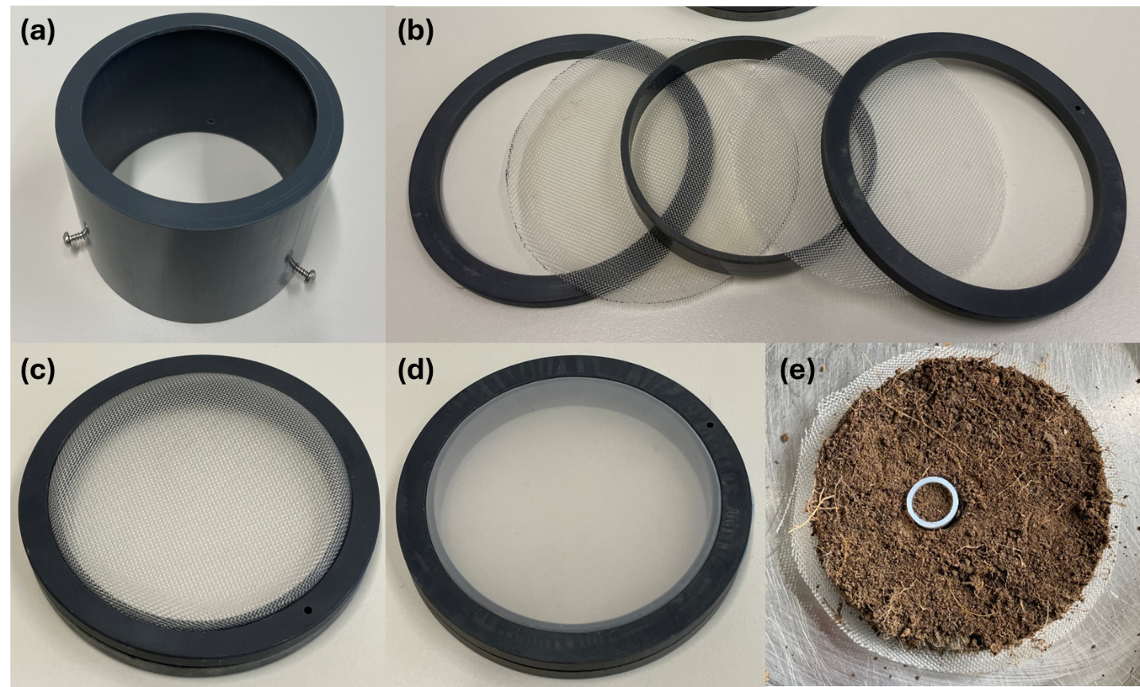

Fig. S2: Layout of hyphobox burial at the grassland site. Thirty-six hyphoboxes were buried in a fully randomized layout on an 8 × 5 m area, with 1-m spacing between hyphobox positions. Each square represents the position of a labeling chamber beneath which an individual hyphobox had been installed three months prior to pulse labeling. Numbers above squares indicate the unique hyphobox IDs (Supporting Information Tab. S1 informs about analyses performed for each individual hyphobox). Box colours denote the sampling time following the ¹³CO₂-pulse labelling (1, 3, or 7 days). For each hyphobox, treatments are depicted (¹⁵N-labelled and/or ¹³C-labelled). Hyphobox replication was n = 11 for the ¹⁵N-¹³C-labelled, n = 13 for the ¹³C-only-labelled, and n = 12 for the unlabelled treatment.
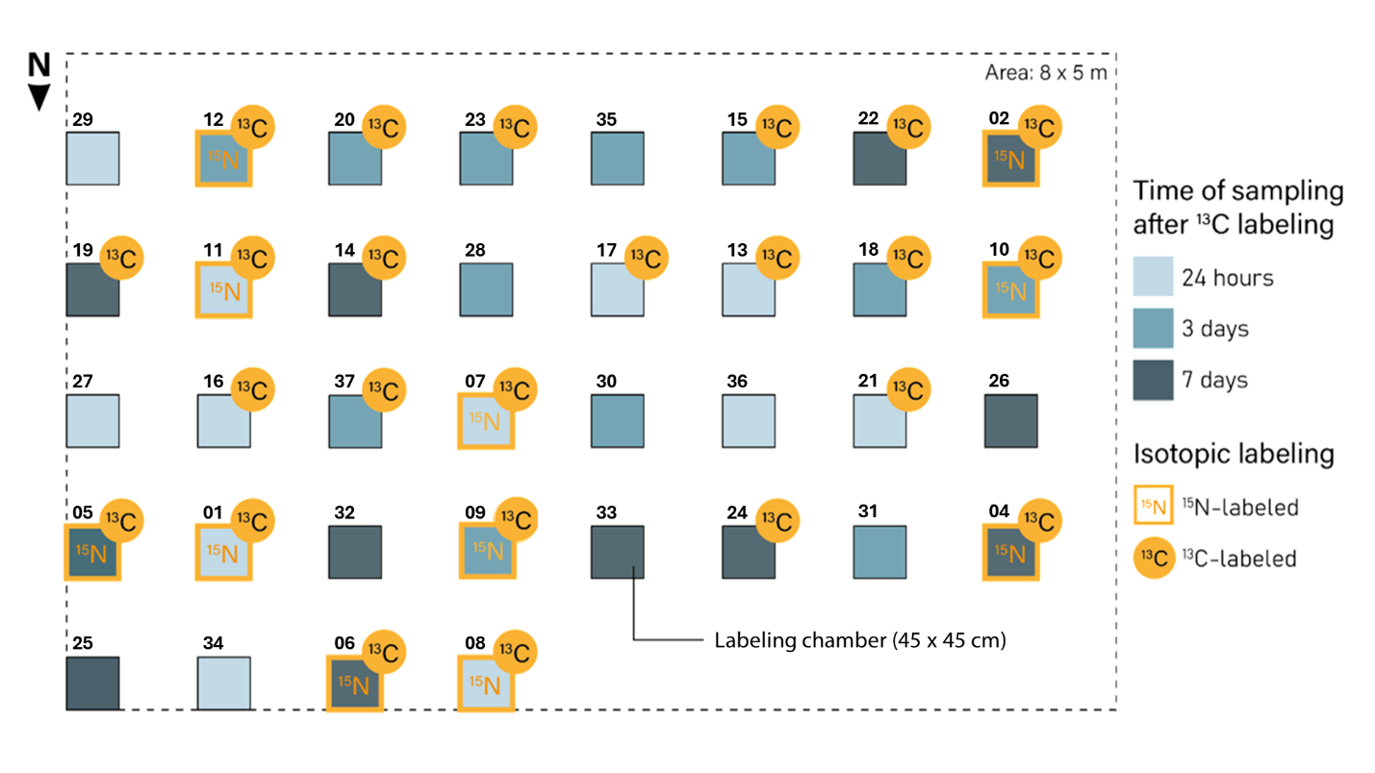
Fig. S3: CO₂ concentration monitoring during pre-experimental plant CO₂ consumption tests and ¹³CO₂ pulse labeling. (a) CO₂ concentration in closed chambers over time during plant CO₂ consumption tests conducted on June 2, 2021 (n = 7 measurements). These tests were used to estimate plant CO₂ uptake rates and to calibrate the required amount of NaHCO₃ for the pulse labeling. (b) CO₂ concentration monitored in the unlabeled control chamber (receiving ¹²CO₂) during the three consecutive labeling days (July 19–21, 2021). CO₂ was maintained within the target range of 380–800 ppm by stepwise addition of H₃PO₄ to NaHCO₃, with fluctuations reflecting acid additions and plant CO₂ uptake.

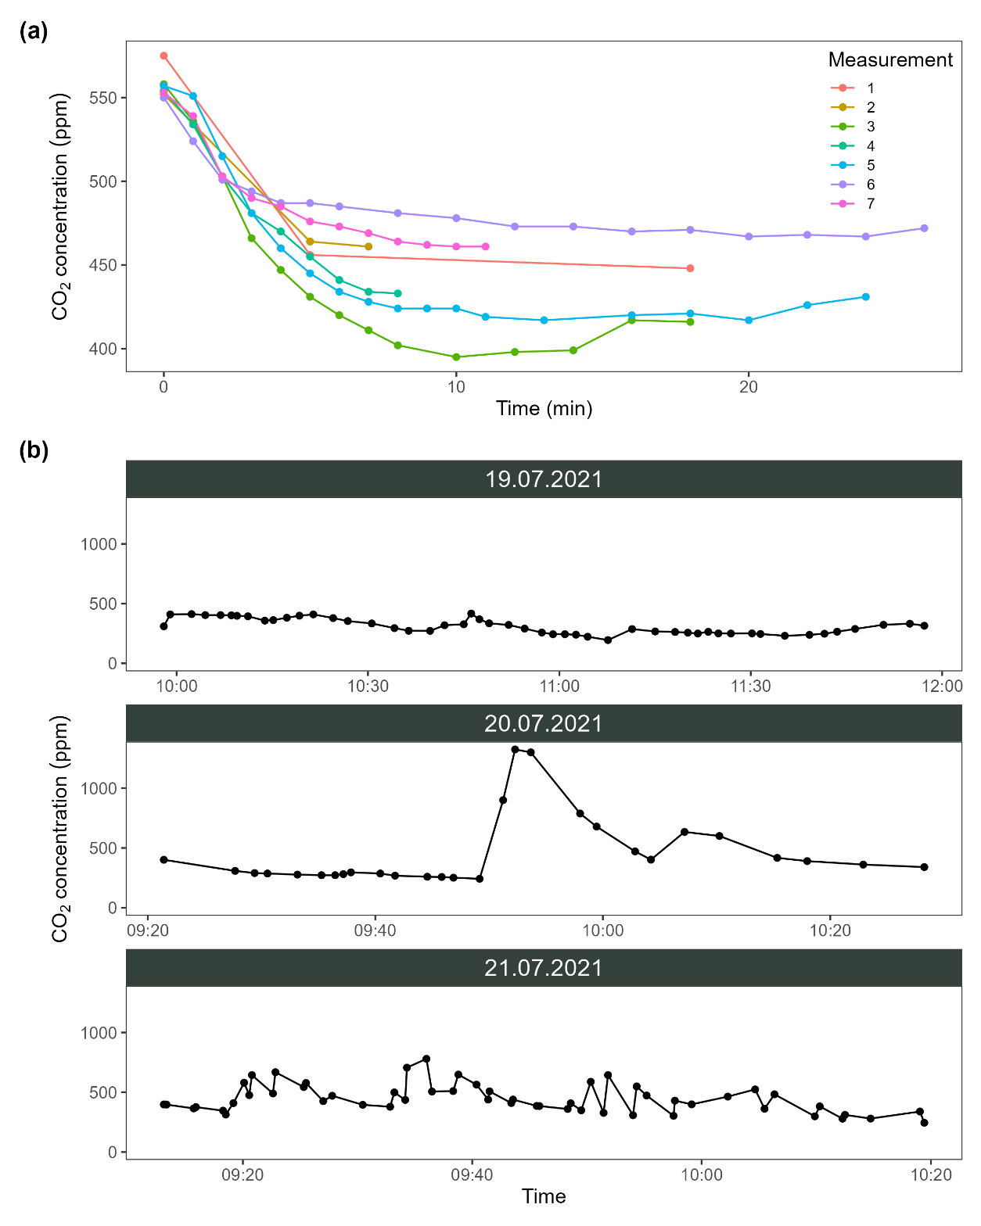
Fig. S4: Individual secondary ion images from NanoSIMS analysis of the four soil regions shown in the main text (Fig. 4). Rows show the distribution of the measured ion species: ¹⁶O⁻, ¹²C₂⁻, ¹²C¹³C⁻, ¹²C¹⁴N⁻, ¹²C¹⁵N⁻, ³¹P⁻, and ²⁷Al¹⁶O⁻; each column corresponds to one measured region. Ion signals are displayed as counts, with intensity increasing from blue (low) to red (high); scales are adjusted per image for optimal contrast and are therefore not directly comparable between panels.
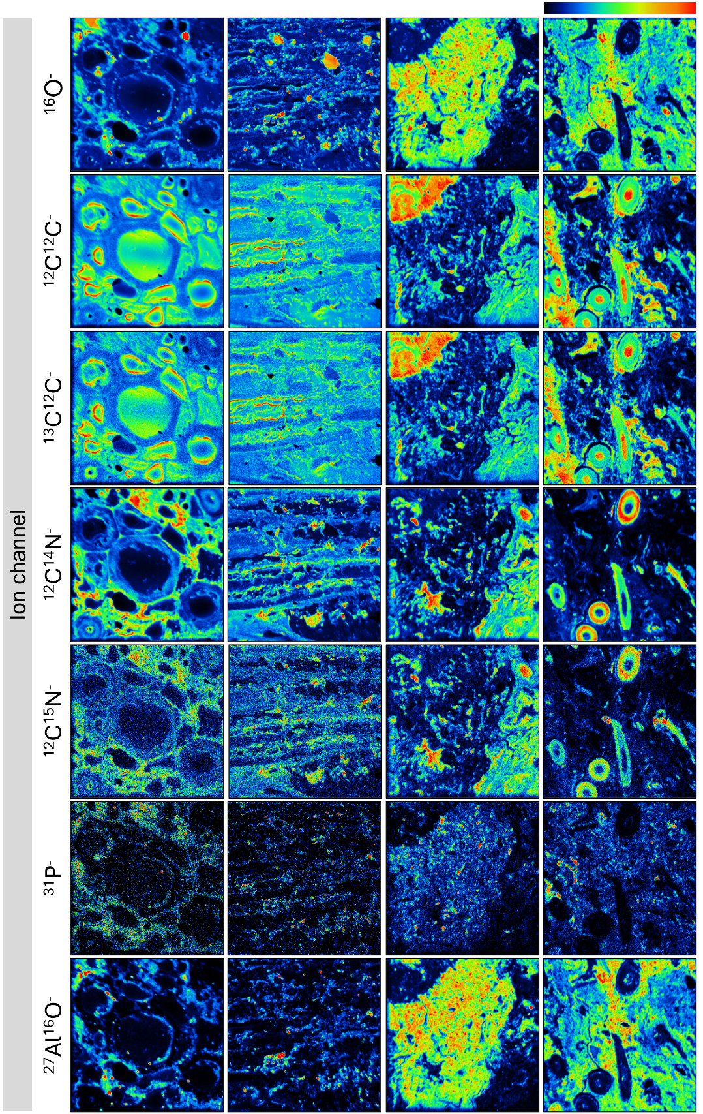
Fig. S5: Average NanoSIMS secondary ion signal intensities across structural segments. Mean ion counts per pixel for ¹⁶O⁻, ¹²C₂⁻, ¹²C¹³C⁻, ¹²C¹⁴N⁻, ¹²C¹⁵N⁻, ³¹P⁻, and ²⁷Al¹⁶O⁻ within non-enriched and isotopically enriched regions of resin, mineral, and organic matter (OM) segments, averaged across the four regions shown in Fig. 4a–d. Note the break in the y-axis to accommodate the wide range in signal intensities across ion species.
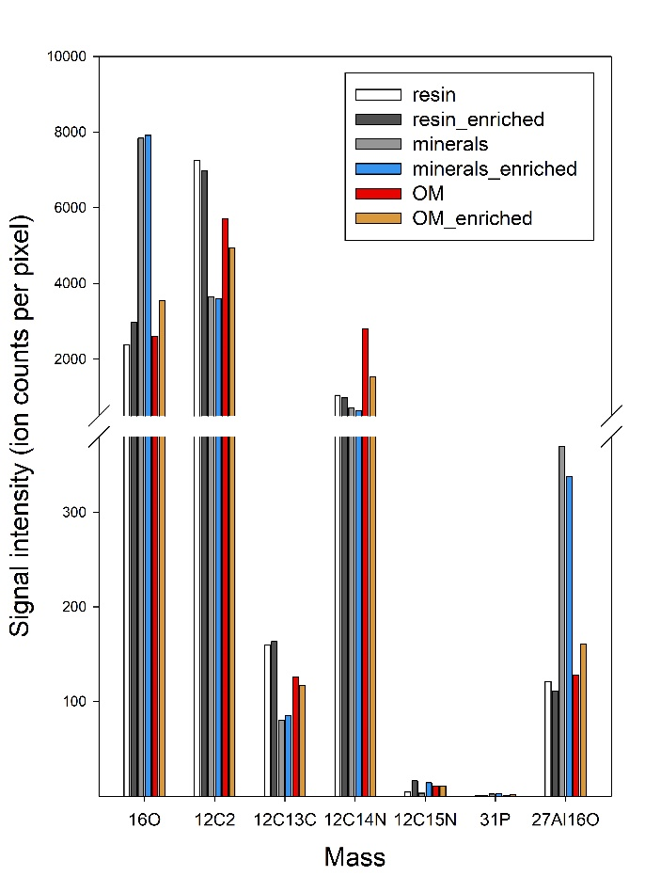

Fig. S6: Plant shoot and root biomass at the time of sampling. (a) plant shoot biomass in a 40x40 area covered by the labelling chamber and (b) root biomass in the rhizosphere compartment at the different sampling days, summarized across labeling treatments. Each mean represents n=12 observations. Dots represent means and bars standard deviations. Letters denote significant (p < 0.05) differences between timepoints according to linear modeling.
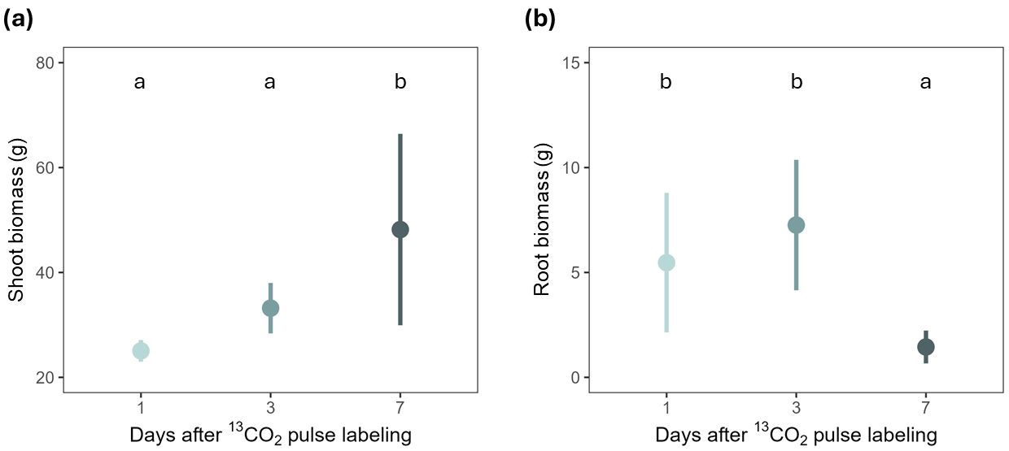

Fig. S7: ¹³C and ¹⁵N atom-% in plant shoots, roots, and soils across bulk soil and hyphobox compartments. (a–c) ¹³C atom-% and (d–f) ¹⁵N atom-% in (a, d) plant shoot biomass harvested from a 40 cm × 40 cm area covered by the labeling chamber, (b, e) root biomass of the (mycor)rhizosphere compartment (RC), and (c, f) the bulk soil (BS) and soils of the different hyphobox compartments, i.e. the RC, hyphosphere compartment (HC), and substrate compartment (SC), at one, three, and seven days after ¹³CO₂ pulse-labeling. ¹³C atom-% values are pooled across the ¹³C-only- and ¹³C-¹⁵N-labeled treatments (n = 8 per timepoint, except roots at day three where n = 7); ¹⁵N atom-% values represent the ¹³C-¹⁵N-labeled treatment (n = 4 per timepoint, except day 3 where n = 3). Dotted lines indicate the mean of the unlabeled control treatment, averaged across sampling days (n = 12). Dots show means and bars standard deviations.

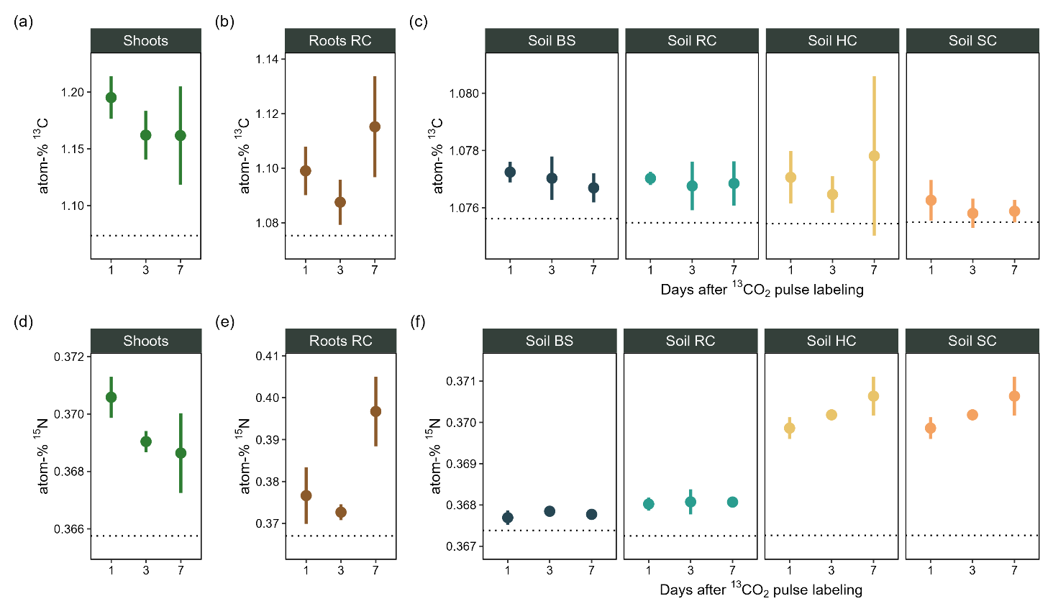

Fig. S8: Soil water content across bulk soil and hyphobox compartments. Shown are means (dots) and standard deviations (bars) of soil water contents at the time of sampling, averaged across treatments and sampling days, for the bulk soil (BS), (mycor)rhizosphere compartment (RC), hyphosphere compartment (HC), and substrate compartment (SC). Each mean represents n = 36 observations. Different letters indicate significant differences among compartments (p < 0.05) based on linear mixed-effects modeling.
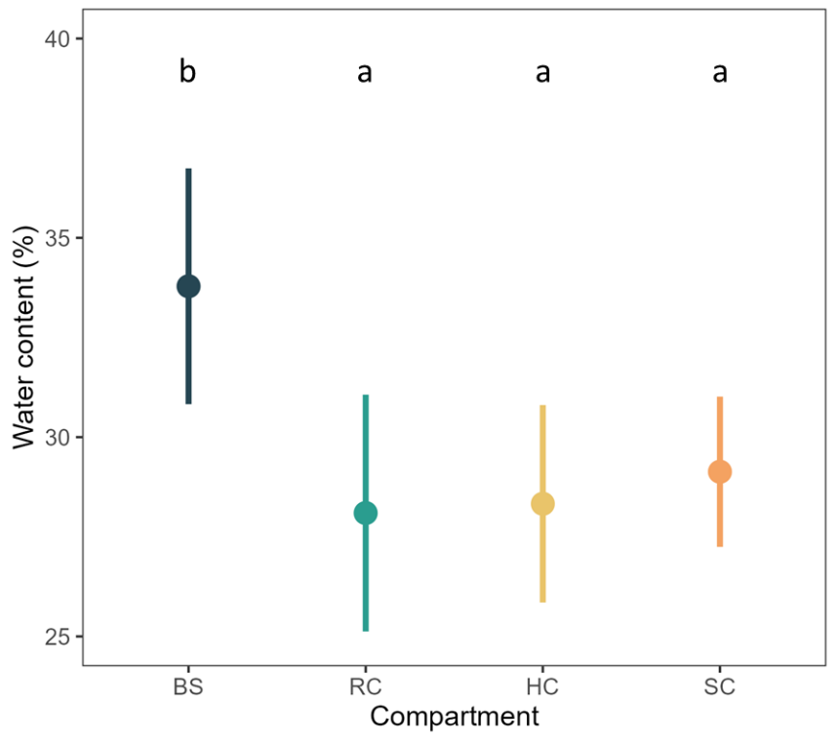

Fig. S9: Variations in the content of the neutral lipid fatty acid (NLFA) 16:1ω5 between labeling treatments and sampling days. Shown are results for the bulk soil (BS), (mycor)rhizosphere compartment (RC), hyphosphere compartment (HC), and substrate compartment (SC). Dots represent means and bars standard deviations.
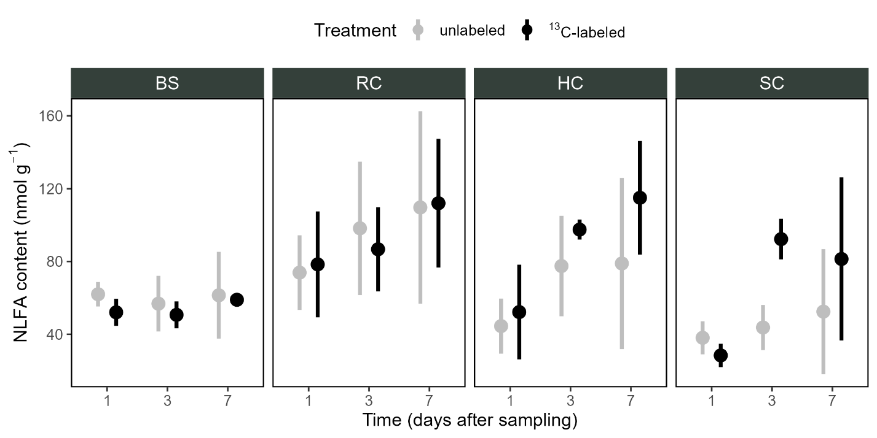
Fig. S10: NanoSIMS ion images of ²⁷Al¹⁶O⁻ and ³¹P⁻ in the imaged regions. RGB overlay images showing the distribution of ²⁷Al¹⁶O⁻ (magenta) and ³¹P⁻ (green) in (a) the bulk soil, (b) the (mycor)rhizosphere compartment, (c) the hyphosphere compartment, and (d) the substrate compartment, corresponding to the same regions shown in Fig. 4a–d in the main text.

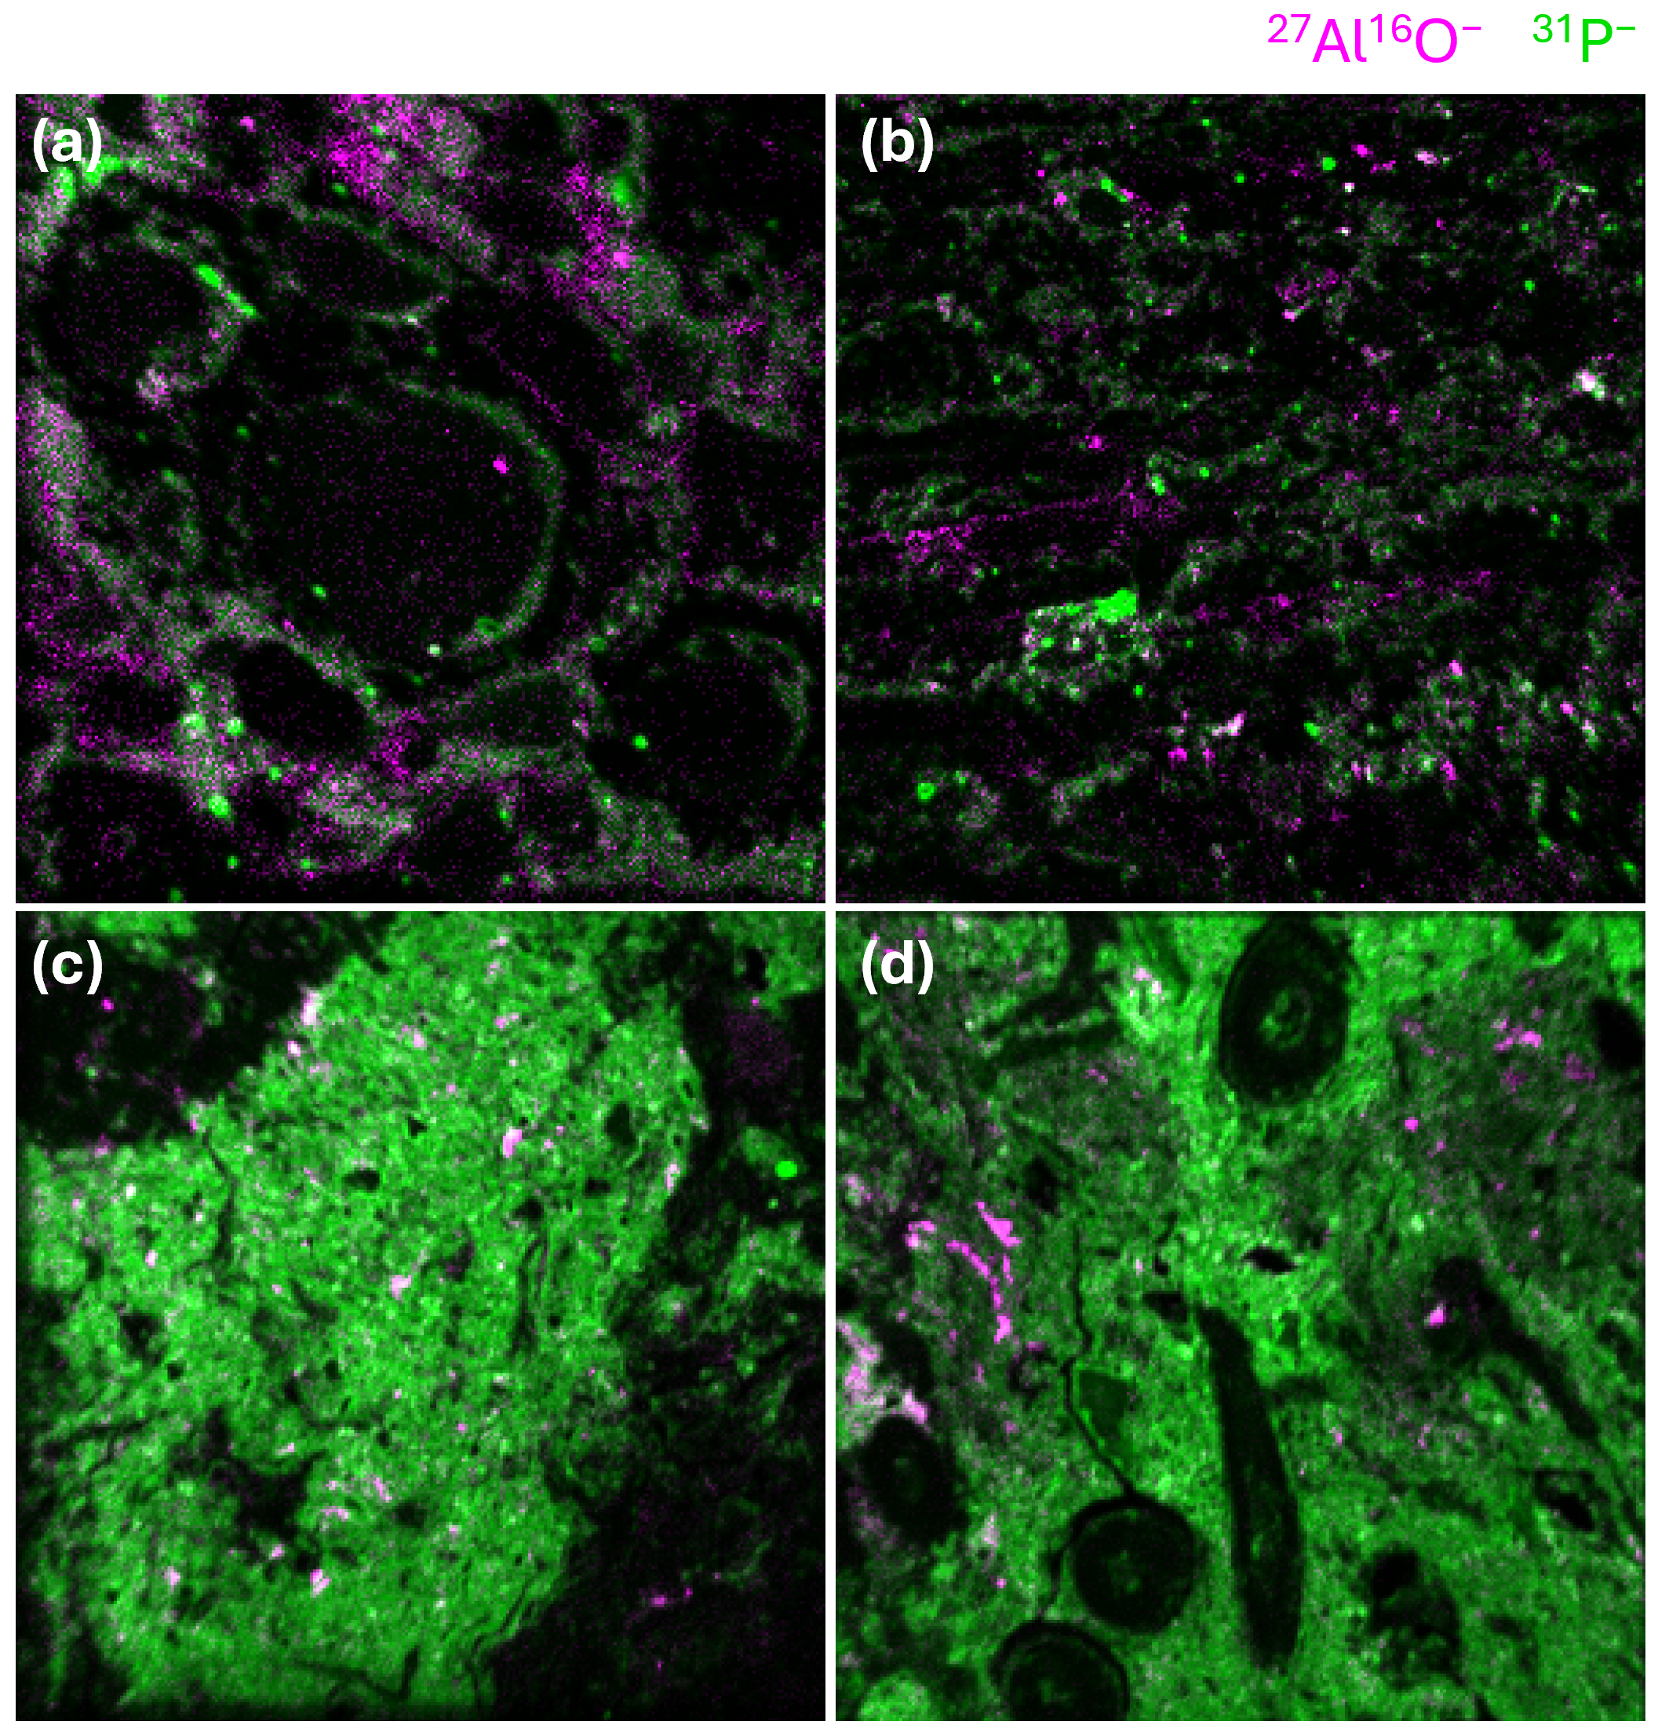

Fig. S11: Diversity indices of bacterial and fungal communities. Panels show bacterial a) Shannon diversity and b) Simpson diversity, as well as fungal c) Shannon diversity and d) Simpson diversity. Data points are coloured by their assignment either to the bulk soil (BS), or one of the hyphobox compartments, i.e., the rhizosphere compartment (RC), hyphosphere compartment (HC), or substrate compartment (SC). Each mean represents n = 8 observations. Dots represent means and bars standard deviations. Letters denote significant (p < 0.05) differences between compartments according to linear mixed-effects modeling.
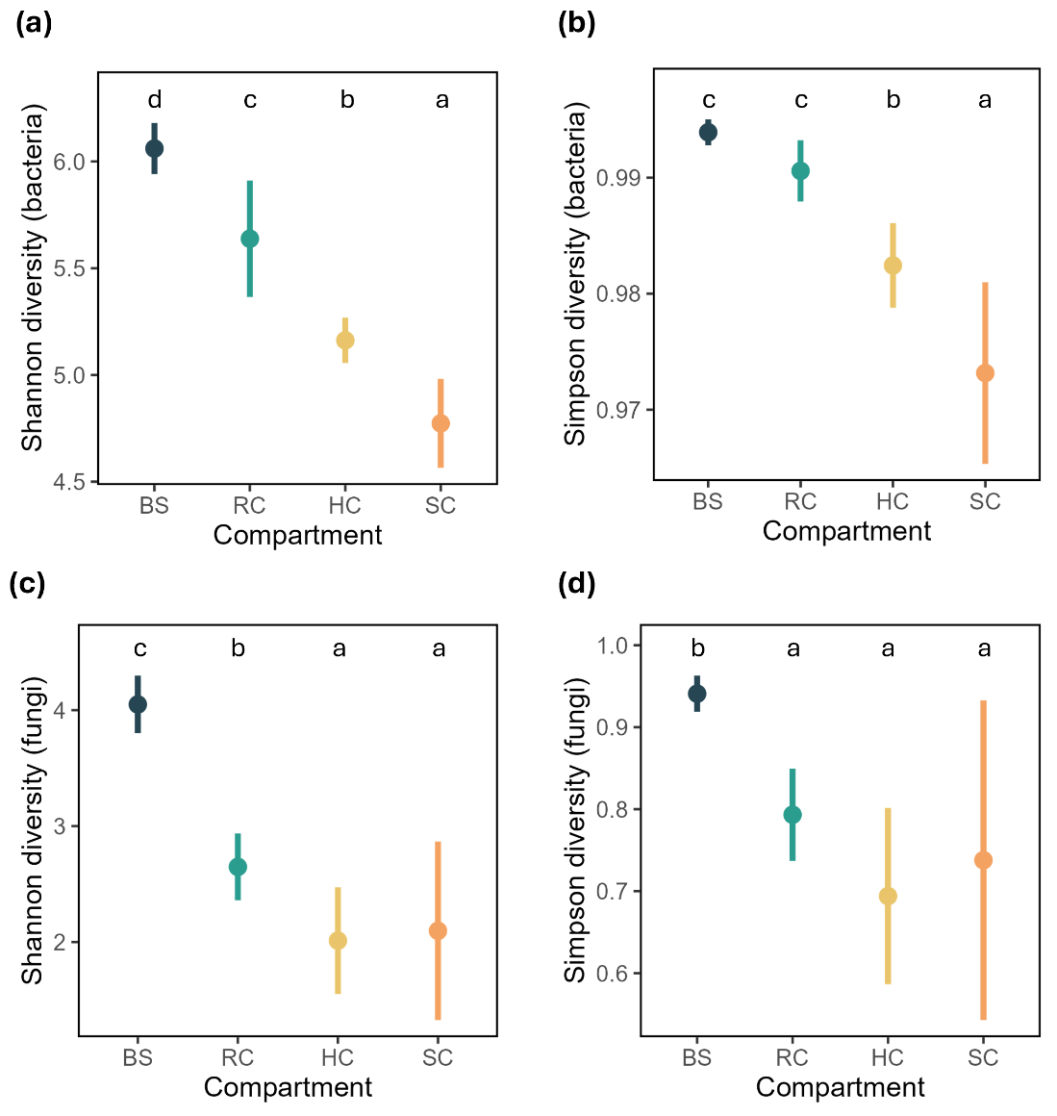
Fig. S12: Non-metric multidimensional scaling (NMDS) ordination of bacterial and fungal communities. a) bacterial (stress value: 0.14) and b) fungal community compositions (stress value: 0.15) across compartments (bulk soil, BC; (mycor)rhizosphere compartment, RC; hyphosphere compartment, HC; substrate compartment, SC) based on Bray–Curtis dissimilarities calculated from relative abundance data. Each point represents one sample, and colors indicate compartments. Distances between points reflect differences in community composition, with closer points indicating more similar communities. For bacteria, BS samples were omitted from the plot to improve visualization of differences among the other compartments, as their pronounced compositional divergence dominated the ordination space.
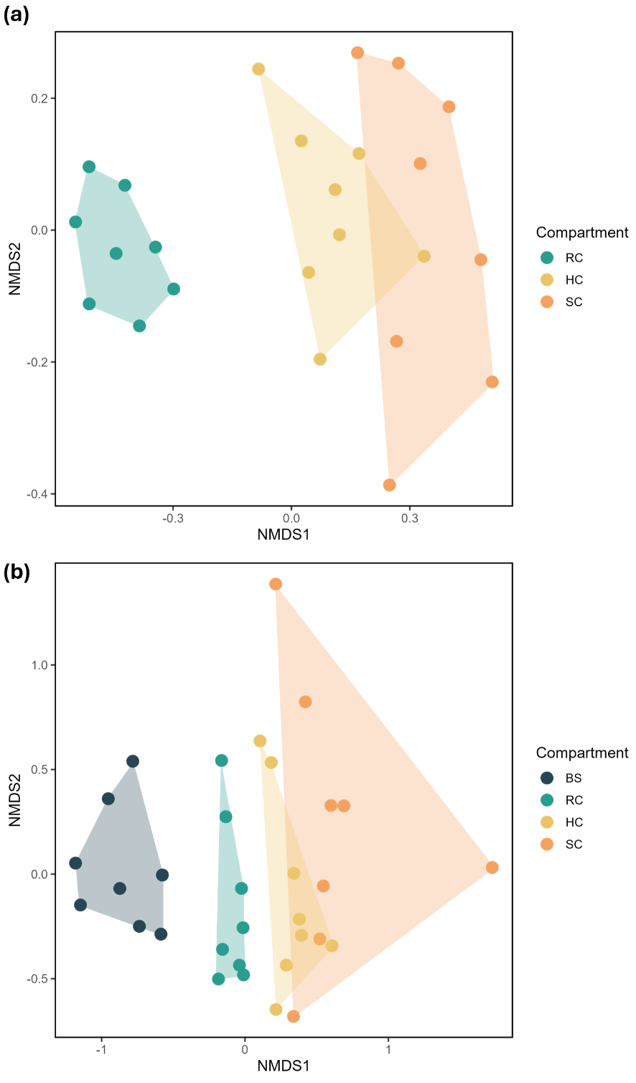
Fig. S13: Differential abundance of bacterial phyla across compartments. Forest plots showing log₂ fold changes (LFCs) (±95% confidence intervals) for the 15 most abundant bacterial phyla across the three contrasts: rhizosphere compartment (RC) vs bulk soil (BS), hyphosphere compartment (HC) vs RC, and substrate compartment (SC) vs HC. Phyla with p < 0.05 and |LFC| > 1.5 are highlighted in black, while all others are shown in grey. Positive values indicate relative enrichment, and negative values indicate depletion.
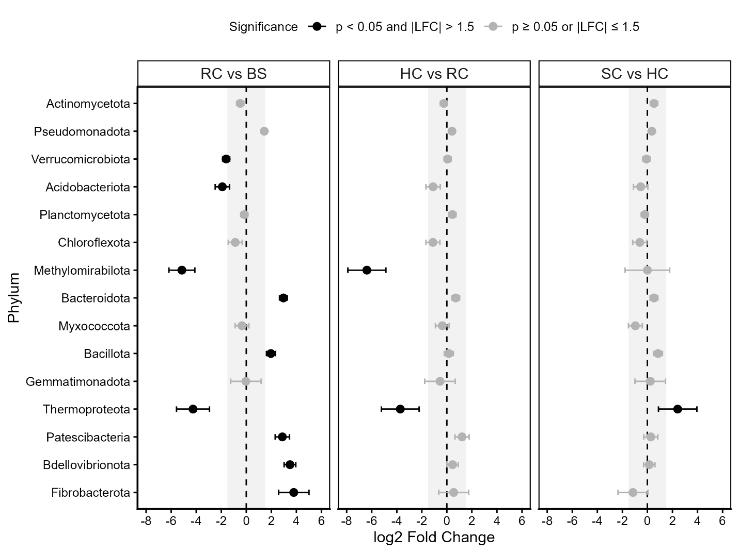
Fig. S14: Differential abundance of fungal phyla across compartments. Forest plots showing log₂ fold changes (LFCs) (±95% confidence intervals) for the 15 most abundant fungal phyla across the three contrasts: rhizosphere compartment (RC) vs bulk soil (BS), hyphosphere compartment (HC) vs RC, and substrate compartment (SC) vs HC. Phyla with p < 0.05 and |LFC| > 1.5 are highlighted in black, while all others are shown in grey. Positive values indicate relative enrichment, and negative values indicate depletion.
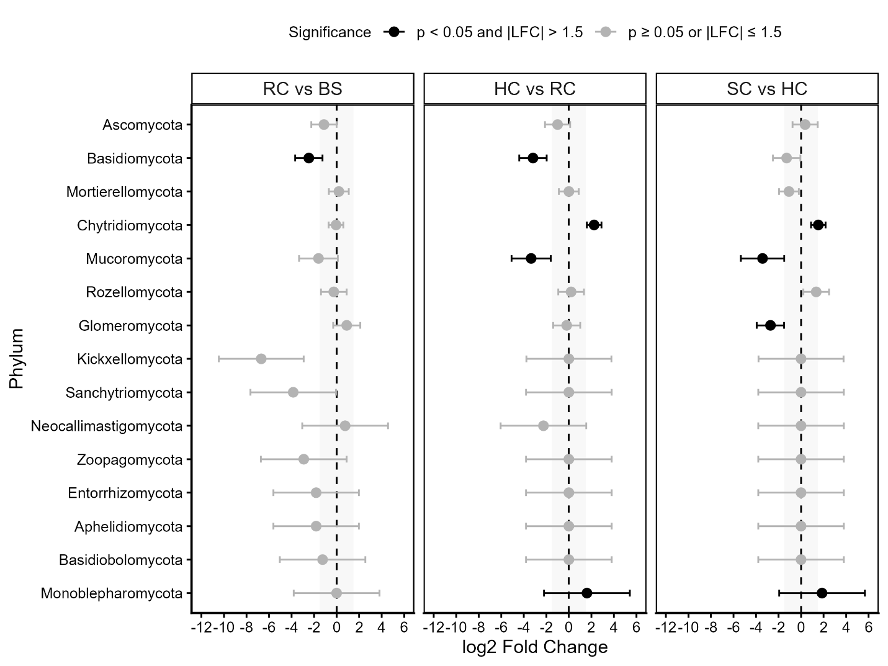
Table S1: Analyses performed for each individual hyphobox. Overview of each hyphobox, including the exact dates of ¹³CO₂ pulse labeling and sampling, and all performed analyses. Abbreviations: C, carbon; N, nitrogen; PLFA, phospholipid fatty acid; NLFA, neutral lipid fatty acid; NanoSIMS, nanoscale secondary ion mass spectrometry. Different blue background colors denote timepoints, while ¹³C and ¹⁵N labeling treatments are highlighted in green (labeled) and red (unlabeled).
Hyphobox  ID | ¹³C Labeling date (D/M/Y) | Sampling date  (D/M/Y) | Days | ¹⁵N | ¹³C | C, N | PLFAs  /NLFA | Amplicon  sequencing | NanoSIMS
1 | 21.07.2021 | 22.07.2021 | 1 | yes | yes | x
7 | 21.07.2021 | 22.07.2021 | 1 | yes | yes | x |  |  | x
8 | 21.07.2021 | 22.07.2021 | 1 | yes | yes | x
11 | 21.07.2021 | 22.07.2021 | 1 | yes | yes | x
13 | 21.07.2021 | 22.07.2021 | 1 | no | yes | x | x | x
16 | 21.07.2021 | 22.07.2021 | 1 | no | yes | x | x | x
17 | 21.07.2021 | 22.07.2021 | 1 | no | yes | x | x | x
21 | 21.07.2021 | 22.07.2021 | 1 | no | yes | x | x | x
27 | - | 22.07.2021 | 1 | no | no | x | x | x
29 | - | 22.07.2021 | 1 | no | no | x | x | x
34 | - | 22.07.2021 | 1 | no | no | x | x | x | x
36 | - | 22.07.2021 | 1 | no | no | x | x | x
37 | 20.07.2021 | 23.07.2021 | 3 | no | yes | x
9 | 20.07.2021 | 23.07.2021 | 3 | yes | yes | x
10 | 20.07.2021 | 23.07.2021 | 3 | yes | yes | x
12 | 20.07.2021 | 23.07.2021 | 3 | yes | yes | x
15 | 20.07.2021 | 23.07.2021 | 3 | no | yes | x | x
18 | 20.07.2021 | 23.07.2021 | 3 | no | yes | x | x
20 | 20.07.2021 | 23.07.2021 | 3 | no | yes | x | x
23 | 20.07.2021 | 23.07.2021 | 3 | no | yes | x | x
28 | - | 23.07.2021 | 3 | no | no | x | x
30 | - | 23.07.2021 | 3 | no | no | x | x
31 | - | 23.07.2021 | 3 | no | no | x | x
35 | - | 23.07.2021 | 3 | no | no | x | x
2 | 19.07.2021 | 26.07.2021 | 7 | yes | yes | x
4 | 19.07.2021 | 26.07.2021 | 7 | yes | yes | x
5 | 19.07.2021 | 26.07.2021 | 7 | yes | yes | x
6 | 19.07.2021 | 26.07.2021 | 7 | yes | yes | x |  |  | x
14 | 19.07.2021 | 26.07.2021 | 7 | no | yes | x | x
19 | 19.07.2021 | 26.07.2021 | 7 | no | yes | x | x
22 | 19.07.2021 | 26.07.2021 | 7 | no | yes | x | x
24 | 19.07.2021 | 26.07.2021 | 7 | no | yes | x | x
25 | - | 26.07.2021 | 7 | no | no | x | x
26 | - | 26.07.2021 | 7 | no | no | x | x
32 | - | 26.07.2021 | 7 | no | no | x | x
33 | - | 26.07.2021 | 7 | no | no | x | x |  | x
Table S2: Number of reads retained per sample at each step of the DADA2 pipeline for 16S rRNA gene amplicon sequencing.
Hyphobox ID | Compartment | input | filtered | denoisedF | denoisedR | merged | nonchim
13 | BS | 77382 | 57388 | 54429 | 54707 | 45939 | 45716
16 | BS | 80169 | 61370 | 58267 | 58210 | 48115 | 47884
17 | BS | 79909 | 60792 | 57674 | 57720 | 46896 | 46687
21 | BS | 91400 | 69694 | 66189 | 66466 | 54887 | 54707
27 | BS | 93229 | 71007 | 67444 | 67717 | 56960 | 56733
29 | BS | 118383 | 87435 | 83881 | 84035 | 72718 | 72373
34 | BS | 89032 | 68828 | 65426 | 65674 | 54038 | 53794
36 | BS | 143224 | 112000 | 107223 | 107077 | 90684 | 90284
13 | RC | 37686 | 26829 | 24854 | 25189 | 21327 | 21252
16 | RC | 80662 | 62384 | 59561 | 59760 | 52695 | 52376
17 | RC | 71173 | 54756 | 52510 | 52503 | 46917 | 46713
21 | RC | 80876 | 64120 | 61280 | 61449 | 53664 | 52987
27 | RC | 94278 | 73504 | 70537 | 70481 | 62322 | 61846
29 | RC | 102615 | 73041 | 70322 | 70600 | 63505 | 62978
34 | RC | 116462 | 85504 | 81872 | 82112 | 72595 | 71915
36 | RC | 121718 | 94902 | 91472 | 91301 | 80127 | 79650
13 | HC | 96182 | 67933 | 66062 | 66459 | 61072 | 60272
16 | HC | 113345 | 90489 | 88275 | 88475 | 82416 | 80849
17 | HC | 91797 | 71602 | 69905 | 69974 | 65320 | 64570
21 | HC | 104310 | 76622 | 74814 | 74985 | 70006 | 69037
27 | HC | 108058 | 83706 | 81931 | 81941 | 75659 | 74711
29 | HC | 130650 | 104010 | 102307 | 102490 | 96429 | 95079
34 | HC | 93877 | 72684 | 70615 | 70723 | 64314 | 63399
36 | HC | 135271 | 104409 | 102536 | 102599 | 96536 | 95165
13 | SC | 87366 | 67386 | 65825 | 66052 | 61205 | 59311
16 | SC | 181150 | 143625 | 141451 | 141838 | 134631 | 131182
17 | SC | 112033 | 75897 | 74457 | 74384 | 70342 | 69899
21 | SC | 79386 | 62295 | 60879 | 60980 | 57091 | 56735
27 | SC | 74506 | 57728 | 56548 | 56531 | 52650 | 52081
29 | SC | 95133 | 74979 | 74039 | 74091 | 70445 | 69196
34 | SC | 523666 | 398534 | 395520 | 396180 | 380130 | 366893
36 | SC | 96876 | 76820 | 75562 | 75815 | 71128 | 69776
negative control |  | 47 | 20 | 2 | 2 | 0 | 0
negative control |  | 39 | 10 | 1 | 1 | 0 | 0
negative control |  | 32 | 11 | 5 | 5 | 5 | 5
standard soil |  | 102054 | 71660 | 66977 | 67008 | 52217 | 52093
standard soil |  | 133000 | 101622 | 96190 | 96113 | 76055 | 75757
standard soil |  | 116992 | 89442 | 84045 | 84245 | 65778 | 65611
Table S3: Number of reads retained per sample at each step of the DADA2 pipeline for ITS amplicon sequencing.
Hyphobox ID | Compartment | input | filtered | denoisedF | denoisedR | merged | nonchim
13 | BS | 53055 | 30036 | 39518 | 39277 | 37096 | 34677
16 | BS | 55760 | 30708 | 38794 | 38907 | 36849 | 35664
17 | BS | 57429 | 30625 | 40665 | 40710 | 37421 | 36011
21 | BS | 48157 | 25518 | 34220 | 34075 | 31250 | 30610
27 | BS | 50295 | 27142 | 34608 | 34722 | 32683 | 32137
29 | BS | 69690 | 36495 | 49443 | 49492 | 45015 | 43201
34 | BS | 63427 | 33946 | 45385 | 45471 | 43020 | 42292
36 | BS | 78270 | 44691 | 58950 | 58829 | 55100 | 52870
13 | RC | 43937 | 24163 | 32188 | 32026 | 30341 | 30072
16 | RC | 46925 | 27119 | 34066 | 34124 | 30917 | 29899
17 | RC | 52974 | 29890 | 37748 | 37853 | 32627 | 31548
21 | RC | 65080 | 36755 | 48948 | 48874 | 44148 | 41089
27 | RC | 81405 | 46399 | 60618 | 60504 | 57385 | 54798
29 | RC | 94567 | 56584 | 73216 | 73145 | 70517 | 66611
34 | RC | 75276 | 41284 | 52438 | 52356 | 49244 | 46865
36 | RC | 78440 | 44722 | 57446 | 57050 | 53069 | 49269
13 | HC | 87616 | 52830 | 67514 | 67304 | 65751 | 63863
16 | HC | 96190 | 60190 | 75033 | 74975 | 72239 | 69240
17 | HC | 109518 | 64329 | 82696 | 82599 | 69490 | 64597
21 | HC | 36851 | 21029 | 26619 | 26657 | 25013 | 23849
27 | HC | 40387 | 25635 | 31193 | 31096 | 29959 | 28405
29 | HC | 42918 | 28550 | 34266 | 34236 | 33780 | 32295
34 | HC | 40556 | 25178 | 30990 | 30948 | 29947 | 29063
36 | HC | 32956 | 19768 | 24048 | 23868 | 22723 | 22165
13 | SC | 41039 | 23411 | 31345 | 31288 | 30575 | 29889
16 | SC | 24238 | 14494 | 17785 | 17824 | 17609 | 17466
17 | SC | 48597 | 31110 | 38193 | 38175 | 35202 | 32652
21 | SC | 46025 | 25827 | 31751 | 31798 | 27393 | 27383
27 | SC | 52846 | 31732 | 40184 | 40215 | 38139 | 36841
29 | SC | 75011 | 44303 | 57730 | 57730 | 55751 | 53052
34 | SC | 51329 | 31564 | 39584 | 39557 | 38631 | 37739
36 | SC | 53714 | 30892 | 39179 | 39169 | 35260 | 35231
negative control |  | 54 | 14 | 12 | 10 | 10 | 10
negative control |  | 14 | 1 | 2 | 2 | 0 | 0
negative control |  | 18 | 5 | 4 | 4 | 4 | 4
standard soil |  | 39100 | 18673 | 27061 | 26915 | 25291 | 24927
standard soil |  | 37852 | 16778 | 25521 | 25375 | 23820 | 23569
standard soil |  | 41168 | 18632 | 28141 | 27885 | 26432 | 26286
Table S4: Summary of linear (LM) and linear mixed-effects models (LMM) after model simplification testing effects of Compartment, Time and Treatment on different variables. Non-significant terms were removed during model simplification (backward elimination). Only effects retained in final models are shown. Test statistics are F values for LM and Wald χ² values for LMM. Degrees of freedom (df) are shown for numerator (and denominator for LM).
Response variable | Model type | Effect | Test statistic | df | p value
Root biomass | LM | Time | F = 14.951 | 2, 33 | < 0.001
Plant biomass | LM | Time | F = 13.745 | 2, 33 | < 0.001
Soil water content | LMM | Compartment | χ² = 144.09 | 3 | < 0.001
Soil excess ¹³C | LMM | Compartment | χ² = 30.128 | 3 | < 0.001
Plant root excess ¹³C | LM | Compartment | F = 2.9968 | 2, 21 | 0.07163
Plant shoot excess ¹³C | LM | no significant effect | – | – | –
Soil excess ¹⁵N | LMM | Compartment | χ² = 688.9 | 3 | < 0.001
Plant root excess ¹⁵N | LM | no significant effect | – | – | –
Plant shoot excess ¹⁵N | LM | no significant effect | – | – | –
NLFA content AMF | LMM | Compartment | χ² = 63.14 | 3 | < 0.001
NLFA content AMF | LMM | Time | χ² = 9.4 | 2 | 0.009
NLFA content AMF | LMM | Treatment | χ² = 1.19 | 1 | 0.274
NLFA content AMF | LMM | Compartment × Time | χ² = 17.83 | 6 | 0.007
NLFA content AMF | LMM | Compartment × Treatment | χ² = 11.2 | 3 | 0.011
PLFA content saprotrophic fungi | LMM | Compartment | χ² = 463.81 | 3 | < 0.001
PLFA content GP bacteria | LMM | Compartment | χ² = 3704.3 | 3 | < 0.001
PLFA content GN bacteria | LMM | Compartment | χ² = 1754.1 | 3 | < 0.001
Bacterial Shannon diversity | LMM | Compartment | χ² = 317.14 | 3 | < 0.001
Bacterial Simpson diversity | LMM | Compartment | χ² = 131.08 | 3 | < 0.001
Fungal Shannon diversity | LMM | Compartment | χ² = 152.29 | 3 | < 0.001
Fungal Simpson diversity | LMM | Compartment | χ² = 26.201 | 3 | < 0.001

Table S5: Pairwise comparisons of the labeled vs. unlabeled treatments within each Time × Compartment combination for ¹³C incorporation into microbial fatty acids. Pairwise comparisons were calculated using estimated marginal means (emmeans) from linear mixed-effects models with Tukey adjustment. Prior to analysis, four outliers were excluded: for the fungal PLFA C18:2ω6, values from the SC of hyphobox 20 and from the HC of hyphobox 23, both belonging to the ¹³C-only-labeled treatment at day 3; and for Gram-positive and Gram-negative bacteria, values from the SC of hyphobox 31 belonging to the unlabeled treatment at day 3. Degrees of freedom were estimated using the Kenward-Roger method. Only significant (p < 0.05) and marginally significant (0.05 ≤ p < 0.10) comparisons are shown.

Response | Time | Compartment | Estimate | SE | df | t | p value
NLFA ¹³C atom-%  arbuscular mycorrhizal fungi | 1 | BS | -0.275 | 0.048 | 38.9 | -5.71 | <0.001
NLFA ¹³C atom-%  arbuscular mycorrhizal fungi | 3 | BS | -0.153 | 0.048 | 38.9 | -3.18 | 0.003
NLFA ¹³C atom-%  arbuscular mycorrhizal fungi | 7 | BS | -0.087 | 0.048 | 38.9 | -1.80 | 0.080
NLFA ¹³C atom-%  arbuscular mycorrhizal fungi | 1 | RC | -0.319 | 0.048 | 38.9 | -6.63 | <0.001
NLFA ¹³C atom-%  arbuscular mycorrhizal fungi | 3 | RC | -0.179 | 0.048 | 38.9 | -3.73 | 0.001
NLFA ¹³C atom-%  arbuscular mycorrhizal fungi | 7 | RC | -0.100 | 0.048 | 38.9 | -2.09 | 0.044
NLFA ¹³C atom-%  arbuscular mycorrhizal fungi | 1 | HC | -0.301 | 0.048 | 38.9 | -6.25 | <0.001
NLFA ¹³C atom-%  arbuscular mycorrhizal fungi | 3 | HC | -0.226 | 0.051 | 43.8 | -4.48 | <0.001
NLFA ¹³C atom-%  arbuscular mycorrhizal fungi | 7 | HC | -0.129 | 0.048 | 38.9 | -2.69 | 0.011
NLFA ¹³C atom-%  arbuscular mycorrhizal fungi | 1 | SC | -0.121 | 0.048 | 38.9 | -2.52 | 0.016
NLFA ¹³C atom-%  arbuscular mycorrhizal fungi | 3 | SC | -0.231 | 0.053 | 48.2 | -4.37 | <0.001
NLFA ¹³C atom-%  arbuscular mycorrhizal fungi | 7 | SC | -0.095 | 0.048 | 38.9 | -1.98 | 0.055
PLFA ¹³C atom-% saprotrophic fungi | 1 | BS | -0.047 | 0.012 | 58.2 | -3.80 | <0.001
PLFA ¹³C atom-% saprotrophic fungi | 3 | BS | -0.031 | 0.012 | 58.2 | -2.49 | 0.016
PLFA ¹³C atom-% saprotrophic fungi | 7 | BS | -0.034 | 0.012 | 58.2 | -2.77 | 0.008
PLFA ¹³C atom-% saprotrophic fungi | 1 | RC | -0.041 | 0.012 | 58.2 | -3.29 | 0.002
PLFA ¹³C atom-% saprotrophic fungi | 3 | RC | -0.029 | 0.012 | 58.2 | -2.31 | 0.025
PLFA ¹³C atom-% saprotrophic fungi | 7 | RC | -0.047 | 0.012 | 58.2 | -3.77 | <0.001
PLFA ¹³C atom-% saprotrophic fungi | 1 | HC | -0.081 | 0.012 | 58.2 | -6.54 | <0.001
PLFA ¹³C atom-% saprotrophic fungi | 7 | HC | -0.041 | 0.012 | 58.2 | -3.28 | 0.002
PLFA ¹³C atom-% Gram-negative bacteria | 7 | HC | -0.003 | 0.001 | 39.1 | -3.51 | 0.001
PLFA ¹³C atom-% Gram-negative bacteria | 7 | SC | -0.002 | 0.001 | 39.1 | -2.08 | 0.044
PLFA ¹³C atom-% Gram-positive bacteria | 7 | SC | -0.003 | 0.001 | 40.8 | -2.58 | 0.014

