Supplemental data
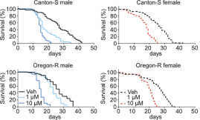Supplemental figure 1: Lifespan of male and female Canton-S and Oregon-R Drosophila melanogaster strains. Each group consisted of 100 flies and was subjected to different concentrations of erastin (0 µM, 1 µM, 10 µM) mixed in 5% sucrose-based food.

