Supplementary Material for „Conventional diversity metrics underestimate gut microbiome disruption under florfenicol exposure in Nile Tilapia (Oreochromis niloticus)“

Lisa-Marie Streb^{1.*}. Inácio Mateus Assane². Gabriela Freitas Pereira de Souza³. Fabiana Pilarski². Anna Paula Queiroga³. Susanne Walch¹. Susanne Rath³ & Michael Schloter^{1.4}
Affiliations:
¹ Research Unit Comparative Microbiome Analysis. Helmholtz Munich. Neuherberg. Germany
² Laboratory of Microbiology and Parasitology of Aquatic Organisms. Aquaculture Center of São Paulo State University (UNESP). Jaboticabal. São Paulo. Brazil.
³ Institute for Chemistry. University of Campinas. Campinas. São Paulo. Brazil
⁴ Chair of Environmental Microbiology. TUM School of Life Sciences. Technical University Munich. Freising. Germany

Supplementary Tables
Table S1: Global Network Topologies (value ± sd).
 | Control | Florfenicol
Node Number | 261 | 268
Edge Number | 516 | 409
Average Path Length | 4.49 | 5.54
Betweenness | 450.77 ± 378.24 | 557.94 ± 673.62
Degree | 9.91 ± 3.42 | 8.1 ± 3.96
Neighbour | 4.43 ± 0.97 | 3.55 ± 1.47
Modularity | 0.57 | 0.64
Positive Edge Percentage | 74.2 % | 74.1 %
Clustering Coefficient | 0.071 | 0.068

Table S2: Hub genera identified in the co-occurrence network approach per group and their respective phylum classification. Hubness and IVI values.
Control
Hub Genus | Phylum | Hubness Score |  | IVI
Hyphomicrobium | Proteobacteria | 3.05269543 |  | 100
Afipia | Proteobacteria | 2.37317678 |  | 79.3342602
Clostridium sensu stricto 2 | Firmicutes | 2.14428628 |  | 82.1208998
Breznakia | Firmicutes | 2.11567497 |  | 58.5642579
Megasphaera | Firmicutes | 2.05129952 |  | 51.1581139
Haloimpatiens | Firmicutes | 2.01553538 |  | 53.1120789
Proteiniclasticum | Firmicutes | 2.01553538 |  | 56.6782961
Rhizobium | Proteobacteria | 1.95115993 |  | 60.0531337
FFCH7168 | Chloroflexi | 1.88678447 |  | 68.6745461
Helcococcus | Firmicutes | 1.88678447 |  | 60.7600973
Actinobacillus | Proteobacteria | 1.88678447 |  | 56.3750308
Haemophilus | Proteobacteria | 1.82240902 |  | 60.2919074
Acetobacteroides | Bacteroidota | 1.79379771 |  | 48.9664066
Aurantimicrobium | Actinobacteriota | 1.75803357 |  | 62.7173429
Leucobacter | Actinobacteriota | 1.75803357 |  | 61.8341581
Aureispira | Bacteroidota | 1.75803357 |  | 48.7209635
Dechloromonas | Proteobacteria | 1.75803357 |  | 35.7523898
Clostridium sensu stricto 1 | Firmicutes | 1.69365812 |  | 30.7665047
Aggregatibacter | Proteobacteria | 1.69365812 |  | 47.4592946
Lactobacillus | Firmicutes | 1.62928267 |  | 36.2387426
Cetobacterium | Fusobacteriota | 1.46476762 |  | 36.8964885
UCG-004 | Firmicutes | 1.46476762 |  | 46.2566967
Macellibacteroides | Bacteroidota | 1.46476762 |  | 30.3764657
Florfenicol
Streptococcus | Firmicutes | 4.62982872 | 100
Clostridium sensu stricto 2 | Firmicutes | 3.54529642 | 57.797829
Erysipelothrix | Firmicutes | 3.39673035 | 55.8298754
Proteiniclasticum | Firmicutes | 3.09959821 | 46.5982551
Frisingicoccus | Firmicutes | 2.98074535 | 47.1270854
Propionicicella | Actinobacteriota | 2.98074535 | 37.6071755
Peptostreptococcus | Firmicutes | 2.96588875 | 61.2731104
Kouleothrix | Chloroflexi | 2.92131892 | 40.2170322
Vagococcus | Firmicutes | 2.78760946 | 42.7087955
Herbiconiux | Actinobacteriota | 2.4310509 | 35.5616827
Family XIII AD3011 group | Firmicutes | 2.37162447 | 26.2572115
Porphyromonas | Bacteroidota | 2.31219804 | 30.3742621
Paraclostridium | Firmicutes | 2.05963572 | 46.1902748
Family XIII UCG-001 | Firmicutes | 1.94078287 | 33.8773187
Erysipelatoclostridium | Firmicutes | 1.92592626 | 28.3915121
Kineosporia | Actinobacteriota | 1.88135644 | 19.9208549
Murdochiella | Firmicutes | 1.86649983 | 27.380143
Aggregatibacter | Proteobacteria | 1.80707341 | 18.560052
Peptococcus | Firmicutes | 1.74764698 | 15.9806652
Pasteurella | Proteobacteria | 1.68822055 | 22.7847608
Veillonella | Firmicutes | 1.50994127 | 14.023747
Peptoniphilus | Firmicutes | 1.49508466 | 21.4824086

Table S3: Technical characteristics and edge selection stability values of pooled vs. phase-stratified networks.
Type | samples | retained reads (%) | nodes | StARS  instability | edges | Edge  stability | Edge  Stability  > 0.8 (%) | Edge  Stability  > 0.9 (%) | Edge  Stability  < 0.5 (%)
C Pool | 30 | 96.3 | 261 | 0.0379 | 516 | 0.35 | 24.6 | 14.7 | 41.3
FFC Pool | 33 | 95.8 | 268 | 0.0321 | 409 | 0.4 | 24.2 | 14.4 | 38.9
C Exposure | 15 | 98.2 | 311 | 0.0371 | 762 | 0.25 | 11.8 | 6.2 | 57.5
FFC  Exposure | 14 | 96.3 | 266 | 0.0409 | 582 | 0.25 | 10.1 | 6 | 60
C  Recovery | 15 | 91.5 | 138 | 0.0338 | 129 | 0.35 | 26.4 | 20.2 | 39.5
FFC  Recovery | 19 | 94 | 176 | 0.0192 | 56 | 0.45 | 19.6 | 3.6 | 28.6

Table S4: Global topology metrics of phase-stratified and pooled networks.
Type | Degree | Betweenness | Neighbour | Clustering  coefficient | Av. Path  length | Modularity | Pos.  Edges (%)
C Pool | 9.91 ± 3.42 | 450.77 ± 378.25 | 4.33 ± 0.97 | 0.071 | 4.49 | 0.591 | 74.2
FFC Pool | 8.1 ± 3.96 | 557.95 ± 673.63 | 3.56 ± 1.47 | 0.068 | 5.54 | 0.653 | 74.1
C  Exposure | 11.8 ± 3.02 | 469.93 ± 319.5 | 5.2 ± 0.71 | 0.077 | 4.03 | 0.54 | 64.3
FFC Exposure | 10.75 ± 2.88 | 436.26 ± 294.24 | 4.64 ± 0.74 | 0.086 | 4.29 | 0.574 | 64.1
C  Recovery | 5.74 ± 2.05 | 255.28 ± 506.41 | 2.09 ± 0.74 | 0.082 | 9.09 | 0.853 | 80.6
FFC  Recovery | 3.27 ± 1.62 | 0.86 ± 2.52 | 0.68 ± 0.79 | 0 | 2.11 | 0.93 | 75

Table S5: Overview of genera showing within-group abundance changes relative to the pre-treatment baseline and time-matched between-group estimates (FFC vs. Control). Differentially abundant taxa were identified with beta-binominal regression modelling.
Within Control temporal responders vs pre-treatment baseline (31 unique genera)
Timepoint | Genus | Estimate
d1 Treatment | Bacillus | -2,80
d1 Treatment | Clostridium sensu stricto 1 | 0,24
d1 Treatment | Curtobacterium | -0,28
d1 Treatment | Cutibacterium | -2,31
d1 Treatment | Diaminobutyricimonas | -1,10
d1 Treatment | Hyphomicrobium | -0,37
d1 Treatment | Nocardioides | -2,19
d1 Treatment | Streptococcus | -0,02
d1 Treatment | Turicibacter | -1,46
d1 Treatment | alphaI cluster | 1,43
d5 Treatment | Acinetobacter | 0,22
d5 Treatment | Rhizobium | 0,20
d5 Treatment | Bacillus | -2,62
d5 Treatment | Bacteroides | 4,06
d5 Treatment | Curtobacterium | 0,62
d5 Treatment | Diaminobutyricimonas | -2,57
d5 Treatment | FFCH7168 | 5,10
d5 Treatment | Fusobacterium | 3,37
d5 Treatment | Massilia | 0,42
d5 Treatment | Methylobacterium-Methylorubrum | 0,83
d5 Treatment | Peptoniphilus | 3,86
d5 Treatment | Peptostreptococcus | 3,27
d5 Treatment | Porphyromonas | 3,22
d5 Treatment | Pseudomonas | -0,65
d5 Treatment | Reyranella | -0,39
d5 Treatment | Rhodobacter | -1,59
d5 Treatment | Sphingomonas | -0,36
d5 Treatment | Streptococcus | 0,60
d5 Treatment | alphaI cluster | -1,18
d10 Treatment | Rhizobium | -1,30
d10 Treatment | Clostridium sensu stricto 1 | 1,99
d10 Treatment | Corynebacterium | 0,06
d10 Treatment | Diaminobutyricimonas | -2,15
d10 Treatment | Legionella | -1,48
d10 Treatment | Peptostreptococcus | 3,33
d10 Treatment | Phreatobacter | -0,15
d10 Treatment | Rhodobacter | -1,43
d10 Treatment | Sarcina | -0,44
d10 Treatment | Staphylococcus | -0,81
d10 Treatment | alphaI cluster | -0,30
3d post-treatment | Staphylococcus | -3,94
7d post-treatment | Acinetobacter | -3,68
7d post-treatment | Rhizobium | -0,59
7d post-treatment | Bacillus | -1,89
7d post-treatment | Candidatus Profftella | -1,11
7d post-treatment | Cetobacterium | 3,59
7d post-treatment | Curtobacterium | -3,15
7d post-treatment | FFCH7168 | 2,24
7d post-treatment | Methylobacterium-Methylorubrum | -1,78
7d post-treatment | Nocardioides | 1,42
7d post-treatment | Phreatobacter | 1,28
7d post-treatment | Pseudomonas | 1,32
7d post-treatment | Rhodobacter | 0,90
7d post-treatment | Sphingomonas | -1,83
7d post-treatment | Staphylococcus | 0,09
7d post-treatment | Streptococcus | -3,16
15d post-treatment | Rhizobium | 0,83
15d post-treatment | Bacillus | -0,78
15d post-treatment | Diaminobutyricimonas | -0,10
15d post-treatment | Hyphomicrobium | 0,63
20d post-treatment | Bacteroides | 1,74
20d post-treatment | Sarcina | 1,47
20d post-treatment | Staphylococcus | -5,28
Within FFC temporal responders vs pre-treatment baseline (37 unique genera)
Timepoint | Genus | Estimate
d1 Treatment | Bacillus | -1,49
d1 Treatment | Clostridium sensu stricto 1 | -0,20
d1 Treatment | Curtobacterium | 1,00
d1 Treatment | Diaminobutyricimonas | -4,78
d1 Treatment | Nocardioides | 0,72
d1 Treatment | Shewanella | 2,65
d1 Treatment | Streptococcus | 0,83
d1 Treatment | Turicibacter | -1,81
d1 Treatment | alphaI cluster | -0,77
d5 Treatment | Acinetobacter | -0,12
d5 Treatment | Aeromonas | 2,56
d5 Treatment | Rhizobium | 0,16
d5 Treatment | Bacillus | -1,70
d5 Treatment | Bacteroides | 2,38
d5 Treatment | Chryseobacterium | 1,22
d5 Treatment | Curtobacterium | 0,22
d5 Treatment | Diaminobutyricimonas | 0,15
d5 Treatment | Falsiporphyromonas | 1,28
d5 Treatment | Fusobacterium | 2,62
d5 Treatment | Gemmobacter | 1,21
d5 Treatment | Lactobacillus | -2,13
d5 Treatment | Massilia | 2,04
d5 Treatment | Methylobacterium-Methylorubrum | 0,45
d5 Treatment | Pantoea | 0,43
d5 Treatment | Peptoniphilus | 3,67
d5 Treatment | Peptostreptococcus | 3,22
d5 Treatment | Reyranella | 2,03
d5 Treatment | Rhodobacter | 2,33
d5 Treatment | Romboutsia | -2,78
d5 Treatment | Streptococcus | 0,46
d5 Treatment | Veillonella | 1,35
d5 Treatment | alphaI cluster | 1,19
d10 Treatment | Rhizobium | 0,77
d10 Treatment | Clostridium sensu stricto 1 | -0,72
d10 Treatment | Corynebacterium | -0,65
d10 Treatment | Defluviimonas | 4,14
d10 Treatment | Diaminobutyricimonas | -5,02
d10 Treatment | Falsiporphyromonas | 2,59
d10 Treatment | Lactobacillus | -0,66
d10 Treatment | Legionella | 0,58
d10 Treatment | Peptostreptococcus | 4,45
d10 Treatment | Phreatobacter | 2,05
d10 Treatment | Rhodobacter | 0,85
d10 Treatment | Sarcina | -4,43
d10 Treatment | Staphylococcus | -0,80
d10 Treatment | alphaI cluster | 0,82
3d post-treatment | Staphylococcus | -0,62
7d post-treatment | Acinetobacter | 0,43
7d post-treatment | Aeromonas | 2,16
7d post-treatment | Rhizobium | 0,71
7d post-treatment | Bacillus | -0,78
7d post-treatment | Candidatus Profftella | 0,17
7d post-treatment | Cetobacterium | 2,96
7d post-treatment | Curtobacterium | 0,59
7d post-treatment | Methylobacterium-Methylorubrum | 0,19
7d post-treatment | Nocardioides | -0,73
7d post-treatment | Pantoea | 0,56
7d post-treatment | Phreatobacter | 2,04
7d post-treatment | Rhodobacter | -0,03
7d post-treatment | Romboutsia | -0,64
7d post-treatment | Shinella | 4,00
7d post-treatment | Staphylococcus | -0,32
7d post-treatment | Streptococcus | -0,90
15d post-treatment | Rhizobium | -1,00
15d post-treatment | Bacillus | -1,72
15d post-treatment | Diaminobutyricimonas | -5,97
15d post-treatment | Lactobacillus | -1,81
20d post-treatment | Bacteroides | 2,09
20d post-treatment | Flavobacterium | -0,10
20d post-treatment | Sarcina | -1,57
20d post-treatment | Staphylococcus | 0,45
Differential responders: FFC vs Control (43 unique genera)
Timepoint | Genus | Estimate
d1 Treatment | Bacillus | 1,47
d1 Treatment | Clostridium sensu stricto 1 | -0,32
d1 Treatment | Curtobacterium | 1,43
d1 Treatment | Cutibacterium | 3,02
d1 Treatment | Diaminobutyricimonas | -3,42
d1 Treatment | Hyphomicrobium | -0,77
d1 Treatment | Nocardioides | 3,22
d1 Treatment | Shewanella | 3,19
d1 Treatment | Streptococcus | 0,99
d1 Treatment | Turicibacter | -0,19
d1 Treatment | alphaI cluster | -1,90
d5 Treatment | Acinetobacter | -0,43
d5 Treatment | Aeromonas | -0,78
d5 Treatment | Rhizobium | 0,22
d5 Treatment | Bacillus | 1,09
d5 Treatment | Bacteroides | -1,69
d5 Treatment | Chryseobacterium | 0,89
d5 Treatment | Curtobacterium | -0,38
d5 Treatment | Diaminobutyricimonas | 2,72
d5 Treatment | FFCH7168 | -4,24
d5 Treatment | Falsiporphyromonas | -2,00
d5 Treatment | Fusobacterium | -0,59
d5 Treatment | Gemmobacter | 1,71
d5 Treatment | Lactobacillus | -0,78
d5 Treatment | Massilia | 1,85
d5 Treatment | Methylobacterium-Methylorubrum | -0,46
d5 Treatment | Pantoea | -0,81
d5 Treatment | Peptoniphilus | -0,17
d5 Treatment | Peptostreptococcus | -0,04
d5 Treatment | Porphyromonas | -1,87
d5 Treatment | Pseudomonas | -0,55
d5 Treatment | Reyranella | 2,41
d5 Treatment | Rhodobacter | 3,81
d5 Treatment | Romboutsia | -1,71
d5 Treatment | Sphingomonas | 1,52
d5 Treatment | Streptococcus | -0,06
d5 Treatment | Veillonella | -0,96
d5 Treatment | alphaI cluster | 2,37
d10 Treatment | Rhizobium | 2,15
d10 Treatment | Clostridium sensu stricto 1 | -2,53
d10 Treatment | Corynebacterium | -0,67
d10 Treatment | Defluviimonas | 4,37
d10 Treatment | Diaminobutyricimonas | -2,84
d10 Treatment | Falsiporphyromonas | 0,07
d10 Treatment | Lactobacillus | 0,34
d10 Treatment | Legionella | 2,15
d10 Treatment | Peptostreptococcus | 1,17
d10 Treatment | Phreatobacter | 2,29
d10 Treatment | Rhodobacter | 2,37
d10 Treatment | Sarcina | -3,85
d10 Treatment | Staphylococcus | 0,07
d10 Treatment | alphaI cluster | 1,19
3d post-treatment | Staphylococcus | 2,94
7d post-treatment | Acinetobacter | 4,29
7d post-treatment | Aeromonas | 2,75
7d post-treatment | Rhizobium | 1,49
7d post-treatment | Bacillus | 1,44
7d post-treatment | Candidatus Profftella | 1,52
7d post-treatment | Cetobacterium | -0,37
7d post-treatment | Curtobacterium | 3,87
7d post-treatment | FFCH7168 | 1,57
7d post-treatment | Methylobacterium-Methylorubrum | 2,23
7d post-treatment | Nocardioides | -2,16
7d post-treatment | Pantoea | 2,34
7d post-treatment | Phreatobacter | 0,95
7d post-treatment | Pseudomonas | -1,76
7d post-treatment | Rhodobacter | -0,74
7d post-treatment | Romboutsia | -0,17
7d post-treatment | Shinella | 3,40
7d post-treatment | Sphingomonas | 1,76
7d post-treatment | Staphylococcus | -0,47
7d post-treatment | Streptococcus | 2,44
15d post-treatment | Rhizobium | -2,02
15d post-treatment | Bacillus | -1,07
15d post-treatment | Diaminobutyricimonas | -6,14
15d post-treatment | Hyphomicrobium | -1,38
15d post-treatment | Lactobacillus | -3,46
20d post-treatment | Bacteroides | 0,28
20d post-treatment | Flavobacterium | 1,20
20d post-treatment | Sarcina | -2,71
20d post-treatment | Staphylococcus | 5,66

Table S6: Sensitivity analysis of different cutoff values for classification of hub genera.
Hub_cutoff | Control | FFC | Shared | Shared taxa
85th percentile | 37 | 41 | 7 | Clostridium sensu stricto 2; Proteiniclasticum;  Actinobacillus; Aggregatibacter; Bacteroides;  Bacillus; Murdochiella
Original cutoff (~90th percentile) | 23 | 22 | 3 | Clostridium sensu stricto 2; Proteiniclasticum;  Aggregatibacter
95th percentile | 13 | 14 | 2 | Clostridium sensu stricto 2; Proteiniclasticum

Supplementary Figures

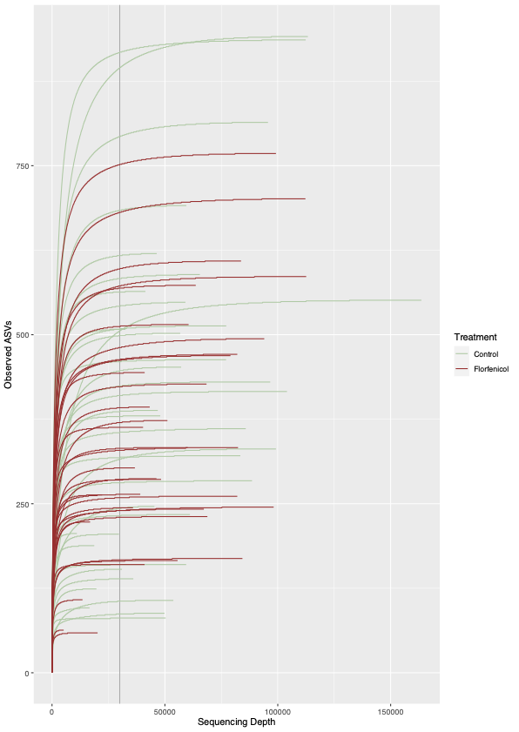
Figure S1: Rarefaction curve showing observed ASV richness by sequencing depth.

Figure S2: a) Temporal dynamics of top 40 bacterial genera in control and florfenicol-treated fish. b) Compositional heatmap showing core genera in the gut microbiome of control (b) and florfenicol-treated (c) fish. Prevalence = 60 %. detection threshold = 0.05 %.

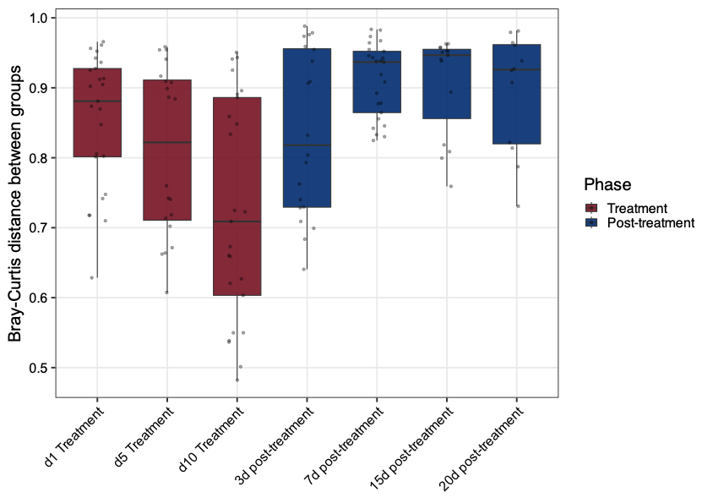
Figure S3: Between-group Bray-Curtis dissimilarities over the experimental period.

Figure S4: a) Changes in edge association following florfenicol treatment. b) Top 20 network nodes with the highest number of edges gained or lost under FFC treatment.

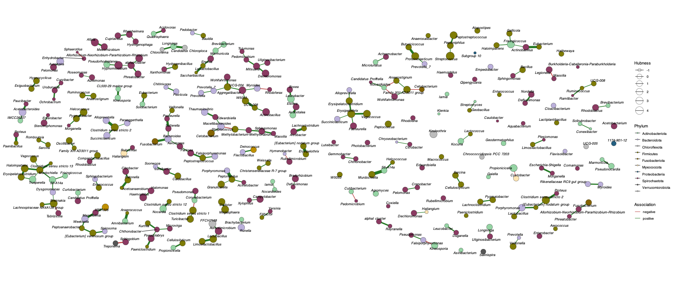
Figure S5: Network plots showing hub taxa and their respective association partners in the control (right) and florfenicol network (left).

