Supplemental Material
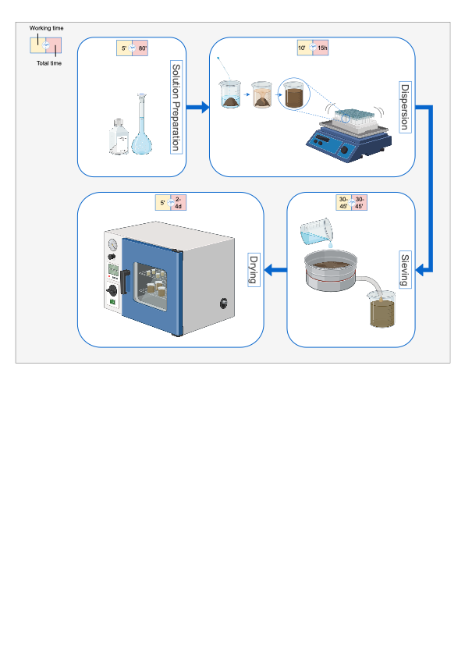
Figure S1 – A detailed scheme of the Na-HMP fractionation workflow.
Working time and total time for Na-HMP solution preparation, dispersion, sieving, and drying (Created with BioRender.com).

Figure S2 – Diagnostic plots for the mixed-effects model of Range fC₄.
A: Residuals vs fitted values showing no systematic patterns.
B: Normal Q–Q plot indicating approximate normality of residuals.
Together, these diagnostics suggest that model assumptions are reasonably met.

Figure S3 – Mass and organic carbon (OC) recovery distributions (%) for the Na-HMP and US450 extraction methods.
The top panel shows mass recovery, and the bottom panel shows OC recovery across five sites.
Boxplots display the median (center line) and interquartile range (25th–75th percentiles).
Individual dots represent replicate measurements, illustrating sample variability and potential outliers
Code in brackets refers to texture class (S = sand, SL = sandy loam, SiL = silt loam, CL = clay loam)
Figure S4 – The effect size (Hedges' g) across five sites, comparing the differences in OC recovery between methods.
The dashed lines indicate commonly used thresholds for small (0.2), medium (0.5), and large (0.8) effect sizes.

Figure S5 - Site-specific OC contributions (mg g⁻¹ soil) of POM and MAOM under Na-HMP and US450.
Bars represent mean ± SD. The magnitude of these differences varied significantly among sites (method × fraction × site interaction: p < 0.001).
Code in brackets refers to texture class (S = sand, SL = sandy loam, SiL = silt loam, CL = clay loam)

Figure S6 – Boxplots illustrating the reproducibility of methods (CV of C (%)).
The left panel presents the distribution of CV (%) values across fractions. The right panel compares the CV (%) values between methods and data points for each method.

