Table S1. Values of the temperatures sum tested for birch to modify the start and end of the season. For grasses this it is based on a phenological calendar and were tested accordingly.

Pollen type | Variable | Initial | Decreased | Increased
 | Start heat sum* (°C) | 87 ± 2.2 | -5 (~82) | +5 (~92)
 | Start heat sum* (°C) | 87 ± 2.2 | -10 (~77) | +10 (~97)
 | Start heat sum* (°C) | 87 ± 2.2 | -20 (~72) | +25 (~103)
 | Start heat sum* (°C) | 87 ± 2.2 |  | +30 (~107)
Birch | Start heat sum* (°C) | 87 ± 2.2 |  | +40 (~117)
Birch | End heat sum* (°C) | 169 ± 5.2 | -10 (~159) | +10 (~179)
 | End heat sum* (°C) | 169 ± 5.2 | -20 (~149) | +15 (~184)
 | End heat sum* (°C) | 169 ± 5.2 | -30 (~139) | +20 (~189)
 | End heat sum* (°C) | 169 ± 5.2 |  | +30 (~199)
 | End heat sum* (°C) | 169 ± 5.2 |  | +40 (~209)
 | Start the season (DOY**) | 145 ± 10 | -5 (~140) | ---
 | Start the season (DOY**) | 145 ± 10 | -10 (~135) | ---
Grasses | Start the season (DOY**) | 145 ± 10 | -15 (~130) | ---
 | Start the season (DOY**) | 145 ± 10 | -20 (~125) | ---
 | Start the season (DOY**) | 145 ± 10 | -30 (~115) | ---
*Start and end of the accumulation of the temperature. **DOY: Day of the Year

Table S2. Overview of pollen emission parameter adjusted for each pollen type

Pollen type | Initial | Decreased | Increased
Birch* (pollen grains m⁻²yr⁻¹) | 1e⁹ | -5 % (9.5e⁸) | ---
Birch* (pollen grains m⁻²yr⁻¹) | 1e⁹ | -20% (8.0e⁸) | ---
Birch* (pollen grains m⁻²yr⁻¹) | 1e⁹ | -40% (6.0e⁸) | ---
Birch* (pollen grains m⁻²yr⁻¹) | 1e⁹ | -80% (2.0e⁸)  -90% (1.0e⁸) | ---
Grasses** (pollen grains m⁻²yr⁻¹) | 2e⁷ | --- | By factor of 2.5 (5.0e⁷)
Grasses** (pollen grains m⁻²yr⁻¹) | 2e⁷ | --- | By factor of 7.0 (1.4e⁸)
Grasses** (pollen grains m⁻²yr⁻¹) | 2e⁷ | --- | By factor of 11 (2.2e⁸)
Grasses** (pollen grains m⁻²yr⁻¹) | 2e⁷ | --- | By factor of 13 (2.6e⁸)
Grasses** (pollen grains m⁻²yr⁻¹) | 2e⁷ | --- | By factor of 15 (3.0e⁸)
Grasses** (pollen grains m⁻²yr⁻¹) | 2e⁷ | --- | By factor of 16 (3.2e⁸)
* For birch the amount of pollen was reduced in percentage. ** For grass was done increasing by factor.

Table S3. Birch – Calculating the local factor for the emission of the amount of pollen within a year based on the observed vs the forecasted SPIn
Station | 2021 | 2022 | 2023 | 2024 | 2025
DELEIP | 0.29 | 1.36 | 0.29 | 9.78 | 0.18
DEHOF | 0.20 | 1.10 | 0.89 | 1.96 | 0.33
DEGARM | 0.22 | 0.47 | 0.36 | 0.39 | 0.16
DEVIEC | 0.13 | 0.93 | 0.39 | 2.03 | 0.16
DEBIED | 0.28 | 0.32 | 0.15 | 0.16 | 0.07
DEFEUC | 0.18 | 0.13 | 0.05 | 0.16 | 0.02
DEMUNC |  |  | 0.51 | 1.48 | 0.24
DEMIND | 1.04 | 0.33 | 0.15 | 0.43 | 0.07
DEALTO | 0.74 | 2.23 | 0.65 | 1.08 | 0.60
DEMARK | 0.49 | 0.91 | 0.68 | 0.73 | 0.13
DEBERL | 0.23 | 0.78 |  | 2.67 | 0.47
Median | 0.26 | 0.85 | 0.38 | 1.08 | 0.16
Pollen emission SILAM | 1.00E+09 | 1.00E+09 | 1.00E+09 | 1.00E+09 | 1.00E+09
By year | 2.55E+08 | 8.47E+08 | 3.79E+08 | 1.08E+09 | 1.62E+08

Table S4. Grasses - Calculating the local factor for the emission of the amount of pollen within a year based on the observed vs the forecasted SPIn

Stations | 2021 | 2022 | 2023 | 2024 | 2025
DELEIP | 8.44 | 20.01 | 10.06 | 10.81 | 3.07
DEHOF | 2.54 | 18.15 | 19.40 | 15.58 | 3.94
DEGARM | 1.93 | 11.55 | 28.66 | 32.49 | 32.10
DEVIEC | 2.00 | 18.22 | 19.37 | 22.47 | 22.10
DEBIED | 1.62 | 8.01 | 9.87 | 3.29 | 4.31
DEFEUC | 3.53 | 2.63 | 3.00 | 1.77 | 4.96
DEBERL | 5.13 | 20.85 |  | 32.63 | 46.88
DEMUNC |  |  | 22.22 | 4.58 | 14.84
DEMIND | 5.56 | 1.16 | 1.28 | 1.44 | 2.21
DEALTO | 2.31 | 5.19 | 6.35 | 4.19 | 15.31
DEMARK | 2.83 | 13.76 | 25.05 | 10.61 | 6.89
Median | 2.68 | 12.65 | 14.72 | 10.61 | 6.89
Pollen emission SILAM | 2.00E+07 | 2.00E+07 | 2.00E+07 | 2.00E+07 | 2.00E+07
By year | 5.36E+07 | 2.53E+08 | 2.94E+08 | 2.12E+08 | 1.38E+08

Table S5, Birch and grasses -Specific combination of variables by year

Pollen type | Variable | Original | 2021 | 2022 |  | 2023 |  | 2024 |  | 2025
Birch | Internal configuration | Rotated grid Lat-long | Non-rotated grid Lat-Lon
Birch | Source map | Compiled by SILAM | European atlas
Birch | Pollen emission (pollen grains m⁻²yr⁻¹) | 1e⁹ | 2e⁸ |  | 6e⁸ | 2e⁸ | 9e⁸ |  | 2e⁸
Birch | HS* start (°C) | 87 ± 2.2 | -10 |  | 5 | +20 | +20 |  | +20
Birch | HS* end (°C) | 169 ± 5.2 | -30 |  | 0 | +30 | +30 |  | +30
Grasses | Internal configuration | Rotated grid Lat-long | Non-rotated grid Lat-Lon
Grasses | Source map | Compiled by SILAM | Grassland map from Copernicus
Grasses | Pollen emission (pollen grains m⁻²yr⁻¹) | 2e⁷ | 5e⁷ |  | 9.5e⁸ | 2.6e⁸ | 1.4e⁸ |  | 9.5e⁸
Grasses | Start DOY** | 145 ± 10 | -5 |  | -15 | -15 | -15 |  | -10
Grasses | End DOY** | 228 ± 8 | -5 |  | -15 | -15 | -15 |  | -10
* HS: Heat sum, temperature sum, DOY: Day of the Year

Figure S1- Birch. Effect of changes of map distributions and phenological parameters on correlation (timing) or slope (pollen emission) of the curve of predicted values compared to those observed at the eleven stations in the years 2021-2025; a) a comparison of two distribution maps on correlation and b) on the slope of the curve; c) effect of changing the pre-set pollen emission released by the model during a season on correlation and d) on the slope, the pollen emission rate (10⁸ pollen grains m⁻²yr⁻¹) was reduced in steps from -5% to -80%; e) and f) changes in correlation and slope when adjusting the temperature sum for the start of flowering season (around 87 ± 2.19 °C ), which was gradually decreased to -20 °C or increased +40 °C; g) r and h) slope for the end of the flowering season, temperature sum around 169 ± 5.18 °C, gradually decreased to -30 °C and increased to +40 °C. The y-axis of the slope is shown on a square-root scale.

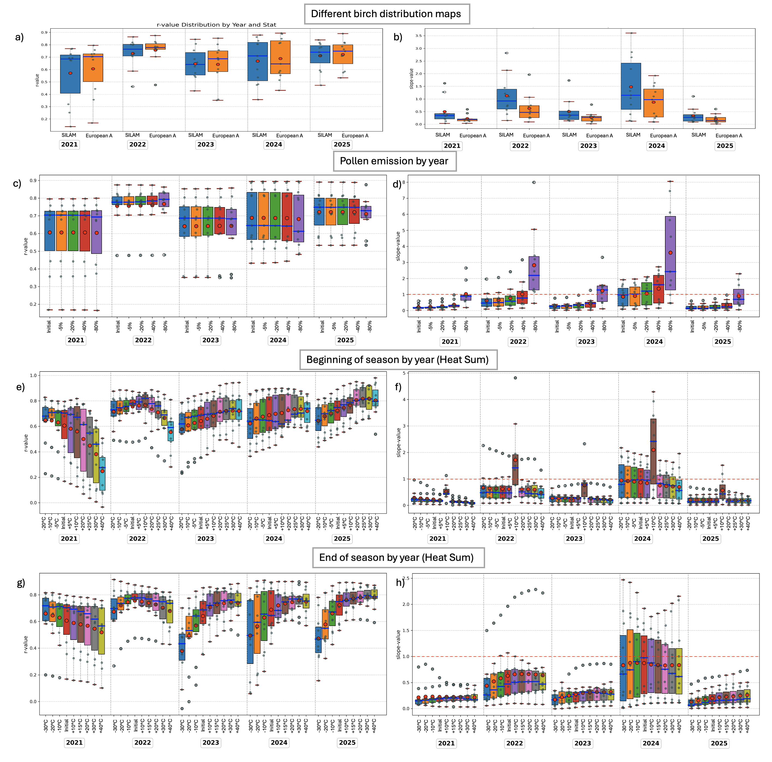

Figure S2-grasses. Effect of changes in map distribution (with different resolutions) and phenological parameters on the correlation (timing) or slope (pollen emission) of the curve of predicted values compared to those observed at the eleven stations in the years 2021-2025; a) the effect on correlation and b) the slope of six different distribution maps; c) r and d) slope of the comparison of maps of different resolution (from 100x100m to 5x5km grid cell; e) changes in correlation and slope when increasing the pollen emission rate (2 x10⁶ pollen grains m⁻²yr⁻¹) in steps from 2.5 to 16 times; g) r and h) slope of modifying the beginning of the flowering season around day 145 ± 10 of the year which was gradually reduced to 30 days. The y-axis of the slope is shown on a square-root scale.

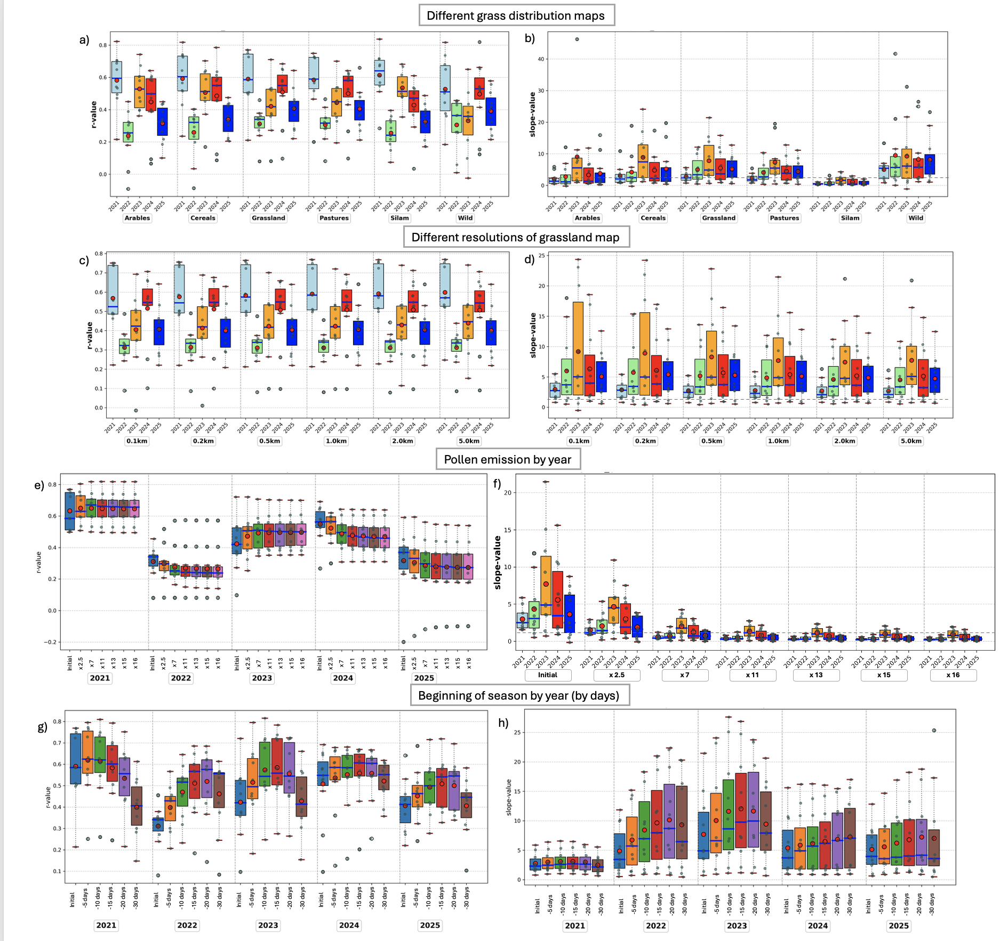

Fig. S3. Time series for a) birch and b) grasses. Pollen observation (blue line), the standard forecast configuration (red line), and the optimal forecast adjusted to regional conditions with scaling factor (green line). The parameters adjusted to reginal condition were internal configuration, specially from rotated to non-rotated grid (coordinate system), distributions maps, the pollen emission rate released during the season (individual per year) and the seasonal flowering time based on temperature accumulation for birch and a calendar for grass (adjusted individually per year).
