Supporting Information

Selenium-Integrated Cyanine Dye with Enhanced Photophysical Properties for Optoacoustic-Guided Cancer Imaging and Therapy

Divyesh Shelar, Snehal Salunkhe, Tony Fröhlich, Uwe Klemm, Pia Anzenhofer, Birgit Rathkolb, Martin Hrabě de Angelis, Oliver Plettenburg, Michael Sattler, Sudesh T Manjare*, Vipul Gujrati, Vasilis Ntziachristos*

D. Shelar, U. Klemm, P. Anzenhofer, V. Gujrati, V. Ntziachristos
Chair of Biological Imaging, Central Institute for Translational Cancer Research (TranslaTUM), School of Medicine and Health & School of Computation, Information and Technology, Technical University of Munich, Munich, Germany
Institute of Biological and Medical Imaging, Bioengineering Center, Helmholtz Zentrum München, Neuherberg, Germany
Email (V. Ntziachristos): bioimaging.translatum@tum.de

S. Salunkhe, S. T. Manjare
Department of Chemistry, University of Mumbai, Mumbai, India
Email: sudeshmanjare@chemistry.mu.ac.in

T. Fröhlich, M. Sattler
Institute of Structural Biology, Molecular Targets and Therapeutics Center, Helmholtz Munich, Neuherberg, Germany

Bavarian NMR Center, Department of Bioscience, TUM School of Natural Sciences, Technical University of Munich, Garching, Germany

B. Rathkolb, M. Hrabě de Angelis
Institute of Experimental Genetics, German Mouse Clinic, Helmholtz Zentrum München, German Research Center for Environmental Health (GmbH), Ingolstädter Landstraße 1, Neuherberg, Germany

German Center for Diabetes Research (DZD), Ingolstädter Landstraße. 1, Neuherberg, Germany

B. Rathkolb
Institute of Molecular Animal Breeding and Biotechnology, Gene Center, Ludwig-Maximilians-Universität München, Feodor-Lynen Str. 25, Munich, Germany

M. Hrabě de Angelis
Chair of Experimental Genetics, TUM School of Life Sciences, Technische Universität München, Alte Akademie 8, Freising, Germany

O. Plettenburg
Institute of Medicinal Chemistry, Molecular Targets and Therapeutics Center, Helmholtz Munich, Neuherberg, Germany

Center for Biomolecular Drug Research (BMWZ), Institute of Organic Chemistry, Leibniz University Hannover, Hannover, Germany

Institute for Lung Health (ILH), Justus Liebig University, Giessen, Germany

German Center for Diabetes Research (DZD), Neuherberg, Germany

Synthesis
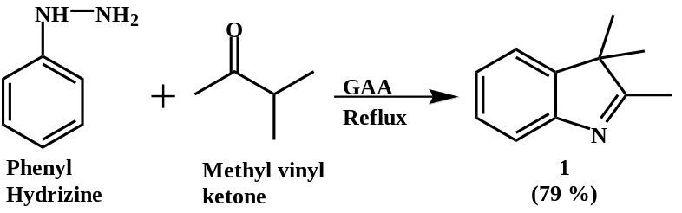
Synthesis of 2,3,3-trimethyl-3H-indole (1)
The 2,3,3-trimethyl-3H-indole (1) was synthesized according to a previously reported procedure.^{[1]} To the mixture of phenyl hydrazine (0.73 g, 4.62 mmol) and 3-methyl-2-butanone (0.44 g, 5.08 mmol), glacial acetic acid (GAA) (5 mL) was added. The reaction mixture was refluxed for 15 h and monitored by thin-layer chromatography. After completion of the reaction, the solvent was removed under vacuum. The obtained residue was neutralized (pH 7) using saturated aqueous sodium bicarbonate solution, and the mixture was extracted with dichloromethane (20 mL × 3). Further, the organic layer was washed with brine solution. The organic layer was dried over anhydrous Na₂SO₄, and the solvent was evaporated using a rotary evaporator. The crude compound was purified using silica gel column chromatography using ethyl acetate:pet ether (1:10) to afford a yellow oil (78.67% yield, 0.58 g). The product was characterized by ¹H NMR spectroscopy. Spectroscopic Data: ¹H (300 MHz, DMSO-d₆): δ (ppm) 7.43-7.40 (d, 1H), 7.17-7.14 (m, 1H), 7.12-7.09 (m, 1H), 7.05-7.02 (m, 1H), 2.12 (s, 3H), 1.12 (s, 6H).

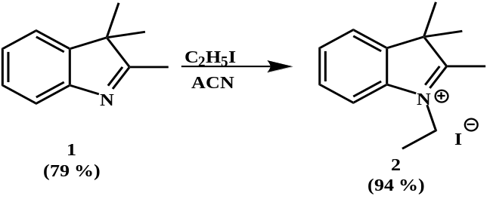
Synthesis of 1-Ethyl-2,3,3-trimethyl-3H-indol-1-ium iodide (2)
1-Ethyl-2,3,3-trimethyl-3H-indol-1-ium iodide (2) was synthesized by the reported procedure.^{[2]} 2,3,3-trimethyl-3H-indole (1) (2 g, 12.56 mmol) was dissolved in dry 1,4-dioxane (5 mL) under an inert atmosphere. After complete dissolution, ethyl iodide (3.92 g, 25.12 mmol) was added to the reaction mixture and refluxed for 24 h. Further, the reaction mixture was cooled ⁵⁹to obtain the crude solid compound. The resulting crude solid was filtered and recrystallized using ethanol to afford a yellow-brown colored solid in a yield of 93.87% (3.72 g). The product was characterized using ¹H NMR spectroscopy. Spectroscopic Data: ¹H (300 MHz, CDCl₃): δ (ppm) 7.73 (s, 1H), 7.57 (m, 3H), 4.73-4.71 (m, 2H), 3.12 (s, 3H), 1.63 (s, 9H).

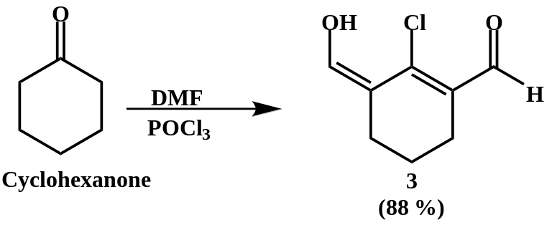
Synthesis of 2-chloro-3-(hydroxymethylene)cyclohex-1-ene-1-carbaldehyde (3)
2-chloro-3-(hydroxymethylene)cyclohex-1-ene-1-carbaldehyde (3) was synthesized using a previously reported synthetic procedure.^{[3]} To the synthesized compound 3, the mixture of DMF (9.7 mL, 125.5 mmol) and DCM (10 mL) was added over 30 min at 0 °C. After 30 min, POCl₃ (9.22 mL, 98.93 mmol) and cyclohexanone (2.36 g, 24.13 mmol) were added dropwise with constant stirring. The reaction mixture was refluxed for 3 h and allowed to cool at room temperature. The reaction mixture was poured upon ice and allowed to stand overnight to obtain the yellow solid in a yield of 87.45% (3.64 g). The product was characterized by ¹H NMR spectroscopy. Spectroscopic Data: ¹H (300 MHz, CD₃OD): δ (ppm) 10.15 (s, 1H), 7.25 (s, 1H), 4.86 (s, 1H), 2.48-2.44 (t, 2H), 2.37-2.33 (t, 2H), 1.66-1.61 (m, 2H).

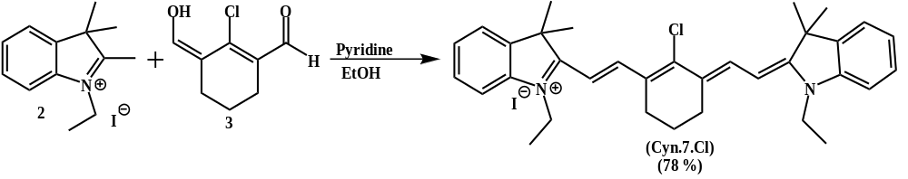
Synthesis of Compound 2-((E)-2-((E)-2-chloro-3-(2-((E)-1-ethyl-3,3-dimethylindolin-2-ylidene)ethylidene)cyclohex-1-en-1-yl)vinyl)-1-ethyl-3,3-dimethyl-3H-indol-1-ium Iodide (Cyn.7.Cl)
2-((E)-2-((E)-2-chloro-3-(2-((E)-1-ethyl-3,3-dimethylindolin-2-ylidene)ethylidene)cyclohex-1-en-1-yl)vinyl)-1-ethyl-3,3-dimethyl-3H-indol-1-ium Iodide (Cyn.7.Cl) was synthesized by a previously reported procedure.^{[4]} To the mixture of 2-chloro-3-(hydroxymethylene)cyclohex-1-ene-1-carbaldehyde (3) (1.23 g, 4.50 mmol) and 1-ethyl-2,3,3-trimethyl-3H-indolinium iodide (2) (3.12 g, 9.91 mmol) in absolute ethanol (20 mL), pyridine (0.6 mL, 11.26 mmol) was added. The reaction mixture was stirred at 40 °C. The reaction was monitored by TLC. After completion of the reaction, it was extracted using DCM (20 mL × 3). The organic layer was dried over anhydrous Na₂SO_{4,} and the solvent was evaporated under reduced pressure. The crude compound was purified using silica gel column chromatography (DCM:MeOH, 99:1) to afford the crystalline dark green solid in a yield of 77.89% (2.24 g). The product was characterized by using ¹H NMR spectroscopy. Spectroscopic Data: ¹H (300 MHz, DMSO-d₆): δ (ppm) 8.39-8.35 (d, 2H), 7.42-7.40 (d, 4H), 7.29-7.21 (qt, 4H), 6.23-6.18 (d, 2H), 4.30-4.23 (qt, 4H), 2.77-2.73 (t, 4H), 2.01-1.97 (t, 2H), 1.73 (s, 12H), 1.50-1.45 (t, 6H).
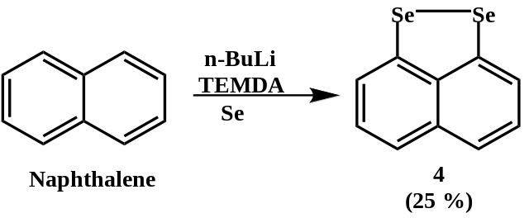
Synthesis of naphtho[1,8-cd][1,2]diselenole (4)
Naphtho[1,8-cd][1,2]diselenole (4) was synthesized by using a literature method.^{[5]} To the stirred solution of naphthalene (1.0 g, 7.80 mmol) in 15 mL of hexane, n-BuLi (19.5 mL, 31.20 mmol) and tetramethylethylenediamine (TMEDA; 4.68 mL, 15.6 mmol) were added at -10 °C under an inert atmosphere. The reaction mixture was stirred at 60 °C for 3 h. The resulting brown suspension of lithio derivative was allowed to cool at -10 °C and was diluted with 50 mL of anhydrous THF. Next, selenium (2.46 g, 31.20 mmol) was added to the reaction mixture, and the resulting mixture was stirred for 12 h at room temperature. The crude product was extracted with chloroform (3 × 25 mL), and the collected organic layer was dried over anhydrous sodium sulphate. The product was purified by silica gel column chromatography using pet ether/ethyl acetate (1:1 v/v) as mobile phase to afford red-brown crystals (1.68 g, 25%) of compound 4. The product was characterized by ¹H NMR spectroscopy. Spectroscopic Data: ¹H (300 MHz, DMSO-d₆): δ (ppm) 7.46-7.43 (d, 2H), 7.34-7.32 (d, 2H), 7.25-7.19 (t, 2H).

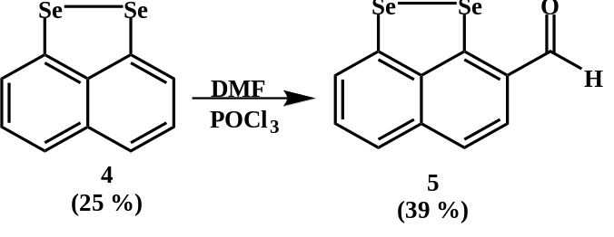
Synthesis of naphtho[1,8-cd][1,2]diselenole-3-carbaldehyde (5)
Naphtho[1,8-cd][1,2]diselenole-3-carbaldehyde (5) (naphtho[1,8-cd][1,2]diselenole-3-carbaldehyde) was synthesized by the reported procedure.^{[6]} To naphtho[1,8-cd] [1,2]diselenole (4) (1.17 g, 4.7 mmol), 14 mL of dry DMF was added at -10 °C under an inert atmosphere. Then, POCl₃ (2.37 g, 15.48 mmol) was added dropwise to the reaction mixture with vigorous stirring. The reaction mixture was stirred at room temperature for 24 h. After completion of the reaction, the mixture was poured into ice-cold water to afford the orange solid, which was extracted with ethyl acetate (20 × 3 mL) and washed with brine. The organic layer was separated and dried over anhydrous sodium sulphate, and the solvent was evaporated under vacuum. The crude compound was purified by silica gel column chromatography using pet ether/ethyl acetate (1:1 v/v) as mobile phase to get a yellow crystalline product (0.490 g, 38.15%). The product (7.10) was characterized by ¹H NMR spectroscopy. Spectroscopic Data: ¹H (300 MHz, CDCl₃): δ (ppm) 10.1 (s, 1H), 7.74-7.73 (t, 1H), 7.70-7.60 (t, 2H), 7.59-7.56 (d, 1H) 7.51-7.45 (t, 1H).

Characterization

FIGURE S1. ¹H nuclear magnetic resonance (NMR) spectrum of 2,3,3-trimethyl-3H-indole (1).

FIGURE S2. ¹H nuclear magnetic resonance (NMR) spectrum of 1-Ethyl-2,3,3-trimethyl-3H-indol-1-ium iodide (2).

FIGURE S3. ¹H nuclear magnetic resonance (NMR) spectrum of 2-chloro-3-(hydroxymethylene)cyclohex-1-ene-1-carbaldehyde (3).
FIGURE S4. ¹H nuclear magnetic resonance (NMR) spectrum of 2-((E)-2-((E)-2-chloro-3-(2-((E)-1-ethyl-3,3-dimethylindolin-2-ylidene)ethylidene)cyclohex-1-en-1-yl)vinyl)-1-ethyl-3,3-dimethyl-3H-indol-1-ium Iodide (Cyn.7.Cl).

FIGURE S5. ¹H nuclear magnetic resonance (NMR) spectrum of naphtho[1,8-cd][1,2]diselenole (4).
FIGURE S6. ¹H nuclear magnetic resonance (NMR) spectrum of naphtho[1,8-cd][1,2]diselenole-3-carbaldehyde (5).

FIGURE S7. ¹H nuclear magnetic resonance (NMR) spectrum of 1-(naphtho[1,8-cd][1,2]diselenol-3-ylmethylene)-2-phenylhydrazine (6).
FIGURE S8. ¹³C nuclear magnetic resonance (NMR) spectrum of 1-(naphtho[1,8-cd][1,2]diselenol-3-ylmethylene)-2-phenylhydrazine (6).

FIGURE S9. Mass spectrum of 1-(naphtho[1,8-cd][1,2]diselenol-3-ylmethylene)-2-phenylhydrazine (6).
FIGURE S10. Mass spectrum of 1-(naphtho[1,8-cd][1,2]diselenol-3-ylmethylene)-2-phenylhydrazine (6).

FIGURE S11. ¹H nuclear magnetic resonance (NMR) spectrum of 1-ethyl-2-((E)-2-((E)-3-(2-((E)-1-ethyl-3,3-dimethylindolin-2-ylidene)ethylidene)-2-(2-((E)-naphtho[1,8-cd][1,2]diselenol-3-ylmethylene)-1-phenylhydrazineyl)cyclohex-1-en-1-yl)vinyl)-3,3-dimethyl-3H-indol-1-ium (Se-Cyn).
FIGURE S12. ¹³C nuclear magnetic resonance (NMR) spectrum of 1-ethyl-2-((E)-2-((E)-3-(2-((E)-1-ethyl-3,3-dimethylindolin-2-ylidene)ethylidene)-2-(2-((E)-naphtho[1,8-cd][1,2]diselenol-3-ylmethylene)-1-phenylhydrazineyl)cyclohex-1-en-1-yl)vinyl)-3,3-dimethyl-3H-indol-1-ium (Se-Cyn).

FIGURE S13. ⁷⁷Se nuclear magnetic resonance (NMR) spectrum of 1-ethyl-2-((E)-2-((E)-3-(2-((E)-1-ethyl-3,3-dimethylindolin-2-ylidene)ethylidene)-2-(2-((E)-naphtho[1,8-cd][1,2]diselenol-3-ylmethylene)-1-phenylhydrazineyl)cyclohex-1-en-1-yl)vinyl)-3,3-dimethyl-3H-indol-1-ium (Se-Cyn).
FIGURE S14. Mass spectrum of 1-ethyl-2-((E)-2-((E)-3-(2-((E)-1-ethyl-3,3-dimethylindolin-2-ylidene)ethylidene)-2-(2-((E)-naphtho[1,8-cd][1,2]diselenol-3-ylmethylene)-1-phenylhydrazineyl)cyclohex-1-en-1-yl)vinyl)-3,3-dimethyl-3H-indol-1-ium (Se-Cyn).

FIGURE S15. Expanded mass spectrum of 1-ethyl-2-((E)-2-((E)-3-(2-((E)-1-ethyl-3,3-dimethylindolin-2-ylidene)ethylidene)-2-(2-((E)-naphtho[1,8-cd][1,2]diselenol-3-ylmethylene)-1-phenylhydrazineyl)cyclohex-1-en-1-yl)vinyl)-3,3-dimethyl-3H-indol-1-ium (Se-Cyn).

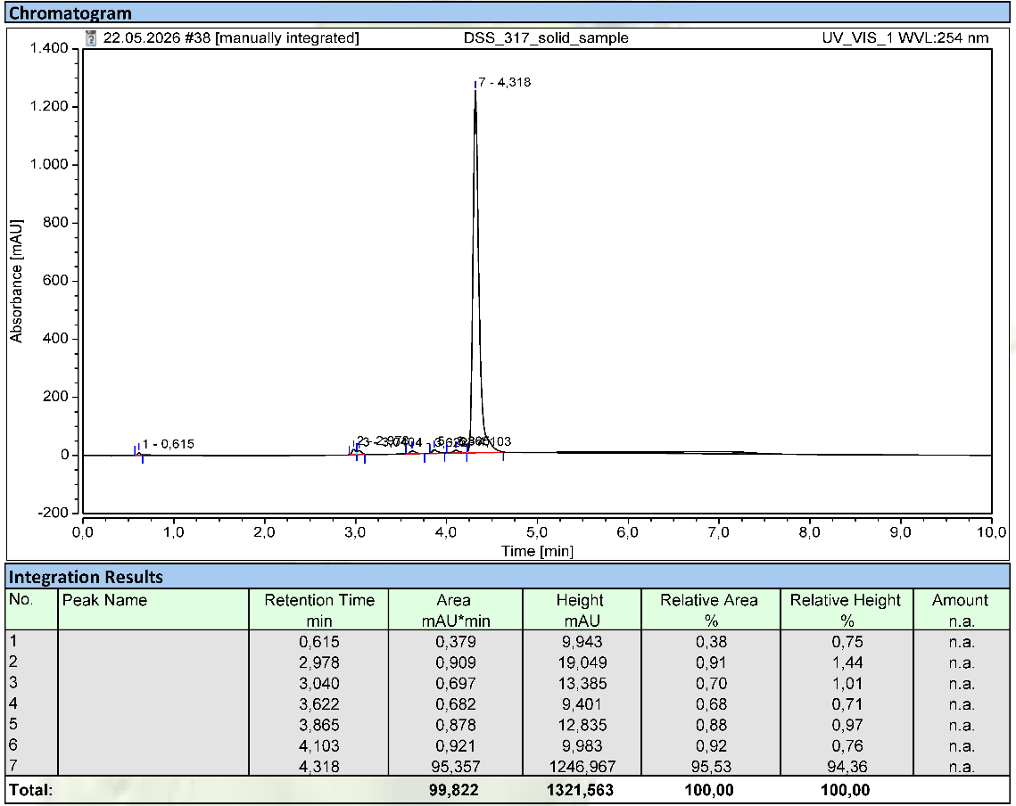
FIGURE S16. Representative HPLC chromatogram of 1-ethyl-2-((E)-2-((E)-3-(2-((E)-1-ethyl-3,3-dimethylindolin-2-ylidene)ethylidene)-2-(2-((E)-naphtho[1,8-cd][1,2]diselenol-3-ylmethylene)-1-phenylhydrazineyl)cyclohex-1-en-1-yl)vinyl)-3,3-dimethyl-3H-indol-1-ium (Se-Cyn).

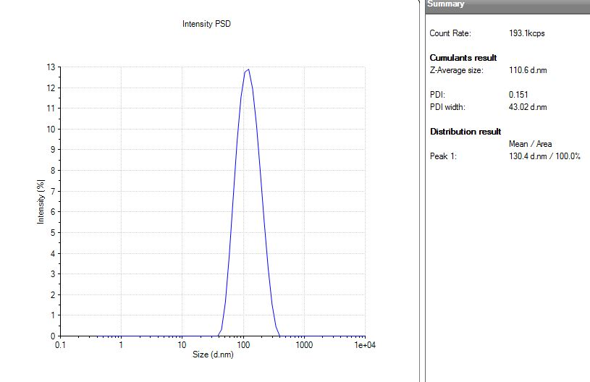
Fig. S17 Polydispersity index (PDI) of Selenium-Cyanine (Se-Cyn) nanoparticles (NPs).

Fig. S18 Zeta potential of Selenium-Cyanine (Se-Cyn) nanoparticles (NPs).

Fig. S19 Zeta potential of Selenium-Cyanine (Se-Cyn) nanoparticles (NPs) in water over 14 days.

Figure S20. UV-Vis spectra of Selenium-Cyanine (Se-Cyn) dissolved in tetrahydrofuran at different concentrations for determination of loading efficiency.

Figure S21. Fitted calibration curve of UV-Vis absorbance vs concentration of Selenium-Cyanine (Se-Cyn) in tetrahydrofuran at 794 nm.

Figure S22. UV-Vis spectrum of Selenium-Cyanine (Se-Cyn) nanoparticles (NPs) dissolved in Tetrahydrofuran.

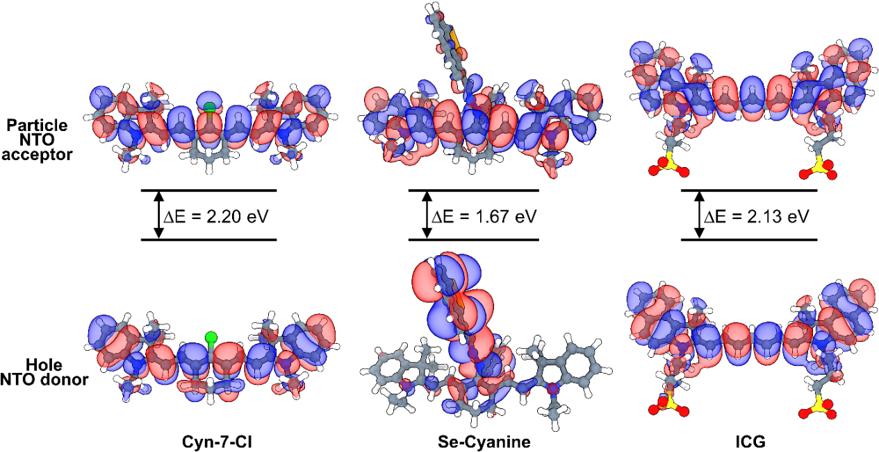
FIGURE S23. Natural transition orbitals (NTOs) of Cyn-7-Cl, Se-Cyanine and indocyanine green (ICG) corresponding to the lowest-energy electronic excitation (S1) calculated using time-dependent density functional theory (TD-DFT) at the B3LYP/def2-TZVP level with implicit solvation (SMD, water). The dominant NTO pair is shown, where the “hole” represents the electron density removed upon excitation (donor orbital) and the “particle” represents the electron density gained upon excitation (acceptor orbital).

FIGURE S24. Optoacoustic properties of indocyanine green nanoparticles (ICG NPs): linear relationship between optoacoustic (OptA) signal intensity and absorbance.

FIGURE S25. Optoacoustic properties of Cyn.7.Cl: linear relationship between optoacoustic (OptA) signal intensities and absorbances.
FIGURE S26. Optoacoustic properties of Selenium-Cyanine (Se-Cyn) nanoparticles (NPs): linear relationship between optoacoustic (OptA) signal intensities and absorbances.

FIGURE S27. Optoacoustic properties of Selenium-Cyanine (Se-Cyn): linear relationship between optoacoustic (OptA) signal intensities and absorbances.

TABLE S1. Optoacoustic signal generation efficiency (OGE) of Selenium-Cyanine (Se-Cyn), Se-Cyanine (Se-Cyn) nanoparticles (NPs), Cyn.7.Cl and indocyanine green nanoparticles (ICG NPs). OGEs are shown compared to the OGE of ICG NPs (OGE_{ICG}).

Compound | OGE | Folds
ICG NPs | 664.8 | 1
Cyn.7.Cl | 307.4 | 0.46
Se-Cyn | 807.7 | 1.21
Se-Cyn NPs | 879.6 | 1.36

FIGURE S28. Cell viability of HCT16 cells incubated with Selenium-Cyanine (Se-Cyn) nanoparticles (NPs) (0-25 μg/mL, PBS) with or without laser irradiation (780 nm excitation, 0.8 W/cm² for 5 min). ***P < 0.001.
FIGURE S29. Cell viability of U87MG cells incubated with Selenium-Cyanine (Se-Cyn) nanoparticles (NPs) (0-25 μg/mL, PBS) with or without laser irradiation (780 nm excitation, 0.8 W/cm² for 5 min). ***P < 0.001.

FIGURE S30. Plot showing changes in the absorbance of DPBF at 410 nm as a function of irradiation time (780 nm, 0.8 W/cm²) in the presence of Selenium-Cyanine (Se-Cyn) nanoparticles (NPs), with indocyanine green nanoparticles (ICG NPs) serving as the standard for determination of singlet oxygen quantum yield (Φ_{Δ}).

Figure S31. UV-Vis spectrum of Selenium-Cyanine (Se-Cyn) nanoparticles (NPs) (100 μg/mL, PBS) with or without laser irradiation (780 nm excitation, 0.8 W/cm²) for determination of photobleaching.

Figure 32. Relative viability of 4T1 cells subjected to various treatments. 1: cells without any treatment; 2: cells incubated with 25 μM Selenium-Cyanine (Se-Cyn) nanoparticles (NPs); 3: cells incubated with 25 μM Se-Cyn NPs, followed by irradiation with a 780 nm CW laser (0.8 W/cm²); 4: cells incubated with GSH (100 μM antioxidant); 5: cells incubated with 25 μM Se-Cyn NPs and GSH (100 μM antioxidant), followed by irradiation with a 780 nm CW laser (0.8 W/cm²); 6: cells incubated with 25 μM Se-Cyn NPs, followed by irradiation with a 780 nm CW laser (0.8 W/cm²) while the culture dish was maintained in an ice-water bath.

FIGURE S33. Representative unmixed multispectral optoacoustic tomography (MSOT) images of major organs 24 h post-injection of Selenium-Cyanine (Se-Cyn) nanoparticles (NPs) (0.2 mg Se-Cyn NPs in 100 μL of PBS).

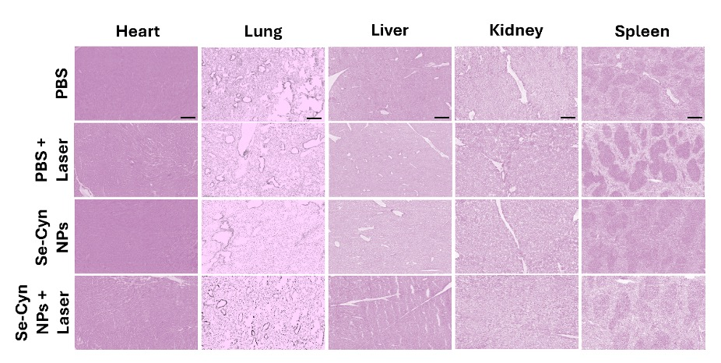

FIGURE S34. Representative images showing hematoxylin and eosin (H&E)-stained cryosections of major organs from the four treated groups (Scale bar 100 μm).

FIGURE S35. Preliminary tolerability assessment of Selenium-Cyanine (Se-Cyn) nanoparticles (NPs) 14 and 21 days after injection. Representative images of hematoxylin and eosin (H&E)-stained sections of major organs from mice treated with Se-Cyn NPs (Scale bar: 50 μm).

TABLE S2. Comparative overview of photothermal/photodynamic agents reported in the literature.

Dye / Platform | Heavy Atom | Absorption (nm) | Photostability | PCE (%) | ROS Generation | Opto  acoustic | Efficacy  test | Reference
Cyanine Dye (Benzoselenazole) | Se | 784 | Stable | NR | High | NR | In vivo | ^{[7]}
I₂-BODIPY (Halogenated) | I | 530-540 | High | NR | High | NR | In vitro | ^{[8]}
Activatable Aza-BODIPY NPs | I | 680 | High | 33.4 | Activatable | High | In vivo | ^{[9]}
Aza-BODIPY | I | 674 | High | 40.1 | High | Good | In vivo | ^{[10]}
Cyanine | Cl/Br/I | 800 | Moderate | 42-47 | Moderate | NR | In vitro | ^{[11]}
IR820 (LPS-EMVs) | Cl | 800 | Improved | NR | Low | NR | NR | ^{[12]}
DPP-TPA NPs | None | 660 | Excellent | 34.5 | High | Excellent | In vivo | ^{[13]}
Albumin-chaperoned cyanine | None | 1000-1100 | High | NR | Low-Moderate | NR | In vivo | ^{[14]}
ICG–Pillar[5]arene | None | 800 | Improved | NR | Moderate | NR | In vitro | ^{[15]}
Cyanine NPs | Se | 806 | Excellent | 59 | Moderate | Excellent | In vivo | Current study

NR: Not Reported, Se: Selenium, I: Iodine, Cl: Chlorine, Br: Bromine

References
[1] L. Wu, X. Li, C. Huang, N. Jia, Anal. Chem. 2016, 88, 8332.
[2] J. Wang, W.-F. Cao, J.-H. Su, H. Tian, Y.-H. Huang, Z.-R. Sun, Dyes and Pigments 2003, 57, 171.
[3] L. Wang, J. Jin, X. Chen, H.-H. Fan, B. K. F. Li, K.-W. Cheah, N. Ding, S. Ju, W.-T. Wong, C. Li, Org. Biomol. Chem. 2012, 10, 5366.
[4] S. Pascal, A. Haefele, C. Monnereau, A. Charaf-Eddin, D. Jacquemin, B. Le Guennic, C. Andraud, O. Maury, J Phys Chem A 2014, 118, 4038.
[5] A. J. Ashe III, J. W. Kampf, P. M. Savla, Heteroatom Chemistry 1994, 5, 113.
[6] D. Manna, G. Mugesh, J. Am. Chem. Soc. 2012, 134, 4269.
[7] A. V. Prakash, F. Yazabak, I. Hovor, F. Nakonechny, O. Kulyk, O. Semenova, A. Bazylevich, G. Gellerman, L. Patsenker, Dyes and Pigments 2023, 211, 111053.
[8] J. Sun, E. Feng, Y. Shao, F. Lv, Y. Wu, J. Tian, H. Sun, F. Song, ChemBioChem 2022, 23, e202200421.
[9] W. Liu, Y. Hou, W. Liu, R. Wang, S. He, X. Xia, C. Lv, H. Gu, Q. Yao, Q. Pan, Z. Su, D. Zhou, W. Sun, J. Fan, X. Peng, Chinese Chemical Letters 2024, 35, 109631.
[10] M. Zhao, Q. Zeng, X. Li, D. Xing, T. Zhang, Nano Res. 2022, 15, 716.
[11] H. Liu, J. Yin, E. Xing, Y. Du, Y. Su, Y. Feng, S. Meng, Dyes and Pigments 2021, 190, 109327.
[12] G. Della Pelle, A. Delgado López, M. Salord Fiol, N. Kostevšek, International Journal of Molecular Sciences 2021, 22, 6914.
[13] Y. Cai, P. Liang, Q. Tang, X. Yang, W. Si, W. Huang, Q. Zhang, X. Dong, ACS Nano 2017, 11, 1054.
[14] G. Jiang, Z. Hu, L. Bai, C. Zhong, S. Lu, B. Han, Z. Sun, S. Zhu, Y. Liang, H. Sun, J. Mater. Chem. C 2023, 11, 7243.
[15] Y. Ding, C. Wang, B. Lu, Y. Yao, Front. Chem. 2021, 9.

