Supplementary material

Table S1. Antibodies used in the present study
Antibody | Fluorochrome | Company | Catalogue no. | Clone | Dilution
α-CD4 | AF647 | BD | 557681 | RM4-5 | 200
α-CD45 | AF700 | Invitrogen | 56-0451-82 | 30-F11 | 400
α-CD4 | FITC | BD | 553055 | RM4-4 | 400
α-Foxp3 | PE | eBioscience™ | 12477182 | NRRF-30 | 200
α-RORγt | Alexa Fluor 647 | BD | 562682 | Q31-378 | 200
α-GATA3 | eFluor 450 | Invitrogen | 48-9966-42 | TWAJ | 100
α-GATA3 | BV421 | BD | 563349 | L50-823 | 100
α-T-bet | PE-Cy7 | Invitrogen | 25-5825-82 | eBio4B10 (4B10) | 600

Table S2. RT-PCR primers used in the present study
Gene of interest | forward primer | reverse primer
Reg3γ | CAA GAT GCT TCC CCG TAT AAC | AGC TGC TAC GTG AAG ATG G
Tff3 | GCT AAT GCT GTT GGT GGT CC | TCC GAT GTG ACA GAG GGG TA
Muc2 | CAC CAT CTA CCT CAC CCA CA | GGT CTG CAT GCC ATT GAA GT
Cldn8 | CTG GAG GAG CAC TGT TCT GT | TGG CTG GTT TGG TGA TTT AT
Ocln | ATC CAC CTA TCA CTT CAG A | TAA TCT CCC ACC ATC CTC
Tjp1 | CCA CCT CTG TCC AGC TCT TC | CAC CGG AGT GAT GGT TTT CT
Il23 | GAG CAA CTT CAC ACC TCC CTA | TAG AAC TCA GGC TGG GCAT C
Gapdh | AGA ACA TCA TCC CTG CAT CC | GGT CCT CAG TGT AGC CCA AG

Table S3. Summary of the study results
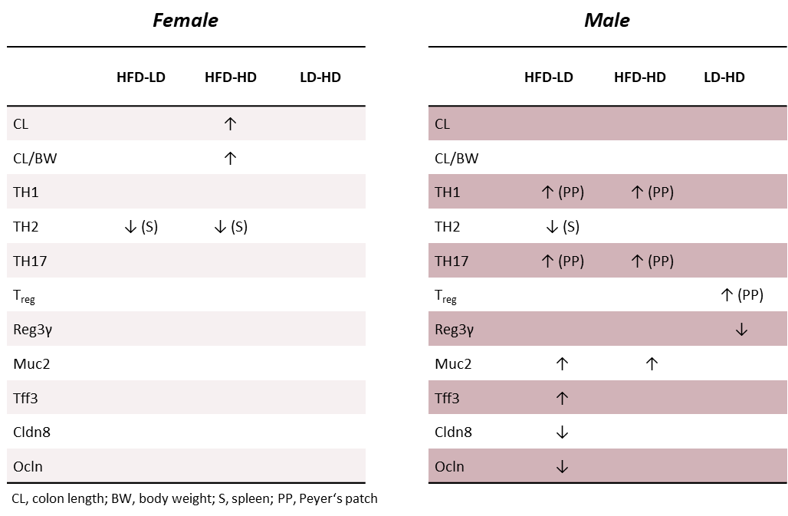

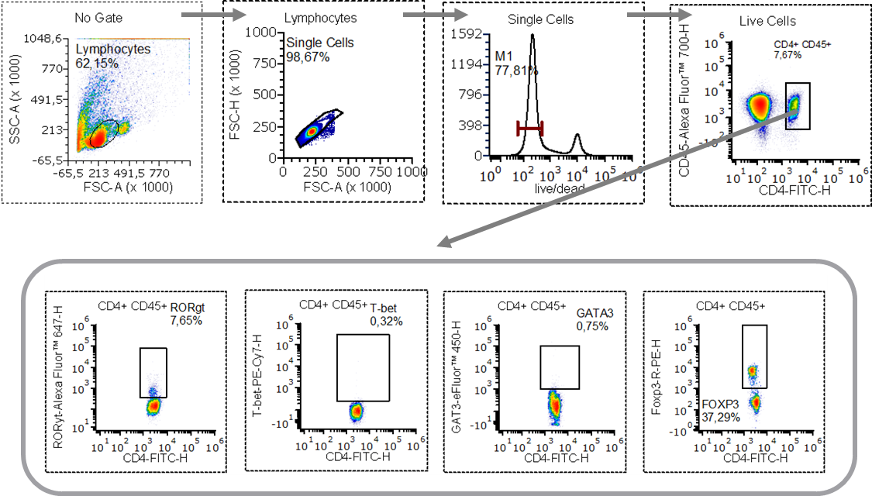
Figure S1. Representative gating strategy for the identification of splenic and Peyer's patch CD4⁺ T-cell subsets. Following exclusion of doublets and dead cells, CD45⁺ CD4⁺ T cells were identified and subsequently classified as Th1 (T-bet⁺), Th2 (GATA3⁺), Th17 (RORγt⁺), or Treg (FoxP3⁺) cells according to lineage-specific transcription factor expression.

