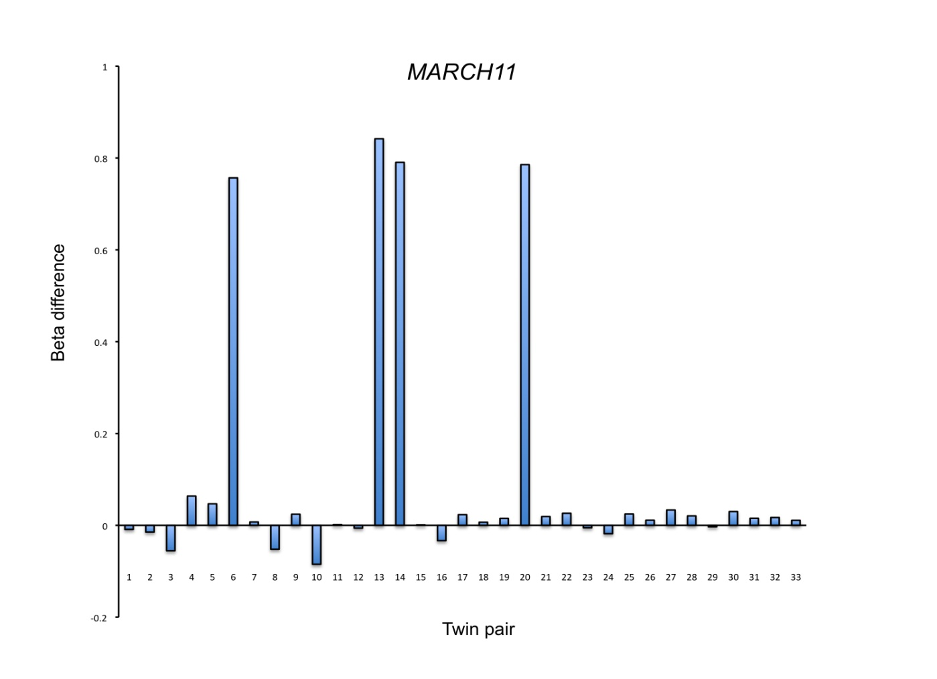

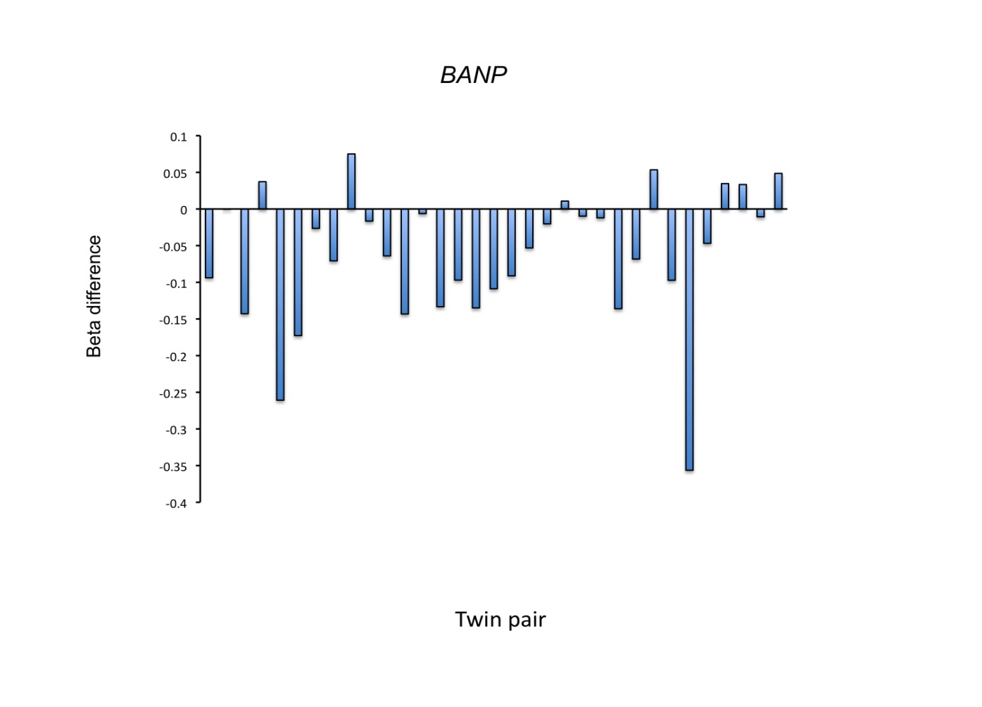

**Supplementary Figure S1.** Differences in DNA methylation values (∆β) of unaffected minus CWP-affected twin for cg06782035 located at *MARCH11* (upper panel) and cg05224642 located at *BANP* (lower panel).