***Crybb2* associates with *Tmsb4X* andis crucial for**

**dendrite morphogenesis**

**Minxuan Suna*, Jun Lib, Nafees Ahmad a,c , Jochen Grawd**

aJiangsu Key Lab of Medical Optics, Suzhou Institute of Biomedical Engineering and Technology, Chinese Academy of Sciences, Suzhou, China

b Quanzhou Institute of Equipment Manufacturing, Haixi Institutes, Chinese Academy of Sciences, Quanzhou, China.

c Institute of Biomedical & Genetic Engineering, Islamabad, Pakistan

dHelmholtz Center Munich, German Research Center for Environmental Health, Institute of Developmental Genetics, Neuherberg, Germany.

**Key words:**

*Crybb2, Tmsb4X, dendrite, hippocampal Neuron*

*Corresponding author. Jiangsu Key Lab of Medical Optics, Suzhou Institute of Biomedical Engineering and Technology, Chinese Academy of Sciences, Suzhou 215163, China.

Email address：sunmx@sibet.ac.cn (M. Sun),

**Abstract**

Dendrite morphogenesis is a complex but well-orchestrated process. Various studies reported the involvement of alteration in dendrite morphology in different brain disorders, including neuropsychiatric disorders. Initially, βB2-crystallin (gene symbol: *Crybb2*/*CRYBB2*) has been described as a structural protein of the ocular lens. Mutations of the corresponding gene, *Crybb2*, lead to cataract. Recent studies in mice suggested that mutations in *Crybb2* cause alterations in hippocampal morphology and function, albeit its function in hippocampal neuron development remained elusive. In the current study, we found that *Crybb2* contributes to dendritogenesis *in vitro* and *in vivo*. Furthermore, screening of previous data on differential expression-arrays, we found *Tmsb4X* up-regulated in *Crybb2* mutants mouse brain. Additionally, *Tmsb4X* was co-expressed with *Crybb2* at actin-enriched cell ruffles. Over-expression of *Tmsb4X* in cultured hippocampal neurons inhibited dendritogenesis, which phenocopied *Crybb*2 knock-down. The current study uncovers a new function of *Crybb*2 in brain development, especially in dendritogenesis, and the possible interplay partner *Tmsb4X* involved in this process.

**Introduction**

In all [vertebrate](https://en.wikipedia.org/wiki/Vertebrate) animals, the brain serves as the center of the [nervous system](https://en.wikipedia.org/wiki/Nervous_system) . It is very well organized by neurons and glial cells, in which neurons are mainly responsible for conducting information of whole central nervous system (Luo et al., 2008). Neurons are morphologically characterized by the presence of axons, somata, and dendrites. The shape of dendrites is the major indication how neurons integrate and process incoming information, and thus, they play a vital role in the functional properties of neural circuits (Gao, 2007; Urbanska et al., 2008). During the last years, many studies documented considerable evidence that dendrite morphology (dendrite number and branches) is relatively dynamic. Alterations in dendrite morphology have been consistently observed in psychiatric disorders like schizophrenia (Balck et al., 2004; Broadbelt et al., 2002). Numerous studies have been endeavored to explore the mechanism underlying proper dendrite morphology development. The mechanism requires the tight control by neuronal signaling such as calcium as well as proteins involved in cytoskeletal rearrangement (Rosenberg et al., 2011, Hou et al., 2005).

As one of the most prominent members of the crystallins, βB2-crystallin (gene symbol: *Crybb2*/*CRYBB2*) has been considered for a long time to be just a structural protein of the ocular lens (Graw, 2017). Several clinical observations in human suggest that mutations in *CRYBB2*, especially the mutations in exon 6, are highly involved in the pathogenesis of cataract (Santhiya et al., 2010; Zhou et al., 2016). Different mouse mutants also showed that mutations in *Crybb2* leads to cataract (for review see Graw, 2009). Besides that, there are a few reports that βB2-crystallin has additional functions. *Crybb2* mutants have problems in fertility (Gao et al., 2014), and *Crybb*2 participates in axonal regeneration (Liedtke et al., 2007). Most interestingly, βB2-crystallin also has moderate ability to bind calcium, suggesting a role as calcium buffer (Jobby et al., 2007).

In addition, *Crybb2* is also found to be expressed in several regions of the mammalian brain, although its function in the brain remains mostly unknown. To uncover its function in the brain, in the previous study we combined behavioral, neuroanatomical, and physiological analyses in a *Crybb2* mouse mutant, *O377* (Ganguly et al., 2008; Sun et al., 2013). Altered hippocampal morphology and neuronal functions were observed in these mutants, *O377*, as well as increased free intracellular Ca2+ levels and expression changes of calcium-channel related proteins (NMDA receptor).

*Crybb2* was found to be clearly up-regulated in the regenerating retina (compared to the unregenerated retina; Liedtke et al., 2007). Overexpression of *Crybb2* in retinal ganglion **cells** and in hippocampal neurons increased axon formation. However, its function in dendrite morphology has not been analyzed so far. In this study, we focused on the functions of *Crybb2* on hippocampal dendrite morphology, mainly on dendrite number and dendrite branching. In addition, by analysis of previous data and further overexpression studies *in vitro*, we identified TMSB4X as an associated partner of CRYBB2 being involved in the process of dendrite formation.

**Result**

***Crybb2* is expressed in dendrites and the over-expression of *Crybb*2 promotes dendritogenesis**

To see whether CRYBB2 might play a role in dendrite formation, we checked its expression in dendrites of hippocampal neurons. GFP-tagged *Crybb*2 was transfected in hippocampal neurons at 4 days cultured *in vitro* (DIV4) and grew for 48 h before fixation, a key period for morphogenesis of dendrites (Kessels et al., 2011). Interestingly, *CRYBB2* was found to be co-localized with the microtubule-associated protein 2 (MAP2) (Fig 1A), a dendrite marker used previously (Hou et al., 2015).

Given the fact that CRYBB2 is expressed in dendrites, we hypothesized CRYBB2 may play a role in the establishment of neuronal dendrite morphology. To address it, GFP or GFP-tagged *Crybb*2 was separately transfected in the hippocampal neurons as described above (DIV4), which were processed after for 48 hrs for morphological analysis. The quantitative evaluation revealed a significant increase of dendrite number and dendrite branch in neurons transfected with *Crybb2*-GFP (Fig1C, D, E) compared with GFP control (Fig 1B, D, E).

**Loss of CRYBB2 inhibits dendritic development**

To further investigate the role of *CRYBB2* in dendrite morphology, we studied how the loss of *CRYBB2* affected the hippocampal neuron. 3 different shRNAs targeting *Crybb2* were designed and inserted into Lentilox 3.7 vector. Since no cell line we checked expressed *Crybb2*, we over-expressed *Crybb2* with Lentilox3.7 or with RNAi constructs in *COS-7* cells. They were characterized by immunoblotting analyses (Fig S1). The most effective construct was named as RNAi and used for the further experiment.

Primary hippocampal neurons were transfected at DIV4 with RNAi and control vector (Lentilox 3.7). 2 days later, neurons developed and the cells were proceeded for morphology analysis. An obvious reduction of dendrite number and dendritic branches were found in RNAi transfected hippocampal neurons (Fig 2B) compared to the controls (Fig 2A). Quantitative analysis revealed that the decreased amount of CRYBB2 leads to a reduced number of dendrites (Fig 2C) and dendritic branches (Fig 2D). This is in line with the observation that overexpression of *Crybb2* induced an increased number of dendrites and dendritic branches.

To confirm these observations in mice, we further analyzed the neuronal morphology in *Crybb2* mutant mouse model (*O377*) and wild-type mouse. Golgi staining was performed in wild type and *O377* mouse (*Crybb2* mutant) brain sections (Fig 2E). The average number of dendrites (Fig 2G) and dendritic branches (Fig 2H) at the dentate gyrus are less compared to the wild type. All these data (the quantitative analysis of *Crybb2* overexpression and the knockdown of *Crybb2* via RNAi in primary cultured neurons, as well as the evaluation in the *Crybb2* mutant mouse models) led us conclude that CRYBB2 plays a critical role in promoting dendritic morphogenesis.

**TMSB4X presented at F-actin enriched cell ruffles with CRYBB2.**

Knowing that *Crybb2* is very important to neuron morphology, the underlying mechanism is still unknown. To address this, CRYBB2-GST pull-down was performed in brain extracts to find out the interaction partner, however, no protein was found (data not show). However, expression-profiling experiments have been performed using genome-wide DNA microarrays for brains of and wild-type and O377 mice (Ganguly *et al.,* 2008). Within the confirmed up and down-regulated genes, *Tmsb4X* is the most interesting candidate, as it was reported to be involved in neurite outgrowth (Yang et al., 2008).

TMSB4X (thymosin β4) is primarily an actin-sequestering protein (Yu et al., 1993). To study the functional relevance of *Tmsb4X* to actin and *Crybb2*, we explored the cellular localization of TMSB4X and CRYBB2 with actin in cell. GFP-tagged *Crybb*2 and RFP-tagged *Tmsb4X* were transfected in COS-7 cells, while GFP and RFP were transfected in COS-7 cells as control. As expected,GFP-tagged CRYBB2 and RFP tagged *Tmsb4X* accumulated in areas of cell ruffling in COS-7 cells where they co-localized extensively with F-actin (Fig 3B), while the cells with GFP and RFP expression showed no special F-actin accumulation (Fig 3A).

***Tmsb4X* is up-regulated at *Crybb2* mutant mouse brain.**

In previous studies, *Tmsb4X* have been reported to be highly involved in different brain functions (Nachmias et al., 1993), however, its detailed expression pattern in the brain is unknown. To study its expression in wild-type and *O377* mutant brains*, in-situ* hybridization was performed at 3-month-old brain sections. Meanwhile, *in-situ* hybridization of *Crybb2* was also performed. *Crybb2* (Fig 3C) and *Tmsb4X* (Fig 3D) were found to be expressed in the hippocampus of wild-type and *O377* mutant mice. The expression pattern of *Crybb2* and *Tmsb4X* in *O377* mutants was not altered compared to the wild type, however, higher expression of *Tmsb4X* in the hippocampus of *O377* mutants was observed, while the expression level of *Crybb2* is not altered. To further quantitatively compare the expression level of *Tmsb4X* in wild-type and *O377* mutant, we employed real-time PCR to detect the expression of *Tmsb4X*. Indeed, we found *Tmsb4X* was significantly increased at 3-month-old *O377* mice by about 114% (Fig 3E).

***Tmsb4X is* expressed in dendrites and inhibits dendritogenesis**

To explore the function of TMSB4X in dendrite development of the hippocampus, we asked whether *Tmsb4X is* expressed in the dendrites of hippocampal neurons. GFP-tagged *Tmsb4X* was transfected in the hippocampal neurons at DIV4 and fixed 2 days later. Under these conditions, TMSB4X was found to be co-localized with MAP2 at hippocampal dendrites (Fig 4A).

As we know, TMSB4X is enriched at F-actin enriched cell ruffles and co-expressed with CRYBB2 at dendrites, we hypothesized that *TMSB4X* play an important role in neuronal dendrite morphology. To test it, GFP and GFP-tagged *Tmsb4X* were transfected in hippocampal neurons at DIV4. After 2 days, neurons were fixed and processed for morphology analysis. The significant decrease of dendrite number and dendritic branch was detected in neuron transfected with *Tmsb4X-*GFP (Fig 4C) compared with GFP control (Fig 4B). A quantitative evaluation conferred the observation (Fig 4D, E).

**Conclusion:**

We showed that overexpression of CRYBB2 promoted dendritogenesis, while the loss of CRYBB2 decreased dendritogenesis *in vitro* and *in vivo*. Moreover, we found that *Tmsb4X* is up-regulated at *Crybb2* mutant mouse brain. Overexpression of *Tmsb4X* inhibits dendritogenesis, which phenocopied the loss-of *Crybb*2 knock-down *in vitro*. The current study uncovers a new function of CRYBB2 in brain development, especially in dendritogenesis, and the possible interplay partner *Tmsb4X* involved in this process.

**Discussion**

The brain develops in an intricately orchestrated and highly organized manner. The proper development of neurons, especially the dendritic morphology, are the structural basis of the complex architecture of neuronal networks and the connectivity of the neurons, which is also the basis of the function in the brain. Whereas the expression of *Crybb2* in the brain is quite clear (Ganguly et al., 2008), the function of *Crybb2* in the brain, especially in dendrite morphogenesis, is largely unknown. Here we demonstrate that *Crybb2* is crucial for dendrite morphogenesis, with the potential expression-regulation of *Tmsb4X*.

Dendrite morphology is the major indication how neurons integrate and process incoming information, and thus, dendrites play a vital role in the functional properties of neural circuits (Luo et al., 2008; Urbanska et al., 2008; Jan et al., 2010). Alteration in dendrite morphology implicates different diseases. A previous Golgi staining study in human schizophrenia patients showed a significant decrease in the number of both primary and secondary basilar dendrites in both layer III and layer V of pyramidal neurons (Broadbelt et al., 2002). Changes in dendritic complexity also have been observed in other psychiatric disorders like Rett syndrome and posttraumatic stress disorders (Jan et al., 2010; Jentarra et al., 2010).

Moreover, in our previous study (Sun et al., 2013), altered neuronal activities in the hippocampus and changes in the behavior were demonstrated in *Crybb2* mutant mouse, *O377*. As CRYBB2 has been demonstrated to be expressed at the brain, and over-expressed CRYBB2 colocalized with dendritic marker MAP2, we explored the role of CRYBB2 at dendrite morphogenesis. Interestingly, we observed that over-expression of CRYBB2 in cultured hippocampal neuron promoted dendritogenesis, while knock-down of *Crybb2* by RNAi inhibited dendritogenesis. Additionally, the number of dendrite number and the number of dendrite branch are significantly reduced in the *Crybb*2 mutant mouse, *O377*, compared to the wild type. The morphological studies *in vitro* and *in vivo* consistently demonstrated that CRYBB2plays a very important role in dendrite morphogenesis. Moreover, *Crybb2* was found to be strongly up-regulated in regenerating retinal ganglion cells (RGCs) (Liedtke et al., 2007). Moreover, *Crybb2* was also demonstrated to be expressed in the retinal and hippocampal neurons by immunohistochemistry. Overexpression of *Crybb2* promotes axonal outgrowth in RGCs and hippocampal neurons, suggesting that CRYBB2 also plays an important role in axonal growth. Considering the important contribution of dendrite morphology to neural circuits, the deficit of dendritogenesis in *Cryyb2* mutants could, at least partially, explain the reported altered function in the hippocampus of *Crybb2* mutants.

Cell ruffles are composed of a subset of new actin filaments at leading edges of the cells. In the current study, we observed the over-expressed CRYBB2 and TMSB4Xat actin-enriched cell ruffles, which may indicate that CRYBB2 is associated with the actin related protein thymosin b4 (*Tmsb4X*). Thymosin proteins play a very important role in numerous cellular processes, including cell immigration, vesicle trafficking and cell morphology development (Yu et al., 1993; Marks et al., 2016). In addition, actin cytoskeleton related proteins have been involved in different processes of neuron formation, especially dendrite morphogenesis (Mollinari et al., 2009; Yang et al., 2008). In this study, we found the co-expression of CRYBB2and TMSB4X at the cell ruffles where is highly active in actin dynamics. In the brain, the expression pattern of TMSB4X in *O377* mutants was not altered compared with wild-type mice. However, a higher expression of TMSB4X in *O377* mutants was observed. β-thymosins are a family of actin monomer (G-actin) sequestering proteins widely expressed in mice and humans. *TMSB4X* (thymosin β4) is a small polypeptide having one of the highest expression levels among the thymosin family (Yu et al., 1993). As a G-actin binding protein, thymosin β4 was reported to be involved in axonal outgrowth (Yang et al., 2008). Down-regulation of thymosin β4 leads to enhanced neurite outgrowth of differentiated neuron from neurosphere on day 7 (Mollinari et al., 2009), which indicated an inhibitory effect of thymosin β4 on neuron dendrite elongation and development. Interestingly, it is in line with our results that overexpreesion of *Tmsb4X* reduces the number of dendrites and dendrite branches in the hippocampal neuron. The role of *CRYBB2* and thymosin β4 in dendritogenesis and up-regulation of thymosin β4 in *O377* mutants suggest that *Crybb2* mediates the dendritic outgrowth by regulating thymosin β4 expression. However, controversial results about thymosin β4 also suggested that thymosin β4 overexpression would also greatly promote axonal outgrowth (Yang et al., 2008). Further studies are required to investigate the role of thymosin β4 of in the reorganizationof the actin cytoskeletal (depolymerization or polymerization)that occurs during axon outgrowth of *O377* mutant and wild-type neurons. It is conceivable that loss of *Crybb2* leads to overexpression of thymosin β4, thus overexpressed thymosin β4 inhibit the dendritogenesis by directly binding to G-actin and promote depolymerization of filament actin. However, the detailed mechanisms how the *Crybb2* leads to over-expression of thymosin β4 still needs further explore and exploration.

**Material and methods**

**Plasmid construction**

To generate RNAi constructs directed against *Crybb2* the following oligonucleotides were annealed and subcloned into pLentilox 3.7 (Biofeng, Shanghai, China).

|  |  |
| --- | --- |
| **Table 1: List of oligonucleotides used in the RNAi plasmid construction** | |
| RNAi-: | 1: 5′-TGGCTACGAGCAGGCTAATT TTCAAGAGAAATTAGCCTGCTCGTAGCC TTTTTTC-3′  2:5′- TCGAGAAAAAAGGCTACGAGCAGGCTAATTTCTCTTGAAAATTAGCCTGCTCGTAGCCA -3′ |
| RNA: | 3: 5′- TCCCCAAGATCATCATCTTC TTCAAGAGAGAAGATGATGATCTTGGGG TTTTTTC -3′  4: 5′-TCGAGAAAAAACCCCAAGATCATCATCTTCTCTCTTGAAGAAGATGATGATCTTGGGGA-3′ |
| RNA+: | 5: 5′- TCCTGAAGGAGACTGGTATG TTCAAGAGACATACCAGTCTCCTTCAGG TTTTTTC -3′2  6: 5′-TCGAGAAAAAACCTGAAGGAGACTGGTATGTCTCTTGAACATACCAGTCTCCTTCAGGA-3′ |

### Cell culture and Immunofluorescence Microscopy

### COS-7 cells were maintained and transfected as described (Hou et al., 2015). Primary hippocampal cultures were prepared and processed for immunofluorescence as described previously (Hou et al., 2015). Transfections of neurons were performed at day 4, according to the instructions of the manufacturer (Life Technology, Shanghai, China). Neurons were fixed in 4% Paraformaldehyde (PFA) in PBS (pH 7.4) for 8 min at room temperature 2 days after transfection. Images were recorded digitally using either Nikon TS2 (Nikon, Shanghai, China) or Leica SP8 confocal microscopy (Leica, Shanghai, China) equipped with CCD camera from Diagnostic Instruments (Wholesun Equipments, Shanghai, China) and processed in compatible Software.

### Morphology of transfected hippocampal neurons were measured by NIH Image Software (ImageJ: https://imagej.nih.gov/ij/). Each experiment was repeated 2-4 times with independent neuronal preparations. Neuron dendrites were identified by anti-MAP2 staining and sampled randomly for morphology analyses. The number of neurites protruding from the cell body and the number of dendritic branch from at least 80 neurons for each condition were counted and measured at day 6 in culture.

,Ganguly et al., 2008; , but later transferred to Suzhou Institute of Biomedical Engineering and Technology, Chinese Academy of Sciences. Here, animals were raised for preparation of hippocampal neurons All animal experiments were carried out in accordance with the regulations of the German or Chinese Law on Animal Protection and institutional guidelines.

### *In-situ* hybridization

*In-situ* hybridization was performed as described before (Sun et al., 2013). Briefly, mouse brains from wild types and *O377* mutants were dissected and frozen in isopentane at −30 °C and proceeded for cryosection. cRNA probes were generated from cloned inserts into the pCRII-TOPO vector (Invitrogen, Carlsbad, CA, USA). Cryosections were fixed in 4 % PFA, and *in-situ* hybridization was processed as described previously (Sun et al., 2013).

**Golgi staining and neurolucida analysis**

The mouse brains from wild-type and *O377* homozygotes were freshly prepared, sliced 120 µm and proceed following the instructions of manufacturer of “FD Rapid GolgiStain” kit (FD Neurotech, Columbia, MD, USA). The neuron morphology analysis was performed via neurolucida software (MBF Bioscience, Williston, VT, USA) equipped on an Olympus BX51 microscopy (Olympus, Munich, Germany). To get more homogenous neurons, only the mature neurons in the ventral dentate gyrus were selected. Classification of the mature neuron is based on previous publications (Wang et al., 2000; Fujioka et al., 2004): only neurons having more than 2 primary dendrites are mature neurons.

### RNA isolation, cDNA production, reverse-transcription PCR, and quantitative real-time PCR

|  |  |
| --- | --- |
| Total RNA from mouse brain was isolated by RNA-Bee (AMS Biotechnology, Abingdon, UK). Isolated RNA was treated with DNase (Promega, Madison, WI, USA) according to the manufacturer’s protocol. cDNA was synthesized by T-Primed First-strand Kit (Amersham Biosciences, GE Healthcare, Piscataway, NJ, USA) for reverse-transcription PCR and quantitative real-time PCR. Reverse-transcription PCR was performed on a PCR thermal cycler using the Taq DNA polymerase; the PCR mixture was made following the manufacturer’s instructions. Quantitative real-time PCR was performed on a step one device (Applied Biosystems, Life Technologies, Carlsbad, CA, USA). EvaGreen® qPCR Master Mix (Solis BioDyne, Tartu, Estonia) was used according to the manufacturer’s protocol. In quantitative real-time PCR, *Tuba1a* was used as a control; primers for real-time PCR were listed in table 2.  **Table 2: List of PCR primer sequences** | |
| *Crybb2*: | Forward: 5′-AAGCTAGCATGGCCTCAGACCACCAG-3′  Reverse:5′-AAGGATCCGCTGGAGGGGTGGAAG-3′ |
| *Tmsb4X*: | Forward: 5′-ATGTCTGACAAACCCGATATGG-3′  Reverse: 5′-CGATTCGCCAGCTTGCTTC-3′ |
| Tuba1a: | Forward: 5′-CCAGATGCCAAGTGACAAGA-3′  Reverse: 5′-GTGGGTTCCAGGTCTACGAA-3′ |

**Conflicts of interest**

### The authors declare no conflict of interest.

**Acknowledgement**

This work was supported by the National Natural Science Foundation of China (61675226), the Jiangsu Province Natural Science Foundation for Youths (BK20150358) and the Chinese Academy of Sciences President’s International Fellowship for Visiting Scientists (Nafees Ahmad).

**Fig 1. *Crybb2* overexpression increases the number of dendrites and dendritic branches.**

(A) Co-localization (right panel) of overexpressed *Crybb2* (left panel) with MAP2 (middle panel) stained dendrites in the DIV6 primary hippocampal neurons.

(B-C) Primary hippocampal neurons overexpressing *Crybb2-*GFP (C) showed an increase in dendrite number and branching compare with control neuron expressing GFP (B). Immunostaining of MAP2 (middle panel of B.C) was used as a dendritic marker. (D-E) Quantitative examinations of the number of dendrites (D) and dendritic branches (E). Cells were from 3 independent assays. Data represent mean ± SEM. GFP, n=145; *Crybb2-*GFP n=111. \**P*<0.05; \*\**P*<0.01; \*\*\**P*<0.001 (student t-test).Scale bar: 10 μm.

**Fig 2. Loss of CRYBB2 leads to a reduction of dendrites and dendritic branches.**

(A-B) Primary hippocampal neurons transfected with *Crybb2* targeting shRNA vector (RNAi, B) showed a reduced number of dendrites and branching compared to the control (A). Immunostainings of MAP2 (middle panel) were used as a marker for quantification of dendrites. (C-D) Quantitative examinations of neuronal dendrite number (C) and dendritic branches (D) in cultured hippocampal neurons. Cells were from 3 independent assays. Data represent mean ± SEM. control, n=96; RNAi n=105. *P<0.05; **P<0.01; ***P<0.001 (student t-test)**.** Scale bar: 10μm. (E) Golgi staining of WT (left) and *Crybb2* mutant O377 (right) hippocampal neuron in dentate gyrus. (F) Lucida trace of the corresponding neuron selected in (E). (G, H) Quantitative examinations the number of neuronal dendrites (G) and of dendritic branches (H) in WT and *O377* homozygotes. Cells are from 5 WT and 4 *O377* animals. Data represent mean ± SEM. control, n=82 from 5 different animals; *O377* n=71 from 4 different animals. *P<0.05; **P<0.01; ***P<0.001 (student t-test).Scale bar: 20 μm.

**Fig 3. TMSB4Xassociated with CRYBB2 and up-regulated in the hippocampus of *Crybb2* mutant.**

(A-B) CRYBB2-GFP and TMBSB4X-RFP were found to be accumulated at F-actin enriched ruffles (B), but overexpressed GFP and RFP show no enrichment at ruffles (A). (C-D) *In-situ* hybridization showed that *Crybb2* (C) and *Tmsb4X* (D) were co-expressed in the hippocampus of wild-type mice and in the *Crybb2* mutants (*O377*), and *Tmsb4X* was up-regulated in the hippocampus of *O377* mice. (E) Real-time PCR analyses confirmed the up-regulation of *Tmsb4X* in the hippocampus of *O377*. Data represent mean ± SEM. *P<0.05; **P<0.01; ***P<0.001 (student t-test). Scale bar: 50 μm.

**Fig 4. TMSB4Xinhibits dendritic morphogenesis of hippocampal neurons.**

(A) Co-localization (right panel) of overexpressed TMSB4X (left panel) with MAP2 (middle panel) in dendrites of DIV6 primary hippocampal neurons. (B-C) Primary hippocampal neurons overexpressing *Tmsb4X-*GFP (C) showed a decrease in the number of dendrite and in branching compared to control neurons expressing GFP (B). Immunostaining of MAP2 (middle panel) was used as a marker for the quantification of dendrites. (D-E) Quantitative examinations of the number of neuronal dendrites (D) and of dendritic branches (E). Cells are from 2 independent assays. Data represent mean ± SEM. GFP, n=56; *Tmsb4X-*GFP, n=51. \**P*<0.05; \*\**P*<0.01; \*\*\**P*<0.001 (student t-test). Scale bar:10 μm.

### Fig 1

### C:\Users\sun\Desktop\BBRC\FIG 1.jpg

### Fig 2

### C:\Users\sun\Desktop\BBRC\FIG 2.jpg

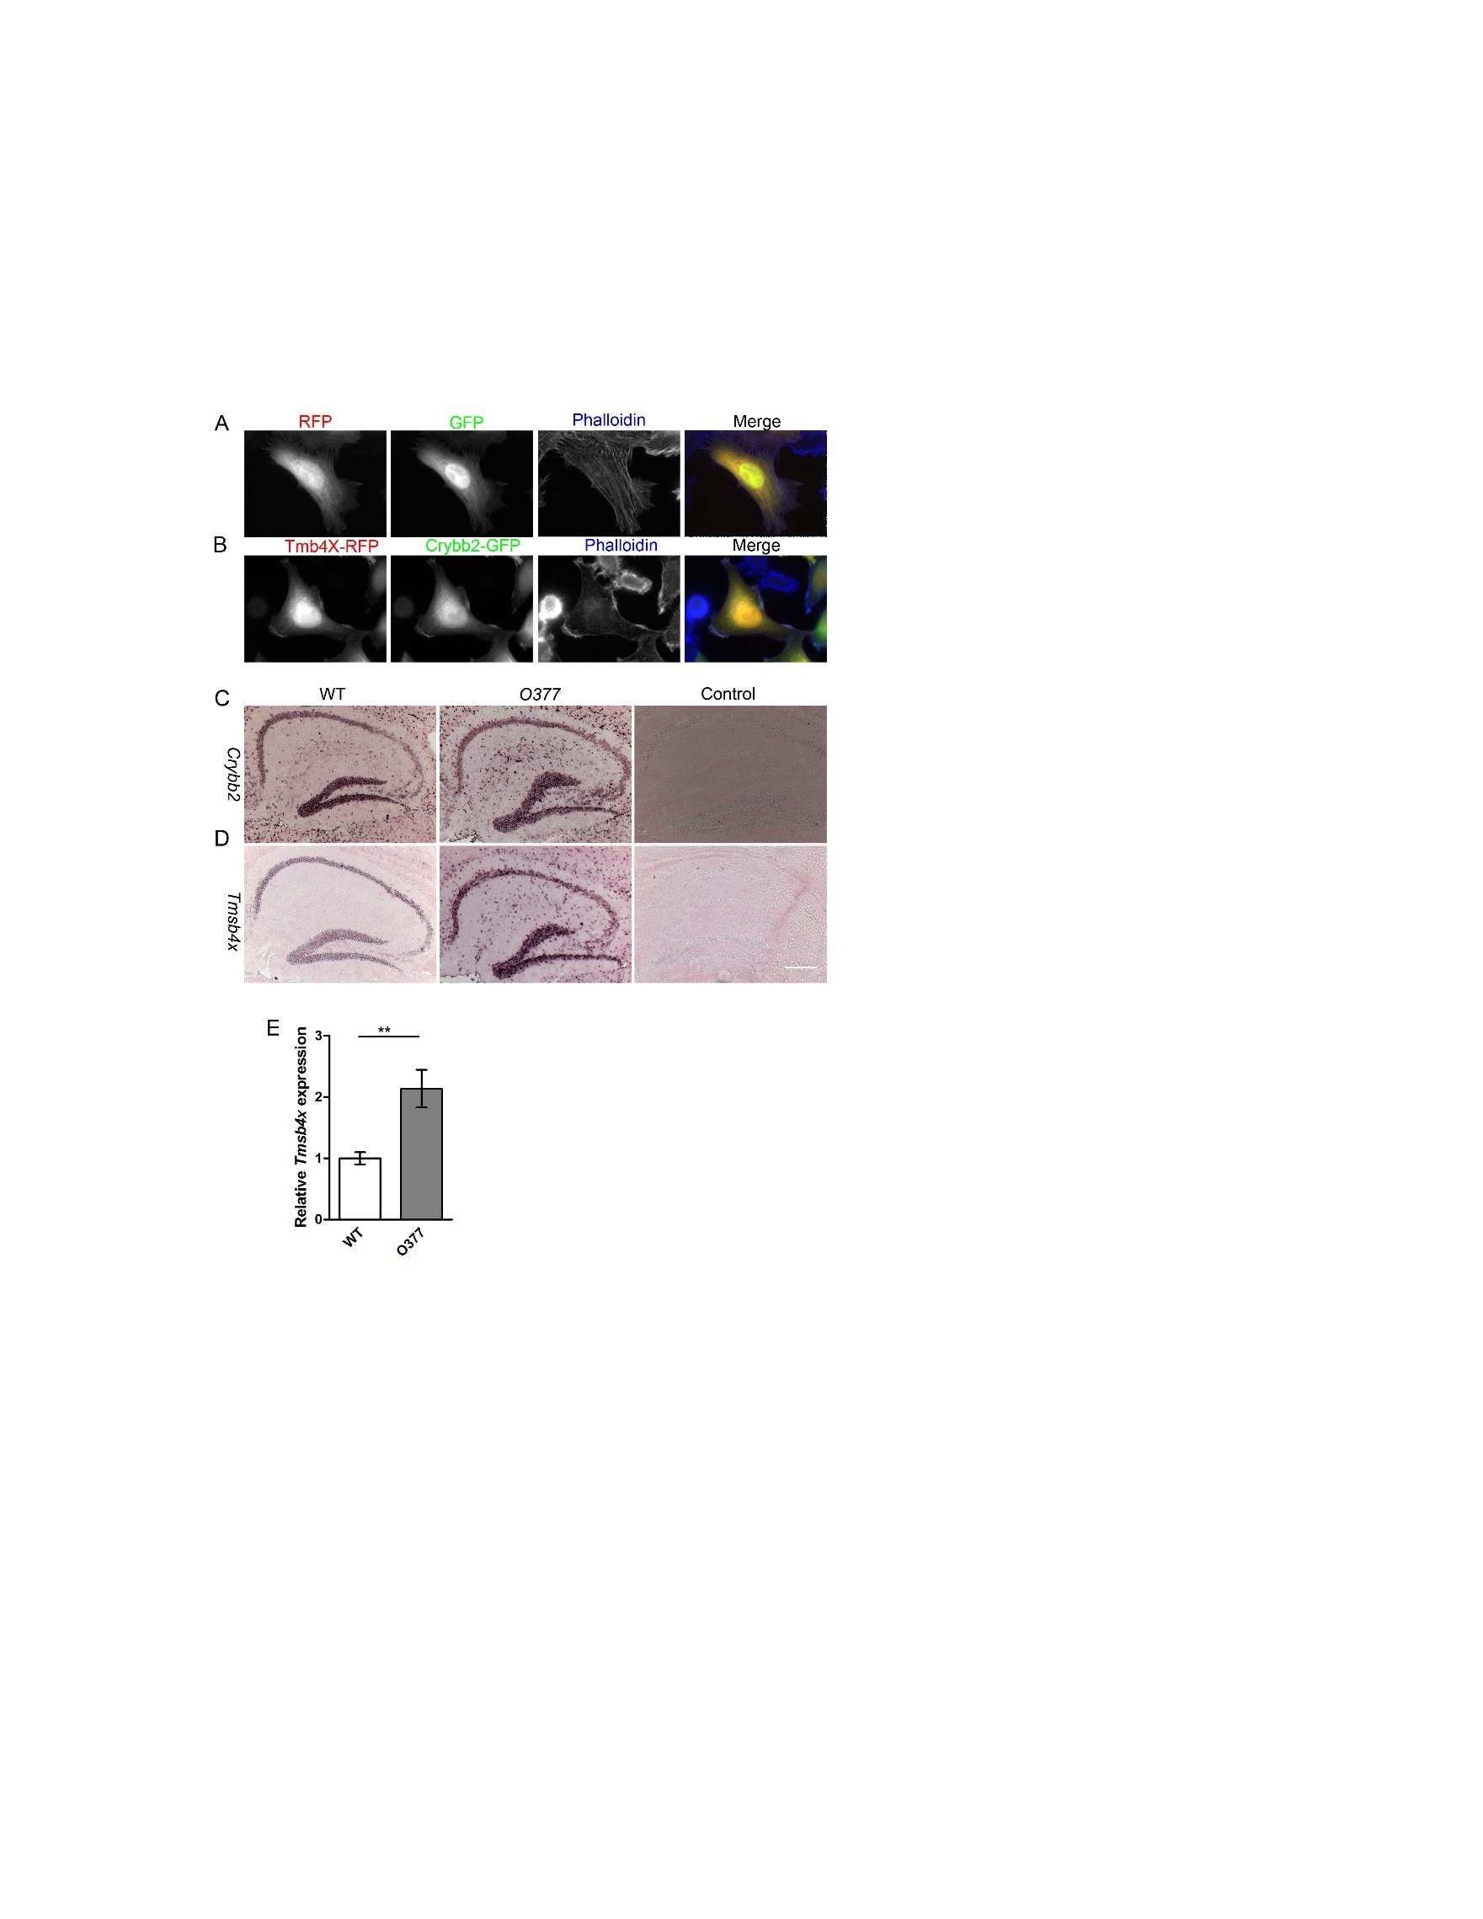**Fig 3**

**Fig 4**

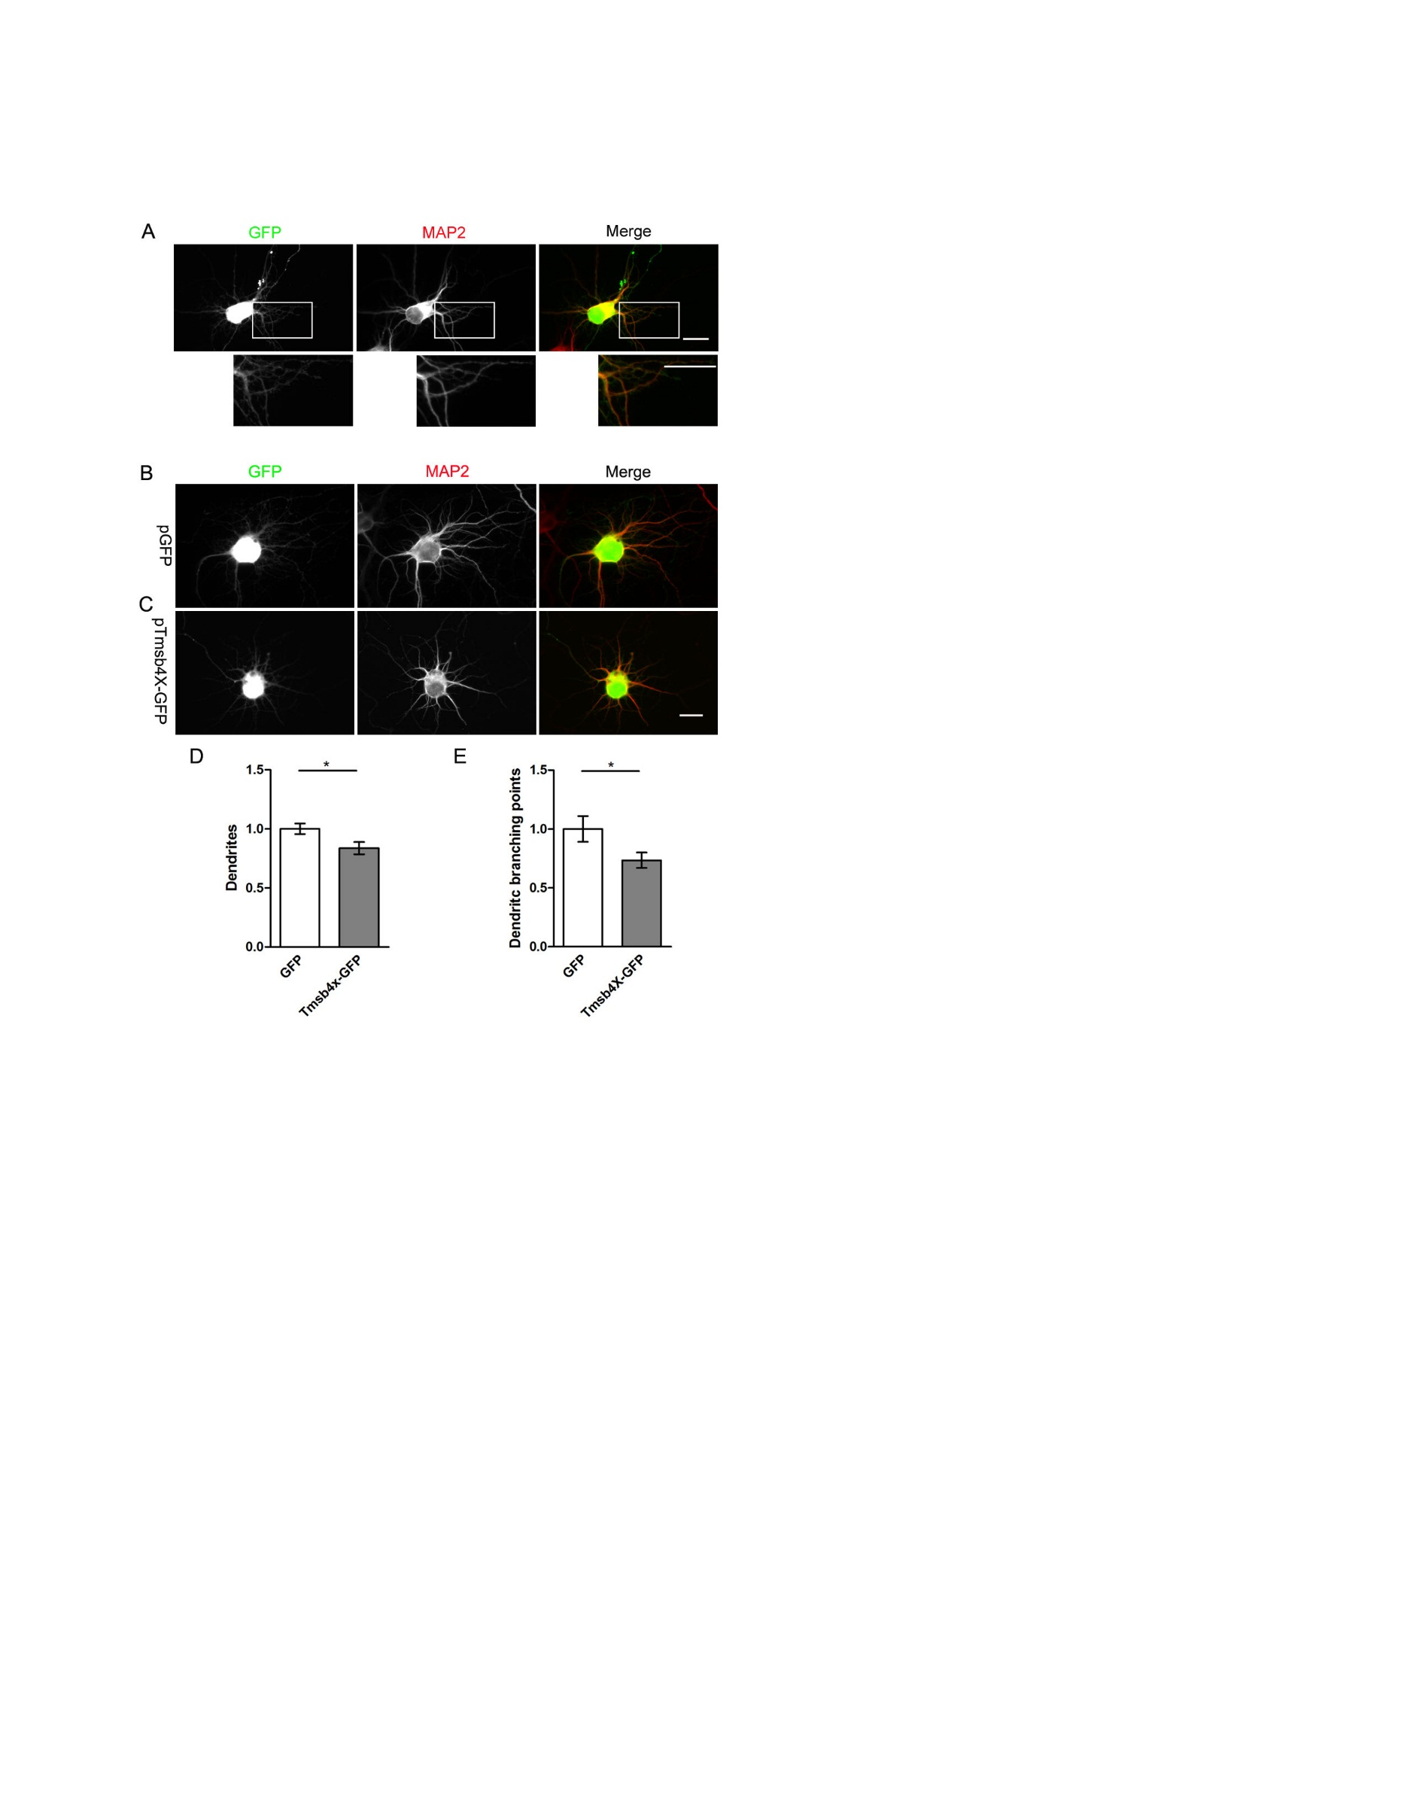

Fig 1 S **Evaluation the RNAi efficiency by western blot**

Efficiency of RNAi vector targeting *Crybb2* was evaluated by Western blot, GAPDH was employed as a loading control.

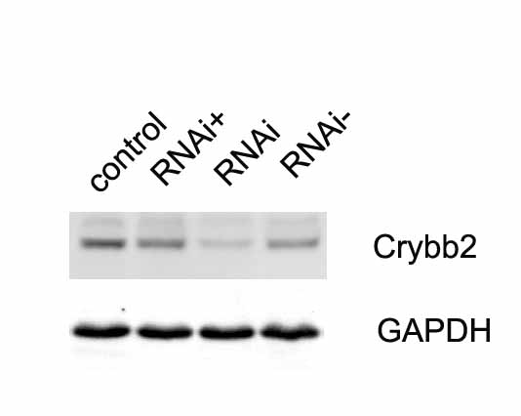

**Reference**

[1] L. Luo, E.M. Callaway, K. Svoboda, Genetic dissection of neural circuits, Neuron 57 (2008) 634-660.

[2] F.B. Gao, Molecular and cellular mechanisms of dendritic morphogenesis, Curr Opin Neurobiol 17 (2007) 525-532.

[3] M. Urbanska, M. Blazejczyk, J. Jaworski, Molecular basis of dendritic arborization, Acta Neurobiol Exp (Wars) 68 (2008) 264-288.

[4] J.E. Black, I.M. Kodish, A.W. Grossman, A.Y. Klintsova, D. Orlovskaya, V. Vostrikov, N. Uranova, W.T. Greenough, Pathology of layer V pyramidal neurons in the prefrontal cortex of patients with schizophrenia, Am J Psychiatry 161 (2004) 742-744.

[5] K. Broadbelt, W. Byne, L.B. Jones, Evidence for a decrease in basilar dendrites of pyramidal cells in schizophrenic medial prefrontal cortex, Schizophr Res 58 (2002) 75-81.

[6] S.S. Rosenberg, N.C. Spitzer, Calcium signaling in neuronal development, Cold Spring Harb Perspect Biol 3 (2011) a004259.

[7] N. Yamashita, R. Aoki, S. Chen, A. Jitsuki-Takahashi, S. Ohura, H. Kamiya, Y. Goshima, Voltage-gated calcium and sodium channels mediate Sema3A retrograde signaling that regulates dendritic development, Brain Res 1631 (2016) 127-136.

[8] J. Graw, From eyeless to neurological diseases, Exp Eye Res 156 (2017) 5-9.

[9] S.T. Santhiya, G.S. Kumar, P. Sudhakar, N. Gupta, N. Klopp, T. Illig, T. Soker, M. Groth, M. Platzer, P.M. Gopinath, J. Graw, Molecular analysis of cataract families in India: new mutations in the CRYBB2 and GJA3 genes and rare polymorphisms, Mol Vis 16 (2010) 1837-1847.

[10] Y. Zhou, Y. Zhai, L. Huang, B. Gong, J. Li, F. Hao, Z. Wu, Y. Shi, Y. Yang, A Novel CRYBB2 Stopgain Mutation Causing Congenital Autosomal Dominant Cataract in a Chinese Family, J Ophthalmol 2016 (2016) 4353957.

[11] K. Ganguly, J. Favor, A. Neuhauser-Klaus, R. Sandulache, O. Puk, J. Beckers, M. Horsch, S. Schadler, D. Vogt Weisenhorn, W. Wurst, J. Graw, Novel allele of crybb2 in the mouse and its expression in the brain, Invest Ophthalmol Vis Sci 49 (2008) 1533-1541.

[12] J. Graw, J. Loster, D. Soewarto, H. Fuchs, A. Reis, E. Wolf, R. Balling, M. Hrabe de Angelis, Aey2, a new mutation in the betaB2-crystallin-encoding gene of the mouse, Invest Ophthalmol Vis Sci 42 (2001) 1574-1580.

[13] Q. Gao, L.L. Sun, F.F. Xiang, L. Gao, Y. Jia, J.R. Zhang, H.B. Tao, J.J. Zhang, W.J. Li, Crybb2 deficiency impairs fertility in female mice, Biochem Biophys Res Commun 453 (2014) 37-42.

[14] T. Liedtke, J.C. Schwamborn, U. Schroer, S. Thanos, Elongation of axons during regeneration involves retinal crystallin beta b2 (crybb2), Mol Cell Proteomics 6 (2007) 895-907.

[15] N.J. Kleiman, R. Chiesa, M.A. Kolks, A. Spector, Phosphorylation of beta-crystallin B2 (beta Bp) in the bovine lens, J Biol Chem 263 (1988) 14978-14983.

[16] M.K. Jobby, Y. Sharma, Calcium-binding to lens betaB2- and betaA3-crystallins suggests that all beta-crystallins are calcium-binding proteins, FEBS J 274 (2007) 4135-4147.

[17] M. Sun, S.M. Holter, J. Stepan, L. Garrett, J. Genius, E. Kremmer, M. Hrabe de Angelis, W. Wurst, D.C. Lie, L. Bally-Cuif, M. Eder, D. Rujescu, J. Graw, Crybb2 coding for betaB2-crystallin affects sensorimotor gating and hippocampal function, Mamm Genome 24 (2013) 333-348.

[18] V.T. Nachmias, Small actin-binding proteins: the beta-thymosin family, Curr Opin Cell Biol 5 (1993) 56-62.

[19] F.X. Yu, S.C. Lin, M. Morrison-Bogorad, M.A. Atkinson, H.L. Yin, Thymosin beta 10 and thymosin beta 4 are both actin monomer sequestering proteins, J Biol Chem 268 (1993) 502-509.

[20] Y.N. Jan, L.Y. Jan, Branching out: mechanisms of dendritic arborization, Nat Rev Neurosci 11 (2010) 316-328.

[21] G.M. Jentarra, S.L. Olfers, S.G. Rice, N. Srivastava, G.E. Homanics, M. Blue, S. Naidu, V. Narayanan, Abnormalities of cell packing density and dendritic complexity in the MeCP2 A140V mouse model of Rett syndrome/X-linked mental retardation, BMC Neurosci 11 (2010) 19.

[22] A. Muneer, Staging Models in Bipolar Disorder: A Systematic Review of the Literature, Clin Psychopharmacol Neurosci 14 (2016) 117-130.

[23] E.D. Marks, A. Kumar, Thymosin beta4: Roles in Development, Repair, and Engineering of the Cardiovascular System, Vitam Horm 102 (2016) 227-249.

[24] C. Mollinari, L. Ricci-Vitiani, M. Pieri, C. Lucantoni, A.M. Rinaldi, M. Racaniello, R. De Maria, C. Zona, R. Pallini, D. Merlo, E. Garaci, Downregulation of thymosin beta4 in neural progenitor grafts promotes spinal cord regeneration, J Cell Sci 122 (2009) 4195-4207.

[25] H. Yang, X. Cheng, Q. Yao, J. Li, G. Ju, The promotive effects of thymosin beta4 on neuronal survival and neurite outgrowth by upregulating L1 expression, Neurochem Res 33 (2008) 2269-2280.

[26] W. Hou, M. Izadi, S. Nemitz, N. Haag, M.M. Kessels, B. Qualmann, The Actin Nucleator Cobl Is Controlled by Calcium and Calmodulin, PLoS Biol 13 (2015) e1002233.

[27] S. Wang, B.W. Scott, J.M. Wojtowicz, Heterogenous properties of dentate granule neurons in the adult rat, J Neurobiol 42 (2000) 248-257.

[28] T. Fujioka, A. Fujioka, R.S. Duman, Activation of cAMP signaling facilitates the morphological maturation of newborn neurons in adult hippocampus, J Neurosci 24 (2004) 319-328.

[29] M.M. Kessels, L. Schwintzer, D. Schlobinski, B. Qualmann, Controlling actin cytoskeletal organization and dynamics during neuronal morphogenesis, Eur J Cell Biol 90 (2011) 926-933.

J. Graw, Genetics of crystallins: cataract and beyond. Exp Eye Res 88 (2009) 173-189