**Additional File S1**

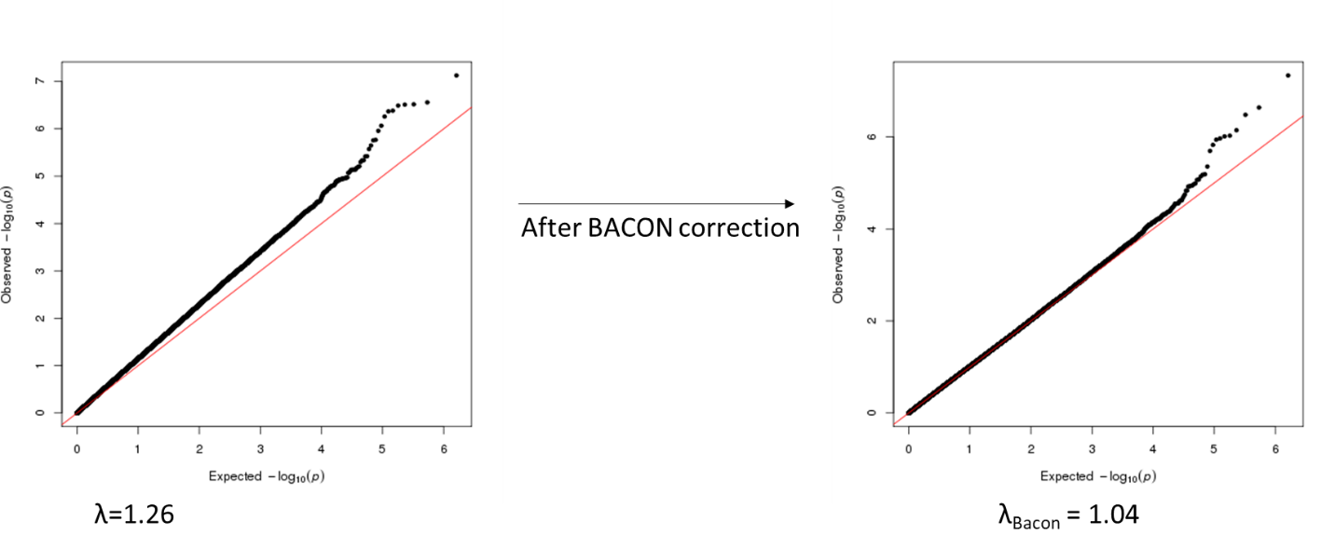

**Fig S1: Extended Q-Q plot of salivary DNA methylation associated with PDQ.**

Quantile-quantile (QQ) plots of observed and expected distributions of p-values of the association between salivary DNA methylation and PDQ. Lambda (λ) is the genomic inflation factor, and λBacon is the genomic inflation factor after correction for inflation, estimated using the method of van Iterson et al. (2017) (102), implemented using the *bacon* R package.

**Additional File S2**

**Fig S2: Enrollment flowchart for FELICITy Study**