A Computational Model for Oxygen Depletion Hypothesis in FLASH Effect

Ankang Hu1,2, Rui Qiu1,2,*, Zhen Wu1,3, Hui Zhang1,2, Weibo Li4, Junli Li1,2

1. Department of Engineering Physics, Tsinghua University, Beijing, China

2. Key Laboratory of Particle & Radiation Imaging, Tsinghua University, Ministry of Education, Beijing, China

3. Nuctech Company Limited, Beijing, China

4. Institute of Radiation Medicine, Helmholtz Zentrum München - German Research Center for Environmental Health (GmbH) Ingolstädter Landstr. 1, 85764 Neuherberg, Germany

Running title: Model for Oxygen Depletion in FLASH Effect

Corresponding author:

Rui Qiu, Ph.D., Associate Professor

Department of Engineering Physics

Tsinghua University

Beijing, 100084, P.R.China

Email: qiurui@tsinghua.edu.cn

Tel: 86-10-62773980

Hu, A., Qiu, R., Wu, Z., Li, C., Zhang, H. Li, W. and Li, J. A Computational Model for Oxygen Depletion Hypothesis in FLASH Effect. Radiat. Res.

Experiments have reported low normal tissue toxicities during FLASH radiation, but the mechanism has not been elaborated. Several hypotheses have been proposed to explain the mechanism. One of them is oxygen depletion hypothesis. We analyze the time-dependent change of oxygen concentration in the tissue to study the oxygen depletion hypothesis using a computational model. The effects of physical, chemical and physiological parameters on oxygen depletion were explored. The kinetic equation of the model is solved numerically using the finite difference method with rational boundary conditions. Results of oxygen distribution is supported by the experiments of oxygen-sensitivity electrodes and experiments on the expression and distribution of the hypoxia-inducible factors. The analysis of parameters show that the steady-state oxygen distribution before iradiation is determined by the oxygen consumption rate of the tissue and the microvessel density. The change of oxygen concentration with time after radiation has been found to follow a negative exponential function, and the time constant is mainly determined by the microvessel density. The change of oxygen consumed by radiation increases with dose rate and tends to be saturated. When the dose rate is high enough, the same dose results in the same reduction of oxygen concentration regardless of dose rate. The analysis of the FLASH effect in the brain tissue based on this model does not support the explanation of the oxygen depletion hypothesis. The oxygen depletion hypothesis remains controversial because the oxygen in most normal tissues cannot be depleted to the radiation resistance level by FLASH radiation.

Key words: oxygen depletion hypothesis; FLASH radiation; computational model.

# Introduction

Some animal experiments have reported unexpectedly low normal tissue toxicities during ultra-high dose rate radiation, which is called FLASH effect(*1-3*). Because of the great potential clinical benefit resulted from the low damage to normal tissue, FLASH radiotherapy is attracting great attention in the radiation oncology community(*4*). However, a mechanism explaining the FLASH effect has not yet been demonstrated(*3, 4*). Some questions remain controversial, for example, whether a shorter pulse could lead to a more significant effect while the total dose remains same. If a reasonable mechanism were proposed, targeted experiments could be performed to explore the mechanism and the condition of FLASH effect. Oxygen depletion hypothesis has been proposed to explain the FLASH effect(*5-8*). The hypothesis assumes that cells irradiated by ultra-high dose rate radiation become hypoxic, showing radiation resistance. P Wilson et al and J Wilson et al pointed out that the oxygen depletion may be the mechanism to explain the biological effect in ultra-high dose rate radiation(*3, 9*). The oxygen depletion hypothesis has been utilized to predict the parameters that may lead to the FLASH effect, such as the pulse width, the interval between two pulses, the total dose of the radiation beam, and the original oxygen tension in the tissue(*6*). Some experiments were conducted to explore the relationship between oxygen depletion and FLASH effect. Montay-Gruel et al indicated that the FLASH effect was related to oxygen, based on their results of animal experiments and H2O2 measurements after FLASH irradiation(*10*). Wardman commented that yields of H2O2 reported in the FLASH versus conventional comparison differ from what would have been expected(*11*). Adrian et al concluded that the FLASH effect depended on oxygen, based on the experiment of prostate **cancer** cell line DU145(*12*). They found that the cancer cells were protected by FLASH irradiation when the oxygen concentration was low enough, and the effect was not observed for higher oxygen level. We think this result is not the support of the oxygen depletion hypothesis because the FLASH radiation spares the normal tissue while keeping the damage to cancer cell. Moreover, Acharya et al found reduced DNA damage following ultrahigh dose-rate irradiation in normal cells grown in vitro in equilibrium with 200 µmol/L O2, which indicated that ultra-high dose rate radiation could lead to protective effect even if the cells were normoxic(*13*). Besides the oxygen depletion hypothesis, different views have also been proposed(*14, 15*). Labarbe et al proposed that the reduction of 𝑅𝑂𝑂· lifetime is the main root of FLASH effect instead of the hypothesis of transient oxygen depletion(*16*). The premise of oxygen depletion hypothesis is that the oxygen in the tissue could be depleted by the irradiation. Oxygen tension in normal tissues was determined in brain, bone marrow and lung: free oxygen varies between 150 𝜇𝑚𝑜𝑙/𝐿 in arterial blood and 40 𝜇𝑚𝑜𝑙/𝐿 in venous ends(*16*). The oxygen tension in the normal tissue is too high to be depleted by ~20 Gy FLASH irradiation, so that 20 Gy FLASH irradiation cannot result in radiation-resistance. Abolfath et al proposed that the FLASH may be explained by the reaction between reactive oxygen species(ROS). They performed molecular dynamics simulation to analyze the reaction after FLASH radiation and found that ROS reacted to generate non-reactive oxygen species(NROS) leading to less damage(*17*).

With the development of radiation chemistry, we are able to quantitatively explore the radiolytic oxygen consumption and study the oxygen depletion hypothesis in detail. Considering that oxygen diffusion, reaction and metabolism are dynamic processes, the qualitative analysis cannot provide enough results to understand the role of oxygen depletion in FLASH effect. The reaction of oxygen in the tissue is strongly affected by the chemical reaction rate of free radicals, not just the yield and reaction types of free radicals so that the change of oxygen concentration in the tissue may not be proportional to the yield of the free radicals. Oxygen diffusion in the tissue also contributes to the distribution of oxygen, the diffusion rate is related to the time scale of the oxygen depletion. Therefore, a computational model is required to describe the spatial and time dependent distribution of oxygen concentration during the FLASH irradiation. The study to explore the effects of physical, chemical and physiological parameters on oxygen depletion helps to understand the oxygen depletion hypothesis and FLASH effect. The model can give answers to questions related to experimental study, for example, whether the higher dose rate leads to more oxygen consumption and whether the kinetics of oxygen depletion in different tissue are same.

Some researchers proposed models to study the oxygen depletion in FLASH irradiation. A computational model has been introduced by Pratx and Kapp(*6*). The model was presented with a differential equation to calculate the oxygen distribution around a single capillary and predict the biological effect based on the oxygen enhancement model. The equation was solved with only one boundary condition which fixed the oxygen concentration at the boundary of the capillary. However, generally, the second order differential equation must be solved with two independent boundary conditions in order to get one unique solution. Moreover, the model assumed that the oxygen consumption rate was a constant under any oxygen concentration, which was inconsistent with the real situation. Besides, they set 3mmHg/s as the value of oxygen consumption rate of the tissue, which was not a typical value or a universal value, without any explanation. The oxygen consumption rate varies greatly in different tissues and the oxygen consumption rate adopted in the model could also strongly affect the result. Petersson et al proposed a model to analyze the oxygen depletion in FLASH effect, setting the parameter of oxygen recovery rate *λ* as 1 s-1 without any explanation and using this model to predict the effect for different conditions(*18*). The oxygen recovery rate is a key parameter deciding the effect of dose rate on oxygen depletion. Spitz et al added Fenton reaction, chain reaction of lipid peroxidation and other oxygen-related reactions to estimate the oxygen consumed by radiation qualitatively(*19*). However, these reactions are about four orders of magnitude slower than the reaction between oxygen and organic radicals. They did not provide sufficient experiment-based evidence to explain why 10 Gy radiation pulse could deplete 25 μmol/L oxygen. To overcome the limitations of the previous studies, we performed a study on the oxygen concentration surrounding a capillary using the computational model. The equation was solved with more rational boundary conditions and the values of the important parameters were chosen based on the experimental measurements or studied in a reasonable range.

The study of the oxygen depletion contains two important aspects: oxygen distribution before the irradiation and the change of oxygen during the irradiation. These aspects direct to the kernel of the oxygen depletion hypothesis: the oxygen in the tissue can be depleted or not. The physiological parameters affect the oxygen distribution before the irradiation and the oxygen recovery during and after the irradiation. The physical and chemical parameters are related to the oxygen depletion during the irradiation. Our study analyzes these parameters and their effect on FLASH effect. We pay more attention to the physics and chemistry processes in FLASH effect, which are the original differences between FLASH and conventional radiation effects. The oxygen depletion hypothesis is discussed based on the result of physics and chemistry changes in FLASH irradiation. Moreover, brain tissue, in which FLASH effect has been observed(*2*), is chosen as an example for the calculation to evaluate the oxygen depletion hypothesis and the FLASH effect in detail.

# Oxygen distribution before irradiation

The oxygen distribution in the tissue before irradiation is the primary state of the oxygen depletion. It also reflects the oxygen distribution during the conventional irradiation because the dose rate is too low to affect the oxygen distribution. The oxygen distribution is mainly affected by two physiological parameters: metabolic oxygen consumption of tissue and the microvessel density.

## Metabolic oxygen consumption of tissue

The oxygen distribution in the tissue is strongly affected by the oxygen consumption rate (*m*, to keep the same expression as Pratx and Kapp) of the tissue(*20*). Oxygen consumption rate(*m*) of the tissue tends to be zero when the oxygen tension tends to be zero and shows a tendency of saturation when the oxygen concentration increases(*21*). There is no exact function to describe how *m* changes with oxygen concentration. We choose a negative exponential function as the *m* function, which shows the same tendency of the oxygen consumption rate with oxygen concentration and is easy to calculate its derivative. The *m* of the tissue is given by

|  |  |  |
| --- | --- | --- |
|  | , | (1) |

where *p* is the oxygen concentration, *OCR*max is the maximum oxygen consumption rate and *λ* is a constant.

When the oxygen concentration is about 1.4 μmol/L(1 mmHg), *m* is observed at the half level of OCRmax typically(*22*). The value of *λ* is calculated by the data. Any curves showing a similar form can be used as the *m* function. We compared our *m* function with the hyperbolic curve, finding that the differences are within 10% for oxygen concentration ranging from 10 to 200 μmol/L. Some models regard the *m* as a constant(*6, 22*),however, which may lead to a negative value of oxygen tension in the reaction-diffusion model. Therefore, a negative exponential function, formula(1), is used to describe the relationship between *m* and the oxygen concentration in our model.

Average cerebral metabolic rate of oxygen was measured by Kety-Schmidt technique, which can be regarded as the reference method for the measurement. According to the measurements, the average cerebral metabolic rate of oxygen for the healthy young adult is 3.0 ml/100g/min. It means that 100 g tissue would consume 3.0 ml oxygen per minute. For 1L tissue, the oxygen consumption is 30 ml/min, which is equal to 1.2 mmol/min so that we can calculate that the oxygen consumption rate of brain is about 20 μmol/L/s.

In order to use the chemical reaction rate equation to analyze the oxygen depletion induced by the FLASH radiation directly, we employed oxygen molar concentration (μmol/L) rather than oxygen tension (mmHg) to describe the oxygen in the tissue. The oxygen tension (mmHg) in the tissue could be transformed to the oxygen concentration (μmol/L) by multiplying a factor of 1.4.

## Simplified tissue-capillary model

The structure of the capillary system is quite complicated. There exist some problems to calculate the distribution of oxygen in the tissue accurately, such as establishing the detailed model of capillaries in the tissue and solving the kinetic equation of oxygen in such complex geometry. Therefore a simplified model is required to calculate the oxygen distribution in the tissue approximately(*23*). We use the Krogh geometrical model, a widely used model, to describe the capillary-tissue system(*24, 25*). The model describing the oxygen diffusion given by Pratx and Kapp is also the Krogh cylinder model. The model regards a capillary and the surrounding tissue as two coaxial cylinders. The inner cylinder represents the capillary and the outer cylinder represents the tissue around the capillary. The oxygen diffused from the capillary to the tissue. The geometrical model is shown in figure 1.

We further assume that the tissue around the capillary is homogeneous, which means they have the same composition and oxygen consumption rate. For the substance which cannot freely cross the cell membrane, an effective diffusion constant determined by the tortuosity in the extracellular space is introduced(*26*). The oxygen can cross the membrane freely, so we think the diffusion is slightly affected by the tortuosity of the extracellular space so that we use the diffusion rate constant in water directly. Then the oxygen diffusion and consumption in the tissue can be described by

|  |  |  |
| --- | --- | --- |
|  | , | (2) |

where *p* is the molar concentration of O2 in the tissue, *D* is the diffusion coefficient of O2, and *m*(*p*) is the function of oxygen consumption rate related to the *p*. The steady-state transport of O2 is governed by

|  |  |  |
| --- | --- | --- |
|  | . | (3) |

Considering that the radius of the outer cylinder(<100μm) is far less than the length of the capillary(~1mm), we assume that the axial diffusion of O2 in the tissue is negligible compared to the radial diffusion. Oxygen distribution in the tissue can be described in the cross-section plane with polar coordinates. The steady-state equation is simplified to

|  |  |  |
| --- | --- | --- |
|  | . | (4) |

Equation (4) is subject to the following boundary conditions

|  |  |  |
| --- | --- | --- |
|  | , | (5) |

where *p*w is the molar concentration of O2 at the capillary-tissue interface, *r*c is the radius of the capillary, and *r*t is obtained from the value of microvessel density. The value of *r*t is approximately equal to the half distance between two adjacent capillaries. The fluxes of oxygen from these two adjacent capillaries are equal at the position *r* = *r*t, so that the first derivative of *p* versus *r* is equal to zero. The boundary condition *r*t considers the density of capillaries in the tissue. One of the main differences between the model in this study and that of Pratx and Kapp is the boundary condition(*6*). A finite difference method was adopted to solve the equation (3) with the boundary conditions. The steady-state oxygen distribution in the tissue can be obtained from the solution.

# Change of oxygen during the FLASH irradiation

The change of oxygen during the irradiation depends on the radiolytic oxygen consumption and the oxygen diffusion. We extended the steady-state equation to dynamic model by adding the reaction term of radiolytic products. Noted that oxygen diffusion is strongly affected by the physiological parameters, we explore the effect of radiolytic oxygen consumption and physiological parameters on time-dependent change of oxygen.

## Radiolytic oxygen consumption

The radiolytic oxygen consumption is a key parameter in oxygen depletion hypothesis. However, detailed analysis by considering every relative reaction is almost impossible because of complex composition in the cell especially for living tissue(*11*). We try to simplify the complex routes to several types of reactions and estimate the radiolytic oxygen consumption based on some experiments. Radiation generates radicals, which can react with oxygen leading to oxygen consumption. Radiation interacts with water and cellular constituents to generate radicals such as eaq, H·, ·OH and organic radicals. Then most radicals (including most part of eaq, H·and ·OH) react with cellular constituents to generate organic radicals(*27*). Organic radicals react with oxygen to generate peroxyl radicals, which is the main process of transient oxygen depletion by radiation(*11, 16*). The rate constant of this process ranges from k = 108 to 1010 L/mol/s in water, depending on the electronic properties of radicals(*28*). We chose the value k = 109 L/mol/s in this study to represent the consumption rate of oxygen and the difference between the actual value and the chosen does not contribute significantly to oxygen depletion, because the time scale of oxygen diffusion in the tissue is at least the magnitude of ten milliseconds (described below). The reactions in the cell after irradiation are too complex for the model to describe one by one specifically. A general and simplified process is used to describe the quantity and kinetic of oxygen depleted by radiation. The quantity of oxygen depleted by radiation is an important parameter in oxygen depletion hypothesis. The yields of radicals generated by water are 0.28(eaq), 0.28(·OH) and 0.062(H·) μmol/L/Gy(*16*). It means that the organic radicals generated by primary radicals is about 0.5μmol/L/Gy leading to oxygen consumption of 0.5μmol/L/Gy. Colliaux et al gave the oxygen depletion rate of 0.5μmol/L/Gy in the water(*29*). Ling et al used a 3ns pulse to irradiate CHO cells equilibrium with 0.44% O2 (4.68μmol/L)(*30*). They found that the cell survival curve switched from an oxygenated to an anoxic response at the breakpoint dose D = 12 Gy due to radiochemical depletion of the intracellular oxygen. It means that 12 Gy radiation would deplete the oxygen in the cell so that the rate constant is about 0.4μmol/L/Gy. To analyze the transient oxygen depletion by the pulse change affected by the parameter, we solved the model by setting the parameter as 0.2-0.6 μmol/L/Gy . Other routes for oxygen depletion such as lipid peroxidation and Fenton reaction are ignored in this study because these reactions are too low to affect the oxygen concentration in the tissue. The lipid peroxidation is started by peroxyl radicals (ROO·), which is relatively long-lived with a second-time half-life(*16*). The reaction rate constant of Fenton reaction is ~10 L/mol/s. The time scale of these routes is longer than the oxygen diffusion and much longer than the critical time window (1-2 ms) of oxygen-sensitive effect so that the oxygen concentration is not affected by these routes because oxygen in the tissue is largely supplied from the capillaries(*11*).

The mechanistic effect of radiolytic oxygen consumption in the cell and living tissue remains controversial because of complex routes in the cell and living tissue. We try to estimate it based on *in vitro* cell experiments and analyze the oxygen depletion hypothesis according to the existing results to study the oxygen depletion hypothesis quantitatively.

## Time-dependent change of oxygen distribution during FLASH

The steady-state equation gives the oxygen distribution in the tissue with no radiation. To consider the change of oxygen distribution in the tissue receiving FLASH radiation, we add a reaction term to the steady-state equation. The reaction term is expressed in the form of the chemical reaction rate equation, instead of *L*ROD*Dp*/*T* given by Pratx and Kapp, which would fail when the oxygen concentration is quite low. As described above, radicals generated by radiation consume the oxygen in the tissue. We assume that the radicals yielded by low-LET radiation are homogeneous in the tissue(*7*) on the scale of capillary. The time-dependent change of oxygen distribution is governed by

|  |  |  |
| --- | --- | --- |
|  | , | (6) |

where *k* is the reaction rate constant of oxygen-radical reaction and *L*(*t*) is the molar concentration of the radicals. The molar concentration of the reducing radicals *L*(*t*) is described by

|  |  |  |
| --- | --- | --- |
|  | , | (7) |

where *R*(*t*) is the yielding rate of radicals, which is directly proportional to the dose rate.

We assume that the oxygen in capillaries can hardly be affected by radiation because the hemoglobin carries a large amount of oxygen compared with the dissolved oxygen in the tissue(*24*). We solve equation (6) and (7) with the same boundary conditions used in the steady-state equation. Moreover, the steady-state oxygen distribution is used as the initial value, and the initial value of the reducing radicals is set to be zero.

The Crank-Nicolson method is used to solve the time-dependent equation of oxygen distribution. Solutions of the time-dependent equation reflect the effect of radiation on oxygen distribution. We can quantitatively analyze the oxygen depletion hypothesis using these solutions.

To explore the relationship between the time-dependent change of oxygen distribution and some biological parameters such as microvessel density and oxygen consumption rate, we set different values of *r*t and *OCR*max.

## Biological effect predicated by oxygen enhancement model

The radiosensitivity is significantly affected by the oxygen concentration for low-LET radiation. Several models have been proposed to fit experimental cell survival data according to the oxygen level. We choose a classical model to predict the biological effect of FLASH radiation. Oxygen enhancement ratio (OER) is defined to represent the radiosensitivity of the tissues on different oxygen levels. In the mentioned classical model(*31*), OER is given by

|  |  |  |
| --- | --- | --- |
|  | , | (8) |

where *p* is the molar concentration of oxygen, μmol/L; *m* and *K* are constant parameters, 2.9 and 7.2 μmol/L, respectively. The parameters in this model were calculated by the fitting of experiment data. Recent OER models(*32*) are given by introducing parameters to link the OER to some mechanisms. They reflect the similar phenomenon with the classical OER model used in this study.

We can calculate the OER based on the model and the solution of the time-dependent equation to estimate the biological effect of FLASH according to the oxygen depletion hypothesis.

We can calculate the value of OER of each position when receiving FLASH radiation and compare it with the OER under steady-state oxygen concentration. The oxygen concentration in conventional radiation is considered to keep the value of the steady-state oxygen concentration because of low dose rate of conventional radiation. If the pulse width is several milliseconds, the OER is calculated by(*6*)

|  |  |  |
| --- | --- | --- |
|  | , | (12) |

where *T* is the width of the pulse and *Rate*(*t*) is the function of dose rate.

## Parameters of the model

Studies on brain tissue have measured the data of biological parameters of the brain such as the OCR and the microvessel density of brain tissue(*33, 34*). We choose the brain tissue as an example to analyze oxygen consumption during FLASH radiation. The model is solved with typical values of microvessel density, *OCR*max, and oxygen concentration at the venous end of the capillary in the brain tissue. If we assume that capillaries are arranged in parallel, the boundary condition *r*t can be calculated by length density of capillary. The microvessel density is converted to the boundary condition *r*t by

|  |  |  |
| --- | --- | --- |
|  | , | (9) |

where *Lv* is the length density of capillary(*33*), and *f* is a factor related to the form of arrangement. If the capillaries are arranged in the form of square lattice in the cross-section plane, *f* is equal to 2.0. If the capillaries are arranged in the form of a hexagonal lattice, *f* is equal to 2.278. We choose 2.0 as the value of *f*, which leads to more zones at the low oxygen level. If the result of the model using this parameter showed no hypoxic zone, the model using a larger value of *f* would not give the result showing a hypoxic zone. A typical value of *Lv* in the cerebral cortex, 500 mm-2, is chosen to calculate the boundary condition(*33*).

The constant dose rate during the pulse is assumed for its simplicity. The yield of radicals reacting with oxygen, *G*, is 0.2-0.6 μmol/h/Gy(*6*). Yielding rate of radicals, *R*(*t*), is given by

|  |  |  |
| --- | --- | --- |
|  | , | (10) |

where *Rate*(*t*) is the dose rate, Gy/s. Parameters of the model are listed in table 1.

With these typical parameters, we analyze the FLASH effect on the brain tissue.

# Results and discussion

## Oxygen distribution in the tissue

We solved the steady-state equation of oxygen distribution with different values of *r*t and *OCR*max to evaluate the relationship between oxygen distribution and biological parameters. The results are shown in figure 2.

Results show that oxygen distribution is significantly affected by oxygen consumption rate and the boundary condition. The oxygen concentration is lower when a larger *r*t is set, because large distance between two capillaries leads to low oxygen concentration level in the tissue. The high level of oxygen consumption rate results in the low oxygen concentration because of fast oxygen consumption. The boundary condition *r*t and oxygen consumption rate are two important parameters deciding the steady-state oxygen concentration in the tissue. For the brain tissue, the value of oxygen concentration is higher than the level (< 20 μmol/L) at which the radiation-resistant phenomenon can be observed. Our result shows that the oxygen concentration of the cerebral cortex is about 50 μmol/L, which is equivalent to 5 kPa oxygen tension measured by the oxygen-sensitivity electrodes(*35*). The oxygen concentration in the cerebral cortex is in accordance with the experimental results of the oxygen-sensitivity electrodes.

## Characteristic of time-dependent change of oxygen distribution

The time-dependent equation was solved with different parameters to evaluate the influence of biological parameters. For each situation, the tissue receives a pulse with a total dose of 20 Gy and a pulse width of 50 ms, which is set to keep the computing time at a rational level. The dose of the pulse is higher than most FLASH experiments, and the dose rate is up to 400 Gy/s, which is higher than 40 Gy/s. The pulse represents a typical situation of FLASH radiation even if it does not correspond to the pulse in the experiment. The time-dependent change of oxygen at the position *r* = 18μm is shown in figure 3.

We found that the change of oxygen concentration is approximately a negative exponential curve after the pulse, which can be described by

|  |  |  |
| --- | --- | --- |
|  | , | (11) |

where *p*s is the steady-state oxygen concentration, Δ*p* is the oxygen consumed by radiation pulse, and *τ* is the time constant of oxygen concentration recovering. Besides, the values of time constant at the positions *r*=23, 43 and 63 μm for *r*t=66 μm are calculated. Table 2 shows the values of *τ* at different positions for different biological parameters.

The extent of oxygen consumption (Δ*p* in formula 11) is proportional to the values of oxygen consumption rate constant. We further found that *τ* is independent of *OCR*max but related to *r*t and the position *r*. The distance to the capillary *r* affects *τ* slightly at the position far away from the capillary, compared to the influence of the *r*t. It indicates that the time-dependent change of oxygen concentration is closely related to *r*t, which is determined by the value of microvessel density. We summary the relationship between the maximum oxygen change and dose rate for different values of *r*t in figure 4.

Moreover, theoretical analysis based on formula (11) indicates that oxygen consumed by the radiation pulse is no longer related to the width of the pulse, if the pulse width is much less than *τ*. It means that the same dose results in the same change range of oxygen concentration when the dose rate is high enough (figure 4).

The pulse with 20 Gy dose and 50 ms pulse width is chosen to consider the device that provides continuous radiation during tens of milliseconds. The superconducting linear accelerators on CTFEL (in Chengdu, China) can provide a micro pulse every 18.5 ns, which can be regarded as continuous radiation. The dose rate of X ray is up to 1000Gy/s(*36*). Experiments using this device were performed to study the FLASH effect. According to the analysis, the maximum change of oxygen concentration induced by the pulse with 20 Gy is just 10 μmol/L. The difference between the maximum change of oxygen concentration and the change induced by the pulse with 50 ms pulse width is less than 1%. There is no need to calculate other situations with smaller pulse width. In other words, the pulse with several milliseconds width show the same effects as the pulse with shorter widths as the perspective of radiolytic oxygen depletion.

For radiation with longer pulse width, the change of oxygen concentration is smaller than the pulse with short pulse width because of the recovery induced by the oxygen diffusion. For radiation with multi-pulses, the change of oxygen concentration is also smaller than a single pulse with the whole dose because of the recovery between pulses. Moreover, formula (11) can be regarded as the impulse response function of a system so that the time-dependent curve can be obtained by convolution, which is widely used in the analysis of a signal system. The analysis on the change of oxygen concentration in this study well represents the typical change of the oxygen concentration in FLASH radiation.

## Biological effect predicted by oxygen enhancement model

We calculated the OER of the brain tissue in the previously calculated FLASH pulse (20 Gy, 50 ms), and the OER of conventional irradiation was calculated by using the oxygen distribution before irradiation. The differences of OER values between FLASH and conventional irradiation at different positions of the brain tissue are shown in figure 5.

The maximum differences of OER values is about 1% (0.03/2.7) between FLASH radiation and conventional irradiation under the steady-state oxygen concentration. There is no obvious change of OER for the brain tissue receiving FLASH radiation. The reason could be explained as follows. The steady-state oxygen concentration is higher than 50 μmol/L at every position, and the 20 Gy radiation pulse just consumes 4-12 μmol/L oxygen(for oxygen consumption constant from 0.2 μmol/L/Gy to 0.6 μmol/L/Gy). The values of oxygen concentration in both steady-state and FLASH radiation are far from the interval (< 20 μmol/L), in which radiation resistance caused by hypoxia is significant.

## Discussion on boundary conditions of the model

As the aforementioned analysis of oxygen concentration in the tissue, the spatial distribution and the time-dependent change of oxygen concentration are both strongly affected by the boundary conditions. A comparison between our model and the model given by Pratx and Kapp is performed below.

The oxygen consumption function *m*(*p*) in equation (4) is set to be a constant *OCR* so that we can compare the difference in boundary conditions between two mentioned models. There is an analytic solution of equation with the constant oxygen consumption rate, given as formula (12).

|  |  |  |
| --- | --- | --- |
|  |  | (12) |

*C*1 and *C*2 are constant determined by the boundary conditions. The function in formula (12) will become infinity when *r* tends to be infinity. Two independent boundary conditions are necessary to calculate *C*1 and *C*2 while solving the equation. However, Pratx and Kapp solved the equation with the boundary condition *p*(*r*≤*r*c)=*p*0. There is much hemoglobin in the capillary which carries most oxygen of the blood. The oxygen concentration in the capillary cannot be described by the equation (4) because hemoglobin releases oxygen to the blood is not considered by equation (4) For the above reason, the first derivative of *p*(*r*) is not continuous at *r*c. The boundary condition *p*(*r*≤*r*c)=*p*0 is equivalent to *p*(*r*=*r*c)=*p*0. It means that there is only one boundary condition to solve the equation in that study. As two boundary conditions are indispensable to solve the equation，the solution may be determined by an implicit boundary condition which existed but not illustrated in the article. Our result on time-dependent change of oxygen concentration further indicates that the recovery time of oxygen concentration is strongly affected by the boundary condition. The boundary condition is also an important factor for the analysis of oxygen changing during the radiation.

## Oxygen depletion hypothesis remains controversial

The oxygen depletion hypothesis states that FLASH radiation consumes a large amount of oxygen in the tissue in such a short time that the tissue shows radiation resistance because of hypoxia. The original oxygen concentration and oxygen consumption by the radiation are two important factors. If the tissue were hypoxic, the FLASH irradiation could deplete the oxygen to make the tissue show radiation-resistance. An enough large area of the tissue at the low oxygen level is a necessary condition of the proof of the oxygen depletion hypothesis. Considering that a typical dose of FLASH in published experiments is about 20 Gy (consuming 10 μmol/L oxygen) or less, the original oxygen concentration should be low enough so that the significant change of radiosensitivity determined by oxygen can be observed(*31*).

Our results show that the values of original oxygen concentration at all positions in the brain are much higher than 20 μmol/L, but FLASH effect has been observed in the brain tissue. Moreover, our results of the oxygen concentration in the tissue are calculated for the tissue around the venous end of the capillary. The oxygen concentration at the arterial end of the capillary is 140 μmol/L (~100mmHg), which is much higher than that at the venous end of the capillary(57 μmol/L, 40mmHg). The oxygen concentration levels in other areas are higher than that of our results because the oxygen concentration at the capillary between the arterial end and the venous end is higher than that at the venous end. The oxygen in the tissue between the atrial end and the venous end cannot be depleted to the radiation resistance level by the FLASH radiation, either. Our results of the oxygen concentration give a lower bound of oxygen concentration in the brain tissue.

Recent experiments have reported FLASH effect in lung and brain. There is no significant evidence showing that a large zone of hypoxic tissue can be observed in these organs. Results of experiments on expression and distribution of the hypoxia-inducible factors (HIF) showed that most zones in the normal tissue are not hypoxic(*37*). Measurements of oxygen tension in the tissue via oxygen-sensitive electrodes also showed that the oxygen levels in the normal tissue (~5kPa at the cerebral cortex) are much higher than the interval in which the oxygen tension can be consumed to make the tissue radiation-resistant by 20 Gy FLASH radiation.

Results of our computational model and other experiments of measurements of oxygen in the tissue show that oxygen tension in normal tissues is much higher than the interval that shows significant radiation-resistance and FLASH irradiation with 20 Gy dose can hardly change the radiosensitivity by transient oxygen consumption. Because measurements of the oxygen in the tissue and our analysis of the time-dependent distribution of the oxygen during FLASH irradiation do not support the oxygen depletion hypothesis, the hypothesis remains controversial.

## Limitations of this study

It should be noted that there are still some limitations in our study. The main limitation is brought by the Krogh cylinder model. The simple Krogh cylinder model describing the capillary-tissue system cannot consider the complicated geometry of the real capillary system. Some experiments have reported that there are hypoxic microenvironments in neural stem cell niches (oxygen concentration in the stem cell niches between 10-80 μmol/L)(*38*), which cannot be explained by the Krogh cylinder model. The uncertainty of microvessel density and oxygen consumption and the assumption of uniform distribution of radicals may lead to the difference of results. However, the oxygen concentration in the brain tissue calculated by our model is larger than 50 μmol/L at every position. The value is far beyond the range in which OER changes obviously (< 20 μmol/L). Therefore, these limitations can hardly affect the conclusion.

Analysis of other tissues is not performed due to the lack of data on biological parameters. The model can be used to analyze the time-dependent change of oxygen concentration in other tissues as long as the biological parameters are available. Moreover, the model of biological effect affected by oxygen is limited to cell survival. There is no widely accepted model to describe the relationship between chronic effects and oxygen in radiation because of the complexity of chronic effects. Our study is limited to cell survival affected by the oxygen concentration during irradiation. Some experiments showed that the FLASH irradiation led to the same result of cell survival as the conventional irradiation*(14)*, it indicated that cell survival may not be the sole determinant of any FLASH effect. Other explanations such as lipid peroxidation and NROS still need further research.

# Conclusion

A detailed analysis was performed to study the oxygen distribution and the kinetics of oxygen in the tissue on the scale of microvessel using a computational model. The model with the new boundary conditions and more realistic term in the equation in our study overcomes the limitations of ignoring the influence of surrounding capillaries and regarding the oxygen consumption rate of tissue as a constant in previous models. We explore the relationship between the FLASH effect and oxygen concentration with the computational model and take the FLASH effect in brain tissue as an example.

The study on the oxygen concentration in the tissue using this model gives some conclusions on the time-dependent change of distribution: (1) The steady-state oxygen distribution is determined by the values of oxygen consumption rate and distance between capillaries. (2)The oxygen concentration recovers to the steady-state with a negative exponential format after radiation. (3)The extent of radiolytic oxygen consumption is proportional to oxygen consumption rate constant. It is a key parameter in oxygen depletion hypothesis but the value remains uncertain for real cellular condition. (4)The time constant of the exponential format is determined by the distance between capillaries, which means that the oxygen recovery is mainly determined by the microvessel density. (5)The same dose results in the same reduction range of oxygen concentration regardless of dose rate, if the pulse width is much less than the time constant. From the perspective of the oxygen consumption, a pulse with several milliseconds width is equal to the pulse with several microseconds even nanoseconds width.

The computational analysis for brain tissue in this work does not support the oxygen depletion hypothesis to explain the observed FLASH effect. The results of oxygen concentration in brain tissue calculated by the model are supported by the measurements of HIF and oxygen tension in the brain tissue. Therefore, we suppose the oxygen depletion hypothesis remains controversial.

# References

*1*.Favaudon V, Caplier L, Monceau V, Pouzoulet F, Sayarath M, Fouillade C, et al. Ultrahigh dose-rate FLASH irradiation increases the differential response between normal and tumor tissue in mice. Sci Transl Med 2014; 6:doi:ARTN 245ra93

10.1126/scitranslmed.3008973

*2*.Simmons DA, Lartey FM, Schuler E, Rafat M, King G, Kim A, et al. Reduced cognitive deficits after FLASH irradiation of whole mouse brain are associated with less hippocampal dendritic spine loss and neuroinflammation. Radiother Oncol 2019; 139:4-10.

*3*.Wilson P, Jones B, Yokoi T, Hill M and Vojnovic B. Revisiting the ultra-high dose rate effect: implications for charged particle radiotherapy using protons and light ions. Brit J Radiol 2012; 85:E933-E939.

*4*.Durante M, Brauer-Krisch E and Hill M. Faster and safer? FLASH ultra-high dose rate in radiotherapy. Brit J Radiol 2018; 91:

*5*.Montay-Gruel P, Acharya MM, Petersson K, Alikhani L, Yakkala C, Allen BD, et al. Long-term neurocognitive benefits of FLASH radiotherapy driven by reduced reactive oxygen species (vol 116, pg 10943, 2019). P Natl Acad Sci USA 2020; 117:25946-25947.

*6*.Pratx G and Kapp DS. A computational model of radiolytic oxygen depletion during FLASH irradiation and its effect on the oxygen enhancement ratio (vol 64, 185005, 2019). Phys Med Biol 2020; 65:

*7*.Spitz DR, Buettner GR, Petronek MS, St-Aubin JJ, Flynn RT, Waldron TJ, et al. An integrated physico-chemical approach for explaining the differential impact of FLASH versus conventional dose rate irradiation on cancer and normal tissue responses. Radiother Oncol 2019; 139:23-27.

*8*.Vozenin MC, Hendry JH and Limoli CL. Biological Benefits of Ultra-high Dose Rate FLASH Radiotherapy: Sleeping Beauty Awoken. Clin Oncol-Uk 2019; 31:407-415.

*9*.Wilson JD, Hammond EM, Higgins GS and Petersson K. Ultra-High Dose Rate (FLASH) Radiotherapy: Silver Bullet or Fool's Gold? Front Oncol 2019; 9:1563. doi:10.3389/fonc.2019.01563

*10*.Pierre Montay-Gruel MMA, Kristoffer Peterssona, Leila Alikhanic, Chakradhar Yakkala, Barrett D. Allen, Jonathan Ollivier, Benoit Petit, Patrik Gonçalves Jorge, Amber R. Syage, Thuan A. Nguyen, Al Anoud D. Baddour, Celine Lu, Paramvir Singh, Raphael Moeckli, François Bochud, Jean-François Germond, Pascal Froidevaux, Claude Bailat, Jean Bourhis, Marie-Catherine Vozenin, and Charles L. Limoli. Long-term neurocognitive benefits of FLASH radiotherapy driven by reduced reactive oxygen species. Proceedings of the National Academy of Sciences of the United States of America 2019; 116:8. doi:doi:10.1073/pnas.1901777116/-/DCSupplemental.

*11*.Wardman P. Radiotherapy Using High-Intensity Pulsed Radiation Beams (FLASH): A Radiation-Chemical Perspective. Radiation Research 2020; 194:

*12*.Adrian G, Konradsson E, Lempart M, Back S, Ceberg C and Petersson K. The FLASH effect depends on oxygen concentration. Br J Radiol 2020; 93:20190702. doi:10.1259/bjr.20190702

*13*.Acharya S, Bhat NN, Joseph P, Sanjeev G, Sreedevi B and Narayana Y. Dose rate effect on micronuclei induction in human blood lymphocytes exposed to single pulse and multiple pulses of electrons. Radiat Environ Biophys 2011; 50:253-63. doi:10.1007/s00411-011-0353-1

*14*.Buonanno M, Grilj V and Brenner DJ. Biological effects in normal cells exposed to FLASH dose rate protons. Radiother Oncol 2019; 139:51-55. doi:10.1016/j.radonc.2019.02.009

*15*.Fouillade C, Curras-Alonso S, Giuranno L, Quelennec E, Heinrich S, Bonnet-Boissinot S, et al. FLASH Irradiation Spares Lung Progenitor Cells and Limits the Incidence of Radio-induced Senescence. Clin Cancer Res 2020; 26:1497-1506. doi:10.1158/1078-0432.CCR-19-1440

*16*.Labarbe R, Hotoiu L, Barbier J and Favaudon V. A physicochemical model of reaction kinetics supports peroxyl radical recombination as the main determinant of the FLASH effect. Radiother Oncol 2020; doi:10.1016/j.radonc.2020.06.001

*17*.Abolfath R, Grosshans D and Mohan R. Oxygen depletion in FLASH ultra-high-dose-rate radiotherapy: A molecular dynamics simulation. Med Phys 2020; doi:10.1002/mp.14548

*18*.Petersson K, Adrian G, Butterworth K and McMahon SJ. A Quantitative Analysis of the Role of Oxygen Tension in FLASH Radiation Therapy. Int J Radiat Oncol Biol Phys 2020; 107:539-547. doi:10.1016/j.ijrobp.2020.02.634

*19*.Spitz DR, Buettner GR, Petronek MS, St-Aubin JJ, Flynn RT, Waldron TJ, et al. An integrated physico-chemical approach for explaining the differential impact of FLASH versus conventional dose rate irradiation on cancer and normal tissue responses. Radiother Oncol 2019; 139:23-27. doi:10.1016/j.radonc.2019.03.028

*20*.Buerk DG and Saidel GM. Local Kinetics of Oxygen-Metabolism in Brain and Liver-Tissues. Microvasc Res 1978; 16:391-405.

*21*.Longmuir IS, Martin DC, Gold HJ and Sun S. Nonclassical Respiratory Activity of Tissue Slices. Microvasc Res 1971; 3:125-&.

*22*.Grimes DR, Fletcher AG and Partridge M. Oxygen consumption dynamics in steady-state tumour models. Roy Soc Open Sci 2014; 1:

*23*.Sharan M, Gupta S and Popel AS. Parametric analysis of the relationship between end-capillary and mean tissue PO2 as predicted by a mathematical model. J Theor Biol 1998; 195:439-449.

*24*.Krogh A. The number and distribution of capillaries in muscles with calculations of the oxygen pressure head necessary for supplying the tissue. J Physiol-London 1919; 52:409-415.

*25*.Whiteley JP, Gavaghan DJ and Hahn CEW. Mathematical modelling of oxygen transport to tissue. J Math Biol 2002; 44:503-522.

*26*.Hrabe J, Hrabetova S and Segeth K. A model of effective diffusion and tortuosity in the extracellular space of the brain. Biophys J 2004; 87:1606-17. doi:10.1529/biophysj.103.039495

*27*.O'Neill P and Wardman P. Radiation chemistry comes before radiation biology. Int J Radiat Biol 2009; 85:9-25. doi:10.1080/09553000802640401

*28*.Babbs CF and Steiner MG. Simulation of free radical reactions in biology and medicine: a new two-compartment kinetic model of intracellular lipid peroxidation. Free Radic Biol Med 1990; 8:471-485. doi:10.1016/0891-5849(90)90060-v

*29*.Colliaux A, Gervais B, Rodriguez-Lafrasse C and Beuve M. Simulation of ion-induced water radiolysis in different conditions of oxygenation. Nucl Instrum Meth B 2015; 365:596-605. doi:10.1016/j.nimb.2015.08.057

*30*.Ling CC, Michaels HB, Epp ER, Gerweck LE and Peterson EC. Oxygen Diffusion into Mammalian-Cells Following Ultrahigh Dose-Rate Irradiation and Lifetime Estimates of Oxygen Sensitive Species. Radiation Research 1978; 74:493-494.

*31*.Alper T and Howardflanders P. Role of Oxygen in Modifying the Radiosensitivity of E-Coli-B. Nature 1956; 178:978-979.

*32*.Grimes DR and Partridge M. A mechanistic investigation of the oxygen fixation hypothesis and oxygen enhancement ratio. Biomed Phys Eng Express 2015; 1:045209. doi:10.1088/2057-1976/1/4/045209

*33*.Jensen JH, Lu HZ and Inglese M. Microvessel density estimation in the human brain by means of dynamic contrast-enhanced echo-planar imaging. Magn Reson Med 2006; 56:1145-1150.

*34*.Madsen PL, Holm S, Herning M and Lassen NA. Average blood flow and oxygen uptake in the human brain during resting wakefulness: a critical appraisal of the Kety-Schmidt technique. J Cereb Blood Flow Metab 1993; 13:646-55. doi:10.1038/jcbfm.1993.83

*35*.Keeley TP and Mann GE. Defining Physiological Normoxia for Improved Translation of Cell Physiology to Animal Models and Humans. Physiol Rev 2019; 99:161-234. doi:10.1152/physrev.00041.2017

*36*.Gao F, Yang Y, Zhu H, Wang J, Xiao D, Zhou Z, et al. First demonstration of the FLASH effect with ultrahigh dose-rate high-energy X-rays. 2021; 2020.11.27.401869. doi:10.1101/2020.11.27.401869 %J bioRxiv

*37*.Talks KL, Turley H, Gatter KC, Maxwell PH, Pugh CW, Ratcliffe PJ, et al. The expression and distribution of the hypoxia-inducible factors HIF-1alpha and HIF-2alpha in normal human tissues, cancers, and tumor-associated macrophages. Am J Pathol 2000; 157:411-21. doi:10.1016/s0002-9440(10)64554-3

*38*.Mohyeldin A, Garzon-Muvdi T and Quinones-Hinojosa A. Oxygen in stem cell biology: a critical component of the stem cell niche. Cell Stem Cell 2010; 7:150-61. doi:10.1016/j.stem.2010.07.007

Table 1 Parameters of the model for the brain tissue(*6*)

|  |  |
| --- | --- |
| Parameter | Value |
| *OCR*max | 20×10-3 μmol/L/ms for brain tissue(*34*)  (10-30)×10-3 μmol/L/ms |
| *λ* | 0.485 L/μmol(*22*) |
| *D* | 2 μm2/ms(*6*) |
| *p*w | 57 μmol/L(*6*) |
| *r*c | 3 μm(*6*) |
| *r*t | 26 μm for brain tissue(*33*)  26-66 μm |
| *f* | 2.0 |
| *k* | 1×109 L/mol/s(*7*) |
| *G* | 0.2-0.6 μmol/h/Gy(*6*) |
| *m* | 2.9(*31*) |
| *K* | 7.2 μmol/L(*31*) |

Table 2 Values of time constant at different positions for different biological parameters

|  |  |  |  |
| --- | --- | --- | --- |
| *r*t(μm) | *OCR*max(μmol/L/s) | *r*(μm) | *τ*(ms) |
| 26 | 10 | 18 | 255 |
| 26 | 20 | 18 | 255 |
| 26 | 30 | 18 | 255 |
| 46 | 10 | 18 | 1072 |
| 66 | 10 | 18 | 2479 |
| 66 | 10 | 23 | 2502 |
| 66 | 10 | 43 | 2607 |
| 66 | 10 | 63 | 2660 |

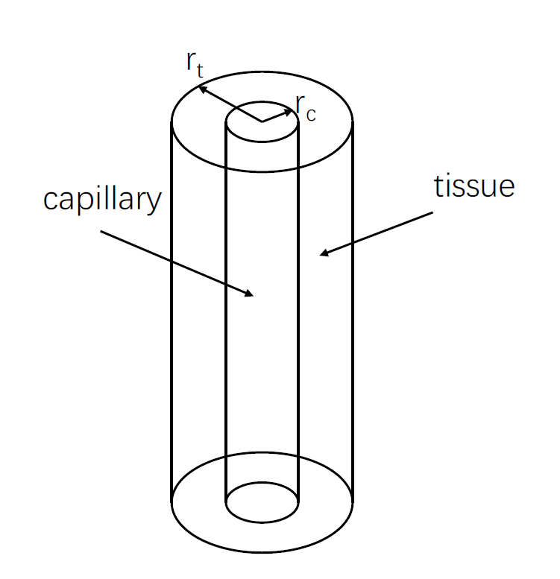

Figure 1. Diagram of Krogh cylinder. The inner cylinder is the capillary with a radius of *r*c, and the outer cylinder is the tissue surrounding the capillary.

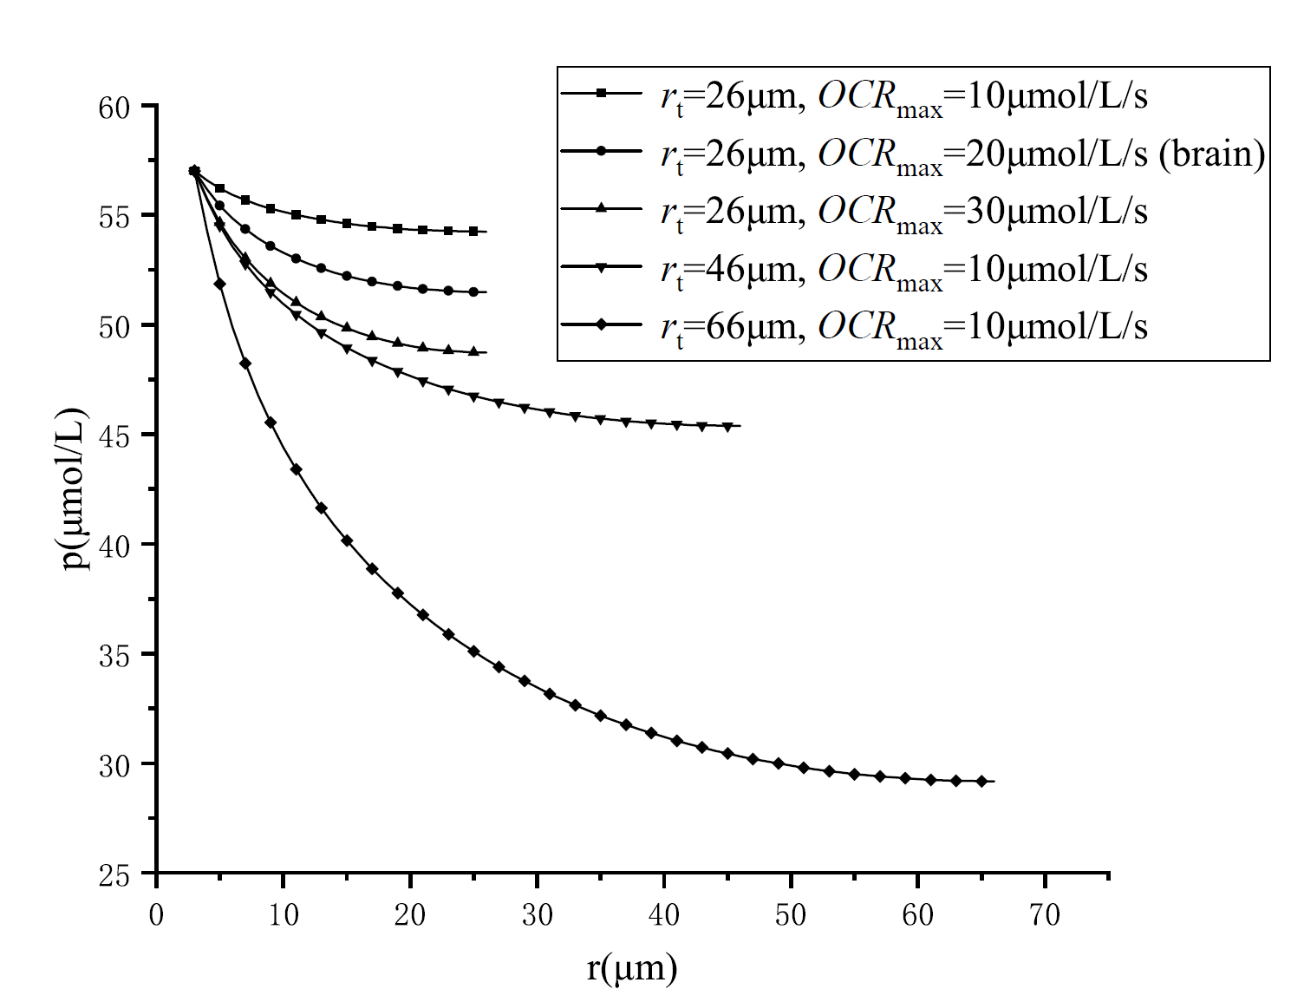

Figure 2. Oxygen distribution for different *r*t and *OCR*max. The steady-state oxygen distribution is calculated by setting different values of *r*t and *OCR*max.

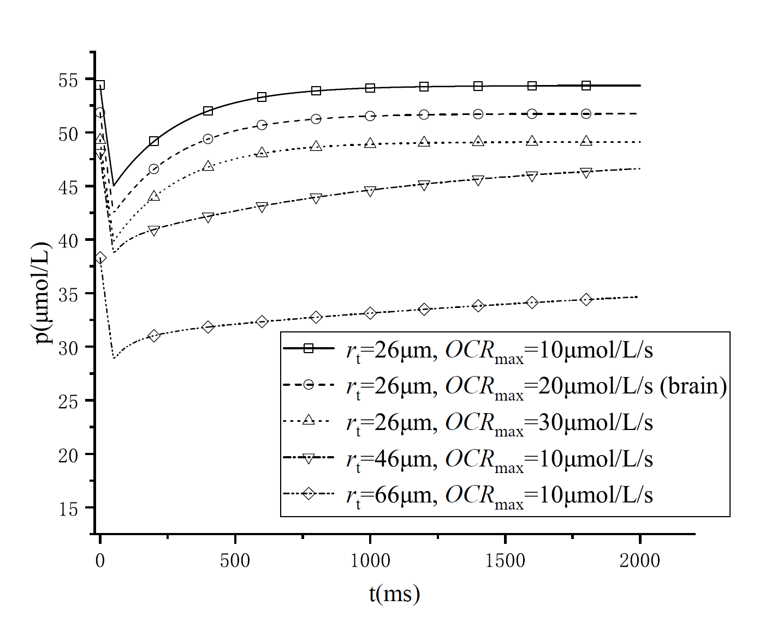

(a)

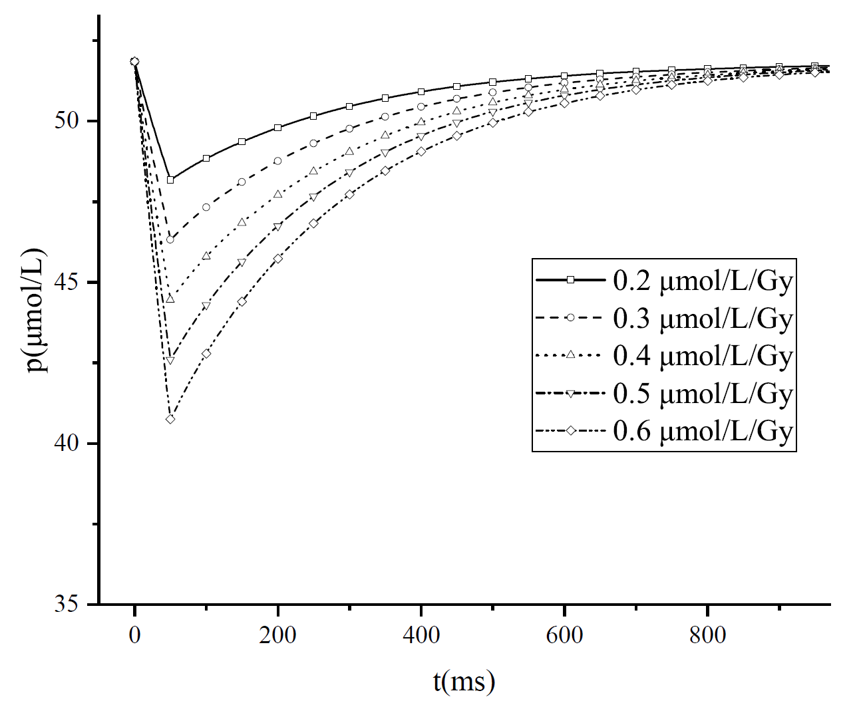

(b)

Figure 3. (a)time-dependent change of oxygen concentration for different biological parameters. Curves of change of oxygen concentration at 18 μm under different biological parameters (*r*t and *OCR*max) and fixing the *G*=0.5μmol/L/Gy are shown in this figure. The initial values of the curves are the values of steady-state oxygen concentration determined by the related values of *r*t and *OCR*max. (b) time-dependent change of oxygen concentration for different *G* values. The biological parameters are the same as the brain tissue *r*t=26μm, *OCR*max=20μmol/L. The maximum change of oxygen is determined by *G* value

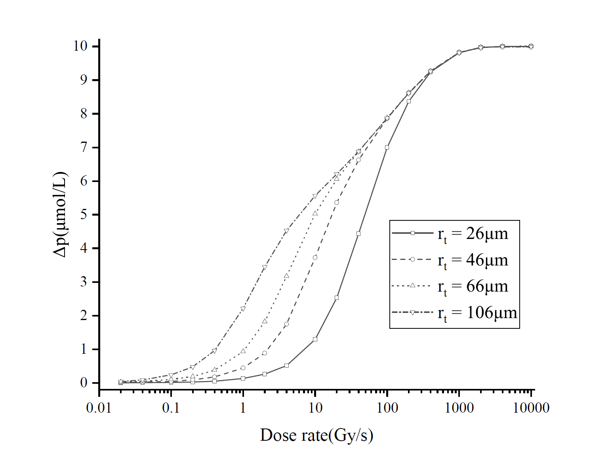

Figure 4. Maximum change of oxygen by different dose rate pulse for tissue with different *r*t(related to the microvessel density)

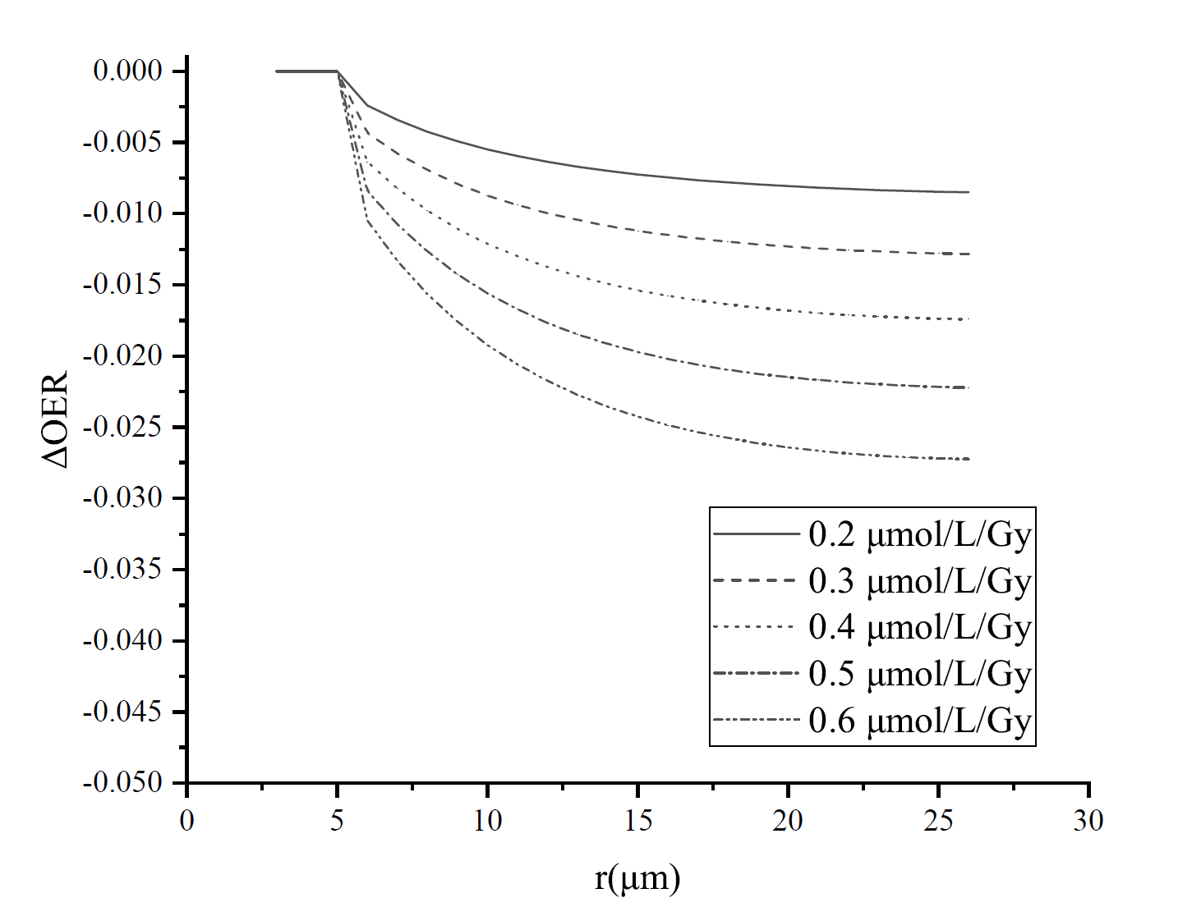

Figure 5. Differences on OER between conventional irradiation and FLASH radiation at different positions of the brain tissue under oxygen depletion hypothesis