**Visual food cues decrease blood glucose and glucoregulatory hormones following an oral glucose tolerance test in normal-weight and obese men**

**Swantje Bredea, Birte Lutzkea, Elena Albersa, Chiara Dalla-Manb, Claudio Cobellib ,Manfred Hallschmidc,d,e, Johanna Klementa, Hendrik Lehnerta,d,f**

aDepartment of Internal Medicine I, University of Lübeck, Ratzeburger Allee 160, 23538 Lübeck, Germany

bDepartment of Information Engineering, University of Padova, Italy

cDepartment of Medical Psychology and Behavioural Neurobiology, University of Tübingen, Schleichstraße 4, 72076 Tübingen, Germany

dGerman Center for Diabetes Research (DZD), Ingolstädter Landstr. 1  
85764 Neuherberg, Germany

eInstitute for Diabetes Research and Metabolic Diseases of the Helmholtz Center Munich at the University of Tübingen (IDM), Ottfried-Müller-Straße 10, 72076 Tübingen, Germany

fUniversity of Salzburg, Kapitelgasse 4-6, A-5020 Salzburg, Austria

**Corresponding Author:**

Swantje Brede, MD

University of Lübeck, Center of Brain, Behavior and Metabolism

Marie-Curie-Straße, 23562 Lübeck, Germany

Phone: 0049-451 3101 7818/ Fax: 0049-451 3101 7874

swantje.brede@gmx.de

**Abbreviations:** cephalic phase insulin release, CPIR

**Abstract**

Previous experiments of our group have demonstrated that preprandial processing of food cues attenuates postprandial blood glucose excursions. Here we systematically re-evaluated the glucose-lowering effect of visual food cues by submitting 40 healthy fasted men (20 normal-weight men, mean age 24.8 ± 3.7 years, BMI 21.9 ± 0.3 kg/m2; 20 obese men, 26.8 ± 4.2 years, 34.3 ± 1.3 kg/m2) to an oral glucose tolerance test (OGTT) following exposure to pictures of high-calorie food items versus neutral items. OGTT-related changes in blood concentrations of glucose and relevant glucoregulatory hormones including GLP-1 were assessed and analyzed according to the oral minimal model. Independent of body weight, food-cue compared to neutral stimulus presentation reduced postprandial concentrations of glucose (p = 0.041), insulin (p = 0.026) and C-peptide (p = 0.007); accordingly, oral minimal model analyses yielded a food-cue induced decrease of dynamic-phase insulin secretion (p = 0.036). We also observed a trend towards lower GLP-1 levels directly after food cue stimulation in both body weight groups (p = 0.057), as well as a trend towards decreased heart rate (p = 0.093) and significantly decreased diastolic blood pressure (p = 0.019). While we did not detect indicators of an early rise in insulin levels in terms of a ‘cephalic phase insulin response’, our findings support the assumption that preprandial processing of food cues exerts marked effect on postprandial glucose regulation, with possible contributions of changes in GLP-1. The mechanisms linking food cue exposure and glucoregulatory improvements should be investigated in greater detail, to potentially open new treatment options for metabolic dysfunctions.

**Keywords:** visual cues; food pictures; OGTT; glucose homeostasis; GLP-1

**Introduction**

The increasing prevalence of metabolic disorders, such as obesity, poses a major problem for global health care. The majority of people is constantly exposed to pictures of palatable foods, which in conjunction with the rapid availability of high-calorie food, rich in sugar and fat, may contribute to overconsumption and development of overweight. Over the last years, numerous studies using functional magnetic resonance imaging (fMRI) demonstrated that watching food pictures activates large bilateral brain networks typically involved in food and reward processing, as well as energy homeostasis [1, 2]. However, the findings on actual food consumption are controversial. Earlier studies showed that exposure to real food increases the rated desire to consume this particular food item [3] and exposure to food pictures increased the size of portions that normal-weight women intended to eat [4]. In contrast, a recent study of our group could not demonstrate increased food intake following exposure to food pictures in fasted and satiated lean and obese men [5]. This lack of effect of food cue stimulation was also shown in women in another recent study [6].

Besides possible neuronal and behavioral effects, visual food cues can affect metabolic and endocrine parameters. Thus, watching appetizing food leads to an increase of gastric acid and serum gastrin levels [7] and the orexigenic hormone ghrelin [8]. In our recent study, we could demonstrate that compared to neutral pictures, viewing pictures of food items reduces postprandial blood glucose concentrations in lean and obese subjects without changes of caloric or macronutrient intake from a test buffet. However, no differences in insulin or C-peptide concentrations could be found [5]. Because of its peak after food intake, insulin might act as a satiety signal and contribute to a reduction in appetite [9]. Besides this, a reduction in peripheral insulin sensitivity in humans seems to impair the ability of CNS insulin to regulate peripheral glucose homeostasis [10].

In order to gain deeper insight into the impact of visual food cues on glucose metabolism, we have now applied the standardized technique of an oral glucose tolerance test (OGTT) instead of a test buffet. Moreover, we employed a denser schedule of glucose and hormone measurements and analyzed our results by means of the oral minimal model. Also, we extended the analysis to include measurements of glucoregulatory hormones, such as cortisol and especially GLP-1, in order to investigate the glucose-reducing effect of food pictures in greater detail. With a view to the respective relevance of body weight, we investigated 20 normal-weight and 20 obese healthy young men who were shown pictures of food as well as non-food items before an OGTT. Based on our previous data we hypothesized that pictures of high calorie food items would lower glucose concentrations in both lean and obese men via an early insulin increase triggered by an early cephalic phase response, representing an effect of food cues on beta-cell function.

**Subjects and Methods**

***Subjects*.** We included forty healthy young (18-35 years) men in this study: twenty normal-weight (requested BMI 18.5-24.9 kg/m2; mean BMI ± SEM 21.9 ± 0.3 kg/m2; mean age ± SEM 24.8 ± 3.7 years; *see table S1 in the supplement*) and twenty obese men (requested BMI > 30 kg/m2; mean BMI ± SEM 34.3 ± 1.3 kg/m2; mean age ± SEM 26.8 ± 4.2 years; *see table S1 in the supplement*). Subjects with an increased level of physical activity (e.g., exhaustive daily training) or participating in competitive sports were excluded from the study. All participants underwent clinical examination, including medical history, exclusion of abuse of alcohol, nicotine or any drugs, and routine laboratory tests.

Based on the results of previous studies [5, 11] we expected medium effect sizes (f = 0.25) for differences on glucose concentrations by the visual stimulation (within-groups comparison) as well as BMI-dependent differences (between groups comparison). Based on a sample size of 20 normal-weight and 20 obese subjects in each of our experiments, an alpha level of 0.05, and a correlation between repeated measures of 0.5, the calculated power was 87% (calculated for ANOVA, repeated measures, within-between-interaction, by G*Power version 3.1.9.2, Heinrich-Heine University Düsseldorf). This sample size was regarded sufficient to detect physiologically relevant effects with the smallest possible number of participants.

All participants submitted written informed consent and the study was approved by the Ethics Committee of the University of Lübeck, Germany.

***Experimental procedure*.** Experiments were carried out in the Center of Brain, Behavior and Metabolism at the University of Lübeck, Germany during June 2017 and May 2018 and were performed as a 2×2 (lean vs. obese and food picture vs. non-food/neutral picture) comparison. Thus, each participant was studied at two different conditions (food pictures vs. neutral pictures). Between sessions, there was a 14-day interval with the order of conditions balanced across subjects. All subjects were instructed to be fasted (with exception of drinking water) after 22:00h on the day preceding each session. Moreover, they were instructed to avoid sport activities on the evening before each experimental day.

Participants arrived at the lab at 09:00h. Medical history was assessed and physical examination performed. Body composition was assessed by bioelectrical impedance analysis (Nutriguard-M, Data Input, Darmstadt, Germany) at the start of each experimental session and respective results were averaged across conditions for subsequent statistical analyses. The volunteers were instructed to avoid intake of food, alcohol or other liquids and physical exercises was not allowed in the 8 hours before measurements. After emptying their urinary bladder and removing all metallic objects, such as jewellery, they rested in a supine position on an examination bed for at least 5 minutes and electrodes where attached to their hand and feet at the dominant side of the body.

To enable blood sampling during the experiments, a venous cannula (Vasofix Safety® 18-20 G, B.Braun, Melsungen) was inserted into the non-dominant lower arm or cubital fossa and blood samples were taken by aspiration (Monovette®, Sarstedt AG & Co. KG, Nümbrecht, Germany). Blood samples were obtained at 09:50h and 10:05h for baseline assessments of hormonal parameters and blood glucose. Further blood samples were obtained during and after the glucose load at 10:20h, 10:40h, 10:50h, 11:00h, 11:30h, 12:00h, 12:30h, 13:00h and 13:30h. At the same time points, blood pressure and heart rate were measured.

As a cover story, participants were told that the experiment aimed to investigate the impact of visual cues on gustatory perception. Therefore, a snack test as part of this cover story was performed at the end of the experiment. A picture set of 50 pictures of food items or – in the other condition – non-food items was shown on a notebook computer. This set comprised high-resolution images of food from a standardized database, showing high-calorie meals (caloric values rated above > 300 kcal for each of the items), e.g. chocolate cake, pasta or ice-cream. Neutral images were adopted from the database of Brooks and colleagues and depicted non-food items such as books or pencils [12]. Each picture was displayed for ten seconds, yielding a total of eight minutes and twenty seconds for the whole set of pictures. After watching the picture set, participants ingested 300 ml Accu-Check Dextrose O.G.T. solution (containing 75 g anhydrous glucose) within 60 seconds.

Throughout the experiments, participants filled out different questionnaires at six time points: two before, three during and one after the oral glucose test in each session (09:40h, 10:20h, 10:40h, 11:00h, 12:00h and 13:00h). Mood was rated by the Multidimensional Mood Questionnaire on a 5-point scale containing items of the categories good/bad mood, alertness/sleepiness, and calmness/agitation [13]. Moreover, symptoms were rated with 10-point scales assessing neuroglucopenic (dizziness, tingling, blurred vision, difficulty in thinking, faintness) and autonomic symptoms (anxiety, palpitation, hunger, sweating, irritability, tremor) [14]. For the assessment of subjective feelings of hunger, satiety, or desire to eat something, visual analogue scales (0–10 cm) were employed [15].

***Oral Minimal Model Method****.* The oral minimal model method allows the assessment of insulin sensitivity, ß-cell responsivity, and hepatic insulin extraction based on an oral glucose tolerance test and according to the following two models. The oral glucose model provides an index of insulin sensitivity SI [10-4 dL/kg/min per µU/mL], which reflects the ability of insulin to stimulate glucose disposal and inhibit glucose production. The oral C-peptide model assesses beta-cell function by providing glucose-stimulated indices: dynamic responsivity Φd [10-9 min-1] (the stimulatory effect of the increase in glucose concentration upon the secretion of promptly releasable insulin); static responsivity Φs [10-9min-1] (the stimulatory effect of glucose on above basal β-cell secretion at steady state); the global index Φtot [10-9min-1] of β-cell responsivity to glucose, combining Φs and Φd; non-glucose stimulated index Φb [10-9min-1] (basal insulin secretion per unit of basal glucose) [16-18]. For a more detailed description of the oral minimal model see ref. [17].

***Metabolic and endocrine parameters*.** 40 µl of DPP-IV inhibitor was added to EDTA monovettes for GLP-1 analyses, which were stored at 4°C before blood sampling. Blood samples were centrifuged (centrifugation speed 1000 G, temperature 4°C and 15 minutes for fluoride plasma and EDTA monovettes; centrifugation speed 2500 G, room temperature and 10 minutes for serum monovettes) and supernatants were stored at -80°C. Plasma glucose was measured in fluoride plasma (Roche-Diagnostic GmbH, Mannheim, Germany). Routine assays were used for the measurement of insulin, C-peptide, cortisol (all ECLICA, Roche-Diagnostics GmbH, Mannheim, Germany) and GLP-1 (ELISA, Merck Millipore, Darmstadt, Germany).

***Statistical analyses*.** Data are presented as mean absolute values ± SEM and were analyzed with SPSS statistical software (SPSS 25.0, Inc., Chicago, USA). Baseline-adjusted values of the blood parameters were obtained by subtracting the individual average of baseline values (at 09:50h and 10:05h) from subsequent individual measurements. Normal distribution was tested prior to analyses by Shapiro-Wilk tests. Statistical comparisons were based on analyses of variance (ANOVA) with the between-subjects factor “group” (normal-weight vs. obese) and the within-subject factors “condition” (food vs. non-food pictures) and “time” (comprising nine baseline-corrected time points) as appropriate. Pooled analyses of normal-weight and obese participants were performed whenever the factor “group” did not indicate an influence of body weight. Significant ANOVA effects were specified by post-hoc pairwise t-tests and comparisons of incremental areas under the curve (AUC) covering the relevant time periods.

In addition, Pearson correlations were carried out to detect associations between the AUCs. For parameters without normal distribution, the Wilcoxon test was used (for insulin parameters in obese men). Greenhouse-Geisser procedure was used for correction of degrees of freedom. A p-value <0.05 was generally considered significant.

**Results**

***Glucose homeostasis***. Pre and post-OGTT glucose concentrations were higher in obese than in lean men (F(1,38) = 4.47, p = 0.003 for between-subjects factor group), but showed no interaction with the respective conditions (p = 0.860 for “group × condition”, *see figure 1*). C-peptide and insulin concentrations were likewise higher in obese than lean men (F(1,38) = 22.08, p < 0.001 for insulin; F(1,38) = 21.52, p < 0.001 for C-Peptide*, see figure 1*); again, body weight status did not interact with condition. Glucose indices revealed higher HOMA-IR values (derived from fasting glucose and insulin concentrations) in obese than lean participants (4.09 ± 0.74 vs. 1.00 ± 0.07, p = 0.001; *see table S1 in the supplement*). Moreover, Matsuda indices based on post-OGTT concentrations of glucose and insulin were lower in obese than in lean participants (*see table S1 in the supplement*) but did not meet the reference criteria of whole body insulin resistance (≤ 2.5), without differences between conditions (p = 0.403).

In pooled analyses of the data of all participants (n = 40), baseline concentrations of glucose, insulin and C-peptide were comparable between conditions (p > 0.1 for all comparisons). Presentation of food pictures in comparison to neutral pictures before the OGTT significantly decreased glucose concentrations 60 to 120 minutes after oral glucose load (F(1,38) = 4.47; p = 0.041 for “condition” 60-120 min post OGTT; *see figure 2*). Pooled analyses moreover revealed significantly lower insulin levels following food cue presentation (F(1,38) = 5.35; p = 0.026 for “condition” t 30-120 min post OGTT; *see figure 2*). C-Peptide concentrations paralleled those of insulin with a significant intervention-induced decrease after the OGTT (F(1,38) = 8.10; p = 0.007 for “condition” t 30-120 min post OGTT; *see figure 1*). A positive correlation between post-OGTT glucose and insulin concentrations was detectable (p = 0.000, r = 0.647 for AUC t 30 -120 min post OGTT). Correspondingly, the oral minimal model analysis revealed a food-cue induced decrease in the dynamic component Φd, indicating reduced dynamic-phase insulin secretion (df(38) = -2.81, p = 0.036, *see figure 3*). Other parameters of the oral minimal model (SI, Φb, Φs, Φtot) were not significantly affected by the treatment condition (all p > 0.08, *see figure 3*).

***GLP-1 concentrations***. Obese as compared to lean men displayed higher fasted concentrations of total GLP-1 without differences between conditions (df(38) = -3.512, p = 0.001 for the food picture condition; df(38) = -2.436, p = 0.020 for the neutral picture condition, *see figure 1*). However, after the OGTT lean men had higher GLP-1 concentrations than obese men (F (1,38) = 4.325; p = 0.044 for group comparison t 0-60 min post OGTT; *see figure 1*).

In pooled analyses, baseline concentrations (t = 0) of GLP-1 were comparable between conditions (all p > 0.3). The presentation of pictures of food compared to neutral pictures induced a trend towards lower GLP-1- concentrations independent of body weight (F(2,92) = 2.79, p = 0.057 for “condition x time” t 10-50 min post visual food cues; *see figure 2*).

***Cortisol.*** Baseline-corrected values of cortisol concentrations were slightly higher in obese than lean men in both conditions (F (1,38) = 5.77; p = 0.021; *see figure 1*). In pooled data analyses, baseline concentrations of cortisol did not differ between conditions (all p > 0.1) and cortisol levels were comparable after watching food or neutral pictures (F(1,38) < 1; p > 0.4 for “condition”; *see figure 2*).

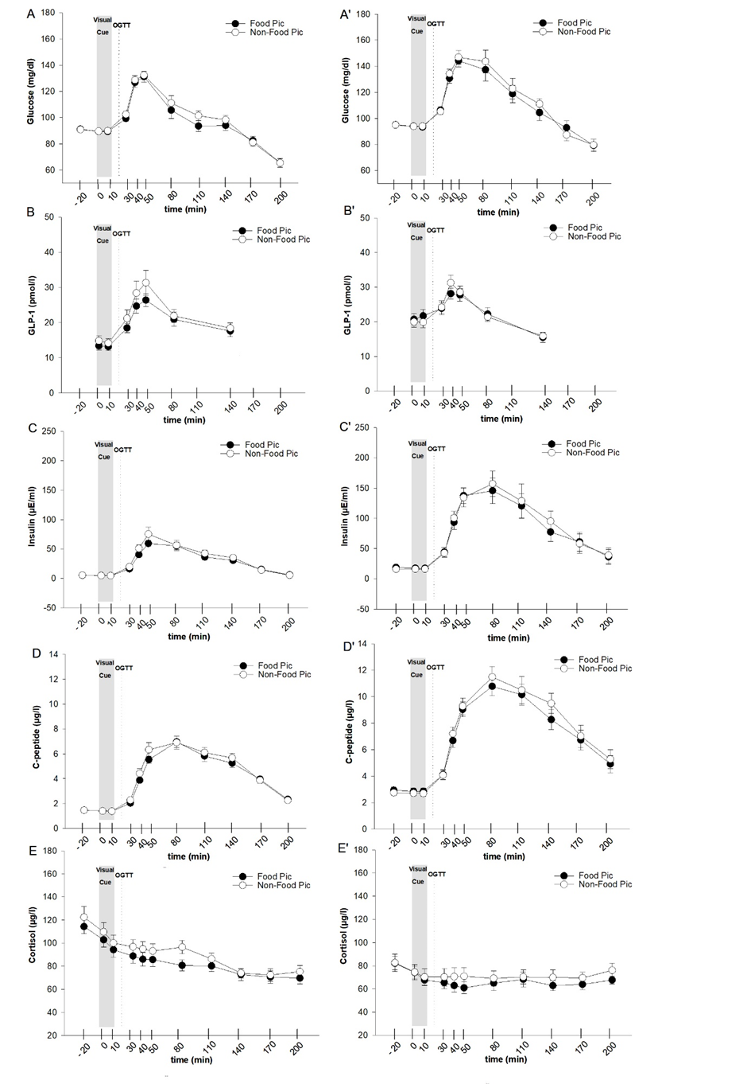

***Figure 1****. Comparison of blood parameters. Mean ± SEM plasma or serum absolute concentrations of glucose, GLP-1, insulin, C-peptide and cortisol during baseline and after watching food pictures (black circles) or neutral items (white circles) in lean (A-E) and obese (A’-E’) men. Baseline concentrations of glucose, GLP-1, insulin, C-peptide and cortisol were comparable between conditions (all p > 0.1). *P≤0.05, **P<0.01, ***P<0.001 as derived from paired t-tests; N=20.*

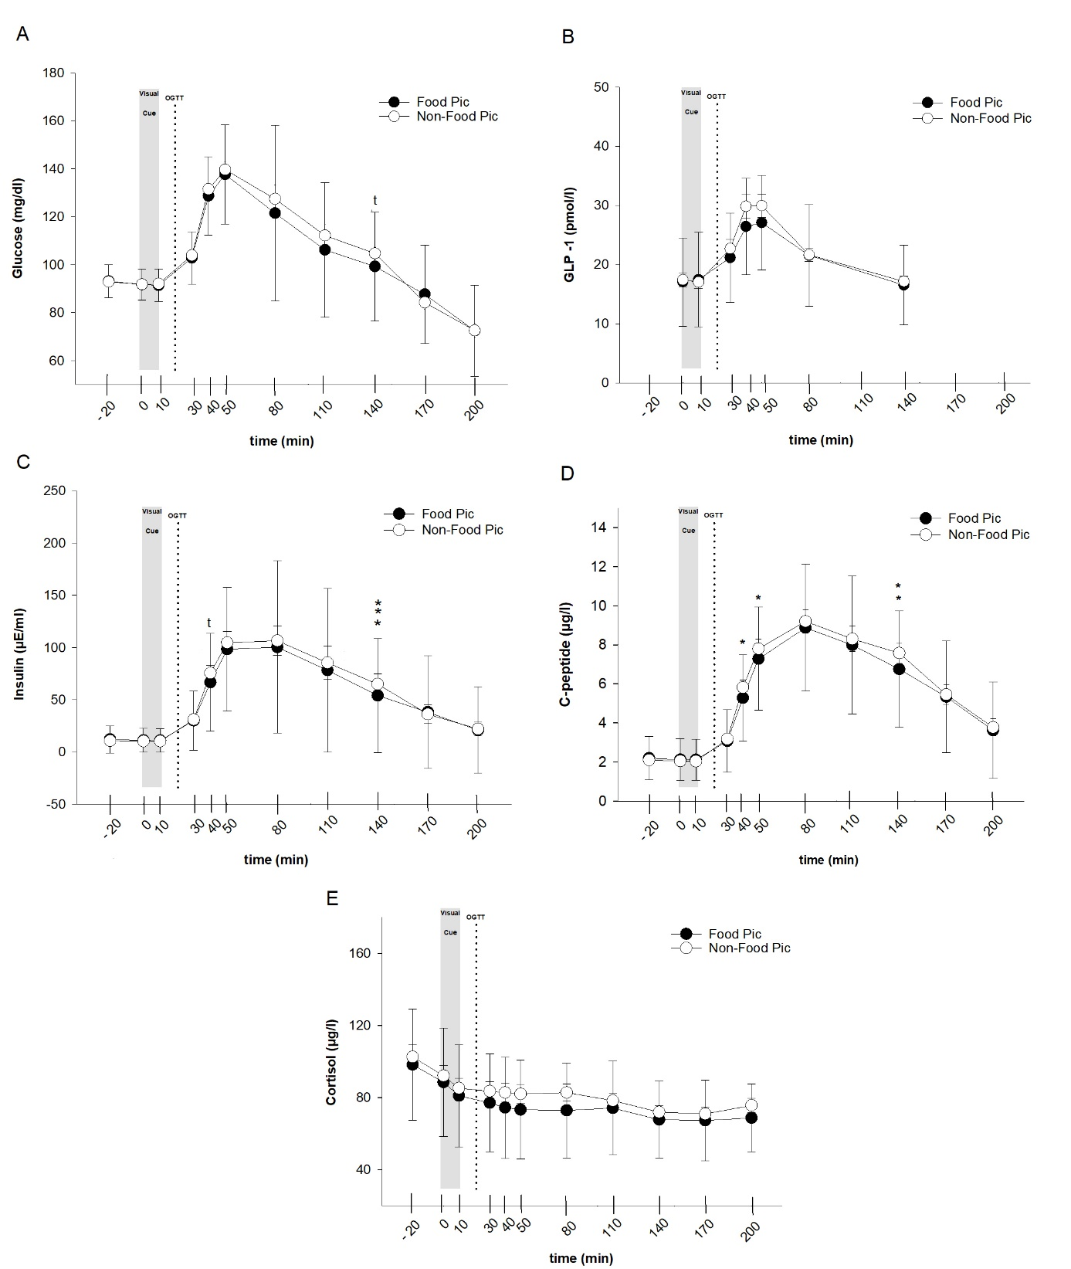

***Figure 2****. Parameters of glucose homeostasis as derived from analyses of pooled data (n = 40). Mean ± SEM plasma or serum concentrations of glucose (A), GLP-1 (B), insulin (C), C-peptide (D) and cortisol (E) during baseline and after watching food pictures (black circles) or neutral items (white circles). Baseline concentrations of glucose, glp-1, insulin, C-peptide and cortisol were comparable between conditions (all p > 0.1). *P≤0.05, **P<0.01, ***P<0.001 as derived from paired t-tests; N = 40.*

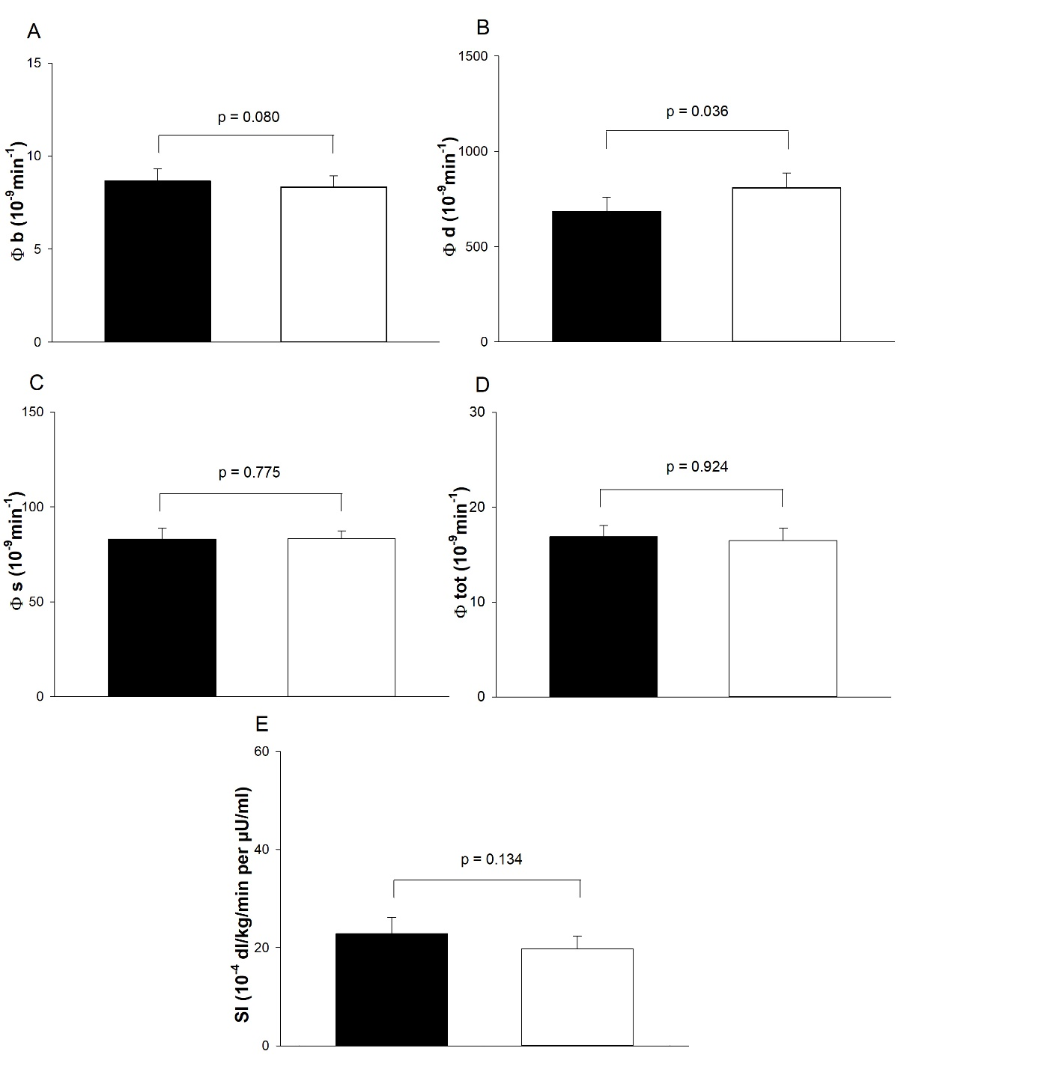

***Figure 3.*** *Oral minimal model-derived estimates of the non-glucose stimulated component Phi b (Φb; A), the dynamic component Phi d (Φd; B), the static responsivity Phi s (Φs; C),* *the global index Phi tot (Φtot; D) and the insulin sensitivity (SI; E) in the food picture (black bars) and neutral picture conditions (white bars). *P≤0.05 as derived from paired t-tests applied to the pooled sample of participants; N=40.*

***Blood pressure and heart rate.*** Heart rate did not differ between weight groups (F (1,38) = 2.67; p = 0.109 for “group”; *see table S1 in the supplement*). Diastolic blood pressure values were also comparable (F(1,38) = 1.73; p = 0.196 for “group”; *see table S1 in the supplement*); systolic blood pressure was generally elevated in obese compared to lean men in both conditions (F(1,38) = 5.58; p = 0.023 for “group” *see table S1 in the supplement*).

In pooled analyses (n = 40), baseline values of systolic and diastolic blood pressure as well as basal heart rates were comparable between conditions (all p > 0.1*, see table S1 in the supplement*). After watching pictures of food, there was a slight trend towards reduced heart rate mainly 30 minutes after the visual stimulation (F(1,39) = 2.97; p = 0.093 for “condition”; *see table S1 in the supplement*). Moreover, diastolic blood pressure was significantly reduced in the food compared to neutral picture condition (F(1,39) = 6.04; p = 0.019 for “condition”; *see table S1 in the supplement*), whereas systolic blood pressure did not differ (F(1,39) < 1; p = 0.504 for “condition”; *see table S1 in the supplement*).

***Body composition***. Lean compared to obese participants had less lean body mass (61.1 ± 1.2 vs. 79.2 ± 2.6 kg ± SEM; p < 0.001 for between-subjects comparisons; *see table S1 in the supplement*) and fat mass (11.9 ± 0.8 vs. 35.2 ± 3.0 kg ± SEM; p < 0.001 for between-subjects comparisons; *see table S1 in the supplements*).

***Ratings***. There were no difference between weight groups regarding autonomic symptoms (p > 0.9). Ratings of neuroglucopenic symptoms were slightly higher in normal-weight than in obese participants (p = 0.091 for group comparison), but were comparable between conditions (p > 0.3; *see table S2 in the supplement*). No differences were detected between groups in subjective ratings in the categories “good/bad mood” (all p > 0.2), “alertness/sleepiness” (all p > 0.2) and “calmness/agitation” (all p > 0.9; *see table S2 in the supplement*). In addition, visual analogue scales ratings of “hunger”, “satiety” or “desire to eat” were comparable between weight groups (all p > 0.1 for group comparison; *see table S2 in the supplement*).

In pooled analyses, baseline values were comparable between both conditions (all p > 0.1). Subjective ratings in the categories “good/bad mood” (all p > 0.4), “alertness/sleepiness” (all p > 0.2) and “calmness/agitation” (all p > 0.9) did not differ between conditions (*see table S2 in the supplement*). There were also no differences in visual analogue scale ratings of “hunger”, “satiety” or “desire to eat” in response to food pictures (all p > 0.1 for “condition”; *see table S2 in the supplement*). Moreover, ratings of autonomic (p > 0.4) and neuroglucopenic (p > 0.9) symptoms did not differ between conditions (*see table S2 in the supplement*).

**Discussion**

We investigated the glucoregulatory effects of food picture presentation in lean and obese men. Our data confirm the hypothesisthatviewing food pictures induces a consistent reduction in blood glucose concentrations after an oral glucose load in healthy lean and obese men. Moreover, we detected significantly lowered insulin and C-peptide concentrations following food cue presentation, which is also reflected by a food-cue induced decrease of dynamic-phase insulin secretion analyzed according to the Oral Minimal Model. Additionally, we found significantly decreased diastolic blood pressure and a trend towards decreased GLP-1 levels and heart rate directly after food cue in comparison to non-food picture presentation. As expected, concentrations of glucose, insulin and C-peptide were higher in obese than lean men, but we did not find indicators of body weight-dependent effects of food cue presentation on glucose metabolism including HOMA-IR and Matsuda index values as well as cardiovascular and psychological parameters.

An increase of circulating insulin emerging between three and nine minutes after olfactory and visual exposure to a standard meal was found in men in earlier studies [19] and defined as an early insulin release occurring in response to sensory stimulation prior to nutrient absorption, the so-called anticipatory or cephalic phase insulin release (CPIR) [20]. Most likely, this response is vagally mediated [21]. Although we could observe a glucose lowering effect of food cue stimulation, we did not find a significant increase in insulin or C-peptide concentrations immediately after exposure to food pictures. These results are in line with our previous study, demonstrating lower postprandial glucose concentrations without differences in glucoregulatory hormones after visual cue stimulation and food intake from a test buffet in lean and obese men [5]. In several studies in humans, an improved glucose control by the CPIR has been described. Thus, administration of insulin immediately prior to a meal, i.e. during the preabsorptive period, improves glucose control in obese humans [22] by inhibiting gluconeogenesis in the liver and thereby reducing hepatic glucose production [23]. Additionally, CPIR prevents a rapid postprandial rise in plasma glucose levels that would require prolonged and increased post-prandial insulin release [20]. In our study, we could detect a significant postprandial decrease of insulin and C-peptide concentrations after watching pictures of food followed by an oral glucose load. Of note, this cue-induced effect was equally evident in normal-weight and obese men. In line with our previous study [5], this finding indicates that increased body weight does not weaken the impact of food cues on glucose metabolism. Matching the reduced insulin and C-peptide levels, analyzes based on the Oral Minimal Model indicated a food-cue induced decrease in the dynamic component of insulin release (Φd) [17]. Φd represents the stimulatory effect of the increase in glucose concentrations on the secretion of promptly releasable insulin, and thus likely relates to exocytosis of insulin from secretory vesicles docked to the membrane of the beta cells [17]. The revealed food-cue induced decrease in Φd indicates a reduction of the amount of secreted insulin per unit increase of glucose concentration, which could be related to the lowered glucose concentration after watching food pictures. Other parameters of the Oral Minimal Model like the insulin sensitivity index SI were not affected by visual stimulation.

There are several possible causes why we could not detect an early insulin response after watching pictures of food in our study. First, considering that CPIR peaks within 4 minutes after sensory stimulation [20], we might have missed the optimal time frame, although blood sampling was conducted earlier than in our previous study (directly after the end of the presentation of pictures). Second, the CPIR is of small magnitude reaching only approximately 1% of normal postprandial insulin release and exhibits a large intra- and intersubject variability [20], so our statistical power might not have been strong enough to detect this small effect. Third, the visual stimulation alone might not be sufficient to mediate the full cephalic metabolic responses in humans. Accordingly, the experimental evidence for a cephalic phase insulin response remains ambiguous. For example, in rats [24] but not in humans, tasting a sweet substance appears to be sufficient to generate the CPIR [25]. Given the fact, that we used a liquid oral glucose load in our experiment, this may also contribute to the lack of an early insulin rise.

Interestingly, we could detect a trend towards lower GLP-1 concentrations after watching food cues compared to neutral cues. This food cue-mediated effect was observed both in normal-weight and obese participants, even though the normal-weight subjects displayed higher postprandial GLP-1 levels than their obese counterparts in both conditions. The latter observation is in line with previous results of other groups indicating lower levels of GLP-1 in obese humans after an oral load of carbohydrates [26]. Under physiological conditions, the ingestion of nutrients leads to secretion of GLP-1 from the intestinal L-cells within a few minutes [27] and increased levels of the hormone mediate satiety and contribute to the termination of food intake [28]. The strongest stimulus for secretion is a rise of blood glucose [29]. Thus, decreased GLP-1 concentrations following food cue stimulation may be due to the reduced postprandial glucose levels in our study. However, reduced GLP-1 concentrations were detected 30 to 50 minutes after food cue presentation, whereas glucose concentrations differ mainly 80 to 140 minutes after watching food pictures. Thus, food pictures per se may also lead to a reduced GLP-1 secretion by yet unknown mechanisms in lean and obese men. The physiological effects of GLP-1 are mediated by the GLP-1 receptors, which are expressed in numerous organs, including the pancreas [30]. Stimulation of the GLP-1 receptor results in glucose-dependent insulin secretion with insulinotropic effects of GLP-1 only present when plasma levels of glucose are above normal fasting plasma levels [30]. Thus, the postprandial decrease of insulin and C-peptide levels in our study may possibly be due to decreased GLP-1 concentrations after watching food pictures. Physiologically, a decrease of GLP-1, glucose and insulin concentrations initiate orexigenic effects mediated by hypothalamic NPY neurons in the arcuate nucleus of the hypothalamus [31]. Lowered hormone and glucose levels after visual stimulation with food pictures may therefore lead to increased food intake. However, we have previously been unable to find any respective effects on food intake in lean and obese men [5]. Also in the present study, there was no effect on rated hunger or desire to eat in both weight groups. A possible reason might be the test time: reduced GLP-1 levels could be detected 10 - 50 min after visual stimulation while glucose and insulin concentrations were mainly decreased 80 to 140 minutes after watching food pictures. The experiment ended 200 min after stimulation, thus the test time may have been too short to detect possible effects on food intake.

In addition to the hormonal effects, there was a significant reduction in diastolic blood pressure as well as a trend towards reduced heart rate immediately after exposure to food compared to non-food pictures. Systolic blood pressure, which was generally increased in obese compared to lean men, did not respond to the presentation of food pictures. The reduction in diastolic blood pressure and heart rate upon exposure to food cues is a very interesting effect possibly indicating vagally mediated effects on the autonomic nervous system. Vagal innervation has been shown to harbor a relevant role in the regulation of glucose metabolism [32], with efferent vagal signals to the pancreas modulating insulin secretion [33]. Vagal stimulation enhances insulin secretion and thereby lowers blood glucose levels [34]. On the other hand, we could not detect any increase in insulin concentration directly after visual stimulation. Our study design does not allow for a more detailed analysis; therefore, further studies will be necessary to investigate the effects in greater detail. Women should be included in these studies to determine possible gender differences as well as patients with manifest type-2 diabetes. In addition, an extension of the experimental time per day would be plausible for detecting possible effects on eating behavior occurring at a later time point.

**Conclusion**

Our study confirms the attenuating effect of food picture presentation on postprandial glucose concentrations in healthy lean and obese men, as described previously by our group [5]. Again, we could not demonstrate a CPIR as the underlying mechanism because insulin and C-peptide were not increased directly after watching the picture set. Moreover, the oral minimal model analysis reveals a food-cue induced decrease in the dynamic component Φd, indicating a depression of dynamic-phase secreted insulin. Interestingly, we detected a trend towards a postprandial decrease of GLP-1 concentrations in both body weight groups as well as a reduced heart rate and diastolic blood pressure after visual stimulation with food compared to non-food pictures. Taken together, the attenuation of postprandial glucose excursions upon exposure to food pictures was confirmed in lean and obese men, suggesting that the glucose-regulating effects of visual stimulation are independent of body weight. While the mechanisms behind these effects are still unclear, it appears attractive to speculate that GLP-1 and the autonomic nervous system might be contributing factors. Further investigation of the metabolic and endocrine sequelae of food cue exposure is crucial given the potential link between the increasing number of environmental food stimuli and the rising prevalence of obesity.

**Funding**

This work was supported by the Deutsche Forschungsgemeinschaft [SFB Transregio 134]; the German Federal Ministry of Education and Research (BMBF) to the German Center for Diabetes Research (DZD e.V.) [01GI0925]; and the Helmholtz Alliance Imaging and Curing Environmental Metabolic Diseases (ICEMED), through the Initiative and Networking Fund of the Helmholtz Association.

The funding sources had no involvement in study design; in the collection, analysis and interpretation of data; in the writing of the report; and in the decision to submit the article for publication.

All authors declare no conflicts of interest.

This work has not been peer-reviewed previously.

**Acknowledgements**

The authors thank Kirstin Nordhausen, University of Lübeck, for her invaluable laboratory work, and all the volunteers who participated in this study.

References

[1] Kroemer, N. B., Krebs, L., Kobiella, A., Grimm, O., Vollstadt-Klein, S., Wolfensteller, U., et al. (Still) longing for food: insulin reactivity modulates response to food pictures. Hum Brain Mapp. 2013,34:2367-80.

[2] Schur, E. A., Kleinhans, N. M., Goldberg, J., Buchwald, D., Schwartz, M. W., Maravilla, K. Activation in brain energy regulation and reward centers by food cues varies with choice of visual stimulus. Int J Obes (Lond). 2009,33:653-61.

[3] Marcelino, A. S., Adam, A. S., Couronne, T., Koster, E. P., Sieffermann, J. M. Internal and external determinants of eating initiation in humans. Appetite. 2001,36:9-14.

[4] Ferriday, D., Brunstrom, J. M. How does food-cue exposure lead to larger meal sizes? Br J Nutr. 2008,100:1325-32.

[5] Brede, S., Sputh, A., Hartmann, A. C., Hallschmid, M., Lehnert, H., Klement, J. Visual food cues decrease postprandial glucose concentrations in lean and obese men without affecting food intake and related endocrine parameters. Appetite. 2017,117:255-62.

[6] van Nee, R. L., Larsen, J. K., Fisher, J. O. Direct effects of food cues seen during TV viewing on energy intake in young women. Appetite. 2016,101:80-5.

[7] Feldman, M., Richardson, C. T. Role of thought, sight, smell, and taste of food in the cephalic phase of gastric acid secretion in humans. Gastroenterology. 1986,90:428-33.

[8] Schussler, P., Kluge, M., Yassouridis, A., Dresler, M., Uhr, M., Steiger, A. Ghrelin levels increase after pictures showing food. Obesity (Silver Spring). 2012,20:1212-7.

[9] Stingl, K. T., Kullmann, S., Guthoff, M., Heni, M., Fritsche, A., Preissl, H. Insulin modulation of magnetoencephalographic resting state dynamics in lean and obese subjects. Front Syst Neurosci. 2010,4:157.

[10] Santiago, J. C. P., Hallschmid, M. Outcomes and clinical implications of intranasal insulin administration to the central nervous system. Exp Neurol. 2019,317:180-90.

[11] Ott, V., Finlayson, G., Lehnert, H., Heitmann, B., Heinrichs, M., Born, J., et al. Oxytocin reduces reward-driven food intake in humans. Diabetes. 2013,62:3418-25.

[12] Brooks, S. J., O'Daly, O. G., Uher, R., Friederich, H. C., Giampietro, V., Brammer, M., et al. Differential neural responses to food images in women with bulimia versus anorexia nervosa. PLoS One. 2011,6:e22259.

[13] Hinz, A., Daig, I., Petrowski, K., Brahler, E. [Mood in the German population: norms of the Multidimensional Mood Questionnaire MDBF]. Psychother Psychosom Med Psychol. 2012,62:52-7.

[14] Mitrakou, A., Ryan, C., Veneman, T., Mokan, M., Jenssen, T., Kiss, I., et al. Hierarchy of glycemic thresholds for counterregulatory hormone secretion, symptoms, and cerebral dysfunction. Am J Physiol. 1991,260:E67-74.

[15] Flint, A., Raben, A., Blundell, J. E., Astrup, A. Reproducibility, power and validity of visual analogue scales in assessment of appetite sensations in single test meal studies. Int J Obes Relat Metab Disord. 2000,24:38-48.

[16] Brede, S., Fehr, S., Dalla-Man, C., Cobelli, C., Lehnert, H., Hallschmid, M., et al. Intranasal oxytocin fails to acutely improve glucose metabolism in obese men. Diabetes Obes Metab. 2019,21:424-8.

[17] Cobelli, C., Dalla Man, C., Toffolo, G., Basu, R., Vella, A., Rizza, R. The oral minimal model method. Diabetes. 2014,63:1203-13.

[18] Dalla Man, C., Caumo, A., Cobelli, C. The oral glucose minimal model: estimation of insulin sensitivity from a meal test. IEEE Trans Biomed Eng. 2002,49:419-29.

[19] Simon, C., Schlienger, J. L., Sapin, R., Imler, M. Cephalic phase insulin secretion in relation to food presentation in normal and overweight subjects. Physiol Behav. 1986,36:465-9.

[20] Teff, K. L. How neural mediation of anticipatory and compensatory insulin release helps us tolerate food. Physiol Behav. 2011,103:44-50.

[21] Zafra, M. A., Molina, F., Puerto, A. The neural/cephalic phase reflexes in the physiology of nutrition. Neurosci Biobehav Rev. 2006,30:1032-44.

[22] Teff, K. L., Townsend, R. R. Early phase insulin infusion and muscarinic blockade in obese and lean subjects. Am J Physiol. 1999,277:R198-208.

[23] Shimazu, T. Central nervous system regulation of liver and adipose tissue metabolism. Diabetologia. 1981,20:343-56.

[24] Berthoud, H. R., Trimble, E. R., Siegel, E. G., Bereiter, D. A., Jeanrenaud, B. Cephalic-phase insulin secretion in normal and pancreatic islet-transplanted rats. Am J Physiol. 1980,238:E336-40.

[25] Teff, K. L., Devine, J., Engelman, K. Sweet taste: effect on cephalic phase insulin release in men. Physiol Behav. 1995,57:1089-95.

[26] Ranganath, L. R., Beety, J. M., Morgan, L. M., Wright, J. W., Howland, R., Marks, V. Attenuated GLP-1 secretion in obesity: cause or consequence? Gut. 1996,38:916-9.

[27] Sonne, D. P., Rehfeld, J. F., Holst, J. J., Vilsboll, T., Knop, F. K. Postprandial gallbladder emptying in patients with type 2 diabetes: potential implications for bile-induced secretion of glucagon-like peptide 1. Eur J Endocrinol. 2014,171:407-19.

[28] Heni, M., Kullmann, S., Gallwitz, B., Haring, H. U., Preissl, H., Fritsche, A. Dissociation of GLP-1 and insulin association with food processing in the brain: GLP-1 sensitivity despite insulin resistance in obese humans. Mol Metab. 2015,4:971-6.

[29] O'Donovan, D. G., Doran, S., Feinle-Bisset, C., Jones, K. L., Meyer, J. H., Wishart, J. M., et al. Effect of variations in small intestinal glucose delivery on plasma glucose, insulin, and incretin hormones in healthy subjects and type 2 diabetes. J Clin Endocrinol Metab. 2004,89:3431-5.

[30] Andersen, A., Lund, A., Knop, F. K., Vilsboll, T. Glucagon-like peptide 1 in health and disease. Nat Rev Endocrinol. 2018,14:390-403.

[31] Zhang, L., Hernandez-Sanchez, D., Herzog, H. Regulation of Feeding-Related Behaviors by Arcuate Neuropeptide Y Neurons. Endocrinology. 2019,160:1411-20.

[32] Titchenell, P. M., Lazar, M. A., Birnbaum, M. J. Unraveling the Regulation of Hepatic Metabolism by Insulin. Trends Endocrinol Metab. 2017,28:497-505.

[33] Edvell, A., Lindstrom, P. Vagotomy in young obese hyperglycemic mice: effects on syndrome development and islet proliferation. Am J Physiol. 1998,274:E1034-9.

[34] Das, U. N. Vagus nerve stimulation as a strategy to prevent and manage metabolic syndrome. Med Hypotheses. 2011,76:429-33.