**The phenomenon of thunderstorm asthma in Bavaria, Southern Germany: a statistical approach**

Annette Strauba, Verena Frickea, Patrick Olschewskib, Stefanie Seuberta, Christoph Becka, Daniela Bayrc ,d, Franziska Kolekc ,d, Maria P. Plazac ,d, Vivien Leier-Wirtzc ,d, Sigrid Kaschubac ,d, Claudia Traidl-Hoffmannc ,d, Wolfgang Buermanna, Michael Gerstlauere, Athanasios Damialisc ,d, and Andreas Philippa

aInstitute for Geography, University of Augsburg, Augsburg, Germany

bProfessorship for Regional Climate Change and Health, University of Augsburg, Augsburg, Germany

cGerman Research Centre for Environmental Health, Chair and Institute of Environmental Medicine, Technical University of Munich and Helmholtz Centre Munich, Augsburg, Germany

dDepartment of Environmental Medicine, Faculty of Medicine, University of Augsburg, Augsburg, Germany

eDepartment of Pediatric Pneumology and Allergology, University Hospital Augsburg, Augsburg, Germany

**ABSTRACT**

Higher incidences of asthma during thunderstorms can pose a serious health risk. In this study, we estimate the thunderstorm asthma risk using statistical methods, with special focus on Bavaria, Southern Germany. In this approach, a dataset of asthma-related emergency cases for the study region is combined with meteorological variables and aeroallergen data to identify statistical relationships between the occurrence of asthma (predictand) and different environmental parameters (set of predictors). On the one hand, the results provide evidence for a weak but significant relationship between atmospheric stability indices and asthma emergencies in the region, but also show that currently thunderstorm asthma is not a major concern in Bavaria due to overall low incidences. As thunderstorm asthma can have severe consequences for allergic patients, the presented approach can be important for the development of emergency strategies in regions affected by thunderstorm asthma and under present and future climate change conditions.

**ARTICLE HISTORY**

Received 27 April 2021

Accepted 23 September 2021

**KEYWORDS**

Thunderstorm asthma, seasonal asthma, environment, health

**CONTACT** Annette Straub [annette.straub@geo.uni-augsburg.de](mailto:annette.straub@geo.uni-augsburg.de) Institute of Geography, University of Augsburg, Alter Postweg 118, Augsburg D - 86159, Germany

© 2021 Informa UK Limited, trading as Taylor & Francis Group

**Introduction**

Thunderstorm asthma, the phenomenon of increased numbers of asthma occurrences in conjunction with thunderstorm events, can be a severe risk factor for human health (D’Amato et al. [2016](https://www.tandfonline.com/reader/content/17d3b4e77b7/10.1080/09603123.2021.1985971/format/epub/EPUB/xhtml/index.xhtml#cit0018)). However, the mechanisms underlying the thunderstorm asthma phenomenon are not fully understood. The proposed mechanisms include various biometeorological processes. Among these, an increased release of fresh pollen from the anthers as a consequence of strong wind gusts is often invoked (Taylor et al. [2002](https://www.tandfonline.com/reader/content/17d3b4e77b7/10.1080/09603123.2021.1985971/format/epub/EPUB/xhtml/index.xhtml#cit0057); Taylor and Jonsson [2004](https://www.tandfonline.com/reader/content/17d3b4e77b7/10.1080/09603123.2021.1985971/format/epub/EPUB/xhtml/index.xhtml#cit0058)). Fungal spores also play a role (Kevat [2020](https://www.tandfonline.com/reader/content/17d3b4e77b7/10.1080/09603123.2021.1985971/format/epub/EPUB/xhtml/index.xhtml#cit0037)). These pollen and fungal spores are too large to reach the lower airways as unbroken grains (usually larger than 20 µm) (Taylor et al. [2002](https://www.tandfonline.com/reader/content/17d3b4e77b7/10.1080/09603123.2021.1985971/format/epub/EPUB/xhtml/index.xhtml#cit0057)). However, pollen grains can be ruptured by osmotic shock (Suphioglu et al. [1992](https://www.tandfonline.com/reader/content/17d3b4e77b7/10.1080/09603123.2021.1985971/format/epub/EPUB/xhtml/index.xhtml#cit0055); Taylor et al. [2004](https://www.tandfonline.com/reader/content/17d3b4e77b7/10.1080/09603123.2021.1985971/format/epub/EPUB/xhtml/index.xhtml" \l "cit0056)) or by germination in contact with humidity or rainwater (Grote et al. [2003](https://www.tandfonline.com/reader/content/17d3b4e77b7/10.1080/09603123.2021.1985971/format/epub/EPUB/xhtml/index.xhtml" \l "cit0031)) as well as by mechanical impact (Visez et al. [2015](https://www.tandfonline.com/reader/content/17d3b4e77b7/10.1080/09603123.2021.1985971/format/epub/EPUB/xhtml/index.xhtml" \l "cit0061)) or contact with the electric field (Vaidyanathan et al. [2006](https://www.tandfonline.com/reader/content/17d3b4e77b7/10.1080/09603123.2021.1985971/format/epub/EPUB/xhtml/index.xhtml" \l "cit0060)). Thus, a large number of smaller sized fragments of pollen (0.6 to 2.5 µm), which are then able to penetrate the human lower airways (Suphioglu et al. [1992](https://www.tandfonline.com/reader/content/17d3b4e77b7/10.1080/09603123.2021.1985971/format/epub/EPUB/xhtml/index.xhtml#cit0055)), are released and transported to a relatively thin atmospheric layer near the ground by the dry and cool thunderstorm downdraft (Taylor and Jonsson [2004](https://www.tandfonline.com/reader/content/17d3b4e77b7/10.1080/09603123.2021.1985971/format/epub/EPUB/xhtml/index.xhtml" \l "cit0058); Kevat [2020](https://www.tandfonline.com/reader/content/17d3b4e77b7/10.1080/09603123.2021.1985971/format/epub/EPUB/xhtml/index.xhtml" \l "cit0037)). Fungi are mentioned to be able to produce respirable-sized fragments, too (Taylor and Jonsson [2004](https://www.tandfonline.com/reader/content/17d3b4e77b7/10.1080/09603123.2021.1985971/format/epub/EPUB/xhtml/index.xhtml#cit0058)). Consequently, aeroallergen loads can increase significantly during thunderstorms, which can lead to an enhanced exposure of also allergic persons (Marks et al. [2001](https://www.tandfonline.com/reader/content/17d3b4e77b7/10.1080/09603123.2021.1985971/format/epub/EPUB/xhtml/index.xhtml#cit0040); Taylor and Jonsson [2004](https://www.tandfonline.com/reader/content/17d3b4e77b7/10.1080/09603123.2021.1985971/format/epub/EPUB/xhtml/index.xhtml" \l "cit0058)) and may trigger an asthmatic response (D’Amato et al. [2017](https://www.tandfonline.com/reader/content/17d3b4e77b7/10.1080/09603123.2021.1985971/format/epub/EPUB/xhtml/index.xhtml" \l "cit0014)). In fact, unusually high aeroallergen concentrations have sometimes been observed during the pollen season after rainfall events (e.g. Suphioglu et al. [1992](https://www.tandfonline.com/reader/content/17d3b4e77b7/10.1080/09603123.2021.1985971/format/epub/EPUB/xhtml/index.xhtml#cit0055)). Additionally, distinctly increased pollen and fungal spore concentrations have been measured during thunderstorm asthma events (e.g. Thien et al. [2018](https://www.tandfonline.com/reader/content/17d3b4e77b7/10.1080/09603123.2021.1985971/format/epub/EPUB/xhtml/index.xhtml#cit0059)). Asthma relevant species include pollen from grass (*Poaceae*) (Thien et al. [2018](https://www.tandfonline.com/reader/content/17d3b4e77b7/10.1080/09603123.2021.1985971/format/epub/EPUB/xhtml/index.xhtml#cit0059)), olive (*Olea europaea*) (Losappio et al. [2011](https://www.tandfonline.com/reader/content/17d3b4e77b7/10.1080/09603123.2021.1985971/format/epub/EPUB/xhtml/index.xhtml" \l "cit0039)), wall pellitory (*Parietaria* spp.) (D’Amato et al. [2008](https://www.tandfonline.com/reader/content/17d3b4e77b7/10.1080/09603123.2021.1985971/format/epub/EPUB/xhtml/index.xhtml" \l "cit0015)), alder (*Alnus* spp.), hazel (*Corylus avellana*) and birch (*Betula* spp.) (Grote et al. [2003](https://www.tandfonline.com/reader/content/17d3b4e77b7/10.1080/09603123.2021.1985971/format/epub/EPUB/xhtml/index.xhtml" \l "cit0031)) as well as the fungal spore genera of *Alternaria* (Pulimood et al. [2007](https://www.tandfonline.com/reader/content/17d3b4e77b7/10.1080/09603123.2021.1985971/format/epub/EPUB/xhtml/index.xhtml" \l "cit0043)), *Cladosporium* (Dales et al. [2003](https://www.tandfonline.com/reader/content/17d3b4e77b7/10.1080/09603123.2021.1985971/format/epub/EPUB/xhtml/index.xhtml#cit0019)), and *Didymella* (Packe and Ayres [1985](https://www.tandfonline.com/reader/content/17d3b4e77b7/10.1080/09603123.2021.1985971/format/epub/EPUB/xhtml/index.xhtml#cit0042)). The fact that thunderstorm asthma occurs mostly during the pollen and fungal spore seasons indicates that these factors are important. However, increased concentrations of bioaerosols have not been measured during all thunderstorm asthma events (e.g. Anderson et al. [2001](https://www.tandfonline.com/reader/content/17d3b4e77b7/10.1080/09603123.2021.1985971/format/epub/EPUB/xhtml/index.xhtml#cit0004)). Thus, alternative explanations have to be considered, too. A peak in PM10 (particulate matter with aerodynamic diameter <10 µm) concentrations was observed during the thunderstorm asthma event in Melbourne (Thien et al. [2018](https://www.tandfonline.com/reader/content/17d3b4e77b7/10.1080/09603123.2021.1985971/format/epub/EPUB/xhtml/index.xhtml#cit0059)), and particulate matter of different size fractions can cause respiratory symptoms (e.g. Anderson et al. [2012](https://www.tandfonline.com/reader/content/17d3b4e77b7/10.1080/09603123.2021.1985971/format/epub/EPUB/xhtml/index.xhtml" \l "cit0003)). NO2 originating naturally from lightning strikes is another possible factor since it is an irritant gas by itself and serves also as a precursor for the production of ozone (Bond et al. [2001](https://www.tandfonline.com/reader/content/17d3b4e77b7/10.1080/09603123.2021.1985971/format/epub/EPUB/xhtml/index.xhtml#cit0009)). Therefore, concentrations of both gases could increase during thunderstorms and could lead to asthmatic responses in sensitive individuals (Kaynak et al. [2008](https://www.tandfonline.com/reader/content/17d3b4e77b7/10.1080/09603123.2021.1985971/format/epub/EPUB/xhtml/index.xhtml#cit0036)). In addition, pollen allergens exposed to NO2 and O3 have been found to show increased immunogenicity (Zhou et al. [2021](https://www.tandfonline.com/reader/content/17d3b4e77b7/10.1080/09603123.2021.1985971/format/epub/EPUB/xhtml/index.xhtml#cit0067)).

In regard to geographic distribution, thunderstorm asthma events have been reported in Canada (Wardmann et al. [2002](https://www.tandfonline.com/reader/content/17d3b4e77b7/10.1080/09603123.2021.1985971/format/epub/EPUB/xhtml/index.xhtml#cit0063)), Italy (e.g. D’Amato et al. [2008](https://www.tandfonline.com/reader/content/17d3b4e77b7/10.1080/09603123.2021.1985971/format/epub/EPUB/xhtml/index.xhtml" \l "cit0015); Losappio et al. [2011](https://www.tandfonline.com/reader/content/17d3b4e77b7/10.1080/09603123.2021.1985971/format/epub/EPUB/xhtml/index.xhtml" \l "cit0039)), the USA (e.g. Grundstein et al. [2008](https://www.tandfonline.com/reader/content/17d3b4e77b7/10.1080/09603123.2021.1985971/format/epub/EPUB/xhtml/index.xhtml" \l "cit0032)), Great Britain (Packe and Ayres [1985](https://www.tandfonline.com/reader/content/17d3b4e77b7/10.1080/09603123.2021.1985971/format/epub/EPUB/xhtml/index.xhtml" \l "cit0042); Alderman et al. [1986](https://www.tandfonline.com/reader/content/17d3b4e77b7/10.1080/09603123.2021.1985971/format/epub/EPUB/xhtml/index.xhtml" \l "cit0001); Celenza et al. [1996](https://www.tandfonline.com/reader/content/17d3b4e77b7/10.1080/09603123.2021.1985971/format/epub/EPUB/xhtml/index.xhtml" \l "cit0012); Pulimood et al. [2007](https://www.tandfonline.com/reader/content/17d3b4e77b7/10.1080/09603123.2021.1985971/format/epub/EPUB/xhtml/index.xhtml" \l "cit0043); Elliot et al. [2014](https://www.tandfonline.com/reader/content/17d3b4e77b7/10.1080/09603123.2021.1985971/format/epub/EPUB/xhtml/index.xhtml" \l "cit0024)), Australia (e.g. Bellomo et al. [1992](https://www.tandfonline.com/reader/content/17d3b4e77b7/10.1080/09603123.2021.1985971/format/epub/EPUB/xhtml/index.xhtml" \l "cit0007); Girgis et al. [2000](https://www.tandfonline.com/reader/content/17d3b4e77b7/10.1080/09603123.2021.1985971/format/epub/EPUB/xhtml/index.xhtml" \l "cit0029); Thien et al. [2018](https://www.tandfonline.com/reader/content/17d3b4e77b7/10.1080/09603123.2021.1985971/format/epub/EPUB/xhtml/index.xhtml" \l "cit0059)), Iran (e.g. Forouzan et al. [2014](https://www.tandfonline.com/reader/content/17d3b4e77b7/10.1080/09603123.2021.1985971/format/epub/EPUB/xhtml/index.xhtml" \l "cit0025)), Kuwait (Ali et al. [2019](https://www.tandfonline.com/reader/content/17d3b4e77b7/10.1080/09603123.2021.1985971/format/epub/EPUB/xhtml/index.xhtml#cit0002)), Israel (Yair et al. [2019](https://www.tandfonline.com/reader/content/17d3b4e77b7/10.1080/09603123.2021.1985971/format/epub/EPUB/xhtml/index.xhtml#cit0065)), New Zealand (Sabih et al. [2020](https://www.tandfonline.com/reader/content/17d3b4e77b7/10.1080/09603123.2021.1985971/format/epub/EPUB/xhtml/index.xhtml#cit0047)) and China (Xu et al. [2021](https://www.tandfonline.com/reader/content/17d3b4e77b7/10.1080/09603123.2021.1985971/format/epub/EPUB/xhtml/index.xhtml#cit0064)). These events were accompanied by five to tenfold increases in admission numbers of asthma patients in emergency units. The most comprehensively studied and most serious event registered until today took place in November 2016 in Melbourne and led to more than 3,000 additional asthma-related emergency cases and more than 400 additional hospital admissions due to asthma and even ten deaths were reported (Thien et al. [2018](https://www.tandfonline.com/reader/content/17d3b4e77b7/10.1080/09603123.2021.1985971/format/epub/EPUB/xhtml/index.xhtml#cit0059)). As a consequence of this event, a prototype of a thunderstorm asthma forecasting system has been developed in Australia (Bannister et al. [2021](https://www.tandfonline.com/reader/content/17d3b4e77b7/10.1080/09603123.2021.1985971/format/epub/EPUB/xhtml/index.xhtml#cit0006)). Furthermore, during a thunderstorm asthma event in Great Britain in 1994, unusually high numbers of patients were also registered at the deputising service (Higham et al. [1997](https://www.tandfonline.com/reader/content/17d3b4e77b7/10.1080/09603123.2021.1985971/format/epub/EPUB/xhtml/index.xhtml" \l "cit0034)) and at general practitioners’ surgeries (Hajat et al. [1997](https://www.tandfonline.com/reader/content/17d3b4e77b7/10.1080/09603123.2021.1985971/format/epub/EPUB/xhtml/index.xhtml" \l "cit0033)). Additionally, it should be noted that many affected persons with less severe symptoms treat themselves instead of visiting a doctor (Clayton-Chubb et al. [2019](https://www.tandfonline.com/reader/content/17d3b4e77b7/10.1080/09603123.2021.1985971/format/epub/EPUB/xhtml/index.xhtml" \l "cit0013); Muzalyova et al. [2019](https://www.tandfonline.com/reader/content/17d3b4e77b7/10.1080/09603123.2021.1985971/format/epub/EPUB/xhtml/index.xhtml" \l "cit0041)) and therefore the actual number of asthma occurrences during thunderstorm asthma events may be substantially higher. Risk factors for thunderstorm asthma include not only previously diagnosed asthma but also undiagnosed asthma as well as pollen allergy, atopy, and rhinitis (Rangamuwa et al. [2017](https://www.tandfonline.com/reader/content/17d3b4e77b7/10.1080/09603123.2021.1985971/format/epub/EPUB/xhtml/index.xhtml" \l "cit0044); D’Amato et al. [2017](https://www.tandfonline.com/reader/content/17d3b4e77b7/10.1080/09603123.2021.1985971/format/epub/EPUB/xhtml/index.xhtml" \l "cit0014); Thien et al. [2018](https://www.tandfonline.com/reader/content/17d3b4e77b7/10.1080/09603123.2021.1985971/format/epub/EPUB/xhtml/index.xhtml" \l "cit0059)). Apart from case studies, few studies have investigated the statistical relationship between thunderstorms and asthma occurrences. While some studies report no significant relationship between these parameters (e.g. Caminati et al. [2018](https://www.tandfonline.com/reader/content/17d3b4e77b7/10.1080/09603123.2021.1985971/format/epub/EPUB/xhtml/index.xhtml" \l "cit0010)), several others find generally increased numbers of asthma cases on thunderstorm days (Anderson et al. [2001](https://www.tandfonline.com/reader/content/17d3b4e77b7/10.1080/09603123.2021.1985971/format/epub/EPUB/xhtml/index.xhtml" \l "cit0004); Dales et al. [2003](https://www.tandfonline.com/reader/content/17d3b4e77b7/10.1080/09603123.2021.1985971/format/epub/EPUB/xhtml/index.xhtml#cit0019); Grundstein et al. [2008](https://www.tandfonline.com/reader/content/17d3b4e77b7/10.1080/09603123.2021.1985971/format/epub/EPUB/xhtml/index.xhtml#cit0032)).

Southern Germany, especially southern Bavaria, is among the regions with highest thunderstorm activity within Central Europe [Wapler [2013](https://www.tandfonline.com/reader/content/17d3b4e77b7/10.1080/09603123.2021.1985971/format/epub/EPUB/xhtml/index.xhtml#cit0062), cf. also [Figure 1](https://www.tandfonline.com/reader/content/17d3b4e77b7/10.1080/09603123.2021.1985971/format/epub/EPUB/xhtml/f0001.xhtml) (left)]. An increase of severe thunderstorms in the Alpine region is also expected due to climate change (Schefczyk and Heinemann [2017](https://www.tandfonline.com/reader/content/17d3b4e77b7/10.1080/09603123.2021.1985971/format/epub/EPUB/xhtml/index.xhtml#cit0048)). In addition, increasing frequencies of allergies and asthma have already been observed in industrialised countries, presumably due to the interaction of different environmental factors such as air temperature and air quality, which are influenced by climate change and urbanisation (Andrae et al. [1988](https://www.tandfonline.com/reader/content/17d3b4e77b7/10.1080/09603123.2021.1985971/format/epub/EPUB/xhtml/index.xhtml#cit0005); Cecchi et al. [2013](https://www.tandfonline.com/reader/content/17d3b4e77b7/10.1080/09603123.2021.1985971/format/epub/EPUB/xhtml/index.xhtml#cit0011)). Besides, aeroallergen abundances and seasonal distribution are also influenced by various environmental factors. Air temperature, water availability, and CO2-concentrations have a direct effect on plant phenology and growth and all these environmental factors are changing under climate change. Consequently, shifts in the temporal and spatial distribution of aeroallergens due to a general increase of pollen concentrations, a larger number of events with exceptionally high pollen concentrations, an extension of the pollen season, and a different composition of pollen species can be expected (e.g. D’Amato et al. [2020](https://www.tandfonline.com/reader/content/17d3b4e77b7/10.1080/09603123.2021.1985971/format/epub/EPUB/xhtml/index.xhtml" \l "cit0016)). Furthermore, allergen concentrations within pollen grains increase due to changes in CO2-concentrations and ambient temperatures (Cecchi et al. [2013](https://www.tandfonline.com/reader/content/17d3b4e77b7/10.1080/09603123.2021.1985971/format/epub/EPUB/xhtml/index.xhtml" \l "cit0011)).

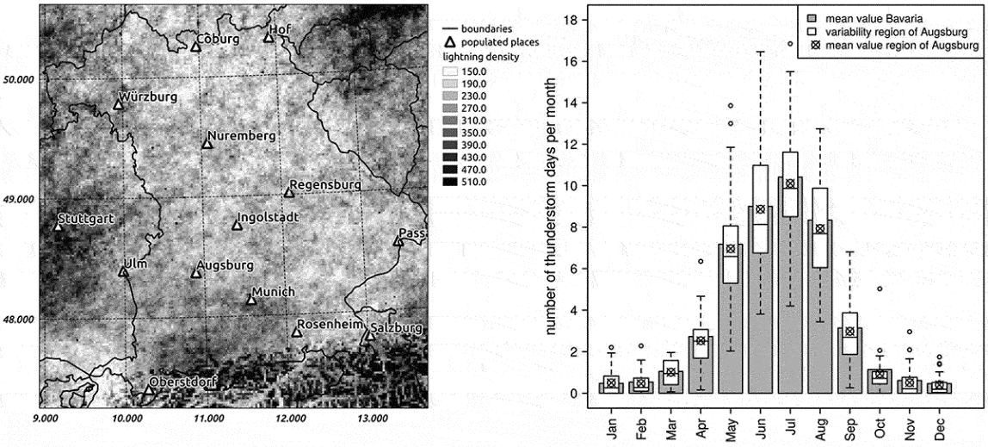

**Figure 1**. Spatial distribution of cloud-to-ground (CG) lightnings in Bavaria and adjacent regions on a 2 × 2 km regular grid (left) and mean annual cycle of numbers of thunderstorm days in Bavaria and the region of Augsburg including interannual variability for the period from 1992 to 2018 (right) (data: Siemens AG, cf. section ‘meteorological data’). The box-whisker plots contain the median and the 1st as well as 3rd quartile (lower/upper boundary of the box, respectively), the whiskers mark the 1.5-fold interquartile range from the upper/lower boundary of the box

In this study, we attempt to shed more light into the various factors that may cause thunderstorm asthma with a special focus on Germany for which there are no such studies. The main aims of this study are as follows: (1) to identify the statistical relationships between acute asthma exacerbations and the occurrence of thunderstorms in combination with other meteorological variables and (2) to evaluate the thunderstorm asthma risk in Bavaria, southern Germany. For this purpose, simple weather type classifications (composites and anomalies) as well as hypothesis tests (contingency tables and the χ2-test for independence) are applied, utilising lightning as a proxy for thunderstorms and emergency data as a proxy for acute asthma exacerbations.

**Materials and methods**

***Study region***

The study region is Bavaria in southern Germany. Parts of the analysis focus on the city of Augsburg, which is situated in the southwestern part of Bavaria (48.37°N; 10.90°E) because pollen and fungal spore data are only available for Augsburg.

Bavaria belongs to the type *Cfb* according to the Köppen-Geiger climate classification. Thus, the region has a warm temperate climate with perennial humid conditions (Kottek et al. [2006](https://www.tandfonline.com/reader/content/17d3b4e77b7/10.1080/09603123.2021.1985971/format/epub/EPUB/xhtml/index.xhtml#cit0038)). Following the annual cycle of air temperature, there is a summerly maximum of thunderstorm activity, with the main thunderstorm season lasting from May to August ([Figure 1](https://www.tandfonline.com/reader/content/17d3b4e77b7/10.1080/09603123.2021.1985971/format/epub/EPUB/xhtml/f0001.xhtml) right). 93% of the cloud-to-ground (CG) lightning strikes of a year occur within this period. In general, the mean monthly numbers of thunderstorm days in the region of Augsburg (defined as a rectangular spatial subset containing Augsburg and the adjacent administrative districts, approx. 10.24–11.31°E, 48.08–49.1°N) are lower than the Bavarian mean values throughout the year. In addition, the interannual variability is large, especially during the main thunderstorm season ([Figure 1](https://www.tandfonline.com/reader/content/17d3b4e77b7/10.1080/09603123.2021.1985971/format/epub/EPUB/xhtml/f0001.xhtml) right). The spatial distribution of CG-lightnings in Bavaria shows differences due to elevation. While in the northern parts of Bavaria, the number of CG-lightnings is relatively small, it is distinctly higher in southern Bavaria, especially in the Alpine foreland and the Alps. Furthermore, spatially inhomogeneous distributions of lightnings are visible in proximity of the cities of Augsburg (494 m a.s.l, population approx. 300,000), Munich (519 m a.s.l., population approx. 1.5 million) and Nuremberg (309 m a.s.l., population approx. 518,000) ([Figure 1](https://www.tandfonline.com/reader/content/17d3b4e77b7/10.1080/09603123.2021.1985971/format/epub/EPUB/xhtml/f0001.xhtml) left).

***Meteorological data***

Data from the BLIDS (Blitz Informationsdienst Siemens) lightning positioning system, which is part of the EUCLID network (Drüe et al. [2007](https://www.tandfonline.com/reader/content/17d3b4e77b7/10.1080/09603123.2021.1985971/format/epub/EPUB/xhtml/index.xhtml#cit0022)), were provided by Siemens AG for southern Germany (47–51°N; 6–14°E). The time series contains the years from 1992 to 2018 including position, time (UTC), type (cloud-to-cloud or cloud-to-ground lightning), current strength and quality flag of the measurement for each lightning strike (Siemens [2019](https://www.tandfonline.com/reader/content/17d3b4e77b7/10.1080/09603123.2021.1985971/format/epub/EPUB/xhtml/index.xhtml#cit0051)). For further analysis, the cloud-to-ground (CG) lightnings were aggregated to hourly sums on a regular 2 × 2 km grid (47–51°N; 9–14°E). They were utilised to identify spatial clusters of lightning activity, hereafter referred to as thunderstorm cells, on an hourly basis for the study period containing the years 2010 to 2018. A simple threshold-based procedure was used to also include the vicinity of large thunderstorm cells but exclude single occurrences of lightning. At first, a low-pass filter was applied three times to the gridded hourly lightning densities. Local maxima of lightning density, i.e. ‘centres’ of the thunderstorm cells, were identified from the smoothed fields. After that, the remaining pixels were attributed to their respective nearest neighbouring centre of lightning activity. For the attribution to a thunderstorm cell the individual pixels of the smoothed lightning densities had to contain more than 0.3 lightnings per hour. Using this value also ensures the inclusion of some pixels around the actual thunderstorm. As some mechanisms of thunderstorm asthma are based on the circulation around a thunderstorm, i.e. updrafts, outflows and gusts, it is important to take into account areas where these phenomena occur. Besides, the detection of meaningful spatial clusters by the utilised threshold value was verified visually by inspecting various exemplary scenes. Pixels with values smaller than 0.3 were not included in any thunderstorm cell. The resulting 42,434 thunderstorm cells were characterized by further attributes, including their spatial extent, number of lightnings, precipitation characteristics and meteorological data from local measurement stations from the German Weather Service (Deutscher Wetterdienst, DWD Climate Data Center [2019](https://www.tandfonline.com/reader/content/17d3b4e77b7/10.1080/09603123.2021.1985971/format/epub/EPUB/xhtml/index.xhtml#cit0023)).

Various large-scale gridded variables from the Global Forecast System Analyses (GFSA) from the National Oceanic and Atmospheric Administration (NOAA) were utilised in three-hourly temporal resolution in order to characterise the atmospheric circulation (geopotential height ‘HGT’, air temperature ‘TMP’, relative humidity ‘RH’, wind speed ‘WSPD’, each at the 1000 hPa-, 500 hPa- and 200 hPa geopotential height level) as well as the atmospheric stability (planetary boundary layer height ‘HPBL’, convective available potential energy ‘CAPE’, four-layer lifted index ‘4LFTX’, convective inhibition ‘CIN’). The CAPE index is a measure of the energy available in the atmosphere for convection. High values of this index imply that intense convective movements and, therefore, severe thunderstorms are possible (Riemann-Campe et al. [2009](https://www.tandfonline.com/reader/content/17d3b4e77b7/10.1080/09603123.2021.1985971/format/epub/EPUB/xhtml/index.xhtml#cit0045)). The lifted index is calculated as the difference of an air parcel’s temperature lifted adiabatically from ground level to the 500 hPa level and the surrounding temperature at the 500 hPa level (Galway [1956](https://www.tandfonline.com/reader/content/17d3b4e77b7/10.1080/09603123.2021.1985971/format/epub/EPUB/xhtml/index.xhtml#cit0027)). Thus, positive values indicate a stable atmospheric layering, and negative values indicate unstable conditions. In this study, a variant based on four vertical levels is used. The convective inhibition describes the energy an air parcel has to overcome in order to reach the level of free convection in the atmosphere, i.e. it is a limiting factor for convection. Low values of the convective inhibition are beneficial for the development of thunderstorms (Riemann-Campe et al. [2009](https://www.tandfonline.com/reader/content/17d3b4e77b7/10.1080/09603123.2021.1985971/format/epub/EPUB/xhtml/index.xhtml#cit0045)). A domain covering Europe and the North Atlantic (−30–40°E, 30–70°N) with 0.5°x0.5° spatial resolution was taken into account.

***Health data***

Data on initially outpatient-managed asthma-related emergencies were provided by Kassenärztliche Vereinigung Bayerns (KVB, health insurance association). They contain altogether 186,393 cases for the whole of Bavaria within the period from January 2010 to June 2018 with a temporal accuracy of minutes. Spatially, the data are differentiated by postal code because for this retrospective study, the data could not be provided with higher spatial resolution due to data protection guidelines. The cases utilised for the analysis were selected according to ICD-10 codes (International Classification of Disease, 10th Revision). The following groups of ICD-10 codes were formed and analysed: allergic and severe asthma (‘AA’), non-allergic asthma (‘AB’), allergic asthma and dyspnoea (‘AAD’), allergic asthma and non-allergic asthma (‘AAB’), allergic asthma and non-allergic asthma and dyspnoea (‘AABD’), allergic asthma only (‘J45’) and extended definition of allergic asthma (‘AAext’) (cf. [Table 1](https://www.tandfonline.com/reader/content/17d3b4e77b7/10.1080/09603123.2021.1985971/format/epub/EPUB/xhtml/t0001.xhtml)). The resulting groups contain very unequal numbers of emergency cases. The most frequent group of diagnoses is related to dyspnoea (ICD-10 codes R06.0, R06.1, R06.2, R06.4, R06.88, R09.2, J80.09, J96.99) with an overall number of 100,939 cases, while allergic asthma (ICD-10 code J.45 only) amounts only to 2,096 cases for the whole of Bavaria. For Augsburg, the overall number of cases is 8,314. 89 of them are related to allergic asthma (ICD-10 code J.45) (cf. [Table 1](https://www.tandfonline.com/reader/content/17d3b4e77b7/10.1080/09603123.2021.1985971/format/epub/EPUB/xhtml/t0001.xhtml)). Forming these different groups of ICD-10 codes enables the analysis of different types of asthma separately as well as narrowing down the diagnosis of allergic asthma with varying accuracy. Diagnoses related to dyspnoea, which describe the symptom of shortness of breath, have the disadvantage that the cause is unknown. Thus, including them in the analysis also leads to the inclusion of emergency cases that are not related to thunderstorms. On the other hand, they represent a considerable percentage of all cases and excluding them would probably lead to excluding many relevant cases. Groups AA and AB include emergencies, which are related to asthma, but here it is not clear if the asthma case is caused by an allergy. Group AABD, which contains all diagnoses, is the group with the largest uncertainties concerning the relevance of cases for this study, but on the other hand, the sample is large. For allergic asthma (J45) it is reasonable to analyse this single ICD-10 code separately because it can be expected to be related to thunderstorm asthma. However, it forms only a small sample. Group AAext tries to overcome this disadvantage by summarising cases, which are possibly caused by allergies.**Table 1**. Groups of ICD-10 codes analysed together and their respective denomination in this study, the number of individual emergency cases within each group for the whole of Bavaria and for the city of Augsburg as well as the 95th percentile of the maxima of 24-h sums (threshold value for inclusion of a postal code in the analysis) ([Table view](https://www.tandfonline.com/reader/content/17d3b4e77b7/10.1080/09603123.2021.1985971/format/epub/EPUB/xhtml/t0001.xhtml))

| Group | ICD-10 codes | abbr. | number Bavaria | number Augsburg | Q95 |
| --- | --- | --- | --- | --- | --- |
| Allergic and severe asthma | J45.0, J46 | AA | 4269 | 166 | 4 |
| Non-allergic asthma | J45.1, J45.8, J45.9, F54, J82 | AB | 15190 | 496 | 4 |
| Allergic asthma + dyspnoea | J45.0, J46, R06.0, R06.1, R06.2, R06.4, R06.88, R09.2, J80.09, J96.99 | AAD | 104994 | 2904 | 6 |
| Allergic asthma + non-allergic asthma | J45.0, J46, J45.1, J45.8, J45.9, F54, J82 | AAB | 19348 | 657 | 5 |
| Allergic asthma + non-allergic asthma + dyspnoea | J45.0, J46, J45.1, J45.8, J45.9, F54, J82, R06.0, R06.1, R06.2, R06.4, R06.88, R09.2, J80.09, J96.99 | AABD | 119255 | 3371 | 7 |
| Only J45.0 (allergic asthma) | J45.0 | J45 | 2096 | 89 | 4 |
| Allergic asthma, extended | J45.0, J45.8, J45.9, J46 | AAext | 18551 | 631 | 5 |

As the definition of a thunderstorm asthma event requires unusually high numbers of asthma cases, spatiotemporal accumulations of asthma cases were identified for further analyses. In order to define these spatiotemporal accumulations, the data set was aggregated to hourly numbers of asthma cases for each group of ICD-10 codes and for each postal code area separately. For each postal code area, sums of cases in a running 24 h window and a 5 km radius were calculated. In a first step, an accumulation event was defined as a period with a 24 h sum above the 99th percentile of the respective postal code area. Thus, each postal code has an individual threshold for the definition of an accumulation event, which takes into account that the cases are distributed unevenly in space (e.g. due to differences in population density). However, the distribution of the data is right-skewed. For postal codes with a very small overall number of asthma-related emergencies, this definition leads to considering every single asthma case as an ‘accumulation’, which is not meaningful for this analysis. For this reason, in a second step only postal codes with relevant accumulation events were kept: The maxima of the 24 h sums were calculated for each postal code area and their 95th percentile was used as a threshold. Postal code areas with 24 h maxima below this value were discarded in further analyses. Based on the characteristics of the data set, this procedure results in accumulation events with only exceptionally high numbers of asthma cases in relation to the respective temporal distribution of cases in each postal code area. [Figure 2](https://www.tandfonline.com/reader/content/17d3b4e77b7/10.1080/09603123.2021.1985971/format/epub/EPUB/xhtml/f0002.xhtml) shows the mean annual cycle of the resulting accumulation events for each ICD-10 group. While the groups AB, AAB and AAD have slight maxima in April and September/October, the other groups do not show any clear patterns of the seasonal distribution. The largest numbers of accumulation events were found for groups AAD and AABD because they include the largest numbers of ICD-10 codes, whereas for allergic asthma (J45) only 69 events were defined for the whole study period. The spatial distribution of asthma-related emergency cases in Bavaria depends on population density and shows maximum numbers in the largest cities. Consequently, urban areas are represented more often in the accumulation events resulting from the described procedure.

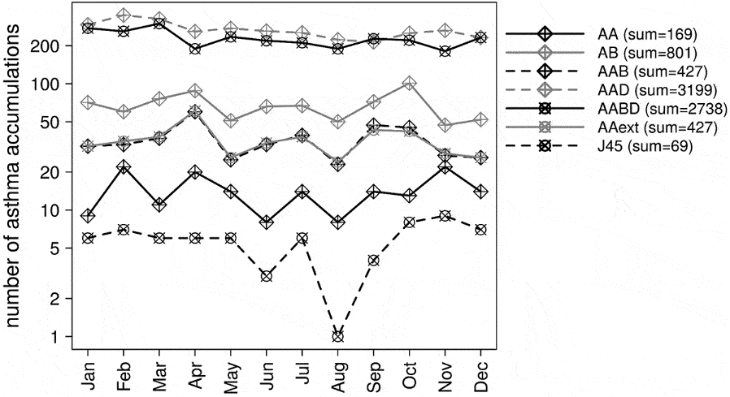

**Figure 2**. Mean annual cycle of asthma accumulation events for Bavaria including the years from 2010 to 2018. Numbers in brackets indicate the overall number of accumulations of the respective group of ICD-10 codes within the study period (data: KVB)

***Pollen data***

Pollen and fungal spore concentrations for Augsburg were estimated from measurements from a Hirst-type pollen trap (Hirst [1952](https://www.tandfonline.com/reader/content/17d3b4e77b7/10.1080/09603123.2021.1985971/format/epub/EPUB/xhtml/index.xhtml#cit0035)). They were measured for the years from 2015 to 2017, identified and counted manually by the Chair of Environmental Medicine, Technical University of Munich. All the methods used followed the standard protocol of aerobiological monitoring according to Galan et al. ([2014](https://www.tandfonline.com/reader/content/17d3b4e77b7/10.1080/09603123.2021.1985971/format/epub/EPUB/xhtml/index.xhtml#cit0026)). Airborne pollen concentrations were classified by pollen type including the most allergenic pollen taxa defined based on the regional abundance of atmospheric pollen as well as the prevalence and sensitization frequency. *Alternaria* fungal spores were included in the data set too. The pollen concentrations exhibit a distinct seasonal cycle with a maximum in spring and early summer and a minimum in winter. The exact timing and magnitude of the maximum differs between taxa. The most frequent pollen types are from birch (*Betula)*, ash (*Fraxinus)*, pine (*Pinus)*, grasses (*Poaceae)* and nettle (*Urticaceae)*. However, for this analysis, all pollen taxa were examined together. Case studies of thunderstorm asthma identify several relevant pollen taxa, but a variety of additional factors may be contributing, too, particularly other pollen taxa. In addition, the most frequent taxa in the data set have allergic potential (Damialis et al. [2019](https://www.tandfonline.com/reader/content/17d3b4e77b7/10.1080/09603123.2021.1985971/format/epub/EPUB/xhtml/index.xhtml" \l "cit0020)). The annual cycle of *Alternaria* spore concentrations shows the highest values from July to September.

***Case studies***

In order to achieve a first overview on the relations, time series of asthma accumulations that coincide with thunderstorm activity were examined alongside the temporal development of meteorological variables from the nearest neighbouring DWD station. For the region of Augsburg, the pollen and fungal spore concentrations for the co-occurrences of asthma and thunderstorms were also included.

***Weather type classifications***

As a relatively simple approach to weather type classification, compositing was applied. This environment-to-circulation approach classifies a local variable, in this case, the occurrence or non-occurrence of asthma accumulations and relates the classes with corresponding patterns of atmospheric variables (Yarnal et al. [2001](https://www.tandfonline.com/reader/content/17d3b4e77b7/10.1080/09603123.2021.1985971/format/epub/EPUB/xhtml/index.xhtml#cit0066)). Composites were calculated seasonally (March to May: ‘MAM’, June to August: ‘JJA’, September to November: ‘SON’, December to February: ‘DJF’ and April to September: thunderstorm season ‘TH’) for each postal code and group of ICD-10 codes separately. Two classes were formed: the first includes time periods without asthma-related accumulation and the second includes accumulation periods. For these two classes mean fields of the gridded GFSA variables were calculated. This results in spatial patterns of the meteorological variables for both classes. Differences in the patterns of the classes can give hints on possible relationships between the respective meteorological variable and asthma occurrences. In addition to these mean fields, anomalies for both classes were calculated. These anomalies are the deviations between the mean field of a class (i.e. the composite) and the overall seasonal mean field of the gridded variable. The differences in the central tendency of the two classes were tested for significance using the Mann–Whitney U-test. The test was applied for each grid point separately resulting in spatial patterns of p-values. Thus, not only the mean spatial patterns of the two classes but also the regions with significant differences in the large-scale meteorological variables between the classes could be identified.

***Contingency tables and χ2-test***

2 x 2 contingency tables and the non-parametric χ2-test for independence (α = 0.1 and α = 0.05) between categorical variables were applied to investigate the statistical relationship between the occurrence of asthma accumulations and different environmental parameters. For this purpose, the large-scale meteorological variables (CAPE, CIN, 4LFTX, HPBL, HGT, TMP, WSPD, RH) were classified into two classes. The occurrences of values above or below the mean and influence or no influence of a thunderstorm cell, respectively, were compared with the occurrences of asthma accumulations. For the city of Augsburg, tests were also performed for pollen and *Alternaria* spores concentrations above vs. below the mean. The analysis was performed differentiated by seasons (meteorological seasons and the thunderstorm season as defined in section ‘weather type classification’) as well as on an annual basis, for each postal code region and if applicable for the vertical levels of the meteorological variables separately. The tests were evaluated using the p-value and the odds ratio (e.g. Schmidt and Kohlmann [2008](https://www.tandfonline.com/reader/content/17d3b4e77b7/10.1080/09603123.2021.1985971/format/epub/EPUB/xhtml/index.xhtml#cit0049)). P-values were additionally corrected for multiple testing using the simple Bonferroni correction (e.g. Shaffer [1995](https://www.tandfonline.com/reader/content/17d3b4e77b7/10.1080/09603123.2021.1985971/format/epub/EPUB/xhtml/index.xhtml#cit0050)).

**Results**

***Case studies***

In most of the cases of asthma accumulations, no thunderstorm influence could be detected. Especially the asthma events with the largest numbers of cases, reaching up to 24 asthma cases in 4 hours in some postal code regions, were not accompanied by lightning activity. However, there are several accumulation events that coincide with a thunderstorm. [Figure 3](https://www.tandfonline.com/reader/content/17d3b4e77b7/10.1080/09603123.2021.1985971/format/epub/EPUB/xhtml/f0003.xhtml) (left) shows an example from the municipality of Oberstdorf (813 m a.s.l., population approx. 9,900) in the German Alps from Aug. 22nd, 2012. Six cases of asthma emergencies occurred within an hour after a thunderstorm accompanied by a minor peak in wind speeds and moderate rainfall. Another case from the city of Augsburg with two preceding thunderstorms (cf. [Figure 3](https://www.tandfonline.com/reader/content/17d3b4e77b7/10.1080/09603123.2021.1985971/format/epub/EPUB/xhtml/f0003.xhtml) right) beginning on May 9th, 2015, shows slightly increasing pollen concentrations after each occurrence of lightning activity accompanied by some asthma emergencies. Besides, there were also asthma emergencies following a maximum of pollen concentrations 2 days later. The most important pollen taxa in this period were pine (*Pinus*, 51.6%), spruce (*Picea*, 25.5%), grass (*Poaceae*, 8.9%), and oak (*Quercus*, 7.4%). Except from spruce, the pollen of these taxa has allergic potential, although it has to be remarked that sensitization towards *Pinaceae* is rare (e.g. Gioulekas et al. [2004](https://www.tandfonline.com/reader/content/17d3b4e77b7/10.1080/09603123.2021.1985971/format/epub/EPUB/xhtml/index.xhtml#cit0028)).

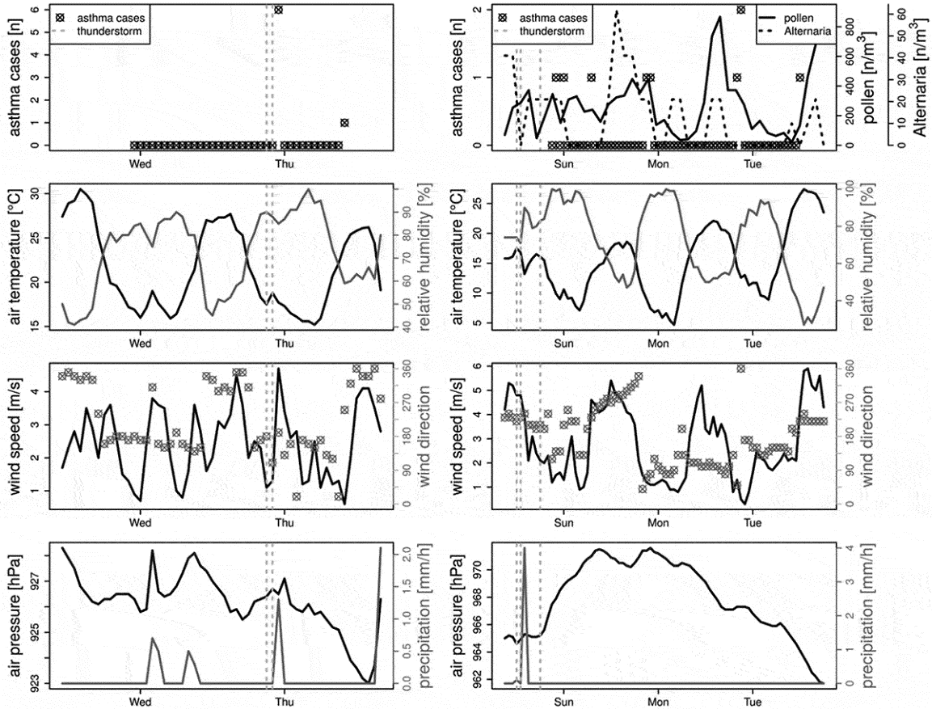

**Figure 3**. Examples of co-occurrences of a thunderstorm and an asthma accumulation in Oberstdorf on Aug. 22nd, 2012 (left) and Augsburg on May 9th, 2015 (right), including meteorological conditions at the nearest DWD station and in the case of Augsburg aeroallergen concentrations. The distances to the DWD station amount to 4362 m for Oberstdorf and 7469 m for Augsburg, respectively. Dashed vertical lines indicate the times of thunderstorm occurrences. Asthma cases comprise cases from ICD-10 group AAD

***Composites and anomalies***

Many of the composites and anomalies do not show any indication of a positive relationship between asthma accumulations and thunderstorms. In some cases, there is even an opposing association with positive anomalies of the CAPE index for periods without asthma accumulations. An example is given in [Figure 4](https://www.tandfonline.com/reader/content/17d3b4e77b7/10.1080/09603123.2021.1985971/format/epub/EPUB/xhtml/f0004.xhtml), which shows composites of the CAPE index for a postal code in the city of Munich. For situations without asthma accumulations of ICD-10 group AABD in this region (left map in [Figure 4](https://www.tandfonline.com/reader/content/17d3b4e77b7/10.1080/09603123.2021.1985971/format/epub/EPUB/xhtml/f0004.xhtml)), the values of the CAPE index in the study region are significantly higher than for periods with asthma accumulations (right map in [Figure 4](https://www.tandfonline.com/reader/content/17d3b4e77b7/10.1080/09603123.2021.1985971/format/epub/EPUB/xhtml/f0004.xhtml)). This applies especially to southern Bavaria. In the surroundings of the city of Munich the values of CAPE reach up to 120 J/kg on average in situations without asthma accumulations but amount to only 20 J/kg in situations with asthma accumulations.

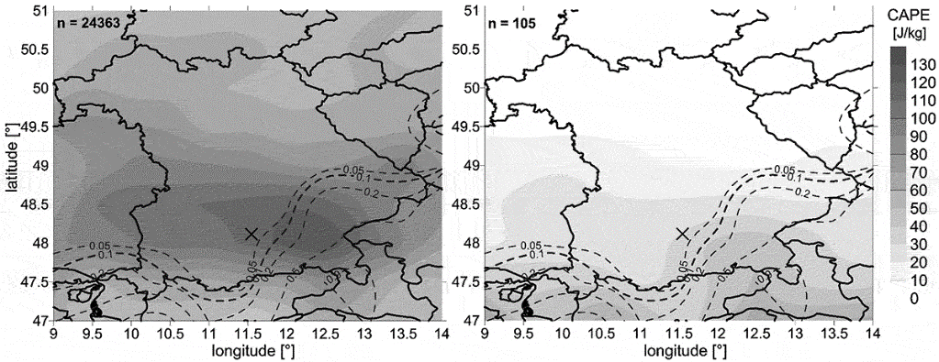

**Figure 4**. Composites (mean spatial patterns) of the CAPE index [J/kg] for periods without asthma accumulations of group ‘AABD’ in Munich (left) vs. periods with asthma accumulations (right), annual analysis. ‘n’ indicates the number of time steps included in the calculation of the composite. Dashed lines are isolines of the p-values of u-tests for significant differences between the two classes at each individual grid point of the GFSA data. The cross marks the geographical position of the city of Munich

On the other hand, there are several postal code regions where the results support the supposed thunderstorm asthma mechanisms. For example, some regions show positive anomalies of the CAPE index for periods with asthma accumulations. This applies for different seasons, including the thunderstorm season. Anomalies of the CAPE index for Nuremberg for the thunderstorm season show positive values, i.e. higher than the seasonal mean values, for periods with accumulations of the ICD-10 group AAext ([Figure 5](https://www.tandfonline.com/reader/content/17d3b4e77b7/10.1080/09603123.2021.1985971/format/epub/EPUB/xhtml/f0005.xhtml), right map). On the other hand, in time periods without asthma accumulations the anomalies are negative, which means that the CAPE values are lower than the seasonal mean ([Figure 5](https://www.tandfonline.com/reader/content/17d3b4e77b7/10.1080/09603123.2021.1985971/format/epub/EPUB/xhtml/f0005.xhtml), left map). The patterns of the two classes are significantly different from each other around the city of Nuremberg ([Figure 5](https://www.tandfonline.com/reader/content/17d3b4e77b7/10.1080/09603123.2021.1985971/format/epub/EPUB/xhtml/f0005.xhtml)).

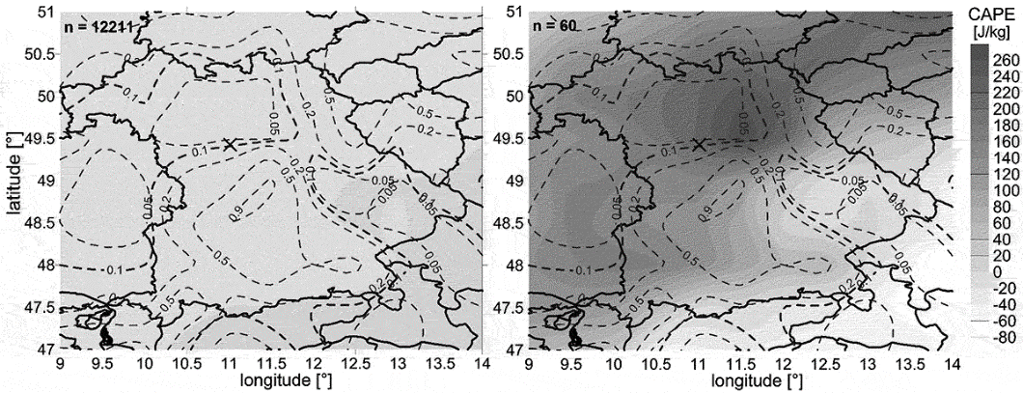

**Figure 5**. Anomalies from the seasonal mean for the CAPE index [J/kg] for the thunderstorm season in Nuremberg for periods without asthma accumulations of ICD-10 group ‘AAext’ (left), and with accumulations (right). ‘n’ indicates the number of time steps included in the calculation of the spatial pattern of anomalies. Dashed lines are isolines of the p-values of u-tests for significant differences between the two classes at each individual grid point of the GFSA data. The cross marks the geographical position of the city of Nuremberg

Although these results are not consistent over all Bavarian postal code regions, seasons or ICD-10 groups, the coincidence of asthma accumulations with enhanced convective activity in the atmosphere is not a rare exception. [Table 2](https://www.tandfonline.com/reader/content/17d3b4e77b7/10.1080/09603123.2021.1985971/format/epub/EPUB/xhtml/t0002.xhtml) indicates the percentage of postal code regions with significant anomalies of selected variables at the nearest GFSA grid point in time periods with asthma accumulations. They amount to up to 44.4%. Thus, in a considerable percentage of composites, there is evidence of a connection between increased convection, unstable conditions or thunderstorm activity and asthma-related emergency cases.**Table 2**. Percentage of composites with significant anomaly at the nearest grid point of the GFSA data in the class with asthma accumulation compared with the class without asthma accumulation (tested individually for each postal code region and season), differentiated by ICD-10 groups and stability indices. The groups of ICD-10 codes are abbreviated as follows: allergic and severe asthma = AA, non-allergic asthma = AB, allergic asthma and dyspnoea = AAD, allergic asthma and non-allergic asthma = AAB, allergic asthma and non-allergic asthma and dyspnoea = AABD, allergic asthma only = J45 and extended definition of allergic asthma = AAext. Positive anomalies (‘pos.’) were counted for the convective available potential energy (CAPE), negative anomalies (‘neg.’) for the convective inhibition (CIN) as well as the four-layer lifted index (4LFTX) and both directions for the height of the planetary boundary layer (HPBL). The number of calculated composites (comprising postal code regions and seasons) is indicated for each ICD-10 group (‘n’) ([Table view](https://www.tandfonline.com/reader/content/17d3b4e77b7/10.1080/09603123.2021.1985971/format/epub/EPUB/xhtml/t0002.xhtml))

|  | AA (n = 60) | AB (n = 218) | AAB (n = 168) | AAD (n = 678) | AABD (n = 544) | AAext (n = 85) | J45 (n = 9) |
| --- | --- | --- | --- | --- | --- | --- | --- |
| **CAPE pos.** | 13.3% | 20.2% | 13.1% | 23.0% | 18.0% | 16.5% | 0% |
| **HPBL pos.** | 13.3% | 9.2% | 5.9% | 10.9% | 10.6% | 7.1% | 33.3% |
| **CIN neg.** | 16.7% | 19.3% | 16.7% | 20.1% | 18.8% | 15.3% | 0% |
| **4LFTX neg.** | 30.0% | 22.0% | 19.0% | 37.2% | 29.4% | 18.8% | 11.1% |
| **HPBL neg.** | 20.0% | 12.8% | 15.5% | 14.5% | 14.0% | 11.8% | 44.4% |

***χ2-tests***

Results of the annual variant of the χ2-tests for association between asthma accumulations and different large-scale variables show some significant associations with meteorological variables. [Figure 6](https://www.tandfonline.com/reader/content/17d3b4e77b7/10.1080/09603123.2021.1985971/format/epub/EPUB/xhtml/f0006.xhtml) shows the results of the annual analysis of the tests with Bonferroni correction for multiplicity in different postal code regions. Thus, only the tests with the lowest probability of error are kept (two levels of significance are applied, α = 0.1 and α = 0.05). For each ICD-10 group and each meteorological variable, the medians of the odds ratios of all tests are presented. Also, the number of tested postal code regions is included (numbers above the bars). Values of the odds ratio above 1 indicate an increased risk of an accumulation of asthma emergencies in the case of above-average values of the respective meteorological variable and thus a positive relationship. On the other hand, odds ratios below 1 indicate a reduced risk of asthma accumulation in the case of above-average values of the respective meteorological variable and thus a negative relationship between asthma and meteorology.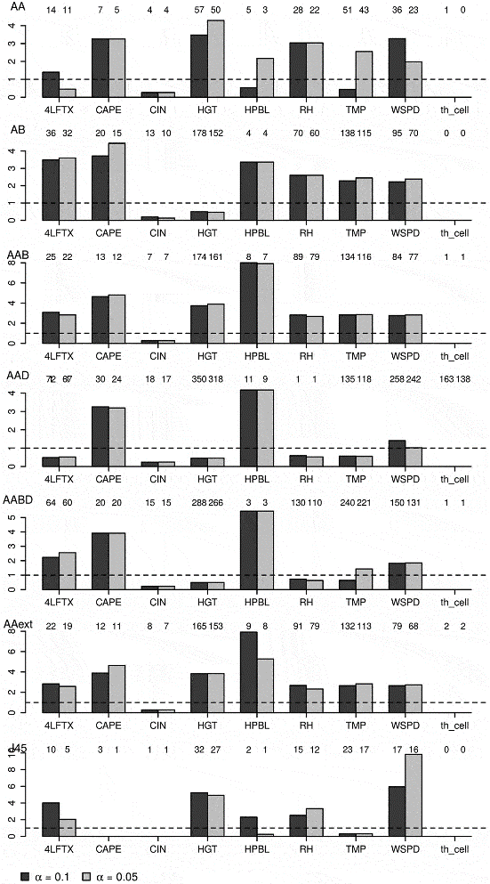

**Figure 6**. Results of the annual variant of the χ2-tests for the different ICD-10 groups and GFSA variables as well as thunderstorm influence (‘th_cell’). Medians of the odds ratios are presented for tests with significant p-values (for α = 0.1 in dark grey and for α = 0.05 in light grey) after Bonferroni correction. The numbers above the bars indicate the number of tests included in the calculation of the median (resulting from included postal codes and vertical levels for TMP, HGT, RH and WSPD). The ICD-10 group is given in the upper left corner of each bar plot

After the Bonferroni correction, a considerable number of postal code regions show significant relationships between the occurrence of asthma accumulations of different ICD-10 groups and meteorology (cf. [Figure 6](https://www.tandfonline.com/reader/content/17d3b4e77b7/10.1080/09603123.2021.1985971/format/epub/EPUB/xhtml/f0006.xhtml)). These tests show a positive association with the CAPE index and the four-layer lifted index, as well as a negative association with convective inhibition for most of the ICD-10 groups (cf. [Figure 6](https://www.tandfonline.com/reader/content/17d3b4e77b7/10.1080/09603123.2021.1985971/format/epub/EPUB/xhtml/f0006.xhtml)). For HPBL, there are several ICD-10 groups with positive relationships. In all ICD-10 groups, there is a positive association with wind speed. For relative humidity, there is a tendency towards more positive than negative relationships. However, for most of the variables there are also some ICD-10 groups with a majority of tests showing the opposite relationship, e.g. for CAPE for group J45 or 4LFTX for group AAD. In group J45, though, there is only a small number of accumulation events. Besides, only a few postal code regions remain significant after the Bonferroni correction, which makes the results for this group less robust. For air temperature and geopotential height, the results are very variable among the ICD-10 groups.

However, it has to be emphasized that the relationships described above can only be observed in a part of the Bavarian postal code regions. The analysis without Bonferroni correction as well as a variant with seasonal differentiation shows many opposing and insignificant test results (not shown).

**Discussion**

The presented study investigates the statistical relationship between accumulations of asthma emergencies and environmental variables in Bavaria. It analyses the relevance of thunderstorm asthma in the study area by applying case studies, a simple approach to weather type classification, and 2 × 2 contingency tables and χ2-tests. Statistical analyses of this phenomenon are rare, in general, and thunderstorm asthma has not been studied in Germany yet. Many case reports from different parts of the world have shown that thunderstorm asthma can have severe consequences. Therefore, knowledge on the relevance of the phenomenon is important for the proper adaptation and the prevention of overloading of medical care services.

The results show weak but significant relationships between the occurrence of asthma accumulations and different variables. These associations cannot be observed consistently over the whole of Bavaria, for all seasons or groups of ICD-10 codes. However, the relationships revealed by the different statistical methods point in the same direction. Accumulation of asthma cases significantly correlates with enhanced convective activity and decreased atmospheric stability. It has to be noted that the relationships with the four-layer lifted index are partly not in line with the other stability indices. The CAPE index has the highest absolute correlation with cloud-to-ground lightning densities in all seasons except winter. Consequently, it can be considered as the most appropriate index for the occurrence of atmospheric convection leading to thunderstorm development and, thus, increased thunderstorm asthma risk. The relationship with the height of the planetary boundary layer can be interpreted in two ways. On the one hand, higher boundary layers are an indicator for increased convection and, thus, increased probability for the occurrence of thunderstorm asthma. On the other hand, lower boundary layer heights possibly indicate higher concentrations of aeroallergens and other pollutants because these constituents are distributed over a smaller volume of air, which could lead to increased numbers of allergic reactions. This assumption well relates to the higher accumulation of airborne pollen at shorter boundary layer heights, as in the Mediterranean-climate Thessaloniki, Greece, where it was found that airborne levels of pollen and fungal spores were consistently higher at the boundary layer (Damialis et al. [2017](https://www.tandfonline.com/reader/content/17d3b4e77b7/10.1080/09603123.2021.1985971/format/epub/EPUB/xhtml/index.xhtml#cit0021)). The positive relationship between wind speed and asthma accumulations indicates an increased release and transport, as well as mechanical rupture of pollen grains, e.g. as reported by Visez et al. ([2015](https://www.tandfonline.com/reader/content/17d3b4e77b7/10.1080/09603123.2021.1985971/format/epub/EPUB/xhtml/index.xhtml#cit0061)), and may contribute to higher allergen loads. For some ICD-10 groups, there are positive relationships with relative humidity, which could be related to osmotic rupture of pollen grains in contact with humidity. Thus, several of the observed relationships support the mechanisms of thunderstorm asthma reported in the literature (e.g. Taylor and Jonsson [2004](https://www.tandfonline.com/reader/content/17d3b4e77b7/10.1080/09603123.2021.1985971/format/epub/EPUB/xhtml/index.xhtml" \l "cit0058)). The non-uniform results over the study area could be a consequence of the inclusion of different regions with locally differing thunderstorm statistics, climatic conditions, and pollen and fungal spore composition. As asthma attacks or dyspnoea can result from a multitude of different environmental and non-environmental factors (Strachan [2000](https://www.tandfonline.com/reader/content/17d3b4e77b7/10.1080/09603123.2021.1985971/format/epub/EPUB/xhtml/index.xhtml" \l "cit0054); Cecchi et al. [2013](https://www.tandfonline.com/reader/content/17d3b4e77b7/10.1080/09603123.2021.1985971/format/epub/EPUB/xhtml/index.xhtml" \l "cit0011)) finding a strong statistical relationship with meteorological factors was not to be expected.

The inspection of examples of asthma accumulations shows that in several cases thunderstorms and increased numbers of asthma emergencies occur in spatial and temporal vicinity. The two case studies from Oberstdorf and Augsburg show numbers of seven or nine asthma emergencies within a period of ten hours or two days, respectively. Thunderstorm asthma events reported in the literature often comprise large numbers of emergency cases, e.g. exceeding 3000 patients per event in Melbourne (Thien et al. [2018](https://www.tandfonline.com/reader/content/17d3b4e77b7/10.1080/09603123.2021.1985971/format/epub/EPUB/xhtml/index.xhtml#cit0059)) or 2000 in Ahvaz, Iran (Forouzan et al. [2014](https://www.tandfonline.com/reader/content/17d3b4e77b7/10.1080/09603123.2021.1985971/format/epub/EPUB/xhtml/index.xhtml#cit0025)). But there are also reports of cases with distinctly less asthma-related emergencies, e.g. seven cases in Naples were reported by D’Amato et al. ([2008](https://www.tandfonline.com/reader/content/17d3b4e77b7/10.1080/09603123.2021.1985971/format/epub/EPUB/xhtml/index.xhtml#cit0015)) or 14 in New Zealand by Sabih et al. ([2020](https://www.tandfonline.com/reader/content/17d3b4e77b7/10.1080/09603123.2021.1985971/format/epub/EPUB/xhtml/index.xhtml#cit0047)). For the latter, it can be expected that they did not lead to a capacity overload of medical care services. The reported time periods with increased numbers of presentations due to asthma reach up to two days, following a thunderstorm event, e.g. Xu et al. ([2021](https://www.tandfonline.com/reader/content/17d3b4e77b7/10.1080/09603123.2021.1985971/format/epub/EPUB/xhtml/index.xhtml#cit0064)). Thus, the two presented cases for Bavaria are in line with case studies from other countries and a relationship of the asthma cases with the preceding thunderstorm is possible. Even though a causal connection between thunderstorms and asthma emergencies cannot be revealed by these examples, they can serve as an indication for the existence of the phenomenon of thunderstorm asthma in Bavaria.

Spatially continuous data or at least a better spatial coverage of measurement stations as well as longer time series for pollen and fungal spores would be of advantage because there are reports from several studies that thunderstorm asthma is connected to pollen allergy (as reviewed by D’Amato et al. [2016](https://www.tandfonline.com/reader/content/17d3b4e77b7/10.1080/09603123.2021.1985971/format/epub/EPUB/xhtml/index.xhtml#cit0018)). This connection could only be captured adequately for the city of Augsburg in this study. Utilising modelled pollen concentrations could be a solution and would also permit to take long-range transport into account. Additionally, the diagnosis given by the emergency doctor may not always be 100% correct. They may sometimes be imprecise and can be changed during further treatment of the patient. Furthermore, a considerable percentage of the Bavarian population has asthma (Steppuhn et al. [2017](https://www.tandfonline.com/reader/content/17d3b4e77b7/10.1080/09603123.2021.1985971/format/epub/EPUB/xhtml/index.xhtml#cit0053)) and pollen allergy is also common (Bergmann et al. [2016](https://www.tandfonline.com/reader/content/17d3b4e77b7/10.1080/09603123.2021.1985971/format/epub/EPUB/xhtml/index.xhtml" \l "cit0008)). Thus, the small number of emergency cases related to allergic asthma (ICD-10 code J.45) may lead to an underestimation of the thunderstorm asthma risk in this study.

Further variables could be considered in future studies, for example, the occurrence and intensity of wind gusts, the kind of thunderstorm (frontal or convective) and variables of air quality, like ozone concentrations, nitrogen oxides or particulate matter in the surrounding of the thunderstorm cell. Besides, air samples from the outflow of the thunderstorm could be collected to count pollen and fungal spore concentrations, determine the composition of taxa and to examine the presence of ruptured pollen grains. Hence, a comprehensive characterisation of the environmental conditions would be possible. A promising method to gather this information are measurement flights with unmanned aerial vehicles in the surroundings of thunderstorm cells. This could help to gain a better understanding of the exact mechanisms and identify the relevant pollen or fungal spore taxa and other involved variables. In addition, numbers of visits at deputising services or general practitioners would help to generate a more comprehensive picture of the frequency of asthma cases and additionally enable to differentiate according to the severity of the cases. This could serve as an indicator of the severity of a thunderstorm asthma epidemic. In a prospective setting, more details about severity of symptoms, whereabouts and activity of the patient at the onset of the symptoms, possible exposure to outside conditions, underlying health conditions or presence of risk factors could be collected via questionnaires or interviews. This can help identify possible cases of thunderstorm asthma and exclude other cases of asthma or dyspnoea. An individual examination of each patient by a medical specialist could verify the diagnosis (Spina et al. [2020](https://www.tandfonline.com/reader/content/17d3b4e77b7/10.1080/09603123.2021.1985971/format/epub/EPUB/xhtml/index.xhtml" \l "cit0052)). Another possibility could be (electronic) allergy diaries filled out by participants of a cohort study, in order to include also patients who have allergic symptoms during thunderstorms but do not consult a doctor. Therefore, it is highly suggested that additional use of personalised, well-characterised, human cohorts in the form of panel studies would provide more detailed information on the atopy status of participating allergic patients, which would potentially reveal clearer patterns of thunderstorm-associated respiratory symptoms (e.g. as in Gökkaya et al. [2020](https://www.tandfonline.com/reader/content/17d3b4e77b7/10.1080/09603123.2021.1985971/format/epub/EPUB/xhtml/index.xhtml" \l "cit0030)).

In this retrospective study, we found that thunderstorm asthma until now did not lead to a capacity overload of medical services in Bavaria. However, this cannot be generalised. According to Caminati et al. ([2018](https://www.tandfonline.com/reader/content/17d3b4e77b7/10.1080/09603123.2021.1985971/format/epub/EPUB/xhtml/index.xhtml" \l "cit0010)) the specific characteristics of allergen release, which is geographically variable, can be critical for the relevance of thunderstorm asthma. In addition, each single event can be highly relevant to specific individuals. The provision of information on the phenomenon to vulnerable groups would be necessary to prevent severe asthma, as also stated by D’Amato et al. ([2017](https://www.tandfonline.com/reader/content/17d3b4e77b7/10.1080/09603123.2021.1985971/format/epub/EPUB/xhtml/index.xhtml#cit0014)). Furthermore, the relevance of thunderstorm asthma can increase due to climate change, e.g. due to changes in phenology (D’Amato et al. [2015](https://www.tandfonline.com/reader/content/17d3b4e77b7/10.1080/09603123.2021.1985971/format/epub/EPUB/xhtml/index.xhtml#cit0017)) and habitats of plants (D’Amato et al. [2020](https://www.tandfonline.com/reader/content/17d3b4e77b7/10.1080/09603123.2021.1985971/format/epub/EPUB/xhtml/index.xhtml" \l "cit0016)), altered pollen concentrations (Ziello et al. [2012](https://www.tandfonline.com/reader/content/17d3b4e77b7/10.1080/09603123.2021.1985971/format/epub/EPUB/xhtml/index.xhtml" \l "cit0068); D’Amato et al. [2020](https://www.tandfonline.com/reader/content/17d3b4e77b7/10.1080/09603123.2021.1985971/format/epub/EPUB/xhtml/index.xhtml" \l "cit0016)), elongation of the pollen season (D’Amato et al. [2015](https://www.tandfonline.com/reader/content/17d3b4e77b7/10.1080/09603123.2021.1985971/format/epub/EPUB/xhtml/index.xhtml" \l "cit0017)) or increased concentrations of allergens in the pollen grains (Cecchi et al. [2013](https://www.tandfonline.com/reader/content/17d3b4e77b7/10.1080/09603123.2021.1985971/format/epub/EPUB/xhtml/index.xhtml" \l "cit0011)). Rojo et al. ([2021](https://www.tandfonline.com/reader/content/17d3b4e77b7/10.1080/09603123.2021.1985971/format/epub/EPUB/xhtml/index.xhtml" \l "cit0046)) have already observed earlier starts of the pollen season and increases in pollen production for some species in Bavaria. Allergies have already become more frequent and are expected to increase further in the future (Ziello et al. [2012](https://www.tandfonline.com/reader/content/17d3b4e77b7/10.1080/09603123.2021.1985971/format/epub/EPUB/xhtml/index.xhtml#cit0068); Damialis et al. [2019](https://www.tandfonline.com/reader/content/17d3b4e77b7/10.1080/09603123.2021.1985971/format/epub/EPUB/xhtml/index.xhtml" \l "cit0020)). In addition, southern Bavaria already belongs to the regions with the highest numbers of thunderstorms in Germany (Wapler [2013](https://www.tandfonline.com/reader/content/17d3b4e77b7/10.1080/09603123.2021.1985971/format/epub/EPUB/xhtml/index.xhtml" \l "cit0062)) and increasing frequencies of extreme thunderstorms are expected due to climate change (Schefczyk and Heinemann [2017](https://www.tandfonline.com/reader/content/17d3b4e77b7/10.1080/09603123.2021.1985971/format/epub/EPUB/xhtml/index.xhtml" \l "cit0048)). Consequently, it is possible that thunderstorm asthma will become more problematic in Bavaria in the future. The approach presented in this study can be useful for the investigation of this phenomenon in other regions and under future conditions.

**Summary and conclusion**

The presented study utilises different approaches to find statistical relationships between accumulations of asthma-related emergency cases and thunderstorms as well as meteorologic conditions in Bavaria, Southern Germany. The results give some weak evidence for thunderstorm asthma. Several significant associations between large-scale meteorological variables and asthma accumulations support the mechanisms of thunderstorm asthma presented in the literature. A significant number of coincidences of periods with asthma accumulations and enhanced convective activity as well as relationships with different atmospheric stability indices and the height of the planetary boundary layer have to be highlighted. A case study shows a sudden increase of asthma-related emergency cases following a thunderstorm in the municipality of Oberstdorf. However, the causality of the observed associations cannot be shown in the current study. Longer time series, aerobiological data and meteorological observations from the direct surroundings of thunderstorm cells as well as more extensive health data could be utilised in further studies to gain more insight on causal connections and the underlying processes.

Although an adaptation of medical services in Bavaria regarding thunderstorm asthma is not necessary based on the current results, the phenomenon is relevant for individuals with more severe asthma or higher pollen sensitisation. Furthermore, future developments should be observed under the aspect of climate change and the increase of allergies.

**Acknowledgements**

The authors would like to thank Siemens AG for providing the lightning data and Kassenärztliche Vereinigung Bayerns (KVB), especially Mr.Bachetzky and Dr.Gerlach, for providing the asthma data. Both data sets were essential for this study.

**Disclosure statement**

No potential conflict of interest was reported by the author(s).

**Funding**

This research project is funded by the Bavarian State Ministry of the Environment and Consumer Protection (StMUV) as well as the Bavarian State Ministry of Health and Care (StMGP) within the scope of the compound project “climate change and health”.

**References**

Alderman PM, Sloan JP, Basran GS. 1986. Asthma and thunderstorms. *Arch Emerg Med*. 3(4):260–262. .

Ali F, Behbehani N, Alomair N, Taher A. 2019. Fatal and near-fatal thunderstorm asthma epidemic in a desert country. *Ann Thorac Med*. 14(2):155–160. .

Anderson JO, Thundiyil JG, Stolbach A. 2012. Clearing the air: a review of the effects of particulate matter air pollution on human health. *J Med Toxicol*. 8(2):166–175. .

Anderson W, Prescott GJ, Packham S, Mullins J, Brookes M, Seaton A. 2001. Asthma admissions and thunderstorms: a study of pollen, fungal spores, rainfall, and ozone. *Q J Med*. 94(8):429–433. .

Andrae S, Axelson O, Björkstén B, Fredriksson M, Kjellman NIM. 1988. Symptoms of bronchial hyperreactivity and asthma in relation to environmental factors. *Arch Dis Child*. 63(5):473–478. .

Bannister T, Ebert EE, Silver J, Newbigin E, Lampugnani ER, Hughes N, Looker C, Mulvenna V, Jones PJ, Davies JM, et al. 2021. A pilot forecasting system for epidemic thunderstorm asthma in Southeastern Australia. *BAMS*. 102(2):E399–E420.

Bellomo R, Holmes P, Gigliotti P, Treloar A, Suphioglu C, Singh MB, Knox B. 1992. Two consecutive thunderstorm associated epidemics of asthma in the city of Melbourne: the possible role of rye grass pollen. *Med J Aust*. 156(12):834–837. .

Bergmann KC, Heinrich J, Niemann H. 2016. Current status of allergy prevalence in Germany. Position paper of the environmental medicine commission of the Robert Koch Institute. *Allergo J Int*. 25(1):6–10. .

Bond DW, Zhang R, Tie X, Brasseur G, Huffines G, Orville RE, Boccippio DJ. 2001. NOX production by lightning over the continental United States. *J Geophys Res*. 106(D21):27701–27710. .

Caminati M, Senna G, Vianello A, Ricci G, Bellamoli R, Longhi S, Crivellaro M, Marcer G, Monai M, Passalacqua G. 2018. Thunderstorm asthma: a critical appraisal based on clinical practice. *J Investig Allergol Clin Immunol*. 28(4):273–275. .

Cecchi L, D’Amato G, Annesi-Maesano I. 2013. Climate, urban air pollution, and respiratory allergy. *Clim Vulnerability*. 1:105–113. .

Celenza A, Fothergill J, Kupek E, Shaw RJ. 1996. Thunderstorm associated asthma: a detailed analysis of environmental factors. *BMJ*. 312(7031):604–607. .

Clayton-Chubb D, Con D, Rangamuwa K, Taylor D, Thien F, Wadhwa V. 2019. Thunderstorm asthma: revealing a hidden at-risk population. *Intern Med J*. 49(1):74–78. .

D’Amato G, Annesi Maesano I, Molino A, Vitale C, D’Amato M. 2017. Thunderstorm-related asthma attacks. *J Allergy Clin Immunol*. 139(6):1786–1787. .

D’Amato G, Cecchi L, Liccardi G. 2008. Thunderstorm-related asthma: not only grass pollen and spores. *J Allergy Clin Immunol*. 121(2):537–538. .

D’Amato G, Chong-Neto HJ, Monge Ortega OP, Vitale C, Ansotegui I, Rosario N, Haahtela T, Galan C, Pawankar R, Murrieta-Aguttes M, et al. 2020. The effects of climate change on respiratory allergy and asthma induced by pollen and mold allergens. *Allergy*. 75(9):2219–2228.

D’Amato G, Holgate ST, Pawankar R, Ledford DK, Cecchi L, Al-Ahmad M, Al-Enezi F, Al-Muhsen S, Ansotegui I, Baena-Cagnani CE, et al. 2015. Meteorological conditions, climate change, new emerging factors, and asthma and related allergic disorders. A statement of the World Allergy Organization. *World Allergy Organ J*. 8(25):52. .

D’Amato G, Vitale C, D’Amato M, Cecchi L, Liccardi G, Molino A, Vatrella A, Sanduzzi A, Maesano C, Annesi-Maesano I. 2016. Thunderstorm-related asthma: what happens and why. *Clin Exp Allergy*. 46(3):390–396. .

Dales RE, Cakmak S, Judek S, Dann T, Coates F, Brook JR, Burnett RT. 2003. The role of fungal spores in thunderstorm asthma. *CHEST*. 123(3):745–750. .

Damialis A, Traidl-Hoffmann C, Treudler R. 2019. Climate change and pollen allergies. In: Marselle M, Stadler J, Korn H, Irvine K, Bonn A, editors. *Biodiversity and health in the face of climate change*. Cham: Springer; p. 47–66. .

Damialis A, Kaimakamis E, Konoglou M, Akritidis I, Traidl-Hoffmann C, Gioulekas D. 2017. Estimating the abundance of airborne pollen and fungal spores at variable elevations using an aircraft: how high can they fly? *Sci Rep*. 7(1):44535. .

Drüe C, Hauf T, Finke U, Keyn S, Kreyer O. 2007. Comparison of a SAFIR lightning detection network in northern Germany to the operational BLIDS network. *J Geophys Res*. 112(D18):D18114. .

DWD Climate Data Center. 2019. [ftp://opendata.dwd.de/climate_environment/CDC/](http://ftp/opendata.dwd.de/climate_environment/CDC/). Accessed 01.10.2019

Elliot AJ, Hughes HE, Hughes TC, Locker TE, Brown R, Sarran C, Clewlow Y, Murray V, Bone A, Catchpole M, et al. 2014. The impact of thunderstorm asthma on emergency department attendances across London during July 2013. *Emerg Med J*. 31(8):675–678. .

Forouzan A, Masoumi K, Shoushtari MH, Idani E, Tirandaz F, Feli M, Assarehzadegan MA, Darian AA. 2014. An overview of thunderstorm-associated asthma outbreak in Southwest of Iran. *J Environ Public Health*. 4(p). .

Galan C, Smith M, Thibaudon M, Frenguelli G, Oteros J, Gehrig R, Berger U, Clot B, Brandao R, EAS QC Working Group. 2014. Pollen monitoring: minimum requirements and reproducibility of analysis. *Aerobiologia*. 30(4):385–395.

Galway JG. 1956. The lifted index as a predictor of latent instability. *Bull Am Meteorol Soc*. 37(10):528–529. .

Gioulekas D, Papakosta D, Damialis A, Spieksma F, Giouleka Patakas D. 2004. Allergenic pollen records (15 years) and sensitization in patients with respiratory allergy in Thessaloniki, Greece. *Allergy*. 59(2):174–184. .

Girgis ST, Marks GB, Downs SH, Kolbe A, Car GN, Paton R. 2000. Thunderstorm-associated asthma in an inland town in south-eastern Australia. Who is at risk? *Eur Respir J*. 16(1):3–8. .

Gökkaya M, Damialis A, Nussbaumer T, Beck I, Bounas-Pyrros N, Bezold S, Amisi MM, Kolek F, Todorova A, Chaker A, et al. 2020. Defining biomarkers to predict symptoms in subjects with and without allergy under natural pollen exposure. *J Allergy Clin Immunol*. 146(3):583–594.

Grote M, Valenta R, Reichelt R. 2003. Abortive pollen germination: a mechanism of allergen release in birch, alder, and hazel revealed by immunogold electron microscopy. *J Allergy Clin Immunol*. 111(5):1017–1023. .

Grundstein A, Sarnat SE, Klein M, Shepherd M, Naeher L, Mote T, Tolbert P. 2008. Thunderstorm-associated asthma in Atlanta, Georgia. *Thorax*. 63(7):659–660. .

Hajat S, Goubet SA, Haines A. 1997. Thunderstorm-associated asthma: the effect on GP consultations. *Br J Gen Pract*. 47:639–641.

Higham J, Venables K, Kopek E, Bajekal M. 1997. Asthma and thunderstorms: description of an epidemic in general practice in Britain using data from a doctors’ deputising service in the UK. *J Epidemiol Community Health*. 51(3):233–238. .

Hirst JM. 1952. An automatic volumetric spore trap. *Ann Appl Biol*. 39(2):257–265. .

Kaynak B, Hu Y, Martin RV, Russell AG, Choi Y, Wang Y. 2008. The effect of lightning NOx production on surface ozone in the continental United States. *Atmospheric Chem Phys*. 8(17):5151–5159. .

Kevat A. 2020. Thunderstorm asthma: looking back and looking forward. *J Asthma Allergy*. 13:293–299. .

Kottek M, Grieser J, Beck C, Rudolf B, Rubel F. 2006. World map of the Köppen-Geiger climate classification updated. *Meteorol Z*. 15(3):259–263. .

Losappio L, Heffler E, Contento F, Cannito C, Rolla G. 2011. Thunderstorm-related asthma epidemic owing to Olea Europaea pollen sensitization. *Allergy*. 66(11):1510–1511. .

Marks GB, Colquhoun JR, Girgis ST, Hjelmroos Koski M, Treloar ABA, Hansen P, Downs SH, Car NG. 2001. Thunderstorm outflows preceding epidemics of asthma during spring and summer. *Thorax*. 56(6):468–471. .

Muzalyova A, Brunner JO, Traidl-Hoffmann C, Damialis A. 2019. Pollen allergy and health behavior: patients trivializing their disease. *Aerobiologia*. 35(2):327–341. .

Packe GE, Ayres JG. 1985. Asthma outbreak during a thunderstorm. *Lancet*. 326(8448):199–203. .

Pulimood TB, Corden JM, Bryden C, Sharples L, Nasser SM. 2007. Epidemic asthma and the role of the fungal mold Alternaria alternate. *J Allergy Clin Immunol*. 120(3):610–617. .

Rangamuwa KB, Young AC, Thien F. 2017. An epidemic of thunderstorm asthma in Melbourne 2016: asthma, rhinitis, and other previous allergies. *Asia Pac Allergy*. 7(4):193–198. .

Riemann-Campe K, Fraedrich K, Lunkeit F. 2009. Global climatology of Convective Available Potential Energy (CAPE) and Convective Inhibition (CIN) in ERA-40 reanalysis. *Atmos Res*. 93(1–3):534–545. .

Rojo J, Picornell A, Oteros J, Werchan M, Werchan B, Bergmann KC, Smith M, Weichenmeier I, Schmidt-Weber CB, Buters J. 2021. Consequences of climate change on airborne pollen in Bavaria, central Europe. *Reg Environ Change*. 21(9). .

Sabih A, Russell C, Chang CL. 2020. Thunderstorm-related asthma can occur in New Zealand. *Respirol Case Rep*. 8(7):e00655. .

Schefczyk L, Heinemann G. 2017. Climate change impact on thunderstorms: analysis of thunderstorm indices using high-resolution regional climate simulations. *Meteorol Z*. 26(4):409–419. .

Schmidt CO, Kohlmann T. 2008. When to use the odds ratio or the relative risk? *Int J Public Health*. 53(3):165–167. .

Shaffer JP. 1995. Multiple hypothesis testing. *Annu Rev Psychol*. 46(1):561–584. .

Siemens. 2019. BLIDS – der Blitz Informationsdienst von Siemens. <https://www.industry.siemens.com/services/global/de/portfolio/plant-data-services/blids/seiten/default.aspx>. Accessed 14.08.2019.

Spina MF, Banfi PI, Nicolini A. 2020. Thunderstorm-asthma, two cases observed in Northern Italy. *Multidiscip Respir Med*. 15(679). .

Steppuhn H, Kuhnert R, Scheidt-Nave C. 2017. 12-month prevalence of asthma among adults in Germany. *J Health Monit*. 2(3):34–42. .

Strachan DP. 2000. The role of environmental factors in asthma. *Br Med Bull*. 56(4):865–882. .

Suphioglu C, Singh MB, Taylor P, Bellomo R, Holmes P, Puy R, Knox RB. 1992. Mechanism of grass-pollen-induced asthma. *Lancet*. 339(8793):569–572. .

Taylor PE, Flagan RC, Miguel AG, Valenta R, Glovsky MM. 2004. Birch pollen rupture and the release of aerosols of respirable allergens. *Clin Exp Allergy*. 34(10):1591–1596. .

Taylor PE, Flagan RC, Valenta R, Glovsky MM. 2002. Release of allergens as respirable aerosols: a link between grass pollen and asthma. *J Allergy Clin Immunol*. 109(1):51–56. .

Taylor PE, Jonsson H. 2004. Thunderstorm Asthma. *Curr Allergy Asthma Rep*. 4(5):409–413. .

Thien F, Beggs PJ, Csutoros D, Darvall J, Hew M, Davies JM, Bardin PG, Bannister T, Barnes S, Bellomo R, et al. 2018. The Melbourne epidemic thunderstorm asthma event 2016: an investigation of environmental triggers, effect on health services, and patient risk factors. *Lancet Planet Health*. 2(6):255–263.

Vaidyanathan V, Miguel AG, Taylor PE, Flagan RC, Glovsky MM. 2006. Effects of electric fields on pollen rupture. *J Allergy Clin Immunol*. 117(2):157. .

Visez N, Chassard G, Azarkan N, Naas O, Sénéchal H, Sutra JP, Poncet P, Choël M. 2015. Wind-induced mechanical rupture of birch pollen: potential implications for allergen dispersal. *J Aerosol Sci*. 89:77–84. .

Wapler K. 2013. High-resolution climatology of lightning characteristics within central Europe. *Meteorol Atmospheric Phys*. 122(3–4):175–184. .

Wardmann AED, Stefani D, MacDonald JC. 2002. Thunderstorm-associated asthma or shortness of breath epidemic: a Canadian case report. *Can Respir J*. 9(4):267–270. .

Xu YY, Xue T, Li HR, Guan K. 2021. Retrospective analysis of epidemic thunderstorm asthma in children in Yulin, northwest China. *Pediatr Res*. 89(4):958–961. .

Yair Y, Yair Y, Rubin B, Confino-Cohen R, Rosman Y, Rottem M, Shachar E. 2019. First case of thunderstorm asthma in Israel. *Geophys Res Abstr*. 21:EGU2019–1786.

Yarnal B, Comrie AC, Frakes B, Brown DP. 2001. Developments and prospects in synoptic climatology. *Int J Climatol*. 21(15):1923–1950. .

Zhou S, Wang X, Lu S, Yao C, Zhang L, Rao L, Liu X, Zhang W, Li S, Wang W, et al. 2021. Characterization of allergenicity of platanus pollen allergen a 3 (Pla a 3) after exposure to NO2 and O3. *Environ Pollut*. 278:116913. .

Ziello C, Sparks TH, Estrella N, Belmonte J, Bergmann KC, Bucher E, Brighetti MA, Damialis A, Detandt M, Galán C, et al. 2012. Changes to airborne pollen counts across Europe. *PLoS ONE*. 7(4):e34076.