A

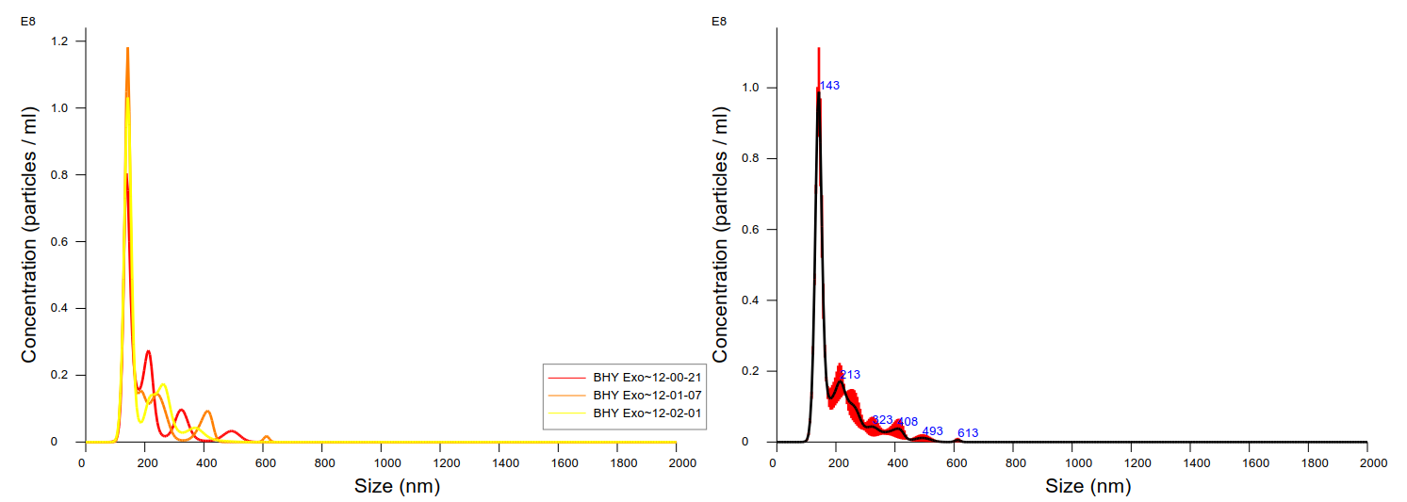

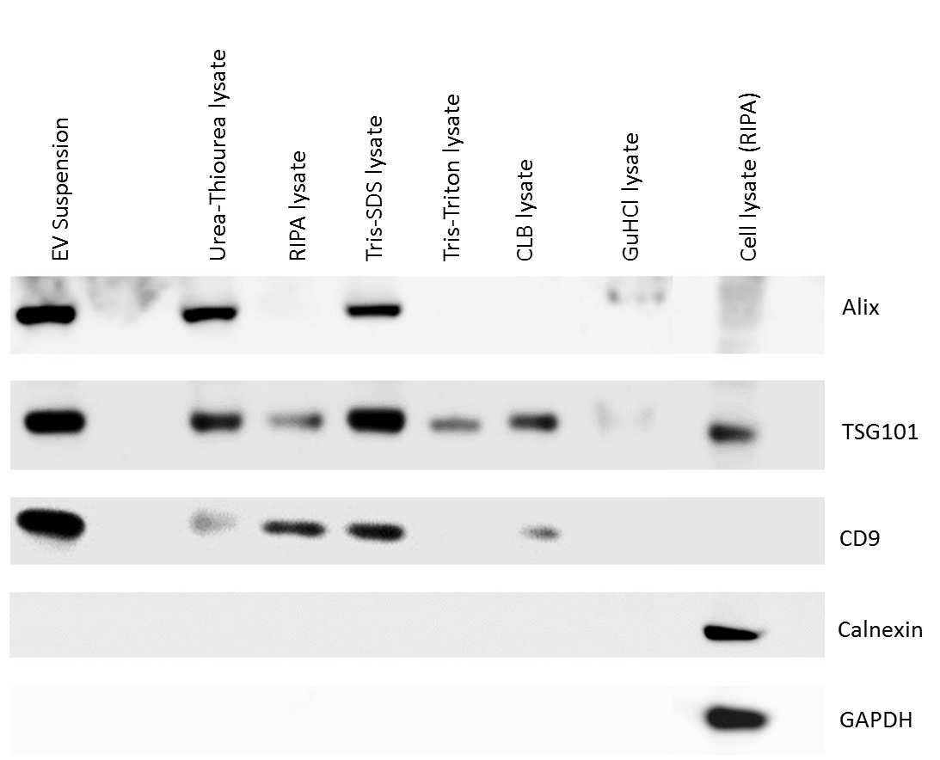

B

**SM Figure 1.** Characterization of EVs: (A) The size distribution of EVs: The EVs had a mean diameter of 195 nm (mode 143 nm) and a concentration of (1.01 × 109 ± 2.99 × 107­­) particles/ mL after a 1:1000 dilution. The measurement was carried out on Nanosight LM 10 microscope (Malvern, Baden-Wuerttemberg, Germany). Clumping of EVs can be observed (signals above 200 nm).

(B) Western blot depicting typical positive/negative EV-related markers: Eight µL EV suspension (~ 8.08 × 109 particles), 10 µg lysed EVs (urea-thiourea, RIPA, Tris-SDS, Tris-Triton, CLB and GuHCl), and 10 µg RIPA-lysed cell lysate were used for immunoblotting. One of the positive markers for EV, TSG101, was observed in the EV-suspension as well as in all lysis conditions. Negative markers for EVs- Calnexin and GAPDH, were not observed in EVs but in cell lysate after RIPA-lysis.

**SM Figure 2.** Gene ontology (GO) analysis (www.pantherdb.org) of proteins exclusively identified with respective buffers compared against RIPA buffer. Only proteins identified in all three replicates (n=3) in such buffers were considered. The numbers inside the bar charts represent the ‘component hits’ of the identified proteins when ‘Cellular Component’ analysis was performed. Proteins belonging to cellular component: protein-containing complex (GO:0032991), organelle (GO:0043226), extracellular region (GO:0005576) and cell (GO:0005623) were identified.