*Supplementary table 1.* General characteristics of included participants

|  |  |  |
| --- | --- | --- |
| Variable | Mean ± SD | Range |
| Age (years) | 8.56 **±** 0.95 | 7.33 – 11.23 |
| BMI (kg/m2) | 18.79 ± 4.25 | 12.11 – 34.01 |
| BMI percentile | 67.85 ± 29.07 | 0.06 – 99.58 |
| BMI z-score | 0.77 ± 1.05 | -1.64 – 2.64 |
| Body fat (%) | 25.05 ± 9.07 | 12.7 – 57.10 |
| Waist – hip ratio | 0.88 ± 0.05 | 0.79 – 1.04 |
| Homa-IR | 1.19 ± 1.28 | 0.23 – 7.58 |
| ISI-Matsuda | 10.69 ± 6.56 | 0.94 – 26.57 |
| Fasting glucose (mg/dL) | 85.49 ± 10.19 | 64.91 ± 130.40 |
| 2-hour glucose (mg/dL) | 114.90 ± 21.32 | 66.00 ± 158.80 |

*Supplementary table 2.* General characteristics of excluded participants

|  |  |  |
| --- | --- | --- |
| Variable | Mean ± SD | Range |
| Age (years) | 8.46 **±** 0.98 | 7.34 – 11.34 |
| BMI (kg/m2) | 18.73 ± 4.03 | 12.11 – 27.87 |
| BMI percentile | 67.58 ± 28.71 | 0.06 – 99.45 |
| BMI z-score | 0.68 ± 1.20 | -3.32 – 2.54 |
| Body fat (%) | 24.62 ± 8.34 | 13.50 – 42.40 |
| Waist – hip ratio | 0.87 ± 0.07 | 0.73 – 1.03 |
| Homa-IR | 0.98 ± 0.80 | 0.18 – 3.10 |
| ISI-Matsuda | 11.72 ± 6.55 | 2.07 – 26.20 |
| Fasting glucose (mg/dL) | 85.10 ± 8.46 | 61.00 ± 112.80 |
| 2-hour glucose (mg/dL) | 113.96 ± 19.34 | 81.00 ± 179.00 |

*Supplementary Table 3. Participants’ characteristics stratified by sex*

|  |  |  |  |
| --- | --- | --- | --- |
| Variable | Boys (*N* = 24) | Girls (*N* = 29) | p-value |
|  | Mean ± SD | Mean ± SD |  |
| Age (years) | 8.70 ± 1.06 | 8.49 ± 0.94 | 0.45 |
| BMI (kg/m2) | 19.63 ± 4.70 | 18.62 ± 3.97 | 0.40 |
| BMI percentile | 70.56 ± 30.62 | 69.84 ± 24.60 | 0.93 |
| BMI z-score | 0.87 ± 1.24 | 0.71 ± 0.89 | 0.58 |
| Body fat (%) | 24.89 ± 11.00 | 25.18 ± 7.31 | 0.91 |
| Waist-hip ratio | 0.89 ± 0.05 | 0.87 ± 0.05 | 0.19 |
| HOMA-IR | 1.19 ± 1.08 | 1.19 ± 1.45 | 0.99 |
| ISI-Matsuda | 10.38 ± 6.56 | 10.95 ± 6.66 | 0.76 |
| Fasting glucose (mg/dL) | 86.97 ± 7.47 | 84.27 ± 11.98 | 0.34 |
| 2-hour glucose (mg/dL) | 120.35 ± 7.47 | 110.39 ± 21.20 | 0.09 |

*Abbreviations: ISI = insulin sensitivity index, SD = standard deviation, BMI = body mass index, HOMA-IR = homeostatic model assessment for insulin resistance.*

**Task-based functional connectivity analysis including exposure to GDM as covariate**

We further assessed the effects of ISI on children’s FC patterns by adding GDM exposure as a covariate. Results are reported in *supplementary table 4* and *Supplementary figures 1-4*.

The main effect of ISI group (Lower ISI > Higher ISI) no longer reached statistical significance after small volume correction. The main effect of ISI (Lower ISI < Higher ISI) and the time-point × sex interaction remained largely unchanged by the inclusion of GDM as covariate. Finally, the ISI × sex interaction, included the left middle cingulate cortex, in addition to the previously reported left precentral gyrus. All other findings remain the same.

*Supplementary Table 4.*

|  |  |  |  |  |  |  |  |
| --- | --- | --- | --- | --- | --- | --- | --- |
| **Seed region** | **Target region** | **MNI coordinates of target region (X Y Z)** | | | **Peak T** | **Cluster size** | **p FWE** |
| Lower ISI > Higher ISI | | | | | | | |
| L anterior insula | R Nucleus caudate | 9 | 17 | 8 | 3.80 | 9 | 0.14svc |
| Lower ISI < Higher ISI | | | | | | | |
| L posterior insula | R Middle temporal gyrus | 51 | -28 | -4 | 4.99 | 103 | 0.01* |
| Time-point (before vs. after glucose ingestion) × sex | | | | | | | |
| L postcentral gyrus | L anterior insula | -45 | 5 | -10 | 4.87 | 193 | <0.001* |
| ISI (Lower vs. Higher) × sex | | | | | | | |
| R anterior insula | L middle cingulate cortex;  L precentral gyrus | -13  -24  -15 | 5  -7  -7 | 41  56  53 | 5.23  4.68  4.20 | 216 | <0.001* |

*\*indicates significance at the cluster level, svc indicates significance after small volume correction. For the svc, we used the mask as specified in section 2.7 of the main manuscript. R = right; L = left, FWE = family wise error corrected for multiple comparisons. Data are adjusted for age, BMI z-score, and GDM exposure.*

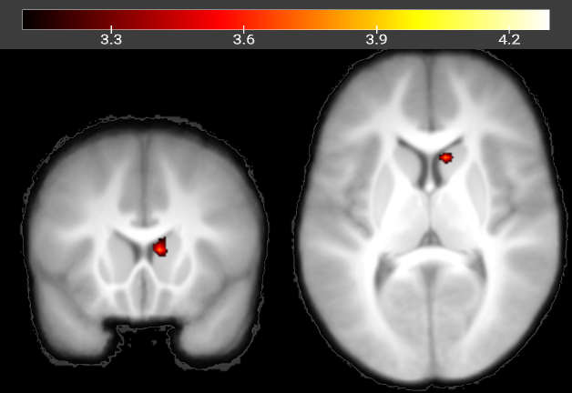

*Supplementary figure 1. Main effect of ISI (Lower ISI > Higher ISI). Shown is the cluster in the right nucleus caudate (Y=17, Z=8), which is not significant after further adjustment for GDM exposure. Color map corresponds to T values (P < 0.001 uncorrected for display) overlaid on the average normalized T1 weighted image of the children. Data are adjusted for age, BMI z-score, and GDM exposure.*

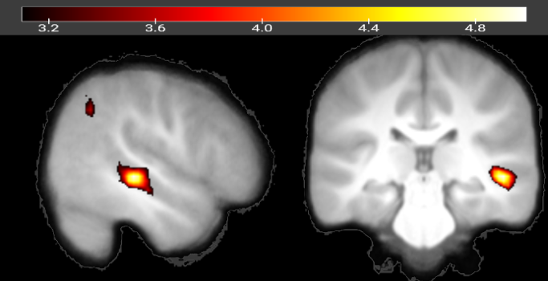

*Supplementary figure 2. Main effect of ISI (Lower ISI < Higher ISI). Shown is the cluster in the middle temporal gyrus(X=51, Y=-28). Color maps on the left correspond to T values (P < 0.001 uncorrected for display) overlaid on the average normalized T1 weighted image of the children. ISI = Insulin Sensitivity Index. Data are adjusted for age, BMI z-score, and GDM exposure.*

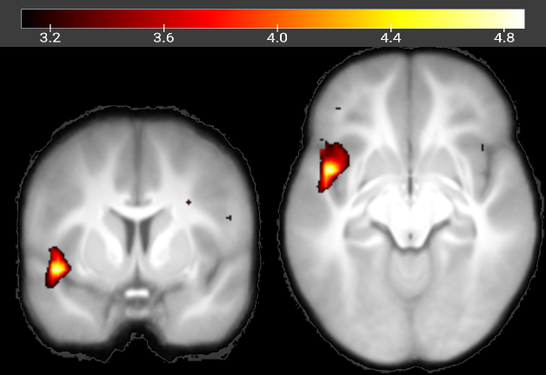

*Supplementary figure 3.* *Time-point (before vs. after glucose ingestion) × sex interaction on functional connectivity in children. Shown is the cluster on the left anterior insula (Y=5, Z=-10). Color maps on the left correspond to T values (P < 0.001 uncorrected for display) overlaid on the average normalized T1 weighted image of the children. Data are adjusted for age, BMI z-score and GDM exposure.*

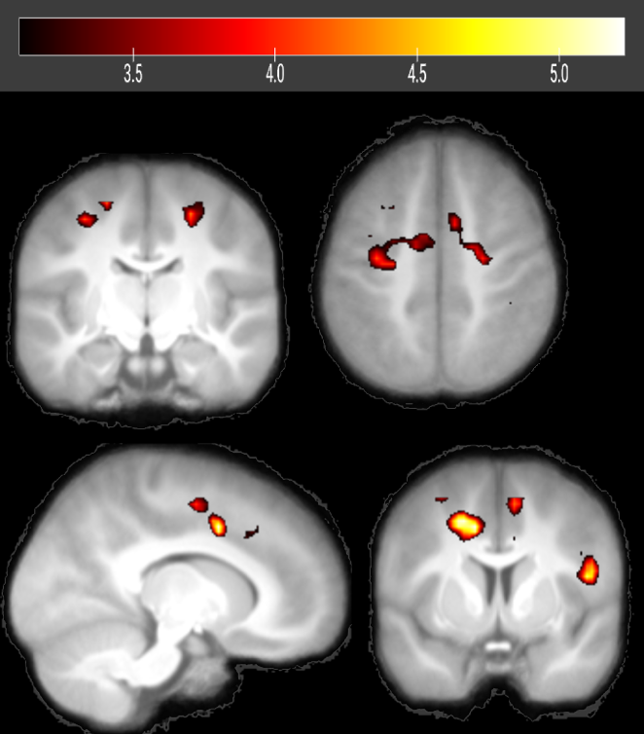

*Supplementary figure 4. ISI (Lower vs. Higher) × sex interaction on functional connectivity in children. Shown are the clusters on the left precentral gyrus (Top, Y=-13, Z=50) and on the left middle cingulate cortex (Bottom, X=-12, Y=5). Color maps on the left correspond to T values (P < 0.001 uncorrected for display) overlaid on the average normalized T1 weighted image of the children. * indicates* pFDR *≤0.01, \*\*\** pFDR *≤0.0001. ISI = Insulin Sensitivity Index*