**Title** Dose-dependent long-term effects of a single radiation event on behaviour and glial cells

**Authors**

Marie-Claire Ung1, Lillian Garrett1, Claudia Dalke1, Valentin Leitner6, Daniel Dragosa6, Daniela Hladik6, Frauke Neff2, Florian Wagner3, Horst Zitzelsberger4, Gregor Miller5, Martin Hrabĕ de Angelis5,8,9, Ute Rößler7, Daniela Vogt Weisenhorn1, Wolfgang Wurst1,6, Jochen Graw1, *Sabine M. Hölter1,5,6

•Helmholtz Zentrum München, German Research Centre for Environmental Health, 1Institute of Developmental Genetics , 2Institute of Pathology, 3Institute of Radiation Medicine,4Research Unit of Radiation Cytogenetics, 5German Mouse Clinic, Institute of Experimental Genetics, 6Technical University Munich, 7Federal Office for Radiation Protection, Department of Radiation Protection and Health, Neuherberg, Germany, 8Chair of Experimental Genetics, School of Life Science Weihenstephan, Technische Universität München, Freising, Germany, 9German Center for Diabetes Research (DZD), Neuherberg, Germany.

**Corresponding author \***Sabine M. Hölter, hoelter@helmholtz-muenchen.de, ORCID ID 0000-0003-4878-5241

**Supplementary information 1**

Figure S1 illustrates the main results of the analysis of general radiation dose effects over the course of the study revealed by the linear model with random intercepts. Since there were no significant sex- or genotype-specific radiation effects revealed by the linear model on the parameters presented, data of all mice per radiation dose and all three behavioural testing time points were pooled for this figure. An additional one-way ANOVA performed on this data confirmed significant radiation dose effects on total distance (radiation dose effect: F(3, 602) = 5.644, p = 0.0008) and speed (radiation dose effect: F(3, 601) = 4.545, p = 0.004) in open field and on acoustic startle reactivity (radiation dose effect: F(3, 604) = 3.395, 0.02). The post-hoc Tukey’s analysis revealed that there was significantly lower distance, speed and acoustic startle reactivity in the 0.5 Gy irradiated mice compared to both the sham irradiation control and the 0.063 Gy irradiated mice (see Figure S1 a, b and c).

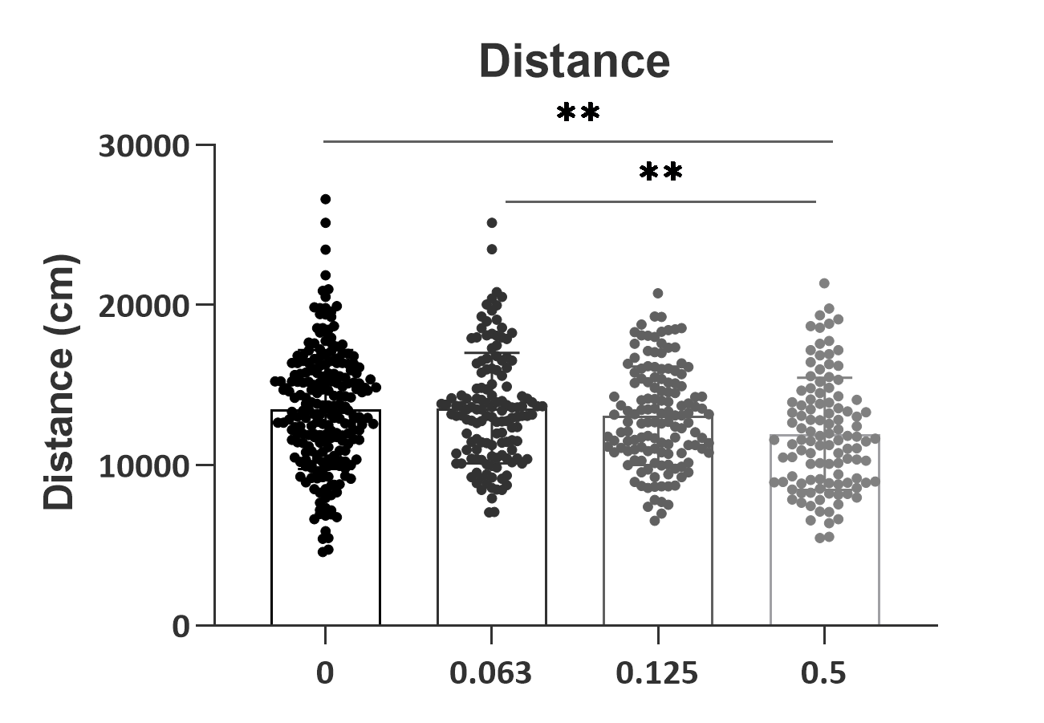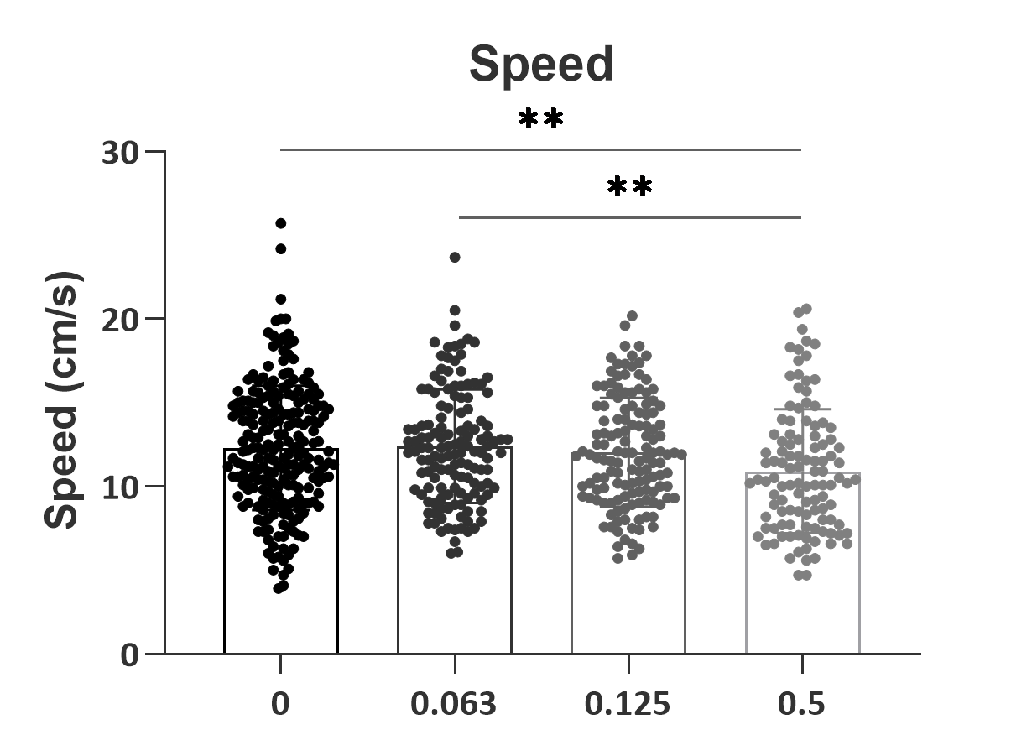

**c**

**b**

**a**

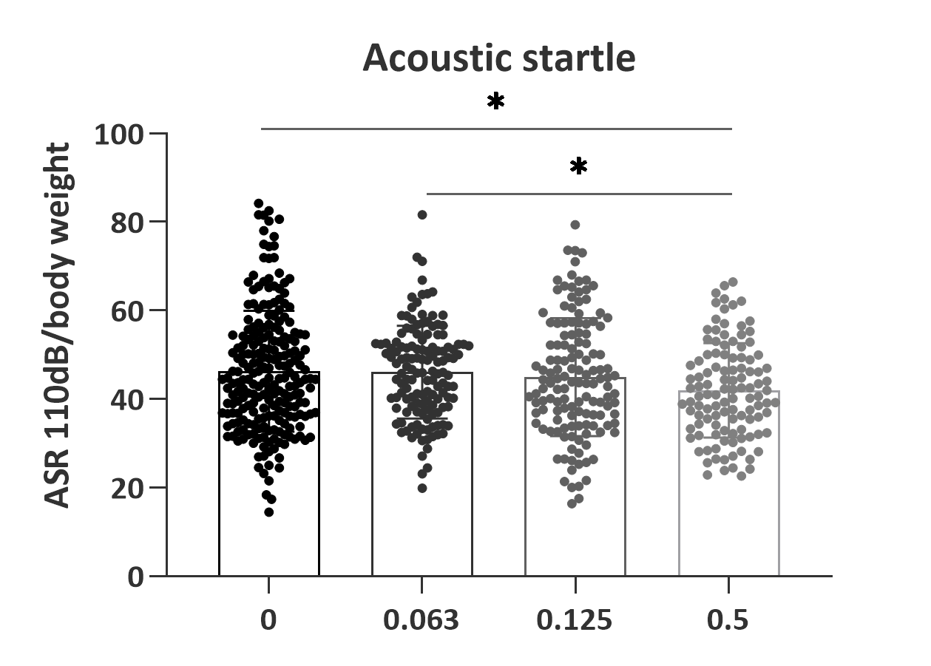

**Figure S1. Dose-dependent effects of irradiation on distance travelled (a) and speed (b) in the open field and on acoustic startle reactivity (ASR) at 110dB (c)**. Using a one-way ANOVA with *post-hoc* Tukey’s test, there was significantly decreased distance and speed in open field and acoustic startle reactivity in the 0.5 Gy irradiation mice compared to sham control (0) and the 0.063 Gy irradiated mice. *p < 0.05, **p < 0.01 vs. 0.5 Gy irradiated mice.

**Supplementary information 2**

Figure S2 illustrates the results of the analysis of general radiation dose effects over the course of the study on olfactory investigation time during the sample phase of the social discrimination test revealed by the linear model with random intercepts. To illustrate the significant sex x radiation interaction effect on this parameter revealed by the linear model, data of all males and females per radiation dose and all three behavioural testing time points were pooled for Figure S2a. A two-way ANOVA with sex and irradiation dose as factors performed on this data confirmed a significant interaction effect on social affinity during the social discrimination test (F(3, 592) = 3.808, p = 0.01). The post-hoc Bonferroni’s test analysis revealed that this effect was driven by differences between the sexes, where females show lower social affinity towards the ovariectomized female used as stimulus animal in this test than males (Figure S2a). Likewise, for Figure S2b data of all wt and mut mice per radiation dose and all three behavioural testing time points were pooled for Figure S2b. A two-way ANOVA analysis confirmed a significant genotype x irradiation dose interaction effect (F(3, 592) = 2.88, p = 0.04) that was, however, not significant in post-hoc analysis (Figure S2b).

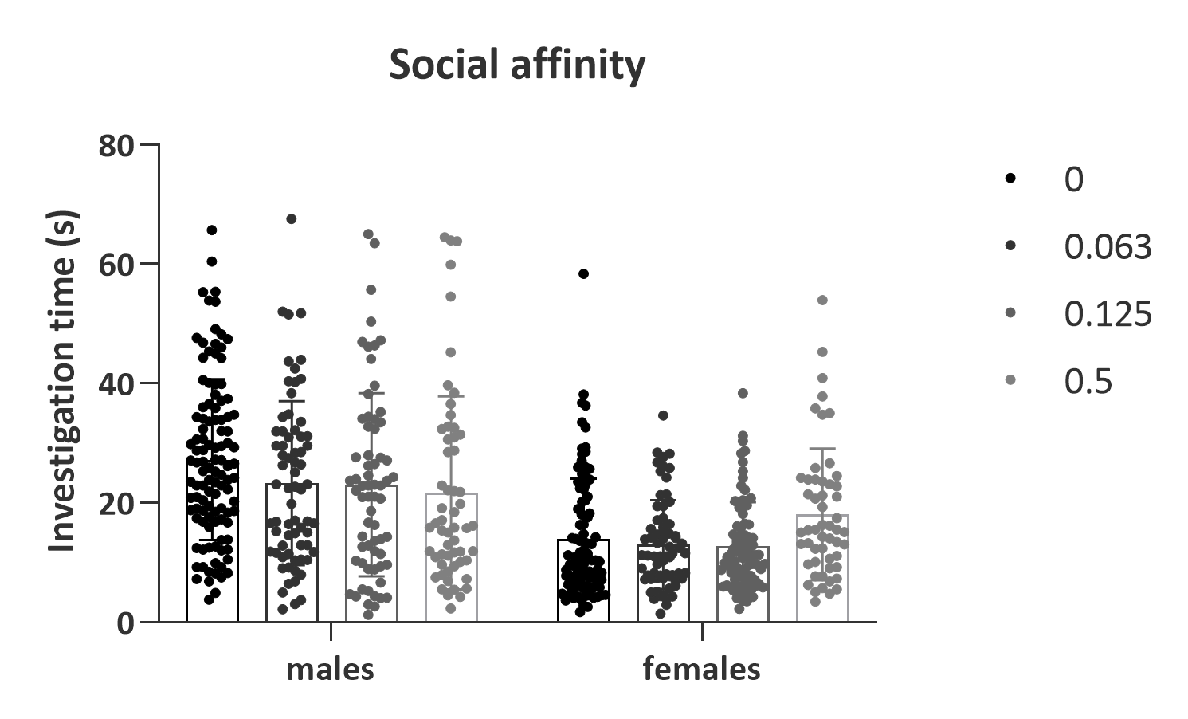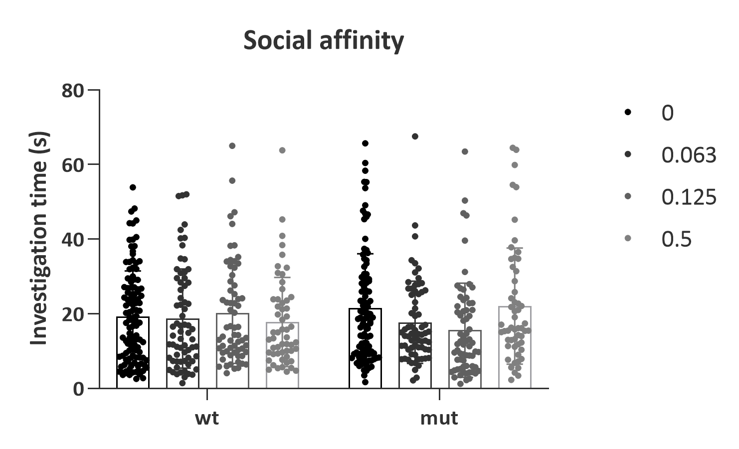

**a**

**b**

**Figure S2. Effects of sex and irradiation dose (a) and genotype x irradiation (b) on social affinity during the social discrimination tests.**

**Supplementary information 3**

A Pearson’s correlation analysis between locomotor activity (distance travelled, locomotor speed) parameters in the open field with sensorimotor recruitment in acoustic startle reactivity revealed significant positive correlations at 18 months post irradiation. Thus, lower distance travelled and speed at this time point could be related to lower acoustic startle responses (Figure S3a and b).

**a**

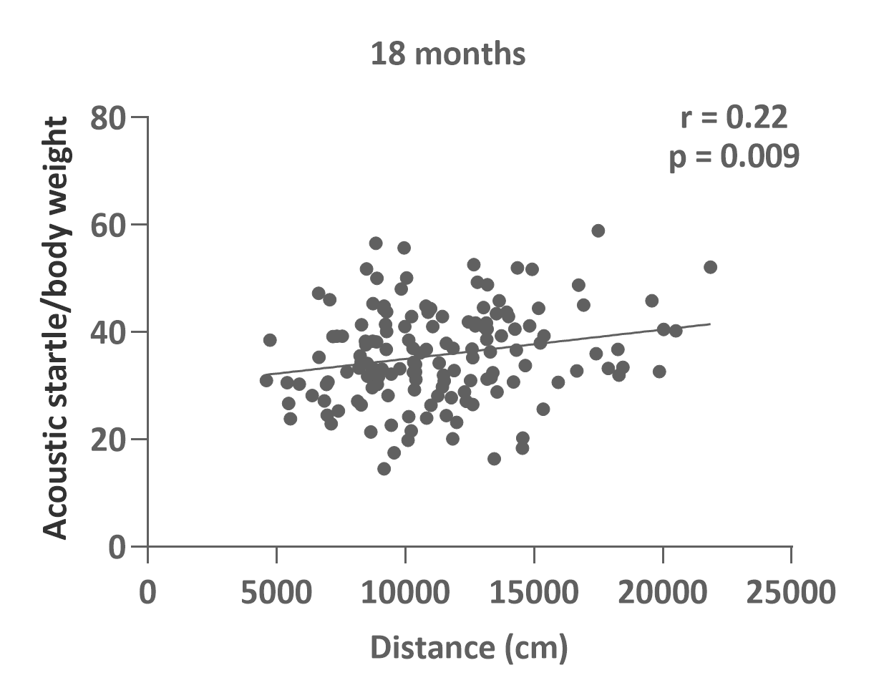

**b**

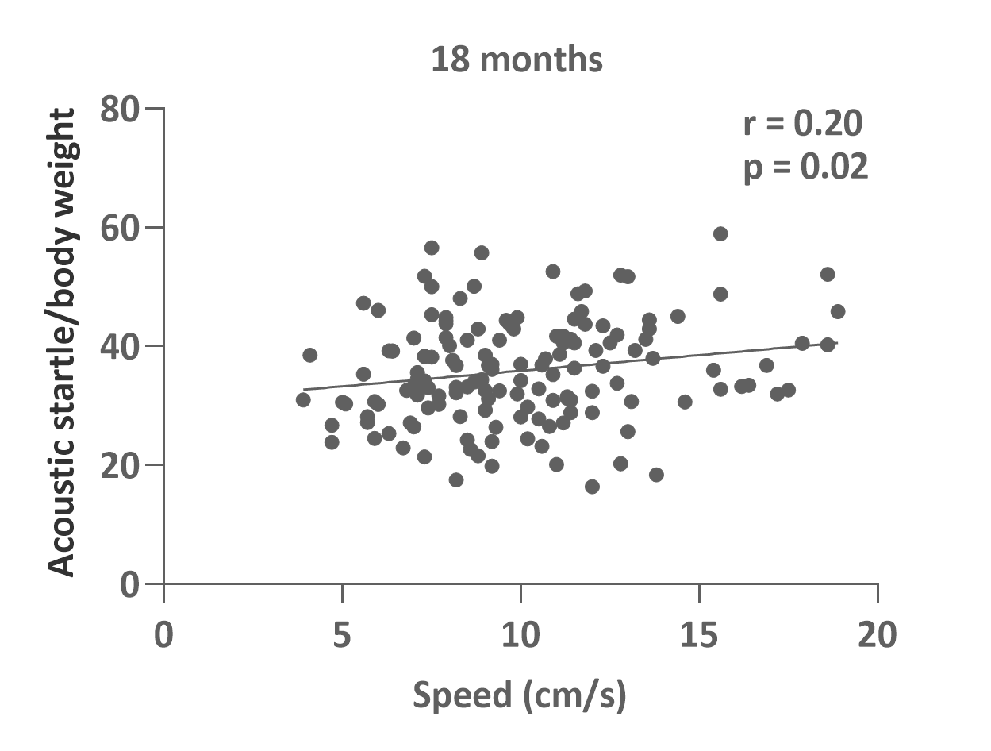

**Figure S3. Correlation analysis between acoustic startle reactivity with total distance or average speed in open field at 18 months post-irradiation**. There was significant positive correlations between the total distance and acoustic startle **(a)** and speed and acoustic startle **(b).** R = Pearson’s r statistic

**Supplementary information 4**

2-way ANOVA analyses of GFAP+ astrocytes and IBA1+ microglia quantification in the dentate gyrus (DG), Cornu Ammonis (CA) 1, 2/3 of the hippocampus with radiation (trt) and sex as factors. There were no significant sex x radiation interaction effects and so sexes were pooled for a 1-way ANOVA analysis of radiation effects.













**Supplementary information 5**

**Supplementary table S1 Dose-dependent radiation effects on microglial branching complexity and volume.** Data were analysed with 2-way Repeated Measures (RM) ANOVA and post-hoc tests were performed with Sidak’s multiple comparisons. 10 cells/animal were traced. n=6-13 animals/group. * p ≤ 0.05; ** p ≤ 0.01; *** p ≤ 0.001; **** p ≤ 0.0001

|  |  |  |  |  |  |  |  |  |  |
| --- | --- | --- | --- | --- | --- | --- | --- | --- | --- |
| Number of endings | | | | | | | | | |
| Radiation dose (Gy) | Distance from Soma [µm] | | | | | | | | |
|  | 5 | 10 | 15 | 20 | 25 | 30 | 35 | 40 | 45 |
| sham vs 0.063 Gy | - | - | * | **** | **** | **** | **** | * | - |
| sham vs 0.125 Gy | - | - | - | - | - | - | - | - | - |
| sham vs 0.5 Gy | - | - | ** | **** | *** | * | - | - | - |
| 0.063 Gy vs. 0.125 Gy | - | - | - | **** | **** | **** | **** | *** | - |
| 0.063 Gy vs. 0.5 Gy | - | - | **** | **** | **** | **** | **** | *** | - |
| 0.125 Gy vs. 0.5 Gy | - | - | ** | * | - | - | - | - | - |

|  |  |  |  |  |  |  |  |  |  |
| --- | --- | --- | --- | --- | --- | --- | --- | --- | --- |
| Number of intersections | | | | | | | | | |
| Radiation dose (Gy) | Distance from Soma [µm] | | | | | | | | |
|  | 5 | 10 | 15 | 20 | 25 | 30 | 35 | 40 | 45 |
| sham vs 0.063 Gy | - | * | **** | **** | **** | **** | *** | - | - |
| sham vs 0.125 Gy | - | - | **** | *** | * | - | - | - | - |
| sham vs 0.5 Gy | - | **** | **** | **** | *** | * | - | - | - |
| 0.063 Gy vs. 0.125 Gy | - | *** | **** | **** | **** | **** | **** | ** | - |
| 0.063 Gy vs. 0.5 Gy | - | **** | **** | **** | **** | **** | **** | ** | - |
| 0.125 Gy vs. 0.5 Gy | - | ** | * | - | - | - | - | - | - |

|  |  |  |  |  |  |  |  |  |  |
| --- | --- | --- | --- | --- | --- | --- | --- | --- | --- |
| Branch length | | | | | | | | | |
| Radiation dose (Gy) | Distance from Soma [µm] | | | | | | | | |
|  | 5 | 10 | 15 | 20 | 25 | 30 | 35 | 40 | 45 |
| sham vs 0.063 Gy | - | - | **** | **** | **** | **** | *** | ** | - |
| sham vs 0.125 Gy | - | - | * | *** | ** | * | - | - | - |
| sham vs 0.5 Gy | - | * | **** | **** | **** | ** | - | - | - |
| 0.063 Gy vs. 0.125 Gy | - | - | **** | **** | **** | **** | **** | **** | - |
| 0.063 Gy vs. 0.5 Gy | - | **** | **** | **** | **** | **** | **** | **** | - |
| 0.125 Gy vs. 0.5 Gy | - | * | * | - | - | - | - | - | - |

**Supplementary table S2 Dose-dependent radiation effects on astrocytic branching complexity and volume.** Data were analysed with 2-way Repeated Measures (RM) ANOVA and post-hoc tests were performed with Sidak’s multiple comparisons. 10 cells/animal were traced. n=10-16 animals/group. * p ≤ 0.05; ** p ≤ 0.01; *** p ≤ 0.001; **** p ≤ 0.0001

|  |  |  |  |  |  |  |  |  |  |
| --- | --- | --- | --- | --- | --- | --- | --- | --- | --- |
| Number of endings | | | | | | | | | |
| Radiation dose (Gy) | Distance from Soma [µm] | | | | | | | | |
|  | 5 | 10 | 15 | 20 | 25 | 30 | 35 | 40 | 45 |
| sham vs 0.063 Gy | - | - | - | - | - | - | - | - | - |
| sham vs 0.125 Gy | - | - | - | - | **** | **** | * | - | - |
| sham vs 0.5 Gy | - | - | - | * | ** | ** | - | - | - |
| 0.063 Gy vs. 0.125 Gy | - | - | - | - | **** | **** | * | - | - |
| 0.063 Gy vs. 0.5 Gy | - | - | - | - | * | * | * | - | - |
| 0.125 Gy vs. 0.5 Gy | - | - | - | - | - | - | - | - | - |

|  |  |  |  |  |  |  |  |  |  |
| --- | --- | --- | --- | --- | --- | --- | --- | --- | --- |
| Number of intersections | | | | | | | | | |
| Radiation dose (Gy) | Distance from Soma [µm] | | | | | | | | |
|  | 5 | 10 | 15 | 20 | 25 | 30 | 35 | 40 | 45 |
| sham vs 0.063 Gy | - | - | - | - | - | - | - | - | - |
| sham vs 0.125 Gy | - | ** | **** | **** | **** | - | - | - | - |
| sham vs 0.5 Gy | - | - | ** | ** | * | - | - | - | - |
| 0.063 Gy vs. 0.125 Gy | - | - | **** | **** | **** | - | - | - | - |
| 0.063 Gy vs. 0.5 Gy | - | - | ** | *** | * | - | - | - | - |
| 0.125 Gy vs. 0.5 Gy | - | - | - | * | - | - | - | - | - |

|  |  |  |  |  |  |  |  |  |  |
| --- | --- | --- | --- | --- | --- | --- | --- | --- | --- |
| Branch length | | | | | | | | | |
| Radiation dose (Gy) | Distance from Soma [µm] | | | | | | | | |
|  | 5 | 10 | 15 | 20 | 25 | 30 | 35 | 40 | 45 |
| sham vs 0.063 Gy | - | - | - | - | - | - | - | - | - |
| sham vs 0.125 Gy | - | - | **** | **** | **** | * | - | - | - |
| sham vs 0.5 Gy | - | * | ** | ** | ** | - | - | - | - |
| 0.063 Gy vs. 0.125 Gy | - | - | **** | **** | **** | ** | - | - | - |
| 0.063 Gy vs. 0.5 Gy | - | - | ** | **** | *** | - | - | - | - |
| 0.125 Gy vs. 0.5 Gy | - | - | - | - | - | - | - | - | - |

**Supplementary information 5**

**Correlation between Microglia and Locomotor and Acoustic Startle Behaviour**

Because the mice were repeatedly tested for behaviour at 4, 12 and 18 months and their brain tissue subsequently used for immunohistochemistry 24 months post-radiation, behaviour assessed at the latest time point, 18 months post-radiation, was correlated with the results of the stereological analysis performed on the brain tissues of the same mice. These analyses revealed a significant negative correlation between ASR/BW at 18 months post-radiation and the number of Iba1+ cells in the CA1 region 24 months post-radiation (Spearman’s r = 0.493, p = 0.003, **a**). Furthermore, glia and Iba1+ cell number in the dentate gyrus at 24 months post-radiation both correlated negatively with locomotor activity and speed at 18 months post-radiation (Glia + Locomotor activity: Spearman’s r = -0.347, p = 0.02; Glia + Speed: Spearman’s r = -0.352, p = 0.02; dentate gyrus Iba1+ cells + Locomotor activity: Spearman’s r = -0.475, p = 0.003, dentate gyrus Iba1+ cells + Speed: Spearman’s r = -0.471, p = 0.004, **b-e**.)

**Supplementary figure S4 Correlation between behaviour and glial cell numbers. a**. Significant positive correlation was evident between body weight normalized acoustic startle (ASR/BW) at 110 dB at 18 months p.i and the number of Iba1+ microglial cells in the hippocampal Cornu Ammonis (CA) 1 region (Spearman’s r = 0.493, p = 0.003) at 24 months post-radiation. Distance travelled in the 20 minute open field at 18 months post-radiation also correlated negatively with both dentate gyrus (DG) Iba1+ cell numbers and general glial cell numbers demarcated by Nissl stain (**b**, **c**) as did locomotor speed (**d**, **e**).

